CHAPTER -1
INTRODUCTION

1.1 Introduction
Bangladesh is a densely populated developing country of 147570 sq. km (BBS, 2000) area with about 145.2 million people (GOB, 2010). Bangladesh's per capita income went up to $848 in the current fiscal year from $816 last year (Bangladesh Bureau of Statistics-2012) but "Bangladesh has world’s highest malnutrition rate". (oneworld.net & UNICEF). In Bangladesh, 26% of the populations are undernourished and 46% of the children suffers from moderate to severe underweight problem.43% of children under 5 years old are stunted. ("The state of food insecurity in the food 2011". fao.org. & "Bangladesh Healthcare Crisis". BBC News. 28 February 2000). Retrieved 14 February 2012. The economy of Bangladesh mostly depends on agricultural resources. Approximately eighty five per cent people of the country rely on agriculture in one way or other for their livelihoods. Commercial layer farming is not only a source of employment, income and food but also critical to strong socio-cultural linkage in a 'country like Bangladesh. The demand for egg is increasing with the rapid increase in population. To meet up the increasing demand, apart from egg production, efficient egg marketing is necessary. It is difficult to run a profitable business without proper and organized marketing system. Therefore, marketing is a very important factor for egg as a commercial product. An efficient marketing system is needed for availability of product supply at a fair price and to encourage higher production. For this reason, it is essential to observe the present marketing system, to identify the problems and to improve the marketing system of egg in Bangladesh.

Egg is an excellent source of protein and nutrients which are essential for health and growth of the body. Egg is also an inexpensive source of protein among all animal products and also a delicious food item. The increase in production of egg was significant in recent years.

Table-1: Production of egg:
Production ( In lac )
Year | 05-06 | 06-07 | 07-08 | 08-09 | 09-10 | 10-11 | 11- 12  February/12
Egg | 54220 | 53690 | 56532 | 46420 | 57424 | 42110 | 40561
Source: Livestock, Ministry of Fisheries and Livestock.

Much of the increased egg production has come from commercial poultry sector. Since the last decade it is observed that poultry was one of the major activities where a large number of employments could generate a greater portion of local value addition. Government has declared poultry as a thrust sector and classified it as;
agro-based industry.

Table-2: Availability and consumption of egg in the country:

Year | Population estimated(million) | Net availability of eggs(million number) | Per capita consumption of eggs(number)
2009-2010 | 146.1 | 5742.4 | 39.30
2010-2011 | 149.7 | 4211 | 28.12
2011-2012 | 151.6 | 7303.8 | 48.17
2012-2013 | 153.6 | 5134.7 | 33.42

Note:
2012-13* Figures except population refer upto February 2013.
Source: 1995-96 to 1998-99 Statistical pocketbook of Bangladesh 2000 ,p.389
1999-00 Statistical pocketbook of Bangladesh2003 p.403 2000-01 to 2003-04 Statistical pocketbook of Bangladesh 2005, p.415 2004-05 Statistical pocketbook of Bangladesh 2012,p.417 Population from 2001-02 to 2012-13Bangladesh Economic Survey 2013, p.303 Meat and egg from 2001-02 to 2012-2012-13 Bangladesh Economic Survey 2013,p.10

Table-3: Current demand of egg:
Particulars | Production | Demand | Excess
Eggs(crore)/day | 1.6 | 1.5 | 0.1

Source: Bangladesh Poultry Association as cited by Moazzem and Raz 2014

1.3. Present status of Egg Production in Bangladesh:
Bangladesh has a long historical background of poultry rising under traditional backyard farming. Almost all eggs and poultry are produced by villagers in this country since domestication of poultry. The villagers generally kept indigenous chicken under semi-natural conditions mainly for their domestic consumption with very little commercial motives. Rising of improved type of birds was first started in government poultry farm in Bangladesh.
Commercial egg production has become a specialized and speedy business at present time for the people of Bangladesh. Now-a- day’s layer farming is being accepted as a profitable business. Now a day’s thousands of people engaged in poultry rearing especially for egg production. At present annual egg production is 57424 lac,42110 lac, 40561 lac in 2009,2010, 2011 respectively all over the countr (DLS).. As a result a good number of small, median and large farms have already been established all over the country. Number of egg production increase day by day to fulfill the demand of consumer.
The present study was conducted to satisfy the following objectives,
- To examine the existing marketing system of egg.
- To identify the present marketing channel of egg at Shitakundo upazilla under Chittagong district.
- To identify the problems of egg production, marketing and suggested
measures for improvement of egg marketing.
- To determine the marketing cost and marketing margin in different channels.

CHAPTER -2

RESEARCH METHODOLOGY

2.1. Introduction:
Methodology is an indispensable and integral part of any research. The methodology is related to selection of the study areas, selection of the samples, preparation of the survey schedule, collection of data, period of data collection, tabulation, editing and analysis of data. The methodology of the present study is discussed in this chapter.

2.2. Selection of the study Area:
Selection of the study area is an important step for conducting any study. It depends on the objectives or purposes set for the study and where the concerned commodity or work is available. For the present study, Sitakundu Upazilla under Chittagong district was selected because, recently a large number of commercial layer farms have been established there. So, there is a good prospect of egg marketing in the study area.
2.3. Selection of sample:
The total sample size was 30 in which 10 farms owner, 10 Aratder-cum-wholers, 10 retailers were selected for interviewing.

2.4. Selection of sample size:
For the different stages of egg marketing, samples of egg farmers and traders were purposively selected in order to meet the objectives of thew study. The total sample size 30 in which 10 farms owner, 10 Aratder-cum-wholers, 10 retailers were selected for interviewing from the study area.

2.5. Period of Data collection:
The data were collected both primary and secondary sources for the study. Primary data were collected by the researcher himself in the month of September in 2016. For the present study, data were collected during the period of 01 to 30 June 2016.

2.6. Collections of Data:
Data were collected both from primary and secondary sources for the study. Primary data were collected by the researcher herself through face to face interview with the selected respondents in the study area. Before the actual interview respondents were given a brief introduction about the nature and purpose of the study. At the time of interview the researcher asked the questions systematically and explained the questions whenever it was found necessary. The layer farm owners were interviewed at their farms while the traders were interviewed at market place.
2.7. Processing and Tabulation of Data:
After collection of data from the field, all the collected data for the present study were coded, tabulated, summarized and processed for analysis. The first step was taken to scrutinize the data of each and every schedule to find out any inconsistency or omission in the data collection and to avoid irrelevant information. The data were then transferred from survey schedule to tabular forms for systematic study. Then these were analyzed to achieve the desired objective of the study.

2.8. Analytical Technique:
A list of tables were prepared on the basis of findings of the analysis to achieve the objectives of the study. Data were presented mostly in the tabular form. Statistical methods such as mean, percentage etc. were applied for analyzed the data.

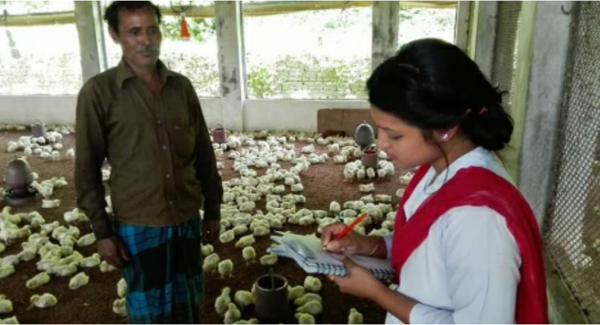
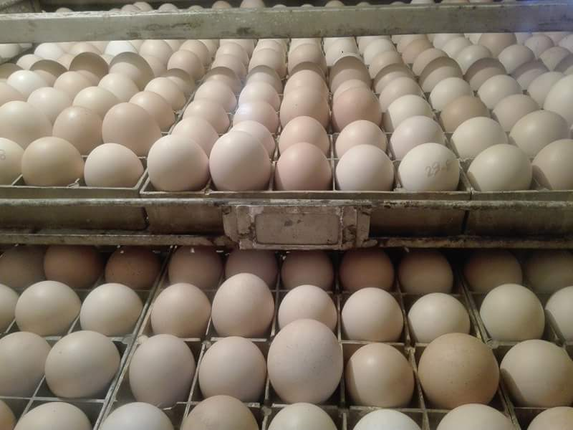

Figure 2: Eggs collected for transportation and selling.
Figure 1: Collection of data.

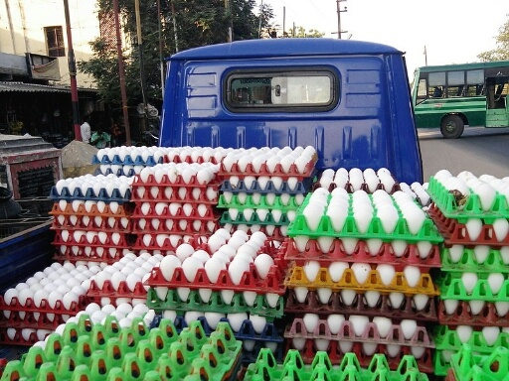
Figure 3: Loading of eggs for transportation.

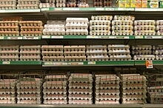
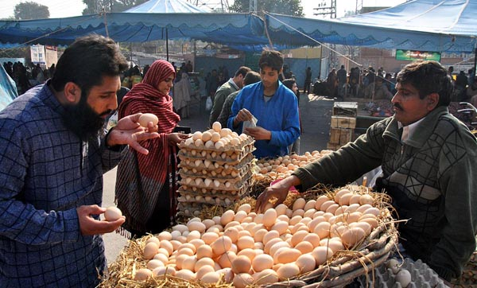

Figure 5: Buying of eggs by the consumer
Figure 4: Egg selling at grocer shop

2.9. Problems Faced in Data Collection:
The researcher faced varies problems while collecting data. These are discussed below:
- There was limitation of the time and for this, data and other necessary information had to be collected within the shortest possible time.
- Most of the respondents hesitated to give their actual information about production, income and profit. Because they were always afraid of tax imposition. To overcome this problem a good deal of time was spent to establish rapport with the respondents.
- Most of the respondents had no previous idea about such study. They were always apprehensive about the purpose of the study and it was therefore difficult to explain the purpose of this research to convince them.
- Most of the respondents were not well educated. Since majority of the layer farm owners and egg traders did not keep any records of their business.
- Sometimes the respondents did not cooperate willingly with the researcher because of no direct benefit from supplying information.
- The owners of the layer farms and egg traders were not available at their farms or shops because they remained busy with their outside work. For this, sometimes more than two visits were needed to collect the desired information from a single respondent.

CHAPTER -3

Results and Discussion

Marketing channel for eggs
3.1. Introduction
The marketing system is sometimes referred to as “the marketing machinery” or “the product distribution system”. The system plays two important roles in the industry. The role of physical distribution, which is concerned with the physical handling and transfer of products as they move from producers to consumers and the role of adding value to the farm commodities and facilitating the exchange process between buyers and sellers (KIohls and Uhl, 1980 pp.5-6).
Marketing system of egg is composed of mainly three components namely marketing channels, market participants and numerous business activities. These components are discussed below:
3.2. Marketing Channels of Eggs
The chain of intermediaries or middlemen through which the transaction of goods takes place between producer and consumers is known as marketing channel.
According to Gandhi (1983, p. 350). Marketing channel may be defined as “a pathway composed of intermediaries also called middlemen, who perform such functions as needed to ensure smooth and sequential flow of goods and services from the manufacturing ends to the consuming ends in order to achieve marketing objectives of a company”.

.

Present marketing channels of eggs are as follows:
Farm owner

Wholesaler-cum-retailer
Aratdar-cum-wholesaler

Institutional Buyer
Retailer

Consumer

In my study area the marketing channels of eggs are as follows:

Farm owner owownero

Aratdar –cum- wholesaler
Wholesaler-cum-retailer

Retailer

Consumer

On the basis of Figure the following channels can be identified:
Channel –I: Farm owner→Aratdar-cum-wholesaler→Retailer→Consumer
Channel-II: Farm owner→Wholesaler-cum-retailer→Consumer
Channel-III: Farm owner→ Retailer→Consumer
Channel-IV: Farm owner→ Consumer.

Comparison between preceding and present marketing system:
In previous time most of the farmer sold their egg directly to the consumer in weekly market or hat. In some cases they also sold their egg door to door and sometimes consumer brought the egg directly from the production center or farm. But in present time there was number of channel for eggs marketing due to high productivity of eggs and demand of protein. In present time egg marketing was done by using number channels like as, Farm owner→Aratdar-cum-wholesaler→Retailer→Consumer and Farm owner→Wholesaler-cum-retailer→Consumer and so on.

3.3. Market participants:
The participants in the marketing channels of eggs in the study areas are briefly discussed below:

3.4. Layer farm owner:
The first link in the chain of egg marketing was the layer farm owners. The layer farm owners produced eggs in their farms thought the year. They sold their eggs to the intermediaries. In the study areas farm owners sold their eggs directly to the wholesaler-cum-retailer and retailer.

3.5. Aratdar-cum-Wholesaler:
They purchased large volume of eggs directly from the farmers and sold them to retailers.
3.6. Retailer:
In the study area, most of retailers purchased eggs from the wholesaler-cum-retailers and some retailers purchased eggs from the farmers and sold to the ultimate consumers in the local market.
3.7. Marketing functions performed by egg traders:
- Buying: Farm owners supply eggs at the Aratdar stores. Retailers and suppliers of the institutional buyers purchased entire volume of eggs from Aratdar-cum-wholesalers. They purchase in cash or on credit or both. They purchase mainly on the basis of three forms viz, bargaining, accepting prevailing market price and both bargaining and prevailing market price.
- Selling: Aratdar-cum-wholesaler sell eggs to retailer, suppliers of institutional buyers and institutional buyers. Retailers sell eggs to consumer and institutional buyers. This function is operated by in cash or on credit or both. Selling price are fixed by bargaining or prevailing market price or a ‘Mark up” on purchase price or on tender.
- Transportation: Aratdar-cum-wholesalers mainly use truck, supplier use pick-up and rickshaw-van, retailers use rickshaw for the transportation of eggs.
- Storage: Egg traders store egg at shop in basket for one to three days, inplastic case for four to seven days, in cold storage for one month and above.
- Marketing information: Egg traders receive market information from fellow traders, market visit and personal observation.
- Grading: Grading is one of the important functions of marketing. Grading is the sorting or product into different lots each of which has essentially the same quality characteristics. Size and colour were mainly used as basis for grading eggs. In the study area the farm owners graded eggs on the basis of colour (white and brown). The brown colour egg was comparatively higher priced because of higher cost of production and preference of consumers. No formal grading was followed at wholesale and retail levels.
- Financing: The financing function is the advancing of money to carry on the various aspects of marketing. In the study area most of the farm owners and egg traders were self-financed, other sources of financing were banks, mahajons, friends and relatives.
- Market information: Market information is one of the facilitative marketing functions required for efficient operation of a marketing system. Accurate and timely market information facilitates farmers in deciding about the price, time and place of sale of their produce (Kohls and Uhl 1980, p.331). In the study areas, fellow farm owners, traders and visit to market place were the source of information for the layer farm owners. In the case of trader, fellow traders and market visit and personal observation were the source of market information.
- Risk bearing: The bearing function is the accepting of the possibility of loss in the marketing of a product. In case of egg marketing both physical and market risk were observed in the study area. Physical risk occurs from destruction or deterioration of the product itself by road accident, breakage and spoilage of eggs. Breakage of egg is an important physical risk. Market risk arises from the changes in market price.

3.9. Marketing cost and margin:

Introduction:
The purpose of this chapter is to analyze the marketing cost, margins along with price spreads of different market intermediaries of different market channels of egg marketing in the selected study area and attempt has also been taken to estimate marketing efficiency to understand which channel was the most efficient.

Marketing cost of layer farm owner:
An estimation of the cost of marketing of the layer farm owners would be made in this section. They performed the function of selling egg to wholesaler-cum-retailers at marketplace and retailers at farm place.

Table-4: Marketing cost of layer farm owners:
Cost items | Cost (Tk. /100 eggs) | Percentage
Transportation cost | 41 | 54.66
Cost of cage | 6 | 8.00
Wastage | 18 | 24.00
Other marketing cost | 10 | 13.34
Total cost | 75 | 100.00

Marketing cost of Aratdar cum-Wholesaler:
In the study area the wholesaler-cum-retailer had their own shops on the market place. They usually purchased egg from layer farm owners and sold to retailers. Marketing cost of Aratdar cum-Wholesaler is given below.
Table-5: Marketing cost of Aratdar cum-wholesaler
Cost items | Cost  (Tk per 100 eggs) | Percentage
Rent of shop | 0.45 | 16.6
Electricity | 0.26 | 9.59
Wages and salary | 0.5 | 18.45
Tools and equipment (cage and khacha) | 0.15 | 5.54
Wastage (Breakage and spoilage) | 0.7 | 25.84
Market security | 0.05 | 1.84
Market toll | 0.05 | 1.84
Telephone/Mobile phone bill | 0.2 | 7.38
Personal expenses | 0.15 | 5.54
Miscellaneous cost | 0.2 | 7.38
Total cost | 2.71 | 100

Marketing cost of retailer:
The retailers preformed the function of buying from wholesaler-cum-retailer and farmer and selling directly to the ultimate consumers. Total cost incurred by the retailers for 100 eggs was calculated at the table below.

Table-6: Marketing cost of retailer
Cost items | Cost  (Tk per 100 eggs) | Percentage
Transportation | 12.1 | 30.86
Rent of shop | 8.2 | 20.92
Electricity | 1.4 | 3.57
Tools and equipment | 0.7 | 1.79
Wastage | 11.7 | 29.85
Market security | 0.6 | 1.53
Market toll | 0.6 | 1.53
Mobile bill | 0.7 | 1.79
Miscellaneous | 3.2 | 8.16
Total cost | 39.2 | 100
Total marketing cost of egg intermediaries:
Nature and extent of marketing cost varied from trader to trader. The total cost of marketing of egg included all costs incurred by different types of intermediaries operated the producers and consumers. Table-9 shows the total marketing cost of egg for all intermediaries.

Table-7: Total marketing cost of eggs for various intermediaries (per 100 eggs):
Cost items | Layer farm owner | Aratdar-cum-Wholesaler | Retailer | Total cost | Percentage
Transportation | 41 | - | 12.1 | 12.1 | 28.87
Rent of shop | - | 0.45 | 8.2 | 8.65 | 20.63
Electricity | - | 0.26 | 1.4 | 1.66 | 3.95
Wages and salary | - | 0.5 | - | 0.5 | 1.19
Tools and equipment | 6 | 0.15 | 0.7 | 0.85 | 2.20
Wastage | 18 | 0.7 | 11.7 | 12.4 | 29.58
Market security | - | 0.05 | 0.6 | 0.65 | 1.55
Market toll | - | 0.05 | 0.6 | 0.65 | 1.55
Mobile bill | - | 0.2 | 0.7 | 0.9 | 2.14
Personal expenses | - | 0.15 | - | .15 | 0.35
Miscellaneous | 10 | 0.2 | 3.2 | 3.4 | 8.11
Total cost | 75 | 2.71 | 39.2 | 41.91 | 100
Percentage | 100 | 6.46 | 93.54 | 100

Marketing Margin:
The differences between the price received by the producers and price paid by the consumers referred to as the marketing margin.
In this section both gross and net marketing margin of egg were calculated separately for different intermediaries. Marketing margin was calculated by subtracting the value of purchase of egg from their value of sales proceeds and net margin (profit) was calculated by subtracting the total marketing cost of eggs from the marketing margin.

Marketing margins of different intermediaries of egg are shown in the table-8

Table-8: Marketing margins of market participants (Tk. /100eggs)
Intermediaries | Purchase price | Sale price | Marketing margin | Marketing cost | Net margin
Aratdar-cum-Wholesaler | 725 | 750 | 25 | 2.71 | 22.29
Retailer | 750 | 850 | 100 | 39.20 | 60.8

Taka per 100 eggs

Fig no.01: Marketing cost, gross marketing margin and net marketing margin of egg intermediaries.

Table 8. Indicates that the gross marketing margins of wholesaler-cum-retailer and retailer were Tk.25 and Tk.100 and net margins were Tk.22.29 and Tk.60.8 respectively for 100 eggs. The net margin of retailer was higher than that of wholesaler-cum-retailer because the selling price of retailer was much higher as compared to that of wholesaler-cum-retailer.

PROBLEMS AND SUGGESTIONS

Introduction
Risk and uncertainty are quite common factors of agricultural business. Apart from these, layer farm owner, Aratdar-cum-Wholesaler and Retailers have currently been facing a number of chronic problems. With the limited local production of corn and thus the need to rely on imports, feed costs are high.
The aim of this chapter is to identify the major problems faced by the selected layer farm owners, Aratdar-cum-Wholesaler and Retailers and to recommend measures for these problems so that they can get better economic return from production and egg trading.

Table 9: Problem faced by layer farm owners.
Problem | Layer farm owner (N=10)
 | Number | Percentage (%) | Ranking
Lack of capital | 7 | 70 | 4
Lack of institutional credit | 8 | 80 | 3
High feed price | 10 | 100 | 1
Insufficient electricity supply | 10 | 100 | 1
Inadequate supply of vaccine and medicine | 10 | 100 | 1
Lack of government support | 7 | 70 | 4
Outbreak of disease | 7 | 70 | 4
Low quality day old chick due to hatchery problem | 6 | 60 | 5
Fluctuation of demand of egg | 6 | 60 | 5
High price of day old chick | 7 | 70 | 4
Breakage of egg at transport | 9 | 90 | 2
Above Table 9: indicates that the most Problem faced by layer farm owners due to high feed price,(100% & ranking-1) Insufficient electricity supply,(100% & ranking-1) Inadequate supply of vaccine and medicine(100% & ranking-1) .
Suggested Measures are as follows:
Reasonable price of feed should be ensured.
Low price of chicks should be ensured.
Establishment of scientific hatchery.
Government intervention for capital.
Provision of adequate supply of medicine and vaccine.
Regularity of electricity supply should be provided.
Improvement of transport system.

Table 10: Problem faced by Aratdar-cum-Wholesaler and Retailers.
Problem | Egg trader (N=20)
 | Number | Percentage | Ranking
Lack of operating capital | 11 | 55 | 4
Lack of institutional credit | 12 | 60 | 3
Absence of storage facility | 9 | 45 | 5
Lack of proper transport | 5 | 25 | 7
Breakage and spoilage | 20 | 100 | 1
Price instability | 20 | 100 | 1
Inadequate space in market | 6 | 30 | 6
Unfavorable condition | 14 | 70 | 2

Above Table 10: indicates that the most Problem faced by Aratdar-cum-Wholesaler and Retailers. due to Breakage and spoilage(100% & ranking-1) and Price instability
(100% & ranking-1).

Suggested Measures are as follows:
Transportation and communication system should be established.
Government regulation of price through regular monitoring.
Institutional facility should be increased.
Development of storage facilities.
Provide adequate space in market.

Recommendations:
On the basis of the findings of this study the following recommendations are made for improvement of the existing production and marketing system of eggs.
- Farmers should be given training to improve their technical knowledge and management skill.
- Financial institutions and NGOs should provide credit facility at easy terms and conditions to the layer farm owners and egg traders to meet their production and marketing requirements.
- Feed manufacturing factory should be established the local area.
- Provisions should be made to increase vaccine production by exploring the existing capacity also encouraging potential entrepreneurs in vaccine production.
- Regular electricity supply should be ensured to operate the layer farming and egg trading.
- Communication and transportation system must be developed to increase the efficiency of egg marketing system. Adequate transportation facilities should be made available for carrying egg form farm yard to market for reducing wastage of egg.
- Price stabilization and floor price schemes should be chalked out to ensure minimum level of profit from egg production.

The study also recommends that the expansion of layer farming and egg marketing is necessary for the creation of employment both in rural and urban areas. Government, private entrepreneurs, different NGOs, veterinarians and poultry specialists can play an important role for development of production and marketing in the country.

CONCLUSION

It was observed in the present study that egg farming and marketing was a profitable business. The findings, therefore, suggest that there is wide scope for the development of layer farming and egg trading in this country. Development of this enterprise is helpful in employment generation and poverty alleviation which are now the concern of the planners of the country. A large number of people are coming forward in production and marketing of eggs. If proper and adequate steps could be taken to develop this enterprise commercially then the business would be more profitable to the entrepreneurs and there is a great possibility to expand the egg marketing all over the country.

REFERENCES

Achary, S.S. and N.L Agarwal (1999): Agricultural Marketing in India. 4th Edition, Oxford and IBH Publishers, Calcutta.

Bhuiyan, H.A. (2003): A comparative Economic Analysis of Poultry Production under Supervision of Aftab Bahumukhi Farm and Farmers Own Management in Some Selected Areas of Kishoreganj District Unpublished M.S. Thesis, Department of Agricultural Economic, Bangladesh Agricultural University, Mymensingh.

Department of Livestock Services (2001): A Brief of Organizational Structure and other Activities, Directorate of Livestock Services, Farmgate, Dhaka.

DLS, (1998): Livestock Conservation and Development Programme, Directorate of Livestock of Services, Farmgate, Dhaka.

Gandhi, . J.C (1985): Marketing: A Managerial Introduction. TATA McGraw Hill Publishing Company Limited, Delhi, India.

Government of Bangladesh (GoB). 2010. Report on the Economic Survey of Bangladesh. Ministry of Finance, Ministry of Planning, Government of the Peoples Republic of Bangladesh, Dhaka.

Kohls, R.L and J.N. Uhl (1980): Marketing of Agricultural Products. 5th Edition, Macmillan Publishing Co., Inc., New York.

Rahman M. (2003): “Growth of Poultry Industry in Bangladesh Poverty Alleviation and Employment Opportunity”. Presented in Third International Poultry Show and Seminar, February 28-March 2, 2003, Organized by World’s Poultry Science Association, Bangladesh.

Rahman, M. (2004): Some Importance Decision Regarding Day-old Chicks. Poultry Khamar Bichitra (Monthly Magazine), April 2001, Dhaka.

Rahman, M. (2005): “Poverty alleviation and employment opportunity through poultry”. Its opportunities, problems and some recommendation. Presented in 4th International Poultry Show and Seminar, 10-12 March, 2005, Organized by World’s Poultry Science Association, Bangladesh Branch, Dhaka.

Rahman, M.H. (1980): Marketing of Egg in Bangladesh: Pattern and Problems; Bureau of business Research, University of Dhaka, Bangladesh.

Rahman, M.M. (2004): A Report on the Seminar of Bangladesh Poultry Industries Co-ordination Committee. Poultry Khamar Bichitra (Monthly Magazine), March 2004, Dhaka.

Tomek, W.G. and K.I. Robinson (1979): Agricultural Product Prices, Cornell University Press, London.

APPENDIX-1

English version of interview schedule
Department of Basic and Social Science
Chittagong Veterinary & Animal Sciences University
Khulshi, Chittagong-4202

An interview schedule for research study entitled ‘Marketing System of egg
In Shitakundo Upazilla Under Chittagong District

Name of the respondent………………… Serial No ……………...........
Village………………………………………..Date………………………….
Union…………………………………………

Please answer the following questions:

- Age:………………………….years

- Retailer price and wholesaler price:…………………………

- Number of shed for layer?....................

- Which channel used for marketing?.................

- Credit receipt
Did you receive any credit for goat rearing purpose last year?

Yes…………………………………….. No……………………….
If yes, pleased give answer to the following questions:
Sl. No. | Source of credit | Amount of credit receipt
01. | Bank (Sonali, Krishi, Janata etc.)
02. | Village money lender
03. | Relatives
04. | Livestock division
05. | NGO
06. | Rural development division
07. | Others (if any)

- Number of layer.
10000 60000 52000 90000
- Lighting Period ( in hours )
16 17 15 14

- Male & Female ratio:
1:10 1:6 1:8 1:9
- Amount of egg collection.
8500 6000 7700 9000
- Average weight per egg.(gm)
50 52 55 48
- Production Cost per egg. (in tk)
6.5 6.0 5.5 7.0
12. Selling price per egg.( in tk)
8.0 8.5 7.5 9.0

13. Net profit per egg.(in tk )
2.0 2.5 1.7 1.5
14. Any local consumer can buy?
Yes No
15. Any institutional buyer?
Yes No
16. Any type of faria involved?
Yes No
17. Marketing Channels.
Direct Indirect
18. Wholesaler comes in farm.
Yes No
19. Any egg borne diseases.
Yes No
20. Any feeding problems.
Yes No
21. Rearing system of layers.
Cage Floor
22. What types of eggs are demandable?
Fertile Table Both
23. What types of color are preferable?
White Brown

- Please mention your problem (s) during marketing of eggs.
Sl. No. | problems | Extent of problem
 |  | high | moderate | low
01.
02.
03.
04.
05.

25.Mortality rate?
1% 2% 3% 4%

26.Which is the easy method of transport?
van truck s other transport

27.Which breed used by the farm owner?

Thank you for your co-operation and interviewing.

Signature of the interviewer
………………………………..
Date………………………….

