Study on clinico-pathological features and therapeutic management of goat diseases at NazirpurUpazilla Veterinary Hospital
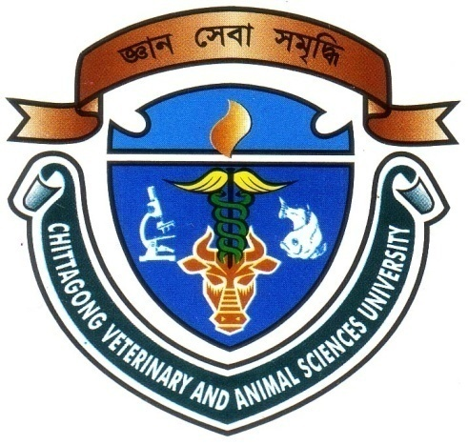

This Clinical report submitted as per approved style and contents

…………………………………………………….
Signature of Supervisor
DR. AvijitDutta
Lecturer, Dept. of Microbiology & Veterinary Public Health

…………………………………

Signature of Author

Md. Rahabul Islam
Intern ID: 53
Roll No: 12/45
Reg. No: 00778
Session: 2011-2012

Chittagong Veterinary and Animal Sciences University

Khulshi, Chittagong-4225

September, 2018
IV

