INTRODUCTION

Livestock is an important component of the mixed farming system practiced in Bangladesh for centuries. Ruminant, especially cattle and goats constitute the major portion of the livestock. People of rural areas as well as urban areas are involved in livestock rearing which plays a crucial role in the traditional economy in Bangladesh. Most of these animals are reared under smallholder traditional management system in rural areas. There are about 22.67 million cattle, 1.11 million Buffalo, 19.16 million goats and 2.47 million sheep reared in Bangladesh (Director of livestock services, DLS, 2005). In 2004, livestock sectors had a share of 4.98% in GDP of country (Economic census, 2004).

Despite the large number of livestock, there has been a decline in national and per capita production of livestock and livestock products, export earnings from livestock and per capita consumption of food from livestock origin in comparison to other countries due to disease and other constraints (Ayele S et al, 2003). Even if much number of tanneries is involved in production of finished and semi-finished leather products, the sector and the country are losing revenue due to a decline in leather quality. A considerable portion of these pre-slaughter defects are directly related to skin diseases or secondary damage that occurs when the animal scratches itself to relieve the itching associated with some of these diseases (Addise A, Achenef M, 2013). The existence of various skin diseases affecting ruminants is frequently reported from different areas of Bangladesh. These different skin diseases in Ethiopia are accountable for considerable economic losses particularly to the skin and hide export due to various defects, 65% of which occur in the pre slaughter states directly related mostly to skin disease and skin and hides are often rejected because of poor quality. Apart from quality degradation of skin and hides, skin diseases induce associated economic losses due to reduction of wool quality, meat and milk yield, losses as a result of culling and occasional mortalities and related with cost of handlers. The effect of skin problems on animal productivity also varies from mild irritations to rapid death (Yacob HT, Yalew TA, Dinka A, 2008). External parasites are the most serious threat since they feed on body tissues such as blood, skin and hair. More significant, however, is that any blood-sucking arthropod may transmit diseases from infected animals to healthy ones. In addition, arthropod pests also may reduce weight gains, produce general weakness, severe dermatitis, and create sites for secondary invasion of disease causing organisms. The common skin disease conditions are Pityriasis, Parakaratosis, Hyperkeratosis, Pachydermia, Impetigo, Urticaria, Eczema, Dermatitis, Photosensitization etc in epidermis and dermis, Sub-cutaneous edema, Angioneurotic edema, Emphysema, Sub cutaneous hemorrhage, Sub cutaneous abscess, Lymphangitis in hypodermis or sub cutis and some Other diseases of the skin are Alopecia, Burns, Yoke gall, Cutaneous neoplasm’s, Congenital Defects etc.

The management practices of animals and geo-climatic condition of Bangladesh are favorable for the occurrence of various diseases. Veterinary hospital is an ideal and reliable source of information about animal diseases and their solution. People from the neighboring areas bring their sick animals every day to the Upazilla Veterinary Hospital, Birampur, Dinajpur. Analysis of the case record gives a comprehensive idea about the disease problems at local areas. The most common ruminant skin diseases reported in Birampur Upazilla are lice infestation, mange infestation, dermatophytosis, alopecia and maggot wound . These diseases are responsible factor for discomfort, zoonoses, and loss of market value, weight gain, milk production and draught power of the animal. Some times these skin diseases cause zoonosis by spreading from animal to animal and animal to man by direct contact. It may also be spread from animal to animal when contact is made with a contaminated object (equipment, trough, feeder).

More information is required to describe the pattern of occurrence of clinical diseases for the provision of appropriate veterinary care and effective disease control programme and animal production. Therefore this study was conducted at the Upazila Veterinary Hospital, Birampur, Dinajpur with the following purposes-

- To determine the prevalence of major skin diseases or disorders in cattle and goats
- To know the epidemiology of these diseases.
- Comparison between different skin disease in large and small ruminants.

MATERIAL AND METHODS

Study area:
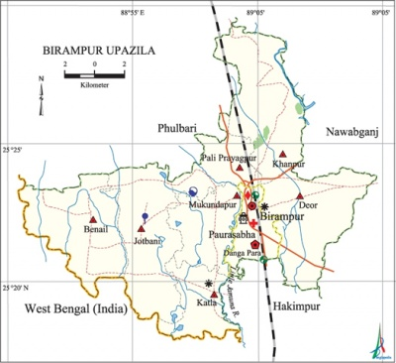
The study was conducted in Birampur sadar Upazilla in Dinajpur District which is about 211.81 sq km, located in between 25°18' and 25°29' north latitudes and in between 88°50' and 89°05' east longitudes.

Figure: Map of Birampur Upazilla

The livestock population in the area comprises of cattle (147637), goat (25081), sheep (9032) (District Statistics 2011). Rural poor farmers of Birampur Upazilla in Dinajpur District are largely depend on the mixed family farming consisting of 1-2 cattle and 1- 2 goats.

Study period:
The study was carried out in Upazilla Veterinary Hospital (UVH), Birampur, Dinajpur during internship placement period from 1February to 29 March, 2018.

Reference Population:
Considering reference population was the domesticated ruminants (Cattle& goats) under Birampur upazilla of Dinajpur district and the study animals were cattle and goat that had brought to Birampur upazilla veterinary hospital and it include sex, all breeds and all age groups weather they are from intensive or extensive farming system. In study periods 673 animals( cattle=416 and goats=257) were treated in Upazilla Veterinary Hospital due to different diseased condition. Among those patient 183 cases( cattle=112 and goats=71) was suffering from skin diseases.

Case definition:
Case of skin diseases ruminants were considered in the present study when the animal registered with clinical sign like rough hair coat, severe pruritis, alopecia, inappitance, thickened and corrugated skin, grayish-black, scaly etc. Some lesions consists of firm, raised, oval nodules, creamy pus was expelled from most of the nodules on squeezing.

Predicating sites of skin diseases or conditions:
The most predicating sites of skin diseases or conditons were neck and head (mange, mite and lice), back (dermatophilosis), goat pox (whole body parts). The lesions were observed in the ventral abdomen, thigh, neck, shoulder, poll, costal area, face, gluteal region, back, tail, and ear, hind legs, fore legs, eyelid, and inguinal region.

Diagnostic approach:

Adequate lighting facility is required for proper visualization of skin lesion. Suspected animals were placed in a well lighted place or under the spectrum of illuminating lamp as there might be some hidden lesions under the long hairs. Some times clipping of hairs was require for detecting the nature and extending of lesion.

Data collection:
In this study, informations for the diagnosis of skin diseases was collected directly from the owner of the animal through questionnaire. The questionnaire includes following information such as Demographic information (age, sex, body wt., breed, color, and species), socio-economic status of the farmer (Farmers occupation, Rearing experience), and patient data. (Duration of illness, history of previous treatment, number of infected animals, body condition), farmers complain and management system (Feeding, Housing, Hygienic measures etc.)

History of the animal:

In the history following aspects were considered: duration of lesions, nature of lesions, number of other animals affected with similar lesions, previous treatment rendered and history of environment.

Age of the animal:

Certain skin diseases occur predominantly in younger age group of animal e.g. Demodecosis and ringworm. On the other hand, neoplasms of skin occur frequently in old animal. There are certain conditions which do not have any age barrier.

Breed of the animal:

Long haired breeds are susceptible to acaro dermatitis.

Diagnosis:
The skin diseases were diagnosed by physical examination, clinical findings and laboratory diagnosis of diseases or disease conditions.

Physical Examination
The study animals were properly recode and then each animal were carefully inspect for the skin pathogens. The signs ,number ,location and physical characteristics of lesions, size shape ,texture, colour were recorded. Clinical skin disease investigations were conducted by examination of skin of each animal through taking history, close inspection, palpation parting of hair coats and itch reflex (Kral and Schwartzman, 1964). For positive cases on clinical examination, detailed husbandry and health history were taken from the owner of the animals.

Clinical Examination
Lice infestation:
Causal agent:
- Haematopinus sp,
- Linognathas sp,
- Damalinia sp
Clinical sign:
1.Scratching, rubbing and licking leading to restlessness, damage to fleece and hides.
2. Inanition, loss of milk production.
3. Anemia incase of heavy parasitism.

Mite infestation (Mange):
Causal agent:
- Sarcoptic scabiei,
- Demodex bovis.
Clinical sign:
1.Main sign are irritation with encrustation.
2..Loss of hair and excoridation from rubbing and scrating.
3.In long standing case the skin becom thickened and nodules may develop on the less well-haired parts at the skin, including the muzzle around the eyes and inside the ear.

Myiasis:
Causul agent:
Larvae of diptera flies
Clinical sign:
1.Anorexia, dullness and affected animals keep themselves away from the rest of the flock.
2. Attempts to bite the affected area.
3. Presence of maggot in and around the wound lesions.
4. Odor and exudative secretion from the lesion

Humpsore:
Causal agent: Stafanofilaria assamensis
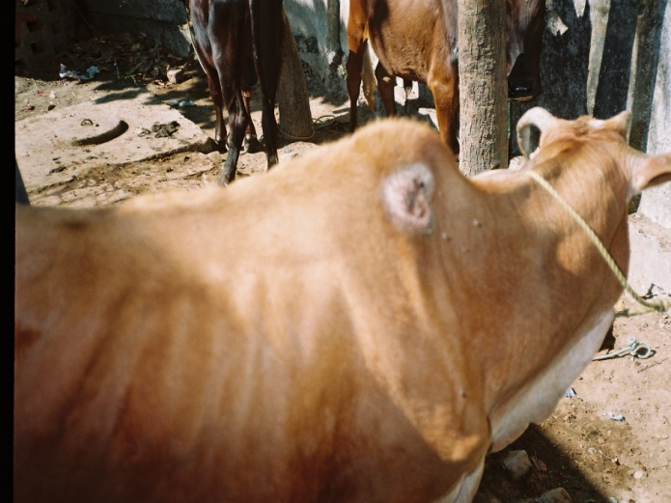

Fig: Hump sore in cattle

Clinical sign:
1.Chronic ulcerative, granulomatosis dermatitis lesion mostly present around the hump, dewclaws, poll, chest, udder, teat, abdomen etc.
2. Lesions are characterized by papules, exudation, crusts, fissures, ulceration etc. Fig: Hump sore in cattle

Burn:
Causal agent: Injury caused by dry heat.
Clinical sign:
1.Clinical signs depend on the degree of burn generally pain and irritation are characteristics.
2.Secondary bacterial infection may cause necrosis or formation of pus.
3.Dehydration, toxemia and shock may cause the death of the animal.

Yoke gall:
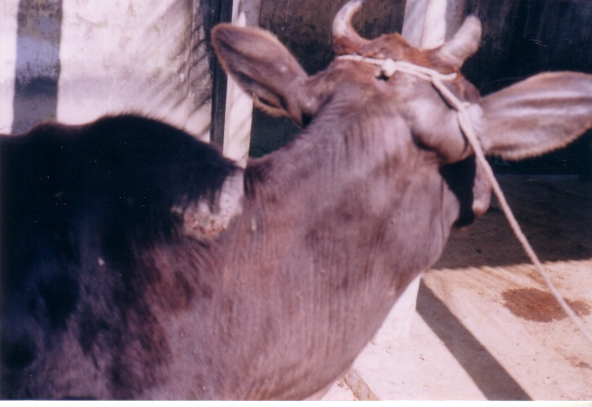
Causal agent: Injury or friction caused by yoke at the neck during ploughing or pulling on the ligamentous nuchae in cattle.

Fig: Yoke gall in cattle

Clinical sign:
1.Presence of acute or chronic swelling at the yoke position of the neck.
2.Sometime complication of the lesion with humpsore and myiasis may be occurred.
3.Continuous friction due to yoke may cause formation of fibrous tissue to form a cavity

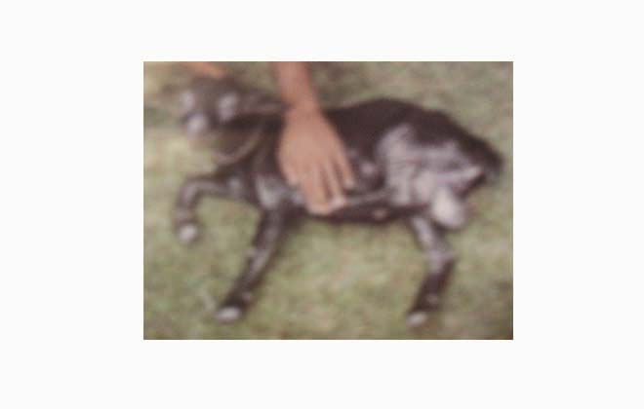
Alopecia:
Causal agent: Parasitic cause, vitamin deficiency
Clinical sign:
1.Hair loss usually starts as a focal patch that may enlarge and coalesce with adjacent lesions or remain static.
2. Pruritus is variable

Dermatophytosis (Ringworm):
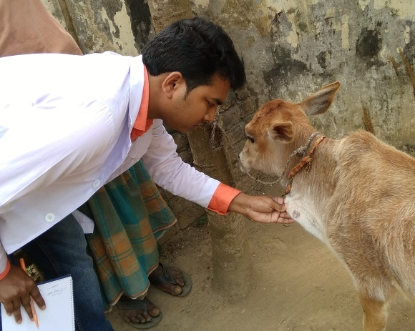

Fig: Dermatophytosis

Causal agent: Trichophyton sp
Clinical sign:
1.The lesions are mostly located on the head,around the eyes,neck,ears and dewlap.
2. The affected areas of the skin become erythematous and the hairs over the area fall of thus giving a picture of alopecia.
3. The lesions are discrete and almost circular and borders are raised having thick grayish crust.
4. The lesions have tendency to extend peripherally with central healing.
5. In some cases, the lesions coalesce forming diffused lesions.

Papillomatosis (Wart):
Causal agent: Papilloma virus
Clinical sign:
1.The skin surfaces of the neck, legs, back and abdomen are the more usual sites, because these are probably more subject to abrasions and wound through which the virus may infect the tissues.
2. Cutanious papillomas in cattle can be various size, depending on the area infected, and have a cauliflower-like appearance and a fibroma base in the dermis.

Contagious ecthyma:
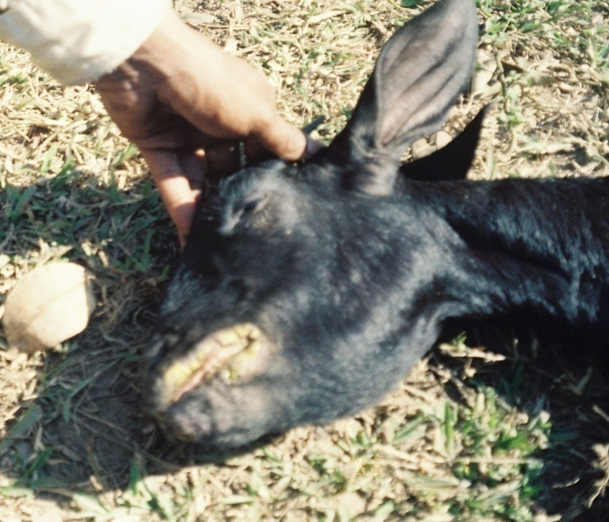
Causal agent: Para poxvirus

Fig: Contagious ecthyma
Clinical sign:
1. Proliferative crusting lesions, the majority of which occurs on the mucocutaneous junction
as the mouth and nose.
2. Contagious ecthyma include papules, vesicles and pustules in aftected skin.
3.Lesion may spread to the oral cavity, feet,eyelids and teats.

Laboratory Examination
The samples were taken for identification. Examination of skin scraping for isolation and identification of arthropod parasites on morphological basis was following conventional technique of Veterinary Entomology (Benbrook and Sloss, 1968). Diagnosis of the skin diseases was made on the basis of interpretation of epidemiological features, history, findings of clinical examination of the specimen like recovery of mites from skin scrapings digested with 10% KOH solution and examined under microscope.

Procedure:
There are two methods or procedures described by Nooruddin and Sing (1987) for the examination of skin scraping and hair for isolation and identification of dermatophyte.

These methods are Direct KOH Method and Sedimentation method.
Direct KOH Method | Sedimentation method
At first skin scraping was taken from the suspected case  Then placed on a microscopic slide  1drop of 10%KOH was added  Then the specimen was allowed to stain for  few minutes with gentle warming  Microscopic examination was revealed hyphae and spores (Trichophyton spp) in the infected materials. | Skin scraping was taking from suspected case  ↓  Place the skin scraping in glass test tube  ↓  Treat with 10% KOH  ↓  Then heat gently (not boiled) the treated materials till the skin debris is digested.  ↓  Then centrifuge the digested material at 3000 R.P.M. for 5 minutes.  ↓  Spread the sediment over the glass slide and examine under low power of Microscope.

Disease with diagnosis and picture
Diseases | Lab based examination | Figure
Pediculosis | Lice are wingless, flattened insects, usually 2–4 mm long. The claws of the legs are adapted for clinging to and moving among hairs or feathers | 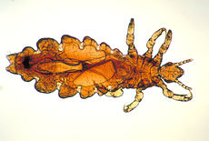
Mange | Six-legged larvae hatch from fusiform-shaped eggs and undergo several molts to become eight-legged nymphs and ultimately adults.  Adults are eight-legged, slender, and elongated mites; their appearance is often described as cigar-shaped. | 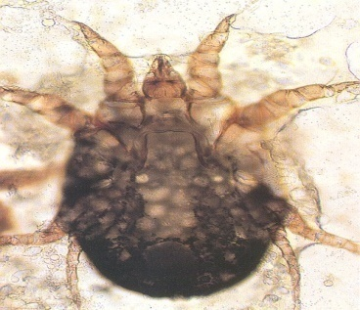

RESULTS & DISCUSSION
The prevalence of skin diseases were measured in two different species, cattle and goat in Birampur Upazilla Veterinary Hospital (UVH), Dinajpur. Total 657 animals were suffering different types of disease, of them 183 cases were suffering from skin disease. Among 416 cattle, 112 ( 26.9%) were found as different types of skin diseases . In the same time 71 (27.6%) goats from 257 were found as different skin diseases.

Fig 01: Graphical Presentation of skin diseases in cattle.
Figure 02: Graphical Presentation of skin diseases in goat.
In the earlier, the present finding is agreed with the previous study of the prevalence of skin diseases in cattle was 62%(13,421cattle) and goat was 28.8%(5,771goats) (Nooruddin, A.S.Dey, 1990). But the result of this study did not agreed with the earlier study as 26.9%(416 cattle) and 27.6%(257 goats).
There is great variation between these two studies. The reason for this variation would be the ecological variation, the types of soil, seasonal variation and overall the small sample size.

Table 01: Different types of skin diseases in cattle and goats:
Name of the diseases condition | Cattle | Goat | Total
Liceinfestation (Pediculosis) | 44 | 12 | 56
Mite infestation(Mange) | 15 | 21 | 36
Hump sore (Stephanofilariasis) | 6 | _ | 6
Alopecia | 11 | 23 | 34
Myiasis | 12 | 4 | 16
Dermatophytosis (Ringworm) | 8 | 4 | 12
Papillomatosis | 5 | _ | 5
Contagious ecthyma | _ | 7 | 7
Yoke gall | 9 | _ | 9
Burn | 2 | _ | 2
Total | 112 | 71 | 183

Figure 03: Graphical Presentation of skin diseases in ruminants (Cattle and Goats)

The study showed frequency distribution of different types of skin diseases in different species in the table no-02.

Table-02: Frequency Distribution of different types of skin diseases in different species:
Name of Diseases | No. | Cattle (%) | Goat (%) | Total no. of affected animals
Lice infestation (padiculosis) | 56 | 44 (78.57%) | 12 (21.43 %) | 56(30.60%)
Mite infestation (Mange) | 36 | 15(41.67%) | 21 (58.33%) | 36 (19.67%)
Humpsore (Stephanofilariasis) | 6 | 6(100%) | - | 6(3.28%)
Alopecia | 34 | 11(32.35%) | 23 (67.65%) | 34(18.58%)
Myiasis | 16 | 12(75%) | 4(25%) | 16 (8.74%)
Name of Diseases | No. | Cattle (%) | Goat (%) | Total no. of affected animals
Dermatophytosis | 12 | 8(66.67%) | 4(33.33%) | 12 (6.56%)
Papillomatosis | 5 | 5(100%) | - | 5 (2.73%)
Contagious ecthyma | 7 | - | 7 (100%) | 7 (3.82%)
Yokegall | 9 | 9(100%) | - | 9(4.92%)
Burn | 2 | 2 (100%) | - | 2 ( 1.1%)
Total | 183 | 112 | 71 | 183( %)

It was observed that lice and mite infestation was 44(78.57%), 12(21.43%), and 15(41.67%), 21(58.33%) in cattle and goat respectively. In other case hump sore and alopecia 6 (100%), 0(0.0%) and 11(32.35%), 23(67.65%) in cattle and goat was affected respectively. In case of Myiasis and Dermatophytosis 12(75%), 4(25%) and 8(66.67%), 4(33.33%) in cattle and goat respectively. In Papillomatosis and contagious ecthyma 5(100%); 0 (0.0%) and 2(100%), 0(0.0%). In Yoke gall and burn 9(100%); 0(0.0%) and 1(100%), 0(0.0%) in cattle and goat respectively.

The remaining result showed in table-03 and figure- 04 and 05. It was also observed that the highest estimation was observed ectoparasite infestation 61.20% followed by nutritional deficiency 18.03%, viral infestation 7.65%, and fungal infestation 7.10% and other injury 6.02%.

Table-03: Frequency distribution of skin diseases according to different etiological agent.
Name of causal agent | No. of animal affected | Percentage of disease
Ectoparasite | 112 | 61.20%
Fungus | 13 | 7.10%
Virus | 14 | 7.65%
Nutritional deficiency | 33 | 18.03%
Other injury | 11 | 6.02%
Total | 183 | 100%

Fig 04: Graphical Presentation of skin diseases or conditions according to different etiological agents.
Fig 05: Frequency distribution of skin diseases according to different etiological agent.

Treatment schedule
Lice infestation
Ivermectin1% (Inj. Amectin Acmi drug) 0.2mg/kg b.wt S/C for SD
Mite infestation
Trichlophen 0.5%( Pulp. Neguvon), 0.5% solution, Spray or Dipping 1st, 8th & 15th day
Ivermectin1% (Inj. Ivermec) 0.2mg/kg S/C S/D
Humpsore
Ivermect in1% (Inj. Amectin), 0.2mg/kg, S/C, SD
Alopecia
Antihistami-nic Drug, 0.2mg/kg IM, 5 days
Promethazine Hcl, Zincsulph-ate 20%, Iodine .25%, 50mg/ml, 5 to 10 gm/day, 5 days
Dermatophytosis
Salicylic acid 3%, Benzoic acid 6% and Vaseline ( Whitfield ointment 3%/ 6% Solution Topically 7 days
Papillomatosis
Lithium antimony, Thiomalate, (Inj. Antheomalin), 15-20 ml/cow, I/M, 5 days intervel at 5 days
Autohaemotherapy
Myiasis
\Oil of turpentine
OTC-100mg/ml, Inj.Renamycin,10mg/kg

Contagious ecthyma
PotashBorax +honey (10% Solution), Adlibitum, Topically Until recovery
OTC Adlibitum 1ml/10kg I/M5 days
Yoke gall
Manthol & thimol1%, 1% ointment, Topically, Until recovery
Antibiotic OTC (Inj.Tetravet) 1ml/10kg, IM, 5days
Burn
1%Acriflavin, Topically
Antihistaminic drug, PromithazineHcl, Inj.Astsvet, 2mg/kg, IM, 5days
Antibiotic OTC, Inj.tetravet, 1ml/10kg, IM, 7days
LIMITATIONS

During my study period in Birampur Upazilla Veterinary Hospital (UVH), Dinajpur the following limitation was encounted. Due to the short duration of the study period the relationship of different types of skin diseases with the season can not be studied. We know that season plays a great role in the epidemiology of some disease for which prevalence or incidence of different diseases is varies with the season.

Small number of sample size. If the sample size of the cattle, goat population in which I conducted my study will large, then the result may become more accurate than this result. Lack of laboratory diagnosed mainly by taking clinical finding. If laboratory diagnostic facility was available then the accuracy of the result will be more significant.

CONCLUSION

This study was conducted to identify the prevalence of major skin diseases or disease conditions in ruminants (cattle and goats). From the study period 26.9% cattle and 27.6% goat were found as different types of skin disease. It was revealed that a skin disease is a great problem incase of domestic ruminants. The most common skin diseases identified were lice infestation, mange mite infestation, dermatophytosis, alopecia and maggot wound. Lice was the most abundant ectoparasites in the study area. The infestations of skin diseases are important as they affect the health and productivity of ruminants. Lack of awareness about the significance of the problems among owners for control schemes have contributed to the wide spread nature of skin disease in the area. In view of the significance of skin and hide production as important source of foreign currency to the country and the ever increasing demands of livestock market, the high prevalence of skin diseases prevailing in cattle, sheep and goat in the area requires serious attention to minimize the effect of the problem.

Based on the above conclusion the following Recommendations are forwarded. Strategic treatment of ruminants with insecticides and acaricides should be practiced in the study area to minimize the impact of ectoparasites on the health of animals. Awareness creation for the local farmers about the control of skin diseases is essential.

Vaccination should be applied for viral disease before its occurrence season. Newly introduced animals should be treated before they are introduced in the herd or in to the farm. Better ruminant animal management practices should be implemented to minimize transmission of the disease and increase the productivity of the animals. Further detail study should be done to assess the seasonal dynamicity and major ectoparasites borne disease in the study area.

ACKNOWLEDGMENT

First of all the author desire to express his deepest sense of gratitude to “The Almighty Allah” with whose blessing his ability to complete this valuable work.

The author also feels grateful to the supervisor Dr. kh. Nurul Islam, Professor of department of Anatomy and histology, Faculty of veterinary medicine, in Chittagong Veterinary and Animal Sciences University,Khulshi,Chittagong, for his guidance, inspiration during the study period and also preparing of this clinical reports. The author also grateful to the farmers of those areas, who were helping in various aspects of the study.
The author also grateful to the placement supervisor Dr. Mohammad Idris Ali, Upazilla livestock officer, Birampur Hospital, Dinajpur, for his sincere co-operation.
The author also feels much proud to convey his profound thanks to his friends and all well-wishers who have seriously encouraged him to run this study work.

Lastly but not the least express his deepest sense of gratitude and heart- felt thanks to his beloved parents, brothers and sisters who have sweet much to bring his up today’s position.

The Author September 2018

REFERENCES

Addise A, Achenef M (2013). Major Skin Diseases of Cattle: Prevalence and Risk Factors in and around Hawassa, Southern Ethiopia. JAVR 3: 147-153.
Ayele S, Assegid W, Orkalemahu MA, Jabbar MM, Ahmed, et al. (2003). Livestock marketing in Ethiopia: A review of structure, performance and development initiatives Socio economics and Policy Research. Livestock Marketing Authority the Federal Democratic Republic of Ethiopia, Addis Ababa, Ethiopia.
Blood, D.C. Radostits,O.M.Gay,C.C. and Hincheliff,K.W.(2000). Disease caused by Helminthes parasites. Veterinary Medicine, 9th edition, Book power formerly ELST with Saunders in co-operative with the British Council PP.1376.
Cambell, M.C. and Stewart, J.L (1980) . The medical Mycology Hand book, John wile and sons, New York.
Chatterjee, A. (1989) . Skin infection in Domestic Animals, Motripub. Cal.
Davis, L.E (1980): Thermal burns In:Swaim,S.F.(ed) Surgery of traumatized skin management and reconstruction in the cattle and goat. Dhilacleplphia, W.B. Daunders.
Gill, B.S. Balakrishman,P.Hosin,M.and singh,J.(1988). Treatment of humpsore (Stephanofilariasis ) of cattle with invermectin.Indian J. Anim.Sci. 58:552-560.
Huq, M.M. and Mollah,M.A (1972). A survey of the prevalence of lice in sheep and goats of Dhaka and Mymensigh district, Bangladesh veterinary Journal. 7:10-15.
Huq, M.M. and Mollah,M.A (1972). A survey of the prevalence of lice in sheep and goats of Dhaka and Mymensigh district, Bangladesh veterinary Journal. 7:10-15
Islam, K.S. (1985) . Bangladesh Gobadhi Poshu O Hash-Murghir Rogbhadhir , Barthamom Abastha.48-85.
Kaplan,W.et al . (1953). Ann. N.Y. Acad, Sci, 70:636.
Kral, Eand Sehwartzman, R.M.(1964) . Veterinary and comparative Dermatology. 1st edition J.P.Lipincott co. Philadelphia.
Noorduddin, M, and Singh, B. (1987) . Dermatophytosis in buffaloes, cattle and their attendants. Mykosen.30:594-600.
Noorduddin, M, and Singh, B. (1987) . Dermatophytosis in buffaloes, cattle and their attendants. Mykosen.30:594-600.
Nooruddin, M.and Dey, A.S. (1990) Further study on the prevalence of skin diseases in domestic ruminats in Bangladesh. The Bangladesh Veterinariant 7(2). 75-81.
Pande, P.G.(1935).In the indentity of the nematodes worm recovered from humpsore of cattle in India. Indian J. Vet.Sei.Anim. Husband. 6:346-361.
Patnai K,B.1973 . Studies on stephanofilariasis in Orissa. III. Life. Cycle of S. asamensis pande. 1963. Z. Tropenmed parasitology: 24:457-466. Pocket book of the year, 2005, BBS.
Rashid,M.A. Noorudin,M.and Dey,A.S.(1999) . Distribution of dermatomycosis in cattle, goats and their in contact humans. Bangladesh Veterinarian 13(1-2): 9-12.
Samad, M.A. (2001) Observation of clinical Disease in Rumants at the Bangladesh Agricultural University Veterinary Clinic. Bangladesh Vet. J.35 (3-4) 93-120.
Webster,R.M.& Bugbya. (1990). Light spot and fleck grain defects of econmic importance to the UK leather industry part-I, indetification of Causal agent. Laboratory Report 148. Northapton, British Leather confederation.
Yacob HT, Yalew TA, Dinka A (2008). Ectoparasite prevalences in sheep, and goats in and around Wolaita Soddo, Southern Ethiopia. Rev Med Vet 9: 450-454.

BIOGRAPHY

A.M.M. Golam Mortuza , Son of Md.Nurul Islam and Mst.Moriam Begum. He is an interned veterinary doctor under the faculty of Veterinary Medicine (FVM) in Chittagong Veterinary and Animal Sciences University (CVASU). He passed his Secondary School Certificate (SSC) Examination in 2008 followed by Higher Secondary Certificate (HSC) Examination in 2010 from Rajshahi board. In future he would like to do Research work about animal welfare, epidemiological study and Zoonotic diseases those take public health significance in the world regarding one health constitution.

Appendix
Questionnaire
Birampur Upazilla Veterinary Hospital (UVH), Dinajpur.
0 | 0 | 1

1. Case No. 2. Date: --/--/--
3. Owner’s Name: ……………………………………………………………….…....
4. Address of the Owner: …………………………………………………………….
5. Socio-economic status of farmer: …………………………………………………
a. Occupation: service/Business/Farmer/Others
b. Rearing experience: 1year/2year/3year/more than three
6. Demographic information:
a. Age:…………………… d. Sex: ………………..
b. Body weight:…………. e. Breed:………………
c. Colour: ……………….. f. Species:……………..
7. Patient data:
a. Duration of illness: ……………………………………….
b. History of previous treatment:……………………………
c. Number of infected animals:……………………………..
d. Body condition score: ……………………………………
8. Farmers complain:
9. Management system: a. Feeding: b. Housing: c. Hygienic measures:
10. Clinical Sign:
11. Tentative diagnosis:
12. Medication/Treatment:
Signature

