Table of contents

Table of contents…………………………………………………………… | 1
List of figures……………………………………………………………..... | 2
List of abbreviation…………………………………………………………. | 2
Abstract……………………………………………………………………... | 3
Introduction………………………………………………………………… | 4
Case report on Soft tissue sarcoma in goat……………………………......... | 5-8
Discussion…………………………………………………………………... | 9
Conclusion…………………………....…………………………………….. | 10
Limitations………………………………………………………………...... | 11
References …………………………………………………………………. | 12-13
Acknowledgements………………………………………………………… | 14
Biography…………………………………………………………………... | 15

LIST OF FIGURES

NO | TITLE | PAGE
Fig. 1 | Pedal tumor at right forelimb of the dog | 5
Fig. 2 | Restraining and anesthesia | 6
Fig. 3 | Electrocautery | 6
Fig. 4 | Preparation of incision site | 7
Fig. 5 | Incision was given | 7
Fig. 6 | Incision through the junction of skin and tumor | 7
Fig. 7 | Complete removal of tumor | 7
Fig. 8 | Suturing the incised skin | 7
Fig. 9 | Right forelimb after surgery with tumor | 7

LIST OF ABBREVIATIONS

ABBREVIATION | ELABORATION
STS | Soft tissue sarcoma

Abstract

A case report on Soft tissue sarcoma (STS) in a dog

A 3 years old, local breed, male dog having weigh 20 kg was brought by owner to Veterinary College and Research Institute (VCRI), Namakkal, Tamil Nadu Veterinary and Animal Sciences University. The dog has been suffering from soft tissue sarcoma (pedal tumor) for the last six months. In this case study, the clinical findings, diagnostic procedure, surgical correction, medicinal treatment and advices of Soft tissue sarcoma (STS)are presented.The predominant sign was tumor mass in foot pad of right forelimb. The condition was diagnosed by fine needle aspiration cytology (FNAC). The tumor was surgical corrected through excision of the tumor mas by electrocautery. After removing the tumor antibiotic, painkiller and local antiseptic were prescribed for wound healing. Findings of the case study might be useful for clinical practice.

Key words:STS, tumor mass, FNAC, excise, electrocautery, antibiotic, clinical practice.

Introduction

Recently pet population is increasing rapidly through our country. As the number of dogs is increasing, it is important to know about the diseases and disease conditions of this species. Among these, different types of tumor are common. Tumor is basically two types such as benign and malignant tumor. Malignant tumor is known as cancer.

Soft tissue sarcoma is a group of benign or malignant tumors that form in an animal’s soft and/or connective tissues. Most commonly, the tumors form in the smooth and skeletal muscles, lymph vessels, blood vessels, and fatty tissues, but they can actually arise in any part of the body.
The exact cause of soft tissue sarcoma is currently unknown, but while the disease is usually very invasive to the surrounding tissues, it tends to have a low precedence of metastasis (spreading to other parts of the body).

Soft tissue sarcomas accounts for 15% of all cutaneous tumors and 7% of all subcutaneous tumors found on dogs and cats. When a pet canine has a cutaneous soft tissue sarcoma, it is most commonly identified by one or more soft, fleshy tumors on the body.

The most common symptom of a soft tissue sarcoma is a soft and fleshy growth that is developing on the animal’s body. Aspiration of the tumor with a fine needle and perform a chemical blood profile, a complete blood count and a urinalysis can be done. A tissue biopsy may also be performed to confirm a diagnosis.

Soft tissue sarcomas are very difficult to treat because they invade and latch onto the surrounding tissues and bones with tentacle-like fissures. As a result, it can be nearly impossible to successfully remove the entire tumor. In cases where the tumor is located on an extremity, amputation of the limb is sometimes the most effective treatment consideration. In other cases, surgical removal of as much of the tumor as possible may be performed, followed by chemotherapy and/or radiotherapy. When chemotherapy is used, the pet is usually administered carboplatin or doxorubicin (with or without cyclophosphamide), intravenously every 21 days for 4-6 treatments, which are tapered over the course of a year. Other medications used can include bleomycin, neoplasene, adriamycin, and dexamethasone.

The case report was carried out with the objective of knowing the soft tissue sarcoma regarding clinical findings, diagnosis and surgical treatment.

Case report on Soft tissue sarcoma (SIS) in a dog

Case History:
A 3 years old male local breed dog having weigh 20 kg was brought by owner to Veterinary College and Research Institute(VCRI), Namakkal, Tamil Nadu Veterinary and Animal Sciences University. The case was confirmed as acanine footpad soft tissue sarcoma (pedal tumor) on the basis of clinical history, clinical signs by the surgeon. Surgeon decided to remove the tumor surgically by using electrocautery.

1.Owners complain:
The owner reported that the animal having tumor mass present in foot pad in right forelimb for six months.

2. Clinical findings:
Position and posture:Abnormal posture
Body condition: Emaciated
Body weight: 20 kilograms
Rectal temperature: 102° Fahrenheit
Heart rate: 80 per minute
Respiration rate: 24 breaths per minute.
Skin/coat: Dull
Musculoskeletal:A large mass of tumor about 15 cm in diameter was noticed at the left forelimb. Swelling and fluids were oozing out. There was no pain on palpation.
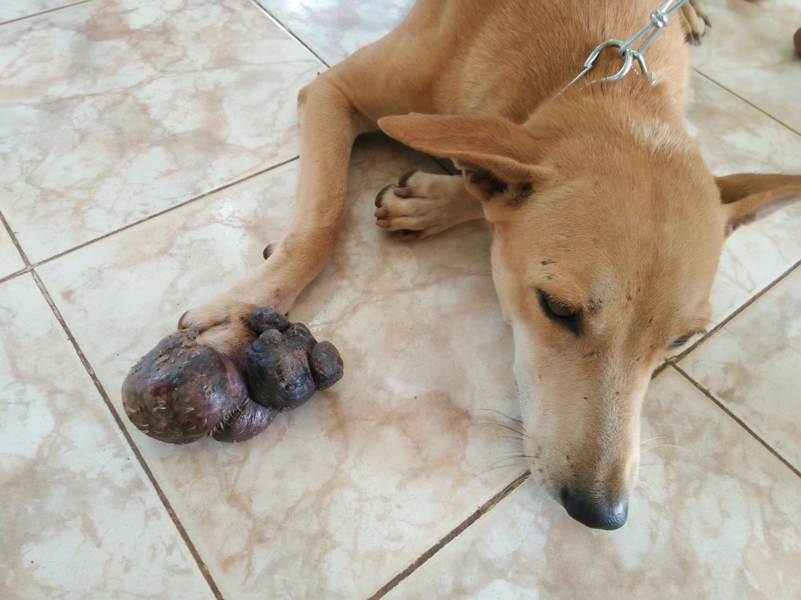
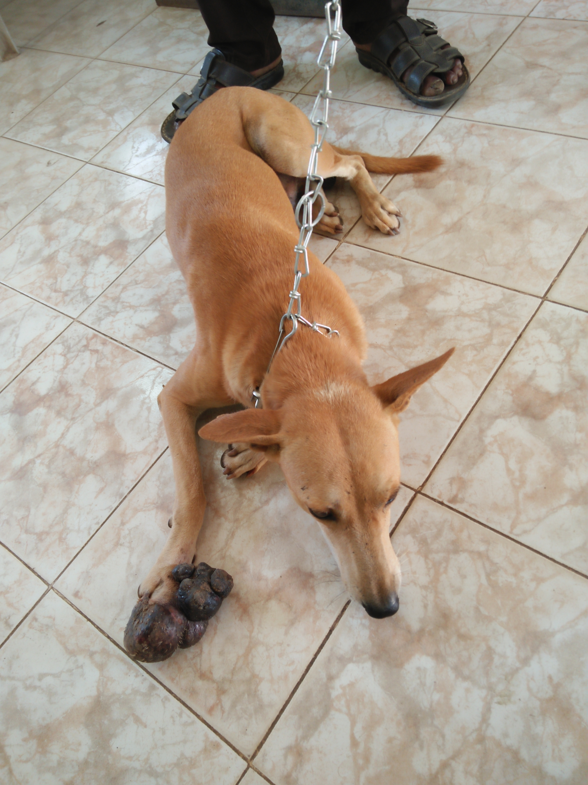

Pedal tumor
Fig 1: Pedal tumor at right forelimb of the dog
Fig 5: Blood collection from the dog
Fig 6: X-ray was performed
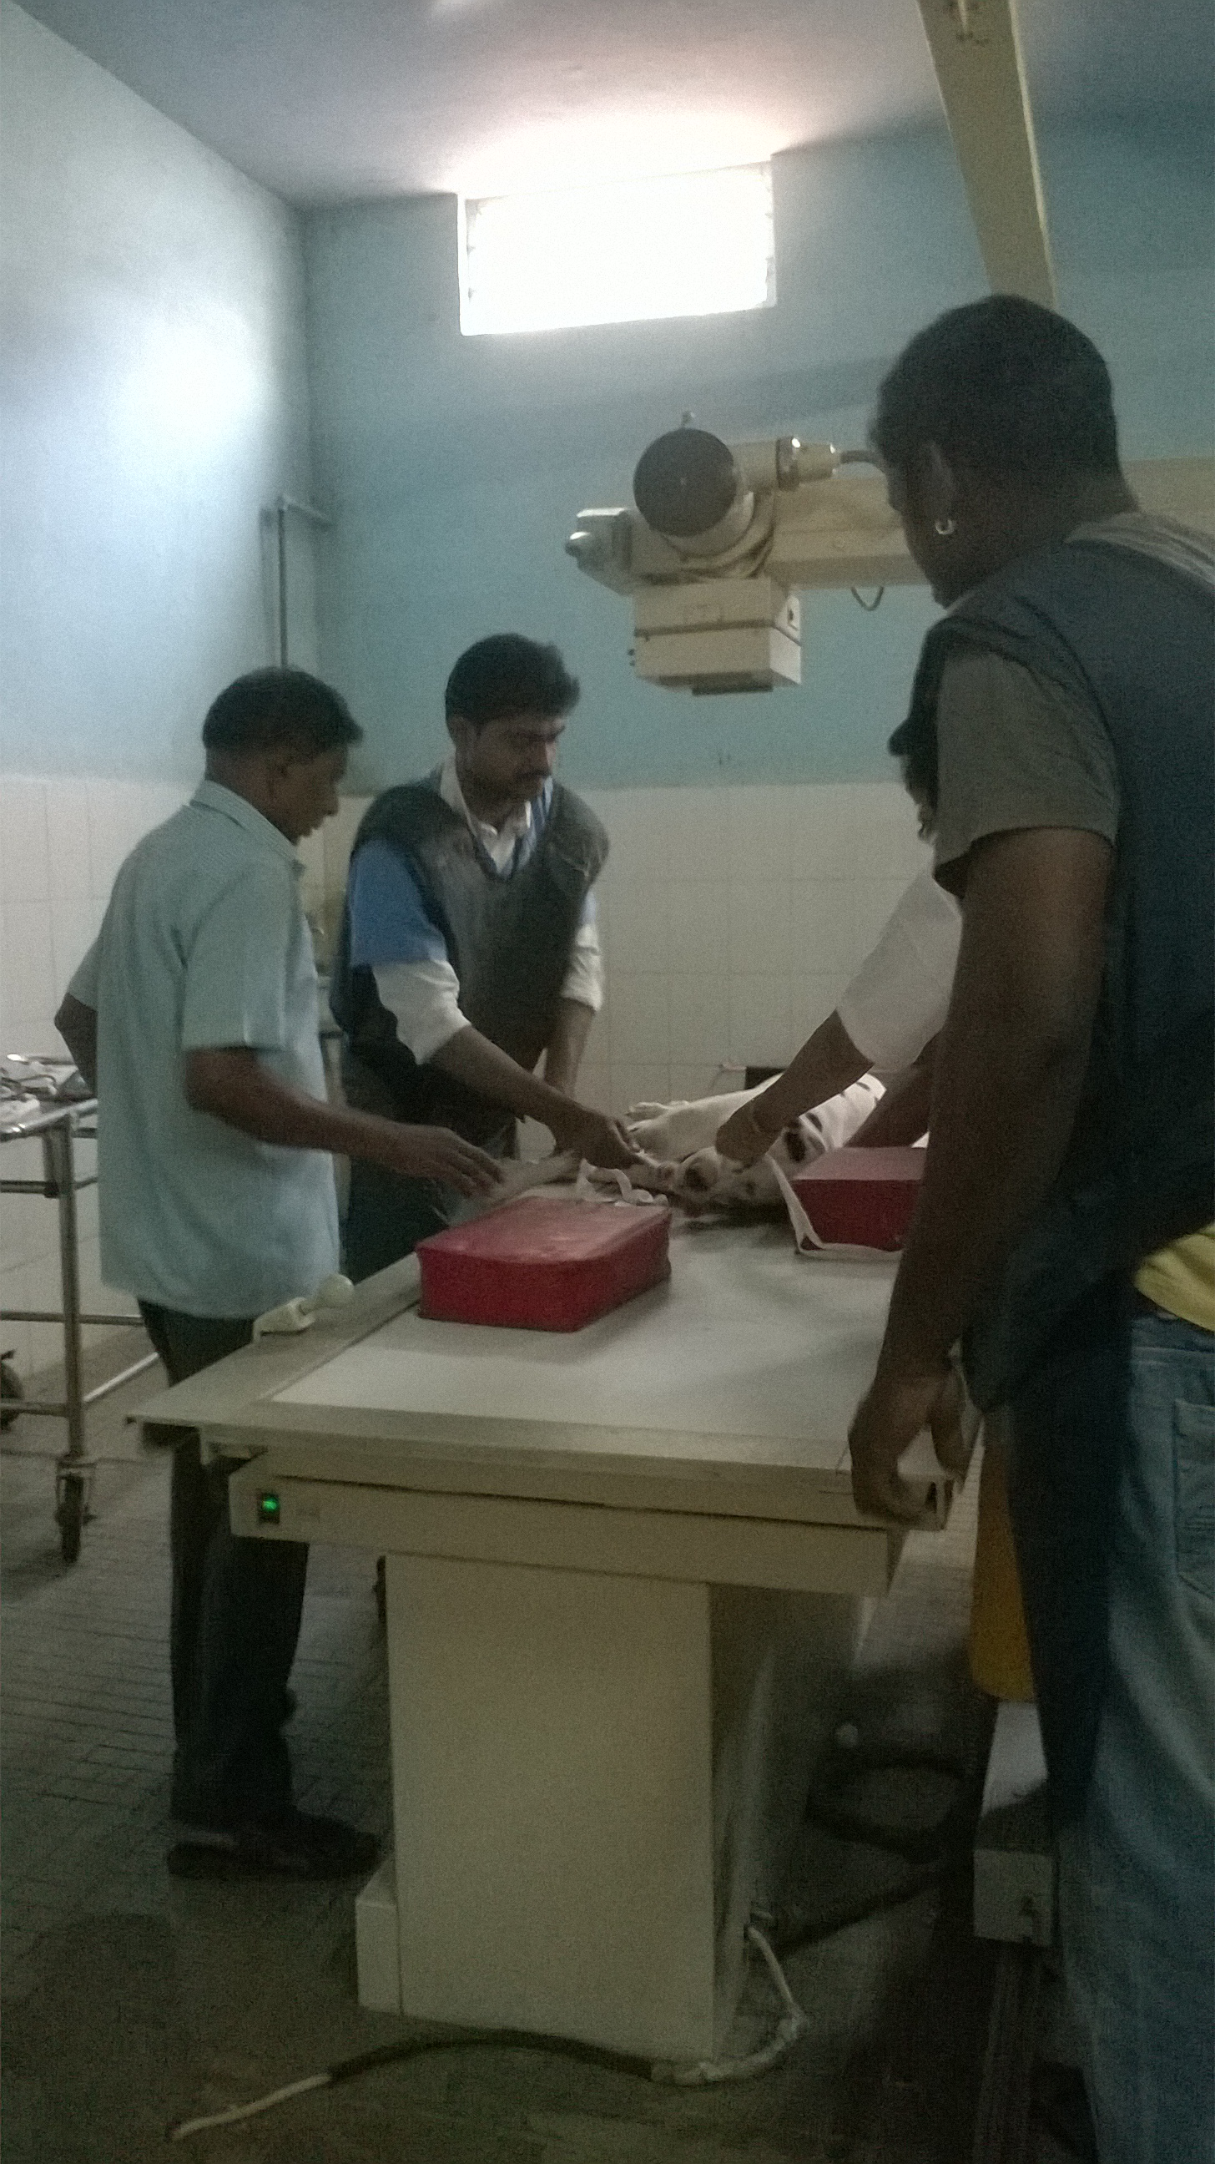
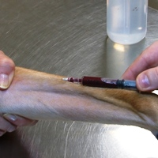

3. Diagnosis: FNAC (Fine needle aspiration cytology) was performed to confirm the tumor.
4. Surgical procedure:
4.1 Instruments and drugs required for surgery: 1. Electrocautery
2. Scalpel
3. Cotton roll and gauze
4. Needle
5. Artery forceps
6. Nylon
7. Povidone iodine
8. Diazepam
9. Ketamine
10. Normal saline

4.2Restraining and anesthetic procedure: At first the animal was restrained manually with the help of the owner. Then anesthesia was done by using combination ofDiazepam@ .1-.5mg/kg and Ketamine@ 5-10mg/kg through intravenous route with normal saline (0.9% NaCl).

4.3 Procedure:
At first the animal was restrained and kept in lateral position. The area of excision was cleaned with povidone iodine solution. Electrocautery was prepared and the cautery was kept hot before surgery. A small incision was given at the junction of the tumor and skin by electrocautery. Bleeding was checked by using cotton roll. Incision was given gradually through the boundary of the junction of tumor and skin. Full tumor was removed with some portion of skin. After removing the tumor, the incised skin was sutured by nylon thread. All debris and blood were cleaned.
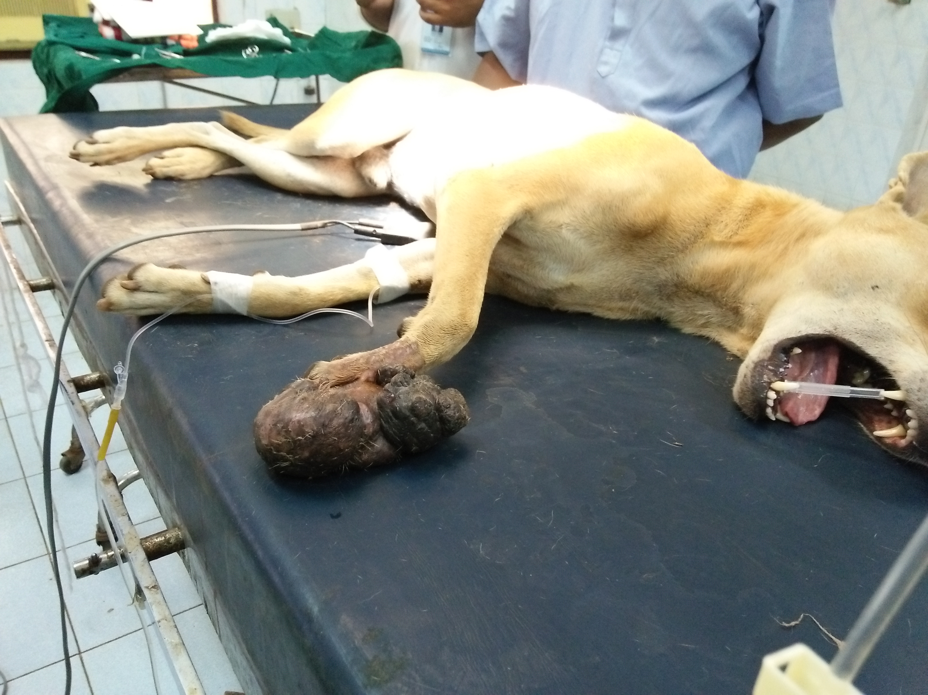
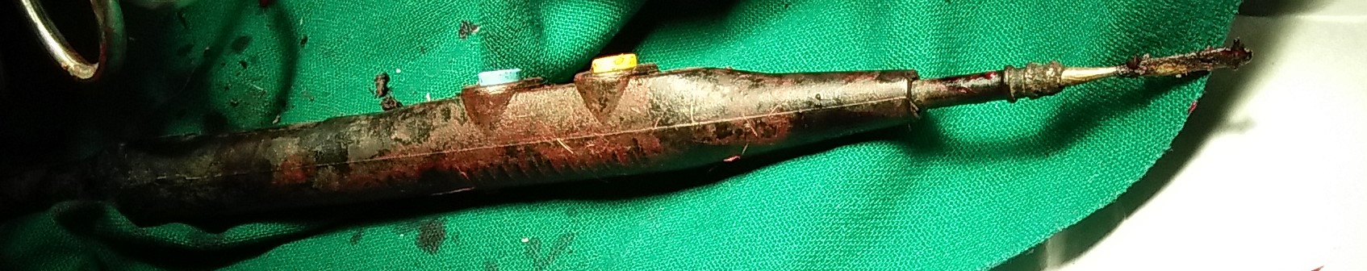

Fig 3: Electrocautery

Fig 2: Restraining and anesthesia

Fig 5: Incision was given by thermocautery

Fig 4: Surgical preperation

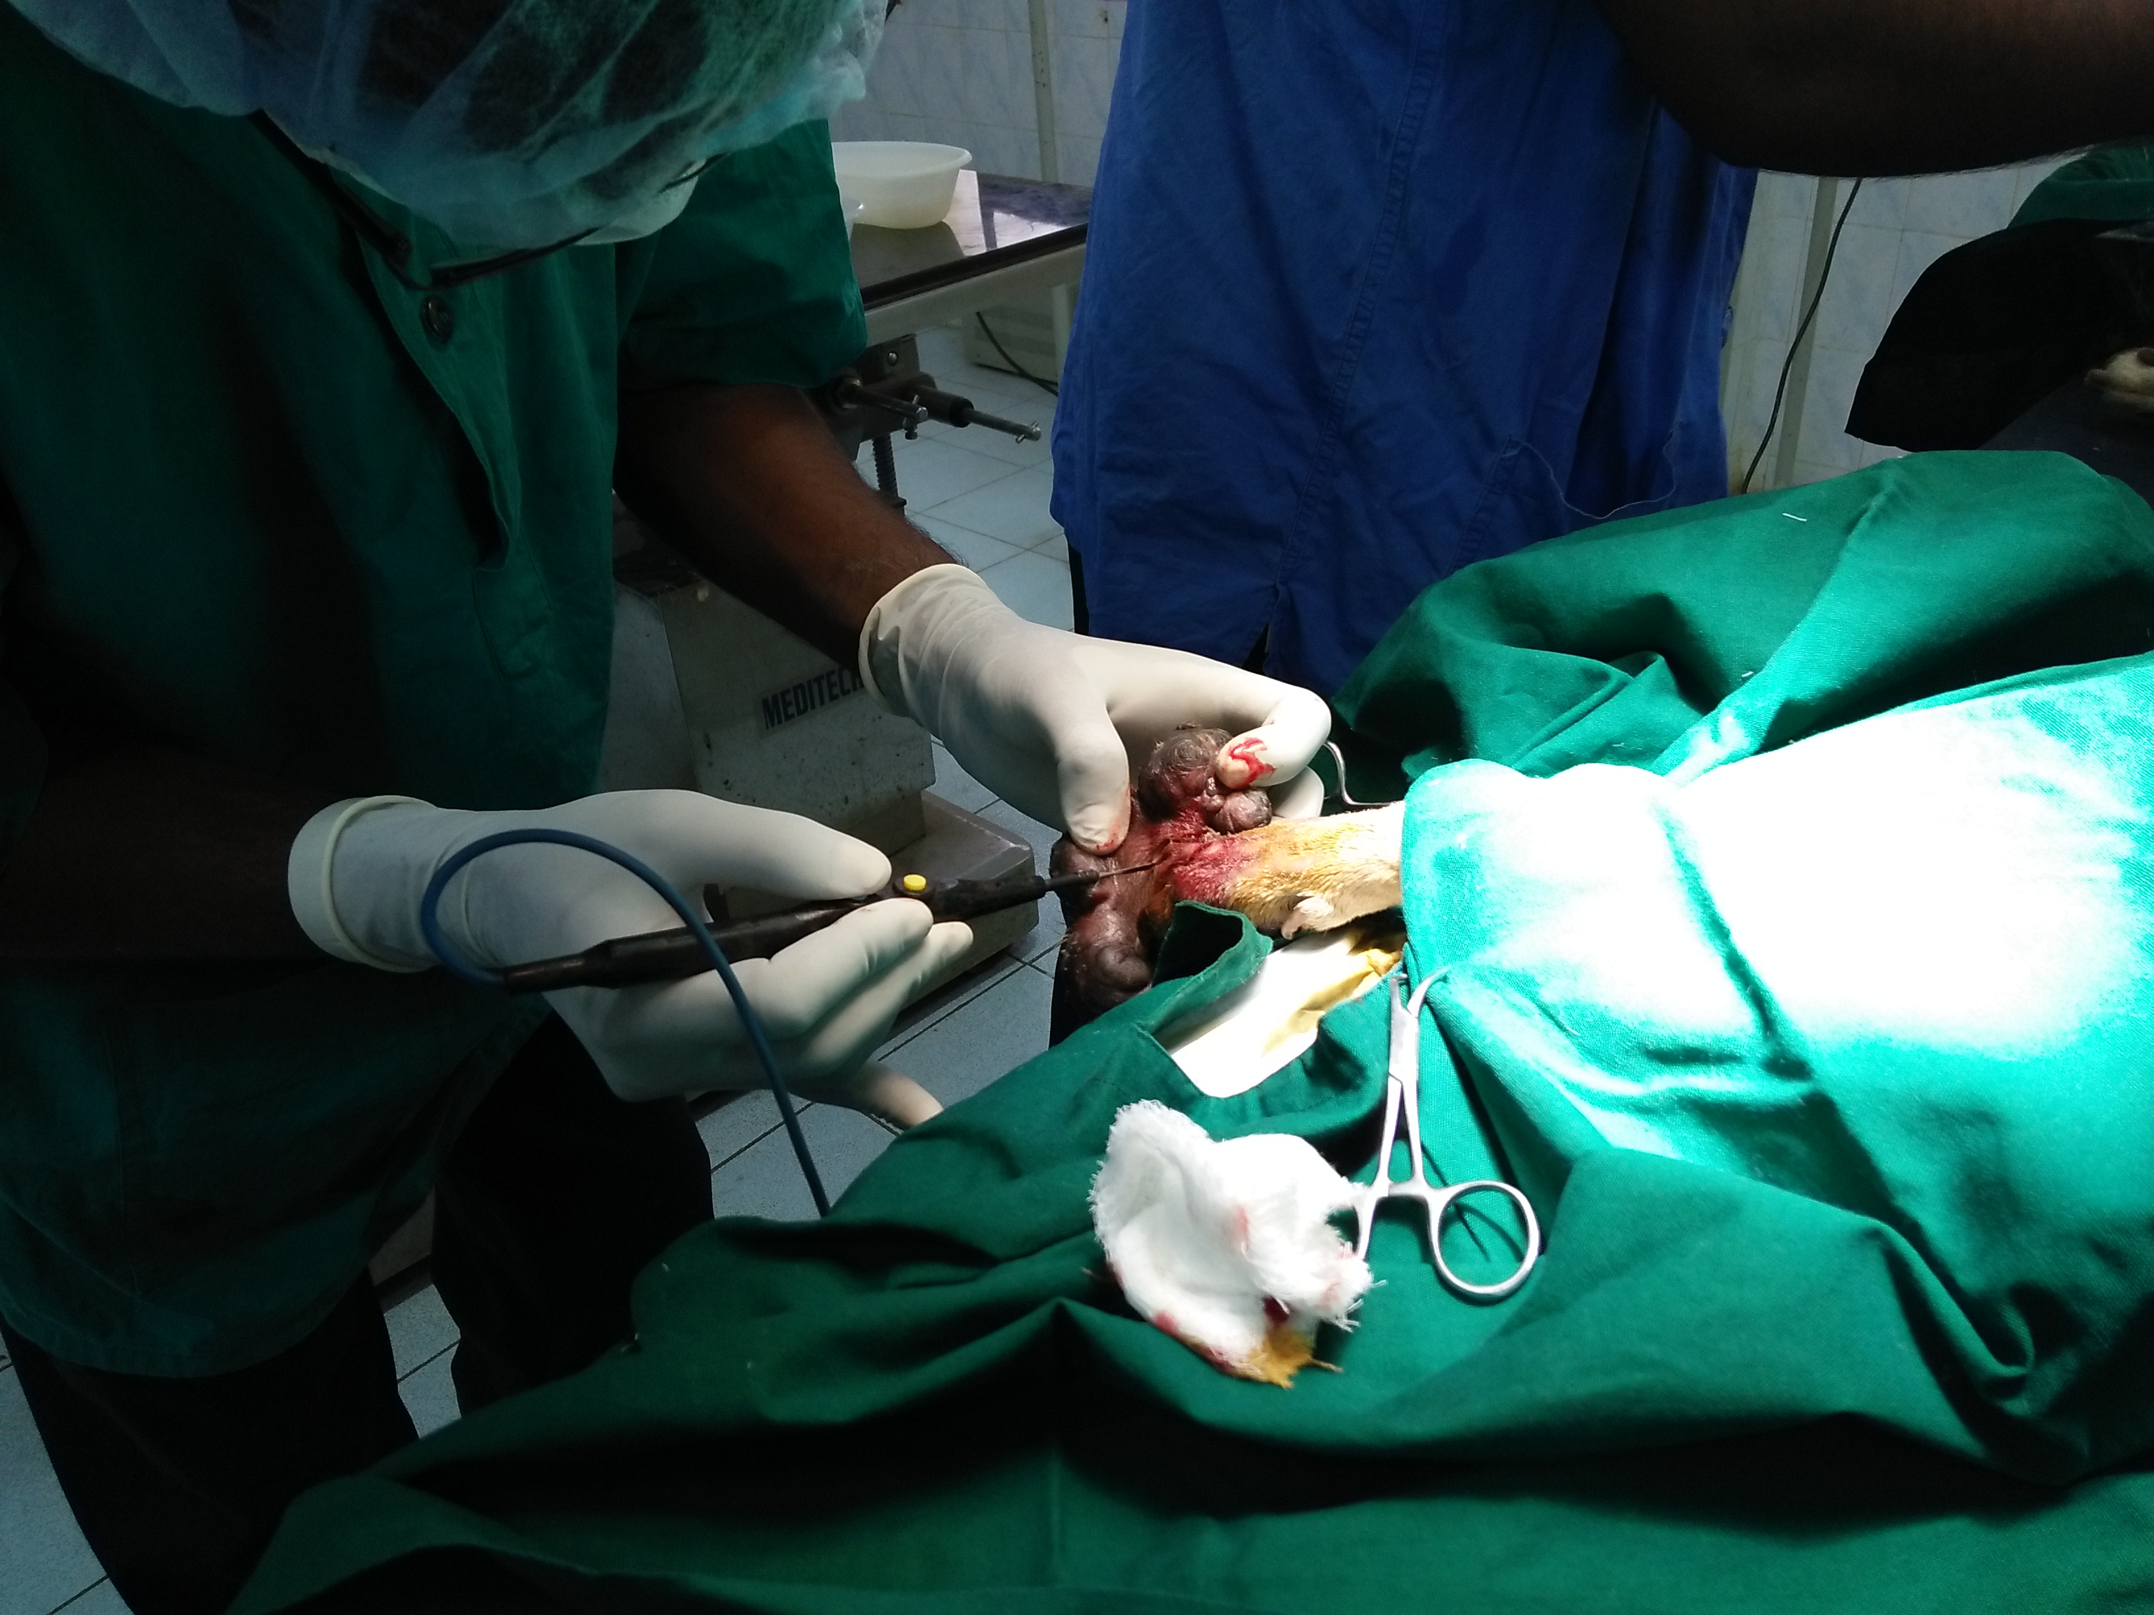
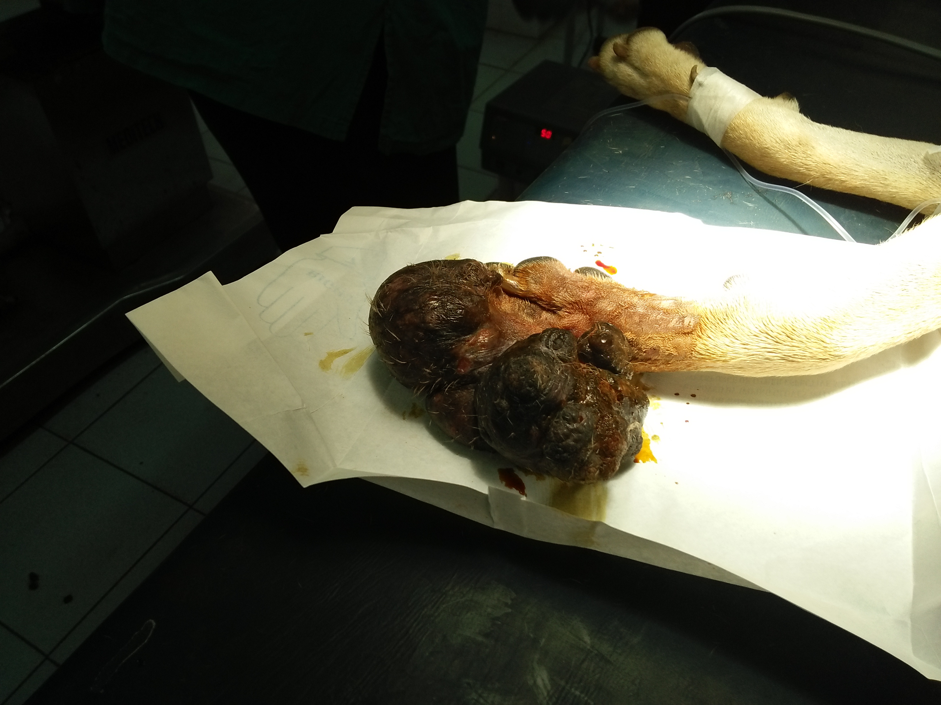

Fig 5: Incision

Fig 4: Preparation of incision site

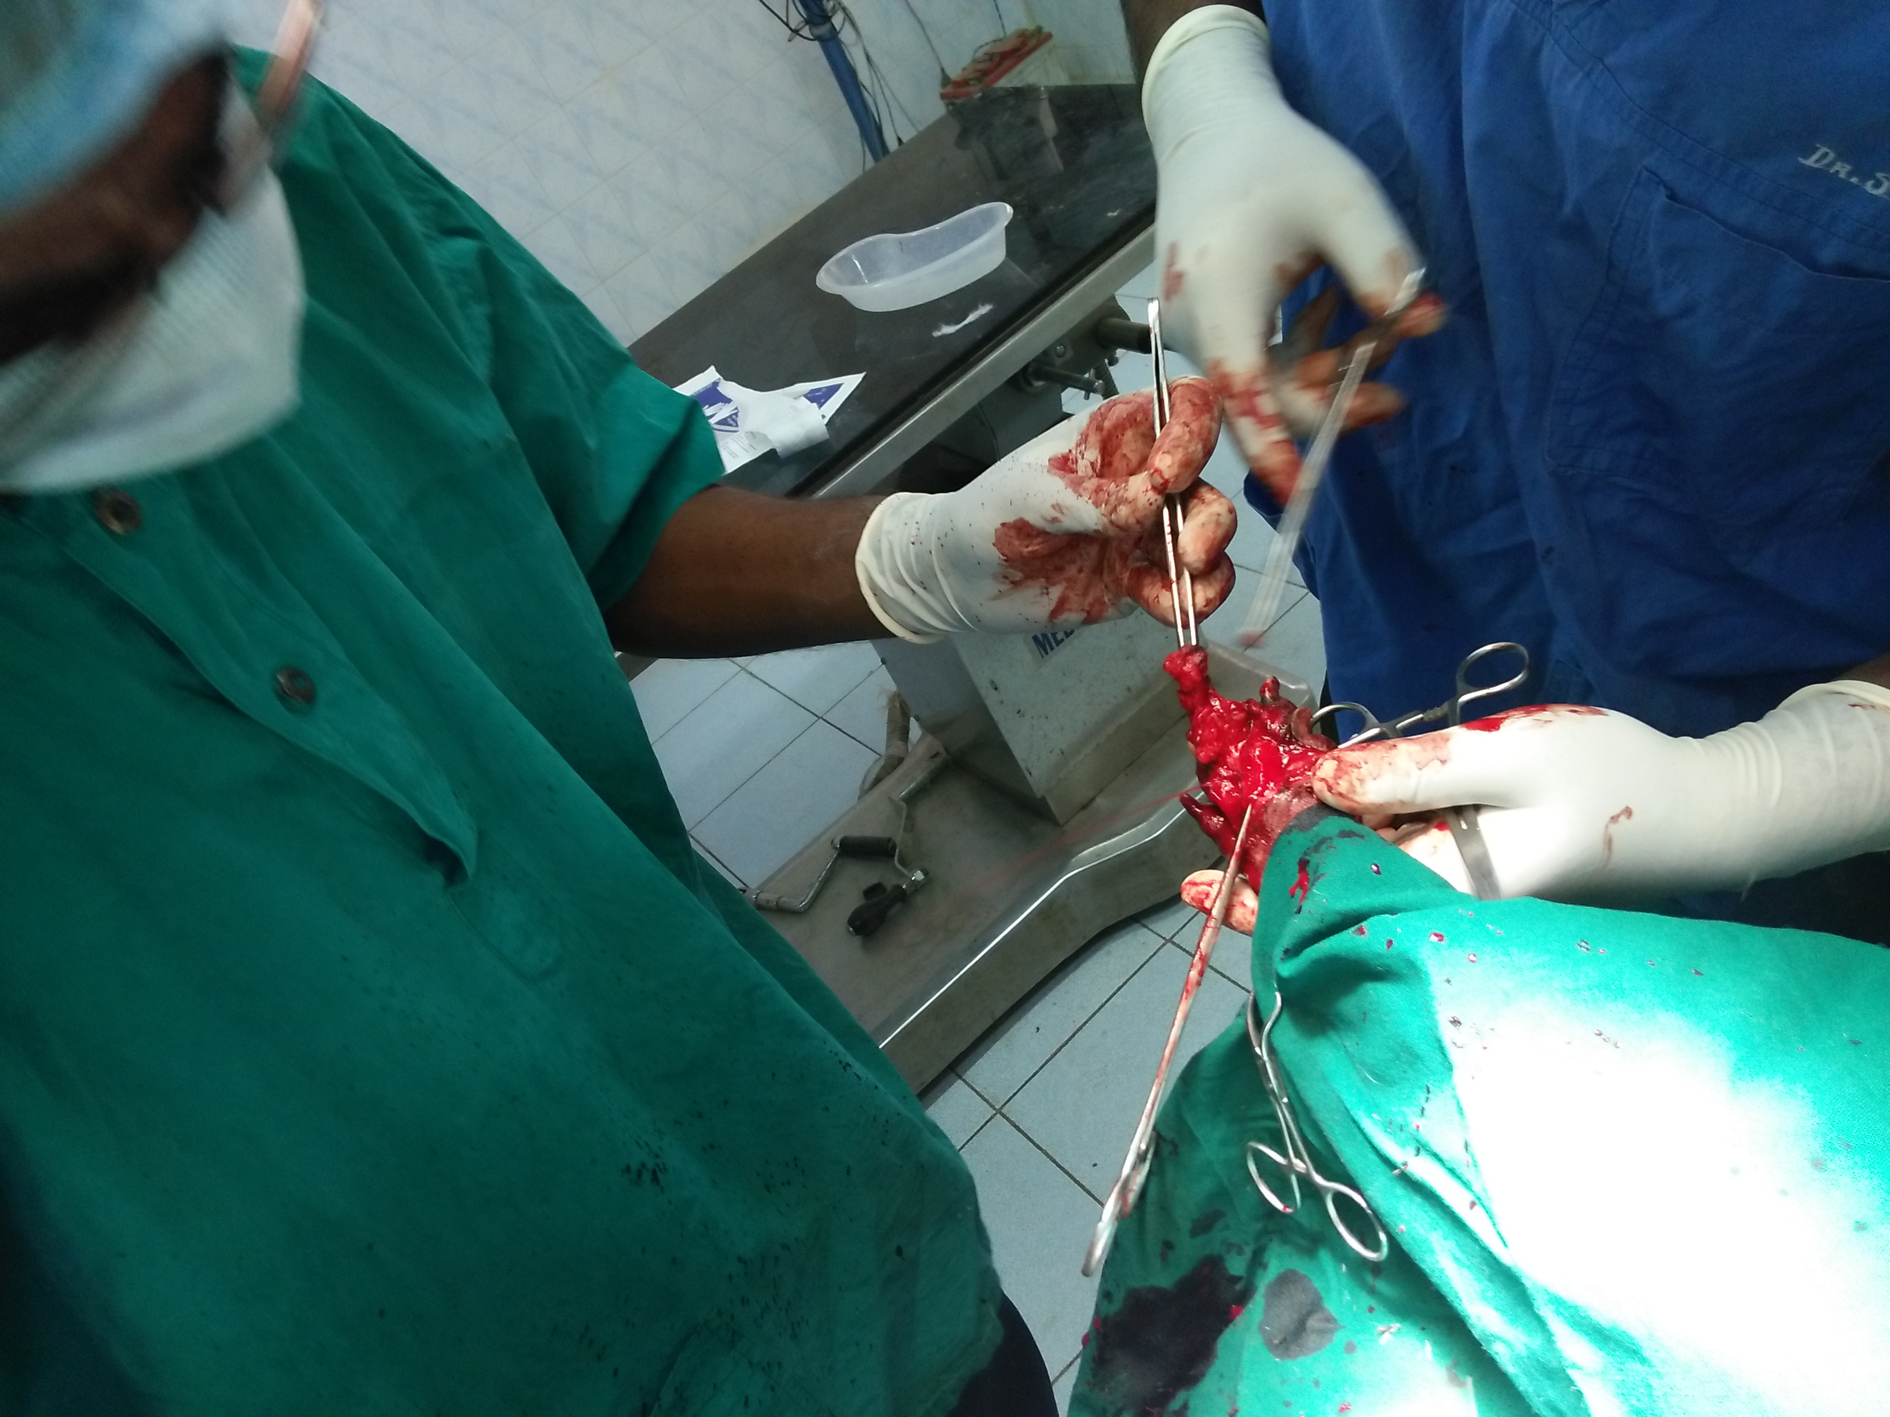
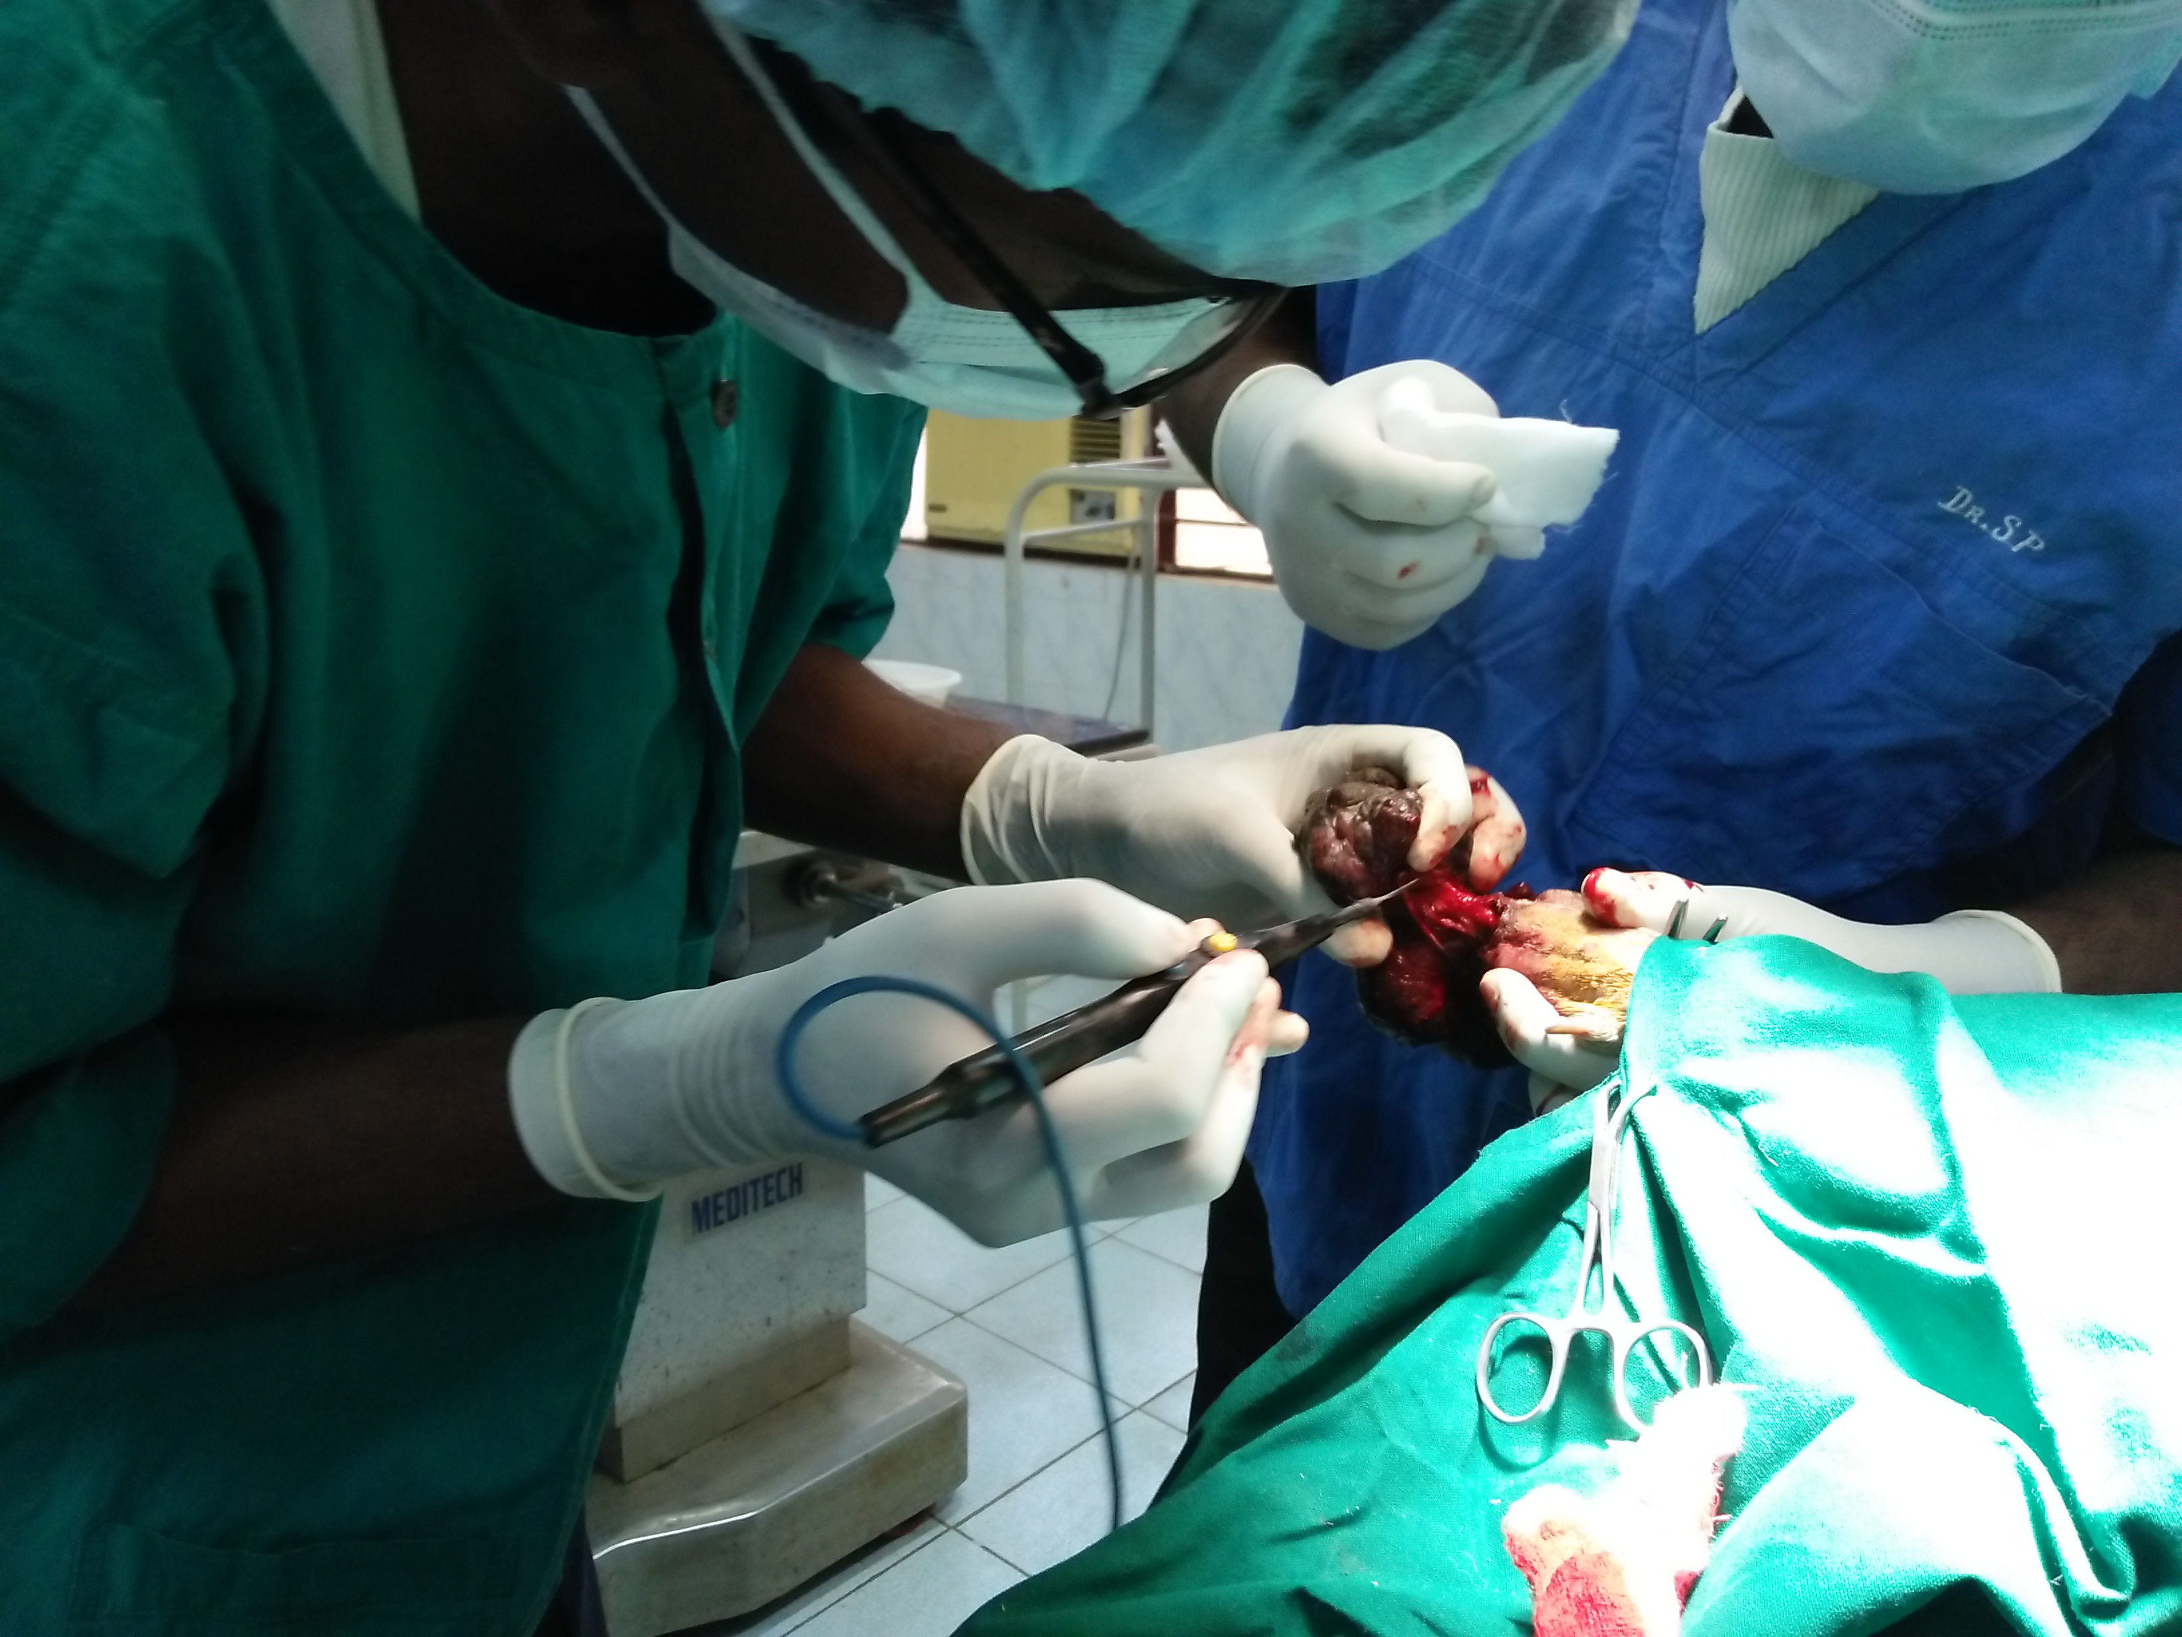

Fig 7: Complete removal of tumor

Fig 6: Site of incision at the junction of skin and tumor

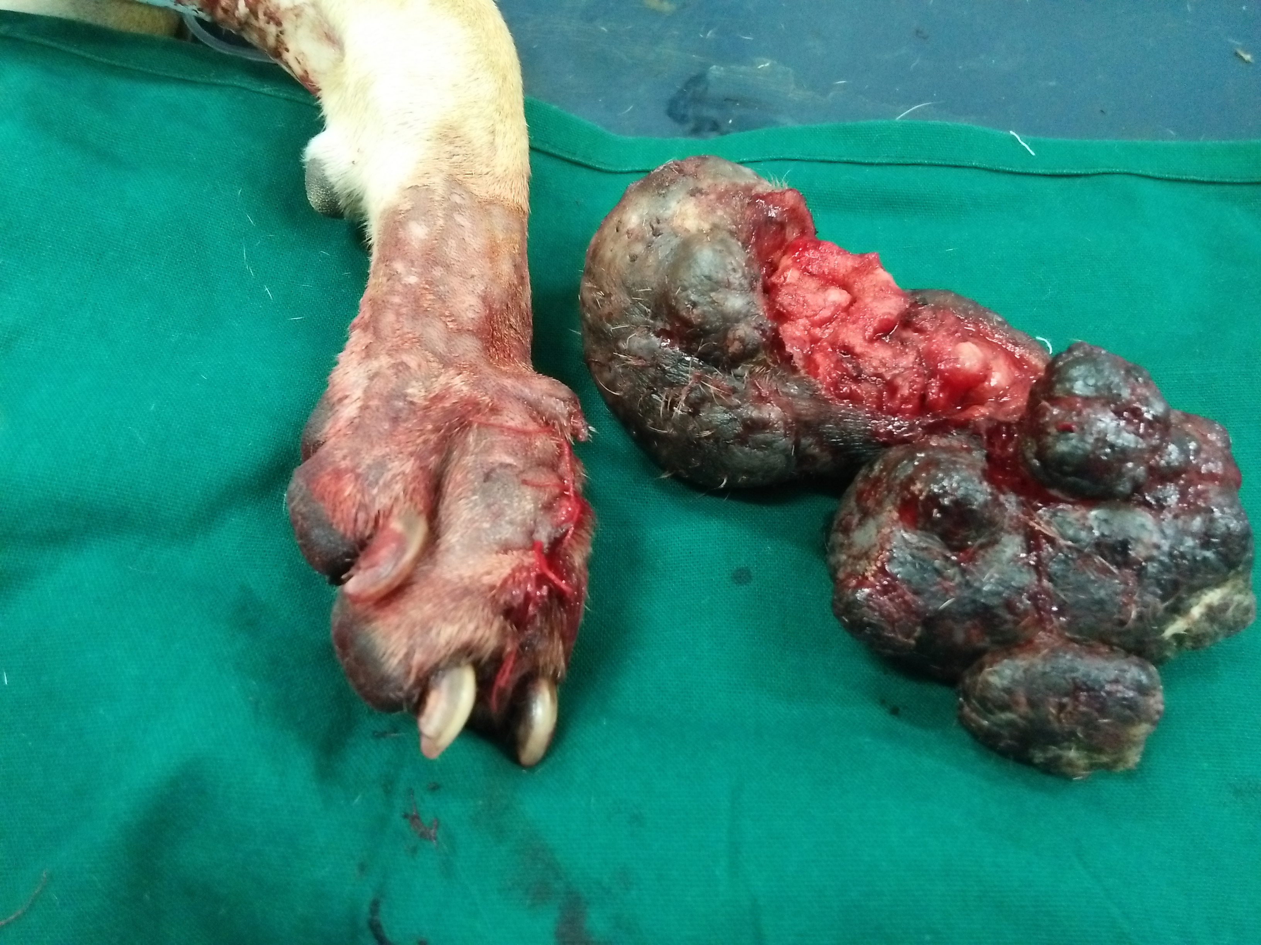
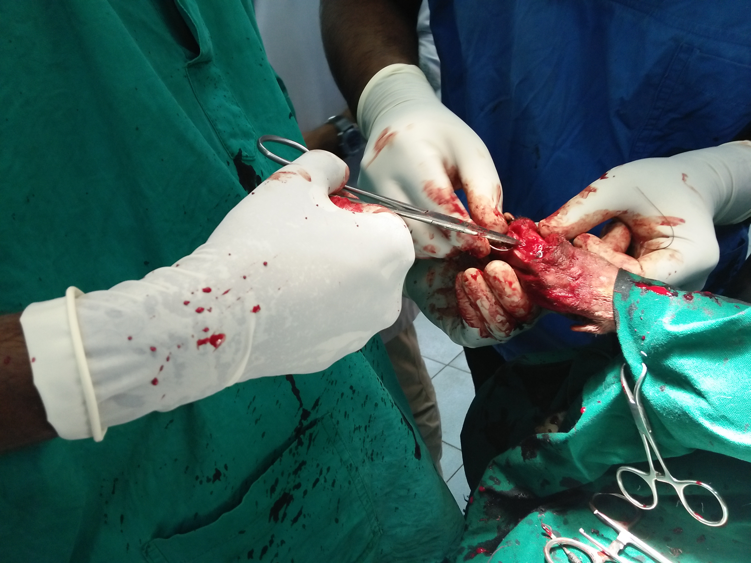

Fig 9: Right forelimb after removal of tumor

Fig 8: Suturing the incised skin

Medicinal treatment:

1. Injection Meloxicam (0.2 mg/kg) was given subcutaneously to reduce pain.
2. Injection Ceftriaxone (15-50 mg/kg) was given intravenously to prevent bacterial infection.
3. Povidone iodine 10% was given for regular dressing.

Advice:
Owner was told to continue the treatment for minimum 7 days. Regular dressing was advised up to recovery. Owner was told to bring the animal after recovery to remove the suture materials.

Discussion
Soft tissue sarcomas (STSs) are a heterogenous group of tumors that originate from connective tissues surrounding, supporting and bridging anatomical structures or tissues. STSs have similar biological behaviors, often displaying both benign and malignant characteristics. Although skin and subcutaneous tumors are the most commonly observed STSs, these sarcomas can, in principle, arise from any part of the body (Ehrhart 2005; Ettinger 2003; Kuntz et al. 1997).

The prognosis of STSs depends on tumor size, histologic grade, site, fiation to underlying structures, presence of metastasis, and completeness of removal (i.e., the surgical margins) (Ettinger 2003;). The incidence of metastases in STSs is low (<20%), but higher grade tumors have been reported to have higher rates (up to 50%) (Liptak et al. 2007).

Median age of dogs affected with STSs is 10 years (range, 5–17 years) (McSporran 2009). Middle to large breed dogs are commonly affected, with no known breed or sex predilection. STSs represent 8%–15% of all skin and subcutaneous tumors in dogs and 7%–18% in cats (Mukaratirwaet al. 2005; Theilen and Madewell 1979; Dobson et al. 2002). A STS incidence of 142 per 100,000 dogs per year was reported in the UK (Dobson et al. 2002). Median age at presentation for STSs in cats is 8–11 years (range 1–17 years) (Davidson et al. 1997; Dillon et al. 2005).

STSs commonly present as firm, fried masses. STSs generally grow slowly, and symptoms are related to the site of involvement and the degree of invasion. They can cause dysfunction of an involved organ or signs can be caused by pressure onto surrounding structures. STSs appear to be encapsulated but often show an invasive growth pattern. The macroscopic capsule is in fact a
pseudocapsule, comprised of compressed tumor cells and reactive fibro vascular tissue. Measurement of tumor boundaries by physical examination commonly underestimates the actual tumor dimensions (McEntee and Samii 2000); therefore, advanced imaging techniques are
recommended for surgical planning.

In the case of metastasis, STSs usually spread hematogenously, preferably to the lungs (Dernell et al. 1998; Ehrhart 2005; Ettinger 2003; Liptak 2007). Reported overall rate of metastasis in dogs
is dependant on tumor grade (up to 13% for grade I and grade II STSs compared to 41%–44% for grade III STSs) (Baker-Gabb et al.2003; Ettinger et al. 2006; Kuntz et al. 1997; Simon et al. 2007).

Conclusion

Surgical excision might be the one of the best way to correct the tumor growth. Supportive drugs are useful. Proper knowledge about this soft tissue sarcoma is important for treating the diseased animal.

Limitation

The study has some limitations which includes:
- Time was limited for the study.
- Further study is required for clear conception of the disease.

References

Baker-Gabb, M., G.B. Hunt, and M.P. France. 2003. Soft tissue sarcomas and mast cell tumours in dogs: Clinical behaviour and response to surgery. Aust Vet J 81(12):732–738
Davidson, E.B., C.R. Gregory, and P.H. Kass. 1997. Surgical excision of soft tissue firosarcomas in cats. Vet Surg26(4):265–269.
Dernell, W.S., S.J. Withrow, C.A. Kuntz, et al. 1998. Principles of treatment for soft tissue sarcoma. Clin Tech Small AnimPract13(1):59–64.
Dillon, C.J., G.N. Mauldin, and K.E. Baer. 2005. Outcome following surgical removal of nonvisceral soft tissue sarcomas in cats: 42 cases (1992–2000). J Am Vet Med Assoc227(12):1955–1957.
Dobson, J.M., S. Samuel, H. Milstein, et al. 2002. Canine neoplasia in the UK: Estimates of incidence rates from a population of insured dogs. J Small AnimPract43(6):240–246.
Ehrhart, N. 2005. Soft-tissue sarcomas in dogs: A review. J Am AnimnHospAssoc41(4):241–246.
Ettinger, S.N. 2003. Principles of treatment for soft-tissue sarcomas in the dog. Clin Tech Small AnimPract18(2):118–122.
Kuntz, C.A., W.S. Dernell, B.E. Powers, et al. 1997. Prognostic factors for surgical treatment of soft-tissue sarcomas in dogs: 75 cases (1986–1996). J Am Vet Med Assoc211(9):1147–1151.
Liptak, J.M. 2007. Soft tissue sarcomas. In Withrow&MacEwen’s SmallAnimal Clinical Oncology, pp. 425–454. S.J. Withrow and E.G. MacEwen, editors. WB Saunders: St. Louis.
McEntee, M.C. and V.F, Samii. 2000. The utility of contrast enhanced computed tomography in feline vaccine associated sarcomas: 35 cases [abstract]. Vet Radiol Ultrasound 41:575.
McSporran, K. 2009. Histologic grade predicts recurrence for marginally excised canine subcutaneous soft tissue sarcomas. Vet Pathol46(5):928–933.
Mukaratirwa, S., J. Chipunza, S. Chitanga, et al. 2005. Canine cutaneous neoplasms: Prevalence and inflence of age, sex and site on the presence and potential malignancy of cutaneous neoplasms in dogs from Zimbabwe. J S Afr Vet Assoc76(2):59–62.
Theilen, G.H. and B.R. Madewell. 1979. Veterinary Cancer Medicine. Lea &Febiger: Philadelphia.

Acknowledgement

The author is ever grateful and indebted to the Almighty Allah without whose grace it would never been possible to pursue this study in this field of science and to complete this clinical report for the Degree of Doctor of Veterinary Medicine(DVM).

The author would like to thank his beloved teacher and supervisor Professor Dr. Mohammad Mejbah Uddin, Department of Anatomy and Histology, Chittagong Veterinary and Animal Sciences University, for his valuable advice, suggestions and kind co-operation during the study period.

The author expresses his sincere gratitude and gratefulness to Dr. P. Shankar, Associate professor, VCRI, Namakkal, Tamil Nadu Veterinary and Animal Sciences University for his valuable advice, inspiration, cordial co-operation, valuable suggestions during the study period.

The author would like to thank to the Director of External Affairs, Professor Dr. A.K.M Saifuddin, Dept. of Physiology, Biochemistry and Pharmacology, Chittagong Veterinary and Animal Sciences University for his suggestion.

Biography

This is Muhammad minhajul karim from Chittagong. He completed his Secondary School Certificate (SSC) examination in 2008 with GPA-5 from Nanupur A.S. high school, Chittagong and Higher Secondary School Certificate (HSC) examination in 2009 with GPA-4.9 from Govt. Haji Mohammad Mohsin College, Chittagong. Currently he has been doing his internship program which is the compulsory of DVM degree under the Faculty of Veterinary Medicine, Chittagong Veterinary and Animal Sciences University. He feels massive interest in pet bird practice.

