A case report on Soft Tissue Sarcoma (STS) in a dog

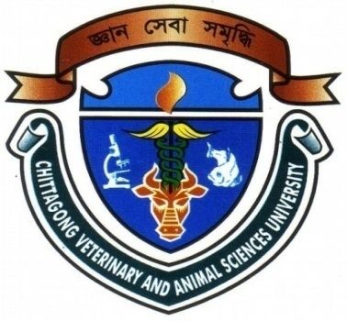

A Clinical report submitted by:

Intern ID: 59

Roll No: 11/105

Reg No: 0654

Session: 2010-2011

A clinical report is submitted for Partial fulfillment of the Degree of Doctor of Veterinary Medicine (DVM)
Faculty of Veterinary Medicine

Chittagong Veterinary And Animal Sciences University.

Khulshi, Chittagong-4225

September,2018

A case report on Soft Tissue Sarcoma (STS) in a dog

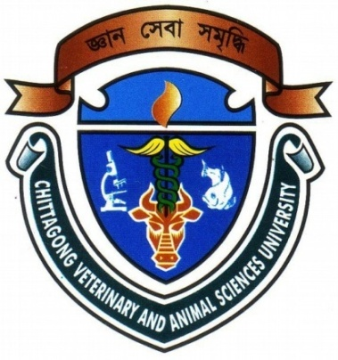

A Clinical report submitted by:

Intern ID: 59

Roll No: 11/105

Reg No: 0654

Session: 2010-2011

Approved as to style and content by

..................................................  Signature of Author  Muhammad Minhajul Karim  Roll No: 11/105  Reg No: 0654  Session: 2010-2011 | ……………………………….  Signature of Supervisor  Dr. Mohammad Mejbah Uddin  Professor  Dept. Anatomy and Histology  CVASU

