CHAPTER-I

1. INTRODUCTION

In Bangladesh, umbilical infections are frequently characterized by umbilical abscess and high temperature in neonatal calves, it is known as navel ill (Ortega et al., 2007). Less than one week of young calves are commonly affected (Chase et al., 2008).

Navel ill indicates affecting the umbilicus (navel cord) (Mcdonald et al., 2014). The blood vessels of navel cord supply oxygen and nutrients in calf during gestation. It occurs as a result of infection entering through the umbilical cord at, or soon after, birth (Grady et al., 2002). Where the bacteria spread, there infection can result in a range of signs (Angulo et al., 2004). Chronic umbilical infections have an unfavourable influence on the general condition and health of the animal (Capra et al., 2013). The various components of the umbilical cord pass through the ventral abdominal wall in developing fetus (Jungers et al., 2005). These comprise the umbilical vein which leads to the liver, two umbilical arteries which arise from the iliac arteries and the urachus passing to the bladder (Waldner et al., 2009). The amniotic membrane of the cord is seperated at birth and progressively close the umbilical vein and the urachus, even though they momentarily remain outside the umbilicus. The short the cord is torn, the greater the risk of infection. Infection may causeomphalitis, omphalophlebitis and omphaloarteritis if it occurs soon after birth (Pardon et al., 2012).

The local infection may affect the liver or through the urachas to the bladder and result in chronic ill health, or to produce systemic septicemia (Robert et al., 2016). In the joints, the blood born infections localization is most common producing a suppurative or non-suppurative arthritis. There is usually a mixed bacterial flora including E.coli, Proteus spp, Staphylococcus spp.Actinomycespyogenesetc (Sherif et al., 2017).The facultative myiasis producing flies such as houseflies, blowflies, flash flies can be responsible for navel infections. Though antibody level in the body vary the infection but it also depends on the management after birth (Waldner et al., 2009). Due to development of septicemia, the mortality is also high during this time. The condition can be complicated through myiasis and septicemia associated with joint ill can consequence the condition (Ramya et al., 2016). After birth, housing and floor management is very important as male calves have more chance of getting infection and calves remain in high risk within 3-5 days according to the antibody level in the blood (Meyer et al., 2005). There was found lots of study about these case in international society. Very few study was found in Bangladesh related with this case. Therefore, the aim of the study was to find out the infection rate of navel ill and associate risk factors in calves at Raozan in Chittagong.

Considering the above mentioned facts, the study was carried out with the following objectives:
- To know the relationship of navel ill with the floor management of the housing.
- To know the relationship of navel ill with age & sex of calves and nature of complications take places.
- To know the mortality rate of calves irrespective to age and complications of the cases.

CHAPTER –II

2. MATERIALS AND METHODS

2.1. Study area
The study was carried in Raozan Upazilla Veterinary Hospital in Chittagong District.

2.2. Study period
The total study period was 2 months from 1st February to 29th March 2018.

2.3. Population
A total number of 22 infected cases were found and their different housing system, age, sex, breed were observed to investigate the incidence of navel ill.

2.4. Preparation of the interview schedule
The interview schedule was prepared to fulfill the objectives of the study. The questions were set in the interview schedule chronologically, so that the farmers can provide information in a systematic manner.

2.5. Variables and their measurement
Some factors of navel ill were taken as variables of the study. Those were age, sex, breed, environment, antiseptic used after birth, types of floor where the calf is reared.

2.6. Clinical examination of the patient was done by 3 ways:
⇓
⇓ ⇓ ⇓
Distal inspection Close inspection Palpation
⇓ ⇓ ⇓
General appearance  - Dull and depressed  - Lie down  - Swelled navel area  - Swelled joint area | Appearance of local area  - Swelled area  - Pus and bloody discharge  - Maggot coming out.  - Foul smell | Area palpation  - Hard mass and pain  - Blood mixed pus  - Needle aspiration of pus from joint
2.7. Presenting clinical signs:
- The navel area were swelling with heat and pain.
- Pus coming out from the infected area.
- Raised temperature up to 105°F.
- Animals were usually unable to stand, stiffed gait.
- Swelled joint area.
- In some cases myiasis in the navel area.

2.8. Treatment:

Steps were taken for general correction of navel ill:
The patient was restrained physically and placed dorsoventrally.

The navel area was sterilized by using tincture of iodine.

If the area was sealed by fibrous tissue then a small incision was given on the area.

For drained out the pus manual pressure was applied.

Tincture of iodine or potassium permanganet solution was applied in the area by using cotton holding with forceps and wash properly to destroy the pyogenic membrane.

Finally a tincture iodine mixed gauge was left in the area without any suture to maintain proper drainage of the discharges.

The local antibiotic was given in the area along with systemic antibiotics.

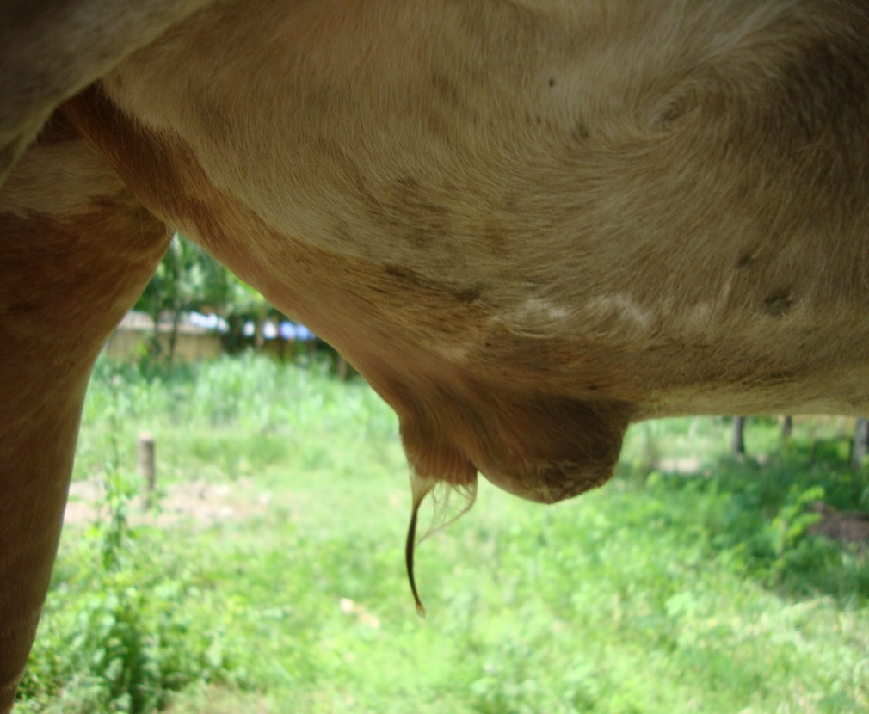

Fig: Navel ill with non-descriptive abscess formation in a calf.

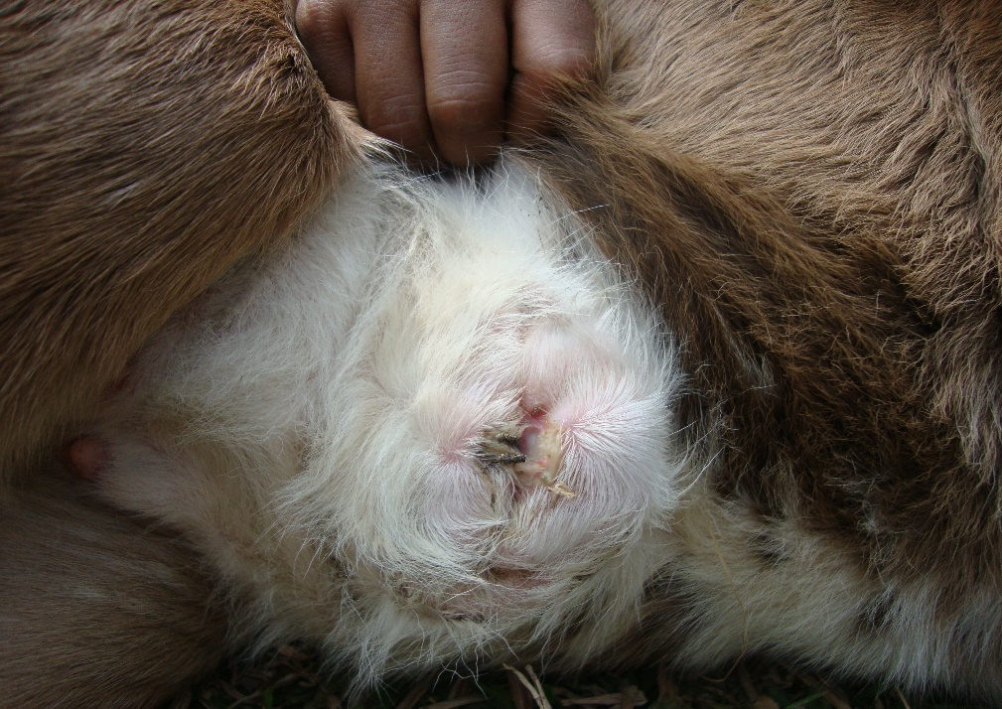

Fig: Navel ill with maggot infestation in a calf.

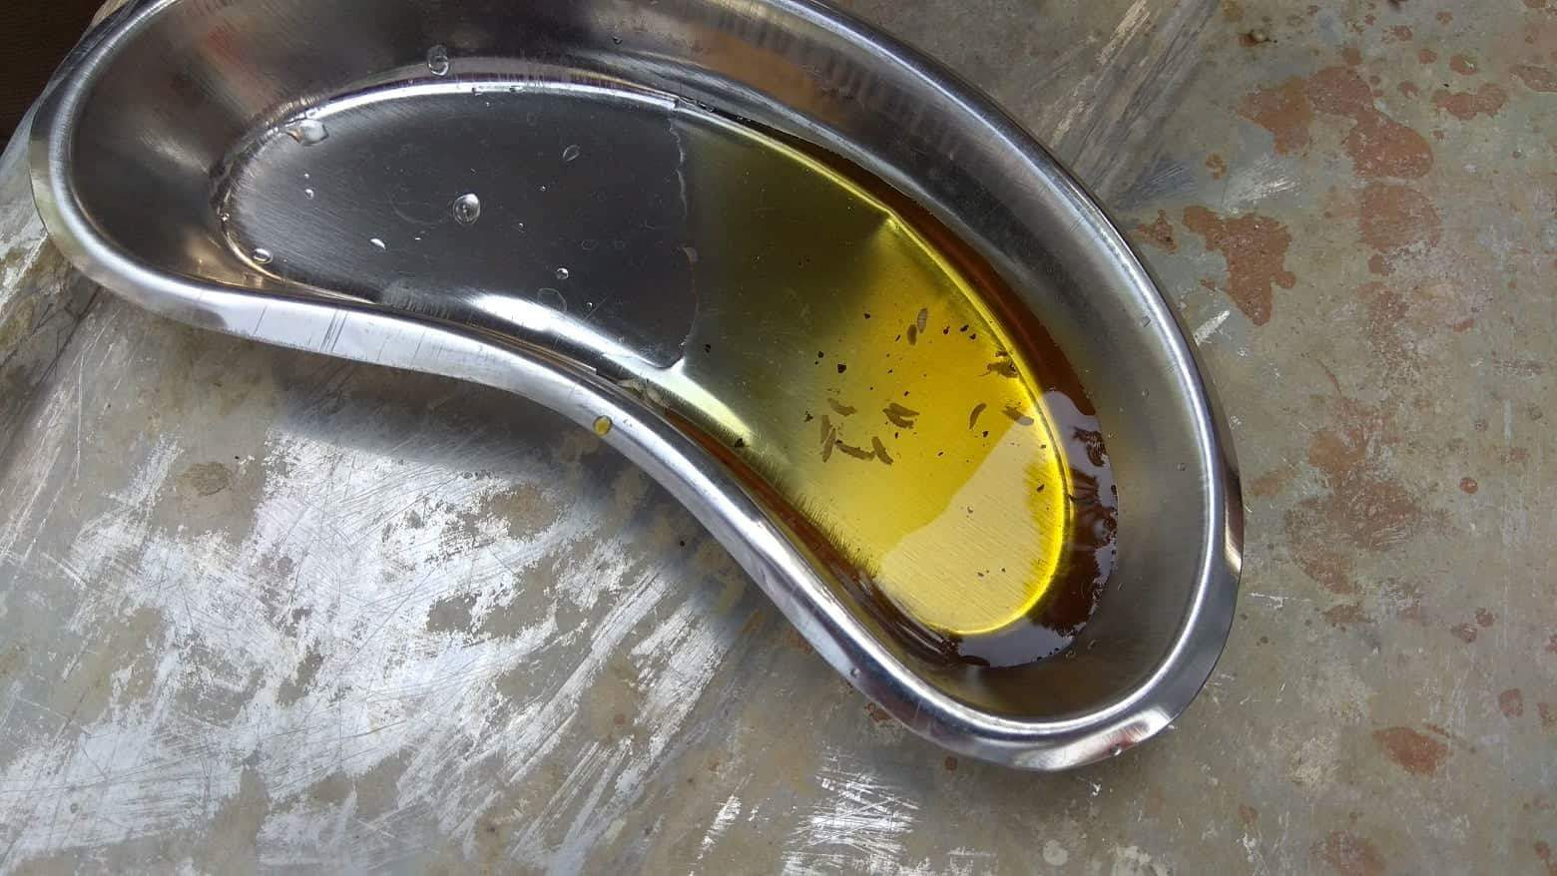

Fig: Few maggots in kidney tray collected from affected calf

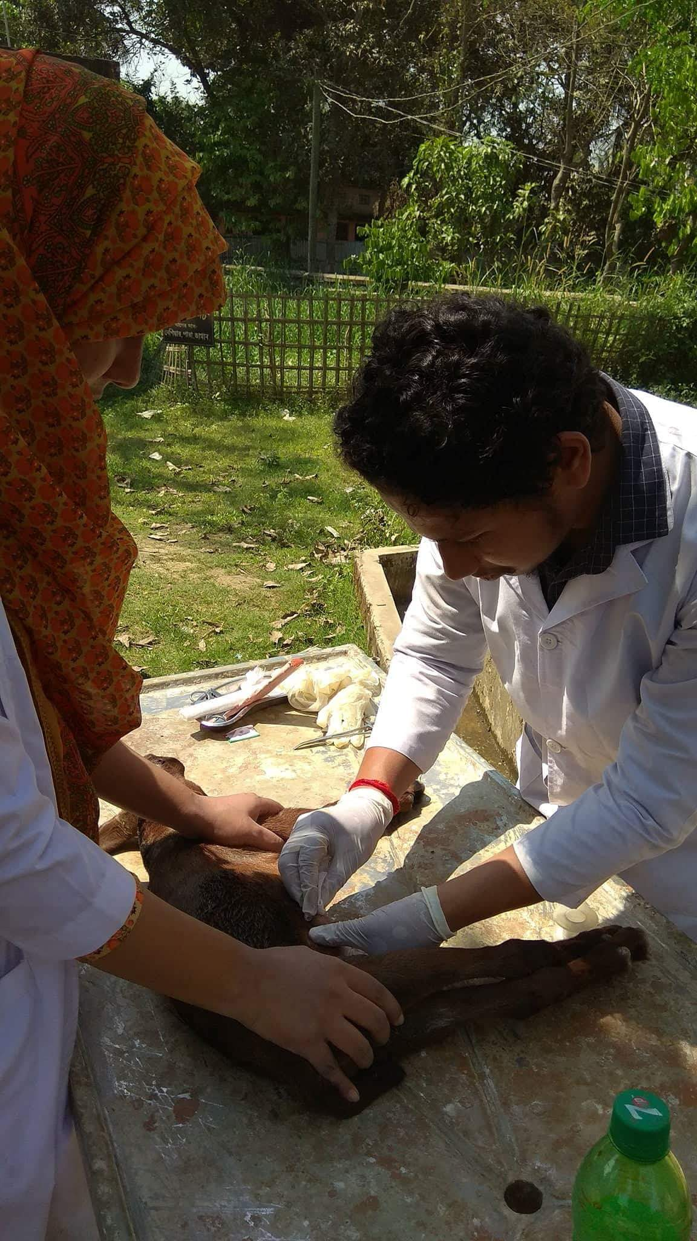

Fig: Treatment of navel infection in a calf.
Steps were taken for the complication of navel ill with myiasis (maggot infestations):
The patient was restrained physically and placed dorsoventrally.

The navel area was sterilized by using tincture of iodine.

Then visible maggots were removed from the wound by holding them with a forceps.

As much as possible, maggot was removed from the wound.

Then oil of turpentine or naphthalene powder was applied within the wound by forceps.

The patient was left for sometimes to make the oil of turpentine or naphthalene powder working.

Then all the inactivated worms were removed from the wound.

Finally a tincture iodine mixed gauge was left in the area without any suture to maintain proper drainage of the discharges.

Finally the local antibiotic was given in the area along with systemic antibiotics.

Steps were taken for the consequence of navel ill (Joint ill):

The patient was restrained and placed carefully

The joint area was sterilized by using tincture of iodine

In case of highly swollen the joint area needle aspiration was done to remove the accumulated serous fluid from the joint as it can minimize pain sensitivity of the patient

Then 0.2 % potassium permanganate solution was pushed in to the joint to wash it

Then systemic and local antibiotic was given to the patient

Table:1 The variable treatments were given after surgical correction
Sl. No | Drugs used | Generic name | Trade name | Dose prescribed | Route | Duration
1 | Antibiotics | Procaine penicillin, Benzyl penicillin & Streptomycin | SP-Vet | 1 ml/15 Kg | i/m | 5 days
 |  | Procaine penicillin, Benzyl penicillin & Streptomycin | Streptopen | 1 ml/15 Kg | i/m | 5 days
 |  | Oxytetracycline Hydrochloride | Renamycin LA | 1 ml/10 Kg | i/m | 7 days
2 | NSAIDS | Diclofenac sodium | Clofenac vet | 1ml/20 kg | i/m | 4 days
 |  | Ketoprofen | Kop-Vet | 1 ml/30 kg | i/m | 4 days
3 | Antihistaminics | Pheneraminemeleate | Histavet | 2 ml/calf | i/m | 5 days
 |  | Pheneraminemeleate | Antihista vet | 2 ml/calf | i/m | 5 days
 |  | Promethazine | Dellergen | 2 ml/calf | i/m | 5 days
4 | Steroids | Dexamethasone sodium phosphate | Dexavet | 1 ml/calf | i/m | 1 day
2.9. Post operative observation:
During this study period 11 infected calves were treated under the upazila veterinary hospital. 1 calves died out of these calves and other calves were supervised under upazila veterinary hospital. They were recovered from this disease.

2.10. Statistical analysis:
Microsoft office excel was used in the test. Pearson chi²–test was done to find out P-value. And P-value was found out through STRATA. P-value of less than 0.05 was considered as significant.

CHAPTER-III

3. RESULT AND DISCUSSION

Table: 2
Distribution of different demographic, managemental and environmental factors:
Variables | Category | Infected | Total no. of  infected cases | Percentage  (%) | P
Demographic
Age | 0-15 days | 7 | 11 | 45.45 | 0.160
 | 16-30 days | 3 | 11 | 45.45
 | 31-60 days | 1 | 11 | 9.09
Sex | Male | 8 | 11 | 63.64 | 0.338
 | Female | 3 | 11 | 36.36
Breed | Local breed | 9 | 11 | 81.82 | 1.000
 | Cross breed | 2 | 11 | 18.18
Managemental
Types of floor | Concrete floor | 1 | 11 | 9.09 | 0.325
 | Semi-concrete floor | 2 | 11 | 18.18
 | Mud floor | 8 | 11 | 72.73
Antiseptic used after birth | Not used | 10 | 11 | 81.82 | 0.138
 | Used | 1 | 11 | 18.18
Environmental | Hygienic | 2 | 11 | 18.18 | 1.000
 | Unhygienic | 9 | 11 | 81.82

*P-value is significant less than 0.05 value.

The distribution of different variables among the 11 calves with their frequencies and percentages were presented in Table-2.

Age:
During the study period it was found that among the 11 no of infected calves, 7 calves were within 0 -15 days and 3 calves were within 16-30 days and 1 calves were within 31-60 days of age. The result was representing around 45.45% of the total cases were within 0-15 days, 45.45% of the cases were within 16-30 days & 9.09% were within 31-60 days of old. The relationship among the age group was not significant. The infection rate was high (73.03%) at 0-30 days of age than 31-90 days of age (24.72%) and it was very low (2.25%) in >90 days (Samad et al., 2001). The study was found similarity with the previous study. It was found that calves of 0-15 days got highest percentage of infection in this study and the lowest percentage of infection was found in 16-30 days and 31-60 days old calves. It was perhaps unhygienic environment condition, less population size.

Sex: In the study it was found that the infection rate was higher in male (63.64%) than female (36.36%). The relationship between sex group were not significant. Male calves were more susceptible to the infection than the females (Radostits et al., 2007).The study result was found similarity with the previous study. Male calves were having urethral opening nearer to the navel area. So the navel area of males have more chance to be soiled by urine.

Breed:
In local breed the rate of infection (81.82 %) was higher than the cross breed (18.18 %).The relationship between breed group were not significant. Local breeds, the infection (70.76%) rate was higher than crossbred (29.24%) calves (Rweyemamu et al., 2008). Local breed got highest percentage of infection and cross breed got lowest percentage of infection. It was probably inadequate sample size.

Types of floor:
Out of 11 infected calves, 8 were reared in mud floor, 2 were in semi concrete floor and 1 in concrete floor. Higher percentage of infection (72.73%) was occurred in calves which were reared on mud floor than semi concrete (18.18 %) and concrete floor (9.09 %). The relationship disease percentage among types of floor were not significant. Mud floor (60.20%) was higher infection rate than semi-concrete floor (30.36%) and concrete floor (9.44%) (Waltner et al., 2006). It was similar to the study. Mud floor got highest percentage of infection and semi concrete and concrete floor got lowest percentage of infection. It was probably unhygienic environment condition of the farm.
Uses of antiseptics:
Study showed that if antiseptic not used the rate of infection was higher (81.82 %) than use of antiseptic (18.18%). The relationship between antiseptic used disease percentage group were not significant. In case of antiseptic was not used the rate of infection was higher (60.28%) than use of antiseptic (39.72%)(Smith et al., 2004). It was similar to the study. The study got highest percentage of infection antiseptic was not used and got lowest percentage of infection in antiseptic was used. This may be due to inhibition of microbial migration into the calves body.

Environmental condition:
Unhygienic condition is the main predispose cause of infection. In rural condition, most of calves are reared with their dam on the mud floor. The manure and urine are mixed and create very unhygienic condition. In this study among the infected calves 81.18 % calves were found to rear in unhygienic condition which was higher than hygienic condition (18.82%). The relationship based on environment condition disease percentage group were not significant. Unhygienic environment condition the infection rate was higher than in hygienic condition (Gorden et al., 2010). This study was found similar result following this article. It was similar to the study.

Table-3: Navel ill found irrespective of complications
Complication | Animals affected | Total no of animals | Percentage  (%)
Non descriptive abscess formation | 8 | 11 | 72.72
Infection with myiasis | 2 | 11 | 18.18
Infection consequence arthritis | 1 | 11 | 9.09

During the study period among 11 infected cases non descriptive abscess formation were found in 8 calves ,which represents 72.72% , of the total cases. The infection with myiasis were in 2 calves, which represents 18.18%. The navel infection consequences with arthritis were found in 1 in number, which represents 9.09% of the total cases. Navel ill can be complicated with abscess formation as a primary condition leading to a systemic reaction, with toxemia, and extension of the pyogenic infection (Das et al., 2003). It was similar to the study.

Table -4: Mortality found irrespective to complications
Complications | No. of dead calves | Total complicate animals | Percentage  (%)
Non descriptive abscess formation | 00 | 08 | 00
Infection with myiasis | 01 | 02 | 50
Infection consequence arthritis | 00 | 01 | 00

During the study period among 11 infected calves 1 calf was died due to complication with severe myiasis which represent 50% mortality. No mortality was found in case of non-descriptive abscess formation and arthritis. According to the result the navel infections which were complicated with myiasis were more vulnerable than the other complications found (Berry et al., 2002). If the infection becomes complicated with myiasis, it causes loss of nutrient from the body along with the development of toxicity. Secondary bacterial infection from myiasis can also lead to death. Septicemia and toxemia development from non-descriptive abscess formation may also lead to the death of the animals (Khair et al., 2006). It was similar to the study.

Therefore, the following study represent that navel ill and subsequently occurred joint ill can be control by the following ways:

- Polyarthritis can be prevented by allowing adequate colostral milk since IgG level is lowered in colostrum deprived calf and foals.
- Navel cord should be dipped in Tr. Iodine or povidone iodine after birth.
- Floor should be scrubbed and disinfected prior to calving.
- Navel sucking by other calf or mother should be prevented.
- External genitalia of the mother should be cleaned prior to delivery.
- Any surgical operation (castration, docking etc) should be done with adequate pre-caution under full coverage of antibacterial umbrella.
- Fly repellant should be used to curb down the fly population and thus spread to infection.

CHAPTER-IV

CONCLUSION

The study was found that various factors were responsible for the navel ill infection. Unhygienic condition leads to create infection. Prevention is the key of this disease. Proper planning and management can prevent the build-up of disease that occurs in too many calving areas. Antiseptic can reduce the risk of bacteria entering through the navel, but there is no substitute for hygiene. The result of this study would be very effective to create awareness for preventing navel ill disease in calves by improving management facilities of the farm.

ACKNOWLEDGEMENT

All praises are due to Almighty God, who was created everything of the nature and who enable the author to complete this study. The author does not have adequate words to express his heartfelt sense of gratification sincere appreciation to his benevolent teacher and report supervisor. The author express his sincere gratitude, heartfull respect and immense indebtness to his supervisor DR. Abdullah Al Faruq, Lecturer in the Department of Anatomy & Histology, Chittagong Veterinary and Animal Sciences University for his valuable advice, guidance, suggestions, inspiration and who was involved with this study through its inception. Special thanks to Dr. A. K. M. Saifuddin, Professor & Director (External affairs), Department of Physiology, Biochemistry & Pharmacology, for his valuable advice and co-operation. I would like to express my deep sense of gratitude and thanks to Vice Chancellor, Professor Dr. Goutam Buddha Das and Professor Mr. Md. A. Halim, Dean Faculty of Veterinary Medicine, Chittagong Veterinary and Animal Sciences University. I would like to express my special gratitude to DR. Lenin Dey, Veterinary surgeon. Without their sympathy and kind co-operation, the completion of the study would not possible.
Supervisors` help and co-operation have been received from many persons during the tenure of this place of report. The author is immensely grateful to all of them, although it is not possible to mention everyone by name.

The Author

REFERENCES

Angulo, J. F., Nargund, V. N., Chiller, T. C. 2004. Evidence of an association between use of anti-microbial agents in food animals and the human health consequences of such resistance. 10 (11). 1439.

Bart, Pardon., Koen, De, Bleecker., Miel, Hostens., Piet, Deprez. 2011.Longitudinal study on morbidity and mortality in white veal calves in Belgium. Indian Journal of Paediatrics. 39 (7). 1824-7288.

Berry E.A., Hillerton J.E. 2002. The effort of selective dry cow treatment on new intramammary infections. Journal of Dairy Science. 85 (1). 112-121.

Chase., Christopher, C. L., David, Hurley, J., Adrian, J., Reber. 2008. Neonatal immune development in the calf and its impact on vaccine response. Veterinary Clinics of north America. 24(1). 87-104.

Das B.C., Hasim M.A. 2003. Studies on surgical affections in calve. Bangladesh Veterinary Journal. 30 (5). 53-57.

Gordon P.J., Plummer P. 2010. Control management and prevention of bovine respiratory disease in dairy calves and cows. Veterinary Clinics of North America. 26 (3). 243-259.

Naomy, P. O., Grady., Mary, Alexander.,Patcher, E., Dollinger.2002. Guideline for the prevention of intravascular catheter. Clinical Infectious Disease. 35 (11). 1281-1307.

Jungers, A., Katherine, Carinele., Goff, Robert, P. T. 2005. Diseases of young calves. The Veterinary Journal. 5 (5). 609-617.

Khair A., Alam M M., Islam M.T., Chowdhury E.H. 2013. Incidence of reproduction and production diseases of cross-bred dairy cattle in Bangladesh. Bangladesh Journal of Veterinary Medicine. 11 (1). 31-36.

Lucetta, capra., Giovanna, Tezza., Federica, Mazzei. 2013. The influence of maternal diseases and lifestyle during gestation. The Origin of Health and Disease. 34(4). 345-405).

Mcdonald, J. Susan., Philippa, Middleton., Therese, Dowswell., Peter, S., Morris. 2014. Effect of timing of umbilical cord clamping of term infant on maternal and neonatal outcomes. A Cochrane Review Journal Banner. 9 (2). 303-397.

Meyer, Joram., Feldon, Manfred., Schedlowski., Beniamin, K. 2005. Towards an immune-precipitated neurodevelopmental animal model of schizophrenia. Neuroscience and Behavioral Reviews. 29 (6). 913-947.

Mikael, Robert.,Gwenola, Touzot-Jourde., Nora, Cesborn., Borhane, Fellah. 2016. Laparoscopic evalution of umbilical disorders in calves. Veterinary Pathology. 43 (5). 430-450).

Ortega, J., Daft, B., Assis, R. A., Kinde, H., Anthenill, L., Odoni, J., Uzal, F. A. 2007. Infection of internal umbilical remnant by clostridium sordellii. Veterinary Pathology. 44(3): 269.

RadostitsO.m., Gay, C.C., Hinchcliff K.W. 2007. A textbook of the diseases of cattle, horses, sheep, pigs and goats.Veterinary Medicine. 10th ed. London. 45 (6). 345-674.

Ramya, Kollipara., Andrew, J., Peranteau. Zeena.,Nawas. Y. 2016. Emerging infectious diseases with cutaneous manifestations: Fungal, helminthic, protozoan and ectoparasitic infections.Journal of the American Academy of Dermatology. 75 (1). 19-30.

Rweyemamu, M., Roeder, P., Mackay, D., Sumption, K., Brownlie, J. 2008. Epidiological patterns of foot-and- mouth disease worldwide. Transboundary and Emerging Diseases. 55 (1). 57-72.

Samad, M. A. 2001. PoshuPalon O Chikitshavidya.2nd edition. LEP Pub. No.08. BAU campus, Mymensingh.

Sherif, H. H. A., Khalil, S. K. H., Hegazi, A.G., Moharram, M. A. 2017. Factors affecting the antibacterial activity of chitosan-silver nanocomposite. Veterinary Pathology.11 (6). 731-737.

Smith & Sherman (2004). Diseases caused by bacteria in Veterinary Pathology. 6th edition. A Waverly Company Ltd.USA.PP. 455.

Waldner, L., Cheryl, Leigh., Rosengren. B. 2009. Factors associated with serum immunoglobulin levels in beef calves from albetra and Saskatchewan and association between passive transfer and health outcomes. Veterinary Pathology. 50 (3). 275-281.

Waltner, Toews D., Martin S. W., Meek, A.H. 2006. Dairy calf management, morbidity and mortality in Ontario Holstein herds. Preventive Veterinary Medicine. 55(1). 57-72.

BIOGRAPHY

I am Bishwajit Chowdhury, from Chittagong. I have passed Secondary School Certificate examination in 2006 (G.P.A-5.0) and Higher Secondary Certificate examination in 2008 (G.PA-4.90). I am a student of 18th Batch and now I am an intern student under the Faculty of Veterinary Medicine in Chittagong Veterinary and Animal Sciences University. In future I would like to work in the field of Veterinary Microbiology and Research.
APPENDIX

QUESTIONNAIRE

Sl No. Date:

1. Name of the owner & Address:…………
2. Name of the farm:……………….
3. Description of the animal:
a) Age…………………..b) Breed…………….c) Sex…………..
d) BCS……………………e) Date of birth (approximately)………

f) Body temperature………………..g) Breeding history…………
4. From when you have seen this infection…………….
5. Is it a congenital case…………………….
6. After birth of the calf have you use any antiseptic to the umbilical region of the calf…………………..
7. Have you use any fly repellent to the house after birth……………
8. Housing type: Intensive/semi-intensive/other…………..
9. Type of floor of the house…………….
10. Used of antiseptic………………….
11. Have you use any disinfectant to the floor and how frequent………
12. Where the calf lie on………......................
13. Stay with dam…………………………….
14. After birth colostrum eat or not…………………..
15. Environment (Hygienic/Unhygienic)……………………….

