Dystocia Management by Cesarean Section with Two Types of Anesthesia Techniques in Goat

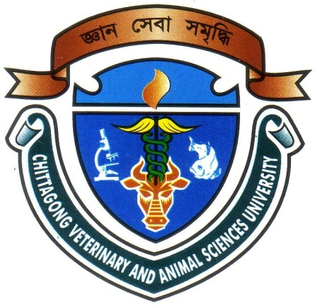

A Clinical Report Submitted
By
Intern ID: 20
Roll No: 13/20
Registration No: 00937

The report submitted in the partial fulfillment of the requirements for the Degree of Doctor of Veterinary Medicine

Chittagong Veterinary and Animal Sciences University
Khulshi, Chittagong-4225, Bangladesh
August, 2018

Dystocia Management by Cesarean Section with Two Types of Anesthesia Techniques in Goat

A Clinical Report Submitted
By
Intern ID: 20
Roll No: 13/20
Registration No: 00937

Approved as to style and content by

…………………………......
Signature of Author
Nasreen Sultana
Roll No: 13/20
Reg. No: 00937
Intern ID: 20

……………………………….............
Signature of Supervisor
DR.Tuli Dey
Lecturer
Department of Medicine and Surgery,
CVASU

Chittagong Veterinary and Animal Sciences University
Khulshi, Chittagong-4225, Bangladesh

ACKNOWLEDGEMENTS
All praises are due to the Almighty Allah, the creator and supreme authority of the universe, who empowers me to strength and opportunity to complete the report successfully.
Completion of any work or responsibility gives nice feelings. But the accomplishment of this work, as the partial fulfillment of the requirements for the degree of Doctor of Veterinary Medicine (DVM) in (CVASU) , not only has given me the pleasure, but also have given me the confidence to move ahead and showed me a new opening to knowledge. Standing at this opening, it is an honor to revoke the names of the person and the Organization I am grateful to.
I would like to extend my gratitude to my supervisor, DR.Tuli Dey, Lecturer, Dept. of Medicine and Surgery, Chittagong Veterinary and Animal Sciences University. My heartfelt thanks to her for her valuable guidance, suggestion, supervision and encouragements during the entire period of this study to complete this clinical report.
I would like to express my deep sense of gratitude and thanks to Professor Dr. Gautam Buddha Das, honorable vice chancellor and Professor Prof. Md.Abdul Halim, Dean, Faculty of Veterinary Medicine, CVASU for arranging this type of research work as a compulsory part of this internship program.
Special thanks to Director of Clinics and Surgery team, SAQTVH, Chittagong Veterinary and Animal Sciences University for their support during work. I express my sincere gratitude and thanks to Professor Dr. A. K. M. Saifuddin, Director of External Affairs, and for his supervision and kind co-operation during the period of internship.
Last but not least, I am profoundly grateful to my family members,friends and all well wishers for their endless sympathies, kind co-operation, sacrifices and prayers.

Author

September, 2018

