A clinical report submitted by
Apu Raihan
Intern ID: E-21.
Roll No: 2013/21.
Reg. No: 0938.
Session: 2012-2013

Report presented in partial fulfillment for the Degree of
Doctor of Veterinary Medicine (DVM)
Faculty of Veterinary Medicine
Chittagong Veterinary and Animal Sciences University,
Khulshi, Chittagong-4225.

A clinical report submitted as per approved style and content

Signature of the Author  Apu Raihan  Intern ID: E-21  Roll No: 2013/21.  Reg. No: 0938.  Session: 2012-2013. | Signature of the Supervisor  DR.Tanjila Hasan  Lecturer  Department of Medicine and Surgery  Faculty of Veterinary Medicine

Faculty of Veterinary Medicine
Chittagong Veterinary and Animal Sciences University
Khulshi, Chittagong-4225

INDEX
CHAPTER | CONTENTS | PAGE NO
1. | Abstract……………………………………………………… | 4
2. | Introduction…………………………………………………... | 5
3. | Materials and methods………………………………………. | 6-7
4. | Results and discussion……………………………………… | 8-10
5.  6.  7. | References…………………………………………………….  Acknowledgements…………………………………………..  Biography…………………………………………………… | 11-12  13  14

Abstract

Leptospirosis is an infection of bacterial spirochetes, which dogs acquire when subspecies of the Leptospira interrogans penetrate the skin and spread through the body by way of the bloodstream. It has zoonotic significance too. A 6-year-old male Saint Bernerd dog was brought to the SAQTVH with a history of anorexia, passing melena, lethargy, vomiting, unable to walk and chronic weight loss. On clinical examination it revealed sign of dehydration with sunken eyeball, icteric conjunctival mucus membrane of the eye, gum, penis and the skin of the ventral abdomen. Based on the clinical signs, the dog was suspected for leptospirosis. Then blood sample was collected for estimation of haematological and biochemical parameters like Hb, PCV, WBC and BUN etc. Urine samples were subjected to various tests to determine different parameters such as leukocytes, nitrite etc. Dark field microscopy (DFM) was performed on urine to detect the presence of Leptospira organism. Neutrophilia, leukocytosis, increased level of PCV, TLC, TP, ALP, BUN, creatinine, and decreased the value of Hb as well as increased level of ALT, AST, specific gravity, proteinuria, bilirubinuria further observation spirochete under DFM confirmed that dog was affected with leptospirosis. As post operative care antibiotic, antiemetic, diuretic and fluid therapy was given. The dog was followed for next 2 month. The dog had an uneventful recovery without further complication.

Keywords: Dog, Leptospira spp., diagnosis, management

Chapter I: Introduction
Leptospirosis is a common and widespread zoonotic disease, with reservoirs in domestic and wild animals (Waitkins, 1985; Bharti et al., 2003; Nelson and Couto, 2003; Heymann, 2008; Costa et al., 2015). Leptospires are thin, flexible, motile, filamentous spirochete bacteria. Leptospiral infections cause both acute and chronic disease and the severity of infections are related to the virulence of the organism, susceptibility of the host, and the affected host species (Radostits, et. al., 2000). All cases of canine leptospirosis are caused by infection with the parasitic species Leptospira interrogans, of which eight serovars are most important to dogs. The genus has been classified into new species on the basis of genetic relatedness. L. interrogans is distributed worldwide in approximately 160 mammalian hosts.2 More than 200 serovars that belong to 23 serogroups of L. interrogans have been identified. 2 Specific serovars are maintained in nature by several subclinically infected wild and domestic reservoir hosts that serve as sources of exposure and illness for dogs, humans, and other incidental hosts. When incidental hostsare infected, they can develop severe clinical illness and shed organisms for shorter periods than the reservoir host.1 The most commonly incriminated serovars in canine leptospirosis have been canicola, icterohaemorrhagiae, pomona, bratislava, and grippotyphosa. 1,3 Widespread use of bivalent vaccines produced in the 1980s that are serovar-specific for only canicola and icterohaemorrhagiae has resulted in a decreased prevalence of disease associated with those serovars. However, increased awareness of infections with serovars pomona, bratislava, and grippotyphosa has become apparent in the past 15 to 20 years.4–10 The predominance of disease associated with these latter serovars is likely associated with increasing exposure of unnatural hosts (e.g., dogs) to wild reservoir hosts in rural or subur-ban areas, along with improved recognition of these serovars with broader serologic testing.
Chapter II: Materials and methods
2.1. History and Clinical Examination
A 4-year-old male Dobberman dog was brought to the SAQTVH with a history of anorexia, weakness, melena, lethargy, vomiting and chronic emaciation. On clinical examination the animal revealed dehydration with sunken eyeball, ictric conjunctival mucus membrane of the eye (Fig. 1), skin of the ventral abdomen (Fig. 2), ear pinnae (Fig. 3). The dog had 102º F body temperature. The dog was on lateral recumbency and unable to bear the weight on hind limbs. Based on the clinical sign, the animal was suspected for leptospirosis. Blood sample was collected into two vacuum container with anti coagulant and without anticoagulent for the estimation of hemoglobin (HB), Erythrocyte Sedimentation Rate (ESR), total count of Red Blood Cell (RBC), total count of White Blood Cell (WBC), Packed cell Volume (PCV), SGPT, SGOT respectively. Again, urine sample was collected. The urine sample was also collected in a sterilized glass vial by catheterization for detection of leptospira organism under dark field microscopy for confirmatory diagnosis.
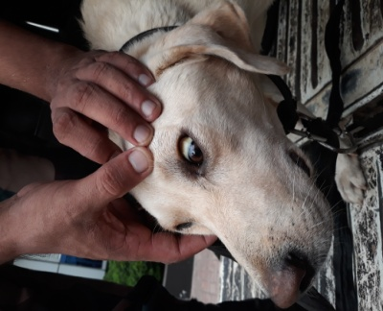 | 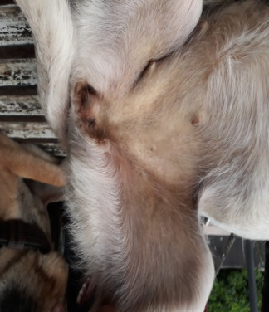 | 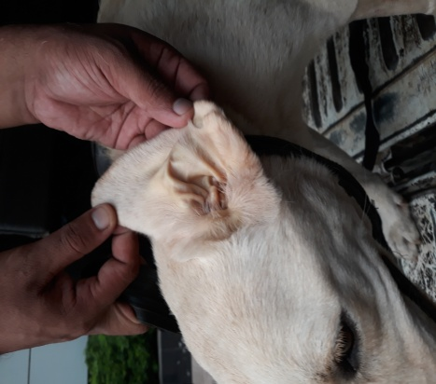
Figure 1: Icteric mucous membrane of eye | Figure 2: Icteric abdominal skin | Figure 3: Icteric skin of ear pinnae

2.2. Laboratory diagnosis
Hematological examination revealed hemoglobin estimation (Hb%), packed cell volume (PCV), total erythrocyte count (TEC), total leukocyte count (TLC), total protein (TP), albumin, total bilirubin, aspartate, aminotransferase (AST), alanine aminotransferase (ALT), alkaline phosphatase (ALP), creatinine, blood urea nitrogen (BUN), Urine sample showed leukocytes, nitrite, urobilinogen, protein, pH, blood, specific gravity, ketone bodies, bilirubin, and glucose. In addition, dark field microscopy (DFM) there found thin spirochete.

2.3. Treatment and management
The animal was treated with streptopenicillin @ 40,000 IU/kg body wt. Other supportive therapy such as Tab. Losectile (SkF, Bangladesh) 3mg/kg Body wt orally to subside acidity, Tab. Bumecard (Incepta, Bangladesh), 2mg/ka Body wt orally to check infection in kidney, Inj. Lasix 5mg/kg body wt IM as diuretic and Inj. amizid (Sanofi Aventis, BD, Ltd) 2ml/IM to check SGOT, SGPT etc. Fluid therapy was also administered for a long period. The dog was followed for next 2 month. The dog had an uneventful recovery without further complication.

Chapter III: Results and Discussion

The physical examination of the dog showed severely icteric, moderately dehydrated. The present findings supported the observations of earlier workers in induced leptospirosis in Wistar rats (Khan et al., 2009).
The biochemical analysis revealed BUN-80.3 mg/dl, creatinine-292 mg/dl and, SGPT and SGOT showed 110U/L and -145U/L, respectively. According to Greene,et. al., (1998), the kidney and liver are the major organs affected by leptospiremia. The increased levels of liver and kidney specific enzymes might be due to damage caused by leptospiral organism on liver and kidney.
Leptospiral endotoxins may cause hepatocellular injury and the persistence of the organism in the liver results in altered circulation, fibrosis, and immunologically mediated injury that may perpetuate to chronic active hepatitis, particularly with L. grippotyphosa infections. Similar results were found by Greene et al. (1998). The haematological analysis revealed decreased hemoglobin level of 7.6g/dl and increased PCV of 60% and WBC of 2.7 (/μl) with 102% neutrophils and lymphocyte 150%. The decreased hemoglobin and increased packed cell volume and total leucocyte counts can be attributed to toxins released by leptospiral organisms, which cause damage to RBCs. increased levels of total bilirubin, ALT, and AST in bovine (Miller et al., 1977) increased ALP, ALT, urea, and creatinine in dogs (Keim et al., 1995); increased ALP, ALT, total bilirubin, direct bilirubin, and creatinine in equine (Govindarajan et al., 2011); increased ALP, ALT, urea, and creatinine in Wistar rats (Goldstein et al., 2006); increased BUN, creatinine, cholesterol, ALT, AST, and bilirubin in goats (Govindarajan et al., 2011) have been reported in different studies in past. Contrary to this, Millar et al. (1977) could not find any alteration function in sheep. It is reported that AST activity is non-specific, but ALT activity is a good indicator of
Table 1: Biochemical analysis of blood and urine of Leptospira spp. affected dog

Name of test | Result | Reference value
Blood and serum test
Hb% | 7.6 | 11.9-18.9
PCV (%) | 60 | 35-57
RBCs 10⁶/μl | 2.95 | 4.95-7.87
WBC (/μl) | 2.7 | 5-14.1
Neutrophils (%) | 102 | 58-85
Lymphocytes (%) | 50 | 8-21
Monocytes (%) | 15 | 2-10
Eosinophils (%) | 11 | 0-9
Basophils (%) | 0 | 0-1
Albumin (g/l) | 60 | 20-40
Total protein (g/l) | 105 | 60-80
PLT (10³/ μl) | 231 | 211-621
BUN (mg/dl) | 80.3 | 25-30
Cre (μmol/l) | 292 | 60 μmol+BW
ALP (IU/l) | 170 | 10-150
ALT (IU/l) | 145 | 5-107
AST(IU/l) | 203 | <44
SGOT u/l | 110 | 5-55
Urine test
Speific gravity | 2.83 | 1.01-1.03
Proteinuia | 14 | 0.5-1.0
Bilirubin | 7 | 0.0-0.9
Glucose | 70 | 80-120
liver damage among ruminants, and similarly, higher total bilirubin level occurs in liver damage (Tonin et al., 2012).Thus, the report of biochemical parameters studied presently in a limited way

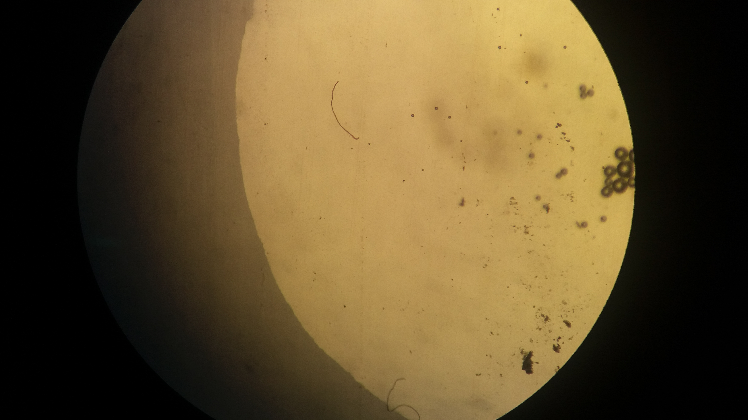

Figure 4: Spirochete (Leptospira spp.) under DFM
of biochemical parameters studied presently in a limited way was suggestive of hepatic damage and resupported the general consensus that the hepatic damage does occur in leptospirosis. This result supported the report of Yang et al. (2001), who noted that renal and hepatic damage used to occur in leptospirosis. However, in this study, various biochemical parameters did not support kidney damage possibly because kidneys continue to function apparently in a normal way for a long time due to the excess reserve of kidney tissue provided by nature till it reaches to the “point of no return.” Hypoproteinemia could be due to number of non-specific factors such as parasitism, low/poor protein level in feed, anemia, and hepatic ailment. The specific reason could not be ascertained in the absence of complete anamnesis of the individual animal as it would be only hypothetical to link it with leptospirosis. According to Birnbaum, 1998, Microscopic agglutination test (MAT) is considered as the “gold standard” diagnostic test for leptospirosis. The serovar with the highest titer is assumed to be the strain causing clinical disease. In the present study the highest titre (1:3200) was observed for serovar grippotyphosa and microscopic agglutination test was found to be the confirmatory technique for the diagnosis of leptospirosis. In the present study the motile organisms were detected in the urine sample by dark-field microscopy. This was found to be quick test for the detection of leptospirosis infection in dogs at field level and easy to perform. This is in accordance with Brown et al. (1996) and O’Keefe, 2002, they reported dark-field microscopy is a good screening tool for urine. Successful therapy is dependent on good supportive care and appropriate antibiotics. In the present case, Animal shows great improvement after the treatment. This is in agreement with Greene,et.al, 1998, who reported Procaine penicillin-G can be given at a dose of 40,000 IU/kg IM or S/C b.i.d. and found Penicillin and its derivatives are the drug of choice for leptospiremia.

Chapter IV: References
Khan S, Hassan M, Yasin G (2009). Acute Leptospirosis in Dog- A case report. The International Journal of Veterinary Medicine, 7(2).

Birnbaum N (1998). Journal of Small Animal Practice, 39: 231-236.

Brown CA et al. (1996).Journal of American Medical Association, 209 (7): 1265-1266.

Goldstein RE, Lin RC, Langston CE, Scrivani PV, Erb HN and Barr SC (2006). Influence of infecting serogroup on clinical features of leptospirosis in dogs. Journal of International. Medicine, 20: 489-494.

Govindarajan R, Ramaswamy V, and Manohar BM (2011). Biochemical profiles in bovine Leptospirosis. Tamilnadu Journal of Veterinary Animal Science, 7(5): 243-246.
Greene CE, Millar MA, Brown CA (1998). Leptospirosis. In: Infectious diseases of the dog and cat. (2nd Edn). WB Saunders, Philadelphia, 273-281.

Kiem NT, Charan K, Srivastava SK, Parihar NS and Bist GS (1995). Haematological, biochemical and serological studies on experimental leptospirosis in goats. Indian Veterinary Journal, 72: 229-232.

Millar KR, Hodges RT, Sheppard AD and Hammington MW (1977). Clinical and biochemical changes in sheep inoculated with Leptospira interrogans serotype Pomona. New Zealand Veterinary Journal, 25(8): 203-207.
O’Keefe JS (2002). New Zealand Veterinary Journal, 50: 9-13. Diagnosis and treatment of Leptospirosis in a dog - A Case report
Tonin AA, da Salva AS, de MIA, Franca RT, Paim FT, Schaefer PC, Martins JLR, Badke MRT and Sonia ALT (2012). Hematologic and biochemical alterations in Wistar rats experimentally infected by Leptospira interrogans. Comparative. Clinical. Pathology,17: 887-890.
Yang CW, Wu MS and Pan MJ (2001) Leptospirosis renal disease. Nephrological dialysis transplant, 16: 73-77.
Cutler DR, Edwards TC, Beard KH, Cutler A, Hess KT, Gibson J, Lawler JJ (2007). Random forests for classification in ecology, 88:243–251.
Acknowledgements

All praises are due to “Almighty Allah” who enabled the author to complete this report successfully.

The author express his deep sense of gratitude, heartfelt respect and immense indebt to his supervisor DR. Tanjila Hasan, Lecture, Department of Medicine and Surgery, Chittagong Veterinary and Animal sciences University for his valuable advice, scholastic guidance, suggestions, inspiration and who was involved with this report through its inception.

I also express thank to my friends for their help and co-operation during the tenure of writing of this report. The author is immensely grateful to all of them, although it is not possible to mention everyone by name.

Biography

Name | Apu Raihan
Present position and affiliation | Intern student, 18th Batch, FVM, Chittagong
 | Veterinary and Animal Science University.
Educational background and year | Doctor of Veterinary Medicine in 2017
 | (appeared), Chittagong Veterinary and Animal
 | Science University.
Research interest | Poultry and Large Animal Sector
Aim | Establish a veterinary health complex in field level

