TRENDS OF BODY WEIGHT GAIN IN FAYOUMI AND SONALI CHICKEN UNDER INTENSIV FARMING CONDITION
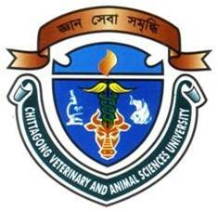

By:

By:
NARGIS SULTANA
Roll No: 11/ 28; Reg. No: 674
Intern ID: C – 27
Session: 2010 – 2011

A production report submitted in partial satisfaction of the requirements for the degree of
Doctor of Veterinary Medicine

Faculty of Veterinary Medicine
Chittagong Veterinary and Animal Sciences University
Khulshi, Chittagong, Bangladesh

December 2016
TRENDS OF BODY WEIGHT GAIN IN FAYOUMI AND SONALI CHICKEN UNDER INTENSIV FARMING CONDITION

A RePoultry

Signature of Author:  Nargis Sultana  Roll no: 11/28  Reg. no: 674  Internship ID: C-27  Session: 2010-2011  Date : | -------------------------------  Signature of supervisor:  Dr. Ashutosh Das  Assistant professor  Department of Genetics and  Animal Breeding  Faculty of Veterinary Medicine  Chittagong Veterinary and  Animal Sciences University  Date :

Faculty of Veterinary Medicine
Chittagong Veterinary and Animal Sciences University
Khulshi, Chittagong, Bangladesh

December 2016

