Study on Areca sheath as an alternate dry fodder for cattle

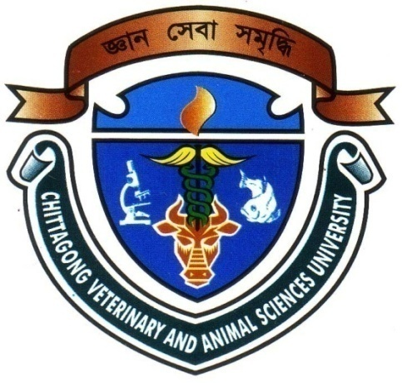

A production report submitted by

Roll no: 11/23

Reg. no: 00667

Internship ID: C-22

Session: 2010-2011

A production report presented in partial fulfillment of the requirement for the degree of
Doctor Of Veterinary Medicine
Faculty of Veterinary Medicine
Chittagong Veterinary and Animal Sciences University,
Khulshi, Chittagong, Bangladesh

November 2016
Study on Areca sheath as an alternate dry fodder for cattle

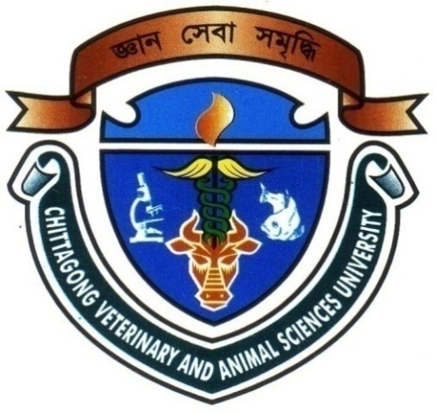

A production report submitted as per approved style and content

Signature of Author:  Robiul Hossen Rubel  Roll no: 11/23  Reg. no: 00667  Internship ID: C-22  Session: 2010-2011  Date : | Signature of supervisor:  Dr. Md. Hasanuzzaman  Professor  Department of Animal Science and  Nutrition  Faculty of Veterinary Medicine Chittagong Veterinary and Animal Sciences University  Date :

Table of contents

Content Page

List of tables iv
List of figures iv
List of abbreviations iv
Abstract v
Chapter 1: Introduction 1-3
Chapter 2: Methods and Materials 4-7
Photo Gallery 8-9
Chapter 3: Results 10-11
Chapter 4: Discussion 12-13
Conclusion 14
Limitations 15
References 16-17
Acknowledgements 18
Biography 19

List of Tables
Sl. no. | Name of the Tables | Page  no.
Table- 01 | The nutrient composition of areca sheath found elsewhere of the world | 6
Table- 02 | Nutrient composition of Areca sheath found in laboratory | 10
Table- 03 | Composition of the nutrition value between areca sheath and rice straw | 11
List of Figures (Photo Gallery)
Photo no. | Page no.
01.Areca trees (Areca catechu) | 8
02.Shedded areca sheath (whole) | 8
03.Fallen sheath collection | 8
04.Prepared sample | 8
05.Estimation of DM | 9
06.Estimation of CF | 9
07.Estimation of CP | 9
08.Estimation of Ash | 9
09.Estimation of Sand silica | 9
10.Provided areca sheath to cattle | 9
List of Abbreviations
Abbreviations | Elaborations
BBS | Bangladesh Bureau of Statistics
GDP | Gross Domestic Production
DAE | Department of Agriculture Extension
NIANP | The National Institute of Animal Nutrition and Physiology
CVASU | Chittagong Veterinary And Animal Sciences University
ABSTRACT
Areca nut cultivation as a commercial crop, the nut, called supari in Bangla, is quite extensive in Cox’s bazaar, Chittagong, Noakhali, Comilla, Bhola, many regions of Bangladesh and there is a possibility of using the fallen areca leaf sheath as an alternate resource. Areca leaf sheath has been evaluated for use as a fodder. The present study was conducted to evaluate the proximate composition of areca leaf sheath after its dried and shredded form. The laboratory analysis of areca sheath samples for its nutritional composition showed almost similar composition to rice straw. The DM, CP, CF, EE, NFE, total ash and sand silica content of areca sheath was 88.2, 1.9, 59.5, 0.1, 22.8, 3.9 and 2.2 percent, respectively. The total digestible nutrient was 49.3% of areca leaf sheath in DM basis. After finishing the laboratory task in CVASU, then compared to rice straw, found similar nutritional composition and minerals were better in dried areca leaf sheath. From this study it can be recommended that this unconventional dry leaf sheath may be used as safely cattle feed as alternative to rice straw in the diet of livestock.

Keyword: Areca leaf sheath, proximate component, paddy straw

