CHAPTER-I
GENERAL INTRODUCTION
Goats are important species of livestock in India as well as in the whole world. They contribute greatly to the agrarian economy, especially in areas where crop and dairy farming are not economical, and play an important role in the livelihood of a large proportion of small and marginal farmers and landless labourers. Tellicherry goats are one among the recognized breeds of goats in India and is widely distributed in Malabar region of Kerala and also reared in different places of Tamil Nadu.. This breed is considered as a unique genotype exhibiting higher multiple birth percentages and higher milk yields. Studies on performance of Tellicherry goats in their native environment have been reported [1] and in Tamil Nadu [2, 3]. Goat rearing has been promoted by various governmental and non-governmental organizations all over the world to mitigate rural poverty, especially in unfavorable arid/semi-arid tropical environments [4]. Goats are a drought-tolerant animal, eating mainly wild grasses, tree buds and leaves. They require less care, and reproduce quickly as they start to bear kids from the age of one year old. They also provide small farmers and landless laborers with precious employment opportunities in agricultural lean seasons and play an important role as “livestock” since they can be sold when most needed, for instance, during a severe drought [5]. Birth weight, weaning weight, growth rate and ADG are economically important traits. These traits are controlled by polygenes and are also affected by feeding practices, climatic factors and management under farm conditions.
Pure breeds of Tellicherry goats are found in the districts of Thalacherry, Kasargod, Kannur and Kozikkot in Kerala. Tellicherry goats are also known or called as Malabari, Talacherry, Telacherri, Thalacherri, Thalassery, Tellicherri, Talacheri, Thalachery and Thalacheri.
They are medium sized animals of dual utility and constitute 10-12 % of the total goat population of India. They do not have any uniform body colour. However, most of them found are in white colour. There are also found these goats with black or with mixed colours of black, white and brown. They have medium sized head with straight face and some goats have slightly raised face as well. These goats are raised for meat and milk mainly. A female (doe) goat of tellicherri gives birth to four kids in a year and triplets are very common in this breed. On an average a Tellicherry doe gives 2 litres milk per day and have a lactation period of 6 months. This breed is also a good broiler goat breed, gain 20-25 KG weight within 3-4 months, because it has high feed conversion capacity.
They gain maturity (for breeding) in five to six months of age. Birth weight of Tellicherry goat kid is 2.3-2.4 kg and the weight of adult male and female reach up to 38 KG and 31 KG respectively.
The following findings clearly indicate that tellicherry goat farming is a promising sector in meat production.

Therefore the objectives of the present study were,
- To know the growth and production performance of Tellicherry goat in a farm.
- To be introduced with the housing, breeding and feeding system of Tellicherry goat.
- To observe the total management system of goat rearing in Namakkal.

CHAPTER-II
MATERIALS AND METHODS

2.1 LOCATION OF STUDY:
The study was conducted at goat farm of Veterinary College and Research Institute(Namakkal) of Tamil Nadu Veterinary and Animal Sciences University, India. The farm includes two different sheds of Tellicherry goat. During the observation the total number of male, female and kids were respectively.
2.2 Total Number of Goats: Total 75 goats in two sheds.
Male: 4
Female: 60
Kids: 11
2.3 HOUSING AND MANAGEMENT:
Housing for the Tellicherry goat breed of Namakkal was semi intensive and stall fed system; in which buck, doe and kids were reared together.
2.3.1 HOUSING TYPE:
a)Gable Roof house
Fencing: 8 ft high
Roof: Tin shed
Flooring: Reared on hardened soil
Floor Space: 40 ft in length and 20 ft in width
Drainage: 3 drains for cleaning of the house
Manger and Water Trough: 3 mangers of 10.5 sq, ft and 2 water troughs of 8 sq. ft
b)Elevated house
Height from ground: 4 ft
Fencing: 5 ft
Space: 120 sq. ft for every 10 goats
Floor: Wooden flooring is used
Drainage: There are small gaps in the floor
Feed and Water Trough: 10 feed and water trough for goats of ten partition
2.4 FEEDING SYSTEM:
Stall fed system and grazing system both are practiced; stall fed 2 times in a day(morning and afternoon) and grazing in the middle of this two time. Feeds are mostly roughage(chopped grass and straw) but concentrates also provided.
Goats usually eat 4-5% food daily of their total body weight[6].
For feeding Tellicherry goat two own ration formula is used,

Table 1. Feed ingredients and percentage of goat ration
Ingredients | Parts
Deoiled ground nut cake | 12
Horse gram | 30
Wheat/maize/jowar (grain) | 30
Rice polish/wheat bran | 15
Dried unsalted fish | 10
Mineral mixture | 1.5
Common salt | 1.5
VitAB2D3 | 25 gms/100 kg of feed mixture

Table 2. Ration for buck
Ingredients | % of ration
Corn | 50
Alfa lfa meal | 15
Oats | 17
Soybean meal | 12
Molasses | 3
Trace mineral salt | 1
Vitamins ADE | 1
DCP and Limestone | 1
Protein | 14-15%

Table 3. Grain mixes for nursing or lactating does(NRC, 1981)
Ingredients(%) | Protein  14 | Content  16 | %  18
Corn Grain | 37 | 35 | 32
Oats grain | 34 | 32 | 29
Wheat bran | 16 | 14 | 15
Oil meal (soybean, linseed) | 9 | 15 | 20
Molasses | 2.5 | 2.5 | 2.5
Dicalcium phosphate | 0.5 | 0.5 | 0.5
Trace mineral salt | 0.5 | 0.5 | 0.5
Vitamins ADE | 0.5 | 0.5 | 0.5

These goats were also fed with coconut oil cakes and jack leaves.
2.5 Reproduction of Tellicherry Goat:
Tellicherry goats are very high profile breeders and usually kid twice in a year with a high rate of prolificacy. Twinning and Triplets (2 and sometimes 3 kids in one delivery) are common in Tellicherry goat reproduction cycle in the farm.
Mass mating is usually practiced and one male (Buck) per 25 to 30 does. Regarding this male bucks were kept in small shady camps during hot periods with a small amount of growing supplement. Bucks were usually left during evening for mating with does.

2.6 Vaccination:
Vaccination is followed to prevent some common infectious diseases of goat; such as PPR, FMD, Antrax etc.

2.6.1 Vaccination Schedule for Tellicherry Goat in the farm:
Diseases | Age and booster doses | Route
Foot and mouth disease | 6-8 weeks,repeat every 6-9 months | s/c or i/ m depending on the vaccine
Enterotoxaemia | 3-4 months, repeat after 15 days and then annually | 2.5 ml s/ c
Hemorrhagic septicemia | 3-4 months,, repeat annually | 1ml s/c
Anthrax | 4-6 months, repeat annually | 0.5 ml s/ c at tail fold
Tetanus | 3-4 months, repeat at six months and then annually | 0.5 – 1 ml s/c or i/m

DataCollection:
Data collection was done during my training programme in VCRI, Namakkal, India by own observation & interviewing the coordinator of respective farm from 15th April 2016 to 29th April 2016.

CHAPTER-III
DISCUSSION
The farm is a potential commercial and research farm for goat rearing. Tellicherry bucks are sold at one year of age when expected weight is gained i.e. about 30kg.although the birth weight of Tellicherry goat is satisfactory(on an average 2.62 for male and 2.34 for female). The birth weight in small ruminants is attributed to the type of breed and non genetic parameters such as season, birth and parity. The birth weights of kids are also affected by the nutrition of the dam received during pregnancy [7]. Higher body weight at birth for the male kids were also reported by Elabid [8], Karna et al. [9] and Afzal et al. [10] for chegu and beetal goats. The effect of year is also significant and the average improvement in body weight and growth rate of the kids was observed in third and fourth year of the dams at the farm [11].
It is observed that Variation in supply and composition of feeds and fodder affects weight of kids at different life stages. Several reports indicated that season and year of birth [12] and type of birth [13], influenced body weight and growth rate in goats.
However, little has been known on the productivity and the factors that affect productivity of tropical goat breeds. Such information is important if they are to be incorporated into goat production systems.

CHAPTER-IV
CONCLUSIONS
Growth performance of Tellicherry goats in hot and humid climatic condition of Tamilnadu is satisfactory. However, further studies need to be carried out pertaining to their lifetime performance and disease tolerance in the climate and especially so at selected field location before large scale introduction of the breed in the region.The rearing and management system of the farm was so far so good. However, the goat farming is profitable and it may be an income generating source by alleviating unemployment burden. By goat farming our country can enrich our animal meat supply and thus will meet the daily protein requirement of the nation.

RECOMMENDATIONS:
- Further study should be conducted with adequate time.
- Proper management study is recommended.
- Farmer should be trained up for scientific way of goat rearing.

CHAPTER-V
REFERENCES

[1] Acharya, R.M., 1982. Sheep and Goat Breeds of India. FAO Animal Production and Health Paper 30, Food and Agriculture Organization of the United Nations, Rome, pp viii +190.
[2] Sivakumar, T and M. Thiagarajan, 1999. Growth rate and growth production in Madras Red lambs and Tellicherry kids. Cheiron, 28: 140-147.
[3] Thiruvenkadan, A.K., M.R. Purushothaman, K. Karunanithi and G. Singh, 2007. Husbandry practices for Mecheri sheep in its breeding tract of Tamil Nadu. Indian J. Anim. Sci., 77: 489-493.
[4] Vries, J.D., 2008. Goats for the Poor: Some Keys to the Successful Promotion of Goat Production among the Poor. Small Rum. Res., 77: 221–224.
[5] Shankarnarayan, K.A., H.C. Bohra, and P.K. Ghosh, 1985. The Goat: An Appropriate Animal for Arid and Semi- Arid Regions. Economic and Political Weekly 20(45–47), Special Edition: 1965–1972.
[6]Anon. 1984. Guide to the Care and Use of Experimental Animals. Canadian Council on Animal Care. Ottawa. Vols. 1 and 2
[7] Otuma, M.O and I.I Osake, 2008. Estimation of genetic parameters of growth traits in Nigeris Sahelian goats. Res. J. Anim. Sci., 2(3): 83-86
[8] Elabid, K.L., 2008. Various factors affecting birth weight of Sudanese Nubian
goat kids. Research J. Agri. Biological Sci., 4(6): 700-03.
[9] Karna, D.K., G.L. Koul and G.S. Bisht, 2001. Birth
weight, morphometry and relative gain in body weight of Chegu kids. Indian J. Anim. Sci., 71(2): 180-82.
[10] Afzal, M., K. Javed and M. Shafiq, 2004. Environmental Effects on birth weight in Beetal goat kids. Pakistan Vet. J., 24(2): 104-06.
[11] Sandip, B and D. Jana, 2010. Factors Affecting Birth Weight of Sirohi Goat Kids Reared in Hot and Humid Climate of West Bengal. World Appl. Sci. J., 9 (12): 1379-1382.
[12] Baiden, R.Y., 2007. Birth weight, birth type and pre-weaning survivability of West African Dwarf goats rose in the Dangme West District of the Greater Accra Region of Ghana. Trop. Anim.Heal.Prod.,39:141– 147.
[13] Zahraddeen, D., I.S.R. Butswat and S.T. Mbap, 2007. Factors affecting birth weight, litter size and survival rates of goats in Bauch, Nigeria. Anim. Prod. Res. Adv., 3: 46–51.

CHAPTER-VI
APPENDIX-I
QUESTIONNAIRE
Farm information’s....... Date…
Basic information:
1. Name and address of the farm:
2. Name of the owner/coordinator:
3. Type of farm (Meat type/Dairy).
4. Housing system (Shed/Gable).
5. Floor type (concrete/ slat/ mud/ others).
6. Vaccination schedule: (Good/ moderately practiced/ not performed).
7. Biosecurity: a) Access: (not restricted/ restricted).
b) Wild birds/ animal access: (yes/ no).
c) Sanitation: (good/ moderate/ poor).
8. No. of goats….
9. Rearing unit (1/2/3...).
10. Feed intake…..; feeding system…… ….
11. Body weight gain……….
12. Fertility……..%
13. Mortality ….%

APPENDIX-||
FIGURES

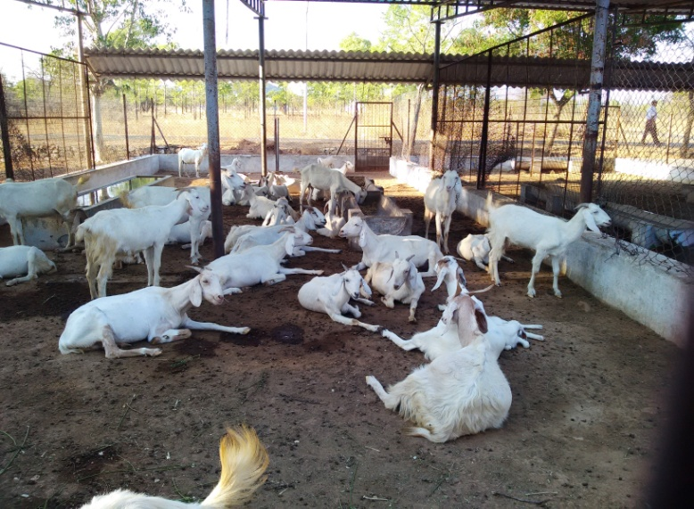
Tellicherry Goat Farm, VCRI, Namakkal

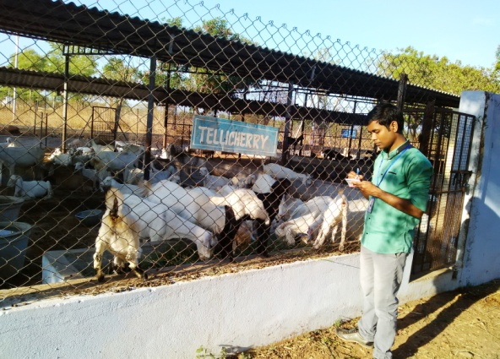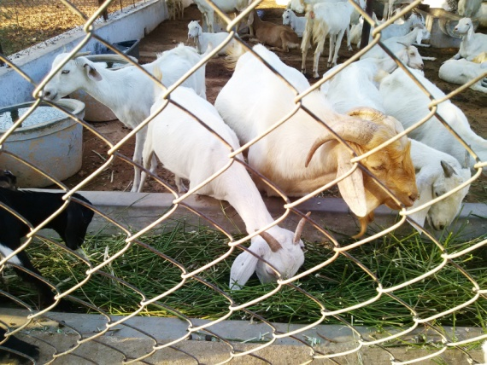
Collection of Information Feed Intake of Goats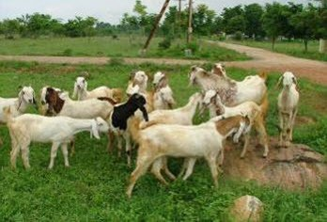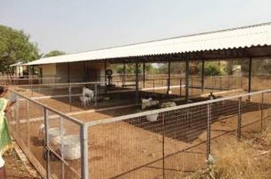
Grazing in field Shed- 2

