Rearing and Management of Tellicherry Goat in VCRI Goat Farm,
Namakkal,India
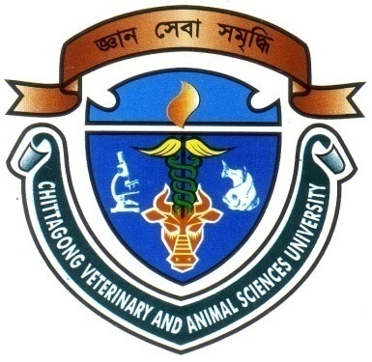

A production report presented in partial fulfillment of the requirements for the degree of
Doctor of Veterinary Medicine (DVM)
By

HAMIDUR RAHMAN MAJUMDER
Roll No. : 10/101
Reg. No. : 00504
Intern ID: E-49
Session : 2009-2010
CHITTAGONG VETERINARY AND ANIMAL SCIENCES UNIVERSITY
KHULSHI, CHITTAGONG-4202

Rearing and Management of Tellicherry Goat in VCRI Goat Farm,
Namakkal,India

Approved as to Style and Contents By

Dr. Babu Kanti Nath
Assistant professor
Dept. of Dairy and Poultry Science
Chittagong Veterinary and Animal Sciences University

October, 2016

