CHAPTER-I
Introduction
Bangladesh is the highest densely populated country (1015 people per k$m^{2}$) of the world with a population of 149.772 million people within the area of 147570 K$m^{2}$(BBS, 2011). About 80% people of this country still live in villages and are extremely poor. In 2000, 52.5% of the urban and 44.3% of the rural people was surviving under the poverty line (Sumy et al., 2010). However, the people of our country is blessed with a variety of agricultural resources of which goat rearing is considered to have potential both for poverty alleviation and food production (Sumy et al., 2010).

Livestock is an integral section of agricultural economy of Bangladesh performing multidimensional functions such as provision of meat, milk, eggs, nutrition, income, savings, draft power, manure, transport, social and cultural functions (Tareque and Chowdhury, 2010). Small ruminants especially goat is very important in rural economy and nutrition and has the potentially using it as a strong tool for poverty reduction in Bangladesh (Ershaduzzaman et al., 2007). Goats are usually considered as the poor man’s cow (Kashem et al., 2011), reared in backyard system by rural farmers, especially the poor women or children as a vital part of the farming system (Chowdhury et al., 2003).

Goats were among the first farm animals to be domesticated. As proved by the archaeological evidence, they have been associated with man in a symbiotic relationship for up to 10,000 years (Ensminger and Parker, 1986). Goats distributed all over the world because of their great adaptability to varying environmental conditions and the different nutritional regimes under which they were evolved and subsequently maintained. They proved useful to man throughout the ages due to their productivity, small size, and no competiveness with him for food. In Bangladesh, goats make a very valuable contribution, especially to the poor in the rural areas. Goat undeniably plays a vital role in the rural economy of many developing countries in Asia.
Goat production is mostly run out by smallholders where the animals are kept in small flocks at an average of 5-10 head/family. It requires low initial capital and guarantees a high return on investment in as fast as two years; hence, it is an attractive undertaking among rural households.

Goats are very hardy and well-adapted to harsh climates. Due to their peculiar grazing habits, they are able to browse on plants that would normally not be eaten by other livestock species. Thus, the presence of goats in mixed species grazing systems can lead to a more efficient use of the natural resources and add flexibility to the management of livestock.
Goats provide their owners with a broad range of products and socio-economic services and have played a vital role in the social life of many people being used as gifts, dowry, in religious rituals and rites of passage (Peacock, 1996).

Goats can play an important role in ensuring the food security of a household, often being the only asset possessed by a poor family. In time of trouble, such as crop failure or family illness, goats can be sold and food or medicine purchased. This is critical to safeguarding the security of family members. Goats, especially dairy ones are ideal species for poverty reduction and economic development in developing countries like Bangladesh. Many people cannot drink cow milk as they are allergic to it. Several studies indicated that people with cow’s milk allergy could tolerate goat’s milk (Restani, 2004).

Human populations are growing, and creating a significant and increasing demand for additional animal protein foods. Protein intake is recommended to be in range of 0.8 to 1.6 gm per kg body weight for normal human health (Anonymous, 1998). The goat can play a vital role in meeting these demands. This calls for farmers to put value in their goat enterprises by shifting from subsistence production to commercial production. Goat meat contains high quality protein and micro-nutrients which has had a tremendous impact on health and nutrition for the poor people in rural areas (Neumann et al., 2002; Barroetoa, 2007). Again, another study reported that it can be the main source of family earning or can provide sufficient income and gainful employment opportunity to rural farmers throughout the year (Bhende, 2006). In other parts of the world goats are kept for their wool (mohair).

Goats play an important socio-economic role in rural areas and women who are among the most resource poor farmers in Asia. They are prolific and require low inputs for a moderate level of production, reach maturity early and are profitable to keep in house (Devendra and Burns, 1980). Farmers are increasingly relying on goats as means of survival and a way of boosting their income (Peacock, 2005). Goats can withstand heat stress and can endure prolonged water deprivation. They have additionally great adaptability to adverse climatic and geophysical conditions, where cattle and sheep cannot survive. They can efficiently utilize poor quality forage and cover long distances looking for food. Their peculiar feeding habits make it easier to choose diets to meet their requirements. The role of goats in supplying food to human food cycle has been well stated by many researchers (Devendra, 1985). Accurate statistics are required to determine the future outlook of the goat populations and their productivity. The world total numbers of goats was 861.9 million (FAOSTAT, 2008).
Country | Number (million) | Percentage of world total (%)
China | 149.4 | 17.3
India | 125.7 | 14.6
Pakistan | 56.7 | 6.6
Bangladesh | 56.4 | 6.5
Nigeria | 53.8 | 6.2
Total | 861.9
Table 1: Numbers of goats in the top five countries and their percentages from the total number in the world (FAOSTAT, 2008).
According to FAOSTAT (2008), total meat inventory is about 280 million MT. Goat meat represents only 2% of this total. The total amount of goat meat produced in 2008 was 4.9 million MT. The developing countries produced approximately 97% of this amount, reflecting the great importance of goat meat to feed millions of people in these countries.
Country | Total meat  (million MT) | Number of animals  slaughtered (million) | Average meat produced  per animal (kg)
China | 1.8 | 133.3 | 13.7
India | 0.5 | 47.8 | 10.0
Nigeria | 0.3 | 21.3 | 12.7
Pakistan | 0.3 | 15.4 | 17.0
Bangladesh | 0.2 | 30.0 | 7.0
Table 2: The amount of goat meat produced in the top five countries, numbers of animals slaughtered and the average amount of meat produced per animal. (FAOSTAT, 2008).
The district Chittagong occupies an important place in Bangladesh in respect of goat farming because of availability of all facilities. So, the present study was undertaken to evaluate the existing local management system of goat farming and understanding the socio-economic condition of the goat farmers.
The specific objectives of the study:
- To know the socio-economic status of the household goat farmer
- To study the common management system of household goat farm in Bangladesh
- To identify the better management system
- To determine the productivity, profitability, cost and return aspects of different types of goat farms under different management practices
- To collect information for policy maker to take necessary action for improvement of this sector.

CHAPTRE- II
Materials and Methods

2.1 Study area/ Location of the study
The study was conducted at Chittagong district in Bangladesh. It is located in the south-eastern region of Bangladesh. It consists of 14 upazilas and 12 thanas under Chittagong City Corporation area. The places of my study were thanas under Chittagong City Corporation area. The samples were collected from the household goat farms in Akbarshah, Bandar, Bayejid, Halishahar, Kotwali, Khulshi and Pahartali Thana. The Chittagong City Corporation area was selected due to availability of large number of household goat farms and good communication facilities.
The geographical location of Chittagong district is 22°33'75" N (North) and 91°83'89" E (East) in DMS (Degrees Minutes Seconds).
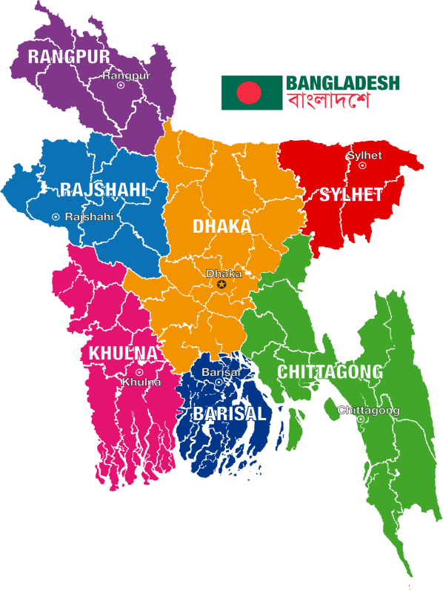
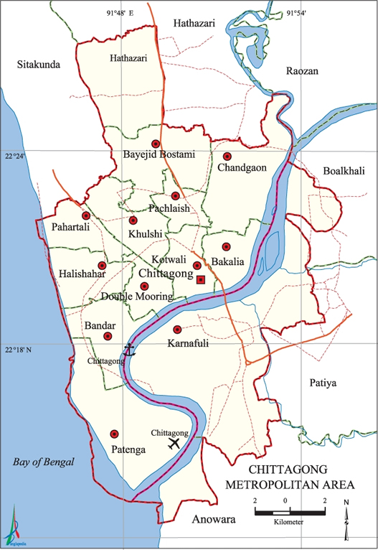
a
b
Figure 2.1: Geographical location of sample collection site. Map of Bangladesh (a) Map of Chittagong district (b).
2.2 Study period
The study was carried out for the periods of 3 months from 1st August, 2016 to 20th October, 2016 from different thanas under Chittagong City Corporation area.
2.3 Sources of data
Data for this study was obtained from both primary and secondary sources. The primary data were collected from the production performance, activities and economic condition of the goat producers using structured questionnaires and the secondary data was obtained from District Livestock Office under Chittagong district.
2.4 Research design
The research design adopted for this study was of ex-post-facto in nature since the phenomenon has already occurred. According to Sevilla et al., (2007) ex-post facto research is a systematic empirical inquiry in which the researcher does not have direct control over independent variables, because their manifestation has already occurred or because they are not inherently manipulated.
2.5 Sampling procedure
In an empirical investigation, it is impossible to collect information from the whole population. Therefore, the researchers are often forced to make inferences based on information derived from a representative sample of the population. The sample size and the degree of variation usually affect the quantity and quality of information obtained from the survey. Using appropriate sampling methods, both factors can be controlled (Scheaffer, 1986).
The aim is to devise a sampling scheme which is economical; easy to operate; and, provides unbiased estimates with small ‘variance’ (Barnett, 1991). Given limitations in terms of money; time; efforts; and, data management - sampling is more appropriate method. Further, sampling not only saves cost and time but can also give more accurate results than a census which are more acceptable (Kinnear and Taylor, 1987; Casley and Kumar, 1988). Following steps have been involved in the sampling procedure:
2.5.1 Defining the population
Classification of the population is the first step in the sampling procedure, namely, the sector or element under investigation, the sampling unit, the area or extent of investigation, and the duration of investigation (Kinnear and Taylor, 1987). All the farms of the district engaged in goat production were classified as population of the study.

2.5.2 Sample size
Casely and Kumar, (1988) suggested that a good survey sample should have both a small sampling error and minimum standard error. This can be obtained if one has unlimited resources. However, given constraints, such as finance, time and data management compromises have to be made in selecting the sample size (Poate and Daplyn, 1993).
Thus on the basis of nature of research and analysis; number of variables; resource constraints; and, the importance of decision, a sample size of 72 household goat farms engaged in goat production was selected.

2.5.3 Sampling methods:
Chittagong district and Chittagong City Corporation area were selected biasly (Non random selection). Chittagong City Corporation area has twelve thanas. From these thana, seven thanas were randomly selected and from seven thanas, few villages were selected randomly (Multi-stage random sampling). From these selected villages few farms were selected randomly (Stratified random sampling). Each farm rearing at least 2 goats is taken under consideration.

STUDY DESIGN
Chittagong district

Biased Selection
Chittagong City Corporation area
Multi-stage random sampling
Random selection of 7 Thana out of 12

Multi-stage random sampling
Random selection of few villages from each thana

Stratified random sampling
Random selection of few household goat farms from each village

Figure 2.2: Sampling methods used in current study.
2.6 Methods of data collection
Data were collected through direct interviewing and recorded in a questionnaire. The schedule was prepared maintaining relevance with the objectives of the study. Before launching the survey, the questionnaire was pretested and improved accordingly. In order to collect the more purified data of various farms an organized questionnaire was formatted (Nauta et al., 2001; De Jong and Van Soest, 2001). Key informant technique was also employed to get the basic relevant information of the proposed study.

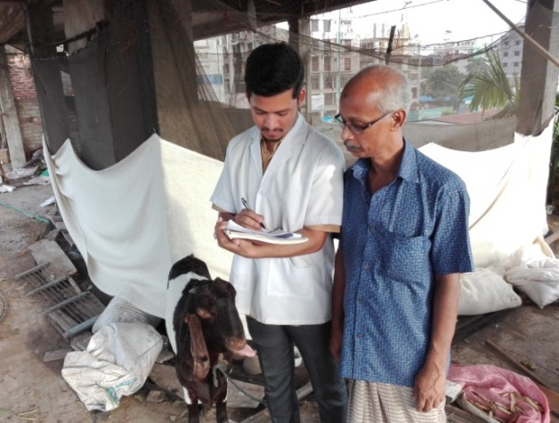
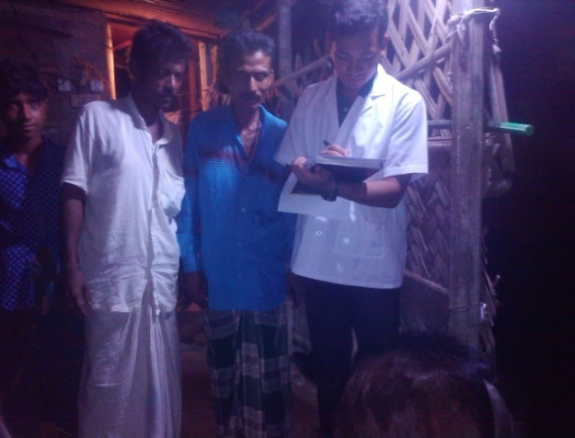
b
a

Figure 2.3: Data collection by farmer’s interview (a) Kotwali (b) Halishahar

2.7 Analytical techniques
The data were put on the master sheet in Microsoft Office Excel 2007 and were arranged in tabular form. The obtained data imported to software STATA-13 for analysis. Descriptive statistics (i.e. means, frequencies etc) was done to estimate the different variables ( Uddin et al., 2012 ).

CHAPTRE- III
Result and Discussion
3.1 General description of the farm
Variables | Categories | Frequency | Percentage (%) of farms
Farm size | $<$ 10 | 60 | 83.33
 | 10-20 | 10 | 13.89
 | $>$ 20 | 2 | 2.78
Source | Farm borne | 22 | 30.56
 | External | 50 | 69.44
Breed | BBG | 4 | 5.56
 | Jamnapari | 19 | 26.39
 | Cross | 49 | 68.06
Number of animal | Doe | 194 | 39.11
 | Buck | 55 | 11.09
 | Kid | 246 | 49.60
Goat with other species | Yes | 34 | 47.22
 | No | 38 | 52.78
BCS | 1 | 36 | 50
 | 2 | 28 | 38.89
 | 3 | 8 | 11.11
The Table 3.1 revealed that 83.33% farm size (Number of animals) are $<$ 10, 13.89% farm size are 10-20 and 2.78% farm size are $>$ 20. 30. According to Ekong (1988) majority of the farm size is less than 10 in household condition. 56% goats are farm borne and remaining 69.44% goats from outside of the farm. In our study we found that farm had 5.56% Black Bangle goat, 26.39% jamnapari goat and 68.06% cross breed. Farm had 39.11% does, 11.09% bucks and 49.60% kids in total population.It is comparable with Jayashree et al. (2014) where does, bucks and kids are 49.99%, 17.22% and 39.21% resprctively. About 47.22% goats are reared with other species in the household condition.

Table 3.1: Analysis of different parameters related to farms

3.2 Socio-economic condition of the farmers
Different factors associated with socio-economic condition of the farmers of Chittagong district are listed in Table 3.2 and specific findings of the study also describe below:
Table 3.2: Factors associated with socio-economic status of the farmers in Chittagong district (N=72).
Variables | Categories | No. of farm/  Farm owner | Percentage (%)
Type of farmer | Landless (0-100 percentile) | 35 | 48.61
 | Marginal (101-200 percentile ) | 25 | 34.72
 | Small (201-300 percentile) | 5 | 6.94
 | Medium (301-500 percentile) | 5 | 6.94
 | Large (501-1000 percentile) | 2 | 2.78
Occupation | Business | 15 | 20.83
 | Farmer | 8 | 11.11
 | Housewife | 20 | 27.78
 | Night guard | 3 | 4.17
 | Private service | 10 | 13.89
 | Rickshaw | 3 | 4.16
 | Student | 9 | 12.50
 | Wage earner | 4 | 5.56
Sex | Male | 52 | 72.22
 | Female | 20 | 27.78
Source of investment | Own | 29 | 40.28
 | Loan | 30 | 41.67
 | Both | 13 | 18.05
Number of animals | $<$ 10 | 60 | 83.33
 | 10-20 | 10 | 13.89
 | $>$ 20 | 2 | 2.78
Training | Yes | 3 | 4.17
 | No | 69 | 95.83
Family Type | Single | 61 | 84.72
 | Joint | 11 | 15.28
Education | Illiterate | 30 | 41.67
 | Class 5-8 | 25 | 34.72
 | SSC | 9 | 12.50
 | Above HSC | 8 | 11.11
Level of farm management skill | High | 14 | 19.44
 | Medium | 25 | 34.72
 | Poor | 33 | 45.83
3.2.1 Socio-economic status in terms of land
About 48.41% landless, 34.72% marginal, 6.94% marginal, 6.94% small and 2.78% large farmers were involved in household goat farming in Chittagong district (Table 3.2). These findings agree with the study of Rahman et al., (2002) in Rajshahi district. These findings indicate that, in this sector, comparatively poor farmers are more involved than rich, although Islam et al., (2010) reported that all of the farmers involved in the farming are small categories.
3.2.2 Occupation of farm owner
The present study shows that, about 20.83% farm owner deal with business, 27.78% housewife, 13.89% private service, 12.50% student, 11.11% farmer, 5.56% wage earner, 4.17% night guard, 4.16% rickshaw puller.
3.2.3 Sex of farm owner:
In present study it was revealed that about 72.22% farm owner are male and remaining 27.78% are female. It is almost similar with Melissa et al. (2016) where male and female are 92.8% and 7.2% respectively.
3.2.4 Sources of investment of the farm owner
The present study shows that, 40.28% farmer invest their own money in farming and 41.67% takes loan from different cooperative society or NGO, 18.05% manage from both own investment and loan from NGO. These findings have similarity with Rahman et al., (2002) in a study in Rajshahi district.
3.2.5 Size of the farm
The size of the farm reflects the socio-economic status of the farmer. About 83.33% of the farmers have less than 10 animals, 13.89% have 10-20 animals and 2.78% have more than 20 animals in farm.

3.2.6 Training
Only 4.17% of the farmer had received training of farming and left 95.83% did not take any training at all about goat farming. It was enumerated that 8.5 % of the farmer had received training in any times of his farming life (BBS, 2011).
3.2.7 Level of farm management skill
Most of the farmers have poor level of farm management (45.83%), 34.72% have medium level of management skill and 19.44% have high level of farm management skill. Rahman et al., (2002) found that, 71.43% and 24.29% of the farmers have poor and medium level of management skill respectively. So the findings of my study more or less similar with Rahman et al., (2002).
3.2.8 Literacy level of the farmers
The literacy level of the farmers has been grouped into four educational groups according to Sumy et al., (2010). The Table 3.3 shows the literacy level of the farmers. There were found 41.67% illiterate, 34.72% Class 5-8 class, 12.50% SSC and remaining 10% are above HSC. These findings are agreement more or less with Sumy et al., (2010) that were in a study on backyard goat owners.
Table 3.3: Literacy level of the farmers (N=72).
Literacy levels Farmers | No. of farmers | Percentage (%)
Illiterate | 30 | 41.67
Class 5-8 | 25 | 34.72
SSC | 9 | 12.50
Above HSC | 8 | 11.11
Total | 72 | 100

3.2.9 Educational status of farmer’s children
The level of education of the farmer’s children reflects the socio-economic position of a family in a society. In my study there were found (Table 3.4) 59.72% Class 1-4, 22.22% Class 5-8 and 5.56% SSC. These findings of the study agreement with Ahmed et al., (2009) they also found more or less similar findings.
Table 3.4: Educational status of farmer’s children (N=72).
Particulars | Frequency | Percentage (%)
No children | 9 | 12.50
Class 1-4 | 43 | 59.72
Class 5-8 | 16 | 22.22
SSC | 4 | 5.56
Total | 72 | 100

3.2.10 Sources of drinking water and latrine condition
In present study it was revealed that about 18.06% of the farmer uses their own deep tube well as a source of drinking water. 56.94% use cooperative society deep tube well and 26.39% use water from WASA (Table 3.5).
Table 3.5: Sources of drinking water and condition of latrines (N=72).
Particulars | No. of farmer | Percentage (%)
Sources of drinking water
Own deep tube-well | 13 | 18.06
Cooperative society deep tube-well | 41 | 56.94
WASA | 19 | 26.39
Latrine condition
Katcha | 0 | 0
Semi-sanitary | 23 | 31.94
Sanitary | 49 | 68.06

No farmer use katcha latrine, 31.94% use semi-sanitary and 68.06% use sanitary latrine. Ahmed et al., (2009) showed using of higher percentage of semi-sanitary latrine among the farmer.
3.2.11 Health statuses of the farmers
In terms of health status there revealed that about 22.2% of the farmers had good health, 26.4% and 51.4% had moderate and poor health respectively. The health statuses of the farmers are shown in figure 3.1.
Figure 3.1: Health statuses of the farmers.
19
37
51.4%
26.4%
22.2%
16

3.2 Costs and returns
The estimated costs and return to goat enterprise were net 37500 TK and net 92000 TK respectively (Table 3.6). Cost of foundation stock accounted for half (62.86%) of the total cost while revenue from weaned kids had share (60.87%) of total revenue. The total revenue on the average was net 92000 TK while the gross margin and return to management were net 57000 TK and net 54500 TK respectively. The profit margin percentage was 59.24% while the ratio of net returns to total expenses was 1.45 and the operating expense ratio of 38.04 indicates that 38.04% of gross revenue was used to cover operating expenses, which accounted for about 96.3% of the total costs. The benefit cost ratio is 2.4 and it is almost similar with Baruwa et al (2013) where benefit cost ratio is 2.3. The ratio is indicative of the profitability of goat enterprise in the study area.
SN | Items | Mean amount | Percentage of cost/revenue (%)
1. | Cost/ Revenue
i | 28 weaned kid @ 2000 TK | 56000 | 60.87
ii | 9 culled doe @ 4000 TK | 36000 | 39.13
a | Total revenue (TR) | 92000
2. | Variable cost
iii | Cost of foundation stock 11 weaned kid @ 2000 TK | 22000 | 62.86
iv | Cost labour | -
v | Cost of drugs and veterinary services | 2000 | 5.71
vi | Maintenance cost on house unit | 1000 | 2.86
vii | Feed cost | 10000 | 28.57
b | Total Variable Cost (TVC) | 35000
c | Gross Margin (GM)= (TR-TVC) | 57000
3 | Fixed cost
viii | Depreciation cost | 2500
d | Total Fixed Cost (TFC) | 2500
e | Total Cost (TC)= TFC+TVC | 37500
f | Net Income (NI))= GM-TFC | 54500
g | Profit Margin (%)= f/a*100 |  | 59.24
h | Ratio of net returns to total expenses= f/e |  | 1.45
i | Operating expense ratio= b/a*100 |  | 38.04
j | Benefit Cost Ratio (BCR)= a/e |  | 2.4

Table 3.6: Enterprise budget for goat production (10 does and 1 buck)
Foundation stock: 10 does, 1 buck; Number of doe remaining at maturity = 9 does (10% mortality): 9 does kidding twice a year (36 kids on the average): 28 does survived to weaning age (20% mortality)
3.3 Common management practices in household goat farms:
In rearing system, 23.61% goat reared in free range system, 22.22% in intensive system, 47.22% semi-intensive system and 5.94% in tethered condition. According to Melissa et al. (2016) the intensive and semi-intensive are 48.3% and 40.2 % respectively.
In the farm about 62.50% case wood use as flooring materials, 18.06% case jute bag, 9.72% case concrete and 9.72% case pavement. It is comparable with Verma et al. (2007) where it is 52.8%.
In feeding regiment, about highest 45.83% case is grass and bran, then grass, bran and leaf combination 31.94%, only grass 8.33%, only bran 4.17%, Vegetable and pea husk combination 9.72%. About 73.61% case the feeding trough is clean and use only water (86.11%) or water with detol (13.89%) for cleaning the feeding trough.
In the farm we found about 100% goats are bred by natural ways. Farmer did milking only 31.94% case and they did not follow sanitary measures and not used any antiseptic during milking.
The most prevalent diseases are myiasis(50%), fever, pneumonia (18.06%), PPR (79.17%), diarrhea (86.11%), dullness (69.44%), anorexia (73.61%), dog bite (52.77%), mastitis (26.39%), udder edema (2.78%), dysticia (16.67%).
About 20.83% case farmer use vaccine and mostly used PPR (20.83%) vaccine in goat farm. Farmer did deworming regularly in 68.05% cases and irregular basis in 31.94% cases.
Variables | Categories | Frequency | Percentage (%) of farms
Rearing system | Free range | 17 | 23.61
 | Intensive | 16 | 22.22
 | Semi-intensive | 34 | 47.22
 | Tethered | 5 | 5.94
Flooring materials | Concrete | 7 | 9.72
 | Wood | 45 | 62.50
 | Pavement | 7 | 9.72
 | Jute bag | 13 | 18.06
Muddiness in floor | 0-25% muddy | 49 | 68.06
 | 26-50% muddy | 13 | 18.06
 | 51-75% muddy | 8 | 11.11
 | 75-100% muddy | 2 | 2.78
Feces coverage in floor | 0-25% feces coverage | 31 | 43.05
 | 26-50% feces coverage | 26 | 36.11
 | 51-75% feces coverage | 13 | 18.05
 | 75-100% feces coverage | 2 | 2.78
Cleaning frequency of floor | Daily | 55 | 76.39
 | 2 times daily | 13 | 18.06
 | 2 times daily | 2 | 2.78
 | 4 times daily | 2 | 2.78
Feeding regiments | Grass | 6 | 8.33
 | Bran(Full Concentrate mix) | 3 | 4.17
 | Grass, bran | 33 | 45.83
 | Grass, bran, leaf | 23 | 31.94
 | Vegetable, pea husk | 7 | 9.72
Cleaning frequency of feeding trough | Daily | 47 | 65.28
 | 2 times daily | 15 | 20.83
 | 3 times daily | 4 | 5.56
 | 4 times daily | 5 | 6.94
 | Weekly | 1 | 1.39
Cleanliness of feeding trough | Clean | 53 | 73.61
 | Not clean | 19 | 26.39
Cleaning material | Water | 62 | 86.11
 | Detol water | 10 | 13.89
Breeding | Natural | 72 | 100
 | AI | 0 | 0
Milking | Yes | 23 | 31.94
 | No | 49 | 68.04
Sanitary measure during milking | Not follow | 72 | 100
Antiseptic used during milking | Not used | 72 | 100
Myiasis | Yes | 36 | 50
 | No | 36 | 50
Pneumonia | Yes | 13 | 18.06
 | No | 59 | 81.94
PPR | Yes | 57 | 79.17
 | No | 15 | 20.83
Diarrhea | Yes | 62 | 86.11
 | No | 10 | 13.89
Dullness | Yes | 50 | 69.44
 | No | 22 | 30.56
Anorexia | Yes | 53 | 73.61
 | No | 19 | 26.39
Fever | Yes | 43 | 59.72
 | No | 29 | 40.28
Dog bite | Yes | 38 | 52.77
 | No | 34 | 47.22
Mastitis | Yes | 19 | 26.39
 | No | 53 | 73.61
Udder edema | Yes | 2 | 2.78
 | No | 70 | 97.22
Dystocia | Yes | 12 | 16.67
 | No | 60 | 83.33
Vaccination | Yes | 15 | 20.83
 | No | 57 | 79.17
Vaccine Used | PPR | 15 | 20.83
 | No Vaccine | 57 | 79.17
Deworming | Regular | 49 | 68.05
 | Irregular | 23 | 31.94
Treatment given by | Self | 11 | 15.28
 | VFA | 18 | 25
 | Vet | 43 | 59.72
Udder cleanliness | 1 | 19 | 26.39
 | 2 | 46 | 63.89
 | 3 | 5 | 6.94
 | 4 | 2 | 2.78
Thigh cleanliness | 1 | 11 | 15.28
 | 2 | 51 | 70.83
 | 3 | 9 | 12.50
 | 4 | 1 | 1.39
Leg cleanliness | 1 | 2 | 2.28
 | 2 | 41 | 56.94
 | 3 | 24 | 33.33
 | 4 | 5 | 6.94
Table 3.7: Common management practices in household goat farms

Photo gallery
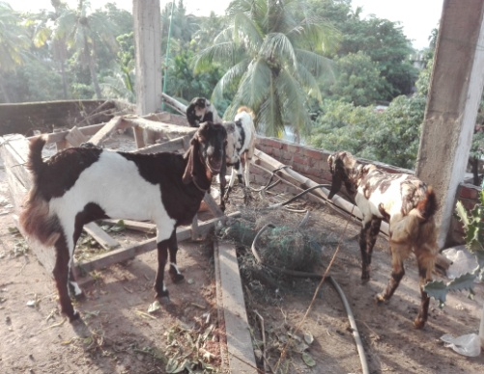
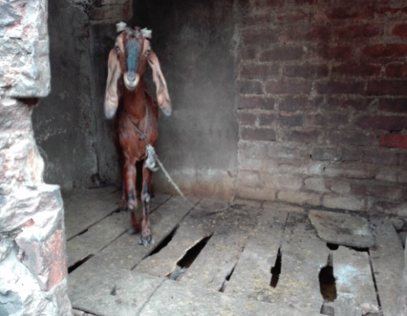
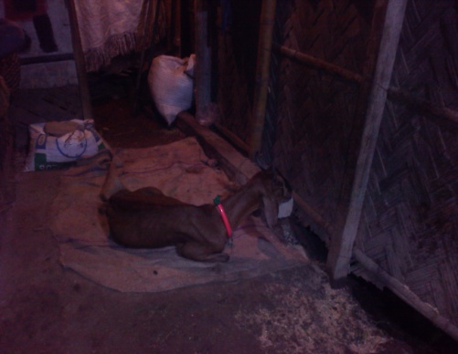

a
b
c
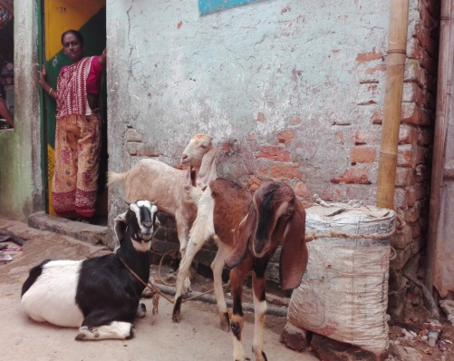
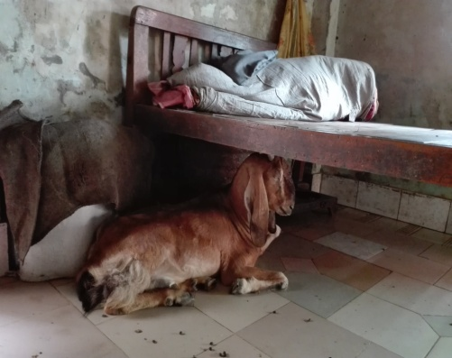
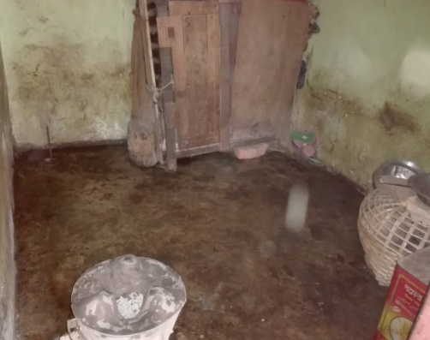

f
e
d
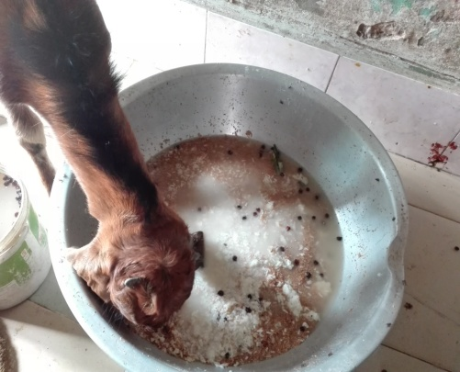
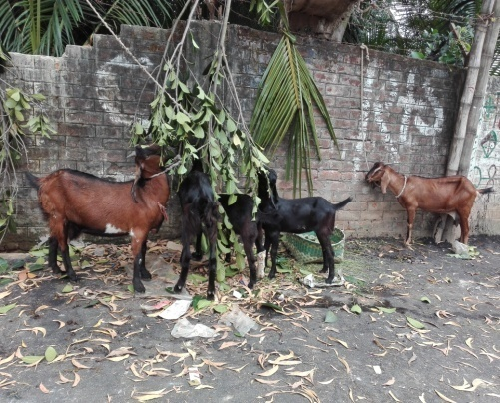
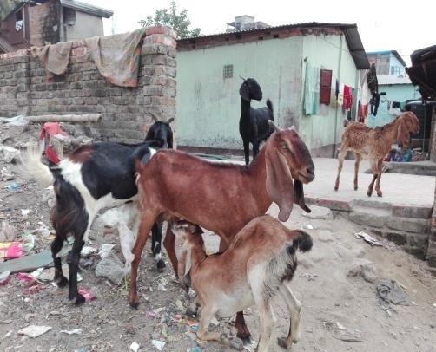

i
h
g

Figure 3.2: Common management practices in household goat farms. Jute bag use as floor material (a), Wooden floor material (b), Concrete floor material in roof (c), goat house in kitchen room (d), goat in bed room (e), Tethered goat rearing in road (f), Goat in free range condition (g), feeding jackfruit leafs to goat (h), Feeding to goat in feces contaminated feeding trough (i).
CHAPTRE- IV
Recommandations
In the study area, a lot of problems and difficulties were found in goat farming. To overcome the difficulties of goat rising and to make goat farming more profitable in the country as well as uplifting the socio-economic status of the farmers, the following recommendations are put forward for the improvement of existing production of goat.
- Regular vaccination is a prerequisite for any improvement in goat production. Necessary steps should be taken to reduce the losses from diseases.
- To get rid of the problem of credit, the provision of short-term loan for goat business should be made with immediate effect on easy terms and conditions.
- In order to provide necessary veterinary services to the goat, the government should establish new veterinary care centers with adequate veterinary technicians, field assistants and modern logistic supports.
- The treatment facilities should be extended by arranging effective disease control programs in the country.
- Frequent training should be arranged for the farmers.
- Provision of financial support to the farmers.

CHAPTRE- V
Limitations
There were some limitations in my study. The study period was limited and study area restricted to a particular district, for this reason the findings may not reflect the whole country. There was limited recording system in household goat farms under study as a result it was difficult to select valid data. Some of the farmers were not cooperative to give information.

CHAPTRE- VI
Conclusion
Goat farming is a great opportunity for the rural people and youth as a means of income generation. Socio-economic development might be achieved with the help of household goat farming. There is a wide scope for the development of household goat farming in the countrywide because rural poor people have enough time for rearing goat. It would be really very helpful for income generation, women empowerment and fill up nutritional gap for the rural family. Socio-economic position on subsidiary occupation, monthly household income and expenditure, cash in hand, savings with bank, household assets, number of school going children, monthly consumption of milk, meat, vegetables and fish, sources of drinking water, condition of latrines and health status of farmers were improved and the annual cost for treatment is reduced after adopting farming. Since most of the people irrespective of caste and religion prefer goat meat and milk, its demand and price is gone up. Most of the farmers were small farmers while some of them were landless. Some improvements in the status of clothing, toilet condition, medical facilities, drinking water and housing have been taken place because of farming. In the present study, in terms of overall socio-economic improvement it was found that household goat farming helped to improve their socioeconomic condition. As a result, tendency to initiate goat farming is widely observed in rural areas.

CHAPTRE- VII
Refferences
Ahmed JU, Mozumdar L, Farid KS Rahman MW, 2009. Broiler farming: An approach to improve rural livelihood. Journal of Bangladesh Agricultural University. 7(2): 395-402.
Ali MH, Bhuiyan MKJ, Alam MM, 2011. Retrospective epidemiologic study of diseases in ruminants in Khagrachari hill tract district of Bangladesh. Bangladesh Journal of Veterinary Medicine. 9(2): 145-153.
Anonymous, 1998. Food and nutrition guidelines for healthy adolescents. Ministry of health, New Zealand.
Barnett V, 1991. Sample Survey Principles and Methods. Third edition, Edward Arnold Publisher Ltd, London.
Banerjee GC, 1998. A text book of animal husbandry. Eighth edition, Oxford and IBH publishing Company Private Limited, New Delhi: 880-899.
Baruwa OI, 2013, Empirical Analysis of Costs and Returns to Goat Production under Tropical Conditions. Journal of Livestock Science.4:44-50.
BBS, 2010. Statistical Year Book of Bangladesh. Bangladesh Bureau of Statistics, Statistical Division, Ministry of Planning, Government of the People's Republic of Bangladesh, Dhaka, Bangladesh.
Chowdhury SA, Shill BK, Hossain SMJ, 2003. Chagolpalon manual. 2nd edn, Bangladesh Livestock Research Institute (BLRI), Savar, Dhaka-1341.
Casely D, Kunnar K, 1988. The collection, analysis and use of monitoring and evaluation data Baltimore. The Hohnces Hopkins University Press, Department of Agricultural Economics and Business, Wye College.
Devendra C, 2006. Small ruminants in Asia; contribution to food security, poverty alleviation and opportunities for productivity enhancement.
Devendra C, 1988. Goat production in small farm systems, Paper presented at the workshop on Small ruminant Research and Development in the near east, Cairo, Egypt.
Devendra C, 1993. Sustainable Animal Production from Small Farm Systems in South-East Asia. FAO Animal Production and Health Paper:106.
De Jong H, Van Soest Y, 2001. De biologische melkveehouderijsector in kaart gebracht. Productschap Zuivel, Rijswijk.
De Haan N, 2001. Of goats and groups: a study on social capital in development projects. Agr. and Hum.18:71–84.
Ershaduzzaman M, Rahman M, Roy BK, Chowdhury SA, 2007. Studies on the diseases and mortality pattern of goats under farm conditions and some factors affecting rates in Black Bengal kids. Bangladesh Journal of Veterinary Medicine.5 (1 and 2): 71-76.
Ensminger ME, Parker RO, 1986. Sheep and Goat Science, Fifth Edition. Danville, Illinois: The Interstate Printers and Publishers Inc.
FAOSTAT, 2008. http://faostat.fao.org/default.aspx
Hassan MM, Hoque MA, Islam SKMA, Khan SA, Roy K and Banu Q, 2011. A prevalence of parasites in Black Bengal Goats in Chittagong, Bangladesh. International Journal of Livestock Production. 2 (4): 40-44.
Kashem MA, Hossain MA, Ahmed SSU, Halim MA (2011). Prevalence of diseases, morbidity and mortality of Black Bengal Goats under different management systems in Bangladesh. University Journal of Zoology, Rajshahi University 30: 01-04.
Kinnear TC, Tayler JR, 1995. Marketing Research: An Applied Approach. Mc Grow. Hill Book Company, Singapore.
Nauta WJ, Baars T, Groen AF, Veerkamp RF, Roep D, 2001. Animal Breeding in Organic Farming. Discussion paper, Louis Bolk Institute, Driebergen.
Oberoi RC, Morti TV, Anti Sharma AK, 1992. Comparative economics of sheep and goat rearing (A study of tribal farms in Western Himalaya). Livestock Adviser. 17(1):25-30.
Poate CD, Daplyn PF, 1993. Data for Agrarian Development. First edition, Cambridge University Press.
Peacock C, 1996. Improving Goat Production in the Tropics. Oxfam- Farm Africa, Oxford:386.
Rahman SMA, Sayeed MA, Sarker NR, Alam J, 2006. Impact of improved poultry management technique on socio-economic condition of beneficiaries. Journal of Bangladesh Agricultural University. 4 (2): 401-411.
Restani P, 2004. Goat milk allerginicity. Journal Paediatric Gastroenterology and
Nutrition. 39:323-324.
Sevilla CG, Ochave JA, Punsalan TG, Regala BP, Uriarte GG, 2007. Research methods. Third edition, Rex book store.
Schaeffer RL, Mendenhall W, Ott L, 1986. Elementary Survey Sampling. Third edition, Duxbury Press, Boston, USA.
Sumy MC, Khokon MSI, Islam MM, Talukder S, 2010. Study on the socio-economic condition and productive performances of backyard goat in some selected areas of Pabna district. Journal of Bangladesh Agricultural University, 8(1): 45-50.
Tareque AMM, Chowdhury SMZH, 2010. Agricultural Research Priority: Vision 2030 and beyond. Bangladesh Agricultural Research Council. Farmgate, Dhaka.
Uddin MN, Uddin MB, Mamun M, Hassan MM, Khan MMH, 2012. Small Scale Dairy Farming for Livelihoods of Rural Farmers: Constraint and Prospect in Bangladesh. Journal of Animal Science Advances. 2(6): 543-550

Appendex
A questionnaire for an investigation of Socio-economic status of farmers and common management practices in goat farming in Chittagong, Bangladesh.
Section I: Farm Identification :
Farm ID no (FID):………...
Name of Owner: ……………………………..Age…..:…........ Sex: (a) Male (b) Female
Vill/ward:…………...Upazilla:…………….Dist:……………..Contact no:…………….
Educational status: (a) Illiterate (b) Class 5-8 (c) Secondary school level (d) Above higher secondary level
Children’s education: (a) Illiterate (b) Class 1-4 (c) Class 5-8 (d) Secondary school level (f) Above higher secondary level
Occupation: (a) Service holder (b) Business (c) Job seeker (d) Agriculture (e) Others…
Family type: (a) Single (b) Joint
Land size: (a) Landless (0-100 percentiles) (b) Marginal (101-200 percentiles) (c) Small (201-300 percentiles) (d) Medium (301-500 percentiles) (e) Large (500-1000 percentiles) (f) Above
Source of water:……………………………………………………………………………
Latrine condition: …………………………………………………………………………
Source of fund: (a) Loan (b) Own (c) Both
Training received: (a) Yes (b) No
Section II: Farm Information:
Source of Animals: (a) Farm borne (b) Bought/ External
Types of breed: Local/BBG/Jamnapari/Cross/Othors………...
Farm size:…….. No. of adult does:……. No. of adult bucks:….. No. of goat kids............
No of Pregnant animal:………. No of Parity:………No of Lactating animal:....................
Stage of Lactation:………….....Weeks

Section III: Animal Husbandry:
Rearing system: Intensive……………../Semi-intensive…………/Tethered…………../
Free range: People and goats stay in the same house…... Goats have separate house…….
Others...................................................................................................................................
Do your goats live with other species of livestock? Yes/no
If yes, which species: Sheep……………….…...Poultry……………..…. Others………. Feeding Regimen: Roughage: Grass…….…..Concentrate………Others: Jackfruit……...
Do your goats eat with other species? Yes or No
Flooring material:……………………………………………………………...…
Dirt scores for muddiness:
l. (0-25% muddy) 2. (>25-50% muddy) 3. (>50-75% muddy) 4.(>75-100% muddy)
Dirt scores for feces:
l. (0-25% feces coverage) 2. (25-75% feces coverage) 3. (75-100% feces coverage)
Cleaning frequency or the floor:.........................................................per Day/Week/Month
Cleaning frequency of the feeding trough:………………………per Day/Week/ Month
Cleanliness of the feeding trough: Clean/ not Clean
Cleaning materials used: Ash/ Sand/ Water/ Detergent/ Soap/ Other…………………...
Level of farm management skill: (a) High (b) Medium (c) Poor
Section IV: Animal Production:
Age: ………………….…...Day/Month/Year. Body weight:……………………...……...
BCS: 1. (extremely thin with no fat reserves, bones clearly outlined and protruding) 2 (small amount of fat reserves back bone still visible with continuous ridge, ribs still felt) 3. (Even layer of fat covers ribs, ribs barely seen, and back bone not prominent) 4. (Back bone is not visible, ribs are not seen, side of animal is sleek in appearance) 5. (Excessive reserves, back bone is buried by fat, ribs not visible).
Type of Breeding: Natural/AI. Date of parturition in the last 12 months………………...
No. of parity in the last 12 months:………………………………………………………..
Do non-biological kids nurse from the same goat or multiple goats? Yes/No
If so, how many kids nurse from one goat?……………………………………………..
How soon after a kid is weaned is the doe bred again?.................................Days /Months

Section V: Health, Vaccinations and Medication:
What are the most prevalent diseases:………………………………………………….
Any previous medication used to treat current illness: Yes/No
Previous history of mastitis: Yes/No if yes, date of occurrence:………………………
History of Periparturient disease: Yes/ No If yes what: Pregnancy toxemia/ Periparturient hypocalcaemia/ lactation tetany/ Lactation ketosis/ Lactic acidosis/ Other
History of udder edema: Yes/No
Vaccination: Yes/ No
Deworming: Regular/ Irregular
Treatment of animal by the help of: Vet/ VFA/ Self/ Neighbor
Udder cleanliness: 1/2/3/4; Thigh cleanliness: 1/2/3/4; Leg cleanliness: 1/2/3/4

………………………………. Date:………………...
Signature of farmer

ACKNOWLEDGEMENT
All praises are due to the Almighty Allah, the creator and supreme authority of the universe, who empowers me to strength and opportunity to complete the report successfully.
Completion of any work or responsibility gives nice feelings. But the accomplishment of this work, as the partial fulfillment of the requirements for the degree of Doctor of Veterinary Medicine (DVM) in CVASU, not only has given me the pleasure, but also have given me the confidence to move ahead and showed me a new opening to knowledge. Standing at this opening, it is an honor to revoke the names of the person and the Organization I am grateful to.
I would like to extend my gratitude to my supervisor, Goutam Kumar Debnath, Professor and Head Dept. of Dairy and Poultry Science, Chittagong Veterinary and Animal Sciences University. My heartfelt thanks to him for valuable guidance, suggestion, supervision and encouragements during the entire period of this study to complete this clinical report.
I would like to express my deep sense of gratitude and thanks to Professor Dr. Gautam Buddha Das, honorable vice chancellor and Professor Dr. Md. Ahasanul Hoque, Dean, Faculty of Veterinary Medicine, CVASU for arranging this type of research work as a compulsory part of this internship program.
I express my sincere gratitude and thanks to Professor Dr. A. K. M. Saifuddin, Director of External Affairs, and for his supervision and kind co-operation during the period of internship.
Thanks to owners of farm, owners of animals and attendance that have helped me in collecting data for this study and lab work.
Last but not least, I am profoundly grateful to my family members for their endless sympathies, kind co-operation, sacrifices and prayers.
Author
November, 2016
Biography:

Name | Delower Hossain
Present status | Intern student, Faculty of veterinary medicine (FVM), Chittagong Veterinary and Animal Sciences University (CVASU).
Educational background and Year | H.S.C in 2010 (GPA-4.90), Govt. City College, Chittagong; S.S.C in 2008 (GPA-5.00), Govt. Muslim High School, Chittagong.
No. of publication | No
Research interest | PCR based isolation and identification of microorganisms.

