CHAPTER I:

INTRODUCTION
Bangladesh is an agro-based developing country and the growth and sustainability of agricultural production are prerequisite for attaining the rate of overall growth of the economy. Livestock is an important sub-sectors that committed to supply cheap sources of good quality nutritious animal protein to the nation. Poultry farming has turned out to be promising dynamic enterprise with enormous potential for rapid poverty reduction in Bangladesh. Poultry farming provides substantial economic contribution and generates self-employment opportunities for the unemployed youth generation. A noticeable development has been taken place in poultry farming in Bangladesh. The overall contribution of the broad agriculture sector at constant price was 19.95 percent of GDP in 2010/11 (BER 2011).In agriculture sector, contribution of crops, livestock and forestry were 11.24, 2.57 and 1.71% respectively. Commercial or intensive poultry farming has now turned into a profitable business in Bangladesh. Poultry industry in Bangladesh has made significant progress during the last two decades where commercial poultry started in 1980 in Bangladesh. Chowdhury (2013) started that commercial poultry increased significantly during 1980-1990 (6%) and 1990-2000 (8%) in this country. Sonali chicken, the crossbreed of Fayomi female and RIR (Rhode Island Red) male developed in 1986, has been reported to perform better with respect to egg and meat production, rapid growth and low mortality under scavenging , semi-scavenging and intensive farming system. It has been taking its place besides the indigenous hens due to its adaptability and acceplability in the climatic conditions of Bangladesh . Sonali, with a phenotypic appearance similar to local chicken has higher market demand than exotic breed. As an important segment of livestock production, the Sonali chicken industry in Bangladesh is considered a great avenue for the economic growth and simultaneously creates numerous employment opportunities. About 76 percent of Sonali beneficiary has improved their conditions by rearing this type of poultry (Hossen et al. 2012). Bangladesh reportedly is turning to be a society of sick, stunted and degenerated bunch of people due to chronic protein deficiency. This country has already marked for its poverty, external dependence and unemployment problem. In this circumstance, Sonali chicken farming would be excellent and appropriate way to promote the nutritional and economic security of the people living in rural, tribal and inaccessible areas in a sustainable manner.Sonali chicken production provides higher returns to the farmers. This enterprise is gaining popularity in the country gradually due to its high yield potentiality, although proper management and appropriate level of input use are important for achieving such higher yield andprofits.Some researches have been conducted about hatchability, fertility, growth rate and mortality rate of Sonali chicken and a few researches have been done on the comparative analysis of Sonali chicken breed with other poultry breeds. Saleque and Saha (2013) conducted a studyon production and economic performance of small scale Sonali bird farming for meat production in Bangladeh; Hossen et al. (2012) conducted a study on the problems and prospects of Sonali chicken farming in different village levels of Joypurhate distric in Bangladesh; Miazi et al. (2012) examined a study on fertility and hatchability of Fayomi and Sonali chicks. However, the present research explores information on the economic aspects of Sonali chicken farming which is indeed a new study in the poultry industry. This study is very important in terms of producing meaningful information to uplift the productivity and to ensure the sustainability of Sonali chicken industry.The overall objective of the study is to estimate the profitability of Sonali chicken production and the efficiency of resources used for such production.
Now attention is, therefore being focused on cheap but suitable alternative feedstuff,especially crop residues and industrial by product,to sustain livestock industry.The evaluation of unconventional feed resources alongside other strategies would reduce pressure on the demand for conventional feed ingredient and accelerate the attainment of feed security for poultry.For this purpose saw dust can be used as unconventional feed resources for livestock. Millions of lignocelluloses material(saw dust) which are wasted every year are found around industrial sites such as sugar mills and saw mills can be used as unconventional feed ingredient. This study was undertaken to investigate the use of steamed sawdust in Sonali diets. Therefore, it is imperative to explore cheaper locally available feedstuff to reduce feed cost. About 80% feedstuffs used in poultry ration are being imported. As a result, the cost of feed prepared for poultry using those grains stand high. Computing feed with conventional feed ingredients available hardly permits profitable poultry production.

The current use of highly processed ingredients in poultry diets has negative effects on the development of the digestive tract of poultry. Sonali housed in a litter floor system consume saw dust, possibly to compensate for the low levels of coarse fibrous materials in their diet. The coarse fibrous nature of sawdust may improve the development of the gizzard allowing improved nutrient utilization (Amerahet al., 2007).

It has been shown that the presence of crude fiber improves growth and feed efficiency and gives beneficial effects on feathering and on protection from cannibalism in chicks (Hetlandet al., 2003.). However, crude fiber is poorly digested in poultry (Tasaki I. et al., 1959). Indeed, insoluble fibre itself has shown beneficial effects on nutrient digestion and gizzard activities (Hetlandet al., 2003). Recently, it has been reported that dietary fiber may have protective effects against accumulation and lipid metabolism in the certain diseases in humans (Cummings, 1973; Heaton, 1976) and growing chicks, atherosclerosis induced by increased serum cholesterol concentration in chicks (Menge, 1974).
The aim of this research was to investigate the effects of steamed sawdust (8% in total feed) in Sonali diets by closely observing the growth performance of the Sonali. This would be the first research in Bangladesh. Therefore, the present research program was designed with the following objectives:
a. To know the effect of steamed sawdust on the Sonali performance.
b. To reduce the cost of production using cheaper unconventional diet for Sonali.
c. To improve performance and meat quality of Sonali.

CHAPTER II:

MATERIALS AND METHODS

The study was conducted on ten growing Sonali of same age (1 day) and reared in poultry shed of Shamim Poultry farm, at Sitakunda, Chittagong.

2.1Preparation of steamed sawdust
Sawdust collected from local saw mill. Removing of unwanted particles from sawdust. Then heating of sawdust by water vapor at 100⁰ C. Heating was done up to sweetish odor come from steamed sawdust. After collection of that steamed sawdust, air dry was done by ceiling fan.
Table 1: Proximate composition of steamed saw dust (Silkoroi) (Ref. Production report, Jahidurrahman, 06/12).
Parameters | Percentage
Dry matter (DM) | 94.6
Crude protein | 1.9
Crude fibre | 65
Ether extract | 2
Nitrogen free extract | 25.03
ASH | 0.67
ME (kcal/kg) | 3148

2.2 Feed formulation

Name of ingredients | Percentage of ingredients | Required Amount of ingredients (kg) | Rate of ingredients/kg (TK) | Cost of ration (TK)
Maize | 59 | 4.956 | 23 | 113.988
Soybean meal | 22 | 1.848 | 58 | 107.184
Protein conc. | 5 | 0.42 | 80 | 33.60
Rice polish | 3 | 0.252 | 20 | 5.04
Saw dust | 8 | 0.672 | 05 | 3.36
Oil | 2 | 0.168 | 110 | 18.48
Lime stone | 1 | 0.084 | 08 | 0.672
Enzyme | Trace amount
Total | 100 | 8.4 |  | 282.324
Metabolizable Energy (Kcal/100kg) was 3009.11 and Crude Protein was 18.95%
So, feed cost per kg 33.61 Taka

2.3 Housing
House was cleaned and old litter material was removed. Rice husk was used as litter material. Then Sonali were purchased from a farmer and placed in the modern poultry shed which was made with wood, net and tin. Proper lighting was provided at night 100 watt bulb.

2.4Feeding and watering
Adlibitum feed and water was supplied to the birds throughout the experimental period. Fresh clean and cool drinking water was supplied all times in drinker. For each cage one feeder and one watererwere given. Before giving these, cleaning and washing were done. At morning and evening, we changed the feed and water. Feed residue was measured daily.

2.5Ventilation and curtain management
Ventilation was facilitated to maintain good air quality for poultry and appropriate litter moisture for a healthy environment. It was confirmed by cross ventilation system to remove carbon dioxide and ammonia from poultry houses and to bring in oxygen.

2.6Sanitation
Proper hygienic measure and sanitation program was followed during the experimental period. Feeder and drinker was cleaned regularly to prevent infection.

2.7 Weight recording
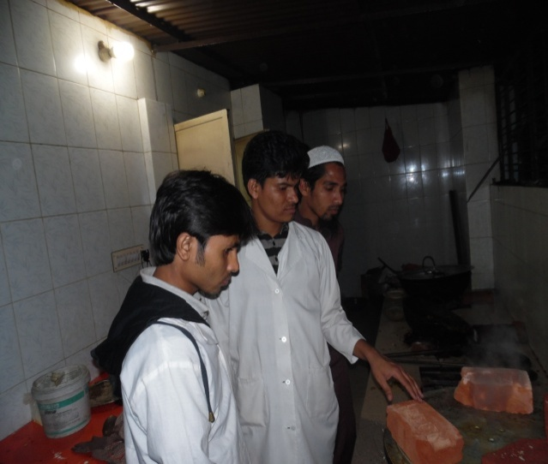
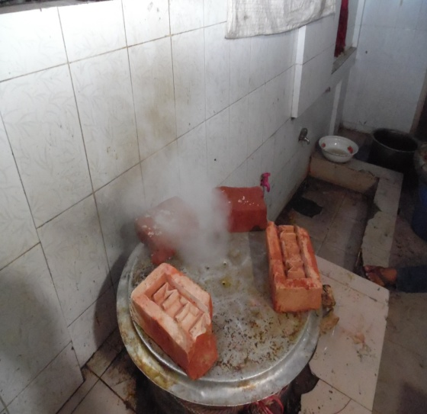
Before placing in the house weight of the Sonali were measured and marking was given. After 7 days of rearing another weight was measured and recorded in the sheet.
Fig2: Sweetish odor
Fig1:Steamed sawdust

Fig4: Feed formation
Fig3:Weighing ingredients

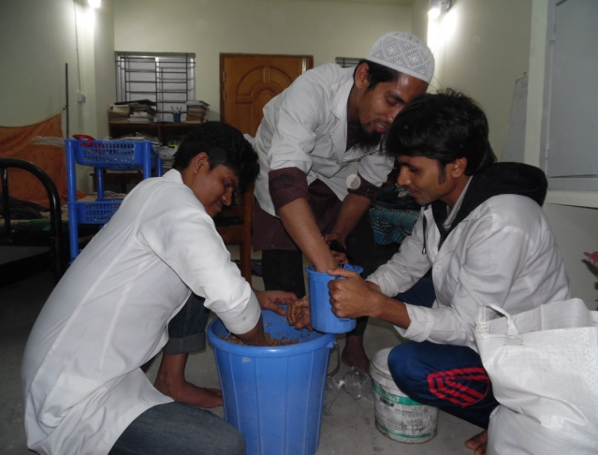
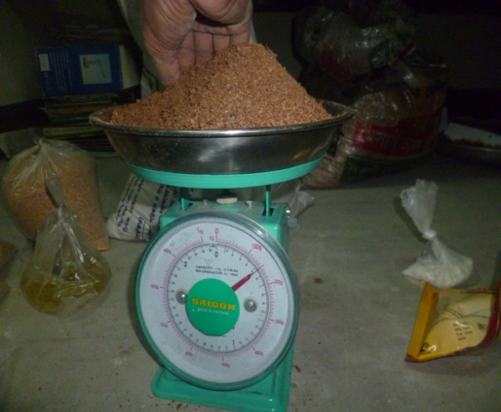
vxvxdvdvgdsg

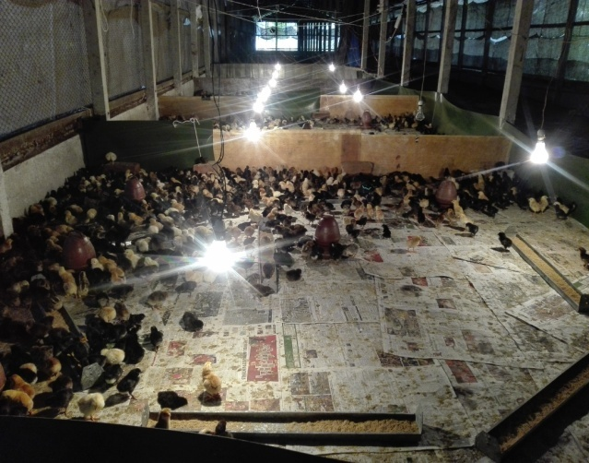
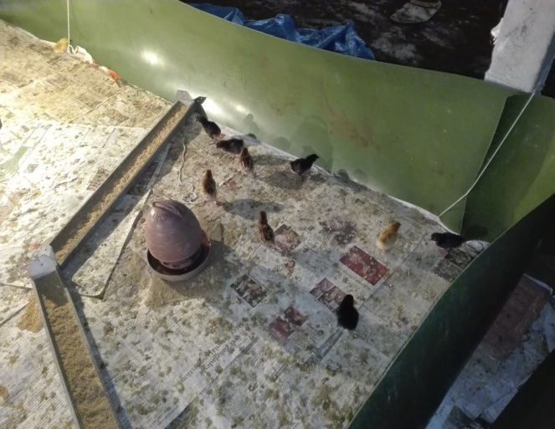
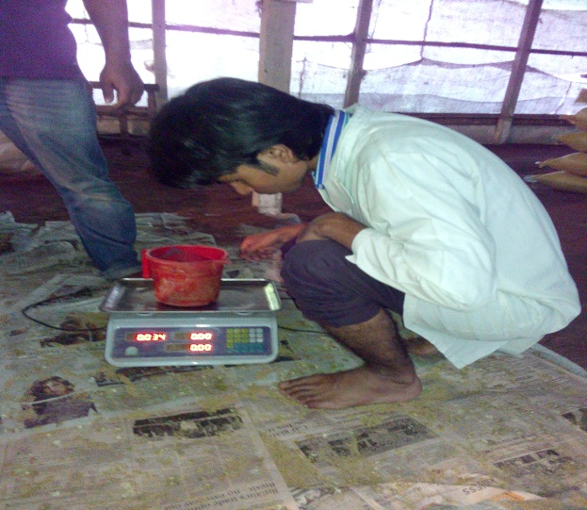
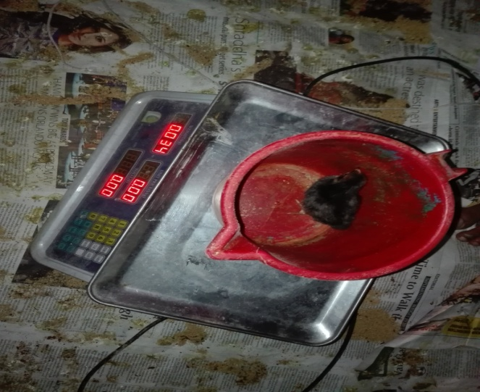
Fig 5: Shed of experimental Sonali
Fig 6: Shed of Sonali of the farm

steamedsssssssteamedsa

Fig 7:Body weight measured at day 1
Fig 8:Body weight measured at day 7

steamedsssssssteamedsa

CHAPTER III:

RESULTS
Table 4: Recorded body weight and feed intake per bird
Replications | Serial No. | Body weight at 1st day (gm) | Body weight at 7th day (gm) | Weight gain (gm) | Feed intake(gm) in 7 days
R1 | 1 | 37 | 66 | 29 | 105
 | 2 | 34 | 58 | 24 | 105
 | 3 | 31 | 55 | 24 | 105
 | Average | 34 | 59.67 | 25.67 | 105
R2 | 4 | 36 | 60 | 24 | 105
 | 5 | 37 | 62 | 25 | 105
 | 6 | 40 | 68 | 28 | 105
 | Average | 37.67 | 63.33 | 25.67 | 105
R3 | 7 | 39 | 68 | 29 | 105
 | 8 | 33 | 62 | 29 | 105
 | 9 | 41 | 70 | 29 | 105
 | 10 | 39 | 65 | 26 | 105
 | Average | 38 | 66.25 | 28.25 | 105
In R1, R2 and R3 average body weight (gm) at 1st day were 34, 37.67 and 38 respectively; average body weight (gm) at 7th day were 59.67, 63.33 and 66.25 respectively; average weight gain (gm) were 25.67, 25.67 and 28.25 respectively and average feed intake was 105 gm.
Table 5: Production performance of growing Sonali fed on diets containing steamed saw dust
Age (days) | Replications |  | Traits
 |  |  | Initial body weight (gm) | Final body weight (gm) | Weight gain (gm) | Feed intake (gm) | Adjusted FCR (Feed intake/Weight gain)
1 | R1 |  | 34
 | R2 |  | 37.67
 | R3 |  | 38
7 | R1 |  |  | 59.67 | 25.67 | 105 | 4.09
 | R2 |  |  | 63.33 | 25.67 | 105 | 4.09
 | R3 |  |  | 66.25 | 28.25 | 105 | 3.72
Average |  | 36.56 |  | 63.08 | 26.53 | 105 | 3.97
Average initial body weight, final body weight, live weight gain and adjusted feed conversion ratio (FCR) were 36.56 gm, 63.08 gm, 26.53 gm and 3.97 respectively in 3 replications.
Table 6: Cost analysis
Replications | Adjusted FCR | Feed cost/kg (Taka) | Feed cost/kg live weight (Adj. FCR*Feed cost/kg) in Taka | Revenue/kg live weight (Market price/kg live weight-Feed cost/kg live weight) in Taka
R1 | 4.09 | 33.61 | 137.46 | 42.54
R2 | 4.09 | 33.61 | 137.46 | 42.54
R3 | 3.72 | 33.61 | 125.03 | 54.97
Average | 3.97 | 33.61 | 133.32 | 46.68
Market price of Sonali was 180 Taka/kg live weight
In the study average gross revenue was 46.68 Taka.

CHAPTER IV:

DISCUSSION

Traditionally, the salient criteria for appraising the performance of Sonali have been growth rate and FCR and less frequently, carcass composition (Cahaneret al., 1987;Cabel and Waldroup, 1991; Smith andPesti, 1998; Rzaeiet al., 2004). Weight gain of growing Sonali fed on diets containing 8% steamed sawdust varies from bird to bird due to variation in initial body weight of birds. Average feed intake per bird is 105 gm per day. Fibre reduces the density of diets (Savory and Gentle, 1976). Fibre level (8%) in that Sonali chick fed is within recommended level by Heuseret al., 1945 (maximum 9%). Steaming was done in sawdust for increasing the digestibility of sawdust. Trace amount of enzyme also added to increase the digestibility of sawdust. Feed cost per kg live weight of Sonali is calculated based on adjusted feed conversion ratio (FCR). Revenue per kg live weight of Sonali is calculated only on the basis of feed cost per kg live weight gain and market price of per kg live weight. The deterministic model by Groenet al., (1998) is flexible. Economic values can be derived with different basis of evaluation, that is per individual Sonali, per unit of products etc.
According to the Breeding Company, birds consume 1003 and 1836g feed respectively up to 21 and 28 days with corresponding FCR value of 1.31 and 1.46 respectively (Cobb-500, Commercial Broiler Management Guide, 2004). In this study, Sonali consumed 105 gm feed per day with average Adjusted FCR is 3.97. In this study, adjusted FCR is higher than normal level.
Ahmed (1999) found maximum profit of 22.14 Tk/bird in Arbor Acre broilers. Another report of the same author also stated maximum profit of Tk. 19.47 in the same type of bird comparing with those of i757 (Tk. 15.92) and Starbro (Tk. 15.23) respectively. Since profit from different group of birds in this study was calculated as Tk/kg live bird, the results could not be related to the findings of this study. In this study, the average body weight gain were 25.67 gm, 25.67 gm and 28.25 gm and the average feed intake was 105 gm respectively. The average initial body weight, final body weight, live weight and adjusted feed convertion ratio (FCR) were 36.56 gm, 63.08 gm, 26.23 gm and 3.97 respectively.. The average gross revenue was 46.68 Taka on the basis of feed cost per kg live bird and market price is 180 takaper kg live bird. There is no death of bird during this study period. So, mortality rate is 0% in this study.

LIMITATIONS

During my study period following limitations were observed:
a. Short duration of the study period.
b. Sample size was very small.

CONCLUSION

The result of the experiment shows that steamed sawdust can be used in Sonali ration as unconventional feed ingredients. During scarcity of conventional feed ingredients, it can be used to fill up gap and to minimize the feed cost. Steamed sawdust treated with enzyme for 7 days had the most beneficial effect on the growth and other performance. Economy of production also favoured the use of steamed sawdust for 7 days and incorporated at 8% inclusion level.

It is concluded that consumption of steamed saw dust may have commercial application in poultry diet to improve nutrient digestibility and production performance.

REFERENCES
BER (Bangladesh Economic Review) (2011).
Economic Advisers Wing, Finance Division, Ministry of Finance, Government of Peoples Republic of Bangladesh, Dhaka..
Cummings, J. H., (1973) Dietary fiber. Gut 14, 69-81.
Chowdhury SD (2013). Opportunities and Challenges Facing Commercial Poultry Production in Bangladesh Eighth International Poultry Show and Seminar, WPSA-BB, Dhaka, Bangladesh.
Fisher, H., Siller, W. G., &Grimminger, P., 1966. The retardation by pectin of cholesterol-induced atherosclerosis in the fowl. J., Atheroscler. Res. 6, 292-298.
Hetland, H., Choct, H., and Svihus, B., 2004. Role of insoluble non-starch polysaccharides in poultry nutrition. World's Poultry Science Journal (2004), 60:415-422.
Hetland, H., Choct, H., and Svihus, B., 2004. Role of insoluble non-starch polysaccharides in poultry nutrition. World's Poultry Science Journal (2004), 60:415-422.
Hossen MF, Siddque MAB, Hamid MA, Rahman MM, Moni Miz (2012). Study on the Problems and Prospects of (Sonali) Poultry Farming in Different Village Levels of Joypurhat Distric in Bangladesh. Bangladesh Research Publications Journal, 6; 330-337.
Miazi OF, Mia G, Miazi MM, Uddin MM,Hasan MM, Faridhasan M (2012) Fertility and Hatchability of Fayomi and Sonali Chicks. Scholarly Journal of Agricultural Science, 2; 83-86.
Mmereole, F.U.C., 1996. The study haematological parameters in the Nigerian local chicken. Nig. J. Anim. Prod., 1: 94-97.
PAN. 1995. Annual Reports, Poultry Association of Nigeria, Lagos, Nigeria, 33:3437
MT Uddin, SJ Mitu, IA Begum. Production of Sonali Chick in Selected Areas of Gazipur Distric- an Economic Study.
Saleque MA, Saha AA (2013). Production and Economic Performance of Bird Farming for Meat Production in Bangladesh. Eighth International Poultry Show and Seminar, WPSA-BB, Dhaka, Bangladesh.
Sonnaiya, EB.O.,Atumbi, A., and Dare, A. C., 1997. An assessment of Health and production costs for small-holder poultry in South-Western Nigeria. In: Sustainable Rural Poultry Prodution in Africa. African Network for Rural Poultry Development pp: 89-93.
Tasaki, I., &Kibe, K., 1959. A study on the digestion of cellulose in poultry. PoultrySci. 38, 376-379.
Zaman S, Siddique SU, Faruq MA, Pramani MR, Katoh M (2010). Composition and Trends of Homestead Agroforesty in Bangladesh; A Case Study in Dinajpur District. Journal of Sustainable Development, 6;1-6.

BIOGRAPHY

Name | Md. Suruzzaman Sarkar
Present status | Intern student, Faculty of veterinary medicine, Chittagong Veterinary and Animal Sciences University (CVASU).
Educational background and Year | S.S.C in 2007 (GPA-5.00), Alhera Academy(School and College),Pabna. H.S.C in 2009 (GPA-4.60), Dulai High School,Pabna.
No. of publication | 0
Research interest | PCR based isolation and identification of microorganisms.

