CHAPTER I: INTRODUCTION
Increasing number of broiler farms and faster growth of broiler has been occurring since 1990. Broiler provides nutritious meat and egg for human consumption within shortest possible time. For this reason broiler industry is one of the most profitable ventures of agriculture sector. In Bangladesh now days, broiler farming is an important part of commercial broiler enterprise which provides a large part of increasing demand for Animal Protein (AP), cash income and creates employment. About 85,000 different sized farms have been established in the country. Of them, 20% reared 1,000 to 50,000 broiler and rests are very small with 100 to 1000 (Huque, 2008).
For normal growth and development, balanced food is an important factor. Animal protein (AP) especially meat is essential for good health and mental development. According to WHO, 55g animal protein is required per person per day. But, we are getting only 15.6g (Huque, 2008). To reduce the gap between demand and supply of animal protein (AP), broiler can play an important role. Broiler meat is nutritious, tender, easy to chew or grind, mild in flavor, blends well with other foods easy to handle and digest.
The principal problem facing the broiler industry today, particularly the broiler production, remains the high costs of broiler feeds resulting from the soaring costs of grains (Mmereole, 1996; Mmereole, 2008). The grains are known to constitute 60-70% of the broiler feed (Ekenyem, 2007). The high costs of grains are for competition for grains between livestock feeds and other large scale demands such as for human consumption and industrial uses as in the case of breweries and confectionaries. Presently, most of the broiler farms dotted all over Bangladesh and some other Low-income, Food Deficit Countries (LIFDC) have shut down due to high costs of broiler feeds (Ekenyem, 2007), thereby escalating the animal protein deficiency crisis existing in such countries (Sonaiya, 1997).
If broiler production must improve and the growth sustained, alternative energy resources which must be cheap and abundant. In the past decades, studies have been carried out to identify alternative and non-conventional feed resources which are cheap and easily available for broiler production (Aduku, 1993; Esonu et al., 2003; Ekenyem, 2007).
Traditional broiler diet is formulated with high proportion of grains. In Bangladesh local grain production (Wheat and Maize) cannot meet up the demand to human, broiler and livestock. Maize has traditionally been the ingredient of choice for the supply of energy in monogastric animal diets with inclusion levels of 50-70% (PAN 1995). As a result huge grain is imported each year using hard earn foreign currency. Moreover use of costly imported grains in diet increase feed cost high enough to limit broiler rearing. Therefore nutritionists are suggesting using cheaper unconventional locally available substitute to grains.
Now attention is, therefore being focused on cheap but suitable alternative feedstuff, especially crop residues and industrial by product, to sustain livestock industry. The evaluation of unconventional feed resources alongside other strategies would reduce pressure on the demand for conventional feed ingredient and accelerate the attainment of feed security for poultry. For this purpose saw dust can be used as unconventional feed resources for livestock. Millions of lignocelluloses material (saw dust) which are wasted every year are found around industrial sites such as sugar mills and saw mills can be used as unconventional feed ingredient. This study was undertaken to investigate the use of steamed sawdust in broiler diets. Therefore, it is imperative to explore cheaper locally available feedstuff to reduce feed cost. About 80% feedstuffs used in poultry ration are being imported. As a result, the cost of feed prepared for poultry using those grains stand high. Computing feed with conventional feed ingredients available hardly permits profitable poultry production.

The current use of highly processed ingredients in poultry diets has negative effects on the development of the digestive tract of poultry. Broilers housed in a litter floor system consume saw dust, possibly to compensate for the low levels of coarse fibrous materials in their diet. The coarse fibrous nature of sawdust may improve the development of the gizzard allowing improved nutrient utilization (Amerah et al., 2007).

It has been shown that the presence of crude fiber improves growth and feed efficiency and gives beneficial effects on feathering and on protection from cannibalism in chicks (Hetland et al., 2003.). However, crude fiber is poorly digested in poultry (Tasaki I. et al., 1959). Indeed, insoluble fibre itself has shown beneficial effects on nutrient digestion and gizzard activities (Hetland et al., 2003). Recently, it has been reported that dietary fiber may have protective effects against accumulation and lipid metabolism in the certain diseases in humans (Cummings, 1973; Heaton, 1976) and growing chicks, atherosclerosis induced by increased serum cholesterol concentration in chicks (Menge, 1974).
The aim of this research was to investigate the effects of steamed sawdust (8% in total feed) in broiler diets by closely observing the growth performance of the broiler. This would be the first research in Bangladesh. Therefore, the present research program was designed with the following objectives:
a. To know the effect of steamed sawdust on the broiler performance.
b. To reduce the cost of production using cheaper unconventional diet for broiler.
c. To improve performance and meat quality of broiler.

CHAPTER II: MATERIALS AND METHODS
The study was conducted on ten growing broilers of same age (22 days) and reared in poultry shed of department of dairy science and poultry science for 7 days.
2.1 Preparation of steamed sawdust
Sawdust collected from local saw mill. Removing of unwanted particles from sawdust. Then heating of sawdust by water vapor at 100⁰ C. Heating was done up to sweetish odor come from steamed sawdust. After collection of that steamed sawdust, air dry was done by ceiling fan.
Table 1: Proximate composition of steamed saw dust (Silkoroi) (Ref. Production report, Jahidur rahman, 06/12).
Parameters | Percentage
Dry matter (DM) | 94.6
Crude protein | 1.9
Crude fibre | 65
Ether extract | 2
Nitrogen free extract | 25.03
ASH | 0.67
ME (kcal/kg) | 3148

2.2 Feed formulation
Name of ingredients | Percentage of ingredients | Required Amount of ingredients (kg) | Rate of ingredients/kg (TK) | Cost of ration (TK)
Maize | 59 | 4.956 | 23 | 113.988
Soybean meal | 22 | 1.848 | 58 | 107.184
Protein conc. | 5 | 0.42 | 80 | 33.60
Rice polish | 3 | 0.252 | 20 | 5.04
Saw dust | 8 | 0.672 | 05 | 3.36
Oil | 2 | 0.168 | 110 | 18.48
Lime stone | 1 | 0.084 | 08 | 0.672
Enzyme | Trace amount
Total | 100 | 8.4 |  | 282.324
Metabolizable Energy (Kcal/100kg) was 3009.11 and Crude Protein was 18.95%
So, feed cost per kg 33.61 Taka
2.3 Housing
House was cleaned and old litter material was removed. Rice husk was used as litter material. Then broilers were purchased from a farmer and placed in the modern poultry shed which was made with wood, net and tin. Proper lighting was provided at night 100 watt bulb.
2.4 Feeding and watering
Adlibitum feed and water was supplied to the birds throughout the experimental period. Fresh clean and cool drinking water was supplied all times in drinker. For each cage one feeder and one waterer were given. Before giving these, cleaning and washing were done. At morning and evening, we changed the feed and water. Feed residue was measured daily.
2.5 Ventilation and curtain management
Ventilation was facilitated to maintain good air quality for poultry and appropriate litter moisture for a healthy environment. It was confirmed by cross ventilation system to remove carbon dioxide and ammonia from poultry houses and to bring in oxygen.
2.6 Sanitation Proper hygienic measure and sanitation program was followed during the experimental period. Feeder and drinker was cleaned regularly to prevent infection.
2.7 Working procedure
2.7.1 Weight recording
Before placing in the house weight of the broilers were measured and marking was given. After 7 days of rearing another weight was measured and recorded in the sheet.
2.7.2 Processing of broiler
After weighing the broilers were slaughtered by halal method and blood was removed. Feathers, skin and viscera was removed manually. Then dressed weight was recorded. Abdominal fat was also removed and weighed in the balance.

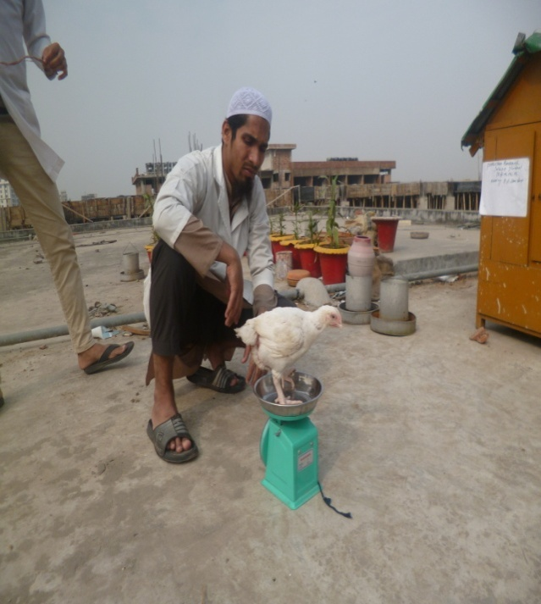
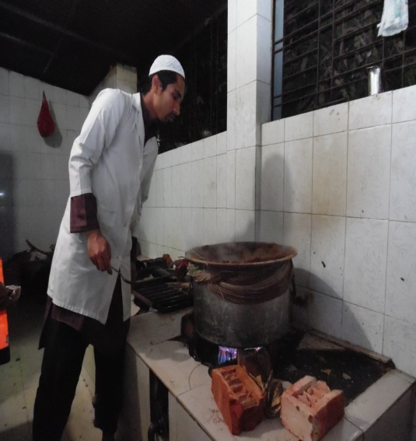
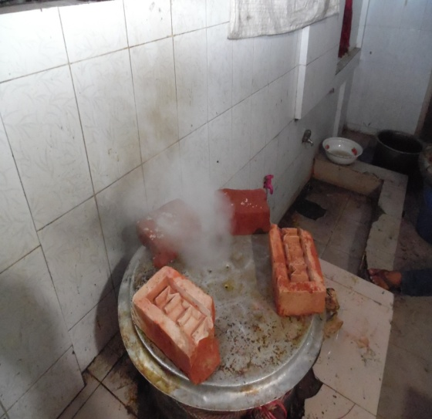
Fig 1: Making steamed sawdust
Fig 2: Sweetish odor from steamed sawdust

steamed sssssssteamed sa
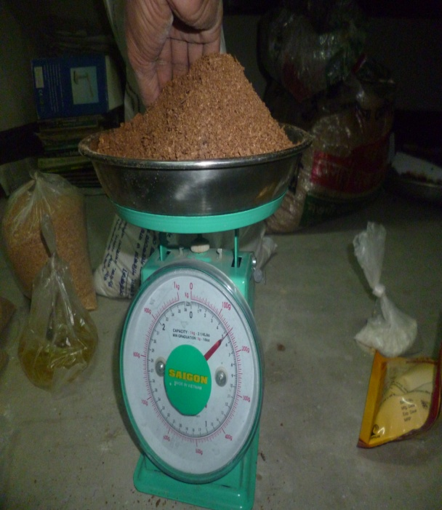
Fig 4: Weight measuring of broiler
Fig 3: Weighing of ingredients

Fig 6: Slaughtering of bird by halal method
Fig 5: Broiler shed

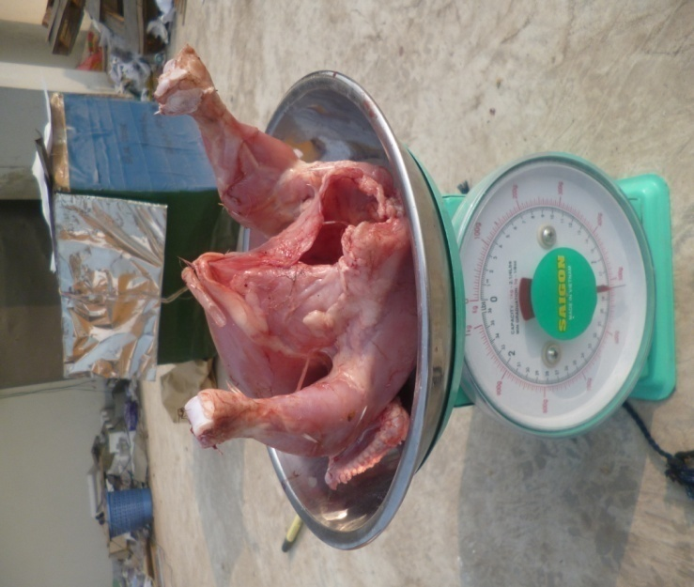

Fig 8: Weight measuring of abdominal fat
Fig 7: Weight measuring of dressed carcass

CHAPTER III: RESULTS
Table-03: Recorded body weights and feed intake of broilers
SL No. of broilers | IBW (gm) | FBM (gm) | Wt gain (gm) | Feed intake (gm) | Adjusted FCR
1 | 800 | 1240 | 440 | 700 | 1.59
2 | 700 | 970 | 270 | 700 | 2.59
3 | 790 | 1120 | 330 | 700 | 2.12
4 | 680 | 920 | 240 | 700 | 2.92
5 | 790 | 1050 | 260 | 700 | 2.69
6 | 760 | 1020 | 260 | 700 | 2.69
7 | 820 | 1260 | 440 | 700 | 1.59
8 | 740 | 1020 | 480 | 700 | 2.50
9 | 780 | 1040 | 260 | 700 | 2.69
10 | 710 | 1000 | 290 | 700 | 2.41

Here , initial body weight (IBW) was measured from 22 day’s old broiler and final body weight (FBW) was measured from 29 day’s old broiler.

Table-04: Recorded dressed weight and fat weight of broilers
SL No. | Live wt (gm) | Dressed wt (gm) | Dressing % | Fat wt (gm) | Fat %  (Live wt)
1 | 1240 | 690 | 55.60 | 23 | 1.85
2 | 970 | 530 | 54.64 | 17 | 1.75
3 | 1120 | 620 | 55.36 | 19 | 1.69
4 | 920 | 520 | 56.52 | 11 | 1.20
5 | 1050 | 590 | 56.19 | 16 | 1.52
6 | 1020 | 560 | 54.90 | 15 | 1.50
7 | 1260 | 700 | 55.55 | 22 | 1.75
8 | 1020 | 550 | 53.92 | 16 | 1.57
9 | 1040 | 580 | 55.77 | 15.50 | 1.49
10 | 1000 | 550 | 55.00 | 15 | 1.50

Here, live weight means weight of broilers at 29 days old.
Table-05: Ten (10) broilers grouped three replications where R₁ and R₂ have 3 birds and R₃ has 4 birds respectively. Production performance of growing broiler fed on diets containing 8% steamed sawdust
Age | Replication | Traits
 |  | Initial  BW (gm) | Final  BW (gm) | Wt. gain (gm) | Feed intake (gm) | FCR
22 days | R₁ | 763.33
 | R₂ | 743.33
 | R₃ | 762.50
29 days | R₁ |  | 1110 | 346.67 | 700 | 2.02
 | R₂ |  | 996.66 | 253.33 | 700 | 2.76
 | R₃ |  | 1080 | 317.50 | 700 | 2.20
Average |  | 756.39 | 1062.22 | 305.83 | 700 | 2.33

Average feed intake per bird is 700 gm. FCR of the three replication R₁, R₂ and R₃ are 2.02, 2.76, and 2.20 respectively. Average initial and final live weights are 756.39 and 1062.22 gm respectively.
Table-06: Carcass characteristics
Traits | Replication | Live wt (gm) | Dressing wt (gm) | Dressing % | Fat wt (gm) | Fat %
Dressing yield | R₁ | 1110 | 613.33 | 55.25
 | R₂ | 996.66 | 556.66 | 55.85
 | R₃ | 1080 | 595.00 | 55.09
 | Average | 1062.22 | 588.33 | 55.40
Fat yield | R₁ |  |  |  | 19.67 | 1.77
 | R₂ |  |  |  | 14.00 | 1.40
 | R₃ |  |  |  | 17.13 | 1.59
 | Average |  |  |  | 16.93 | 1.59

Dressed weight and fat weight of broilers in R₁ group is higher than others group.
Table-07: Cost analysis
Replication | Adjusted FCR | Feed cost per kg | Feed cost per kg live wt | Revenue per kg live wt
R₁ | 2.02 | 33.61 | 67.89 | 62.11
R₂ | 2.76 | 33.61 | 92.76 | 37.24
R₃ | 2.20 | 33.61 | 73.94 | 56.06
Average | 2.33 | 33.61 | 78.20 | 51.80

Here, Revenue per kg live weight = Market price per kg live wt – feed cost per kg live wt. Market price per kg live wt. = 130 taka. Feed cost per kg live wt = Feed cost per kg feed * Adjusted FCR
DISCUSSION
Traditionally, the salient criteria for appraising the performance of broiler have been growth rate and FCR and less frequently, carcass composition (Cahaner et al., 1987; Cabel and Waldroup, 1991; Smith and Pesti, 1998; Rzaei et al., 2004). Weight gain of growing broilers fed on diets containing 8% steamed sawdust varies from bird to bird due to variation in initial body weight of birds. Average feed intake per bird is 700 gm per day. Feed intake per day decreased because first 21 days broilers fed on pellet feed. Fibre reduces the density of diets (Savory and Gentle, 1976). Fibre level (8%) in that broiler fed is within recommended level by Heuser et al., 1945 (maximum 9%). Steaming was done in sawdust for increasing the digestibility of sawdust. Trace amount of enzyme also added to increase the digestibility of sawdust. Feed cost per kg live weight of broiler is calculated based on adjusted feed conversion ratio (FCR). Revenue per kg live weight of broiler is calculated only on the basis of feed cost per kg live weight gain and market price of per kg live weight. The deterministic model by Groen et al., (1998) is flexible. Economic values can be derived with different basis of evaluation, that is per individual broiler, per unit of products etc.
According to the Breeding Company, birds consume 1003 and 1836g feed respectively up to 21 and 28 days with corresponding FCR value of 1.31 and 1.46 respectively (Cobb-500, Commercial Broiler Management Guide, 2004). In this study, broiler consumed 700 gm feed per day with average Adjusted FCR is 2.33. In this study, adjusted FCR is higher than normal level.
Ahmed (1999) found maximum profit of 22.14 Tk/bird in Arbor Acre broilers. Another report of the same author also stated maximum profit of Tk. 19.47 in the same type of bird comparing with those of i757 (Tk. 15.92) and Starbro (Tk. 15.23) respectively. Since profit from different group of birds in this study was calculated as Tk/kg live bird, the results could not be related to the findings of this study. In this study, the average revenue per kg live bird is 51.80 taka on the basis of feed cost per kg live bird and market price per kg live bird. There is no death of bird during this study period. So, mortality rate is 0% in this study.
LIMITATIONS
During my study period following limitations were observed:
a. Short duration of the study period.
b. Sample size was very small.
c. Broilers fed on pellet fed from DOC to 21 day old.

CONCLUSION

The result of the experiment shows that steamed sawdust can be used in broiler ration as unconventional feed ingredients. During scarcity of conventional feed ingredients it can be used to fill up gap and to minimize the feed cost. Steamed sawdust treated with enzyme for 7 days had the most beneficial effect on the growth and other performance and carcass characteristics of the experimental broiler chickens. Economy of production also favoured the use of steamed sawdust for 7 days and incorporated at 8% inclusion level.

It is concluded that consumption of steamed saw dust may have commercial application in poultry diet to improve nutrient digestibility and production performance.

REFERENCES
- Aduku, A. O., 1993. Tropical Feed Stuff Analysis. Pluto Publ. Zaria, pp: 28.
- Ahmed, S. U., 1999. Performance of different strains of broilers in rainy, winter and summer seasons of the year. BAU Res. Prog., 10 : 94-95.
- Amerah, A. M., Ravindran, V., Lentle, R.G., Thomas, D.G., 2007. Effects of fibre source and whole wheat inclusion on the performance, starch digestibility and gut parameters of broiler chickens, Asia Pac J Clin Nutr, 16 (Suppl 3): S59.
- Cabel, M. C., and Waldroup, P.W., 1991. Effect of dietary protein level and lengthof feeding on performance and abdominal fat content of broiler chickens. Poultry science, 70:1550-1558.
- Cahaner, A., Dunnington, E.A., Jones, D.E., Cherry, J.A. and Siegel, P.B., 1987. Evaluation of two broiler lines differing in efficiency of feed utilization. Poultry Science, 66:1101-1110.
- Cobb-500, 2004. Commercial Broiler Management Guide. The Cobb Breeding Company Ltd. East Hanningfield, Chelmsford, ESSEX, CM3 8BY, United Kingdom.
- Cummings, J. H., (1973) Dietary fiber. Gut 14, 69-81.
- Ekenyem, B.U., 2007. Effect dietary inclusion of 1pomea ascarifolia Leaf meal on the performance of carcass and organ Characteristics of grower pigs. Advances in Science and Technology, pp 87-91.
- Ekenyem, B.U., 2007. Effect dietary inclusion of 1pomea ascarifolia Leaf meal on the performance of carcass and organ Characteristics of grower pigs. Advances in Science and Technology, pp 87-91.
- Esonu, B.O., Ihekwumere, T.C., Iwuji, N., Akanu and Nwugo, O. H., 2003. Evaluation of Microdesmis puberula leaf meal as a feed ingredient in broiler starter diets. Nigeria Journal of Animal Production, pp 3-7.
- Fisher, H., Siller, W. G., & Grimminger, P., 1966. The retardation by pectin of cholesterol-induced atherosclerosis in the fowl. J., Atheroscler. Res. 6, 292-298.
- Groen, A. F., Jiang,X., Emmerson, D.A., and Verijken,A., 1998. A deterministic model for the economic evaluation of broiler production systems. Poultry Sci. 77:925-933.
- Hetland, H., Choct, H., and Svihus, B., 2004. Role of insoluble non-starch polysaccharides in poultry nutrition. World's Poultry Science Journal (2004), 60:415-422.
- Heaton, K. W., 1976. Fiber, blood lipids, and heart disease. Am. J. Clin. Nutr. 29, 125-126.
- Heuser, G.F., Morris, L.C., Peeler, H.T., and Scott, M.L., 1945. Futher study on the apperent effect of digestibility upon growth. Poul. Sci., 16: 2232-2240
- Huque, Q. M. E., 2008. Poultry industry in Bangladesh and strategies for its improvement, Second International Poultry Show and Seminar, 16-17`h February, 2008. Word's Poultry Science Association of Bangladesh BranAdelina, P.U.; 2002. Replacement Value of Sweet Potato (Ipomoea batatas) for Maize in Broiler diets. M.ScThesis, ATBU Bauchi.
- Menge, H., Littlefield, L. H., Frobish, L. T., & Weinland, B. T., 1974. Effect of cellulose and cholesterol on blood and yolk lipids and reproductive efficiency of the hen. J. Nutr. 104, 1554-1566.
- Mmereole, F.U.C., 1996. The study haematological parameters in the Nigerian local chicken. Nig. J. Anim. Prod., 1: 94-97.
- Mmereole, F.U.C., 2008. Effects of replacing groundnut cake with rubber seed meal on the haematological and serological indces of broilers. In. J. Poult. Sci., 7: 622-624.
- PAN. 1995. Annual Reports, Poultry Association of Nigeria, Lagos, Nigeria, 33:3437.
- Rezaei, M., Nassiri, H., Moghaddam, Pour Reza, J., and Kermanshahi, H., 2004. The effect of dietry protein and lysine levels on broilers performance and carcass characteristics and N. Excretion. Int. J. Poultry Sci., 3(2): 148-152.
- Savory, C.J., and Gentle, M.J., 1976. Changes in food intake and gut size in Japanese quail in response to manipulation of dietary fibre content. Br. Poul. Sci., 17: 271-280.
- Smith, E.R., Pesti, G.M., Bakalli, R.I., Ware, G.O., and Menten, J.F., 1998. Further studies on the influence of genotype and dietery protein on the performance of broilers. Poultry Science, 77: 1678-1687.

- Sonnaiya, EB.O., Atumbi, A., and Dare, A. C., 1997. An assessment of Health and production costs for small-holder poultry in South-Western Nigeria. In: Sustainable Rural Poultry Prodution in Africa. African Network for Rural Poultry Development pp: 89-93.
- Tasaki, I., & Kibe, K., 1959. A study on the digestion of cellulose in poultry. PoultrySci. 38, 376-379.

ACKNOWLEDGEMENTS
All praises are due to the Almighty Allah, the creator and supreme authority of the universe, who empowers me to strength and opportunity to complete the report successfully.
I would like to extend my gratitude to my supervisor, MD. Akhtar-uz-Zaman, Professor, Department of Dairy and Poultry Science, Faculty of Veterinary Medicine, Chittagong Veterinary and Animal Sciences University, . My heartfelt thanks to him for valuable guidance, suggestion, supervision and encouragements during the entire period of this study to complete this production report.
I would like to thanks to the Director of External affairs, Professor Dr. A.K.M Shaifuddin, Dept. of Physiology, Biochemistry and Pharmacology, Chittagong Veterinary and Animal Sciences University for his suggestion.
I would like to express my heart felt appreciation and thanks to all staffs of department of Dairy and Poultry Science, Chittagong Veterinary and Animal Sciences University for their kind cooperation during the study period
I would like to express my deep sense of gratitude and thanks to Professor Dr. Md. Ahasanul Hoque, Dean, Faculty of Veterinary Medicine, Chittagong Veterinary and Animal Sciences University.
Last but not least, I am profoundly grateful to my family members for their endless sympathies, kind co-operation, sacrifices and prayers.
Author

BIOGRAPHY
Mohaiminul Islam; son of Late Md. Fasiul Alam and Begum Rokeya Ferdousi passed the Secondary School Certificate Examination in 2008 followed by Higher Secondary School Certificate Examination in 2010. Now he is an interns’ student of Doctor of Veterinary Medicine in CVASU. His favorite hobby is reading books; scientific journals and he want to be an honest Veterinarian. He has immense interest to work on pet animal infectious diseases.

