CHAPTER-I

INTRODUCTION
Humans maintain wild animals in zoological parks for the purposes of education, conservation, research, and recreation. However, abnormal behaviors may develop in animals housed in human-made environments, if those environments do not allow them to carry out their natural behaviors (such as swimming, climbing, stalking, and predation).The Bengal tiger, also called the Royal Bengal tiger (Panthera tigris tigris), is the most numerous tiger subspecies. It is the national animal of both India and Bangladesh (Chundawat et al., 2011) by 2011; the total population was estimated at fewer than 2,500 individuals with a decreasing trend. None of the Tiger Conservation Landscapes within the Bengal tiger's range is considered large enough to support an effective population size of 250 adult individuals. Since 2010, it has been classified as endangered by the IUCN (Lytton, E. 1841). Presently, five sub-species of tigers have been recognized as existing in the world. Bengal tiger (Panthera tigris tigris) is one of the most beautiful sub-species for its royal beauty, for which it is called Royal Bengal tiger (distribution specially in Sundarban of Bangladesh & India, also few area in Nepal, Bhutan & North-west of Myanmar). The Royal Bengal tiger is an excellent indicator species for the health of the Sundarbans (Ali Reza, et al. 2000). It is a solitary animal that inhabits in thorny, dry or moist, deciduous, semi-evergreen, mangrove, swamps, grassland etc. In a group, one tiger ‘owns’ the territory, 1 or 2 are extremely low ranking & the rest share a central social position (Fraser, et al. 1991). The population of free ranging Bengal tigers in Bangladesh (Sundarban) by 2016 was about 106 (Tiger census by IUCN and UNDP). The Bengal tiger's coat is yellow to light orange, with stripes ranging from dark brown to black; the belly and the interior parts of the limbs are white, and the tail is orange with black rings. The white tiger is a recessive mutant of the Bengal tiger, which is reported in the wild from time to time in Assam, Bengal, Bihar and especially from the former State of Rewa. However, it is not to be mistaken as an occurrence of albinism. In fact, there is only one fully authenticated case of a true albino tiger, and none of black tigers, with the possible exception of one dead specimen examined in Chittagong in 1846 (McDougal, C. 1977). Male Bengal tigers have an average total length of 270 to 310 cm (110 to 120 in) including the tail, while females measure 240 to 265 cm (94 to 104 in) on average (Mazak V., 1981). The tail is typically 85 to 110 cm (33 to 43 in) long, and on average, tigers are 90 to 110 cm (35 to 43 in) in height at the shoulders (Karanth, K. U., 2003)The weight of males ranges from 180 to 258 kg (397 to 569 lb), while that of the females ranges from 100 to 160 kg (220 to 350 lb) (Barlow, A. 2010). The smallest recorded weights for Bengal tigers are from the Bangladesh Sundarbans, where adult females are 75 to 80 kg (165 to 176 lb) Bengal tigers have exceptionally stout teeth, and the canines are the longest among all living felids; measuring from 7.5 to 10 cm (3.0 to 3.9 in) in length (Sunquist, M, 2002). Bangladesh having 6 zoos and 2 safari park
One reason for the shift to “naturalistic” exhibition styles was an increased public concern for animal welfare. Many animals in captivity perform abnormal behaviors known as “stereotypes’” (Carl stead, 1996). Stereotypic behavior can be described as a pattern of movement such as pacing and head bobbing that is performed repeatedly, is relatively invariant in form, and has no apparent function or goal (Carl stead, 1996). Such behaviors are rarely seen in wild animals; therefore they are considered an indication of stress. Stereotypes’ occur in many species and are thought to have a variety of causes. For example, they may arise when animals are consistently unable to reach a goal, such as natural feeding behavior (Carl stead, 1996; Rushen and de Passille, 1992; Shepherdson et al., 1993). Shepherdson et al. (1993) found that captive felids often spent the time prior to feeding performing stereotypic pacing behaviors. Duckler (1998) found that the skulls of captive tigers had distinctively malformed external occipital protuberances that are not found in wild specimens. These were caused by excessive grooming behavior in the captive tigers and a reduction in the jaw muscles due to eating processed food (Duckler, 1998). 13 Stereotypic behavior may also appear when an animal is physically restrained from moving to a desired place. For example, Meyer-Holzapfel (1968) found that a dingo (Canis familiaris dingo) separated from its pack, paced in a figure-eight pattern along the separating barrier. Stereotypes’ may also develop from other behavioral and physiological stresses, such as boredom, physical restraint, fear, or frustration (Carl stead, 1996). The limitation of space is thought to be another cause of stereotypic behavior. In most cases, the smaller the enclosure, the more likely the animal will display stereotypes’ (Carl stead, 1996). However, it would be difficult to determine the exact amount of space that an animal needs to avoid developing stereotypic behaviors. Draper and Bernstein (1963) found that changes in the physical dimensions of the captive environment were often accompanied by a marked change in behavior. Lyons et al. (1997) studied the behavior pattern of 19 captive felid species and found that the cats in relatively larger enclosures had a higher level of exploratory behavior. Low stimulus diversity is yet another factor influencing stereotypic behavior. In sterile environments, captive animals often appear to be “bored” or lethargic due to a lack of stimulation. Carl stead (1996) reports two ways that captive animals adapt to low stimulus environments: (1) they decrease the stimulus-seeking behavior (lethargy), or (2) they attempt to satisfy the stimulus-seeking behavior through other means (stereotypes’). Common stereotypes’ in felids include pacing, head-twisting, tail and toe sucking, and fur plucking (Wooster, 1997).Mellen et al. (1998) found that the relationship between pacing and several variables that characterize the physical and social environment was a useful measure of well being in small captive felids. Preventing Stereotypic Behavior Through Environmental Enrichment According to Shepherdson et al. (1998) environmental enrichment “is an animal husbandry principle that seeks to enhance the quality of captive animal care by identifying and providing the environmental stimuli necessary for optimal psychological and physiological well-being”. Environmental enrichment includes a wide variety of techniques. For instance, food can be 14 hidden throughout exhibits to entice animals to perform hunting behaviors; wood blocks or logs can be given to satisfy felid scratching behavior when trees are not available; stimulating scents can be spread throughout enclosures; and sterile concrete enclosures can be replaced with natural substrate and vegetation. Environmental enrichment programs are important in that they provide for the well being of the animals, allow the animals to display “natural” behaviors to the public, and increase reproductive success (Shepherdson et al., 1998). Adding natural substrate, vegetation, water features, rocks, and other features not only makes the environment more pleasant for the animals, but it also increases the educational value of zoo exhibits for visitors. Poole (1998) explains that the captive environment should be sufficiently complex to allow a full range of locomotors activities, including walking, climbing, swimming, or burrowing as appropriate to the species concerned. In the wild, a mammal chooses a living area that offers suitable facilities for its needs, so the zoo manager should do the same for those in his care. Carl stead (1998) illustrates that making the environment more complex and unpredictable can reduce stereotypic behavior; by providing stimuli, you reduce the tiger’s desire to perform a negative behavior (Carl stead, 1998). In planning for environmental enrichment, scale (Seidensticker and Forthman, 1998), vertical spacing, and horizontal spacing (Mench, 1998) are three important spatial factors that should be considered. In captivity, large animals are placed in scaled-down versions of the natural environment. All aspects of the natural environment should be included in the captive enclosure, and planning by scale is important to ensure that this criterion is met (Seidensticker and Forthman, 1998). Vertical and horizontal spaces, including height, levels, and angles are also important in planning zoo exhibits as they are a part of the “natural” world that are often left out of exhibit design. Deroo (1993) emphasizes the importance of vertical and horizontal spacing, as “space can be used to create a safe, enriching environment that encourages and rewards natural behavior…[A] boulder, an incline, a well-placed tree or stream can give an animal an illusion of space, as well as the distance it needs from other animals.” Mammals live 15 in complex three-dimensional habitats, and their captive environments should reflect a similar topography (Poole, 1998)

Objective:
- To know the status of Royal Bengal tigers in Bangladesh.

CHAPTER-II

MATERIALS AND METHODS
2.1. Methods:
- Visiting
- Observation
- Interview
- Photography
2.2. Study area:
The study area was different zoo of Bangladesh (Dhaka Zoo, Khulna Zoo, Rangpur Zoo) and safari park (Bangabondhu Sheikh Mujib safari park, dulahazra, Cox’s bazar and Bangabondhu safari park, Gazipur).
2.3. Study design:
A cross-sectional study was done by pre-questionnaire.

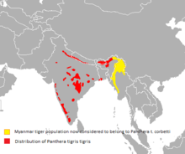

Figure-1: Distribution Of Royal Bengal Tiger in The World

2.4. Tiger related information:
2.4.1. Feeding:
Tigers are carnivores. They prefer hunting large ungulates such as chital, sambar, gaur, and to a lesser extent also barasingha, water buffalo, nilgai, serow and takin. Among the medium-sized prey species they frequently kill wild boar, and occasionally hog deer, muntjac and grey langur. Small prey species such as porcupines, hares and peafowl form a very small part in their diet. Because of the encroachment of humans into their habitat, they also prey on domestic livestock (Andheria, A. P, 2007).
2.4.2. Breeding:
The tiger in Bangladesh and India has no definite mating and birth seasons. Most young are born in December and April. Young have also been found in March, May, October and November. In the 1960s, certain aspects of tiger behavior at Kanha National Park indicated that the peak of sexual activity was from November to about February; with some mating probably occurring throughout the year Males reach maturity at 4–5 years of age, and females at 3–4 years. A Bengal comes into heat at intervals of about 3–9 weeks, and is receptive for 3–6 days. After a gestation period of 104–106 days, 1–4 cubs are born in a shelter situated in tall grass, thick bush or in caves. Newborn cubs weigh 780 to 1,600 g (1.72 to 3.53 lb) and they have a thick wooly fur that is shed after 3.5–5 months. Their eyes and ears are closed. Their milk teeth start to erupt at about 2–3 weeks after birth, and are slowly replaced by permanent dentition from 8.5–9.5 weeks of age onwards. They suckle for 3–6 months, and begin to eat small amounts of solid food at about 2 months of age. At this time, they follow their mother on her hunting expeditions and begin to take part in hunting at 5–6 months of age. At the age of 2–3 years, they slowly start to separate from the family group and become transient — looking out for an area, where they can establish their own territory. Young males move further away from their mother's territory than young females. Once the family group has split, the mother comes into heat again (Sanderson, G. P., 1912).

2.4.3. Vaccination:
In captive condition only Tryphanosomiasis Vaccine is given to the tiger at early age of 6 month.
2.4.4. Deworming:
In carnivores commonly Anthelmentics were used because they are highly susceptible to gut acting parasites

2.4.5. Habitation:
Due to some practical limitations, the study has covered a period of 3month duration. During this period, population was very healthy and good birth rate with is total of 27 tigers. At present (on October 2016) the population is 25. Two (1 males 1 female) had died and the record of causes of death was collected. Data was collected by prepared questionnaire with following information age, sex, feeding, management status, rearing system and baby management.

CHAPTER-III
RESULTS AND DISCUSSION
Table-1: Status of Tiger:
Name of zoo and safari park | Number of Tigers
Dhaka zoo | 7 (4 female+3 male)
Khulna zoo | 2 (1 female+1 male)
Rangpur zoo | 2 (1female+1 male)
Bangabondhu Sheikh Mujib safari park, Dulahazra, Cox’s Bazar | 4 (2 female+1 male+1 cub)
Bangabondhu safari park, Gazipur | 10 (4 female+4male+2 cub)
Besides this the population of free ranging Bengal tigers in Bangladesh (Sundarban) by 2016 is about 106 (Tiger census though pug mark), But previously the population of royal Bengal tiger was about 445 in the year of 2005 (Tiger census by IUCN and UNDP). It indicates that the tiger population in free range decreasing day by day. 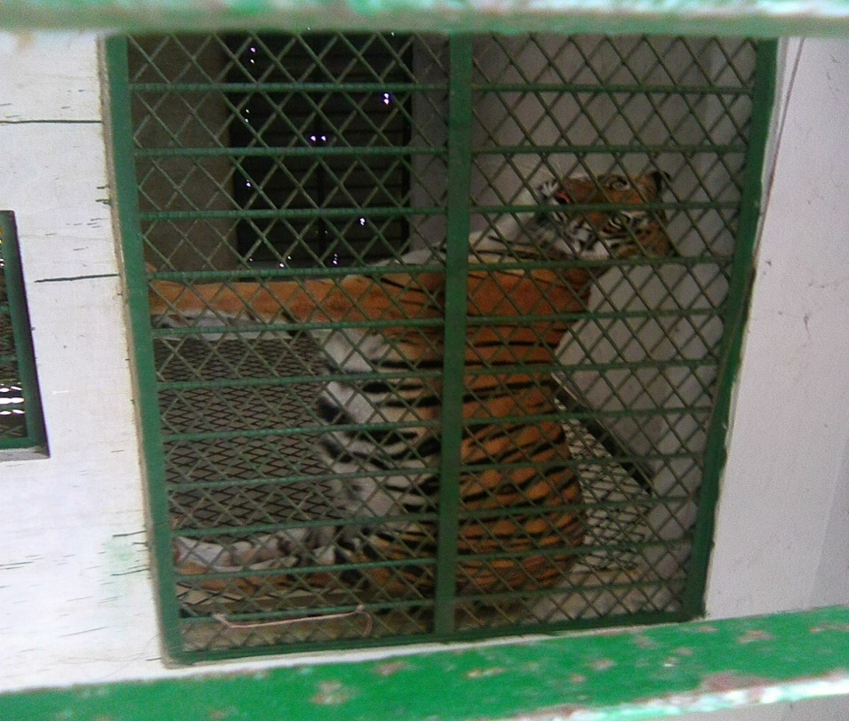
Figure-2: Royal Bengal Tiger at Dulahajra safari park
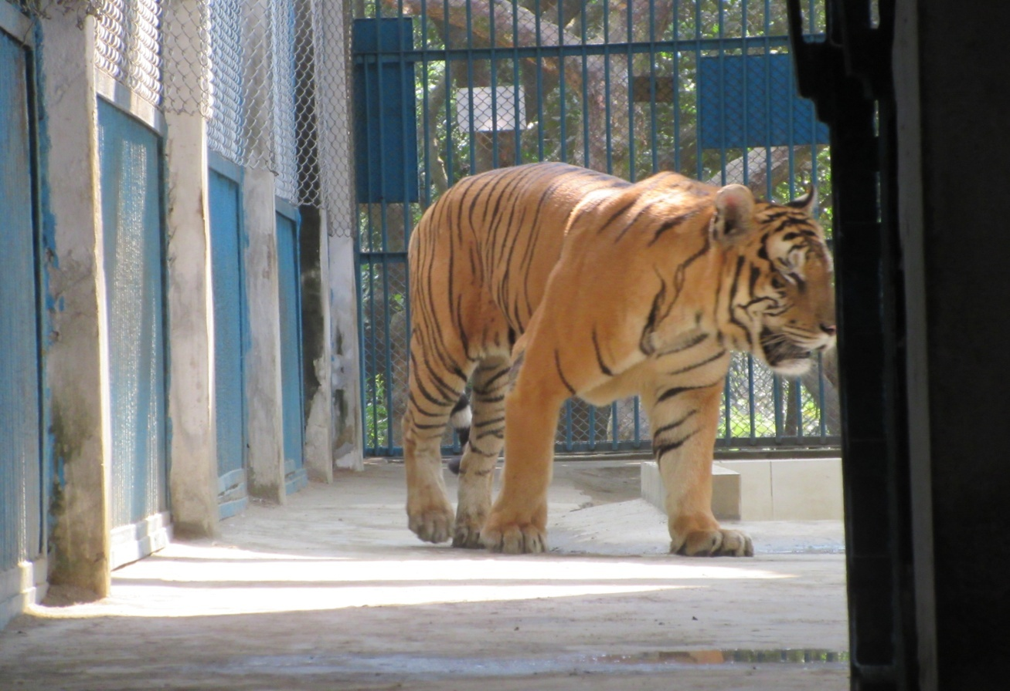
Figure-3: Royal Bengal Tiger at Dhaka zoo

Now in captivity total population of royal Bengal tiger is 25. In some zoo (Chittagong, comilla and Rajshai zoo) previously have tiger but now absent due to death.
Table-2:Status of Feeding:
Name of zoo and safari park | Feed supply (meat)
Dhaka zoo | 12 kg meat per day/adult tiger
Khulna zoo | 6 kg meat per day/ adult tiger
Rangpur zoo | 5.5 kg meat per day/ adult tiger
Bangabondhu Sheikh Mujib Safari Park, Dulahazra, Cox’s Bazar | (5-7) kg meat per day/ adult tiger
Bangabondhu Safari Park, Gazipur). | (6-8) kg meat per day/ adult tiger

In captivity except Sunday (off day considering the tiger’s health condition), every day for each adult tiger, beef, liver & Vitamin - mineral premix were supplied. Once a week poultry is provided.

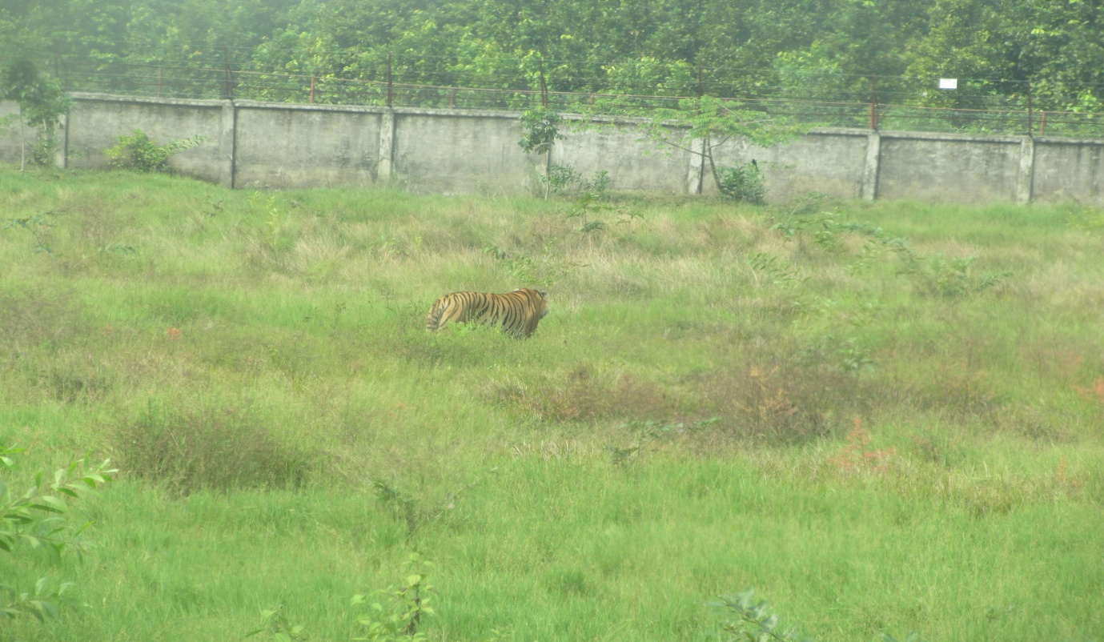

Figure-4: Royal Bengal Tiger at Bongabhondu safari park,Gazipur

Status of Habitation
To study the habitat status, an observation of 45 days was conducted. Condition of the shed, water house, space measurement, quality of protection net and bar were observed. Excluding the moat, all the sheds were not so naturalistic and had no privacy for the animals from visitors.
Status of Breeding:
The observed ratio (male: female) was not satisfactory, which was very difficult to manage. Male tigers were in the moat and it was not possible to free them all at a time because of dominant behaviors. The zoo caretaker’s psychological signals helped to manage them. In this stipulated time one pair was donated to the Dulahazra safari park, Cox’s Bazar, Bangladesh, another pair was donated to the Jahanabad cantonment zoo, Khulna, but this exchange is not properly maintain. Exchange is difficult because different zoo are under the different authority.
- Dhaka and Rangpur zoo under livestock department
- Rajshai and Barisal zoo under city corporation
- Chittagong zoo under district commissioner office
- Khulna zoo under Khulna cantonment
- Bangabondhu Sheikh Mujib safari park, Dulahazr, Cox’s Bazar under Bangladesh forest department
- Bangabondhu safari park, Gazipur under Bangladesh forest department

CHAPTER-IV
CONCLUSIONS
Zoo and safari park are very nice place for breeding, conservation of endangered animals but due to lack of proper breeding policy, many problems are faced. Due to inbreeding effects, weak kittens with various nervous syndromes, developmental anomalies occur and many unnatural behaviors are observed. It is very difficult to manage the animals during medical problems, as Dhaka zoo has no squeeze cage facility with proper equipments. Severe economic loss of managing this large group should be considered also. Male and female ratio and habitat constraints are also major areas of concern. Increasing the area of the tigers and immediate reconstruction of the sheds to make them naturalistic. considering the inbreeding effects, feed cost minimization (economic), male and female ratio and habitat constraints - a complete and long term breeding road map is needed for maintenance of proper book keeping. Animal exchange programme should be strengthened. Adequate laboratory facilities and a complete veterinary unit should be developed in Dhaka zoo, Bangladesh. Print and audio-visual media should take active part with positive reporting. Regular training, workshop and seminars should be arranged to identify, solve the problems and related matters. This will improve research also. Zoo legislation or act should be prepared at the earliest

REFERENCE

Ali Reza, A. H. M., M. M. Chowdhury and C. Santiapillai (2000). Tiger paper, January - March. 27(1): 1-5.
Andheria, A. P.; Karanth, K. U.; Kumar, N. S. (2007). "Diet and prey profiles of three sympatric large carnivores in Bandipur Tiger Reserve, India". Journal of Zoology. 273 (2): 169–17. doi:10.1111/j.1469-7998.2007.00310.x
Brander, A. (1923). Wild Animals in Central India. Edwin Arnold & Co., London.
Chundawat, R. S., Khan, J. A., Mallon, D. P. (2011). "Panthera tigris tigris". IUCN Red List of Threatened Species. Version 2015.2. International Union for Conservation of Nature.
Chundawat, R. S., Khan, J. A., Mallon, D. P. (2011). "Panthera tigris tigris". IUCN Red List of Threatened Species. Version 2015.2. International Union for Conservation of Nature.
Dinerstein, E. (2003). Return of the Unicorns. Columbia University Press. ISBN 0-231-08450-1
Fraser M. C, J. A. Bergeron, A. Mays and S.E. Aiello (1991). The Merck Veterinary Manual.
Global Tiger Initiative. (2011). Global Tiger Recovery Program 2010–2022. Global Tiger Initiative Secretariat, Washington.
Gopalaswamy, A. M., Delampady, M., Karanth, K. U., Kumar, N. S., Macdonald, D. W. (2015). "An examination of index-calibration experiments: counting tigers at macroecological scales". Methods in Ecology and Evolution. early view. 6 (9): 1055–1066. Doi:10.1111/2041-210X.12351.
J Hewett, J. P., Hewett Atkinson, L. (1938). Jungle trails in northern India: reminiscences of hunting in India. Metheun and company limited, London.
Jhala, Y. V., Qureshi, Q., Sinha, P. R. (Eds.) (2011). Status of tigers, co-predators and prey in India, 2010.National Tiger Conservation Authority, Govt. of India, New Delhi, and Wildlife Institute of India, Dehradun. TR 2011/003 pp-302
Karanth, K. U. (2003). "Tiger ecology and conservation in the Indian subcontinent". Journal of the Bombay Natural History Society. 100 (2–3): 169–189. Archived from the original on 10 March 2012.
Karanth, K. U. (2003). "Tiger ecology and conservation in the Indian subcontinent". Journal of the Bombay Natural History Society. 100 (2–3): 169–189. Archived from the original on 10 March 2012.
Kitchener, A. (1999). Tiger distribution, phenotypic variation and conservation issues. Pages 19–39 in: Seidensticker, J., Chardback ISBN 0-521-64057-1, paperback ISBN 0-521-64835-1
Kitchener, A. C.; Dugmore, A. J. (2000). "Biogeographical change in the tiger, Panthera tigris". Animal Conservation. 3 (2): 113–124. i:10.1111/j.1469-1795.2000.tb00236.x.
Lytton, E. (1841). The Critical and Miscellaneous Writings of Sir Edward Lytton, Vol. 2, page 167.
Lytton, E. (1841). The Critical and Miscellaneous Writings of Sir Edward Lytton, Vol. 2, page 167
Mazák,V(1981). "Pantheratigris" (PDF). MammalianSpecies (152):18. doi:10.2307/3504004.JSTOR 3504004
Mc Dougal, C. (1977). The Face of the Tiger. Rivington Books and André Deutsch, London
McDougal, C. (1977). The Face of the Tiger. Rivington Books and André Deutsch, London.
Mohan, V. (2015). India's tiger population increases by 30% in past three years; country now has 2,226 tigers. The Times of India, Delhi.
NTNC (2013). "NTNC Chairman Released the Recent Tiger Number in Nepal". Kathmandu: National Trust for Nature Conservation.
Pocock, R. I. (1929). "Tigers". Journal of the Bombay Natural History Society. 33: 505–541.
Sanderson, G. P. (1912). Thirteen years among the wild beasts of India: their haunts and habits from personal observations; with an account of the modes of capturing and taming elephants. John Grant, Edinburgh.
Sangay, T., Wangchuk, T. (2005). Tiger Action Plan for Bhutan 2006–2015. Nature Conservation Division, Department of Forests, Ministry of Agriculture, Royal Government of Bhutan and WWF Bhutan Programme, Thimphu.
Smith, J. L. D.; Sunquist, M. E.; Tamang, K. M.; Rai, P. B. (January 1983). "A technique for capturing and immobilizing tigers". The Journal of Wildlife Management. 47 (1): 255–259. doi:10.2307/3808080. JSTOR 3808080.
Sterndale, R. A. (1884). Felis Tigris. No. 201 in: Natural History of the Mammalia of India and Ceylon. Thacker, Spink and Co., Calcutta.
Sunquist, M.; Sunquist, F. (2002). Wild Cats of the World (1st. Ed.). University of Chicago Press. pp. 7–350. ISBN 978-0-22-677999-7.
Sunquisti, M.; Sunquist, F. (2002). Wild Cats of the World (1st. ed.). University of Chicago Press. pp. 7–350. ISBN 978-0-22-677999-7.
University of Oxford. (2015). "Flawed method puts tiger rise in doubt, calls for new approach." Science Daily, 23 February 2015
Wood, G. (1983). The Guinness book of animal facts and feats. i Co. Inc., 3rd ed., ISBN 978-0-85112-235-9

ACKNOWLEDGEMENTS
All praises are due to the Almighty Allah, the creator and supreme authority of the universe, who empowers me to strength and opportunity to complete the report successfully.
I would like to extend my gratitude to my supervisor, Professor Dr.Gouranga Chandra Chanda, Dept. of Dairy and poultry science, Chittagong Veterinary and Animal Sciences University. My heartfelt thanks to him for valuable guidance, suggestion, supervision and encouragements during the entire period of this study to complete this production report.
I would like to express my deep sense of gratitude and thanks to Professor Dr. Md. Ahasanul Hoque, Dean, Faculty of Veterinary Medicine, And Professor Dr.A.K.M Saifuddin, External affairs, Chittagong Veterinary and Animal Sciences University.
Special thanks to DR.Mostafizur Rahman, Veterinary Surgeon, Veterinary Hospital, Bangabondhu Sheikh Mujib safari park, Dulahajra, Cox’s Bazar. For his constructive guidelines and admirable co-operation for performing this work.
Finally, The Author Expresses Thanks To All Of His Family Members, Friends, Seniors, Juniors For Their Cordial Helping Hands.

………………
Author
November, 2016

