CHAPTER-I
GENERAL INTRODUCTION

Quail is the smallest and latest domesticated poultry species. There are about 131 species and 17 to 18 varieties of wild quail found all over the world, of which Japanese, Bobwhite, King and Stable quail are most important. Japanese quails are natural inhabitant of Japan. Quails are reared in Japan from the time immemorial. The scientific name of Japanese quail is Coturnix coturnix japonica under the class aves and family Phasianoidea (Hashanuzzaman, 2013).

Poultry eggs and meat provide approximately 70% of total animal protein in India. India’s animal wealth is huge in terms of its population of cattle (204.5 million), buffaloes (84.2 million), poultry (800 million), sheep (50.8 million), goats (115.3 million) and pigs (12.8 million). Compared with the rest of the livestock sector the poultry industry in India is more. The protein consumption from animal origin in India is significantly lower than in other countries of the world. The annual average deficit of meat is 3.81 million metric ton and the annual avg. deficit of chicken egg is 6939 million numbers (Andrew, 2003). With the rapid increase in total population the demand for poultry products has been increasing. To meet up the growing demand for poultry products, the development of poultry industry is very important.

The popularity of quail husbandry is increasing all over the world. Quail farming for egg and meat is quite popular in Japan, Hongkong, Korea, China, Singapore, India, Thailand, Malaysia, Indonesia, France, Italy, Germany, Britain and Russia. Only Bobwhite quail and Japanese quail have been domesticated for commercial purposes.

The Namakkal-1 quail, reared for meat and egg under intensive management due to their low maintenance cost, early sexual maturity, higher exponential growth, higher heat tolerance, fitness for higher density rearing, higher disease resistance and higher egg production than that of other poultry species in Namakkal India. Short generation interval and quick business return and the requirement of low investment attracting people to rear them. It appears that quail rearing may be an important to chicken when chicken survived in hostile climates and also for havoc like avian influenza and salmonellosis. The climate and natural condition of Namakkal is very suitable for quail rearing. Quail can be reared in this State throughout the year with good performance in meat and egg production. It has a shorter life cycle and its production requires less capital and land (Vali et al., 2005).

The meat from broiler quail is very delicious and tasty. It is considered as a superior item in different restaurant and homes. One five week old broiler quail attains 190-210 gm body weight within 5 weeks of age and yields 72.5 % carcass for consumption.

Success in poultry farming depends on scientific breeding, feeding, management and disease control of the flocks. There is a relationship of Namakkal-1 quail (Japanese quails ) line to dietary energy levels and graded essential amino acid levels on growth performance and immuno-competence (Kaur et al., 2008).

Santos et al., 2011 worked with growth of quail broilers to establish the nutrient requirements and feeding practices suitable for quail under tropical and subtropical countries. For optimum growth of quail broilers, a diet containing 27% CP with 11.72 MJ ME/ Kg is recommended up to 2 weeks of age & a diet containing 24% protein with the same energy for birds from 3 to 5 weeks.

Genchev, 2012 reported that Japanese quail requires 14-18 hours of light per day to maintain maximum egg production and fertility. This means that supplementary lighting must be provided in the autumn, winter and spring months to maintain production. It was also observed that the storage length influenced the rates of egg mass loss during incubation and the hatching time (Romao et al., 2010).

Yalcin et al., 2006 studied the inheritance of carcass and meat quality of Japanese quail. According to this study heritability’s of carcass and meat quality traits in Japanese quail (Coturnix coturnix japonica) are moderate to high. Selection for increased and/ or decreased quail body weight has some correlated effects on meat quality trait.

The profitability in quail farming is possible by better management due to the above reasons. Reports on quail growth and body composition are numerous. The better growth performance and meat quality of broiler quail (Japanese quail) are supported by the findings of (Kaur et al., 2008 and Vali, 2008). The findings of their study clearly indicate that quail farming is a promising sector in poultry meat production.

Therefore the objectives of the present study were-
- To know the growth and production performance of Namakkal-1 quail (Japanese quail) under controlled housing.
- To familiar with cage brooding system of quail farm.
- To observe the total management of controlled housing system of quail rearing in Namakkal.

CHAPTER-II
MATERIALS AND METHODS

2.1 LOCATION AND DURATION OF THE STUDY:
The study was conducted at Namakkal Quail farm & hatchery, Namakkal India. It is a large quail farm which includes three rearing units and one hatchery. During observation, the total numbers of brooder cum grower, broiler and breeder quails were 4960,2050 and 5184 respectively.

2.2 HOUSING AND MANAGEMENT:
Housing system is most important. In case of Namakkal-1 quail farming, the housing system were California “M” type cage rearing system.
2.2.1 Floor space:
The house for rearing brooder was 37.4 ft long and 22.5ft wide and house for broiler was 87.3 ft long and 22.5 ft wide. The floor space for day old chicks up to 3 wks was 50 sq cm/ bird and from 3 weeks up to 5 wks (marketing age) it was 70 sq cm/bird.
2.2.2 Cage system and roof type:
California “M” type cage and Gable type roof.
2.2.3 Watering system and feeding system:
Automatic Nipple drinkers .One nipple or cup should be provided for every 5 birds. Manual feeding for broiler and semi- automatic feeding for breeder quail.Adult quail need 1.25-2.5 cm of feeder space per bird.
2. 2. 4 Pre incubation care of egg :
Eggs were collected from own hatchery, stored at a temperature 15°C and were fumigated after they are collected. Fumigation was done by using 25 gm of potassium permanganate and 35 ml of formalin (40%) for each cubic meter of incubator space.
2. 2. 5 Incubation and hatching:
The incubation period for quail is 17-18 days, depending on the strain and the incubation procedures. Successful hatches depend upon a good understanding of incubator controls.The incubation temperature was 38.3°C (101°F) which did not exceed 39.5°C (103°F) temperature until hatching was completed. Temperature was measured at the top of the eggs. Humidity was less than 70%. The eggs were turned by hand at least three, and preferably five, times in a day. A pencil mark on the side of each egg helped to ensure proper turning. The eggs were hatched at 17th to 18th day of incubation.
2.2.6 Brooding:
The chicks were brooded under continuous lighting for the first two weeks and were kept within a cage. Papers were used as litter and were changed every day. During brooding 50sq cm space was maintained per bird. 95°F temperature was maintained for 24 hrs as brooding temperature from the day of hatching up to 2 wks.
2.2.7 Lighting management:
During brooding period (0-2 wks) 24 hours lighting was ensured. After the brooding period (0-2 wks), lighting program normally changed depending on the purpose of production. As those birds were reared for meat production so they were exposed to 23 hours lighting with 1 hour darkness.
2.2.8 Temperature schedule:
During brooding period (0-2 wks), 95°F temperature and from 3 wks to marketing age (5 wks) 75°F temperature was maintained.
2.2.9 Feeding and nutrition:
In the farm, controlled packaged ready feed was provided to birds. Per chicks were supplied with 3gm feed daily on avg. in (0-1) wks. However, 20gm feed per bird daily were supplied to birds on avg. form 3 wks to the marketing age (5wks).
TABLE 1: NUTRITIONAL LEVEL OF FEED:
Type of nutrition | ME(Kcal/kg) | CP% | Ca% | Avg,P%
Starter(0-2 wks) | 3000 | 26 | 1.10 | 0.50
Finisher(3-5 wks) | 3100 | 24 | 1.05 | 0.45
Breeder | 2950 | 22 | 2.30 | 0.60
ME=Metabolizable Energy, CP=Crude protein, Ca=Calcium, P=Phosphorus.
2.2.10 Body weight gain and feed conversion ratio
Body weight gain:
Average daily gains (ADG) were estimated using the formula
ADG = (W2−W1)/N
Where W2 is the final weight
W1 is the initial weight
W2 -W1=Live weight gain
N is the number of days taken from initial weight to the present weight.
Live weights of the birds were recorded weekly from 0-5 wks. From this live weight, the live weight gain was calculated. And then, avg. daily weight gain (ADG) was calculated by dividing the every obtained value per wk. with 7. Such as the hatch weight of chick was 10gm and the weight of 1st week was 20 gm. So, live weight gain of 1st week = (live weight of 1st week – hatch weight).
Now the ADG at 1st wk. = (live wt. gain at 1st wk. /7). Similarly, live weight gain of 2nd week= (live weight of 2nd week – live weight of 1st week).
Feed Conversion Ratio (FCR):
The gain per feed intake was estimated for the first 5 weeks on weekly basis. This was estimated using the formula:
Feed conversion ratio = Feed intake/ Avg. daily weight gain.
The FCR of starter was 1.2-1.3,grower 2.7-2.8 and finisher 2.9-3.0.
2. 2. 11 Data collection:
I visited the farm and collected the data by own observation & interviewing to the Dr. Vasanthakumar, Assistant Professor, Dept. of Poultry Science of VC and RI ,Namakkal from 15th April 2016 to 29th April 2016.

CHAPTER-III
RESULTS
The farm is a potential commercial and research farm for quail rearing. The adult birds were sold after 5 weeks of age when the expected weight is acquired i.e. about 190-210 gm. During this study, the average body weight of the targeted batch of 5 weeks aged birds were 195 gm and FCR were 2.9-3.0. Feed intake was 9 gm per bird daily on average up to 2 weeks and 25 gm per bird daily on average from 3-5 wks. Mortality rate was higher at (0-2) wks.
The results of my study are based on the following data:
Livability:95%
Mean egg weight: 14.9 gm.
Mean hatch weight: 9.2 gm.
Egg production (from7-47 weeks): 81%
Mean fertility rate: 85%
Mean total hatchability: 89.5%
Adult male body weight: 210 gm.
Adult female body weight: 260 gm.
Feed efficiency: 2.9-3.0
Mortality: 3-4%
Egg production/year/Quail: 240-160.

TABLE 2: Overall performances of the Namakkal-1 Quail in VCRI in relation to the standard value from Literature shown in the following table:
TIME (WK.) | FI (gm) / day (avg.) |  | LW  (gm) | LWG (gm) | ADG (gm) | FCR (gm) |  | MY  (%)
 | SD. | Achieved | Achieved |  |  | SD. | Achieved | Achieved
0-1 | 3-4 | 2 | 20 | 10 | 1.43 | 1.33 | 1.40 | 4
2 | 7-9 | 9 | 45 | 25 | 3.57 | 1.93 | 2.52 | 3.5
3 | 11-14 | 17 | 90 | 45 | 6.43 | 2.34 | 2.64 | 2.5
4 | 15-18 | 20 | 150 | 50 | 7.10 | 2.93 | 2.80 | 2
5 | 18-20 | 25 | 210 | 60 | 8.57 | 3.44 | 2.91 | 1.1

FI= Feed intake, LW=Live weight, LWG=Live wt. gain, ADG= Average daily gain, FCR= Feed Conversion Ratio, MY=Mortality, SD. = Standard value, WK. = Week.
Source of the standard feed intake value: (Das, 2004) and
Standard FCR by: (Naim, 2012).
According to the above table, the feed intake of chicks at 1st and 2nd weeks were 2 gm and 9 gm/bird/day respectively, where at 1st week given 2 gm feeds were below the standard feed intake levels (3-4 gm). Although, the feed intake at 3rd wk. was 15gm but at 4-5 wks and onward in every wk. per birds were given 25 gm (avg.) feeds/ day.The live weight of birds at (0-5) wks were 20 gm, 45 gm, 90gm, 150 gm and 210 gm respectively and ADG at (0-5) wks were 1.43,3.57, 6.43, 7.10 and 8.57 respectively. The table shows that, live weight gain was increasing gradually with the live weight and age up to 5 wks of age. The average weight gain of birds at marketing age (5wks) was 210 gm. The FCR was 1.4, 2.52, 2.64, 2.80 and 2.91 at 1st to 5th wks respectively.The mortality % (4.0 & 3.5) was higher within 0-2 wks of age. After that, mortality rate was decreased at a decreasing rate.

CHAPTER-IV
DISCUSSION
From the technical and economic points of view, quail rearing is attractive due to their rapid growth and early onset of lay, high reproduction rates and low feed intake (Seker et al., 2004). In an observational study by Dauda et al., 2014 it was found 89.5 % hatchability of Namakkal 1 quail eggs which was greater than this study of 71.42 % hatchability. The storage of Namakkal 1 quail eggs at tropical temperature seems to be suitable up to 6 days when hatchability remains 80 %. After one week of storage there is an increasing rate of unhatched eggs, mainly due to pre-incubation mortality or early embryonic death. In the study, the birds were fed formulated diet containing (22-23) % crude protein and (2900-3000) Kcal/Kg metabolizable energy, both of which were higher than earlier study of Begum and Howlider, 2000 where, 18 % CP & 2800 Kcal/Kg ME were provided . Birds should also provide appropriate amount of feed in every wks as mentioned by (Das, 2004). Daily feed intake recorded in study of control feeding & choice feeding of adult quail was 24.92 gm in control feeding & 24.38 gm in case of choice feeding (Canogullare et al., 2004). Adult Japanese quail eat between 14 to 18 gms of feed per day (Sakunthala et al., 2010). In an experimental study, Rahman et al., 2010 reported that average daily feed intake of Japanese quails were increased with increasing dietaryCP level. Here, although the feed intake (FI) from 4th - 5th wks were 20-25 gm average, but in (0-1) wks it was 2 gm/bird only where, the FI value in 1st wk does not support the recommendation by (Das, 2004). In the study, the average daily gain (ADG) and live weight gain (LWG) in 1st wk. was 1.43 gm & 10 gm respectively and recorded maximum LWG of 60 gm and ADG of 8.57 gm in between 5 wks of age. The marketing age was (35-40) days after gaining 210 gm body weight. The average daily gain & live weight gain increased with chronological age up to 5 wks. The study showed that, the final FCR (2.91) was found much lower than the standard FCR value 3.44 for broilers (Das, 2004). Here, feed conversion ratio increased gradually from initial stage of life (1.4) up to 5th weeks (2.91) of age. The higher FCR may be due to lower intake of energy and CP in the regular feeds and also due to less feed intake (<3 gm) in the early stage supporting statement of (Hashanuzzaman, 2013). However, an improvement in FCR in growing quails with increasing dietary energy level or increasing dietary energy to protein ratio have been mentioned by (Gheisari et al., 2011). The mortality rate decreased with age and was relatively higher in 0-2 wks (4.0-3.5 %). The findings on growth and productive performance of Namakkal 1 quails in this study suggest that although the housing and hatchery management is favorable to the birds but daily feed intake must follow standard Namakkal 1 (Japanese broiler) Quail feeding guideline and ready feeds should be checked for ME and CP for their proper maintenance, optimum growth and production.

CHAPTER-V
CONCLUSION AND RECOMMENDATION

CONCLUSION:
In India has nearly achieved self-sufficiency in staple food. But still the countrysuffers from animal protein deficiency. Quail raising has strong potentiality for reducing protein deficiency as well as unemployment problem. It has an unique advantage of tapping the vast market potential for chicken and duck products, especially in the urban areas. It is now actual time to make quail farming as a major profession for growth of livelihood and sustainable development. The policy makers should, therefore, take necessary measures which would encourage development of quail farming. Thus, this farming site will quickly spread all over the country which will make an example for this sub-continent. By combining mental strength, physical effort with few basic technical knowledge one can easily become a successful quail farmer. It is no doubt, that quail farming is become one of the main poultry industries of India. The major advantage of quail rearing is its low investment compared to other poultry farming and disease resistant. The management system and performance of the studied farm is surprising. However, the quail farming is profitable and it may be an income generating source by alleviating unemployment burden. By Quail farming Bangladesh can enrich poultry meat supply and thus will meet the daily protein requirement of the nation.

RECOMMENDATION:
- Namakkal-1 Quail can be reared in Bangladesh due to it’s high temperature tolerancy, high productivity, good feed convertion ratio.
- Proper management of Quail is recommended for Bangladesh.
- Farmer should be trained up for scientific way of quail rearing.

CHAPTER-VI
REFERENCES
Andrew, S. W. "Global production and consumption of animal source foods." The Journal of Nutrition 133, no. 11 (2003): 4048S-4053S.

Begum, R and M. A. R. Howlider. "Effects of dietary protein on egg production performance of Japanese quail under Bangladesh condition." Bangladesh Veterinarian 17, no. 2 (2000): 106-110.

Canogullare, S., B. Mikail and C. Ahmet. "Diet Selection by Japanese Quails (Coturnix Coturnix japonica) Offered Grounded Wheat and Concentrate Feed as a Choice." Journal of Animal and Veterinary Advances 3, no. 7 (2004): 419-423.

Das, G. B. "Quail management". In: Poultry production, 1st ed., Bangla Academy Press, Dhaka 1000, Bangladesh (2004). P: 237-245.

Dauda, G., O. M. Momoh, N. I. Dim and D. M. Ogah. "Growth, production and reproductive performance of Japanese Quails (Coturnix coturnix japonica) in humid environment." Egyptian Poultry Science Journal 34, no. 2 (2014): 102-107.

Genchev, A. "Quality and composition of Japanese quail eggs (Coturnix japonica)." Trakia Journal of Sciences 10, no. 2 (2012): 91-101.
Gheisari, A., H. Allah, G. H. Maghsoudinegad, M. T. Alibemani and S. E. Saeid. "Effect of different dietary levels of energy and protein on performance of Japanese quails (Coturnix coturnix Japonica)." International Conference on Agricultural and Animal Science, Singapore, vol. 4 (2011): 54-58.

Hashanuzzaman, M. "Growth, egg production potential and reproductive fitness of six different mutants of Japanese Quail isolated at BAU ".M.Sc. Thesis, Bangladesh Agricultural University, Mymensingh-2202, Bangladesh (2013).

Kaur, S., A. B. Mandal, K. B. Singh and M. M. Kadam. "The response of Japanese quails (heavy body weight line) to dietary energy levels and graded essential amino acid levels on growth performance and immuno-competence." Livestock Science 117, no. 2 (2008): 255-262.

Larbier, M and B. Leclercq. "Nutrition and feeding of poultry". Edited. Julian Wiseman. Nottingham University Press (1994).

Naim, M. "Management and growth performance of Japanese Quail in a local Quail farm at Noakhali, Bangladesh." Intern report (2012).

Rahman, M. S., K. M. G. Rasul and M. N. Islam. "Comparison of the productive and reproductive performance of different color mutants of Japanese quails (Coturnix japonica)". Proceedings of theAnnual research Review Workshop-BLRI, Savar, Dhaka, Bangladesh 3, no.1 (2010): 50-56.

Romao, J. M., T. G. V. Moraes, E. E. Silva, R. S. C. Teixeira and W. M. Cardoso. "Incubation of Japanese quail eggs stored at tropical temperatures." Livestock Research for Rural Development 22, no. 1 (2010): 22-27.
Sakunthala, D. K., G. B. Ramesh, P. M. Gnana and S. Qudratullah. "Genetic studies on growth and reproduction traits in two strains of Japanese quails." Tamilnadu Journal ofVeterinary and Animal Sciences 6, no. 5 (2010): 223-230.
Santos, T. C., A. E. Murakami, J. C. Fanhani and C. A. L. Oliveira. "Production and reproduction of egg-and meat-type quails reared in different group sizes." International Journal of Animal Science13, no. 1 (2011): 9-14.
Seker, I., S. Kul and M. Bayraktar." Effects of parental age and hatching egg weight of Japanese quails on hatchability and chick weight." International Journal ofPoultry Science 3, no. 4 (2004): 259-265.

Sultana, F., M. S. Islam and M. A. R. Howlider. "Effect of dietary calcium sources and levels on egg production and egg shell quality of Japanese quail." International Journal of Poultry Science 6, no. 2 (2007): 131-136.

Vali, N., M. A. Edriss and H. R. Rahmani. "Genetic parameters of body and some carcass traits in two quail strains." International Journal of Poultry Science 4, no. 5 (2005): 296-300.

Vali, N. "The Japanese quail: A review." Interenationals Journal of Poulry Science 7, no. 9 (2008): 925-931.

Yalcin, S. I., I. Oguz and S. Otles. "Carcass characteristics of quail (Coturnix coturnix japonica) slaughtered at different ages." British Poultry Science 36, no. 3 (2006): 393-399.

CHAPTER-VII
APPENDIX-I
QUESTIONNAIRE

Farm informations....... Date…
Basic information:
1. Name and address of the farm:
2. Name of the owner:
3. Type of farm (Broiler/ layer/ breeder).
4. Housing system (Litter floor/ battery/ cage).
5. Floor type (Litter/ concrete/ slat/ mud/ others).
6. Litter materials………..
7. Vaccination schedule: (Good/ moderately practiced/ not performed).
8. Biosecurity: A) Access: (not restricted/ restricted).
B) Foot bath: (present/ absent).
C) Wild birds/ animal access: (yes/ no).
D) Sanitation: (good/ moderate/ poor).
9. No. of birds….
10. Rearing unit (1/2/3...).
11. Feed intake…..; feeding system……and feed conversion ratio….
12. Body weight gain……….
13. Fertility……..%
14. Hatchability…..%
15. Mortality ….%

APPENDIX-II
Figures:
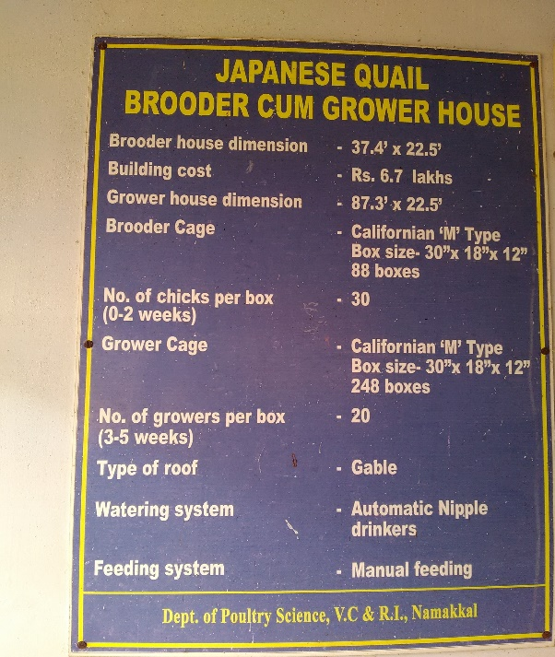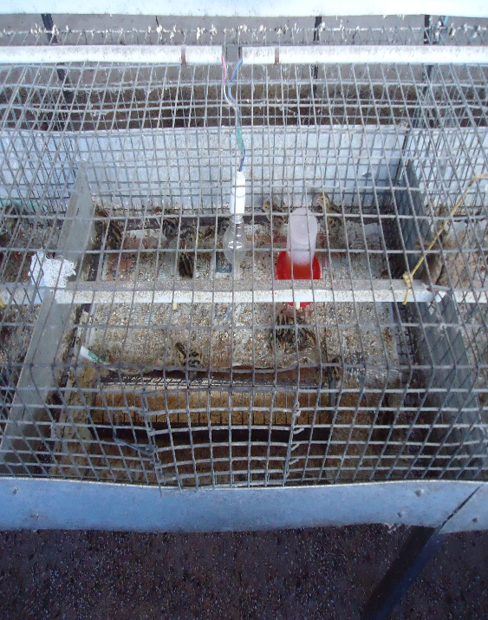
Fig 2: Brooding of Quail.
Fig 1:Basic information of Brooder cum Grower House.

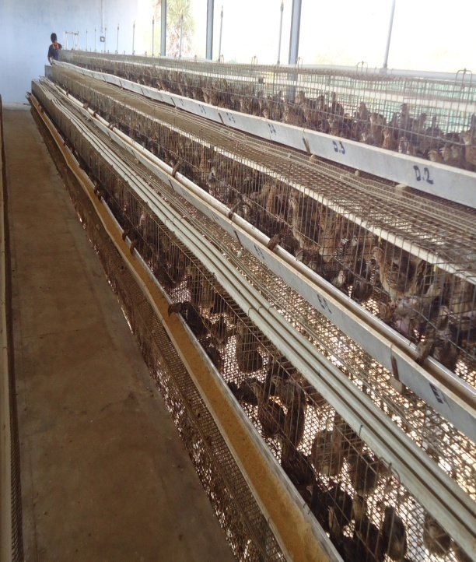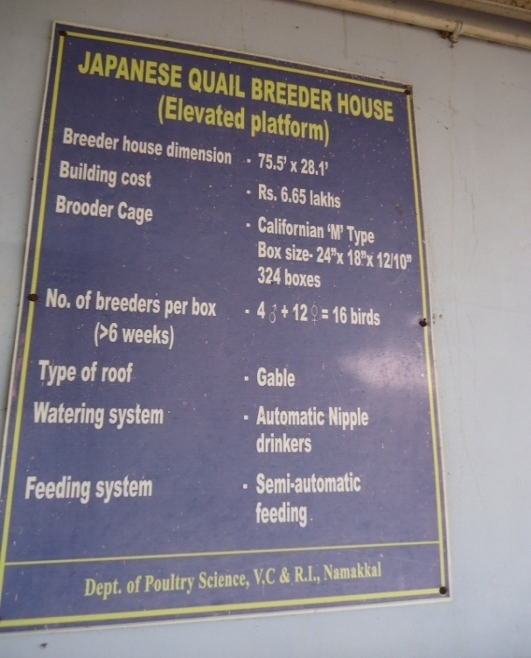
Fig 4: Basic information of Quail Breeder House.
Fig 3: Quail in Cage Rearing System.

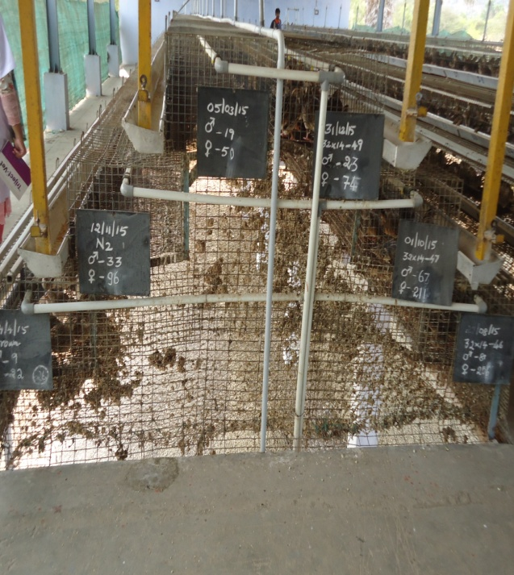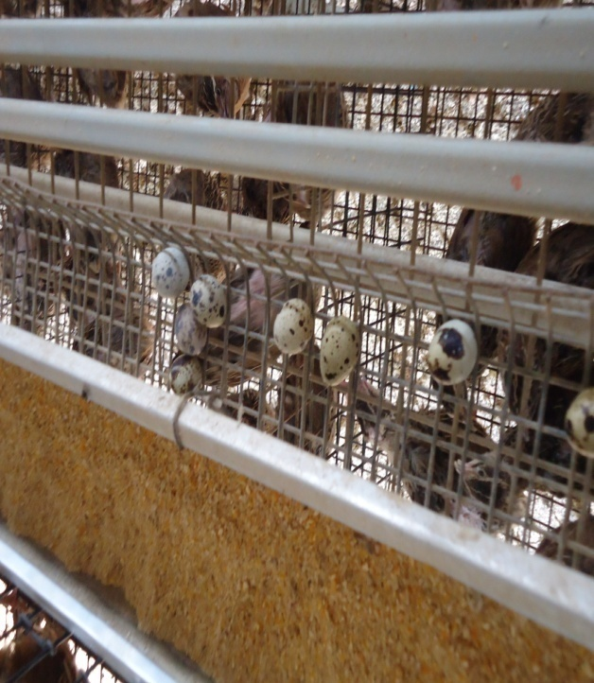
Fig 6: Egg of Quail.
Fig 5: Line Breeding System of Quail.

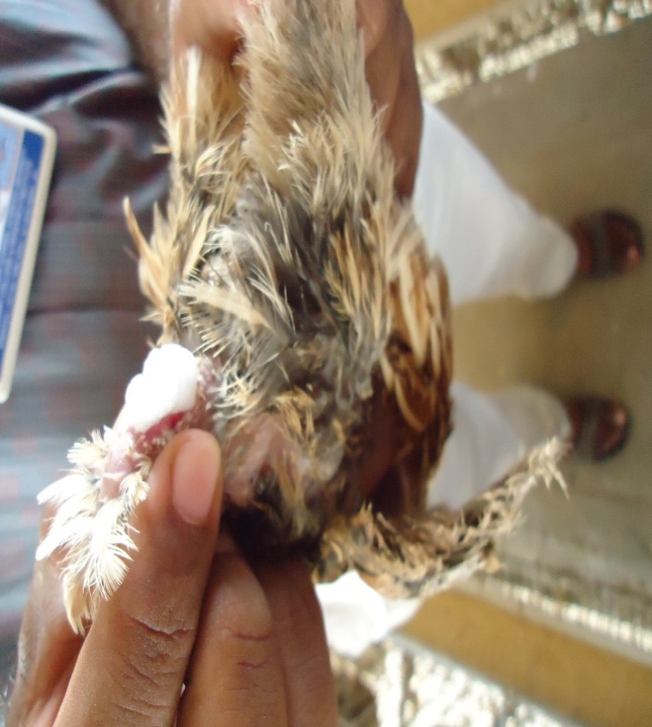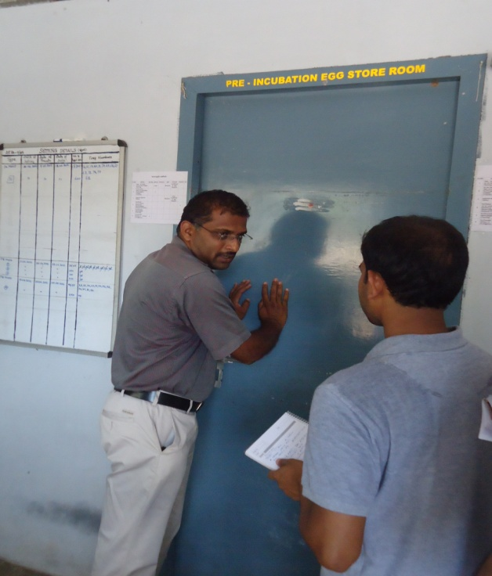
Fig 8: Information collection about incubation of Quail Egg.
Fig 7: Detection of Foamy Gland in Male Quail.

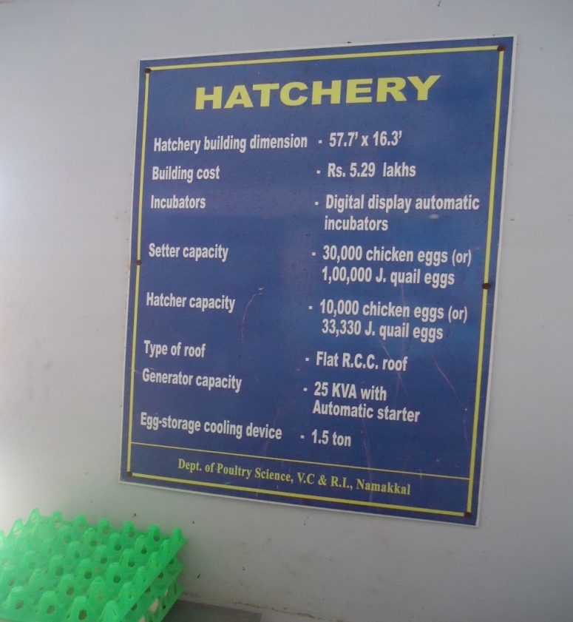
Fig 9: Basic information about Incubator.

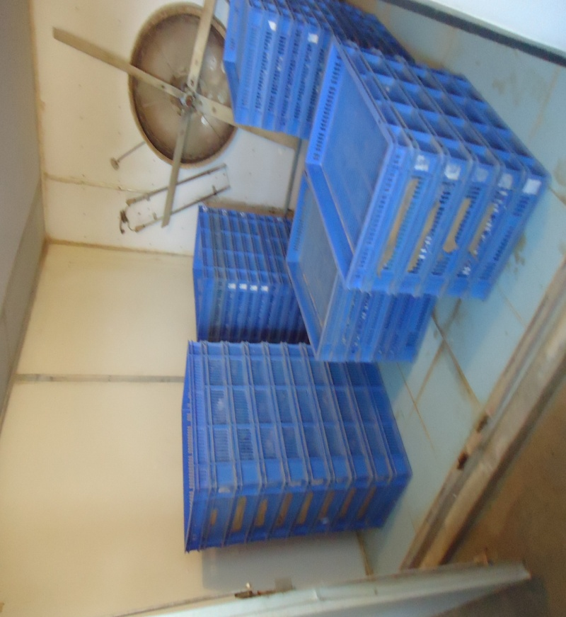
Fig 10: Egg Hatcher

BIOGRAPHY
I am Harun Or Rusid. Home district is Chittagong, Bangladesh. I was born on 5th january, 1992. I completed my S. S. C in 2007 and H. S. C in 2009. At present, I am continuing internship in Chittagong Veterinary and Animal Sciences University. My research interest is Livestock Development in Bangladesh.

