MANAGEMENT SYSTEM OF NAMAKKAL-1 QUAIL (JAPANESE QUAIL) IN VC&RI QUAIL FARM, INDIA.
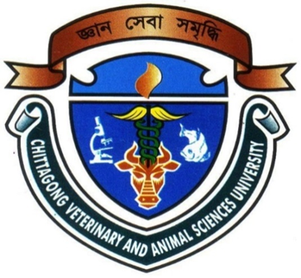

By
HARUN OR RUSID
Roll No: 11/54
Reg. No: 00711
Intern ID. : E–48
Session: 2010 – 2011

A production Report submitted in partial satisfaction of the requirements for the degree of
DOCTOR OF VETERINARY MEDICINE
Faculty of Veterinary Medicine

CHITTAGONG VETERINARY AND ANIMALSCIENCES UNIVERSITY, KHULSHI,CHITTAGONG-4225.

MANAGEMENT SYSTEM OF NAMAKKAL-1 QUAI L IN VC&RI QUAIL FARM, INDIA
MANAGEMENT SYSTEM OF NAMAKKAL-1 QUAIL (JAPANESE QUAIL) IN VC&RI QUAIL FARM, INDIA.

Signature of Author  Harun Or Rusid  Roll No: 11/54  Reg. No: 00711  Intern ID. : E–48  Session: 2010 – 2011 | Signature of Supervisor  Dr. Babu Kanti Nath  Assistant Professor  Dept. of Dairy and Poultry Science  Chittagong Veterinary and Animal Sciences University

Faculty of Veterinary Medicine
Chittagong Veterinary and Animal Sciences University Khulshi, Chittagong-4225, Bangladesh
October, 2016

