Chapter I

Introduction

Bangladesh is a highly populated, agricultural-based developing country where most of the rural peoples are dependent on agriculture for their livelihood. Livestock sub-sector is playing a crucial role in the traditional subsistence farming, contributing about 2.9% of the GDP, 13% of the total foreign exchange earnings and providing employment to 20% of the population (BBS, 2012). Dairying is nearly always part of mixed farming system in Bangladesh (Saadullah, 2001). There are many commercial dairy farms in the country and most of the milk is produced by the rural households. Local cows are the main source of our country. Their milk quality is very good where as the amount production is poor, for this purpose the concept of crossbred come forward with the concept of dairy farming. It was recorded that the number of milking cows in Bangladesh is about 3.79 million, which is 16 per cent of all cattle and 35 percent of all cows. Only 10 percent of our cows were reported to be crossbred (BBS, 2012). The statistic said that Bangladesh has 25.7 million of cows of which 3.79 million is dairy cows yielding 2.28 million metric ton milk per year whereas demand is 12.82 million metric ton milk per year which indicates the importance of the requirement for increasing the milk production in Bangladesh (Banglapedia, 2015). Bangladesh is importing powder milk to meet the deficit. The volume of imported milk has increased over the year due to faster domestic demand and costs of importation have exerted pressure on the countries balance of payments and have depressed the local initiative for milk production. About two-third of the total population in Bangladesh suffers from malnutrition. The magnitude of malnutrition can be substantially reduced by the consumption of milk or dairy products (FAO, 2011).
The average milk production of local cows is very low and it varies between 300-400 liters per lactation period of 180 to 240 days. But there is a great variation of milk production among cows.
Generally crossbred cows under village condition yield from 600 to 800 liters per lactation of 210 to 240 days (Uddin et al., 2008). The low productivity of a milking cow for this purpose the concept of intensive dairy farming with high yielding crossbred cows comes forward. The daily per capita availability and requirement of milk are estimated at adult 34.86 ml and 250 ml, respectively (DLS, 2009). To increase the number of crossbred animals in Bangladesh, Central Cattle Breeding and Dairy Farm (CCBDF) was established and it has been increasing day by day with spread of artificial insemination (AI). A good number of small, medium and large sized farms has been developed mostly in urban and semi-urban milk pocket areas like Pabna, Sirajgonj, Manikgonj, Munshigonj, Faridpur, Madaripur, Kishoregonj, Rangpur, Kustia and Chittagong district (Rokonuzzaman et al., 2009). The economic condition of a dairy farm depends to a greater extent on productive and reproductive performance of the animal. The productive performance is considered as average milk yield per lactation per cow, average lactation length of different genotypes.
The reproduction performance is considered as age at first heat, age at first calving, service per conception, gestation length, calving interval, days open. Prolonged days open and low conception rate are the major constraints limiting the dairy farming in Bangladesh (Rokonuzzaman et al., 2009).
Objectives
- To identify superior genotype considering productive and reproductive performance in Bangladesh.

- To determine the productive and reproductive performance of same farming condition at different genotype crossbred cows.

Chapter- II

Methodology

2.1. Study Area
The study was conducted in Sreepur dairy farm under Magura district and in the Department of Genetics and Animal Breeding at Chittagong Veterinary and Animal sciences University (CVASU).

2.1.1. Tropography of Magura
Magura district located in south-western part of Bangladesh under Khulna division which is 176 kilometer away from Dhaka city having an area of 1048 km²and surrounded by Rajbari district to the north, Jessore and Narail districts to the south, Faridpur district to the east and Jhenaida district to the west.
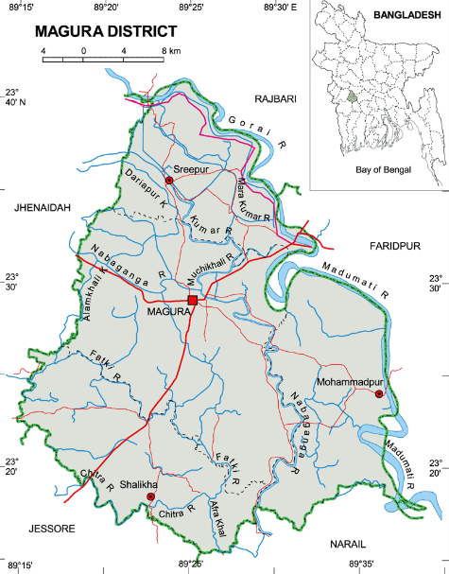
Figure 1: Map of Magura district.

2.2. Study time
The study was conducted from May, 2016 to November, 2016.

2.3. Data Collection
A predesigned well structured questionnaire was used for collecting the information on cow production and reproduction at Sreepur Upazila in Magura districts. Data was collected on various productive parameters (live weight, milk yield, lactation length and lactation production, birth live weight, weaning weight, mature weight, puberty weight, bull weight) and reproductive parameters (calving interval, gestation length, postpartum heat period, age at first sexual maturity and service per conception).The survey was conducted through direct farm visit by the researchers with the correspondence of farm stuff.
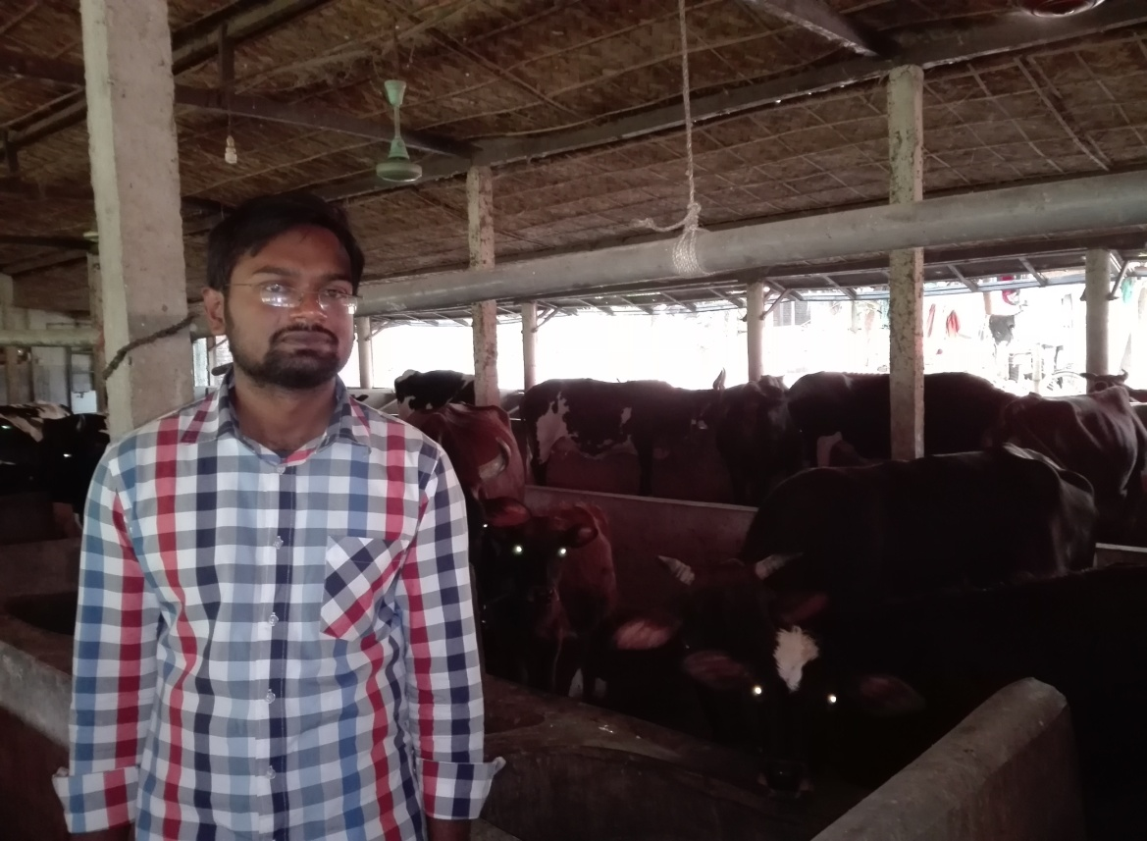
Figure 2: Data collection from Sreepur dairy farm.

2.4. Identification of Genotype
Genotype was determined by observing AI record book and direct visual observation of different phenotypic characteristics (e.g. Color, body confirmation etc.).

2.5. Study population
Two different genotype was selected (50% HF × 50% SL and 50% HF 75% × 50% L) from Sreepur dairy farm. About 100 crossbred cows (50 for each genotype) were selected, those already completed 3rd lactation.

2.6. Management of cows
Information on farm management was collected through interviewing farm stuff and veterinary doctor by asking following questions.
- Which vaccine they usually use and from which source?
- When they start milking after parturation?
- What are the available feeds throughout the year?
- What type of farming is usually practice?
- How much milk product per cow?

2.7. Breeding methods of cows
Information on cattle breeding methods collected from record sheet and collecting data farm stuff.
- How they detect estrus in cows?
- What are the usual breeding methods they practice?
- Which genotype usually preferred and why?
- What are the age of sexual, calving interval, service per conception for which genotype?

2.8. Availability of feeds and fodders
There was a huge amount of cultivated fodder field found near the farm. The labors collect Napier and German grass twice daily and provide the cows according requirement. The concentrates are usually given on the basis of milk production.

2.9. Some Productive parameters

2.9.1. Calculation of Live Weight (LWT)
Body length (L) was taken from the point of shoulder to the pin bone and heart girth (G) were measured in inch using a measuring tape and the live weight of each cow was calculated according to the method of (Hossain and Akhter,1999) using the following formula:
2
$$LWT=\frac{L×G }{300×2.25}$$

2.9.2. Daily milk yield
The milk yield was calculated by helps of milk record book and then mean of the total lactation is use as a daily milk yield.
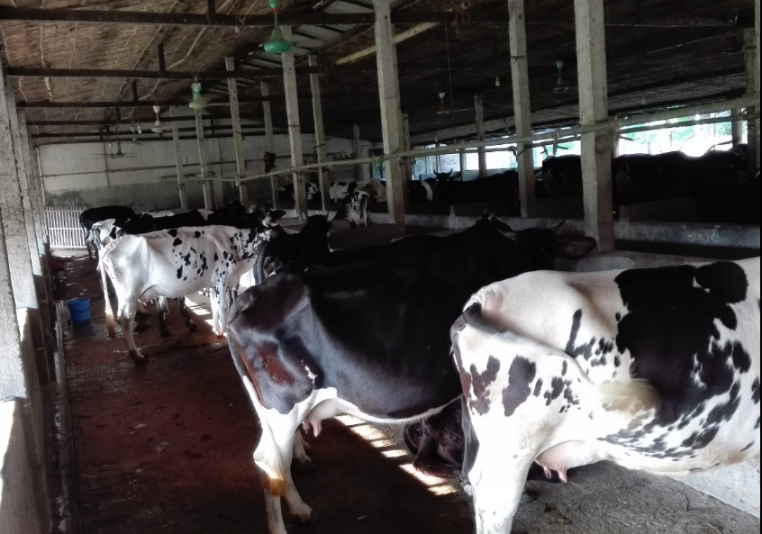
Figure 3: Housing system of crossbred cows under intensive farming system

2.10. Some reproductive parameters.

2.10.1. Age at first heat
It was determined by observing first estrus date and was collected data record book.

2.10.2. Service per conception
Service per conception was determined by the average number of services for conception.

2.10.3. Age at first calving
It was determined by collecting date of first calving.

2.10.4. Gestation length
It was determined by calculating intervals from the date of successful AI to date of calving.

2.10.5. Average daily milk yield per cow
It was determined by calculating the total milk yield per lactation.

2.10.6. Days open
It was determined by calculating intervals from the date of calving and date of first estrus after calving and was expressed in days.

2.10.7. Calving interval
The calving intervals were recorded on the basis of interval between the dates of one calving to the date of next calving and were expressed in months.

2.10.8. Average lactation length
Lactation length was calculated from the date of let-down of milk after calving to the date of end of milking of a cow in days.

Chapter-III

Results
The productive and reproductive performance of crossbreds and indigenous dairy cows are discussed below.

4.1. Productive performance of crossbred cows.
The mean with standard error values of different productive traits is shown in Table-1. All the productive parameters (daily milk yield; lactation length; total milk yield; live weight; birth weight of male; birth weight of female; weaning weight of male; weaning weight of female; puberty weight of female; mature weight of female; bull weight) were found significantly higher in (50%HF×50%SL) crossbreed than (50%F×50%L) crossbred.
The daily milk yield, lactation length and total milk yield of (50%F×50%SL) crossbreed are 11.72±0.32L, 277.44±2.12days and 3230±33.77 L, respectively whereas 6.5±.17L, 198±1.3 days & 1199±10.71L, respectively for (50%F×50%L) crossbred.
The birth weight, birth weight male; female birth weight ; male weaning weight ; female weaning weight ; female puberty weight ; female mature weight ; & bull live weight of (50%HF×50%SL) crossbreed are 28.26±.33kg, 24±.28kg, 109±1.2kg, 110±1.59kg, 297±3.29kg, 321±1.64kg & 376±3.79kg, respectively.
The male birth live weight; female birth weight ; male weaning weight ;female weaning weight; female puberty weight; female mature weight; & bull weight of (50% HF × 50% L) crossbred are 23.89±.34kg, 21.94±.29kg, 90±1.1.31kg, 88.21±1.23kg, 191.21±1.29kg, 289.12±3.4kg & 348.57±2.7kg , respectively.

Table 1: Mean ± standard error of various productive traits in crossbred cows (50% HF × 50% SL & 50% HF × 50% L)
Traits | 50%F*50%S | 50%F*50%L
DMY(litter) | 11.72ª±0.302 | 6.5^{b}±0.17
LL(Litter) | 277.44ª±2.12 | 198^{b}±1.3
TMY(Litter) | 3230.0ª±33.77 | 1199.0^{b}±10.71
BLW(M)kg | 28.26ª±0.33 | 23.89^{b}±0.34
BLW(F)kg | 24.0ª±0.28 | 21.94^{b}±0.29
WLW(M)kg | 109.0ª±1.2 | 90.0^{b}±1.31
WLW(F)kg | 110ª±1.59 | 88.21^{b}±1.23
PLW(F)kg | 297.0ª±3.29 | 191.21^{b}±1.29
MLW(F)kg | 321ª±1.64 | 289.12^{b}±3.4
BLW(kg) | 376.0ª±3.79 | 348.57^{b}±2.7
Legends: DMY= daily milk yield; LL= lactation length ;TMY= total milk yield; LW= live weight; BLW(M)= birth weight male; BLW(F)= birth weight female; WLW(M) = weaning weight male ;WLW(F)= weaning weight female; PLW(F)= puberty weight female; MLW(F)= mature weight female; BLW= bull weight.

4.2. Reproductive performance of crossbreed cows.
About 100 crossbred dairy cows of two different genotype were studied to know their productive and reproductive performance (e.g. age at sexual maturity, service per conception, gestation length, calving interval and post partum heat period average ). The results are shown in Table 2.
The age of sexual maturity showed significant 0.05 among to genotype that is shown in table-2. It is found that the age of sexual maturity are 622.73±4.37 and 676±2.234 respectively. The lowest age of sexual maturity is found in (50% HF × 50% SL) crossbreed. The calving interval is 389.47±6.48 and 397±2.16, respectively and the lowest calving interval are found in (50% HF × 50% SL) crossbreed. The gestation length of cows is significant different 0.05 among the two genotype. It is found that the gestation length of crossbred (50% HF × 50% SL & 50% HF × 50% L) are 281±1.01 days and 281.94±0.7394 days which are not statistically significant. The post partum heat period of those cross breed are 50.57±1.67 days and 52±1.43 days which have no statistically significant different. The service per conception of (50% HF × 50% SL) crossbreed is 2.31±.174. And service per conception of (50%F×50%L) crossbreed is 1.80±0.17. Which data indicate that (50%F×50%L) crossbred shows low service per conception rate.
Traits | 50%HF×50%SL | 50%HF×50%L
ASM (day) | 622.73ª±4.37 | 676^{b}±3.234
CI(day) | 389.47ª±6.48 | 397ª±2.16
GL(day) | 281.78ª±1.01 | 281.94ª±0.7394
PPH(day) | 50.57ª±1.67 | 52ª±1.43
SPC(day) | 2.31ª±0.174 | 1.80^{b}±0.17
Table 2: Mean ± standard error of various reproductive traits in crossbreed cows (50% HF × 50% SL & 50% HF × 50% L)
Legends: ASM= age at sexual maturity; I=calving interval; GL= gestation length; PPH= post partum heat period; SPC= service per conception

Chapter-IV

Discussion
The mean productive and reproductive performance of 50% HF × 50% SL crossbred cows and 50% HF × 50% L crossbred cows are shown in Table -1 and Table -2. It appears that age at sexual maturity, and service per conception are statistically significant (P<0.05) whether the other productive and reproductive performance (gestation length, calving interval and post partum heat period) are not statistically significant (P>0.05).
Our study result shows live weight are 321kg and 289kg for 50% HF × 50% SL crossbred and 50% HF × 50% L crossbred cows respectively. Which are similar with Rokonuzzaman ,et al., 2009. and Hossen et al., 1999.The male cow showed significantly more live weight than female cows .Usually male cows are heavier than female reported by Chantakhana and Bunyavejchewwin.,1989)

The average birth weight of (50% HF × 50% SL) crossbred cows and (50% HF × 50% L) crossbred are 28kg and 24kg respectively,. Which are similar with a Alam et al.,1994.
Our study shows 11.72±2.27 L and 6.5±0.17 L milk for 50% HF × 50% SL crossbred and 50% HF × 50% L crossbred cows respectively. This result is similar with Bhuin et al., 2005. and Hasan, et al.,1999) . Adequate supply of green fodder and good management system cause perfect production of milk yield.
The average lactation production under intensive farming system was found higher in 50% HF × 50% L crossbred cows than 50% HF × 50% L crossbred cows for higher milk yield and lactation length. The total milk yield 3230±33.77L for (50% HF × 50% SL) crossbred .
The lowest age of sexual maturity (622.70 ± 4.36 days) is found in 50% HF × 50%S L crossbred farm and age of sexual maturity (676.00 ± 3.235 days) is found in50% HF × 50%S L crossbred Service per conception, which are similar with Million et al., 1998.
The average service per conception was found lowest in ( 50% HF × 50% L) crossbred cows( 1.8±0.17) than in ( 50% HF × 50%S L) crossbred cows (2.3±0.17).
Which are similar with Kabir & Islam., 2009. (their result is 2±0.2) and lower than with Rokonuzzamane et al., 2009. (here SPC is 1.5 and our result is 2.3)

Chapter-V

Conclusion and Recommendation
In this study an attempt was made to find out the comparison of productive and reproductive performance of different genetic groups of cows at same farming condition in Magura district in Khulna Division, Bangladesh. We know that productive and reproductive performance of cows mostly depends on their genetic merits. The live weight and daily milk yield of (50% HF × 50% SL) crossbred cows are higher than (50% HF × 50% L) crossbred cows. But service per conception of (50% HF × 50% L) crossbred cows is lower than (50% HF × 50% SL) crossbred cows. However overall, on the basis of productive and reproductive traits, we can say that the (50% HF × 50% SL) crossbred cows are more suitable than (50% HF × 50% L) crossbred cows.

Chapter-V

Limitation
In this study comparison of productive and reproductive performance of different genetic groups of crossbred cows at different farming conditions are shortly discussed. Due to lack of sufficient data of each of the specific genotypes of animal, precision of the results might be lesser or more. So, more studies are suggested to drawing an absolute conclusion.

Chapter VI

References

Alam, M. G. S. and Ghosh, A. (1994). Plasma and Milk Progesterone Concentrotion in Early Pregnancy Diagnosis in Zebu Cows. Asian Australian Jaurnal of Animal Science., 78:131-136.
Banglapedia. (2015). Livestock. http://en.banglapedia.org/index.php?title=Livestock
BBS, (2012). Bangladesh Census of Agriculture, Bangladesh Bureau of Statistics, Dhaka, Bangladesh.
Bhuiyan, A. K. F. H. and Sultana, T. (1994). Analysis of Performance of Exotic Cattle Breeds and their Crosses in Bangladesh.
DLS, (2012). Annual Progress Report. Department of Livestock Services, Farm gate, Dhaka.
FAO, (2012). Balanced Feeding for Improved Livestock Productivity – Increase in Milk Production and Nutrient use Efficiency and Decrease in Methane Emission, by M. R. Garg.
FAO. (2011). Bangladesh and FAO Achievements and success stories. http://www.fao.org/3/a-at002e.pdf
Hasan, M. M. (1995). Distribution Pattern and Some Economic Dairy Characters of Locals and Crossbred Cows in Mymensingh Sadar, M. S. Thesis, Department of Dairy Science, Bangladesh Agricultural University, Mymensingh
Hossain, N.M, Akhter, s., (1999). Practical animal sciences . 1st edition. Zaman printers, Mymensingh: 1-24.

Islam, S. K. M. A., Hoque, M. A., Alam, M. R., Hassan, M. and Rahman, M. A. (2006). A Cross-sectional Study on Production Performance of Stall Feed Dairy Cattle at Central Cattle Breeding Station (CCBS), Savar, Dhaka. Bang. Journal of Veterinary Medicine, 4 (1): 61–63.
Kabir, F. and Isalm, M.R. (2009).Comparative Study on Productive and Reproductive Performance of Local and Different Crossbreed Dairy Cows at Daulatpura, Khulna in Bangladesh. Bangladesh Research Publication Journal. 3(2): 909-914.

Million, T., and Tadelle, D., (1998) Milk production performance of Zebu, Holstein Friesian and their crosses in Ethiopia. Debre Zeit Agriculture Research Centre, P.O.Box 32, Debre Zeit, Ethiopia
Rokonuzzaman, M., Hassan, M. R., Islam, S. and Sultana, S. (2009). Productive and reproductive performance of crossbred and indigenous dairy cows under smallholder farming system. Journal of Bangladesh Agrilcultural University. 7(1): 69–72.

Saadullah, M., (2001). Smallholder Dairy Production and Marketing in Bangladesh. Paper presented at South-South Workshop on Smallholder Dairy Production and Marketing. NDDB-ILBS, 13-16, Ahmedabad, India.

Chapter VII

Brief Biography
Md. Mozammel Hossain passed the SSC Examination in 2007 from Sreepur M.C. Pilot High School and the HSC Examination in 2009 from Dariapur Degree collage. Then he admitted to the Chittagong Veterinary and Animal Sciences University in 2009-2010 session. Now he is intern student, working on home and abroad for achieving different kinds of knowledge and experience in veterinary field. He has great interest on Veterinary Medicine.

