Phenotypic Characters of Several Type Feathers of Indian Peacock in Sheikh Rashel Aviary and Eco-park, Rangunia, Chittagong
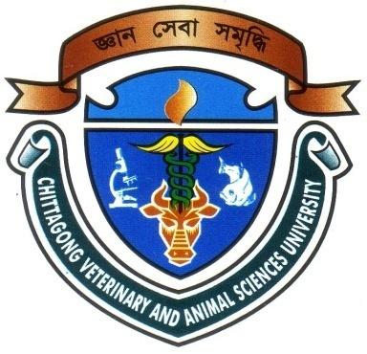

By:
Nanda Barua
Roll No.: 11/31, Registration No.: 00678
Intern ID: C-30
Session: 2010-2011
A production report submitted in partial satisfaction of the requirements for the degree of
Doctor of Veterinary Medicine

Faculty of Veterinary Medicine
Chittagong Veterinary and Animal Sciences University Khulshi, Chittagong-4225, Bangladesh
November 2016
Phenotypic Characters of Several Type Feathers of Indian Peacock in Sheikh Rashel Aviary and Eco-park, Rangunia, Chittagong

…………………………….
Signature of Supervisor
DR. Omar FarukMiazi
Associate Professor and Head
Department of Genetics and Animal Breeding, CVASU
…………………………
Signature of Author
Nanda Barua
Roll No.: 11/31
Reg. No.: 00678
Intern ID: C-30

Faculty of Veterinary Medicine
Chittagong Veterinary and Animal Sciences University Khulshi, Chittagong-4225, Bangladesh
November 2016
Table of Contents
ABSTRACT v
CHAPTER I: INTRODUCTION 1
CHAPTER II:MATERIALS AND METHODS 3
CHAPTER III: RESULTS 4
3.1 Crown Feather 8
3.2 Neck Feather 8
3.3 Dorsal/Back Feather 8
3.4 Contour Feather 12
3.5 Flight Feather 12
3.6 Tail Feather 15
3.6.1. The main tail feather 15
3.6.2. Decorative tail feather 15
3.6.2.1. Eye feather 15
3.6.2.2. T feather 16
3.6.2.3. Sword feather 16
CHAPTER IV: DISCUSION 20
CONCLUSION 22
REFERENCES 23
Acknowledgements 26
Biography 27

List of Figures
Fig 1: Plumage pattern of male peacock………………………..…………………….6
Fig 2: Plumage pattern of peacock….………….……………………………………..7
Fig 3: Measuring the length of crown feather of male and female peacock………….9
Fig 4: Neck feather in male and female peacock……………………………………10
Fig 5: Back feather in male and female peacock………………………………...….11
Fig 6: Measuring the length of contour feather of peacock…………………………13
Fig 7: Measuring the length of flight feather in male and female peacock………....14
Fig 8: Various types of tail feathers in male peacock……………………………….17
Fig 9: Presence of eyespot in eye feather of male peacock…………………………18
Fig 10: Coloration of eyespot……….………………………………………………18
Fig 11: Measuring tail feather of male and female peacock………………………...19

List of Tables
Table 1: Average length of different feathers of Indian Peacock……………………5

ABSTRACT
The study was carried out from January 2016 to February 2016 on Indian Peafowl under captive rearing condition at Shiekh Rashel Aviary and Eco-park, Rangunia, Chittagong. The objectives of current study were to describe the complete documentation of feathers present in different body parts of peacock (Pavocristatus) including their phenotypic characters. The data was collected from 3 male mature Peacocks and 2 mature Peahens. The average length of crown feather in Peacock and Peahen were 7 cm and 3 cm. Peacock was more attractive in comparison to Peahen for their bright blue neck and his train. The length of neck feather was found higher 5 cm in Peacock but lower in Peahen 3 cm. There was found brownish white barb saddle feather in Peacock and grayish in Peahen. The average length of contour feather was comparatively higher 7.5 cm in Peacock than Peahen 6 cm. The average length of breast feather in case of Peahen was also lower 5 cm than Peacock 7 cm. Average length of flight feather of Peacock was found 35 cm but it was found 30 cm in case of Peahen. The average length of tail feather was greater in case of Peacock, 65 cm compared to Peahen 42.5 cm. A total of 200 tail feather was found in Peacock where as the highest length was recorded 84 cm. Peahen has no train and dull looking due to white belly and most of the feathers are brown color. The causes of variations are not known and open a wide field for scientific research under developmental biology, ecology, ethology and behavioral studies.
Keywords: Indian Peafowl, feather, phenotypic characters, Sheikh Rashel Avairy and Eco-park.

