Chapter I
Introduction
The domestic cat (Felis catus) is a small, typically furry, carnivorous mammal. They are often called house cats when kept as indoor pets or simply cats when there is no need to distinguish them from other felids and felines (Wozencraft, 2005). Cats are often valued by humans for companionship and for their ability to hunt vermin. There are more than 70 cat breeds; different associations proclaim different numbers according to their standards.
Cats are similar in anatomy to the other felids, with a strong, flexible body, quick reflexes, sharp retractable claws, and teeth adapted to killing small prey. Cat senses fit a crepuscular and predatory ecological niche. Cats can hear sounds too faint or too high in frequency for human ears, such as those made by mice and other small animals. They can see in near darkness. Like most other mammals, cats have poorer color vision and a better sense of smell than humans. Cats, despite being solitary hunters, are a social species and cat communication includes the use of a variety of vocalizations (mewing, purring, trilling, hissing, growling, and grunting), as well as cat pheromones and types of cat-specific body language (Moelk and Mildred, 1944).
Cats have a high breeding rate. Under controlled breeding, they can be bred and shown as registered pedigree pets, a hobby known as cat fancy. Failure to control the breeding of pet cats by neutering and the abandonment of former household pets has resulted in large numbers of feral cats worldwide, requiring population control (Rochlitz and Irene, 2007). In certain areas outside the cat’s native range, this has contributed, along with habitat destruction and other factors, to the extinction of many bird species. Cats are thought to be primarily, though not solely, responsible for the extinction of 33 species of birds.
Since cats were venerated in ancient Egypt, they were commonly believed to have been domesticated there (Nicholas et al., 2007) but there may have been instances of domestication as early as the Neolithic from around 9,500 years ago 7,500 BC (Gerard et al., 2004). A genetic study in 2007 concluded that domestic cats are descended from Near Eastern wildcats, having diverged around 8,000 BC in West Asia (Wade and Nicholas, 2007). A 2016 study found that leopard cats were undergoing domestication independently in China around 5,500 BC, though this line of partially domesticated cats leaves no trace in the domesticated populations of today (Grimm and David, 2016). As of a 2007 study, cats are the second most popular pet in the United States by number of pets owned, behind freshwater fish (Thompson and Andrea, 2015)
The felids are a rapidly evolving family of mammals that share a common ancestor only 10–15 million years ago (Johnson, Warren, O’Brien and Stephen., 1997) and include lions, tigers, and many others. Within this family, domestic cats (Felis catus) are part of the genus Felis, which is a group of small cats containing about seven species (depending upon classification scheme (ITIS, 2011).
Cats have either a mutualistic or commensal relationship with humans. Two main theories are given about how cats were domesticated. In one, people deliberately tamed cats in a process of artificial selection as they were useful predators of vermin. This has been criticized as implausible, because the reward for such an effort may have been too little; cats generally do not carry out commands and although they do eat rodents, other species such as ferrets or terriers may be better at controlling these pests. The alternative idea is that cats were simply tolerated by people and gradually diverged from their wild relatives through natural selection, as they adapted to hunting the vermin found around humans in towns and villages.
Objectives of the study
To know the rearing and management system of pet cat at Chittagong metropolitan area.

Chapter II

Materials and Methods

2.1 Study area
The study was conducted on rearing and management of pet cat at Chittagong metropolitan area, which is the part of Chittagong division, Bangladesh. This area is located south-eastern region of Bangladesh at 22.2438 latitude and 92.0126 longitudes. This area is covered by hilly tracts.

2.2 Study period
In order to collect the more purified data of pet cat an organized questionnaire was formatted. The total duration of the study was August 2016 to October 2016.

2.3 Collection of data
Actually overall data of individual pet were core material in this occasion. These data were collected by using following techniques:
- Visiting of owner house.
- Cross questioning to the owner
- Records maintain by the owner (if there any)

2.4 Data analysis
After collecting all the data of individual pet cat were analyze some very much vital management issues like Housing, Feeding, Breeding, Grooming, Washing, Hygienic status and Heath status etc. The collected data was analyzed by descriptive analysis.

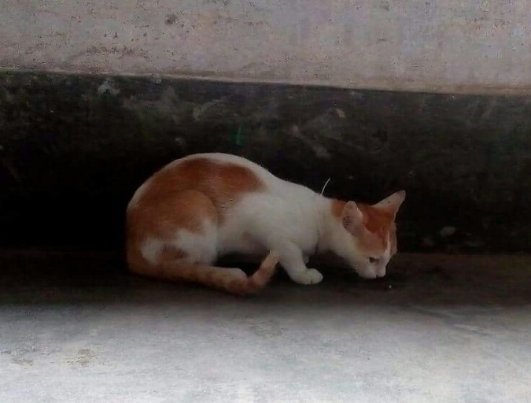
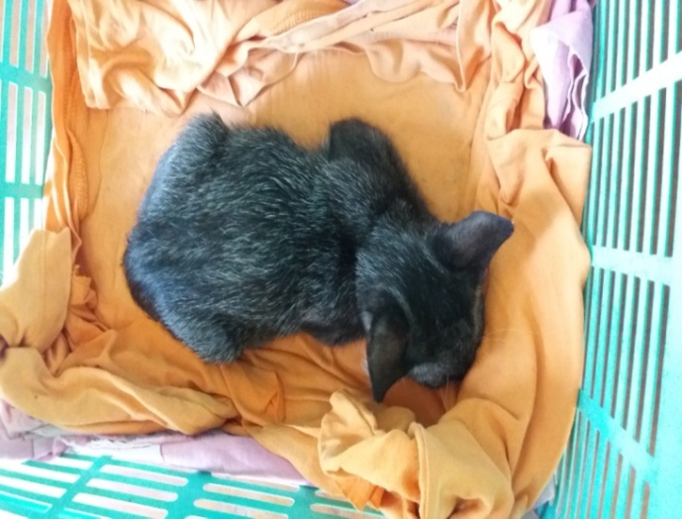
Local cat eating from floor
Local cat resting in a basket

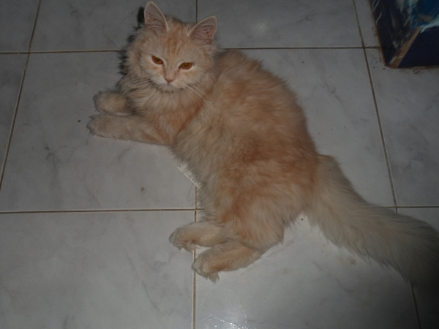

A Persian cat sitting in floor

Chapter III
Results and Discussion
The study was conducted on rearing and management pet cat in Chittagong Metropolitan area.In this study, 40% data was collected from Chawkbazar, 30% from Khulsi, 20% from Agrabad and 10% from Bayezid thana. 60% of the cat is male and 40% is female. Among them, 80% breed is local and 20% breed is Persian. 70% of the cat’s BCS is 4, 20% cat’s BCS is 3 and 10% is 2.Most of the cat’s age is one to two year (80%).
3.1 Housing Status
An efficient management of a catwill be incomplete without a well planned & adequate housing. Improper planning in the arrangement of a pet housing may result disease and loss of owner.
Table 1: Data analysis of housing of pet dog
Variable | Category | Percentage (%)
Ventilation | Good | 70
 | Poor | 30
Drainage | Good | 80
 | Poor | 20
Cleanliness status | Good | 75
 | Poor | 25
Routine schedule to clean | Yes | 35
 | No | 65

3.2 Feeding management
Cats hunt small prey, primarily birds and rodents (Harris et al., 2003) and are often used as a form of pest control (Hill et al., 2008). Domestic cats are a major predator of wildlife in the United States, killing estimated 1.4–3.7 billion birds and 6.9–20.7 billion mammals annually (Peter et al., 2013). Feeding management is a key part of overall management system. Different owner of Chittagong practiced the different types of feeding system.
Table 2: Data analysis on feeding of pet cat
Variable | Category | Percentage(%)
Feeding schedule | Yes | 85
 | No | 15
Offer human feed | Yes | 55
 | No | 45
Change feed | Yes | 70
 | No | 30
Provide food | Bowl | 70
 | Open floor | 30
 | Rice, fish, meat | 50
Type of food | Kichuri, rice, fish | 20
 | Rice, fish | 30

3.3 Hygienic Management
Hygienic management is an important manifesto for a pet cat. Owner of Chittagong are more or less concern about this issue. In my study hygiene management is good.The average lifespan of pet cats has risen in recent years. In the early 1980s it was about seven years, (Williams et al., 1984) rising to 9.4 years in 1995 and 12–15 years in 2014 (Franny, 2015)
Table 3: Data analysis on hygienic status of pet cat
Variable | Category | Percentage (%)
Time of groom and bath in a week | Once | 20
 | Twice | 30
 | More | 50
Use of shampoo/soap | Shampoo | 60
 | Soap | 40
Nail trimming | Yes | 60
 | No | 40
Time of cleaning feeder | Once | 10
 | Twice | 40
 | More | 50
3.4 Breeding Management
Female cats are seasonally polyestrous, which means they may have many periods of heat over the course of a year, the season beginning in spring and ending in late autumn. Heat periods occur about every two weeks and last about 4 to 7 days (VLS, 2009).As domestic cats are little altered from wild cats, they can readily interbreed. This hybridization poses a danger to the genetic distinctiveness of some wildcat populations, particularly in Scotland and Hungary and possibly also the Iberian Peninsula (Alves et al., 2008).Breeding management is an important issue for a pet cat. In this study, the owner who do not want to get progeny they treat their pet by spaying. In all most pet delivery is normal. The owner does not need to detect heat in most cases.
Table 4: Data analysis on breeding management of pet cat
Variable | Category | Percentage (%)
Want progeny | Yes | 60
 | No | 40
Parity No | One | 50
 | Two | 15
 | More | 35
Delivery | Normal | 95
 | Induced | 5
Post delivery care | Yes | 80
 | No | 20

3.5 Disease Management
Cats can suffer from a wide range of health problems, including infectious diseases, parasites, injuries, and chronic disease. Vaccinations are available for many of these diseases, and domestic cats are regularly given treatments to eliminate parasites such as worms and fleas.In addition to obvious dangers such as rodenticides, insecticides, and herbicides, cats may be poisoned by many chemicals usually considered safe by their human guardians (Vetinfo.com, 2011). Owners tried from their best to protect or control his/her pet from various disease as well as health hazard. Miss management & lack of fundamental knowledge suffered the pet from diseases & health disorder. Survey reviled in Chittagong these health hazards:
- Feline panleukopenia
- Rabies
- Feline Calci virus infection
- Different poisons

Table 5: Data analysis on disease management of pet cat
Variable | Category | Percentage (%)
Vaccination | Yes | 80
 | No | 20
Anthelmintics | Yes | 60
 | No | 40
Skin lesion | Yes | 20
 | No | 80
Cat die previously | Yes | 10
 | No | 90

Limitations
It is very difficult to collect data from owner because they are not interested to give information about his/her pet cat. Besides this, the owner does not keep actual record about his/her pet cat. So, actual data cannot be found in most cases. The sample size of the study was so small due to short duration of time for the study. There are no standard values of management to compare the data of this study.

Conclusion
Although most the owner of cat in the Chittagong Metropolitan area are conscious about their pet, they do not control their pet cat from disease due to mismanagement that adapted by owner. Most of the owners of the study area do not maintain standard husbandry practices regarding housing, feeding and health management. All the owners do dot employ any person to look after his/her pet cat.
It may be concluded that, with good management the hazard can be decreased up to the standard level which will definitely make the owner more satisfied.

References
Dennis, S Hill. 2008. Pests of Crops in Warmer Climates and Their Control – Page 120.
Franny, S. 2015. What Is the Life Span of the Common Cat? About.com Home.
Grimm and David. 2016. Were cats domesticated more than once? sciencemag.org. Retrieved 27 January 2016.
ITIS Standard Report Page: Felis."ITIS Online Database. Retrieved14 December 2011.
Johnson, Warren, O'Brien and Stephen J.,1997. Phylogenetic Reconstruction of the Felidae Using 16S rRNA and NADH-5 Mitochondrial Genes. Journal of Molecular Evolution. 44 (0): S98–S116.
Loss, Scott R., Will, Tom, Marra and Peter P. 2013. The impact of free-ranging domestic cats on wildlife of the United States. Nature Communications. 4: Article number: 1396.
Moelk and Mildred. 1944. Vocalizing in the House-cat. A Phonetic and Functional Study. The American Journal of Psychology. 57(2):184-205. doi:10.2307/1416947. JSTOR1416947.
Nassar R., Mosier J.E. and Williams L.W. 1984. Study of the feline and canine populations in the greater Las Vegas area. American Journal of Veterinary Research. 45 (2): 282–7. PMID 6711951.
Oliveira R., Godinho R., Randi E. and Alves, P. C. 2008. Hybridization Versus Conservation: Are Domestic Cats Threatening the Genetic Integrity of Wildcats (Felissilvestrissilvestris) in Iberian Peninsula?. Philos. Trans. R. Soc. Lond., B, Biol. Sci. 363 (1505): 295329861.
Rochlitz and Irene. 2007. The Welfare of Cats. Animal Welfare series. Berlin and Springerpp. 141–175.ISBN 1-4020-6143-9.
Thompson and Andrea. 2015. What's the Most Popular Pet? Live Science. Retrieved 15December 2015.
Toxic to Cats. VetInfo.com. 2011. Retrieved 14 December 2011. This tertiary source reuses information from other sources but does not name them.
Veterinary Learning Systems. 2009. Prolific Cats: The Estrous Cycle (PDF)
Wade and Nicholas. 2007. Study Traces Cat’s Ancestry to Middle East-New York Times. New York: NYTC. Retrieved 2 April 2008.
Woods M., McDonald R.A. and Harris S. 2003. Predation of wildlife by domestic cats Felis catus in Great Britain. Mammal Review. 23 (2): 174–188. doi:10.1046/j.1365-2907.2003.00017.x
Wozencraft,W.C. 2005.Order Carnivora.In Wilson, D.E. and Reeder, D.M. Mammal Species of the World. A Taxonomic and Geographic Reference (3rded). Johns Hopkins University Press. pp. 532–545 ISBN 978-0-8018-8221-0.OCLC 62265494

Acknowledgement
All praises are due to Almighty Allah, the creator and supreme authority of the universe; who enabled me to complete this work successfully.The author feels proud in expressing his deep sense of great gratitude and indebtedness to respected teacher and supervisor Dr. Md. Saiful Bari, Assistant Professor, Dept. of Dairy and Poultry Science, Chittagong Veterinary and Animal Sciences University (CVASU) for his scholastic guidance, sympathetic supervision, valuable advice, constant inspiration, affectionate feeling, radical investigation and constructive criticism in all phases of this study.
I would like to pay my solemn gratitude to respectable teacher Professor Dr. Md. Ahsanul Haque, Dean, Faculty of Veterinary Medicine, Chittagong Veterinary and Animal Sciences University (CVASU).
The Author
October, 2016

Biography
I am Mohammad Abu Tayyeb, Son of Md. Abdul Hamid and Jannat Ara Begum. I passed my Secondary School Certificate (SSC) examination from Govt. Muslim HighSchool, Chittagong in 2007 and Higher Secondary Certificate (HSC) examination from Hazi Mohammad Mohsin College, Chittagong in 2009. Now I am an intern veterinarian under the Faculty of Veterinary Medicine in Chittagong Veterinary and Animal Sciences University. In the future I would like to work as a veterinary practitioner.

Annex-1
A questionnaire on rearing and management of pet Cat at Chittagong Metropolitan Area
Owner information:
- Name: ………………………………………………………………………..
- Address: ………………………………………………………………..……
- Occupation: …………………………………………………..………………..
- Mobile No: ……………………………………………………………………
Information of pet cat:
- Spp: …………………….
- Patient name(if any ): ……………………………
- Age: ……………….
- Sex : ……………..
- Color : …………………
- Weight : …………………..
- BCS: 1(Cachectic)/2(Fair)/3(poor)/4(Good)/5(Over wt/Fatty)
- Physiological status : Dry/ Estrus/ Pregnant / Recently pup
- No. of pet cat reared : ……………..
- Where it was brought from : ……………………..

Housing information:
- Where specifically will the animal keep:
- During the day: ………………………………….
- While you’re home: ………………………….
- At night: ……………………………………………
- When you’re not home: …………………..
- Do you have fenced yard : Yes / No
- Do you have a cat pen : Yes / No
- Does he run loose in an unfenced area : yes / No
- Floor of cat pen: Good/ Fair / Poor
- Status of ventilation : Good/Fair/Poor
- Status of drainage system : Good/ Fair/ Poor
- Status of cleanliness outside of pen: Good/Fair/Poor

Feeding information:
- Is your cat on a feeding schedule or self-feed(food left out flat):
- How many times you provide food: ………………..
- Do you ever feed your cat people food from table: Yes / No
- Type of food you provide: ……………………………….
- Do you maintain any change in the regular food item : Yes / No
- Do you face any behavioral problems associated with food: Yes / No
- Do you feed all the cat together or individually: Yes / No
- Where do you keep food: Bowl/Open floor
- Where do you keep water: Pot/Drinker?/Others
- Hygienic condition of feeder and waterer: Good/Fair/Poor

Grooming and Washing:
- Do you brush your cat: Yes/No
- Does he growl or snap when grooming: Yes/ No
- How many times you groom and bathe your cat in a week: ……………..
- Mention if any shampoo/soap is used: ………………..
- How do you bathe your cat: Sprinkler/Pour on/Others
- Period of time you groom and bathe your cat: ………………
Breeding information:
- Do you want to get progeny: Yes/No
- Mention the service with: Local breed/Exotic
- Parity no: ………………………………………………….
- Mention last when she gave birth: …………………….
- If you don’t want progeny, you follow: Spaying/Not allow mating with dog
- Delivery: Normal/Induced
- Your male cat undergoes castration: Yes / No
- Do you follow post-delivery care : Yes/ No
- Do you or employed person look after the pet cat: Yes/No
Health care information:
- Do you check health of cat by vet in a clinic: Yes/No
- Do your cat have vaccination: Yes/No
- Did your cat have anthelmintics: Yes/No
- Any diseases occur previously: Yes/No
- Do you follow vaccination schedule: Yes/No
- Is nail trimming done: Yes/No
- How many times: ………………………….
- Do you have any health sound certificate for your cat: Yes/No
- Any hypothricosis/skin lesions had seen in last six months: Present/Absent
- Any cat get died due to disease previously: Yes/No
- Before death it was treated: Yes/No
Hygienic activities information:
- How many times you clean cat shed in a month: ……………
- Mention the cleaning agents: …………………
- How many times you clean feeder and waterer: ……………..
- Where do you discharge stool and food wastages: ……………………
- Any covering you use during winter in the wall of cat house: Yes/ No
- Do you have any daily routine of activities for cleaning of cat house: Yes/No
- Any ectoparasiticidal agents is used outside of cat shed and in the drain: Yes/No
- Condition of outside of dog pen: Bushy/ Muddy/ Dry and clean

