EFFECT OF EXOTIC BLOOD PERCENTAGE ON PRODUCTIVITY AND ENVIRONMENTAL ADAPTABILITY OF DAIRY COW – A SELECTED FARM STUDY
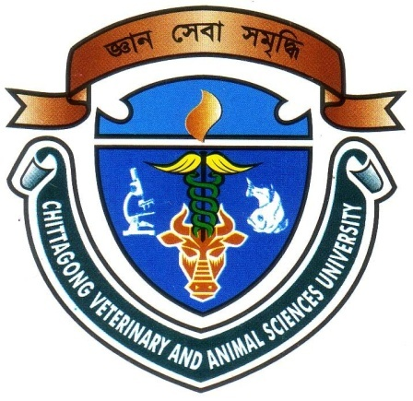
A Production Report Submitted
By
Intern ID: F-55
Roll No: 10/34
Registration No: 00512

The Production report submitted in the partial fulfillment of the requirements for the Degree of Doctor of Veterinary Medicine (DVM)

Chittagong Veterinary and Animal Sciences University
Khulshi, Chittagong-4225, Bangladesh

November, 2016
EFFECT OF EXOTIC BLOOD PERCENTAGE ON PRODUCTIVITY AND ENVIRONMENTAL ADAPTABILITY OF DAIRY COW – A SELECTED FARM STUDY
A Production Report Submitted
By
Intern ID: F-55
Roll No: 10/34
Registration No: 00512

Approved as to style and content by
………………………………
Signature of Supervisor
DR. Mahabub Alam
Assistant Professor
Department of Animal Science and Nutrition, CVASU
…………………………..
Signature of Author
Name: Jakir Hossain
Roll No: 10/34
Reg. No: 00512
Intern ID: F-55

C
Chittagong Veterinary and Animal Sciences University
Khulshi, Chittagong-4225, Bangladesh

