A survey on production and reproduction status in small holder cattle farming in Tangail district
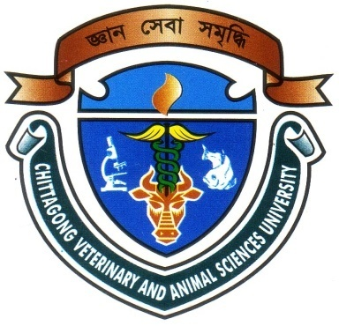

A production report submitted in partial fulfillment of the requirementsfor the degree of Doctor of Veterinary Medicine

Submitted By

Roll No: 11/26

Registration No: 00672

Intern ID: C-25

Session: 2010-2011

Faculty of Veterinary Medicine

Chittagong Veterinary and Animal Sciences University

Khulshi, Chittagong-4225

November 2016
A survey on production and reproduction status in small holder cattle farming in Tangail district

-------------------------------
(Signature of supervisor)
Dr. Ashutosh Das
Associate Professor

Department of Genetics and Animal Breeding

Faculty of Veterinary Medicine

Chittagong Veterinary and Animal Sciences University

Khulshi, Chittagong-4225

November 2016

