Successful Correction of Dystocia Due to Schistosomus Reflexus
By Forced Traction in a Goat

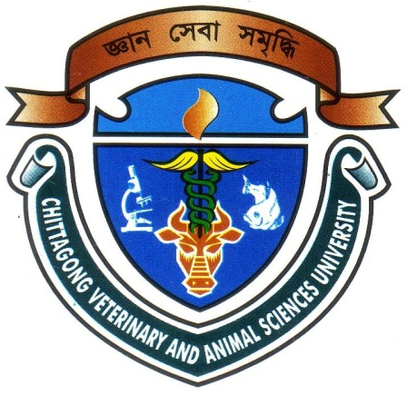

A Clinical Report Submitted
By
Intern ID: 17
Roll No: 13/17
Registration No: 00931

The report submitted in the partial fulfillment of the requirements for the Degree of Doctor of Veterinary Medicine (DVM)

Chittagong Veterinary and Animal Sciences University
Khulshi, Chittagong-4225, Bangladesh

September, 2018
Successful Correction of Dystocia Due to Schistosomus Reflexus
By Forced Traction in a Goat

A Clinical Report Submitted
By
Intern ID: 17
Roll No: 13/17
Registration No: 00931

Approved as to style and content by
…………………………......
Signature of Author
Tamanna Nayon Noor
Roll No: 13/17
Reg. No: 00931
Intern ID: 17

……………………………….............
Signature of Supervisor
Dr. Md. Anowar Parvez
Assistant Professor
Department of Medicine & Surgery CVASU

Chittagong Veterinary and Animal Sciences University
Khulshi, Chittagong-4225, Bangladesh

