CHAPTER – I
INTRODUTCTION
The relationship between people and dogs is unique. Among domesticated, dogs are capable of performing a wide variety of roles for human: sheep herding, sniffing out drugs and explosives, hunting of prey and security; breeding purposes and companionship (Pet). To be precise about when the friendship started is very difficult but a reasonable guess suggest that, it has been going strong for more than 14,000 years (Bradshaw, 2012; Udell et al., 2008). Despite the fact that we live so closely with dogs. However, it is not entirely without any health risk. A high zoonotic risk is involved with the increasing number of people, as the people keep dogs for various purposes without much knowledge on the zoonoses (Omudu et al., 2010). Dogs in Bangladesh often live in close proximity to humans and act as pathogen carriage, serve as a potential source of infection to humans (Bruce and Fleming, 1983; Goossen et al., 1991; Burnens et al ., 1992; Ene et al., 1992; Moreno et al., 1993; Torre and Tello, 1993; Fernandez et al., 1994; Robinson and Pugh, 2002; Workman et al., 2005; Sabry, 2009). Thus the possibility of direct transmission of pathogens to human is more. Pathogenic organisms have long been recognized as a significant problem owing to their pathogenicity potential to animals and their zoonotic risk to humans. Among them many pathogens causing serious impact on public health (Goldberg and Rubin, 1988; Baserisalehi et al., 2006; Humphrey et al., 2007; Ethelberget et al., 2004). Importantly, frequent use of antibiotic against pathogens creating resistant microorganism and thus pathogens can acquire resistant factor which is transferable to human. Human may acquire these resistance factors (Lee, 2003) after effective zoonotic transmission including direct contact with pets, contact with feces from pets, preparation of raw meat and bones for pet consumption, and the handling of commercial pet treats (Cherry et al., 2004).
Antimicrobial resistance is common problem all over the world. Antibiotic resistance in clinically healthy animals is continuously increasing too (Coates et al., 2002; Davis et al., 2014; Henning et al., 2001; Manian, 2003). However, there is a dearth of information and research on antimicrobial resistance in dogs in Bangladesh. Antibiotic resistance among many potential pathogenic organisms’ posses a great threat to human in this areas. Moreover, pathogens of the normal flora can easily acquire and transfer resistance genes. Thus regular monitoring of the level of resistance in pathogens of the normal flora has been recommended (Martel J-L et al., 2001).
Organisms of the nasal cavities and rectum of clinically healthy dogs may be zoonotic and may escape into the environment while the dog breaths and defecate. The behavioral habits of dog owners/lovers may expose them to pathogenic agents through inhalation, ingestion, skin contact etc. The transmission of disease can occur through both “droplet” and “feces”.
Therefore, this study was carried out to determine the status of antibiotic resistance of pathogenic organisms in nasal and rectum of apparently healthy dogs in order to provide updated information and the suspected role of dogs in its zoonotic significance.

CHAPTER – II
MATERIALS & METHODS

2.1. Collection of samples
Samples of nasal and rectal swabs were collected from the 10 dogs from SAQTVH, CVASU using sterile cotton swabs from March, 2018 to May, 2018 and transferred to the PRTC laboratory for culture and susceptibility testing. These dogs were used as guards, pets, and other various purposes in different areas of Chittagong. None of the dogs had apparent bacterial infections or was receiving antimicrobial therapy at the time of sample collection. Two samples one from nasal cavity and another from rectum were collected per animal. (Fig.1, 2) Structured questionnaire and closest interaction with dog owner were used to get the necessary information. Samples were collected and transported directly to the laboratory of PRTC for further analysis.

2.2. Antimicrobial Susceptibility Test
Samples were inoculated into 5ml buffer peptone water in a falcon tube for enrichment of bacteria. (Fig.3). The solutions were incubated at 37°C for 24 h. After incubation, a loop full of the buffer peptone water was inoculated onto 5% sheep blood agar to enrich the growth of bacterial colony. After enough growth of bacterial colonies, one colony was taken in to a test tube containing 3 ml PBS saline and match with 0.5% Mac Ferland turbidity standard in just eyes level (Fig.4). After matching of turbidity (0.5%), 1 swab sticks from this colony containing PBS saline were spread into fresh Mueller Hinton agar (Fig.5) and 9 different antimicrobial discs were inoculated (Fig.6) and again incubated at 37°C for 18 to 24 hours to observe and measure the zone of inhibition (Fig.7, 8).

The susceptibility of identified samples to antimicrobial agents was determined by the standard Kirby-Bauer disk diffusion method according to the method describe previously (Bauer AW et al., 1996; Woods GL & Washington JA., 1995). Zones of growth inhibition were interpreted according to Clinical and Laboratory Standards Institute (CLSI) guidelines.
Susceptibility to the following antimicrobials were determined for different samples: amoxycillin (30μg), ampicillin (30μg), ciprofloxacin (30μg), cefotaxime (30μg), doxycycline (30μg), gentamycin (30μg), cefixime (30μg), penicillin G (30μg), sulphamethaxazole (30μg).

CHAPTER – III
RESULTS
A total of 20 samples were obtained from 10 nasal swabs (table 1) and 10 rectal (table 2) swabs of apparently healthy dogs. The results of antibiotic sensitivity test for the nine antimicrobial agents for different samples were identified. Our result showed that, out of 20 samples amoxycillin 17 (85%), ampicillin 19 (95%), cefotaxime 11 (55%), ciprofloxacin 5 (25%), doxycline 11 (55%) and gentamycine 7 (35%) were resistant. All samples were found to be 100% resistant to cefixime, penicillin G and sulphamethaxazole (table 3).

Table 1: Results of antibiotic sensitivities test where S=Sensitive, R=Resistant, N=nasal sample
Sample | AX | AM | CTX | CIP | PO | GN | CFM | P | SXT
N-1 | R | R | R | 20mm | 10mm | 12mm | R | R | R
N-2 | R | R | R | 18mm | 14mm | 8mm | R | R | R
N-3 | R | R | R | 14mm | R | R | R | R | R
N-4 | 10mm | R | R | 16mm | 12mm | R | R | R | R
N-5 | 8mm | R | 12mm | R | 10mm | 18mm | R | R | R
N-6 | R | R | R | R | R | R | R | R | R
N-7 | 16mm | 10mm | 14mm | 20mm | R | 10mm | R | R | R
N-8 | R | R | R | 16mm | R | 12mm | R | R | R
N-9 | R | R | 10mm | 14mm | R | 16mm | R | R | R
N-10 | R | R | 12mm | 20mm | 8mm | 14mm | R | R | R
LEGEND: GN-Gentamycin (10μg), CIP-Ciprofloxacin (5μg), AX-Amoxicillin (30μg), AM-Ampicillin(30μg), CTX-Cefotaxime(30μg), DO-Doxycycline(30μg), CFM-Cefixime, P-Penicillin G(30μg), SXT-Sulphamethaxazole(30μg).

Table 2: Results of antibiotic sensitivities test where S=Sensitive, R=Resistant, F=fecal sample
Sample | AX | AM | CTX | CIP | PO | GN | CFM | P | SXT
F-1 | R | R | 8mm | 18mm | 8mm | 16mm | R | R | R
F-2 | R | R | R | 14mm | R | 10mm | R | R | R
F-3 | R | R | R | R | R | 18mm | R | R | R
F-4 | R | R | 14mm | 10mm | 12mm | R | R | R | R
F-5 | R | R | R | R | R | R | R | R | R
F-6 | R | R | 10mm | 12mm | R | 8mm | R | R | R
F-7 | R | R | 12mm | 18mm | R | R | R | R | R
F-8 | R | R | R | R | 8mm | 10mm | R | R | R
F-9 | R | R | R | 14mm | R | 14mm | R | R | R
F-10 | R | R | 10mm | 12mm | 6mm | R | R | R | R
LEGEND: GN-Gentamycin (10μg), CIP-Ciprofloxacin (5μg), AX-Amoxicillin (30μg), AM-Ampicillin(30μg), CTX-Cefotaxime(30μg), DO-Doxycycline(30μg), CFM-Cefixime, P-Penicillin G(30μg), SXT-Sulphamethaxazole(30μg).

Table 3: Results of antibiotic sensitivities test of antimicrobial agents
Number of total samples: 20
Antimicrobial Agents | Sensitivity | Resistant | Sensitivity(%) | Resistant(%)
Amoxycillin(AX) | 3 | 17 | 15% | 85%
Ampicillin(AM) | 1 | 19 | 5% | 95%
Cefotaxime(CTX) | 9 | 11 | 45% | 55%
Ciprofloxacine(CIP) | 15 | 5 | 75% | 25%
Doxycycline(DO) | 9 | 11 | 45% | 55%
Gentamycine(CN) | 13 | 7 | 65% | 35%
Cefixime(CFM) | 0 | 20 | 0% | 100%
Penicillin G(P) | 0 | 20 | 0% | 100%
Sulphamethaxazole(SXT) | 0 | 20 | 0% | 100%

CHAPTER – IV

Discussion and Conclusion
Laboratory culture and susceptibility results are usually used for monitoring antimicrobial resistance. In this study, a total of 20 samples were cultured included 10 nasal and 10 rectal swabs to see the antimicrobial resistance pattern in dog brought to the SAQTVH, CVASU.
This study can only support the fact about development and prevailing antimicrobial resistance among bacteria. We found that, all isolates were sensitive to ciprofloxacine and gentamycine. It may be due to least use of these drugs in dog now days. Majority of the isolates were resistant to amoxycillin, ampicillin, cefixime, penicillinG and sulphamethaxazole. These are the drugs commonly using to treat the dog in this hospital. Rate of resistance in dogs and other animals may range from 15 to 94% (Modolo et al., 1991; Gaudreau and Gilbert, 1998; Saenz et al., 2000; De Vega et al., 2005) which is supporting our findings. We also got this range of resistance in our findings. In the present work, the great variability in this antibiotic's efficacy is probably due to its worldwide use both at therapeutic or low doses. We found the gentamycin resistance though the gentamycin is not commonly using in dogs. Increased resistance of these antimicrobials was observed may be due to genetic mutations interfering with bacterial DNAgirase. Prudent use of antimicrobials is an important step in reducing the emergence of antimicrobial resistance. Pathogen randomly selected from the study population is susceptible to a particular antimicrobial on disk diffusion testing are likely to be susceptible to antimicrobials. Other factors including pharmacokinetics, antimicrobial use strategies to reduce the emergence of resistance, drug safety profile, cost and convenience of administration must be considered. However, almost all antimicrobials are consistent with increasing antimicrobial resistance. Antimicrobial resistance observed might be due to the indiscriminate and irrational use of antimicrobials (Tambekar et al., 2007) in animals for preventive or therapeutic purposes irrespective of etiological agents.
It is of importance to implement strategies to reduce the spread of resistance otherwise new drug discovery also showed resistance development. Culture and susceptibility testing for individual cases remains the best instrument for guiding treatment decisions, especially for recurrent infections. Increasing antimicrobial resistance is a growing concern in both human and veterinary medicine. Because pathogens isolated from recurrent infections are more resistant and resistance is increasing over time, appropriate management of recurrent infections is critical to control antimicrobial resistance. A continuous surveillance and monitoring of the antimicrobial resistance in dogs and other pet animals is essential to the implementation of effective policies for controlling and preventing contamination and infection by this pathogen. The use of antibiotics as therapeutic and prophylaxis for animals should be carefully evaluated and monitored because acquisition of antibiotic resistant strains by man has serious health implications. The growing antibiotic resistance trend among bacteria in humans and animals in both diseased and clinically healthy state instigates a need for continuous research to avert the impending danger of antibiotic resistance (CDC, 2010; Coates et al., 2002; FDA, 2000). Underlying anatomic or metabolic problems should be identified and addressed whenever possible. In order to detect early changes in bacterial susceptibilities before a high resistance is selected or developed, regular monitoring of antimicrobial resistance in normal flora of companion animals will be needed. Since the number of reports from different drug resistance mechanisms in canine is scarce, more studies will be needed.

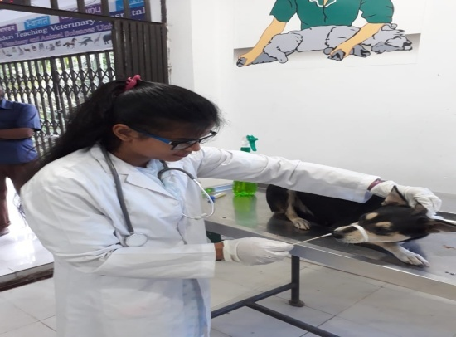
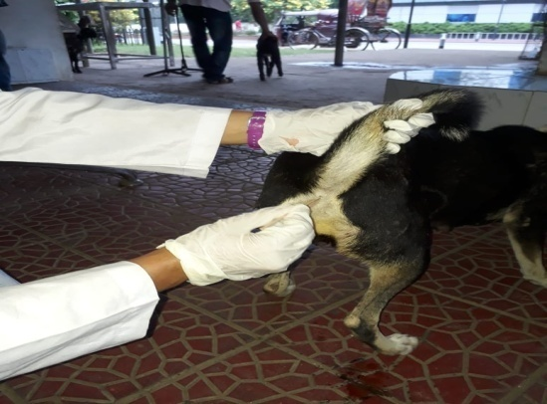
PHOTO GALARRY

Fig. 2: Collection of fecal swab

Fig.1: Collection of nasal swab
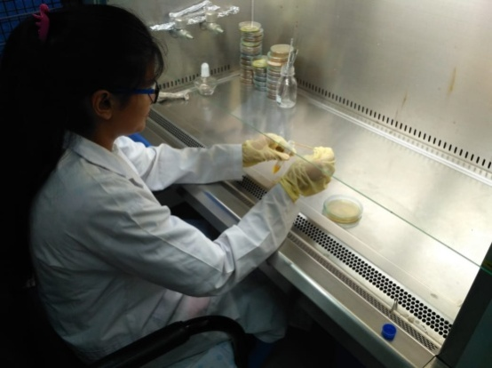
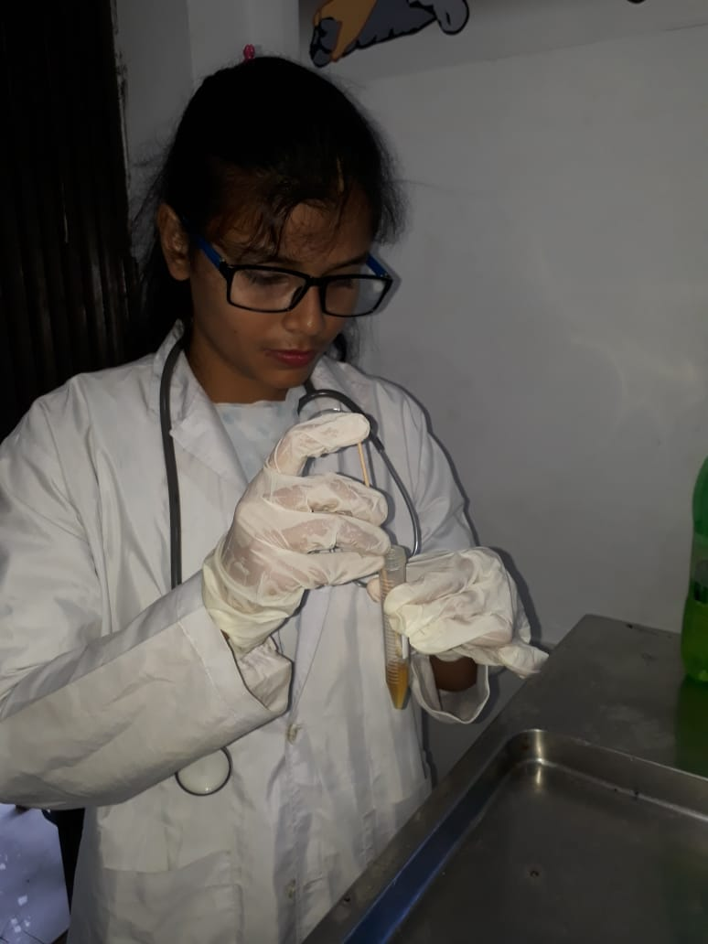

Fig.4: Making of Standard dilution

Fig.3: Inoculation of sample into 5ml buffer peptone
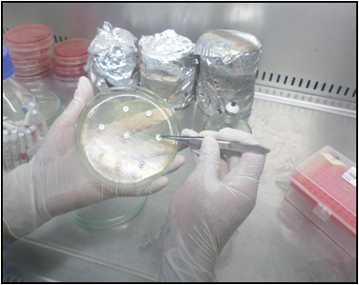
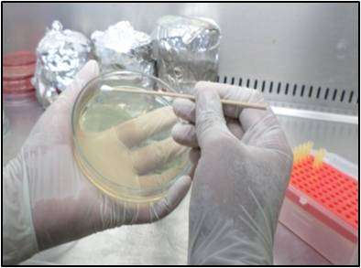

Fig.6: Inserting antimicrobial discs
Fig.5: Sticking sample into fresh Mueller Hinton agar
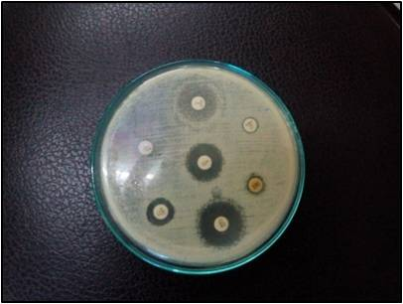
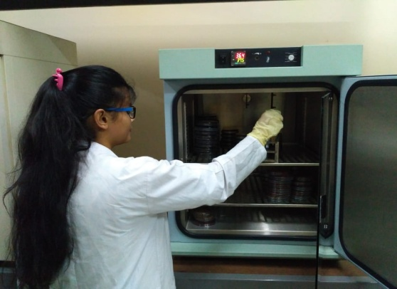

Fig.8: Observation of result

Fig.7: Incubation at 37⁰C

CHAPTER-V
REFERENCES

- Frederick and N. Huda, 2011. Salmonellas, Poultry House Environments and Feeds: A Review Journal of Animal and Veterinary Advances, 10: 679-685.

- Baserisalehi, M., N. Bahador and B.P. Kapadnis, 2006.Campylobacter: An emerging pathogen. Res. J. Microbiol., 1: 23-37.

- Bauer AW, Kirby WMM, Sherris JC, Turck M. Antibiotic susceptibility testing by standard single disc method. Am J Clin Pathol. 1996; 45:493–496.

- Bradshaw John. In defense of Dogs: Why dogs need our understanding. Penguin Books Ltd; 2012. ISBN-10: 014104649X.

- Bruce, D. and G.A. Fleming, 1983. Campylobacter isolations from household dogs. Vet. Rec., 112: 16-16.

- Burnens, A.P., B. Angeloz-Wick and J. Nicolet, 1992. Comparison of Campylobacter carriage rates in diarrheic and healthy pet animals. Zentralbl.Veterinarmedizin B, 39: 175-180.

- CDC. Get smart: know when antibiotics work. Centers for Disease Control. Atlanta GA: 2010.

- Cherry B, Burns A, Johnson G S. SalmonellaTyphimurium outbreak associated with veterinary clinic. Emerg Infect Dis. 2004; 10:2249–2251.

- Coates A, Hu Y, Bax R, Page C. The future challenges facing the development of new antimicrobial drugs. Nat Rev Drug Discov. 2002;1(11):895–910.

- Davis J A, Jackson C R, Fedorka-Cray P J, Barrett J B, Brousse J H, Gustafson J, Kucher M. Carriage of methicillin-resistant staphylococci by healthy companion animals in the US. Letters in Applied Microbiology.2014 ISSN 0266-8254.doi: 10.1111/lam.12254.

- De Vega, G., E. Mateo, A.F. de Aranguiz, K. Colom, R. Alonso and A. Fernandez-Astorga, 2005. Antimicrobial susceptibility of Campylobacter jejuni and Campylobacter coli strains isolated from humans and poultry in North of Spain. J. Biol. Sci., 5: 643-647.

- Ene, L., S. Sfartz, M. Giongradi, Y. Ene and C. Giongradi, 1992. Campylobacter jejunietiological agent of the enteritis: Assessment of the systematic research in a close community of infants. Proc. Cong. Foodborne Infect. Intoxications, 1: 151-155.

- Ethelberg, S., K.E. Olsen, P. Gerner-Smidt and K. Molbak, 2004. Household outbreaks among culture-confirmed cases of bacterial gastrointestinal disease. Am. J. Epidemiol., 159: 406-412.

- FDA. FDA Task Force on Antimicrobial Resistance: key recommendations and report. Washington DC FDA, Washington DC: 2000.

- Fernandez, H., K. Kahler, R. Salazar and M. Rıos, 1994. Prevalence of thermotolerant species of Campylobacter and their biotypes in children and domestic birds and dogs in southern Chile. Rev. Inst. Med. Trop. Sao. Paulo., 36: 433-436.

- Gaudreau, C. and H. Gilbert, 1998. Antimicrobial resistance of clinical strains of Campylobacter jejuni subsp. Jejuni isolated from 1985 to 1997 in Quebec, Canada. Anti.Agen. Chem., 42: 2106-2108.

- Goossen, H., L. Vlases, J.P. Butzler, A. Adnet and P. Hanicqet al., 1991. Campylobacter uspsaliensis enteritis associated with canine infections. Lancet, 337: 1486-1487.

- Goldberg, M.B. and R.H. Rubin, 1988. The spectrum of Salmonella infection. Infect. Dis. Clin. North Am., 2: 571-598.

- Henning S, Marianne S. Resistance to antibiotics in the normal flora of animals. INRA, EDP Sciences. Vet. Res. 2001; 32:227–241.

- Humphrey, T., S. O'Brien and M. Madsen, 2007.Campylobacters as zoonotic pathogens: A food production perspective. Int. J. Food Microbiol., 117: 237-257.

- Lee J H. Methicillin (oxacillin)-resistant Staphylococcus aureus strains isolated from major food animals and their potential transmission to humans. Appl. Environ. Microbiol. 2003; 69:6489.

- Manian F A. Asymptomatic nasal carriage of mupirocin-resistant, methicillin-resistant Staphylococcus aureus (MRSA) in a pet dog associated with MRSA infection in household contacts. Clin Infect Dis. 2003; 36:26–28.

- Martel J-L, Tardy F, Sanders P, Boisseau J: Review: New trends in regulatory rules and surveillance of antimicrobial resistance in bacteria of animal origin. Vet Res. 2001, 32: 381-392. 10.1051/vetres:2001131

- Modolo, J.R., F.A. Gottschalk, G. Moreno, C.A.D.M. Lopes, L.F. Margatho and C. Del Fava, 1991. Campylobacter in dogs with and without diarrhea: Incidence and susceptibility to 21 antimicrobials. Rev. Microbiol., 22: 288-292.

- Moreno, G., P. Griffiths, I. Connerton and R. Park, 1993. Occurrence of Campylobacters in small domestic and laboratory animals. J. Applied Bacteriol., 75: 49-54.

- Omudu E A, Okpe G, Adelusi S M. Study on Dog population in Makurdi, Nigeria (II): Asurvey of Ectoparasite infestation and its public health implications. Journal of research in forestry, wildlife and environment. 2010; 2(3):85–93.

- Robinson, R.A. and R.N. Pugh, 2002. Dogs, zoonoses and immunosuppression.Perspect. Public Health, 122: 95-98.

- Sabry, M.A., 2009.Captive dogs as reservoirs of some zoonotic bacteria. Res. J. Microbiol., 4: 222-228.

- Saenz, Y., M. Zarazaga, M. Lantero, M.J. Gastanares, F. Baquero and C. Torres, 2000.Antibiotic resistance in Campylobacter strains isolated from animals, foods and humans in Spain in 1997-1998. Antimicrob. Agents Chemother., 44: 267-271.

- Tambekar, D.H., D.V. Dhanorkar, S.R. Gulhane and M.N. Dudhane, 2007.Prevalence, profile and antibiotic susceptibility pattern of bacterial isolates from blood. J. Med. Sci., 7: 439-442.

- Torre, E. and M. Tello, 1993.Factors influencing fecal shedding of Campylobacter jejuni in dogs without diarrhea. Am. J.Vet. Res., 54: 260-262.

- Udell M. A. R, Wynne C D L. A review of Domestic Dogs’ (Canisfamiliaris) Human-like behaviours: or Why Behaviour Analyst should stop worrying and love their dogs. J. Exp Anal Behav. 2008;89(2):247–261.
- Woods GL, Washington JA. Antibacterial susceptibility tests: dilution and disk diffusion methods. In: Murray PR, Baron EJ, Pfaller MA, Tenover FC, Yolken RH, eds. Manual of clinical microbiology. 6th ed. Washington, DC: American Society for Microbiology, 1995 :1327 – 41.

- Workman, S.N., G.E. Mathison and M.C. Lavoie, 2005. Pet dogs and chicken meat as reservoirs of Campylobacter species in Barbados. J. Clin. Microbiol., 43: 2642-2650.

ACKNOWLEDGEMENT
The author is ever grateful and indebted to the Almighty God without whose grace it would have never been possible to pursue this study in this field of science and to complete this Clinical report writing for the Degree of Doctor of Veterinary Medicine (DVM).
The author would like to thanks his reverend and beloved teacher and supervisor Professor Dr. Mohammed Yousuf Elahi Chowdhury, Dept. of Medicine and Surgery, Chittagong Veterinary and Animal Sciences University for his valuable advice, suggestions, kind co-operation and providing funds and necessary facilities for conducting the study during the study period.
The authors of this study are highly thankful to Poultry Research and Training Centre, staff of Poultry Research and Training Centre for assistance in laboratory works and the owners of the dogs who gave their permission for their dogs to take part in the study.
The author would like to thanks to the Director of External affairs, Professor Dr. A.K.M Saifuddin, Department of Physiology, Biochemistry & Pharmacology, Faculty of Veterinary Medicine, Chittagong Veterinary and Animal Sciences University for his suggestion.
Finally, the author expresses his gratefulness to his parents, seniors, juniors and well-wishers.

The Author
September, 2018

BIOGRAPHY
I’m Joya Dhar Mumu, an intern student at Chittagong Veterinary and Animal Sciences University (CVASU), originate from Chittagong. After completing one year intern period, I will receive my Doctor of Veterinary Medicine (DVM) degree with lots of real life experiences. As an intern student I’ve received clinical training from Madras Veterinary College and Veterinary College & Research Institute, Namakkal, Tamilnadu, India. I have more interest on theriogenology, medicine, surgery, microbiology and epidemiological field area.

