ASSESSMENT OF SKIN DISEASES IN CATTLE AT UPAZILA VETERINARY HOSPITAL, KISHOREGANJ, NILPHAMARI
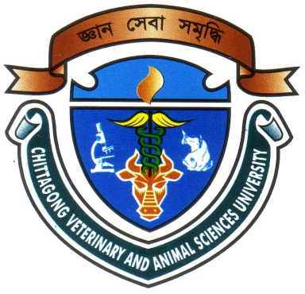

Report presented in partial fulfillment of the requirement for the degree of Doctor of Veterinary Medicine.

A Report Submitted by
Dilruba Yasmin
Roll No: 13/47
Intern ID: 45
Reg No: 00978
Session: 2012-2013

Faculty of Veterinary Medicine
Chittagong Veterinary and Animal Sciences University
Zakir Hossain Road, Khulshi, Chittagong-4225
September, 2018
ASSESSMENT OF SKIN DISEASES IN CATTLE AT UPAZILA VETERINARY HOSPITAL, KISHOREGANJ, NILPHAMARI
e

Clinical Report Submitted as per approved style and content

--------------------------------------------- ---------------------------------------------
Signature of the student  Dilruba Yasmin  Roll No: 13/47  Intern ID: 45  Reg No: 00978  Session: 2012-2013 | Signature of the supervisor  (DR. MOHAMMED ASHIF IMTIAZ SHAWN)  Assistant Professor  Department of Physiology, Biochemistry and Pharmacology  Faculty of Veterinary Medicine  Chittagong Veterinary and Animal Sciences University

Faculty of Veterinary Medicine
Chittagong Veterinary and Animal Sciences University
Zakir Hossain Road, Khulshi, Chittagong-4225
September, 2018

