INTRODUCTION

Skin, habitually known as the integumentary system is in fact the largest segment of the body. This is a multilayer interface between body and environment, responsible for various important functions while maintaining homeostasis, regulate the temperature, both by insulation and sweating, involved in the functioning of the nervous system and to protect the organism from mechanical injuries, microorganisms, substances, and radiation present in the environment (Dabrowska et al., 2016; Baroli, 2010). Skin contains numerous cells that provide immune functions to protect against infections, many external physical damage, bacterial invasion and line of defense against toxins, ultraviolet radiation and harmful pollutant. It helps in absorption, excretion of different waste materials, secretion and water transport. On skin, there presents various nerve cells which give stimulation and sensation against external triggers (Dąbrowska et al., 2018). This part keeps vital chemicals and nutrient in the body while providing a barrier against dangerous substances from entering the body and gives a shield (Elizabeth, 2010).
Skin can be affected with various diseases. There may be present diverse visible lesions on the skin which may cause dermatitis. It can hamper the production of animals by different ways such as mite infestation creates scales, alopecia, itching, erythema, hyperkeratosis; lice produce marked itching, irritation, formation of erythematous macula’s, dermatitic lesions and anemia incase of heavy infestation. Lice, mites also form obvious inanition that leads to weakness and poor health. Dermatophilosis, dermatophytosis and hump sore generate crust, alopecia and hyperkeratosis in the skin of cattle (Kassaye et al., 2003).
These kinds of disease conditions are significant for much more socio-economic impacts. Apart from the quality degradation of hides and skin, skin diseases provoke economic losses due to reduction of wool and hide quality, meat and milk yield, sufferers due to culling and occasional mortalities of that animal (Salih et al., 2015; Yacob et al., 2008). This huge impact of socio-economic perspective still demands the nationwide. On Bangladesh point of view, skin disease is one of the major causes of hindering the development of livestock population. It is very common in ruminants both rural as well as urban areas. The tropical environment (temperature, humidity, rainfall)and abundance of vectors creates a vulnerable condition for the easy growth of micro-organism and parasites. There has been a lot of impact on tannery sector; reduce the market value of hides and skin. They also affect the health and productivity of livestock.
Dermatitis, the inflammation of the skin produced by numerous agents like external irritants, burns, allergens, trauma and infection (bacterial, viral, parasitic or fungal) associated with concurrent internal or systemic diseases or hereditary factors (Andrew Forbes). These diseases are characterized by itchiness, red skin and a rash. In cases of short duration, there may be small blisters, while in long-term situation the skin may become thickened (Nedorost and Susan, 2012). The area of skin involved can vary from small to the entire body (NIAMS, 2013).
On other hand, lots of damage conditions of skin are also observed on cattle of rural and periurban areas. Hair loss and alopecia are very frequent. It could be result from genetics, diseases, parasite infestation and poor husbandry. Sometimes it can be found as alopecia, ranges from mild to severe. This appears as a secondary symptom in various bovine bacterial and viral diseases (Andrew Forbes). In case of alopecia, the nutritional deficiency is much more important to reveal the condition in an animal. Most of the time hair loss can occur due to deficiency of iron, zinc, vitamins, minerals and so on. A balanced dietary ration along with multivitamin and zinc supplement either orally or parenterally which can try to reduce the condition.
Ecto-parasites are responsible for great economic loss due to reduction in wool quality, meat and milk yield, damage on health problem which causes severe financial fatalities to the farmer, the tanning industries and country as whole (Beyecha et al., 2014). They also cause detrimental effect to animals via blood loss stress, irritation and impairment in immune function (Manan and Ahmed, 2007). The symptoms of ecto-parasitic infestation are local irritation on the skin and hair loss due to climatic change and prevalence of vector borne diseases (Holds and Worth, 2005). Like in winter cattle are commonly infested with lice, ticks or mites, which favoring the expansion of their populations. The impact of lice and mange ranges from death due to anemia in sucking blood. Lice affect host directly by causing irritation and damaged skin, change in behavior indirectly having weight loss, production loss, decreased feed utilization, anaemia on heavy infestation and transfer pathogen of zoonotic significance (Forbes A, 2017).
Mites cause skin diseases, tremendous loss of skin through injury, loss of production, anemia and death when found in large number resulting in impatience, anxiety and loss of weight to the livestock that is responsible for economic losses (Kabir et al., 2011). Moreover, Ticks cause direct effect on animals by sucking blood and responsible for transmission of numerous viral infections and carrying pathogens such as bacteria, protozoa. They are vector of many diseases including ticks paralysis, ticks typhus, anaplasmosis (Agarwal and Gupta, 2010) ticks bite abscesses, irritation and dermatophilosis.
Incase of hum psore which is caused by the nematode Stephanophilaria spp. mechanically transmitted by flies (Taylor et al., 2004) which is characterized by skin lesions like alopecia and ulcerative nodules mainly on the neck portion of the body. Parenteral administration of ivermectin was 100% effective in curing the disease and as secondary drug anti-histamine was a great drug of choice.
Therefore, this study was chosen to assess the skin diseases at Upazila, Veterinary Hospital, Kishoreganj, Nilphamari with the following objectives:
- To evaluate the prevalence of skin disease conditions at northern part of Bangladesh
- To recognize the distinguishing features for common skin diseases
- To identify the predisposing risk factors of skin disease conditions

MATERIALS AND METHODS

Area and Study Population
This study was conducted on cattle residing at Kishoreganj Upazila, Nilphamari. The cattle examined mostly were local (indigenous) with some exotic cross breed (e.g. Friesian). A total of 356 cases were treated in Upazila Veterinary Hospital (UVH), Kishoreganj Upazila, Nilphamari during 1st February to 31st March, 2018.

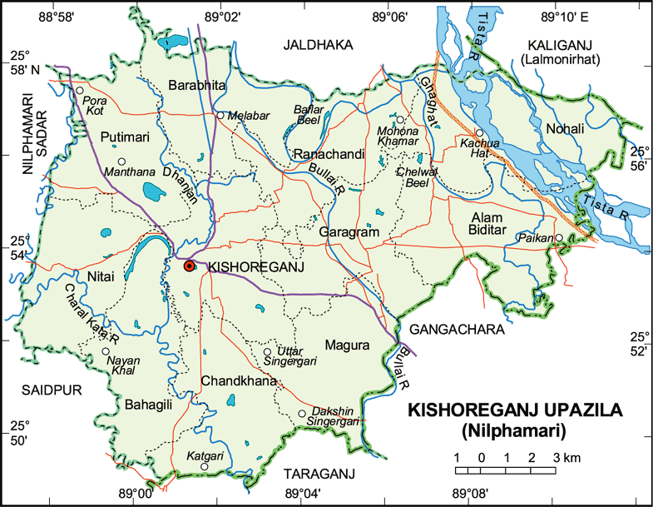

Study Lay out:

Patient data
Species, Breed, Age, Sex and Weight of patient.

Identification of the case
by
Epidemiological study (Questionnaire)

Identification of the affected cases on target groups orpopulation

Selection of the study area

Depthness of the wound
Temperature, Pulse, Respiration

Disease history
Pre-disposing factor
Onset and duration of illness
Weakness of patient
Anamnesis
Clinical Examination

Inspection/
Observation

Palpation and determination

Affected region of the body
Hair coat and Skin

Close Inspection
Distant Inspection
General attitude, Posture, Gait and Body Condition Score (BCS)of the patient.

Data collection
A structured questionnaire was carefully prepared and this was filled up by repeated questioning to the animal owner, personal observation of patient (Thrusfield, 2005). Important animal level data recorded including affected animals, species, breed, age, sex, body condition of the animal, weakness of the animal, onset and duration of illness, affected sites, frequencies of infection and pre-disposing factors of the case. Other information sought included history of de-worming and vaccination, pregnancy status, parity, housing pattern, type of the floor in the animal house (Katcha/ dirty floor/ muddy/ brick/ concrete/ rubber bedded), rearing system (intensive/ semi-intensive/ free-range) as well as whether or not a system of grazing or zero-grazing was practiced. Clinical examinations were performed according to questionnaire designed mentioning about temperature, hair coat, skin, general attitude of animal, posture, gait, wound, depthness of wound etc.

Case Identification and Diagnosis
i. Owner’s complaint
ii. Anamnesis: History was taken about weakness of patient, onset and duration of illness from owner/ farmer.
iii. Clinical examination of patient; It includes:

Inspection
Distant Inspection: Firstly the general attitude of the patient (alertness/ dullness/ depression) was carefully inspected. Following this, the body condition of the animal (Cachectic/ poor/ fair/ good/ fat/ over fat) was observed as described by Radostitis et al., 2000. In addition, posture and gait (normal or defective) were examined according to the condition of the animal.
Close Inspection: Following distant inspection, the patient was closely examined by parting of hair/fleece, light palpation and close direct inspection to detect hair coat and skin abnormalities. Skin lesions, nature of lesions (foul odorous discharge, crusts, scale and dandruff), location/ distribution of those lesions were also studied. In addition, external parasites (eg. ticks, lice, flea, flies and larvae of flies) identified during examination were documented.

Diseases | Clinical examination | Diagnostic pictures
Alopecia | Hair loss usually starts as afocal patch that may enlarge and coalesce with adjacent lesions through all over the body. | 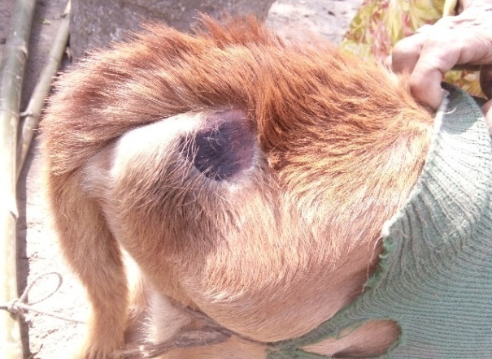
Tick infestation | Scratching, rubbing and licking, damage to skin, fleece and hides  Inanition, anemia. | 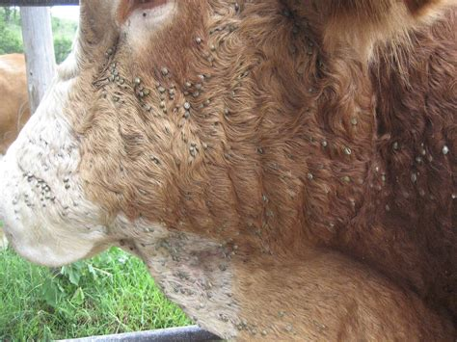
Hump sore | Chroniculcerative, granulomatous dermatitis present around the hump which was moist. | 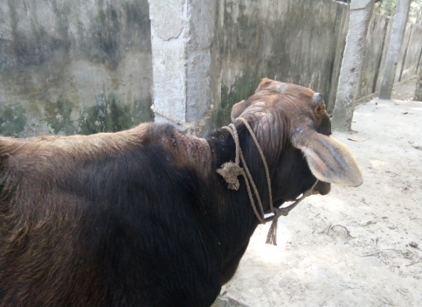

Data Analysis
All the data that were collected (categorical variables like breed, season, body area etc. and continuous variables like age, BCS etc.) were entered into MS excel (Microsoft office excel-2007, USA). Descriptive analysis was done by means of creating histogram and pie charts.
RESULTS

The assessment of skin diseases were evaluated on cattle at Upazila Veterinary Hospital (UVH) under Nilphamari district. A total of 356 animals were presented and treated from different diseases where 183 cases (51.4%) were skin diseases. Among themthere found 76.5% alopecia, 19.1% tick infestation and 4.4% humpsore.
Graphical representation of skin diseases

Fig: Proportionate of cattle were affected with skin diseases

Frequency distribution of skin diseases according to different etiological means
Disease condition | Etiological agent | No. of affected animals | Percentages
Alopecia | Nutritional deficiency | 125 | 89.28%
 | Bacterial cause | 15 | 10.8%
Tick infestation | Ectoparasite | 34 | 19.1%
Hump sore | Ectoparasite | 5 | 55.6%
 | Poor management | 2 | 22.2%
 | On agriculture field work | 2 | 22.2%
The estimated result showing in the table indicates that the highest disease prevalence occurred due to nutritional deficiency (89.28%), then ectoparasitic infestation (23%), bacterial cause (10.8%) and the remaining as poor management and used in agricultural field (22.2%).

Frequency distribution of skin diseases according to BCS of animal
Disease condition | BCS of animal | No of affected animals | Percentage
Alopecia | 2 | 78 | 55.7%
 | 3 | 57 | 40.7%
 | 4 | 5 | 3.6%
Tick infestation | 2 | 26 | 76.5%
 | 3 | 7 | 20.6%
 | 4 | 1 | 2.9%
Hump sore | 2 | 5 | 55.6%
 | 3 | 3 | 33.3%
 | 4 | 1 | 11.1%
Total |  | 183 | 100%

Poor body conditioned animals were most prone to skin diseases. The table showed, in case of alopecia, cattle with poorly scored was 55.7% where as average scored were 40.7%. Other hand, 76.5% tick infested cattle were emaciated and thinner. Moreover, humpsore were observed on 55.6% emaciated cattle and 33.3% cattle was medium body conditioned.

Frequency distribution of skin diseases according to age of the animal
Disease condition | Age of the animals | No of affected animals | Percentages
Alopecia | Young | 55 | 39.3%
 | Adult | 85 | 60.7%
Tick infestation | Young | 5 | 14.6%
 | Adult | 29 | 85.4%
Hump sore | Young | 0 | 0%
 | Adult | 9 | 100%

The table indicated that, all the adult cattle are mostly affected with various skin diseases. Aged animal were found much more attacked with tick (85.4%) and lost their skin integrity and smoothness. On other hand, More than 4 years old cattle had been faced the problem of hair and fleece lost and susceptible for skin injury with alopecia (60.7%). It is obvious that hump sore was very common to adult cattle (100%).

Frequency distribution of skin diseases based on treatment efficacy
Disease condition | Treatment given | Percentages
Alopecia | Ivermectin | 7.5%
 | Parenteral Zinc inj | 92%
 | Histavet | 0.5%
Tick infestation | Ivermectin | 95%
 | Histavet | 2%
 | Antibiotic | 3%
Hump sore | Histavet | 3%
 | Antibiotic | 17%
 | Neguvon powder | 80%

The above table shows that, in case of alopecia, the animals mainly treated with zinc preparation (92%), sometimes nonspecifically they were treated with ivermectin (7.5%). On other hand, ectoparasitic tick infestation, ivermectin was frequently used (95%) and hump sore was treated with neguvon powder (80%).

Frequency distribution of skin diseases based on affected part of the body
Disease condition | Affected body parts of the animals |  | Percentage
Alopecia | Head |  | 52%
 | Neck |  | 27%
 | Back region |  | 9%
 | Tail |  | 7%
 | Limb | Forelimb | 4%
 |  | Hind limb | 1%
Tick infestation | Whole body |  | 100%
Hump sore | Hump region |  | 100%

In case of alopecia the most susceptible site was head (52%) next to that neck region (27%) whereas tick infestation was found on whole over the body (100%) and incase of hump sore hump region was totally damaged (100%).

DISCUSSION

Skin diseases are rarely fatal, but they can cause significant discomfort to livestock and are often highly contagious. These skin diseases can lead to production losses due to reduced or disrupted feeding caused by irritation on damaged skin. Many disorders are caused by ecto-parasites or a fungal infection, but most can be prevented and treated successfully (Wilkinson, 2017).

The study indicates that skin diseases caused by parasites and nutritional deficiencies were common in and around Kishoreganj, Nilphamari on cattle: their overall prevalence were 76.5% alopecia, 19.1% tick infestation and 4.4% humpsore. These relative high frequencies would be associated with nutritional factor, climatic stress, large quantity of vectors (flies, ticks, mites) and favorable condition for diseases agent multiplication. As different flocks of animals came in close contact at available communal watering and grazing because of the feed scarcity, the establishment and spread of skin diseases infections were encouraged. The prevailing insufficient veterinary services, improper application of drugs by non-professionals could also amplify this endemic situation.

Among skin diseases, the prevalence of alopecia was important on the study in cattle which was mainly due to nutritional deficiency and supports the study of Yacub et al., 2008. There also found bacterial cause on alopecia. The prevalence of ectoparasite was not significant in the study it is due to specifically the animal which was infested with tick or lice it was treated with ivermactin (acaricide). According to various studies, subcutaneous injection or dipping or pour on ivermactin is the specified preferred drug for ectoparasite infestation in cattle. Moreover, hump sore was another finding which was prevailed on that northern territory of Bangladesh. Poor management and abundance of fly was the main cause of this infection which is supported by Addise and Achenef, 2013; Kaufman et al., 2011 and Aiello and Mays, 1998. Mainly on hump sore cases were treated with Trichlorfon preparation. Furthermore, on case of alopecia, due to shortage of nutrition, cattle were treated with zinc supplement and antihistamine to prevent allergic reaction which was illustrated on Mercks veterinary manual.

It was observed that poor conditioned with emaciated body structured cattle mostly affected with alopecia. On others, ecto-parasitic infested cattle body growth was rapidly downing and hair coat was found as rough. The study is similar to the study of Kaufman et al., 2011; Yacub et al., 2008. Surprisingly, adult cattle were susceptible more than younger one. Most vulnerable site on alopecia sufferer cattle was head and neck portion. It may be due to the cattle mostly were used for the purpose on agricultural field.

CONCLUSION

Skin disease plays a vital role on health and productivity of any animals particularly on cattle. A study was conducted to estimate proportionate prevalence and probable predisposing factors of skin diseases caused by ecto-parasites in cattle at Upazila Veterinary Hospital, Kishoreganj, Nilphamari during February-March 2018. A total of 356 cases were presented at the hospital where 183 (51.4%) cases were indigenous cattle with diverse skin diseases on which alopecia (76.5%), tick infestation (19.1%) and hump sore (4.4%) were common. Due to short duration of study period, it’s not possible to establish the relationship of disease with seasonal factor. On other hand, all the cases were not fully overlooking due to time constraint. From this study it can be said that, ivermectin is the best drug of choice for the treatment of ectoparasitic skin disease. Furthermore, farmers were not concerned about the bio-security of animal shed and also not careful about shed hygiene. Owners were also careless to keep their animal neat and clean by grooming whereas skin damage, injury and infection rate are growing higher and higher. So, to avoid the occurrence of skin diseases several controlling measures are essential such as maintain proper hygienic management in animal shed, regular de-worming of cattle at 4 months interval and isolate the diseased animal from the healthy stock.

REFERENCES

"Handout on Health: Atopic Dermatitis (A type of eczema)". NIAMS. May 2013.
Addise A, Achenef M (2013). Major Skin Diseases of Cattle: Prevalence and Risk Factors in and around Hawassa, Southern Ethiopia. JAVR 3: 147-153.
Agarwal P and Gupta AR (20100. Management of Ectoparasite of Livestock Department. Dairy Cattle, 23: 89-33.
Aiello SE, Mays A (1998). The Merck Veterinary manual. (8th edn) Merck NJ co Inc, white house station: USA.
Andrew Forbes, www.vettimes.co.uk/.../ectoparasite-infestation-in-winter-housed-dairy-cattle.
Anthony Wilkinson (2017). Managing livestock skin diseases on-farm: causes and treatments, News letter, Farmers guardian.
Baroli B (2010). Penetration of nanoparticles and nanomaterials in the skin: fiction or reality? J Pharm Sci‐Us. 99: 21‐50.
Beyecha K, Kumsa B and Beyene D (2014). Ectoparasites of goats in three agro ecologies in central Oromia, Ethiopia. Comp. Clin. Path., 23: 21-28.
Dabrowska AK, Rotaru GM, Derler S (2016). Materials used to simulate physical properties of human skin. Skin Res Technol. 22: 3‐14.
Elizabeth H Page MD (2010). Assistant Clinical Professor of Dermatology, Harvard Medical School; Staff Physician, Lahey Hospital and Medical Center.
Holds and Worth, P.A. 2005. Ectoparasiticide use in contemporary Australian livestocks production. Avacre,Canberra Australia., PP: 45-57.
Kabir MHB, Mondal MMH, Eliyas M, Mannan MA, Kashem MA and Elahi MF (2011). An epidemiological survey on investigation of ticks infestation in cattle at Chittagong district Bangladash. Afr. J. mic. res., 5 (4): 346-352.
Kassaye E, Moser I, Woldemeskel M (2003). Epidemiological study on clinical bovine dermatophilosis in northern Ethiopia. DTW. Deutsche tierarztliche Wochenschrift 110 (10): 422-425.
Kaufman PE, Koehler PG and Butler JF (2011). External Parasites on Beef Cattle. University of florida, IFAS extension pp: 1-13.
Manan AZ and Ahmed (2007). Prevalence and Identification of Ixodid Ticks genera in frontier Region, Peshwar. J. Agri. Bio. Sci., 2: 19-16.
Nedorost and Susan T (2012). Generalized Dermatitis in Clinical Practice. Springer Science and Business Media. pp. 1–3, 9, 13–14. ISBN 9781447128977.
Radostits OM, Gay CC, Blood DC and Hinchcliff KW (2000). In: Veterinary Medicine, A textbook of disease of cattle, sheep, pigs, goats and horses, 9th edition. W B Saunders, pp: 1387-1416.
Salih DA, El Hussein AM, Singla LD (2015). Diagnostic approaches for tick-borne haemoparasitic diseases in livestock. J. Vet. Med. Anim. Health 7(2): 45-56.
Taylor SM, Hunter AG and Andrews AH (2004). Ectoparasites tick and arthropod borne diseases. In:Andrews AH, Bowey RN, Boyd H, Eddy RG, editors. Bovine medicine: diseases and husbandry of cattle. Ames Blackwell publisher, Pp: 740-77.
Thrusfield MV (2005). Criteria for Success of Questionnaire. In: Veterinary Epidemiology. 3rd edi., Oxford, UK: Blackwell Science. pp: 189-213.
Yacob HT, Nesanet B, Dinka A (2008). Prevalence of major skin diseases in cattle, sheep and goats at Adama Veterinary Clinic, Oromia regional state, Ethiopia. Revue Méd. Vét. 159 (8-9): 455-461.

BIOGRAPHY OF THE AUTHOR

Dilruba Yasmin; daughter of Md. Delwar Hossain and Fency Akther had been passed the Secondary School Certificate examination in the year 2009 followed by Higher Secondary Certificate examination in 2011. Now, she is a candidate for the degree of Doctor of Veterinary Medicine (DVM) from Chittagong Veterinary and Animal Sciences University (CVASU), Bangladesh.

