Acknowledgement
All praises are due to “Almighty ALLAH” who enabled the author to complete this report successfully.
The author express his deep sense of gratitude, heartfelt respect and immense indebtness to his supervisor Prof. Mohammad Belayet Hossain, Department of Physiology, Biochemistry and Pharmacology, Chittagong Veterinary and Animal sciences University for his valuable advice, scholastic guidance, suggestions, inspiration and who was involved with this report through its inception.

I would like to express my deep sense of gratitude and thanks to Professor Mr. Md. Abdul Halim, Dean, Faculty of Veterinary Medicine, Chittagong Veterinary and Animal Sciences University for his valuable suggestion & inspiration.

The author is deeply owe, Dr. Aiyub Miah Rana, Upazilla Livestock officer, Hathazari ,Chittagong. for his constant help .

The author wishes to express his gratitude to the Professor and Director of External Affairs, Dr. A.K.M Saifuddin, Chittagong Veterinary and Animal Sciences University, for his supervision and kind co-operation during the period of internship

I also express thank to my friends for their help and co-operation during the tenure of writing of this report. The author is immensely grateful to all of them, although it is not possible to mention every one by name.

The Author
September 2018
Abstract
Uterine prolapse is a non-hereditary complication occurring immediately after parturition and occasionally up to several hours afterwards. It is a common obstetrical problem, which adversely affects productive and reproductive performance of cattle by affecting postpartum return to estrus, conception rate and calving interval. Incidence of uterine prolapse as 42.9% among various obstetrical problems in buffalo. A three years old buffalo cow with a history of parturition at first parity was brought to the Upazilla Veterinary Hospital of Upazilla Livestock Development Centre, Hathazari, Chittagong. Breed of the buffalo cow was Murrah, breed of domestic dairy buffalo. The breeding system of the buffalo was natural. The buffalo showed protrusion of fleshy mass through the vulva and severe straining was found after its first calving. On clinical examination animal was apparently healthy and confirmed as uterine prolapse. The Uterine prolapse was corrected manually following proper precautionary measure like application of epidural anesthesia. To prevent the recurrence, Buhner's suture was applied perivaginally. The animal was followed up for 15 days and had an uneventful recovery.

Keywords: Buffalo cow ,Uterine prolapse , Buhner's suture

Introduction
Uterine prolapse is the protrusion of the uterus from the vulva with the mucosal surface exposed. Prolapse, or eversion, of the uterus is most commonly observed in large ruminants like cows, buffaloes and sheep. It generally occurs during the 3rd stage of parturition or immediately after it in buffaloes, but in rare cases it may be seen 24 h to 48 h after parturition. The inverted uterus is visible as a large mass protruding from the vulva and may extend to the hock joint. Prolapse of the uterus is a common complication of the third stage of labour in the cow (Arthur et al., 1996). In ruminants the prolapse is generally a complete inversion of the gravid cornua (Arthur et al., 1996). Uterine Prolapse is one of the most potentially dangerous complications associated with calving. A uterine prolapse can vary in size from about 18 inches to 3-4 feet in a buffalo.
The uterus is completely expelled out at the back of hind legs when the cow is standing. Uterine prolapse is a life threatening condition for animal. In the period immediately after prolapse the tissues appear almost normal, but within a few hours they become enlarged and edematous. Some animals will develop hypovolumic shock, secondary to internal blood loss, laceration of the prolapsed organ or incarceration of abdominal viscera (Ramsingh et al., 2013; Mohan et al., 2013). It is regarded as a veterinary emergency because without treatment, the cow is likely to die (Murphy and Dobson, 2002; Miesner and Anderson, 2008). The uterus must be replaced back to its normal position within the abdomen as quickly as possible. A buffalo cow with uterine prolapse can go into shock quickly and die from blood loss. Avoid chasing or moving a cow with uterine prolapse.
The etiology of uterine prolapse is unknown, But many factors have been associated.
Complications associated with calving. Difficult calving that cause injury or irritation of the external birth canal , severe straining, or excessive force applied when pulling an oversize calf can cause a uterine prolapse. Poor uterine tone and low blood calcium levels have been incriminated and animals in poor body condition, weight of retained fetal membranes will have increased risk of getting uterine prolapse. Conditions that increased intra abdominal pressure including tympany and excessive estrogen content in the feed also act as risk factor of uterine prolapse( Hanie et al., 2006 ).
Few authors reported that 40% of cows became pregnant after uterine prolapse. If prompt treatment is instituted, a post operative fertility rate of 40-60% has been recorded (Tyagi and Singh, 2002). Delayed cases may develop fatal septicaemia. Success of treatment depends on the type of case, the duration of the case, the degree of damage and contamination.
The aim of this study was to manage and correct the clinical cases of uterine prolapsed to save buffalo cows from severe consequences.

Materials and Methods

Case history and Clinical Observation
A three years old buffalo cow weighing about 350 kg was presented at Hathazari upazilla, Chittagong, with a calving history 7 hours ago. A male calf was born before seven hours. The total uterine mass was prolapsed after the fetal membrane sheds normally. The cow was off fed since then. Interaction with the owner revealed that it was the first parturition.
On gynaeco-clinical examination it was found that the buffalo was in recumbent position and the physiological parameters were within the normal range but the respiration was slightly increased due to stress. The ocular mucous membrane was slightly congested.
The general health of the cow was poor .The prolapsed mass was larger and longer , hanging down to the hocks when standing, more deep red in colour and covered with foetal membranes. The prolapsed mass was also edematous, engorged and soiled with fecal materials, straw, dirt ,debris and blood clots.
A thorough physical examination was carried out and the vital parameters were:
Temperature 102.5ºF, Heart rate 130 beats/min, Respiratory rate 75 cycles /min and pulse rate 130 beats/min. The animal was showing signs of discomfort.
Based on the clinical examination, it was diagnosed as a case of Uterine prolapse.

Surgical management
- General Approach
Before to the treatment physical examination was done and recorded. The animal was placed on the dry and clean area in dorsal recumbency and was restrained physically by the assistants
- Correction of uterine prolapse
Epidural anesthesia was done by infiltration of 10 ml 2% lidocaine hydrochloride solution (Jasocaine®, Jayson Pharmaceuticals Ltd., Dhaka, Bangladesh) into the first sacrococcygeal vertebrae to prevent straining during replacement of the prolapsed organ. After allowing 10 min for the anaesthetics to take effect, sensitivity around the perineal region was assessed by pricking with a needle.
The debris and foetal membrane was carefully separated avoiding damage to maternal caruncles and bleeding. The tissue debris was removed by washing and cleaning the prolapsed mass with clean luke warm water. The prolapsed uterine mass along with the perineal region was thoroughly irrigated with potassium permanganate solutions (1:1000) with gloved and lubricated hand.
Then the animal was placed on sternal recumbency and the two hind limbs were pulled out behind her. Then using both hands with moderate force the prolapsed uterus was gently pushed in through the vagina. The body was first pushed in followed by the horns. Then the Buhner’s suture with sterile cotton thread was placed in the vulva as a retention technique to hold the uterus in place. Re-occurance of prolapse due to tenesmus was prevented by applying Buhner’s suture .
The suture was removed after 14 days. The cow recovered uneventfully without any complications.
- Post operative care
Dressing the prolapsed area regularly .Calcium borogluconate solution (450ml, intravenously), Antibiotic (Inj. Streptopenicillin, 10ml, intramuscularly)
Antihistaminic (Inj. Pheneramine meleate, 20ml, intramuscularly) and Dextrose saline [(20%) 2000ml, intravenously] were injected for 7 days.

Results
The buffalo cow showed good recovery without recurrence and other complications. The suture was removed after 14 days. It is generally noticed during immediately post-partum especially after dystocia but in this reported case, the prolapse was observed in buffalo cow after normal parturition of a male calf. The objective in the treatment of uterine prolapse was replacement of the organ to its original position and prevention of recurrence.
It was observed that the hygienic handling, proper management and treatment should definitely prevent further reproductive tract damage and aid in quick recovery.In this case hematological parameter showed low serum calcium level (7.5 mg/dl) indicating hypocalcaemia. Decreased level of calcium can lead to reduced vaginal and uterine muscle tone which predisposes the animal to prolapse (Noakes et al., 1999).
Based on the results of the present study, deficiency of Calcium (7.0 mg/dl), Magnesium (1.5 mg/dl) and Phosphorus (3.5mg/dl) might be the possible factor that leads to prolapse of genital track in buffalo.
Biochemical blood analysis in cow suffering from uterine prolapse
Name of the test | Result | Normal Range
Serum Calcium | 7.0 mg/dl | 9.7-12.4 mg/dl
Serum Magesium | 1.5mg/dl | 1.8-2.3 mg/dl
Serum Phosphorus | 3.5 mg/dl | 5.6-6.5 mg/dl

Figures

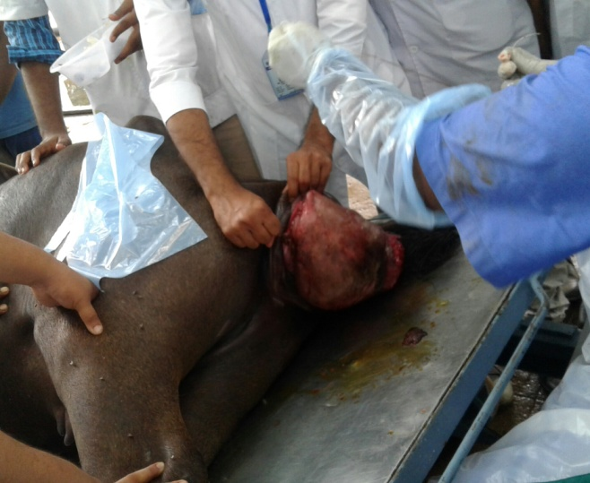  A | 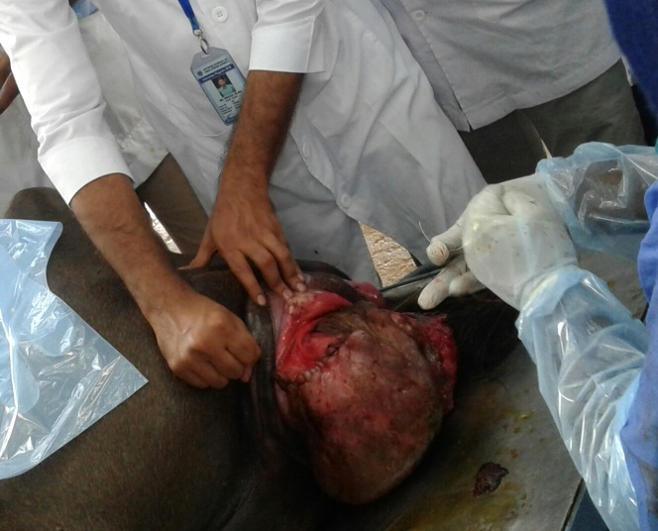  B
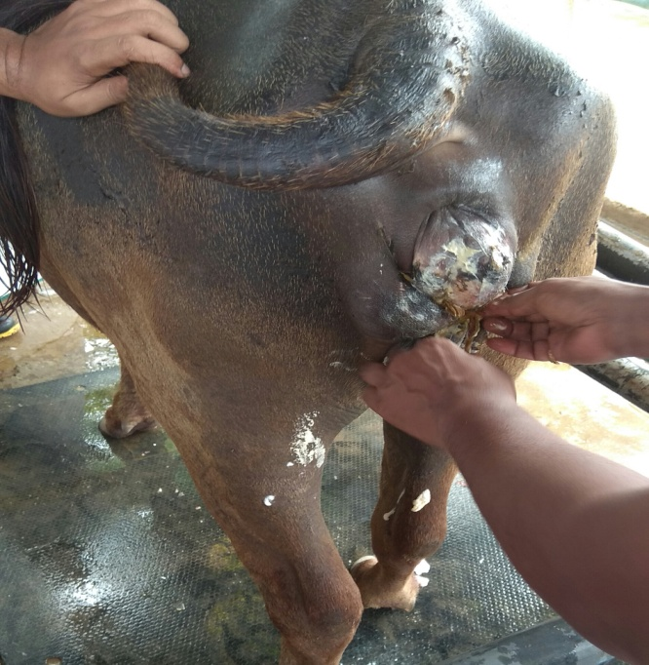  C | 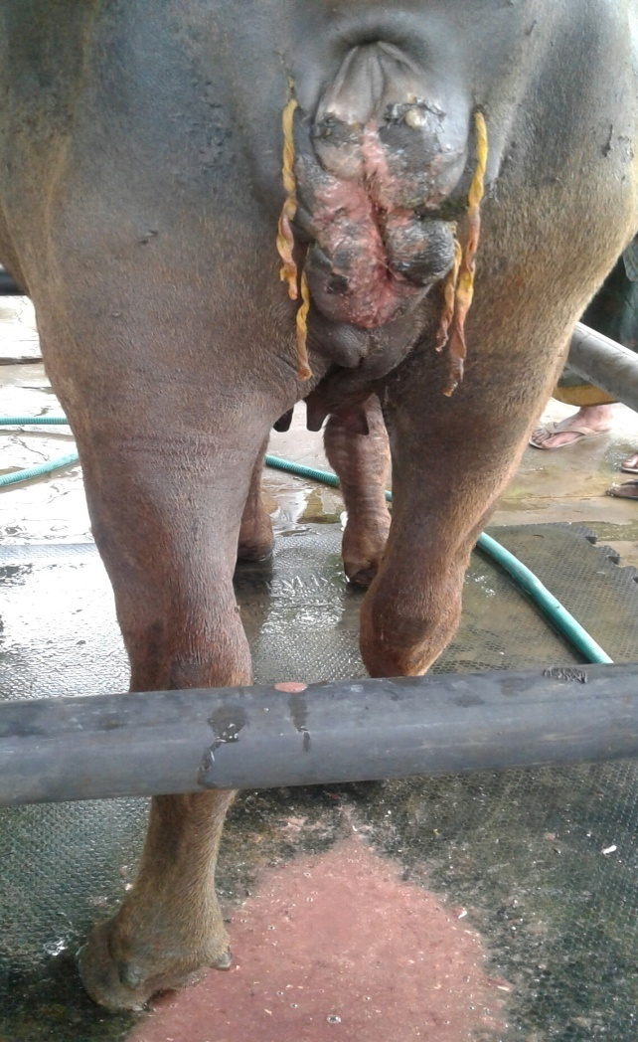  D
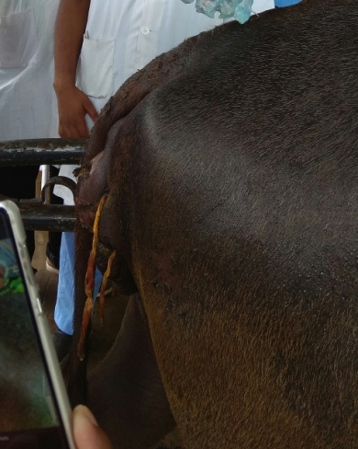  E | - Protruted mass  - Suturing in uterus  - Buhners suture applied  - Untie the suture for post operative care  - Recovered buffalo

Discussion
Prolapse of the uterus normally occur during the third stage of labour at a time when the fetus has been expelled and the fetal cotyledons has separated from the maternal caruncles (Gardner et al., 1990 ). The goal in the treatment of uterine prolapse is replacement of the organ followed by a method to keep it in the retained position. A full clinical examination of animals with uterine prolapse must be undertaken as signs of toxaemia like in appetence, an increased respiratory rate, raised pulse and congested mucus membranes may be consisted with metritis. Vascular compromise, trauma and faecal contamination may also increase toxin intake across the uterine mucosa. However, careful removal of these materials, after soaking with warm dilute antiseptic solution is usually successful causing only minor capillary bleeding. Vigorous attempts to remove superficial contamination should be avoided as they may prove counterproductive by increasing toxin uptake (Gardner et al., 1990). A caudal epidural anaesthesia is essential before replacement of a uterine prolapse as it decreases straining and desensitizes the perineum. The uterine prolapse can be replaced with the animal in standing or recumbent position (Hanie, 2006).Once the uterus is replaced, the operators hand should be inserted to the tip of both uterine horns to be sure that no remaining invagination could incite abdominal straining and reprolapse (Fubini and Ducharme, 2006). If the uterus is completely and fully replaced all the way to the tips of the uterine horns, the prolapse is unlikely to occur (Hanie, 2006).
The tension of a rope around the posterior abdomen, raising the animal’s hind legs on board or on a truss of straw, or even casting her and raising her part by means of a block and tracle hooked to figure of eight rope around the hooks.This is also suggested by different author (Arthur et al., 1999). Before replacement of uterus epidural anesthesia was performed. The replacement of uterus was performed little by little,starting the vulval lips upper and lower portion. The prolapsed uterus was pushed into vagina by manual pressure and takes care of vulval lips. Once the uterus is in its normal position, oxytocin 10 i.u intramuscularly should be administered to increase uterine tone. It has also been reported that most animals with uterine prolapse are hypocalcaemic (Fubini and Ducharme, 2006).Where signs of hypocalcaemia are noticed such animals should therefore, be given calcium borogluconate. An injectable broad spectrum antibiotics once administered for three to five days after replacement of the prolapsed will prevent secondary bacterial infection (Borobia-Belsue, 2006; Hosie, 1993; Plunkett, 2000). Animals with uterine prolapse that were properly managed can conceive again without problems. Complications develop when lacerations, necrosis and infections are present or when treatment is delayed. Shock, hemorrhage and thromboembolism are potential sequelae of a prolonged prolapse (Noakes et al., 1999). The high vital parameters witnessed in this case when the animal was first brought could be as a result of metritis caused by secondary bacterial infection especially as the animal was brought for treatment after three days of occurrence of the prolapse. Treatment with broad spectrum antibiotics (Ceftiofur sodium 2mg/kg) was responsible for the lowering of the vital parameters to the normal values after three days of treatment. Ceftiofur sodium was given to prevent the secondary bacterial infection. By gentile pressure, the nearest cotyledons are pushed into vagina, taking care that the lips of the vulva remain well apart and don’t become turned inwards. It is generally best to replace portion of the upper and lower surface alternatively. In recumbent animal, the immediate need is to cover the prolapsed mass with clean, wet cloth to keep the mass moist and free from further animal. In standing animal, the free from wrapped in a cloth and hold high level of the vulva. Handling of the prolapsed organ invariably leads to about of tenasmus and therefore light epidural anesthesia is mandatory (Tyagi and Singh, 2002). Plenderleith (1986), described a method which is now in common usage amongst practitioners. The cow is placed in sternal recumbency with both hind legs pulled out. The usually the edematous placentomes allow easy separation of cotyledons from caruncles (Potter, 2008). Prognosis of prolapsed uterus generally favorable for uncomplicated cases where there has been no serious damage to the uterus. In one study a two week survival rate of 72.4% (Gardner et al., 1990) was found, with other studies findings survival rates of 73.5% (Jubb et al., 1990) and 80% (Murphy and Dobson, 2002).

Conclusion
Uterine prolapse may appear in peri-parturient period. Diagnosis and treatment of uterine prolapsed is very much important task. Delayed in correction may cause some critical condition such as edema, fibrosis, necrosis, septicemia. Applying buhner’s sutre is the effective method to correct it . Buhner’s suture also help to prevent recurrency. The farmers and veterinarians should be careful about early recovery of the condition which will save the cow from life threatening condition.

Refferences
Arthur, G. H., Noakes, D. E., Peterson, H and Parkinson, T.J. 1996. Veterinary reproduction and Obstetrics, 7th edn. WB Saunders company Ltd.,London.
Arthur, G. H., Noakes, D. E., Pearson, H. and Parkinson, T. J. 1999. Veterinary Reproduction and Obstetrics, 7th Edition,Saunders Company Ltd., Philadelphia, PA,WB.
Borobia-Belsue, J.2006. Replacement of rectal prolapsed in sows. Vet. Rec., 36: 380.
Fubini, S.L. and Ducharme,G.N. 2006. Surgical Conditions of the Post Partum Period. Text Book of Farm Animal Surgery, Pp: 333-338.
Gardner, I .A., Reynolds, J .P., Risco, C .A. and Hird, D. W. 1990.Pasterns of Uterine Prolapsed in Dairy Cows and Prognosis After Treatment. Journal of American Veterinary Medical Association, 197: 1021-1024.
Hanie, E.A.2006. Prolapse of the Vaginal and Uterus:Text Book of Large Animal Clinical Procedures for Veterinary Technicians. Elsevier, Mosby,Pp: 218-221.
Hosie, B.1993. Treatment of Vaginal Prolapse in Ewes. Practice, 15: 10-11 .
Jackson, P.G.G.2004. Postparturient Problems in Large Animals. Hand Book of veterinary Obstetrics.2nd Edn., Elsevier Saunders, Pp: 209-231.
Murphy AM and Dobson H (2002), “Predisposition, Subsequent Fertility and Mortality of Cows with Uterine Prolapsed”, Veterinary Record, Vol. 151, pp. 733-735.
Plenderleith R (1986), “Uterine Prolapsed in the Cows”, In Practice, Vol. 8, p. 14
Potter T (2008), “Prolpase of the Uterus in the Cow”, Uk Vet., Vol. 13.
Smythe R H (1948), Personal Communication to GH Arthur
Tyagi R P S and Singh J (2002), A Text Book of Ruminant Surgery, 1 st Edition.
Jubb T F, Malmo J, Brighting P and Davis G M (1990), “Survival and Fertility After Uterine Prolapsed in Dairy Cows”, Australian Veterinary Journal, Vol. 67, pp. 22-24
Ramsingh L, KM Mohan and KS Rao, 2013. Correction and management of uterine prolapse in crossbred cows. Int. J. Agris. Sci. & Vet. Med., 1: 1
Gustafsson H, B Kornmatitsuk, K Königsson and H Kindahl, 2004. Peripartum and early post partum in the cow-physiology and pathology. Medicine Vet. OPQ., 34: 64-65.

Biography

Name | Mohammad Iqbal Habib
Present position and affiliation | Intern student, 18th Batch, FVM,
 | Chittagong Veterinary and Animal Science University.
Educational background and year | Doctor of Veterinary Medicine in 2017
 | (appeared), Chittagong Veterinary and Animal
Science University.
I have completed my S.S.C and H.S.C
with GPA5 from Govt. Hazi Mohammad Mohsin High School , Chittagong.
I have completed my H.S.C with GPA-5 from Government City College ,Chittagong.
Research interest | Poultry and Dairy Animal Sector
Aim | Establish a Veterinary Health Complex and Diagnostic Centre in field level

.

