Authorization
I hereby declare that I am the sole author of the thesis. I also authorize the Chittagong Veterinary and Animal Sciences University (CVASU) to lend this thesis to other institutions or individuals for the purpose of scholarly research. I further authorize the CVASU to reproduce the thesis by photocopying or by other means, in total or in part, at the request of other institutions or individuals for the purpose of scholarly research.
I, the undersigned, and author of this work, declare that the electronic copy of this thesis provided to the CVASU Library, is an accurate copy of the print thesis submitted, within the limits of the technology available.

Mahabub Alam
December 2014

Acknowledgements

Firstly, the author would like to express his deepest sense of gratitude to “The Almighty Allah”, who enables me to complete the research work and dissertation.
Secondly, the author would like to express the first and foremost heartiest appreciation, deepest sense of gratitude and best regards to the supervisor Dr. Md. Hasanuzzaman, Associate Professor, Department of Animal Science and Nutrition, CVASU. The author really deems it a proud to do a research work under his constructive, useful and effective supervision.
The author feel much pleasure to convey the profound thanks to co-supervisor, Mohammad Mahmudul Hassan, Associate Professor, Department of Physiology, Biochemistry and Pharmacology, CVASU for his valuable advice and scholastic guidance.
The author also privilege to acknowledge his honorable teacher Md. Emran Hossain, Associate Professor, Department of Animal Science and Nutrition, CVASU for his support in breed identification and manuscript correction.
The author deeply owes to DR. Md. Saiful Bari, Lecturer, Department of Dairy and Poultry Science, CVASU for his full time support in data analysis and valuable advice during research work.
The author also thanks to Tofazzal Md. Rakib, intern student, Faculty of Veterinary Medicine, CVASU for his valuable support during the research work.
The author acknowledges all the members of the Department of Animal Science and Nutrition, and the authority of the Department of Physiology, Biochemistry and Pharmacology for their laboratory and physical support.
The author also expresses his good wishes, thanks and warmest sense of gratitude to the Beparies (cattle traders) who cooperate in research work with their useful information and participation.
Last but not least the author expresses his deepest sense of gratitude, cordial respect of feelings to his beloved family members for their immense sacrifice, blessings and encouragement.

December 2014
Table of contents
Authorization iii
Acknowledgements v
List of Tables ix
List of figures x
List of abbreviations xi
Abstract xii
Chapter-1: Introduction 1
Chapter-2: Review of literature 5
2.1 History of Animal Transportation 5
2.2 Farm animals and transport 5
2.3 Cattle Transportation in Bangladesh 6
2.4 Welfare in Transported Cattle 6
2.5 Stress 7
2.6 Stress due to transportation 8
2.7 Mechanism of stress response of animal 8
2.7.1 The HPA axis 10
2.7.2 The autonomic axes 12
2.8 Measurement of stress of Animal 13
2.9 Physical injuries during transportation 14
2.10 Hematological changes 17
2.11 Biochemical changes 18
2.12 Hormonal changes in transportation 20
2.13 Immune response in transportation 22
2.14 Effect of transportation on live weight shrinkage 23
2.15 Effect of transportation on meat 24
2.16 Effect of Transport stress on production 25
2.17 Recent trends regarding transportation of livestock 26
Chapter-3: Materials and Methods 29
3.1. Study area and period 29
3.2 Research design 29
3.3 Reference population 31
3.4 Target population 31
3.5 Sources of data 31
3.6 Environmental condition during transportation 31
3.7 Management of cattle during and after transportation 31
3.8 Data collection 31
3.9 Sample collection 32
3.10 Transportation and preservation of sample 32
3.11 Physical Examinations 34
3.12 Estimation of Dehydration 34
3. 13 Hematological Analysis 34
3.13.1 Haemoglobin 34
3.13.2 Packed Cell Volume (PCV) 35
3.13.3 Erythrocyte Sedimentation Rate (ESR) 35
3.13.4 Total Erythrocyte Count (TEC) 35
3.13.5 Total Leukocyte Count (TLC) 35
3.13.6 Differential Leukocyte Count (DLC) 35
3. 14 Biochemical Analysis 38
3.15 Hormonal Analysis 38
3.16 Data analysis 38
Chapter- 4: Results 40
4.1 Frequency of physical injuries 40
4.2 Types of physical injuries 40
4.2.1 Abrasion 40
4.2.2 Laceration 44
4.2.3 Swelling 44
4.2.4 Scarification 45
4.2.5 Barbed wire injury 45
4.2.6 Horn fracture 45
4.3 Number of physical injuries 45
4.4 Location of physical injuries 45
4.5 Physical conditions 46
4.6 Hematological changes 48
4.7 Biochemical changes 50
4.8 Hormonal changes 51
4.9 Immune response 52
Chapter- 5: Discussion 55
5.1 Frequency of physical injuries 55
5.2 Types of physical injuries 56
5.3 Number of physical injuries 56
5.4 Location of physical injuries 57
5.5 Physical conditions 57
5.6 Hematological changes 57
5.7 Biochemical changes 59
5.8 Hormonal changes 60
5.9 Immune response 61
Chapter-6: Conclusions 63
Chapter-7: Recommendations 65
Future perspective 66
References 67
Annexure-1: Proforma of Record Sheet (Questionnaire) 83
Annexure- 2: Procedure of biochemical analysis 84
Annexure- 3: Hormone assay 88
Brief Biography of the Student 90

List of Tables

Table 1: Injuries in cattle and water buffalo at market level in Bangladesh 15
Table 2: Prevalence of skin injuries among 560 cattle and water buffalo presented market level in Bangladesh 17
Table 3: Body weight losses during transportation 24
Table 4: Effects of transport and movement on cattle 26
Table 5: Parameters for assessment of level of dehydration 34
Table 6: Frequency of physical injuries of cattle before and after transportation 40
Table 7: Distribution of physical injuries at before and after transportation among different breeds of cattle 41
Table 8: Various types and number of injuries before and after transportation of cattle 44
Table 9: Distribution of physical injuries on parts of the body before and after transportation 46
Table 10: Level of dehydration among the cattle before and after transportation 47
Table 11: Hematological parameters before, after and 24h of post transportation of cattle 48
Table 12: Observed biochemical parameters before, after and 24h of post transportation of cattle 50

List of figures

Figure 1: A schematic representation of the central and peripheral components of the stress system, their functional interrelations and relations to other central systems 10
Figure 2: Study area with road map of cattle transportation in Bangladesh 30
Figure 3: Activities during cattle transportation 33
Figure 4: Study population, animal identification and sample collection 36
Figure 5: Biochemical and hormonal analysis 37
Figure 6: Layout of sample analysis 39
Figure 7: (a) Types of injuries that are identified during research duration 42
Figure 8: (b) Types of injuries that are identified during research duration 43
Figure 9: Comparative presentation of nasal discharge and diarrhea before and after transportation 47
Figure 10: Serum cortisol of cattle before and after transportation 52
Figure 11: Total leukocyte count before, after and after 24h of post transportation 52
Figure 12: Neutrophils and lymphocytes changes at before, after and 24h of post transportation 53
Figure 13: Neutrophil and lymphocyte (N:L) ratio at before, after and 24h of post transportation 53

List of abbreviations

Abbreviation | Elaboration
AA | Amino Acid
ACTH | Adrenocorticotropic Hormone
ALP | Alkaline Phosphatase
ALT | Alanine Amino Transferase
AST | Aspartate Amino Transferase
ATP | Adenosine Triphosphate
CK | Creatine Kinase
DFD | Dark Farm Dry
DLC | Differential Leukocyte Count
DMS | Degree Minute Second
EDTA | Ethylenediamine Tetraacetic acid
ESR | Erythrocyte Sedimentation Rate
EU | European Union
GABA | Gama Amino Butyric Acid
GDP | Gross Domestic Product
Hb | Hemoglobin
HPA | Hypothalamic Pituitary Axis
Ig | Immunoglobulin
km | Kilometer
mg | Milligram
ml | Milliliter
NEFA | Non-esterified Fatty Acid
PCV | Packed Cell Volume
PSE | Pale Soft Exudative
PVN | Para Ventricular Nucleus
RBC | Red Blood Cell
T₃ | Tri-idothyronine
TG | Triglyceride
TLC | Total Leukocyte Count
TP | Total Protein
WBC | White Blood Cell

Abstract
A cross-sectional study was conducted during the period of July- December, 2014 to determine the effect of transportation stress of cattle used for beef purpose in Bangladesh. A total of 100 cattle were randomly selected, those were subjected to long distance transportation (648km, 14h). A pre-structured record sheet was used to record the injury related data, physical parameters and others relevant data both before and after transportation. Blood samples were collected from 50 selected cattle for three times (before, after and 24h of post transportation) from each. Routine examinations of blood were done by standard procedure. The biochemical and cortisol hormone analysis were performed by using biochemical analyzer and ELISA based commercial kit, respectively from serum. The frequencies of injuries were increased significantly (P<0.01) after transportation (47%) than before (26%). The injuries were most common in Hariana cattle both before (5%) and after (8%) transport. Abrasion was dominated type of injury (11%) and were increased significantly (P<0.05) after transportation. The most frequent location of injuries was pin bone in both phase of the study. The frequencies of nasal discharge and degree of dehydrations were significantly (P<0.01) increased after transportation. Among the hematological parameters the hemoglobin (Hb), total erythrocyte count (TEC), total leukocyte count (TLC) and neutrophils count were increased significantly (P<0.05) after transportation while the lymphocytes count were decreased significantly (P<0.01). Among the biochemical parameters the serum total protein (TP), calcium (Ca), phosphorus (P), creatine kinage (CK) and triglyceride (TG) level were increased significantly (P<0.01) after transportation, while serum alkaline phosphatase (ALP) level was decreased. The serum cortisol hormone revealed no significant variation (P>0.05) before and after transportation. Immune responses of the transported cattle were expressed by increased (P<0.01) neutrophil count, decreased (P<0.01) lymphocyte count and increased (P<0.01) neutrophils and lymphocytes ratio after transportation (0.56$±$0.01) than before (0.48$±$0.01). Increased number of injuries, enormous changes of hemato-biochemical parameters during transportation indicates relatively higher degree of stress and suffering. Cattle trader should aware about the comfortless of animal during transportation for maximum productivity as well as to maintain animal welfare.
Key words: Transportation stress, Cattle, Haematological, Biochemical, Immune response, Cortisol, Physical injury, Welfare.

Chapter-1: Introduction
Since independence, the livestock and poultry sector has developed significantly in size and variety (BBS, 2010). Livestock plays an important role in the national economy of Bangladesh with direct contribution of around 8% to the agricultural GDP and providing 32% of total employment in the economy of Bangladesh (Alam et al., 2014). It is also declared that cattle of Bangladesh are an indivisible and essential part of the agricultural farming and agribusiness (Ahmed et al., 2010).

The transportation of livestock is an essential element of extensive farm production systems (Harris, 2001). Particularly for pasture-based farming systems it is necessary to move animals to central points, whether for sale or slaughter. Almost all cattle are transported at some time during their lives (Palme, 2000). The transportation of livestock developed first by ship, then by rail, road, and finally by air. As far known the first vehicle based transportation was commenced in 1607, the Susan Constant, an English ship carried cattle and smaller livestock as provisions. The first shipment of live cattle to Chicago by rail occurred on September 5, 1867. Livestock may be transported within properties, between properties, and between a property and sale yard, abattoir, feedlot, and pre-export assembly depot. Livestock can also be transported to growing and finishing properties or to make best for the best use of seasonal conditions. The nature of modern cattle farming dictates that transport of animals from one place to another is necessary (Swanson and Morrow-Teach, 2001).
Transport stress is a complex issue. Many factors are responsible for transportation stress that includes pre-transport management, noise, vibration, novelty, social regrouping, separation of the animals from familiar groups and eventually move to new areas, crowding, climatic factors (temperature, humidity, and gases), handling methods and facilities, restraint, loading and unloading, time of transit, mixing with unfamiliar animals and feed and water deprivation (Samuel, 2013; Swanson and Morrow-Tesch, 2001). The response of animals to the effects of transportation stress involves a complex interaction between neurons and hormones. The results of such interactions are manifested clinically (Minka and Ayo, 2013). The animals reflect by changes in physical, biochemical and immunological parameters of the body (Sporer et al., 2008). The physical changes include increased body temperature, increased heart and respiration rates etc. (Swanson and Morrow-Tesch, 2001). The biochemical changes due to transportation stress include concentrations of glucose, NEFA (Non-esterifies free fatty acid), muscle enzymes, such as CK etc. (Ishiwata et al., 2008; Uetake et al., 2009). Measurements reflective of dehydration have also been reported, including increased packed cell volume (Sporer et al., 2007) and serum protein (Ishiwata et al., 2008; Sporer et al., 2008). Due to activation of hypothalamic-pituitary-adrenal axis (HPA) (Swanson and Morrow-Tesch, 2001). Researchers also suggested about marked changes in cortisol and catecholamine in different stages of transportation (Ishizaki et al., 2005; Sporer et al., 2007).
While considering the immune response, transport stress increases the number of total white blood cells (WBC) and specific types of WBC (neutrophils, eosinophils, and mononuclear cells) in circulation (Lomborg et al., 2007; Mitchell et al., 2008). Lymphocyte numbers are decreased which, along with increasing numbers of neutrophils, increases a particular measure of stress, the neutrophil and lymphocyte ratio (N:L ratio). These changes increase the disease susceptibility due to transportation (Mitchell et al., 2008; Hulbert et al., 2011). These changes may be effective bio-markers for estimation of degree of transportation stress (Fazio et al., 2012).Transport stress has a negative effect on productive and reproductive performances (King et al., 2006), moreover transportation causes body weight loss that varies from 3-12 percent in different duration and different conditions of journey (Santosa et al., 2014).
The transportation of livestock in Bangladesh is mainly by road vehicles. In Bangladesh the primary sources of cattle for trade are rural markets. From rural markets cattle are purchased by the traders and transport them to larger market located in different cities of Bangladesh (Hossain and Chandra, 2002). From recent trends it is found that a large number of cattle are imported from India to Bangladesh each year. These cattle are first transported in border cattle markets of Bangladesh like- Benapole of Jessore, Satkhira of Khulna district, Kustia etc. and are then transported to different central markets of larger cities like Dhaka, Chittagong etc. for sale (Gregory, 2008).
Bangladesh is a tropical country where the temperature and humidity become higher during summer season. Most of the days are covered with hot sunlight. In winter particularly night are very much cooler. People of Bangladesh attempts to transport animals in this adverse weather which are very much detrimental for the animals. The scenarios of cattle transportation in Bangladesh are not also good. During transportation people pay less attention in transport activities like loading, unloading, space allocation for transport etc. The transportation system of animal in Bangladesh is full of cruelty, rough handling and unethical, road transport conditions involve high stocking densities, poor ventilation on the animals’ underside, high humidity and temperatures, and crude forms of animal restraint, including the tying legs together, which may increase the risk of muscle injury, fatigue and stress (Kober et al., 2014). In a nut shell, transportation stress results multidirectional effects that includes body injuries, body weight shrinkage, degradation of meat quality (Teke et al., 2014), decrease immunity, increase disease susceptibility and eventually death of animal all together causes huge economic loss in cattle trade.
Globally a lots of research have been conducted on transportation stress including Europe (Gosalvez et al., 2006; Averos et al., 2008; Averos et al., 2009), Unites States (Sporer et al., 2007; Hulbert et al., 2011; Burdick et al., 2011) , Canada (Mitchell et al., 2008), Japan (Ishizaki et al., 2005), Australia(Stockman et al., 2013; Phillips and Santurtun, 2013), Uk (Gregory, 2008), Turkey (Teke et al., 2014) Nigeria (Minka and Ayo, 2013; Minka and Ayo, 2007) etc. In transportation the degree of transport stress mostly depends on environmental condition (Samuel, 2013). So it is required to study the effect of transportation in Bangladesh environmental condition. In Bangladesh only a limited study on transportation stress were conducted. As far known all the study were includes a cross section of animals from the terminal market (Market where the cattle are transported), without considering the initial market (The market from where transportation started) before transportation, hence the changes in biomarkers due to transportation are not clearly identified. Furthermore, most of the previous study in Bangladesh were limited to identification of physical injuries (Kober et al., 2014, Alam et al., 2010) and some were includes some biochemical parameters (Alam et al., 2010b) but did not involve the evaluation of hormone change. So it is utmost important to conduct a comprehensive study covering the physical injury, biochemical and hormonal changes as well as immune response both before and after transportation of cattle. So the current study was designed with the aim to identify the effect of transportation of cattle in Bangladesh environment condition and transportation practices with the following objectives:
- To determine the frequency of physical injury during transportation of cattle in Bangladesh
- To assess the changes of biomarkers of stress (Hematology, biochemical parameters and hormones) and immune response due to transportation and
- To observe the trends of biomarkers after 24h of post transportation.

Chapter-2: Review of literature
Animal transportation is an integral part of a livestock marketing chain. Animals can be transported in various ways, including road, rail, water or air. Wide variations were observed in animal transportation ranging from most cruelty to most polite and gentle in different countries or different regions of the same countries. Lots of scientific studies were conducted to investigate the stressful events of the livestock based agribusiness system. Many scientific studies detected that the transportation as one of the most stressful events for animals in their lifetime (Chamber and Grandin, 2001; King et al., 2006; Fazio et al., 2012). After that, scientists are trying to identify the specific effects on the animal body due to transportation such as species of animal, transportation systems and environmental conditions. The details of studies conducted by different scientist about transportation stress are described in this chapter. The main purpose of this chapter is to provide up-to-date information as far as possible concerning the research work which is addressed here. Detailed of the required information related to the current study is presented here under the following headings and sub-headings.

2.1 History of Animal Transportation
The movement of animal from one place to another is called transportation. The animal can be transported by ship, rail, road or air. There are many reasons for why livestock are transported including grazing, breeding, sale, cattle shows etc. The transportation of livestock was developed step by step as firstly by ship after that by rail than road, and finally by air. Historically, livestock has been transported on foot, but with increasing urbanization of the people and commercialization of animal production the livestock transport by road and rail or other vehicles increases. Susan Constant, an English ship carried cattle and smaller livestock in 1607 (Skaggs, 1986). As the New World developed, supply of ships carrying livestock from England to other countries was increased. In the mean time purebred seed livestock importation was also increased (Ishizaki et al., 2005).

2.2 Farm animals and transport
Transportation is an integral part of livestock based agribusiness. Farm animals are shifted several times during their lifetime. Most of the livestock are transported to slaughter and the journey may be both short or long distances: within and between the countries. These animal need to be transport for a number of reasons including marketing, slaughter, re-stocking from poor areas to better grazing and transfer of ownership (Appleby, 2011). Each year about 45 million cattle (cows, beef cattle and calves) are transported around the EU for the purpose of breeding, fattening, and slaughter (Samuel, 2013).Whatever the system of transportation of livestock is certainly the most stressful and injurious phase in the chain of operations between farm and slaughterhouse and contributes significantly to poor animal wellbeing and loss of production (Chamber and Grandin, 2001).

2.3 Cattle Transportation in Bangladesh
In Bangladesh most of the food animals are transported by truck, rail for long distance, on foot for little distance. In most of the cases recommended welfare issues are not maintained. Factors affecting the degree of stress on animal transported by road in tropical countries are high ambient temperature, relative humidity and extreme solar radiation occurring during the hot-dry season of the year (Rajion et al., 2001; Minka et al., 2007). In addition, the majorities of animal in tropical regions are reared under extensive management systems and are difficult to handle. The stress encountered during preparation for transport, loading, unloading, rounding-up and handling, which have been recognized as the major stress issue during road transport of animals (Knowles et al., 1999, Grandin, 2002, Averos et al., 2008; Gregory, 2008; Ibironke et al., 2010).

2.4 Welfare in Transported Cattle
Welfare is the state of the animal and assessing it in terms of the level of biological functioning such as injury or malnutrition, extent of suffering and of positive experience (Broom, 1986 and Fraser, 1993). The framework of five freedoms presents a useful tool for identifying what might constitute animal welfare issues during long-distance transportation of cattle. The five freedoms are mentioned by the Farm Animal Welfare Council such as freedom from hunger and thirst, freedom from fear and distress, freedom from discomfort, freedom from pain, injury or disease and freedom to express normal behavior (FAWC, 1992). Transportation of cattle has the potential to affect welfare through violation of these freedoms. During long distance transportation deprivation of feed and water causes the animals to be hungry and thirsty; handling during transportation including loading and unloading can lead to fear and distress; discomfort may result from long times spent standing crowded at high density; transportation of animals and stress can lead to injury and disease and finally, being unable to move freely and lack of feed and water during transportation can lead to abnormal behaviors (Flint, 2013).
Welfare can be measured in a scientific way by assessing suffering and satisfaction but consequences of different causes of suffering and satisfaction can be compared in various ways (Lester et al., 1996; Faucitano and Schaefer, 2008). To assess the welfare during handling and transportation it is required to considering both behavioral and physiological measurements (Grandin, 1997). There are different parameters to be considered for welfare assessment during transportation among them the main parameters are: behavioral alteration, stress hormones, meat pH value, temperature, relative humidity and vibration.

2.5 Stress
The term “stress” derived from the French word “destresse”, which is derived from Latin word “stringere” that means “to draw tight”. Biological stress is an organism's reaction to a stressor such as an environmental circumstance or a stimulus. Stress is a body's method of interaction to a challenge. According to the stressful event, the body's way to respond to stress is by the activation of sympathetic nervous system which causes the fight-or-flight response (Tsigos et al., 2002). The body cannot keep this response for long periods of time; because afterwards the parasympathetic system returns the body's physiological situation to normal. Stress describe as a positive or negative condition that alter mental and physical well-being of animal.
Stress is the ‘biological response elicited when an individual perceives a threat to its homeostasis’. The thread may be either physiological like- dehydration or hyperthermia, or psychological, such as fear (Flint, 2013). ‘‘Stress’’ can be also defined as a state of disharmony or threatened homeostasis. The concepts of stress and homeostasis is more ancient concept in Greek history, however, the consideration stress with physiologic and patho-physiologic mechanisms and their relationship with specific illnesses is much more recent idea (Tsigos et al., 2002). In broad term stress implies a threat to which the body needs to cope with. To adjust with stress the body needs to broad changes in physiology and behavior that permit for a rapid recovery or alteration to the change (Von Borel, 2001).

2.6 Stress due to transportation
Animal encounters variable degrees of stress during transportation. There are great variations observed in amount of stress received by an animal. The level of stress to which animals are exposed during transport may be affected by the age of the animal, breed differences, previous experience of the animals to handling and transportation, road conditions and driver variables, stocking density, climatic conditions, duration of the journey, and others (Burdick et al., 2010; Nielsen et al., 2011; Odore et al., 2011; Stockman et al., 2011). The factors of stress may be divided into two categories; either random factors or fixed factors. The random factors include use of driving aids, excitement at loading, mixing (strange animals, male and female, horned and polled etc.) transport time, real driving time and stop time, Road Quality (Index), number of stops, bedding, available space, mounting prevention, re-loading mounting or fighting in lairage, lairage time, temperature/ humidity into the vehicle, temperature / humidity outside the vehicle etc. and fixed factors are sex, breed, slaughter house, season of the year, housing (group, tied, pasture), unloading (level/slope, back/side) etc. (Von-Holleben et al. 2009).

2.7 Mechanism of stress response of animal
The animal’s life maintains a dynamic equilibrium that is called homeostasis which may be challenged by various intrinsic or extrinsic factors that are called the stressors (Chrousos and Gold, 1992). When the surrounding is favorable the individual can maintain the body homeostasis constantly. In contrast any activation of the response against stress response in threatening conditions that is away from the control of the individual leads to break in homeostasis and adverse health effects (Tsigos and Chrousos, 2002). When animal responds to the multi-directional stimuli of transportation processes then the normal physiological condition shifts away from the homeostatic condition. Physiologic reaction of the body to a stressor consists of two phases. The phase is the stage of “perception of events.” Hypothalamic-pituitary-adrenal (HPA) axis is activated in this phase. The activation is the result from poor handling practices, adverse environment, novelty, anxiety etc. (Grandin, 1997; Jacobson and Cook, 1998; Mitchell et al., 1998). The other phase is the sympathetic adrenal medulla response which is results from neurogenic stimulation (Mitchell et al., 1988). The mixture of perceived environmental stress and neurogenic-associated stress may create a combined response by these two phases (Mitchell et al., 1998).
When animal are subjected to potential stress, whether it is physical or emotional, the animal create an adaptive responses which is relatively stereotypic nonspecific in nature which is called as ‘‘the general adaptation syndrome.’’ The brain focused on the perceived threat when the stress, attention is enhanced.
Signals originating from stress like transportation stress are transmitted to the hypothalamus in the brain, activating hypothalamic the pituitary adrenal (HPA) and sympatho-adrenal axes. The HPA axis affects perception in the brain that results the release of hypothalamic factor, corticotrophin-releasing factor and vasopressin that stimulates the anterior pituitary gland to secrete adrenocorticotropic hormone (ACTH). The ACTH circulating in the blood stimulates the adrenal cortex. The stimulation produces the major hormone glucocorticoids and minor hormone catecholamine. The essential component of the stress-adaptive mechanism of the body is glucocorticoids that are potent immunosuppressive agents (Aich et al., 2007). The glucocorticoids and catecolamines enhance the synthesis of acute-phase proteins (APP) through the stimulation of proinflammatory cytokines by macrophages and lymphocytes, in hepatocytes, thereby increase the peripheral APP levels in stressed animals (Murata, 2007). The regulation of the production of excessive pro-inflammatory cytokines and APP are maintained by feedback mechanism of glucocorticoids within the hypothalamic-pituitary adrenal axis (EL-Deeb and El-Bahr, 2014). It is postulated that the sympathetic nervous system and the hypothalamic corticotropin-releasing hormone (CRH) system are functionally related to each other and to regulate jointly their activities within the central nervous system (Ul- rich-Lai and Engeland, 2005).
The circuits of brain that regulate and maintain the stress response are sketched in figure 2.1. The central control stations of the stress system are located in the hypothalamus and the brain stem and include the parvocellular corticotropin- releasing hormone (CRH) and arginine – vasopressin (AVP) neurons of the paraventricular nuclei (PVN) of the hypothalamus, and the locus ceruleus (LC) – norepinephrine system (central sympathetic system) (Chrousos, 1992; Tsigos et al., 1994). The hypothalamic – pituitary – adrenal (HPA) axis, together with the efferent sympathetic, represent the effect or limbs, via which the brain influences all body organs during exposure to threatening stimuli (Figure 2.1). The brain also differentially activates a subset of vagal and sacral parasympathetic efferent that mediate the gut responses to stress. There are mutual interactions of the central stress stations with three higher brain control areas that influence the anticipatory phenomena, the initiation, propagation and termination of stress system activity and the setting of the pain sensation (Habib et al., 2001).
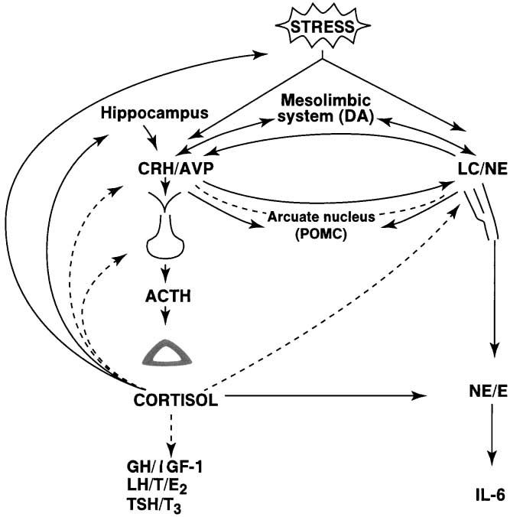

Figure 1: A schematic representation of the central and peripheral components of the stress system, their functional interrelations and relations to other central systems [Source: (Chrousos, 1992)]

2.7.1 The HPA axis
The hypothalamus controls the secretion of ACTH from the anterior pituitary, which, in turn, stimulates the secretion by the adrenal cortex of glucocorticoid hormones, mainly cortisol in human. The principal hypothalamic stimulus to the pituitary – adrenal axis is CRH, a 41 amino acid peptide first isolated in 1981 by Vale. AVP is a potent synergistic factor with CRH in stimulating ACTH secretion; however, AVP has little ACTH secretagogue activity alone (Lamberts et al., 1984). Furthermore, it appears that there is a reciprocal positive interaction between CRH and AVP at the level of the hypothalamus, with each neuropeptide stimulating the secretion of the other.
In non stressful situations, both CRH and AVP are secreted in the portal system in a circadian, pulsatile fashion, with a frequency of about two to three secretory episodes per hour (Engler et al.,1989). Under resting conditions, the amplitude of the CRH and AVP pulses increase in the early morning hours, resulting finally in ACTH and cortisol secretory bursts in the general circulation (Chrousos et al., 1998). These diurnal variations are perturbed by changes in lighting, feeding schedules and activity and are disrupted by stress. During acute stress, the amplitude and synchronization of the CRH and AVP pulsations in the hypophyseal portal system markedly increases, resulting in increases of ACTH and cortisol secretory episodes. Depending on the type of stress, other factors such as AVP of magnocellular neuron origin, angiotensin II and various cytokines and lipid mediators of inflammation are secreted and act on hypo- thalamic, pituitary or adrenal components of the HPA axis, potentiating its activity (Tsigos et al., 1994).
Circulating ACTH is the key regulator of glucocorticoid secretion by the adrenal cortex. Other hormones or cytokines, either originating from the adrenal medulla or coming from the systemic circulation, as well as neuronal information from the autonomic innervation of the adrenal cortex may also participate in the regulation of cortisol secretion (Hinson, 1990).
Glucocorticoids are the final effectors of the HPA axis and participate in the control of whole body homeostasis and the organism’s response to stress. They play a key regulatory role on the basal activity of the HPA axis and on the termination of the stress response by acting at extra- hypothalamic centers, the hypothalamus and the pituitary gland (de Kloet, 1991). The inhibitory glucocorticoid feedback on the ACTH secretory response acts to limit the duration of the total tissue exposure to glucocorticoids, thus, minimizing the catabolic, antireproductive and immunosuppressive effects of these hormones.
Glucocorticoids exert their effects through their ubiquitous cytoplasmic receptors. On ligand binding, the glucocorticoid receptors translocate into the nucleus, where they interact as homodimers with specific glucocorticoid responsive elements (GREs) within the DNA to activate appropriate hormone-responsive genes. The activated receptors also inhibit, through protein – protein interactions, other transcription factors, such as NF-kB, which are positive regulators of the transcription of several genes involved in the activation and growth of immune and other cells (Scheinman et al., 1995). Furthermore, glucocorticoids change the stability of messenger RNAs and hence the translation of several glucocorticoid-responsive proteins, as well as the electrical potential of neuronal cells.

2.7.2 The autonomic axes
The autonomic nervous system provides a rapidly responding mechanism to control a wide range of functions (Tsigos et al., 1994). Cardiovascular, respiratory, gastrointestinal, renal, endocrine and other systems are regulated by the sympathetic nervous system or the parasympathetic system, or both. Interestingly, the parasympathetic system may assist sympathetic functions by withdrawing and can antagonize them by increasing its activity.
Sympathetic innervation of peripheral organs is derived from the efferent preganglionic fibers, whose cell bodies lie in the intermediolateral column of the spinal cord. These nerves synapse in the bilateral chains of sympathetic ganglia with postganglionic sympathetic neurons that richly innervate the smooth muscle of the vasculature, the heart, skeletal muscles, kidney, gut, fat and many other organs. The preganglionic neurons are cholinergic, whereas the postganglionic neurons are mostly noradrenergic. The sympathetic system also has a humoral contribution, providing most of the circulating epinephrine and some of the norepinephrine from the adrenal medulla. In addition to the classic neurotransmitters acetylcholine and norepinephrine, both sympathetic and parasympathetic subdivisions of the autonomic nervous system contain several subpopulations of target-selective and neurochemically coded neurons that express a variety of neuropeptides and, in some cases, ATP, nitric oxide or lipid mediators of inflammation (Benarroch, 1994). Interestingly, CRH, neuropeptide Y (NPY) and somatostatin are colocalized in noradrenergic vasoconstrictive neurons. Transmission in sympathetic ganglia is also modulated by neuropeptides released from preganglionic fibers and short interneurons (e.g. enkephalin and neurotensin), as well as from primary afferent collaterals (e.g. substance P) (Elfvin et al., 1993).

2.8 Measurement of stress of Animal
There are wide ranges of parameters of the body that can be used for the measurement of stress in animals. These parameters may be behavioral, physiological, hemato-biochemical, hormonal changes or even changes in meat pH and quality. The assessment of these parameters gives measurement of variable degrees of stress to the animal body. Transportation stress can also change the various parameters of metabolism, inflammation and steroid hormones (Sporer et al., 2008). Changes of biochemical levels in the serum (Levels of different hormones like- cortisol, adrenaline, non-esteridied fatty acids, iron, urea, glucose etc.) are helpful in the evaluation of transport stress (Warriss et al., 1995; Pregel et al., 2005).
Animals under stress will often shows abnormal or stereotypic behavior or may change their usual behavior patterns based on this the stress of animal can be evaluated (Dawkins, 2004). There are also numerous behaviors that are related with acute stress, such as vocalizations and wastes elimination (Grandin, 1997). These behaviors can be detected to estimate the levels of distress in the animal (Grandin, 1997; Dawkins, 2004). Measurement of animal behavior can be an important tool for non invasive measurement of stress. In this method it takes into consideration both the animal physical and mental situation. The merit of this method is that it requires no exclusive and costly instruments or any sophisticated test. There are some demerits of behavior measures. It is not possible to clearly identify all the behaviors weather the behavior indicate discomfort or comfort during transient assessment. For example, if observed that the higher percentage of cattle are standing we may consider it as discomfort for cattle as in most of the time the cattle rest in lying down. But the standing condition may be due to adequate feed supply, cattle are remaining standing during feed intake. The standing condition may also be due to adverse floor condition where standing condition is more comfortable for animals. So the behavioral measurement of stress may misguide the actual situation. There is also problem human to human variation of stress assessment. One person may detect some stressful behavior more intensely than other (Flint, 2013).
Changes of different physiological parameters can also be the measures of stress. The physiological parameters includes heart rate, respiration rate, body temperature (Flint, 2013), cardiac output, catabolism and metabolism rate, blood flow and perfusion to the vital organs (heat, lung, liver and kidney), frequency of defecation and urination etc. (Sheridan and Dobbs, 1994; Take et al., 2004).
Hematological parameters that can be used to measure the degree of stress include the estimation of packed cell volume (PCV), total leukocyte count (TLC) and differential leukocyte count (DLC). In transport stress condition the PCV, TLC and ratios of lymphocytes and neutrophils are increased (Lomborg et al., 2007; Mitchell et al., 2008). Various biochemical parameters of the body give the more correct measurements of transport stress. One of the potent parameter is the stress hormone the cortisol. Stress also alters the others biochemical parameters that includes glucose, calcium (Ca), phosphorus (P), creatinine kinage (CK), alkaline phosphatase (ALP), total protein (TP), specific types of immunoglobulin’s (Igs), non-esterified free fatty acids (NEFAs), blood pH, levels of lactate, levels of cholesterol etc. (Sporer et al., 2008; Ishiwata et al., 2008; Mitchell et al., 2008; Uteke et al., 2009 and Flint et al., 2013). Stress has also been shown to stimulate acute phase protein (APP) and serum haptoglobin that are potent markers of stress (Alsemgeest et al., 1995; Deak et al., 1997; Hicks et al., 1998; Arthington et al., 2003; Hickey et al., 2003).
Several previous studies assess the blood concentrations of APP in calves after exposure to different categories of stressors such as housing on slippery floors condition (Alsemgeest et al., 1995), vehicle based transportation (Murata and Miyamoto, 1993), sudden weaning (Hickey et al., 2003) and amalgamation of animals (Arthington et al., 2003). The exact mechanism of APP synthesis due to stress is not clearly identified but it is suggested that it is related to activation of the hypothalamic-pituitary-adrenal axis ( Lomborg et al., 2008).

2.9 Physical injuries during transportation
When the animals are transported from one place to another in Bangladesh, there are several stages which have the potential to cause injury to the animal body (Gregory, 2008). Animal transportation in logical and gentle manner has less chance of injury. The short distance transport of cattle in Bangladesh is mostly done by foot, but the long distance transport is done by vehicle (mostly by truck). The vehicle transport of cattle in Bangladesh mostly conducted with high stocking densities of animals, poor ventilation on and around the animal, high environmental humidity and temperatures, and poor restraining method of animal, for example tying legs together etc. These all activities increase the risk of injury during transportation (Kober et al., 2014). The injuries results from transportation are probably high stocking densities and uneven road that leads to rubbing of animal body to the side wall of the vehicles. The injuries are also results from rough handling during loading and unloading including biting of animal using sharp object and improper restraining during transportation in Bangladesh (Gregory, 2008; Kober et al., 2014).
There may be wide varieties of physical injuries during transportation of animals, these includes abrasion, laceration, horn fracture, desquamation, bruising, sloughing off, hematomas, sore mark, rub mark, pin mark, edema, fracture, dislocation, subcutaneous fat necrosis, ulceration, bleeding, swelling, scarification, wound, nose injury, horn injury, tail injury etc. (Gregory, 2008; Alam et al., 2010; Kober et al., 2014).
A study was conducted in Bangladesh livestock cattle market to assess the frequency of nose and tail injuries. That study revealed that the frequency of nose piercing among the transported cattle and buffalo was 64%. Among the nose pierced animal, 69% of the cattle and 54% of the buffalo had tearing injuries at the nostrils. About 47% of the nose- pierced animals had lacerations and ulcerations near the piercing of nose. Pus was observed at the nostril in 56% of animals about 58% of the animal had extended and severe injuries. Among the cattle breeds in Bangladesh, the frequency of tail injuries was 65% (Alam et al., 2010).

Table 1: Injuries in cattle and water buffalo at market level in Bangladesh
 | Cattle | Water buffalo
Number of animal examined | 368 | 192
Animals imported from India (%) | 78 | Not known
Nose piercing
Nose pierced (%) | 69 | 54
Animals suppurating at nose (%) | 46 | 40
Tail injuries
Kinked tail (%) | 51 | 15
Tail end absent (%) | 1 | 1
Skin injuries
With skin injuries (%) | 84 | 99
[Source: (Alam et al., 2010)].
Another study in Bangladesh livestock cattle market revealed the frequency of abrasion, laceration, bleeding, swelling and scarification of cattle were 73, 45, 4, 3 and 67%, and of buffaloes were 71, 9, 23, 41% and 87%, respectively. The injuries were higher number in Haryana in comparison with Rajasthani, Shahiwal and Indian non descriptive cattle breeds. The frequency of tail injury in cattle and buffaloes was 65 and 23%, respectively. In the slaughter house, the frequency of abrasion, laceration, penetration and scarification were 79, 75, 8, 75 in cattle, and 85, 70, 0 and 67% in buffaloes, respectively (Kober et al., 2014).

Table 2: Prevalence of skin injuries among 560 cattle and water buffalo presented market level in Bangladesh
Types of injuries | Number of affected animals | Percentage (%)
Abrasion | 410 | 73.2
Laceration | 229 | 40.9
Penetration | 21 | 3.8
Ulceration | 7 | 1.3
Bleeding | 16 | 2.9
Swelling | 47 | 8.4
Hyperkeratosis | 104 | 18.4
Scar | 279 | 49.8
Source: (Kober et al., 2014)
Minka et al. (2007) reported that the total number of injuries (comprising of wounds, contusions, lacerations, fractures, dislocations and abdominal hernia) sustained per animal in the Red Bororo (RB), White Fulani (WF) and Sokoto Gudali (SG) were 17.1, 9.2 and 7.9%, respectively. The abdominal and thoracic walls were the most affected body parts. Other sites with high values were the head and neck. The average percentages of meat condemned per carcasses body weight as a result of superficial and deep intramuscular hemorrhage in RB, WF and SG were 3.2, 1.6 and 1.0% per affected animal, respectively, while the percentages of skin that fell below the 2nd category of market value were 7.7, 4.5 and 3.7% in RB, WF and SG, respectively. Aktas et al. (2011) described that immediately after the transport in-coordination, apathy and exhaustion were prominent clinical ﬁndings exhibited by the animals. The animals resisted walking when they were moved forward. Von-Holleben et al. (2009) reported that marked increase of bruising for increasing transport times. A transport time of > 6h increase injuries by 6%.

2.10 Hematological changes
Blood is a liquid tissue in which, suspended in the watery plasma are seven types of cells and cell fragments these are red blood cells (RBCs), platelates/ thrombocytes and five kinds of white blood cells (WBCs), i.e. lymphocytes, monocytes, neutrophils, eosinophils and basophils.
Transportation stress leads to various changes in hematological parameters including changes in packed cell volume (PCV), total leukocyte count (TLC), total erythrocyte count (TEC) and proliferation of specific types of white blood cells (Murata et al., 1987; Yagi et al., 2004). Complete blood cell counts demonstrated a trend towards an increased numbers of total white blood cells in stressed animals compared to control calves following transportation (Mitchell et al., 2008). The proliferation of WBC is due to stimulating effects of glucocorticoids on blood cells (Weber et al., 2006).
Various studies report that the hematological parameters are normal except the neutrophil leukocytosis, the numbers of lymphocytes and monocytes remained similar between both the transported and non transported group (Ishiwata et al., 2008; Mitchell et al., 2008). It has been shown that changes in hematological value of neutrophil/lymphocyte ratio (N/L) are good indicator of stress (Altan et al., 2003; Broom, 2003).
Some studies suggested the increment of PCV, TEC and hematocrit that leads to hemo-concentration (Mitchell et al., 2008; Hulbert et al., 2011) after 9.75 hours of transportation. The hemo-concentration is mainly due to dehydration resulting from feed and water deprivation during transportation (Knowles et al., 1999).

2.11 Biochemical changes
There are wide variations in biochemical changes during road transportation of cattle. Studies shows that the blood glucose concentration decreases after transportation in comparison to before transportation (Ishiwata et al., 2011) owing to psychological stress of novel environment and unfamiliar animals and handlers. Serum total protein, triiodothyronine and total cholesterol concentrations increase due to transportation (Tarrant et al., 1992; Warriss et al., 1995; Honkavaara et al., 2003). However studies of Sporer et al. (2008) revealed the total plasma protein concentration was decreased by 11% at 24 h of transportation. On the other hand Ishiwata et al. (2011) also found higher concentration of TP before transportation.
However, studies suggest that the other physiological measurements such as plasma cortisol and blood lactate concentrations, serum pH and heart rate did not change after transport. The increase in T3 concentration could promote the metabolism of protein. As a result, the concentration of total protein in serum might increase before and just after transport (Ishiwata et al., 2011). Due to long distance transportation the serum albumin and globulin concentrations decreased by 7% and 4.5% at 24 hours in comparison to -24 hours of transportation, respectively. Creatine kinage (CK) is an enzyme that released due to muscle breakdown which is normally retained into the muscle. Higher the muscle breaks the more amount of enzyme released into the blood. During transportation, long time standing on vehicle results sufficient muscle activity to cause muscle breakdown. As a result CK release from the muscle enters into the circulation and these are measured as increased level in blood serum after transportation. A 221% increase of blood CK was observed after 24 hours of transportation (Sporer et al., 2008).
Study in Japan it is revealed that the concentration of alanine aminotransferase (ALT) was found higher in transported cattle in comparison to control group (Ishiwata et al., 2008). The similar results were also worked out by the others studies (Honkavaara et al., 2003; Utake et al., 2009). Aspartate aminotransferase (AST) is muscle enzyme i.e generally they remain into the muscle tissue. They enter the blood from the muscle tissues by exercise (Nomura, 2006). During transportation the animal remain standing condition on vehicle and they have to maintain their body balance as a result they have to do sufficient muscle activity to release AST from muscle to blood and elevate the level of AST in blood (Utake et al., 2009). The concentration of serum AST is usually relatively higher immediately after transport of animal (Ishiwata et al., 2008).
Higher concentrations of lactic acid and acidification in blood suggest exercise stress that was caused by long hours of disturbance of physical rest while in the moving vehicle and due to prolonged deprivation of water that increase the concentration of lactic acid in blood. The concentrations of blood lactic acid tended to be higher after transportation (Higuchi and Tsunoda, 2007; Utake et al., 2009).
It is documented that the blood cholesterol concentration were significantly higher just after transport in comparison with 1 week of post transportation (Hodate, 2005).
Acute phase proteins like haptoglobin and fibrinogen decrease with the onset of transportation stress. Haptoglobin reached its lowest point at 4.5 h (39.02$±$1.32 mg/dL), at a 53% reduction from pre-transportation values (82.06 $±$1.73 mg/dL) and remained depressed through 48 h. Plasma fibrinogen decreased by 44% at 14.25 h (313.11 $±$5.40 mg/dL) compared with 551.53 $±$9.81 mg/dL at −24 h, and concentrations remain depressed at all time points after −24 h (Sporer et al., 2008). Utake et al. (2009) reported that, serum haptoglobin increase in transportation stress at 12 h and remained elevated at 36 h. The higher concentration of NEFA also suggests the effect of hunger stress during transportation (Ishiwata et al., 2008). During hunger stress NEFA is used as source of energy in the tissues (Tsuda et al., 2004). It is documented that the plasma antioxidant concentration decreases due to transportation. The mean value for antioxidant capacity immediately after transport is 443 pmol/litre, while after recovery it is 545 pmol/litre (Niedzwiedz et al., 2013).

2.12 Hormonal changes in transportation
Transportation stress activates a complex mechanism in the body that leads to changes in hormone concentration in blood. The more remarkable hormones that are synthesized in response to stress are cortisol- the stress hormone, epinephrine (adrenaline) and norepinephrine (Noradrenalin). However, limited information is available on the effect of transport on changes in thyroid and adrenal function of cattle (Fazio et al., 2005; Uetake et al., 2009).
The hypothalamic–pituitary–adrenal (HPA) axis is activated in response to stressful events (Knights et al., 2007). Corticotrophin releasing factor (CRF) and arginine vasopressin (AVP) mediate stress-induced ACTH secretion from the anterior pituitary (AP) through their cognate receptors, CRF receptor-1 (CRFR1) and AVP receptor V3 (V3) (Saito, 1995; Smith et al., 1998). ACTH stimulates the release of corticosteroids from the adrenal cortex. These compounds classically exert negative feedback effects at the hypothalamus, at other higher brain regions and at the Anterior Pituitary (AP) to minimize the magnitude and duration of the endocrine response to stress (Mason et al., 2002). In rodents, repeated or prolonged periods of exposure to the same stressor (homotypic) have been associated with a decline in the stress response (Lachur et al., 1994; Dhabhar et al., 1997; Fernandes et al., 2002; Armario et al., 2004).
The most commonly measured indicator of short term stress is cortisol, but its levels are highly variable based on duration and distance of transportation (Grandin, 1997; Pragel et al., 2005; Ishiwata et al., 2008). Most of the studies revealed that the concentration of cortisol reaches in peak during first 1.5 to 4 hours of transportation (Warriss et al., 1995; Honkavaara et al., 2003). Honkavaara et al. (2003) have reported that cortisol concentration is higher after a short period (approximately 1.5 h) of transportation than after long periods (approximately 7 and 10 h) of transportation. Warriss et al. (1995) have also shown comparable results, although their transportation time and study conditions were different.
There are some reports that cortisol concentration increases in response to the stresses associated with loading and at the initial stages of transport but then recovers as the journey proceeds (Warriss et al., 1995; Grigor et al., 2001). Cortisol concentration might not be appropriate for the indicator of stress of long distance transport but, it is become high just after transportation (Ishiwata et al., 2008).
Plasma cortisol is greatly elevate with the onset of transportation when compared with −24 h, a 321% increase at 4.5 h (42.54$±$2.10 ng/mL compared with 13.22$±$1.30 ng/mL at −24h) (Sporer et al., 2008). Marked elevation of cortisol levels was observed soon after transportation. A significantly higher (three-fold) concentration (P < 0.01) of plasma cortisol was found at 4 h after starting transportation compared with the case before transportation. It was reported that the plasma cortisol concentration in cattle was subjected to 6-h road transportation rose immediately after loading, and continued to increase during the early stage of the journey (Ishizaki et al., 2005).
Cortisol concentration (ng/mL) significantly increased after transportation at 50 km (6.3$±$ 5.6) and gradually declined at 100 (4.1$±$ 4.1) and 150 km (3.0$±$2.5) than the pre-transportation value (1.7$±$1.2) (Uetake et al., 2011). The concentration of cortisol returns to normal during long distance transportation due to habituation or adaptation or reduce responsiveness of central nervous system (Sakellaris, 1975; Lay, 1996).
Norepinephrine and epinephrine are two hormones that are also produced upon HPA activation. These hormones interact with alpha and beta-adrenergic receptors to mediate the adaptive cardio-vascular and metabolic effects under the conditions of stress (Sheridan and Dobbs, 1994). However, these hormones have a short half-life of 1–3 min, and their concentration in the blood changes in 1–2 min, so their concentrations reflect only instantaneous activity of the sympathetic nervous system (Cohen et al. 1999; Uetake et al., 2009). Some studies revealed the increase of catecholamine concentration in blood during short time screening (Uetake et al., 2011).
Plasma concentrations of the steroids testosterone and progesterone were also show changes due to transportation. Plasma testosterone level is depressed in transportation stress, reaching its lowest point at 4.5 h (4.05 $±$0.20 ng/mL), 74% less than −24 h (15.41 $±$1.88 ng/mL). In contrast, plasma progesterone, although present at low concentrations in bulls, is elevate at 4.5 h (0.43 $±$ 0.047 ng/mL), increase by 215% of its −24h concentration (0.19 $±$0.02 ng/mL) (Sporer et al., 2008). It is documented that the plasma triiodothironine (T3) level in also changes during transportation. Higher concentrations of T3 observed at immediately after transportation. The increase of T3 is due to handling and transportation stress (Mitchell et al., 1988). It is possible that T3 concentrations increased to boost oxygen consumption in the muscles used during long distance transport (Ishiwata et al., 2008; Utake et al., 2009).

2.13 Immune response in transportation
Increased levels of circulating glucocorticoids, induced by stress, have been linked to immunosuppression in transported cattle (Mackenzie et al., 1997; Dixit et al., 2001) and thereby may increase susceptibility to infectious diseases (Mormede et al., 1982; Grandin, 1997). On a cellular level, it was shown that stress in Bos taurus cattle, including transportation, resulted in leukocytosis, with associated neutrophilia, lymphopenia, and eosinopenia (Kent and Ewbank, 1986; Mackenzie et al., 1997), and impaired leukocyte function, with decreased response to mitogen-stimulated lymphocyte proliferation and impaired antibody production (Kelley et al., 1981; Blecha et al., 1984). Transport-induced immunosuppression is of particular concern for animals transported to feedlots and those shipped to international markets, and it has been linked to increased incidences of “shipping fever,” resulting in productivity losses (Grandin, 1997; Stanger and Ketheesan 2005). To date, researchers investigating transport stress in cattle have primarily employed a Bos taurus calf model, whereas the effects of transporting mature, tropical Bos indicus breeds have largely been ignored (Stanger and Ketheesan, 2005).

2.14 Effect of transportation on live weight shrinkage
During transportation, animal loses a considerable quantity of body weight. The amount of body weight loss or shrink of animal during transport is directly related to their level of hydration, food and water deprivation, duration of transportation and environmental, and vehicle internal temperature and humidity (Jones et al., 1990; Warriss, 1990; Schaefer et al., 1992; Gonzalez et al., 2012).
Reduction in live weight is a consistent ﬁnding in cattle transport studies with losses of up to 11% total body weight (Earley et al., 2006) reported in many transportation studies. This live weight loss is mainly attributed to loss of gutﬁll, urination, dehydration, fasting and the possible synergistic effects of ambient temperature (Knowles et al., 1999). As found in other studies (Knowles et al., 1995) the sheep lost weight during transport. The deprivation, metabolism and elimination, rather than stress-related effects, are responsible for weight loss during journeys. Nevertheless, as reported by others (Knowles et al., 1995) these effects were rather long-lasting because the animals had not regained their weight by the following day, despite the overnight provision of ample food and water (Earley et al., 2013).
Bulls transported for the ﬁrst 9 h journey by road had a mean live weight loss of 6.2 ±0.44%, they regained 3.1 ±0.17% during the 12 h mid-journey rest period, lost 4.0 ±0.59% during the second 9 h journey, and had an overall live weight loss of 4.0 ±0.60%. Another study comments that body weight was decreased at 9.75 h by 10% and remained decreased at 48 h after transportation (Sporer et al., 2008).

Table 3: Body weight losses during transportation
Species | Duration of transportation (Hours) | Body weight losses/shrinkage | References
Cattle | - | 11% | Earley et al., 2006
Cattle (Bull) | 09 | 6.2$±$0.44% | Sporer et al., 2008
Cattle | 18-24 | 3-11% | Santosa et al., 2014
Cattle | - | 5.5-10.5% | Ilham and Yusdja, 2004
Cattle | 12 | 6% | Suryadi et al., 2011
 | 24 | 8%
 | 48 | 12%
 | 96 | 14%
Cattle | - | 12.6% | Suryadi et al., 2011
Cattle | - | 11-12% | Ilham and Yusdja, 2004
Cattle (Bull) | - | 10% | Sporer et al., 2008
Sheep | - | 3.6-5.5% | Knowles et al., 1999
Chicken (broiler) | - | 7g/bird | Delezie et al., 2007

2.15 Effect of transportation on meat
During transportation, livestock are subjected to physical demands and the energy required to service this demands is enormous and this will have a negative impact on muscles metabolism. In addition, sudden, unaccustomed and exhausted stress or exercise, increase in oxygen uptake by skeletal muscles, and intense production of free radicals, reactive oxygen species (ROS), nitrogen oxygen species (NOS) and E- type prostaglandin release in circulation during stress has been reported to be the major cause of changes in muscle metabolism and delayed-onset-muscular- soreness (DOMS) which may result to dark-firm-dry (DFD) meat (Kannan et al., 2002; Gregory, 2008; Powers & Jackson, 2008). Transported animals that developed DOMS and muscular damage may develop dark-firm- dry (DFD) meat, which is an undesirable meat quality (Brown et al., 1999). An increase in physiological stress or physical activity in farm animals during transportation and pre-slaughter handling leads to depletion of muscle glycogen reserves before slaughter, which may result in a higher ultimate meat pH, greater water- holding capacity, darker meat color and tougher meat (Gregory, 1998). Preslaughter stress like transportation stress causes the depletion of glycogen and the consequently inability of muscles to develop adequate acidity levels postmortem (Gregory and Grandin, 1998). Dark muscle color is a common condition encountered when animals are exposed to situations that deplete muscle glycogen levels prior to slaughter. The DFD meat characterized by elevated postmortem pH, dark muscle and has negative impact on economic returns (Smith et al., 1992).
PSE beef and DFD pork differ from normal meat in physiological and biochemical characteristics. The unusual pH and water-holding capacity of PSE and DFD muscles lead to unusual meat colors (Ledward, 1992). Various differences in color stability among PSE, normal, and DFD muscle during retail display have been demonstrated (McCaw et al., 1997). It has been assumed that PSE beef is least stable and DFD pork is most stable in color among the two muscle conditions because the rate of myoglobin autoxidation increased and the rate of enzymatic metmyoglobin reduction decreased with decreasing pH which is caused due to slaughtering animal immediately after transport (Ledward, 1983).

2.16 Effect of Transport stress on production
Many elements of the transport process can be harmful. The adverse effects of these factors and their combinations may range from mild discomfort and aversion to death of the animals. Poor transportation can have serious deleterious effects on the welfare of livestock and can lead to significant loss of meat quality and production loss. Although transportation is inseparable part of livestock production, but transportation may hamper both qualitative and quantitative production loss.

Table 4: Effects of transport and movement on cattle
Conditions | Effects
a. Stress | Leading to DFD beef and PSE pork
b. Bruising | Perhaps the most insidious and significant production waste in the meat industry
c. Trampling | This occurs when animals go down due to slippery floors or overcrowding
d. Suffocation | This usually follows on trampling
e. Heart failure | Occurs mostly in pigs when overfed prior to loading and transportation
f. Heat stroke | Pigs are susceptible to high environment temperatures and humidity
g. Sun burn | Exposure to sun affects pigs seriously
h. Bloat | Restraining ruminants or tying their feet without turning them will cause this
i. Poisoning | Animals can die from plant poisoning during trekking on hoof
j. Predation | Unguarded animals moving on the hoof may be attacked
k. Dehydration | Animals subject to long distance travel without proper watering will suffer weight loss and may die
l. Exhaustion | May occur for many reasons including heavily pregnant animals or weaklings
m. Injuries | Broken legs, horns
n. Fighting | This occurs mostly when a vehicle loaded with pig stops, or amongst horned and polled cattle.
Source: Chamber and Grandin (2001)

2.17 Recent trends regarding transportation of livestock
It is now well known that livestock transportation is a stressful event for animal’s life that hampers animal welfare and productivity as well. Since last few years researchers are trying to reduce stress during transportation by improving method and environment of transportation. The scientists are trying to reduce animal stress by using some chemical substances like antioxidant, supplements or others in very recent years.
Ascorbic acid (AA) is a potent antioxidant that is known to affect mood, and it is the first known vitaminergic neurotransmitter (Karanth et al., 2000; Balz, 2003). It has been established that the administration of AA is beneficial to humans, animals, and poultry under stress situations (Tauler et al., 2003; Minka and Ayo, 2010; Sivakumar et al., 2010; Asala et al., 2011; Clero and Grandjean, 2012). Although ruminants may not require AA supplementation in the diet under normal conditions, during stress the requirement of the body in AA exceeds the synthetic capacity of the liver (Lykkesfeldt and Svendsen, 2007). Besides, stress factors are known to deplete adrenal AA (Balz, 2003; Lykkesfeldt and Svendsen, 2007; Gade et al., 2010; Sivakumar et al., 2010). Therefore, AA supplementation at the point of stress may provide a potentially important, cheap, and nontoxic alternative treatment to the animal. Ascorbic acid has attracted the attention of scientists in recent years because of its ability to cope with stress (high environmental temperature, disease and transport) in various animal species. Ascorbic acid is a natural antioxidant that can specifically stimulate GABA (gamma amino butyric acid), a type of receptor that serves to modulate the communication between cells in the brain. Recent research has shown that GABA will cease to function in the brain when ascorbic acid is not available in the body or in the brain (Calero et al., 2011). Asala et al. (2010) showed a decrease of antioxidants in the body caused by stress. Ascorbic acid is a vitamin that gives potential antioxidant function for the body, relatively inexpensive and virtually no toxic effects and easily metabolized in the body.
At the time of stress due to transport livestock, the hormone cortisol is secreted into the blood vessels, thus generally giving effect to the excretion of urine and faces. This leads to loss body weight in cattle during transport. However, the administration of ascorbic acid, which is the stress hormone cortisol can be inhibited by GABA, so that defecation and urination can be reduced. The positive emotional response from acidifying ascorbic acid will run through the body and is received by the brain stem, then transmitted to one of the major parts of the thalamus of the brain. Then, contact the thalamus hippocampus to secrete GABA which served as a control emotional response, and inhibits acetylcholine, serotonins’ and other neurotransmitters that produce cortisol secretion (Calero et al., 2011; Santosa et al., 2014). Recently researchers also trying to observe the effect of immuno-modulator (agents that modulate the immune system) like east cell wall products on transportation stress (Eicher et al., 2010).
From the above discussion of previous research, it is clear that very limited and non-structural works had been done on transportation stress in Bangladesh. Although most of the global studies consider the sample and data from both before and after transportation, in Bangladesh most of the studies are based on the data and sample from after transportation i.e did not take into consideration of condition on animal before transportation. So, it is utmost important to conduct a comprehensive research by considering data and sample from both before and after transportation in Bangladesh environment. This is the necessity to design the current study to minimize the limitation of previous works of Bangladesh on transportation stress.

Chapter-3: Materials and Methods

3.1. Study area and period
A large number of cattle are imported from India to Bangladesh every year. These cattle are first transported in border cattle markets of Bangladesh like- Benapole of Jessore, Satkhira of Khulna, Kustia etc. and are then again transported to different central markets of larger cities like Dhaka, Chittagong, Sylhet etc. for sale (Gregory, 2008). A study was conducted in two selected cattle markets of Bangladesh namely Portkhali situated in border area and Sagorika located in Chittagong city. For the convenience of the current research Benapole cattle market (Portkhali) of Jessore was selected as border market and marked as primary market and the Sagorika cattle market of Chittagong was selected as central cattle market and marked as secondary market. The geographical location of Banapole is 23°02'31" N (North) and 88°53'44" E (East) in DMS. The Sagorika cattle market situated at Chittagong metropolitan area under Chittagong district of Bangladesh and located at 22°22′0″N 91°48′0″E.
The distance between the primary and secondary market is about 648 km that covers a minimum of 14 hours vehicle journey. Everyday large numbers of cattle are transported from the Benapole cattle market to Chittagong cattle market via vehicle especially on Truck. As the current study was designed to investigate the effects of transportation on animal body, these two distances situated markets were selected. The current study was conducted during a period of July to December, 2014.

3.2 Research design
According to Sevilla et al. (2007) ex-post facto research is a systematic empirical inquiry in which the researcher does not have direct control over independent variables, because their manifestation has already occurred or because they are not inherently manipulated. So the research design adopted for this study was of ex-post-facto in nature since the phenomenon has already occurred. The current research is a cross-sectional study designed to determine the detrimental effect of long distance transportation on cattle of Bangladesh.
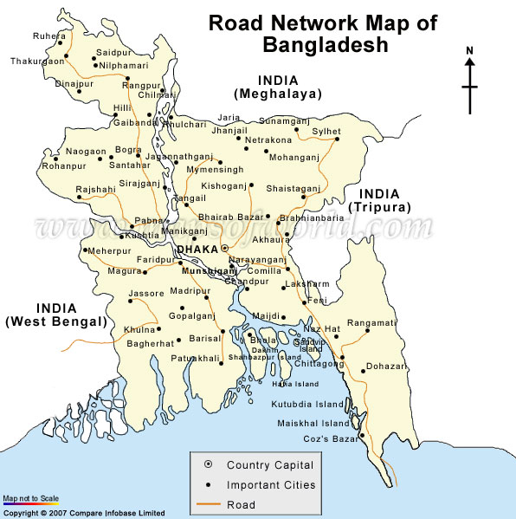
(Total road distance from the primary to secondary market= 648 km)
Road of cattle transport

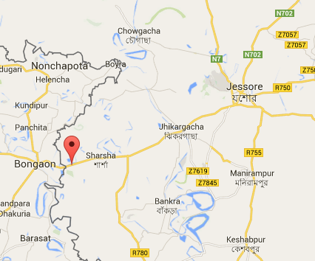  Benapole cattle market | 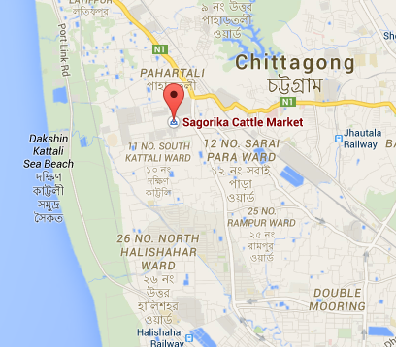
Figure 2: Study area with road map of cattle transportation in Bangladesh

3.3 Reference population
Those cattle that are subjected to long distance transportation in their marketing channel from the primary market (border market) to the secondary market (central cattle market) were considered as reference population.

3.4 Target population
Those cattle that are transported from the Portkhali cattle market of Jessore to Sagorika cattle market of Chittagong during the research period were considered as target population.

3.5 Sources of data
Mainly the primary data were used in the current research. The primary data were obtained directly from the personnel of different levels involved in cattle trading. Some supportive secondary data were also collected from the office of primary and secondary cattle markets.

3.6 Environmental condition during transportation
The average temperature and relative humidity of environment recorded as 36⁰C and 67%, respectively during transportation. Transportation time is usually at night but cattle were also exposed to sun light of 1st part (morning) of the day.

3.7 Management of cattle during and after transportation
During transportation the cattle were remain fasting condition. The average space allocation for animal were 9 square feet and animal were remain standing during transportation with minimum restraining. After transportation in the secondary market the cattle are maintain only with paddy straw and water up to sale.

3.8 Data collection
A pre tested questionnaire was designed in relation to the objectives of the study for data collection that containing the questions about the presence or absence of injury, types of injuries (Abrasion, laceration, desquamation, barbed wire injury, scarification, sunburn etc.), location of injuries on the body, environmental condition (temperature, humidity, intensity of sunlight, frosting in winter etc), transportation time (morning, day, afternoon or evening), length and duration of transportation, stocking density, and feeding and watering before, after or during transportation etc. Data of necessary conditions of cattle were collected from 100 randomly selected bullocks from the primary markets before their transportation and the cattle were marked by painting on body and collar marking. Again necessary data were collected from the same animals when they were reaching in the secondary market after transportation.

3.9 Sample collection
Among all the selected cattle, 50 randomly selected cattle were considered for sample collection randomly. Blood sample were collected three times such as immediately before, after and after 24h (hour) of post transportation time of the same cattle. Blood sample were collected through jugular vanipuncture in two sterile vacutainer (3 ml for each), one containing EDTA (anticoagulant) for hematology and another do not contain anticoagulant which was used for serum separation for biochemical and hormonal profiling. After collection of blood from the primary market the cattle were marked using paint on body and collar marking for subsequent sample collection from the same animal at immediately after transport and after 24h of post transport time in the secondary market. During blood collection the collection site was disinfected with 70% alcohol solution.

3.10 Transportation and preservation of sample
The collected blood samples were immediately transferred to ice box to maintain cool chain. After transported the sample from the market to laboratory the serum was separated by centrifugation and the serum were then taken into epindorf tube and preserved into freezer with temperature maintaining -18⁰C for further analysis. The samples with anticoagulants were preserved in 4⁰C and analysis was started immediately.

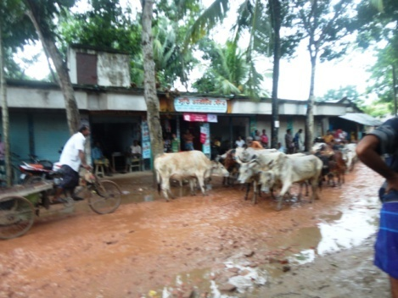 | 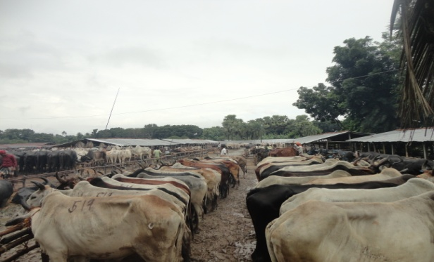
- Entry of cattle into Benapole | - Cattle market in Benapole
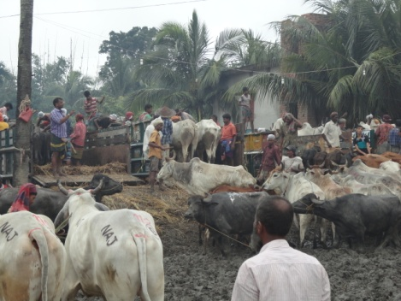 | 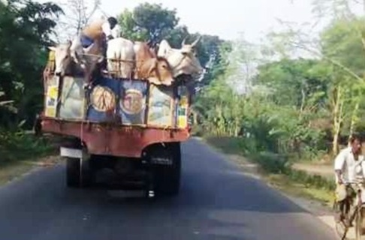
- Loading of cattle at beanpole | - Transportation of cattle
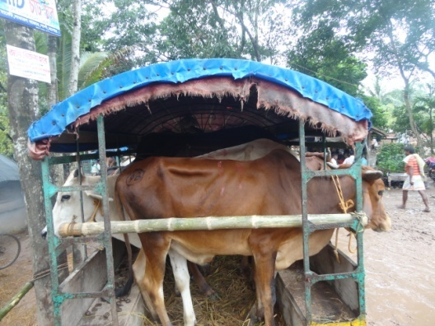 | 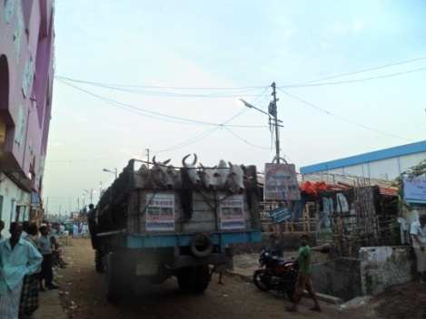
- Transportation by small vehicle | - Cattle reach to Sagorika
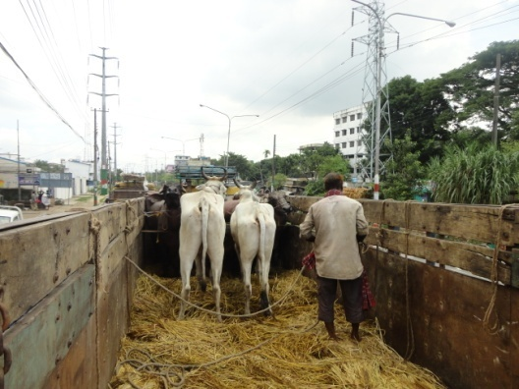
- Unloading at Sagorika | - Cattle in Sagorika
Figure 3: Activities during cattle transportation

3.11 Physical Examinations
During data collection from the cattle markets the physical parameters were recorded in a pre-structured data sheet. During physical examination only the inspection technique was used to find out the abnormal conditions such as nasal discharge, diarrhea, presence or absence of injury, types of injuries like abrasion, laceration, desquamation, barbed wire injury, scarification, sunburn etc., location of injuries on the body and so on.

3.12 Estimation of Dehydration
To estimate the dehydration both inspection and palpation techniques were used. The assessment of level of dehydration was determined by inspection of the eye and skin fold test on eyelid as per mentioned by Chakrabarti (2005).
Table 5: Parameters for assessment of level of dehydration
Degree of dehydration (%) | Sunken eyes | Retention of skin fold/sec.
Mild (4-8) | Not sunken | Absent
Moderate (6-8) | Barely visible | 2-4
Severe (8-10) | Pronounced | 6-10
Shock (10-12) | More pronounced | 20-45

3. 13 Hematological Analysis
The samples collected with anticoagulant were analyzed for routine examination of blood as per Weiss and Wardrop (2011). The samples were analyzed within 24 hours of collection. Hemoglobin (Hb), Packed cell volume (PCV), Erythrocyte sedimentation rate (ESR), Total leukocyte count (TLC), Total Erythrocyte count (TEC) and Differential leukocyte count (DLC) were performed in Physiology laboratory of Chittagong Veterinary and Animal Sciences University (CVASU).

3.13.1 Haemoglobin
Haemoglobin (Hb) was determined by acid hematin method. Hb is converted to acid hematin by dilute HCl which in solution brown in colour. The intensity of this colour depends on the amount of acid hematin in solution which in turn depends on Hb concentration. The colour of the solution is matched against brown tinted glass filter by direct vision and the results were expressed as gm/100ml blood (gm %).

3.13.2 Packed Cell Volume (PCV)
Blood samples were centrifuged in a haematocrit tube. The RBC (Sp. gr. =1.09) being heavier than plasma (Sp. gr. = 1.03) get pack towards the bottom of the tube by centrifugal force. The reading of the percentage of blood that is red cells was then noted.

3.13.3 Erythrocyte Sedimentation Rate (ESR)
ESR was estimated by Wintrobe’s method. Blood samples were added to hematocrit tube up to the mark 10. The RBC (Sp. gr. = 1.09) being heavier than plasma (Sp. gr. = 1.03) settle down gradually towards the bottom of the tube. The rate in mm at which the RBC settles was noted at the end of certain period.

3.13.4 Total Erythrocyte Count (TEC)
The number of RBC was estimated by using Neubaur Haemocytometer. The blood was diluted 200 times with Hayem’s solution. Red blood cells were than counted into Neubaur Haemocytometer under microscope in diluted blood. The TEC in undiluted blood was calculated by multiplying volume correction factor and dilution factor. The results were expressed as number of RBC per ml of blood.

3.13.5 Total Leukocyte Count (TLC)
The blood was diluted with 0.1N HCl which destroys the red cells and stains the nuclei of WBC. White blood cells (WBC) were than counted into a Haemocytometer under microscope in diluted blood. The TLC in undiluted blood was calculated by multiplying volume correction factor and dilution factor. The results were expressed as number of WBC per ml of blood.

3.13.6 Differential Leukocyte Count (DLC)
A small drop of blood used to make a thin film of blood on a glass slide. Blood film was than stained with Wright’s stain. The different white blood cells on stained film were than counted under microscope based on their morphology. The results were expressed as percentages of different white blood cells.
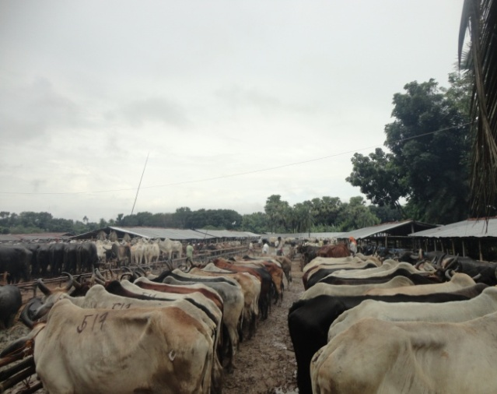 | 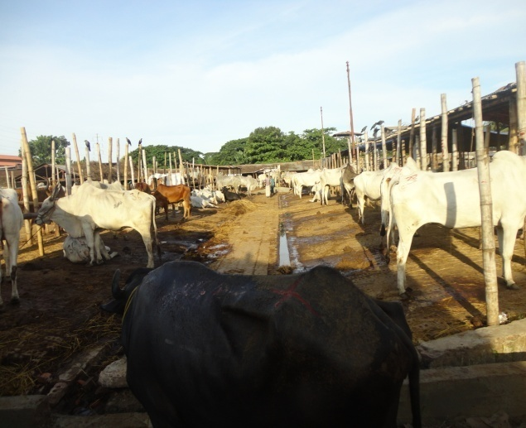
- Cattle in Benapole cattle market | - Cattle in Sagorika cattle market
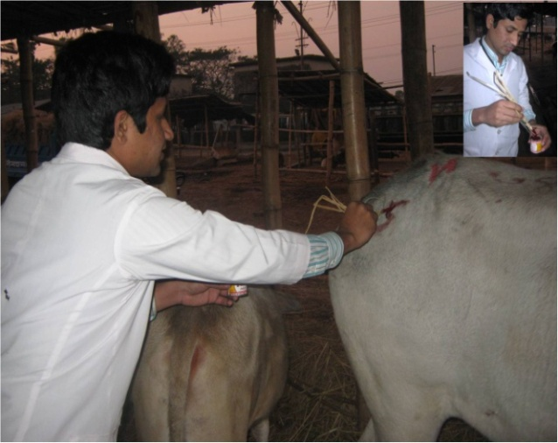 | 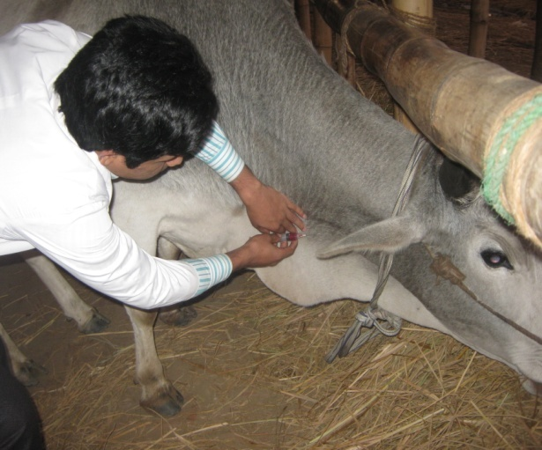
- Marking of cattle | - Blood collection
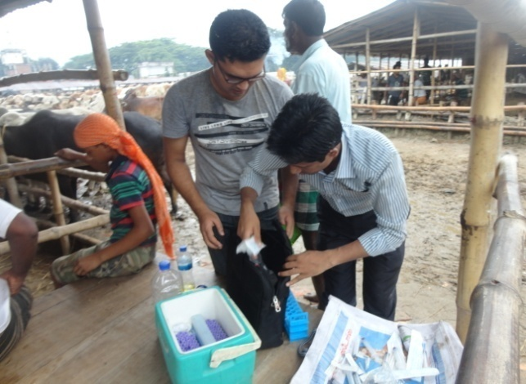 | 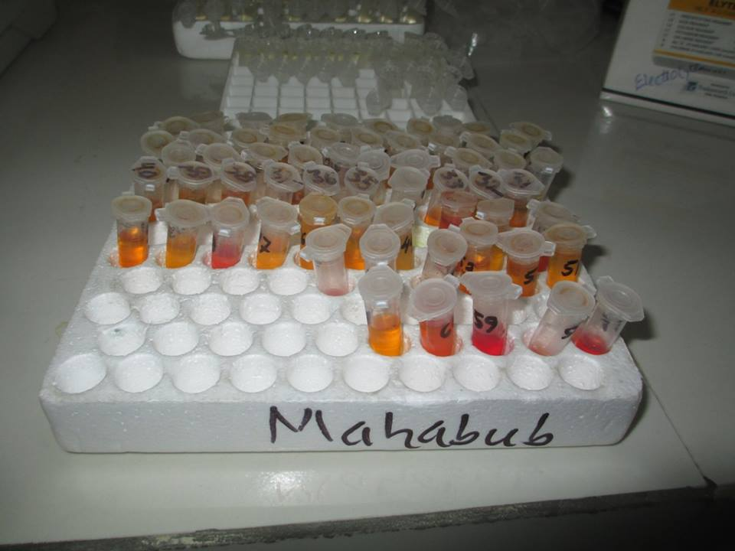
- Blood Samples into ice box | - Serum samples
Figure 4: Study population, animal identification and sample collection
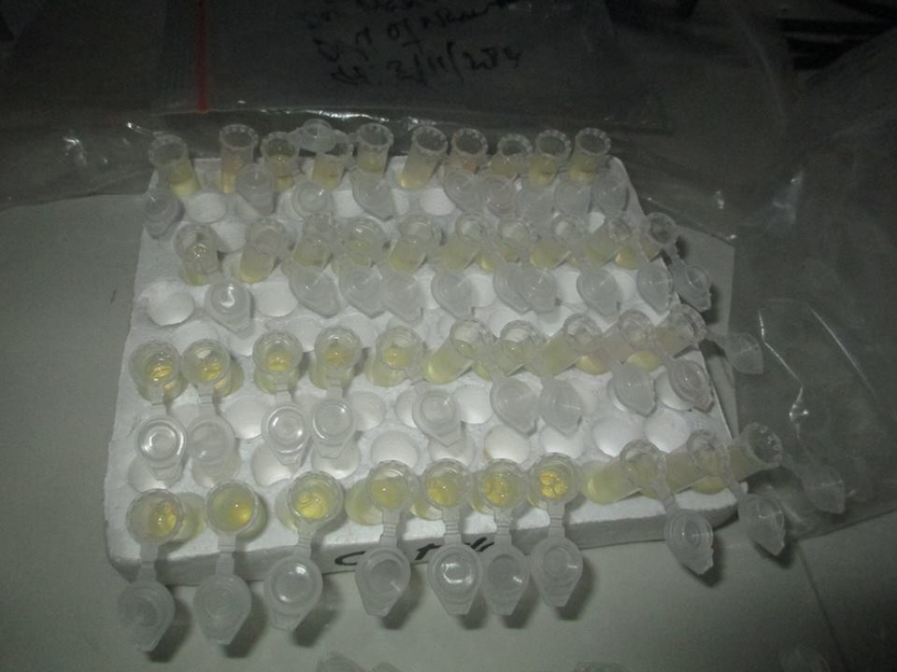 | 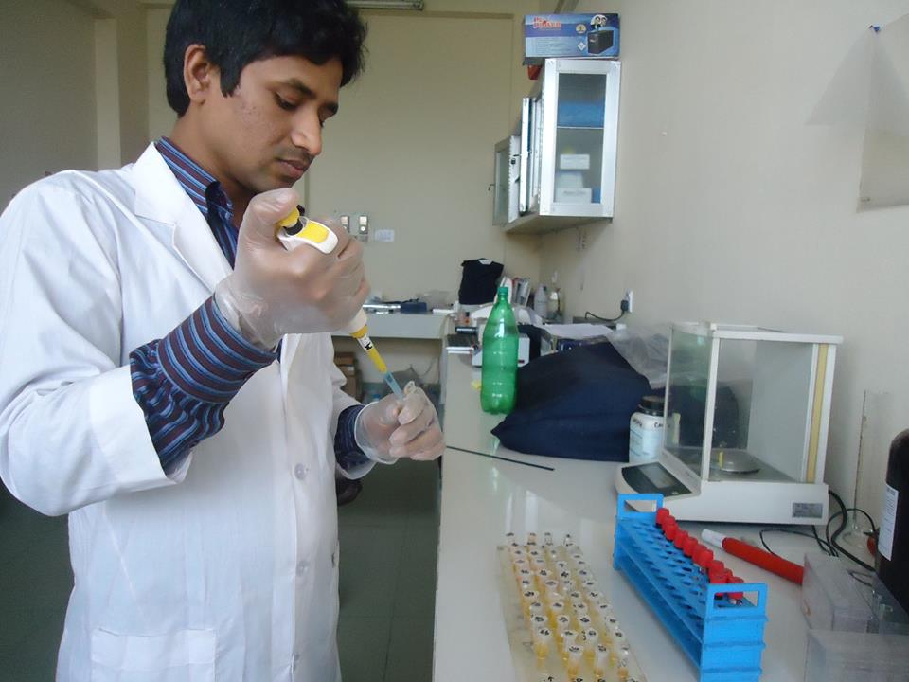
- Eppendorf tubes with reagents | - Adding sample to reagent
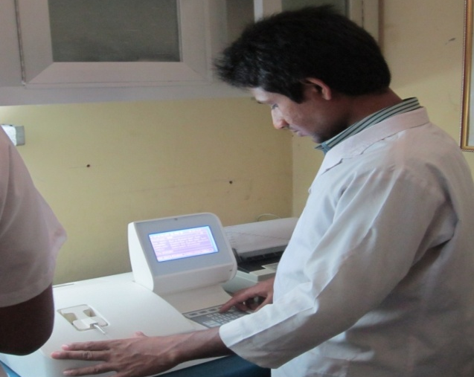 | 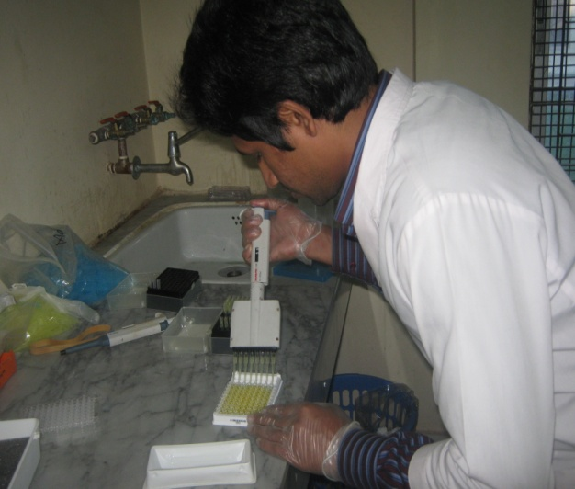
- Calibration of Humalyzer | - Adding sample to ELISA plate
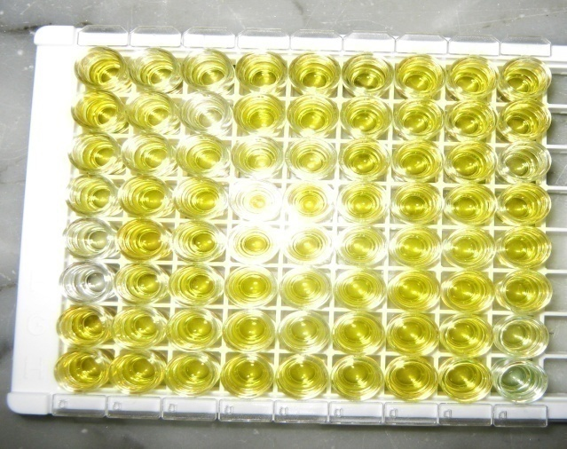 | 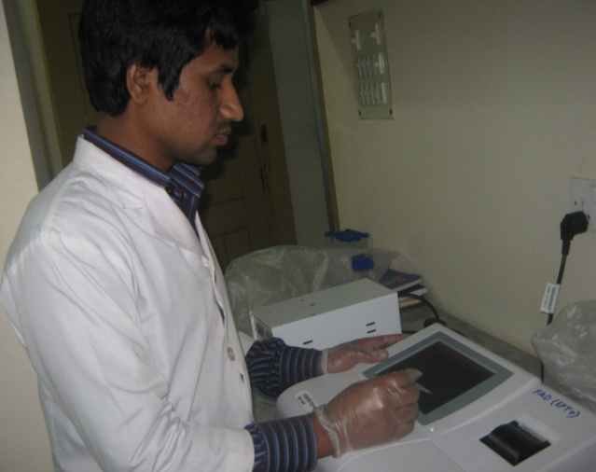
- Color appearance of ELISA plate | - Taking ELISA plate reading

Figure 5: Biochemical and hormonal analysis

3. 14 Biochemical Analysis
The biochemical analysis was performed from the preserved serum sample. The samples were allowed to be in room temperature before starting the analysis. The serum glucose, total protein (TP), Calcium (Ca), Phosphorus (P), Alkaline phosphatase (ALP), Creatinine kinase (CK) and triglyceride level were estimated by using biochemical analyzer ((Humalyzer-3000 Chemistry Analyzer, semi automated Benchtop chemistry photometer) in biochemistry laboratory of CVASU. For each parameters the commercial kit of RANDOX company (http://www.randox.com/reagent) were used and followed the manufacturer’s procedure.

3.15 Hormonal Analysis
Cortisol hormone level was determined by using serum sample. Before analysis the serum was allowed to be in room temperature. The cortisol hormone analysis was performed by using ELISA based commercial kit of Monobind Inc Company (http://www.monobind.com/site/index.html) and followed the manufacturer’s procedure.

3.16 Data analysis
All collected data and sample evaluated values were imported in Microsoft Excell-2007 and transferred to SPSS-16 software for analysis. Descriptive statistics of some parameters were done. The comparison of different qualitative parameters at before and after transportation was performed by using McNemer’s test. Comparison among the quantitative parameters at before, after and after 24h rest of transportation were performed by using Repeated measures ANOVA. The differences of different parameters were considered significant when the P- values were < 0.05 and highly significant when P- values were < 0.01.

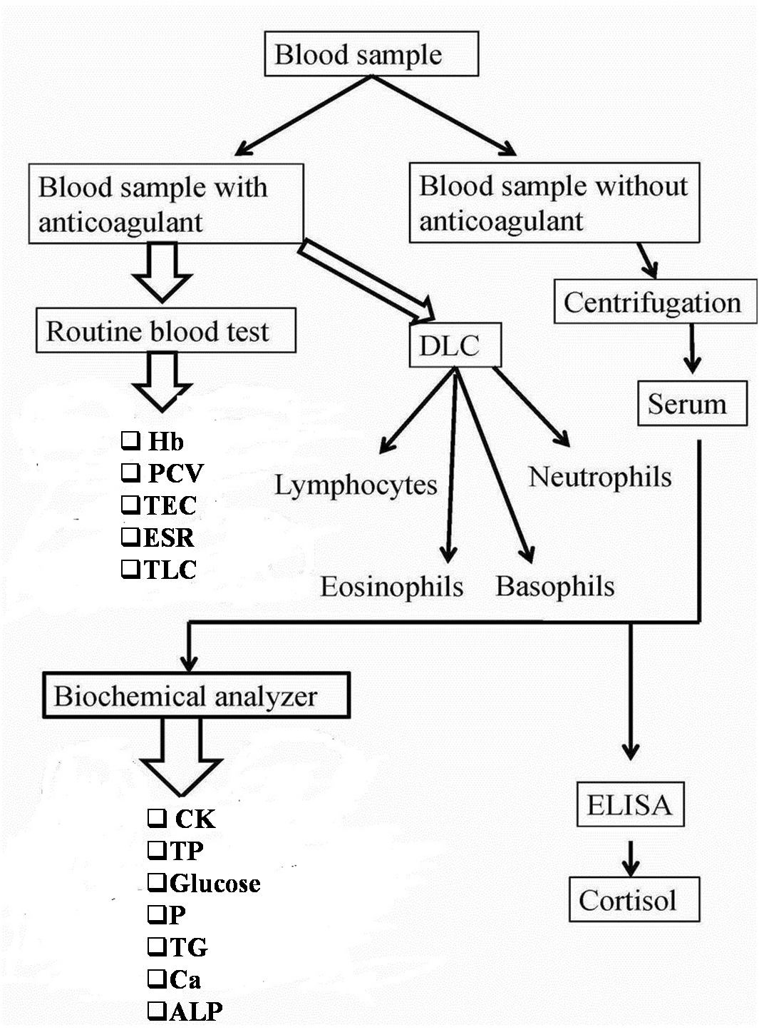
Figure 6: Layout of sample analysis

Chapter- 4: Results
Transportation is a stressful event in which animal exposed to different types of physical injuries and also affects different bio-markers of the body that hampers the animal productivity and welfare. This chapter describes the different types of injuries, hemato-biochemical and hormonal changes, and immune response of cattle during transportation that are worked out by the present study.

4.1 Frequency of physical injuries
Table 6: Frequency of physical injuries of cattle before and after transportation
Phase of transportation | Total no. of cattle examined | No. of cattle bearing injuries | % of cattle bearing injuries | P-value
Before | 100 | 26 | 26 | ***
After | 100 | 47 | 47
***= Significant (P<0.001)
From the above table (Table 6) it was found that about 26% of the cattle had injuries on their bodies in the primary market (Portkhali market) and the frequencies were significantly increased (p<0.01) after transportation to central cattle market (47%) at Sagorika cattle market.

4.2 Types of physical injuries
Table 7 and Table 8 show the status of different injuries like abrasion, laceration, swelling, scarification, barbed wire injury and horn fracture of cattle before and after transportation.

4.2.1 Abrasion
Among different types of injuries, abrasion was the most frequent type of physical injuries, both before and after transportation. A significant (P>0.01) increment of number of abrasions was observed after transportation (21%) than before transportation (11%). The abrasion was more frequently observed in Hariana cattle in comparison to other breeds of cattle in both before (5%) and after (8%) transportation.

Table 7: Distribution of physical injuries at before and after transportation among different breeds of cattle
Breed | Types of injuries
 | Abrasion (%) |  | Laceration (%) |  | Swelling (%) |  | Scarification (%) |  | Barbed wire injury (%) |  | Horn fracture (%)
 | Before | After | Before | After | Before | After | Before | After | Before | After | Before | After
Hariana | 5 | 8 | - | 2 | - | 1 | 1 | 1 | 2 | 5 | - | -
Hallikar | 2 | 4 | 1 | 1 | 1 | 1 | 1 | 1 | 2 | 3 | - | -
Gir | - | 4 | 1 | 1 | 1 | 1 | 2 | 2 | 2 | 4 | 2 | 2
Ongole | - | 1 | - | 1 | - | - | - | - | - | 1 | - | -
Tharparkar | 1 | 3 | - | 1 | - | - | 1 | 1 | 1 | 2 | - | -
Indian ND | - | 1 | - | 3 | - | - | 1 | 1 | 2 | 3 | - | -
N= 100; ND: Non descriptive.

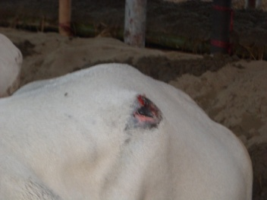 | 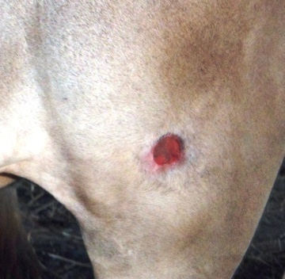
Abrasion on hip bone | Abrasion on thigh
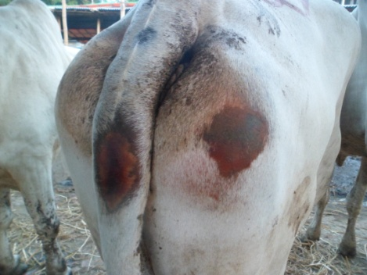 | 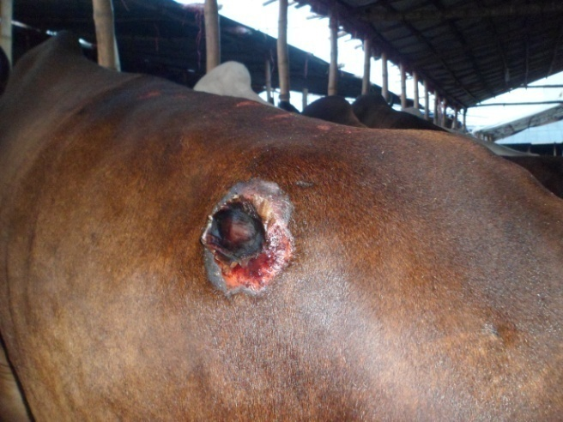
Abrasion on Pin bone and tail | Abrasion on paralumbar fossa
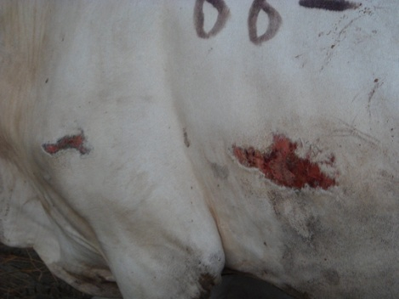 | 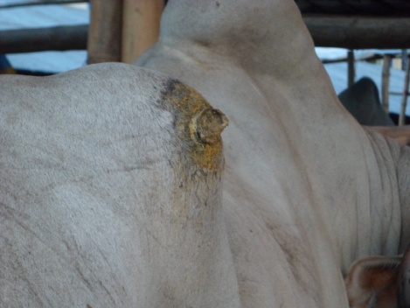
Abrasion on thoracic region | Swelling on back

Figure 7: (a) Types of injuries that are identified during research duration

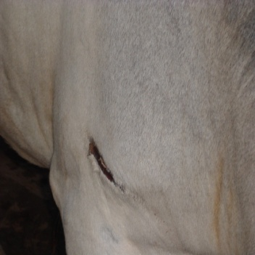 | 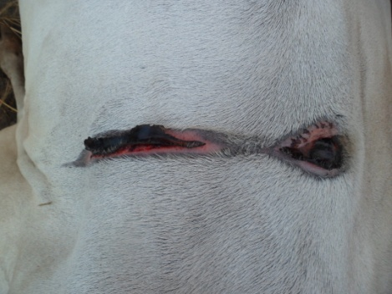
Barbed wire injury on Shoulder | Barbed wire injury on back
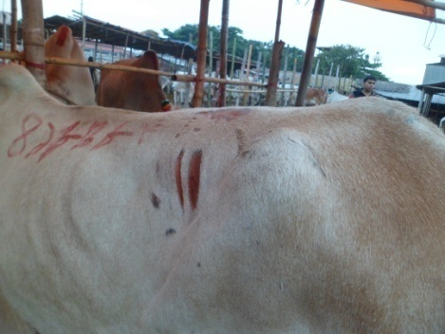 | 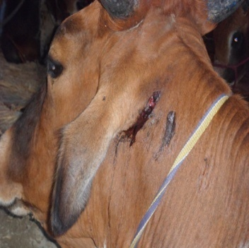
Barbed wire injury on paralumbar fossa | Laceration on ear
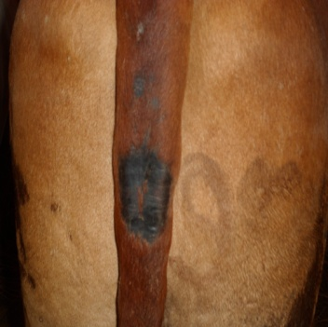 | 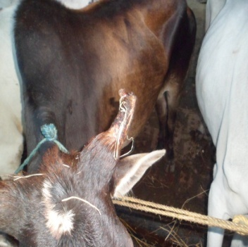
Scarification on tail | Horn fracture
Figure 8: (b) Types of injuries that are identified during research duration

Table 8: Various types and number of injuries before and after transportation of cattle
Variable | Categories | Percentage |  | McNemar’s chi square value | P-value of McNemar’s test
 |  | Before | After
Types of injury | Abrasion | 11 | 21 | 10.00 | **
 | Laceration | 3 | 8 | 5.00 | NS
 | Swelling | 2 | 3 | 1.00 | NS
 | Scarification | 6 | 6 | 0 | NS
 | Barbed wire injury | 9 | 18 | 9.00 | ***
 | Horn fracture | 2 | 2 | 0 | NS
Number of injury (Among the injuries) | Single | 21 | 36 | 15.00 | ***
 | Double | 4 | 8 | 4.00 | NS
 | Multiple (> 2) | 1 | 2 | 1.00 | NS
N =100; NS= Non-Significant (P>0.05); **= Significant (P<0.01); ***= Significant (P<0.001)

4.2.2 Laceration
Laceration was found in Hallikar and Gir breeds of cattle both at before (1%) and after (1%) transportation, but in other breeds lacerations were found only after transportation (1, 1, and 3%, respectively in Ongole, Tharparkar and Indian ND). The total number of cattle bearing laceration was insignificantly (P>0.05) increased after transportation.

4.2.3 Swelling
Among the various types of injuries swelling was found in Hallikar (1%) and Gir (1%) breeds of cattle both before and after transportation. Other than these, Hariana (1%) bore swelling after transportation. The total number of swelling were insignificantly (P>0.05) increased after transportation.

4.2.4 Scarification
Scarifications were found among all the breeds of cattle under the study except Ongole both before and after transportation. Variations were not found in terms of number of scarifications at both phases of transportation (6% in each phase).

4.2.5 Barbed wire injury
The current study revealed that barbed wire injuries were found among all the breeds of cattle under the study both the cases (before and after transportation) except Ongole in which barbed wire injuries were only found after transportation. Significant variations (P<0.05) were found in terms of number of barbed wire injuries at after (18%) transportation than before (9%).

4.2.6 Horn fracture
Horn fractures were only found in Gir breeds of cattle both before and after transportation. It was the least frequent types of physical injury in the current study. There also observed no variation in terms of number of horn fractures both before and after transportation (2% in both phases of transportation).

4.3 Number of physical injuries
Among all types of injuries the frequencies of single, double and multiple injuries were found as 36, 8 and 2%, respectively (Table 8). The results revealed that all the injuries were increased after transportation at secondary market, although the increment was significant (P<0.01) only in case of single injuries.

4.4 Location of physical injuries
Distribution of different types of physical injuries on parts of the body of cattle is shown in Table 9. Considering the location of the body the injuries were most frequently found on pin bone of cattle both before (11%) and after (16%) transportation. Other than pin bone the injuries were also found on the hip region, paralumbar fossa, tail, point of hip, thoracic region, back, thigh, ear and horn both before and after transportation. On most of the body parts (hip region, paralumbar fossa, tail, thoracic region and back) the injuries were numerically increased after transportation (16, 2, 4, 2, 4 and 7%, respectively) in comparison to before transportation (11, 1, 1, 1, 2 and 5%, respectively) though the increment was not statistically significant (P>0.05). Total number of injuries on other locations like thigh, ear and horn did not change which found as 3, 2 and 2%, respectively both before and after transportation.
Table 9: Distribution of physical injuries on parts of the body before and after transportation
Location of the body | Percentage |  | McNemar’s chi square value | P-value of McNemar’s test
 | Before | After
Pin bone | 11 | 16 | 5.00 | NS
Hip region | 1 | 2 | 1.00 | NS
Paralumbar fossa | 1 | 4 | 3.00 | NS
Tail | 1 | 2 | 1.00 | NS
Point of hip | 1 | 1 | 0 | NS
Thoracic region | 2 | 4 | 2.00 | NS
Back | 5 | 7 | 2.00 | NS
Thigh | 3 | 3 | 0 | NS
Ear | 2 | 2 | 0 | NS
Horn | 2 | 2 | 0 | NS
N=100; NS= Non-Significant (P>0.05)

4.5 Physical conditions
In terms of physical effects on the body due to transportation, other than physical injuries the current study also investigated the changes of two important physical conditions such as nasal discharge and diarrhea of the body. Both of these parameters increased significantly (P<0.01) after transportation (28% and 23%, respectively) than before (15%, respectively) (Figure 9).
(N=100)
P= 0.0078

P= 0.0002
Diarrhea
Nasal Discharge
Figure 9: Comparative presentation of nasal discharge and diarrhea before and after transportation

Table 10: Level of dehydration among the cattle before and after transportation
Variable | Categories | Percentage |  | McNemar’s chi square value | P-value
 |  | Before | After
Dehydration | Mild | 49 | 15 | 34.00 | ***
 | Moderate | 43 | 65 | 22.00 | ***
 | Severe | 8 | 20 | 12.00 | ***
N=100; ***= Significant (P<0.001)
Table 10 shows the dehydration status of cattle before and after transportation. From this study it was revealed that the frequency of mild, moderate and severe dehydration were 49, 43 and 8 percent, respectively before transportation. After transportation the number of animals showing mild dehydration was reduced (15%) significantly (P<0.01), but the numbers showing moderate (65%) and severe (20%) dehydration were increased (P<0.01).

4.6 Hematological changes
Table 11: Comparison of mean values of hematological parameters among 3 time periods of sampling
Variable | Time periods of transportation | Mean | SE | F statistic  (Repeated ANOVA) | P- value  (Repeated ANOVA)
HB (mg/dl) | Before | 11.10 | 0.37 | 4.37 | **
 | Immediately after | 12.31 | 0.45
 | After 24 hours | 10.61 | 0.42
PCV (%) | Before | 30.12 | 0.74 | 3.05 | NS
 | Immediately after | 32.38 | 0.76
 | After 24 hours | 30.26 | 0.73
TEC (10⁶/ ml) | Before | 4.72 | 0.22 | 11.49 | ***
 | Immediately after | 5.67 | 0.17
 | After 24 hours | 4.50 | 0.14
TLC (10³/ ml) | Before | 6.24 | 0.21 | 32.61 | ***
 | Immediately after | 7.25 | 0.19
 | After 24 hours | 5.25 | 0.05
Lymphocyte (%) | Before | 61.60 | 0.64 | 8.45 | ***
 | Immediately after | 58.14 | 0.54
 | After 24 hours | 60.58 | 0.67
Monocyte (%) | Before | 4.84 | 0.25 | 1.83 | NS
 | Immediately after | 4.28 | 0.35
 | After 24 hours | 4.16 | 0.26
Neutrophil (%) | Before | 29.68 | 0.55 | 6.62 | **
 | Immediately after | 32.74 | 0.63
 | After 24 hours | 30.22 | 0.64
Eosinophil (%) | Before | 3.76 | 0.23 | 6.38 | **
 | Immediately after | 4.72 | 0.36
 | After 24 hours | 5.30 | 0.33
Basophil (%) | Before | 0.12 | 0.05 | 0.00 | NS
 | Immediately after | 0.12 | 0.05
 | After 24 hours | 0.12 | 0.05
L:N | Before | 0.48 | 0.01 | 8.02 | **
 | Immediately after | 0.56 | 0.01
 | After 24 hours | 0.50 | 0.01
N= 50; SE= Standard Error; N: L - Neutrophil and lymphocyte ratio; NS= Non-Significant (P>0.05); **= Significant (P<0.01); ***= Significant (P<0.001)
From the above table it revealed that the hemoglobin (Hb), PCV and TEC were increased after transportation in comparison to before and 24h (hours) (h) of post transportation. The increment of Hb (12.31$±$0.45 gm/dl) and TEC (5.67$±$0.17) was highly significant (P<0.01) whereas the increment of PCV (32.38$±$0.76 %) was insignificant (P>0.05).
While considering the white blood cell the total leukocyte count (TLC) was lowest (5.25$±$0.05 × 10³/ml) at the 24h of post transportation and highest (7.25$±$0.19× 10³/ml) at after transportation. Before transportation of cattle the TLC was 6.24$±$0.21× 10³/ml. The values of TLC differ significantly (P<0.01) among before, after and the 24h of post transportation. Among the WBC the percentage of lymphocytes were decreased (58.14$±$0.54%) and the percentage of neutrophils were increased (32.74$±$0.63) after transportation in comparison to before and after 24h of post transportation (P=0.01). The percentage of eosinophils were comparatively higher (P=0.01) after and 24h of post transportation but no change (P>0.05) of basophiles count were observed. The ratio between neutrophils and lymphocytes were significantly increased (P<0.01) after transportation (0.56$±$0.01) in comparison to before (0.48$±$0.01) and the 24h (0.50$±$0.01) of post transportation (Table 11).

4.7 Biochemical changes
Table 12: Comparison of mean values of biochemical parameters among 3 time periods of sampling
Variable | Time periods of transportation | Mean | SE | F statistic  (Repeated ANOVA) | P- value  (Repeated ANOVA)
Glucose (mg/dl) | Before | 40.62 | 2.41 | 1.10 | NS
 | Immediately after | 36.04 | 2.55
 | After 24 hours | 36.77 | 2.33
Total protein (g/dl) | Before | 6.84 | 0.18 | 13.36 | ***
 | Immediately after | 8.20 | 0.27
 | After 24 hours | 6.90 | 0.20
Calcium (mg/dl) | Before | 11.31 | 0.32 | 9.31 | **
 | Immediately after | 13.00 | 0.37
 | After 24 hours | 12.39 | 0.14
Phosphorus (mg/dl) | Before | 7.34 | 0.19 | 18.01 | ***
 | Immediately after | 7.63 | 0.35
 | After 24 hours | 5.34 | 0.31
Alkaline phosphatase (u/l) | Before | 303.03 | 12.66 | 4.25 | *
 | Immediately after | 327.03 | 11.67
 | After 24 hours | 363.08 | 17.50
Creatine kinase (u/l) | Before | 574.91 | 23.52 | 201 | ***
 | Immediately after | 1288 | 48.84
 | After 24 hours | 469.06 | 20.77
Triglyceride (mg/dl) | Before | 104.72 | 4.72 | 4.33 | *
 | Immediately after | 127.68 | 5.26
 | After 24 hours | 116.26 | 6.71
N= 50; SE= Standard Error; NS= Non-Significant (P>0.05); *= Significant (P<0.05); **= Significant (P<0.01); ***= Significant (P<0.001)
Table 12 shows the biochemical parameters of cattle before, after and 24h of post transportation evaluated from serum sample. The mean glucose concentration was highest before transportation (40.62$±2.41$ mg/dl) and lowest after transportation (36.04$±$2.55 mg/dl). The mean glucose concentration after 24h of post transportation was 36.77$±$2.33 mg/dl. The differences of values of serum glucose concentration were insignificant (P>0.05). Serum total protein (TP), creatine kinase (CK) and triglyceride (TG) were significantly higher (P<0.05) after transportation (8.20$±$0.27 g/dl, 1288$±$48.84 u/l and 127.68$±$5.26 mg/dl, respectively) in comparison with before (6.84$±$0.18 g/dl, 574.91$±$23.52 u/l and 104.72$±$4.72 mg/dl, respectively) and after 24h of post transportation (6.90$±$0.20 g/dl, 469.06 $±$20.77 u/l and 116.26$±$6.71mg/dl, respectively). Serum calcium (Ca) level was significantly higher (P<0.01) after transportation (13.00$±$0.37 mg/dl) and 24h of post transportation (12.39$±$0.14 mg/dl) in comparisons to before transportation (11.31$±$0.32 mg/dl). A significantly low level of serum phosphorus (P<0.01) and alkaline phosphatase (P<0.05) concentration revealed at 24 hours of post transportation (5.34$±$0.31 mg/dl and 363.08$±$17.50 u/l, respectively) in comparisons with before (7.34$±$0.19 mg/dl and 303.03$±$12.66 u/l, respectively) and after transportation (7.63$±$0.35 mg/dl and 327.03$±$11.67 u/l, respectively).

4.8 Hormonal changes
Among the different types of hormone that are released from glands of the body of cattle due to transportation stress, only the serum cortisol level were evaluated in the current study. The mean serum cortisol concentration were comparatively higher after transportation (4.76$±$ 0.48 µg/dl) in comparisons to before transportation (3.96$±$0.37 µg/dl), though the differences of values of serum cortisol concentration before and after transportation were statistically insignificant (P>0.05). Figure 10 shows the graphical presentation of serum cortisol level for each transported cattle before and after transportation.
Cortisol concentration (µg/ml)

(Mean= 4.76$±$ 0.48 µg/dl
(Mean= 3.96$±$0.37 µg/dl)
Individual transported animal
P = 0.16
Figure 10: Serum cortisol of cattle before and after transportation

4.9 Immune response
Among the various types of immune responses of the body during transportation only the cell mediated immune response was evaluated in this research based on the proliferation of WBC.
(N=50)
(P< 0.0001)
Note: Error bars represent the mean$±$ SE
5.25$±$0.05
7.25$±$0.19
6.24$±0.21$
Number of cells×10³/ml
Figure 11: Total leukocyte count before, after and after 24h of post transportation
Figure 11 shows the trends of proliferation of WBC before, after and after 24h of post transportation. TLC was lowest (5.25$±$0.05 × 10³/ml) at 24h rest of transportation and highest (7.25$±$0.19× 10³/ml) just after transportation. At before transportation stage the TLC was 6.24$±$0.21 × 10³/ml. The values of TLC differ significantly (P<0.01) among the before, after and 24h of post transportation.
(P=0.005)
(P=0.01)
Figure 12: Neutrophils and lymphocytes changes at before, after and 24h of post transportation

0.56$±$0.01
Note: Error bars represent the mean$±$SE

0.48$±$0.01
0.51$±$0.01
(P= 0.006)
Figure 13: Neutrophil and lymphocyte (N:L) ratio at before, after and 24h of post transportation

Among the percentage WBC the lymphocytes were decreased (58.14$±$0.54%) and the percentage of neutrophils were increased (32.74$±$0.63) after transportation in comparison to before and after 24h of post transportation (P<0.01) (Figure 12). The ratio between neutrophils and lymphocytes were significantly increased (P<0.01) after transportation (0.56$±$0.01) in comparison to before (0.48$±$0.01) and 24h (0.51$±$0.01) of post transportation (Figure 13).

Chapter- 5: Discussion
The current study investigated the harmful effects of transportation on cattle in terms of frequencies of physical injuries, hemato-biochemical and hormonal changes, and immune response. About 14 hours of transportation in this study elicited a classical stress response in cattle. As far known, none of the researcher compares the stress response of cattle during before and after transportation in Bangladesh environment. So the current study was conducted with the hypothesis that the transportation stress may increase the frequency of physical injuries, changes in hemato-biochemical parameters, stress hormone level (cortosol) and immune response of the body. In this study, the physical and physiological data were measured at the market before transport could not be used as a base line because the cattle are previously transported to the border market (primary market) from India before transported in central market (secondary market); (Gregory, 2008).

5.1 Frequency of physical injuries
From the current study it was revealed that a considerable population (26%) of the cattle bears injuries on their body in primary market (before transportation). This is because in present study the transportation of cattle only considers from the primary market, but as Gregory (2008) mentioned actually these cattle had already transported long distance into India to reach primary market as the source of cattle in primary market of Bangladesh is from India. The current study could not find out the duration and ways of transportation of cattle into India to reach the primary markets and the target cattle population already had some physical injuries on their bodies. The frequencies of physical injuries that are discovered in present study before transportation were significantly increased (p<0.05) after transportation among all the breeds of cattle. This finding has agreement with several researchers who have also found increased the frequency of injuries after transportation among cattle (Minka and Ayo, 2007; Gregory, 2008). In Bangladesh, the outcomes of some studies (Alam et al., 2010; Kober et al., 2014) also indicate the higher frequencies of physical injuries due to transportation, although they only consider the data from the central market after transportation without considering the data of primary market (before transportation). The increment of injuries most probably due to contact with inner wall of vehicles during the transport (Alam et al., 2010; Bigras-Poulin et al., 2006), from loading and unloading activities; due to higher stocking density (Friend, 2000) although some of the injuries also may come from the conflict among the cattle with their horn (Gregory, 2008).
According to current study the injuries were more commonly observed in Hariana breeds of cattle both before and after transportation. These findings have similarity with the findings of Kober et al. (2014), and they concluded that all injuries were higher in Hariana cattle compared to Rajasthani, Sahiwal and other exotic breeds which are found in Sagorika and Bibirhat cattle markets at Chittagong District (Sagorika market) in Bangladesh. Specific breeds are susceptible to injury is also supported by Minka et al. (2007), they showed that the injuries were more frequently found in Red Bororo cattle than White Falani and Sokoto Gudali, respectively. Alam et al. (2010) showed species variations in prevalence of injuries and they concluded that the injuries were more commonly found in cattle in comparison to buffalo.

5.2 Types of physical injuries
In present study, it was revealed that the most common types of injuries among the cattle were abrasion both before and after transportation. This finding has close agreement with the findings of Alam et al. (2010) in a study on two cattle markets in Bangladesh although they consider the injuries only after transportation. Other types of injuries encountered in the present study are laceration, swelling, scarification, barbed wire injury and horn fracture. Among them most of the injuries were found insignificant changes after transportation. As far known, no published data are available with comparing different types of injuries before and after transportation though there have some scattered information about the higher frequencies of lacerations, scarification, swelling, leg and tail injuries (Alam et al., 2008; Alam et al., 2010; Kober et al., 2014), after transportation without considering the data of primary market (before transportation).

5.3 Number of physical injuries
The current study showed the frequencies of single, double and multiple injuries were increased after transportation. These findings have partial similarity with Alam et al., 2010; Kober et al., 2014, they also showed more than one injuries in animal body after transportation.

5.4 Location of physical injuries
According to the current study injuries were most frequently found on pin bone of cattle both before and after transportation. Alam et al. (2010a) concluded that more frequent location of injury was buttock region though they did not classify the location pin bone and which is under buttock area hence this finding might consider similar with the current research. The current research finding has slightly dissimilarity with the findings of Minka et al. (2007), where they reported most frequent location of injury were neck and belly region in Red Bororo and White Falani cattle, respectively.
Other than pin bone the injuries were also found on the hip region, paralumbar fossa, tail, point of hip, thoracic region, back, thigh, ear and horn at both the cases (before and after transportation). The injuries due to transportation were also recorded by different researcher on head, neck, belly, tail, leg, perineum, horn etc. (Minka et al., 2007; Alam et al., 2008; 2010, 2010a; Kober et al., 2010).

5.5 Physical conditions
The increment of nasal discharge in current study was in close agreement with the finding of Ishizaki et al. (2005) and Mitchell et al. (2008). The increase level of nasal discharge after transportation might results from invasion of bacteria and virus into the upper respiratory tract due to immune depression by transportation stress (Sporer et al., 2007).
The current study showed insignificant increment of diarrhea after transportation. These findings were partially similar with research findings of Bywater (1980). The present study showed that the severity of dehydration increased after transportation. This findings concord with the findings of Villarroel et al. (2001) and Hogan et al. (2007). The dehydration were results from long time water deprivation, high evaporative water loss due to higher ambient temperature and water loss through diarrhea (Schwartzkopf-Genswein, 2012) of some animals.

5.6 Hematological changes
The increment of Hb and TEC in current study after transportation indicates hemo-concentration due to effect of dehydration during transportation. These findings have similarity with the findings of some studies (Mitchell et al., 2008; Hulbert et al., 2011), suggested the increment of PCV, TEC and hemoglobin that leads to hemo-concentration after 9.75 hours of transportation. Various studies reported that the normal hematological parameters except white blood cell count (Ishiwata et al., 2008; Mitchell et al., 2008). The hemo-concentration in current study is mainly due to dehydration resulting from feed and water deprivation during transportation (Knowles et al., 1999). One of the findings of present study was that insignificant variation of PCV before, after and after 24h of post transportation also supported by the findings of Hulbert et al. (2011) and Stockman et al. (2013).
While considering the white blood cell count in current study the TLC was highest after transportation compared to before and 24h of post transportation. Similar results were also reported by other investigators (Mitchell et al., 2008, Stockman et al., 2013). Some researcher showed no significant change of TLC after transportation compared to before (Hulbert et al., 2011) in short duration (4 hours) of transportation. The proliferation of WBC in present study might be due to stimulating effects of glucocorticoids on white blood cells during long time transportation (Weber et al., 2006).
The current study revealed that among the WBC the percentage of lymphocytes were decreased and the percentage of neutrophils was increased after transportation in comparison to before and 24h of post transportation. These findings are coincide with the findings of several researcher (Sporer et al., 2007; Mitchell et al., 2008; Halbert et al., 2011; Stockman et al., 2013).
The ratio between neutrophils and lymphocytes was significantly increased in present study after transportation in comparison to before and 24h of post transportation. This finding has similarities with the research outcomes of several investigators (Hulbart et al., 2011; Stockman et al., 2013).
In current study the changes in neutrophil percentages in the periphery were results from the changes in surface adhesion molecules and release of new neutrophils into the periphery from bone marrow (Burton et al., 2005). One anti-inflammatory action of glucocorticoids (secreted during transportation stress) is to down-regulate neutrophil l-selectin and 2-integrin (adhesion molecule) gene expression on blood neutrophils (Burton et al., 2005). Adhesion molecules play a critical role in leukocyte adhesion to epithelium and migration from peripheral circulation into sites of infection (Tempelman et al., 2002). A decrease in neutrophil gene expression might increase the number of neutrophils and ultimately increased neutrophil and mononuclear cell ratio in the current study.

5.7 Biochemical changes
The present study suggested that the insignificant variations among the serum glucose concentration before, after and 24h of post transportation. Great variations were observed in different research findings about the effects of transportation on serum glucose concentration. The present research findings have similarity with Stockman et al. (2013) but dissimilarity with the research outcomes of Ishiwata et al. (2008) and (2011), where they showed that the glucose concentration decreased after transportation in comparison to before transportation and comments that this might indicates psychological stress of novel environment and unfamiliar animals and handlers. On the other hand, Donal and Phillips (1995), and Hulbert et al. (2011) reported that glucose concentration was increased after short time transportation. The relative static condition of serum glucose concentration in the current study before, after and after 24 h of post transportation is may be due to mobilization of body energy reserve (Triglycerides); (Hulbert et al., 2011) during long distance transportation by the activity of adrenaline and nor- adrenaline, the two hormones that are secreted during transportation stress.
The current study showed that serum total protein (TP), creatine kinase (CK) and triglyceride (TG) were significantly (p<0.05) higher after transportation in comparison to before and after 24h of post transportation. The research findings of several researcher showed that the effect of transportation on total protein level were variable. The TP concentration of present study agreed with the findings of Tarrant et al. (1992), Warriss et al. (1995) and Honkavaara et al. (2003) but disagreed with the research outcomes of Sporer et al. (2008) and Ishiwata et al. 2011. The higher level of serum TP concentration after transportation in present study may be due to promote metabolism of protein by T3, a hormone that is secrete during transportation and also due to passive effect (proportionally increase) of dehydration (Friend, 2000). The concentration of CK in serum have the similarity with the research outcomes of Sporer et al. (2008), they concluded that initially (9.75 h of transportation) the serum CK was decreased than increased and reaches its peak at 24 h of post transportation than again decrease after 24h of post transportation. Creatine kinage (CK) is an enzyme that released due to muscle breakdown which is normally retained into the muscle. Higher the muscle breaks the more amount of enzyme released into the blood (Akyay et al., 2014). During transportation, long time standing on vehicle results sufficient muscle activity to cause muscle breakdown. As a result CK release from the muscle enters into the circulation and these are measured as increased level in blood serum after transportation (Sporer et al., 2008).
The finding of present study showed that serum triglyceride (TG) was significantly higher after transportation is disagree with the findings of Saeb et al. (2010) and Ishiwata et al. (2011), they found no remarkable changes of TG after long distance transportation. The increment of TG level after transportation in current study might be due to mobilization of body energy reserve as triglycerides (Hulbert et al., 2011) during starting of transportation by the activity of adrenaline and nor- adrenaline, that have short plasma half-life. The research set by the aforementioned researchers are comparatively longer distance than the present study as a result the activity of adrenaline and nor- adrenaline might no longer persist during last portion of transportation.
In current study the serum alkaline phosphatase was higher after transportation than 24h of post transportation. This outcome has similarity with research findings of Ochi et al. (2013) on beagle dogs. The dissimilarity of higher concentration of ALP before transportation might be due to pre-transportation of cattle in India to reach the border market.
The research findings of higher serum calcium and lower phosphorus level may be due to hyperparathyroidism activity (Chakera et al., 2012) to maintain blood calcium level in long time transportation stress.

5.8 Hormonal changes
Transportation stress is a complex mechanism in the body that leads to changes in hormone concentration in blood (Knights et al., 2007). Signals originating from stress like transportation are transmitted to the hypothalamus in the brain, activating hypothalamic pituitary adrenal (HPA) and sympatho-adrenal axes. The HPA axis affects perception in the brain resulting the release of hypothalamic factor, corticotrophin-releasing factor and vasopressin, that are stimulates the anterior pituitary gland to secrete adrenocorticotropic hormone (ACTH). The ACTH circulating in the blood stimulates the adrenal cortex. The stimulation produces the major hormone glucocorticoids (Aich et al., 2007; Fazio et al., 2005; Uetake et al., 2009).
The present study suggested that the concentrations of endocrine hormone, cortisol did not show significant elevation after transportation. This can be explained by the longer transportation (≥ 14 h) time used in this study. The levels of cortisol are highly variable based on duration and distance of transportation (Grandin, 1997; Pregel et al., 2005; Ishiwata et al., 2008). Honkavaara et al. (2003) have reported that cortisol concentration become higher after a short period (approximately 1.5 h) of transportation than after long periods (approximately 7 and 10 h). Warriss et al. (1995), Villarroel et al. (2003) and Uetake et al. (2009) have also shown comparable results, although their transportation time and study conditions were different. Sporer et al. (2008) suggested that plasma cortisol concentration was greatly elevated with the onset of transportation when compared with −24 h and a 321% increase at 4.5 h compared with −24h. Ishizaki et al. (2005) reported a three-fold higher concentration of plasma cortisol within 4 hours of transportation. There are some reports that cortisol concentrations were increased in response to the stresses associated with loading and at the initial stages of transport but then recover as the journey proceeds (Warriss et al., 1995; Grigor et al., 2001). Although the cortisol concentration become higher just after transportation, cortisol concentration might not be appropriate as the indicator of stress of long distance transportation (Ishiwata et al., 2008).

5.9 Immune response
Among the multiple immune responses of animal during transportation, the current study only investigated the cellular immune response. From the current study it was revealed that TLC was significantly higher at after transportation than before and 24h of post transportation. These finding have similarity with the research findings of Lomborg et al. (2007) and Mitchell et al. (2008), who also concluded that the transport stress increases the number of total white blood cells (WBC) and specific types of WBC (neutrophils, eosinophils, and mononuclear cells) in circulation. The proliferation of WBC was due to stimulating effects of glucocorticoids on blood cells (Weber et al., 2006). The current study also suggested that after transportation the percentages of neutrophils were increased and the percentage of lymphocytes were decreased in comparison to before and 24h of post transportation. The increased neutrophil and decreased lymphocyte numbers following transportation have been documented in previous studies (Earley and O’Riordan, 2006; Earley et al., 2006, 2010, 2011, 2012; Earley and Murray, 2010; Hulbert et al., 2011). The significant increase of N: L ratio in present study also have similarity with the findings of Mitchell et al. (2008) and Hulbert et al. (2011). It has been shown that the changes in hematological value of neutrophil/lymphocyte ratio (N: L) were good indicators of stress (Altan et al., 2003; Broom, 2003).
The study was conducted for six months only which was very short period to reveal the exact scenario of transportation stress of cattle. The current study had considered only cattle for assess the effects of transportation because of limited time and low financial support. It could be better to consider several species like cattle, buffalo, goat etc. to find out the exact response of animal to transport. The present study did not show any seasonal variations, it could be better to evaluate the seasonal effects. This study only based on the samples from the cattle before, immediately after and after 24h of post transportation. It could be better to consider the samples from the cattle during transportation also in different time fragments. Moreover with the limitations of time, financial support and other facilities this study was a complete study to measure the stress response of cattle transportation in Bangladesh.

Chapter-6: Conclusions
The transportation system of animal in Bangladesh is full of cruelty, rough handling and unethical. The road transport conditions involve high stocking densities, poor ventilation, high humidity and temperatures, and crude forms of animal restraint, including the tying legs together, which may increase the risk of muscle injury, fatigue and stress. Transport stress is a complex issue. The response of animals to the effects of transportation stress involves a complex interaction between neurons and hormones.
In Bangladesh, the changes in biomarkers due to transportation are not clearly identified. So the current study was designed to identify the effect of transportation of cattle in Bangladesh environment condition and transportation practices with the aims to determine the frequency of physical injury during transportation, to assess the changes of biomarkers of stress (Hematology, biochemical parameters and hormones) and immune response due to transportation and to observe the trends of biomarkers after 24h of post transportation cattle from primary market to secondary market in Bangladesh.
A cross-sectional study was conducted during the period of July- December, 2014. A total of 100 cattle were randomly selected subjected to long distance transportation. Blood samples were collected and tested by standard procedure. The biochemical and cortisol hormone analysis were performed by using commercial kit. This study identified that the frequencies of injuries were increased after transportation (47%) than before (26%). The Hariana cattle bore highest percentage of injuries both before (26%) and after transportation (47%). The most common type of injuries was abrasion and was increased after transportation. Among the different locations of the body the pin bone was mostly affected by injuries. The frequencies of nasal discharge and degree of dehydrations were significantly increased after transportation. Among the hematological parameters the hemoglobin (Hb), packed cell volume (PCV), total erythrocyte count (TEC), total leukocyte count (TLC) and neutrophils count were increased after transportation while the lymphocytes count were decreased. Among the biochemical parameters the serum total protein (TP), calcium (Ca), phosphorus (P), creatine kinage (CK) and triglyceride (TG) level were increased after transportation, while serum alkaline phosphatase (ALP) level was decreased. The serum cortisol hormone revealed no significant variation before and after transportation. Immune responses of the transported cattle were revealed by increased neutrophil count, decreased lymphocyte count and increased neutrophils and lymphocytes ratio after transportation than before.
Enormous variations of hemato-biochemical changes observed in the present study indicate relatively higher degree of stress and suffering due to transportation that is opposition to animal welfare and productivity. The government and cattle traders should take proper measures to reduce such types of detrimental effect of transportation of cattle to improve animal productivity and welfare.

Chapter-7: Recommendations
This study on the investigation of detrimental effects of transportation on health and productivity of cattle used in beef purpose in Bangladesh suggests the following recommendations:
- The cattle trader and personnel involved in cattle transportation should be aware with the different activities involves in cattle transportation
- The loading and unloading activities should be gentle and quit to avoid physical injuries Transportation should be maintained optimum stocking density with bedding materials
- Animal should be properly fed before transpiration.
- In long duration the animal should provide sufficient rest in the interval of transportation
- Animals should not transport during extreme environment like hot and humid climate or very cold environment
- During hot sunny days the animal should transported at night
- Finally proper legislation should be followed for cattle transportation in Bangladesh

Future perspective
The current study covers the transportation stress only at before, immediately after and during 24h of rest but not encounter during transpiration. The present study only considers two markets and only one specific distance and duration of transportation. So, a comprehensive study may be conducted enclosing different markets with different duration and time combination with considering every distinguish periods of transportation. The present study only consider one hormone (Cortisol), there may be multiple hormone choice during future research. Here, only cellular immune response has been investigated and further study may include other components of immune system. One of the findings of the current study is increased calcium level after transportation and this might be due to hyperparathyroidism. Best of my knowledge, none of the researcher had estimated serum parathyroid hormone level yet. So the further study may be needed based on the hypothesis of hyperparathyroidism during transportation stress.

References
Ahmed T, Hashem MA, Khan M, Rahman MF and Hossain MM. 2010. Factors related to small scale cattle fattening in rural areas of Bangladesh. Bangladesh Journal of Animal Science. 39 (1 and 2): 116-124.
Aich P, Jalal S, Czuba C, Schatte G, Herzog K, Ross AR, Potter AA, Babiuk LA and Griebel P. 2007. Comparative Approaches to the Investigation of Responses to Stress and Viral Infection in Cattle. A Journal of Integrative Biology. 11(4): 413-434.
Aktas MS, Ozkanlar S, Karakoc A, Akcay F and Ozkanlar Y. 2011. Efﬁcacy of vitamin E + selenium and vitamin A + D + E combinations on oxidative stress induced by long term transportation in Holstein dairy cows. Livestock Science. 141: 76-79.
Akyay A, Olcay L, Sezer N, Atay Sönmez Ç. 2014. Muscle strength, motor performance, cardiac and muscle biomarkers in detection of muscle side effects during and after acute lymphoblastic leukemia treatment in children. Journal of Pediatric Hematology/ Onchology. 36(8):594-8.
Alam M, Das BC, Hassan MM, Ahaduzzaman, Faruk MSA and Hasanuzzaman M. 2014. Ruminalacidosis- A case compilation study in SAQ Teaching Veterinary Hospital, Bangladesh. Veterinary World. 7(1): 38-43.
Alam MR, Gregory NG, Jabbar MA, Uddin MS, Chaudhury S, Saifuddin AKM, Debnath NC, Arafat MY and Silva- Fletcher A. 2008. Welfare of cattle and water buffalo at livestock market in Bangladesh. Proceedings of the Sixth Annual Scientific Conference of the Chittagong Veterinary and Animal Sciences University. p. 94-113. March 2008, Chittagong, Bangladesh.
Alam MR, Gregory NG, Jabbar MA, Uddin MS, Kibria ASMG, Silva-fletcher A. 2010a. Skin injuries identified in cattle and water buffaloes at livestock markets in Bangladesh. Veterinary Record. 167: 415-419.
Alam MR, Gregory NG, Jabbar MA, Uddin MS, Widdicombe JP, Kibria ASMG, Khan MSI, Mannan A. 2010b. Frequency of dehydration and metabolic depletion in cattle and water buffalo transported from India to a livestock mark et in Bangladesh. Animal Welfare 19: 301-305.
Alam MR, Gregory NG, Uddin MS, Jabbar, MA, Chaudhury, S and Debnath, NC. 2010. Frequency of nose and tail injuries in cattle and water buffalo at livestock markets in Bangladesh. Animal Welfare. 19:295-300.
Alsemgeest SPM, Lambooy IE, Wierenga HK, Dieleman SJ, Meerkerk B, van Ederen AM and Niewold TA. 1995. Influence of physical stress on the plasma concentrations of serum amyloid A (SAA) and haptoglobin (HP) in Calves. Veterinary Quarterly. 17: 9–12.
Altan O, Pabuccuoglu A, Altan A, Konyalioglus and Bayraktav H. 2003. Eﬀect of heat stress on oxidation stress, lipid peroxidation and some stress parameters in broilers. British Poultry Science. 44:545–550.
Appleby MC. 2011. Introduction to farm animal welfare. Business Benchmark on Farm Welfare Investors Briefing No. 3.
Armario A, Valles A, Dal-Zotto S, Marquez C and Belda X. 2004. A single exposure to severe stressors causes long-term desensitization of the physiological response to the homotypic stressor. Stress. 7:157–172.
Arthington JD, Eicher SD, Kunkle WE and Martin FG. 2003. Effect of transportation and commingling on the acute-phase protein response, growth, and feed intake of newly weaned beef calves. Journal of Animal Science. 81: 1120–1125.
Asala OO, Ayo JO, Rekwot PI, Minka NS and Adenkola AY. 2010. Rectal Temperature Responses of Pigs Transported by Road and Administered with Ascorbic Acid During the Hot-Dry Season. Journal of Cell and Animal Biology. 4: 051-057.
Asala OO, Ayo JO, Rekwot PI, Minka NS, Omoniwa DO and Adenkola AY. 2011. Effect of ascorbic acid administration on erythrocyte osmotic fragility of pigs transported by road during the hot – dry season, Veterinary Research Communication. 35: 245-254.
Averos X, Herranz A, Sanchez R and Gosalvez LF. 2009. Effect of the duration of commercial journeys between rearing farms and growing–finishing farms on the physiological stress response of weaned piglets. Livestock Science. 122:339–344.
Averos X, Martin S, Riu M, Serratosa J, Gosalvez LF. 2008. Stress response of extensively reared young bulls being transported to growing-finishing farms under Spanish summer commercial conditions. Livestock Science. 119 (1-3):174–182.
Balz F. 2003.Vitamin-C intake. Nutritional Diseases. 14:1–18.
BBS. 2010. Statistical Year Book of Bangladesh. Bangladesh Bureau of Statistics, Statistical Division, Ministry of Planning, Government of the People's Republic of Bangladesh. Dhaka, Bangladesh.
Bigras-Poulin M, Thompson R A, Chriel M, Mortensen S, and Greiner M. 2006. Network analysis of Danish cattle industry trade patterns as an evaluation of risk potential for disease spread. Preventive Veterinary Medicine. 76:11–39.
Blecha F, Boyles SL and Riley JG. 1984. Shipping suppressed lymphocyte blastogenic responses in Angus and Brahman × Angus feeder calves. Journal of Animal Science. 59:576–583.
Broom DM. 2003. Causes of poor welfare in large animal during transportation, Veterinary Research Communication. 27:515–518.
Broom DM.1986. Indicators of poor welfare. British Veterinary Journal. 142: 524-526.
Brown SN, Knowles TG, Edwards JE and Warriss PD. 1999. Behavioural and Physiological responses of pigs to being transported for up to 24 hours followed by six hours recovery in lairage. Veterinary Record. 145: 421-426.
Burdick NC, Carroll JA, Randel RD, Willard ST, Vann RC, Chase CC, Lawhon SD, Hulbert LE and Welsh TH. 2011. Influence of temperament and transportation on physiological and endocrinological parameters in bulls. Livestock Science. 139: 213–221.
Burdick NC, Carroll JA, Hulbert LE, Dailey JW, Willard ST, Vann RC, Welsh JTH and Randel RD. 2010. Relationships between temperament and transportation with rectal temperature and serum concentrations of cortisol and epinephrine in bulls. Livestock Science. 129:166–172.
Burton JL, Madsen SA, Chang LC, Weber PSD, Buckham KR, Van- Dorp R, Hickey C and Earley B. 2005. Gene expression signatures in neutrophils exposed to glucocorticoids: A new paradigm to help explain ‘‘neutrophil dysfunction’’ in parturient dairy cows. Veterinary Immunology and Immunopathology. 105: 197–219.
Bywater RJ. 1980. Comparison between milk deprivation and oral rehydration with a glucose-glycine-electrolyte formulation in diarrhoeic and transported calves. The Veterinary Record. 13;107(24):549-51.
Chakera AJ, Simon HSP and Vaidya B. 2012.Treatment for primary hypothyroidism: current approaches and future possibilities. Drug Design Development and Therapy. 6: 1–11.
Chakrabarti A. 2005. Textbook of Clinical Veterinary Medicine. Kalyani Publishers, New Delhi, India. P. 82-83.
Chamber PG and Grandin T. 2001. Guidelines for humane handling, transport and slaughter of livestock. Food and Agricultural Organization of United States Regional Office of Asia and Pacific. Rap Publication.
Chrousos GP and Gold PW. 1992. The concepts of stress system disorders: overview of behavioral and physical homeostasis, JAMA. Journal of American Medical Association. 267:1244 – 1252.
Chrousos GP and Gold PW. 1998. A healthy body in a healthy mind and vice versa the damaging power of ‘‘uncontrollable’’ stress. Journal of Clinical Endocrinology Metabolism. 83: 1842 –184 5.
Clero D and Grandjean D. 2012. Influence of high-fat/high-antioxidants nutritional supplementation before and during endurance exercise on physiological and biochemical responses in physically trained search and rescue dogs. Journal of Veterinary Behavior: Clinical Applications and Research. 7: 56.
Dawkins MS. 2004. Using behaviour to assess animal welfare. Animal Welfare. 13: 3–7.
Deak T, Meriwether JL, Fleshner M, Spencer RL, Abouhamze A, Moldawer LL, Grahn RE, Watkins LR and Maier SF. 1997. Evidence that brief stress may induce the acute phase response in rats. American Journal of Physiology. 273 (R): 1998-2004.
Delezie E, Swennen Q, Buyse J and Decuypere E. 2007. The effect of feed withdrawal and crating density in transit on metabolism and meat quality of broilers at slaughter weight. Poultry Science. 86: 1414–1423.
Dhabhar FS, McEwen BS and Spencer RL. 1997. Adaptation to prolonged or repeated stress – comparison between rat strains showing intrinsic differences in reactivity to acute stress. Neuroendocrinology. 65:360–8.
Dixit VD, Marahrens M and Parvizi N. 2001. Transport stress modulates adrenocorticotrophin secretion from peripheral bovine lymphocytes. Journal of Animal Science. 79:729–734.
Earley B and Murray M. 2010. The effect of road and sea transport on inflammatory, adrenocortical, metabolic and behavioural responses of weanling heifers. BMC Veterinary Research. 6: 36. http://dx.doi.org/10.1186/1746-6148-6-36.
Earley B and O’Riordan EG. 2006. Effects on transporting bulls at different space allowances on physiological, haematological and immunological responses to a 12 h journey by road. Irish Journal of Agricultural and Food Research. 45: 39–50.
Earley B, Fisher AD and O’Riordan EG. 2006. Effects of pre-transport fasting on the physiological responses of young cattle to 8 h road transport. Irish Journal of Agricultural and Food Research. 45: 51–60.
Earley B, McDonnell B, Murray M, Prendiville DJ, and Crowe MA. 2011. The effect of sea transport from Ireland to the Lebanon on inflammatory, adrenocortical, metabolic and behavioural responses of bulls. Research Veterinary Science. 91 (3): 454–464.
Earley B, Murray M, Prendiville DJ, Pintado B, Borque C and Canali E. 2012. The effect of transport by road and sea on physiology, immunity and behaviour of beef cattle. Research Veterinary Science. 92 (3): 531–541.
Earley B, Murray M, Prendiville DJ. 2010. Effect of road transport for up to 24 h followed by twenty-four hour recovery on live weight and physiological responses of bulls. BMC Veterinary Research. 6: 38.
Eicher SD, Wesley IV, Sharma VK and Johnson TR. 2010.Yeast cell-wall products containing b-glucan plus ascorbic acid affect neonatal Bos taurus calf leukocytes and growth after a transport stressor. Journal of Animal Science. 88:1195–1203.
EL-Deeb WM and El-Bahr SM. 2014. Acute-phase proteins and oxidative stress biomarkers in water buffalo calves subjected to transportation stress. Comparative Clinical Pathology. 23:577–582.
Engler O, Pham T, FuIIenon MJ, Ooi G, Funder JW and Clarke IJ. 1989. Studies of the secretion of corticotropin releasing factor and arginine vaso- pressin into hypophyseal portal circulation of the conscious sheep. Neuroendocrinology. 49: 367 – 381.
FAWC. 1992. FAWC updates the five freedoms. Veterinary Record. 131, 357.
Fazio E, Medica P, Cravana C, Cavaleri S, and Ferlazzo A. 2012. Effect of temperament and prolonged transportation on endocrine and functional variables in young beef bulls. Veterinary Record. 638.
Fazio E. Medica, P, Alberghina D. Cavaleri, S. and Ferlazzo A. 2005. Effect of long-distance road transport on thyroid and adrenal function and haematocrit values in Limousin cattle: influence of body weight decrease. Veterinary Research Communications. 29:713–719.
Fernandes GA, Perks P, Cox NK, Lightman SL, Ingram CD and Shanks N. 2002. Habituation and cross-sensitization of stress-induced hypothalamic pituitary–adrenal activity: effect of lesions in the paraventricular nucleus of the thalamus or bed nuclei of the stria terminalis. Journal of Neuroendocrinology. 14:593–602.
Flint HE. 2013. Load Characteristics and the Behaviour of Beef Cattle Unloaded for Feed, Water and Rest During Long Distance Transportation in Canada. A Thesis presented for the degree of Master of Science in Population Medicine to the University of Guelph, Guelph, Ontario, Canada.
Fraser D. 1993. Assessing animal well-being: common sense, uncommon science. In Food Animal Well-being, West Lafayette (USA), USDA and Purdue University. 37-54.
Friend TH. 2000. Dehydration, stress, and water consumption of horses during long-distance commercial transport. Journal of Animal Science. 78(10): 2568-80.
Friend TH. 2000. Dehydration, stress, and water consumption of horses during long-distance commercial transport. Journal of Animal Science. 78(10):2568-80.
Friend TH. 2001. A review of recent research on the transportation of horses. Journal of Animal Science.79 (E):32–40.
Gade NE, Singh G, Sonawne PR and Mahapatra RK. 2010. Effect of ascorbic acid supplementation on plasma protein profile in buffalos. Indian Veterinary Research. 19: 56-62.
Gonzalez LA, Schwartzkopf-Genswein KS, Bryan M, Silasi R and Brown F. 2012. Factors affecting body weight loss during commercial long haul transport of cattle in North America. Journal of Animal Science. 90:3630–3639.
Gosalvez LF, Averos X, Valdelvira JJ and Herranz A. 2006. Influence of season, distance and mixed loads on the physical and carcass integrity of pigs transported to slaughter. Meat Science. 73: 553–558.
Grandin T. 1997. Assessment of stress during handling and transport. Journal of Animal Science. 75(1): 249-257.
Grandin T. 2002. Behavioural Principles of Livestock Handling. American Registry of Professional Animal Scientists. pp.1-11.
Gregory NG. 2008. Animal welfare at markets and during transport and slaughter. Meat Science. 80: 2–11.
Grigor PN, Cockram MS, Steele WB, Le Sueur CJ, Forsyth RE, Guthrie JA, Johnson AK, Sandilands V, Reid HW, Sinclair C and Brown HK. 2001. Effects of space allowance during transport and duration of mid-journey lairage period on the physiological, behavioural and immunological responses of young calves during and after transport. Animal Science. 73: 341–360.
Habib KE, Gold PW and Chrousos GP. 2001. Neuroendocrinology of stress: Endocrinology and Metabolism. American Journal. 30: 695 – 728.
Harris T. 2001. The history and development of European and North American transportregulations and international trade issues, Journal of Animal Science. 79 (E): 73–85.
Hickey MC, Drennan M and Early B. 2003. The effect of abrupt weaning of suckler calves on the plasma concentrations of cortisol, catecholamines, leukocytes, acute-phase proteins and in vitro interferongamma production. Journal of Animal Science. 81: 2847–2855.
Hicks TA, McGlone JJ, Whisnant CS, Kattesh HG and Norman RL. 1998. Behavioral, endocrine, immune, and performance measures for pigs exposed to acute stress. Journal of Animal Science. 76: 474–483.
Higuchi S and Tsunoda G. 2007. Blood gas values and related components in healthy and diarrhea-affected Japanese Black calves, measured with a portable blood gas analyzer. Japanese Journal of Veterinary Clinics. 30: 51–55.
Hinson JP. 1990. Paracrine control of adrenocortical function: a new role for the medulla? Journal of Endocrinology. 124:7 – 9.
Hodate K. 2005. Effects of stress during fattening on vitamin condition and beef quality. Journal of Clinical Veterinary Medicine. 23: 30–35.
Hogan JP, Petherick JC and Phillips CJ. 2007. The physiological and metabolic impacts on sheep and cattle of feed and water deprivation before and during transport. Nutrition Research Reviews. 20(1):17-28.
Honkavaara M, Rintasalo E, Ylönen J and Pudas T. 2003. Meat quality and transport stress of cattle. Deutsche Tierärztliche Wochenschrift. 110, 125–128.
Hossain MI and Chandra SS. 2002. A Study on Beef Cattle Marketing in Bangladesh, OnLine Journal of Biological Sciences. 2(7): 481-482.
Hulbert LE, Carroll JA, Burdick NC, Randel RD, Brown MS and Ballou MA. 2011. Innate immune responses of temperamental and calm cattle after transportation. Veterinary Immunology and Immunopathology. 143: 66–74.
Ibironke AA, McCrindle CME, Adejuwon TA and Cadmus SIB. 2010. Losses associated with mortality of cattle and camels during transportation to Oko- Oba abattoir, Lagos, Nigeria, European Journal of Translational Myology. 1: 13-16.
Ilham N and Yusdja N. 2004. Sistem Transportasi Perdagangan Ternak Sapi dan Implikasi Kebijakan di Indonesia. Pusat Penelitian and Pengembangan Sosial Ekonomi Pertanian. 2: 37-53.
Ishiwata K, Sasaki G, Ogawa J, and Miyata T. 2011. Phylogenetic relationships among insect orders based on three nuclear protein-coding gene sequences. Molecular Phylogenetics and Phylogeny. 58:169-180.
Ishiwata T, Uetake K, Eguchi Y and tanaka T. 2008. Physical conditions in a cattle vehicle during spring and autumn conditions in Japan, and reactions of steers to long distance transport. Animal Science Journal. 79: 620–627.
Ishizaki H, Hanafusa Y and Kariya, Y. 2005. Influence of truck-transportation on the function of bronchoalveolar lavage fluid cells in cattle. Veterinary Immunology and Immunopathology. 105: 67–74.
Jacobson LH and Cook CJ. 1998. Partitioning psychological and physical sources of transport related stress in young cattle. The Veterinary Journal. 155(2): 205-208.
Jones SDM, Schafer AL, Robertson, WM and Vincent BC. 1990. The effects of withholding feed and water on carcass shrinkage and meat quality in beef cattle. Meat Science. 28:131–139.
Kannan G,Terrill TH, Kouakou B, Gelaye S and Amoah EA. 2002. Simulated preslaughter holding and isolation effects on stress responses and liveweight shrinkage in meat goats. Journal of Animal Science. 80: 1771–1780.
Karanth S, Yu WH, Walczewska A, Mastronardi C and Mccann SM. 2000. Ascorbic acid acts as inhibitory transmitter in the hypothalamus to inhibit stimulated luteinizing hormone-releasing hormone release by scavenging nitric oxide. Proceedings of the National Academy of Science. U.S.A. 15: 1891–1896.
Kelley KW, Osborne CA, Evermann JF, Parish SM and Hinrichs DJ. 1981. Whole blood leukocyte vs. separated mononuclear cell blastogenesis in calves: Time-dependent changes after shipping. Canadian Journal Comparative Medicine. 45:249–258.
Kent JE and Ewbank R. 1986. The effect of road transportation on the blood constituents and behavior of calves. III. Three months old. British Veterinary Journal. 142:326–335.
King DA, Pfeiffer SCE, Randel RD, Welsh TH, Oliphint RA, Baird Be, Curley KO, Vann RC, Hale DS and Savell JW. 2006. Influence of animal temperament and stress responsiveness on the carcass quality and beef tenderness of feedlot cattle. Meat Science. 74: 546–556.
Knights M and George WS. 2007. Decreased ACTH secretion during prolonged transportation stress is associated with reduced pituitary responsiveness to tropic hormone stimulation in cattle. Domestic Animal Endocrinology. 33: 442–450.
Knowles TG, Brown SN, Edwards JE, Philips AJ and Warriss PD. 1999. Effect on young calves of a one-hour feeding stop during a 19-hour road journey. Veterinary Record.144: 687–692.
Kober AKMH, Bari MS, Rakib MR and Ali MS. 2014. Injuries of cattle and buffaloes during transportation and slaughter at Chittagong City Corporation of Bangladesh. Bangladesh Journal of Animal Science. 43(1): 74-77.
Lachuer J, Delton I, Buda M and Tappaz M. 1994. The habituation of brainstem catecholaminergic groups to chronic daily restraint stress is stress specific like that of the hypothalamo–pituitary–adrenal axis. Brain Research. 638:196–202.
Lamberts SWJ, Verleun T, Oosterom R, DeJong P and Hackeng WHL. 1984. Corticotropin releasing factor and vasopressin exert a synergistic effect on adrenocorticotropin release in man. Journal of Clinical Endocrinology and Metabolism. 58: 298 – 303.
Lay JDC, Friend TH, Randel RD, Jenkins OC, Neuendorff DA and Kapp GM. 1996. Adrenocorticotropic hormone dose–response and some physiological effects of transportation on pregnant Brahman cattle. Journal of Animal Science. 74:1806–1811.
Ledward DA. 1983. Haemoproteins in meat and meat products. In Development in Food Proteins, III. Elsevier Applied Science, London. pp. 33-68.
Ledward DA. 1992. Color of raw and cooked meat, In the Chemistry of Muscle- based Foods. The Royal Society of Chemistry, Thomas Graham House, Science Park, Cambridge. pp. 33-68.
Lester SJ, Mellor DJ, Holmes RJ, Ward RN and Stafford KJ. 1996. Behavioural and cortisol responses of lambs to castration and tailing using different methods. New Zealand Veterinary Journal. 44, 45–54.
Lomborg SR, Agerholm, JS, Jensen AL and Nielsen LR. 2007. Effects of experimental immunosuppression in cattle with persistently high antibody levels to Salmonella Dublin lipopolysaccharide O-antigens, BMC Veterinary Research. 3:17.
Lykkesfeldt TJ and Svendsen O. 2007. Oxidants and antioxidants in disease: oxidative stress in farm animals. Veterinary Journal. 173: 502-511.
Mackenzie AM, Drennan M, Rowan TG, Dixon JB and Carter SD. 1997. Effect of transportation and weaning on humoral immune responses of calves. Research in Veterinary Science. 63:227–230.
Mason D, Hassan A, Chacko S and Thompson P. 2002. Acute and chronic regulation of pituitary receptors for vasopressin and corticotrophin releasing hormone. Archives Physiology Biochemistry. 110:74–89.
McCaw J, Ellis M, Brewer MS and McKeith FK. 1997. Incubation temperature effects on physical characteristics of normal, DFD, and halothane carrier pork longissimus carcasses. Journal of Animal Science. 75: 1547-1552.
Minka NS and Ayo JO. 2007. Effects of loading behaviour and road transport stress on traumatic injuries in cattle transported by road during the hot-dry season. Livestock Science. 107: 91–95.
Minka NS and Ayo JO. 2013. Physiological and behavioral responses of goats to 12-hour road transportation, lairage and grazing periods, and the modulatory role of ascorbic acid. Journal of Veterinary Behavior. 8:349–356.
Mitchell G, Hattingh J and Ganhao M. 1988. Stress in cattle assessed after handling, after transport and after slaughter. Veterinary Record. 123: 201–205.
Mitchell GB, Clark ME, Siwicky M and Caswell JL. 2008. Stress alters the cellular and proteomic compartments of bovine bronchoalveolar lavage fluid. Veterinary Immunology and Immunopathology. 125:111–125.
Mitchell MA and Kettlewell PJ. 1998. Physiological and welfare of broiler chickens in transit; solutions not problems. Poultry Science. 77: 1803–1814.
Mormede P, Soissons J, Bluthe R, Raqult J, Legarff G, Levieux D and Dantzer R. 1982. Effect of transportation on blood serum composition, disease incidence, and production traits in young calves: Influence of the journey duration. Annals of Veterinary Research. 13:369–384.
Murata H and Miyamoto T. 1993. Bovine haptoglobin as a possible immunomodulator in the sera of transported calves. British Veterinary Journal. 149: 277–283.
Murata H. 2007. Stress and acute phase protein response: an inconspicuous but essential linkage. Veterinary Journal. 173(3):473–474.
Niedzwiedz A, Kubiak K and Nicpon J. 2013. Plasma total antioxidant status in horses after 8-hours of road transportation. Acta Veterinaria Scandinavica. 55:58.
Nielsen BL, Dybkjær L and Herskin MS. 2011. Road transport of farm animals: effects of journey duration on animal welfare. Animal. 3 (5): 415–427.
Nomura F. 2006. AST (GOT), ALT (GPT). In: Nakai T, Ozaki Y, Komuro K, Odahara M, Nomura F, Kensachi M. 3rd ed. pp. 5–8.
Ochi T, Nishiura I, Tatsumi M, Hirano Y, Yahagi K, Sakurai Y, Sudo Y, Koyama H, Hagita Y, Fujimoto Y, Kitamura S, Hashimoto H, Nakamura T, Yamada A, Tanimoto M and Nishina N. 2013. Effects of transport stress on serum alkaline phosphatase activity in beagle dogs. Experimental Animal. 62(4):329-32.
Odore R, Badino P, Re G, Barbero R, Cuniberti B, D’Angelo A, Girardi C and Tarantola M. 2011. Effects of housing and short-term transportation on hormone and lymphocyte receptor concentrations in beef cattle. Research in Veterinary Science. 90 (2): 341–345.
Palme R, Robia C, Baumgartner W and Mostl E. 2000. Transport stress in cattle as reflected by an increase in faecal cortisol metabolite concentrations. Veterinary Record. 146: 108-109.
Phillips CJC and Santurtun E. 2013.The welfare of livestock transported by ship. The Veterinary Journal. 196: 309–314.
Powers SK and Jackson MJ. 2008. Exercise-induced oxidative stress: Cellular mechanisms and impact on muscle force production. Physiological Review. 88: 1243-1276.
Pregel P, Bollo E, Cannizzo FT, Biolatti B, Contato E and Biolatti PG. 2005. Antioxidant capacity as a reliable marker of stress in dairy calves transported by road. Veterinary Record. 156: 53-54.
Rajion MA, Soat IM, Zulkifli I and Goh YM. 2001.The effects of road transportation on some physiological stress measures in goats. Asian- Australian Journal of Animal Science. 9: 1250-1252.
Saeb M, Baghshani H, Nazifi S and Saeb S. 2010. Physiological response of dromedary camels to road transportation in relation to circulating levels of cortisol, thyroid hormones and some serum biochemical parameters. Tropical Animal Health and Production. 42(1):55-63.
Saito M, Sugimoto T, Tahara A and Kawashima H. 1995. Molecular cloning and characterization of rat V1b vasopressin receptor: evidence for its expression in extra-pituitary tissues. Biochemical and Biophysical Research Communication. 212:751–757.
Sakellaris PC and Vernikos-Danellis J. 1975. Increased rate of response of the pituitary–adrenal system in rats adapted to chronic stress. Endocrinology. 97:597–602.
Samuel A. 2013. Animal Transport and Welfare with special emphasis on Transport time and Vibration, Doctoral Thesis. Department of Energy and Technology, Faculty of Natural Resources and Agricultural Sciences, Swedish University of Agricultural Sciences, Uppsala.
Santosa U, Khusnu G, Kurnia A and Kamil. 2014. The effect of ascorbic acid on body weight loss of bali cattle during transportation. Animal Science. 57.
Schaefer AL, Jones SDM, Tong AKW, Young BA, Murray NL and Lepage P. 1992. Effects of post-transport electrolyte supplementation on tissue electrolytes, hematology, urine osmolality and weight loss in beef bulls. Livestock Production Science. 30: 333–346.
Schwartzkopf-Genswein KS, Faucitano L, Dadgar S, Shand P, González LA and Crowe TG. 2012. Road transport of cattle, swine and poultry in North America and its impact on animal welfare, carcass and meat quality: a review. Meat Science. 92(3):227-43.
Sevilla CG, Ochave JA, Punsalan TG, Regala BP and Uriarte GG. 2007. Research methods. Rex book store. P. 125-130.
Sheridan JF and Dobbs C. 1994. Psychoneuroimmunology: stress effects on pathogenesis and immunity during infection. Clinical Microbiology Reviews. 7(2): 200-212.
Sivakumar AVN, Singh G and Varshney VP. 2010. Antioxidants Supplementation on Acid Base Balance during Heat Stress in Goats. Asian-Australian Journal of Animal Science. 23(11):1462-1468.
Skaggs JM. 1986. Prime Cut: Livestock Rising and Meatpacking in the United States 1607 1983. Texas A and M University Press, College Station.
Smith GC, Savell JW, Clayton RP, Field TG, Griﬃn DB and Hale DS.1992. Improving the consistency and competitiveness of beef – A blueprint for total Quality Mangement in the Fed-Beef Industry. The Final Report of the National Beef quality Audit-1991. National Cattemen’s Association, Englewood, Co.
Smith GW, Aubry JM, Dellu F, Contarino A, Bilezikjian LM and Gold LH. 1998. Corticotropin releasing factor receptor 1-deficient mice display decreased anxiety, impaired stress response, and aberrant neuroendocrine development. Neuron. 20:1093–1102.
Sporer KRB, Burton JL, Earley B and Crowe, MA. 2007. Transportation stress in young bulls alters expression of neutrophil genes important for the regulation of apoptosis, tissue remodeling, margination, and anti bacterial function, Veterinary Immunology and Immunopathology. 118: 19–29.
Sporer KRB, Weber PSD, Burton JL, Earley B and Crowe MA. 2008. Transportation of young beef bulls alters circulating physiological parameters that may be effective biomarkers of stress. Journal of Animal Science. 86:1325-1334.
Stanger KJ, Ketheesan N, Parker AJ, Coleman, CJ, and Lazzaroni SM. 2005. The effect of transportation on the immune status of Bos indicus steers. Journal of Animal Science. 83:2632–2636.
Stockman CA, Collins T, Barnes AL, Miller D, Wickham SL, Beatty DT, Blache D, Wemelsfelder F and Fleming PA. 2013. Flooring and driving conditions during road transport influence the behavioural expression of cattle, Applied Animal Behaviour Science. 143: 18– 30.
Stockman CA, Collins T, Barnes AL, Miller D, Wickham SL, Beatty DT, Blache D and Fleming PA. 2011. Qualitative behavioural assessment and quantitative physiological measurement of cattle naïve and habituated to road transport. Animal Production Science. 51 (3): 240–249.
Suryadi U, Santosa U and Tanuwiria HU. 2011. Stress Elimination Strategies in Beef Cattle Transportation Using Organic Chromium. Padjadjaran University Press, Bandung
Swanson JC and Morrow-Tesch J. 2001. Cattle transport: Historical, research, and future perspectives, Journal of Animal Science. 79(E): 102-109.
Tarrant PV, Kenny FJ, Harrington D and Murphy M. 1992. Long distance transportation of steers to slaughter: effect of stocking density on physiology, behaviour and carcass quality. Livestock Production Science. 30: 223–238.
Tauler P, Aguilo A, Gimeno I, Fuentespina E, Tur JA and Pons A. 2003. Influence of Vitamin C diet supplementation on endogenous antioxidant defences during exhaustive exercise. Pflugers Archive. 446: 658–664.
Teke B, Akdag F, Ekiz B and Ugurlu M. 2014. Effects of different lairage times after long distance transportation on carcass and meat quality characteristics of Hungarian Simmental bulls. Meat Science. 96: 224–229.
Tempelman RJ, Saama PM, Freeman AE, Kelm SC, Kuck AL, Kehrli JR, and Burton, JL. 2002. Genetic variation in bovine neutrophil sensitivity to glucocorticoid challenge. Acta Agricultura Scandanvica. 52:189–202.
Tsigos C and Chrousos GP. 1994. Physiology of the hypothalamic – pituitary –adrenal axis in health and dysregulation in psychiatric and autoimmune disorders, Endocrinology Metabolism Clinics of North America. 23: 451 – 466.
Tsigos C and Chrousos,G. 2002. Hypothalamic–pituitary–adrenal axis, neuroendocrine factors and stress. Journal of Psychosomatic Research. 53: 865 – 871.
Tsuda T, Obara Y and Kato K. 2004. Kachiku Seirigaku (Livestock Physiology), 2nd edn, Yokendo. Tokyo. (In Japanese).
Uetake K, Ishiwata T, Tanaka, T and Sato, S. 2009. Physiological responses of young cross-bred calves immediately after long-haul road transportation and after one week of habituation, Animal Science Journal. 80: 705–708.
Uetake K, Tanaka T and Sato S. 2011. Effects of haul distance and stocking density on young suckling calves transported in Japan. Animal Science Journal. 82: 587–590.
Ul-rich-Lai YM and Engeland WC. 2005. Sympatho-adrenal activity and hypothalamic-pituitary-adrenal axis regulation. In: Steckler T, Kalin T, Reul, NH, J.M.H.M. (Eds.), Handbook On stress, Immunology and Behaviour. Elsevier Science, Amsterdam. pp. 419–435.
Vale WW, Spiess S, Rivier C. and Rivier J. 1981. Characterization of a 41- residue ovine hypothalamic peptide that stimulates secretion of corticotropin and beta-endorphin. Science. 213:1394 – 1397.
Villarroel M, María G, Sanˇ udo C, García-Belenguer S, Chacon G and Gebresenbet G. 2003. Effect of commercial transport in Spain on cattle welfare and meat quality. Deutsche Tierärztliche Wochenschrif. 110: 105–107.
Villarroel M, María GA, Sierra I, Sañudo C, Garćia-Belenguer S and Gebresenbet G. 2001. Critical points in the transport of cattle to slaughter in Spain that may compromise the animals' welfare. The Veterinary Record. 11;149(6):173-6.
Von-Borel EH. 2001. The biology of stress and its application to livestock housing and transportation assessment. Journal of Animal Science. 79: 260–267.
Von-Holleben K, Schmidt T and Henke S. 2009. Effect of transport time up to 8h on physiological and biochemical stress indicators and resulting carcass / meat quality in cattle, Training and consultancy institute for careful handling of breeding and slaughter animals. Session 23.
Warriss PD, Brown SN, Knowles TG, Kestin SC, Edwards JE, Dolan SK and Phillips AJ. 1995. Effects on cattle of transport by road for up to 15 hours. Veterinary Record. 136: 319–323.
Warriss PD. 1990. The handling of cattle pre-slaughter and its effects on carcass and meat quality. Applied Animal Behaviour Science. 28:171–186.
Weber PSD, Madsen-Bouterse SA, Rosa GJM, Sipkovsky S, Ren X, Almeida PE, Kruska R, Halgren RG, Barrick JL and Burton JL. 2006. Analysis of the bovine neutrophil transcriptome during glucocorticoid treatment. Physiological Genomics. 28 (1): 97–112.
Weiss DJ, Wardrop KJ. 2011. Schalm's Veterinary Hematology. John Wiley and Sons Publication. p. 140-160.
Yagi Y, Shiono H, Chikayama Y, Ohnuma A, Nakamura I and Yayou KI. 2004. Transportation stress increases somatic cell counts in milk, and enhances the migration capacity of peripheral blood neutrophils of dairy cows. Clinical Patholology. 66 (4): 381–387.

Annexure-1: Proforma of Record Sheet (Questionnaire)

Department of Animal Science and Nutrition
Faculty of Veterinary Medicine
Chittagong Veterinary and Animal Sciences University, Bangladesh

Title: Transportation stress of cattle in Bangladesh: its effects on body, biochemical and hormonal changes, and immune response.

- Name of cattle traders with address and mobile no: ……………………………
- Breed: ………………………………………………………………………….
- Sex of the cattle: ………………………………………………………………
- Meteorological Information
- Temperature: ………………………………………………………………
- Relative humidity: …………………………………………………………
- General Physical conditions
- Dehydration: Mild/ Moderate/ Severe
- Nasal discharge: Yes/ not
- Diarrhea: Yes/ not
- Physical injury:
- Presence/ absence of injury: ………………………………………………
- Types of injury: …………………………………………………………..
- Location on body: ……………………………………………………….
- Number of injury: ……………………………………………………….
- Information about cattle transportation
- Length of transportation (km): ……………………………………………
- Duration of transportation (hours): ……………………………………….
- Stocking density: …………………………………………………………
- Types of vehicle: ………………………………………………………..
- Others information (Any special circumstances):

-------------------------------- ------------------------------
(Signature of respondents) (Signature of interviewer)

Annexure- 2: Procedure of biochemical analysis
Biochemical tests
Different biochemical test were performed using the commercial kits of RANDOX company (http://www.randox.com/reagent). The biochemical tests were performed according to manufacturer’s direction. A brief description of the procedures is given below:
- Serum glucose
Assay Principle
Glucose was determined after enzymatic oxidation in the presence of glucose oxidase (GOD). The hydrogen peroxide formed reacts, under catalysis of peroxidase (POD), with phenol and 4-aminophenazone to form a red – violet quineimine dye as indicator.
Reaction
$$Glucose+ O_{2}+ H_{2}O \underset{→}{GOD} Gluconic acid+ H_{2}O_{2}$$
$$2H_{2}O_{2}+4-aminophenazone+Phenol \underset{→}{POD} Quinoneimine+4H_{2}O$$
Procedure
The sterile eppendorf tubes were taken. Then 1000μl glucose reagent was taken in an eppendorf tube and 20 μl of sample serums were taken in each eppendorf tube. The eppendorf tube was then kept in room temperature for 20 minutes. Then all eppendorf tubes containing sample serum reagent was examined by automated humalyzer and the reading was taken. The standard value was used as a compared tool.
The test was then run with water blank and glucose standard provided by manufacturer. Absorbance of sample and standard was performed against reagent blank with the wavelength 500nm and expressed as mg/dl after calculation as follows-
$Glucose conc.= \frac{A_{sample}}{A_{standard}} ×standard conc.({mg}/{dl})$

- Serum calcium
Principle:
Calcium ions form a violet complex with O-Cresolphthalein complexone in an alkaline medium.

Reagents
All reagents were pre-prepared and ready for use. The buffer and chromogen were mixed together and kept at +2 to +8ᴼC.
Procedure:
After measuring the sample absorbance (A_{sample}) according to the assay procedure, one drop of EDTA was added to the samples to make it colorless. After 10 second the absorbance of sample was taken again.
Therefore, A_{sample} (corrected) = A_{sample} - A_{sample/EDTA}
Pipette into test tubes:
 | Reagent Blank | Standard | Sample
Sample | - | - | 25µl
Distilled Water | 25µl | - | -
Standard | - | 25µl | -
Working Reagent | 1.0 ml | 1.0 ml | 1.0 ml
The absorbance of the sample (A_{sample}) and standard (A_{standard}) against the reagent blank were measured after 5 to 50 minutes.
Calculation
Concentration (mmol/L) = $\frac{Asample}{Astandard}$ × 2.50
Concentration (mg/dl) = $\frac{Asample}{Astandard}$ × 10
- Serum Phosphorus
Inorganic phosphate reacts with aluminium molybdate in the presence of sulfuric acid to form phosphomolybdic complex which is measured at 340nm.
$PO_{4}^{3-}+ H^{+}+ (NH_{4})_{6}{Mo}_{7}O_{24} \underset{→}{P_{1}} Phosphomolybdic Complex$
Absorbance of sample and standard was measured against reagent blank at 340nm.
- Serum Triglyceride
Assay Principle
The triglycerides were determined after enzymatic hydrolysis with lipases. The indicator is a quinoneimine formed from hydrogen peroxide, 4 –aminophenezone and 4 –Chlorophenol under the catalytic influences of peroxidease.
Reaction
Lipases
Triglycerides + H₂O Glycerol+Fatty acid
GK
Glycerol +ATP glycerol 3 phosphate +ADP
GPO
Glycerol -3- phosphate +O₂ Didydroxyacetone+Phosphate+H₂O₂
POD
2H2O +4Aminophenazone +4Chlorophenolquiniamine Quiniamine+HCl+4 H2O
Procedure
The sterile eppendorf tubes were taken. Then 1000μl TG standards was taken in an eppendorf tube and 10μl of sample serums were taken in each eppendorf tube The eppendorf tube was then kept in room temperature for 10 minute. TG standards with conjugate reagent were examined first for determined of the standard value. Then all eppendorf tubes containing sample serum reagent was examined by automated humalyzer and the reading was taken. The standard value was used as a compared tool.
- Total Protein
Cupric ions, in an alkaline medium, interact with protein peptide bonds resulting in the formation of a colored complex. Absorbance of the sample was measured and of the standard () against the reagent blank at the wavelength of 546nm (530-570nm). The concentration was calculated as follows-
$TP\left(g/{dl }\right)= \frac{A_{sample}}{A_{standard}} ×Standard conc.(g/{dl}$)
- Alkaline Phosphatase
Serum ALP activity was determined by colorimetric method. It is an optimized standard method according to the recommendations of the Deutsche Gesellschaft für Klinische Chemie.
The absorbance of the sample was measured under the wavelength Hg 405nm simultaneously at 1, 2, 3min. The concentration was calculated by following formulae-
$$ALP\left(U/l\right)= 3300 × ∆A 405{nm}/{min} Macro$$
$$ALP\left(U/l\right)= 2760 × ∆A 405{nm}/{min} Semi-Micro$$
$$ALP\left(U/l\right)= 2760 × ∆A 405{nm}/{min} Micro$$
- Creatinine Kinase
The CK assay used an optimized standard method and levels were measured on an automatic analyzer.
$$Creatinine Phosphate+ADP \underset{→}{CK} Creatine+ATP$$
$$Glucose+ATP \underset{→}{HK} Glucose-6-P+ADP$$
$$Glucose-6-P+NADP^{+} \underset{→}{G-6-PDH} Gluconate-6-P+NADPH+ H^{+}$$
The absorbance was measured at 340nm. Concentration was calculated as follows
$$CK \left(U/l\right)= 4127 × ∆ A 340 {nm}/{min}$$
$$CK \left(U/l\right)= 8095 × ∆ A 340 {nm}/{min}$$

Annexure- 3: Hormone assay

Cortisol hormone
The essential reagents required for an enzyme immunoassay include antibody, enzyme-antigen conjugate and native antigen. Upon mixing biotinylated antibody, enzyme-antigen conjugate and a serum containing the native antigen, a competition reaction results between the native antigen and the enzyme-antigen conjugate for a limited number of antibody binding sites.
Reagents preparation
1. Working Enzyme Reagent
0.7 ml of Cortisol Enzyme Reagent was measured and added to the vial containing Steroid Conjugate Buffer.
2. Wash Buffer
The contents of wash solution were diluted to 1000 ml with distilled or deionized water in a suitable storage container.
3. Working Substrate Solution
Working substrate solution was made by mixing the contents of two vials that are mentioned by manufacturer.
Test procedure
- 0.025 ml (25µL) of the appropriate serum reference, control or specimen into the assigned well was taken.
- 0.050 ml (50µl) of the working Cortisol Enzyme Reagent to all wells were added
- The micro plate was swirled gently for 20-30 seconds to mix.
- 0.050 ml (50µl) of Cortisol Biotin Reagent was added to all wells.
- The micro plate was swirl gently for 20-30 seconds to mix. The contents were then cover and incubate for 60 minutes at room temperature.
- The content was than discard.
- 350µl of wash buffer was added and aspirate after a little swirl. The process was repeated for at least 3 times.
- 100µl of working substrate solution was added to all wells.
- The content was than incubate at room temperature for 15 minutes.
- 50µl of stop solution was added to each well and the content was mixed gently for 15-20 seconds.
- The absorbance was than measure for each well at in a micro plate reader within 30 minutes.
Calculation of results
- A dose response curve was used to ascertain the concentration of cortisol in unknown specimens.
- The absorbances were ploted for each duplicate serum reference versus the corresponding cortisol concentration in µg/dl on linear graph paper.
- The points were connected to make a best-fit curve.
- To determine the concentration of cortisol for an unknown, the average absorbance locate was located for the duplicates for each unknown on the vertical axis of the graph, then the intersecting points were find out to read the concentrations.

Brief Biography of the Student
This is Mahabub Alam; son of Rahiz Uddin and Johara Begum from Kaligong Upazila under Gazipur district of Bangladesh. He has passed the Secondary School Certificate Examination in 2003 followed by Higher Secondary Certificate Examination in 2005. He obtained his Doctor of Veterinary Medicine Degree in 2011 (held in 2013) from Chittagong Veterinary and Animal Sciences University (CVASU), Bangladesh with CGPA 3.91 (out of 4.00) that hold him to the second position among 62 students of his batch. Now, he is a candidate for the degree of MS in Animal Science under the Department of Animal Science and Nutrition, Faculty of Veterinary Medicine, CVASU. He has been working as a lecturer in the Department of Animal Science and Nutrition, Faculty of Veterinary Medicine, CVASU since March 02, 2014. He published 07 (Seven) scientific articles in national and international peer- reviewed journals. He has immense interest to work in Transportation stress and other Animal Welfare issues.

