TRANSPORTATION STRESS ON CATTLE IN BANGLADESH: ITS EFFECTS ON PHYSICAL, BIOCHEMICAL AND HORMONAL CHANGES, AND IMMUNE RESPONSE

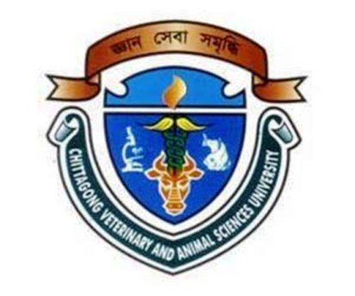

MAHABUB ALAM
Roll No. 0213/02
Registration No.161
Session: 2013-2014

A thesis submitted in the partial fulfillment of the requirements for the degree of Master of Science in Animal Science

Department of Animal Science and Nutrition
Faculty of Veterinary Medicine
Chittagong Veterinary and Animal Sciences University
Chittagong-4225, Bangladesh

December 2014

