Chapter I Introduction
Backyard poultry rearing is common in the rural communities of low income countries. It is a valued resource for the livelihood of rural peoples. It is not only important for food production, but also contributes in income for subsistence farmers, especially women.
Bangladesh has a long historical record of rearing poultry under backyard system. Poultry plays a vital role in the subsistence economy and contribute about 1.6% in GDP (SAEDF 2008) in Bangladesh. Village poultry are usually regarded as a “Walking Bank” or “Bank Coin” for the poor families.
Bangladesh is a low-income country where 90% of rural households rear poultry. The practice of raising backyard poultry makes a important contribution to the livelihood of rural families and to the national economy. In Bangladesh, about 40% of the population lives in absolute poverty in terms of calorie intake, and malnutrition and child mortality remain major concerns. The per capita meat and egg consumption in Bangladesh is one of the lowest in the world. The average per capita meat and egg requirement is 43.25 kg and 104 numbers respectively and the available values are only 9.12 kg and 36 numbers per year (FAO/APHCA 2008). In 2004, 2 kg of the 4.6 kg per capita poultry meat consumption came from backyard poultry in Bangladesh. The annual egg production from the ‘backyard system’ is estimated to be 4.4 billion, which is 67% of the total egg production of Bangladesh. The poorest households sell most eggs proportionately, and use the income to meet their household needs. To decrease the gap between demand and supply of animal protein, poultry can play an important role. Moreover, poultry meat has a great demand as compared to other kinds of meat simply because of the socio-economic limitations and religious taboos on pork and beef (Jabbar et al. 1983). In Bangladesh, the meat and eggs of deshi chicken are more attractive and demanded to the consumer in both urban and rural areas (Das 1995).
In Bangladesh and many other developing countries, the meat and eggs of indigenous chicken are highly preferred for their taste, palatability and suitability for special dishes resulting in even higher market prices for these chickens than their exotic counterpart (Islam and Nishibori 2009). Scavenging system of poultry rising is a century old traditional production system of the country. Indigenous chicken serve as an investment and source of income for households in addition to their use as sources of meat and eggs for consumption and of income (Muchadeyi et al. 2007). Villagers who cannot afford to maintain the stock of cattle or goat can easily maintain a few stocks of chicken, duck and/or pigeon. However, the rural farmers do not have enough knowledge on different aspects of poultry management. Despite of their importance indigenous breeds are under threat due to various factors such as changing production systems and indiscriminate crossbreeding (Besbes 2009). However, sufficient knowledge on backyard poultry rearing in this respect is important. There is a paucity of systematic data on rural poultry production. In relation to the indigenous poultry rearing, there are many diseases of poultry such as highly pathogenic avian influenza, Newcastle disease, infectious bursal disease, colibacillosis, salmonellosis, mycoplasmosis, fowl pox, duck plague etc. that causes loss of production and high mortality in poultry. Indigenous poultry can be infected with highly pathogenic avian influenza (H5N1) virus, which can be transmitted to humans.
The objectives of this study was to-
- To determine present status of backyard poultry rearing and assessing the extent of knowledge of the farmers in respect of breeding, feeding, housing, prevention and control of diseases on poultry.
- To observe the productive performances of backyard poultry.
- To understand why rural residents raise backyard poultry and to characterize their regular interaction with their poultry.
.

Chapter II Materials and Methods

2.1. Location of study area
Brahmmanbaria district is located in the south-eastern part of Bangladesh, consists of 9 upazilla where Bancharampur upazilla is one of them. Three villages namely Vhelanagor, Bahadorpur and Paratoli under Bancharampur upazilla were selected purposively and 75 farmers having 25 from each village were selected randomly. The farmers were considered on the basis of their traditional crop production combined with livestock and small-scale poultry production system.

2.2. Duration of study
The study was conducted from July to October 2016.

2.3. Sampling Strategy
The samples were collected from 3 selected villages having 25 families in each village randomly. For easy data analysis each household was categorized according to the number of poultry reared. Then data were collected from farmers by interviewing. The researcher have collected all information related to the poultry management from 75 families and then analyzed the data according to the objectives.

2.4. Data collection process and tools
The data were collected through face to face interview of farmers regarding the objectives of the study using interview schedule. Some parameters like feed weight, egg weight and body weight were recorded directly by the researchers. Both qualitative and quantitative data were collected during study period.

2.5. Data analysis
Collected data were analyzed in accordance with the objectives of the study. Descriptive statistics were used mainly to illustrate the results.

Chapter III Results and Discussion

3.1. Rearing of backyard poultry
Farmers seldom rear all the two types of poultry birds; chicken & duck at the same time. Some rear chicken or duck only, some chicken with duck. It was found that highest proportion (63.49%) of farmers reared both chicken and duck together rather than rearing other species at a time (Figure 1). Thus, chicken and duck were found to be the most common poultry species reared by the farmers in each villages.

Figure 1: Rearing pattern of backyard poultry
In case of chicken, all farmers reared indigenous type (deshi). However, several breeds of duck namely, deshi, Khaki Campbell, Jinding and swan were reared by farmers (Figure 2). Figure shows that 63% of the farmers reared only deshi ducks followed by rearing 7% Khaki Campbell and 4% Jinding & deshi duck. The proportion of farmers rearing deshi duck in this study was lower than that of (Rahman 2009), who found 82.25% farmers reared deshi duck and higher than (Alam et al. 2014), who reported 54% farmers raised deshi duck.

Figure 2: Different poultry breeds reared by farmers (%)

3.2. Population of poultry
Poultry producers can be classified into three categories; namely low producer having less than 10 no’s; medium producer having 11 to 20 no’s and high producer having more than 20 no’s of poultry. The number of chicken reared by each farmer ranged from 1 to 31 with an average of 10.4 (Table 1). The number of ducks ranged from 1 to 40 with an average of 9.95 (Table 1). From the Table 1, it can be seen that more than 50% farmers were low producers than medium and high producers.
Table 1: Categories of poultry producers
Species | Category | Number of Poultry Farmers (%) | Average poultry/Farmer
Chicken | Low (1-10) | 59.26 (32) | 11.21
 | Medium (11-20) | 29.63 (16)
 | High (>20) | 11.11 (6)
Duck | Low (1-10) | 55.10 (27) | 10.54
 | Medium (11-20) | 36.73 (18)
 | High (>20) | 8.16 (4)

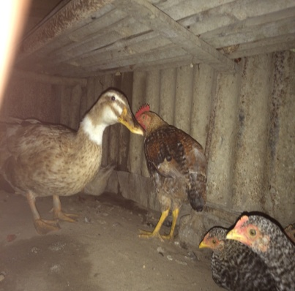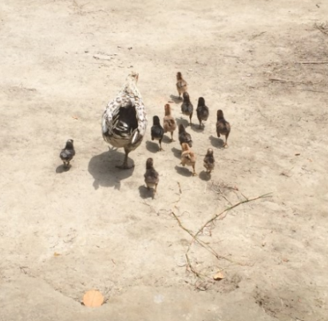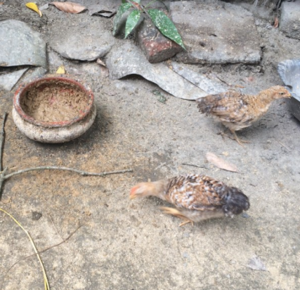
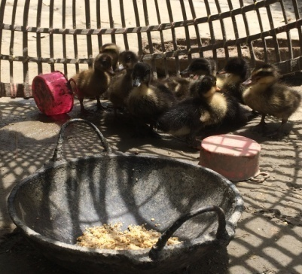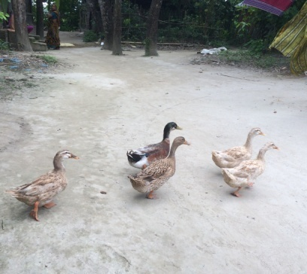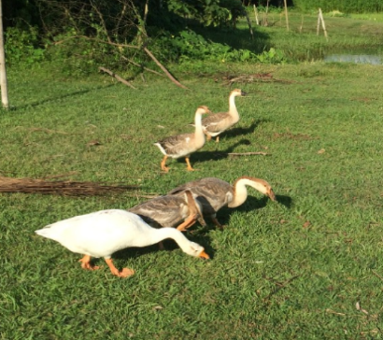
Figure 3: Poultry population in backyard rearing system

3.3. Poultry rearing system
All farmers under the study area reared poultry in semi-scavenging system. The observation accedes with Jensen (1996) who reported that semi-scavenging has recently been established in Bangladesh. More than 1 million semi-scavenging smallholder farms have been established and their number is growing at the rate of 1 lac annually.
Table 2: Housing patterns of poultry
Parameters | Number of farmers in Vhelanagor (%) | Number of farmers in Bahadorpur (%) | Number of farmers in Paratoli (%) | Average (%)
Living House | 56.52 (13) | 50 (10) | 55 (11) | 53.84
House of tin & wood | 30.43 (7) | 30 (6) | 30 (6) | 30.14
House of soil, wood & bamboo | 13.04 (3) | 20 (4) | 15 (3) | 16.01

Table 3: Bedding materials used in poultry houses
Parameters | Number of farmers in Vhelanagor (%) | Number of farmers in Bahadorpur (%) | Number of farmers in Paratoli (%) | Average (%)
Ash | 60.87 (14) | 70 (14) | 65 (13) | 65.29
Sand | 26.08 (6) | 20 (4) | 25 (5) | 23.69
Ash & Sand | 13.04 (3) | 10 (2) | 10 (2) | 11.01
Table 4: Cleaning schedule of poultry houses
Parameters | Number of farmers in Vhelanagor (%) | Number of farmers in Bahadorpur (%) | Number of farmers in Paratoli (%) | Average (%)
Daily | 69.57 (16) | 55 (11) | 50 (10) | 58.19
Thrice a week | 17.39 (4) | 25 (5) | 20 (4) | 20.80
Twice a week | 8.70 (2) | 20 (4) | 20 (4) | 16.23
Once a week | 4.35 (1) | 0 (0) | 10 (2) | 4.78

3.4. Feeds and feeding of poultry
Poultry farmer used a wide variety of supplementary feed for their poultry species. Study showed that about 57% of the farmers used boiled rice and rice polish other than using rice, rice polish, paddy, broken rice and wheat bran as feed ingredients for poultry in both villages (Figure 4).

Figure 4: Ingredients used in poultry diet

3.5. Housing of poultry
Variation in housing pattern, bedding materials and frequency of cleaning of poultry house was observed. About 53.84% farmers kept poultry in their living house while rest of farmers used wooden and tin shed house or soil bamboo and wood shed house (Table 2). Halim (1988) observed in Naogaon district that 44, 28 and 28% poultry were kept in bamboo cages, living house and earthen house, respectively. All farmers reported to use a common house for different types and age group of poultry. Predominating bedding materials were ash, sand and both ash & sand. It was observed that 65.29% farmers used ash then using sand or ash & sand together as a bedding material in their poultry house. It was also reported that over fifty percent farmers clean their poultry house daily (Table 4). The farmers did not follow any specific composition while mixing ingredients. About 65% farmers provided feed to their poultry twice in a day during morning and evening.
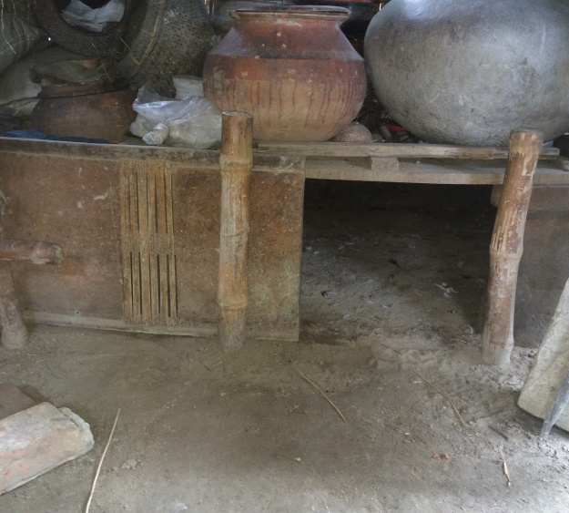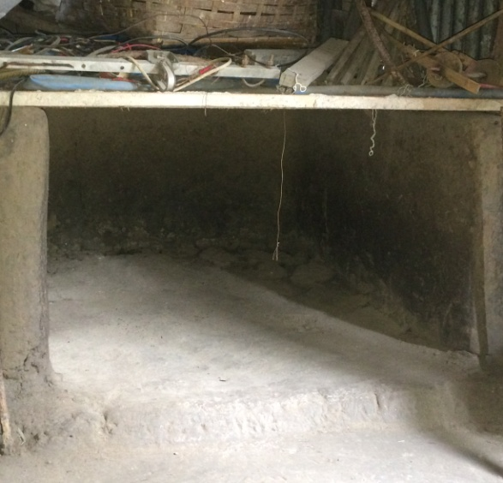
Figure 5: Housing system for Chicken and Duck
The amount of feed supplied to chicken ranged from 35 to 65g/d and duck ranged from 90 to 125g/d, with an average 52.50g/d and 109.34g/d, respectively (Table 5). On the basis of feeds supplied to chicken and duck farmers were classified into 3 categories; namely low, medium and high. More than 40% and 60% farmers were supplied around 41 to 50g feed per day to their chicken and duck, respectively. The amount of supplemental feed/d of each chicken 52.50g, these findings is lower than that of Yeasmin et al. (2003). They investigated the feed intake g/d of Rhode Island Red, White Leghorn, Fayomi, Deshi normal and Deshi dwarf and reported the values 96.07, 92.71, 93.55, 75.10 and 57.81g, respectively. Present result also agrees with Rahman et al. (2009). They observed that 62 percent farmers gave supplemental feeding to their ducks amounting to 118g per day to maximize egg production.
Table 5: Amount of feeds supplied to poultry daily
Species | Category | Number of poultry farmers (%) | Average
Chicken | Low (up to 40g) | 16.67 (9) | 52.50
 | Medium (41-50g) | 53.70 (29)
 | High (>50g) | 29.63 (16)
Duck | Low (up to 95g) | 16.33 (8) | 109.34
 | Medium (96-110g) | 55.10 (27)
 | High (>110g) | 28.57 (14)

3.6. Use of feeder and waterer
About 75% of farmers did not use feeder and 82% of farmers did not use waterer. In this rearing system, farmers were used mainly plastic or earth pot/ball for supplying feed and water of their poultry in both villages (Figure 4).

Figure 6: Use of feeder and waterer

3.7. Productivity of poultry
The study was captured age at sexual maturity, adult body weight, egg production, egg weight and hatchability of chicken and duck as productivity parameters that presented in Table 6 and 7, respectively. Age at sexual maturity of chicken and duck varied from 180 to 220 days with an average of 188.75 and 194.37, respectively (Table 6 and 7). Among farmers, 37.5% obtained first egg of chicken at 180 days of age. About 42.42% of the farmers obtained first egg of duck at 190 days of age. This observation agrees with the previous report of Huque et al. (1992). He stated that the age of sexual maturity of deshi chicken varied between 190 to 200 days. This observation also agrees with Islam et al. (2003) and Sarker (2005). They reported the age of sexual maturity of deshi duck varied 180-210 days. Eswaran et al. (1984) observed age at first egg in 138 days for Khaki Campbell ducks vs. 158 days for deshi ducks. The observed result agrees with Huque et al. (1992). They stated that the weight of adult deshi chicken was 1.2 to 1.5 kg. Present result also agrees with Islam et al. (2003) and Sarker (2005). They stated the weight of adult deshi duck was 1.5 to 1.8kg. This observation is also similar to that of Hamid et al. (1988). Egg production ranged from 35-62/chicken/year and 80-180/duck/year with an average of 44.16 and 126.52 eggs, respectively (Table 6 and 7). Among farmers, about 46.29% obtained 45 eggs per chicken per year. However, egg production is higher for duck than that of chicken. About, 55.10% found 101-150 eggs per duck per year. The observed result more or less agrees with Bulbul (1983); Ahmed and Islam (1985). They reported that the egg production of adult deshi chicken was 35-40. The observation on egg production of duck was lower than that of Ukil (1992). He stated that deshi ducks laid 150-200 eggs per year under semi-scavenging system but the observation was higher than that of Islam et al. (2003) and Sarker (2005). They reported that the egg production of deshi duck 85-90/duck/year. The weight of chicken and duck eggs ranged 35-44g and 52-68g with an average of 38.77g and 61.20g, respectively (Table 6 and 7). The egg weight of chicken obtained coincides with that of Ahmed and Islam (1985) and Huque et al. (1992). They reported the egg weight of deshi chicken was 35-39g. Present result of deshi duck coincides with that of Islam et al. (2003) and Sarker (2005). They reported the egg weight of deshi duck was 65g. The hatchability of chicken and duck egg ranged from 69 to 80% and 76 to 90% with an average of 76.35% and 82.44%, respectively (Table 6 and 7). Approximately 55.56% of farmers got the hatchability more than 71% for chicken eggs (Table 6) and about 55.10% of farmers got the hatchability more than 76% for duck eggs (Table 7). Present result of chicken egg hatchability was lower than that of Azharul et al. (2005) and Khatun et al. (2005). Azharul et al. (2005) investigated that hatchability of broody hens under Bangladesh condition was 86.6%. Khatun et al. (2005) showed that the hatchability on fertile eggs ranged from 78.33 to 90.79% in different genotypes of native chicken. On the other hand, hatchability of duck egg was approximately similar to Rahman (2009) and Hamid et al. (1988). Rahman (2009) found 79% hatchability of duck egg and Hamid et al. (1988) reported the hatchability of deshi ducks as 66%.

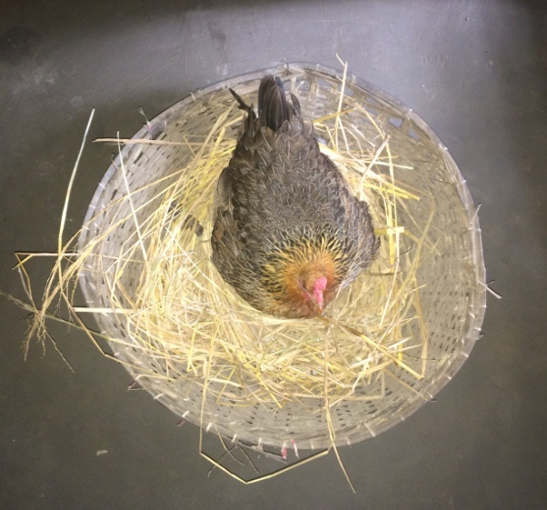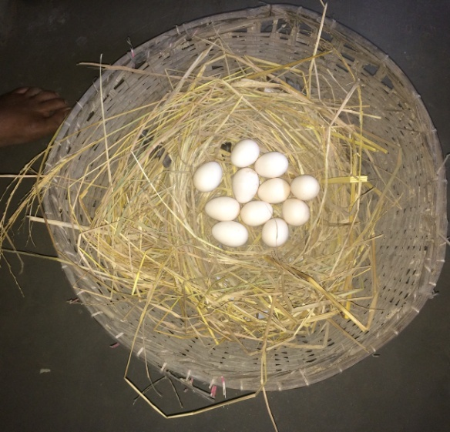
Figure 7: Broody hen in backyard rearing system

Table 6: Productivity of chicken
Parameters | Category | Number of farmers (%) | Average
Sexual maturity | Early (<180 d) | 35.19 (19) | 188.75
 | Moderate (181-190 d) | 38.89 (21)
 | Late (>190 d) | 25.93 (14)
Adult weight | Low (up to 1000g) | 33.33 (18) | 1141.5
 | Medium (1001-1250g) | 42.60 (23)
 | High (>1250g) | 24.07 (13)
Egg production | Low (up to 45) | 46.29 (25) | 44.16
 | Medium (46-60) | 31.48 (17)
 | High (>60) | 22.22 (12)
Egg weight | Low (up to 36g) | 33.33 (18) | 38.77
 | Medium (37-42g) | 50 (27)
 | High (>42g) | 16.67 (9)
Hatchability (%) | Low (up to 70) | 14.81 (8) | 76.35
 | Medium (71-76) | 55.56 (30)
 | High (>76) | 29.63 (16)

Table 7: Productivity of duck
Parameters | Category | Number of farmers (%) | Average
Sexual maturity | Early (<190 d) | 36.73 (18) | 194.37
 | Moderate (191-205 d) | 51.02 (25)
 | Late (>205 d) | 12.24 (6)
Adult weight | Low (up to 1500g) | 18.37 (9) | 1625.00
 | Medium (1501-1750g) | 48.98 (24)
 | High (>1750g) | 32.65 (16)
Egg production | Low (up to 100) | 24.49 (12) | 126.52
 | Medium (101-150) | 55.10 (27)
 | High (>150) | 20.41 (10)
Egg weight | Low (up to 55g) | 32.65 (16) | 61.20
 | Medium (56-62g) | 51.85 (28)
 | High (>62g) | 10.20 (5)
Hatchability (%) | Low (up to 75) | 28.57 (14) | 82.44
 | Medium (76-85) | 55.10 (27)
 | High (>85) | 16.33 (8)

3.8. Disease of poultry
Diseases that outbreak frequently in the study area are presented in Table 8. From Table 8, it was observed that 50% and 47% farmers stated that their chickens and ducks were affected with New castle and duck cholera, respectively in three villages which was mostly prevalent disease. This finding coincides with that of Mohanty (1987) and Saha (2003). They reported that the most prevalent disease of deshi chicken was New castle, followed by Fowl pox, Coccidiosis, respiratory problems and other miscellaneous diseases.
Table 8: Important diseases of poultry
Species | Diseases | Farmers (%)
Chicken | New castle disease | 50
 | Fowl pox | 23
 | Fowl cholera | 15
 | Respiratory problems | 9
 | No disease | 3
Duck | Duck cholera | 47
 | Duck plague | 34
 | Limber neck poisoning | 7
 | No disease | 12

The results agree with more or less similar to that of Rahman (2009) and Baki et al. (1986). Rahman (2009) found, 100% of the duck owners in Noakhali Sadar and Ramgati reported that the most prevalent diseases of ducks were Duck plague and Duck cholera. Baki et al. (1986) mentioned that Duck plague and Duck cholera are the common diseases of epidemic nature in Bangladesh.

3.9. Vaccination
Among the farmers in both villages about 82.67% did not vaccinate their poultry because of lack of facilities and knowledge of vaccination (Figure 5).

Figure 8: Use of vaccine in poultry

3.10. Mortality of poultry
Mortality of chicken and duck ranged from 10 to 37% with an average of 28.11 and 20.18%, respectively (Table 9). The mortality in this observation is higher than that of Ershad (2005). He mentioned that the mortality of deshi chicken was 14.5%. The mortality in this observation is lower than that of Huque and Husain (1994) and Khanum et al. (2005). Huque and Husain (1994) reported that the mortality of Khaki Campbell and Deshi duck were 58% and 72%, respectively. Khanum et al. (2005) reported that the mortality of duck in Netrokona was 27.1%.
Table 9: Mortality (%) of chicken and duck
Species | Categories | Number of poultry farmers (%) | Average (%)
Chicken | Low (up to 20) | 14.81 (8) | 28.11
 | Medium (21-30) | 53.70 (29)
 | High (>30) | 31.48 (17)
Duck | Low ( up to 15) | 20.41 (10) | 20.18
 | Medium (16- 25) | 65.31 (32)
 | High (>25) | 14.29 (7)

3.11. Source of poultry
There are some ways of getting poultry by farmers. A large number of farmers did not purchase bird from anywhere. They incubate chicken and duck egg under broody hen to get baby chicks and duckling. The farmers incubating eggs of chicken and duck for baby chicks and ducklings were 48% and 53%, respectively (Figure 6). Moreover, they go to market and neighbors (17% and 35 %; 16% and 31%, for chicken and ducks, respectively) for getting poultry (Figure 6).

Figure 9: Sources of chicken and ducks

3.12. Constraints of backyard poultry rearing
There are a large number of factors that constraint the backyard rearing of poultry in Bangladesh. Among this factors, some factors was identified as a inhibitors in backyard rearing system of poultry such as traditional methods, scarcity of feed, lack of appropriate housing facilities, disease prevalence, inadequate supply of vaccine and medicine, attack of predators were identified as the major problems for backyard poultry rearing.

3.13. Recommendation to improve backyard poultry

- For increasing the productivity of backyard poultry, provision of high yielding varieties of deshi birds will be introduced.
- A systemic training program needs to be organized for the village women on rearing management of poultry.
- Availability of feed, medication and vaccination to the farmers at reasonable price will have to increase the productivity of backyard poultry
- A large number of farmers did not use vaccine to prevent diseases. So it’s needed to be strengthened to educate the farmers on taking prevention and curative measures against diseases. Support from the Government to develop backyard poultry into a viable venture is required.
- Extension and motivational works should be carried out in the villages to encourage the farmers to increase the level of poultry operation pattern.

Chapter IV

Conclusion

Poultry raising is a rational choice for low income rural communities because of the benefits to family nutrition and income. The study concluded that backyard poultry farmers were low producers and chicken and duck were found to be the most common poultry species reared by the farmers. Poultry rearing knowledge such as breeding, feeding, housing, prevention and control of diseases are not satisfactory of the farmers. Therefore, a need-based extension program should be introduced among the farmers giving more focus on building awareness and ability about poultry production.

Chapter V

References
Ahmed S, Islam N (1985). Backyard Poultry Development Project in 100 Villages. Proceedings of the 1st Conference of Bangladesh Animal Husbandry Association. Bangladesh Agricultural Research Council, Dhaka.
Azharul IM, Ranvig H, Howlider MAR (2005). Incubation capacity of broody hen and chicken performance in Bangladesh. Livestock Research for Rural Development, 17: 1-10.
Baki MA, Sarker AJ, Mondal MMH (1986). Pathological investigation on the mortality of ducks in Bangladesh. Proceedings of workshop, Bangladesh Agricultural University, Research Progress, held at Bangladesh Agricultural University on 4-5 October.
Besbes B (2009). Genotype evaluation and breeding of poultry for performance under suboptimal village conditions, World’s Poultry Science Journal, 65: 260-271.
Bulbul SM (1983). More protein for the undernourished through a village poultry project. Maximum livestock production from minimum land. Proceedings of the fourth seminar held in Bangladesh Agricultural University, Mymensingh, Bangladesh.
Das SR (1995). A study on production and marketing of poultry products in Sylhet Sadar Thana. MS Thesis, Department of cooperation and marketing, Bangladesh Agricultural University.
Ershad SME (2005). Performance of hybrid layers and native hens under farms management in selected area of Bangladesh. International Journal of Poultry Science, 4: 228-232.
Eswaran KR, Ramakrishnan A, Venugopalan CK, Nair GR (1984). Comparative perfor-mance of Khaki Campbell and Deshi ducks. 2. Egg production, feed efficiency and egg quality. Indian Journal of Poultry Science, 20: 42-45. FAO/APHCA (2008). Asian milk for health and wealth.
Hamid MA, Chowdhury SMRK, Chowdhury SD (1988). A comparative study of the performance of growing ducklings of Khaki Campbell, Indian Runner and Indigenous ducks under farm conditions. Indian Journal of Poultry Science, 23: 118-121.
Huque QME, Hossain MJ (1994). Comparative performance of three genotypes of ducks under rural conditions. Bangladesh Journal of Scientific Research, 12: 157-160.
Huque QME, Ukil MA, Haque ME, Hossain MJ (1992). Nutritional status of scavenging hen in Bangladesh. Bangladesh Journal of Scientific and Industrial Research, 10: 217-222.
Islam MA, Nishibori M (2009). Indigenous naked neck chicken: a valuable genetic resource for Bangladesh. World's Poultry Science Journal, 65: 125-138.
Islam MN, Huque QME, Uddin MS, Sarker MSK (2003). Potentiality of native genotypes of Ducks. Proceedings of Third International Poultry Show and Seminar, World’s Poultry Science Association, Bangladesh Branch, Dhaka, 259-270
Jabbar MA, Geen DAG (1983). The Status and Potential of Livestock with in the Context of Agricultural Development Policy in Bangladesh. Aberystyth, the University College, Wales, UK.
Jensen HA (1996). “Semi-scavenging poultry flock”, in Frands Dolberg and Poul Henning Petersen (eds.), Integrated Farming in Human Development, Proceeding of the Workshop March 25-29, Tune Landboskole, Denmark, 56-63.
Khanum J, Chwalibog A, Huque KS (2005). Study on rural duck production systems in selected areas of Bangladesh. Livestock Research for Rural Development, 17: 113.
Khatun R, Islam MS, Faruque S, Azmal SA, Uddin MS (2005). Study on the productive and reproductive performance of 3 native genotypes of chicken under intensive management. Journal of Bangladesh Agricultural University 3: 99-104.
Mohanty G (1987). Poultry health programme for rural poultry development. Paper presented at the FAO expert consultation on rural poultry development in Asia, Dhaka.
Muchadeyi FC, Wollny CBA, Eding H, Weigend S, Makuza M, Simianer H (2007). Variation in village chicken production systems among agro-ecological zones of Zimbabwe. Tropical Animal Health and Production, 39: 453-461.
Rahman MM (2009). Development of feeding strategy for ducks raised by small farmers in coastal areas of Bangladesh. M.S. Thesis, Department of Poultry Science, Bangladesh Agricultural University, Mymensingh.
Rahman MM, Khan MJ, Chowdhury SD, Akbar MA (2009). Duck rearing system in southern coastal districts of Bangladesh. Bangladesh Journal of Animal Science, 38: 132–141.
SAEDF (2008). South Asia Enterprise Development Facility, a multi-donor facility managed by the International Finance Corporation of the World Bank Group, Dhaka, Bangladesh.
Saha D (2003). Status of rural poultry production in North 24 Parganas district of West Bengal. MVSc Thesis, Division of Extension Education, IVRI, Izatnagar.
Sarkar K (2005). Duck farming for resource-poor farmers in Bangladesh. In: Proceedings of the 4th International Poultry Show and Seminar, Dhaka, Bangladesh. World’s Poultry Science Association, Bangladesh Branch, Dhaka, 130-141.
Ukil MA (1992). Availability of nutrients to scavenging chickens and ducks in Bangladesh. M. Sc. Thesis, Department of Poultry Science, Bangladesh Agricultural University, Mymensingh.
Yeasmin T, Howlider MAR, Ahammad MU (2003). Effect of introgressing dwarf gene from Bangladesh indigenous to exotic breeds on egg production. International Journal of Poultry Science, 2: 264

Chapter VI

Appendix
ID.NO…………………… Date…………………
- Description of the farmer
- Name:
- Village:
- Number of poultry
- Chicken:
- Breed:
- Duck:
- Breed:
- Source of poultry: Own/Market/Neighbours/……………………………
- Housng system: Intensive/Semi-intensive/Free range/……………………
- Feeding system:
- Feed ingredients used for feeding: Boiled rice/Rice polish/Paddy/Broken rice/Snail/……………………..
- Use of feeder: Yes/No
- Use of waterer: Yes/No
- Bedding materials used: Ash/Sand/Ash & Sand
- Use of vaccine: Yes/No
- Disease prevalence:
- Mortlity rate:………………%
- Production status:
- Adult weight of birds:………………..g
- Egg production:……………./year
- Egg weight:………………...g
- Hatchability (%):………………..
- What are the factors that constraints rearing of backyard poultry:

Chapter VII

Brief Biography of the student
Md. Bayazid Bostami is an intern student for the degree of Doctor of Veterinary Medicine (DVM), Faculty of Veterinary Medicine, CVASU. He passed the Secondary School Certificate Examination (SSC) in 2007 from Shah Rahat Ali High School, Bancharampur, Brahmmanbaria and got GPA 5.00 and then Higher Secondary Certificate Examination (HSC) in 2009 from Shah Rahat Ali College, Bancharampur, Brahmmanbaria and earned GPA 4.50 Then he admitted to the degree of Doctor of Veterinary Medicine (DVM), Faculty of Veterinary Medicine, CVASU in 2010-2011 session. Now, he is working on molecular investigation of Cryptosporidium spp from rodents. He has great interest on molecular and clinical isolation and identification of different protozoa.

