

**EFFECT OF FISH OIL ON GROWTH PERFORMANCE, PRODUCTIVITY WITH SPECIAL EMPHASIS ON COCCIDIOSIS PREVENTION IN BROILER**

**Mukti Barua**

Roll No. 0213/01

Registration No. 160

Session: 2013-2014 (July-December)

**A thesis submitted in the partial fulfillment of the requirements for the degree of Master of Science in Animal Science**

**Department of Animal Science and Nutrition**

**Faculty of Veterinary Medicine**

**Chittagong Veterinary and Animal Sciences University**

**Chittagong-4225, Bangladesh**

**DECEMBER 2014**

# Authorization

I hereby declare that I am the sole author of the thesis. I also authorize the Chittagong Veterinary and Animal Sciences University (CVASU) to lend this thesis to other institutions or individuals for the purpose of scholarly research. I further authorize the CVASU to reproduce the thesis by photocopying or by other means, in total or in part, at the request of other institutions or individuals for the purpose of scholarly research.

I, the undersigned, and author of this work, declare that the **electronic copy** of this thesis provided to the CVASU Library, is an accurate copy of the print thesis submitted, within the limits of the technology available.

**Mukti Barua**

**EFFECT OF FISH OIL ON GROWTH PERFORMANCE, PRODUCTIVITY WITH SPECIAL EMPHASIS ON COCCIDIOSIS PREVENTION IN BROILER**

**Mukti Barua**

Roll No. 0213/01

Registration No. 160

Session: 2013-2014 (July-December)

**This is to certify that we have examined the above Master’s thesis and have found that is complete and satisfactory in all respects, and that all revisions required by the thesis examination committee will be addressed**

|  |  |
| --- | --- |
| **--------------------------------------------------------** | **--------------------------------------------------** |
| **(Prof. Dr. Goutam Buddha Das)**  **Supervisor** | **(Dr. Sharmin Chowdhury)**  **Co-Supervisor** |

**-----------------------------------------------**

**(Dr. Md. Hasanuzzaman)**

**Chairman of the Examination Committee**

**Department of Animal Science and Nutrition**

**Faculty of Veterinary Medicine**

**Chittagong Veterinary and Animal Sciences University**

**Khulshi, Chittagong-4225, Bangladesh**

**DECEMBER 2014**

***DEDICATED TO MY BELOVED PARENTS***

# Acknowledgements

*First and foremost I would like to take this opportunity to remember “Almighty”, Who empowers me to complete the research work of this dimension successfully.*

*From core of heart, I deem it a proud privilege to express sincere gratitude, indebtedness, to my respectable and honourable supervisor,* ***Dr. Goutam Buddha Das,*** *Professor, Department of Animal Science and Nutrition, Chittagong Veterinary and Animal Sciences University (CVASU) for his continuous supervision, scholastic guidance, painstaking correction of the manuscript, constructive criticism and constant encouragement throughout the period of this research work.*

*I would like to express my hearty appreciation and immense indebtedness to my co-supervisor,* ***Dr. Sharmin Chowdhury,*** *Associate Professor, Department of Pathology and Parasitology, CVASU, who provided best help with her valuable suggestions, enthusiastic review and fruitful comments in correction of manuscript.*

*It is also a great pleasure for me to express my cordial gratitude to my respected teachers* ***Dr. Md. Hasanuzzaman*** *and* ***Md. Emran Hossain,*** *for their valuable advices and co-operations in completion of the thesis.*

*I would like to extend my boundless gratitude to* ***Dr. AMAM Zonaed Siddiki,******Dr. Mohammad Alamgir Hossain, Dr. Md. Masuduzzaman,*** *Professor, Department of Pathology & Parasitology, CVASU, for their valuable suggestions. Special thanks to* ***DR. Md. Shafiqul Islam*** *for his help in histopathological study. I am also grateful to University Grants Commission (UGC), Bangladesh for funding this research project.*

*I gratefully acknowledge all technical and non-technical staffs of the Department of Animal Science and Nutrition, Department of Pathology & Parasitology, Department of Physiology, Biochemistry and Pharmacology, CVASU, for providing lab facilities, support and cooperation.*

*I am also thankful to all of my friends and well-wishers for their inspirations. Last but not least, I am forever indebted and grateful to my beloved parents and all family members for their blessings, tremendous sacrifice when it was most required.*

***The Author***

Table of contents

Acknowledgements v

List of Tables x

List of Graphs xiii

List of Figures xiv

List of Abbreviations xv

Abstract xvii

Chapter I 2

Introduction 2

Chapter II 6

Review of literature 6

2.1 Causes of coccidiosis 6

2.2 Life cycle of *Eimeria* 6

2.3 Mode of Action of Coccidia 7

2.4 Signs of coccidiosis 7

2.5 Diagnosis of coccidiosis 7

2.5.1 Lesion scoring 7

2.5.2 Oocyst per gram (OPG) 8

2.5.3 Electrophoresis and PCR 8

2.5.4 Coccimorph 8

2.5.5 Anticoccidial sensitivity testing (AST) 8

2.6 Prevention and control of coccidiosis 9

2.6.1 Management of poultry house 9

2.6.2 Chemoprophylaxis using anticoccidials 9

2.6.3 Vaccination 10

2.6.4 Shuttle programs and rotation 11

2.7 Drug resistance 12

2.8 Changes caused by coccidiosis 12

2.9 Dietary fish oil in preventing coccidiosis 13

2.10 Effect of fish oil in production performance of broilers 16

Chapter III 20

Materials and methods 20

3.1 General methodology 20

3.1.1 Location and duration of the experiments 20

3.1.2 Preparation of poultry shed for the experiment 20

3.1.3 Design and layout of the experiment 20

3.1.4 Formulation of feeding diets 21

3.1.5 Collection of experimental broiler chicks 24

3.1.6 Collection of fish oil 24

3.1.7 Collection of essence of banana 24

3.1.8 Collection of feed ingredients 24

3.1.9 Mixing of fish oil with water 24

3.1.10 Management 25

3.1.10.1 Brooding of the chicks 25

3.1.10.2 Maintaining room temperature 25

3.1.10.3 Brooder and cage space 25

3.1.10.4 Feeder and drinker space 25

3.1.10.5 Method of feeding, watering 26

3.1.10.6 Litter management 26

3.1.10.7 Vaccination 26

3.1.10.8 Bio-security/Sanitation 26

3.1.10.9 Record keeping 27

3.1.10.10 Calculation of data 27

3.1.11 Statistical analysis 27

3.2 Effect of fish oil on coccidiosis of broilers 28

3.2.1 Production of fresh oocysts for experimental infection 28

3.2.2 Cleaning of oocysts 28

3.2.3 Preparation of oocysts dose 28

3.2.4 Infection with oocysts 29

3.2.5 Recording of clinical sign 29

3.2.6 Necropsy and gross lesion 29

3.2.7 Identification of *Eimeria* species 30

3.2.8 Histopathological examination 30

3.2.9 Hematological analysis 31

3.2.10 Biochemical analysis 31

3.2.11 Statistical Analysis 31

3.3.1 Effect of fish oil on blood parameters of broilers 32

3.3.2 Statistical Analysis 32

Chapter IV 36

Results 36

4.1 Effect of fish oil on growth and production performance of broilers 36

4.1.1 Feed Consumption 36

4.1.2 Live weight 39

4.1.3 Live weight gain 43

4.1.4 Feed conversion 45

4.2 Effect of fish oil on coccidiosis of broilers 50

4.2.1 Clinical signs 50

4.2.2 Oocyst output 50

4.2.3 Necropsy of birds 51

4.2.4 Histopathology 51

4.2.5 Haematological changes 52

4.3 Biochemical changes 55

4.3 Effect of fish oil on blood parameters of broilers 56

Chapter V 64

Discussion 64

5.1 Effect of fish oil on growth and production performance of broilers 64

5.1.1 Effect of fish oil on feed consumption of broilers 64

5.1.2 Live weight and weekly live weight gain of broilers 65

5.1.3 Effect of fish oil feed conversion (FC) of broilers 67

5.1.4 Effect of fish oil on cost benefit analysis of broilers 68

5.2 Effect of fish oil on coccidiosis prevention of broilers 69

5.2.1 Signs and lesions of coccidiosis 70

5.2.2 Faecal oocyst output 71

5.2.3 Histopathological changes 71

5.2.4 Haematological changes 71

5.2.5 Biochemical changes 73

5.3 Effect of fish oil on different blood parameters of broilers 74

5.3.1 Effect of fish oil on total serum cholesterol of broilers 74

5.3.2 Effect of fish oil on serum HDL-cholesterol level of broilers 75

5.3.3 Effect of fish oil on serum LDL-cholesterol level of broilers 75

5.3.4 Effect of fish oil on serum triglycerides level of broilers 76

5.3.5 Effect of fish oil on serum glucose level of broilers 77

5.3.6 Effect of fish oil on serum total protein (TP) and albumin level of broilers 78

Chapter VI 80

Conclusion 80

Chapter VII 82

Recommendations 82

References 84

Appendix 99

**Brief biography of the author..............................................................107**

# List of Tables

|  |  |  |
| --- | --- | --- |
| **Tables** | **Name of the tables** | **Page No.** |
| **Table 3.1** | Layout of the experiment showing the distribution of DOC to the treatment group and replication | 21 |
| **Table 3.2** | Ingredients and nutritive composition of the experimental broiler starter diets | 22 |
| **Table 3.3** | Ingredients and nutritive composition of the experimental broiler grower diets | 23 |
| **Table 3.4** | Schedule of vaccination | 26` |
| **Table 4.1.1.1** | Feed consumption of broilers at 1st week of age among different dietary treatment groups (gm/broiler) | 36 |
| **Table 4.1.1.2** | Feed consumption of broilers at 2nd week of age among different dietary treatment groups (gm/broiler) | 37 |
| **Table 4.1.1.3** | Feed consumption of broilers at 3rd week of age among different dietary treatment groups (gm/broiler) | 37 |
| **Table 4.1.1.4** | Feed consumption of broilers at 4th week of age among different dietary treatment groups (gm/broiler) | 38 |
| **Table 4.1.1.5** | Cumulative feed consumption (gm/broiler) at different ages in different dietary treatment groups (with or without FO) of broilers | 38 |
| **Table 4.1.2.1** | Initial live weight of broilers with different dietary fish oil supplemented groups and control group (gm/broiler) | 39 |
| **Table 4.1.2.2** | Live weight of broilers with different groups of dietary fish oil supplemented groups and control group at 1st week of age (gm/broiler) | 39 |
| **Table 4.1.2.3** | Live weight of broilers with different groups of dietary fish oil supplemented groups and control group at 2nd week of age (gm/broiler) | 40 |
| **Table 4.1.2.4** | Live weight of broilers with different groups of dietary fish oil supplemented groups and control group at 3rd week of age (gm/broiler) | 40 |
| **Table 4.1.2.5** | Live weight of broilers with different groups of dietary fish oil supplemented groups and control group at 4th week of age (gm/broiler) | 41 |
| **Table 4.1.2.6** | Cumulative body weight of broilers at different market ages fed on diet supplemented with or without fish oil (gm/broiler) | 41 |
| **Table 4.1.3.1** | Live weight gains of broilers with different groups of dietary fish oil supplemented groups and control group at 1st week of age (gm/broiler) | 43 |
| **Table 4.1.3.2** | Live weight gains of broilers with different groups of dietary fish oil supplemented groups and control group at 2nd week of age (gm/broiler) | 43 |
| **Table 4.1.3.3** | Live weight gains of broilers with different groups of dietary fish oil supplemented groups and control group at 3rd weeks of age (gm/broiler) | 43 |
| **Table 4.1.3.4** | Live weight gains of broilers with different groups of dietary fish oil supplemented groups and control group at 4th week of age (gm/broiler) | 44 |
| **Table 4.1.3.5** | Cumulative live body weight gain of broilers at different market ages fed on diet supplemented with or without fish oil (gm/broiler) | 44 |
| **Table 4.1.4.1** | Comparison of feed conversion of broilers at 1st week of age fed on diet supplemented with or without fish oil | 45 |
| **Table 4.1.4.2** | Comparison of feed conversion of broilers at 2nd week of age fed on diet supplemented with or without fish oil | 45 |
| **Table 4.1.4.3** | Comparison of feed conversion of broilers at 3rd week of age fed on diet supplemented with or without fish oil | 46 |
| **Table 4.1.4.4** | Comparison of feed conversion of broilers at 4th week of age fed on diet supplemented with or without fish oil | 46 |
| **Table 4.1.4.5** | Cumulative feed conversion of broilers at different market ages fed on diet supplemented with or without fish oil | 47 |
| **Table 4.1.5** | Cost of production and returns of broilers in different treatment groups | 48 |
| **Table 4.2.1** | Total oocyst output in different dietary treatment groups (Mean of total oocyst output× 106**)** | 50 |
| **Table 4.2.2** | Comparison of red blood cell (RBC) count at 15th and 30th day of study among different groups of the study population (1 × 106 cells per micro liter) | 52 |
| **Table 4.2.3** | Comparison of packed cell volume (PCV) at 15th and 30th day of study among different groups of the study population (%) | 52 |
| **Table 4.2.4** | Comparison of HB (g.dL-1) at 15th and 30th day of study among different groups of the study population | 53 |
| **Table 4.2.5** | Comparison of lymphocyte count at 15th and 30th day of study among different groups of the study population (%) | 53 |
| **Table 4.2.6** | Comparison of monocyte count at 15th and 30th day of study among different groups of the study population (%) | 53 |
| **Table 4.2.7** | Comparison of eosinophil count at 15th and 30th day of study among different groups of the study population (%) | 54 |
| **Table 4.2.8** | Comparison of heterophil count at 15th and 30th day of study among different groups of the study population (%) | 54 |
| **Table 4.2.9** | Comparison of serum alanine aminotransferase (ALT) level at 15th and 30th day of study among different groups of the study population (IUL-1) | 55 |
| **Table 4.2.10** | Comparison of serum aspartate aminotransferase (AST) level at 15th and 30th day of study among different groups of the study population (IUL-1) | 55 |
| **Table 4.3.1** | Total serum cholesterol of broilers at 15th and 30th day of age fed on diets supplemented with different percentage of fish oil or without oil (mg/dl/broiler) | 56 |
| **Table 4.3.2** | HDL-cholesterol of broilers at 15th and 30th day of age fed on diets supplemented with different percentage of fish oil or without oil (mg/dl/broiler) | 56 |
| **Table 4.3.3** | LDL-cholesterol of broilers at 15th and 30th day of age fed on diets supplemented with different percentage of fish oil or without oil (mg/dl/broiler) | 57 |
| **Table 4.3.4** | Triglycerides of broilers at 15th and 30th day of age fed on diets supplemented with different percentage of fish oil or without oil (mg/dl/broiler) | 57 |
| **Table 4.3.5** | Glucose level in serum of broilers at 15th and 30th day of age fed on diets supplemented with different percentage of fish oil or without oil | 58 |
| **Table 4.3.6** | Protein level in serum of broilers at 15th and 30th day of age fed on diets supplemented with different percentage of fish oil or without oil (mg/dl/broiler) | 58 |
| **Table 4.3.7** | Albumin level in serum of broilers at 15th and 30th day of age fed on diets supplemented with different percentage of fish oil or without oil (mg/dl/broiler) | 59 |

# List of Graphs

|  |  |  |
| --- | --- | --- |
| **Graphs** | **Name of the Graphs** | **Page No.** |
| **Graph 1** | The infection status of 24 selected birds from different groups (6 birds from each group) | 51 |

# List of Figures

|  |  |  |
| --- | --- | --- |
| **Figures** | **Name of the figures** | **Page No.** |
| **Fig. 1** | Brooding of broilers | 33 |
| **Fig. 2** | Birds in cages | 33 |
| **Fig. 3** | Measuring weight of broilers | 33 |
| **Fig. 4** | Mixing fish oil with water | 33 |
| **Fig. 5** | Oocysts separation after centrifugation | 34 |
| **Fig. 6** | Ingestion of oocysts | 34 |
| **Fig. 7** | Blood collection from broilers | 34 |
| **Fig. 8** | Block preparation in histopathology | 34 |
| **Fig. 9** | Boxplot of body weight among different dietary treatment groups showing minimum, maximum, 25thquartile, 75th quartile and median | 42 |
| **Fig. 10** | Boxplot of FC among different groups (G-1 to G-4) showing minimum, maximum, 25th quartile, 75th quartile and median | 47 |
| **Fig 11** | Gross lesions in caecal and intestinal sections birds affected with coccidiocis | 60 |
| **Fig. 12** | Caecal and intestinal sections birds affected with coccidiocis | 61 |
| **Fig 13** | Caecal and intestinal sections birds affected with coccidiocis | 62 |

**List of Abbreviations**

|  |  |
| --- | --- |
| Abbreviation | Elaboration |
| FO | Fish oil |
| FCR | Feed conversion ratio |
| LW | Live weight |
| PUFA | Poly unsaturated fatty acids |
| EPA | Eicosapentaenoic acid |
| DHA | Docosahexaenoic acid |
| LDL | Low density lipoprotein |
| HDL | High density lipoprotein |
| ALT | Alanine aminotransferase |
| AST | Aspertate aminotransferase |
| PCV | Packed cell volume |
| TRBC | Total red blood cell |
| WBC | White blood cell |
| Hb | Haemoglobin |
| TEC | Total erythrocyte count |
| SEM | Standard error of mean |
| NS | Non significant |
| < | Less than |
| > | Greater than |
| e.g | Example |
| ml | Millilitre |
| mg | Milligram |
| DOC | Day old chicks |
| Dpi | Day post infection |
| TMLS | Total mean lesion score |
| *et al.* | And his associates |
| etc. | Et cetera |
| gm | Gram |
| % | Percentage |
| i.e. | That is |
| OPG | Oocyst per gram |
| TRBC | Total red blood cell count |
| PBL | Peripheral blood leucocytes |
| VLDL | Very low density lipoprotein |
| Tk | Taka (Bangladeshi taka) |
| TG | Triglycerides |
| GPT | Glutamic pyruvic transaminase |
| GOT | Glutamic oxalacetic transaminase |
| TNF | Tumor necrotizing factor |
| GI | Gastrointestinal |
| ACP | Anticoccidial products |
| IL | Interleukin |
| Sig. | Significance |
| Ref. | Reference |
| MS | Master of Science |
| Ctg | Chittagong |
| CVASU | Chittagong Veterinary and Animal Sciences University |

# Abstract

Chicken coccidiosis is a major threat for emerging poultry industry in Bangladesh. Fish oil (FO) is an important source of omeg-3 polyunsaturated fatty acids (PUFA) which increases immunity to broilers. Fish oil also helps in increasing live weight of broilers. The present investigation was undertaken to determine the influence of dietary FO on growth performance, productivity of broilers. Special emphasis was given to determine the effect of FO in preventing coccidiosis of broilers. A total of 120 commercial broilers were randomly distributed in four groups having three replications per group. Those birds were treated either without FO or with 1%, 2% and 3% FO in regular drinking water. Similar rations were maintained for starter and grower in all treatment groups. The experiment was assigned to three studies. First study was performed to observe the growth and production performance of broilers with FO treatment. In another study, chicks were infected with 104 sporulated oocysts of *Eimeria* spp. The objective of this study was to evaluate gross, histo-pathological, hematological and biochemical changes in broiler chicken naturally infected with *Eimeria*. In the last study, changes in different biochemical parameters in broilers serum due to fish oil supplementation were determined. Supplementation of FO in regular drinking water significantly (P<0.01) increased live weight, weight gain at 3rd and 4th week of age of broilers. This increase was higher in 2% and 3% FO supplemented groups compared to others. There was a significant (P<0.01) increase in feed consumption of broilers with increasing level of FO at 4th week of age. Furthermore, cumulative feed conversion (FC) differed significantly (P<0.01) among different groups at 3rd and 4th week of age with better FC in 2% and 3% FO supplemented groups. Data on cost benefit analysis revealed significantly (P<0.05) increased net profit (TK./broiler) and net profit (TK./kg live broiler) in fish oil treatment groups compared to control group. At necropsy, birds which were not treated with FO (control) developed severe gross lesions of coccidiosis such as enlarged and distended caecam with bloody faeces, hemorrhage in intestine etc. However, birds receiving 1% fish oil also demonstrated similar lesions but those were not severe as control group. However no lesions were developed in birds treated with 2% and 3% FO. In histopathology, microgametocyte, macrogamecocyte and second generation schizont of *Eimeria* spp., severe destruction of epithelium were revealed in caecal and intestinal sections taken from infected birds. Biochemical analysis showed a significant (P<0.05) decrease in level of RBC, Hb and PCV, serum alanine aminotransferase (ALT) and aspartate aminotransferase (AST) and increased level of lymphocyte, monocyte, eosinophil, heterophil in coccidian infected groups. Serum HDL-cholesterol, glucose level were increased and cholesterol, LDL-cholesterol, triglycerides, total protein, albumin, globulin concentrations was decreased significantly (P<0.01) with increasing levels of FO in the broiler diets. This research reveals that supplying 2% or 3% fish oil in regular drinking water of broilers would be effective both in increasing market weight and prevenving coccidiosis of commercial broilers. As a preventive dose, 2% fish oil is recommended.

**Keywords:** coccidiosis, fish oil (FO), polyunsaturated fatty acids, histopathology



**Thesis for MS in Animal Science**

# Chapter I

# Introduction

Poultry industry is considered as a successful leading industry of Bangladesh because it is a substantial contributor to food supply in this country (Ali and Hossain, 2012). Chicken coccidiosis is a parasitic disease causing high morbidity and mortality in commercial poultry (Raman et al., 2011). It remains as one of the major problems for poultry industry throughout the world (Bera et al., 2010; Amare et al., 2012; Adamu et al., 2013; Kadhim, 2014). This disease of poultry is considered as a substantial economic burden estimated to cost the industry more than 800 million dollars in annual losses worldwide (Kitandu and Juranová, 2006). In Bangladesh coccidiosis is a major burden in chickens causing a great economic loss to the poultry industry (Karim et al., 1994; Siddiki et al., 2008).

Coccidiosis is caused by parasites of the genus *Eimeria* and *Isospora* belonging to the phylum Apicomplexa with a complex life cycle. It affects mainly the intestinal tract of mammals and birds (Peek and Landman, 2011). Seven species of *Eimeria* such as *E. tenella, E. acervulina, E. brunetti, E.maxima, E. mitis, E. necatrix* and *E. praecox* with different degrees of pathogenicity are recognized in domestic chicken (Calnek et al., 1997; Shirley, 1999; Gussem, 2007; Patra et al., 2010). Basically two types of coccidiosis are noticed in commercial broilers on the basis of clinical signs: clinical and subclinical. In clinical coccidiosis, the affected birds show typical symptoms of the disease, such as bloody faeces, diarrhoea, reduced weight gain, depression, defeathering and increased mortality but in subclinical coccidiosis, the affected birds show no visible symptoms of the disease (Siddiki et al., 2008; Raman et al., 2011, Adamu et al., 2013). Particularly commercially reared broilers are vulnerable to coccidiosis due to intensive production (Giannenas et al., 2003), leading to malnutrition, low performance and production efficiency of poultry (Yang et al., 2006). The anticoccidials used in prevention of coccidiosis are sulfonamide, amprolium, monovalent ionophores like monensin, narasin, monovalent glycosides like maduramicin, semduramicin (Peek and Landman, 2003; Naciri et al., 2004). Prophylactic use of anticoccidial drugs or vaccines promotes drug resistance to broilers (Kitandu and Juranová, 2006). Acquiring cross resistance to one drug by the use of another drug is also observed in broilers (Chapman, 2007).

Fish oil is an important source of n-3 polyunsaturated fatty acids (EPA and DHA) which is highly unsaturated (Saleh et al., 2009). Many studies have examined the effects of dietary PUFA, supplied as fish oil or fish meal, on the fatty acid composition of the broiler carcass (Scaife, 1994; Nash, 1995; Lopez-Ferrer, 1999, 2001). Fish oil has several positive effects, such as the physiological or metabolic effects of due to PUFA on the performance parameters of broiler chickens (Pike, 1999; Lopez-Ferrer, 1999, 2001). If diets with similar energy and protein are compared, chickens fed with rations that contain oil showed better performances than birds fed diets without the inclusion of oil (Sanz et al., 2000; Lopez-Ferrer et al., 2001; Saleh et al., 2009). Dietary n-3 polyunsaturated fatty acids (PUFA) especially eicosapentaenoic acid (EPA) and docosahexaenoic acid (DHA) have well known effects on human health (Knapp, 1991; Navidshad, 2009). Several researchers reported that omega-3 PUFAs plays an important role in improving immunity, performance, lipid profile besides marketing weight of broilers (Jameel, 2013; Al-Zuhairy and Alasadi, 2013; Al-Zuhairy and Jameel, 2014; Jameel, 2014).

Researchers in previous investigations have shown that feeding diets rich with n-3 (omega-3) fatty acids specially fish oil significantly reduce caecal lesions caused by coccidiosis (Allen et al., 1994; Allen et al., 1996a; Allen et al., 1997; Allen and Danforth, 1998; Yang et al., 2006; Maroufyan et al., 2013). The antiparasitic activity of the diets is due to oxidative stress induced by oxidation of the highly unsaturated fatty acids (Yang et al., 2006). Addition of fish oil in the diet of broilers results in an increased live weight (Alparslan and Özdogan, 2006; Mansoub, 2011; Mansoub and Bahrami, 2011; Das et al., 2014a). It also increases HDL-cholesterol, glucose level and decreases cholesterol, LDL-cholesterol, triglycerides total protein level in blood of broilers (Alparslan and Özdogan, 2006; AL-Mayah, 2009; Saleh et al., 2009; Mansoub, 2011; Das et al., 2014b). Low HDL and high LDL in blood are the two important values associated with atheroschlerosis and coronary heart disease in human. These values can be changed by change in regular diet (Couderc and Machi, 1999; Crespo and Esteve-Garcia, 2003; Mansoub, 2011).

**Therefore the objectives of the present study were,**

1. To see the influences of fish oil on growth performance and productivity of commercial broilers.
2. To determine the effect of fish oil in preventing coccidiosis of broilers.
3. To observe the histopathological, hematological and biochemical changes caused by coccidiosis.
4. To determine the level of fish oil which would be effective for both in increasing growth performance and prevention of coccidiosis in broilers.



**Thesis for MS in Animal Science**

# Chapter II

# Review of literature

The protozoal disease coccidiosis has a significant impact on poultry production (Bera et al., 2010). Though coccidiosis is known for many years, it is still considered as the most economical important parasitic condition. Assuming 50 billion broilers of 2 kg live weight annually produced is lost worldwide. This cost is probably more than 2.3 billion dollar (Gussem, 2007; Sorensen et al., 2006).

## 2.1 Causes of coccidiosis

Coccidiosis is caused by species of intracellular protozoan parasites belonging to the genus *Eimeria* (phylum Apicomplexa). It develops within the intestine of most domestic and wild animals and birds. Seven species of *Eimeria* with different degrees of pathogenicity are recognized in domestic chicken. They are *E. acervulina, E. brunetti, E.maxima, E. mitis, E. necatrix, E. praecox* and *E. tenella*. These species of *Eimeria* can occur concomitantly during the course of natural infection (Calnek et al., 1997; Shirley, 1999; Patra et al., 2010). The pathogenic species of coccidiosis in poultry are *E. acervulina*, *E. maxima* and *E. tenella.* Among them *E. tenella* is the most pathogenic, ubiquitous, best known and easily recognized by broiler farmers (Arakawa and Xie, 1993; Quarzaneet al., 1998; Yadav and Gupta, 2001). The lesions caused by this parasite disturb nutrient absorption, triggeringseveral changes in carbohydrates, lipid, protein, macro and trace mineral metabolism of broilers (Patra et al., 2010; Witlock and Ruff, 1997).

## 2.2 Life cycle of *Eimeria*

The life cycle of *Eimeria* comprises intracellular, extracellular, asexual and sexual stages. The host immunity is also complex and involves many facets of nonspecific and specific immunity (Lillehoj, 1998; Kitandu and Juranová, 2006). Their pathogenicity varies in birds of different genetic background. In natural host, the immunity is species specific (e.g. chickens immune to one species of *Eimeria* are susceptible to others). *Eimeria* species also exhibit different tissue and organ specificities in the infected host. Understanding the interrelationship between the host and the parasites in the intestine is crucial for the design of novel control approaches against coccidiosis (Dalloul and Lillehoj, 2005; Kitandu and Juranová, 2006).

## 2.3 Mode of Action of Coccidia

It was observed that immune reaction is primarily mediated by pro-inflammatory phagocytic cells when a cell is attacked by coccidian. White blood cells (leucocytes) are recruited to the site of inflammation where they produce free radicals which kill the invading cells (Rice-Evans, 1995). They are also considered as the source of pro-inflammatory mediators such as the proteins interleukin-1 (IL-1) and tumour necrosis factor (TNFα). These cytokines are responsible for reduction in feed intake and reduced weight gain (Klasing, 1994).

## 2.4 Signs of coccidiosis

Clinical signs including bloody faeces, diarrhea, loss of appetite, flecks of bloods and mucous in the faeces, sleeping tendency, weakness are observed coccidian affected birds (Siddiki et al., 2008; Adamu et al., 2013).

## 2.5 Diagnosis of coccidiosis

The diagnosis of coccidiosis is labor intensive, costly and sometimes difficult. However there are several methods for diagnosis of coccidiosis.

### 2.5.1 Lesion scoring

Observing gross or macroscopic lesions in intestinal parts of slaughtered birds is a popular way to identify coccidiosis. Lesion scoring is an interpretation based on macroscopic visible lesions caused by *Eimeria*, usually following a scoring system from zero to four (Johnson and Reid, 1970). It is done by observing degree of several lesions caused by several spp. of *Eimeria. Eimeria tenella* infects the caecum of broilers. Because of its deep development in the mucosa and subsequent widespread damage it causes distinct gross lesions with loss of blood. *E. acervulina* is causing white lesions in duodenum and in heavier infections also more caudal, interfering even with the ability for *E. maxima* to develop (Mathis, 2005). *E. maxima* cause petechiae in the midgut. *E. praecox* and *E. mitis* are not scored and are completely disregarded using the lesion scoring method although both species are shown to be able to cause losses through an increased feed conversion rate and in the latter case even morbidity (Gore and Long, 1982; Fitz-Coy and Edgar, 1992; Williams, 1998). The individual scores for all the species are usually compiled for a certain number of birds per flock resulting in a total mean lesion score (TMLS). Lesion scoring method is reliable when performed by skilled people.

### 2.5.2 Oocyst per gram (OPG)

In this method faecal oocysts are collected. Identification of different species based on morphology of oocysts is very challenging and requires expertise. However OPG counts in faeces or litter have a poor relation with the impact of the parasite on the performance of a flock (Gussem, 2007).

### 2.5.3 Electrophoresis and PCR

Morris and Gasser (2006) stated a nice overview in diagnosis of coccidiosis and analysis in genetic variation in *Eimeria.* This review covers both biochemical and molecular methods such as multilocus enzyme electrophoresis, southern blot analysis, pulsed-field gel electrophoresis and several PCR techniques. These techniques are a major addition for scientific research and more practical applications such as establishing vaccine quality control. Unfortunately lack of a rapid, low-cost and especially quantitative test is preventing their broad scale use. The main application of these techniques is for field diagnosticians.

### 2.5.4 Coccimorph

Coccimorph is a very innovative technique in diagnosis of coccidiosis. This is a computational approach for parasite diagnosis, in this case *Eimeria* spp. from chicken. Images from sporulated oocysts from a confirmed species were assessed on different features like curvature characterization, size, symmetry and internal structure characterization. Users can upload their digital images from unidentified oocysts and have the program identify the species concerned. This is very accessible and the low cost is a major advantage. A disadvantage is only sporulated oocysts can be identified, which limits the use of this technique to litter sample identification only (Castanon et al., 2007).

### 2.5.5 Anticoccidial sensitivity testing (AST)

Anticoccidial sensitivity testing (AST) is a well-known technique to assess resistance of a certain coccidial isolate to different anticoccidial drugs. This technique is not routinely used though it’s a valid method for a certain isolate. The main reasons are the long duration and very high cost associated with the complicated character of the test. The short period of testing (usually about six days) without allowing the initially naive birds to recover from artificial infection does not make the interpretation of the results easy. One way to decrease the cost is using strains originating from different houses in one AST. In this way, a worst case result for the different strains may give good information on what anticoccidials could be effectively used on a big portion of farms part of a broiler complex. By meta-analysing AST results from strains with a known drug history, a better knowledge can be obtained on how fast resistance is induced how long it remains established in a certain coccidial population and on whether there is cross-resistance amongst drugs (McDougald, 1987; Chapman, 1998; Naciri et al., 2003; Peek and Landman, 2003).

## 2.6 Prevention and control of coccidiosis

There are basically three means of prevention of coccidiosis: i) Management of poultry house ii) Chemoprophylaxis using anticoccidials and iii) Vaccination.

### 2.6.1 Management of poultry house

Oocysts of coccidia with high reproduction potential can easily disseminate in the poultry house environment. It is a challenging task to keep chickens coccidia free, especially under intensive rearing conditions. Oocysts sporulate readily in the litter. The sporulation of oocysts is affected by degradation, bacterial damage as well as ammonia generated from the litter which may affect their viability (Williams, 1995; Tewari and Maharana, 2011). Removal of caked litter, aeration of the poultry houses at the interval of 2-3 weeks and top dressing with fresh litter before placing a new flock can be practiced for preventing coccidiosis. Besides these a thorough cleanout between flocks, adoption of strict biocontrol measures by the caretakers of poultry houses can play a great role in restricting the spread of infective oocysts (Allen and Fetterer, 2002; Tewari and Maharana, 2011).

### 2.6.2 Chemoprophylaxis using anticoccidials

Chemoprophylaxis by so-called anticoccidial products (ACP) or anticoccidials in the ration is by far the most popular. It is estimated that 95% of the broilers produced receive anticoccidials (Chapman, 2005). Sometimes the term ‘coccidiostats’ are used with regard to ACP. In reality, most of the ACP currently on the market are coccidiocidal and not just static. Generally two groups of anticoccidials are considered, ionophorous antibiotics or ‘ionophores’ and synthetically produced drugs. They are also denominated as ‘chemicals’. Chemicals were the first type of drugs being used in treatment and later on in prevention of coccidiosis. In 1948, sulphaquinoxaline was the first drug administered in the feed continuously at lower doses (Chapman, 2003, McDougald, 2003). Most of the initially marketed chemicals have disappeared from the market because of frequent change in selection due to resistance. There are many anticoccidials that are marketed today, such as amprolium, nicarbazin, robenidin, diclazuril, zoalene, decoquinate, halofuginone. The fact that they are still being marketed is a demonstration of their value to the poultry industry and thus an indication of the more limited potential for resistance build-up compared to the ones which disappeared (McDougald et al., 1987; Peek and Landman, 2003; Naciri et al., 2004). Coccidiocidals can be used in order to reduce the infection pressure of coccidiosis (DeGussem, 2005). Most popular ACPs are carboxylic true ionophores because of relatively limited risk for complete resistance to these products, at least compared to the risk for resistance towards chemicals. After introduction of the first ionophore on the market, monensin, in the 1970’s it is remarkable to see that these drugs are still predominant in the prevention of coccidiosis (Gumila et al., 1996). Total three classes of ionophores can be discriminated: monovalent glycoside and divalent ionophores. The ones registered and marketed worldwide are the monovalent ionophores monensin, salinomycin, narasin, the monovalent glycosides maduramicin and semduramicin and the divalent ionophore lasalocid (Presmann, 1976; Westley, 1982).

## 2.6.3 Vaccination

Live vaccination is less applied in broiler production today. Two types of vaccines are discriminated, attenuated and virulent (Chapman et al., 2002). Attenuated vaccines lack a part of the life cycle (less asexual reproductive cycles) of the original strain they were derived from, and as a consequence have a lower reproductive and pathogenic potential. This is a major advantage towards performance of virulent coccidial vaccines. Because of the lower reproductive potential production costs of attenuated vaccines, their use is significantly higher. Another discrimination to be made is some vaccines consist of anticoccidial-sensitive strains and others are made of more or less resistant strains. The main advantage of the live ACP sensitive vaccines is their ability to alter the level of resistance in a certain coccidial population. There are several reports on this very interesting feature of vaccines (Mathis, 2003; Chapman and McFarland, 2004; Mathis and Broussard, 2006; Peek and Landman, 2006). However still many questions remain on how many consecutive grow-outs should be applied to overcome or prevent resistance to the different anticoccidials marketed. Also the stability of this resensitized populations are not well known. The approach of live vaccination to optimize the efficacy of anticoccidials is very important (Chapman and McFarland, 2003).

## 2.6.4 Shuttle programs and rotation

Kitandu and Juranová (2006) recorded that prophylactic use of anticoccidial drugs or use of three groups of live vaccines (based on virulent strains, live attenuated strains, strains that are relatively tolerant to the ionophores) and non-live subunit vaccines for controlling chicken coccidiosis in broiler industry promotes problem of drug resitance of *Eimeria* species. For preventing antibiotic resistance shuttle program is used in preventing coccidiosis.Switching after a certain grow-out from one anticoccidial to another is called rotation or to a shuttle program (Chapman, 2005). One of the main debates still ongoing amongst coccidiologists is the ability for acquiring resistance to one drug by the use of another drug, the so-called cross resistance (Chapman, 2007). Several papers indicate this cross resistance is less obvious between products of different classes, for instance between maduramicin and monovalent ionophores or between lasalocid and monovalent ionophores (McDougald, 1987; Bedrnik et al., 1989; Marien et al., 2007). For the design of anticoccidial programs, above aspects of resistance and restoration of sensitivity may be used to optimize rotation and shuttle programs. A first consideration is on the definition of shuttle and rotation programs.

In view of the cross resistance described, a more narrow definition would suggest rotation and shuttle to be more valid if switching from one class of drug to another. Indeed, no proof exists that a shuttle between two monovalent ionophores will slow down resistance development; therefore no indication exists to perform this type of shuttles. Another consideration is on giving a simple rest to anticoccidials as proven by Chapman and McFarland (2003) who stated that resting monovalent ionophores is advantageous to the efficacy of a coccidial population towards the ionophore previously used, but cross resistance might invalidate this rest. Therefore, in order to substantially control coccidiosis, and also subclinical losses, prudent use of anticoccidials might include consolidation of ionophores from the same class in the same shuttle or to simply use full programs, and after this use of a class, rotating away, ideally to chemicals or vaccines.

## 2.7 Drug resistance

Siddiki et al. (2008) studied the degree of sulfonamide resistance of field coccidian isolates in Bangladesh which is used extensively for treatment and control of chicken coccidiosis. There are complaints regarding failure of Esb3® (sodium sulfachloropyrazine monohydrate; Ciba-Geigy) in treating clinical coccidiosis. The sulfonamide resistance was assessed on the basis of faecal oocyst counts and clinico-pathological findings after inoculating chicks with 104 sporulated oocysts of *Eimeria*. There was no significant difference (P>0.05) in weight gain between untreated chicks and the chicks treated with Esb3® @ 1 and 2 g/l. The authors recorded a significantly higher (P<0.05) weight gains in subgroups treated with Esb3® @ 2.5 g/l. Chicks treated with 1 g/l Esb3® showed similar clinical coccidiosis and histopathological changes but little less faecal oocyst counts as found in untreated infected control chicks. Chicks treated with 2 g/l Esb3® did not reveal clinical coccidiosis and revealed no or very minimal oocyst counts during the treatment period. In histopathology, arrested or stunted parasitic stages were found during the treatment period. Flourish parasitic development with subacute-chronic ulcerative caecitis was also evident following withdrawal of treatment. They concluded that the drug only cause an arrested parasitic development rather than killing the parasite and suggested for an alternative to the sulfonamides in treating and controlling chicken coccidiosis.

## 2.8 Changes caused by coccidiosis

Adamu et al. (2013) conducted a study to observe hematological, biochemical and histopathological alterations caused by coccidiosis in broiler chickens from an outbreak of bloody coccidiosis in a flock on a small-scale broiler farm in Ethiopia. They identified *Eimeria tenella* and *E. brunette.* The affected birds revealed signs of anemia. There was a decreased number of red blood cells (RBC) and decreased packed cell volume (PCV). They also recorded monocytosis, lymphocytosis, heterophilia and eosinophilia in differential leukocyte counts (DLC). Serum biochemical analysis revealed decrease in alanine aminotransferase/glutamic pyruvic transaminase (ALT/GPT) and aspartate aminotransferase/glutamic oxalacetic transaminases (AST/GOT). A marked increase in alkaline phosphatase (ALP) activities was also observed. There was excessive tissue damage, hemorrhage, the presence of clusters of large schizonts and merozoites in the tissue, and coccidian oocysts in the lumen the affected caeca.

Kadhim (2014) studied histopathological changes of broilers immunized with sporulated oocysts against *Eimeria tenella*. The experiment revealed that there was a mild lesion graded as lesion score +2, with inflammatory cells influxes into the sub mucosa, thickened mucosa and sub mucosal layer with slightly congestion of blood vessel caused by *E. tenella* in an immunized group. However in control group there was severe lesion in the cecum caused by *E. tenella* graded as +4 lesion score. Pathological lesions observed in the cecum section showed necrotized epithelial cells denuded from the mucosal layer and severe hemorrhage in the lamina propria. The crypt cells were highly invaded with the developmental stages of *E. tenella* schizonts and gametocytes and their morphology was almost disappeared.

## 2.9 Dietary fish oil in preventing coccidiosis

Previous studies indicated that diets rich with n-3 fatty acids significantly reduce caecal lesions in broiler chickens caused by different species of *Eimeria.*The reduction in lesions was associated with significant decrease in the development of coccidia within the caecal mucosa. The effects of these diets could be reversed by supplementation with antioxidants. The antiparasitic activity of the diets was due to oxidative stress induced by oxidation of the highly unsaturated fatty acids. Fish oil as a source of n-3 polyunsaturated fatty acids can be used in preventing coccidiosis (Allen et al., 1994, 1996a, 1997, 1998; Allen & Danforth, 1998; Yang et al., 2006).

Yang et al. (2006) investigated the effects of dietary oils (poultry oil, corn oil, fish oil) on coccidiosis of chickens infected with *Eimeria tenella*. Five hundred and four 1-day-old male arbor acres chicks were divided into seven groups. All those birds were inoculated with sporulated oocysts of *Eimeria.* Diets supplemented with oils at 45 g/kg resulted in higher body weight gain than with oils at 25 g/kg or without oils. The authors found that packed cell volume (PCV) in chicks fed with diets supplemented with poultry oil was lower than that in chicks fed with diets supplemented with fish oil, corn oil and without oil. Chickens fed with diets supplemented with poultry oil had higher mortality than that of chickens fed with diets without oil. Increased serum interleukin-6 levels in chickens compared with poultry oil at 25 and 45 g/kg and corn oil at 25 g/kg with the supplementation of fish oil. Fish oil or corn oil enhanced secretory IgA levels in the lumen of the caecum, and oil supplementation tended to decrease serum IgG levels. They concluded that the diets supplemented with saturated fatty acids aggravated mortality in chickens infected with *E. tenella.* Decreased levels of caecal *E. tenella* antigen-binding-specific secretory IgA or serum IgG might be related to the deleterious effects on coccidiosis of the diets supplemented with poultry oils.

Allen et al. (1996a) found that when lower levels of fish oil was included, lesion score of coccidiosis was reduced to a small extent, non-significant, by 1% inclusion while 2.5% and 5% gave progressively greater reductions. Weight gains were variable and in general infection did not significantly (P>0.05) reduce weight gain. There was an apparent reduction of infection in the presence of 2.5% fish oil.

Korver at al. (1997) compared fish oil with corn oil in chicks infected with *E. tenella* at the University of Davis. The oils were included in the diet at 4%. Lesion scores were reduced by fish oil. Fish oil decreased plasma TNFα indicating reduced inflammatory processes. Protective responses such as an increase in the acute phase protein hemopexin which binds released haem groups were enhanced by fish oil. Whereas chicks fed corn oil showed reduced weight gain as a result of the coccidiosis challenge, the fish oil fed birds did not resulting in a statistically significant (diet x infection) interaction. These changes in growth rate were reflections of similar changes in feed intake. These authors concluded that the benefit of fish oil comes at least in part from blunting systemic responses of the chicks to pro-inflammatory mediators.

Allen et al. (1997) observed that there was reduction of lesions with fish oil when chickens were infected with strains of coccidia (*E. acervulina* and *E. maxima*). They also found some indications of reduced lesion score with *E. maxima* when chicks were infected with 5% menhaden oil but the differences were not significant. They also reported that there was an indication that with 15% whole flaxseed in the diet broilers infected with *E. maxima* had reduced weight gain and higher lesion scores than the unsupplemented controls.

Allen and Danforth (1998) reported that addition of 5% fish oil to a basal diet significantly reduced GI lesion score caused by coccidiosis. The authors also found a striking reduction in the number of parasites within the epithelial cells of the caeca in microscopic examination. There was no further improvement in lesion score with increasing fish oil to 10%. With the inclusion of 10% flax and linseed (sources of carbon 18 omega-3 fatty acids (linolenic acid) there was reduction of lesions but not as effectively as 5% fish oil.

Korver and klashing (1997) conducted experiments to determine the effects of dietary (n-3) fatty acids and grain source on the growth-suppressive effects of the inflammatory response and indices of specific immunity. They mixed either fish oil, corn oil or linseed oil in either cereal grain or corn based diets. Subsets of chicks within each dietary treatment were either vaccinated with infectious bronchitis virus (IBV) vaccine or injected with *Salmonella typhimurium* lipopolysaccharide (LPS), heat-killed *Staphylococcus aureus,* or remained noninjected. They observed that with increasing dietary fish oil, but not corn oil there was increased body weight and lessened the growth-suppressing effect of heat-killed *S. aureus* or *S. typhimurium* LPS. Increasing the concentration of dietary fish oil decreased febrile response, circulating hemopexin and metallothionein concentrations. Dietary fish oil resulted in decreased release of interleukin-1 by peritoneal macrophages relative to dietary corn oil. They concluded that inclusion of increasing amounts of fish oil in the diet improved performance, decreased indices of the inflammatory response and either improved or did not change indices of the specific immune response of growing chicks.

Bera et al. (2010) estimated economic loss to poultry industry due to disease. The authors stated that 95.61 per cent of the total economic loss of the commercial broiler industry occurs due to the disease and broilers are major sufferer to coccidiosis. It has revealed from comparison across economic traits that loss is maximum due to reduced body weight gain, followed by increased FCR (23.74%) and chemoprophylaxis (2.83%) in the total loss due to coccidiosis in broiler industry of India.

## 

## 2.10 Effect of fish oil in production performance of broilers

Das et al. (2014a) compared effects of soybean oil, palm oil and fish oil supplementation on the performance of broilers in terms of feed intake, weight gain and feed conversion. They used six hundred day old unsexed broiler chicks and formulated four diets using locally available ingredients as diet without oil, diet containing 3% soybean oil, 3% palm oil and 3% fish oil. Live weight gain of broilers did not differ significantly (P>0.05) among groups up to 3rd week of age. The highest live weight gain at 4th week was found in 3% fish oil supplemented group. The palm oil group showed the least feed conversion value that differed only from fish oil group. They concluded that supplementation of fish oil at 3% level give slightly higher live weight gain and better feed conversion than those of the same level of soybean and palm oil.

Jameel (2014) studied the effect of fish oil, L- carnitine and their combination on immune response and some blood parameters of Broilers. One hundred fifty unsexed one day-old chicks (Ross 308) were randomly distributed into three equal groups as following: T1(control), T2 (birds fed basal diet supplemented daily 3% fish oil) and T3 (birds fed basal diet supplemented daily 3% fish oil and L-carnitine). At the end of the experiment, blood samples were collected and then measured at the end of the experiment. Antibody titers were determined against Newcastle disease. The results indicated that T3 birds which fed basal diet supplemented daily 3% fish oil and L-carnitine (50mg/ Kg) had a significant (P<0.05) improving in RBCs, WBCs, PCV, Hb, H/L ratio and antibody titers against Newcastle disease at age 30 days.

Navid Hosseini Mansoub (2011) assessed the influence of fish oil (FO) in two different levels of protein on growing broilers and some blood parameters.Total eight dietary treatment groups were supplemented with 0, 1.5, 3, or 6 % FO with two dietary crude protein (CP) level (21.5 and 19.5% for grower & finisher phases, respectively) and 10% diluted CP (19.35 and 17.55 for grower & finisher phases, respectively). The author observed that FCR was improved in the groups treated with fish oil and the highest final BW, highest daily BW gain, and best FCR were recorded for the 1.5% FO dietary group. The blood glucose (G) level increased, total protein (TP), albumin (A) and globulin (GL) concentrations decreased with increasing levels of FO in the broiler diets.

Alparslan and Özdogan (2006) evaluated the effects of feed containing no fish oil and feed containing 2% and 4% fish oil on the performance and some blood parameters of broilers. It was found that the differences among the groups were significant (P<0.01) regarding the performance values. They also observed high-density lipoproteins (HDL) in blood parameters of females, Aspartate aminotransferase (AST) in males were higher in the group including 4% fish oil compared to the group control (P<0.01). The highest gross margin in the treatment groups was observed in the group 2% FO.

Mansoub and Bahrami (2011) investigated the influence of fish oil (FO) supplementation in diet of broiler chickens on the humoral immune response as well as some blood parameters. For this purpose two hundred and sixteen one day old broiler chickens were divided into four dietary groups (0%, 1%, 2%, or 4% FO). Chicks were randomly selected, marked and immunized intramuscularly with 0.2 ml of 5% sheep red blood cells (SRBC) as a non-infectious antigen. Blood samples were collected 7 days after each immunization. The highest BW was observed in the 2% FO dietary group (P<0.01) compared to other groups. The serum cholesterol and triglyceride levels significantly (P<0.05) decreased in the FO groups. It was also observed that inclusion of FO in broiler diets significantly increased the blood glucose level and decreased the total protein, albumin and globulin concentrations. Fish oil treated birds had significantly more serum antibody (predominantly immunoglobulin M, IgM) to SRBC than the control group. The highest response were detected for group 4 (4% FO), followed by 2% FO group (P<0.05). The results indicate that the addition of 2 % FO to broiler chick’s diet may stimulate the development of the immune response and improve blood indices, while 4% level was not recommended because of probable off flavours in the product.

Maroufyan et al. (2013**)** conducted a study out to investigate the modulatory effects of dietary methionine and fish oil on immune response, plasma fatty acid profile, and blood parameters of infectious bursal disease (IBD) challenged broiler chickens. Six dietary treatment groups were assigned to three levels of fish oil (0%, 2.5% and 5.5%), and two levels of methionine (NRC recommendation and twice NRC recommendation). The authors observed that after 7 days of IBD challenge, the birds fed with 5.5% fish oil had higher total protein, white blood cell count, and IL-2 concentration than those of other groups. Inclusion of methionine twice the recommendation enhanced the serum IFN-𝛾 and globulin concentration. Neither of fish oil nor methionine supplementation affected the liver enzymes concentration. The authors finally suggested that a balance of moderate level of fish oil (2.5%) and methionine level (twice NRC recommendation) might enhance immune response in IBD challenged broiler chickens.

Das et al. (2014b) conducted another experiment to observe the effect of different oil supplements on humoral immune response and lipid profile. Three groups of birds were maintained on isonitrogenous feed supplemented with soyabean oil, palm oil and fish oil @ 2.5%. They observed that palm oil supplement significantly increased the humoral immune response as compared to soybean and fish oil supplements. Decreased HDL and triglycerides were found in soybean oil supplemented group whereas decreased LDL was found in fish oil supplemented group. Those values were statistically significant (P<0.05). However non-significant (P>0.05) difference was recorded between the groups with respect to unsaturated and saturated fatty acids in abdominal fat.

Navidshad (2009) conducted a study to determine the effect of dietary crude protein level and polyunsaturated fatty acids on performance traits and carcass fat concentration of broilers. A 10% reduction in dietary CP level decreased the weight gain (P<0.05) of chickens but didn’t affect the feed intake. Feed conversion ratio of chicks fed the crude protein diluted diets was higher (P<0.05) than chicks fed recommended CP level. Inclusion of fish oil at 4% level increased the thigh, breast, liver and small intestine weights as a percent of live weight (P<0.05). Reduction in dietary crude protein level, increased the breast ether extract concentration (P<0.05). The chicks fed diets containing 4% fish oil (FO) had a significantly lower ether extract in breast, but a higher ether extract concentration in thigh (P<0.05). The authors finished with the statement that the dietary crude protein level and polyunsaturated fatty acids type act independently on performance traits and carcass fat concentration.



**Thesis for MS in Animal Science**

# Chapter III

# Materials and methods

## 3.1 General methodology

The methodology was designed to determine the 1) comparative effects of supplementing fish oil at different levels on growth and production performance of broilers 2) effect of fish oil in preventing coccidiosis of broilers and 3) comparative effects of fish oil at different levels in different blood parameters of broilers.

### 3.1.1 Location and duration of the experiments

The experiments were carried out from July to December 2014, at the Department of Animal Science and Nutrition experimental farm and research laboratories of Chittagong Veterinary and Animal Sciences University (CVASU), Khulshi, Chittagong, Bangladesh.

### 3.1.2 Preparation of poultry shed for the experiment

At first, poultry shed was selected and prepared for broiler rearing. The broiler shed wasn thoroughly washed and cleaned by using tap water with caustic soda. For killing microorganisms, phenyl solution (according to the manual) was also spread on the floor, corners and ceiling. Following this, brushing was done by using steel brush and clean water. Brooding boxes and broiler cages were also cleaned by using tap water, caustic soda and phenyl solution in the same manner. After cleaning and disinfection the house was left for one week for drying. All windows were opened for proper ventilation. After one-week, lime was spread on the floor and around the shed for strictly maintaining bio-security. Floor space for each bird was 0.17 sq. ft. in brooding box and 0.57 sq. ft. in the cage. Arrangement for rearing broilers was made according to treatments and replications. The compartments were selected in an unbiased way according to treatments and replications for uniform distribution of chicks.

### 3.1.3 Design and layout of the experiment

Birds were organized to Completely Randomised Design (CRD). A total of 120 birds were equally and randomly allocated and distributed in four dietary treatment groups (T0, T1, T2 and T3) with three replications per treatment. These groups were treated without fish oil or with 1%, 2% and 3% fish oil, respectively in regular drinking water of broilers. There were 30 birds per treatment group and 10 birds per replication. Layout of the experiment is shown in Table 3.1.

**Table 3.1** **Layout of the experiment showing the distribution of DOC to the treatment group and replication**

|  |  |  |  |
| --- | --- | --- | --- |
| **Dietary treatment groups** | **No. of broilers/replications** | | **Total no. of broilers per treatments** |
| To (without fish oil) | R1 | 10 | 30 |
| R2 | 10 |
| R3 | 10 |
| T1 (Basal diet + 1% fish oil in drinking water) | R1 | 10 | 30 |
| R2 | 10 |
| R3 | 10 |
| T2 (Basal diet + 2% fish oil in drinking water) | R1 | 10 | 30 |
| R2 | 10 |
| R3 | 10 |
| T3 (Basal diet + 3% fish oil in drinking water) | R1 | 10 | 30 |
| R2 | 10 |
| R3 | 10 |
| Grand total = | | | 120 |

### 3.1.4 Formulation of feeding diets

Two types of ration were formulated according to the requirement of birds in different stages of broilers (i.e. starter and grower) followed by Bangladesh standard specification for poultry feeds (2nd Revision, BDS 233: 2003; Bangladesh Standards and Testing Institution). Starter ration was offered from day 0 to 14 days, and grower ration was offered from day 15 to 30. Feed was supplied ad-libitum. Feed was prepared manually after collection of raw feed ingredients. All the rations were iso-energetic and iso-nitrogenous.The composition of different feed ingredients and nutritive value of starter and grower rations are given in Table 3.2 and Table 3.3.

**Table 3.2 Ingredients and nutritive composition of the experimental broiler starter diets**

|  |  |
| --- | --- |
| **Ingredients (kg/100kg)** | **Starter ration (0-14 days)** |
| Maize | 50 |
| Auto Rice Polish | 4.153 |
| Soybean Meal | 35.5 |
| Full fat Soya | 4.5 |
| Soybean oil | 2.0 |
| Molasses | 0.5 |
| Limestone | 1.5 |
| Salt | 0.3 |
| Vitamin mineral premix | 0.28 |
| DCP | 0.9 |
| L-lysin | 0.1 |
| DL-Methionine | 0.2 |
| Enzyme | 0.045 |
| Antioxidant | 0.022 |
| Total | 100 |
| **Estimated chemical composition (DM basis)** | |
| Metabolizable Energy (Kcal/kg) | 2920 |
| Crude Protein (gm/100gm) | 22.79 |
| Crude Fiber (gm/100gm) | 4.07 |
| Calcium (gm/100gm) | 0.94 |
| Phosphorous (gm/100gm) | 0.68 |
| Lysin (gm/100gm) | 1.38 |
| DL Methionine (gm/100gm) | 0.53 |

**N.B:** Vitamin Mineral Premix provided following per kg diet: Vit. A 5000 IU, D3 1000 IU, K 1.6 mg, B1 1 mg, B2 2mg, B3 16 mg, B6 1.6 mg, B9 320 µg, B12 4.8 µg, H 40 mg, Cu 4 mg, Mn 40 mg, Zn 20 mg, Fe 2.4 mg, I 160 µg.

**Table 3.3 Ingredients and nutritive composition of the experimental broiler grower diets**

|  |  |
| --- | --- |
| **Ingredients (kg/100kg)** | **Grower ration (15-28 days)** |
| Maize | 53 |
| Auto Rice Polish | 2.283 |
| Soybean Meal | 33.45 |
| Full fat Soya | 4.5 |
| Soybean oil | 3.0 |
| Molasses | 0.5 |
| Limestone | 1.35 |
| Salt | 0.3 |
| Vitamin mineral premix | 0.29 |
| DCP | 0.9 |
| L-lysin | 0.07 |
| DL-Methionine | 0.2 |
| Toxi mold | 0.06 |
| Enzyme | 0.072 |
| Antioxidant | 0.025 |
| Total | 100 |
| **Estimated chemical composition (DM basis)** | |
| Metabolizable Energy (Kcal/kg) | 3009 |
| Crude Protein (gm/100gm) | 21.92 |
| Crude Fiber (gm/100gm) | 3.79 |
| Calcium (gm/100gm) | 0.87 |
| Phosphorous (gm/100gm) | 0.66 |
| Lysin (gm/100gm) | 1.29 |
| DL Methionine (gm/100gm) | 0.52 |

**N.B:** Vitamin Mineral Premix provided following per kg diet: Vit. A 5000 IU, D3 1000 IU, K 1.6 mg, B1 1 mg, B2 2mg, B3 16 mg, B6 1.6 mg, B9 320 µg, B12 4.8 µg, H 40 mg, Cu 4 mg, Mn 40 mg, Zn 20 mg, Fe 2.4 mg, I 160 µg.

### 3.1.5 Collection of experimental broiler chicks

The day-old chicks (Cobb 500 strain) of mixed sex (male and female) were purchased from an agent of Nahar Agro Complex Limited, Jhautala Bazar, Khulshi, Chittagong, Bangladesh. All chicks were examined for any kind of abnormalities and uniform size during purchasing. Average body weight of puschased chicks was about 33.75±0.01gm.

### 3.1.6 Collection of fish oil

Fish oil was collected from Bazarghata of Cox’s Bazar, Bangladesh where marine fish oil is available. During collection it was assured that fish oil was fresh and free from dust or any other foreign particles.

### 3.1.7 Collection of essence of banana

Essence of banana was collected from local market of Khatunganj, Chittagong, Bangladesh. In order to remove bad odour coming from fish oil, the essence was added to the mixture.

### 3.1.8 Collection of feed ingredients

The birds were provided with dry mash feed was provided to the birds throughout the experimental period. Raw feed ingredients were collected from retail and wholesale market.

### 3.1.9 Mixing of fish oil with water

Fish oil was supplemented with regular drinking water from 1st day to the end of experiment. At first, little amount of fresh clean drinking water and fish oil was taken into a beaker. Essence of banana (6ml/litre of water) was also added to remove undesirable odour of fish oil. To dissolve fish oil with water, little amount (0.5gm/litre of water) of emulsifier (Eurolipid, ACI limited) was added. The mixture was stirred thoroughly in hot plate magnetic stirrer. After cooling, this mixture was added to large volume of regular drinking water of broilers.

### 3.1.10 Management

The chicks were reared under strict hygienic condition. During the whole experimental periods uniformity in the management practices was maintained as much as possible.

### 3.1.10.1 Brooding of the chicks

The brooding boxes were ready for broiler chicks rearing after proper cleaning and drying. As the experiment was conducted in winter season, the ambient temperature was very low from the normal environmental temperature. Brooding box was pre heated for few hours by using the electric bulb to reach the expected favourable temperature. Dry and clean newspaper was placed in the brooding box and changed for every 24 hours interval from the floor of the brooding box. After seven days later fresh dried rice husk litter materials was spread on the floor of the brooding box at a depth of about 4-5 inches.

### 3.1.10.2 Maintaining room temperature

Room temperature and humidity was maintained using 200 watt incandescent lamps and exhaust fans. The broilers were exposed to continuous lighting. During the brooding period chicks were brooded at a temperature of 95 °F, 90 °F, 85 °F and 80 °F for the 1st, 2nd, 3rd and 4th week, respectively with the help of electric bulbs.Basis on requirement temperature was increased and decreased in the brooding box as well as in the whole house. The key concern was the comfort of broiler birds.

### 3.1.10.3 Brooder and cage space

Each box brooder having 2.38 ft. X 2.08 ft. was allocated for 30 birds. After 14 days later broiler birds were transferred to cage having 3.5 ft. X 1.63 ft. for 10 birds. Therefore, floor space for each bird in the brooding box was 0.17 sq. ft. and cage was 0.57 sq. ft. respectively.

### 3.1.10.4 Feeder and drinker space

Feed and water was given to birds on paper and small waterer in the early stage of brooding. In each brooding box, feeding was done by using one small round plastic feeder. Watering was performed with one round waterer having a capacity of 1.5 liter. The feeders and drinker were fixed in such a way so that the birds could eat and drink conveniently. After 5th day’s later small round feeder was replaced by small liner fedder (2.21 ft. X 0.25 ft.) in each brooding box. During the period of cage rearing large liner feeder (3.5 ft. X 0.38 ft.) and large round waterer with a capacity of three liters were used for feeding and drinking.

### 3.1.10.5 Method of feeding, watering

Formulated mash feed was supplied *ad-libitum* to the birds throughout the experimental period. Fish oil was given with regular drinking water of broilers at different levels. Feed and drinking water were given three times a day. Starter ration was supplied for 0 to 14 days and grower ration for 15 to 30 days. During the early stage of growth feed and water were given to birds on paper and small drinkers.

### 3.1.10.6 Litter management

Fresh and dried rice husk was used as litter material at a depth of 3-4 inch during the brooding period. After the ends of brooding period birds were replaced in the cage for rearing until the end of experiment. Each and every day faeces material were cleaned and disinfected hygienically.

### 3.1.10.7 Vaccination

All birds were vaccinated properly against Newcastle disease on the 4th days and booster dose again on 14th days.

**Table: 3.4 Schedule of vaccination**

|  |  |  |  |
| --- | --- | --- | --- |
| **Age of birds** | **Name of diseases** | **Name of the vaccines** | **Route of administration** |
| 4th days | New Castle Disease | BCRDV (Live) | One drop in one eye |
| 14th days | New Castle Disease | BCRDV (Live) | Do |

After each vaccination, multivitamin (Rena-WS, Renata) was supplied @ 1g/5 liter of drinking water along with vitamin-C to overcome the stressed effect of vaccination and cold weather.

### 3.1.10.8 Bio-security/Sanitation

Bio-security was maintained strictly during the whole experimental period. Footbath containing potassium permanganate was kept at the entrance of the poultry shed. It was changed daily. Feeders were cleaned and washed with Temsen® solution @ 3ml/liter water weekly before being used further. Drinkers were washed with potassium- per- magnate and dried up daily in the morning.

### 3.1.10.9 Record keeping

Following parameters were recorded throughout the experimental period.

**Body weight**

Body weight of the chicks was recorded at first day and then weekly intervals. This measure was done along the whole experimental period.

**Feed intake**

Weekly feed intake was calculated by deducting the left over feeds from the total amounts of supplied feed to the broilers.

### 3.1.10.10 Calculation of data

**Body weight gain**

The body weight gain was calculated by deducting initial body weight from the final body weight of the birds.

Body weight gain: Final body weight-Initial body weight

**Feed intake**

Quantity of offered feed was weighed weekly. Refusal feed was recorded to determine the feed intake per week. Feed intake was calculated weekly as gm/bird.

**Feed conversion (FC)**

The amount of feed intake per unit of weight gain is the feed conversion (FC). This was calculated by using following formula.

Feed intake (kg)

FC =

Weight gain (kg)

### 3.1.11 Statistical analysis

All the data like live weight gain, feed consumption, feed conversion rate etc. were entered into MS excel (Microsoft office excel-2007, USA). Data management and data analysis were done by STATA version-12.1 (STATA Corporation, College Station, Texas). A P value of <0.05 or <0.01 was considered statistically significant.

## 3.2 Effect of fish oil on coccidiosis of broilers

Depending upon the infective dose of *Eimeria* oocysts, degree of infection due to coccidiosis varies from an apparent infection to an acute, highly fatal disease. Age, breed and state of nutrition affect the pathogenicity of different species and strains of *Eimeria*. It has been reported that infection with 104 oocysts of *Eimeria* produces a moderate to severe infection with a very low rate of mortality (Karim, 1988). Another experiment by Siddiki et al. (2008) infection with 104 sporulated oocyst of *Eimeria* also produced lesion of coccidiosis.Therefore 104 sporulated oocysts were used as infective dose in this experiment.

### 3.2.1 Production of fresh oocysts for experimental infection

Seven-day old chicks were infected with 104 sporulated oocysts for production of fresh oocysts. Faeces were collected from 6 days post infection (dpi) and oocysts were collected.

### 3.2.2 Cleaning of oocysts

Cleaning of oocysts was done by adopting the method suggested by Ryley (1973) with few modifications. The faeces was collected in 2% potassium dichromate and homogenized using a food blender. This mixture was centrifuged done at 700 g for 5 minutes. After that the supernatant was discarded and the sediment was resuspended followed by centrifugation at 500g for 5 minutes. The scum which was rich in oocysts was collected with the help of a plastic pasteur pipette. Then the oocysts suspension was passed through a 100 mash (150 µm apperture) sieve. The suspension was diluted with water to at least ten times of its original volume followed by centrifugation of this suspension at 1100 g for 5 minutes. The supernatant was discarded and the oocyst rich sediment was resuspended in 2% potassium dichromate and aerated at room temperature for 48 hours. The sporulation percentage was determined by counting a total of 200 oocysts (sporulated and unsporulated) and stored at refrigeration temperature (4-5ºC).

### 3.2.3 Preparation of oocysts dose

Centrifugation of oocyst suspension was performed at 500 g for 5 minutes in test tubes. The supernatant was discarded and the sediment was resuspended in distilled water and centrifuged again. This process was repeated once. The final sediment was resuspended in distilled water. The number of oocysts per milliliter was counted by a McMaster counting technique following the method described by Soulsby (1986). Finally the number of oocysts as infective inocula (104 sporulated oocysts) was adjusted to a volume of 0.5 to 1 ml with water.

### 3.2.4 Infection with oocysts

All birds from T0 (without fish oil), T1 (1% fish oil), T2 (2% fish oil) and T3 (3% fish oil) groups were infected with 104 sporulated oocysts for each bird at 12 day of age. The infective inocula were introduced directly into the crop of the chick using a plastic dosing tube attached to a 1 ml plastic syringe.

### 3.2.5 Recording of clinical sign

Clinical signs were recorded from the day of infection till the end of the experiment. The signs of coccidiosis were characterized by bloody faeces with diarrhea, loss of weight, flecks of bloods and mucous in faeces, sleeping tendency, depression and weakness of affected birds. Mortality was recorded throughout the experimental period when death occurred in any replication.

### 3.2.6 Necropsy and gross lesion

At 8 days post infection (dpi) six birds from each dietary treatment groups were sacrificed. The whole intestine including the caeca was removed from the sacrificed and dead birds. Gross lesions for various species were noted and scored from scale 0 to 4 following the methods described by Johnson and Reid (1970) with the scores ranging from a scale of 0 (no gross lesion) to 4 (most severe gross lesion). Various portions of the intestines (anterior, middle, posterior, including caecal loop) were collected, slit open and preserved in 10% neutral buffered formalin.However scoring of lesions produced by *Eimeria tenella* was done by the following criteria

* A score of “0” was given for intestines without any gross lesions
* +1 Few petechiae in the cecal wall with the presence of normal contents
* +2 Mild ballooning with thickened cecal wall and bloody contents at the proximal end
* +3 Moderate ballooning of caecal loops with caecal core
* +4 Complete ballooning and distension of caecum packed with caseous cores

The deep scrapings of the affected intestinal serosa and mucosa, as well as the intestinal contents, were examined by light microscope (Leica research binocular microscope, Germany) at the sites of petechiae, plaques and some other lesions. *Eimeria* species were identified by a combination of oocyst size, location in the gut, appearance of the lesions, and schizont size (Conway and Mckenzie, 2007; McDougald and Fitz-Coy, 2008).

### 3.2.7 Identification of *Eimeria* species

Mucosal scrapings for microscopic examination of developmental stages of coccidia were taken from segments of caecum with gross lesions. They were placed on microscopic slides, diluted with a drop of tap water, mixed thoroughly, covered with a coverslip and examined under a microscope for the presence of oocysts (Ashenafi et al., 2004; Lobago et al., 2005). *Eimeria* species were identified by a combination of oocyst size, location in the gut, appearance of the lesions, and schizont size (Conway and Mckenzie, 2007; McDougald and Fitz-Coy, 2008). Mucosal scrapings and tissues were examined using a light microscope. *Eimeria* oocysts were isolated from caecal and lower intestinal mucosa using saturated sodium chloride floatation solution (Permin and Hansen, 1998).

### 3.2.8 Histopathological examination

The intestinal and caecal samples which were fixed in 10% neutral buffer formalin examined for histopathology at Pathology and Parasitology Laboratory, Chittagong Veterinary and Animal Sciences University. The tissue samples were fixed in 10% neutral formalin for histopathological examination. In brief, tissues were trimmed to 3 to 5 μm thickness and then processed in an automatic tissue processor in different chambers containing different alcohol concentrations (70, 80, 95 and 100%). The processed tissues were cleared in xylene and embedded in paraffin for preparation into fine blocks. Blocks were sectioned with a microtome to a size of 5 μm. Afterward they were dewaxed and the tissues section was stained using haematoxylin and eosin (H and E) stain as described by Bancraft et al. (1990). The slides were mounted with distrene plasticizer xylene and allowed to dry before examination under a light microscope.

### 3.2.9 Hematological analysis

Blood samples were collected from the brachial vein of 6 birds from each group (2 birds from each replicate) using a 3 ml sterile syringe and a 23-gauge needle. Each blood sample was transferred immediately into a sterile tube containing the anticoagulant, ethylene diamine tetra acetic acid. The total red blood cell (TRBC) or erythrocyte counts were performed in a 1:200 dilution of blood in Hayem‘s solution. The differential leukocyte counts were determined by preparation of blood smears stained with Wright’s stain. The Hb concentration was evaluated by matching acid hematin solution against a standard colored solution found in Sahl’s hemoglobinometer. Packed cell volume (PCV) was measured by standard manual technique after centrifugation of a small amount of blood using micro-hematocrit capillary tubes (Coles, 1986; Irizaary-Rovira, 2004).

### 3.2.10 Biochemical analysis

Blood was collected without anticoagulant from a total 6 birds from each group at 15th and 30th days of age of broilers. Serum was separated after centrifugation at 3,000 rpm for 15 min. Serum enzyme like alanine aminotransferase/glutamic pyruvic transaminase (ALT/GPT), aspartate aminotransferase/glutamic oxalacetic transaminases (AST/GOT) activities were measured in the post graduate laboratory under the department of Physiology, Biochemistry and Pharmacology, CVASU using standard kits (BioMereux, France) and automatic analyzer (Humalyzer 300, Merck®, Germany)according to the manufacturer’s instruction (FVMAAU; Addis Ababa, Ethiopia).

### 3.2.11 Statistical Analysis

Data related to RBC, Hb and PCV, lymphocyte, monocyte, eosinophil, heterophil and serum ALT and AST level were entered into MS excel (Microsoft office excel-2007, USA). Data management and data analysis were done by STATA version-12.1 (STATA Corporation, College Station, Texas). A P value of <0.05 or <0.01 was considered statistically significant.

## 3.3.1 Effect of fish oil on blood parameters of broilers

At 15th and 30th days of age, blood was collected without anticoagulant from a total of 6 (2 birds from each replicate) birds in each group after random selection. Serum was collected by first allowing the blood to clot, followed by centrifugation at 3000 rpm for 15 minutes. Serum samples were taken into 2ml eppendorf tube and stored under (-20 ºC) until assayed. The estimation of the serum biochemical value was performed in the post graduate laboratory under the department of Physiology, Biochemistry and Pharmacology, CVASU. Serum glucose, total protein, albumin, triglyceride, cholesterol, creatine and uric acid were determined using standard kits (BioMereux, France) and automatic analyzer (Humalyzer 300, Merck®, Germany) following manufacturesr instructions.

## 3.3.2 Statistical Analysis

Data of serum cholesterol, HDL-cholesterol, glucose, LDL-cholesterol, triglycerides, total protein, albumin level were entered into MS excel (Microsoft office excel-2007, USA). Data management and data analysis were done by STATA version-12.1 (STATA Corporation, College Station, Texas). A P value of <0.05 or <0.01 was considered statistically significant.

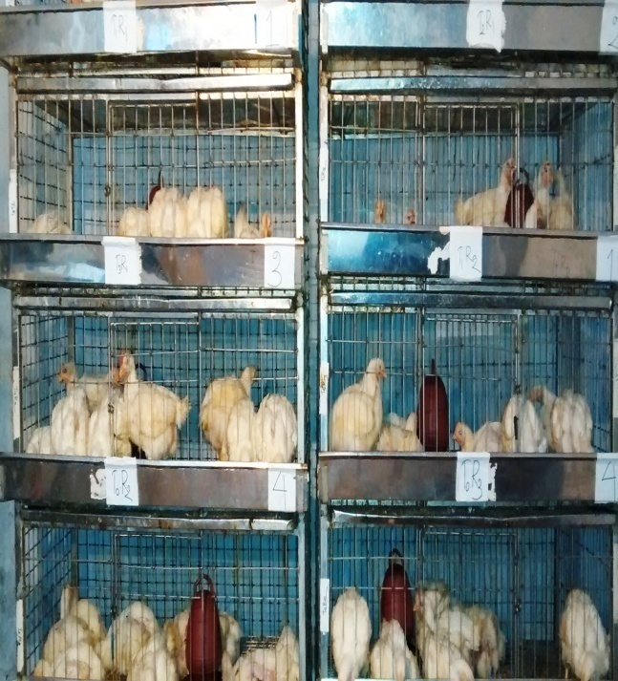**Picture gallery related to methodology**

**Fig 1: Brooding of broilers**

**Fig 2: Birds in cages**

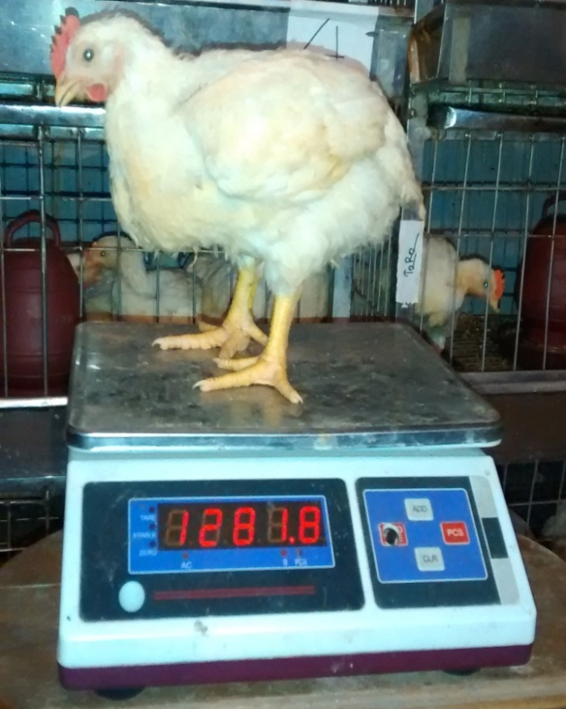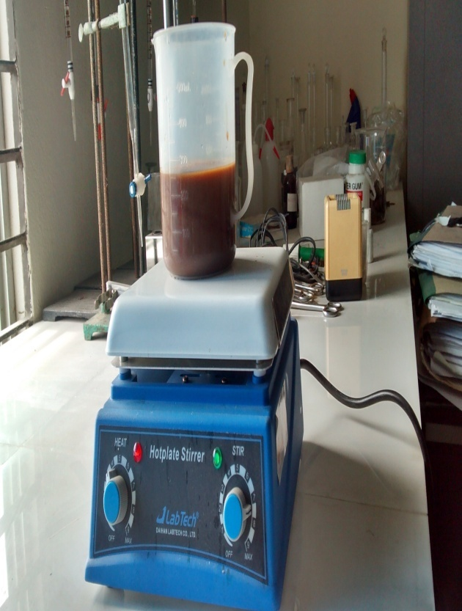

**Fig 3: Measuring weight of broilers**

**Fig 4: Mixing fish oil with water**

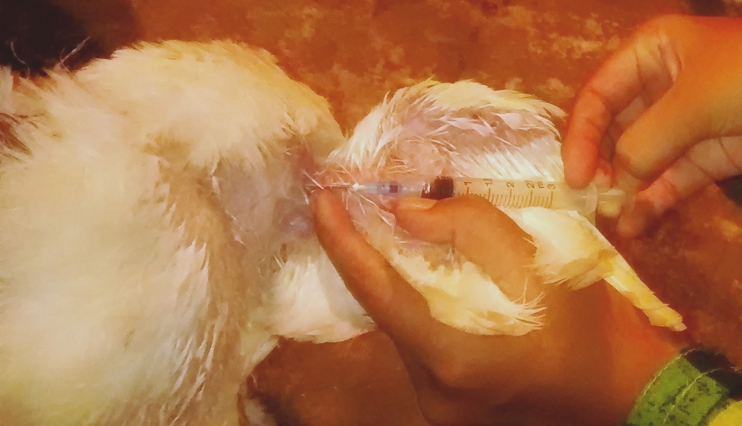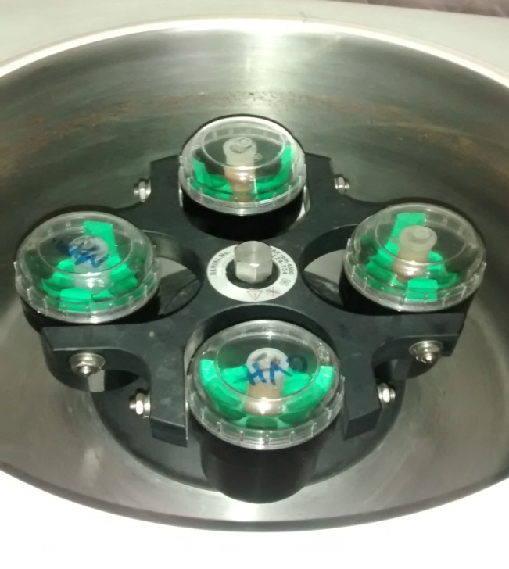

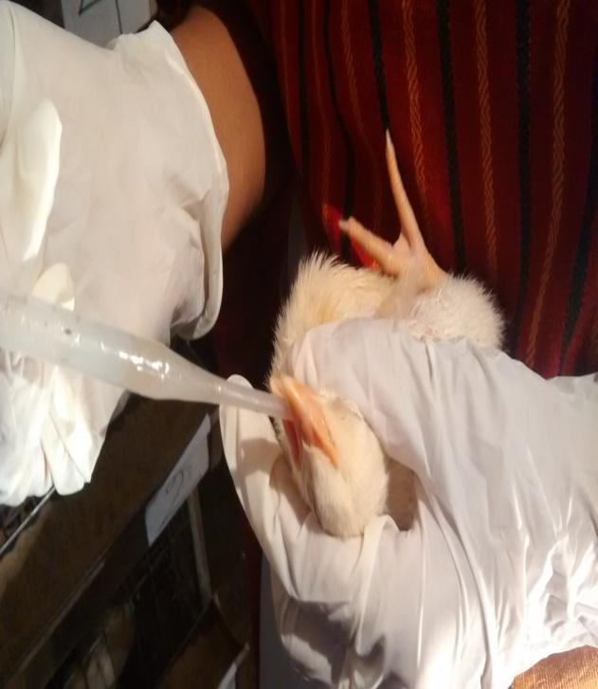

**Fig 5: Oocysts separation after centrifugation**

**Fig 6: Ingestion of oocysts**

**Fig 7: Blood collection from broilers**

**Fig 8: Block preparation in histopathology**



**Thesis for MS in Animal Science**

# Chapter IV

# Results

## 4.1 Effect of fish oil on growth and production performance of broilers

Different parameters were recorded to observe the effect of fish oil on growth and production performance of broilers when base diet was supplemented with 1%, 2% and 3% fish oil or without fish oil. The parameters were feed consumption, live weight gain and feed conversion (FC) of broilers at different ages of broilers. Cost benefit analysis was also calculated in this experiment.

### 4.1.1 Feed Consumption

Feed consumption by birds were recorded daily and calculated at the end of week.

**Table 4.1.1.1 Feed consumption of broilers at 1st week of age among different dietary treatment groups (gm/broiler)**

|  |  |  |  |  |  |
| --- | --- | --- | --- | --- | --- |
| **Variable** | **Level** | **Mean** | **SEM** | **P-value** | **Level of significance** |
| Dietary treatment  groups | T0 (without fish oil) | 119.7 | 7.3 | 0.36 | NS |
| T1 (1% fish oil) | 120.8 | 6.60 |
| T2 (2% fish oil) | 121.6 | 8.58 |
| T3 (3% fish oil) | 118.25 | 7.65 |

SEM = Standard error of mean; NS = Non significant at 5% level

Table 4.1.1.1 represents amount of feed consumption of birds at 1st week of age. The values of different groups were not significant (P>0.05).

**Table 4.1.1.2 Feed consumption of broilers at 2nd week of age among different dietary treatment groups (gm/broiler)**

|  |  |  |  |  |  |
| --- | --- | --- | --- | --- | --- |
| **Variable** | **Level** | **Mean** | **SEM** | **P-value** | **Level of significance** |
| Dietary treatment  groups | T0 (without fish oil) | 316.46 | 7.21 | 0.24 | NS |
| T1 (1% fish oil) | 314.15 | 9.80 |
| T2 (2% fish oil) | 287.5 | 5.98 |
| T3 (3% fish oil) | 289.99 | 5.73 |

SEM = Standard error of mean; NS = Non significant at 5% level

Table 4.1.1.2 is presented with the amount of feed consumption of birds at 2nd week of age. Though feed consumption was increased in birds which were not supplied with fish oil, the values among different dietary treatment groups did not differ significantly (P>0.05).

**Table 4.1.1.3 Feed consumption of broilers at 3rd week of age among different dietary treatment groups (gm/broiler)**

|  |  |  |  |  |  |
| --- | --- | --- | --- | --- | --- |
| **Variable** | **Level** | **Mean** | **SEM** | **P-value** | **Level of significance** |
| Dietary treatment  groups | T0 (without fish oil) | 747.60 | 10.56 | 0.07 | * |
| T1 (1% fish oil) | 658.17 | 8.51 |
| T2 (2% fish oil) | 665.13 | 6.91 |
| T3 (3% fish oil) | 667.33 | 7.61 |

SEM = Standard error of mean; * = Significant at 5% level

Feed consumption by birds in different treatment groups did not differ significantly (P>0.05) at 3rd week of age (table 4.1.1.3).

**Table 4.1.1.4 Feed consumption of broilers at 4th week of age among different dietary treatment groups (gm/broiler)**

|  |  |  |  |  |  |
| --- | --- | --- | --- | --- | --- |
| **Variable** | **Level** | **Mean** | **SEM** | **P-value** | **Level of significance** |
| Dietary treatment  groups | T0 (without fish oil) | 566.7 | 13.41 | <0.0001 | ** |
| T1 (1% fish oil) | 591.65 | 7.31 |
| T2 (2% fish oil) | 741.5 | 8.71 |
| T3 (3% fish oil) | 729.83 | 7.01 |

SEM = Standard error of mean; ** = Significant at 1% level

At 4th week of age, there was a significant (P<0.01) increase of daily feed consumption in the group without fish oil (table 4.1.1.4).

**Table 4.1.1.5 Cumulative feed consumption (gm/broiler) at different ages in different dietary treatment groups (with or without FO) of broilers**

|  |  |  |  |  |  |
| --- | --- | --- | --- | --- | --- |
| **Age (Wks)** | **T0**  **(without FO)** | **T1**  **(1% FO)** | **T2**  **(2% FO)** | **T3**  **(3% FO)** | **Level of significance** |
| 1-2 | 436.16 | 434.95 | 409.1 | 408.24 | NS |
| 1-3 | 1064.06 | 972.32 | 952.6 | 957.32 | NS |
| 1-4 | 1214.3 | 1249.82 | 1406.63 | 1397.16 | ** |

NS = Non significant at 5% level; ** = Significant at 1% level

Cumulative feed consumption by different groups were insignificant (P>0.05) until 3rd week of age which was increased significantly (P<0.01) at 4th week of age in 2% and 3% fish oil treatment groups, respectively (table 4.1.1.5).

### 4.1.2 Live weight

Live weight of birds was recorded at 1st day and at the end of each week.

**Table 4.1.2.1 Initial live weight of broilers with different dietary fish oil supplemented groups and control group (gm/broiler)**

|  |  |  |  |  |  |
| --- | --- | --- | --- | --- | --- |
| **Variable** | **Level** | **Mean** | **SEM** | **P-value** | **Level of significance** |
| Dietary treatment  groups | T0 (without fish oil) | 34.85 | 3.93 | 0.16 | NS |
| T1 (1% fish oil) | 32.91 | 3.51 |
| T2 (2% fish oil) | 33.11 | 3.99 |
| T3 (3% fish oil) | 34.15 | 3.63 |

SEM = Standard error of mean; NS = Non significant at 5% level

Initially no significant difference (P>0.05) in live weight were found among the birds of different dietary treatment groups (table 4.1.2.1).

**Table 4.1.2.2 Live weight of broilers with different groups of dietary fish oil supplemented groups and control group at 1st week of age (gm/broiler)**

|  |  |  |  |  |  |
| --- | --- | --- | --- | --- | --- |
| **Variable** | **Level** | **Mean** | **SEM** | **P-value** | **Level of significance** |
| Group | T0 (without fish oil) | 138.66 | 12.57 | 0.21 | NS |
| T1 (1% fish oil) | 140.76 | 5.66 |
| T2 (2% fish oil) | 142.79 | 4.98 |
| T3 (3% fish oil) | 141.62 | 5.29 |

SEM = Standard error of mean; NS = Non significant at 5% level

Difference in live weight of broilers at 1st week of age was also not significant (P>0.05) among different groups (table 4.1.2.2).

**Table 4.1.2.3 Live weight of broilers with different groups of dietary fish oil supplemented groups and control group at 2nd week of age (gm/broiler)**

|  |  |  |  |  |  |
| --- | --- | --- | --- | --- | --- |
| **Variable** | **Level** | **Mean** | **SEM** | **P-value** | **Level of significance** |
| Group | T0 (without fish oil) | 346.14 | 7.96 | 0.58 | NS |
| T1 (1% fish oil) | 347.44 | 9.14 |
| T2 (2% fish oil) | 348.15 | 2.60 |
| T3 (3% fish oil) | 348.00 | 1.57 |

SEM = Standard error of mean; NS = Non significant at 5% level

Live weight of broilers at 2nd week of age among different groups were insignificant (P>0.05) (table 4.1.2.3).

**Table 4.1.2.4 Live weight of broilers with different groups of dietary fish oil supplemented groups and control group at 3rd week of age (gm/broiler)**

|  |  |  |  |  |  |
| --- | --- | --- | --- | --- | --- |
| **Variable** | **Level** | **Mean** | **SEM** | **P-value** | **Level of significance** |
| Group | T0 (without fish oil) | 727.57 | 12.12 | <0.0001 | ** |
| T1 (1% fish oil) | 734.59 | 15.19 |
| T2 (2% fish oil) | 808.96 | 18.65 |
| T3 (3% fish oil) | 808.23 | 9.95 |

SEM = Standard error of mean, ** = Significant at 1% level

Table 4.1.2.4 shows that difference in live weight among broilers was significant (P<0.01) and was higher in 2 and 3% fish oil dietary treatment groups in comparison with other two groups.

**Table 4.1.2.5 Live weight of broilers with different groups of dietary fish oil supplemented groups and control group at 4th week of age (gm/broiler)**

|  |  |  |  |  |  |
| --- | --- | --- | --- | --- | --- |
| **Variable** | **Level** | **Mean** | **SEM** | **P-value** | **Level of significance** |
| Group | T0 (without fish oil) | 961.77 | 58.72 | <0.0001 | ** |
| T1 (1% fish oil) | 1005.99 | 26.60 |
| T2 (2% fish oil) | 1281.96 | 26.86 |
| T3 (3% fish oil) | 1281.45 | 18.61 |

SEM = Standard error of mean, ** = Significant at 1% level

Significant (P<0.01) difference in live weight of broilers was observed at 4th week of age and 2% dietary fish oil treatment group gained highest weight among the treatment groups (table 4.1.2.5).

**Table 4.1.2.6 Cumulative body weight (gm/broiler) of broilers at different market ages fed on diet supplemented with or without fish oil**

|  |  |  |  |  |  |
| --- | --- | --- | --- | --- | --- |
| **Age (Wks)** | **T0**  **(without FO)** | **T1**  **(1% FO)** | **T2**  **(2% FO)** | **T3**  **(3% FO)** | **Level of Significance** |
| 1-2 | 484.80 | 488.20 | 490.94 | 489.62 | NS |
| 1-3 | 1212.37 | 1222.79 | 1299.90 | 1297.85 | ** |
| 1-4 | 2174.14 | 2228.78 | 2581.86 | 2579.30 | ** |

NS = Non significant at 5% level, * = Significant at 1% level

Table 4.1.2.6 represents that upto 2nd week of age the difference in cumulative live weight of broilers among different groups were not statistically significant (P>0.05) but at 3rd and 4th weeks of age weight was significantly (P<0.01) higher in 2% and 3% fish oil supplemented groups, respectively.



**Fig 9: Boxplot of body weight among different dietary treatment groups (G-1 to G-2) showing minimum, maximum, 25th quartile, 75th quartile and median**

Box plot in figure 9 represents that minimum weight of G-1/T0 (without fish oil), G-2 /T1 (1% fish oil), T2/G-3 (2% fish oil) and group G-4/T3 (3% fish oil) were 855, 1010, 1235 and1260 gm/broiler, respectively. The median body weight of these groups were 940, 990, 1295 and 1290 gm/broiler, respectively. Body weight among 25% of the birds were 920, 990, 1270 and 1280 gm/broiler, respectively. 75% of the birds showed bdy weight at about 1000, 1020, 1270 and 1285 gm/broiler, respectively. Maximum weights in these four groups were 1130, 1020, 1320 and 1315 gm/broiler, respectively.

### 4.1.3 Live weight gain

**Table 4.1.3.1 Live weight gains of broilers with different groups of dietary fish oil supplemented groups and control group at 1st week of age (gm/broiler)**

|  |  |  |  |  |  |
| --- | --- | --- | --- | --- | --- |
| **Variable** | **Level** | **Mean** | **SEM** | **P-value** | **Level of significance** |
| Group | T0 (without fish oil) | 104.21 | 11.50 | 0.32 | NS |
| T1 (1% fish oil) | 107.35 | 4.8 |
| T2 (2% fish oil) | 109.48 | 5.67 |
| T3 (3% fish oil) | 108.47 | 4.19 |

SEM = Standard error of mean; NS = Non significant at 5% level

At 1st week of age, live weight gain of broilers in different dietary treatment groups of broilers were also insignificant (P>0.05) statistically (table 4.1.3.1).

**Table 4.1.3.2 Live weight gains of broilers with different groups of dietary fish oil supplemented groups and control group at 2nd week of age (gm/broiler)**

|  |  |  |  |  |  |
| --- | --- | --- | --- | --- | --- |
| **Variable** | **Level** | **Mean** | **SEM** | **P-value** | **Level of significance** |
| Group | T0 (without fish oil) | 207.35 | 5.96 | 0.59 | NS |
| T1 (1% fish oil) | 206.71 | 7.34 |
| T2 (2% fish oil) | 205.39 | 1.89 |
| T3 (3% fish oil) | 206.24 | 2.57 |

SEM = Standard error of mean; NS = Non significant at 5% level

At 2nd week of age, weight gain among different dietary treatment groups were insignificant (P>0.05) (table 4.1.3.2).

**Table 4.1.3.3 Live weight gains of broilers with different groups of dietary fish oil supplemented groups and control group at 3rd week of age (gm/broiler)**

|  |  |  |  |  |  |
| --- | --- | --- | --- | --- | --- |
| **Variable** | **Level** | **Mean** | **SEM** | **P-value** | **Level of significance** |
| Group | T0 (without fish oil) | 380.43 | 11.15 | <0.0001 | ** |
| T1 (1% fish oil) | 385.17 | 13.19 |
| T2 (2% fish oil) | 460.81 | 17.35 |
| T3 (3% fish oil) | 459.23 | 5.95 |

SEM = Standard error of mean, ** = Significant at 1% level

Significant (P<0.01) difference in weight gain of broilers in different treatment groups was observed which was higher in 2 and 3% fish oil treatment groups (table 4.1.3.3).

**Table 4.1.3.4 Live weight gains of broilers with different groups of dietary fish oil supplemented groups and control group at 4th week of age (g/broiler)**

|  |  |  |  |  |  |
| --- | --- | --- | --- | --- | --- |
| **Variable** | **Level** | **Mean** | **SEM** | **P-value** | **Level of significance** |
| Group | T0 (without fish oil) | 236.2 | 58.72 | <0.0001 | ** |
| T1 (1% fish oil) | 273.45 | 26.60 |
| T2 (2% fish oil) | 472.79 | 26.86 |
| T3 (3% fish oil) | 473.01 | 18.61 |

SEM = Standard error of mean, ** = Significant at 1% level

Significant (P<0.01) difference in weight gain was observed at 4th week of age and 2% dietary fish oil treatment group gained highest weight among the treatment groups (table 4.1.3.4).

**Table 4.1.3.5 Cumulative body weight gain (g/broiler) of broilers at different market ages fed on diet supplemented with or without fish oil**

|  |  |  |  |  |  |
| --- | --- | --- | --- | --- | --- |
| **Age (Wks)** | **T0**  **(without FO)** | **T1**  **(1% FO)** | **T2**  **(2% FO)** | **T3**  **(3% FO)** | **Level of Significance** |
| 1-2 | 311.56 | 314.06 | 314.87 | 314.71 | NS |
| 1-3 | 587.78 | 591.88 | 666.2 | 665.47 | ** |
| 1-4 | 616.63 | 658.62 | 933.6 | 932.24 | ** |

NS = Non significant at 5% level, ** = Significant at 1% level

Cumulative live weight gain among different treatment groups were significantly (P<0.01) higher in 2% and 3% dietary treatment groups at 3rd and 4th week of age of broilers (table 4.1.3.5).

### 4.1.4 Feed conversion

**Table 4.1.4.1 Comparison of feed conversion of broilers at 1st week of age fed on diet supplemented with or without fish oil**

|  |  |  |  |  |  |
| --- | --- | --- | --- | --- | --- |
| **Variable** | **Level** | **Mean** | **SEM** | **P-value** | **Level of significance** |
| Groups | T0 (without fish oil) | 1.15 | 0.12 | 0.09 | * |
| T1 (1% fish oil) | 1.12 | 0.04 |
| T2 (2% fish oil) | 1.10 | 0.01 |
| T3 (3% fish oil) | 1.09 | 0.04 |

SEM = Standard error of mean, * = Significant at 1% level

Table 4.1.4.2 shows that variation in feed conversion was not significant (P>0.05) in different treatment groups.

**Table 4.1.4.2 Comparison of feed conversion of broilers at 2nd week of age fed on diet supplemented with or without fish oil**

|  |  |  |  |  |  |
| --- | --- | --- | --- | --- | --- |
| **Variable** | **Level** | **Mean** | **SEM** | **P-value** | **Level of significance** |
| Groups | T0 (without fish oil) | 1.53 | 0.03 | 0.03 | * |
| T1 (1% fish oil) | 1.52 | 0.03 |
| T2 (2% fish oil) | 1.40 | 0.02 |
| T3 (3% fish oil) | 1.41 | 0.02 |

SEM = Standard error of mean, * = Significant at 5% level

Feed conversion of broilers among different treatment groups was significantly (P<0.05) differed at 2nd week of age (table 4.1.3.1). Feed conversion was higher in control group in comparison with other groups.

**Table 4.1.4.3 Comparison of feed conversion of broilers at 3rd week of age fed on diet supplemented with or without fish oil**

|  |  |  |  |  |  |
| --- | --- | --- | --- | --- | --- |
| **Variable** | **Level** | **Mean** | **SEM** | **P-value** | **Level of significance** |
| Groups | T0 (without fish oil) | 1.96 | 0.13 | <0.0001 | ** |
| T1 (1% fish oil) | 1.45 | 0.03 |
| T2 (2% fish oil) | 1.40 | 0.01 |
| T3 (3% fish oil) | 1.45 | 0.01 |

SEM = Standard error of mean, ** = Significant at 1% level

Table 4.1.4.3 indicates that there was a significant (P<0.01) increase in feed conversion among the birds treated without fish oil or with 1% fish oil.

**Table 4.1.4.4 Comparison of feed conversion of broilers at 4th week of age fed on diet supplemented with or without fish oil**

|  |  |  |  |  |  |
| --- | --- | --- | --- | --- | --- |
| **Variable** | **Level** | **Mean** | **SEM** | **P-value** | **Level of significance** |
| Groups | T0 (without fish oil) | 2.42 | 0.04 | <0.0001 | ** |
| T1 (1% fish oil) | 2.18 | 0.14 |
| T2 (2% fish oil) | 1.57 | 0.03 |
| T3 (3% fish oil) | 1.50 | 0.04 |

SEM = Standard error of mean, ** = Significant at 1% level

Feed conversion was significantly (P<0.01) better in 2% and 3% fish oil supplemented groups among different treatment groups at 4th week of age (table 4.1.4.4).

**Table 4.1.4.5 Cumulative feed conversion of broilers at different market ages fed on diet supplemented with or without fish oil**

|  |  |  |  |  |  |
| --- | --- | --- | --- | --- | --- |
| **Age (Wks)** | **T0**  **(without FO)** | **T1**  **(1% FO)** | **T2**  **(2% FO)** | **T3**  **(3% FO)** | **Level of Significance** |
| 1-2 | 1.39 | 1.384 | 1.299 | 1.297 | * |
| 1-3 | 1.81 | 1.64 | 1.429 | 1.438 | ** |
| 1-4 | 2.01 | 1.89 | 1.50 | 1.49 | ** |

NS = Non significant at 5% level, * = Significant at 5% level; ** = Significant at 1% level

Cumulative feed conversion among different treatment groups were significantly better in 2% and 3% dietary treatment groups at 2nd (P<0.05), 3rd (P<0.01) and 4th (P<0.01) week of age of broilers (table 4.1.4.5).



**Fig 10 Boxplot of FC among different groups (G-1 to G-4) showing minimum, maximum, 25th quartile, 75th quartile and median**

From the box plot represented in figure 10 it was revealed that minimum feed conversion (FC) among G-1/T0 (without fish oil), G-2 /T1 (1% fish oil), G-3/T2 (2% fish oil) and group G-4/T3 (3% fish oil) were 2.34, 1.98, 1.58 and 1.44, respectively. 25% of the birds showed FC about 2.38, 2.08, 1.58 and 1.56, respectively and 75% of the birds showed FC about 2.46, 2.12, 1.58 and 1.54, respectively.

**4.1.5 Effect of fish oil on cost benefit analysis of broiler**

**Table 4.1 Cost of production and returns in different treatment groups**

|  |  |  |  |  |  |  |  |  |  |  |  |  |
| --- | --- | --- | --- | --- | --- | --- | --- | --- | --- | --- | --- | --- |
| **Cost items** | | | | | | | | | | | | |
| **Parameters** | **T0**  **(Control)** | | | **T1**  **(1% FO)** | | | **T2**  **(2% FO)** | | | **T2**  **(3% FO)** | | **Level of**  **Sig.** |
| **Mean** | **SEM** | | **Mean** | **SEM** | | **Mean** | **SEM** | | **Mean** | **SEM** |
| Chick cost  (Tk./chick) | 40.00 | - | | 40.00 | **-** | | 40.00 | **-** | | 40 | **-** | **NS** |
| Fish oil, essence of banana cost (Tk./kg) | **-** | **-** | | 1090 | **-** | | 1130 | - | | 11160 | **-** | **-** |
| Total feed cost (Tk./kg) | 35.35 | 0.08 | | 37.25 | 0.03 | | 38.7 | 0.05 | | 40.2 | 0.07 | * |
| Management cost (Tk./broiler) | 15 | - | | 15 | - | | 15 | - | | 15 | - | **NS** |
| Total feed cost  (Tk./broiler) | 80.8 | 0.07 | | 81.3 | 0.03 | | 82.4 | 0.1 | | 83.7 | 0.25 | * |
| Total cost (Tk./broiler) | 135.8 | 0.02 | | 136.3 | 0.01 | | 137.4 | 0.05 | | 138.7 | 0.07 | * |
| Total cost  (Tk./kg live broiler) | 123.4 | 0.05 | | 121.3 | 0.07 | | 118.2 | 0.02 | | 117.9 | 0.09 | * |
| **Income** | | | | | | | | | | | | |
| Market sale price (Tk./kg broiler) | 130 | | - | 130 | | - | 130 | - | 130 | | - | **NS** |
| Total sale price (Tk./broiler) | 157.38 | | 0.51 | 161.46 | | 0.37 | 166.8 | 0.23 | 169.14 | | 0.45 | * |
| Net Profit (Tk./broiler) | 21.58 | | 0.31 | 25.17 | | 0.27 | 29.43 | 0.25 | 30.44 | | 0.23 | * |
| Net Profit (Tk./kg live broiler) | 6.6 | | 0.04 | 8.7 | | 0.03 | 11.8 | 0.07 | 12.1 | | 0.09 | * |

SEM = Standard error of mean,

NS = Non significant at 5% level, * = Significant at 5% level.

**N.B.** Total feed cost included feed raw materials cost, fish oil and essence of banana cost. Management cost included vaccination cost, labour cost, electricity cost, disinfectant cost and litter material cost. Total cost included total feed cost, chick cost and management cost.

1 US $=78 Taka (approx.)

## 4.2 Effect of fish oil on coccidiosis of broilers

In present study, the birds which were exposed to 104 *Eimeria* oocysts had developed signs and lesions of coccidiosis except the birds which were treated with higher level of fish oil. Role of fish oil in preventing coccidiosis was studied based on clinical signs, gross and histopathological changes, hematological, biochemical changes caused by coccidiosis in chickens.

### 4.2.1 Clinical signs

Clinical coccidiosis was seen with clotted and unclotted blood in faeces among the birds in which no dietary fish oil was used (T0) at four days post infection (dpi). Lesions were aggravated on 6 and 7 dpi. At 7 dpi almost all the birds from control groups were infected. Fresh bloody discharge was found in the droppings of affected birds. Depression, weakness, bloody diarrhoea, anorexia and ruffled feathers were also observed. Birds which received 1% dietary fish oil also showed same clinical signs but the lesions were not so severe like control groups (T1). On 5 dpi and 7 dpi two coccidian infected birds from control group were died. However birds which were fed 2% and 3% fish oil (T2 and T3 groups) with regular drinking water showed very minimal or no clinical signs.

### 4.2.2 Oocyst output

**Table 4.2.1 Total oocyst output in different dietary treatment groups (Mean of total oocyst output × 106)**

|  |  |  |  |
| --- | --- | --- | --- |
| **Groups** | **Mean** | **P-value** | **Level of Significance** |
| T0 (without fish oil) | 2246.7 | <0.00001 | * |
| Group 2 (1% fish oil) | 1131 |
| Group 3 (2% fish oil) | 0 |
| Group 4 (3% fish oil) | 0 |

* = Significant at 5% level

Table 4.2.1 shows that the group in fish oil was not used with daily drinking water passed a large number of oocysts following infection. Birds receiving 1% fish oil also passed oocyst in feces but the number of oocyst was less than control group. No oocysts were found in the birds which were fed 2% and 3% fish oil with drinking water. There was a significant (P<0.01) difference among the values of oocyst count.

### 4.2.3 Necropsy of birds

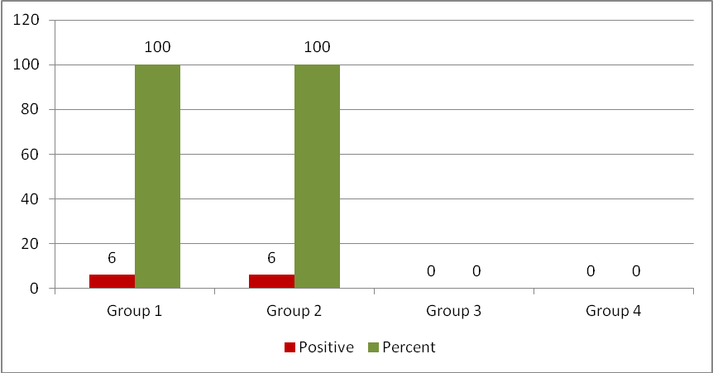

**Histogram 1 Infection status of 24 selected birds from different groups (6 birds from each group)**

All sacrificed birds including two dead birds from T0 (without fish oil) group revealed highly swollen caeca with full of clotted blood and blood mixed feces. Large number of haemorrhagic, necrotic spots on the mucosal surface with oocysts in mucosal scrapings was also observed. Due to formation of oocysts, mottled reddish or milky white colored contents in the caeca was also observed. Those birds were scored either +3 or +4. Birds which received 1% fish oil also showed lesions of coccidiosis such as hemorrhage, bloody faeces with a hyperemic, swollen and thickened caecal wall. But those lesions were not so severe like control group. So they were scored either +1 or +2. No gross lesions of coccidiosis were observed in the intestines of birds receiving 2% and 3% fish oil. They were scored as 0 (Figure 11).

### 4.2.4 Histopathology

Histopathological lesions in intestinal sections of control and 1% fish oil treatment groups (infected) induced loss of epithelial tissue, congestion of blood vessels, which indicated disruption followed by leakage of blood. There were also severe hemorrhage, necrosis of mucosa, submucosa of intestine, presence of clusters of oocysts, merozoites, schizonts and lymphoid cells hyperplasia. Mononuclear cell infiltration was noted in the mucosal layer. Second generation schizont (pathognomonic for *Eimeria tenella*) was found within the caecal cells. Different developmental stages of *Eimeria* like microgametocytes, mocrogametocyes were observed in the epithelial cells of intestine. Moreover huge epithelial cell destruction was found throughout the intestinal layers (Figure 12,13).

### 4.2.5 Haematological changes

**Table 4.2.2 Comparison of red blood cell (RBC) count at 15th and 30th day of study among different groups of the study population (1 × 106 cells per micro liter)**

|  |  |  |  |  |  |  |  |  |
| --- | --- | --- | --- | --- | --- | --- | --- | --- |
| **Dietary**  **treatment**  **groups** | **At 15th day** | | **Level**  **of**  **Sig.** | **At 30th day** | | **Level**  **of**  **Sig.** | **Ref.**  **interval** | **Source** |
| **Mean** | **SEM** | **Mean** | **SEM** |
| T0 (without FO) | 2.9 | 0.4 | NS | 1.6 | 0.5 | * | 2.5–3.5 | Wakenell  (2010) |
| T1 (1% FO) | 3.1 | 0.3 | 1.75 | 0.7 |
| T2 (2% FO) | 3.2 | 0.1 | 3.1 | 0.4 |
| T3 (3% FO) | 3.4 | 0.2 | 3.4 | 0.2 |

SEM = Standard error of mean, NS= Non significant, * = Significant at 5% level

**Table 4.2.3 Comparison of packed cell volume (PCV) at 15th and 30th day of study among different groups of the study population (%)**

|  |  |  |  |  |  |  |  |  |
| --- | --- | --- | --- | --- | --- | --- | --- | --- |
| **Dietary**  **treatment groups** | **At 15th day** | | **Level**  **of**  **Sig.** | **At 30th day** | | **Level**  **of**  **Sig.** | **Ref.**  **interval** | **Source** |
| **Mean** | **SEM** | **Mean** | **SEM** |
| T0 (without FO) | 42.5 | 3.1 | NS | 23.5 | 4.5 | * | 35–55 | Irizaary-Rovira (2004) |
| T1 (1% FO) | 43.5 | 3.5 | 29.5 | 4.1 |
| T2 (2% FO) | 45.4 | 3.3 | 47.8 | 3.9 |
| T3 (3% FO) | 44.75 | 3.4 | 48.5 | 4.6 |

SEM = Standard error of mean, NS= Non significant, * = Significant at 5% level.

**Table 4.2.4 Comparison of HB (g.dL-1) at 15th and 30th day of study among different groups of the study population**

|  |  |  |  |  |  |  |  |  |
| --- | --- | --- | --- | --- | --- | --- | --- | --- |
| **Dietary**  **treatment groups** | **At 15th day** | | **Level**  **of**  **Sig.** | **At 30th day** | | **Level**  **of**  **Sig.** | **Ref.**  **interval** | **Source** |
| **Mean** | **SEM** | **Mean** | **SEM** |
| T0 (without FO) | 9.17 | 1.04 | NS | 6.7 | 0.45 | * | 7-13 | Wakenell  (2010) |
| T1 (1% FO) | 9.2 | 0.95 | 6.9 | 0.32 |
| T2 (2% FO) | 10.5 | 1.23 | 9.9 | 1.1 |
| T3 (3% FO) | 9.3 | 1.19 | 9.8 | 1.3 |

SEM = Standard error of mean, NS= Non significant, * = Significant at 5% level

**Table 4.2.5 Comparison of lymphocyte count at 15th and 30th day of study among different groups of the study population (%)**

|  |  |  |  |  |  |  |  |  |
| --- | --- | --- | --- | --- | --- | --- | --- | --- |
| **Dietary**  **treatment groups** | **At 15th day** | | **Level**  **of**  **Sig.** | **At 30th day** | | **Level**  **of**  **Sig.** | **Ref.**  **interval** | **Source** |
| **Mean** | **SEM** | **Mean** | **SEM** |
| T0 (without FO) | 39.9 | 4.5 | * | 74.5 | 9.8 | * | 34 | MVM  (2011) |
| T1 (1% FO) | 40.3 | 7.9 | 63.5 | 7.9 |
| T2 (2% FO) | 35.8 | 5.7 | 32.5 | 6.5 |
| T3 (3% FO) | 33.3 | 4.3 | 34.5 | 6.9 |

SEM = Standard error of mean, * = Significant at 5% level

**Table 4.2.6 Comparison of monocyte count at 15th and 30th day of study among different groups of the study population (%)**

|  |  |  |  |  |  |  |  |  |
| --- | --- | --- | --- | --- | --- | --- | --- | --- |
| **Dietary**  **treatment groups** | **At 15th day** | | **Level**  **of**  **Sig.** | **At 30th day** | | **Level**  **of**  **Sig.** | **Ref.**  **interval** | **Source** |
| **Mean** | **SEM** | **Mean** | **SEM** |
| T0 (without FO) | 3.35 | 2.7 | * | 5.6 | 1.8 | * | 2.8 | MVM  (2011) |
| T1 (1% FO) | 3.2 | 1.4 | 4.7 | 1.4 |
| T2 (2% FO) | 2.6 | 1.9 | 2.75 | 1.46 |
| T3 (3% FO) | 2.95 | 3.2 | 2.84 | 1.9 |

SEM = Standard error of mean, NS= Non significant, * = Significant at 5% level

**Table 4.2.7 Comparison of eosinophil count at 15th and 30th day of study among different groups of the study population (%)**

|  |  |  |  |  |  |  |  |  |
| --- | --- | --- | --- | --- | --- | --- | --- | --- |
| **Dietary**  **treatment groups** | **At 15th day** | | **Level**  **of**  **Sig.** | **At 30th day** | | **Level**  **of**  **Sig.** | **Ref. interval** | **Source** |
| **Mean** | **SEM** | **Mean** | **SEM** |
| T0(without FO) | 3.9 | 1.12 | * | 6.5 | 5.3 | * | 0.3 | MVM  (2011) |
| T1 (1% FO) | 3.79 | 2.39 | 6.2 | 4.1 |
| T2 (2% FO) | 3.5 | 3.4 | 3.2 | 2.5 |
| T3 (3% FO) | 3.75 | 2.43 | 2.9 | 1.7 |

SEM = Standard error of mean, NS= Non significant, * = Significant at 5% level

**Table 4.2.8 Comparison of heterophil count at 15th and 30th day of study among different groups of the study population (%)**

|  |  |  |  |  |  |  |  |  |
| --- | --- | --- | --- | --- | --- | --- | --- | --- |
| **Dietary**  **treatment groups** | **At 15th day** | | **Level**  **of**  **Sig.** | **At 30th day** | | **Level**  **of**  **Sig.** | **Ref. interval** | **Source** |
| **Mean** | **SEM** | **Mean** | **SEM** |
| T0 (without FO) | 18.3 | 0.32 | NS | 19.7 | 0.04 | * | 0-1 | MVM (2011) |
| T1 (1% FO) | 17.9 | 0.40 | 22.1 | 0.87 |
| T2 (2% FO) | 17.7 | 0.37 | 10.5 | 1.77 |
| T3 (3% FO) | 18.1 | 0.39 | 9.7 | 2.33 |

SEM = Standard error of mean, NS= Non significant, * = Significant at 5% level

Tables 4.2.2 to 4.2.8 represent that birds with 1% fish oil or without fish oil (infected) treatment revealed a significant (P<0.05) decreased level of RBC, Hb and PCV compared to birds with 2% and 3% fish oil (uninfected) treatment groups at 30th day of age. However, at this period increased value of lymphocyte, monocyte, eosinophil and heterophil were found in the bird with 1% dietary fish oil and control groups (infected) compared to 2% and 3% fish oil (uninfected) groups. Those values differed significantly (P<0.05).

## 4.3 Biochemical changes

**Table 4.2.9 Comparison of serum alanine aminotransferase (ALT) level at 15th and 30th day of study among different groups of the study population (IUL-1)**

|  |  |  |  |  |  |  |  |  |
| --- | --- | --- | --- | --- | --- | --- | --- | --- |
| **Dietary**  **treatment groups** | **At 15th day** | | **Level**  **of**  **Sig.** | **At 30th day** | | **Level**  **of**  **Sig.** | **Ref.**  **interval** | **Source** |
| **Mean** | **SEM** | **Mean** | **SEM** |
| T0 (without FO) | 15.7 | 1.1 | NS | 7.5 | 1.9 | * | 20 | MVM (2011) |
| T1 (1% FO) | 16.9 | 0.9 | 9.5 | 2.3 |
| T2 (2% FO) | 15.9 | 1.2 | 18.9 | 3.4 |
| T3 (3% FO) | 16.3 | 0.78 | 21.8 | 2.9 |

IU = International units, SEM = Standard error of mean, NS= Non significant,

* = Significant at 5% level, MVM *=* Merck Veterinary Manual

**Table 4.2.10 Comparison of serum aspartate aminotransferase (AST) level at 15th and 30th day of study among different groups of the study population (IUL-1)**

|  |  |  |  |  |  |  |  |  |
| --- | --- | --- | --- | --- | --- | --- | --- | --- |
| **Dietary**  **treatment groups** | **At 15th day** | | **Level**  **of**  **Sig.** | **At 30th day** | | **Level**  **of**  **Sig.** | **Ref. interval** | **Source** |
| **Mean** | **SEM** | **Mean** | **SEM** |
| T0(without FO) | 126.5 | 26.8 | * | 123.5 | 24.2 | * | 131-486 | MVM (2011) |
| T1 (1% FO) | 130.8 | 24.5 | 127.8 | 37.8 |
| T2 (2% FO) | 232.5 | 35.8 | 239.6 | 23.6 |
| T3 (3% FO) | 235.8 | 37.2 | 247.3 | 27.8 |

IU = International units, SEM = Standard error of mean, NS= Non significant, * = Significant at 5% level, MVM *=* Merck Veterinary Manual

Tables 4.2.9 to 4.2.10 represent that level of alanine aminotransferase (ALT) and aspartate aminotransferase (AST) was reduced significantly (P<0.05) in control and 1% fish oil (infected) supplemented groups at 30th day of age of broilers compared to birds with 2 and 3% fish oil supplemented (uninfected) groups.

## 4.3 Effect of fish oil on blood parameters of broilers

**Table 4.3.1 Total serum cholesterol of broilers at 15th and 30th day of age fed on diets supplemented with different percentage of fish oil or without oil (mg/dl/broiler)**

|  |  |  |  |  |  |  |  |  |
| --- | --- | --- | --- | --- | --- | --- | --- | --- |
| **Dietary**  **treatment Groups** | **At 15th day\*** | | | | **At 30th day** | | | |
| **Mean** | **SEM** | **P-value** | **Level of**  **Sig.** | **Mean** | **SEM** | **P-value** | **Level of**  **Sig.** |
| T0 (without FO) | 155.86 | 1.86 | <0.0001 | ** | 118.3 | 0.87 | <0.0001 | ** |
| T1 (1% FO) | 115.66 | 0.82 | 116.6 | 1.00 |
| T2 (2% FO) | 107.6 | 1.37 | 104.3 | 1.52 |
| T3 (3% FO) | 107.78 | 0.99 | 105.5 | 1.15 |

SEM = Standard error of mean, ** = Significant at 1% level

**Table 4.3.2 HDL-cholesterol of broilers at 15th and 30th day of age fed on diets supplemented with different percentage of fish oil or without oil (mg/dl/broiler)**

|  |  |  |  |  |  |  |  |  |
| --- | --- | --- | --- | --- | --- | --- | --- | --- |
| **Dietary**  **treatment Groups** | **At 15th day\*** | | | | **At 30th day** | | | |
| **Mean** | **SEM** | **P-value** | **Level of**  **Sig.** | **Mean** | **SEM** | **P-value** | **Level of**  **Sig.** |
| T0 (without FO) | 15.32 | 2.07 | 0.001 | ** | 15.60 | 0.70 | <0.0001 | ** |
| T1 (1% FO) | 16.15 | 1.19 | 17.33 | 0.50 |
| T2 (2% FO) | 18.33 | 1.34 | 20.01 | 0.41 |
| T3 (3% FO) | 18.85 | 1.34 | 20.03 | 0.77 |

SEM = Standard error of mean, ** = Significant at 1% level

**Table 4.3.3 LDL-cholesterol of broilers at 15th and 30th day of age fed on diets supplemented with different percentage of fish oil or without oil (mg/dl/broiler)**

|  |  |  |  |  |  |  |  |  |
| --- | --- | --- | --- | --- | --- | --- | --- | --- |
| **Dietary**  **treatment Groups** | **At 15th day\*** | | | | **At 30th day** | | | |
| **Mean** | **SEM** | **P-value** | **Level of**  **Sig.** | **Mean** | **SEM** | **P-value** | **Level of**  **Sig.** |
| T0 (without FO) | 72.93 | 2.84 | 0.0006 | * | 74.76 | 0.74 | <0.0001 | ** |
| T1 (1% FO) | 70.73 | 1.62 | 72.68 | 1.62 |
| T2 (2% FO) | 66.49 | 3.30 | 64.20 | 1.44 |
| T3 (3% FO) | 65.66 | 3.32 | 64.46 | 2.33 |

SEM = Standard error of mean, ** = Significant at 1% level

**Table 4.3.4 Triglycerides of broilers at 15th and 30th day of age fed on diets supplemented with different percentage of fish oil or without oil (mg/dl/broiler)**

|  |  |  |  |  |  |  |  |  |
| --- | --- | --- | --- | --- | --- | --- | --- | --- |
| **Dietary**  **treatment Groups** | **At 15th day\*** | | | | **At 30th day** | | | |
| **Mean** | **SEM** | **P-value** | **Level of**  **Sig.** | **Mean** | **SEM** | **P-value** | **Level of**  **Sig.** |
| T0 (without FO) | 155.28 | 3.95 | <0.0001 | ** | 157.29 | 1.04 | <0.0001 | ** |
| T1 (1% FO) | 116.73 | 1.03 | 117.3 | 0.86 |
| T2 (2% FO) | 102.11 | 6.36 | 96.93 | 2.55 |
| T3 (3% FO) | 103.28 | 6.49 | 97.11 | 1.00 |

SEM = Standard error of mean, ** = Significant at 1% level

**Table 4.3.5 Glucose level in serum of broilers at 15th and 30th days of age fed on diets supplemented with different percentage of fish oil or without oil (mg/dl/broiler)**

|  |  |  |  |  |  |  |  |  |
| --- | --- | --- | --- | --- | --- | --- | --- | --- |
| **Dietary**  **treatment Groups** | **At 15th day\*** | | | | **At 30th day** | | | |
| **Mean** | **SEM** | **P-value** | **Level of**  **Sig.** | **Mean** | **SEM** | **P-value** | **Level of**  **Sig.** |
| T0 (without FO) | 98.78 | 2.66 | <0.0001 | ** | 104.08 | 5.84 | <0.0001 | ** |
| T1 (1% FO) | 110.8 | 6.23 | 114.6 | 2.36 |
| T2 (2% FO) | 120.08 | 1.48 | 123.81 | 2.88 |
| T3 (3% FO) | 119.8 | 5.05 | 124.23 | 1.51 |

SEM = Standard error of mean, ** = Significant at 1% level

**Table 4.3.6 Protein level in serum of broilers at 15th and 30th days of age fed on diets supplemented with different percentage of fish oil or without oil (mg/dl/broiler)**

|  |  |  |  |  |  |  |  |  |
| --- | --- | --- | --- | --- | --- | --- | --- | --- |
| **Dietary**  **treatment Groups** | **At 15th day\*** | | | | **At 30th day** | | | |
| **Mean** | **SEM** | **P-value** | **Level of**  **Sig.** | **Mean** | **SEM** | **P-value** | **Level**  **of**  **Sig.** |
| T0 (without FO) | 3.73 | 0.05 | 0.0003 | ** | 3.76 | 0.04 | <0.0001 | ** |
| T1 (1% FO) | 3.59 | 0.13 | 2.90 | 0.52 |
| T2 (2% FO) | 2.93 | 0.52 | 2.58 | 0.03 |
| T3 (3% FO) | 2.94 | 0.37 | 2.56 | 0.10 |

SEM = Standard error of mean, * = Significant at 1% level

**Table 4.3.7 Albumin level in serum of broilers at 15th and 30th days of age fed on diets supplemented with different percentage of fish oil or without oil (mg/dl/broiler)**

|  |  |  |  |  |  |  |  |  |
| --- | --- | --- | --- | --- | --- | --- | --- | --- |
| **Dietary**  **treatment Groups** | **At 15th day\*** | | | | **At 30th day** | | | |
| **Mean** | **SEM** | **P-value** | **Level of**  **Sig.** | **Mean** | **SEM** | **P-value** | **Level of**  **Sig.** |
| T0 (without FO) | 2.03 | 0.04 | 0.0004 | ** | 2.05 | 0.03 | 0.0007 | ** |
| T1 (1% FO) | 2.00 | 0.02 | 1.98 | 0.06 |
| T2 (2% FO) | 1.96 | 0.04 | 1.94 | 0.04 |
| T3 (3% FO) | 1.92 | 0.02 | 1.93 | 0.03 |

SEM = Standard error of mean, ** = Significant at 1% level

From tables (4.3.1-4.3.7) it is noted that serum HDL level was increased and level of total serum cholesterol, LDL, triglycerides level was reduced significantly (P<0.01) in T2 (2% fish oil) and T3 (3% fish oil) groups in comparison with T1 (1% fish oil) and control groups both at 15th and 30th day of age. The glucose level was increased and total protein (TP), albumin level were decreased in serum significantly (P<0.01) at 15th and 30th day of age in 2% and 3% fish oil treatment groups.

**Gross lesions of coccidiosis in caecum and other intestinal parts of birds treated with fish oil in different levels or without fish oil**

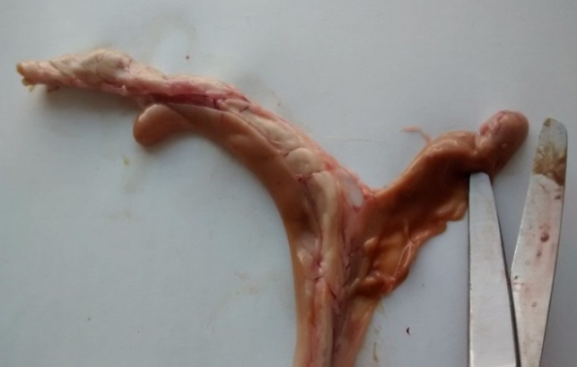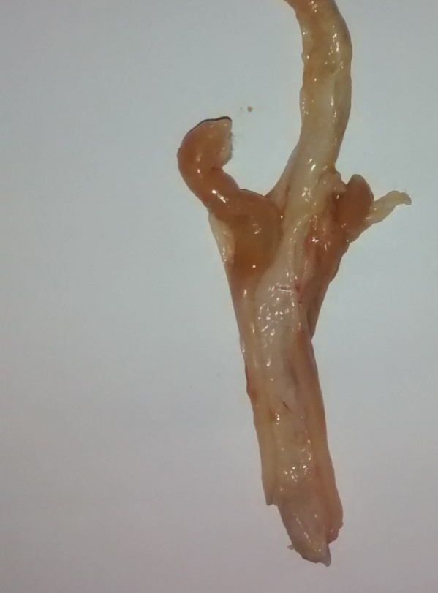

**b**

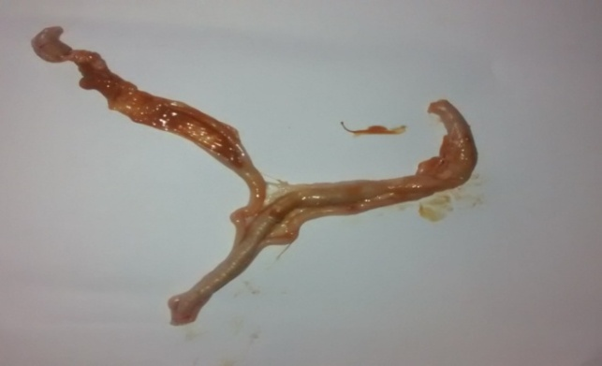

**Plate 1: Caecal and intestinal sections birds affected with coccidiocis (a)** Huge destruction of epithelium (4X) **(b)** Macrogametocyte, microgametocyte and sporozoites of *Eimeria* (40X) **(c)** Second generation sczizont (10X) **(d)** Profuge haemorrhage within the intestinal cells (4X)

**c**

**a**

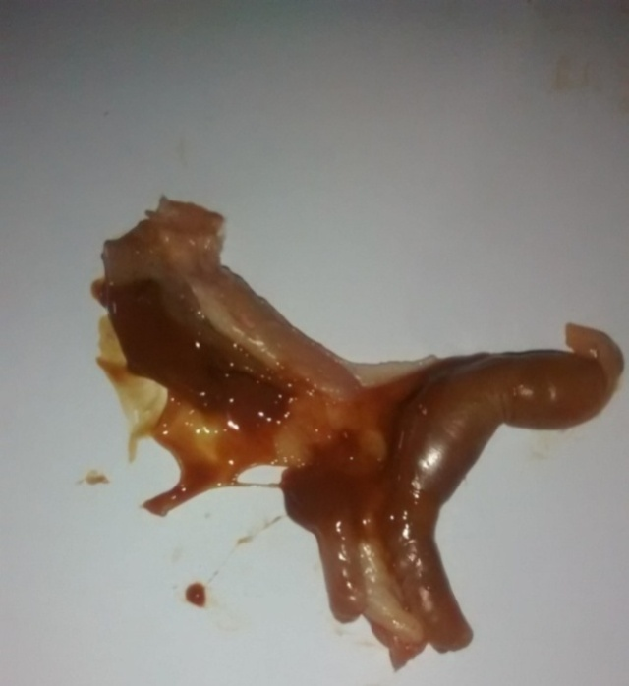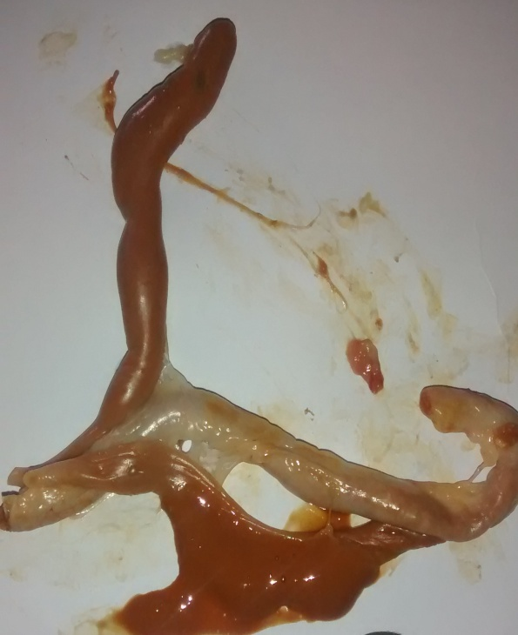

**e**

**d**

**Fig 11: Gross lesions in caecal and intestinal sections of birds affected with coccidiosis (a)** intestinal part collected from birds treated with 2% fish oil showing no visible gross lesions of coccidiosis (scored as “0”) **(b+c)** slight hemorrhage and blood mixed faeces in caecal sections taken from birds treated with 1% fish oil (scored as “1” and “2”, respectively) **(d+e)** enlarged and distended caeca with bloody faeces in birds of control (scored as “3” and “4”, respectively)

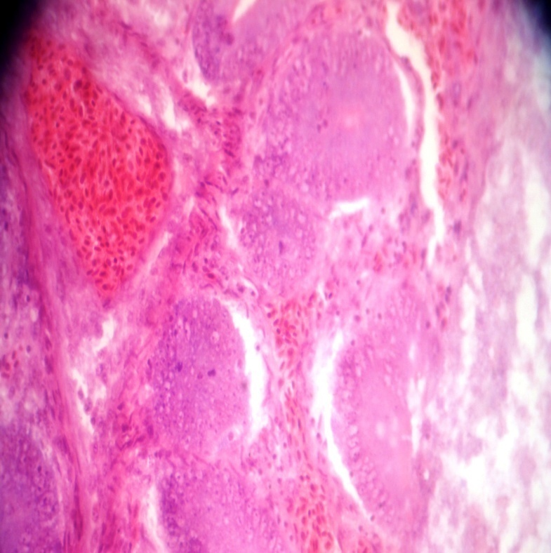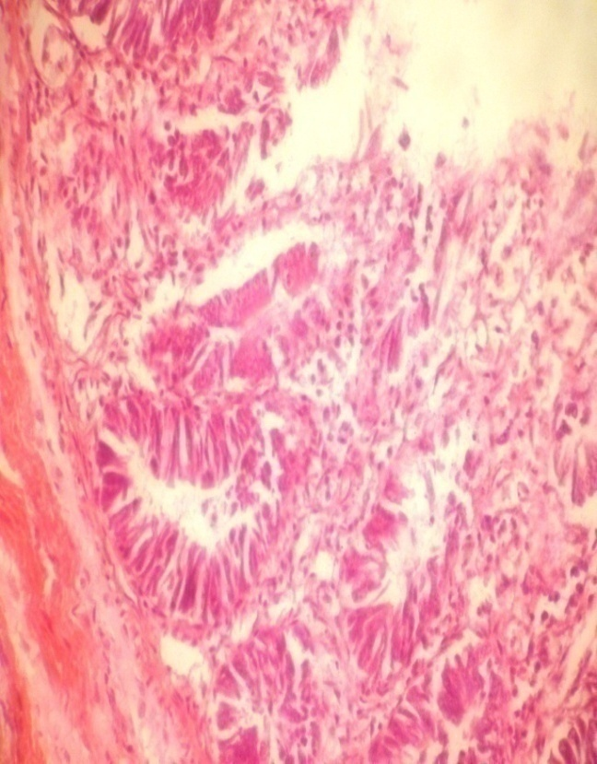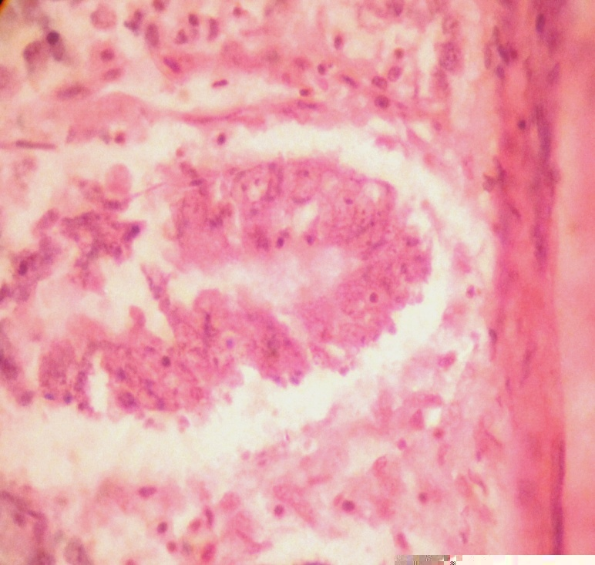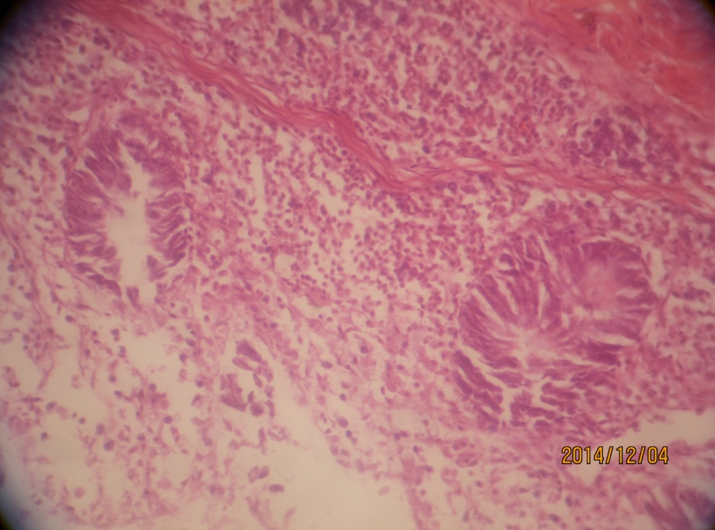**Histopathology of caecal and intestinal sections collected from coccidiosis affected birds**

**b**

**a**

**Fig 12. Caecal and intestinal sections of birds affected with coccidiosis (a)** merozoites of *Eimeria* in mucosa and submucosa of epithelial cell layers of intestine collected from birds of control group (40X) **(b)** deveplopmental stages (macrogametocyte, microgametocyte, second generation schizont and sporozoites) of *Eimeria* in intestinal sections of coccidia affected dead birds (100X) **(c)** destruction of intestinal epithelium of birds treated with 1% fish oil (40X) **(d)** profuge haemorrhage within the intestinal mucosa layer of birds of control group (40X)

**c**

**d**

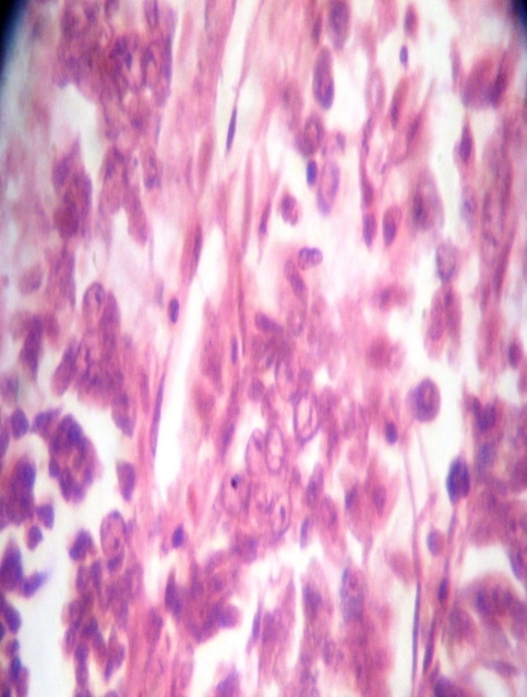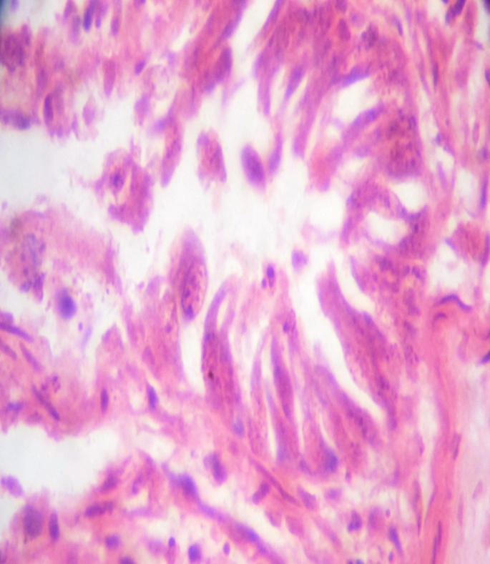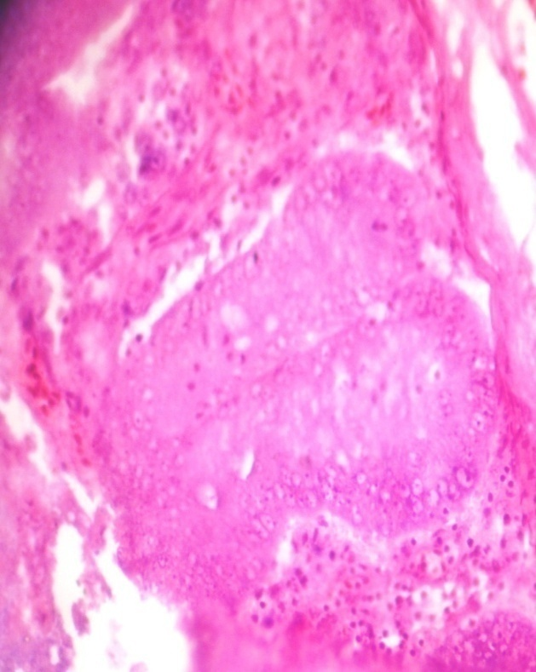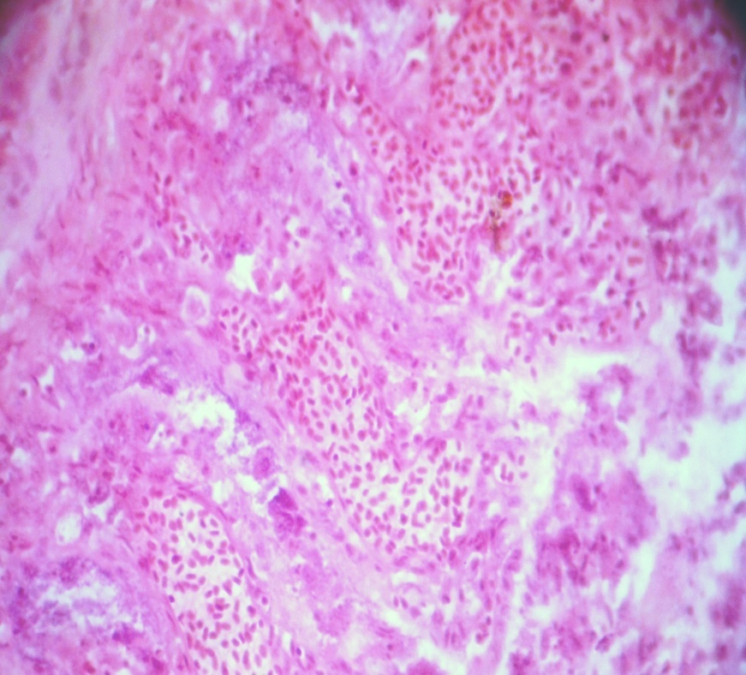

**f**

**e**

**h**

**Fig 13: Caecal and intestinal sections from coccidiosis affected birds (e)** second generation schizont of *Eimeria tenella* in caecal section taken from birds of control group (40X) **(f)** merozoites of *Eimeria* within the intestinal cells of dead birds affected with coccidiosis (40X) **(g)** macrogametocyte of *Eimeria* in caecal sections collected from birds treated with 1% fish oil (100X) **(h)** microgametocyte of *Eimeria* in caecal section of control group (100X)

**g**

**i**

**h**



**Thesis for MS in Animal Science**

# Chapter V

# Discussion

## 5.1 Effect of fish oil on growth and production performance of broilers

Feed consumption, live weight, weight gain, feed conversion (FC) at different ages of broilers and cost benefit analysis were included in this experiment.

### 5.1.1 Effect of fish oil on feed consumption of broilers

At 1st, 2nd and 3rd week of age there were no significant differences (P>0.05) in feed consumption of birds supplemented with or without fish oil (tables 4.1.1.1 to 4.1.1.3). However, significant (P<0.01) difference was observed at 4th week of age where birds supplemented with 2% and 3% fish oil in drinking water showed increased consumption of feed (table 4.1.1.4). Cumulative feed consumption was also increased significantly (P<0.01) in fish oil supplemented groups than control group at 4th week of age (table 4.1.1.5).

Saleh et al. (2009) reported that inclusion of 1.5% of fish oil in poultry diet increased feed intake which is in agreement with the present findings. In tandem with this, Das et al. (2014a) reported supplementation of 3% fish oil resulted higher (P<0.01) feed intake than those on other oils or without oils. In addition, fish meal had positive impact on the palatability of the diet (Das et al., 2014a).

In previous study it was suggested that the degree of food consumption depends on the percentage of fish oil supplemented in diet (Mansoub, 2011). Higher percentage (2% and 4%) of fish oil results in lower food consumption rate in the final period (Alparslan and Özdogan, 2006) and lower percentage (3-8 grams per kg or less than 1%) of auto oxidated fish oil (Koreleski and Świątkiewicz, 2006) or ethyl ester fish oil or glyceryl ester fish oil (Schreiner et al., 2005) leads to an improved feed consumption rate. However, increased food consumption was observed compared to the control group in a study even in higher (8.2%) percentage of fish oil (Mansoub, 2011). In another study, addition of 4% fish oil did not show negative effect on feed consumption (Lopez-Ferrer et al., 2001).

It was observed that fish oil containing diet to broilers caused lower feed intake (Hulan et al., 1988; Chekani-Azar et al., 2010). Some studies reported that daily feed intake decreased in broiler fed diet containing high polyunsaturated fatty acids or PUFA (Atteh et al., 1983; Sklan and Ayal, 1989; Huang et al., 1990). However the effect does not appear to be consistent (Skrivan et al., 2000). The cause of lower feed intake by broilers can be due to higher digestibility of the fat component of PUFA rich diet (Carino et al., 1980; Brue and Latshaw, 1985), involving a higher dietary content of metabolizable energy and thus less feed needed to meet the energy re-quirement (Das et al., 2014a).

### 5.1.2 Live weight and weekly live weight gain of broilers

The responses of broilers in acquiring live weight with or without fish oil are shown in tables (4.1.2.1-4.1.2.5). Initial body weight of birds among different groups differed slightly but those values were not significant statistically (P>0.05). It indicates a higher possibility of having similar weighted birds in different groups prior the beginning of the treatment. Live weight of broilers was improved significantly (P<0.01) in fish oil treatment groups compared to control group at 3rd and 4th week of age (tables 4.1.2.4-4.1.2.5). With increasing level of fish oil cumulative live weight was also increased significantly (P<0.01) at this period (table 4.1.2.6). At 1st and 2nd week of age, weight gain in T0 (control) and T1 (1% fish oil) dietary treatment groups was observed less compared to T2 and T3 groups (2 and 3% fish oil treated groups, respectively). However, those differences were not significant (P>0.05) statistically. Effect of fish oil was more pronounced with the advancement of age. Inclusion of fish oil to diet significantly (P<0.01) improved body weight gain of broilers at 3rd and 4th week of age (tables 4.1.3.3-4.1.3.4). Highest live weight gain was found in broilers supplemented with 3% fish oil and lowest live weight gain was in broilers of control (without oil) group at 4th week of age.

The results of increasing weight gain with the addition of fish oil in the diet of broilers is in agreement with many previous findings (Dobrzanski et al., 2002; Safamehr et al., 2008; Chekani-Azar et al., 2010; Jameel, 2014; Das et al., 2014a). Previous studies revealed that, omega-3 PUFAs improve performance, lipid profile besides increase marketing weight of broilers (Jameel, 2013; Al-Zuhairy and Alasadi, 2013; Sahib, 2013; Jameel and Sahib, 2014; Al-Zuhairy and Jameel, 2014; Jameel, 2014). Highest body weight in the dietary treatment groups containing 1.5% fish oil was observed previously (Mansoub, 2011). Das et al. (2014a) reported significantly (P<0.05) higher live weight gain with the addition of fish oil compared to control and other oil treated groups. An increased daily weight gain was further observed with the addition of 3% fish oil to the base diet compared to the control group (Dobrzansiki et al., 2002). No significant difference (P>0.05) in body weights was observed adding 2% and 4% fish oil to the base diet though the presence of 2% fish oil in the diet lead to higher value of body weight (Alparslan and Özdogan, 2006). However those results were not concordant with the findings of Navidshad (2009) who reported a decreased daily weight gain in the broilers consuming fish oil.

Oils have always been used in the diets of broilers as a source of energy. It has a number of other advantages including, increased palatability, absorption and digestion of lipoproteins and decreased dustiness of poultry diets. Absorption of vita-min A, vitamin E and Ca is also promoted with the addition of oil (Das et al., 2014a; Leeson and Atteh, 1995). Polyunsaturated fatty acids are important constituents of the immune cell structure and eicosanoid formation (Stulnig, 2003; Jameel, 2014). Dietary supply of omega-3 PUFAs affect the development of a strong immune system in birds, increase poultry productivity, reduces disease and thereby contributing to increase economic returns to poultry industry (Gonzales, 2009). It was reported that fish oil contains omega-3 fatty acids (PUFA) specifically eicosapentaenoic acid (EPA) and docosahexaenoic acid (DHA), are being an important factor in the diet for promoting health in human and animals (Chekani-Azar et al., 2007). Fish oil has been administered to poultry diet to enhance production performance and immune responses. It is one of the available sources used in the diet to provide energy for fowls while its supplementation has been shown to improve body weight gain, feed conversion ratio of poultry (Schreiner et al., 2005; Alparslan and Özdogan, 2006; Farhoomand et al., 2009). The digestibility of fat is increased as the degree of unsaturation increases (Newman et al., 1998; Lopez ferrer et al., 2001; Farhoomand and Chekani-Azer, 2009). Therefore, the good performance of fish oil fed broiler may be related to the fatty acid composition of the fish oil.

Similar to weight gain, supplementation of oil showed positive trend in cumulative live weight gain (g/broiler) of broilers at different ages (Table 4.1.3.5). Significant (P<0.01) increase in cumulative live weight gain in both 3rd and 4th week of age was observed among the birds supplemented with 2 and 3% fish oil compared to diet with 1% fish oil and without fish oil, respectively (table 4.1.3.5). However differences among broilers of different treatments up to 2nd week of broilers had no significant (P>0.05) variation. There was a trend of highest cumulative weight gain in case of fish oil receiving group and this gain was increased with increasing (2% and 3%) fish oil percentage. This result is in agreement with (Das et al., 2014a) who recorded significantly (P<0.05) higher cumulative weight in 3% fish oil supplemented group in comparison with other oil group or without oil group at the 4th week of age.

### 5.1.3 Effect of fish oil feed conversion (FC) of broilers

The weekly feed conversion at different ages of broilers fed diets supplemented with or without fish oil is presented in table’s 4.1.4.1.-4.1.4.5. The analysis of data revealed that supplementation of fish oil at different percentages revealed no significant (P>0.05) impact at 1st week of age of broilers among different treatment groups (table 4.1.4.1). Feed conversion was significantly better in the birds receiving 2 and 3% fish oil with regular drinking water 2nd (P<0.05) and 3rd  (P<0.01) week of age (tables 4.1.4.2-4.1.4.3). However, best FC was found in broilers supplemented with 2% fish oil at 4th week of age which differed significantly (P<0.01) from other groups. Next to this group 3% fish oil supplemented groups showed improved FC (table 4.1.4.4). Cumulative feed conversion was also varied among different treatment groups at different week periods which was better in fish oil treatment groups compared to control group (table 4.1.4.5).

Similar findings of better feed conversion with supplementing fish oil to broilers were recorded previously by several researchers (Saleh et al., 2009; Chekani-Azar et al., 2010; Das et al., 2014a). Chekani-Azar et al. (2010) recorded better feed con-version in broilers supplemented a diet with fish oil other than control. Working with different kind of oils observed that palm oil group showed the least feed conversion value than other oil treated groups. But the best feed conversion was observed in fish oil treatment group (Das et al., 2014a). It is reported that feed conversion improved when diet contained 1.5% fish oil (Saleh et al., 2009).

There are some disagreements in the findings of the present study with some previous findings of some authors (Hulan’s et al., 1988; Abas et al., 2004; Navid-shad, 2009). It was observed earlier that daily feed intake and feed conversion was not affected by dietary fish oil (Navid-shad, 2009) and different fat sources and their level of inclusion in the diets did not affect the feed conversion of broilers (Pesti et al., 2002; Abas et al., 2004).

However an improved feed conversion was observed in broilers in some previous studies with increasing dietary PUFA intake (Pinchasov and Nir, 1992; Zollitsch et al., 1997). Several researchers in previous studies have revealed that the digestibility of fat increases as the degree of unsaturation increases (Newman et al., 1998; Lopez-Ferrer et al., 2001; Farhoomand and Chekani-Azer, 2009). Good performance of fish oil fed broilers may be related to the fatty acid composition of fish oil (Das et al., 2014a).

### 5.1.4 Effect of fish oil on cost benefit analysis of broilers

The data on cost-benefit analysis are presented in Table 4.1.5. According to the table, there were no significant (P>0.05) difference was observed in chick cost (Tk./chick), management cost (Tk./broiler). However, significant (P<0.05) difference was observed on total feed cost (Tk./broiler), total cost (Tk./broiler) and total cost (Tk./kg live broiler) among the different treatment groups. In terms of profit, net profit (Tk./broiler) and net profit (Tk./Kg live broiler) were differed significantly (P<0.05) among the treatment groups. Significant increase (P<0.05) in profit was observed with increasing level of fish oil. 2 and 3% fish oil supplemented groups showed significantly higher (P<0.05) profit compared to control and 1% fish oil supplemented groups. Similar result was described by Das et al. (2014a) who reported higher net profit from fish oil supplemented birds than birds supplemented with soybean oil.

## 5.2 Effect of fish oil on coccidiosis prevention of broilers

Several researchers in previous studies recorded that omega-3 PUFAs improve immunity of broilers (Jameel, 2013; Al-Zuhairy and Alasadi, 2013; Sahib, 2013; Jameel and Sahib, 2014; Al-Zuhairy and Jameel, 2014; Jameel, 2014; Jameel, 2014). Control of Coccidiosis is possible by inclusion of omega-3 fatty acids in the diet. In previous study omega-3 fatty acids afforded some protection against malaria. Effect of these fatty acids on prevention of coccidiosis was investigated following this postulation (Levander et al. 1992). With activity of coccidian in the host a fall in the total plasma carotenoids was observed (Allen et al., 1996b; Allen and Danforth, 1998). Allen (1997) reported that levels of free radicals is increased (i.e. peroxynitrite) as the end products of nitrite and nitrate in the blood.

Researchers have reported that because of high amount of eicosapentaenoic acid (EPA) and docosahexaenoic (DHA), fish oil is a valuable ingredient to enrich poultry meat (Chanmugam et al., 1992; Pinchasov & Nir, 1992; Navidshad, 2009). Highly unsaturated omega-3 fatty acids - DHA, EPA and linolenic acid infiltrate tissues of the parasite which become more susceptible to oxidative attack by phagocytic cells. The oxidative stress adversely affects development of coccidia. The unsaturated fatty acids are incorporated into the membranes ofdifferent spp. of *Eimeria* (Baker, 1982). Growth of these parasites involves a continual turnover of their membranes. The composition of which is influenced by dietary fatty acids. These parasites are highly susceptible to oxidation by free radical production of leucocytes which bombard the coccidia (Spurney et al., 1994; Allen, 1997).

Fish oil also acts as an anti-inflammatory agent decreases inflammatory cell production of LTB4 (Miller et al., 1993). It increases production of LTB5 in mammals (Klasing, 1994). The LTB5 produced from omega-3 (n-3) fatty acids is only 1/8th as potent a chemoattractant as the LTB4 from omega-6 (n-6) fatty acids. The former reduces the recruitment of pro-inflammatory agents, that is, it is less inflammatory. Korver et al. (1997) also postulated reduced production of the proinflammatory cytokines, IL-1 and TNFα by fish oil feeding to poultry.

### 5.2.1 Signs and lesions of coccidiosis

In this experiment birds from T0 (without fish oil) and T1 (1% fish oil) groups developed signs of coccidiosis including bloody diarrhoea and weight loss. At necropsy all the birds from T0 and T1 groups revealed lesions of coccidiosis which were characterized by enlarged and distended caeca filled with blood and petechial hemorrhages in some parts of the lower intestine (Figure 11). The severity of infection was more in control group than 1% fish oil treatment group. The signs and lesions of coccidiosis are similar as those mentioned by several authors (Siddiki et al., 2008; Raman et al., 2011, Adamu et al., 2013). Lesion scoring was done to see the degree of infection. All the birds from control group developed severe lesions and scored from +3 to +4 according to the method described by Johnson and Reid (1970). Due to reduction of lesion birds from 1% fish oil treated group were scored between +1 to +2. However birds from T2 (2% fish oil) and T3 (3% fish oil) groups were uninfected and developed no lesions of coccidiosis. They were scored 0 in lesion scoring method. Large no. of oocysts was also observed in faeces of infected birds. The mean no. of oocysts was recorded daily from per gram of faeces which were highest in control group compared to group supplemented with 1% fish oil (Table 4.2.1). The difference in no. of oocysts among the groups was significant (P<0.01), statistically.

Similar findings were also observed in previous studies of some researchers (Allen et al., 1996a; Allen and Danforth, 1998). They recorded that lower level of fish oil (1%) reduce lesion score of coccidiosis non-significantly (P>0.05). Dietary 2.5% and 5% fish oil showed progressively greater reductions of coccidiosis lesions (Allen et al., 1996a). Allen and Danforth (1998) reported a significant (P<0.05) reduction of GI lesion score resulted from coccidiosis with the addition of 5% fish oil to basal diet of broilers. A striking reduction in the number of parasites within the epithelial cells of caeca with microscopic examination was also observed. No further improvement in lesion score was observed when fish oil was increased to 10%. Reduced lesion of coccidiosis was also reported in same study with addition of 10% flax and linseed (sources of carbon 18 omega-3 fatty acids) but less effectively than 5% fish oil. The findings of Allen et al. (1997) postulated that lesion caused by *E. maxima* was reduced by 5% menhaden oil compared to control group but this reduction was not significant (P>0.05). Korver et al. (1997) compared performance of broilers with the addition of 4% corn and fish oil. Fish oil reduced lesion scores insignificantly (P>0.05). Decreased plasma TNFα was observed with the addition of fish oil which indicates that it reduces inflammatory processes.

### 5.2.2 Faecal oocyst output

Significantly (P<0.05) higher no. of oocysts were found in coccidian infected birds (control and 1% fish oil treatment groups) in faecal oocysts count. However no *Eimeria* oocysts were found in 2 and 3% fish oil treatment groups (table 4.2.1). Similar observation was also recorded by Siddiki et al. (2008).

### 5.2.3 Histopathological changes

Histopathological examination of the affected intestines sections (collected from control and 1% fish oil treatment group) revealed characteristic microscopic signs of coccidiosis (Figure 12, 13). Severe tissue damage was observed in the epithelium of caecum. Excessive tissue damage, haemorrhage, presence of second generation schizont, disruption of the caecal glands and destruction of the mucosa and muscularis layer were evident in histopathological examination. Similar findings were also recorded previously by other researchers (McDougald and Fitz-Coy, 2008; Adamu et al., 2013). Large no. of schizonts was revealed from histopathology of *E. brunetti* at 8th day of infection. These lesions were similar to the findings of some researchers (Kaufmann, 1996; McDougald and Fitz-Coy, 2008; Adamu et al., 2013). Microgametes and macrogametes of schizonts were observed in tissue on caecum of infected birds. Matured oocysts and merozites were released into the lumen in huge numbers. Similar findings were also recorded by (Getachew, 2004; Mersha et al., 2009; Adamu et al., 2013).

### 5.2.4 Haematological changes

From tables 4.2.2-4.2.4 it can be noted that the no of RBC, PCV and Hb was decreased significantly (P<0.05) in birds with 1% fish oil and control (coccidian infected groups) compared to 2% and 3% fish oil treatment groups (uninfected groups). This is due to huge destruction of RBC by different pathogenic species of *Eimeria* leading to haemorrhage of affected cells. Data from previous studies revealed that coccidiosis caused by *E. tenella* and *E. brunette* induced a higher reduction in TRBC and PCV (Irizaary-Rovira, 2004; Wakenell, 2010; Adamu et al., 2013). Fukata et al. (1997) reported lower counts of TRBC and PCV in chickens infected with *E. tenella* and *E. acervulina* compared to the uninfected controls. Similar findings was also observed by Ogbe et al. (2010) who reported a slight drop in the PCV, Hb and RBC counts in *E. tenella* infected broilers. A lowest Hb and total erythrocyte count (TEC) have been demonstrated in quail chicks after infection with *E. tenella* experimentally (Razzaq et al., 2003). The most common erythrocyte abnormality in birds is anemia which is characterized by decreased PCV, RBCs, and Hb. Anemic birds contain less than 35% PCV. The causes of reduction of RBC are loss of blood into the gastrointestinal tract (external blood loss) and infectious diseases (Irizaary-Rovira, 2004; Adamu et al., 2013). Moreover, it is reported that addition of 0.5 % of fish oil to the base diet have a significant (P<0.05) effect in improving in RBCs, PCV and Hb level in blood (Patra et al., 2010).

Tables 4.2.5-4.2.8 are represented with the values from differential WBC (leukocyte) count of broilers which were or not affected by coccidiosis. An increased numbers of lymphocytes, monocytes, eosinophils and heterophils were obtained in birds affected with coccidiosis (control and 1% fish oil treatment groups). Those values were compared with the reference values indicated by Merck Veterinary Manual (2011). Similar findings were also mentioned by some authors (Rose et al., 1979; Adamu et al., 2013). It was reported that infection with *E. maxima* and *E. acervulina* in chicken shows the increment in the number of peripheral blood leukocytes (PBL). The number of PBL increased biphasically and changes were found in the count of polymorphonuclear cells, lymphocytes and large mononuclear cells in primary infections (Rose et al., 1979; Adamu et al., 2013). High counts of lymphocytes, heterophils and eosinophils in parasite (malaria and haemosporidin) infected birds were also recorded by some researchers (Ricklefs and Sheldon, 2007; AL-Mayah, 2009). Increase in lymphocyte count may be attributed to the effect of the inflammation of the caeca and intestine (Adamu et al., 2013). In a greatly expanded circulating lymphocyte pool chronic antigenic stimulation may result. The primary functions of the lymphocytes are immunological response, humoral antibody formation and cell mediated immunity (Irizaary-Rovira, 2004). Cell-mediated immunity plays a major role in resistance to infection as T lymphocytes appear to respond to coccidial infection through both cytokine production and a direct cytotoxic attack on infected cells. A minor role is played by antibody mediated responses in protection against coccidiosis (Lillehoj and Trout, 1996; Yun et al., 2000; Adamu et al., 2013). Bessay et al. (1996) reported that *E. tenella* infection is rapidly induced locally at the site of the parasite development in an increased proportion to the CD4+ cells on day 8 post infection and CD8+ cells on days 6 and 8 post infection in caecal intraepithelial lymphocytes of infected chicken (Bessay et al., 1996).

### 5.2.5 Biochemical changes

Serum biochemical analysis of birds from different groups represented a significant (P<0.05) reduced level of alanine aminotransferase (ALT) and aspartate aminotransferase (AST) in control and 1% fish oil dietary treatment groups (coccidian infected) significantly (P<0.05) at 30 days of age of broilers (tables 4.2.9-4.2.10). These results are in agreement with the findings of some authors (Alparslan and. Özdogan, 2006; Mondal et al., 2011; Adamu et al., 2013). They reported that ALT and AST decreased in broiler chickens infected with a field isolate of *Eimeria* spp. On the other hand, the present findings were different from the previous studies indicated by Biu et al. (2006) who reported that the ALT level was increased while ALP activity was decreased in mixed coccidian-infected chickens. Mondal et al. (2011) demonstrated that plasma AST activity was increased in infected broiler chickens with a lower dose of *E. tenella*. A decrease in plasma enzyme levels is much less frequently used for clinical interpretation. However, there are a few specific cases where low plasma enzyme levels will indicate that the relevant organ is hyperplastic, atrophied or destroyed (Kerr, 2002). ALT and AST are the enzymes found in erythrocytes; therefore, the decrease in the activities of serum ALT and AST reported in the present study may be associated with the high reduction of erythrocytes because of the loss of blood into the gastrointestinal tract (Adamu et al., 2013).

## 5.3 Effect of fish oil on different blood parameters of broilers

Blood parameters tested in this experiment were: total serum cholesterol, HDL-cholesterol, LDL-cholesterol, triglycerides, total protein and albumin, respectively.

### 5.3.1 Effect of fish oil on total serum cholesterol of broilers

The average serum cholesterol content of broilers at different ages of growth fed diets supplemented with fish oil at different percentage or diet without fish oil has been presented in table 4.3.1. Both at 15th and 30th day of age there were significant (P<0.01) variations among mean values of total serum cholesterol level of birds among different treatment groups. Highest values of total serum cholesterol level were found in bird without fish oil at 15th and 30th day of age. Second highest value was found in birds with 1% fish oil. With increasing percentage of fish oil, level of total serum cholesterol was gradually reduced. Both 2% and 3% fish oil supplemented groups showed lower level of total serum cholesterol compared to control group and these differences were significant statistically (P<0.01). All these results indicate that with the addition of fish oil to broiler diet, amount of cholesterol is decreased. These results are in agreement with the findings of other studies (Das et al., 2014b; Mansoub et al., 2011; Saleh et al., 2009; Newman, 2002; Celebi and Utlu, 2006). However, a few studies observed that the level of serum cholesterol was not affected noticeably by dietary fish oil (Alparslan and. Özdogan, 2006). This result is in contradiction with our findings. This difference may be attributed to the genetic, sex and dietary factors (Saleh et al., 2009).

It was reported that lipid content of serum reduced as the levels of dietary PUFA increased (Celebi and Utlu, 2006). Diets containing omega-3 and omega-6 fatty acid decreases both plasma cholesterol and triglyceride levels compared to diets with saturated fatty acids (Newman et al., 1998). Alteration of fluidity and composition of plasma cell walls can lead to this difference caused by enrichment of diet with omega-3 fatty acids in fish oil (Manilla et al., 1999; Alparslan and Özdogan, 2006; Mansoub et al., 2011). Decreased cholesterol and triglyceride contents in serum of birds can be resulting due to presence of polyunsaturated fatty acids from direct depot from diet (that is more appropriate) or conversion from precursors by denovo synthesis (desaturation and elongation) in liver and tissue . But, several factors influence the activities of desaturases and elongases (Cook, 1981; Mansoub et al., 2011).

### 5.3.2 Effect of fish oil on serum HDL-cholesterol level of broilers

Values for average HDL-cholesterol of broilers at 15th and 30th day of age fed on diets supplemented with or without fish oil are presented in table 4.3.2. Supplementation of oils caused a significant (P<0.01) impact on HDL-cholesterol level in blood of broilers. Higher values of HDL-cholesterol were found in dietary fish oil supplemented groups compared to control group. 3% fish oil supplemented group showed highest HDL-cholesterol compared to others. The second largest values were seen in birds with 2% fish oil supplemented group. Among these groups, lowest values (P<0.01) were observed in control group both at 15th and 30th day. However it was observed that there was a tendency of gradual increase in HDL-level with the advancement of age. HDL-cholesterol content was higher at 30th day in comparison with 15th day both in fish oil or without fish oil supplemented groups.

The trend of increased HDL-cholesterol level of broilers with soybean and fish oil groups compared to palm oil was recorded by Das et al. (2014b). Blood HDL-cholesterol levels were the highest for fish oil supplemented groups with the advancement of age. Inclusion of oil in low energy diet caused an increase HDL level in serum of broilers (Monfaredi et al., 2011). Researchers reported that low HDL are values associated with atheroschlorosis and coronary heart disease in human (Couderc and Machi, 1999; Crespo and Esteve-Garcia, 2003; Mansoub et al., 2011). Regular diet has an effect on the levels of HDL in blood. It was claimed that in a healthy body the level of HDL is high (Bachorik et al., 1991; Alparslan and. Özdogan, 2006).

### 5.3.3 Effect of fish oil on serum LDL-cholesterol level of broilers

The data of serum LDL-cholesterol level of broilers at different stages of growth fed on fish oil in different percentages or without fish oil are presented in table 4.3.3. LDL-cholesterol level of blood varied significantly (P<0.01) among the different treatment groups. At 15th day, LDL-cholesterol level was significantly (P<0.01) higher among the broilers in which no fish oil was supplemented. Similar observation was also seen at 30th day. However with increasing fish oil percentage there was a decrease in LDL-cholesterol level. 1% fish oil dietary supplemented groups showed highest values among the fish oil supplemented groups both at 15th and 30th day of age. 3% fish oil supplemented groups showed lowest value of LDL-cholesterol at 15th day. At 30th day, 2% fish oil supplemented group showed slightly highest value compared to 3% fish oil supplemented group. In a study carried out by Alparslan and Özdogan (2006), significantly (P<0.05) higher level of HDL was seen in serum of broilers with 2% fish oil compared to control group. Das et al. (2014b) also observed lower level of LDL in serum of broilers supplemented with 3% fish oil but the values were insignificant (P>0.05).

It was reported that omega-3 fatty acids reduce the blood VLDL levels, acting to lower the circulating free LDL concentration (Crespo and Esteve-Garcia, 2003; Mansoub et al., 2011). Animal growth and product quality can be improved by the marine and vegetable origins sources rich in LC -3 PUFA due to lesser LDL and thus lesser cholesterol and triglyceride contents of body (Ozdogan and Aksit, 2003; Grundy, 1991). In a healthy human and animal body the level of LDL is low (Bachorik et al., 1991; Alparslan and Ozdogan, 2006). Atheroschlorosis and coronary heart disease is associated with higher level of LDL in blood (Couderc and Machi, 1999; Crespo and Esteve-Garcia, 2003; Mansoub et al., 2011).

### 5.3.4 Effect of fish oil on serum triglycerides level of broilers

Table 4.3.4 shows the effect of supplementation of fish oil or without fish oil in the regular diet of broilers in the triglyceride content of broilers. Data in the table show that supplementation of oil resulted a great effect on triglyceride level of blood. Significantly (P<0.01) higher level of triglyceride content was seen in blood of broiler group without dietary fish oil. Lowest values of triglyceride level were recorded in blood of broilers with 2% fish oil supplemented groups both at 15th and 30th day of age. Several studies were in agreement with the present findings of decreased triglyceride level in the blood of broilers supplemented with fish oil (Mansoub et al., 2011; Saleh et al., 2009). Alparslan and Özdogan (2006) observed lower level of triglyceride with 2 and 4% fish oil compared to control group though the values were not statistically significant (P>0.05). Das et al. (2014b) observed significantly (P<0.05) lower triglyceride with fish oil at the end of experiment in the group with dietary fish oil indicating its beneficial effect on broilers.

Researchers showed that marine sources are rich in PUFA which contribute to lower triglyceride contents of body of human, animal and birds (Grundy, 1991; Ozdogan and Aksit, 2003; Mansoub et al., 2011). Omega-3 fatty acids reduce the rate of triglyceride synthesis in the liver (Crespo and Esteve Garcia, 2003; Mansoub et al., 2011).

### 5.3.5 Effect of fish oil on serum glucose level of broilers

Effect of supplementation of fish oil in the diet of broilers at glucose level has been presented in Table 4.3.5. There was a significant (P<0.01) difference of glucose values among the different dietary treatment groups. Glucose level of blood of broilers was lowest in group without fish oil both at 15th and 30th day of age compared to other groups. The second lowest values were found in blood of broilers with 1% fish oil irrespective of ages. However, significantly (P<0.01) higher amount of glucose level were found in 2% and 3% fish oil supplemented groups both at 15th and 30th day of age. It can be indicated from those results that fish oil affects on increased glucose level of blood of broilers. Mansoub et al. (2011) also recorded higher level of glucose in 3% fish oil supplemented groups compared to group without fish oil. Touchburn et al. (1981) recorded higher level of glucose with supplementation of fish oil in diet of broilers.

Because of decline in insulin secretion diet rich in polyunsaturated fatty acid increase the amount of serum glucose (Grill et al., 2000; Storlien et al., 2000; Mansoub et al., 2011). Researchers showed that feeding dietary fish and fish oil / meal to human and animals, a significant (P<0.05) decrease in blood pressure could be achieved (Mori et al., 1999). It was observed that long chain n-3 enrichment of a high-saturated fat diet exerted a rapid effect to lower insulin secretion from the islets of langerhans and thus helps in raising the plasma glucose concentration (Crespo and Esteve-Garcia, 2003).

Omega 3 fish oil has such a powerful effect on fat and carbohydrate metabolism. The insulin levels secretion can be changed in diet by supplying to FO as a source of omega-3 PUFAs (Crespo and Esteve-Garcia, 2003; Mansoub et al., 2011). Insulin reduces the use of fat for fuel and also promotes fat storage in the presence of excess calories. Action of hormone sensitive lipase is inhibited by insulin. Lipase is responsible for breaking down of stored fat and preparing it for use of energy. Insulin also activates an enzyme, which, along with fatty acid synthesis, is responsible for converting carbohydrate into fat (Mark et al., 2004). More fat to be used for energy accompanying ultimately raises blood glucose due to drop in insulin levels when diet supplemented with fish oil (Mansoub et al., 2011).

### 5.3.6 Effect of fish oil on serum total protein (TP) and albumin level of broilers

Table 4.3.6 shows the protein level in serum of broilers at different ages with or without supplementation of fish oil in regular drinking water of broilers. A significant (P<0.01) difference was observed among different dietary groups where fish oil supplemented groups showed lower albumin level in blood of broilers in comparison with groups fed without fish oil. Higher level of albumin was observed in control and 1% fish oil supplemented groups (Table 4.3.7). With increasing percentage of fish oil (2 and 3%) there was a decrease in values of total protein at 15th and 30th day of age in comparison with lower percentage (1%) and control group. This result is in agreement with the findings of Mansoub et al. (2011). Previous studies revealed a decreased level of total protein (TP), albumin and globulin level in blood of broilers with supplementation of fats rich in PUFA (Touchburn et al., 1981) and with supplementation of fish oil (Mansoub et al, 2011). Decrease in protein density can be due to increase lipid/protein ratio (Olomu and Baracos, 1991; Mansoub et al., 2011). However increased level of total protein, albumin recorded by AL-Mayah (2009) with the addition of fish oil is in disagreement with the present findings.



**Thesis for MS in Animal Science**

# Chapter VI

# Conclusion

The current study evidenced that at initial period there was no significant (P>0.05) variation in body weight among different experimental groups though at 3rd and 4th week of age of broilers, there was a significant (P<0.01) increase in live weight, weight gain in 2% and 3% fish oil treatment groups compared to control and 1% fish oil treatment groups. It was also observed that the feed intake of birds did not differ significantly (P>0.05) among different groups upto 2nd week of age. However, significant diffences in feed intake were found at 3rd (P<0.05) and 4th (P<0.01) week. Further, feed consumption was increased in fish oil treatment groups compared to control group. Significantly (P<0.01) higher feed conversion was observed in control and 1% fish oil treatment groups. Cumulative feed conversion was better in 2 and 3 percent fish oil treatment groups. Besides these, birds treated either with 2% or with 3% fish oil in regular drinking water of broilers showed a high immune response and effectively reduced signs and intestinal lesions caused by coccidiosis. Fish oil treatment groups also revealed significantly (P<0.01) increased HDL-cholesterol, glucose level and decreased cholesterol, LDL-cholesterol, triglycerides, total protein, albumin, globulin level in blood in broilers. Normally higher HDL-cholesterol and lower cholesterol, triglycerides, LDL-cholesterol level are found in blood of healthy body.

In this study, fish oil treatment groups revealed higher body weight than control group and effectively reduced coccidial signs and lesions. From the above discussion, it can be concluded that supplying 2% or 3% fish oil in regular drinking water will be effective both in increasing market weight and preventing coccidiosis of broilers.



**Thesis for MS in Animal Science**

# Chapter VII

# Recommendations

Fish oil or any other elements containing polyunsaturated fatty acids can be added to broiler diets to increase immunity of broilers. Besides these, fish oil increases market weight of commercial broilers by improving digestibility of feed. In this experipent, it is revealed that supplementation of 2% or 3% fish oil in regular drinking water of broilers successfully increase growth performance and decrease coccidiosis in commercial broilers.

As it is a pilot study, further study may be done on similar work to make a concrete remark. Substantial works on coccidiosis based on experimental infections, feeding, drug and vaccine trials have been performed over many years. However, reports on infection prevalence, infection levels and frequencies of the different *Eimeria* species in commercial poultry productions are few and sporadic. More knowledge of the etiology and population dynamics of mixed coccidial infections in commercial poultry production is therefore needed. Prevalence of diseases should also be evaluated continually.

However, based on above discussions it may be recommended that, 2% fish oil may be supplied in regular drinking water of broilers to make economically benefited ration and as a preventive dose for coccidiosis.



**Thesis for MS in Animal Science**

**Chapter VIII**

# References

Abas I, Ozpinar H, Kahraman R, Kutay HC, Eseceli H, Grashorn MA. 2004. Effect of dietary fat sources and their levels on performance of broilers. [Archiv Fur Geflugelkunde](http://libra.msra.cn/Journal/8746/arch-geflugelk-archiv-fur-geflugelkunde). 68: 145-152.

`Adamu M, Boonkaewwan C, Gongruttananun N, Vongpakorn M. 2013. Hematological, Biochemical and Histopathological Changes Caused by Coccidiosis in Chickens. [Natural Science](https://www.google.com.bd/url?sa=t&rct=j&q=&esrc=s&source=web&cd=1&cad=rja&uact=8&ved=0CBwQFjAA&url=http%3A%2F%2Fkasetsartjnatsci.kasetsart.org%2F&ei=k1ahVJS8N5SJuASO8oDICQ&usg=AFQjCNEAoW7Ff6SBlGl0I4GtkL0q8YoVUw&sig2=XKQCINfKOTon7wnea9AFGA). 47: 238-246.

Ali MM, Hossain MM. 2012. Problems and prospects of poultry industry in Bangladesh: an analysis. AIUB Bus Econ working paper series. pp: 1-18.

Allen PC, Danforth HD, Augustine PC. 1998. Dietary modulation of avian coccidiosis. International Journal for Parasitology. 28: 1131-1140.

Allen PC, Danforth HD, Levander OA. 1994. High dietary levels of flaxseed oil and fish oil lower cecal lesion scores in broiler chickens infected with the cecal parasite, *Eimeria tenella*. proc. 55th flax inst. pp: 123-126.

Allen PC, Danforth HD, Levander OA. 1996a. Diets high in n-3 fatty acids reduce cacal lesion scores in chickens infected with *Eimeria tenella.*Poultry Science. 75: 179-185.

Allen PC, Danforth HD, Levander OA. 1997. Interaction of Dietary Flaxseed with Coccidia Infections in Chickens. Poultry Science. 76: 822-827.

Allen PC, Danforth HD. 1998. Effects of dietary supplementation with n-3 fattyacid ethyl esters on coccidiosis in chickens. Poultry Science.77: 1631-1635.

Allen PC, Fetterer RH. 2002. Recent advances in biology and immunobiology of Eimeria species and in diagnosis and control of infection with these coccidian parasites of poultry. Clinical Microbiology Reviews. 15(1): 58-65.

Allen PC, Patricia C, Danforth HD, Augustine PC. 1998. Dietary modulation of aviancoccidiosis. International Journal for Parasitology. 28: 1131-1140.

Allen PC. 1997. Production of free radical species during *Eimera maxima*infections in chickens. Poultry Science. 76: 814-821.

Allen, Patricia C, Danforth HD, Augustine PC. 1998. Dietary modulation of aviancoccidiosis. [International Journal for Parasitology](http://www.journals.elsevier.com/international-journal-for-parasitology/). 28: 1131-1140.

Allen, Patricia C, Danforth HD, Levander OA. 1996a. Diets high in n-3 fatty acidsreduce cecal lesion scores in chicks infected with *E.tenella.* Poultry Science. 75: 179-185.

Allen, Patricia C, Danforth HD, Levander OA. 1997. Interaction of dietary flaxseedwith coccidia infections in chickens. Poultry Science. 76:822-827.

Allen, Patricia C, Danforth HD, Morris VC, Levander OA. 1996b. Associationof lowered plasma carotenoids with protection againstcecal coccidiosis by diets high in n-3 fatty acids. Poultry Science. 75: 966-972.

Allen, Patricia C, Danforth HD. 1998. Effects of dietary supplementation with n-3 fattyacid ethyl esters on coccidiosis in chickens. Poultry Science. 77: 1631-1635.

AL-Mayah AS. 2009. Effect of fish oil on humoral immunity of broiler chicks. British journal of veterinary research. 8 (2): 23-24.

Alparslan G, Özdogan M. 2006. The effects of diet containing fish oil on some blood parameters and the performance values of broilers and cost efficiency. International Journal of Poultry Science. 5 (5): 415-419.

Al-zuhairy MA, Alasadi YJ. 2013. Effect of in ovo injection with Newcastle disease vaccine, multivitamins AD3E, and omega-3 on performance and immune response of broiler. International Journal of advanced Biological Research. 3(2): 208-211.

Al-zuhairy MA, Jameel YJ. 2014. Effect of ND Vaccine, Multivitamins AD3E, and Omega-3 on Performance and Immune Response of Broilers. [Mirror of research in veterinary sciences and animals](http://www.google.com.bd/url?sa=t&rct=j&q=&esrc=s&source=web&cd=2&cad=rja&uact=8&ved=0CCEQFjAB&url=http%3A%2F%2Fmirrorofresearchinveterinarysciencesandanimals.com%2F&ei=sJmpVOeVG8WPuAT924DoCQ&usg=AFQjCNGMsS8-sxCISk7l82cLD3Egc--Qgg&sig2=b2jrut9Ox2s2Iu0uaxOcRw). 3(1): 42-50.

Amare A, Mengistu A and Nazir S. 2012. Prevalence and etiology of poultry Coccidiosis and associated risk factors in white leghorn grower chickens at Kombolcha Poultry Farm, Ethiopia*.* Journal of World's Poultry Research. 2(3): 54-59.

Arakawa A, Xie MQ. 1993. Control of coccidiosis in chicken. Journal of Protozoology Research. 3: 31-39.

Ashenafi H, Tadesse S, Medin G, Tibbo M. 2004. Study on coccidiosis of scavenging indigenous chickens in central Ethiopia. Tropical Animal Health and Production. 36: 693-701.

Atteh JD, Leeson S, Julian RJ. 1983. Effect of dietary level and types of fat on performance and mineral metabolism of broiler chicks. Poultry Science. 62: 2043-2411.

Bachorik PS, Levy RI, Rifkind BM. 1991. Lipids and Dyslipoproteinemia (Clinical and Diagnosism Management by Laboratory Methods, Edite). 18th ed, W.B. Saunders Company Inc., West Philadelphia, USA. pp. 188-239.

Baker JR. 1982. The Biology of Parasitic Protozoa. Studies in Biology. Arnold, London, UK. P: 138.

Bancraft JD, Stevens A and Turner DR. 1990. Theory and Practice of Histological Techniques. 3rd ed. Churchill Livingstone. London, UK. P: 726.

Barbour GW, Farran MT, Usayran NN, Darwish AH, Uway-jan MG, Ashkarian VM. 2006. Effect of soybean oil supplementation to low metabolizable energy diets on produc-tion parameters of broiler chickens. The Journal of Applied Poultry Research. 15: 190-197.

Bedrnik P, Jurkovic P, Kucera J, Firmanova A. 1989. Cross resistance to the ionophorous polyether anticoccidial drugs in Eimeria tenella isolates from Czechoslovakia. Poultry Science.68(1): 89-93.

Bera AK, Bhattacharya D, Pan D, Dhara A, Kumar S, Das SK. 2010. Evaluation of Economic Losses due to Coccidiosis in Poultry Industry in India. Agricultural Economics Research Review.23: 91-96.

Bera AK, Bhattacharya D, Pan D, Dhara A, Kumar S, Das SK. 2012. Evaluation of Economic Losses due to Coccidiosis in Poultry Industry in India. Global Advanced Research Journal of Chemistry and Material Science. 1(2): 023-034.

Bessay M, Vern YL, Kerboeuf D, Yvore P and Quere P. 1996. Changes in intestinal intraepithelial and systemic T-cell sub populations after an *Eimeria* infection in chickens: Comparative study between *E. acervulina* and *E. tenella*. Veterinary Research. 27: 503-514.

Biu AA, Yusuf SD, Rabo JS. 2006. Use of Neem (*Azadirachta indica*) aqueous extract as a treatment for poultry coccidiosis in Borno, Maiduguri, Nigeria. African Journal of Science. 7:3.

Calnek BW, Barnes HJ, Beard CW, Mc Dougald LR, Saif YM. 1997. Coccidiosis. In: Disease of poultry. 10th ed. Mosby Woife, United States of America. pp: 461-467.

Castanon CAB, Fernandez S, Fraga JS, Fontoura LF, Gruber A. 2007. Coccimorph: a real-time diagnostic tool based on automatic image recognition of protozoan parasites of the genus Eimeria. Proceedings of the World Association for the Advancement of Veterinary Parasitology, 19th-23rd August, Gent- Belgium.

Celebi S, Utlu N. 2006. Influence of animal and vegetable oil in layer diets on performance and serum lipid profile. International Journal of Poultry Science. 5: 370-373.

Chanmugam P, Boudreau M, Boutte T, Park RS, Hebert J, Berrio L, Hwang DH. 1992. Incorporation of different types of n-3 fatty acids into tissue lipids of poultry. Poultry Science. 71: 516-521.

Chapman HD, Cherry T, Danforth H, Richards G, Shirley M, Williams R. 2002. Sustainable coccidiosis control in poultry production: the role of live vaccines. International Journal for Parasitology. 32: 617-629.

Chapman HD, Mcfarland JL. 2003. Rotation Programs with Diclazuril and a coccidiosis vaccine. Proceedings of 52ndWestern Poultry Disease Conference, Sacramento, March 8-11.

Chapman HD. 1998. Evaluation of the efficacy of anticoccidial drugs against *Eimeria* species in the fowl. International Journal of Parasitology.28(7): 1141-1144.

Chapman HD. 2003. Origins of coccidiosis research in the fowl - The first fifty years. Avian Diseases. 47: 1-20.

Chapman HD. 2005. Perspectives for the control of coccidiosis in poultry by chemotherapy and vaccination. Proceedings of the IXth International Coccidiosis Conference, 19th- 23rd September. Foz do Iguassu.

Chapman HD. 2007. Rotation programmes for coccidiosis control. International Journal of Poultry Production. 15: 7-9.

Chekani-Azar S, Hosseini-Mansoub N, Bahrami Y, Ahadi F, Lotfi A. 2010. Dietary fish oil improves performance and carcass characterizes of broilers immunized with sheep Erythrocytes. [International Journal of Current Research and Academic](http://www.ijcrar.com/currentissue.php) Research. 2: 94.

Chekani-Azar S, Maheri-Sis N, Shahriar HA, Ahmadzadeh A. 2007. Effect of different substitution levels of fish oil and poultry fat on performance and parts of carcass on male broiler chicks. Journal of Animal and Veterinary Advances. 6(12): 1405-1408.

Coles EH. 1986. Veterinary Clinical Pathology. 4th ed. Sounders Company. Philadelphia, PA,USA. P: 486.

Conway DP, McKenzie ME. 2007. Poultry Coccidiosis*:* Diagnostic and TestingProcedures. 3rd ed. Blackwell Publishing. Ames, IA, USA. P: 164.

Cook HW. 1981.The influence of trans acids on desaturation and elongation of fatty acids. Lipids. 16: 920-926.

Couderc R, Machi M. 1999. Lipoprotein (a): Risk factor for atherosclerotic vascular disease important to take into account in practice. Annales de biologie Clinique. 57(2): 157-167.

Crespo N, Esteve-Garcia E. 2003. Polyunsaturated Fatty Acids Reduce Insulin and Very Low Density Lipoprotein Levels in Broiler Chickens. Poultry Science. 82: 1134-1139.

Dalloul RA, Lillehoj HS. 2005: Recent advances in immunomodulation and vaccination strategies against coccidiosis. Avian Diseases. 49: 1-8.

Das GB, Ahad A, Hossain ME, Akbar MA, Akther S, Mahmood A. 2014b. Effect of Different Oil Supplements on Humoral Immune Response and Lipid Profile in Commercial Broiler. Pakistan Veterinary Journal. 34(2): 229-233.

Das GB, Hossain ME, Akbar MA. 2014a.Performance and Economic Feasibility of Using Soybean Oil, Palm Oil and Fish Oil in Broiler Diet. Iranian Journal of Applied Animal Science. 4(4): 827-833.

Dobrzanski Z, Jamroz D, Bykowski P, Trziszka T. 2002. Effect of fish oil on broiler performance and meat quality. [Electronic Journal of Polish Agricultural Universities](https://www.google.com.bd/url?sa=t&rct=j&q=&esrc=s&source=web&cd=1&cad=rja&uact=8&ved=0CBwQFjAA&url=http%3A%2F%2Fwww.ejpau.media.pl%2F&ei=nUmgVJb7IIKJuwTg9YCIDQ&usg=AFQjCNHA2EK0B7mkOsT8c-DJYDzTcVHbJw&sig2=TIPTpINyJAIUnwV09Cm5jA). 1: 43-51.

Donaldson EE. 1985. Lipogenesis and body fat in chicken. Protein: calorie ratio and dietary fat. Poultry Science. 64: 1199-1204.

El-Yamany AT, El-Allawy HMH, El-Samee LDA, EL-Ghamry AA. 2008. Evaluation of using different levels and sources of oil in growing Japanese quail diets. American-Eurasian Journal of Agricultural & EnvironmentalSciences. 3(4): 577-582.

Farhoomand P, Chekani-Azer S. 2009. Effects of graded levels of dietary fish oil on the yield and fatty acid composition of breast meat in broiler chickens. Journal of Applied Poultry Research. 18: 508-513.

Fitz-coy SH, Edgar SA. 1992. Pathogenicity and control of *Eimeria mitis* infections in broiler chickens. Avian Diseases, 36: 44-48.

Fukata T, Komba Y, Sasai K, Baba E, Arakawa A. 1997. Evaluation of plasma chemistry and haematological studies on chickens infected with Eimeria tenella andEimeria acervulina. Veterinary Record. 141: 44-46.

Getachew GJ. 2004. Studies on Poultry Coccidiosis in Tiyo Wereda, Arsi Zone, Oromia Regional State. MSc. Thesis. AAU, FVM, Debre Zeit, Ethiopia.

Giannenas I, Florou-paneri P, Papazahariadou M, Christaki E, Botsoglou NA, Spais AB. 2003. Efffect of dietary supplementation with pregano essential oil on performance of broilers after experimentalinfection with Eimeria tenella. Archives of animal nutrition.57(2): 99-106.

Gonzalez D. 2009. Effect of dietary fatty acids, Time of feeding and immune response in poultry. M.Sc. Thesis. Oregon State University.

Gore TC, Long PL. 1982. The biology and pathogenicity of a recent field isolate of Eimeria praecox. Journal of Protozoology. 29: 82-85.

Grill V, Qvigstad E. 2000. Fatty acids and insulin secretion. British Journal of Nutrition. 83: 579-584.

Grundy SM. 1991. Multifactorial etiology of hypercholesterolemia. Arteriosclerosis and thrombosis.11: 1619-1635.

Gussem DM. 2005. Coccidiosis control in poultry: importance of the quality of anticoccidial premixes. Proceedings of the IXth International Coccidiosis Conference. 19th-23rd September. Foz do Iguassu. Abstract Book, P: 97.

Gussem DM. 2007: Coccidiosis in poultry: Review on diagnosis, control, prevention and interaction with overall gut health. In Proceedings of 16 th European Symposium on Poultry Nutrition. World’s Poultry Science Association, Beekbergen, the Netherlands. pp: 253-261.

Hargis PS, Van Elswyck ME, Hargis BM. 1991. Dietary modification of yolk lipid with menhaden oil. Poultry Science. 70: 874-883.

Huang ZB, Ackman RG, Ratnayake WMN, Proudfoot FG. 1990. Effect of dietary fish oil on n-3 fatty acid levels in chicken eggs and thigh flesh. Journal of Agricultural and Food Chemistry. 38: 743-747.

Hulan HW, Ackman RG, Ratnayake WMN, Proudfoot FG. 1988. Omega-3 fatty acid levels and performance of broilers chickens fed redfish meal or redfish oil. [Canadian Journal of Animal Science - Agricultural Institute](https://www.google.com.bd/url?sa=t&rct=j&q=&esrc=s&source=web&cd=1&cad=rja&uact=8&ved=0CBwQFjAA&url=http%3A%2F%2Fpubs.aic.ca%2Fjournal%2Fcjas&ei=a0ugVOyrG5KgugT8rIDIBA&usg=AFQjCNGcTLEr0sjFtOdZcrRUcK10EwMz-w&sig2=1_WhesoTjHmfbq-VGm4Lyw). 68: 533-547.

Huyghebaert G. 1995. Incorporation of Polyunsaturated fatty acids in egg yolk fat at varying dietary fat levels and composition. Arch. Geflu- gelkd. 59: 145-152.

Irizaary-Rovira AR. 2004. Avian and reptilian clinical pathology (Avian hematology & biochemical analysis), In Cowell RL, (ed.). Veterinary Clinical Pathology Secrets. Elsevier Inc. St. Louis, MO, USA. pp. 282-313.

Jameel YJ, 2014. Effect of the content of fish oil, l- carnitine and their combination in diet on immune response and some blood parameters of broilers. International Journal of Science and Nature. 5 (3): 501-504.

Jameel YJ, Sahib AM. 2014. Study of some Blood Parameters of Broilers Fed on Ration Containing Fish Oil. Journal of Biology, Agriculture and Healthcare. 4 (7): 67-71.

Jameel YJ. 2013. The effect of in-ovo injection with Newcastle disease vaccine, multivitamins AD3E and omega-3 oil on subsequence productive performance and some physiological parameters of broiler chicks. Ph.D. Dissertation in science of poultry hygiene. College of Veterinary Medicine. University of Baghdad. Iraq.

Johnson J, Reid WM. 1970. Anticoccidial drugs: lesion scoring techniques in battery and floor pen experiments with chickens. Experimental Parasitology.28: 30-36.

Kadhim LI. 2014. Histopathological changes of broilers immunized with sonicated oocysts against *Eimerria tenella*. International Journal of Advanced Biotechnology Research*.* 4(1): 31-35.

Karim MJ, Begum N, Khan MSR. 1994. Prevalence of coccidiosis in broilers on two farms in Bangladesh. Pakistan Journal of Scientific and Industrial Research. 37: 339-341.

Karim MJ. 1988. “Intra-specific variations in avian coccidian of British and Bangladesh origin” Ph.D. Thesis, University of Liverpool, UK.

Katsurada A, Iritani N, Fukuda H, Noguchi T, Tanaka T. 1986. Effects of dietary nutrients on lipogenic enzyme and mRNA activities in rat liver during induction. Biochimica et Biophysica Acta. 877(3):350-358.

Kaufmann J. 1996. Parasites of poultry. In: Parasitic Infections of Domestic Animals (A Diagnostic Manual). Birkhauser Verlag. Basel, Swizerland. pp. 341-348.

Kerr MG. 2002. Clinical enzymology-plasma enzymes in diagnosis. In*:* Veterinary Laboratory Medicine(Clinical Biochemistry and Haematology). 2nd ed. Blackwell Science, London, United Kingdom. pp. 135-296.

Kinsella JE, Lokesh B, Stone RA. 1990. Dietary n-3 polyunsaturated fatty acid and amelioration of cardiovascular disease: possible mechanisms. Journal of Food Science and Technology. 52: 1-28.

Kitandu A, Juranová R. 2006. Progress in control measures for chicken coccidiosis. Acta Veterinaria Brno. 75: 265-276.

Klasing KC. 1994. Avian leukocytic cytokines. Poultry Science. 73: 1035-1043.

Knapp HR. 1991. Effects of dietary fatty acids on blood pressure: epidemiology and biochemistry. In: HealthEffects of Dietary Fatty Acids.American Oil Chemistry Society, Champaign, Illinois. pp: 94-106.

Koreleski J, Świątkiewicz S. 2006. The influence of dietary fish oil and vitamin E on the fatty acid profile and oxidative stability of frozen stored chicken breast meat. Journal of Animal and Feed Sciences. 15: 631-640.

Korver DR, Wakenell P, Klasing KC. 1997. Dietary fish oil or lofrin, a 5-lipoxyenaseinhibitor, decrease the growth-suppressing effects ofcoccidiosis in broiler chicks. Poultry Science. 76: 1355-1363.

Leeson S, Atteh JO. 1995. Utilization of fats and fatty acids by turkey poults. Poultry Science. 74: 2003-2010.

Levander OA, Ager AL, Morris VC, Fontela R, May RG. 1992. Menhaden oil protects against malaria in mice fed ground chow. Federation of American Societies for Experimental Biology. 6: 1212.

Lillehoj HS, Trout JM. 1996. Avian gut associated lymphoid tissues and intestinal immune responses to *Eimeria* parasites. Clinical Microbiology Reviews. 9: 349-360.

Lillehoj HS. 1998: Role of T lymphocytes and cytokines in coccidiosis. International Journal for Parasitology*.* 28: 1071-1081.

Lobago F, Worku N and Wossene A. 2005. Study on coccidiosis in Kombolcha poultry farm, Ethiopia. Tropical Animal Health and Production. 37: 245-251.

Lopez-Ferrer S, Baucells MD, Barroeta AC, Galobart J, Grashorn MA. 2001. [n-3 enrichment of chicken meat. 2. Use of precursors of long-chain polyunsaturated fatty acids: Linseed oil](http://scholar.google.com/citations?view_op=view_citation&hl=en&user=7neR6qYAAAAJ&citation_for_view=7neR6qYAAAAJ:u5HHmVD_uO8C). Poultry Science. 80(6): 753-761.

Lopez-Ferrer S, Baucells MD, Barroeta AC, Grashorn MA. 1999. N-3 enrichment of chicken meat using fish oil: alternative substitution with rapeseed and linseed oils. Poultry Science. 78: 356-365.

Manilla H, Husveth AF, Nemeth K. 1999. Effects of dietary fat origin on the performance of broiler dietary fat origin on the performance of broiler. Acta Agraria Kaposvariensis. 3: 47-57.

Mansoub NH, Bahrami Y. 2011. Influence of dietary fish oil supplementation on humoral immune response and some selected biochemical parameters of broiler chickens. Journal of Agrobiology. 28(1): 67-77.

Mansoub NH. 2011. Effect of fish oil Fed a Low-protein Diet on performance, carcass characterizes and blood indices in Broiler chicks. Annals of Biological Research. 2(3): 113-120.

Marien M, DeGussem M, Vancraeynest D, Fort G, Naciri M. 2007. Indication of cross-resistance between different monovalent ionophores as determined by an anticoccidial sensitivity test (AST). Accepted for Proceedings XVIth European Symposium on Poultry Nutrition, 26th-30th August. Strasbourg, France. Abstract Book, P: 742.

Mark J, Holness F, Smith D, Gemma K, Greenwood K, Mary C, Sugden C. 2004. Acute omega-3 fatty acid enrichment selectively reverses high-saturated fat feeding. American Diabetes Association. 53: 166-171.

Maroufyan E, Kasim A, YongMeng G, Ebrahimi M, Chwen LT, Mehrbod P, Kamalidehghan B, Farjam AS. 2013. Effect of Dietary Combination of Methionine and Fish Oil on Cellular Immunity and Plasma Fatty Acids in Infectious Bursal Disease Challenged Chickens. P: 9.

Mathis GF, Broussard C. 2006. Increased level of Eimeria sensitivity to diclazuril after using a live coccidial vaccine. Avian Diseases.50 (3): 321-324.

Mathis GF. 2003. Examination of the restoration of sensitivity to Clinacox by using Coccivac-B. Proceedings of the 13th Congress of the Worlds Veterinary Poultry Association. 19th- 23rd July. Denver, CO, USA. P: 211.

Mathis GF. 2003. Vaccine can decrease anticoccidial resistance. World Poultry, Special Supplement Coccidiosis, 4: 22-23.

MATHIS, G. 2005. Reasons for field problems with E. maxima: E. acervulina versus E. maxima. Proceedings of the IXth International Coccidiosis Conference. 19th -23th September. Foz do Iguassu.

McDougald LR, Fitz-Coy SH. 2008. Protozoal infection. In: Disease of Poultry. 12th ed. Blackwell Publishing. Ames, IA, USA. pp: 1068-1080.

Mcdougald LR, Lamas DA, Silva JM, Solis, J, Braga, M. 1987. A Survey of Sensitivity to Anticoccidial Drugs in 60 Isolates of Coccidia from Broiler Chickens in Brazil and Argentina. Avian Diseases. 31(2): 287-292.

Mcdougald LR. 2003. Coccidiosis. Diseases of Poultry. 11th ed. Iowa State University Press, Ames, IA, USA.

Merck Veterinary Manual. 2011. Hematological and serum biochemical reference guides. In: Merck Veterinary Manual. 10th ed. online version, Merck Sharp & Dohme Carp, a subsidiary of Merck & Co., Inc. Whitehouse Station, NJ, USA.

Mersha C, Tamiru N, Samuel BT. 2009. Occurrence of concurrent infectious diseases in broiler chickens is a threat to commercial poultry farms in central Ethiopia. Tropical Animal Health and Production. 41: 1309-1317.

Miller AM, Van bekkum DW, Kobb SM, McCrohan MB, Knaan-shanzer S. 1993. Dietary fish oil supplementation alters LTB4:LTB5 ratios but does not affect the expression of acute graft versus host disease in mice. Prostaglandins Leukotrienes Essential Fatty Acids. 49: 561-568.

Mondal DK, Chattopadhyay S, Batabyal S, Bera AK and Bhattacharya D. 2011. Plasma biochemical indices at various stages of infection with a field isolate of *Eimeria tenella* in broiler chicken. Veterinary World. 4: 404-409.

Monfaredi A, Rezaei M, Sayyahzadeh H. 2011. Effect of supplemental fat in low energy diets on some blood parameters and carcass characteristics of broiler chicks. South African Journal of Animal Science. 41 (1): 24-41.

Mori TA, Michael O, Michael JM. 1999. Dietary fish as a major component of a weight-loss diet: effect on serum lipids, glucose, and insulin metabolism in overweight hypertensive.

Morris, GM, Gasser RB. 2006. Biotechnological advances in the diagnosis of avian coccidiosis and the analysis of genetic variation in Eimeria*.* Biotechnology Advances.24: 590-603.

Naciri M, Chaussé AM, Fort G, Bernardet N, Nérat F, DeGussem K. 2004. Value of anticoccidial sensitivity tests (ASTs) in the prevention of chicken coccidiosis. XXII World’s Poultry Congress . 8th-13th June. Istambul.

Naciri M, DeGussem K, Fort G, Bernardet N, Nérat F, Chausse AM. 2003. Interest of anticoccidial sensitivity tests (ASTs) in the prévention of chicken coccidiosis. British Poultry Science. 44: 826-827.

Nash DM, Hamilton RM, Sanford KA, Hulan HW. 1995. The effect of dietary menhaden meal and storage on the omega-3 fatty acid and sensory attributes of egg yolk in laying hens. Canadian Journal of Animal Science.76: 377-383.

Navidshad B. 2009. The Effects of Fish oil on growth performance and carcass characteristics of broiler chicks fed a low-protein diet. International Journal of Agricultural and Biological Engineering. 11: 635-638.

Newman RE, Bryden WL, Fleck E, Ashes JR, Buttemer WA, Storlien LH, Downing JA. 2002. Dietary n-3 and n-6 fatty acids alter avian metabolism: metabolism and abdominal fat deposition. The British Journal of Nutrition. 88: 11-18.

Newman RE, Downing JA, Bryden WL, Fleck E, Buttemer WA, Storlien LH. 1998. Dietary polyunsaturated fatty acids of the n-3 and the n-6 series reduce abdominal fat in the chicken (*Gallus domesticus*). Proceeding of Nutrition Society of Australia. 22: 54.

Ogbe AO, Atawodi SE, Abdu PA, Oguntayo BO, Dus N. 2010. Oral treatment of Eimeria tenella-infected broilers using aqueous extract of wild mushroom (Ganoderma Sp): Effect on haematological parameters and histopathology lesions. African Journal of Biotechnology. 9: 8923-8927.

Olomu JM, Baracos VE. 1991. Influence of dietary flax- seed oil on the performance, muscle protein deposition, and fatty acid composition of broiler chicks. Poultry Science. 70: 1403-1411.

Özdogan M, Aksit A. 2003. Effects of feeds containing different fats on carcass and blood parameters of broilers. Journal of Applied Poultry Research. 12: 251-256.

Parmentier HK, Nieuwland MG, Barwegen MW, Scharma RP. 1997. Dietary unsaturated fatty acids affect antibody Response and growth of chickens. Poultry Science. P: 76.

Patra G, Ali MA, Chanu KV, Jonathan L, Joy LK, Prava M, Ravindran R, Das G, Devi LI. 2010. PCR based diagnosis of *Eimeria tenella* infection in broiler chicken. International Journal of Poultry Science. 9 (8): 813-818.

Peek H, Landman W. 2003. Resistance to anticoccidial drugs of Dutch avian Eimeria spp. field isolates originating from 1996, 1999 and 2001. Avian Pathology. 32(4): 391-401.

Peek HW, Landman WJM. 2011.Coccidiosis in poultry: anticoccidial products, vaccines and other prevention strategies. Veterinary Q. 3: 143-161.

Permin A, Hansen JW. 1998. The Epidemiology. In: Diagnosis and Control of Poultry Parasites. FAO Animal Health Manuals. Rome, Italy. P: 155.

Pesti GM, Bakali RI, Qiao M, Sterling KG. 2002. A comparison of eight grades of fat as broiler feed ingredients. Poultry Science. 81: 382-390.

Pike IH. 1999. The role of long chain omega-3 polyunsaturated fatty acids in animal feeding. Ifoma Technology Bulletin.3: 1-40.

Pinchasov Y, Nir I. 1992. Effect of dietary polyunsaturated fatty acid concentration on performance, fat deposition and carcass fatty acid composition in broiler chickens. Poultry Science. 71: 1504-1512.

Pressman BC. 1976. Biological applications of ionophores. Annual Review of Biochemistry 45: 501-530.

Quarzane M, Labbe M, Pery P. 1998. *Eimeria tenella*: Cloning and characterizarion of cDNA encoding a S3a ribosomal protein. Gene, 225: 125-130.

Raman M, Samsudeen BS, Gomathinayagam S, Raj GD. 2011. Lesion scoring technique for assessing the virulence and pathogenicity of Indian fifi eld isolates of avian *Eimeria* species. Veterinarski Arhiv.81(2): 259-271.

Razzaq A, Hashmi HA, Kamran A, Rehman H, Khan H. 2003. Clinical and hematological effects of experimentally induced coccidiosis and its prophylactic control in commercial quails. [Pakistan Journal of Scientific and Industrial Research](http://www.researchgate.net/journal/0030-9885_Pakistan_journal_of_scientific_and_industrial_research). 55: 23-26.

Rice-Evans, Catherine. 1995. Free radicals and antioxidants in normal and pathological processes. In: ‘Oxidative Stress, Lipoproteins and Cardiovascular Dysfunction’. London: Portland Press. pp: 1-32.

Ricklefs RE, Sheldon KS. 2007. Malaria prevalence and white-blood-cell response to infection in a tropical and in a temperate thrush: The American Ornithologists’ Union. The Auk: Ornithological Advances. 124: 1254-1266.

Rose ME, Hesketh P, Ogilvie BM. 1979. Peripheral blood leukocyte response to coccidial infection: A comparison of the response in rats and chickens and its correlation with resistance to reinfection. Immunology. 36: 71-79.

Ryley JF. 1973. Techniques (oocyst isolation). In: Coccidia. University Park Press, Baltimore, USA. pp: 419-428.

Safamehr A, Aghaei N, Mehmannavaz Y. 2008. The influ-ence of different levels of dietary fish oil on the performance, carcass traits and blood parameters of broiler chickens. [Research Journal of Biological Sciences](https://www.google.com.bd/url?sa=t&rct=j&q=&esrc=s&source=web&cd=1&cad=rja&uact=8&ved=0CBwQFjAA&url=http%3A%2F%2Fmedwelljournals.com%2Fjournalhome.php%3Fjid%3D1815-8846&ei=AUqgVMNMi6W5BMbXgpgK&usg=AFQjCNH-q6BfJHaiLebwfQ8QFH17C9JV9g&sig2=ppdmpmNnSTcr6bh0IRAC2Q). 10: 1202-1207.

Sahib AM. 2013. Effect of ration supplementation with different levels of fish oil and flaxseed oil on productive traits in broilers. M.Sc. Thesis in science of public health. College of Veterinary Medicine. University of Baghdad. Iraq.

Saleh H, Rahimi SH, Karimi TMA. 2009. The effect of diet that contained fish oil on performance, serum pa-rameters, the immune system and the fatty acid composition of meat in broilers. [The Journal of Applied Research in Veterinary Medicine](https://www.google.com.bd/url?sa=t&rct=j&q=&esrc=s&source=web&cd=1&cad=rja&uact=8&ved=0CBwQFjAA&url=http%3A%2F%2Fwww.jarvm.com%2F&ei=9EygVK2HAZCNuATT6IDYCQ&usg=AFQjCNF5XfvviPhm6nrdzuBKi_HevmmMcQ&sig2=6bo9MKs-UAUX1Q0vB6_1dg&bvm=bv.82001339,d.c2E). 3: 69-75.

Sanz M, Flores A, Lopez-Bote CJ. 2000. The metabolic use of energy from dietary fat in broilers is affected by fatty acid saturation. Journal of British Poultry Science. 41: 61-68.

Schreiner M, Hulan HW, Razzazi-Fazeli E, Böhm J, Moreira RG. 2005. [Effect of different sources of dietary omega-3 fatty acids on general performance and fatty acid profiles of thigh, breast, liver and portal blood of broilers](http://scholar.google.com/citations?view_op=view_citation&hl=en&user=Cqlq9XIAAAAJ&citation_for_view=Cqlq9XIAAAAJ:u5HHmVD_uO8C). Journal of the Science of Food and Agriculture. 85 (2): 219-226.

Shirley MW. 1999. Coccidial parasites from the chicken: their control by vaccination and some new tools to examine their epidemiology. In: International conference and exhibition of Veterinary Poultry Proceedings, Beijing, China. pp: 44-60.

Siddiki AZ, Karim MJ, Chawdhury EH. 2008. Sulfonamide Resistance in Chicken Coccidiosis: A Clinico-Pathological Study. Bangladesh Journal of Microbiology. 25(1): 60-64.

Sklan D, Ayal A. 1989. Effect of saturated fatty acids on growth, body fat and carcass quality in chicks. [British Poultry Science](https://www.google.com.bd/url?sa=t&rct=j&q=&esrc=s&source=web&cd=2&cad=rja&uact=8&ved=0CCIQFjAB&url=http%3A%2F%2Fwww.researchgate.net%2Fjournal%2F1466-1799_British_Poultry_Science&ei=t0ugVJ6JF8SGuAT6qIGICg&usg=AFQjCNFVFOfF5SCvUFxv9rkzs4B1ML87Jw&sig2=IihFF8LSgWcotiTbuHmL4Q). 30: 407-411.

Sorensen JT, Edwards S, Noordhuizen J, Gunnarsson S. 2006. Animal production systems in the industrialised world. Scientific and Technical Review. 25 (2): 493-503.

Soulsby EJL. 1986. Helminths. In: Arthropods and protozoa of domesticated animals. 7th ed. Bailliere, Tindall. P: 766.

Spurney RF, Ruiz P, Albrightson CR, Pisetsky DS, Coffman TM. 1994. Fish oilfeeding modulates leukotriene production in murinelupus nephritis. Prostaglandins. 48: 331-348.

Storlien LH, Higgins JA, Thomas TC, Brown MA, Wang HQ, Huang XF, Else PL. 2000. Diet composition and insulin action in animal models. British Journal of Nutrition. 83: 85-90.

Stulnig TM. 2003. Immunomodulation by polyunsaturated fatty acids: Mechanisms and effects. International Archives ofAllergy and Immunology. 132: 310-321.

Tewari AK, Maharana BR. 2011. Control of poultry coccidiosis: changing trends. Journal of Parasitic Disease. 35(1): 10-17.

Touchburn S, Simon J, Leclercq B. 1981. Evidence of glucose-insulin imbalance and effect of dietary protein and energy level in chickens selected for high abdominal fat content. Journal of Nutrition. 111: 325-335.

Uddin MB, Ahmed SSU, Hassan MM, Khan SA, Mamun MA. 2010. Prevalence of poultry diseases at narsingdi, bangladesh. International Journal of Biological Research. 1(6): 9-13.

Wakenell PS. 2010. Hematology of chickens and turkeys. In: Veterinary Hematology. 6th ed. Ames, Iowa, USA. pp. 957-967.

Westley JW. 1982. Polyethers antibiotics: naturally occuring acid ionophores. In Biology. vol. 1. Marcel Dekker, Inc., New York.

Williams RB. 1995. Epidemiological studies of coccidiosis in the domestic fowl (*Gallus gallus*). II. Physical condition and survival of *Eimeria acervulina* oocysts in poultry house liter. Applied parasitology. 36: 90-96.

Williams RB. 1998. Epidemiological aspects of the use of live anticoccidial vaccines for chickens. International Journal for Parasitology. 28(7): 1089-98.

Witlock DR, Ruff MD. 1997. Comparision of the intestinal surface damaged caused by *Eimeriamivati, E. necatrix, E.maxima, E. brunetti* and *E.acervulina* by scanning electron microscopy. Journal of Parasitology. 63: 193-199.

Yadav A, Gupta SK. 2001. Study of resistance against some ionophores in *Eimeria tenella* field strains. Veterinary Parasitology.122: 69-75.

Yang X, Guo Y, Wang Z, Nie W. 2006. Fatty acids and coccidiosis: effects of dietary supplementation with different oils on coccidiosis in chickens. Avian Pathology. 35(5): 373-378.

Yun CH, Lillehoj HS and Lillehoj EP. 2000. Intestinal immune responses to coccidiosis. Developmental and Comparative Immunology. 24: 303-324.

# Appendix

**Methods of estimating different biochemical parameters (according to manufactures instruction)**

**Cholesterol assay**

**Principle**

The principles outcome of cholesterol is based on the principle of competitive bindings between cholesterol and cholesterol reagent. The cholesterol is determined after enzymatic hydrolysis and oxidation. The indicator quinoneimine is formed hydrogen peroxide and 4-aminophenazone in the presence of phenol and peroxidase. The absorbance of this complex is proportional to the cholesterol concentration in the sample.

**Reactions**

Cholesterol esterage

Cholesterol ester +H2O Cholesterol +Fatty acid

Cholesterol oxidase

Cholesterol+O2  Cholesterol-3-one+H2O2

Peroxidase

2H2O2+ Phenol + 4-Aminoantipyrine Quinoneimine+4H2O

**Materials and reagents**

1. Serum sample

2. Cholesterol conjugate reagent

3. Precision pipettes

4. Eppendorf tube, eppendorf tube holder, disposable pipette tips, distilled water, 70% alcohol, absorbent paper or paper towel or cotton and gloves.

**Procedure**

This was an enzmatic colorimetric test for cholesterol is called CHOD-PAP method. The sterile eppendorf tube was taken. Then 10μl of cholesterol standards was taken in an eppendorf tube and 10μl of sample serums were taken in each eppendorf tube. 1000μl of cholesterol conjugate reagent was then added to each eppendorf tube. The eppendorf tube was then incubated at 37ºC for 10 minutes. Cholesterol standards with conjugate reagent were examined first for determined of the standard value. Then all eppendorf tubes containing sample serum with cholesterol conjugate reagent was examined by automated humalyzer and the reading was taken. The standard value was used as a compared tool.

**Triglyceride assay**

**Principle**

The triglycerides were determined after enzymatic hydrolysis with lipases. The indicator is a quinoneimine formed from hydrogen peroxide, 4-aminophenezone and 4-Chlorophenol under the catalytic influences of peroxidase.

**Materials and reagent**

1. Serum sample

2. TG conjugate reagent

3. Precision pipettes

4. Eppendorf tube, eppendorf tube holder, disposable pipette tips,distilled water, 70% alcohol, absorbent paper or paper towel or cotton and gloves.

**Procedure**

The sterile eppendorf tubes were taken. Then 1000μl TG standards was taken in an eppendorf tube and 10μl of sample serums were taken in each eppendorf tube The eppendorf tube was then kept in room temperature for 10 minute. TG standards with conjugate reagent were examined first for determined of the standard value. Then all eppendorf tubes containing sample serum reagent was examined by automated humalyzer and the reading was taken. The standard value was used as a compared tool.

**LDL assay**

**Principle**

The principles outcome of LDL is based on the principle of competitive bindings between LDL and LDL reagent. Low density lipoproteins are precipitated by the addition of heparin at their isoelectric point (PH-5.04). The HDL and VLDL remain in the supernatant and can be determined by enzymatic methods.

LDL Cholesterol = Total Cholesterol – Cholesterol in the supernatant. The absorbance of this complex is proportional to the LDL concentration in the sample.

**Materials and reagents**

1. Serum sample

2. LDL conjugate reagent

3. Precision pipettes

4. Eppendorf tube, eppendorf tube holder, disposable pipette tips, distilled water, 70% alcohol, absorbent paper or paper towel or cotton and gloves.

**Procedure**

The sterile eppendorf tubes were taken. Then 100μl of LDL standards was taken in an eppendorf tube and 100μl of sample serums were taken in each eppendorf tube. 1000μl of LDL conjugate reagent was then added to each eppendorf tube. The eppendorf tube was then kept in room temperature for 10 minutes and then centrifuged at 4000 rpm for 15 minutes. The LDL concentration of the supernatant was determined within 1 hour after centrifugation. LDL standards with conjugate reagent were examined first for determined of the standard value. Then all eppendorf tubes containing sample serum with LDL conjugate reagent was examined by automated humalyzer and the reading was taken. The standard value was used as a compared tool.

**HDL assay**

**Principle**

Low density lipoprotein (LDL and VLDL) and chylomicron fractions are precipitated quantitavily by the addition of phosphotangstic acid in the presence of magnesium ions. After centrifugation, the cholesterol concentration in the HDL (high density Lipoprotein) fraction, which remains in the supernatant, is determined.

**Materials and reagents**

1. Serum sample

2. HDL conjugate reagent

3. Precision pipettes

4. Eppendorf tube, eppendorf tube holder, disposable pipette tips, distilled water, 70% alcohol.

**Procedure**

The sterile eppendorf tubes were taken. Then 400μl of HDL standards was taken in an eppendorf tube and 200μl of sample serums were taken in each eppendorf tube. 100μl of distilled water was then added to each eppendorf tube. The eppendorf tube was kept in room temperature for 10 minutes and then centrifuged at 4000 rpm for 15 minutes. Then 50 μl HDL concentration of the supernatant was taken and 1000 μl Cholesterol reagent added determined within 1 hour after centrifugation. HDL standards with conjugate reagent were examined first for determined of the standard value. Then all eppendorf tubes containing sample serum with HDL conjugate reagent was examined by automated humalyzer and the r reading was taken. The standard value was used as a compared tool, absorbent paper or paper towel or cotton and gloves.

**Glucose assay**

**Principle**

The principles outcome of glucose is based on the principle of competitive binding between glucose in the test specimen and GOD-PAP reagent of glucose. The glucose is determined after enzymatic oxidation in the presence of glucose oxidase. The formed hydrogen peroxide reacts under catalysis of peroxidase with phenol and 4- aminophenazone to a red-violet quinoneimine dye as indicator.

**Reactions**

GOD

Glucose + O2 + H2O Gluconic acid + H2O2

POD

2H2O2 + 4-aminophenazone + Phenol Quinoneinine + 4 H2O

**Materials and reagents**

1. Serum sample

2. Glucose conjugate reagent

3. Precision pipettes 10 µl, 1.0 ml

4. Eppendorf tube, eppendorf tube holder, disposable pipette tips, distilled water, 70% alcohol, absorbent paper or paper towel or cotton and gloves.

**Procedure**

The sterile eppendorf tubes were taken. 1000 μl of Glucose conjugate reagent was taken each into each eppendorf tube. Then 10μl of Glucose standard was added in with the reagent in eppendorf tube and 10μl of samples serum were taken in each sample eppendorf tube. The eppendorf tube was then incubated at 37ºC for 10 minutes. Glucose standards with conjugate reagent were examined first for determined of the standard value. Then all eppendorf tubes containing sample serum with Glucose conjugate reagent was examined by Biochemical analyzer and the reading was taken. The standard value was used as a compared tool.

**Total protein assay**

**Principle**

The principle outcome of total protein is based on the principle of competitive bindings between cupric ions react with protein in alkaline solution to form a purple complex. The absorbance of this complex is proportional to the protein concentration in the sample.

**Materials and reagents**

1. Serum sample

2. Total protein conjugate reagent

3. Precision pipettes: 20μl and 1.0ml

4. Eppendorf tube, eppendorf tube holder, disposable pipette tips, distilled water, 70% alcohol, absorbent paper or paper towel or cotton and gloves.

**Procedure**

This was a photometric colorimetric test for total proteins are called Biuret method. The sterile eppendorf tubes were taken. Then 20μl of total protein standards was taken in an eppendorf tube and 20μl of sample serums were taken in each 24 eppendorf tube. 1000μl of total protein conjugate reagent was then added to each eppendorf tube. The eppendorf tube was then incubated at 37ºC for 10 minutes. Total protein standards with conjugate.

**Albumin assay**

**Principle**

The principles outcome of albumin is based on the principle of competitive bindings between albumin and albumin reagent. Bromocresol green forms with albumin in citrate buffer a colored complex. The absorbance of this complex is proportional to the albumin concentration in the sample.

**Materials and reagents**

1. Serum sample

2. Albumin conjugate reagent

3. Precision pipettes

4. Eppendorf tube, eppendorf tube holder, disposable pipette tips, distilled water, 70% alcohol, absorbent paper or paper towel or cotton and gloves.

**Procedure**

This was a photometric colorimetric test for albumin is called Bromo Cresol Green method. The sterile eppendorf tubes were taken. Then 10μl of albumin standards was taken in an eppendorf tube and 10μl of sample serum were taken in each eppendorf tube. 1000μl of albumin conjugate reagent was then added to each eppendorf tube. The eppendorf tube was then incubated at 37ºC for 5 minutes. Albumin standards with conjugate reagent were examined first for determined of the standard value. Then all 100 eppendorf tubes containing sample serum with albumin conjugate reagent was examined using automated humalyzer and the reading was taken. The standard value was used as a compared tool.

**Estimation of AST**

**Procedure:**

Fresh ddH2O was aspirated and a new Gain Calibration was performed in flow cell mode. AST in the run test screen was selected and water blank was carried out as instructed. In a test tube 0.05 ml sample and 0.5 ml reagent was taken which was mixed and aspiratedinto the Rx Monza by pipette. In cuvette 0.1 ml sample and 1 ml co-enzyme (α-oxoglutarate) was taken and mixed. The initial absorbance was read after 1 min and again after 1, 2 and 3 min and then calculated. The absorbance change per minute is between 0.11 and 0.16 at 340/ Hg 334 nm or 0.06 and 0.08 at Hg 365 nm.

**Estimation of ALT**

**Reagent Composition**

Contents Concentration in the text

**Rla. Buffer/Substrate**

Tris buffer 100 mmol/l, pH 7.5

L-alanine 0.6 mol/l

**Rlb. Enzyme/Coenzyme/α-oxoglutarate**

α-oxoglutarate 15 mmol/l

LD ≥ 1.2 U/ml

NADH 0.18 mmol/l

**Procedure**

Aspirate Fresh ddH2O was aspirated and a new gain calibration in flow cell mode was performed. Select ALT was selected in the Run Test screen and water blank was carried out as instructed. In a test tube 0.05 ml sample and 0.5 ml reagent was taken which was mixed and aspiratedinto the Rx Monza by pipette. In cuvette 0.1 ml sample and 1 ml co-enzyme (α-oxoglutarate) was taken and mixed. The initial absorbance was read after 1 min and again after 1, 2 and 3 min and then calculated. The use of Saline and Randox Calibration Serum Level 3 is recommended for Calibration. Calibration is recommended with change in reagent lot or as indicated by quality control procedures.

# 

***Brief Biography***

**Thesis for MS in Animal Science**

**Brief biography of the author**

Mukti Barua graduated as a Doctor of Veterinary Medicine (DVM) from Chittagong Veterinary and Animal Sciences University (CVASU), Bangladesh. As an intern she received clinical training from Madras Veterinary College, Veterinary College and Research Institute of Tamilnadu Veterinary and animal Sciences University, India. She has awarded a scholarship by Bangladesh Scholarship Council which is funded by Nippon Foundation, Japan. Mukti has an incredible interest in research and has done different epidemiological research works. In order to detect prevalence and associated risk factors of sub-clinical mastitis in lactating dairy cows, she has performed different indirect screening tests at some selected dairy farms in Chittagong district, Bangladesh and evaluated the accuracy of those tests with sensitivity and specificity test. She has also worked with research team for detection of prevalence and feasible risk factors of Myiasis and PPR with clinico-pathological features of PPR in goat. Mukti has some publications in international journals. She has been working as a research associate in a project under University Grants Comission (UGC), Bangladesh. Her research interest is to work on emerging zoonotic diseases in Bangladesh which are inter-transmissible between vertebrate animals and human.