CHAPTER I

INTRODUCTION

In case of carbonated powder soft drinks it is difficult to maintain the shelf life. Because if normal Sodium Bi Carbonate is used it reacts with citric acid and produced carbon Di oxide gas in packet. This cause the swelling of packed and then burst it. So it is must to keep away Sodium Bi Carbonate from citric acid. But without Sodium Bi Carbonate it is impossible to produce fizz in case of powder soft drinks. So it should be maintained properly that Sodium Bi Carbonate should not react with citric acid until the powder soft drinks is dissolved into the water. For that reason the Sodium Bi Carbonate was encapsulated. Sodium Bi Carbonate was encapsulated by using spray dryer with an emulsion. After encapsulation it is added into powder soft drinks with citric acid for producing fizz. Different flavoured powder soft drinks were prepared. The proper encapsulated Sodium Bi Carbonate gives a slow fizz gradually like as coca cola, 7up, sprite etc. The more gradually slow fizz the more the taste of that powder drinks both in case of taste and flavour in mouth feel.

Encapsulation is a process to entrap active agents within a carrier material (wall material) as encapsulation product can be protected from moisture. The substance that is encapsulated may be called the core material, the active agent, fill, internal phase, or payload phase. The substance that is encapsulating is called the coating, membrane, shell, carrier material, wall material, capsule, external phase, or matrix. Sodium Bi Carbonate (Na₂CO₃) was used as the core material and carbohydrate material was used as the shell material. Spray dryer & Fluid bed coating machine was used in production of encapsulated Sodium Bi Carbonate.

Powder soft drinks are defined as the powder form drinks that is added in proper amount of water and mixed properly and then drink it as instant drinks. In case of carbonated powder soft drinks must be produced carbon Di oxide gas likes as 7up, Sprite etc. In case of that carbonation is direct done using inert of high pressure carbon Di oxide gas into bottle. But in case of powder soft drinks it cannot be done. So Sodium Bi Carbonate was used in powder soft drinks for carbonation.
Different flavoured carbonated powder soft drinks can be prepared such as Lime flavour; Cola flavour; Orange flavour; Energy flavour etc. The more the using Sodium Bi Carbonate the more the fizzing. Finally sensory evaluation was done to understand that which one is better taste and more fizzing. All Quality control tests also conducted to ensure the safety of the product and ingredients used for the production of powder soft drinks related to it. The test report was maintained the BSTI standard of Powder soft drinks (BSTI (2007).Soft Drinks Powder (BDS 1586:2007) First revision, p.3)

Many Companies in Bangladesh tried to produce the fizz powder as their own methods and patters. But they have failed and they have to import it from Australia and USA. Three types of carbonated powder drinks were prepared such as; i) Energy Powder soft drinks; ii) Cola Powder Soft Drinks & iii)ENO powder soft drinks. For producing gas in powder drinks encapsulated Sodium Bi Carbonate was mixed with it to produce fizz (Carbon Di oxide gas). In above 3 types of carbonated drinks the Energy carbonated drinks was better than other two. Because it is almost similar to benchmark Indonesian powder soft drinks. Also the moisture content is much lower than the other drinks as the less moisture the more good the product in case of powder soft drinks. In Bangladesh people are habituated with carbonated ready to drinks such as Coca Cola, 7 up etc. But people are also habituated with powder type drinks like as TANK and most people also like to consume powder drinks. In market the demand of powder drinks is also high because of its shelf life, ease of carrying, taste etc.

The first carbonated powder drinks in Bangladesh market was SHARK and most people were interested to it and liked to consume. But after certain time the packets were swelled and burst because they did not used encapsulated Sodium Bi Carbonate and the result is the SHARK was banned later from market as their fault. Because of high cost they did not used encapsulated Sodium Bi Carbonate and they paid a heavy price for it. After that some companies were preparing carbonated powder drinks and imported fizz powder.

As now the demand of carbonated powder drinks is high the author had developed some different flavoured carbonated powder drinks as well as also produced encapsulated Sodium Bi Carbonate for that. So the study was done on the basis of the following objectives such as
- To encapsulate the Sodium Bi Carbonate to avoid bursting of packet containing powder soft drinks.
- To manufacture three types carbonated powder soft drinks using different kinds of flavours.
- To analyze the Physical & Chemical characteristics of Encapsulated Sodium Bi Carbonate & flavoured carbonated powder soft drinks.
- To observe the shelf life of flavoured carbonated powder soft drinks.

CHAPTER II

REVIEW OF LITERATURE

2.1 Encapsulation
Approximately 30 years ago, encapsulation processes were developed. It involves the coating or entrapment of a pure material or a mixture into another material. The coated or entrapped material is usually a liquid but can be a solid or gas. This material is also known as the core material, actives, fill, internal phase or payload. The coating material can also be called the capsule, wall material, membrane, carrier or shell. The purpose of encapsulation is to protect its contents from the environment which can be destructive while allowing small molecules to pass in and out of the membrane. Natural examples include birds’ egg shells, plant seeds, bacterial spores, skin and seashells.

Early versions of microcapsules were impermeable and were broken apart, most often by mechanical means, for the inner ingredients to become active. Examples included controlled release of flavours and aromas, perfumes, drugs, detoxicants, fertilizers and precursors in textiles and printing (Seiss & Divies, 1981). Enzymes, plant, animal or microbial cells could be encapsulated to allow substrates to enter the membrane and products to leave. This concept was instrumental in the development of artificial kidneys since detoxifying enzymes could be placed in semi permeable membranes (Chang, 1978) and performs the function of the kidney. Nylon membranes have been used by Desoize (1986) to encapsulate and cross-link enzymes such as casein and pepsin. Examples of enzyme encapsulation include juice clarification with pectin esterase, sucrose inversion by invertase and milk coagulation with rennet (Lee, 1996).

An important bacteria used in the industry, lactic acid bacteria, was first immobilized in 1975 on Berl saddles and Lactobacillus lactis was encapsulated in alginate gel beads years later (Linko, 1985). Seiss and Divies (1981) suggested that immobilized lactic acid bacteria could be used to continuously produce yoghurt. However, the alginate beads of L. lactis susp. cremoris leaked large quantities of cells. Other membranes such as poly-L-lysine, nylon to coat alginate beads have also recently been examined (Larisch, 1990) but did not show any improvement in lactic acid production as compared to free cells.
Encapsulation involves the incorporation of various ingredients within a capsule of approximately 5 to 300 micron in diameter (Lee, 1996). The capsule can be made of sugars, gums, proteins, natural and modified polysaccharides, lipids and synthetic polymers. The advantages of encapsulation include improved flow properties and easier handling since they are solid instead of liquid. Stability of the encapsulated material can be improved due to protection from moisture or heat.

Encapsulation can be of many different forms such as a simple membrane coating, a wall or membrane of spherical or irregular shaped, a multiwall structure with walls of the same or varying compositions or numerous cores within for many years, this technique has been used in the pharmaceutical industry for time-release, enhanced stability of formulations and flavour masking. Prescription drugs, over-the-counter drugs, vitamins and minerals have been encapsulated. Therefore, these applications, in addition to many others, would be useful in the food industry.

Applications have been slower in increasing since the technique was thought to be too expensive and highly specific. However, since production volumes have increased and more cost-effective preparation techniques and materials have been developed, the number of encapsulated food products has significantly increased. Microcapsules can improve nutrition since the extensive storage of many products can result in the loss of nutritional value by enabling the addition of oxidation-sensitive vitamins, minerals and proteins to various products.

Now a days the powdered materials encapsulation is increased because it increase shelf life and sometimes necessary for stopping some reaction instant.

2.2 Sodium Bi Carbonate
Sodium bicarbonate is a chemical compound with the formula NaHCO₃. It has a slightly salty, alkaline taste resembling that of washing soda (sodium carbonate). It is a component of the mineral natron and is found dissolved in many mineral springs. It is among the food additives encoded by the European Union, identified as E 500. Since it has long been known and is widely used, the salt has many related names such as baking soda, bread soda, cooking soda, and bicarbonate of soda ("Physical Constants of Inorganic Compounds". CRC Handbook, p. 4-85.)
NaHCO₃ may be obtained by the reaction of carbon dioxide with an aqueous solution of sodium hydroxide. The initial reaction produces sodium carbonate:
CO₂ + 2 NaOH → Na₂CO₃ + H₂O
Further addition of carbon dioxide produces sodium bicarbonate, which at sufficiently high concentration will precipitate out of solution:
Na₂CO₃ + CO₂ + H₂O → 2 NaHCO₃
Commercial quantities of baking soda are also produced by a similar method: soda ash is dissolved in water and treated with carbon dioxide. Sodium bicarbonate precipitates as a solid from this method:
Na₂CO₃ + CO₂ + H₂O → 2 NaHCO₃
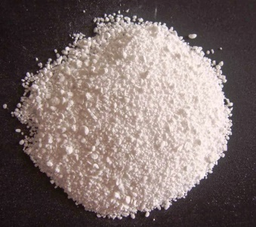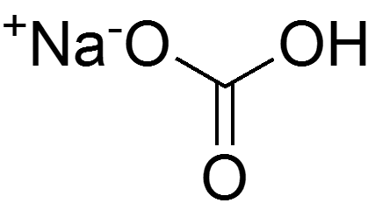
Fig No 2.1: Sodium Bi Carbonate Fig No. 2.2: Chemical structure of SBC

In the presence of water, citric acid [C₆H₈O₇] and sodium bicarbonate [NaHCO₃] (aka baking soda) react to form sodium citrate [Na₃C₆H₅O₇], water, and carbon dioxide [CO₂] (Goldberg, Robert N.; Kishore, Nand; Lennen, Rebecca M. "Thermodynamic quantities for the ionisation reactions of buffers in water". CRC Handbook. pp. 7–13).
C₆H₈O₇ + 3NaHCO₃ = Na₃C₆H₅O₇ + 3H₂O +3CO₂

2.3 Encapsulation Process
Many encapsulation processes are based on making first droplets of the active (in gas, liquid or powder form) and these droplets are subsequently surrounded by carrier material in a gas or liquid phase via different physico-chemical processes. The preparation of melt extrudates, liposomes, inclusion complexation technologies, and the use of natural encapsulates like yeast cells might be the exceptions.

To encapsulate Sodium Bi Carbonate the best technology is Spray Drying. Fluid bed coating is also can be used. (International Journal of food science & Nutrition. 1999 May;50(3):213-24.)

Encapsulation involves the incorporation of food ingredients, enzymes, cells or other materials in small capsules. Applications for this technique have increased in the food industry since the encapsulated materials can be protected from moisture, heat or other extreme conditions, thus enhancing their stability and maintaining viability. Encapsulation in foods is also utilized to mask odours or tastes. Various techniques are employed to form the capsules, including spray drying, spray chilling or spray cooling, extrusion coating, fluidized bed coating, liposome entrapment, coacervation, inclusion complexation, centrifugal extrusion and rotational suspension separation. Each of these techniques is discussed in this review. A wide variety of foods is encapsulated--flavouring agents, acids bases, artificial sweeteners, colourants, preservatives, leavening agents, antioxidants, agents with undesirable flavours, odours and nutrients, among others. The use of encapsulation for sweeteners such as aspartame and flavours in chewing gum is well known. Fats, starches, dextrins, alginates, protein and lipid materials can be employed as encapsulating materials. Various methods exist to release the ingredients from the capsules. Release can be site-specific, stage-specific or signalled by changes in pH, temperature, irradiation or osmotic shock. In the food industry, the most common method is by solvent-activated release. The addition of water to dry beverages or cake mixes is an example. Liposomes have been applied in cheese-making, and its use in the preparation of food emulsions such as spreads, margarine and mayonnaise is a developing area. Most recent developments include the encapsulation of foods in the areas of controlled release, carrier materials, preparation methods and sweetener immobilization. New markets are being developed and current research is underway to reduce the high production costs and lack of food-grade materials (International Journal of food science & Nutrition. 1999 May;50(3):213-24.)

2.3.1 Spray Drying
Spray-drying is one of the oldest processes to encapsulate active agent. It is so common in foods that it is not always perceived as an encapsulate, e.g., aroma in a spray-dried form. Spray-drying of active agent is commonly achieved by dissolving, emulsifying, or dispersing the active in an aqueous solution of carrier material, followed by atomization and spraying of the mixture into a hot chamber (Barbosa-Cánovas et al. 2005; Gharsallaoui et al. 2007). During this process a film is formed at the droplet surface, thereby retarding the larger active molecules while the smaller water molecules are evaporated. Optionally, one may also spray-dry active agent in organic solutions like acetone or ethanol; however, this is used much less for environmental and safety reasons (which also increase the costs).

Spray-dryers in the food industry are usually atomizing the in feed with a high-pressure nozzle or centrifugal wheel (also called rotary atomizer) and operate with a co-current flow of air and particles to give minimal overheating of the particle. This latter is important if the contents are heat sensitive or somewhat volatile (as is the case with aromas). However, co-currently dried particles are likely to be more porous than ones prepared in the counter-current mode.

The size of the atomizing droplets depends on the surface tension and viscosity of the liquid, pressure drop across the nozzle, and the velocity of the spray. The size of the atomizing droplets also determines the drying time and particle size.

The temperature of the droplet surface corresponds at any point in the dryer to the “wet bulb” temperature of the gas phase surrounding the droplet as long as the particle surface is wet. The wet bulb temperature under standard spray-drying conditions is of the order of 50°C. By controlling the air-inlet temperature (typically 150–220°C), the flow rate, the feed rate, the feed temperature, and evaporative cooling, it should be ensured that the droplet temperature never exceeds 100°C. This temperature might be indicated by the air outlet temperature, which is typically 50–80°C. The larger the spray-dryer, the longer the residence time of the particle in the dryer (typically 5–100 s) and hence the larger the maximum size of the droplets that can be dried. Atomizing nozzles are usually mounted to spray downward, but it is also possible to spray upward like a fountain, which permits somewhat larger droplets to be dried because of the larger residence time of the droplet.

During the drying process a film is formed at the droplet surface and the concentration of ingredients in the drying droplet increases. Finally, a porous, dry particle is formed.
The carrier material used should meet many criteria, such as protection of active material, high solubility in water, molecular weight, glass transition, crystallinity, diffusibility, good film forming properties, good emulsifying properties, and low costs (Gharsallaoui et al. 2007). Examples from literature include natural gums (gum arabic, alginates, carrageenans, etc.), proteins (dairy proteins, soy proteins, gelatin, etc.), carbohydrates (maltodextrins and cellulose derivatives) and/or lipids (waxes, emulsifiers).

Conventional spray-dried encapsulates release their active agent immediately upon addition to water (which may also depend on the porosity of the particles). However, recent introductions of more hydrophobic and/or cross-linked carrier materials may provide a more gradual release upon dilution in water. Examples of these are denatured proteins, cross-linked proteins or cross-linked biopolymers.

For many applications, larger particles than those produced by spray-drying (in general about 10–150 mm) might be desirable. This might be achieved by agglomeration or granulation (Barbosa-Cánovas et al. 2005; Ortega-Rivas 2005). In general, this can be achieved in any equipment creating random movements. An option is fluidized bed spray granulation (also called spray-bed-drying), in which a spray-drying step is followed in one or two steps by a secondary agglomeration step in a fluid bed (Fuchs et al. 2006).

Another option is to spray-dry onto another carrier powder (Fuchs et al. 2006). In both cases, the spray-dried particles are not fully dried after the first stage, and therefore remain sticky to facilitate agglomeration during the second phase. Alternatively, a binder solution (e.g., water) can be sprayed onto powder particles during high shear or tumbling (Litster 2003; Barbosa-Cánovas et al. 2005), or in a fluid bed (Uhlemann et al. 2002; Barbosa-Cánovas et al. 2005; Ortega-Rivas 2005).

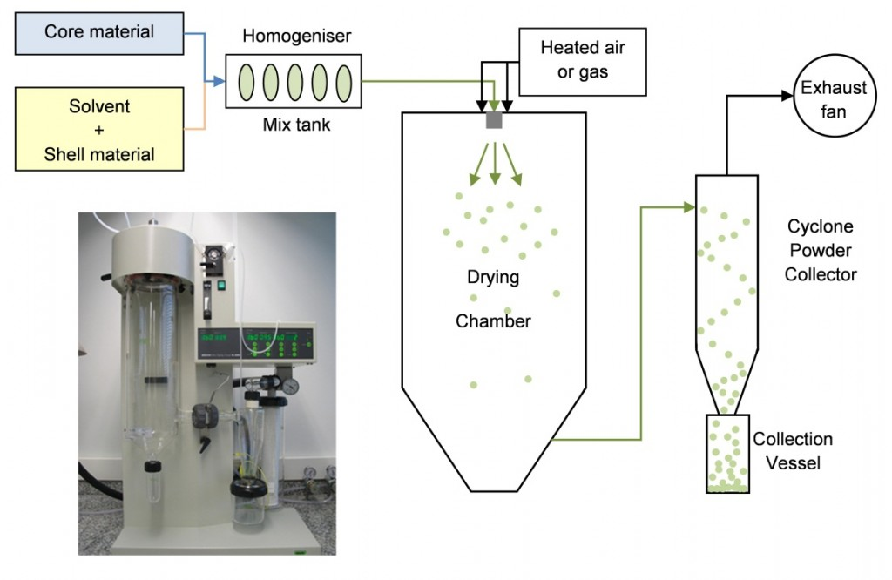
Fig No. 2.3: Spray Dryer
2.3.2 Fluid Bed Coating
Fluid bed coating is a technique in which a coating is applied onto powder particles in a batch process or a continuous set-up. The powder particles are suspended by an air stream at a specific temperature and sprayed with an atomized, coating material. With time, each particle will be gradually covered every time it is in the spraying zone. The coating material must have an acceptable viscosity to enable pumping and atomizing, must be thermally stable and should be able to form a film over a particle surface. In general, 5–50% of coating is applied, depending on the particle size of the core material and application of the encapsulate.

The coating material might be an aqueous solution of cellulose derivatives, dextrins, proteins, gums and/or starch derivatives, and the evaporation of its water content is then controlled by many factors such as the spray rate, the water content of the coating solution, the air flow, the humidity of the air inlet in the chamber, and the temperature of the coating solution, atomized air, and the material in the chamber (Dewettinck and Huyghebaert 1999; Guignon et al. 2002; Teunou and Poncelet 2002, 2005a). Often a so-called Würster set-up is used, in which the coating is sprayed in an inner column from the bottom .The air flow rate is typically 80% in the center flow in the inner column and 20% in the periphery, which brings the powder particles into circulation. This increases the drying rate and reduces agglomeration. The bottom spray reduces the distance between the powder and the drops of coating solution, thereby reducing the risk of premature drying of the coating.

Alternatively, a molten lipid can be used as a coating material which can be either applied from the bottom or the top .Examples of lipids used is hydrogenated vegetable oils, fatty acids, emulsifiers and/or waxes. Care must be taken to prevent solidification of the lipid before it reaches the powder. This might be done by heating not only the storage vessel from which the molten lipid is pumped, but also the line, the nozzle, and atomizing air. Once in the chamber, the rate of congealing (solidification) is controlled by the application rate and the cooled, inlet air (often 10–20°C below its melting point). Product temperature too close to the melting temperature of the fat may result in sticky particles and thus agglomeration. At lower product temperature the congealing might occur before complete spreading so the coating might contain defects and pores.

The particles to be coated by fluid bed should ideally be spherical and dense, and should have a narrow particle size distribution and good flow ability. Spherical particles have the lowest possible surface area and require less coating material for the same shell thickness than no spherical ones. Sharp edges could damage the coating during handling. Fine and low-dense particles might face the risk of accumulating on the filter bags in the top of the machine.

In general, applying a coating to make the powder more resistant to humidity. If desired, more than one coating can be applied on the powders.

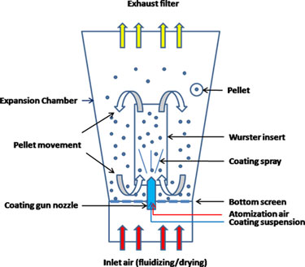
Fig No. 2.4: Fluid bed coating machine

2.4 Powder Soft Drinks
There are different powder soft drinks in world market. About 100 years ago the powder soft drinks was innovated in Indonesia. Day by day it worldwide expanded, now this available in Bangladesh such as Tang, Qualimax, Rasna, shark etc. are global products and C-vita, Vita-C, Glucose, Prome etc. are the local products in our country. Worldwide found only one carbonated powder as medicine which is ENO. This product is manufacture by “gsk”. This is not food product the gsk always marketed it as medicine.

Tang was famously used by some early NASA manned space flights.when Mercury astronaut conducted eating experiments in orbit, Tang was selected for the menu, and was also used during some Gemini flights (John Glen;1962). A NASA engineer working on Gemini explained how and why it was used (paraphrased).
"There was a particular component of the Gemini life support-system module which produced H₂O (water) among other things. This was a byproduct of a recurring chemical reaction of one of the mechanical devices on the life-support module. The astronauts would use this water to drink during their space flight. The problem was, the astronauts did not like the taste of the water because of some of the byproducts produced, which were not harmful of course. So, they added Tang to make the water taste better."

The fast-acting effervescent fruit salts, used as an antacid and reliever of bloatedness, (ENO) was invented (James Crossley Eno 1850s). It has sales of nearly £30 million, with its major markets being Spain, India, Brazil, South Africa, Malaysia and Thailand. It is frequently used as a substitute for baking powder.

As of the summer, 2010, GSK made the decision to withdraw ENO from the UK market. (Info from GSK UK marketing on enquiring directly as to the difficulty on purchasing ENO.

This leaves a major gap in the UK market for a product of this nature as its primary competitor, Andrews, contains 2.1g of sucrose per 5ml measure, making it unsuitable for diabetics. Other effervescent alternatives, such as Resxolve, contain Paracetemol - unnecessary when you have a simple stomach upset. Even own branded alternatives type 'fruit salts' from Boots and Superdrug all contain sucrose, with the result being a sweet sugary taste compared to the historically advertised "refreshing zing" of Enos.

2.4 Powder Soft Drinks Beverage
A drink mix, or powdered drink mix is a processed-food product, a powder designed to mix usually with water to produce a beverage resembling fruit juice or soda in flavor. These are made with sugar, or sold unsweetened, the products are often made with artificial sweeteners such as aspartame, sucralose, cyclamates or saccharin and often include flavors and colors. Some of the products include vitamins or other nutrients. The products are variously marketed to children, athletes, bodybuilders, dieters, or as a vitamin supplement. Some brands are only sold as drink mixes, while some beverage companies produce powdered versions of their products.
(“Tang breakfast drink”. Spokesman-Review. (Spokane, Washington). February 12, 1960. p. 27)

Carbonated powder drinks are new trend now days. It is made with using encapsulated Sodium Bi Carbonate also called fizz powder.

CHAPTER III

MATERIALS & METHODS

3.1 Encapsulation of Sodium Bi Carbonate
3.1.1 List of instruments
- Balance
- Sieves
- Spray Dryer
- Mixture Machine
- Air conditioner
- Dehumidifier
- Moisture analyzer
- Packaging machine

3.1.2 List of raw materials
- Sodium Bi Carbonate ( Beverage Grade)
- Encapsulating material
- Starch
- Water

3.1.3 Information of raw materials
3.1.3.1 Sodium Bi Carbonate
Sodium Bi Carbonate is a white material that release carbon Di oxide when reacts with citric acid. It is white granular powder. The Sodium Bi Carbonate must be supreme grade else it will give a bad aroma when reacts with citric acid. The moisture of sodium carbonate will be less than 0.5.Sodium Bi carbonate was imported from Turkey.

3.1.3.2 Encapsulating Material
Carbohydrates comprise more than 90% of the dry mass of all biomass and more than 90% are carbohydrate polymers – polysaccharides. These natural homo- and copolymers are composed of sugar residues and/or their derivatives. Many native polysaccharides contain a small percentage of peptide residues remaining from their biosynthesis. However, these are normally removed during processing. Native polysaccharides are of enormous varieties. Moreover, they also form valuable sources for chemically modified materials, thus expanding their applicability and usefulness. Overall, polysaccharides are of tremendous economical importance.

Different types of encapsulating material are available in market. But to use in spray dryer the most effective material is Encapsulated carbohydrate material premix 2.Its best properties is that when it is heated it melts and when dried it release quick water. It is also most readily soluble in water.

Table 3.1: Materials suited for encapsulation
Origin | Carbohydrate polymer | Protein | Lipid
Plant | Starch | Gluten (corn) | Fatty acids/alcohols
 | Derivatives | Isolates (pea, soy) | Glycerides
 | Cellulose |  | Waxes
 | Derivatives |  | Phospholipids
 | Plant exudates
 | Gum Arabic
 | Plant extracts
 | Galactomannans
Microbial/animal | Xanthan | Caseins | Fatty acids/alcohols
 | Gellan | Whey proteins | Glycerides
 | Dextran | Gelatin | Waxes

3.1.3.3 Starch
Starch is a polymeric carbohydrate consisting of a large number of glucose units joined by glycosidic bonds. This polysaccharide is produced by most green plants as an energy store. It is the most common carbohydrate in human diets and is contained in large amounts in staple foods such as potatoes, wheat, maize (corn), rice, and cassava.

Pure starch is a white, tasteless and odorless powder that is insoluble in cold water or alcohol. It consists of two types of molecules: the linear and helical amylose and the branched amylopectin. Depending on the plant, starch generally contains 20 to 25% amylose and 75 to 80% amylopectin by weight. Glycogen, the glucose store of animals, is a more branched version of amylopectin. It increases the strength of encapsulation material.

3.1.3.4 Water
The P^{H} range 7.1-7.3 water should be used .It will gives strength the encapsulation process.

3.1.4 Flow Diagram of Sodium Bi Carbonates Encapsulation
The flow diagram of encapsulating Sodium Bi Carbonate is given below.
Selection of proper raw materials (Sodium Bi Carbonate, Encapsulating material, Starch water etc.)

Weighing of raw materials

Dissolve encapsulating material & starch into hot (50-60 degree Celsius) water

Put the solution until it looks clear

Mix Sodium Bi Carbonate into solution

Emulsion making

Pour the emulsion into spray dryer (175 degree C)

Set specification the particle 40-50 mash size

Cooling

Check the moisture of final fizz powder (using moisture analyzer)

Packaging of fizz powder (In aluminum foil)

Labeling

Storing (Air conditioned room)

3.1.5 Process Details
3.1.5.1 Raw materials Selection
The raw materials that will be used as per as the specification that are required. The grade of raw materials must be maintained properly and ensure that the materials are safe for human body. Must be checked COA before use.

3.1.5.2 Weighing of raw materials
Weight all following raw materials as the following ratio:
1. Water: 40 % of coating mixture
2. Encapsulated carbohydrate premix material 2:58% of mixture
3. Starch: 2 % of mixture
4. Sodium Bi Carbonate: 150 % of the coating material

3.1.5.3 Mixing
Mix the encapsulated ingredients properly without Sodium Bi Carbonate. Use 70 degree Celsius hot water for proper mixing. Keep the mixture until its appearance is clear. Then mix Sodium Bi Carbonate into the mixing solution and make an emulsion.

3.1.5.4 Pour the emulsion into spray dryer
Place the emulsion into hoper of spray drier and set all the specification in the spray drier machine. Mesh size set 40-50 to obtain proper encapsulated Sodium Bi Carbonate.

3.1.5.5 Cooling
Cool the encapsulated Sodium Bi Carbonate until temperature is 20-22 degree Celsius. Because if the fizz powder is hot the outer encapsulated layer will be melt in presence of humidity. So dehumidifier must be present at room and humidity should be 38-40%.It is strictly maintained.

3.1.5.6 Moisture check
Moisture of the fizz powder must be around 0.40-0.45 %.The moisture is checked by using moisture analyzer.

3.1.5.7 Packaging
2 layer aluminum foils was used as packaging material. Packaging was done by using auto packaging machine.

3.1.5.8 Labeling
The following information must be included in labeling.
1. Name of the product
2. Manufacturing date
3. Expiry date
4. Net weight
5. Used Ingredients name etc.

3.1.5.9 Storage
Fizz powder must be stored at dry place where the temperature must be 20-22 degree Celsius and humidity must be 38-40% for maintain proper shelf life as it is a powder type product.

3.2 Preparation of powder soft drinks
3.2.1 List of Instruments
  - Balance
  - Sieves
  - Sugar crusher
  - Powder mixture (Ribbon mixture)
  - Drier (Electric / Gas)
  - Air conditioner
  - Dehumidifier
  - Moisture controlled room
  - Moisture analyzer
  - Spoon
  - Packaging machine

3.2.2 List of raw materials
a. Crystal Sugar (particle size ≤ 30 mesh)
b. Permitted sweetening agents ( Aspartame, Acesulfame-Potassium)
c. Acidity regulator (Citric acid anhydrous)
d. Vitamin (Ascorbic acid / Vitamin-C)
e. Buffering agents (Sodium chloride / Sodium citrate)
f. Minerals / Anti-caking agents (Tri-calcium phosphate)
g. Carbonating agents (Sodium bicarbonate)
h. Permitted food colour (Lemon yellow colour, Chocolate brown colour)
i. Permitted food flavour (Cola Flavour, Lime Flavour, Energy Flavour)

3.2.3 Information of raw materials
The brief description of raw materials has given below.

3.2.3.1 Sugar
Sugar is the major ingredients of powder soft drinks and this is used as a sweetening ingredients. The sugar/sucrose has been found in crystal form in our local market. But there is no available size of sugar for carbonated powder soft drinks, so we need to reduce the size of crystal sugar by sugar crusher as require (90 to 100 meshes). The chemical formulation of sucrose is C₁₂H₂₂O₁₁; Molecular weight of sugar/Sucrose is 342 gm/mol.

3.2.3.2 Sweetening Agents
Many kinds of sweetening agents used in our country, but most of the items can not comply rules and regulations of BSTI “Bangladesh Standard and Testing Institution”. Our sweetening agents are Aspartame & Acesulfame Potassium which is 160 times sweeter than sugar; this is complied the rules and regulations of BSTI. An acceptable daily intake (ADI) of 40 milligrams/kilogram of body weight/day was established by scientists in the Food Directorate of Health Canada.

3.2.3.3 Acidity Regulator
There are different types of acidity regulator used in powder soft drinks. Citric acid is the most common acidity regulating agent in the food processing world but there is may uses ascorbic acid (Vitamin-C), lactic acid, malic acid and fumaric acid etc. These acids are complied the rules and regulations of BSTI. There is used citric acid in our project; the chemical formula of citric acid is C₆H₈O₇; molecular weight of citric acid 192 gm/mol.

3.2.3.4 Buffering Agents
According to the rules and regulations of BSTI (BDS; 1586:2007), the buffering agents are used for tuning pH of finished products. As buffering agents we use Sodium Citrate, sodium chloride, potassium chloride; etc. There is used sodium citrate as buffering agent.

3.2.3.5 Anti-Caking Agents
There is used Tri-calcium phosphate as anti-caking agent, which is used 0.5% on total batch volume. This is permitted by the BSTI (BDS; 1586:2007). This is a good of sources of minerals (calcium).

3.2.3.6Clouding Agents
There is used food grade clouding agents which is permitted by the BSTI. Food grade TDO “Titanium dioxide” was used in soft drinks as clouding agents.

3.2.3.7 Vitamin Premix
Vitamin premix is a natural premix contain a good amount of vitamins both fat and water soluble. It is added to drinks for the fortification. It also increase the moth feel and trigger the flavor used in carbonated powder drinks. In soft powder drinks it is generally not used. The moisture content of vitamin premix should be less than 0.6. It contains the following vitamins such as
a. Vitamin B1
b. Vitamin B2
c. Vitamin B6
d. Vitamin C
e. Vitamin A
f. Vitamin B12 etc.

3.2.3.8 Fizz Powder
It is the most important ingredients in carbonated PSD. Without it the fizzing will not be done. It is encapsulated Sodium Bi Carbonate that reacts with citric acid in presence of water to give fizz (CO₂ gas).The moisture of fizz powder must be below than 0.5.The shelf life of fizz powder is 1 year.

3.2.3.9 Food Colouring
Colouring is the most important part for beverage items; there are two types of colouring agents such as- Natural and Artificial colour. In this study used some artificial colour such as- Chocolate brown colour, Egg yellow colour, Lemon yellow colour.

3.2.3.10 Food Flavouring
In this study author had used different types of flavour to increase the test of drinks such as Cola, Lemon, and Energy flavour according to the sense of current market of Bangladesh. It is permitted by FDA.

3.2.4 Formulations
All formulations are developed by ‘The author’.

3.2.4.1 Formulation of cola powder Drinks
The formulation of cola powder drinks given below in a table.

Table No. 3.2: Formulation of cola powder soft drinks
Sl. No. | Name of Ingredients | gm/sachet | %
1 | Sugar | 1.252 | 31.30
2 | Vitamin Premix | 0.200 | 5.00
2 | Aspartame | 0.045 | 1.13
3 | Acesulfame-Potassium | 0.020 | 0.50
4 | Citric Acid | 1.300 | 32.50
5 | Malic Acid | 0.100 | 2.50
6 | Tri Calcium phosphate | 0.008 | 0.200
7 | Sodium citrate | 0.100 | 2.50
8 | Encapsulated Sodium Bi Carbonate | 0.700 | 17.50
9 | Chocolate Brown colour | 0.045 | 1.125
10 | Cola Flavour 421 015 | 0.200 | 5.000
11 | Lime Enc. Flavour 424 015 | 0.030 | 0.750
 | TOTAL = | 4.000 | 100.00

Serving size is 4 gm for 200 ml cold water.
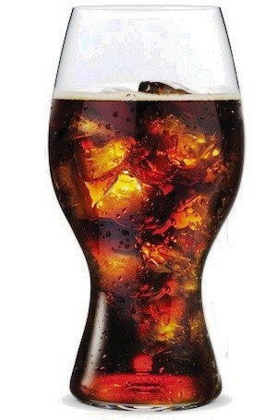
Fig No. 3.1: Cola powder soft drinks

3.2.4.2 Formulation of Energy Powder Soft drinks
The formulation of energy powder soft drinks given below in a table.

Table No. 3.3: Formulation of Energy powder soft drinks
Sl No. | Name of Ingredients | gm/sachet | %
1 | Sugar | 8.735 | 72.792
2 | Aspartame | 0.05 | 0.42
3 | Acesulfame-Potassium | 0.02 | 0.17
4 | Citric Acid | 1.80 | 15.00
5 | Tri Calcium phosphate | 0.03 | 0.250
6 | Vitamin Premix | 0.20 | 1.667
7 | Sodium citrate | 0.06 | 0.50
8 | Fizz Powder (Encapsulated Sodium Bi carbonate) | 0.90 | 7.50
9 | Chocolate brown colour 126 195 | 0.005 | 0.042
10 | Energy Powder Flavour 905 095 | 0.20 | 1.667
 | TOTAL = | 12.000 | 100.00

Serving size is 12 gm for 200ml cold water.
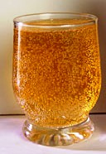
Fig No. 3.2: Energy Powder Soft drinks

3.2.4.3 Formulation of ENO
The formulation of ENO is given below.

Table No. 3.4: Formulation of ENO
Sl No. | Name of Ingredients | gm/sachet | %
1 | Citric Acid (CA) | 2.315 | 46.300
2 | Aspartame | 0.024 | 0.48
3 | Acesulfame-Potassium | 0.006 | 0.12
4 | Fizz Powder | 2.329 | 46.58
5 | Tri Calcium phosphate (TCP) | 0.016 | 0.320
6 | Sodium Chloride (Salt) | 0.04 | 0.700
7 | Lemon Yellow Colour | 0.045 | 0.90
8 | Lime Enc. Flavour 424 015 | 0.03 | 0.600
 | TOTAL = | 5.000 | 100.00
Serving size is 5 gm for 200ml cold water.

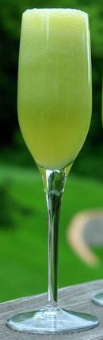
Fig No. 3.3: ENO Powder soft drinks

3.2.5 Flow Diagram
3.2.5.1 Flow diagram of powder soft drinks
Receiving raw materials

Measure the raw materials according to formulation
(By the calibrated balance)

Crushing the Sugar

Mix all ingredients by the ribbon mixture
(Except flavour & Treated sodium bicarbonate)

Spray water for coming appearance
(According to expectation), (as require)

Mixing properly

The mixture put in tray

Drying
Temperature 60-65°C

Cooling
(Under moisture controlled condition)
(Temperature 22-23 °C and Relative Humidity below 40 %)

Fizz powder & Flavour mixing
(Under moisture controlled condition)

Packaging
(Under moisture controlled condition)

Storage
(At room temperature)

Marketing
3.2.6 Process details
The processing of powder soft drinks is not a difficult process, but this is not easy to control the require environment for bring quality. The total process of powder soft drinks is described as follows

3.2.6.1 Raw materials
We should collect every raw materials (Sugar, Citric acid anhydrous, Ascorbic acid, Anti-caking agent, Buffering agents, Clouding agents, Fizz Powder, Permitted food colour, Permitted food flavor etc.) fresh and sound;

3.2.6.2 Weighing
Weight all ingredients according to the formulation. Weighing is most important part of processing of powder soft drinks. Taste, colour, flavour and odour etc. everything was depended on right quantity of the batch volume. So we should ensure the right quantity of ingredients. Another things is important that, always calibrated balance should be used for weighing the all ingredients.

3.2.6.3 Sugar crushing
Particle size is the most important for any types of powdered products. As a powder products sugar particle size should be 30 meshes to 35 meshes. Because of that this is need to dissolve instantly. Crush the sugar by a fine crusher.

3.2.6.4 Mixing
Mixing is another important part of the processing of powder soft drinks. At this stage all ingredients will be mixed by ribbon blender mixture accurately except flavour. All ingredients must be mixed homogenously.

3.2.6.5 Spray water
The water was sprayed in the mixture machine on mixture for getting the appearance and colour. The water quantity always depends on expected colour and appearance. The water should be spraying by the spray bottle.

3.2.6.6 Drying
After mixing the mixture put in tray and then set in the drier; Start drying at 60 to 65 °C temperature. When completed 50% drying the mixture will be subverted time to time. When completed drying it was screened as per requirements. Moisture level must be reducing up to 0.5%.

3.2.6.7 Cooling
After drying the entire mixture shift to a temperature and humidity controlled room. Temperature and Relative Humidity should have 20-22°C and below 40% respectively. Temperature and Relative Humidity controlling is the most necessary part of any types of powdered products.

After cooling mix flavour according to formulation under the same condition (Tem. 20-22°C and RH below 40%). Addition of fizz powder is done for fizzing of drinks after mixing into water before consuming. Flavour is the most important ingredients for powder soft drinks and soft drinks. This is enhancing taste and aroma of the products. There is use special type of powder flavour, this is called encapsulated flavour. There are different types of flavour used in beverage products; e.g. - Lemon Encapsulated Flavour, Lime Encapsulated Flavour, Cola-Cola Encapsulated Flavour, Energy Powder Flavour & liquid flavour.

3.2.6.8 Packaging
This product may packed glass jar or aluminum foil and LDP “Low Density Polyethylene” film etc. The foil packs also called sachet, sachet quantity or serving size would be 4 gm, , 12gm, and 5gm; etc. For every serving water quantity will same (200 ml). After that this sachet will be fill in a box which is contain about 36 sachets. And by the some boxes make carton.

3.2.6.9 Labeling
After the completing process nutrition facts mentioned label was pasting on the jar or bottle. Nutrition facts must be calculated by proper rules and regulation. Must be followed BPFR’1976
(Bangladesh Pure Food Rules – 1976)

3.2.6.1 Storing
Every product must be storage during product life path Step by step. Either manufacturer hand or distributor or retailer or final consumer hand respectively, so we need proper storage system or condition for this product storing. For the different types of product need different temperature, humidity or different environment. For carbonated powder soft drinks need room temperature and normal Relative Humidity.

3.3 Quality Control
Quality control records and reports were maintained with department given below.

3.3.1 By the Quality Control Department
- Sample Identification Form
- Raw materials inspection report form
- Raw materials Exceptions form
- Extraneous matter report
- Warehouse inspection report
- In process Q.C Tasting of Powder drinks
- Check weight inspection Sheet
- Mini Survey sheet
- Quality Control Laboratory report

3.3.2 By the warehouse Department
- Temperature Recording Chart

3.3.3 By the mixing & assembly Department
- Product Formulation & Mixing Direction
- Raw materials control chart
- Temperature relative humidity chart

3.3.4 By the Packing Department
- Daily Size and count Report
- Daily Production report

3.4 Quality Control Test of Fizz powder
3.4.1 Materials for Tests
a. Balance
b. White paper
c. Microscope
d. Digital Moisture analyzer
e. Stopwatch

3.4.2 Physical tests
3.4.2.1 Appearance
The appearance of fizz powder must be bright white. It should be ensured that there would not be any brown spot colour on surface. Brown colour surface indicates the burning of fizz powder. It will be checked by placing some of fizz powder on white paper.

3.4.2.2 Proper Encapsulation test
The fizz powder was placed on a slide and put the slide below the microscope to check the encapsulation was properly done or not. The appearance of encapsulated Sodium Bi Carbonate (fizz powder) was observed.

3.4.2.3 Moisture test
The moisture of the fizz powder must be below that 0.4 to ensure 1.5 years shelf life. For testing moisture 5 gm of sample placed on the plate of moisture analyzer and run the moisture analyzer. The moisture analyzer will show the reading on its screen. The procedure is done 3 times to ensure the moisture percentage.
3.4.2.4 Shelf life test
The shelf life was checked by keeping the final products in 3 different conditions .The conditions are.
1. In presence of high sunlight
2. At normal temperature and atmospheric pressure
3. At 20-22 degree Celsius and 38-40 % humidity

3.4.3 Chemical Test
3.4.3.1 Fizzing test
For measuring fizzing test 1 gm of fizz powder was weighted and 1 gm of citric acid also weighted, mixed properly. Then took 1 glass of water and poured the mix into it which will give a good fizz instant. Then start stopwatch to measure the fizzing time. The more the slow fizzing the more good the encapsulation technologies.

3.5 Powder Soft Drinks Quality Control Tests
For powder soft drinks different test methods are applied. Such as
1. Physical test
2. Instrumental Test
3. Chemical Test
4. Microbiological Test
5. Organoleptic Test

    - Physical Tests
3.5.1.1 Appearance
Measure the appearance of the products (powder soft drinks) in quality control department by method of (BFF; 2010).This test will be completed visually. For the appearance test of powder soft drinks, we take 25 gm product (powder soft drinks) on a tray. Check granules and fluidity visually of the product (powder soft drinks).

    - Instrumental Test
3.5.2.1 Moisture analysis
Take 4 to 5 gm sample of powder soft drinks and this is put in the moisture analyzer, set the program and press OK button. After 2 minutes the machine will show result (moisture content of powder soft drinks). Moisture analysis done by an infrared moisture analyzer; required moisture for powder soft drinks is below 1 % (BSTI; BDS 1586:2007).

3.5.2.2 °Brix
Brix is concentration of the sugar in a solution. We determine the °Brix or concentration of sugar by the instrumental methods. For this test required instrument is refractometer. At first take one serving sample (12, 5 and 4 gm) in a beaker and dilute with 200 ml water properly. Wash the refractometer by distilled water and dry it by the tissue paper. Calibrate the refractometer by distilled water, reading will 0 °Brix. Then put the sample on the refractometer plate, see the result and put in the results table.

3.5.2.3 pH
It is the instrumental test for the sample. For this test required a pH meter and final product (sample in 200 ml water). Sample product put in a 250 ml beaker and switch on the machine. After 5 minutes take reading from the pH meter and put in the results table.
Acidity or pH is the most important factor for product self-life. So always should be careful about it. The pH is determined according to method of BFF (2010).

3.5.2.4 Total Ash content
This method is used to determine ash content in feed stuffs by calcinations. Ash is considered as the total mineral or inorganic content of the sample.

3.5.2.4.1 Material and equipment
- Porcelain crucibles.
- Crucible furnace.
- Dryer.

        - Method
- Place 2.5 to 5 g of dry sample in a crucible and brought to constant weight.
- Place the crucible in a furnace and heat at 550°C for 12 hours; leave to cool and transfer to a dryer.
- Carefully weigh the crucible again with the ash.
3.5.2.4.3 Calculation
Total ash content (%) = 100×A-B/C
Where,
A=Weight of crucible with sample
B=Weight of crucible with ash
C=Weight of sample

    - Chemical Test:
3.5.3.1 Acidity:
For determination of acidity of the carrot juice needs some sample, some reagent, some glass apparatus etc. This test is done by as the method of (BFF;2010).

3.5.3.1 .1 Requirements:
- Sample = 10 ml
- NaOH ( 0.1 N ) = As require
- Phenolphthalein ( 0.1% ) = As require
- Beaker = 2 pcs
- Electronics balance = 1 pcs
- Conical flask = 2 pcs
- Volumetric flask = 1 pcs
- Burette = 1 pcs
- Pipette = 2 pcs
- Pipette filler = 1 pcs

3.5.3.1.2 Equation
Burette Reading x Normality of NaOH x Equivalent weight of acid x 100
% of Acidity =
Weight of sample x 1000
        - Titration method
At first take 10 ml sample product was taken in conical flask.
  - Fill the burette by 0.1(N) sodium hydroxide (NaOH)
  - Take 2 (two) to 3 (three) drops phenolphthalein indicator in the conical flask with sample product.
  - Take 0.1N sodium hydroxide (NaOH) from the burette drop by drop into conical flask until obtained slightly pink colour.
  - Take burette reading (BR) or amount of sodium hydroxide (NaOH) and put in the table.

3.5.4 Microbiological Tests
3.5.4.1 Total Viable Count
It is intended to indicate the level of microorganism in final powder drinks.

3.5.4.1.1 Required Materials
1. Water bath
2. Incubator
3. Sterile pipettes 1ml and 10ml
4. Dilution Bottles
5. Colony Counter
6. Sterilizer

3.5.4.1.2 Required Reagents
1.Plate count agar (PCA)
2. Phosphate buffer

3.5.4.1.3 Procedure
1. Using separate sterile pipettes, prepare decimal dilutions of 10⁻¹, 10⁻², 10⁻³, 10⁻⁴ and others as appropriate of water by transferring 1ml of original drinks sample to 9ml of diluents.
2. Shake all diluents.
3. Take 1 ml of each dilution into separate, duplicate, appropriately marked petri dishes.
4. Add 12-15ml plate count agar (cooled 45º± 1^{oc}) to each plate within 15min of original dilution.
5. Immediately mix sample dilutions and agar medium thoroughly and uniform by alternate rotation and back-and-forth motion of plates on fla level surface.
6. Let agar solidify.
7. Invert solidified Petri dishes and incubate promptly for 48±2 hours at 35ºc.
8. After incubation count colonies.
Expression of results:
1. Consider plates containing 25-300 colonies.
2. Calculate the cfu/ml by multiplying the average count with dilution factor.
No of Bacteria = No of colonies ×dilution factor/volume of sample added.

3.5.4.2 MPN
The method uses a specified number of test tubes to statistically predict the number of organisms present in a sample.

3.5.4.2.1 Required apparatus
1. Pipette (10ml and 1 ml)
2. Test tube with cap
3. Incubator
4. Durhams Tube

3.5.4.2.2 Required reagents
1. Lactose broth
2. EMB agar
3. Bromocresol purple as an indicator

3.5.4.2.3 Procedure
1. 9 test tubes for one sample to be tested were taken.
2. Prepared lactose broth as per the instruction.
3. Dispensed 10ml of dissolve broth per test tube.
4. The whole set was autoclaved.
5. Cooled the whole set after autoclaving.
6. Three large and six small test tube in a rake was set up.
7. Label each tube according to the amount of water that was to be dispersed to it : 10ml (large 3) , 1 ml (small 3) and 0.1ml (small 3) respectively.
8. Mixed the bottle of water to be tested by shaking 25 times.
9. With 10ml pipette transfer 10ml of water to each of the large test tube.
10. With 1ml pipette transfer 1ml of water to each of the small test tube and 0.1ml(1 drop) of water to last 3 test tubes.
11. Incubated the tubes at 37ºc for 24 hours.
12. Examine the tubes and record the number of tubes in each set that have 10 percent or more gas or color change.
13. The MPN from the following table

Table No. 3.5: MPN test chart
Tubes Positive |  |  | MPN | Tubes Positive |  |  | MPN | Tubes Positive |  |  | MPN
10ml | 1ml | 0.1ml |  | 10ml | 1ml | 0.1ml |  | 10ml | 1ml | 0.1ml
0 | 0 | 1 | 3 | 1 | 0 | 0 | 4 | 2 | 2 | 2 | 35
0 | 0 | 2 | 6 | 1 | 0 | 1 | 7 | 2 | 2 | 3 | 42
0 | 0 | 3 | 9 | 1 | 0 | 2 | 11 | 2 | 3 | 0 | 29
0 | 1 | 0 | 3 | 1 | 0 | 3 | 15 | 2 | 3 | 1 | 36
0 | 1 | 1 | 6 | 1 | 1 | 4 | 7 | 2 | 3 | 2 | 44
0 | 1 | 2 | 9 | 1 | 1 | 1 | 11 | 3 | 1 | 1 | 75
0 | 1 | 3 | 12 | 1 | 1 | 2 | 15 | 3 | 1 | 2 | 120
0 | 2 | 0 | 6 | 1 | 1 | 3 | 19 | 3 | 1 | 3 | 160
0 | 2 | 1 | 9 | 1 | 2 | 0 | 11 | 3 | 2 | 0 | 93
0 | 2 | 2 | 12 | 1 | 2 | 1 | 15 | 3 | 2 | 2 | 210
0 | 2 | 3 | 6 | 1 | 2 | 2 | 20 | 3 | 3 | 0 | 240
0 | 3 | 0 | 9 | 1 | 2 | 3 | 24 | 3 | 2 | 3 | 290
0 | 3 | 1 | 12 | 1 | 3 | 0 | 16 | 3 | 3 | 1 | 460
0 | 3 | 2 | 16 | 1 | 3 | 1 | 20 | 3 | 3 | 2 | 1100
0 | 3 | 3 | 19 | 1 | 3 | 2 | 24 | 3 | 3 | 3 | 1100+

3.5.4.3 Escherichia coli and Coliform determination
To determine the fecal contamination of the powder soft drinks.
Procedure: Here at 1st step is to incubate media such as EMB and endo agar from positive presumptive test tube obtained from MPN. In case of EMB the mryhylene blue prevents the gram positive to be growth. The colliform will produce nucleated colony. E-Coli colonies also have the characteristics greenish metallic sheen .In Endo agar the Colliform colonies are red and color the surrounded area.

3.5.5 Sensory Evaluation Tests
Sensory evaluation was defined by the Sensory Evaluation Division of the Institute of Food Technologists (1975) as " the scientific discipline used to evoke, measure, analyze and interpret those reactions to characteristics of foods and materials as perceived through the senses of sight, smell, taste, touch and hearing."
Sensory evaluation involves
- The measurement and evaluation of the sensory properties of foods
- The analysis and the interpretation of the responses by the sensory professional who provides the connection between the internal world of technology and product development and the external world of the marketplace.

Sensory analysis panels can be grouped into four types
- Highly Trained Experts
- Trained Laboratory Panels
- Laboratory Acceptance Panels And
- Large Consumer Panels

3.5.5.1 Highly trained experts (1-3 people)
- Evaluate quality with a very high degree of acuity and reproducibility.
- Evaluations by experts and trained laboratory
Fig No. 3.4: Sensory evaluation conducting room
Fig No. 3.5: Sensory evaluation tray

Two types of sensory tests were conducted.
a. Panel tests
b. Tri-angle tests

3.5.5.2 Panel tests
In panel test there is hedonic scale for numbering of the sample based on different characteristics such as
1. Colour
2. Aroma
3. Mouth feel
4. Texture etc.

The highest number is 10 for the scale and lower number is 0.
- 0-2 = bad
- 3-5=Good
- 6-8=very good
- 9-10=Excellent
The following table is followed for different sample.

Table No. 3.6: Panel test evaluation Chart
Sl. No. | Assessors  (Experts) | Sample name/number | Colour | Aroma | Mouth feel | Texture | Total | Average
1.
2.
3
4

If the total number exceeds more than 80% the product is excellent.
By this the panel test is done and it is calculated by statistical method.

3.5.5.3 Tri-angle Tests
The results of a triangle test indicate whether or not a detectable difference exists between two samples. The panelist receives three coded samples, is told that two of the samples are the same and one is different, and is asked to identify the odd sample. It is used to determine if samples from different production lots are different. It is also used to determine if ingredient substitution or some other change in manufacturing results in a detectable difference in the product
314
542
628
A
A
B

Fig No. 3.6: Tri-angle test system

There are six possible ways in which the samples in a triangle test can be presented
ABB BBA AAB
BAB ABA BAA
Indicate the order in which each panelist should taste the samples by putting the code numbers in the appropriate order on the score sheet.

3.5.5.3.1 Questionnaire for Tri-angle test
PRODUCT: Carbonated Powder Soft Drinks
NAME ----------------------------------------- DATE--------------------
Two of these three samples are identical, the third is different. Taste the samples in the order indicated and identify the odd or different sample.

Code Check odd or different sample
314 --------------------------------------
628 --------------------------------------
542 --------------------------------------
Comments:------------------------------------------------------------------------------------------

3.5.5.3.2 Procedure
Samples were served in coded dishes to 36 panelists. Each panelist received three coded samples: 18 panelists tested two samples from treatment A and one from treatment B; the other 18 panelists received one sample from treatment A and two from treatment B. Because of the nature of the presentation, it was necessary to assign two code numbers to each treatment. Then the panelist will identify the sample and there will be correct and incorrect option in table. By putting values of correct and incorrect in table the result is identified.

Table No. 3.7: Triangle test processed by treatment A or treatment B
 | Odd sample chosen
Code (treatment) | Correct | Incorrect | Total
314(A) 628(B) 542(A)
542(A) 628(B) 149(B)
Total

CHAPTER IV

RESULT AND DISCUSSION

4.1 Test result for encapsulated Sodium Bi Carbonate (Fizz Powder)
4.1.1 Appearance
White colour granular powder. Dissolve in water with no residue left. Flow ability was also good.

4.1.2 Encapsulation Test
Encapsulation was done correctly with no hole and outer surface of Sodium Bi Carbonate is filled with the encapsulating material.

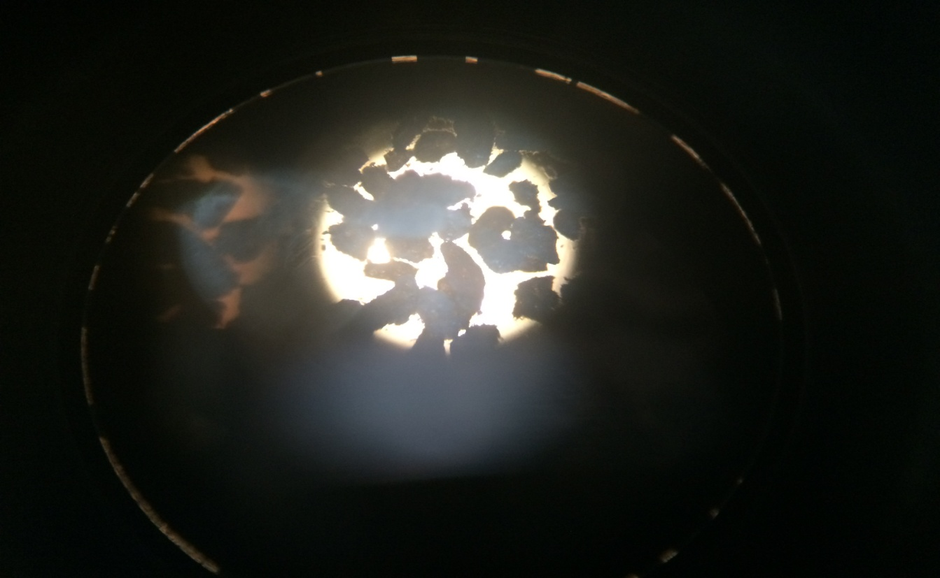
Fig No. 4.1: Sodium Bi Carbonate after Encapsulation in microscope
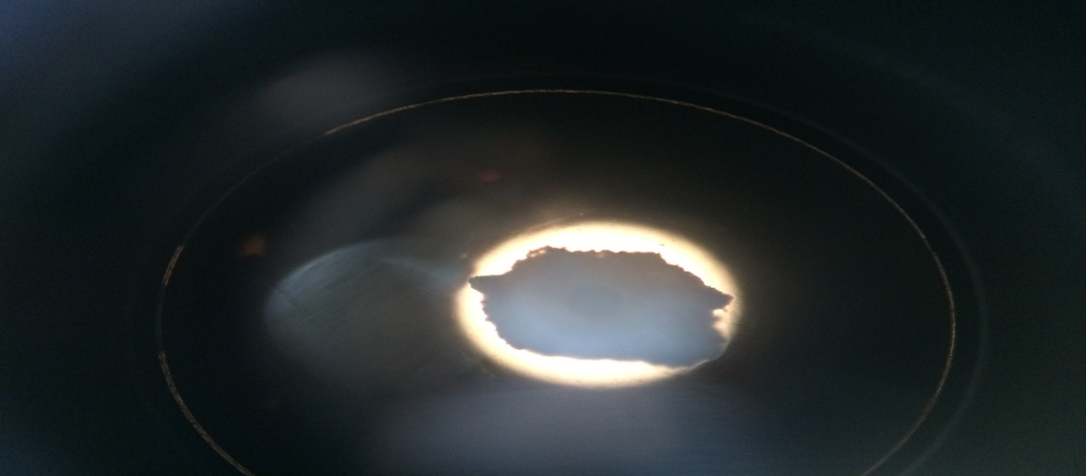
Fig No. 4.2: Single fizz powder after Sodium Bi Carbonates encapsulation

4.1.3 Moisture test
The results of moisture test for 3 samples are given below

Table No. 4.1: Moisture content of Fizz Powder (Encapsulated Sodium Bi Carbonate)
Sl No. | Sample number | Moisture percentage | Standard
01 | A | 0.38 | 0.35-0.45
02 | B | 0.46 | 0.35-0.45
03 | C | 0.60 | 0.35-0.45

Where, Sample A = the author prepared fizz powder
Sample B = Australian fizz powder
Sample C = Non encapsulated Sodium Bi Carbonate

4.1.4 Shelf life test
The results of shelf life test are given below table.
Table No. 4.2: Shelf life of Fizz powder (Encapsulated Sodium Bi Carbonate)
Sl No. | Sample number | Shelf life Time
01 | A | More than 10 months
02 | B | More than 6 months
03 | C | 7 days
Where,
A= Author prepared fizz powder
B=Australian fizz powder
C= Non encapsulated Sodium Bi Carbonate

4.1.5 Fizzing test
The results of fizzing test are given below.
Table No. 4.3: Result of fizzing test
Sl No. | Sample number | Fizzing Time
01 | A | More than 4-5 minutes
02 | B | 3 minutes highest
03 | C | Less than 2 minutes
Where, Sample A = the author prepared fizz powder
Sample B = Australian fizz powder
Sample C = Non encapsulated Sodium Bi Carbonate

4.2 Result of Powder Soft Drinks Tests
4.2.1 Physical Tests
4.2.1.1 Moisture analysis
The results of moisture analysis are given below.

Table No. 4.4: Moisture Content of Powder Soft Drinks
Sl. No. | Sample Name | Moisture percentage | Standard
1 | A | 0.66(1st month)  0.98(after 10 months) | NMT ( ≤ ) 1%
2 | B | 0.59(1st month)  1.12(After 10 months) | NMT ( ≤ ) 1%
3 | C | 0.63(1st month)  1.11(After 10 months) | NMT ( ≤ ) 1%

Where, Sample A = Energy CSD
Sample B = ENO
Sample C = Cola CSD
Fig No. 4.3: Moisture content of powder soft drinks gradually increasing (Graph)

4.2.1.2 ⁰Brix percentage
The degree brix results for 3 different Carbonated CSD are given below.
Table No. 4.5: Brix percentage of Powder Soft Drinks
Sl. No. | Sample Number | Brix percentage
1 | A | 8.9 %
2 | B | 4.4 %
3 | C | 4.6 %
Where, Sample A = Energy CSD; Sample B = ENO & Sample C = Cola CSD

4.2.1.3 P^{H} Test
The results of P^{H} of drinks are given below table.
Table No. 4.6: P^{H} of Powder Soft drinks
Sl. No. | Sample | P^{H}
01 | A | 3.35
02 | B | 3.3
03 | C | 3.5

Where, Sample A = Energy CSD
Sample B = ENO
Sample C = Cola CSD

4.2.1.4 Total ash content
The results of total ash content are given below.

Table No. 4.7: Ash content of powder soft drinks
Sl. No. | Sample | Ash content
01 | A | 0.004
02 | B | 0.003
03 | C | 0.0035
Where, Sample A = Energy CSD ; Sample B = ENO & Sample C = Cola CSD

4.2.2 Chemical Tests
4.2.2.1 Acidity tests
The result of acidity tests are given below.
Table No. 4.8: Acidity of Powder Soft drinks
Sl. No. | Sample | Acidity result
01 | A | 0.70 %
02 | B | 0.74 %
03 | C | 0.59 %
Where, Sample A = Energy CSD; Sample B = ENO & Sample C = Cola CSD
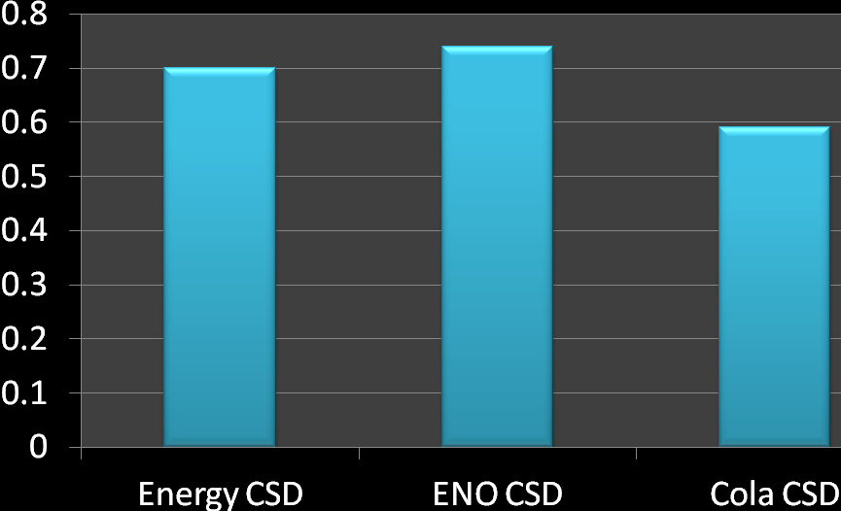
Fig No. 4.4: Acidity of Carbonated powder soft drinks

4.2.3 Microbiological tests
4.2.3.1 TVC
The result of TVC is given below.

Table no. 4.9: TVC of Powder soft drinks
Sl. No. | Sample | Total Microorganism
01 | A | Nil
02 | B | Nil
03 | C | Nil
Where, Sample A = Energy CSD; Sample B = ENO & Sample C = Cola CSD
BSTI standard is maximum TVC = 1000 per ml, max.

4.2.3.2 MPN
There was no Coliform contamination found in 3 different types of samples given below.
Where, Sample A = Energy CSD; Sample B = ENO & Sample C = Cola CSD
But BSTI standard is, MPN =5 per ml max.

4.2.3.3 E-coli
The number of E-coli count was zero. So there was no fecal contamination.
BSTI standard is nil per ml.
4.2.4 Sensory Evaluation Tests
4.2.4.1 Panel tests
Panel test was done by 5 experts. Their results provided by them are given below.

4.2.4.1.1 For ENO
Table No. 4.10: Panel test result for ENO
Sl. No. | Assessors  (Experts) | Sample name/number | Colour | Aroma | Mouth feel | Texture | Total | Average
1. | A | ENO | 8 | 9 | 9 | 8 | 34 | 8.5
2. | B | ENO | 7 | 8 | 9 | 9 | 33 | 8.25
3 | C | ENO | 8 | 9 | 10 | 8 | 35 | 8.75
4 | D | ENO | 7 | 9 | 8 | 9 | 33 | 8.25
5 | E | ENO | 9 | 8 | 8 | 8 | 33 | 8.25
Total average =8.4 (according to hedonic scale)
Where
- 0-2 = Bad; 3-5=Good; 6-8=very good & 9-10=Excellent
So according to panel test the product was very good.

4.2.4.1.2 For Energy powder drinks
Table No. 4.11: Panel test result for Energy PSD
Sl. No. | Assessors  (Experts) | Sample name/number | Colour | Aroma | Mouth feel | Texture | Total | Average
1. | A | Energy PSD | 10 | 9 | 9 | 9 | 37 | 9.25
2. | B | Energy PSD | 9 | 10 | 10 | 9 | 38 | 9.50
3 | C | Energy PSD | 9 | 9 | 9 | 9 | 36 | 9.00
4 | D | Energy PSD | 10 | 9 | 9 | 9 | 37 | 9.25
5 | E | Energy PSD | 10 | 10 | 10 | 9 | 39 | 9.75
Total average = 9.35 (according to hedonic scale)
Where
- 0-2 = Bad; 3-5=Good; 6-8=very good; 9-10=Excellent
So according to panel test the product was excellent.

4.2.4.1.3For Cola powder drinks

Table No. 4.12: Panel test result for Cola PSD
Sl. No. | Assessors  (Experts) | Sample name/number | Colour | Aroma | Mouth feel | Texture | Total | Average
1. | A | Cola PSD | 9 | 8 | 7 | 8 | 32 | 8.00
2. | B | Cola PSD | 8 | 8 | 7 | 8 | 31 | 7.75
3 | C | Cola PSD | 8 | 7 | 7 | 9 | 31 | 7.75
4 | D | Cola PSD | 8 | 7 | 6 | 8 | 29 | 7.25
5 | E | Cola PSD | 9 | 7 | 7 | 8 | 31 | 7.75

Total average=7.7 (according to hedonic scale)
Where,
- 0-2 = Bad; 3-5=Good; 6-8=very good; 9-10=Excellent
So according to panel test the product was very good.

4.2.4.2 Tri-angle test
Tri-angle test was done by 6 persons respectively. The result is given below.

4.2.4.2.1 For ENO

Table No. 4.13: Tri-angle test result for ENO
Evaluation card:
Name of Product: ENO
Two or three samples are identical. Identify and comment on the ENO PSD samples.
Serial No. | Code No. of samples |  | Code No. of Identical sample | Code No. of odd sample
Person ~ 01 | 0X0, X00, 00X |  | X00, 00X | 0X0
Person ~ 02 | 0X0, X00, 00X |  | 0X0, X00 | 00X
Person ~ 03 | 0X0, X00, 00X |  | X00, 00X | 00X
Person ~ 04 | 0X0, X00, 00X |  | 00X , X00 | 0X0
Person ~ 05 | 0X0, X00, 00X |  | X00, 00X | 0X0
Person ~ 06 | 0X0, X00, 00X |  | 0X0, 00X | X00
Note: - “0X0”= PSD (Author developed ENO) sample, “X00” and “00X” is same (GSK ENO) sample. Three persons can be identified the author developed ENO sample. So product was neither satisfactory not satisfactory.

4.2.4.2.2 For Energy PSD
The Tri-angle test result for Energy PSD has given below.

Table No. 4.14: Tri-angle test result for Energy PSD
Evaluation card:
Name of Product: Energy PSD
Two or three samples are identical. Identify and comment on the ENO PSD samples.
Serial No. | Code No. of samples |  | Code No. of Identical sample | Code No. of odd sample
Person ~ 01 | 0X0, X00, 00X |  | X00, 00X | 0X0
Person ~ 02 | 0X0, X00, 00X |  | 0X0, X00 | 00X
Person ~ 03 | 0X0, X00, 00X |  | X00, 00X | 00X
Person ~ 04 | 0X0, X00, 00X |  | 00X , X00 | X00
Person ~ 05 | 0X0, X00, 00X |  | X00, 00X | 0X0
Person ~ 06 | 0X0, X00, 00X |  | 0X0, 00X | X00
Note: - “0X0”= PSD (Author developed Energy PSD) sample, “X00” and “00X” is Indonesian Energy PSD sample. Only two persons was identified author developed Energy PSD sample. So the product was satisfactory.

5.2.4.2.3 For Cola PSD
Table No. 5.15: Tri-angle test result for Cola PSD
Evaluation card:
Name of Product: Cola PSD
Two or three samples are identical. Identify and comment on the ENO PSD samples.
Serial No. | Code No. of samples |  | Code No. of Identical sample | Code No. of odd sample
Person ~ 01 | 0X0, X00, 00X |  | X00, 00X | 0X0
Person ~ 02 | 0X0, X00, 00X |  | 0X0, X00 | 00X
Person ~ 03 | 0X0, X00, 00X |  | X00, 00X | 0X0
Person ~ 04 | 0X0, X00, 00X |  | 00X , X00 | 0X0
Person ~ 05 | 0X0, X00, 00X |  | X00, 00X | 0X0
Person ~ 06 | 0X0, X00, 00X |  | 0X0, 00X | X00
Note: - “0X0”= PSD (Author developed Cola PSD) sample, “X00” and “00X” is Coca cola sample. Four persons was identified author developed Cola PSD sample. So the product was not satisfactory.

CHAPTER V

SUMMARY AND CONCLUSION

Sodium Bi Carbonate was encapsulated by using spray dryer to produce fizz powder. The fizz powder was used in three different types carbonated powder drinks. Comparing different test parameters of the Australian Fizz powder and the author processed fizz powder; among them the author produced fizz powder was better than the Australian fizz powder because of the shelf life and fizzing time. Three different types carbonated drinks such as Energy, Cola & ENO formulation was also developed using fizz powder in all these drinks as well as Energy, Cola & Lime flavour used respectively. Comparing the test parameters of sensory evaluation the Energy carbonated powder drinks was too much similar to the benchmark Indonesian Energy powder soft drinks & the other drinks were less similar to the benchmark. The shelf life of Energy Carbonated Powder soft drinks was also better than Cola & ENO powder soft drinks. So comparing all testing parameters among three Carbonated Powder soft drinks the Energy Powder soft drinks was better than Cola & ENO powder soft drinks. Hence, carbonated powder drinks have various health benefits also, such as hydration, weight loss etc. The taste and texture of carbonated powder drinks after mixing it with water lead to drink a greater volume of sparkling water than one would have consumed had only regular water been available & one of the best way to increase consumer interest in drinking water.

References

About aspartame Directorate of Health Canada has been declared about aspartame on web management http://www.hc-sc.gc.ca/fn-an/securit/addit/sweeten-edulcor/ aspartame-eng.php “Tang breakfast drink”. Spokesman-Review. (Spokane, Washington). February 12, 1960. p. 27

About tang (Kraft foods) history on web management http://en.wikipedia.org/ wiki/Tang_%28drink%29

Acosta E (2009) Bioavailability of nanoparticles in nutrient and nutraceutical delivery. Curr Opin Colloid Interface Sci 14:3–15

Appelqvist IAM, Golding M, Vreeker R, Zuidam NJ (2007) Emulsions as delivery systems in foods. In: Lakkis JM (ed) Encapsulation and controlled release technologies in food systems. Blackwell Publishing, Ames, pp 41–81

Appelqvist IAM, Golding M, Vreeker R, Zuidam NJ (2007) Emulsions as delivery systems in foods. In: Lakkis JM (ed) Encapsulation and controlled release technologies in food systems. Blackwell Publishing, Ames, pp 41–81

Bakker MAE, Galema SA, Visser A (1999) Microcapsules of gelatin and carboxy methyl cellu-lose. Patent EP937496

Barbé CJ, Kong L, Finnie KS, Calleja S, Hanna JV, Drabarek E, Cassidy DT, Blackford MG (2008) Sol-gel matrices for controlled release: from macro to nano using emulsion polymeriza-tion. J Sol-Gel Sci Technol 46(3):393–409

Barbé CJ, Kong L, Finnie KS, Calleja S, Hanna JV, Drabarek E, Cassidy DT, Blackford MG (2008) Sol-gel matrices for controlled release: from macro to nano using emulsion polymeriza-tion. J Sol-Gel Sci Technol 46(3):393–409

Barbosa-Cánovas GV, Ortega-Rivas E, Juliano P, Yan H (2005) Food Powders. Physical proper-ties, processing, and functionality. Kluwer Academic/Plenum Publishers, New York

BFF (2010). (% of Acidity test method) Standard operating procedure and quality control manual – 01, Method no. SOPQCM-01-00-38.

BFF (2010). (Appearance test method) Standard operating procedure and quality control manual – 01, Method no. SOPQCM-01-00-28

BFF (2010). (Moisture analysis method) Standard operating procedure and quality control manual – 01, Method no. SOPQCM-01-00-32.

BFF (2010). (pH test method) Standard operating procedure and quality control manual – 01, Method no. SOPQCM-01-00-33.

BFF (2010). Sensory Evolution Test (Panel Test) Standard operating procedure and quality control manual – 01, Method no. SOPQCM-01-00-23

BSTI (2007). Acidity regulator (Citric acid) for soft drinks powder (BDS 1586: 2007). first revision, topic (3.1.3); p. 3

BSTI (2007). Anti-caking agent (Tri-calcium phosphate) for soft drinks drinks powder (BDS 1586: 2007) first revision, topic (3.2.3); p. 3

BSTI (2007). Buffering agent (Sodium citrate) for soft drinks powder (BDS 1586: 2007) first revision, topic (3.2.4); p. 3

BSTI (2007). Clouding agent for soft drinks powder (BDS 1586: 2007) first revision, topic (3.2.5); p. 3

BSTI (2007). Colouring agent (Egg yellow colour, Orange red colour and Lemon yellow colour for soft drinks powder (BDS 1586: 2007) first revision, topic (3.2.6); p. 3 US code of Federal Regulations, Title 21, (Food & Drugs) part 170.30
BSTI (2007). Sweetener (Aspartame) for soft drinks powder (BDS 1586: 2007). first revision, topic (3.1.1.1). p. 3

Bummer PM (2004) Physical chemical considerations of lipid-based oral drug delivery – solid lipid nanoparticles. Crit Rev Ther Drug Carrier Syst 21:1–20

Bummer PM (2004) Physical chemical considerations of lipid-based oral drug delivery – solid lipid nanoparticles. Crit Rev Ther Drug Carrier Syst 21:1–20

Casana Giner V, Gimeno Sierra M, Gimeno Sierra B, Moser M (2006) Continuous multi-micro-encapsulation process for improving the stability and storage life of biologically active ingre-dients. Patent EP1702675

Casana Giner V, Gimeno Sierra M, Gimeno Sierra B, Moser M (2006) Continuous multi-micro-encapsulation process for improving the stability and storage life of biologically active ingre-dients. Patent EP1702675

Cellesi F, Tirelli N (2006) Sol-gel synthesis at neutral pH in w/o microemulsion: a method for enzyme nanoencapsulation in silica gel nanoparticles. Colloids Surf A Physicochem Eng Asp 288:52–61

Cellesi F, Tirelli N (2006) Sol-gel synthesis at neutral pH in w/o microemulsion: a method for enzyme nanoencapsulation in silica gel nanoparticles. Colloids Surf A Physicochem Eng Asp 288:52–61

Chen C-C, Wagner G (2004) Vitamin E nanoparticle for beverage applications. Chem Eng Res Des 82(A11):1432–1437

Chen C-C, Wagner G (2004) Vitamin E nanoparticle for beverage applications. Chem Eng Res Des 82(A11):1432–1437

Desai KGH, Park HJ (2005) Recent developments in microencapsulation of food ingredients. Drying Technol 23:1361–1394

Desai KGH, Park HJ (2005) Recent developments in microencapsulation of food ingredients. Drying Technol 23:1361–1394

Dewettinck K, Huyghebaert A (1999) Fluidized bed coating in food technology. Trends Food Sci Tech 10:163–168

Formulation of Powder soft drinks powder of Banga Flavour Application Lab “BFAL” a concern of Banga Flavour & Fragrance (Pvt.) Ltd “BFF”

Formulation Powder soft drinks powder of Banga Flavour Application Lab “BFAL” a concern of Banga Flavour & Fragrance (Pvt.) Ltd “BFF”

Gouin S (2004) Microencapsulation: industrial appraisal of existing technologies and trends. Trends Food Sci Tech 15:330–347

McClements DJ (2005) Food Emulsions. Principles, practices and techniques. CRC Press, Boca Raton

Mellema M, Van Benthum WAJ, Boer B, Von Harras J, Visser A (2006) Wax encapsulation of water-soluble compounds for application in foods. J Microencapsul 23(7):729–740

Mozafari MR, Flanagan J, Matia-Merino L, Awati A, Omri A, Suntres ZE, Singh H (2006) Recent trends in the lipid-based nanoencapsulation of antioxidants and their role in foods. J Sci Food Agric 86(13):2038–2045

Swaminathan M. (1987). Book: Food Science Chemistry and Experimental Foods. Chapter: Sensory methods of analysis of foods. PP. 289-290

The GSK marketed Eno as drug history from web management http://en.wikipedia. org/wiki/Eno_%28drug%29

Appendix I: Picture Gallery

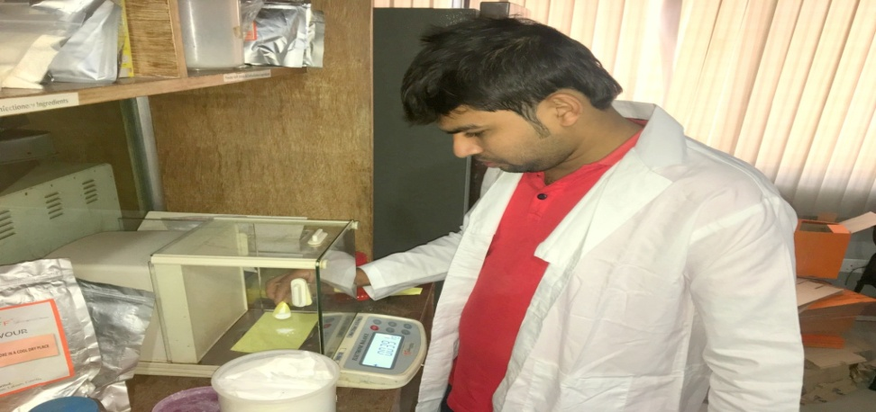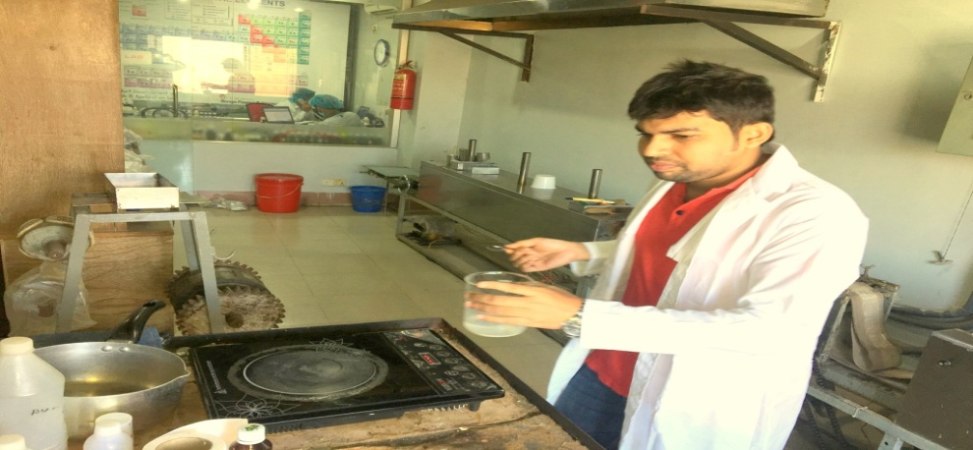
Weighing of Sodium Bi Carbonate Heating of Starch & Water

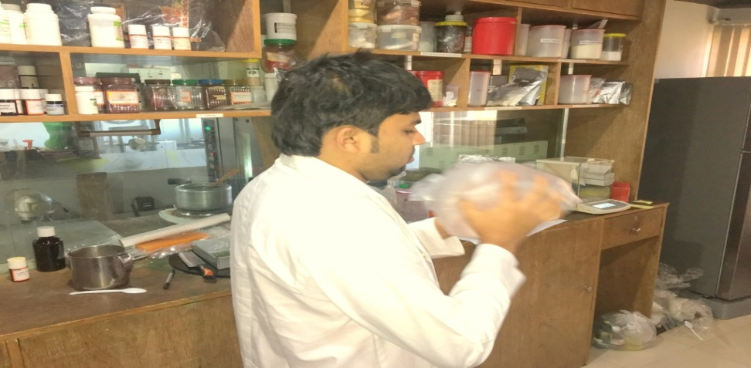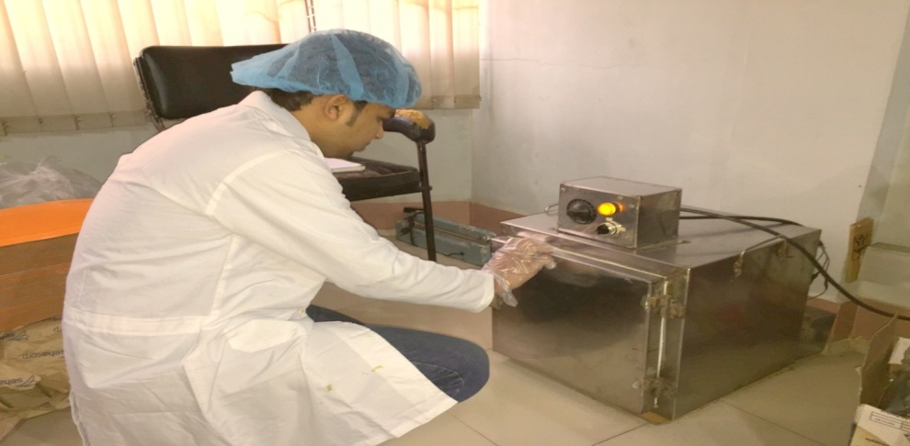
Mixing Drying

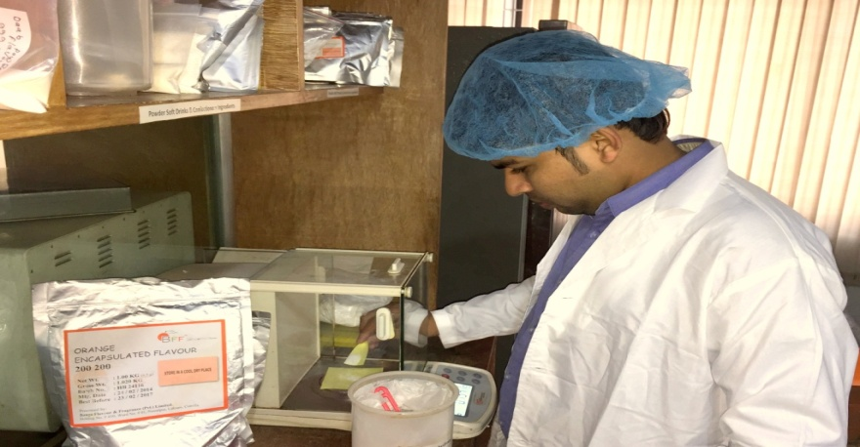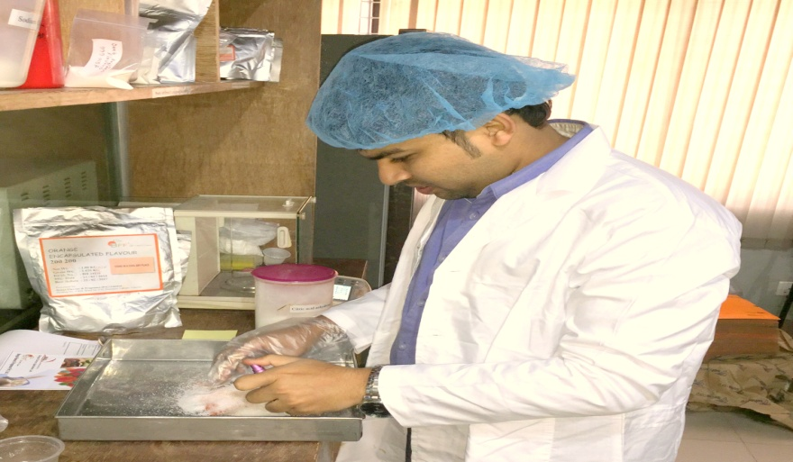
Weighing raw materials for CSD Colouring & Mixing

Appendix I: Picture Gallery (Continued)

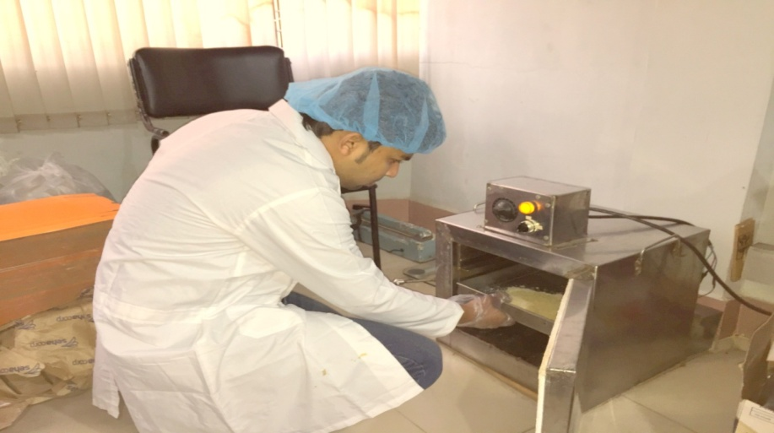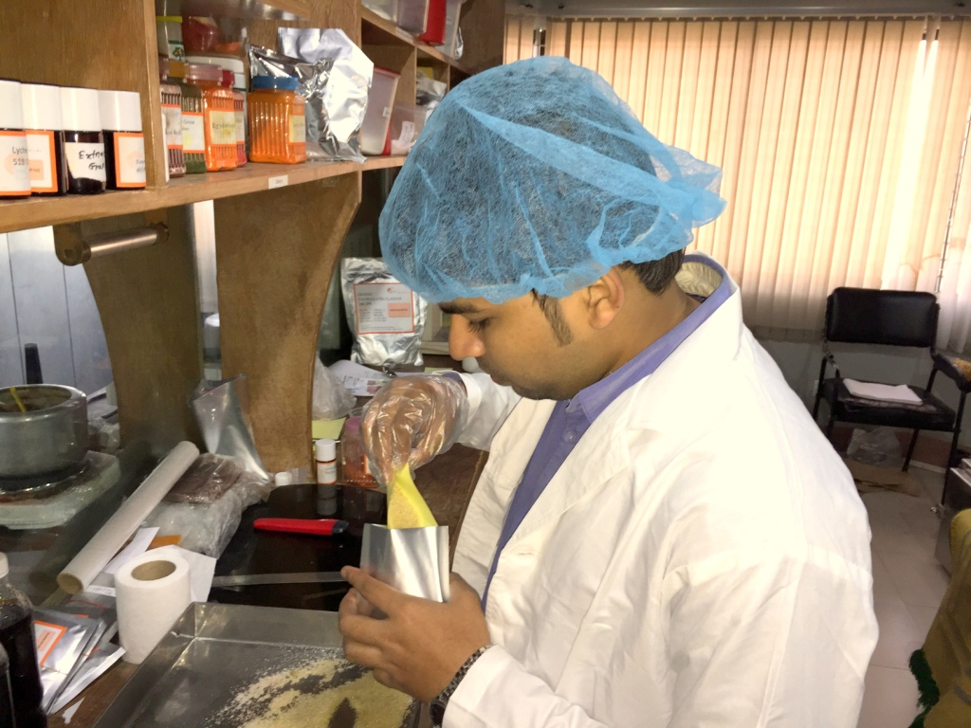
Drying of CSD Packaging of Final Products

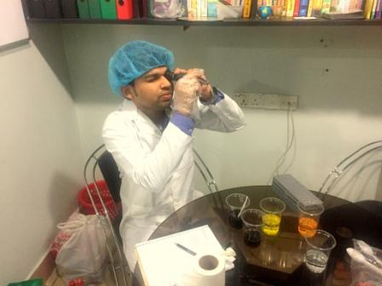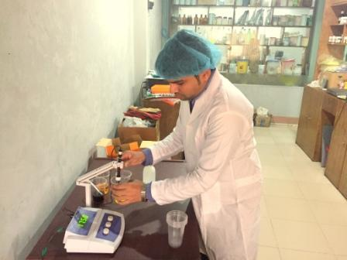
Degree Brix % Test p^{H} Test

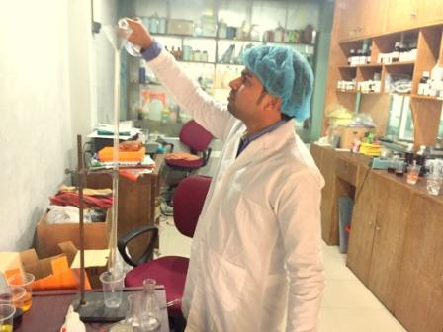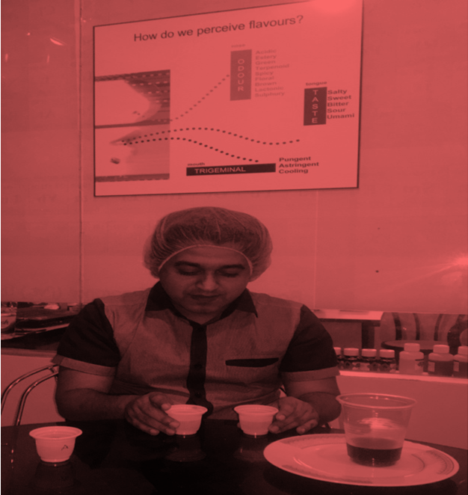
Acidity Test Sensory Evaluation (Tri angle test) By Expert
BRIEF BIOGRAPHY

Amir Khasru Sikder passed the Secondary School Certificate Examination in 2007 and then Higher Secondary Certificate Examination in 2009. Amir Khasru Sikder obtained his B.Sc. (Hons.) in Food Science & Technology in 2014 from Chittagong Veterinary and Animal Sciences University (CVASU), Bangladesh. Now, he is a candidate for the degree of MS in Department of Food Processing & Engineering under Food Science & Technology Faculty; CVASU. He has immense interest to work in Encapsulation & Powder Soft drinks.

