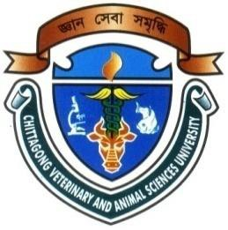

EFFECTS OF LEVOCARNITINE SUPPLEMENTATION ON PRODUCTIVE PERFORMANCE AND CARCASS CHARACTERISTICS OF BROILER

HILLOL SIKDER
Examination Roll No. 0115/04
Registration No. 235 (January-June 2015)
Semester: July-December 2016

A thesis submitted in partial fulfillment of the requirements for the degree of Master of Science in Animal and Poultry Nutrition

Department of Animal Science and Nutrition
Faculty of Veterinary Medicine

Chittagong Veterinary and Animal Sciences University
Chittagong-4225, Bangladesh
December 2016
Authorization
I hereby declare that I am the sole author of the thesis. I also authorize the Chittagong Veterinary and Animal Sciences University (CVASU) to lend this thesis to other institutions or individuals for the purpose of scholarly research. I further authorize CVASU to reproduce the thesis by photocopying or by other means in total or in part, at the request of other institutions or individuals for the purpose of scholarly research.
I, the undersigned and author of this work, declare that the electronic copy of this thesis provided to the CVASU Library is an accurate copy of the print thesis submitted within the limits of the technology available.

The Author
December 2016

EFFECTS OF LEVOCARNITINE SUPPLEMENTATION ON PRODUCTIVE PERFORMANCE AND CARCASS CHARACTERISTICS OF BROILER

HILLOL SIKDER
Examination Roll No. 0115/04
Registration No. 235 (January-June 2015)
Semester: July-December 2016

This is to certify that we have examined the above Master’s thesis and have found that the thesis is complete and satisfactory in all respects and that all revisions required by the thesis examination committee have been made

 | (Md. Emran Hossain) |  |  |  | (DR. Mahabub Alam)
Associate Professor and Head  Department of Animal Science and Nutrition  Supervisor |  |  |  | Assistant Professor  Department of Animal Science and Nutrition  Co-Supervisor
(Md. Emran Hossain)
Associate Professor and Head
Department of Animal Science and Nutrition
Chairman of the Examination Committee
Department of Animal Science and Nutrition
Faculty of Veterinary Medicine
Chittagong Veterinary and Animal Sciences University
Khulshi, Chittagong-4225, Bangladesh
December 2016

Acknowledgements
I am indebted to The Creator who enabled me to complete the research work and write up the dissertation successfully for the degree of Master of Science (MS) in Animal and Poultry Nutrition under the Department of Animal Science and Nutrition, Chittagong Veterinary and Animal Sciences University.
I am grateful to my supervisor Md. Emran Hossain, Associate Professor and Head, Department of Animal Science and Nutrition, CVASU for his valuable supervision and guidance. It was really a great pleasure and an amazing experience for me to work under his supervision. I really deemed it and I realized it was a rare opportunity for me to work under his creative guidance. I understand it was impossible to complete the dissertation without his constructive supervision.
It’s my pleasure to convey my profound gratitude to my co-supervisor DR. Mahabub Alam, Assistant Professor, Department of Animal Science and Nutrition, Chittagong Veterinary and Animal Sciences University (CVASU) for his valuable advice, scholastic guidance, suggestions and inspiration.
I sincerely thank all the members of the department of Animal Science and Nutrition for their help in using their laboratory. Last but not least, I express my deepest sense of gratitude to my beloved family members, my well wishers and my friends for their sacrifice, blessings and encouragement.

The Author
December 2016

Contents
Chapter | List of Contents |  |  | Page No.
 | Authorization |  |  | II
 | Signature page |  |  | III
 | Acknowledgements |  |  | IV
 | List of Abbreviations |  |  | VII
 | List of Tables |  |  | VIII
 | List of Figures |  |  | IX
 | Abstract |  |  | X
Chapter I | Introduction |  |  | 01-03
 | 1.1. | Objectives |  | 02
 | 1.2. | Research questions |  | 02
 | 1.3. | Scope of the study |  | 02
 | 1.4. | Major limitations of the study |  | 03
Chapter II | Review of Literature |  |  | 04-10
 | 2.1. | A brief history and chemistry of levocarnitine |  | 04
 | 2.2. | Synthesis and deficiency of levocarnitine |  | 05
 | 2.3. | Bioavailability and absorption of levocarnitine |  | 06
 | 2.4. | General functions of levocarnitine |  | 06
 | 2.5. | Effect of levocarnitine on poultry |  | 08-10
 |  | 2.5.1. | Performance | 08
 |  | 2.5.2. | Abdominal fat | 09
 |  | 2.5.3. | Effect of levocarnitine on immunity of poultry | 09
 |  | 2.5.4. | Antioxidant effect of levocarnitine in poultry | 10
Chapter III | Materials and Methods |  |  | 11-17
 | 3.1. | Study area |  | 11
 | 3.2. | Study period |  | 11
 | 3.3. | Experimental birds |  | 11
 | 3.4. | Experimental drug |  | 11
 | 3.5. | Design of experiment |  | 11
 | 3.6. | Management |  | 12-14
 |  | 3.6.1. | Housing | 12
 |  | 3.6.2. | Brooder and cage space | 12
 |  | 3.6.3. | Brooding | 13

Chapter | List of Contents |  |  |  |  |  | Page No.
 |  |  | 3.6.4. |  | Temperature and humidity control of experiment |  | 13
 |  |  | 3.6.5. |  | Feeding and watering |  | 13
 |  |  | 3.6.6. |  | Vaccination |  | 14
 |  |  | 3.6.7. | Sanitation |  |  | 14
 | 3.7. |  | Laboratory work |  |  |  | 14-16
 |  |  | 3.7.1. | Estimation of Ether Extract of liver |  |  | 14
 |  |  | 3.7.2. | Carcass characteristics |  |  | 15
 | 3.8. |  | Data collection |  |  |  | 16-17
 |  |  | 3.8.1. | Weight gain |  |  | 16
 |  |  | 3.8.2. | Feed intake |  |  | 16
 |  |  | 3.8.3. | Feed Conversion Ratio |  |  | 17
 | 3.9. |  | Statistical analysis |  |  |  | 17
Chapter IV | Results |  |  |  |  |  | 18-21
 | 4.1. |  | Live weight |  |  |  | 18
 | 4.2. |  | Weight gain |  |  |  | 18
 | 4.3. |  | Feed intake |  |  |  | 19
 | 4.4. |  | Feed Conversion Ratio |  |  |  | 20
 | 4.5. |  | Ether Extract of liver |  |  |  | 20
 | 4.6. |  | Carcass characteristics |  |  |  | 21
Chapter V | Discussion |  |  |  |  |  | 22-28
 | 5.1. | Weight gain |  |  |  |  | 22
 | 5.2. | Feed intake |  |  |  |  | 23
 | 5.3. | Feed Conversion Ratio |  |  |  |  | 24
 | 5.4. | Ether Extract of liver |  |  |  |  | 25
 | 5.5. | Carcass characteristics |  |  |  |  | 25-28
 |  | 5.5.1. |  |  |  | Dressing percentage | 25
 |  | 5.5.2. |  |  |  | Thigh weight | 26
 |  | 5.5.3. |  |  |  | Breast weight | 26
 |  | 5.5.4. |  |  |  | Abdominal fat weight | 26
 |  | 5.5.5. |  |  |  | Liver weight | 27
 |  | 5.5.6. |  |  |  | Spleen weight | 28
 |  | 5.5.7. |  |  |  | Thymus weight | 28
 |  | 5.5.8. |  |  |  | Other parameters | 28
Chapter VI | Conclusion |  |  |  |  |  | 29
Chapter VII | Recommendation |  |  |  |  |  | 30
Chapter VIII | References |  |  |  |  |  | 31-39
 | Brief biography |  |  |  |  |  | 40

List of Abbreviations
 | ˂ | - | Less than
 | % | - | Percentage
 | > | - | Greater than
 | AMP | - | Adenosine monophosphate
 | ANOVA | - | Analysis of variance
 | ATP | - | Adenosine tri-Phosphate
 | BMD | - | Bangladesh meteorological department
 | CoA | - | Coenzyme A
 | CVASU | - | Chittagong veterinary and animal sciences university
 | DOC | - | Day old chick
 | DM | - | Dry matter
 | e.g | - | Example
 | EE | - | Ether extract
 | et al. | - | And his associates
 | etc. | - | Et cetera
 | FCR | - | Feed conversion ratio
 | g | - | Gram
 | i.e. | - | That is
 | Kg | - | Kilogram
 | Km | - | Kilometer
 | mg | - | Milligram
 | mg/l |  | Milligram per liter
 | M_{R} | - | Relative formula mass
 | MS | - | Master of Science
 | NS | - | Non significant
 | Ref. | - | Reference
 | SEM | - | Standard error of mean
 | Sig. | - | Significance
 | USA | - | United States of America

List of Tables
Table 1 | : | Layout of the experiment. | 12
Table 2 | : | Nutritive value of basal diet in broiler feeding. | 14
Table 3 | : | Vaccination schedule. | 14
Table 4 | : | Live weight (g/bird) of the experimental broiler birds fed diets supplemented with levocarnitine. | 18
Table 5 | : | Weight gain (g/bird/day) of the experimental broiler birds fed diets supplemented with levocarnitine. | 19
Table 6 | : | Feed intake (g/bird/day) of the experimental broiler birds fed diets supplemented with levocarnitine. | 19
Table 7 | : | FCR of the experimental broiler birds fed diets supplemented with levocarnitine. | 20
Table 8 | : | Ether extract of liver of the experimental birds at the end of experimental period. | 20
Table 9 | : | Carcass characteristics of the experimental birds at the end of experimental period. | 21

List of Figures
Figure 1 | : | Structural formula of levocarnitine | 04
Figure 2 | : | Endogenous synthesis pathway of levocarnitine | 05
Figure 3 | : | Role of levocarnitine in the transport of long-chain fatty acids through the inner mitochondrial membrane | 07
Figure 4 | : | Sample in airtight bag | 15
Figure 5 | : | Estimation of ether extract | 15
Figure 6 | : | Cutting of thigh | 15
Figure 7 | : | Weighing of the breast | 15
Figure 8 | : | Abdominal fat | 16
Figure 9 | : | Collection of abdominal fat | 16

Abstract
One hundred Cobb 500™ broiler chicks were used in a 28-day trial at Chittagong Veterinary and Animal Sciences University poultry farm to evaluate the functional efficiency of levocarnitine in drinking water on performance and carcass parameters of broiler chickens. Birds were divided into five dietary treatment groups designated as T₀, T₁, T₂, T₃ and T₄ and each treatment was further divided into two replicates having 10 birds per replicate. Levocarnitine was supplemented in drinking water at the rate of 0 mg/l, 25 mg/l, 50 mg/l, 75 mg/l and 100 mg/l respectively. All birds had free access to ad libitum feed and water. Results indicated that, levocarnitine supplementation in drinking water significantly increased body weight (p<0.001) over the whole rearing period. Highest average live weight (1736.0 g/bird) was recorded in the T₄ group and the lowest (1650.2 g/bird) in the T₀ group. A highly significant level of variations (p<0.001) in weight gain was found from 17.0 to 17.2 g/bird/day at 1st week and 54.9 to 58.2 g/bird/day at 2nd week, whereas variations (p<0.01) were also found from 70.9 to 78.1 g/bird/day at 3rd week as the level of levocarnitine supplementation increased from 0 mg/l to 100 mg/l. The feed intake decreased significantly (p<0.01) in the last week in relation with the lower to higher doses of levocarnitine. At the age of 4th week, the lowest average feed intake (137.7 g/bird/day) was recorded in the T₄ group and the highest (148.4 g/bird/day) in T₀ group. The feed efficiency was significantly improved (P<0.001) over the whole experimental period. The best feed conversion ratio (FCR) (1.4) was recorded in the highest level of levocarnitine supplemented group (100 mg/l) and the worst FCR (1.5) in the control group (0 mg/l). Supplementation of levocarnitine in drinking water significantly increased the dressing percentage (p<0.05), thigh weight (p<0.05), breast weight (p<0.01), spleen weight (p<0.05), thymus weight (p<0.01) and decreased (p˂0.01) the abdominal fat weight.
Keywords: Carcass characteristics, Drinking water, Feed conversion ratio, Levocarnitine, Weight gain.

Chapter I: Introduction
Bangladesh is considered as one of the highest density countries of the world which has a population of 157 million people within the area of 148,460 km² (The World Factbook, 2016). Poultry is a substantial contributor to the food supply of Bangladesh. The poultry industry has been successfully becoming a leading industry in Bangladesh (Ali and Hossain, 2012).
In late years, broiler chickens have been intensively selected for increased weight gain. This strategy improved the pace of increase weight gain and feed conversion, but had undesirable effects in the shape of increased deposition of abdominal adipose tissue and greater incidence of metabolic diseases, such as ascites. Excess carcass fat is unattractive to healthy eating consumers who reach for poultry meat because of its nutritional attributes. At the same time, increased carcass fatness reduces the profits of poultry producers. The problem can be addressed through proper selection, but this is a long-term process and breeders look for quick solutions. One solution is to provide broilers with dietary supplements such as levocarnitine (Buyse et al., 2001).
Levocarnitine is synthesized in vivo from lysine and methionine, and it is formed by contributions from vitamins B₃ (niacin), B₆ (pyridoxine), B₁₂ (cyanocobalamin), C (ascorbic acid) and folic acid, as well as iron (Fe²⁺⁾ (Golzar Adabi et al., 2011). This substance is needed to transport long-chain fatty acids into mitochondria, these acids taking part in β-oxidation that leads to the production of energy (Brooks, 1998). Levocarnitine was discovered in the early 20th century by Gulewitsch and Krimberg, who isolated it from muscle tissue (Arslan, 2006). Levocarnitine prevents fatty tissue build up, thus reducing obesity and atherosclerosis. It decreases the calorie requirement and increases the tolerance to effort (Pietrzak and Opala, 1998). Many experiments and clinical observations showed that levocarnitine takes part in regulating the body’s lipid levels. It also has the ability to reduce the level of triacylglycerols and cholesterol (Calvani et al., 2000).
Levocarnitine is known for being the improvement of the growth performance. The improvements in body weight gain of broilers observed due to added dietary levocarnitine may be attributable to an improved utilization of dietary nitrogen,
achieved through more efficient fat oxidation by levocarnitine. The increased fatty acid oxidation induced by levocarnitine may result in decreased availability of long-chain fatty acids for esterification to triacylglycerols, and at the same time can raise the mitochondrial level of acetyl-CoA. Such a situation can affect the activity of pyruvate carboxylase, which is an acetyl-CoA-dependent enzyme that can supply carbon chains for amino acid biosynthesis (Cyr et al., 1991).
Over the last twenty years, many experiments were performed to test the use of levocarnitine in broiler nutrition. Researchers studied its effect on production parameters such as body weight, rate of growth, feed consumption and conversion, content of abdominal fat, proportion of breast and leg muscles, and giblets percentage. It was also investigated if levocarnitine has an effect on chicken health. The results obtained were inconsistent. Some authors provided conclusive evidence that levocarnitine has a beneficial effect on these parameters, while others comments that levocarnitine has no effect on, or even adversely affects production results and mortality (Golzar Adabi et al., 2011). Regarding this inconclusive information this is necessary to re-evaluate the effect of levocarnitine on growth performance of broiler.
  - Objectives
    - To observe the effects of level of levocarnitine supplementation on feed intake, weight gain and FCR in commercial broiler.
    - To identify the effects of level of levocarnitine supplementation on carcass characteristics in commercial broiler.
1.2. Research questions
- Is there any effect of levocarnitine on productive performance of broiler?
- Which level of levocarnitine improves productive performance of the bird?
- Does levocarnitine have any effect on carcass characteristics of broiler?
1.3. Scope of the Study
The purpose of the study is to assess the effectiveness of levocarnitine on productive performance and carcass quality. This study also evaluated the most suitable levels of levocarnitine supplementation for maximum productivity and better carcass quality.
1.4. Major limitations of the study
- The sample size was only 100 birds due to resource limitation.
- Seasonal variations were not observed due to limited study period.
- Comparative meat evaluation based on chemical properties was not done due to financial limits.

Chapter II: Review of Literature
Continuous selection of broilers for better performance, faster weight gain and better feed efficiency is aligned with an alteration of nutrient requirements. As a result, some of the nutrients previously considered as non-essential may become essential. For years, a carnitine requirement was not considered due to endogenous biosynthesis. However, studies show that it becomes an essential nutrient under certain circumstances, such as limited carnitine biosynthesis in young animals, diets high in fat content, and diets low in carnitine.
2.1. A brief history and chemistry of levocarnitine
Levocarnitine (C₇H₁₅NO₃) (Figure 1) is present in both plasma and tissue as free carnitine, or bound to fatty acids as acyl carnitine derivatives (Bieber, 1988). It is a water soluble zwitterionic compound (161.2 M_{R}). It has been recognized to be physiologically important for nearly a century; yet, its fundamental roles in some aspect, such as health and disease remain to be fully understood (Mast et al., 2000).
Due to its asymmetric structure of carbon two, the molecule possesses optical activity and exists in two enantiomeric forms. The D-form does not occur in nature, but may be obtained by chemical synthesis (Liedtke et al., 1982) and only the L-form is biologically active and occurs in nature and it has pharmacological and nutritional properties (Mardones et al., 1999). However, subsequent investigations have shown that D-carnitine acts as a competitive inhibitor of active uptake systems in the L isometric form (Walter and Schaffhauser, 2000).
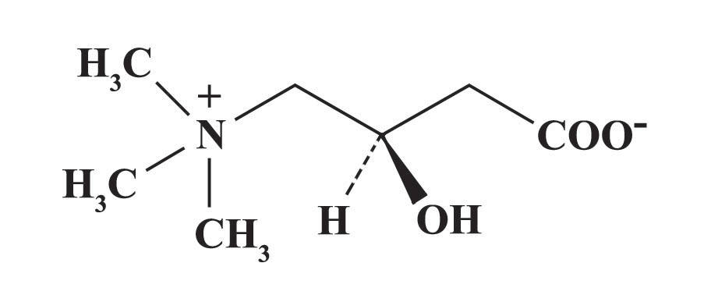
Figure 1: Structural formula of levocarnitine (L-3-hydroxy-4-N trimethylamino-butyrate) (Metzler and Metzler, 2003).

2.2. Synthesis and deficiency of levocarnitine
The first convincing evidence for carnitine biosynthesis in animals was obtained from chick embryos, which contained significant amounts of carnitine. No-one was found in eggs (Bremer, 1983). Endogenous biosynthesis (in the kidney, liver and brain) occurs in small amounts, but appears sufficient to cover normal requirements (Figure 2). However, this is not the case in neonates (Keralapurath et al., 2010a), where birds are under conditions of stress, higher performance and diets rich in fat (Harpaz et al., 1999).
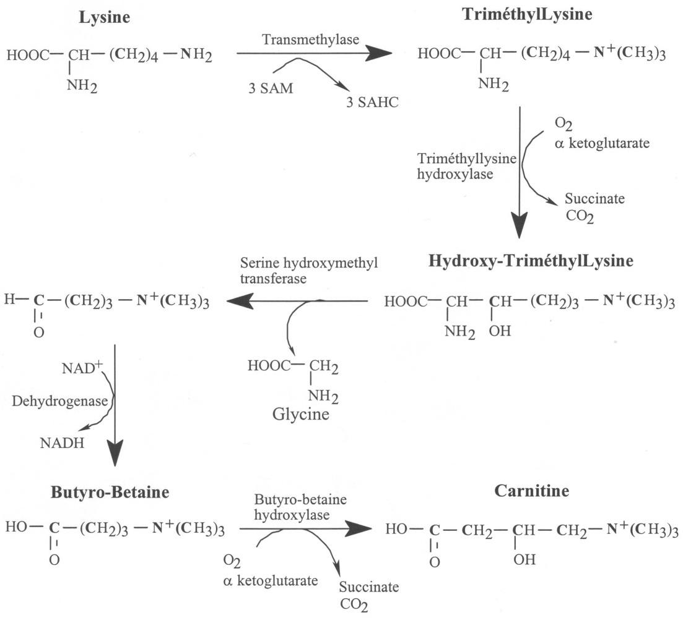
Figure 2: Endogenous synthesis pathway of levocarnitine.
Two essential amino acids (lysine and methionine), three vitamins (ascorbate, niacin in the form of nicotin amide adenine dinucleotide and vitamin B₆), and reduced iron (Fe²⁺) are required as cofactors for the enzymes involved in the metabolic pathway of levocarnitine synthesis (Leibetseder, 1995). Reports of nutritional levocarnitine deficiency are rare (Harpaz, 2005), and accumulation of toxic acyl-coenzyme (CoA) metabolites in the mitochondria due to levocarnitine deficiency impair the citrate cycle, gluconeogenesis and fatty acid oxidation (Knuttel-Gustavsen and Harmeyer, 2007).
2.3. Bioavailability and absorption of levocarnitine
The mechanisms of the absorption of levocarnitine in the small intestine have not yet been completely clarified (Fischer et al., 2009). Some reports have suggested that both, active (dependent on Na⁺) and passive mechanisms are involved in intestinal levocarnitine transport (Garcia-Miranda et al., 2005). More recently, functional and molecular studies revealed that levocarnitine crosses the intestinal apical membrane by an active, Na⁺ dependent and electrogenic transport system that resembles the organic cation/carnitine transporter (OCTN2) which is a member of the solute carrier 22A gene family, localized to the apical membrane of cells (Kato et al., 2006). Another transporter that may be involved in the intestinal absorption of levocarnitine is ATB^{0, +} (the sodium and chloride coupled amino acid transporters). ATB^{0, +} is already known as a high-affinity transporter of cationic and neutral amino acids that also functions as a low-affinity/high-capacity transporter for carnitine (Hatanaka et al., 2004).
2.4. General functions of levocarnitine
Although levocarnitine participates in several metabolic reactions, its most widely known function is probably interference in the overall context of normal fatty acid metabolism (Hoppel, 2003). A major factor controlling the oxidation of fatty acids is the rate of entry into the mitochondria. While some long-chain fatty acids (perhaps 30% in total) enter the mitochondria and are converted to CoA derivatives in the matrix, the majority are ‘activated’ to acyl-CoA derivatives on the inner surface of the outer membranes of the mitochondria (Metzler and Metzler, 2003). Levocarnitine serves as the carrier that transports activated long chain fatty acyl groups across the inner mitochondrial membrane. Levocarnitine acyl transferases are able to reversibly transfer an activated fatty acyl group from CoA to the hydroxyl group of carnitine to form an acylcarnitine ester. The reaction is reversible, so that the fatty acyl CoA derivative can be regenerated from the carnitine ester. Carnitine palmitoyl transferase I (CPTI; also called carnitine acyltransferase I, CATI), the enzyme that transfers long-chain fatty acyl groups from CoA to carnitine, is located on the outer mitochondrial membrane (Figure 3). Fatty acylcarnitine crosses the inner mitochondrial membrane with the aid of a translocase. The fatty acyl group is transferred back to CoA by a second enzyme, carnitine palmitoyl transferase II (CPTII or CATII). The carnitine released in this reaction returns to the cytosolic side of the mitochondrial membrane by the same translocase that brings fatty acylcarnitine to the matrix side. Long-chain fatty acyl CoA, now located within the mitochondrial matrix, is a substrate for β-oxidation (Smith et al., 2004).
Another function of levocarnitine is metabolic function, in this case levocarnitine act as a buffer for excess acyl residues. This function of levocarnitine beneficial effects of the cell, e.g., by elevating the mitochondrial acetyl-CoA/CoA ratio. Sufficiently high concentrations of free CoA are required to keep the substrate flux of the citric acid cycle at a high level (Zeyner and Harmeyer, 1999).
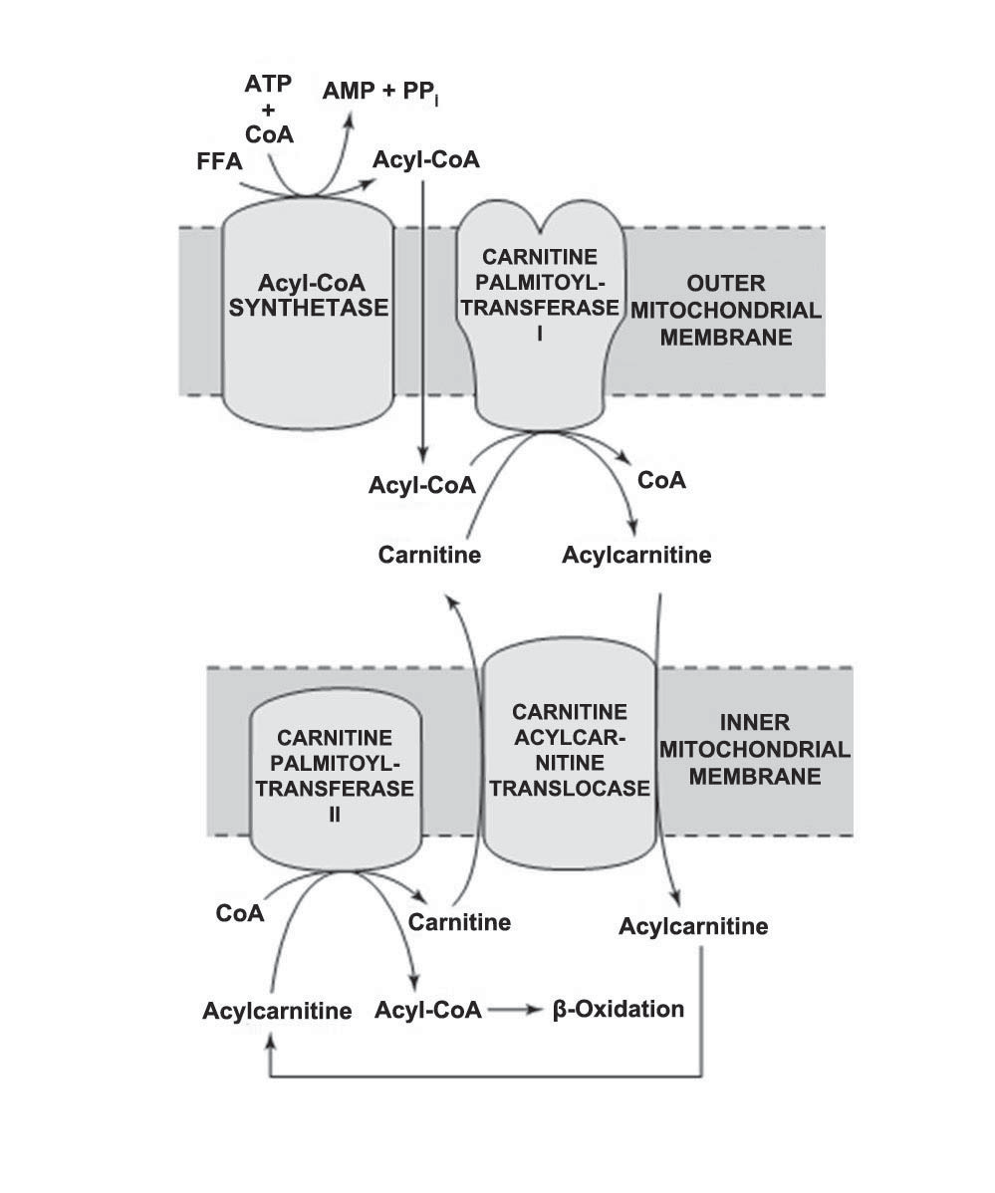
Figure 3: Role of levocarnitine in the transport of long-chain fatty acids through the inner mitochondrial membrane. Long-chain acyl-CoA cannot pass through the inner mitochondrial membrane, but its metabolic product, acylcarnitine; can (Murray et al., 2003).
A study conducted by Owen et al. (2001) showed that supplementation of the pigs’ diet with levocarnitine increased protein accretion. Branched chain keto acids (BCKA) are derived from transamination of branched-chain amino acids (BCAAs; Valine, leucine, and Isoleucine) by BCAA transaminase (Misra et al., 2004). Levocarnitine has also ability to enhance the oxidation of these derivatives and its effect was markedly dependent on its concentration (Van Hinsbergh et al., 1980). Levocarnitine can interfere with the oxidation of BCKA (Hoppel, 2003). Paul and Adibi (1978) concluded that levocarnitine stimulates decarboxylation of BCAA by increasing the conversion of their ketoanalogues into carnitine esters.
2.5. Effect of levocarnitine on poultry
2.5.1. Performance
Feed efficiency remains the most important trait in commercial animal breeding programs, as feed represents 60-70% of the cost of raising an animal to market weight. As mitochondria are responsible for producing 90% of cellular energy, some of the variations in broiler growth performance and phenotypic expression of feed efficiency may be due to differences or inefficiencies in mitochondrial function (Bottje et al., 2002). Levocarnitine is attributed to an increase in the utilization of energy as a result of the increase in fatty acid oxidation by the mitochondria (Bremer, 1983).
Studies on broiler chickens and laying hens (Rodehutscord et al., 2002; Kita et al., 2002; Golzar Adabi et al., 2006a; Geng et al., 2007; Nouboukpo et al., 2010) noticed improved live weight, feed consumption, feed conversion efficiency or egg production by feeding dietary levocarnitine.
A diet of 50 mg/kg dietary levocarnitine in broiler chicks from 0-3 week of old, resulted in an improved feed conversion ratio (Cevik and Ceylan, 2005). Considering this and similar reports it would appear that using levocarnitine during early stages of growth in poultry has a better effect on performance (Kita et al., 2002).

2.5.2. Abdominal fat
Determining the abdominal fat weight as a predictor of total body fat in poultry (Sonaiya, 1985) in feeding studies is a well established methodology. In feeding trials with levocarnitine there have been statistical differences in both abdominal and mesenterical fat percentage, meaning that the levocarnitine group produced lower levels of body fat compared to the control group (Buyse et al., 2001; Xu et al., 2003; Kidd et al., 2005; Ghods-Alavi et al., 2010).
2.5.3. Effect of levocarnitine on immunity of poultry
Interestingly, the selection of today's modern chickens for growth and egg production has resulted in diminished inflammatory response, but selection for more robust immune response results in diminished growth and egg production. It has recently been proposed that certain nutrients can be used as a means to specifically prevent infectious diseases in poultry (Kogut, 2009). Besides taking part in the transfer of long-chain fatty acids, early experiments have demonstrated the immune-modulating properties of levocarnitine (Famularo and De-Simone, 1995). Leghorn-type chickens offered the 1000 mg/kg in feed had a higher primary antibody level against sheep red blood cells (SRBC) than either of the other two groups at week 12. These birds had a higher relative thymus weight than the control at week 12 (Deng et al., 2006). Similarly, Golzar Adabi et al. (2006b) reported that the addition of 100 mg/kg levocarnitine to a broiler diet caused the significantly higher antibody response to SRBC and Newcastle disease virus than non-treated birds. Furthermore, additional dietary 100 mg/kg levocarnitine had the highest bursa of Fabricius, spleen and thymus weight by comparison with the other groups. Buyse et al. (2007) confirmed that 100 mg/kg levocarnitine in the diet of broiler chickens modulates the innate immune response in terms an enhanced acute phase protein response and levocarnitine has glucocorticoid-like effect.
With regard to the role of levocarnitine in cellular immunity, it was present in lymphocytes in high concentrations, and inhibited apoptosis of those immune cells (Moretti et al., 1998) and enhanced their proliferative response to mitogens (De Simone et al., 1994). Furthermore, dietary levocarnitine supplementation significantly increases total Ig G and Ig A but not Ig M responses after both primary and the secondary immunization with bovine serum albumin in broilers (Mast et al., 2000).
2.5.4. Antioxidant effect of levocarnitine in poultry
Oxidative stress constitutes an important mechanism that leads to biological damage, and it is regarded as one of the causes of several pathologies that affect poultry growth (Fellenberg and Speisky, 2006). The main free radicals are those species which superoxide anion (O₂ ⁻•) and hydroxyl radical (HO•) derived from oxygen, and nitric oxide (NO•) derived from nitrogen, but non free-radical species are H₂O₂ and singlet oxygen (O₂). These various forms of activated oxygen can cause oxidative damage in tissues and cells (Gulcin, 2006). Diet can be used as a vehicle to provide compounds with antioxidant properties as they have a special place in the maintenance of high production performance in poultry (Surai, 2007). Levocarnitine prevents oxidative stress and regulates nitric oxide, the cellular respiration (Brown, 1999) and the activity of enzymes involved in defense against oxidative damage (Kremser et al., 1995). Levocarnitine acts as an antioxidant in the protection of glutathione peroxidase, catalase and superoxide dismutase enzymes from further peroxidative damage (Kalaiselvi and Panneerselvam, 1998). It may have functions associated with scavenging of free radicals in cellular sites (Citil et al., 2005) and supplementation of levocarnitine have improved the glutathione and total thiol (-SH) status. Levocarnitine is associated with buffering of excess acetyl-CoA, which in itself can cause free radical formation and potentially toxic to the cells, and it was reported that levocarnitine has a protective effect on lipid peroxidation by reducing the formation of hydrogen peroxide (Bayraktar et al., 2008).

Chapter III: Materials and Methods
3.1. Study area
The experiments were carried out at Chittagong Veterinary and Animal Sciences University poultry farm, and analysis were performed research laboratories, Chittagong Veterinary and Animal Sciences University (CVASU), Khulshi, Chittagong, Bangladesh.
3.2. Study Period
The total research period was from July to December 2016 but the actual feeding trial on broiler was carried from 1st to 28th November 2016. November was considered as post monsoon seasons (Islam and Uyeda, 2006). In November average maximum temperature was 29°C and humidity was 78% (BMD, 2016).
3.3. Experimental birds
The day-old chicks (Cobb 500™ strain) of mixed sex (male and female) were purchased from an agent of the Nahar Agro Complex Limited, Jhautala Bazar, Khulshi, Chittagong, Bangladesh. Before purchasing, all chicks were examined for uniform size and any kind of abnormalities. The average body weight of purchasing chicks was about 46.48 ± 0.01gm.
3.4. Experimental drug
The commercial name of levocarnitine used in this experiment is the Levocar® solution of SQUARE Pharmaceuticals Limited, Bangladesh in which, each 5ml solution contains levocarnitine USP 500 mg.
3.5. Design of experiment
A total of 100 birds were equally and randomly (Completely Randomized Design) allocated and distributed in five treatment groups (T₀, T₁, T₂, T₃ and T₄) with two replications per treatment. These groups were treated with levocarnitine at the rate of 0 mg/l, 25 mg/l, 50 mg/l, 75 mg/l and 100 mg/l respectively in regular drinking water of broilers along with regular homogenous optimum diets (Standard diet; NRC, 1994) for all groups. There were 20 birds per treatment group and 10 birds per replication.
The bird rearing period was 4 weeks. Layout of the experiment is shown in Table 1.
Table 1: Layout of the experiment.
Dietary treatments | No. of birds per replicate |  | No. of birds per treatment
T₀ (0 mg/l levocarnitine) | R₁ | 10 | 20
 | R₂ | 10
T₁ (25 mg/l levocarnitine) | R₁ | 10 | 20
 | R₂ | 10
T₂ (50 mg/l levocarnitine) | R₁ | 10 | 20
 | R₂ | 10
T₃ (75 mg/l levocarnitine) | R₁ | 10 | 20
 | R₂ | 10
T₄ (100 mg/l levocarnitine) | R₁ | 10 | 20
 | R₂ | 10
Grand total |  |  | 100
3.6. Management
3.6.1. Housing
At first, poultry shed was selected and prepared for broiler rearing. The broiler shed was thoroughly washed and cleaned by using tap water with caustic soda. For killing microorganisms, phenyl solution (15 ml/5 liters) was also spread on the floor, corners and ceiling. Following this, brushing was done by using steel brush and clean water. Brooding boxes and broiler cages were also cleaned by using tap water, caustic soda and phenyl solution in the same manner. After cleaning and disinfecting the house was left for one week for drying. All windows were opened for proper ventilation. After one-week, the lime was spread on the floor and around the shed for strictly maintaining bio-security. Arrangement for rearing broilers was made according to treatments and replications. The compartments were selected in an unbiased way, according to treatments and replications for uniform distribution of chicks.
3.6.2. Brooder and cage space
Each brooder box having 2.38 ft. × 2.08 ft. was allocated for 30 birds. After 14 days later broiler birds were transferred to cage having 3.5 ft. × 1.63 ft. for 10 birds. Therefore, floor space for each bird in the brooder box was 0.17 sq. ft. and cage was 0.57 sq. ft. respectively.
3.6.3. Brooding
The brooder boxes were ready for broiler chicks rearing after proper cleaning and drying. Dry and clean newspaper were placed on the floor of the brooder box as bedding materials and was changed for every 6 hours intervals in whole brooding period. Brooding temperature was maintained by using 100, 50 and 25 watt incandescent lamps in each brooder box. The broilers were exposed to continuous lighting. During the brooding period chicks were brooded at a temperature of 95°F, 90°F, 85°F and 80°F for the 1st, 2nd, 3rd and 4th week respectively.
3.6.4. Temperature and humidity control of experiment
Broiler shed was not environmentally controlled, 200 watt incandescent lamps were used to keep the optimum temperature and electric fans were used to distribute the room temperature. In adverse condition, the system had been changed; in cold weather gunny bag were used to prohibit fluctuating the room temperature as well as humidity.
3.6.5. Feeding and watering
Ready-made feed of C.P. Bangladesh Co., Ltd., Bangladesh was supplied to the birds in two different growth stages i.e. starter and grower. Starter ration was offered from day 0 to 14 days and grower ration was offered from day 15 to 28. Feed and water were supplied ad-libitum to all groups of birds in three different times in a day (7.00, 14.00 and 22.00 h) throughout the experimental period. Feed and water was given to birds on small feeder and small drinkers in the early stage of brooding. In each brooder box, feeding was done by using one round feeder and watering was performed with one round drinker having a capacity of 1.5 liters. The feeders and drinkers were fixed in such a way so that the birds could eat and drink conveniently. During the period of cage rearing, large linear feeder (3.5 ft. × 0.38 ft.) and large round drinker with a capacity of three liters were used. The nutritive value of the diets, provided by the manufacturer are presented in Table 2.

Table 2: Nutritive value of basal diet in broiler feeding.
Specification | Type of a diet/Age of chicken (days)
 | Starter (1 - 14) | Grower (15 - 28)
ME (MJ.kg⁻¹) | 3000.00 |  | 3100.00
Crude protein (%) | 21.50 |  | 20.00
Crude fiber (%) | 5.00 |  | 5.00
Fat (%) | 3.50 |  | 3.00
Lysine (%) | 1.25 |  | 1.20
Methionine (%) | 0.50 |  | 0.45
3.6.6. Vaccination
All birds were vaccinated properly against Newcastle disease on the 6th day and Infectious Bursal disease on 12th day. After each vaccination, multivitamin (Rena-WS®, Renata) was supplied @ 1g/5 liters of drinking water along with vitamin-C (Rena-C®, Renata) to overcome the stressed effect of vaccination and cold weather.
Table 3: Vaccination schedule.
Age of birds | Name of diseases | Name of vaccine | Route of administration
6th day | New Castle Disease | BCRDV (Live) | One drop in one eye
12th day | Infectious Bursal Disease | IBD | One drop in one eye
3.6.7. Sanitation
Bio-security was maintained strictly during the whole experimental period. Footbath containing potassium-per-manganate was kept at the entrance of the poultry shed. It was changed daily. Feeders were cleaned and washed with detergent and clean water, weekly before being used further. Drinkers were washed with potassium-per-manganate and dried up daily in the morning.
3.7. Laboratory work
3.7.1. Estimation of Ether Extract (EE) of liver
Moisture free liver sample was weighed and placed into the thimbles and crude fat was extracted by refluxing in Soxtest apparatus (Raypa®, SX-6) using petroleum ether as solvent. Percent crude fat was calculated by difference as per AOAC (2006).
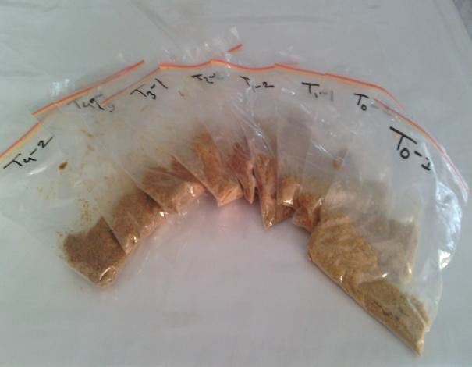  Figure 4: Sample in airtight bag | 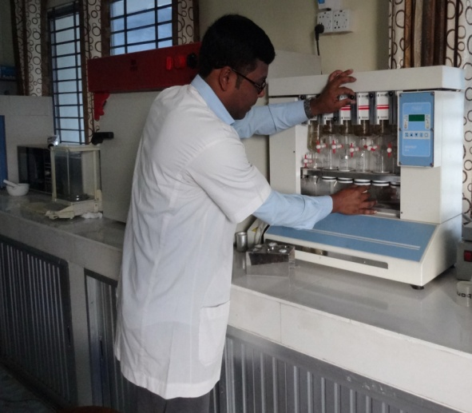  Figure 5: Estimation of ether extract
3.7.2. Carcass characteristics
On days 28 of the study, twenty birds randomly selected from each replication, weighed and then sacrificed by severing of the jugular vein and carotid artery. Once a bird had been allowed to adequately bleed out; the skin with feather was removed using knife and hand force. After defeathering, the birds were eviscerated and the head and feet were removed. During the evisceration process, abdominal fat and liver were excised and weighed. Dressed birds were weighed to obtain a dressed carcass weight. Carcasses were cut into different cuts like- breast, back, thigh, drumstick etc. to measure individual cuts weight. The weights of visceral organs also measured.
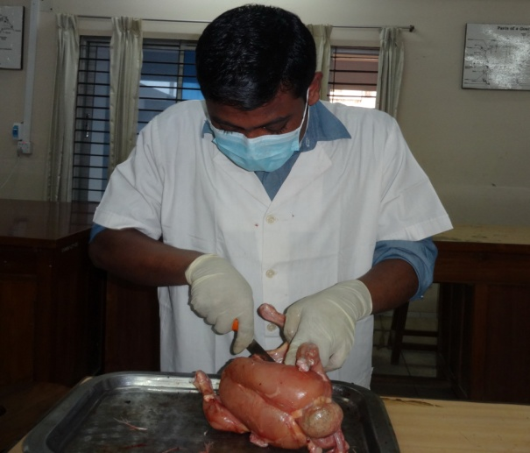  Figure 6: Cutting of thigh | 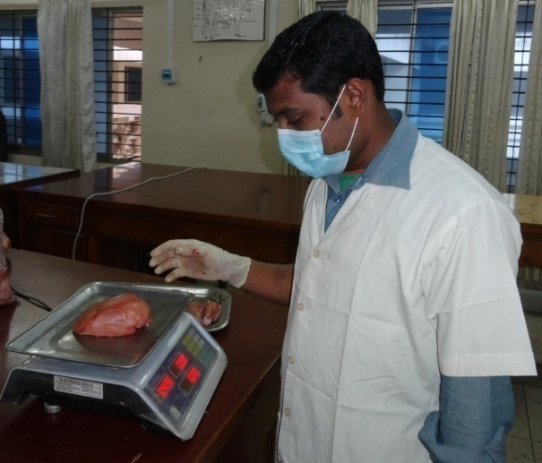  Figure 7: Weighing of the breast
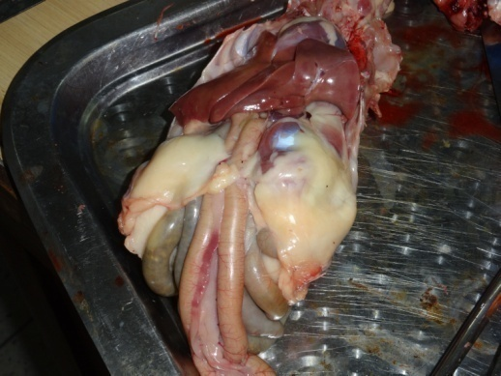  Figure 8: Abdominal fat | 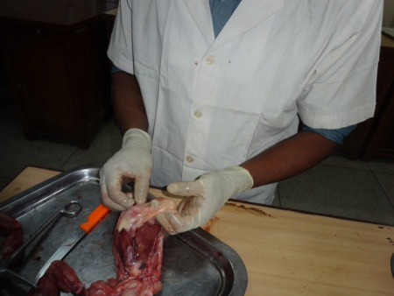  Figure 9: Collection of abdominal fat
3.8. Data collection
Following parameters were recorded throughout the experimental period.
3.8.1. Weight gain
The weight of the chicks were recorded at first day and then weekly intervals. This measures were done along the whole experimental period. The weight gain was calculated by deducting initial body weight from the final body weight of the birds during specific period.
Weight gain = (Final body weight-Initial body weight)
3.8.2. Feed intake
Feed intake was calculated by deducting the left over feed from the total amount of supplied feed to the broilers. Feed intake was calculated as gm/bird/day.
Feed intake = (Offered feed - Residual feed)

3.8.3. Feed conversion ratio (FCR)
During this study, bird weight was measured by treatment on a weekly basis. Weekly weight gain was calculated and these figures were used to the weekly consumption to determine feed conversion ratio. The amount of feed intake per unit of weight gain is the feed conversion (FC). This was calculated by using the following formula.
$$FCR=\frac{Feed intake (kg)}{Weight gain (kg)}$$
3.9. Statistical analysis
All the data of growth performance and carcass characteristics were entered into MS excel (Microsoft office excel-2007, USA). Data management and data analysis were done by using one way ANOVA (Winer et al., 1991) by using SPSS 16.0. A P value of <0.05, <0.01 or <0.001 were considered statistically significant.

Chapter IV: Results
The experiment was carried out to measure the effect of levocarnitine on the performance parameter and carcass characteristics of Cobb-500™ broilers. The results obtained from the study have been described in this chapter.
4.1. Live weight
Live weight of the experimental birds were recorded weekly basis throughout the whole experimental period (Table 4). Results indicated that, weekly average live weight differed significantly (p˂0.001) throughout the trial period as the level of levocarnitine supplementation increased from 0 mg/l to 100 mg/l. Highest average live weight was recorded at the highest level of levocarnitine (100 mg/l) supplementation group and the lowest average live weight was recorded in the control group (0 mg/l levocarnitine) in every week. At the end of the experiment, maximum average weight (1736.0 gm/bird) was recorded in T₄ group and minimum average weight (1650.2 gm/bird) was recorded in T₀ group (control group).
Table 4: Live weight (g/bird) of the experimental broiler birds fed diets supplemented with levocarnitine.
Age of bird | Dietary treatments |  |  |  |  | SEM | Sig.
 | T₀ | T₁ | T₂ | T₃ | T₄
1st week | 165.9 | 166.5 | 166.6 | 167.0 | 166.9 | 0.13 | ***
2nd week | 550.1 | 561.0 | 564.0 | 571.7 | 574.5 | 2.91 | ***
3rd week | 1046.4 | 1097.4 | 1105.1 | 1114.1 | 1121.5 | 9.05 | ***
4th week | 1650.2 | 1703.9 | 1714.2 | 1725.6 | 1736.0 | 10.12 | ***
T₀ = Water containing 0 mg/l levocarnitine; T₁ = Water containing 25 mg/l levocarnitine; T₂ = Water containing 50 mg/l levocarnitine; T₃ = Water containing 75 mg/l levocarnitine; T₄ = Water containing 100 mg/l levocarnitine; SEM = Standard Error of Mean; *** = Significant (p˂0.001).
4.2. Weight gain
The weight gain of the experimental birds revealed that a highly significant (p˂0.001) level of variations were found during the 1st and 2nd week, whereas variations (p<0.01) were also found in 3rd week (Table 5). Considering the data for the 4th week, the live weight gain was differed insignificantly (p>0.05) among the treated groups. In terms of weight gain, T₄ (100 mg/l levocarnitine) group was performed better than other groups and finally highest average daily weight gain (87.8 g/bird/day) was found in T₄ group (p˂0.001).

Table 5: Weight gain (g/bird/day) of the experimental broiler birds fed diets supplemented with levocarnitine.
Age of bird | Dietary treatments |  |  |  |  | SEM | Sig.
 | T₀ | T₁ | T₂ | T₃ | T₄
1st week | 17.0 | 17.2 | 17.2 | 17.2 | 17.2 | 0.02 | ***
2nd week | 54.9 | 56.4 | 56.8 | 57.8 | 58.2 | 0.40 | ***
3rd week | 70.9 | 76.6 | 77.3 | 77.5 | 78.1 | 0.91 | **
4th week | 86.3 | 86.6 | 87.0 | 87.4 | 87.8 | 0.21 | NS
T₀ = Water containing 0 mg/l levocarnitine; T₁ = Water containing 25 mg/l levocarnitine; T₂ = Water containing 50 mg/l levocarnitine; T₃ = Water containing 75 mg/l levocarnitine; T₄ = Water containing 100 mg/l levocarnitine; SEM = Standard Error of Mean; NS = Non-Significant (p>0.05); ** = Significant (p˂0.01); *** = Significant (p˂0.001).
4.3. Feed intake
Feed intake of the experimental birds were varied in a regular fashion during the entire experimental period (Table 6). It was revealed that, the amount of consumed feed was decreased insignificantly (p>0.05) from 1st to 3rd weeks of age compared to control group (0 mg/l levocarnitine), but decreased significantly (p<0.01) at the 4th week of age with increased dose of levocarnitine compared to the control group (0 mg/l levocarnitine). The average feed intake was gradually lower in levocarnitine supplementation groups in comparison with control group throughout the entire experimental period. At the 4th week of age, the highest average feed intake (148.4 g/bird/d) was recorded in T₀ group and the lowest average feed intake (137.7 g/bird/d) was recorded in the T₄ group.
Table 6: Feed intake (g/bird/day) of the experimental broiler birds fed diets supplemented with levocarnitine.
Age of bird | Dietary treatments |  |  |  |  | SEM | Sig.
 | T₀ | T₁ | T₂ | T₃ | T₄
1st week | 20.7 | 20.7 | 20.5 | 20.3 | 20.1 | 0.09 | NS
2nd week | 76.2 | 76.0 | 74.5 | 74.0 | 72.7 | 0.50 | NS
3rd week | 104.7 | 110.0 | 108.6 | 106.9 | 106.4 | 0.70 | NS
4th week | 148.4 | 141.8 | 139.8 | 138.4 | 137.7 | 1.32 | **
T₀ = Water containing 0 mg/l levocarnitine; T₁ = Water containing 25 mg/l levocarnitine; T₂ = Water containing 50 mg/l levocarnitine; T₃ = Water containing 75 mg/l levocarnitine; T₄ = Water containing 100 mg/l levocarnitine; SEM = Standard Error of Mean; NS = Non-Significant (p>0.05); ** = Significant (p˂0.01).

4.4. Feed Conversion Ratio (FCR)
In the first week, feed conversion efficiency (feed/gain) did not differ (p>0.05) within experimental birds (Table 7), however, feed conversion efficiency was significantly diminished (p<0.001) at the 2nd to 4th weeks of age as the level of levocarnitine supplementation increased from 0 mg/l to 100 mg/l. The best FCR (1.6) was observed in the T₄ group and worst FCR (1.7) in the T₀ group at the 4th week of age. The ultimate FCR of levocarnitine supplementation groups were much better than that of the control group (0 mg/l levocarnitine).
Table 7: FCR of the experimental broiler birds fed diets supplemented with levocarnitine.
Age of bird | Dietary treatments |  |  |  |  | SEM | Sig.
 | T₀ | T₁ | T₂ | T₃ | T₄
1st week | 1.2 | 1.2 | 1.2 | 1.2 | 1.2 | 0.01 | NS
2nd week | 1.4 | 1.4 | 1.3 | 1.3 | 1.3 | 0.02 | ***
3rd week | 1.5 | 1.4 | 1.4 | 1.4 | 1.4 | 0.01 | ***
4th week | 1.7 | 1.6 | 1.6 | 1.6 | 1.6 | 0.02 | ***
0-4 week | 1.5 | 1.5 | 1.4 | 1.4 | 1.4 | 0.02 | ***
T₀ = Water containing 0 mg/l levocarnitine; T₁ = Water containing 25 mg/l levocarnitine; T₂ = Water containing 50 mg/l levocarnitine; T₃ = Water containing 75 mg/l levocarnitine; T₄ = Water containing 100 mg/l levocarnitine; SEM = Standard Error of Mean; NS = Non-Significant (p>0.05); *** = Significant (p˂0.001).
4.5. Ether Extract (EE) of liver
Results indicated that, Ether Extract of liver was differed significantly (p˂0.01) at the end of the experiment (Table 8). Highest EE (10.7 gm/100 gm DM) was recorded at 0 mg/l levocarnitine supplementation group (control group) and the lowest EE (8.2 gm/100 gm DM) at 100 mg/l levocarnitine supplementation group at the end of the experiment.
Table 8: Ether Extract of liver of the experimental birds at the end of experimental period.
Parameter (g/100 g DM) | Dietary treatments |  |  |  |  | SEM | Sig.
 | T₀ | T₁ | T₂ | T₃ | T₄
Ether Extract | 10.7 | 9.9 | 9.2 | 8.7 | 8.2 | 0.31 | **
T₀ = Water containing 0 mg/l levocarnitine; T₁ = Water containing 25 mg/l levocarnitine; T₂ = Water containing 50 mg/l levocarnitine; T₃ = Water containing 75 mg/l levocarnitine; T₄ = Water containing 100 mg/l levocarnitine; SEM = Standard Error of Mean; ** = Significant (p˂0.01).
4.6. Carcass characteristics
Among the different carcass characteristics dressed weight, thigh weight and spleen weight increased significantly (p<0.05) in levocarnitine treated groups after the end of the production period (Table 9). The breast and thymus weight also increased significantly (p<0.01) with the gradually higher dose of levocarnitine. On the other hand, the abdominal fat was decreased significantly (p<0.01) in the experimental group in comparison with the control group (0 mg/l levocarnitine). In case of other carcass parameters they were found insignificant (p>0.05) among the different treatment groups.
Table 9: Carcass characteristics of the experimental birds at the end of experimental period.
Parameters (%) | Dietary treatments |  |  |  |  | SEM | Sig.
 | T₀ | T₁ | T₂ | T₃ | T₄
Dressed weight | 61.8 | 62.2 | 63.0 | 64.3 | 66.1 | 0.58 | *
Drumstick weight | 7.8 | 8.0 | 8.3 | 8.3 | 8.8 | 0.13 | NS
Thigh weight | 9.8 | 10.0 | 10.3 | 10.4 | 11.0 | 0.15 | *
Breast weight | 23.7 | 24.2 | 24.8 | 25.4 | 25.9 | 0.27 | **
Neck weight | 2.0 | 2.1 | 2.1 | 2.2 | 2.2 | 0.04 | NS
Back weight | 10.4 | 10.3 | 10.9 | 11.2 | 11.5 | 0.23 | NS
Wing weight | 4.8 | 5.0 | 4.8 | 5.2 | 4.9 | 0.08 | NS
Feet weight | 18.0 | 17.7 | 17.7 | 17.4 | 18.5 | 0.28 | NS
Abdominal fat weight | 1.4 | 1.3 | 1.2 | 1.2 | 0.7 | 0.08 | **
Liver weight | 2.3 | 2.3 | 2.1 | 1.9 | 1.9 | 0.06 | NS
Heart weight | 0.6 | 0.5 | 0.6 | 0.6 | 0.5 | 0.02 | NS
Spleen weight | 0.1 | 0.1 | 0.2 | 0.2 | 0.2 | 0.01 | *
Thymus weight | 0.4 | 0.4 | 0.5 | 0.5 | 0.6 | 0.02 | **
Gizzard weight | 2.4 | 1.6 | 1.5 | 1.8 | 1.9 | 0.12 | NS
Proventiculus weight | 0.4 | 0.6 | 0.4 | 0.4 | 0.4 | 0.03 | NS
T₀ = Water containing 0 mg/l levocarnitine; T₁ = Water containing 25 mg/l levocarnitine; T₂ = Water containing 50 mg/l levocarnitine; T₃ = Water containing 75 mg/l levocarnitine; T₄ = Water containing 100 mg/l levocarnitine; SEM = Standard Error of Mean; NS = Non-Significant (p>0.05); * = Significant (p˂0.05); ** = Significant (p˂0.01).

Chapter V: Discussion
This experiment studied the effect of levocarnitine supplementation on broilers. We hypothesized that levocarnitine supplementation may have a variety of benefits, both in terms of performance and carcass characteristics, which could play a key role in future broiler production. The logical explanation of current research findings is discussed in this chapter.
5.1. Weight gain
Regarding the effect of levocarnitine supplementation on productive traits during the experimental period, it was evident that live weight and weight gain were significantly increased by dietary levocarnitine supplementation as compared with the control group. The obtained results confirmed the previous findings of several researchers (Rodehutscord et al., 2002; Kita et al., 2002; Golzar Adabi et al., 2006a; Geng et al., 2007; Nouboukpo et al., 2010), who found that addition of levocarnitine to a poultry diet significantly improved body weight.
Nouboukpo et al. (2010) investigated the effect of levocarnitine, supplemented in drinking water on the growth of broiler chickens, observed at 7 days of rearing that chickens from the control group had significantly lower body weight compared to the experimental groups receiving 30 and 60 mg of levocarnitine in 1 L of drinking water. Similar result was obtained by Michalczuk et al. (2012), who found that aminocarnifarm (43.68% of levocarnitine) supplemented to drinking water (62.5 g per 100 L) during three periods: from 1 to 7, 21 to 28, and 36 to 42 days of age, contributed to increase in average body weight whole rearing period.
Such improvement may be attributable to an improved utilization of dietary nitrogen, achieved through more efficient fat oxidation by levocarnitine. The increased fatty acid oxidation induced by levocarnitine may result in decreased availability of long-chain fatty acids for esterification to triacylglycerols, and at the same time can raise the mitochondrial level of acetyl-CoA. Such a situation can affect the activity of pyruvate carboxylase, which is an acetyl-CoA-dependent enzyme that can supply carbon chains for amino acid biosynthesis (Cyr et al., 1991). Enhanced growth by
additional carnitine may be partially associated with its amino acid sparing function in addition to its role in fatty acid metabolism. Theoretically, an exogenous carnitine supply can decrease the need for biosynthesis of carnitine from methionine, thus sparing methionine for other biological functions (La Count et al., 1995). Indeed, addition of carnitine to low protein diets had a methionine sparing effect and promote growth in rats (Khairallah and Wolf, 1965). An increased supply of carnitine has been shown to spare branched-chain amino acids from oxidation in tissues (Owen et al., 1996). It is known that insulin-like growth factors (IGFs) stimulate growth rate in a number of animal species (Beccavin et al., 2001). Kita et al., (2002) found that when dietary levocarnitine concentrations were increased from 0 to 1000 mg/kg in an adequate protein diet (200 g/kg), plasma IGF-I (a 70 amino acid peptide) concentrations were increased having the potential to stimulate body weight gain and thereby growth of chicken was improved.
These results, however, not consistent with others (Xu et al., 2003; Cevik and Ceylan, 2005; Kidd et al., 2005; Golzar Adabi et al., 2006b; Buyse et al., 2007; Corduk et al., 2007; Kidd et al., 2009; Keralapurath et al., 2010a, b), who indicated that there was no noticeable influence of levocarnitine supplementation on live weight in broilers. Xu et al. (2003) suggested that this variation might be lower dose of levocarnitine and its considerable microbial degradation in the intestine. Fischer et al. (2009) documented that the reason for these contradictory results is unknown.
5.2. Feed intake
Comparatively lower feed intake in levocarnitine supplemented groups agrees with the findings of Nouboukpo et al. (2010), who reported that during the first week of life, the amount of consumed feed decreased with increasing dose of Levocanitine. For the second week, feed intake of chicks of control group was higher than that of chicks of treated groups.
It might have been due to increased fatty acid oxidation and raises the mitochondrial level of acetyl-CoA, induced by levocarnitine which ultimately increases the energy levels. The increased energy levels reduced feed intake (Vieira et al., 2006).

5.3. Feed Conversion Ratio
The weekly feed conversion at different ages of broilers supplemented with levocarnitine in drinking water, indicated that levocarnitine significantly improved feed conversion ratio of broilers. This result is in close agreement with other researchers (Rodehutscord et al., 2002; Arslan et al., 2004; Cevik and Ceylan, 2005), who found that addition of levocarnitine to a poultry diet significantly improved feed conversion.
Michalczuk et al. (2012) found that supplemented aminocarnifarm (43.68% of levocarnitine) to drinking water (62.5 g per 100 L) improved feed conversion during the whole rearing period. Analogous results were obtained by Nouboukpo et al. (2010), who pointed out that supplementation of 30 and 60 mg of levocarnitine in 1 L of drinking water improves feed efficiency upto 14 days.
Geng et al. (2004, 2007) studied the effects of levocarnitine (added daily to feed from 1 to 42 days of age) on the productivity of males; found that the supplementation improved feed conversion ratio (FCR). In the experiment from 2004, the authors showed that FCR decreased non-significantly, and in the experiment from 2007, FCR decreased significantly in the group of males supplemented with 100 mg of levocarnitine per 1 kg of feed compared to the other groups. Similar result was obtained by Rabie and Szilagyi (1998), who fed levocarnitine from 18 to 53 days of age and feed conversion improved regardless of the amount of dietary energy.
The improvement in feed conversion could be due to the fact that levocarnitine enhances fatty acid burning, thus decreasing calorie requirements (Czeczot and Ścibor, 2005).
The results obtained are not supported by the studies of Rezaei et al. (2007) and Buyse et al. (2001) in which levocarnitine supplemented to the chickens had no effect on feed conversion.

5.4. Ether Extract (EE) of liver
It was evident that Ether Extract of liver decreased significantly with increasing dose of levocarnitine. The experimental groups, in which chickens were supplemented with levocarnitine, have lower EE compared to the control group.
It may be due to oxidation of fatty acids by levocarnitine, makes them less available during esterification to triacylglycerols, which are usually deposited in the liver.
5.5. Carcass characteristics
5.5.1. Dressing percentage
The dressing percentage of experimental broiler at the end of the experimental period showed that the dressing percentage was increased significantly in the experimental groups supplemented with levocarnitine in comparison with the control group.
Michalczuk et al. (2012) investigated the effect of supplemented aminocarnifarm (43.68% of levocarnitine) to drinking water (62.5 g per 100 L), found that dressing percentage was higher in the experimental group supplemented with levocarnitine in comparison with the control group. Similar result was obtained by Daskirian and Teeter (2001) for Cobb broilers, the dressing percentage increased as a result of levocarnitine supplementation, but the differences were not significant.
Improved dressing percentage was also reported by Zhang et al. (2010), who studied the effect of acetyl-levocarnitine on meat quality and lipid metabolism in broilers. Dressing percentage increased with the increasing acetyl-levocarnitine supplementation, but the differences were not significant.
Different results were obtained by Celik and Ozturkcan (2003) who investigated effects of dietary supplemental levocarnitine and ascorbic acid on performance, carcass composition and plasma levocarnitine concentration of broiler chicks reared under different temperature; by Celik et al. (2003) in an experiment studying the effects of levocarnitine and niacin supplied by drinking water on fattening performance, carcass quality and plasma levocarnitine concentration of broiler chicks; and by Kidd et al. (2009) who determined the effect of levocarnitine on thigh yield in broilers. The three studies showed that levocarnitine supplementation had no effect on dressing percentage.
5.5.2. Thigh weight
In our experiment, thigh weight increased significantly in the levocarnitine supplemented groups compared to the control group. The obtained results confirmed the previous findings of several researchers (Rabie and Szilagyi, 1998; Xu et al. 2003; Kidd et al. 2009; Zhang et al. 2010).
Kidd et al. (2009) reported that feeding dietary levocarnitine was attributable to an increase in thigh, but not in drumstick. The addition of acetyl-levocarnitine caused a non-significant increase in the proportion of breast and leg muscles (Zhang et al., 2010). A similar result was found by Xu et al. (2003), who revealed that supplemental levocarnitine increases the proportion of thigh muscles in the carcass.
5.5.3. Breast weight
The breast weight of experimental broiler significantly increased with increasing dose of levocarnitine. The addition of acetyl-levocarnitine caused a insignificant increase (Zhang et al., 2010) or significantly increased (Xu et al., 2003) in the proportion of breast muscle in the carcass.
Different results were reported by Daskirian and Teeter (2001) for broilers, in which dietary levocarnitine exerted no effect on the proportion of breast muscles. Hrnčár et al. (2015) found that the addition of levocarnitine in drinking water to the experimental group caused a insignificant decrease in the percentage of breast muscle in males and females in comparison with the control group.
5.5.4. Abdominal fat weight
The experimental groups in which chickens were supplemented with levocarnitine had lower abdominal fat compared to the control group and decrease significantly with increasing dose of levocarnitine.
Other authors (Buyse et al., 2001; Xu et al., 2003; Kidd et al., 2005; Ghods-Alavi et al., 2010), who studied the effect of levocarnitine found that levocarnitine group produced lower levels of body fat compared to the control group.
Bremer (1983) proved that increased oxidation of fatty acids by levocarnitine makes them less available during esterification to triacylglycerols, which are deposited in adipose tissue. Xu et al. (2003) also found a decrease in the abdominal fat of carcasses from males. In the group supplemented with levocarnitine, the abdominal fat content decreased significantly in relation to the control group. Similar result was obtained by Wang et al. (2003) who found statistically significant differences of abdominal fat content in levocarnitine supplemented group.
The levocarnitine effect on decreasing abdominal fat concurs together with the levocarnitine role in biological systems. Theoretically, diets supplemented with levocarnitine, therefore, should enhance the oxidation of these fatty acids, thereby decreasing their availability for esterification to triacylglycerols and storage in the adipose tissues (Xu et al., 2003).
Opposite result to those in the levocarnitine study was obtained by Buyse et al. (2001) who observed the proportion of abdominal fat to increase in the experimental group of males and to decrease in females. Different results were reported by Corduk et al. (2007) in an experiment investigating the effects of dietary energy density and levocarnitine supplementation on growth performance. Control broilers and those supplemented with levocarnitine in the experimental group (100 mg per 1 kg of feed) had the same abdominal fat content at 15 g per 1 kg of body weight.
5.5.5. Liver weight
The liver weights of the experimental groups were decreased insignificantly with increasing dose of levocarnitine. In an experiment with broiler males Rezaei et al. (2007) found liver weight decreased in the experimental group receiving levocarnitine.
Different result was obtained by Celik et al. (2003) who found an increase in average liver weight, but it was not significant.
5.5.6. Spleen weight
The dietary supplementation of chickens for the experimental groups with levocarnitine had significantly increased spleen weight. Golzar Adabi et al. (2006b) found that additional dietary 100 mg/kg levocarnitine had the highest spleen weight in comparison with the other groups.
5.5.7. Thymus weight
Result of our study showed that levocarnitine significantly increased the thymus weight with increasing dose of levocarnitine. A similar results were found by Deng et al. (2006) and Golzar Adabi et al. (2006b).
5.5.8. Other parameters
The carcass parameters did not differ significantly on the weight of drumstick, neck, back, wing, feet, heart, proventiculus and gizzard in relation to the control group in this study.

Chapter VI: Conclusion
The study investigates the effects of levocarnitine supplementation in Cobb 500™ broilers under intensive rearing system. The birds were assessed based on performance parameters and carcass characteristics. It was evident that, there was a positive relationship between levocarnitine supplementation and performance parameters. The highest weight gain was recorded in the bird’s drinking water containing 100 mg/l levocarnitine. Similar to weight gain, FCR was also improved in birds supplemented with levocarnitine. Regarding the performance parameters, carcass characteristics improved in terms of dressed weight, thigh weight, breast weight, spleen weight, thymus weight and had lower abdominal fat in levocarnitine supplemented group. Our study suggests that levocarnitine as a potential water supplement with an optimum diet at the inclusion level of 100 mg/l in drinking water. However, a long term study is needed with large sample size and multi-dimensional temporal patterns are suggested to increase the sensitivity of the study.

Chapter VII: Recommendation
This study recommended that using of levocarnitine at 100 mg/l drinking water to enhance growth performance and carcass characteristics, but before that the economic aspect and cost effectiveness must be considered because levocarnitine is a relatively expensive supplement. From economic analysis if it found promising, it could be routinely applied in broiler. Levocarnitine is available in some countries as an oral preparation of a commercial form. Levocarnitine can be used in broiler, at inclusion level up to 100 mg/l drinking water, to support its positive effects.
Due to financial constraints and technical limitations, comparative meat evaluation based on chemical properties was not done. The hematological and biochemical effects of levocarnitine were not examined. This could have a vital impact on human health. The study explores new horizon for investigating those parameters as future study.

Chapter VIII: References
Ali MM, Hossain MM. 2012. Problems and prospects of poultry industry in Bangladesh: An analysis. AIUB Bus Econ working paper series. Pp: 1-18.
AOAC. 2006. Official Methods of Analysis of AOAC International. Association of Official Analytical Chemists. 18th edition (Editor: William Horwitz, George W. Latimer), Gaithersburg, USA.
Arslan C, Citil M, Saatci M. 2004. Effects of L-carnitine administration on growth performance, carcass traits, serum lipids and abdominal fatty acid compositions of geese. Revue de Médecine Vétérinaire. 155: 315-320.
Arslan C. 2006. L-carnitine and its use as a feed additive in poultry feeding a review. Revue de Médicine Véterinaire. 157(3): 134-142.
Bangladesh Meteorological Department. 2016. Ministry of Defense of the Government of Bangladesh. http://bmd.gov.bd/?/home/.
Bayraktar N, Pasaoglu H, Pasaoglu A, Kaymaz M, Biberoglu G, Kulaksizoglu S. 2008. The relationship between carnitine levels and lipid peroxidation in glial brain tumors. Turkish Journal of Medical Science. 38: 293-299.
Beccavin C, Chevalier B, Cogburn LA, Simon J, Duclos MJ. 2001. Insulin-like growth factors and body growth in chickens divergently selected for high or low growth rate. Journal of Endocrinology. 168: 297-306.
Bieber LL. 1988. Carnitine. Annual Review of Biochemistry. 57: 261-283.
Bottje W, Tang ZX, Iqbal M, Cawthon D, Okimoto R, Wing T, Cooper M. 2002. Association of mitochondrial function with feed efficiency within a single genetic line of male broilers. Poultry Science. 81: 546-555.
Bremer J. 1983. Carnitine-metabolism, functions. Physiological Reviews. 63: 1420-1480.
Brooks GA. 1998. Mammalian fuel utilization during sustained exercise. Comparative Biochemistry and Physiology Part B: Biochemistry and Molecular Biology. 120: 89-107.
Brown GC. 1999. Nitric oxide and mitochondrial respiration. Biochimica and Biophysica Acta. 1411: 351-369.
Buyse J, Janssens GPJ, Decuypere E. 2001. The effects of dietary L-carnitine supplementation on the performance, organ weights and circulating hormone and metabolite concentrations of broiler chickens reared under abnormal or low temperature schedule. British Poultry Science. 42: 230-241.
Buyse J, Quirine Q, Niewold TA, Klasing KC, Janssens GPJ, Baumgartner M, Goddeeris BM. 2007. Dietary L-carnitine supplementation enhances the lipopolysaccharidein-duced acute phase protein response in broiler chickens. Veterinary Immunology and Immunopathology. 118: 154-159.
Calvani M, Reda E, Arrigoni-Martelli E. 2000. Regulation by carnitine of myocardial fatty acid and carbohydrate metabolism under normal and pathological conditions. Basic Research In Cardiology. 95: 75-83.
Celik E, Ozturkcan O. 2003. Effects of dietary supplemental L-carnitine and ascorbic acid on performance, carcass composition and plasma L-carnitine concentration of broiler chicks reared under different temperature. Archives of Animal Nutrition. 57: 27-38.
Celik L, Ozturkcan O, Inal TC, Canacankatan N, Kayrin L. 2003. Effects of L-carnitine and niacin supplied by drinking water on fattening performance, carcass quality and plasma L-carnitine concentration of broiler chicks. Archives of Animal Nutrition. 57 (2): 127-136.
Cevik AF, Ceylan N. 2005. Etlik piliç yemlerine L-karnitin ilavesinin performans ve karkas özelliklerine etkileri (Effects of dietary L-carnitine supplementation on performance and carcass traits of broiler chickens). 3rd Ulusal Hayvan Besleme Kongresi, Adana Pp: 391-396.
Citil M, Gunes V, Atakisi O, Ozcan A, Tuzcu M, Dogan A. 2005. Protective effect of L-carnitine against oxidative damage caused by experimental chronic aflatoxicosis in quail (Coturnix coturnix). Acta Veterinaria Hungarica. 53: 319-324.
Corduk M, Ceylan N, Ildiz F. 2007. Effects of dietary energy density and L-carnitine supplementation on growth performance, carcass traits and blood parameters of broiler chickens. South African Journal of Animal Science. 37: 65-73.
Cyr DM, Egan SG, Brini CM, Tremblay GC. 1991. On the mechanism of inhibition of gluconeogenesis and ureagenesis by sodium benzoate. Biochemical Pharmacology. 42: 645-654.
Czeczot H, Ścibor D. 2005. Rola L-karnityny w przemianach, żywieniu i terapii. Postepy Higieny i Medycyny Doświadczalnej. 59: 9-19.
Daskirian M, Teeter RG. 2001. Effects of dietary L-carnitine (Carniking®) supplementation on overall performance and carcass characteristics of seven week- old broiler chickens. OklahomaAgricultural Experiment Station, 986p.
De Simone C, Famularo G, Tzantzoglou S, Trinchieri V, Moretti S, Sorice F. 1994. Carnitine depletion in peripheral blood mononuclear cells from patients with AIDS: effect of oral L-carnitine. AIDS. 8: 655-660.
Deng K, Wong CW, Nolan JV. 2006. Long-term effects of early-life dietary L-carnitine on lymphoid organs and immune responses in Leghorn-type chickens. Journal of Animal Physiology and Animal Nutrition. 90: 81-86.
Famularo G, De-Simone C. 1995. A new era for carnitine? Immunology today. 16: 211-213.
Fellenberg MA, Speisky H. 2006. Antioxidants: their effects on broiler oxidative stress and its meat oxidative stability. World's Poultry Science Journal. 62: 53-70.
Fischer M, Varady J, Hirche F, Kluge H, Eder K. 2009. Supplementation of L-carnitine in pigs: Absorption of carnitine and effect on plasma and tissue carnitine concentrations. Archives of Animal Nutrition. 63: 1-15.
Garcia-Miranda P, Duran JM, Peral MJ, Ilundain AA. 2005. Developmental maturation and segmental distribution of rat small intestinal L-carnitine uptake. Journal of Membrane Biology. 206: 9-16.
Geng A, Li B, Guo Y. 2007. Effects of dietary L-carnitine and coenzyme Q10 at different supplemental ages on growth performance and some immune response in ascites-susceptible broilers. Archives of Animal Nutrition. 61: 50-60.
Geng A, Yuming G, Jianmin Y. 2004. Effects of dietary L-carnitine and coenzyme Q10 supplementation on performance and ascites mortality of broilers. Archives of Animal Nutrition. 58 (6): 473-482.
Ghods-Alavi B, Samie H, Jahanian R. 2010. Effects of supplementary dietary L-carnitine on performance and egg quality of laying hens fed diets different in fat level. Italian Journal of Animal Science. 9: e3.
Golzar Adabi SH, Cooper RG, Ceylan N, Corduk M. 2011. L-carnitine and its functional effects in poultry nutrition. World's Poultry Science Journal. 67: 277-288.
Golzar Adabi SH, Moghaddam G, Taghizadeh A, Nematollahi A, Farahvash T. 2006a. Effect of two dietary levels of L-carnitine and vegetable fat powder on broiler breeder fertility, hatchability, egg yolk and serum cholesterol and triglyceride. International Journal of Poultry Science. 5: 970-974.
Golzar Adabi SH, Rahimi SH, Moghaddam G. 2006b. Effect of dietary L-Carnitine supplementation on performance and immune system of broiler chickens. Scientific Journal of Faculty of Agricultural Science of Tabriz University. 16: 218-227 (with English abstract).
Gulcin I. 2006. Antioxidant and antiradical activities of L-carnitine. Life Sciences. 78: 803-811.
Harpaz S, Becker K, Blum R. 1999. The effect of dietary L-carnitine supplementation on cold tolerance and growth of the ornamental cichlid fish pelvicachromis pulcher-preliminary results. Journal of Thermal Biology. 24: 57-62.
Harpaz S. 2005. L-carnitine and its attributed functions in fish culture and nutrition. Aquaculture. 249: 3-21.
Hatanaka T, Haramura M, Fei YJ, Miyauchi S, Bridges CC, Ganapathy PS, Smith SB, Ganapathy V, Ganapathy ME. 2004. Transport of amino acid-based prodrugs by the Na⁺-and Cl⁻- coupled amino acid transporter ATB^{0,+} and expression of the transporter in tissues amenable for drug delivery. Journal of Pharmacology and Experimental Therapeutics. 308: 1138-1147.
Hoppel C. 2003. The Role of carnitine in normal and altered fatty acid metabolism. American Journal of Kidney Diseases. 41: S4-S12.
Hrnčár C , Verguliaková S, Svorad P, Weis J, Arpášová H, Mindek S, Fik M, Bujko J. 2015. Effect of L-carnitine supplementation on fattening and carcass parameters of broiler chickens. Acta Fytotechnica et Zootechnica.18 (1): 15-19.
Islam MN, Uyeda H. 2006. TRMM observed vertical structure and diurnal variation of precipitation in South Asia Proceedings in the IEEE International Geoscience and Remote Sensing Symposium (IGARSS’06). Pp: 1292-1295.
Kalaiselvi T, Panneerselvam C. 1998. Effect of L-carnitine on the status of lipid peroxidation and antioxidants in aging rats. The Journal of Nutritional Biochemistry. 9: 575-81.
Kato Y, Sugiura M, Sugiura T, Wakayama T, Kubo Y, Kobayashi D, Sai Y, Tamai I, Iseki S, Tsuji A. 2006. Organic cation/carnitine transporter OCTN2 (Slc22a5) is responsible for carnitine transport across apical membranes of small intestinal epithelial cells in mouse. Molecular Pharmacology. 70: 829-837.
Keralapurath MM, Corzo A, Pulikanti R, Zhai W, Peebles ED. 2010b. Effects of in ovo injection of L-carnitine on hatchability and subsequent broiler performance and slaughter yield. Poultry Science. 89: 1497-1501.
Keralapurath MM, Keris RW, Corzo A, Bennett LW, Pulikanti R, Peebles ED. 2010a. Effects of in ovo injection of L-carnitine on subsequent broiler chick tissue nutrient profiles. Poultry Science. 89: 335-341.
Khairallah EA, Wolf G. 1965. Growth-promoting and lipotropic effect of carnitine in rats fed diets limited in protein and methionine. Journal of Nutrition. 87: 469-476.
Kidd MT, Gilbert J, Corzo A, Page C, Virden WS, Woodworth JC. 2009. Dietary L-carnitine influences broiler thigh yield. Asian-Australasian Journal of Animal Sciences. 22: 681-685.
Kidd MT, Mcdaniel CD, Peebles ED, Barber SJ, Corzo A, Branton AL, Woodworth JC. 2005. Breeder hen dietary L-carnitine affects progeny carcase traits. British Poultry Science. 46: 97-103.
Kita K, Kato S, Yaman MA, Okumura J, Yokota H. 2002. Dietary L-carnitine increases plasma insulin-like growth factor-I concentration in chicks fed a diet with adequate dietary protein level. British Poultry Science. 43: 117-121.
Knuttel-Gustavsen S, Harmeyer J. 2007. The determination of L-carnitine in several food samples. Food Chemistry. 105: 793-804.
Kogut MH. 2009. Impact of nutrition on the innate immune response to infection in poultry. Journal of Applied Poultry Research. 18: 111-124.
Kremser K, Stangl H, Pahan K, Singh I. 1995. Nitric oxide regulates peroxisomal enzyme activities. European Journal of Clinic Chemistry and Clinic Biochemistry. 33: 763-774.
La Count DW, Drackley JK, Weigel DJ. 1995. Responses of dairy cows during early lactation to ruminal or abdominal administration of L-carnitine. Journal of Dairy Science. 78: 1824-1836.
Leibetseder J. 1995. Studies on effects of L-carnitine in poultry. Archives of Animal Nutrition. 48: 97-108.
Liedtke AJ, Nellis SH, Whitesell LF, Mahar CQ. 1982. Metabolic and mechanical effects using L- and D-carnitine in working swine hearts. Heart and Circulatory Physiology. 243: H691- H697.
Mardones C, Rios A, Valcarcel M, Cicciarelli R. 1999. Enantiomeric separation of D- and L-carnitine by integrating on-line derivatization with capillary zone electrophoresis. Journal of Chromatography A. 849: 609-616.
Mast J, Buyse J, Goddeeris BM. 2000. Dietary L-carnitine supplementation increases antigenspecific Ig G production in broiler chickens. British Journal of Nutrition. 83: 161-166.
Metzler DE, Metzler CM. 2003. Biochemistry: The chemical reactions of living cells. 2nd Edition, Vol. 1 and 2. Pp: 944-945 (New York, Academic Press).
Michalczuk M, Łukasiewicz M, Niemiec J, Wnuk A, Mroczek-Sosnowska N. 2012. Effect of L-carnitine on performance and dressing percentage of broiler chickens. Animal Science. 51: 89-99.
Misra KB, Johnson WA, Medeiros DM. 2004. Stimulation by carnitine of branched-chain alfa keto acid dehydrogenase in intact heart mitochondria of rats. Nutrition Research. 24: 647-657.
Moretti S, Alesse E, Di Marzio L, Zazzeroni F, Ruggeri B, Marcellini S, Famularo G, Steinberg SM, Boschini A, Cifone MG, De Simone C. 1998. Effect of L-carnitine on human immuno deficiency virus-1 infection-associated apoptosis: a pilot study. Blood. 91: 3817-3824.
Murray RK, Granner DK, Mayes PA, Rodwell VW. 2003. Harper's illustrated biochemistry. 26th Edition. Pp: 181 (New York, Lange Medical Books/McGraw-Hill).
National Research Council. 1994. Nutrient Requirements of Poultry. 7th revised edition (National Academy Press, Washington, D.C.).
Nouboukpo KE, Tona K, Agbonon A, Gbeassor M, Buyse J, Decuypere E. 2010. Effects of L-carnitine supplementation in drinking water on layer-type chick juvenile performance. Archiv für Geflügelkunde. 74 (2): 116-120.
Owen KQ, Jit H, Maxwell CV, Nelssen JL, Goodband RD, Tokach MD, Tremblay GC, Koo SI. 2001. Dietary L-carnitine suppresses mitochondrial branched chain keto acid dehydrogenase activity and enhances protein accretion and carcass characteristics of swine. Journal of Animal Science. 79: 3104-3112.
Owen KQ, Nelssen JL, Goodband RD, Weeden TL, Blum SA. 1996. Effect of L-carnitine and soy-bean oil on growth performance and body composition of early-weaned pigs. Journal of Animal Science. 74: 1612-1619.
Paul HS, Adibi SA. 1978. Effect of carnitine on branched-chain amino acid oxidation by liver and skeletal muscle. American Journal of Physiology - Endocrinology and Metabolism. 234: E494-E499.
Pietrzak I, Opala G. 1998. Role of carnitine in human lipid metabolism. Wiadomości Lekarskie. 51: 71-75 (in Polish).
Rabie MH, Szilagyi M. 1998. Effects of L-carnitine supplementation of diets differing in energy levels on performance, abdominal fat content and yield and composition of edible meat of broilers. British Journal of Nutrition. 80: 391-400.
Rezaei M, Attar A, Ghodratnama A, Kermanshahi H. 2007. Study the effects of different levels of fat and L-carnitine on performance, carcass characteristics and serum composition of broiler chicks. Pakistan Journal of Biological Sciences. 10 (12): 1970-1976.
Rodehutscord M, Timmler R, Dieckmann A. 2002. Effect of L-carnitine supplementation on utilisation of energy and protein in broiler chicken fed different dietary fat levels. Archives of Animal Nutrition. 56: 431-441.
Smith C, Marks A, Lieberman MA. 2004. Marks’ basic medical biochemistry: a clinical approach, 2nd edition. Pp: 418-430 (Lippincott Williams & Wilkins).
Sonaiya EB. 1985. Abdominal fat weight and thickness as predictors of total body fat in broilers. British Poultry Science. 26: 453-458.
Surai PF. 2007. Natural antioxidants in poultry nutrition: new developments. Proceedings of the 16th European Symposium on Poultry Nutrition. Strasbourg, France. Pp: 26-30.
The World Factbook. 2016. Bangladesh: Geography, People and Society. Central Intelligence Agency. https://www.cia.gov/library/publications/the-world-factbook/geos/bg.html (Accessed February 23, 2017).
Van Hinsbergh VW, Veerkamp JH, Cordewener JH. 1980. Effect of carnitine and branched-chain acylcarnitines on the 2-oxo acid dehydrogenase activity in intact mitochondria of rat muscle. International Journal of Biochemistry. 12: 559-565.
Vieira SL, Viola ES, Berres J, Olmos AR, Conde ORA, Almeida JG. 2006. Performance of Broilers Fed Increased Levels Energy in the Pre-Starter Diet and on Subsequent Feeding Programs Having with Acidulated Soybean Soapstock Supplementation. Brazilian Journal of Poultry Science. 8 (1): 55 -61.
Walter P, Schaffhauser AO. 2000. L-carnitine a vitamin-like substance for functional food. Annals of Nutrition and Metabolism. 44: 75-96.
Wang J, Du R, Qin J, Wang S, Wang W, Li H, Pang Q. 2003. Effect of yeast chromium and L-carnitine on lipid metabolism of broiler chickens. Asian-Australasian Journal of Animal Sciences. 12: 1809-1815.
Winer BJ, Brown DR, Michels KM. 1991. Statistical Principles in Experimental Design. 3rd Edition. (McGraw-Hill, Inc., Boston, MA).
Xu ZR, Wang MQ, Mao HX, Zhan XA, Hu CH. 2003. Effects of L-carnitine in growth performance, carcass composition, and metabolism of lipids in male broilers. Poultry Science. 82: 408-413.
Zeyner A, Harmeyer J. 1999. Metabolic functions of L-carnitine and its effects as feed additive in horses. Archives of Animal Nutrition. 52: 115-138.
Zhang Y, Ma Q, Bai X, Zhao L, Wang Q, Ji C, Liu L, Yin H. 2010. Effects of dietary acetyl-L-carnitine on meat quality and lipid metabolism in Arbor Acres broilers. Asian-Australasian Journal of Animal Sciences. 12: 1639-1644.

Brief biography
Hillol Sikder passed the Secondary School Certificate Examination from Govt. K. G. Union High School, Kaukhali, Pirojpur in 2005 with GPA 5.00 followed by Higher Secondary Certificate Examination from Notre Dame College, Dhaka in 2007 with GPA 5.00. He obtained his Doctor of Veterinary Medicine Degree in 2013 from Chittagong Veterinary and Animal Sciences University (CVASU), Bangladesh. Now, he is a Candidate for the degree of MS in Animal and Poultry Nutrition, Department of Animal Science and Nutrition, Faculty of Veterinary Medicine, CVASU. He has three scientific articles in international journal.

