CONTENTS
LIST OF FIGURES iii
LIST OF TABLES iii
LIST OF ABBREVIATION AND SYMBOLS iii
ACKNOWLEDGEMENT iv
ABSTRACT v
CHAPTER - I 1
INTRODUCTION 1
CHAPTER - II 4
MATERIALS AND METHODS 4
2.1 Study area and period: 4
2.2 Taking photographs: 4
2.3 Browsing internet and information collection: 4
2.4 Direct observation: 4
CHAPTER - III 5
RESULTS AND DISCUSSION 5
3.1 Species of Bulbul: 5
3.2 Common foods: 8
3.3 Habitats and roasting sites: 9
3.4 Reproduction: 10
3.5 Behavioral characteristics: 11
3.5.1 Vocal communication: 11
3.5.2 Nesting behavior: 11
3.5.4 Locomotion: 11
3.5.5 Territorial behavior: 11
3.6 Health problems of bulbul: 11
3.7 Social status of bulbul: 12
CHAPTER – IV 13
CONCLUSION 13
REFERANCES 14
BIOGRAPHY 17

LIST OF FIGURES

Figure 3.1: The national bird of Bahrain (Pycnonotus leucogenys)..………………………8
Figure 3.2: The national bird of Liberia (Pycnonotus barbatus)…..……………………….8
Figure 3.3: Bulbul eating nectar……………………………………………………………..9
Figure 3.4: Bulbul eating small fruits…….…………………………………………........…9
Figure 3.5: Bulbul brooding eggs……………………………………………………….….12
Figure 3.6: Young bulbuls in nest ……………………………………………………….....12

LIST OF TABLES

Table 3.1: Common species of bulbul available in Bangladesh ………………………………5
Table 3.2: Common foods of bulbul in Bangladesh ……………………………...……………8
Table 3.3: Common habitats and roasting sites of bulbul……………………………………..9
Table 3.4: Different breeding parameters of bulbul………………………………………….10

LIST OF ABBREVIATION AND SYMBOLS

Abbreviation and symbol | Elaboration
sp | Species
IOC | International Ornithologists' Union
BLI | Bird Life International
et al | Et alia, Latin word meaning Other
P. | Pycnonotus
Wiki | Wikipedia

ACKNOWLEDGEMENT
The author is ever grateful and indebted to the Almighty Allah without whose grace he would have ever been able to complete the research work and this clinical report successfully.
The author is grateful to Professor Dr. Gautam Buddha Das, Honorable Vice-Chancellor of CVASU, Professor Dr.Md. Ahasanul Hoque, Honorable Dean of Faculty of Veterinary Medicine, CVASU and Professor Dr. A. K. M. Saifuddin, Honorable Director of External Affairs, CVASU for arranging this type of scientific production report writing and research work as a compulsory part of this internship program.
The author wishes to owe his deep sense of gratitude and thanks to honorable Dr. Gouranga Ch. Chanda, professor, Department of Dairy and Poultry Science, CVASU for the skillful supervision to make this report with his knowledge, perceptiveness, cracking-of-the-whip and encouragement.
The author would like to thanks DR. Mahbub Alam, Lecturer, Dept. of Animal Science and Animal Nutrition, CVASU for his cordial helps.
Finally, the author expresses thanks to all of his family members, friends, seniors, juniors and for their cordial helping hands.

The author,
December, 2015

ABSTRACT

Bulbul is a beautiful passerine song bird. The study was conducted during the period of January to November 2015 to know the available species of bulbul in Bangladesh with their feeding, breeding, behavior and other related features. The study was conducted on the basis of information available on internet, books, journals, periodicals, magazine and direct observation of bulbuls along with their nesting and other behaviors in different roosting sites of bulbul in different areas of Bangladesh. There are about 138 species of bulbul under 27 genera around the world. Among them, only 11 species under 7 genera are available in Bangladesh. These species are Pycnonotus flaviventris, Pycnonotus atriceps, Pycnonotus flavescens, Pycnonotus cafer, Pycnonotus jocosus, Spizixos canifrons, Alophoixus flaveolus, Iole virescens, Hemixos flavala, Ixos mcclellandii and Hypsipetes leucocephalus. Most of the species are frugivorous and insectivorous in nature. They feeds on berries, small fruirs, seeds, buds, nectar and insects. They are mostly habitat in open forest, hilly woodlands, gardens, orchards and secondary forests of the country. They prefer midium sized trees for nest construction. The breeding season of bulbuls is April to October and most of them are monogamous. The average clutch size was found one to four. The egg’s color was found pinkish white to purplish brown depending on the species of bulbul. The average incubation period was found 12 days with a range of 11 to 14 days. Bulbuls are considered as noisy bird or pest for crops in Bangladesh. Among the health problem, colibacillosis, coccidiosis, lice infestation, hemoprotozoal disease, accidental problem were common in bulbul. Although bulbul is not yet considered as endangered or vulnerable species but now a days their number is decreasing in Bangladesh. However, to maintain the ecological balance this beautiful species of bird should be conserved.
Key words: Bulbul, Pycnonotus, frugivorous, clutch size.

CHAPTER - I

INTRODUCTION

Birds (class Aves) are a group of endothermic vertebrates, characterized by feathers, a beak with no teeth, the laying of hard-shelled eggs, a high metabolic rate, a four-chambered heart, and a lightweight but strong skeleton. Birds are considered as a symbol of fortune, peace, scavengers, angel of heaven etc around the world. According to IOC World Bird List (2015), there are about 10,612 extant species and 153 extinct species of birds in this world. All birds are categorized under about 239 families. The bulbul falls under kingdom Animalia, phylum Chordata, class Aves, order Passeriformes, sub-order Passeri, family Picnonotidae, genus Pycnonotus (and other 26 genera) and Pycnonotus cafer (and other 137 species). The family Pycnonotidae is the largest family among passerine birds (Zia et al, 2014). The Pycnonotus bulbuls (Aves, Pycnonotidae) are a bio-diverse group of small passerines comprising 27 genera, 138 species and 355 taxa, widespread in southern Asia, Africa, Madagascar and islands of the western Indian Ocean, many of which live in areas of sympatry and share common food resources (Fishpool and Tobias, 2005; Woxvold et al., 2009). Of the 27 genera currently treated within the family, 11 are exclusively Asian (Fishpool & Tobias 2005). They are Asiatic birds, and they are understood to be distinct from their African counterparts based on molecular research (Pasquest et al., 2001; Moyle and Mark, 2006). Their distribution is widespread throughout Asia, especially in the tropical forests of South Asia and Southeast Asia where vegetation diversity is very high (Fishpool and Tobias 2005). These all 11 species are available in Bangladesh.
The word bulbul derives from Persian word that’s meaning nightingale, but in English, bulbul refers to passerine birds of different families. Other local name of bulbul is- Bulbuli in Bangla, Guldum in Hindi, Kondanchiradi in Tamil, Paklom in Bhutan etc. (wiki).
The bulbuls are medium-sized passerine birds under the family Pycnonotidae. Bulbuls are short-necked slender passerines. The tails are long and the wings short and rounded. In almost all species the bill is slightly elongated and slightly hooked at the end. They vary in length from 13 cm to 29 cm. Overall the sexes are alike, although the females tend to be slightly smaller. They are popular as “passerine songbirds’’. (wiki).
Most bulbuls are non-migratory arboreal frugivorous and live in various types of habitat, including scrub, bamboo, deciduous, broadleaf evergreen, and coniferous forest. They build their nest during breeding season. They prefer medium sized tree for nest construction (Prajapati et al., 2011). Nests are occasionally built inside houses or in a hole in a mud bank. In one instance, a nest was found on a floating mat of Water hyacinth leaves and another observer noted a pair nesting inside a regularly used bus. Nests in tree cavities have also been noted (Prajapati et al., 2011). Bulbuls are a dominant frugivorous songbird in Southeast Asia, foraging mainly on a variety of plant foods -leaves, ripe or unripe fruits, and nectar; (Corlett, 1998; Kitamura et al., 2002; Wydhayagarn et al., 2009) and, very rarely, animal foods (insects and small lizards; Bhatt and Kumar, 2001). Some species feed on insect also.
Bulbuls often assemble in mixed-species flocks and feed together on highly productive fruit plants, especially when fruits are abundant (Sanitjan and Chen, 2009; Wydhayagarn et al., 2009; Sreekar et al, 2010). Group size during the non breeding season may contain as few as 10 individuals or as many as several hundred individuals. Smaller flocks, or pairs of birds, occur during the breeding season.
Acoustic signals play an important role in the lives of birds. Almost all avian species produce vocal signals in a variety of contexts either in the form of calls or songs or both. The genus Pycnonotus includes many highly vocal species. They are capable of producing a broad variety of sounds (Fishpool and Tobias, 2005). For example, Red-vented Bulbuls produce six types of vocalization based on variation in context (Kumar and Bhatt, 2000), and sing a stereotypic song (Kumar, 2004). Many birds in this genus produce melodious, complex vocalizations that are aesthetically appealing to humans; consequently, many species have become popular as cage birds. For example, the Red-whiskered bulbul (P. jocosus) is prized as a cage bird that competes in song contests.
Bulbuls play an important role as seed dispersers in both mature and secondary forest (Corlett 1998; Kitamura et al., 2002; Wydhayagarn et al., 2009).
In 19th century red-vented bulbuls were frequently kept as cage pets and fighting especially in the Carnatic region. They would be held on finger with a thread attached and when they fought they seize the red feather of the opponents (Jerdon, 1863). In Bengali literature many poets noted the songs and beauty of bulbuls in their poem. In some countries, bulbul is considered as their national birds (eg: Bahrain).
After all, bulbuls are occupying an important part of natural ecosystem. IUCN listed bulbul as a bird of least concern due to their extremely large range. In Bangladesh, some species are available but, now a days, the population of some other species of bulbul is decreasing at alarming rate. Due to the disturbance of human to their habitat, they are facing a threat to their living. There is no specific conservation strategy in Bangladesh for bulbul. But Bangladesh government has a strong wild life conservation acts. It can be said that application of existing acts along with rising of public awareness can ensure the existence of this beautiful bird in Bangladesh leading to maintaining ecological balance.

The objectives of the study are as follows:
- To address some fundamental questions of ecology using reference studies in an environment largely untouched by civilization.
- To know the species of bulbul in Bangladesh.
- To analyze their feeding and breeding and other related traits.
- To study the common bio-physical characteristics.
- To evaluate the conservation value of the region including presence of a near-pristine landscape, occurrence of species which are threatened or elsewhere.
- To analyze of communities in primeval habitats as references for the assessment of anthropogenic impact on species communities in Bangladesh.
- To determine the extent and location of existing habitat suitable for meeting the habitat requirements.

CHAPTER - II

MATERIALS AND METHODS

2.1 Study area and period:
The study was conducted in some areas in Bangladesh as per convenience. As an intern student some areas of Chittagong, Bandarban and Cox’s bazar were visited to collect information and photography during January 2015 to November 2015.

2.2 Taking photographs:
It was a very difficult task to taking photographs of bulbul. They are speedy racer, intelligent and sometimes afraid of a slight sound and they fly away. However, some photographs were taken during study period.

2.3 Browsing internet and information collection:
There are many web sites are available about bulbul. Some journals, periodicals, magazines are also available with various studies or experiments on bulbul. There are some books on bulbul also written by some interested authors. The relevant data were collected from those websites and books. Besides this, many data were collected from relevant persons, wild life conservation team etc. Some other data were collected from direct field survey.

2.4 Direct observation:
Observation was also used as a tool for studying about bulbul. This facilitates to study their body characteristics, habitats, feeds and feeding, breeding, diseases etc. Binocular and digital cameras were used for distance observation and roasting sites were visited physically to observe the habitats and nest of bulbul.

CHAPTER - III

RESULTS AND DISCUSSION

3.1 Species of Bulbul:
There are about 138 species of bulbul in the world. Among them 11 species under 7 genera are found in Bangladesh. The bulbul that are found in Bangladesh, are shown in Table 3.1.
Table 3.1: Common species of bulbul available in Bangladesh
Genus | Common Characteristics | Species |  | Distribution | Other Feature | Image
 |  | Common Name | Scientific Name
Pycnonotus | 1. Medium-sized, short-necked slender passerine songbirds.  2. The tails are long and the wings are short and rounded.  3. The bill is slightly elongated.  4. They vary in length from 13 cm to 29 cm.  5. Most species are drab with uniform olive brown to black plumage. The soft plumage of some species is colorful with yellow, red or orange vents.  6. Some have very distinct crests.  7. They lay 3-5 eggs. | Black-crested | Pycnonotus flaviventris | Bangladesh and Indian subcontinent. | The head of this bulbul is black while the rest of its body is yellow (Rasmussen and Anderton, 2005) | 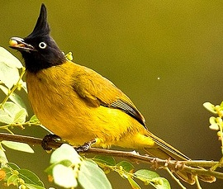
 |  | Black-headed | Pycnonotus atriceps | Bangladesh and  South-east Asia. | It has a mainly olive-yellow plumage with a glossy bluish-black head (BLI, 2012). | 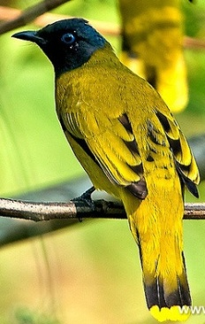
 |  | Flavescent | Pycnonotus flavescens | Bangladesh, China, India, Indonesia, Malaysia, Burma, Thailand, Vietnam. | The natural habitat is subtropical or tropical moist montane forests (BLI, 2012). | 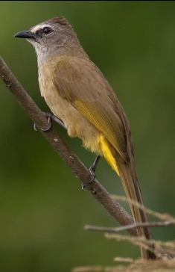
 |  | Red-vented | Pycnonotus cafer | Bangladesh, India, Tonga, the United States, Argentina, New Zealand. | Bulbuls are dominant or important frugivores  (Lever 1987) | 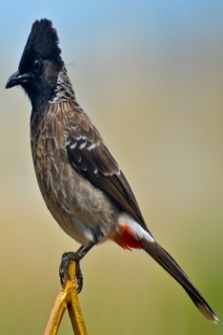
 |  | Red-whiskered | Pycnonotus jocosus | India, Bangladesh, Thailand, Burma, Australia, USA. | They feeds on fruits, seeds, nectar,  leaves and arthropods (Linnebjerg et al., 2009) | 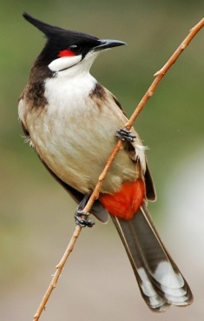
Spizixos | 1. Medium to large sized bird.  2. length varies from 19 to 22 cm. Av. weight is 44gm. | Crested finchbill | Spizixos canifrons | Bangladesh, China, India, Laos, Burma, Thailand, Vietnam. | Noisy, conspicuous bulbul with short, conical bill, dark grey head and pale grey throat. | 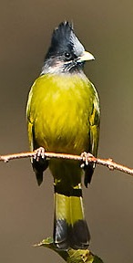
Alophoixus | 1. Small to medium sized bird.  2. Yellow color plumage and round tail. | White-throated bulbul | Alophoixus flaveolus | Bangladesh, Bhutan, China, India, Burma, Nepal, Thailand. | A distinct crest with few feathers in head. | 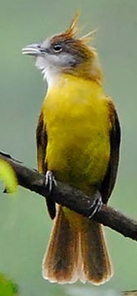
Iole | Olive colored small bird with a distinct crest | Olive bulbul | Iole virescens | Bangladesh, India, Burma, Thailand. | Natural habitats are subtropical or tropical moist lowland forests and montane forests. | 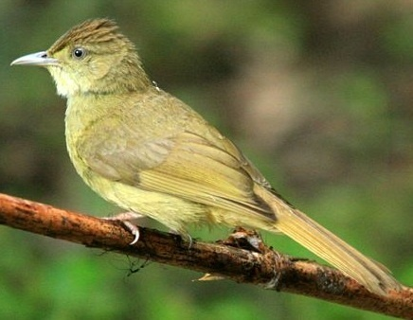
Hemixos | 1. They are birds of the sub-montane forest.  2. They prefer the middle to upper storey of trees. | Ashy bulbul | Hemixos flavala | Bangladesh, Bhutan, India, Indonesia, Malaysia, Burma, Nepal, Thailand, Vietnam. | On the head, brownish grey crown, face grayish and a distinctive triangular black patch at lore and cheek. | 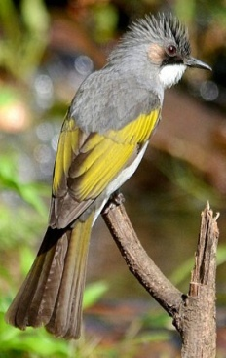
Ixos | They are habited in the mountain especially in the forest of Himalaya. | Mountain bulbul | Ixos mcclellandii | Bangladesh, Indian subcontinent and Southeast Asia. | Crest like shaggy feathers at the crown, White streaks on crown, throat and upper breast. | 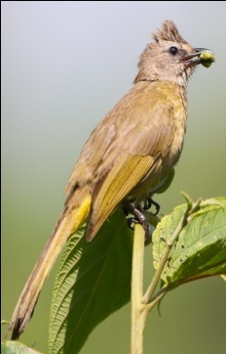
Hypsipetes | 1. Most Hypsipetes bulbuls are dark greyish birds with range or red bills.  2. 24–25 cm in length | Black bulbul | Hypsipetes leucocephalus | Bangladesh, India, China. | It has a long tail and white head with a black fluffy crest (Ali and Ripley, 1996) | 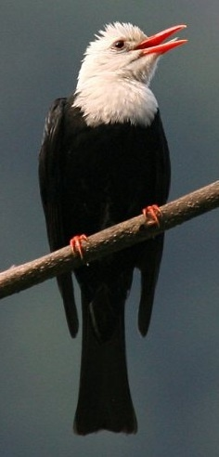

3.2 Common foods:
All bulbuls found in Bangladesh are frugivorous or insectivorous or both in nature. The species specific common foods are noted in Table 3.2.
Table 3.2: Common foods of bulbul in Bangladesh
Species | Common foods
Pycnonotus flaviventris | Fruits, small berries and insects.
Pycnonotus atriceps | Fruits and insects.
Pycnonotus flavescens | Berries and invertebrates.
Pycnonotus cafer | Fruits, nectar, insects.
Pycnonotus jocosus | Fruits, petals of flowers, nectar, insects and occasionally geckos.
Spizixos canifrons | Seeds (e.g. millet, grass), beans, peas, various types of fruit (e.g. Leucospectrum ) and insects.
Alophoixus flaveolus | Berries and insects.
Iole virescens | Berries and insects.
Hemixos flavala | Fruits, nectar, insects and buds
Ixos mcclellandii | Fruits, nectar, insects.
Hypsipetes leucocephalus | Seeds, nectar, insects and a wide range of barriers including Celtis, Rosa, Melia and Ehretia .

Brooks (2013) stated that bulbuls consume small fruits, berries, flowers, and buds .They are insectivorous in nature. They involve gleaning insects from a plant. Other modes of foraging include sallying for flying insects and masticating insect prey on the ground or a utility line. Fishpool and Tobias (2005) described that the common foods of different species of bulbul are seeds, nectar, buds, invertebrate insects etc.
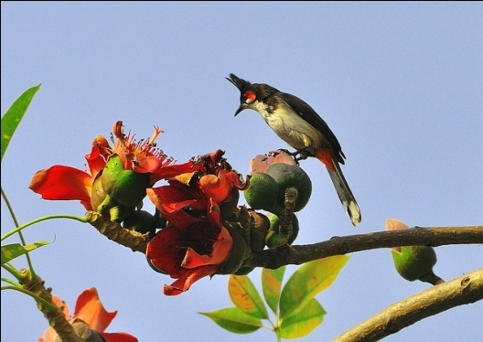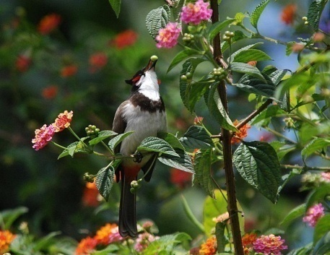
Figure 3.4: Bulbul eating small fruits
Figure 3.3: Bulbul eating nectar

3.3 Habitats and roasting sites:
Most of south Asian bulbuls are habitat in orchard, flower garden, hilly forest, bush, scrub or drier woodland etc of tropical and sub-tropical region. Species specific most probable habitats are presented on Table 3.3.

Table 3.3: Common habitats and roasting sites of bulbul
Species | Habitat or roasting sites
Pycnonotus flaviventris | Open forest, mixed deciduous forest, abandoned clearings, orchards.
Pycnonotus atriceps | Broadleaf evergreen forest, mixed deciduous forest and peat swamp-forest.
Pycnonotus flavescens | Open forest, secondary forest, scrub, mossy forest.
Pycnonotus cafer | Drier deciduous woodland, secondary forest, orchards and gardens.
Pycnonotus jocosus | Dense hilly woodland, secondary scrub, roadsides, parkland.
Spizixos canifrons | Open and stunted evergreen and deciduous forest, scrub, and grasses.
Alophoixus flaveolus | Under storey or middle storey of primary and secondary evergreen forest.
Iole virescens | Moist broadleaf evergreen forest, semi-evergreen forest and tall secondary growth.
Hemixos flavala | Broadleaf evergreen forest, bamboo patches.
Ixos mcclellandii | Canopy of broadleaf evergreen forest.
Hypsipetes leucocephalus | Broadleaf evergreen and mixed deciduous forest.

Rasmussen and Anderton (2005) reported that south Asian bulbuls are bird of dry scrub, open forest, plains and cultivated lands. In their native range, they are rarely found in mature forests. Fishpool and Tobias (2005) described broadleaf evergreen forest, tall hedgerows, orchards, bamboo patches etc as common habitats for most of the Asian bulbuls.
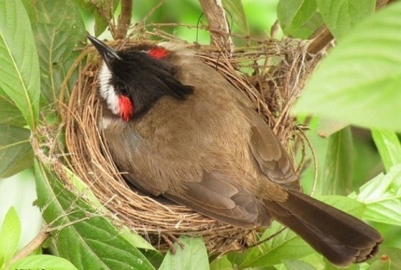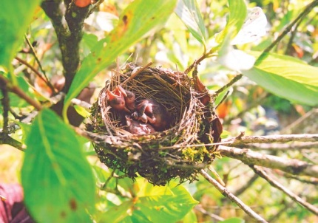
Figure 3.5: Bulbul brooding eggs

Figure 3.6: Young bulbuls in nest

3.4 Reproduction:
In general the breeding season of bulbul is April to October. The bulbuls are generally monogamous. During the breeding season both sexes take part in nest construction. The clutch size of bulbul varies from species to species. Different parameters related to bulbuls found in Bangladesh, are shown in Table 3.4.
Table 3.4: Different breeding parameters of bulbul
Species | Breeding month | Clutch size | Egg color | Incubation period | Nestling period | Hatching success
Pycnonotus flaviventris | June to September | 2-4 | Purplish brown | 12 | 11 | Moderate
Pycnonotus atriceps | March to June | 2-4 | Pinkish white | 13 | 13 | Moderate
Pycnonotus flavescens | March to July | 1-3 | Purplish brown | 11-14 | 12 | Poor
Pycnonotus cafer | March to December | 2-3 | Pale pinkish | 12 | 12 | Moderate
Pycnonotus jocosus | Around the year | 2-3 | Pinkish white | 12 | 12 | Moderate
Spizixos canifrons | March to July | 1-4 | Pinkish white | 11-14 | 13 | Poor
Alophoixus flaveolus | April to July | 1-4 | Purplish brown | 14 | 13 | Moderate
Iole virescens | March to June | 1-4 | Purplish brown | 14 | 13 | Poor
Hemixos flavala | April to July | 1-4 | Pinkish white | 14 | 13 | Poor
Ixos mcclellandii | February to September | 1-3 | Pinkish white | 11-14 | 12 | Moderate
Hypsipetes leucocephalus | April to July | 2-3 | Pinkish with spot. | 12 | 12 | Moderate

Jerdon (1863) first described the characteristics of eggs of red-vented bulbul. The color of eggs of bulbuls may vary from pinkish white to purplish brown with or without different types of irregular spots (Prajapati et al., 2011; Herklots, 1934). The clutch size of different species of bulbul varies from one to four. The largest clutch size was found in the wet season, i.e. August-September. The variation of cutch size depends on the availability of food. The average incubation period is 12 days but it may range from 11 to 14 days (Prajapati et al., 2011).

3.5 Behavioral characteristics:

3.5.1 Vocal communication:
Bulbuls found in Bangladesh, use about ten types of vocal signals: aggressive signals, courtship signals, contact signals, roosting signals, alert signals, alarm signals, twittering signals, distress signals, flying signals and begging signals. They can also produce two types of alarm signals based on predation pressure. Kumar and Bhatt (2000) reported six types of different vocal signals produced by Pycnonotus cafer .

3.5.2 Nesting behavior:
Bulbuls usually build their nest during breeding season. Both male and female take part in nest construction. They prefer to rest the nest at junction of bifurcated branch or on some similar substrate so as to get a firm support at the bottom. They possibly preferred medium sized tree for nest construction. Bulbuls found in Bangladesh prefer to make nests at the level of 1-4 meter high from ground. The nests of bulbul are easily distinguished, having a definite cup shape. Bulbuls prefer the material for built up the nest like as small branches of stems and roots of herbs and grasses. They use polythene fiber also (Prajapati et al., 2011).

3.5.4 Locomotion:
The bulbul flight is direct (not undulating) and flapping, average speed of flight is about 45 km per hour and 15 wings per second. During foraging or escaping from predators speed of flying may increase. On the ground, they typically hop rather than walking.

3.5.5 Territorial behavior:
During breeding season, they defend territories of about 3000 square. They roost communally in loose groups of hundred or more birds in the territory.

3.6 Health problems of bulbul:

Like most other birds, these bulbuls are hosts to coccidian blood parasites like Isospora sp. The most important ectoparasite of bulbul is lice- Menacanthus guldum (wiki). Haemoproteus, Plasmodium and Leucocytozoon are the most prevalent blood protozoa of bulbul. Colibacillosis is the common bacterial disease in bulbul. Among other problems, leg problem, poor feathering, brust air sacs and broken wings are most common.

3.7 Social status of bulbul:

At ancient era, bulbuls were kept as pet for fighting in India. But now, usually bulbuls are not considered as pet bird although the red-whiskered bulbuls and red-vented bulbuls have been captured for the pet trade in great numbers and has been widely introduced to southern Florida, Fiji, Australia, Hawaii and other countries of tropical and subtropical areas. They are regarded as songbirds. Some country consider bulbul as their national bird, for example “Himalayan bulbul (Pycnonotus leucogenys)” is the national bird of Bahrain and “Garden bulbul (Pycnonotus barbatus)” is the national bird of Liberia. In Bangladesh, bulbuls are considered as noisy but beautiful birds. Some species of bulbul are regarded as crop pests, particularly in orchards.
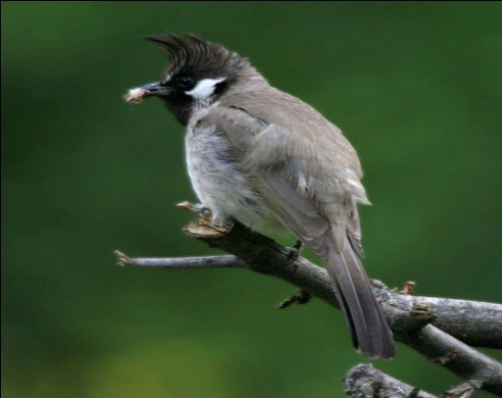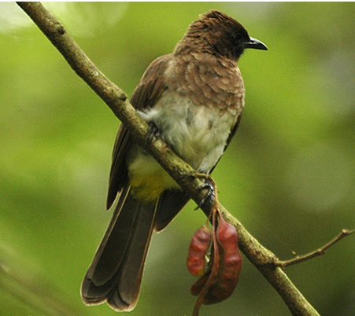
Figure 3.1:The national bird of Bahrain (Pycnonotus leucogenys)
Figure 3.2: The national bird of Liberia (Pycnonotus barbatus)

CHAPTER – IV

CONCLUSION

Birds are the beautiful gift of nature that make our crops safe from harmful insects, helps in pollination and seed dispersing in nature. Bulbul serves our natural ecosystem significantly. In Bangladesh, there are about eleven species of bulbul having different feeding, breeding, morphological and behavioral characteristics. They have a strong voice and they can produce different types of vocal signals for communication. IUCN listed bulbul as a species of least concern at global aspect due to its wide range. In Bangladesh, Bulbuls are not yet considered as endangered or vulnerable bird species. But number of some species is declining day by day. We all should remain concerned about the conservation of this bird to keep safe the ecological balance.

REFERANCES

Ali, S and Ripley S.D., 1996. Bulbul, In: Handbook of the birds of India and Pakistan, Volume 6. 2nd ed. Oxford University Press. Pp: 109–113.
Bhatt, D. and Kumar, A., 2001. Foraging ecology of Red-vented Bulbul Pycnonotus cafer in Haridwar, India. Forktail 17, Pp: 109–110
Bird Life International, 2012. "Pycnonotus flavescens". IUCN Red List of Threatened Species. Version 2013.2. International Union for Conservation of Nature. Retrieved 26 November 2013.
Brooks, D. M., 2013. Ecology, behavior, and reproduction of an introduced population of Red-vented Bulbuls (Pycnonotus cafer) in Houston, Texas. The Wilson Journal of Ornithology, 125(4), Pp: 800-808.
Corlett, R. T., 1998. Frugivory and seed dispersal by birds in Hong Kong shrubland. Forktail .13, Pp: 23–27.
Fishpool, L. D. C. and Tobias, J. A., 2005. Family Pycnonotidae (Bulbuls). In: Handbook of the birds of the world. Volume 10. Cuckoo-shrikes to Thrushes. del Hoyo, J., Eliott, A. & Christie, D. (eds.). Barcelona: Lynx Edicions. Pp: 124–253.
Herklots G. A. C., 1934. "The Birds of Hong Kong. Part XIV. The Bulbuls" . Hong Kong Naturalist 5 (1). Pp: 1–5.
IOC World Bird List (2015). Version 5.4 (http://www.worldbirdnames.org/)
Jerdon, T. C., 1863. In: The Bird of India, Volume 2. Part 1, Military Orphan Press, Calcutta. Pp: 93–96.
Kitamura, S., Yumoto, T., Poonswad, P., Chuailua, P., Plongmai, K., Maruhashi, T., and Noma, N., 2002. Interactions between fleshy fruits and frugivores in a tropical seasonal forest in Thailand. Oecologia 133, Pp: 559–572.
Kumar, A., 2004. Acoustic communication in the Red-vented Bulbul Pycnonotus cafer. Annals of the Brazilian Academy of Sciences 76, Pp: 350–358.
Lever, C., 1987.Naturalized birds of the world. England: Longman.
Linnebjerg, J. F., Hansen, D. M., and Olesen, J. M., 2009. Gut passage effect of the introduced red‐whiskered bulbul (Pycnonotus jocosus) on germination of invasive plant species in Mauritius. Austral ecology, 34(3), Pp: 272-277.
Moyle, R. G. and Marks, B. D., 2006. Phylogenetic relationships of the bulbuls (Aves: Pycnonotidae) based on mitochondrial and nuclear DNA sequence data.Molecular Phylogenetics and Evolution, 40(3), Pp: 687-695.
Pasquet, É., Han, L. X., Khobkhet, O. and Cibois, A., 2001. Towards a molecular systematics of the genus Criniger, and a preliminary phylogeny of the bulbuls (Aves, Passeriformes, Pycnonotidae). Zoosystema-Paris-,23(4), Pp: 857-863.
Prajapati S. H., Patel C. D., Parmar R. V. and Patel M. I., 2011. Breeding performance of Red-vented Bulbul (Pycnonotus cafer). Life Sciences Leaflets, 11, Pp: 298–304.
Rasmussen P.C. and Anderton, J.C., 2005. In: Birds of South Asia: The Ripley Guide. Smithsonian Institution and Lynx Edicions, Pp: 338.
Sanitjan, S. and Chen, J., 2009. Habitat and fig characteristics influence the bird assemblage and network properties of fig trees from Xishuangbanna, south-west China. Journal of Tropical Ecology ,25, Pp: 161–170.
Sreekar, R., Le, N. T. P. and Harrison, R. D., 2010. Vertebrate assemblage at a fruiting fig (Ficus caulocarpa) in Maliau Basin, Malaysia. Tropical Conservation Science. 3, Pp: 218–227.
Woxvold, I. A., Duckworth, J. W., & Timmins, R. J., 2009. An unusual new bulbul (Passeriformes: Pycnonotidae) from the limestone karst of Lao PDR. Forktail. 25, Pp: 1-12.
Wydhayagarn, C., Elliott, S. and Wangpakapattanawong, P., 2009. Bird communities and seedling recruitment in restoring seasonally dry forest using the framework species method in northern Thailand. New Forests . 38, Pp: 81–97.
Zia, U., Ansari, M. S., Akhter, S., & Rakha, B. A., 2014. Breeding Biology of Red Vented Bulbul (Pycnonotus Cafer) In The Area Of Rawalpindi/Islamabad. JAPS, Journal of Animal and Plant Sciences,24(2), Pp: 656-659.
Web sites :
https://en.wikipedia.org/wiki/Bulbul
https://en.wikipedia.org/wiki/List_of_birds_of_Bangladesh
http://www.ebanglapedia.com/en/article.php?id=1036

BIOGRAPHY

Name | Mohammad Shah Jalal
Permanent address | Gohin Jhiree, Fashiakhali union, Lama, Bandarban.
Education | SSC | 2006 | Kishalaya Adarsha Shiksha Niketon, Chakaria
 | HSC | 2008 | Dulahazara College
 | DVM (Intern) | 2015 | Chittagong Veterinary and Animal Sciences University
Publication(s) | One
Research interest | Genetic Microbiology, Immunology

