TABLE OF CONTENTS

Title Page no
PLAGIARISM CERTIFICATE iii
LIST OF TABLE iv
ACKNOWLEDGEMENT v
ABSTRACT 1
CHAPTER -I 2
INTRODUCTION 2
CHAPTER -II 5
MATERIALS AND METHODS 5
2.1 Location and duration of the study 5
2.2 Visiting study areas 5
2.3 Taking photographs 5
2.4 Searching webs 5
2.5 Discussion with the expert 5
CHAPTER -III 6
RESULTS AND DISCUSSION 6
Geographic range: 7
Habitat 7
Physical Description 8
Development 8
Reproduction 9
Lifespan/Longevity 11
Behavior 11
Communication and Perception 11
Food Habits 12
Predation 13
Ecosystem Roles 13
Conservation Status 13
Bengal Monitor in captivity 14
Diseases 14
CHAPTER -IV 15
CONCLUSION 15
CHAPTER -V 16
LIMITATION 16
REFERENCES 17
BIOGRAPHY 19

PLAGIARISM CERTIFICATE

I, Md. Kaisar Rahman, would like to strongly assure you that I have performed all works furnished here in this report. The information has been collected from different books, national and international journals, websites and references. All the references have been acknowledged duly.
Therefore, I reserve entire responsibility of this report.

…………………….
The Author
November, 2015

LIST OF TABLE

Table 3.1: Some featured information about the Bengal Monitor……………………...……6

LIST OF FIGURE

Fig 3.1:Natural habitat of Bengal Monitor…………………………………………………...7
Fig 3.2: Physical features………………………………………………………………….....8
Fig 3.3: Development in environment…………………………………………………….....9
Fig 3.4: Mating of Monitor………………………………………………………………….10
Fig 3.5: Feeding of Bengal Monitor………………………………………………………...13
Fig 3.6: Monitor in captivity………………………………………………………………..14

ACKNOWLEDGEMENT
All praises are due to the Almighty Allah, the creator and supreme authority of the universe, who empowers me to strength and opportunity to complete the report successfully.
I would like to extend my gratitude to my supervisor, Professor Dr. Gouranga Ch. Chanda, Controller of Examinations, Chittagong Veterinary and Animal Sciences University. My heartfelt thanks to him for valuable guidance, suggestion, supervision and encouragements during the entire period of this study to complete this production report.
I would like to express my deep sense of gratitude and thanks to Professor Dr. Md. Ahasanul Hoque, Dean, Faculty of Veterinary Medicine, CVASU.
I express my sincere gratitude and thanks to Professor Dr. A. K. M. Saifuddin, Director of External Affairs, and for his supervision and kind co-operation during the period of internship.
Special thanks to Dr. Md. Saiful Bari, Assistant professor, Dept. of Dairy and Poultry Sciences for his co-operation in data analysis and also DR. Md. Anower sadat, Veterinary surgeon, Bangladesh national zoo, Mirpur, Dhaka for his constructive guidelines and admirable co-operation for performing this work.
Last but not least, I am profoundly grateful to my family members for their endless sympathies, kind co-operation, sacrifices and prayers.

Author
November, 2015

Status of Bengal monitor in Bangladesh.

ABSTRACT

A nine month study of the Bengal Monitor in Bangladesh was conducted to analyze the common characteristics, behavior and other related characteristics. The aim of the study was to know variety of Bengal Monitor in Bangladesh, their behavioral characteristics, physiological status, reproduction, nutrition, diseases and other related traits. The method of this study include observation, photography, query from internet and people around. Bengal Monitor are native to Southeast Asia and West Asia. In Bangladesh Bengal monitor are common, mostly in villages. The Bengal Monitors have long bodies, short legs, and thick coat with coarse texture. These are terrestrial (although the young are often seen on trees), diurnal solitary hunters that search during the day till late evening; active in the early morning and early evening in search of reptiles. They are not so domesticated; but can be tamed to a considerable extent. They are alert and usually shy and avoid humans. It exhibits a cautious routine exit-entry movement, i.e. coming very calmly out of the monitored burrow few hours after sunrise, and if the environment is found undisturbed, they go on foraging following a particular route in its territorial range and returning to the burrow just before sunset. Bengal Monitors are opportunistic hunters feeding mainly on frogs, fish, lizards, snakes and rodents. They are strictly carnivorous in nature.These poikilothermal hazard’s normal body temperature is 34.5⁰C. Mean body weight 6.72 to 7.18 kg. In general, Bengal Monitors attain sexual maturity within 2.5 to 3 years, incubation period is around 4 to 8 months. Average number of offspring is around 20. The life span of Bengal monitor is average 22 years. Like other reptiles the Bengal Monitor suffered by different kinds of diseases such as Septicemia, Septicemic Cutaneous Ulcerative Disease (SCUD), Necrotic Dermatitis, Abscesses, Infectious Stomatitis, Pneumonia, Otitis, Mycobacteriosis, Spinal Osteomyelitis etc.This is an threaten species, in Bangladesh and the number is decreasing day by day. This wild species play role for the nature and also beneficial to mankind.

Key words: Bengal Monitor, Reptile, Behavior, Diurnal.

CHAPTER -I

INTRODUCTION
The Bengal Monitor lizard (Varanus bengalensis) is a wide-ranging species, occurring from Iran to South Asia and throughout Southeast Asia (Papenfuss et al., 2010). The Bengal Monitor falls under the Kingdom: Animalia, Phylum: Chordata, Class: Reptilia, Order: Squamata, Suborder: Lacertilia, Family: Varanidae, Genus: Varanus, Subgenus: Empagusia; and Species: Varanus bengalensis (Byre & Stenherst, 1984). It is a species inhabiting forests, agricultural lands and grasslands (Shah & Tiwari, 2004), and is categorized as a species of Least Concern in the IUCN Red Data List of Threatened Species (Papenfuss et al., 2010), but listed in Appendix I of CITES (CITES, 2012). Previously in Bangladesh, the rate of deforestation had been high (Shrestha et al., 2010), threatening its biodiversity. In response to increase of high rate of population in Bangladesh, which has helped increase the rate of deforestation (Kanel et al., 2005). Conservation of forestry is one of the most successful natural resource management programs of Bangladesh which help to increase the forest and also increase the number of the Bengal Monitor (Shrestha et al., 2010); however, the exact role of conservation of forestry in conserving biodiversity is unclear, as only a few research projects have studied its impacts (Pokhrel & Shah, 2008). According to the forestry department about (17%) forest are present in Bangladesh. There is no specific result of population of Bengal Monitor in Bangladesh.
Bengal Monitors or Common Indian Monitors (Varanus bengalensis) are found across the southern Asian contries. Compared to other varanid lizards, Bengal Monitors have a much larger geographic range, where they are considered less restricted both geographically and environmentally. This species is widely distributed from Afghanistan to Java, including southeastern Iraq, Iran, and Afghanistan, Pakistan and India, southern Nepal, Bhutan, and China, North and South Vietnam, Laos, and islands in the Strait of Malacca and the Greater Sunda Islands (Shrestha et al., 2010).
These lizards have a long body and powerful legs. Most species have strong claws on their feet, and all but the largest Monitors can climb well. The tail is long and powerful, usually about twice as long as the body, and can be flailed as a potent weapon. Monitors grow throughout their life, so the oldest individuals in a population are also the largest ones (Kanel et al., 2005).
These Monitors have a long, specialized tongue with a bifurcated tip that is highly sensitive to smell and taste. The tongue is extended to pick up scent chemicals, and is then retracted into the mouth where the scents are analyzed using an organ on the roof of the mouth (Carroll, 1988)
Monitor lizards grow replacement teeth in the gaps between their mature teeth. They have at least 29 vertebrae above their hips. Nine of these are neck vertebrae, supporting the unusually long neck of these lizards. Their powerful jaws are hinged in the middle, allowing them to swallow large prey. The head of Monitors is tapered, and there are distinct ear holes (Carroll, 1988)
These are active predators, hunting during the day. They stalk a wide range of animals and eat carrion and eggs as well. Monitors ingest their prey whole if it is small enough, but they can also dismember large prey items so they can be swallowed (King et al, 1999).
These Monitors, like all lizards, are poikilothermic or “cold-blooded.” They are most energetic after they have been heated by the morning sun, since their muscles work much more efficiently and easily when they are warm. Monitors can run quickly to chase down prey. When doing so they lift their body and tail clear off the ground. They also swim well, and may seek water as a refuge when threatened. They can walk underwater, and can use their tongue to smell underwater (Murphy et al, 2002).
When threatened, Bengal Monitors can be formidably aggressive animals. They can inflict painful bites and scratches, and the largest species are capable of killing a human. However, Monitors can be readily tamed in captivity (Zug et al, 2001).
Monitors are hunted in many places for their meat, skin, and eggs. A preparation of the fat of Monitors is used in traditional Chinese medicine, and Monitors may be hunted for this trade anywhere that they occur. Monitors are also threatened by losses of their natural habitat in many places. Some populations of the Bengal Monitor have been decimated by poisoning when they attempt to eat the cane toad (Bufo marinus).
The cane toad excretes a highly toxic chemical from large glands on the sides of its neck, which poisons native predators that attempt to eat the toad. The cane toad has been widely introduced in the tropics in misguided attempts to achieve a measure of biological control over some types of insects that are agricultural pests. Some species of predatory birds have also been decimated by the cane toad, and so likely have other species of Monitors in addition to the Bengal Monitor.

The objectives of the study are as follows:
- To address some fundamental questions of ecology, using reference studies in an environment largely untouched by civilization.
- To know the individual populations of priority species groups.
- To analyze their feeding and nutrition (in captivity), breeding and other related traits.
- To study the common bio-physical characteristics.
- To evaluate the conservation value of the region including presence of a near-pristine landscape, occurrence of species which are threatened elsewhere.
- To analyze of communities in primeval habitats as references for the assessment of anthropogenic impact on species communities in Bangladesh.
- To determine the extent and location of existing habitat suitable for meeting the habitat requirements.

CHAPTER -II

MATERIALS AND METHODS

2.1 Location and duration of the study
The study was conducted in different places of Bangladesh such as Dinajpur, Rangpur, Kurigram, Chittagong, Cox’s bazaar; different zoo and safari park. The study time was 15 february to 15 november, 2015.

2.2 Visiting study areas
During the study period visited different places of Bangladesh and discuss with different types of people; Specially collected lot of information about Bengal Monitor from tribal peoples.

2.3 Taking photographs
In this study, photographs of Bengal Monitor have taken. When photographed, it passed by the camera within fractions of a second and moved so fast that most of the pictures were blurred, or slightly out of frame but luckly got some photographs of them.

2.4 Searching webs
Data were collected from browsing internet by searching about Bengal Monitor.

2.5 Discussion with the expert
During the study time discussed with some expert in different veterinary hospital, zoo and wild life conservation centre.

CHAPTER -III

RESULTS AND DISCUSSION

Table 3.1: Some featured information about the Bengal Monitor
Physical features | - Total Length | 61 to 175 cm
 | - Tail | 100 cm
 | - Color | Grey or greenish-grey
 | - Body weight/Size | 6.72 to 7.18 kg
 | - Coat | Rough scales with minute pit
 | - Nose | slit-like and oriented near horizontal
 | - Head shape | Elongated
 | - Tongue | Forked
Physiological characters | - Mating System | Polygynandrous (promiscuous)
 | - Sexual maturity | 2.5 to 3 years
 | - Breeding interval | Two clutches annually
 | - Breeding season | July through early September
 | - Incubation period | 4 to 8 months
 | - Number of offspring | 20 (avg)
 | - Lifespan | 22 years

Geographic range:
Bengal Monitors or Common Indian Monitors (Varanus bengalensis) occur across much of southern Asia. Compared to other varanid lizards, Bengal Monitors have a much larger geographic range, where they are considered less restricted both geographically and environmentally (Marcum, C.L. 1980). This species is widely distributed in whole country in Bangladesh specially found in forest and hilly part such as Chittagong, Khagrachori, Rangamati, Bandarban, Cox’s bazaar, Khulna, Bagerhat, Shatkhira, Mymanshing, Dinajpur, Kurigram etc.

Habitat
Unlike other varanid lizards, Bengal Monitors have the ability to cope with a broad range of environments, from deserts to rainforests to habitats having seasonally snowy winters. However, generally they are found in areas with continuously warm climates, with mean annual air temperatures of approximately 24 ˚C. Most of southern Asia experiences seasonal monsoons and wind patterns influenced by neighboring seas and mountains (CITES, 1984). Thus, precipitation across much of the range for Bengal Monitors is highly variable. Some habitat areas are relatively arid, with mean precipitation less than 200 mm per year. Other habitats are considerably more humid, with annual rainfall reaching 2,200 mm per year. The most common tropical forest habitats for Bengal Monitors are deciduous, semi-deciduous, evergreen tropical forests, and thorn brush (Auffenberg et al, 1991).
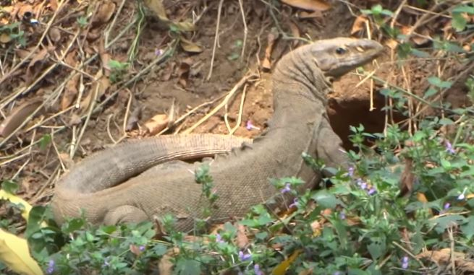
Fig 3.1:Natural habitat of Bengal Monitor

Physical Description
Adult Bengal Monitors are generally grey or greenish-grey in color, with a ventral pattern of grey to black crossbars from the chin to the tail. These markings are generally darkest in the western parts and lightest in the eastern parts of the geographic range. These ventral markings typically become lighter, and the ground color darker, with age. Thus, adults display a less pronounced, less contrasting pattern than younger Bengal Monitors. They have rough scale on skin with minute pits (Emden, H.F. 2008).Their external nostril openings (nares) that is slit-like and oriented near horizontal, and positions between the eye and the tip of the snout Like other varanids, Bengal Monitors have a forked tongue that is protruded in the manner of snakes. The function is mainly sensory, and is not very involved in the transport of food down the throat (Cruze, N.D & S. Kumar, 2011).
In the wild, the heaviest recorded male Bengal Monitor weighed 7.18 kg, though captive individuals have been reported to reach 10.2 kg. In the wild, males generally weigh 42% more than females. Males of the same snout to vent length (SVL) as females are typically 9.2% heavier. Young Bengal Monitors, on average, weigh 0.078 kg (Auffenberg, 1994).

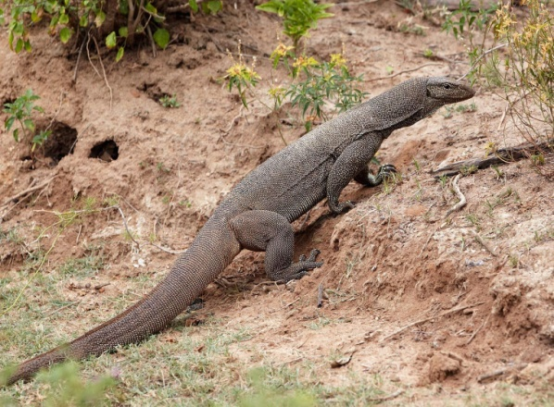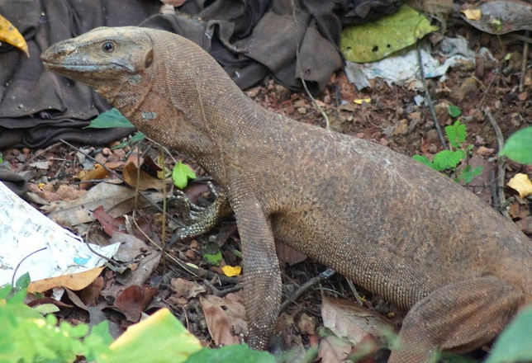

Fig 3.2: Physical features

Development
Development in Bengal Monitors begins with a variable length incubation period. Laboratory investigations have shown this incubation period to range from 70 to 327 days. The length of incubation depends largely on mean egg temperature. However, even within a single brood, there can be variations of up to 105 days from first to last hatching. High incubation temperatures typically lead to shorter development times, but also may skew sex ratios or cause developmental defects (Murphy, James B., et al, 2002).
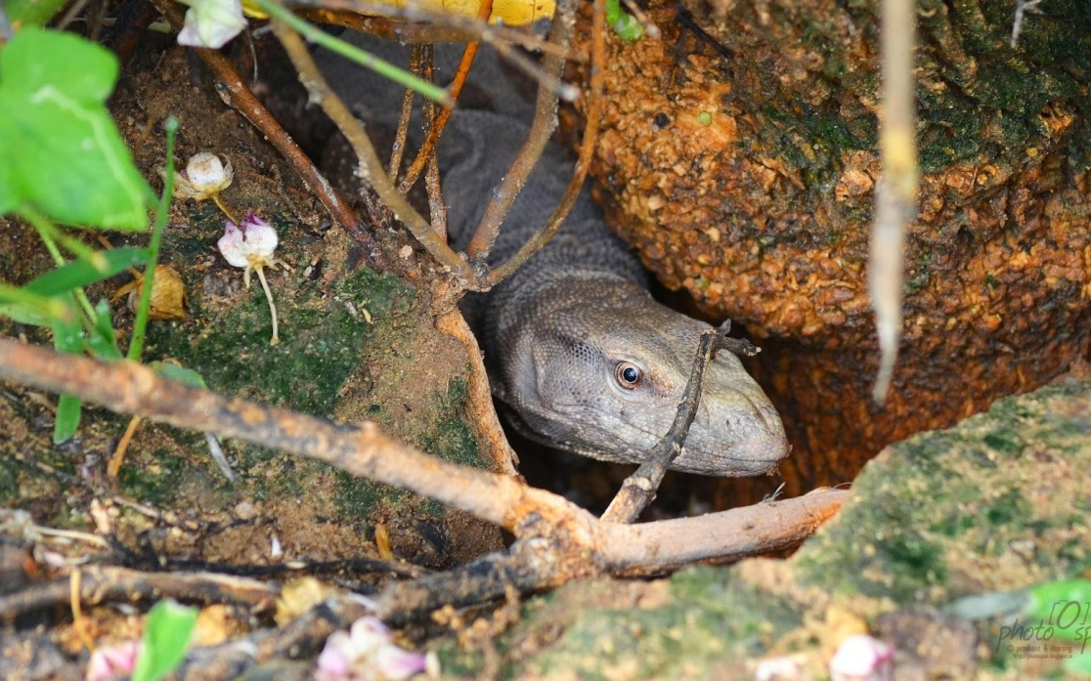Bengal Monitors are relatively long-lived varanids. As such, this species does not reach sexual maturity until 2.5 to 3 years. Most produce one clutch of offspring each year for the remainder of their lives. Environmental influences play an important role in body size and overall length in Bengal Monitors (Cruze, N.D & S. Kumar, 2011). In general, longer individuals are found in areas with greater soil moisture, such as marsh environments, whereas shorter individuals often occur in surrounding forests. In addition, those found on the small islands in both the South China Sea and the Gulf of Thailand have been found to become sexually mature at a much smaller size than those from the nearby mainland, reaching reproductive maturing with SVLs as low as 23.3 cm (Pattanavibool, A.& W.D. Edge, 1996).

Fig 3.3: Development in environment

Reproduction
Chemical cues play an important role in the ability of males to recognize receptive females. These chemical cues are produced by the female, from glands located in skin of the abdomen. In captivity, females show the greatest chances of successful copulation by mating with only one or two individual males in successive years, though they still may be courted by several other males (Auffenberg, 1994). In females, the reproductive cycle is annual. Follicles mature only during one part of the year, shortly before ovulation. Follicles and ovaries reach their largest size during the months of July and August for those individuals in the western part of the species range, and from October to December for those in more southern areas such as India and Sri Lanka (Byers, C.R. & R.K. Stenherst. 1984). Yolk deposition in an egg has no correlation with the ovulatory phase in females, but it does correlate with fat accumulation (Kanel, 1999).
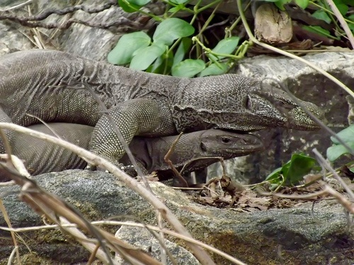Once the egg reaches the lower portion of the oviduct, a shell will form around each egg. Ovulation begins in June, but reaches full force in July. The most successful copulation occurs slightly before or after ovulation has reached its peak (Pattanavibool, A.& W.D. Edge, 1996). Egg laying will occur two weeks after copulation, usually during the months of July, August, and early September. By the last week of October, both sexes are largely inactive with size and sperm production heavily reduced in the male and new follicles for the next year appearing in the ovaries of the female. (Auffenberg, 1994).

Fig 3.4: Mating of Monitor

The average number of eggs laid per year is 20, of which about 80% typically hatch. This results in about 16 young per female per year. Additionally, because V. bengalensis has a large clutch size relative to most tropical lizards, neonates are subject to relatively high predation rates. Because of predation, roughly half of the offspring do not live past the age of two. (Auffenberg, 1994)
Both males and females become sexually mature at approximately 2.5 to 3 years of age, both in the wild and in captivity. In both sexes, the onset of sexual maturity is linked to a body mass greater than 0.4 kg (Wikramanayake, E. et al 1993). In female Bengal monitors, reproductive efforts occur throughout most of their life span. After reaching sexual maturity, females remain reproductively active for the remainder of their lives, which may extend to 27 years. (Wikramanayake, E. 1992)

Lifespan/Longevity
Like many other large predators, V. bengalensis is relatively long-lived. This species is relatively unaffected by drought or daily variations in rainfall, so population sizes remains fairly stable from season to season. Mortality rates are highest for neonates, due to predation, with only about half surviving past the age of two and reaching sexual maturity. For captive individuals, the longest recorded life span was about 22 years. (Auffenberg, 1994)

Behavior
In the wild, Bengal Monitors are almost completely solitary. Much of the daytime is spent in constant movement, searching for food. Bengal Monitor are more likely to interact with one another during the peak breading season, when males compete for mates. (Auffenberg et al, 1991).

Communication and Perception
Like most varanids, Bengal Monitors use primarily scent as their main method of communication and perception. They “taste” the environment around them by constantly flicking their highly sensitive tongues while moving their head from side to side. This is useful in tracking prey and mates and in signaling between Monitors of the same species (Cruze, N.D. & S. Kumar. 2011). It has been documented in the wild that V. bengalensis spends large amounts of time examining the droppings of other Bengal Monitors that have passed through their territory. Even though they are solitary creatures, scent messages in feces are said to be important in communication. The scent perceived by one Monitor from another can inform of hostile intentions or to stay away from the particular territory. (Pianka, E, 1995).
There is a diverse range of intraspecific communication exhibited by V. bengalensis through touching, biting, clawing and wrestling. Being solitary predators, roughly three quarters of encounters begin as purely investigatory and the remaining quarter are for the purpose of sex and courtship (Byers & Stenherst. 1984).
Conflict between males, whether over food or mating, usually results in an initial investigation through acquiring each others scents and their intent. Conflict typically involves vocalization which is usually a hissing noise accompanied by the Monitor inflating its upper body to appear larger. Tail-slapping and whipping is also common behavior between males and sometimes females to establish dominance (Cruze, N.D. & S. Kumar. 2011). Encounters between males can lead to wrestling in which case both males stand on their hind legs and embrace each other while thrashing their heads and upper bodies. Occasionally biting and clawing can occur during wrestling but it is usually collateral damage rather than intentional. (Auffenberg, 1994).

Food Habits
The diet of Bengal Monitors is almost strictly carnivorous. They consume almost anything that is smaller than themselves and that they can easily overpower. They are known to scavenge carcasses of previously felled animals. Their documented observed prey species list is considerable, containing roughly 200 species (Sweet, S., E. Pianka, 2003) Common prey include: annelids, insects, amphibians, smaller reptiles, birds, small mammals, and eggs. Cannibalism of eggs, hatchlings, and even adults has been noted, although predation on adults is rare. As with most varanids, they swallow prey whole but are also capable of ripping and tearing flesh from larger animals and carcasses ( King et al, 1999).
At smaller body sizes for Bengal Monitors, various beetles species represent the largest portion of their diet, averaging 52.8%. The second largest component of their diet is made up of orthopteran insects at 9.5%. The remainder of their diet is made up of other insects, crabs, rodents, reptiles, spiders, birds and almost any other animal they can reasonably consume (Carroll, R.L, 1988).

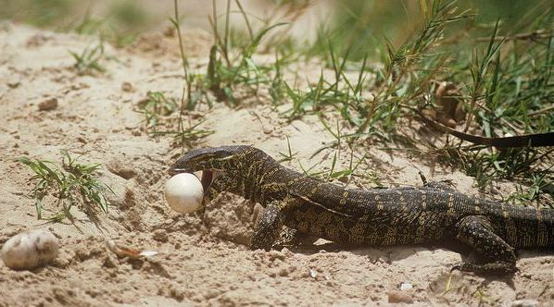

Fig 3.5: Feeding of Bengal Monitor

Predation
V. bengalensis does occur despite the fact that they themselves large predators. Species that prey upon V. bengalensis include other Bengal Monitors, pythons and other large snakes, eagles, mongooses, wild and domesticated dogs, feral cats, and even humans. Most predation occurs early in life as eggs, hatchlings, and juveniles, while only a small portion of predation involves fully grown adults. (Auffenberg, 1994)

Ecosystem Roles
Bengal Monitors are primary predators of many smaller animals in the ecosystems they inhabits. Juveniles are preyed upon by larger predators, including other Monitors (Marcum, C.L. et al, 1980). There are four tick species known to infect Bengal Monitors, including: Aponommon gervaisi, A. varanensis, A. laeve, and Amblyomma helvolum. In addition, trematodes, cestode worms, nematodes, filarial worms, and sporozoan protozoans are known to infect these Monitors (Muths E, 2010)

Conservation Status
According to the IUCN Red List of Threatened Species, V. bengalensis is a species of Least Concern. This is based on its wide geographic range. However, there are increasing pressures on the species. They are hunted for their meat, skins, and for use in medicine. Due to expanding human habitation and urbanization, the range threats to their population are likely to increase in the future. (Papenfuss, et al., 2010).

Bengal Monitor in captivity
Bengal Monitor or Indian Common Monitor can be domesticated, are fairly intelligent, so they are often kept as pets. However, they can be more destructive than desired. In captive condition these pet should be kept in cages and provide feed. Insects, annelids, amphibians are their favourite feed. For proper nutrition supplementation meat and fish are provided to them.
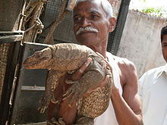

Fig 3.6: Monitor in captivity

Diseases
Bacterial diseases are common in reptiles, with most infections caused by opportunistic agents that infect immunosuppressed hosts. Most bacterial infections involve gram-negative bacteria, many of which are considered commensal. Anaerobic infections are not uncommon, but organisms can be difficult to culture (Byers, C.R. & R.K. Stenherst, 1984). Like other reptiles the Bengal Monitor suffered by different kinds of diseases such as Septicemia, Septicemic Cutaneous Ulcerative Disease (SCUD), Necrotic Dermatitis, Abscesses, Infectious Stomatitis, Pneumonia, Otitis, Mycobacteriosis, Spinal Osteomyelitis etc (Neu, C.W. et al, 1974).

CHAPTER -IV

CONCLUSION
Bengal Monitor are amazing creature. They are also a member of our nature. Although they are ferocious they can be tamed. As veterinarian we must know about their behaviors, feeding, breeding, behavior and conservation strategy. There are common and are not threatened. Bengal Monitor is about 61 to 175cm long. Mean body weight is about 6.72 to 7.18kg. Normal body temperature is 39.5⁰C. They are carnivorous in nature They also prey on grasshoppers, scorpions, centipedes, frogs, crabs. They have long skull with specialized teeth for hunting. Males are comperatively larger than female. They have unique behaviors like social behavior, mating behavior, lifestyle behavior, predation behavior. Sexual maturity attains within 2.5 to 3 years of age and incubation period is 4 to 8 months. Copulation occurs in March,August and October and litter size is 2 to 4. They are susceptible to Septicemia, Septicemic Cutaneous Ulcerative Disease (SCUD), Necrotic Dermatitis, Abscesses, Infectious Stomatitis, Pneumonia, Otitis, Mycobacteriosis, Spinal Osteomyelitis etc. The life span of Bengal Monitor is average 22 years. Although they are wild but they are the part of our ecosystem. They are awesome creature because of their varied phenotypic and behavioral pattern but day by day the population is decreasing in this sub-continent.

CHAPTER -V

LIMITATION

During my study period following limitations were observed:
- Short duration of the assigned period.
- Short area coverage.
- Taking photograph is difficult.
- Lack of adequate data in Bangladesh.

REFERENCES
Auffenberg, W. 1994. The Bengal Monitor. University Press of Florida, Gainesville. 560 p.
Auffenberg, W., Arain, Q. N.& Khurshid N. 1991. Preferred habitat, home-range and movement patterns of Varanus bengalensis in Southern Pakistan. Pp. 7-28. In Böhme, W. & H.-G. Horn (eds.), Advances in Monitor Research, Mertensiella 2. Deutsche Gesellschaft für Herpetologie und Terrarienkunde e.V., Rheinbach.
Byers, C.R. & Stenherst, R. K. 1984. Clarification of a technique for analysis of utilization-availability data. Journal of Wildlife Management 48(3): 1050- 1053.
CITES. 2012. Appendices I, II and III. http://www. cites.org/eng/app/2012/E-2012-09-25.pdf Last accessed 26.02.13.
Carroll, R.L. Vertebrate Paleontology and Evolution. New York: Freeman, 1988.
Cruze, N.D. & Kumar, S. 2011. Effect of anthropogenic activities on lizards communities in northern Madagascar. Animal Conservation 14: 542-552.
Emden, H.F. 2008. Statistics for Terrified Biologists. Wiley-Blackwell, Oxford. 360 p.
Kanel, K.R., Poudyal, R.P. & Baral, J.P. 2005. Nepal community forestry 2005. Department of Forest, Ministry of Forest and Soil Conservation, Kathmandu. Pp. 69-83.
King, Dennis, and Brian Green. Monitors: The Biology of Varanid Lizards. 2nd ed. Melbourne, FL: Krieger, 1999.
Majer, J.D. & Recher, H.F. 1999. Are eucalypts Brazil’s friend or foe? An entomological viewpoint. Animal Society of Entomology Brasil 28(2): 185-200.
Marcum, C.L. & Loftsgaarden, D.O. 1980. A nonmapping technique for studying habitat preferences. Journal of Wildlife Management 44(4): 963-968.
Murphy, James B., et al, eds. Komodo Dragons: Biology and Conservation. Washington, DC: Smithsonian Institution Press, 2002.
Muths, E. undated. USGS. Visual encounter survey for amphibians, Managers’ Monitoring Manual. United States Geological Survey, Fort Collins. www.pwrc.usgs.gov/monmanual/techniques/ves. htm. Last accessed 24.12.2010.
Neu, C.W. & Byers, C.R. 1974. A technique for analysis of utilization-availability data. Journal of Wildlife Management 38(3): 541-545.
Papenfuss, T., Shafiei Bafti, S. Sharifi, M. Bennett D. & Sweet, S.S. 2010. Varanus bengalensis. IUCN Red List of Threatened Species. Version 2012.2. www.iucnredlist.org. Last accessed 19.03.2013.
Pattanavibool, A. & Edge, W.D. 1996. Single-tree selection silviculture affects cavity resources in mixed deciduous forest in Thailand. Journal of Wildlife Management 60(1): 67-73.
Pokhrel, G.K. & Shah, K.B. 2008. Role of community forest in faunal diversity conservation: A case study of community forest within Satbariya Range Post of Dang district, Nepal. Journal of Science and Technology 9: 111-117.
Pianka, E. 1995. Review: Lizards observed. Science, 268/5217: 1636.
Shah, K.B. & Tiwari, S. 2004. Herpetofauna of Nepal: A conservation companion. IUCN Nepal, Kathmandu. Pp. 140. Shrestha, U.B., B.B.
Shrestha & Shrestha, S. 2010. Biodiversity conservation in community forest of Nepal: Rhetoric and reality. International Journal of Biodiversity and Conservation 2(5): 98-104
Sweet, S., Pianka, S. 2003. The Lizard Kings. Natural History, 112/9: 40-45.
Wikramanayake, E. 1992. Energy and water turnover in two tropical varanid lizards, Varanus bengalensis and V. salvator. Copeia, 1992/1: 102-107. Accessed February 04, 2011 at http://www.jstor.org/stable/1446540.
Wikramanayake, E.,Dryden, G. 1993. Thermal Ecology of Habitat and Microhabitat Use by Sympatric Varanus bengalensis and V. salvator in Sri Lanka. Copeia, 1993/3: 709-714.
Zug, George, R., Laurie, J. Vitt, and Janalee, P. Caldwell. 2001. Herpetology: An Introductory Biology of Amphibians and Reptiles. 2nd ed. New York: Academic Press.

BIOGRAPHY

Name | Md. Kaisar Rahman
Present status | Intern student, Faculty of veterinary medicine, Chittagong Veterinary and Animal Sciences University (CVASU).
Educational background and Year | H.S.C in 2008 (GPA-5.00), Cantonment Public School and College, Saidpur. S.S.C in 2006 (GPA-5.00), Sundarban High School, Dinajpur.
No. of publication | Two
Research interest | Conservation of wild life.

