CHAPTER – I

INTRODUCTION
Infectious diseases are the biggest threat of commercial poultry production in Bangladesh (Islam et al., 1998). The rapid growth of poultry industry in Bangladesh till the year 1990 (Jabbar et al., 2007) which has been drastically fallen down in recent years due to emergence of high pathogenic Avian influenza, Newcastle diseases, Infectious bursal diseases etc (Rahman et al., 1996; Giasuddin et al., 2002). However, the poultry practitioners of Bangladesh have been involved with the diagnosis of such diseases through necropsy. Besides, several diagnostic laboratories have been established for the confirmatory diagnosis and for the aid of clinicians with bacteriological, serological and immunodiagnostics tests. One of the most important constrain of specific diagnosis is the presence of mixed infection (Barness and Gross, 1999) and the high cost involved in diagnosis. Often the carcasses become autolysed and inappropriate for the disease diagnosis through post mortem examination. Besides, multiple diseases involve same organ specificity and produces similar lesions as a result differential diagnosis is often difficult for a clinician through standard veterinary diagnostic procedures like necropsy. Therefore, sometimes it becomes very difficult for confirmatory diagnosis especially when infections are complicated with secondary pathogens (Ali and Reynolds, 2000).
Several avian viruses have a predilection for the respiratory tract of chickens e.g. Newcastle disease virus (NDV), Avian influenza virus (AIV), Infectious laryngotracheitis virus (ILTV) and Infectious bronchitis virus (IBV). These agents cause similar respiratory syndromes in infected chickens such as cough, poor growth and high mortality leading to economic losses (Wang and Huang, 2008).
NDV, a member of Paramyxoviridae, causes a highly contagious and fatal disease with highly virulent viruses, and respiratory and nervous signs with moderately virulent viruses. AIV is a highly contagious disease caused by type A influenza virus, a member of Orthomyxoviridae. The disease caused by different viruses varies in severity from high mortality to a very mild form or even non-apparent infection ILTV, a hemorrhagic type of Herpesviridae, causes severe coughing, nasal discharge, and conjunctivitis (Alexander and Jones, 2002). IBV, a prototype of the Coronaviridae virus family, causes respiratory signs. Some strains of IBV exhibit tropisms for the alimentary tract and kidneys (Ziegler et al., 2002).

Newcastle disease virus and avian influenza virus cause similar symptoms in infected birds, which makes a quick diagnosis difficulty. Symptoms are observed in digestive tract, respiratory tract, and nervous system. In internal organs, marked congestion and hemorrhagic lesions occur in mucosa of trachea, lungs, intestine with mucoid and catarrhal exudates in tracheal tract in naturally infected birds (Seal et al., 2000; Panda et al., 2004). The histopathological changes occur in trachea included necrosis and congestion around tracheal rings, proteinaceous material in alveolar spaces. There also found inflammatory zones in lungs, lymphoid hyperplasia with haemorrhages and necrosis in spleen (Manzoor et al., 2013). Traditional methods of isolation and identification of NDV and AIV, such as propagation in chicken embryos or cell culture followed by identification in hemagglutination inhibition test (HI) are time consuming and laborious (Nidzworski et al., 2013).

Multiple diagnostic methods such as isolation and serological tests are required for detecting and differentiating several viral respiratory infections. Although virus propagation in tissue culture or embryonated eggs is sensitive and accurate, it requires several days for a viable virus to cause observable cytopathic effects; thus, such assays are time-consuming and laborious. Other diagnostic tests have also been used, such as immunofluorescence staining and enzyme-linked immunosorbent assay (ELISA) based on the detection of nucleoprotein antigen (Takimoto et al., 1991). ELISAs can rapidly detect viruses, but the sensitivity is comparatively poor. However, it is also costly for a farmer. Molecular methods, such as DNA probes, polymerase chain reaction (PCR) and reverse transcription-polymerase chain reaction (RT-PCR), have been used for rapid and sensitive avian pathogen detection (Williams et al., 1994; Yang et al., 1999; Lee et al., 2001). Avian respiratory disease-specific PCR assays have been reported to detect ILTV, IBV, NDV, and AIV separately. However, those techniques detect only one specific pathogen at a time. But, in recent time multiplex PCR has become popular in different areas of the world for rapid and low cost disease detection tool having the same specificity and sensitivity of conventional PCR when standardized. The multiplex PCR has the ability to amplify and differentiate multiple specific nucleic acids (Atmar et al., 1996; Ali and Reynolds, 2000).
So it is crying need to create an importance for diagnosis and distinguish four common viral respiratory diseases confirmatively with necropsy findings through a rapid, cost effective and most sensitive diagnostic tool. This study was done to achieve the following objectives -
- To study the gross and histopathological changes of major viral respiratory poultry diseases.
- Optimization of multiplex PCR and RT-PCR for the rapid detection of major viral respiratory poultry diseases.
- Evaluation of the accuracy of tentative diagnosis done by necropsy.

CHAPTER-II

REVIEW OF LITERATURE

Poultry plays an important role for improving the nutritional status of the Bangladeshi people through reducing the gap of protein supply within a short period of time. Therefore, to meet up the protein scarcity within shortest possible time, emphasis should be given on intensive poultry farming. Now a days the commercial poultry become popular for income generation, employment opportunity. The commercial poultry farming is getting more popularity, huge employment opportunities are being created among the rural farmers, retailers, traders, various support servicemen, bussinesmen etc. Saleque (2006) said that A total 5 million people are working in this sector of different farm size.
Table1. Livestock and poultry population in Bangladesh (2004-2011)
Species | Year (In millions)
 | 2004-05 | 2005-06 | 2006-07 | 2007-08 | 2008-09 | 2009-10 | 2010-11
Chicken | 183.45 | 194.82 | 206.89 | 212.47 | 221.39 | 228.03 | 234.64
Duck | 37.28 | 38.17 | 39.08 | 39.84 | 41.23 | 42.67 | 44.12
Cattle | 22.67 | 22.80 | 22.87 | 22.90 | 22.98 | 23.05 | 23.12
Source: Bangladesh Economic Review, 2011
Poultry constitutes 30% of animal protein and will increase to 40% before 2015 (IFPRI, 2000). According to the Bangladesh Bureau of Statistics (BBS, 2006) about the 19.8% protein of animal origin comes from poultry. The poultry industry, as a fundamental part of animal production, is committed to supply the nation which is a cheap source of good quality nutritious animal protein in terms of meat and eggs (Akter and Uddin, 2009). However, it is becoming a growing concern that there is introduction of diseases of various etiologies into several poultry farms concurrent with importation of exotic breeds to backyard chickens. Furthermore, intensification is aggravating the rapid spread of the prevailing infectious diseases between and within poultry farms. And the distribution of these exotic breeds to farmers is creating a great treat to the indigenous backyard chickens (Zeleke et al., 2005a). Infectious diseases are the biggest threat of commercial poultry production in Bangladesh (Islam et al., 1998). Jabbar et al. (2007) reported that the rapid growth poultry industry in Bangladesh till the year 1990 which has been drastically fallen down in recent years due to emergence of high pathogenic avian influenza, Newcastle diseases, Infectious bursal diseases etc (Rahman et al.,1996; Giasuddin et al., 2002). Among these threats viral diseases like Newcastle disease, Avian Influenza, Infectious Broncitis, Infectious larygotracheitis etc are the major health constraints inflicting heavy losses (Zeleke et al., 2005a, b).
Viral respiratory diseases can reduce flock performance, productivity and profits without appearing as overt clinical disease. Viruses are therefore potentially more important than bacterial infections. Effective vaccination programme require healthy immune systems. Viral diseases are common, insidious, and persistent and require a structured biosecurity programme using the proven virucidal disinfectant. Major viral respiratory diseases are Avian Influenza, New castle disease, Infectious Bronchitis, Infectious Laryngotracheitis etc.

2.1 AVIAN INFLUENZA
Avian influenza (AI) is a viral zoonotic disease of birds that caused by the Avian Influenza Virus. Of all the viral diseases, the highly pathogenic avian influenza (HPAI) is considered as top ranking viral disease of poultry. The economy of Bangladesh is agro based. About 21.77% of Gross Domestic products (GDP) come from agriculture sector of which livestock alone share 7.23% (BBS, 2006). This viral disease is responsible for serious economic losses every year to the poultry industry all over the world.

2.1.1 History
Highly pathogenic avian influenza (HPAI) a subtype H₅N₁ is a deadly zoonotic pathogen since the first reported human case in Hong Kong Special Administration Region (SAR) in 1997, caused by H₅N₁ virus of poultry origin (De Jong et al., 1997; Claas et al., 1998; Subbarao et al., 1998) between 1997 and 2008. It appears that the threat H₅N₁ influenza virus poses to both poultry and public health has intensified with widening the spread of virus in domestic and wild avian species in 61 countries in the span of four gears-from 2003 to 2007 developing country, such as Indonesia, the numbers of human cases increase. Alexander et al. (2004) reported that since 1959, over 20 HPAI outbreaks have been recorded in poultry, of which three (first one in chickens in Scotland, 1959; second in turkey in England, 1991 and the third started in late 2003 and is continuing in poultry and other birds) were caused by H5N1 subtype.
2.1.2 Economic importance
According to World Health Organization (2004) outbreaks of highly pathogenic avian influenza can be catastrophic for single farmers and for the poultry industry of an affected region as a whole. Economical losses are usually only partly due to direct deaths of poultry from HPAI infection. Measures put up to prevent further spread of the disease levy a heavy toll. Nutritional consequences can be equally devastating in developing countries where poultry is an important source of animal protein. Once outbreaks have become widespread, control is difficult to achieve and may take several years.
2.1.3 Etiology
The H5N1 avian influenza virus (AIV) is a member of the genus Influenzavirus under Orthomyxoviridae family. The viral genome is comprised of eight RNA segments of negative polarity that encodes at least for 11 distinct polypeptides. The polypeptides are three surface proteins HA, NA and matrix 2 (M2)], three polymerases [polymerase basic (PB) 1, PB2 and polymerase acidic (PA)], PB1-F2, nucleoprotein (NP), matrix 1 (M1), non-structural protein (NS1) and nuclear export protein (NEP). On the basis of the antigenicity of these glycoproteins, influenza A viruses currently cluster into sixteen H (H1 - H16) and nine N (N1 - N9) subtypes (Webby et al., 2002).
Group: Group vi (ssrna-rt)
Family: Orthomyxo viridae
Genus: Influenza virus
Species: Avian Influenza Virus
2.1.4 Viral replication
According to Suarez et al. (2007) typically influenza is transmitted from infected mammals through the air by coughs or sneezes, creating aerosols containing the virus, and from infected birds through their droppings. Influenza can also be transmitted by saliva, nasal secretions, feces and blood. Infections occur through contact with these bodily fluids or with contaminated surfaces. Flu viruses can remain infectious for about one week at human body temperature, over 30 days at 0 °C (32 °F), and indefinitely at very low temperatures. They can be inactivated easily by disinfectants and detergents. The cell imports the virus by endocytosis. In the acidic endosome, part of the haemagglutinin protein fuses the viral envelope with the vacuole's membrane, releasing the viral RNA (vRNA) molecules, accessory proteins and RNA-dependent RNA polymerase into the cytoplasm (Suarez et al., 2003). These proteins and vRNA form a complex that is transported into the cell nucleus, where the RNA-dependent RNA polymerase begins transcribing complementary positive-sense cRNA (Lakadamyali et al., 2003).

2.1.5 Epidemiology
Avian influenza is primarily a disease of birds. However, it has been seen, although sporadic, to cross the species barriers to infect humans. The first cases of human infection with avian influenza virus (subtype H5N1) were reported in Hong Kong during 1997, where eighteen individuals were infected leading to six deaths. Subsequently, two people in Hong Kong found positive for H5N1 virus infection leading to one death during 2003 (Peiris et al., 2004). Since late 2003, H5N1 virus has been reported infecting humans, and as of 24th January 2014 a total of 650 confirmed cases of which 386 fatal have been reported to WHO from 16 countries around the world. The AI virus for the subsequent outbreaks of HPAI of H5N1 subtype was obtained from an infection of commercial geese in China in 1996. It seems likely that the virus continued to circulate in southern China primarily in domestic ducks with some genetic variation. This apparently low-level endemic situation changed dramatically from December 2003 to February 2004, when suddenly eight countries in East and South East Asia reported outbreaks of HPAI due to H5N1 virus. An isolated incursion of HPAI H5N1 virus into Europe occurred in October 2004. Despite the application of control measures in most countries infections of HPAI H5N1 continue to occur and in the first two months 2008, outbreaks in poultry were reported in at least 10 countries in Europe, Middle East, Asia, Africa, while infections of wild birds were reported in China, Hong Kong and United Kingdom (OIE, 2008).
Wild aquatic birds, notably members of the orders Anseriformes (ducks and geese) and Charadriiformes (gulls and shorebirds), are carriers of the full variety of influenza virus A subtypes, and thus, most probably constitute the natural reservoir of all influenza A viruses (Fouchier et al., 2005; Webster et al., 2006). While all bird species are thought to be susceptible, some domestic poultry species - chickens, turkey, guinea fowl, quail and pheasants - are known to be especially vulnerable to the sequelae of infection (Gorman et al., 1992).
2.1.6 Physical and chemical properties of AI
The effect of temperature on AIV survival can also be influenced by other environmental conditions such as the presence of organic matter, pH or salinity of the medium (Lu et al., 2003; Swayne and Halvorson, 2003). Disinfectants active against AIVs can be grouped into soaps and detergents, alkalis, acids, chlorine and chlorine compounds, oxidizing agents, aldehydes, phenol compounds, quaternary ammonium compounds (QACs) and alcohols (Ausvetplan, 2005). Most disinfectants have the optimum of efficacy at temperatures above 20°C (Meroz and Samberg, 1995) indicating that environmental temperature is an extremely important factor in influencing the efficacy of disinfection procedures in the field. Orthomyxoviridae are considered to be sensitive to acid pH values, although their retention of infectivity is dependent on the degree of acidity that is obtained and the virus strain .The mechanism by which pH affects the infectivity of Influenza virus has been fully studied (Mittal et al., 2002).
2.1.7 Pathogenesis
Swayne and Suarez (2000) described that pathogenicity is a general viral property in influenza viruses and a polygenic trait and depends largely on an 'optimal' gene constellation affecting host and tissue tropism, replication efficacy and immune evasion mechanisms, amongst others. Influenza A viruses are divided into subtypes on the basis of the possession of one of the 16 antigenically distinct haemagglutinin (HA) (H1 to H16) and one of the nine neuraminidase (NA) antigens (N1 to N9) (Perdue et al., 1998). Avian influenza viruses of all 16 subtypes can cause low pathogenicity avian influenza (LPAI) in susceptible birds. This is, generally speaking, a mild respiratory disease with low mortality rates in poultry. However, in contrast, highly pathogenic avian influenza (HPAI) is a systemic disease with high mortality rates approaching 100% in many gallinaceous birds. This disease is caused by certain strains of the H5 and H7 subtypes. Suarez et al. (2003) suggested that HPAI viruses emerge from H5 and H7 AIV subtypes of low pathogenicity by mutation although there must be more than one mechanism by which this occurs.
2.1.8 Clinical signs
The clinical signs of HPAI are severe and result in high mortality rates in many species of birds, especially domestic fowl. In its highly pathogenic form, the illness in chickens and turkeys is characterized by a sudden onset of severe symptoms and a mortality that can approach 100 % within 48 hours (Swayne and Suarez, 2000). Capua and Mutinelli (2001) reported that the symptoms following infection with low pathogenic AIV may be as discrete as ruffled feathers, transient reductions in egg production or weight loss combined with a slight respiratory disease. In some cases, this infection may cause significant mortality rates, generally when occurring in combination with other bacterial or viral infections. The severity of the clinical condition caused by LPAI viruses does not appear to be correlated with the viral subtype, as clinical conditions associated with decreased performances and symptoms affecting the respiratory, reproductive or enteric tracts have been observed with H1 (Ficken et al., 1989), H3, H5 (Shortridge et al., 1998), H6 (Webby et al., 2002), H7 (Capua et al., 2000) and H9 (Nili and Asasi, 2002) viruses. Depending on the species, age and type of bird, specific characteristics of the viral strain involved, and on environmental factors, the highly pathogenic disease, in fully susceptible birds, may vary from one of sudden death with little or no overt clinical signs to a more characteristic disease with variable clinical presentations including respiratory signs, such as ocular and nasal discharges, coughing, snicking and dyspnoea, swelling of the sinuses and/or head, apathy, reduced vocalisation, marked reduction in feed and water intake, cyanosis of the unfeathered skin, wattles and comb, incoordination and nervous signs and diarrhoea. In laying birds, additional clinical features include a marked drop in egg production, usually accompanied by an increase in numbers of poor quality eggs (OIE, 2012).

2.1.9 Pathology
2.1.9.1 Gross lesions
Elbers et al. (2004) reported that HPAI can be recognized by the high mortality rate in affected flocks as well as by the clinical signs. The lesions in chickens and turkeys are highly variable and resemble those found in other systemic avian diseases. Birds that die per acutely and young birds may have few or no lesions. In other cases, the sinuses may be swollen, and the comb and wattle are often edematous, hemorrhagic, congested and/or cyanotic. There may be subcutaneous edema on the head and neck, edema and diffuse subcutaneous hemorrhages on the feet and shanks, fluid (which may contain blood) in the nares and oral cavity, and congestion, swelling and hemorrhages of the conjunctivae. Hemorrhagic tracheitis can be seen in some birds; in others, the tracheal lesions may be limited to excess mucoid exudates.The lungs may be reddened from hemorrhages and congestion, and they may exude fluid when cut. Petechiae may be noted throughout the abdominal fat, on serosal surfaces and on the peritoneum, and they can sometimes be found in the muscles (Mutinelli et al., 2003). Hemorrhages may also be seen on the mucosa and in the glands of the proventriculus, especially with junction of the gizzard and often with erosion and in the intestinal mucosa. The kidneys can be severely congested and they are sometimes plugged with urate deposits. The ovaries may be hemorrhagic or degenerated, with areas of necrosis. The peritoneal cavity often contains yolk from ruptured ova, which may cause severe airsacculitis and peritonitis. Lesions in ducks may be similar to those seen in chickens though not as marked, or they may be absent altogether.
2.1.9.2 Microscopioc lesions
Neufeld et al. (2009) described lesions in the upper digestive system include mild inflammatory reaction, usually oriented around capillaries in the submucosa of the esophagus and proventriculus. In the trachea, there occasional mild inflammatory reaction composed of heterophils, lymphoplasmacytic cells, and macrophages in the submucosa. Pulmonary inflammatory reaction includes severe focal necrosis of pancreatic acinar exocrine cells was prominent in all animals.
2.1.10 Diagnosis
According to Woolcock and Cardona (2005) and Swayne and Halvorson (2008) there are several commercially available AC-ELISA kits that can detect the presence of influenza a viruses in poultry. Most of the kits are enzyme immunoassays and use a monoclonal antibody against the nucleoprotein; they should be able to detect any influenza A virus. The main advantage of these tests is that they can demonstrate the presence of AI within 15 minutes. The disadvantages are that they may lack sensitivity, they may not have been validated for different species of birds, subtype identification is not achieved and the kits are expensive RT-PCR techniques on clinical specimens can, with the correctly defined primers, result in rapid detection and subtype identification (at least of H5 and H7), including a cDNA product that can be used for nucleotide sequencing (Starick et al., 2000; Suarez, 2007). This technique was used with success during the 2003 HPAI outbreaks in The Netherlands. However, the preferred molecular detection tests for AI virus are the rRT-PCR, a modification to the RT-PCR that reduces the time for both identification of virus subtype and sequencing.

2.1.11 Prevention and control measures
Preventing the introduction of AI and other viruses onto farm should be the goal of all producers. According to Pearson (2003) and Food and agriculture organization of the united (2004) preventing the introduction of AI into flock is not difficult to do if we follow some “common sense” guidelines.
1. Avoid taking birds to (or bringing birds home from) all shows and exhibits during an AI outbreak.
2. All avian species can be carriers of AI. All flocks should be fenced or confined, in order to avoid contact with any wild birds, especially waterfowl.
3. Introduce new stock only from sources you are sure are AI free and particularly not from areas in or near an AI outbreak zone.
Due to its potentially devastating economic impact, HPAI is subject world-wide to vigilant supervision and strict legislation. Measures to be taken against HPAI depend on the epidemiological situation of the region affected. For these purposes, control and surveillance zones are erected around the index case with diameters varying from nation to nation (3 and 10 kilometers, respectively, in the EU).The quarantining of infected and contact farms, rapid culling of all infected or exposed birds, and proper disposal of carcasses, are standard control measures to prevent lateral spread to other farms.

2.2 NEWCASTLE DISEASE
Newcastle disease (ND) is one of the most important infectious diseases of poultry. It is distributed worldwide and has the potential to cause large economic losses in the poultry industry. Its causative agent is Newcastle disease virus (NDV), a virus that is able to infect over 240 species of birds and which spreads primarily through direct contact between infected and healthy birds (Lancaster, 1976).
2.2.1 History
The first outbreak of Newcastle disease as a defined viral infection was in 1926 in Java, Indonesia, and in Newcastle-upon-Tyne, England, from where it gained its name. There are however earlier reports of similar disease outbreaks. Like the death of all the chickens in the Western Isles of Scotland in 1896, which are believed to be due to NDV. From 1930s it has been clear that almost identical viruses can cause less severe infections or subclinical disease (Alexander, 2004).
2.2.2 Economic importance
Newcastle disease (ND) is an acute and highly contagious virus infection that can affect most bird species. The disease is endemic in many parts of the world and causes big economical losses due to high mortality and reduced production. Alexander et al. (2004) reported that in rural areas the disease can kill up to 80% of unprotected poultry and is thereby one of the biggest constraints to village poultry production.
2.2.3 Etiology
Newcastle disease (ND), is one the most important diseases of poultry, negatively affecting poultry production worldwide and is caused by Newcastle disease virus (NDV) or avian paramyxovirus type 1 (APMV-1), a negative-sense single-stranded RNA virus of the genus Avulavirus, family Paramyxovirida. According to Alexander and Senne (2008) the paramyxoviruses isolated from avian species have been classified by serological testing and phylogenetic analysis into ten subtypes designated APMV-1 to APMV-10; ND virus (NDV) has been designated APMV-1.

Group: Group V (-) ssRNA
Order: Mononegavirales
Family: Paramyxoviridae
Genus: Avulavirus
Species: Newcastle disease virus
Kahn (2005) reported he serotypes are usually classified into three groups depending on how virulent they are when inoculated in chicken embryo and chickens, velogenic (virulent), mesogenic (moderately virulent) and lentogenic (low virulence). Even if it is uncommon there have been reports that viruses of low virulence can mutate and become high virulence (Caupa, 2009).

2.2.4 Viral replication
The NDV genome is composed of six genes and encodes their corresponding six structural proteins: nucleoprotein (NP), phosphoprotein (P), matrix (M), fusion (F), hemagglutinin-neuraminidase (HN), and the RNA polymerase (L). RNA editing of the P protein produces additional non-structural proteins V and possibly W (Locke et al., 2000; Mebatsion et al., 2001). While the virulence of NDV is dependent on multiple genes, the fusion protein cleavage site is the critical site responsible for major changes in virulence (de Leeuw et al., 2005). The M, F, and HN proteins are associated with the viral envelope. The F and HN proteins mediate entry and release, and the M protein is involved in the morphogenesis and budding of NDV. According to Lamb and Parks (2007) the V protein is involved in interferon antagonism. The NP protein encapsidates the RNA genome to form the nucleocapsid, which serves as the template for viral transcription and replication. The P protein is essential for viral RNA synthesis and has multiple roles. It forms separate complexes with the NP and L proteins and the nucleocapsid (de Leeuw et al., 2003). Horikami et al. (1992) conducted a report about transcription of the viral genomic RNA occurs by way of the viral polymerase (P-L complex); the catalytic activities of the polymerase are functions of the L protein, and the P protein is responsible for the binding of the P-L complex to the nucleocapsid. Once sufficient viral proteins are generated, NP starts to bind to the leader chain, a process in which the P protein acts as a chaperone to deliver NP to the nascent RNA.

2.2.5 Epidemiology
Newcastle disease is very contagious and is easily spread from one bird to another. The infection is usually transmitted by direct contact with sick birds or unaffected birds carrying the virus. Even vaccinated birds that are clinically healthy can excrete virulent virus after they have been exposed. Virus can also be transmitted indirectly by people, other animals, equipment, vehicles, contaminated poultry products, feed and water (Capua, 2009). Virulent NDV (vNDV) occurs in at least six of the seven continents of the world and is enzootic in several countries, posing a constant threat to the poultry industry. In 2010, infection by vNDV was confirmed in 80 countries, including infections in wild birds in Israel, Kenya, Mongolia, Germany, Italy, Canada, and the United States and infections in domestic poultry in countries of North and South America, Europe, Africa, and Asia. In South America, vNDV infection is endemic in some of the northern countries, such as Venezuela, Colombia, and Suriname, while in southern countries, including Chile, Argentina, Uruguay, and Brazil, the disease is only occasionally reported. Although vNDV circulates and frequently causes outbreaks in South America, very little information is available on the epidemiology and evolutionary trends of the isolates circulating in that continent.
2.2.6 Chemical and physical viral resistance
The infectivity of this virus was reduced by 90 per cent at pH5a0 and likewise at pH 8-0 in 24 hours at 0° C. The range of stabilitv found pH 5.5-7.5 is in according with the findings of Lamb and Parks (2007).

2.2.7 Pathogenesis
According to Curran (1996) virus infection is initiated by attachment of the virion to the surface of the target cell. Binding of the viral HN glycoprotein to sialic acid-containing cell surface proteins, which serve as receptors, triggers the F proteinpromoted fusion of the viral envelope with the plasma membrane of the host cell through a pH-independent mechanism, similar to other paramyxoviruses. The viral nucleocapsid or ribonucleoprotein complex (RNP) contains the RNA genome encapsidated with NP and associated with the polymerase complex composed of the P and L proteins. After entry, the viral nucleocapsid dissociates from the M protein and is released into the cytoplasm. Subsequently, the polymerase complex transcribes the viral genomic RNA to produce the mRNAs that are required for the synthesis of the viral proteins. Binding of the polymerase complex to the nucleocapsid is mediated by the P protein, whereas the catalytic activities are functions of the L protein (Harrison et al., 2010). The switch from transcription to genome replication takes place when sufficient amounts of viral protein have accumulated. The polymerase complex is responsible for the synthesis of full-length plus-strand antigenomic RNA, which in turn serves as the template for synthesis of minus-strand genomic RNA. Viral nucleocapsids are then assembled by association of NP with the newly formed genomic RNA and with the polymerase complex. All components of the virus particle are transported to the plasma membrane where they are assembled under the direction of the M protein. Virions are released from the cell by a process of budding. Takimoto and Portner (2004) reported that the neuraminidase activity of the HN protein facilitates the detachment of the virus from the cell and removes sialic acid residues from progenyvirus particles to prevent self-aggregation.
2.2.8 Clinical signs
The clinical signs in birds infected with ND virus vary greatly from very high morbidity and mortality (up to 100 %) to asymptomatic carriers. The severity of an infection is dependent on factors like the virulence and tropism of the virus, host species, age of host, immune status, other diseases and environmental conditions (Kahn, 2005).
Khan (2005) reported that the onset of the disease is often rapid and the first signs are usually seen throughout the flock within 3-5 days, but can vary from 2-15 days. Young birds are usually more susceptible for infection but the disease causes heavy losses in birds of all ages. Alexander (2004) described as depending the clinical signs and course of disease strains of NDV have been grouped into four different pathotypes. As signs of clinical disease in chickens vary widely and diagnosis may be complicated further by the different responses to infection by different hosts, clinical signs alone do not present a reliable basis for diagnosis of ND. However, the characteristic signs and lesions associated with the virulent pathotypes will give rise to strong suspicion of the disease. NDV is a human pathogen and the most common sign of infection in humans is conjunctivitis that develops within 24 hours of NDV exposure to the eye (Swayne and King, 2003). Reported infections have been non-life threatening and usually not debilitating for more than a day or two (Chang, 1981). According to OIE (2012) the most frequently reported and best substantiated clinical signs in human infections have been eye infections, usually consisting of unilateral or bilateral reddening, excessive lacrimation, oedema of the eyelids, conjunctivitis and sub-conjunctival haemorrhage.
2.2.9 Pathology
2.2.9 .1 Gross lesions
Pazhanivel et al. (2002) stated that as with clinical signs, the gross lesions and the organs involved in birds infected with ND virus depend on the pathotype of the infecting virus, the host and all the other factors that determine the severity of the disease form. Gross lesions may also be absent. Carcasses of birds dying as a result of virulent ND virus usually have a fevered, dehydrated appearance. In acute forms of infection caused by these viruses the only clear lesions may be diffuse haemorrhages. Haemorrhagic lesions associated with virulent ND virus infection are often located in the intestine, most prominently in the mucosa of the proventriculus, caeca and small intestine. Sometimes necrotic foci are observed in the pancreas. Petechial and small ecchymotic haemorrhages are often present on the mucosa of the proventriculus, near the base of the papillae, and concentrated around the posterior and anterior orifices. Spleen, Peyer’s patches, caecal tonsils and other focal aggregations) of lymphoid tissue in the gut wall usually are markedly involved and are responsible for the term viscerotropic, applied to this form of ND. These areas progressively become oedematous, haemorrhagic, necrotic and ulcerative. In chickens that have died from VVND, lymphoid areas can often be observed without opening the gut. Ovaries may be oedematous, haemorrhagic or degenerated. Yolk peritonitis can frequently be observed in layers as a result of VVND; rough, misshapen eggs are typically laid by recovering hens.
2.2.9 .2 Microscopic lesions
According to Alexander and Senne (2008) the microscopic lesions NDV infections is varied as the clinical signs and gross lesions and can be greatly affected by the same parameters. Lesions seen in the central nervous system are those of a nonpurulent encephalomyelitis with neurological degeneration, foci of glial cells, perivascular infiltration of lymphocytes. Hyperimia, edema, and hemorrhage are found in blood vessels of many organs. Regressive changes found in the lymphopoietic system consist of disappearance of lymphoid tissue. The hemorrhagic necrotic lesions seen in the intestinal tract with infection of some virulent form ND appear to develop in lymphoid aggregates. In respiratory tract lesions may extend throughout thelength of the trachea.
2.2.10 Diagnosis
Newcastle disease is generally diagnosed by isolation of NDV in SPF embryonating chicken eggs (ECE), by serology using the hemagglutination-inhibition (HI) test. Mouse monoclonal antibodies (MAbs) directed against strains of NDV have been used in HI tests to allow rapid identification of NDV without the possible cross-reactions with other APMV serotypes that may occur with polyclonal sera. Many MAbs have been produced that give reactions in HI tests that are specific for particular strains or variant NDV isolates (Alexander et al., 2004). Viruses, such as propagation in chicken embryos or cell culture followed by identification in hemagglutination inhibition test (HI) are time consuming and laborious. Fast developing molecular biology tools are an alternative to traditional diagnostic methods and allow for fast and definite identification of a particular pathogen in a sample there has been increasing use of molecular techniques to detect NDV in clinical specimens, the advantage being the extremely rapid demonstration of the presence of virus. Care should be taken in the selection of clinical samples as some studies have demonstrated lack of sensitivity in detecting virus in some organs and particularly in faeces (Creelan et al., 2002; Nanthakumar et al., 2000). Tracheal or oropharyngeal swabs are often used as the specimens of choice because they are easy to process and usually contain little extraneous organic material that can interfere with RNA recovery and amplification by PCR.

2.2.11 Prevention and control

According to Alexander and Senne (2008) quarantine, biosecurity, all-in/all-out production, vaccination etc are the most important steps of prevention and control of NDV. It is common to monitor response to vaccination, especially in breeding birds by the use of routine serological monitoring. HI has been used extensively; ELISA is now also used. These tests do not directly evaluate mucosal immunity, however. Vaccination programmes should use vaccines of high potency, which are adequately stored and take into account the local conditions. A typical programme may involve Hitchner B1 vaccine at day old followed by LaSota-type vaccine at 14 days. The LaSota-type vaccine may even repeat at 35-40 days of age if risk is high. Use of spray application is recommended but it needs to be applied with care to achieve good protection with minimal reaction. Inactivated vaccines have largely replaced the use of live vaccines in lay but they do not prevent local infection.

2.3 INFECTIOUS BRONCHITIS
Infectious bronchitis (IB) is a highly contagious disease of serious economic importance in the poultry industry worldwide. The first report of IB by Schalk and Hawn referred to a highly contagious disease in young chicks with respiratory symptoms in North Dakota, USA in 1931 (Schalk and Hawn, 1931). The disease is caused by avian infectious bronchitis virus (IBV), a coronavirus, and characterized by respiratory signs including gasping, coughing, sneezing, tracheal rales, and nasal discharge. IBV is a highly infectious pathogen, and the infected birds usually develop clinical signs very rapidly, within 36-48 hours. The virus replicates primarily in the upper respiratory tract, leading to viraemia, and then spreads to other organs (Raj and Jones, 1997).
2.3.1 History
Avian infectious bronchitis which is a globally distributed disease was first observed by Schalk and Hawn (1931) in North Dakota in the USA. Pathogenic alterations in the upper respiratory tract of the birds were prominent; hence the disease was named “infectious bronchitis of young chicks”. Five years later, it was demonstrated that the causative agent of this disease is a virus, which was named Infectious Bronchitis Virus (IBV) (Beach, 1926). Although IB was reported initially as a disease of young chicks in the 1940s, but significant losses in laying industry were recorded resulting from diminished egg production following the typical respiratory disease. First nephropathic syndrome was observed in the 1960s (Cavanagh and Naqi, 1997). Jungherr et al. (1956) established that the etiology of IB included multiple serotypes having immunological differences.
2.3.2 Economic importance
Flock management and the strain of the virus involved play a major role in the impact of IBV infection. The principal losses are from production inefficiencies. The respiratory disease is debilitating, resulting in poor utilization of feed by young chicks, and hence poor weight gains. Condemnation at processing due to airsaculitis also contributes to production losses. Following an outbreak of IB, an estimated 3%-8% of the broilers can be condemned at the processing plant, in comparison to flocks in which IBV is controlled, where condemnation can be below 1%. In layers and breeders, the main production losses are from non-realization of full-egg-laying potential. This may be a result of, delayed maturity, decline in production during infection (3% to 50%), sub-optimal production after recovery. Losses also due to downgrading of eggs, in breeders, the fertility rate could be reduced during and after an outbreak (McMartin et al., 1993).

2.3.3 Etiology
IBV was the first coronavirus described and varies greatly genetically and phenotypically, with hundreads of serotypes and strains described. IBV belongs to the order Nidovirales, family Coronaviridae, genus Gammacoronavirus (Gonzalez et al., 2003). The enveloped viral particles are round and pleomorphic in shape. The virions are approximately 120 nm in diameter and contain club-shaped surface projection called spikes, which are 20 nm in size (Cavanagh and Gelb, 2008). The positive sense RNA genome is approximately 27.6 kb in size.
Order: Nidovirales
Family: Coronaviridae
Subfamily: Coronavirinae
Genus: Gamma coronavirus
Species: Avian coronavirus

2.3.4 Virus replication
Infectious bronchitis virus replicates in the cytoplasm, six messenger RNAs being produced by a discontinuous transcription mechanism that can generate recombinants (Lai and cavanagh, 1997). Virion formation occurs by a budding process at the membranes of the endoplasmic reticulum, not at the cell surface. Although the S protein can migrate through the reticulum to the cell surface (Tomley et al., 1987), the M protein cannot. The virions accumulate in smooth vesicles, but the mechanism of their release from the cell is unknown. New virus starts, to appear 3-4 hours after infection, with maximum output per cell being reached within 12 hours at 37ºC. A number of IBV serotypes, e.g. Arkansas, Connecticut (Conn), Massachusetts (Mass), 4/91 or 793B, D274, H120, Italy-02, Baudette, California, Georgia 98 and QX have been identified and reported around the globe (Jackwood et al., 2003; Sjaak de Wit et al., 2011).
2.3.5 Epidemiology
IBV infects a wide range of avian species, especially those reared close to domesticated poultry, for example domestic fowl, partridge, geese, pigeon, guinea fowl, teal, duck and peafowl (Cavanagh, 2005; Cavanagh, 2007). In different hosts, the virus exhibits considerable similarities in its genome. For example, a virus that was isolated from teal and peafowl shared 90-99% sequence related to IBV (Liu et al., 2005). Evidence based on the nucleotide sequences of viruses isolated from samples of ducks, whooper swans, turkeys and pheasants have also shown high similarity to IBV (Jonassen et al., 2005; Hughes et al., 2009).
IBV is a highly infectious pathogen, and the infected birds usually develop clinical signs very rapidly, within 36-48 hours. The virus replicates primarily in the upper respiratory tract, leading to viraemia, and then spreads to other organs (Raj and Jones, 1997). Usually, the virus is present in high concentrations in the upper respiratory tract during the first 3-5 days post infection (El-Houadfi et al., 1986). In general, a large amount of virus is detected in tracheal mucus and feces during the acute and recovery phases of the disease. In some cases IBV persists as a latent infection, and the carrier birds continue to shed virus particles via feces. The virus is transmitted horizontally by the contaminated feed, water or feces. Infected birds shed the virus continuously in the environment and contaminate their surroundings, such as equipment, eggs, also working personnel and trucks, among others, which are the major sources of indirect transmission to different regions. Wild birds may play a crucial role as reservoirs and long-distance carriers of IBV (Chen et al., 2009; Hughes et al., 2009).
Contact with infected chickens is the most likely source of infection, tracheo-bronchial exudates and feces of these birds being the major sources of virus. The virus spreads horizontally by aerosol or ingestion. Feed and drinking water that have been contaminated by feces, are also sources of infection. Contaminated litter, footwear, clothing, utensils, equipment and personnel are all potential sources of virus for indirect transmission and have been implicated in IBV spread over large distances (Purchase et al., 1966).
2.3.6 Resistance to chemical and physical agents
Most strains of IBV are inactivated after 15 minutes at 56ºC and after 90 minutes at 45ºC (Cavanagh and Naqi, 1997). Storage of IBV at -20ºC should be avoided, but infectious allantoic fluid has remained viable after storage at -30ºC for many years.
Strain variation with respect to stability at pH has been reported (Cavanagh and Naqi, 1997). In one survey, the reduction in titer following a pH 3 treatment at room temperature for 4 hours varied from 1-2 log_{10,} for most isolates, to 5 log₁₀ for others. Infectious bronchitis virus in cell culture was more stable in medium at pH 6.5 than at pH 7.0 to 8.0 (Alexander and Gough, 1977).
Infectious bronchitis virus is ether liable, but some virus survived 20% ether (4ºC, 18 hours). All infectivity was destroyed by 50% chloroform (room temperature, 10 minutes) and 0.1% sodium deoxycholate (4ºC, 18 hour) (Cavanagh and Naqi, 1997). Infectious bronchitis is considered to be sensitive to the common disinfectants.
2.3.7 Pathogenesis
Cavanagh and Naqi (1997) reported that Chickens of all age group are susceptible to infectious bronchitis, but chicks of 1-4 weeks are most severely affected. The disease condition is most severe in young birds, where mortality is between 20-90% with secondary infection with mycoplasma or septicaemic E. coli, Incubation period varies from 18-30 hours.
After invasion virus localize in the respiratory system, following which a viraemia occurs and the virus is distributed in the body and affect the reproductive and urinary system, and replicates upto 1-8 days post infection. Urogenital tract infection results in nephritis with tubular damage and interstitial infiltration of lymphoid cells. The laying flocks have lowered egg production and egg may be misshapened, rough, soft shelled. Tissues of the respiratory tract, intestinal tract, kidneys and the oviduct are the major sites of replication of IBV.
2.3.8 Clinical signs
Liu et al. (2005) stated that coughing and rattling are common, most severe in young, such as broilers, and rapidly spreading in chickens confined or at proximity. Morbidity is 100% in non-vaccinated flocks. Mortality varies according to the virus strain (up to 60% in non-vaccinated flocks). Respiratory signs will subdue within two weeks. However, for some strains, a kidney infection may follow, causing mortality by toxemia. Younger chickens may die of tracheal occlusion by mucus (lower end) or by kidney failure. The infection may prolong in the cecal tonsils.
In laying hens, there can be transient respiratory signs, but mortality may be negligible. However, egg production drops sharply. A great percentage of produced eggs are misshapen and discolored. Many laid eggs have a thin or soft shell and poor albumen (watery), and are not marketable or proper for incubation. Normally-colored eggs, indicative of normal shells for instance in brown chickens, have a normal hatchability. Egg yield curve may never return to normal. Milder strains may allow normal production after around eight weeks.

2.3.9 Pathology
2.3.9.1 Gross lesions
In case of respiratory disease trachea is congested with excessive amounts of mucus and where infection has been complicated with E. coli, airsacculitis, pericarditis and perihepatitis may be observed (Fabricant and Levine, 1962).
In case of reproductive form of IB, the oviduct length may be reduced and ovarian regression is noticed in some birds (Sevoian et al., 1957). If IBV infection occurs when chicks are less than two weeks of age, permanent damage of the oviduct may result, leading to poor laying capacity (Crinion et al., 1972).
In case of nephritic form of IB, carcasses are dehydrated and dark in colour, kidneys are enlarged and may be pale or marbled, and deposits of urates may be present in the ureters of some chicks.
Fluid yolk material may be found in the abdominal cavity of chickens that are in production, but this is also seen with other diseases that cause a marked drop in egg production.
Lister et al. (1985), Gough et al. (1992) and Pennycott (2000) noted lesions associated with the infection of coronaviruses in the field are visceral urate deposition (gout) and urolithiasis with gross swelling of the kidneys, which are pale.
2.3.9.2 Microscopic lesions
Cook et al. stated that microscopically, degeneration, vacuolation, and desquamation of the tubular epithelium and massive infiltrations of heterophils into the interstitium are seen. In case of urolitiasis, the ureters associated with atrophied kidneys are distended with urates and often contain large calculi composed mainly of urates.
Microscopically, the tracheal mucosa is frequently edematous with a loss of cilia and minor infiltrations of heterophils and lymphocytes into the lamina propria. Edematous air sacs with epithelial cell desquamation and fibrinous exudates can be seen. In later stages, infiltration heterophils and lymphoid nodules, fibroblast proliferation, and regeneration by cuboidal epithelial cells can be observed (Chen et al., 2009).

2.3.10 Diagnosis
Various methods are used for the detection and identification of IBV. The most common assays for routine diagnosis are virus isolation, haemagglutination inhibition (HI), enzyme-linked immunosorbent assay (ELISA), immunoperoxidase assay (IPA), virus neutralization test (VNT), immunofluorescence assay (IFA), agar gel precipitation test (AGPT), RT-PCR and real-time RT-PCR. The majority of the conventional diagnostic assays in fact are time- and material-consuming, laborious, costly and provide relatively low specificity and sensitivity (de Wit, 2000). Various real-time RT-PCR assays have been recently elaborated in veterinary medicine for the diagnosis of a variety of infectious pathogens (Belak, 2007). Accordingly, a range of real-time RT-PCR assays has been developed for the specific detection of IBV using various approaches, such as the TaqMan technology. In the general real-time RT-PCR technique is highly sensitive and it can be applied not only for the rapid detection and identification of IBV, and even to quantify genomic RNA in clinical samples (Callison et al., 2006).
2.3.11 Prevention and control
According to Cavanagh and Naqi (1997) under normal flock management with 'all-in/all-out' operations, cleaning and disinfection between batches will limit the level of infection to a minimum; however, exclusion of IBV has not been achieved through such measures.
Ideal management practices which include strict isolation and repopulation with high quality, day-old chicks in a fully cleaned and disinfected poultry house are important means to control IB. The only practical means of controlling IB is vaccination, which is routinely used throughout the intensive poultry industry.
2.4 INFECTIOUS LARYNGOTRACHEITIS
Avian infectious laryngotracheitis (ILT) is a major viral respiratory disease which is included within the List B of the Office International des Epizooties (OIE, 1999). It is a viral respiratory tract infection of chickens that may cause severe economic losses due to mortality and/or decrease egg production (Guy et al., 2008). In Bangladesh this disease is coming up as one of the major emerging diseases to cause serious problems to most of the commercial breeder farms resulting in severe economic losses.
The term infectious laryngotracheitis comes from the clinical symptoms caused by ILTV infection, such as dyspnea, coughing with expectoration of blood-stained mucus and nasal discharge, decreased egg production, conjunctivitis and sinusal swelling (Bagust and Guy, 1997).
2.4.1 History
Laryngotracheitis in the United States may have occurred as early as March 1920. In 1926, outbreaks in California chicken flocks were reported in which fowl pox apparently coexisted. Clinical signs were coughing with expulsions of blood and mucus as well as severe dyspnea (Beach, 1926). Necropsy records of specimens submitted for diagnosis to the Department of Veterinary Science, University of Massachusetts, indicate that a disease resembling infectious laryngotracheitis was observed (Gibbs, 1931). Diagnostic laboratories reported a disease with similar signs during the mid 1920s. As with most emerging diseases, several names were used to identify this condition, including infectious bronchitis (Beach, 1926; Beaudette, 1937; Hinshaw, 1925), tracheolaryngitis (May and Tittsler, 1925), infectious tracheitis (Gibbs, 1931), and avian diphtheria. The term infectious laryngotracheitis (ILT) was adopted in 1931 by a special committee on poultry diseases of the American Veterinary Medical Association. The disease could not be reproduced in turkeys, ducks, starlings, quail, pigeons, or sparrows.

2.4.2 Economic importance
During the onset of the ILT symptoms the physical conditions of the affected birds become worsen. At the end of the production cycle, producers of broiler chickens affected with ILT reported losses in the range of 21.74% to 25.68% of the expected sale value. In commercial laying hens, these losses ranged from 6.16% to 38% of the expected sale value, taking into account the increase in mortality, both in breeding and egg laying flocks. In contrast, the implementation of the vectored vaccine represented only 1.05% of the expected value of broiler chickens, whereas in layers this figure ranged from 0.18% to 0.36% (Vinueza et al., 2011).
2.4.3 Etiology
Roizman (1982) reported that Infectious Laryngotracheitis virus (ILTV) is classified as a member of the family Herpesviridae in the subfamily Alphaherpesvirinae. The virus is taxonomically identified as Gallid herpesvirus 1.
Group: Group-1 (dsDNA)
Order: Caudovirales
Family: Herpesviridae
Subfamily: Alphaherpesvirinae
Genus: Infectious Laryngotracheitis virus
Species: Gallid herpesvirus 1
2.4.4 Viral replication
The virus initiates infection by attachment to cell receptors followed by fusion of the envelope with the host cell plasma membrane. The nucleocapsid is released into the cytoplasm and transported to the nuclear membrane; viral DNA is released from the nucleocapsid and migrates into the nucleus through nuclear pores. Transcription and replication of viral DNA occur within the nucleus (Prideaux et al., 1992; Guo et al., 1993).
Transcription of ILTV DNA occurs in a highly regulated, sequentially ordered cascade similar to that of other alpha herpes viruses (Prideaux et. al., 1992). Approximately 70 virus-coded proteins are produced; several are enzymes and DNA-binding proteins that regulate viral DNA replication, but most are viral structural proteins. Viral DNA replication occurs by a rolling circle mechanism with the formation of concatemers. DNA-filled nucleocapsids acquire an envelope by migration through the inner lamellae of the nuclear membrane. Enveloped particles then migrate through the endoplasmic reticulum and accumulate within vacuoles in the cytoplasm (Guo et al., 1993).
2.4.5 Epidemiology
ILT is a major viral respiratory disease included within List E of the Office International des Epizooties (OIE). Sporadic cases occur in all classes of birds, including hobby/show/game chickens, broilers, heavy breeders, and commercial leghorns. In the case of heavy breeders and leghorns, which are typically vaccinated against ILT, sporadic cases are often related to errors in vaccine application and to biosecurity failures. In its acute form, ILT is characterized by signs of respiratory distress in birds, accompanied by gasping and expectoration of bloody exudates (Guy et al., 2008). In addition, the mucous membranes of the trachea become swollen and hemorrhagic. These events last for approximately 7 to 10 days with large amount of ILTV production. This is most important period for virus shedding (Hidalgo, 2003).
The epizootic form of the disease spreads rapidly and although severe forms of the disease cause high morbidity (90–100%) and mortality varies from 5% to 70% and averages 10-20% (Hinshaw et al., 1931). Severe epizootic forms of LT were commonly described in earlier years. However, it is also possible to found mild enzootic forms of ILT observed in the intensive poultry producing areas of Europe, Australia, New Zealand and the United States (Bentonet al., 1958; Linares et al., 1994). These result in morbidity as low as 5% with very low mortality (0, 1-2%) (Raggi et al., 1961).
2.4.6 Resistance to chemical and physical agents
Enveloped LTV infectivity is affected by organic solvents such as chloroform and ether (Meulemans and Halen, 1978a). ILT virus infectivity survives for several months when stored at 4ºC in diluents. LTV infectivity has been rapidly inactivated by heat when exposed to 55ºC for 15 minutes or 38ºC for 48hrs (Jordan, 1963). By the other hand, Meulemans and Halen (1978b) found that 1% of the infectivity of a Belgian strain was retained after 1hr at 56ºC. LTV has been inactivated in less than 1 minute under a 3% cresol or 1% solution action. Laboratory bench surfaces can be readily decontaminated with commercial iodophors or halogen-detergent mixtures. The complete inactivation of ILTV infectivity was obtained with a 5% hydrogen peroxide mist as a fumigant for poultry house equipment.
2.4.7 Pathogenesis
Chickens are infected with ILTV through the upper respiratory and ocular routes (Beaudette, 1937). Ingestion could be another way of infection but after that, exposure of nasal epithelium must occur (Robertson and Egerton, 1981). More frequently, transmission occurs from acutely infected birds. Transmission through contact with clinically recovered carrier birds is more difficult to occur (Hidalgo, 2003). ILTV infections of the upper respiratory tract of susceptible chickens are followed by intense viral replication. Infectious virus usually is present in tracheal tissues and secretions for 6-8 days post infection (Bagust et al., 1986; Robertson and Egerton, 1981). The virus may remain at very low levels up to 10 days post infection (Williams et al., 1992). No clear evidence exists for a viremic phase of infections (Hidalgo, 2003). Indirect transmission occurs when the respiratory secretions are fresh and directly disseminated from sick to susceptible birds. Mechanical transmission can occur by use of contaminated equipment and litter (Beaudette, 1937; Kingbury and Jungherr, 1958).
Clinically inapparent ILTV infection of the respiratory tract is a major feature of persistence. Gibbs (1931) demonstrated that collecting laryngeal and tracheal swabs from recovered infected birds and then inoculating susceptible chickens, indicated a "field" carrier rate of approximately 2% up to 16 months after a disease outbreak. Other studies with tracheal organ cultures explanted from chickens experimentally infected with Australian wild-type ILTV and vaccine strains have been showed latent tracheal infections for similar periods in 50% or more of infected chickens (Bagust, 1986).
2.4.8 Clinical signs
Clinical signs generally appear 6-12 days following natural exposure (Kernohan, 1931). Experimental inoculation via the intratracheal route results in a shorter incubation period of 2-4 days (Benton et al., 1958; Jordan, 1963).
Characteristic clinical signs include nasal discharge and moist rales followed by coughing, gasping, sneezing, depression and conjunctivitis (Beach, 1926; Kernohan, 1931). When severe epizootic forms of the disease occur, signs also include labored breathing and obvious extension of the head and neck during inspiration. On expiration, the head falls down, frequently resting on the floor. This sign is caused by obstruction of the trachea and glottis by desquamated epithelium and exudate. Chickens having large amounts of tracheal exudate with dyspnea produce a whistle or stetorous sound and are designated as "callers". In acute cases and depending on the virulence of the virus, expectoration of blood may occur. In some affected flocks, this sign was so prevalent that the walls and equipment were spattered with dried blood, and upon gross examination of the trachea, severe hemorrhages and mucus plugs are characteristics (Beach, 1926; Hinshaw et al., 1931; Guy et al., 2003).
Clinical signs associated with mild enzootic forms include unthriftiness, reduction in egg production, eye secretion, conjunctivitis, swelling of infraorbital sinuses, persistent nasal discharge, and hemorrhagic conjunctivitis (Hidalgo, 2003).
The course of the infection varies with the severity of lesions. Generally, most chickens recover in 10-14 days, but extremes of 1-4 week have been reported (Beach, 1926; Hinshaw et al., 1931).
2.4.9 Pathology
2.4.9.1 Gross lesions
Gross lesions are most consistently observed in the larynx and trachea, even though the conjunctiva and other respiratory tissues could also be affected. Changes in the tracheal and laryngeal tissues may be mild, with only excessive amount of mucus, conjunctivitis, sinusitis, and mucoid tracheitis (Davidson et al., 1988; Linares et al., 1994), or severe, with hemorrhage and/or diphtheric changes. In severe forms, degeneration, necrosis, and hemorrhage occur in later stages. Mucoid secretions extending along the entire length of the trachea may be present. In other cases, severe hemorrhage into the tracheal lumen may result in blood clots, or blood may be mixed with mucus and necrotic tissue. Inflammation may extend down the bronchi into the lungs and air sacs (Hidalgo, 2003). Edema and congestion of the epithelium of the conjunctiva and infraorbital sinuses may be the only gross lesion observed in mild forms of LT (Hidalgo, 2003).
2.4.9.2 Microscopic lesions
Early microscopic changes in tracheal mucosa include the loss of goblet cells and infiltration of mucosa with inflammatory cells. As the viral infection progresses, cells enlarge, lose cilia, and become edematous. Multinucleated cells (syncytia) are formed and lymphocytes, histocytes, and plasma cells migrate into the mucosa and submucosa after 2-3 days. Later, cell destruction and desquamation results in a mucosal surface either covered by a thin layer of basal cells or lacking any epithelial covering; blood vessels within the lamina propria may protrude into the tracheal lumen. Hemorrhage may occur in cases of severe epithelial destruction and desquamation with exposure and rupture of blood capillaries (Hidalgo, 2003).
Intranuclear inclusion bodies are found in epithelial cells by 3 days post inoculation (Purcell, 1971). Inclusion bodies generally are present only in the early stages of infection by 1-5 days (Vanderkop, 1993; Guy et al., 2008); they disappear as infection progresses, a result of the necrosis and desquamation of cells (Hidalgo, 2003).
2.4.10 Diagnosis
ILT infections must be differentiated from other respiratory diseases which present similar clinical signs and lesions. Thus, for confirmation of diagnosis, laboratory methods are required. Demonstration of LTV antibodies in serum can be done through different tests: agar gel immunodiffusion (AGID), virus neutralization (VN) in ECE or CC, indirect fluorescent antibody (IFA) test, and ELISA. Actually, ELISA offers ease of testing for large number of sera. This method has been demonstrated to be more sensitive than VN (Adair et al., 1985; Bauer et al., 1999) and of comparable sensitivity of IFA, with AGID being the least sensitive (Adair et al., 1985). In embryonated chicken eggs the virus causes formation of opaque plaques on the CAM resulting from necrosis and proliferative tissue reactions. Plaques are observed as early as 2 days p.i. and embryo deaths occur 2-12 days later. Survival time of inoculated embryos decreases with additional egg passages (Brandly, 1937). ILTV has been propagated in a variety of avian cell cultures (CC) including chicken embryo liver (CEL), chicken embryo lung, chicken embryo kidney (CEK), and chicken kidney (CK) cell cultures (Hughes and Jones, 1988). Other rapid assays for identification of ILTV utilize immunoprobes to detect viral antigens. Fluorescent-labeled polyclonal antibodies are commonly used as immunoprobes to detect ILTV in tracheal and conjunctival smears (Wilks and Kogan, 1979). Immunoperoxidase-labeled monoclonal antibodies have been used to detect viral antigens from frozen tissue sections (Guy et al., 2008). Keam et al. (1991) and Key et al., (1994) described techniques for detection of ILTV DNA utilizing dot-blot hybridization assay and cloned ILTV DNA fragments labeled with digoxigenin. These procedures were shown to be highly sensitive for detection of ILTV in acutely infected chickens, as well as convalescent chickens, when detection was no longer possible using virus isolation and ELISA. These assays also were shown to provide rapid methods for detection of chickens latently infected with ILTV. Polymerase chain reaction (PCR) tests for detection of ILTV DNA have been described by Shirley et al. (1990) and Williams et al. (1994).

2.4.11 Prevention and Control
For intensive broiler production, the short growth cycle and high level of biosecurity measures on farms can reduce the need for prophylactic vaccination (Bagust and Johnson, 1995). Laryngotracheitis virus infectivity is readily inactivated outside the host chicken by disinfectants and warm temperatures, thus carryover between successive flocks in a house can be prevented by adequate cleanup (Hidalgo, 2003).
Roizman (1982) reported that for control of an ILT outbreak, the most effective approach is a coordinated effort to obtain a rapid diagnosis, to establish a vaccination program, prevent further virus spread. Vaccination in the face of an outbreak will both limit virus spread and shorten duration of the disease. Spread of LTV between farms can be prevented by appropriated biosecurity measures. Eradication of ILT will be facilitated in the future through the development of genetically engineered ILT vaccines, that induce protective immunity without induction of latently infected carrier chickens, it will then be easier to initiate an effective eradication program. Actually, Hidalgo (2003) noted that a vaccine on the base of a live Fowlpox virus vector genetically modified to express key protective ILTV antigens is commercially available.

CHAPTER-III
MATERIALS AND METHODS
3.1 Study period
The present research work was carried out from November 2013 to April 2014 to identify the viral respiratory infection in poultry by molecular techniques that were tentatively diagnosed as viral respiratory disease based on necropsy findings and to optimize a multiplex PCR protocol for confirmatory diagnosis of viral respiratory disease of poultry.
3.2 Study area
The study populations were commercial chickens in different farms in Chittagong districts involving 48 dead birds from different poultry farms brought by the farmer to Department of Pathology and Parasitology laboratory, Chittagong Veterinary and Animal Sciences University (CVASU) and Department of Physiology Biochemistry Pharmacology, CVASU from various farms of Fatikchori, Boualkhali, Sitakundo, Potia, Hathajari, Baskhali, Lohagara, Chandanaish, Satkania, Raujan, Anaowara etc Thana’s of Chittagong district during the study period as depicted in figure 1. Postmortem examinations were performed by expert veterinary practitioner for tentative diagnosis of the respiratory disease and the samples were only collected from the dead birds which were diagnosed as viral respiratory disease like ND, IB, AI etc. Samples were collected for histopathological examination and molecular investigation. A data sheet was maintained to record the data regarding the farm location, number of bird in the farm, age of the bird, vaccination of the bird, postmortem lesions of affected bird, sample number etc to aid in diagnosis.

Fig: 1. Map showing the location of study area in Chittagong district.

3.3 Sample collection and preservation
Gross pathological changes in trachea and lung as well as other visceral organ like proventriculus, liver, spleen, kidney, etc were observed and smaller tissue sections were collected after tentative diagnosis and fixed in plastic jar containing 10% neutral buffered formalin for histopathological study and the samples included larynx, trachea and lungs with characteristic congestion and hemorrhage were kept in 99.99% pure ethanol for molecular study and were preserved in -80⁰c.
3.4 Histopathological study
For Histopathological study formalin fixed tissue samples were washed and dehydrated in graded ethanol and embedded in paraffin wax. Fixed tissues were sectioned at 5 μm thickness and stained with hematoxylin and eosin as per standard method (Luna, 1968).

3.4.1 Equipment and appliances for histopathology
- Sample from animals (tumor mass, regional lymphnodes, liver and spleen).
- 10% neutral buffered formalin.
- Chloroform.
- Paraffin.
- Alcohol.
- Tape Water.
- Xylene.
- Hematoxylin and Eosin Stain.
- Distilled water.
- Clean Slides.
- Cover slips.
- Mounting media (DPX).
- Microscope.

3.4.2 Collection of samples and processing
During tissue collection the following point were taken into consideration; the tissues were collected in conditions as fresh as possible. Normal and diseased tissues were collected side by side. The thickness of the tissues were as less as possible (5mm approximately). Formalin fixed tissues were processed by following protocol.
Fixation: 10% neutral buffered formalin was added in the plastic container. (10 folds of the tissue size and weight) and fixed for 3-5 days.
Washing: The tissues were trimmed into a thin section and washed over night in running tap water to remove formalin.
Dehydration: The tissues were dehydrated by ascending ethanol series to prevent shrinkage of cells as per following schedule. The tissues were dehydrated in 50%, 70%, 80%, 95%, 100%, 100% ethanol one hour in each.
Cleaning: The tissues were cleaned in chloroform for 3 hours to remove ethanol (two changes; one and half hr in each).
Impregnation: Impregnation was done in melted paraffin (56- 60°c) for 3 hours.
Sectioning: Then the tissues were sectioned with a microtome at 5-µm thickness. A small amount of gelatin was added to the water bath for better adhesion of the section to the slide. The sections were allowed to spread on warm water bath at 40-42°C. Then the sections were taken on grease free clear slides.
Drying: The slides containing section were air dried and kept in cool place until staining.

3.4.3 Routine hematoxylin and eosin staining procedure
The sectioned tissues were stained as described below:
- The sectioned tissues were deparaffinized in three changes of xylene (three minutes in each)
- Then the sectioned tissues were rehydrated through descending grades of alcohol (three changes in absolute alcohol, three minutes in each; 95% alcohol for two minutes; 80% alcohol for two minutes; 70% alcohol for two minutes) followed by distilled water for five minutes.
- The tissues were stained with Harris hematoxylin for fifteen minutes.
- Washed in running tap water for 10-15 minutes.
- Then the tissues were differentiated in acid alcohol by 2 to 4 dips (1 part HCL and 99 parts 70% alcohol).
- Washed in tap water for five minutes followed by 2-4 dips in ammonia water until sections were bright blue.
- Stained with eosin for one minute.
- Differentiated and dehydrated in alcohol (95% alcohol: three changes, 2-4 dips each; absolute alcohol: three changes 2-3 minutes for each).
- Cleaned in xylene: three changes (five minutes each).
- Tissues were mounted with cover slip by using DPX.
- The slides were dried at room temperature and examined under a low (10X) and high (40X, 100X) power objectives.

3.5 Optimization of multiplex PCR protocol for detection of respiratory viruses
3.5.1 Viral nuclic acid extraction
Small amount of trachea and lungs (stored at -80°c) from each sample were macerated in sterile morter and pastle containing autoclaved PBS. Then the fluid was collected in 2ml eppendorf tube and centrifuged at 10000 rpm for about 5 minutes and the supernatant was used for viral Nucleic acid extraction following manufacturers protocol.
All laboratory works related to Nucleic acid extraction and PCR amplification were undertaken in Molecular biology laboratory of Poultry Research and Training Centre (PRTC), CVASU.
Viral Gene-spin™ Viral DNA/RNA Extraction Kit (Intron® Cat. no.17151) was used for viral nucleic acid extraction
Table 2: Materials provided with the extraction kit Viral Gene-spin™ Viral DNA/RNA Extraction Kit
Contents | Quantity
Binding buffer | 40 ml
Lysis buffer (composed with high concentration of guanidium salt) | 30 ml
Washing buffer A | 30 ml
Washing buffer B (40ml of absolute ethanol was added before use) | 10 ml
Elution Buffer | 20 ml
RNase free water | 20 ml
Spin Columns | 50 columns
Collection tubes | 50

3.5.2 Extraction protocol (as described as manufacturer protocol)
- 150 µl of supernatant (sample) was taken in a 1.5 ml microcentrifuge tube.
- 200 µl of lysis buffer was added to the sample.
- Mixed by vortexing for 15 sec and Incubated at room temperature (15~25⁰C) for 10 min.
- 350 µl of Binding buffer was added to the sample and mixed completely by gentle vortexing.
- 750 µl lysates were then placed in the spin columns in a provided 2ml collection tube and centrifuged at 13,000 rpm for 1min.
- Solution was discarded in collection tube and the column placed back in the same 2ml collection tube.
- 500 µl of washing buffer “A" was added to the column and centrifuged for 1min at 13,000 rpm.
- The collected solution in collection tube was discarded and placed the spin column back in the same 2 ml collection tube.
- 500 µl of washing buffer "B" was added to the column and centrifuged for 1min at 13,000 rpm.
- The solution was discarded in the collection tube and again the spin column was placed back in the same 2 ml collection tube and centrifuged for 1 min at 13,000rpm. (The spin column membrane was carefully dried).
- The column was placed back to an RNase-free 1.5ml microcentrifuge tube and 40-60 µl of Elution buffer was added directly onto the membrane.
- The column was then incubated at room temperature for 1 min and centrifuged for 1 min at 13,000 rpm.
- Finally the eluted solution was collected as template and used for PCR.

3.5.2.1 cDNA synthesis of template RNA
cDNA synthesis was done for template RNA by using Maxime RT PreMix Kit (Intron® Cat. No 25081)
Protocol for cDNA synthesis (According to kit manual)
- 2 µl Template RNA and 18 µl distilled water was added into the Maxime RT PreMix tubes (Oligo dT or Random primer) to a total volume of 20 µl
- The clear pellet was then dissolved by pipetting for 1 minute
- cDNA synthesis reaction was performed using PCR machine (Table 3)
- The above reactant was diluted by adding 20-50 μl sterile water into the tube containing the cDNA obtained at RT reactant.
Table 3: cDNA synthesis reaction
Reaction step | Temparature (°C) | Time (minutes)
cDNA synthesis | 45 | 60
RTase inactivation step | 95 | 5

3.5.3 PCR amplification of viral nuclic acid
PCR of virus DNA was conducted using the commercially available Intron ® PCR 2x Master mix and primer (provided in the table 4).
Primers: four pairs of the primers were used for PCR amplification as per the details given in the following table 4.

Table 4: Details of the primers used for PCR
Sl No. | mRT-PCR /mPCR Primers | Primer Name | Sequences (5ʺ-3ʺ) | Annealing temperature (°C) | Amplicon Size (bp) |  | Reference
1 | AIV (All-M) | AIV- M-F | GAA GGT AGA TAT TGA AAG ATG | 44 | 1,023 |  | (Rashid et al., 2009)
 |  | AIV-  M- R | GAA ACA AGG TAG TTT TTT ACT C
2 | IBV  (Nucleo Protein gene) | IBV-F | GCT TTT GAG CCT AGC GTT | 46 | 149
 |  | IBV-R | GCC ATG TTG TCA CTG TCT ATT
3 | NDV  (Fusion protein gene) | NDV-F | GGA GGA TGT TGG CAG CAT T | 49 | 320
 |  | NDV-R | GTC AAC ATA TAC ACC TCA TC
4 | ILTV  (Thiamidine  Kinase gene) | ILTV-F | ACG ATG ACT CCG ACT TTC | 46 | 647
 |  | ILTV-R | CGT TGG AGG TAG GTG GTA

Table 5: PCR Master mix solution [Catalog no. 25027 (1ml); 25028 (5ml). Intron Biotechnology] contained the following reagents:
2X PCR master mix solution(i-TaqTM) | 0.5 ml x 2
TaqTM DNA polymerase (5U/µl) | 2.5 U
dNTPs | 2.5 mM each
PCR reaction buffer | 1X
Gel loading buffer | 1X

3.5.4 Other instrument and chemicals used for PCR
-Thermocycler (Q-cycler)
-Thin walled PCR tubes (0.2ml capacity)
-Gel loading buffer 6X
-RNase free water
-Agarose gel (0.5%)
-Micropipettes
-Tips for micropipettes
-Ice
-Gloves

3.5.5 Optimization of multiplex PCR Protocol
Viral RNA/DNA was extracted from 48 suspected samples having gross lesions of infection (congested trachea and lungs, thickened proventriculus, hemorrhage in proventriculus and cecal tonsil, ulcerated intestinal mucosa, visceral gout, urate on kidney). Then cDNA was made by using kit. After that single step PCR has conducted in separate PCR tube using four specific primer and cDNA of each sample with different annealing temperature of the specific primer to identify the possible respiratory viral pathogens involved in the process. To investigate the ILT extracted DNA was used as template for PCR as it is a DNA virus. The RT-PCR was also done for each specific diseases using RT-PCR kit which was similar to the findings of PCR from cDNA template of the each sample. During the optimization process of mPCR, various modifications were made to the annealing temperature, extension time, cycle number, primer concentration and template dilutions. Template RNA in various dilutions, which were optimized after several mRT-PCR trials, were added in 1-2μL amounts per reaction mixture. 0.5 μL of forward and reverse primers of AIV, IBV, ILTV, and NDV was added in an optimized concentration of 10 pmol/μL was added in 20 μL reaction mixture. This amount was optimized after several trials, and it contained 10 μL master mix solution. Nuclease-free water was added to bring the final volume to 20 μL. The cycling protocol consisted an initial denaturation at 94°C for 5min, then 30 cycles that each consisted of denaturing at 94°C for 1 min, annealing at 56.2°C for 5 min, and extension at 70°C for 1 min, followed by a final extension at 72°C for 10 min and final storage at 4°C. A negative control did not contain template cDNA or DNA and consisted of only PCR master mix, all sets of primers, and nuclease-free water. Several sets of mPCR were carried out like one set contained all specific primers with three identified positive template, another set contained all specific primers with two or one positive template cDNA.
Table 6: Composition of reaction mixture for multiplex PCR
SL No. | Components | Quantity | Total amount | Final  Concentration(20 µl)
1 | 2X PCR master mix | 10 µl | 10.1 µl | --
2 | Forward Primer (10 pmole/μl) | 4 x0.5μl | 2 µl | 10 pmole
3 | Reverse Primer (10 pmole/μl) | 4 x 0.5 μl x1.1 | 2 µl | 10 pmole
4 | Water | 4 µl x 1.1 | 4 µl | --
Total volume |  | 18 μl | 18 µl | --
5 | DNA Template (mixed sample) | 2 µl | 2 µl | --
Grand Total volume |  | 20 µl | 20 µl | --
3.5.6 PCR assay programming in the thermal cycler:
The thermal cycler was programmed according to the program outlined in Table (below) to run the PCR.

Table7: Steps and conditions of thermal cycling for PCR
SL No. | Steps | Temperature | Time
Step 1 | Initial Denaturation | 94°c | 2 min
Step 2 | Denaturation | 94°C | 1 min
Step 3 | Annealing | 56.2 °C | 1 min
Step 4 | Extension | 72 °C | 1.30 sec
Step 5 | 35 cycles from step 2 to step 4
Step 6 | Final Extension | 72 °C | 10 min

N.B:
1. The PCR program was started when PCR tubes were still on ice. The PCR tubes were placed in the thermal cycler after the heat block has reached the temperature of 60°C.
2. After completing the PCR, the tubes containing PCR products were removed from the thermocycler and stored at 4°C in a refrigerator until electrophoresis.

3.5.7 Agar gel electrophoresis
1%agarose gel was made by using 0.5 g agarose powder and 50ml TAE buffer with ethidium bromide. The DNA amplicons were visualized using 4 μl of the final PCR product and 2 μl standard 100bp DNA markers (Invitrogen) at 120 V/100mA for 30 min. Gels were photographed using a gel documentation system Positive or negative amplifications were evaluated as presence or absence of visible orange colour bands on agarose gels under UV light (Rashid et al., 2009).
Briefly the procedure was as follows:
3.5.7.1 Materials and Reagents
Materials:
1. Conical flask
2. 50 ml test tube
3. Aluminum foil
4. Electronic balance
5. Microwave oven
6. Gel electrophoresis tank
7. Agarose
8. Micropipette
9. UV transilluminator
Reagents:
1. 1$\%$agarose.
2. 50x TAE buffer.
3. Distilled water.
4. Ethidium bromide

3.5.7.2 Procedure of agar gel electrophoresis

1. For 1$\%$agarose , 500 mg of agarose and 50 ml of 1 X TAE buffer was mixed thoroughly in a conical flask.
2. The mixture was heated in a microwave oven until agarose was completely dissolved.
3. The agarose-TAE buffer solution was then allowed to cool in room temperature.
4. Gel casting tray was prepared by sealing ends of gel chamber with tape or appropriate casting system and placed appropriate number of combs in gel tray.
5. 10 microlitre of ethidium bromide was added to agarose-TAE buffer mixture, shaked well and poured into gel tray.
6. The gel was then allowed to be cool (left for 15-30 minutes at room temperature).
7. The comb(s) were removed and the electrophoresis chamber was filled with 1x TAE buffer untill the casted gel is drowned completely.
8. 4 μl of DNA and 2 μl of 100bp marker (ladder) were loaded into gel.
9. The electrophoresis was run at 120 volt and 100 mA for 40 minutes.
10. Then the gel were taken to the UV transilluminator for image acquisition and analysis.
3.5.8 Precautions followed in the PCR laboratory
All procedures were carried out under strict aseptic condition. Maximum precautions were taken to avoid contamination. Hand gloves and musk were used all time, nothing were touched in bare hands to avoid contamination with RNase from the skin. All the viral samples were processed under the Biosafety cabinet Class II. Isolation of DNA, preparation of PCR reaction mix, thermo cycling and analysis were performed in three separate rooms to avoid carry-over contamination. Eye protector was used while working with transilluminator (produces UV radiation) for documentation of PCR products.

3.5.9 Schematic outline of the study
Tentative Diagnosis at necropsy (48 samples)
$$↓$$
Collection of Samples from tissues affected ( trachea, lungs, liver, spleen etc)
$$↓$$
Snap freezing and preservation in -80⁰ C for Viral Nucleic Acid extraction and
Preservation in 10% buffered formalin for histopathological study
$$↓$$
Extraction of total Total DNA, RNA $↓$
cDNA synthesis
$$↓$$
PCR/ one step RT-PCR for respiratory viruses by single specific primer
$$↓$$
Gel electrophoresis
$$↓$$
Isolation of samples those were positive for ND, IB, AI, ILT or multiple infections by observing the specific band size in gel electrophoresis

Optimization of multiplex PCR Histopathology
by using four sets of primer
↓
Multiplex PCR of the samples that were marked as multiple infections
↓
Ager gel electrophoresis

CHAPTER-IV
RESULTS

This present study was aimed at identifying the avian respiratory viral diseases in commercial poultry flocks through molecular as well as their histopathological changes in various organs. The use of molecular tools to identify the avian diseases is not widely practiced in our country. Traditionally PCR has always been developed to detect a specific nucleic acid of one pathogen. The multiplex PCR, a relatively new technique, has the ability to amplify, detect, and differentiate multiple specific nucleic acids simultaneously. So the present study was attempt to optimizing a multiplex PCR for the identification and differentiation of important avian respiratory viral pathogens through a single PCR reaction. This study reports the development of multiplex PCR and evaluation for the accuracy of the tentative and confirmatory diagnosis of avian respiratory viral diseases.
4.1 Isolation of field’s sample
Collected Samples were subjected to similar lesion like congestion and hemorrhage in trachea, lungs, proventriculus, visceral gout, cyanotic comb and shank etc that were diagnosed tentatively as respiratory viral disease (Fig: 2)
4.2 Diagnosis of the respiratory viral infections based on gross lesions
Respiratory viral diseases in poultry that were found to have similar gross lesion and mortality includes ND, AI and IB (Table: 8). Out of 48 cases 35.42% was diagnosed as AI, 33.33% were diagnosed as ND, 12.5% as IB, No ILT was diagnosed. Mixed infection was found common in commercial chicken flock. Among the cases 4.17% was diagnosed as AI+ND, 12.5% was AI/ ND and 2.08% was IB/ND (Table: 9).

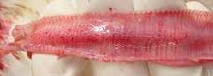
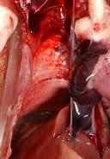
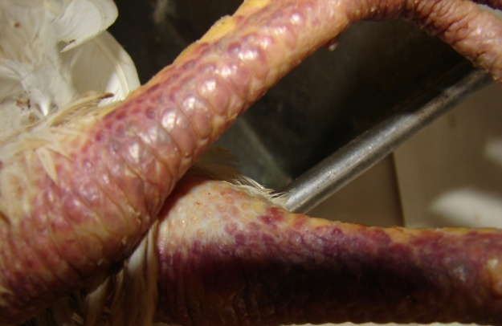
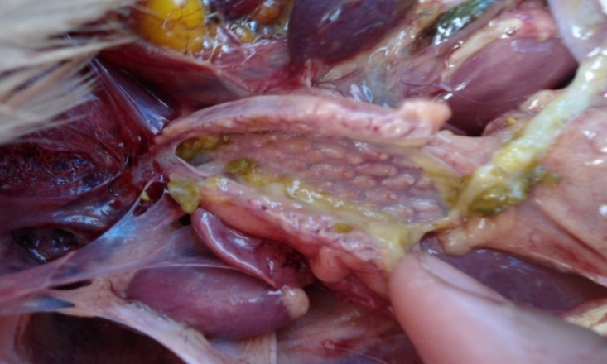

A
B

D
C

E
F
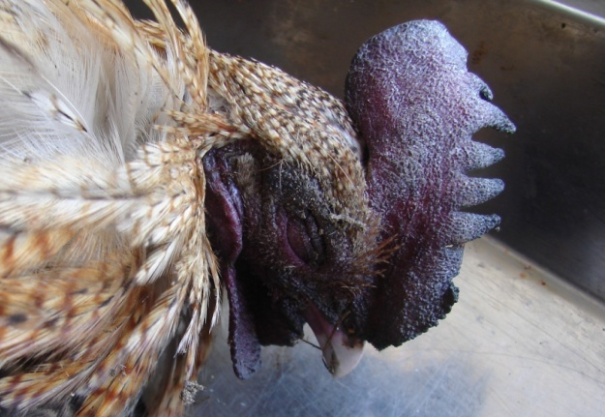

H
G
Fig 2: Figure shows the characteristic postmortem lesions that are in many respiratory disease, lesions includes congestion in trachea (A), lungs (B), hemorrhage in trachea (C), proventriculus (D), cyanotic shank (E), thickened proventriculus (F), cyanotic comb (G) , visceral gout (H)
Table 8: Overall characteristics gross lesion of the suspected diseases
Sample I.D | Major necropsy findings with characteristics sign | No. of sample / case |  | Tentatively diagnosed as
S3, S4, S8, S9, S11, S12, S17, S20, S30, S36, S39, S40 | Cyanotic comb, wattle and shank, Highly congested subcutaneous blood vessel in ventral region, swollen head with nasal secretion, congestion and hemorrhage in trachea and lungs, thickened proventriculus, enlarge spleen | 12 | 17 | AI
S41, S42, S43, S44, S45 | Congested subcutaneous blood vessel, congestion and hemorrhage in trachea and lungs, thickened proventriculus, hemorrhagic ova, hemorrhage in proventriculus. | 5
S1, S5, S7, S10, S13, S15, S27, S29, S32, S33, | Congested trachea and lungs, Thickened proventriculus, Hemorrhage in proventriculus and cecal tonsil, Ulcerated intestinal mucosa | 10 | 16 | ND
S35, S37, S38, S46, S47, S48, | Congested lungs, thickened proventriculus, Hemorrhage in proventriculus, peritonitis, swollen bursa, exudates in intestine. | 6
S2, S19, S23, | Congested trachea and lungs, mucus exudates in trachea, swollen kidney, | 3 | 6 | IB + other bacterial or fungal
S21, S25, S26, | Visceral gout, congested lungs, urates in kidney, | 3
S6, S31 | Congested subcutaneous blood vessel, congested lungs and trachea, thickened proventriculus, hemorrhage in proventriculus, | 2 | 2 | AI+ND
S14, S16, S18, S22, S28, S34 | congested subcutaneous blood vessel in ventral region, thickened proventriculus, Hemorrhage in cecal tonsil. | 6 | 6 | AI/ND
S24 | Congested trachea and lungs, swollen kidney, thickened proventriculus, visceral gout | 1 | 1 | ND/IB/other
In all suspected cases of AI there was found history of high mortality with characteristic congestion in subcutaneous blood vessel under the ventral portion of skin as well as thickened proventriculus which was also observed in ND suspected cases. There was found hemorrhage in proventricus in both AI and ND suspected cases. In case of IB suspected cases visceral gout with urate deposition in kidney were highly encountered. In all the cases trachea and lungs were found congested and hemorrhagic (Table: 8).
Table 9: Overall percentages of tentatively diagnosed diseases
Total no. of sample/Case | Diagnosis of AI based on gross lesion |  | Diagnosis of ND based on gross lesion |  | Diagnosis of IB based on gross lesion |  | Diagnosis of ILT based on gross lesion |  | Mixed infection
 |  |  |  |  |  |  |  |  | AI+ND |  | AI/ND |  | IB/ND
48 | No. | % prevalence | No. | % prevalence | No. | % prevalence | No. | % prevalence | No. | % | No. | % | No. | %
 | 17 | 35.45 | 16 | 33.33 | 6 | 12.5% | 0 | 0 | 2 | 4.17 | 6 | 12.5 | 1 | 2.0 8

4.3 Screening of viral respiratory pathogens by performing PCR from cDNA of the viral nucleic acid and RT-PCR assay
Avian Influenza virus (AIV), Newcastle disease virus (NDV) and Infectious Bronchitis virus (IBV) was identified after performing PCR from cDNA template synthesized from original template RNA as well as using one step RT-PCR kit where extracted RNA was used as a template. Both the method was applied to see the accuracy of the cDNA synthesis kit and one step RT-PCR kit. After that both of the procedure gave same results. (Table: 10) From this screening no ILT specific band was found.

Table 10: Comparison of accuracy of tentative diagnosis with Molecular identification of Respiratory viral diseases
Total no. of sample/  Case | Diseases | Tentative diagnosis  (No. of sample positive ) | Confirmatory diagnosis  No. of PCR (+) ve  Sample | Accuracy (%) of tentative diagnosis
48 | AI | 17 | 12 | 70.58
 | ND | 16 | 13 | 81.25
 | IB(visceral gout) | 6 | 2 | 33.33
 | ILT | no | no | 100
 | AI+ND | 2 | 1(AI) | 50
 | AI/ND | 6 | 5(AI=2; ND=3) | 83.33
 | IB/ND | 1 | 0 | 0

After molecular confirmation it was found that among the diseases, AI was diagnosed in 70.58% cases accurately through necropsy and 81.25% for ND. IB was suspected in 33.33% cases where visceral gout was most prominent lesion. ILT was not diagnosed tentatively which was also proved by molecular diagnosis that indicates the 100% accuracy of the tentative diagnosis (Table: 10).

Table 11: Overall percentage of the diseases confirmed by PCR
Diseases | No. of infected case | Overall percentage
AI | 15 | 31.25%
ND | 16 | 33.33%
IB | 2 | 4.16%
Total | 33 | 68.75%

4.4 Amplification of the PCR product in agarose gel electrophoresis
After performing PCR for separate reaction amplified product was visualized in UV light and compared with a DNA marker, AI positive sample showed 1029bp band in gel (Fig: 3); ND positive sample were amplified in 320bp position (Fig: 4) and IB infected sample was amplified in predicted location of 149bp position (Fig: 5).

Fig 3: Amplification of Matrix (M) gene of AIV by single step PCR or RT-PCR

Fig 4: Amplification of fusion protein gene of NDV by single step PCR or RT-PCR

Fig 5: Amplification of Nucleoprotein gene of IBV by single step PCR or RT- PCR:
4.5 Optimization of Multiplex PCR
Several experiments were performed to get the expected band by changing the templates in the reaction like with or without templates having all sets of primer in the reaction tube. Finally the mPCR products were visualized in gel electrophoresis where bands at 1023 bp indicates for AIV, 320 bp for NDV and 149 bp for IBV infection (Fig: 6). The results obtained from the mPCR assay are displayed in figure 6.

Fig 6: Optimized mPCR assay of different sets of amplification. Figure shows 1% Agarose Gel Electrophoresis of mPCR amplified products of individual field samples. Here, Lane M, ladder (1kb plus Marker); Lanes L1, indicates 3 identified virus, L2 negative control; L3 indicates single ND virus infection; L4 and L5 indicates mixed AI and IB simultaneously; L6 negative control; L7 indicates ND and IB simultaneously; L8 indicates AI and ND. Here, band at 1023 bp is indicative of AIV, 320 for NDV and 149 for IBV infection.

4.6 Histopathological examination
Hemorrhage and congestion were similar lesions in trachea and lungs in most of the samples. In contrast, the chickens infected with AI had congestion and hemorrhage in tracheas and lungs. In some cases liver and spleenic blood vessels were found congested. In ND manifested samples there were observed congestion and hemorrhage in trachea, lungs and proventriculus. Infiltration of lymphocytes and macrophage was found in some AI and ND infected spleen. Hemorrhage was found in kidney and heart muscle in IB affected birds (Fig: 7). In case of IB infected samples epithelial and glandular desquamation with mucus and slight congestion was found in tracheas. In kidneys, congestion, hemorrhage and multifocal necrosis of the renal tubules, focal infiltration of lymphocytes was seen between the urinary ducts. The most prominent histopathological changes in the lungs in IB were congestion, haemorrhage, infiltration of lymphocytes into the submucosa of secondary bronchi with fibrinous exudates and focal infiltration of lymphocyte.
Fig 7:Histopathological changes in some organ showing similar lesion in respiratory infection; figure showing congested lung with normal parencymal structure (A) which was found most of the cases in AI and ND; There is highly congested lung with thickened alveoli and pink color mucus within lung alveoli (B) which was found in IB infected samples. Trachea was found congested (c) and exudates (G) within the lumen were found in most of the ND infected samples. Congested liver (D) and spleen (E) was found in IB and ND infected sample mostly and in some cases in AI. In case of ND and in some cases of AI proventriculus was found hemorrhagic here glandular epitheli shoes hemorrhage on tip of the gland (I). Figure (F) and (H) shows congestion and hemorrhage in heart muscle and kidney respectively.
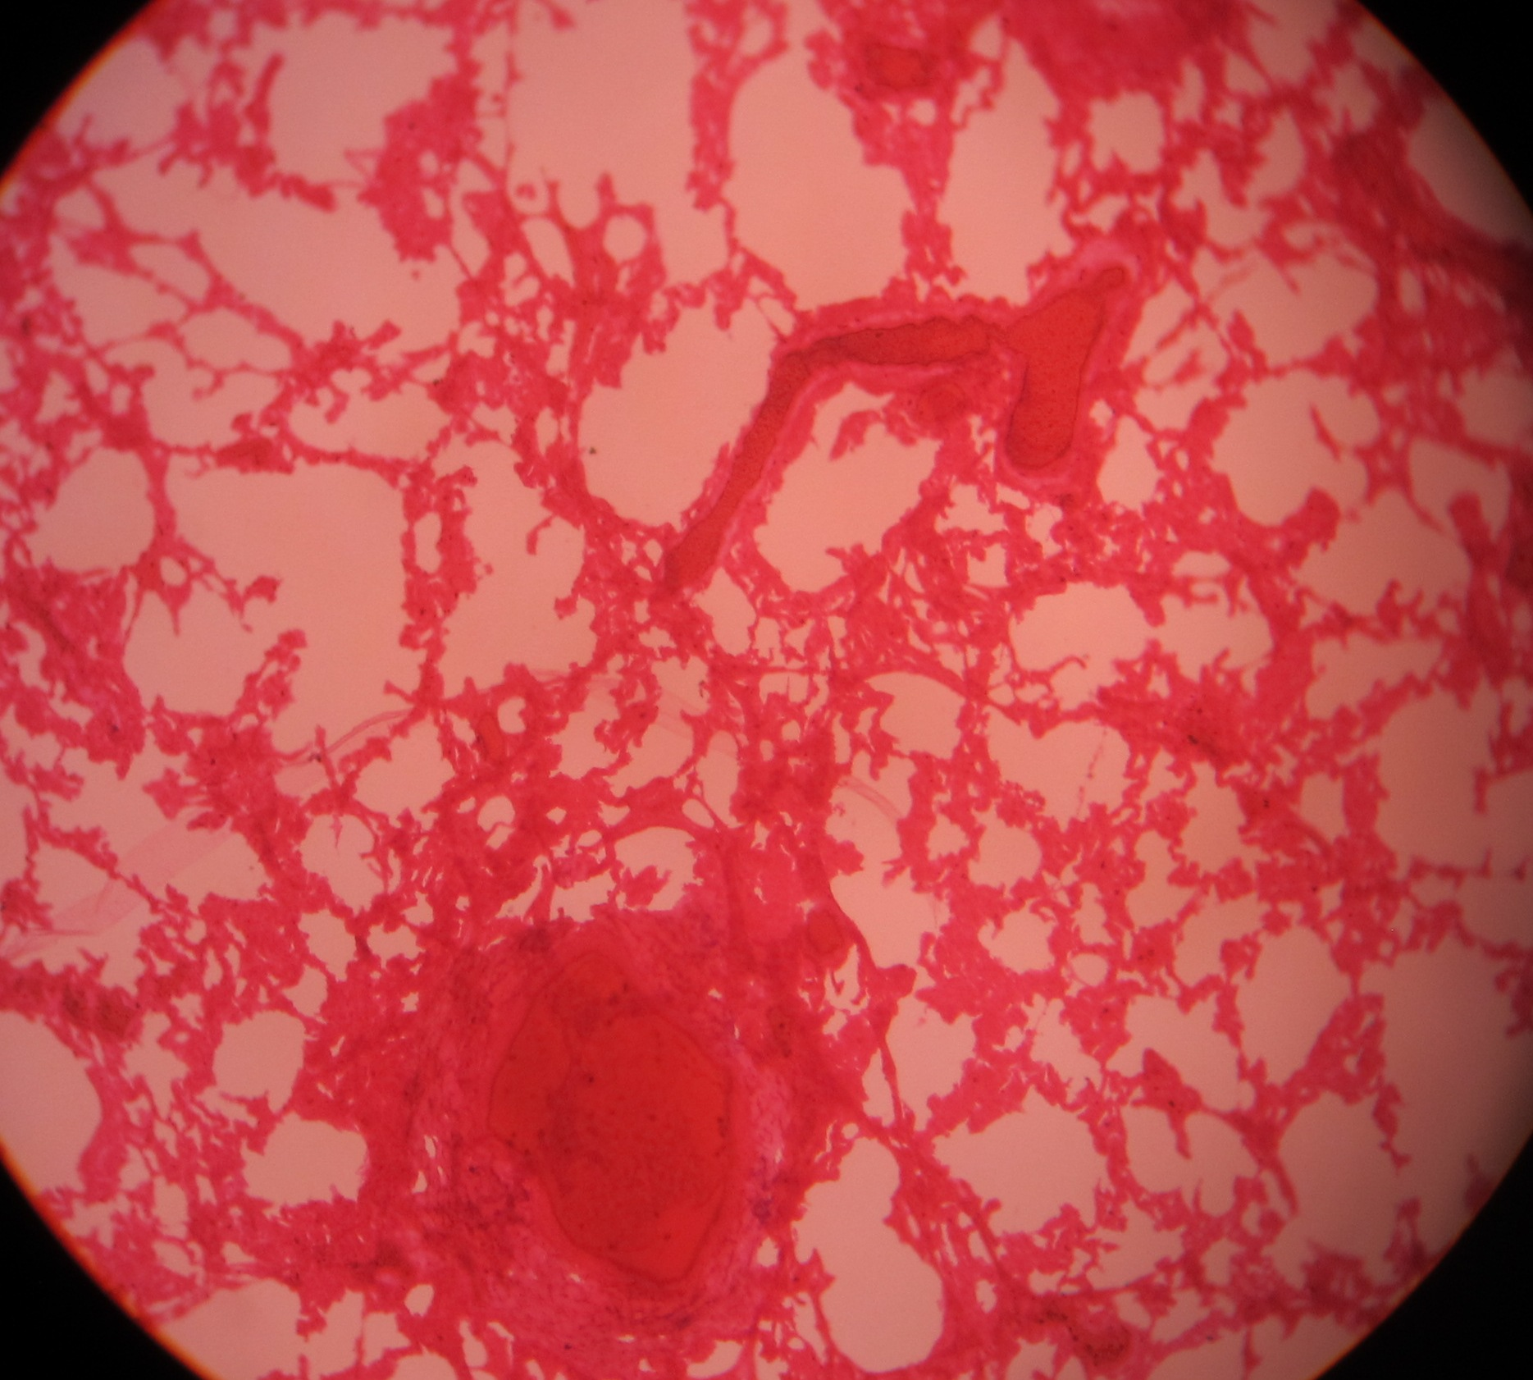
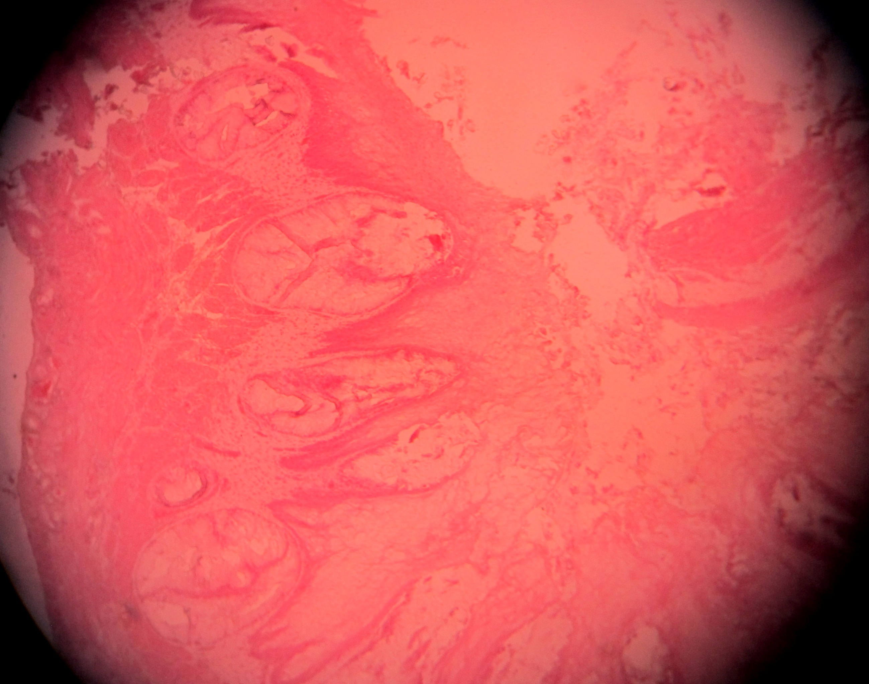
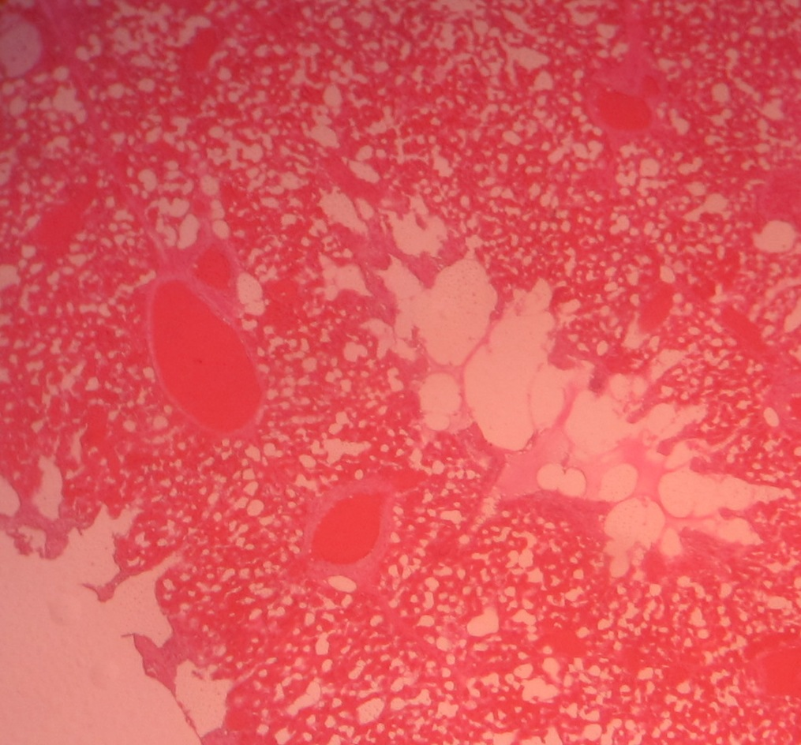
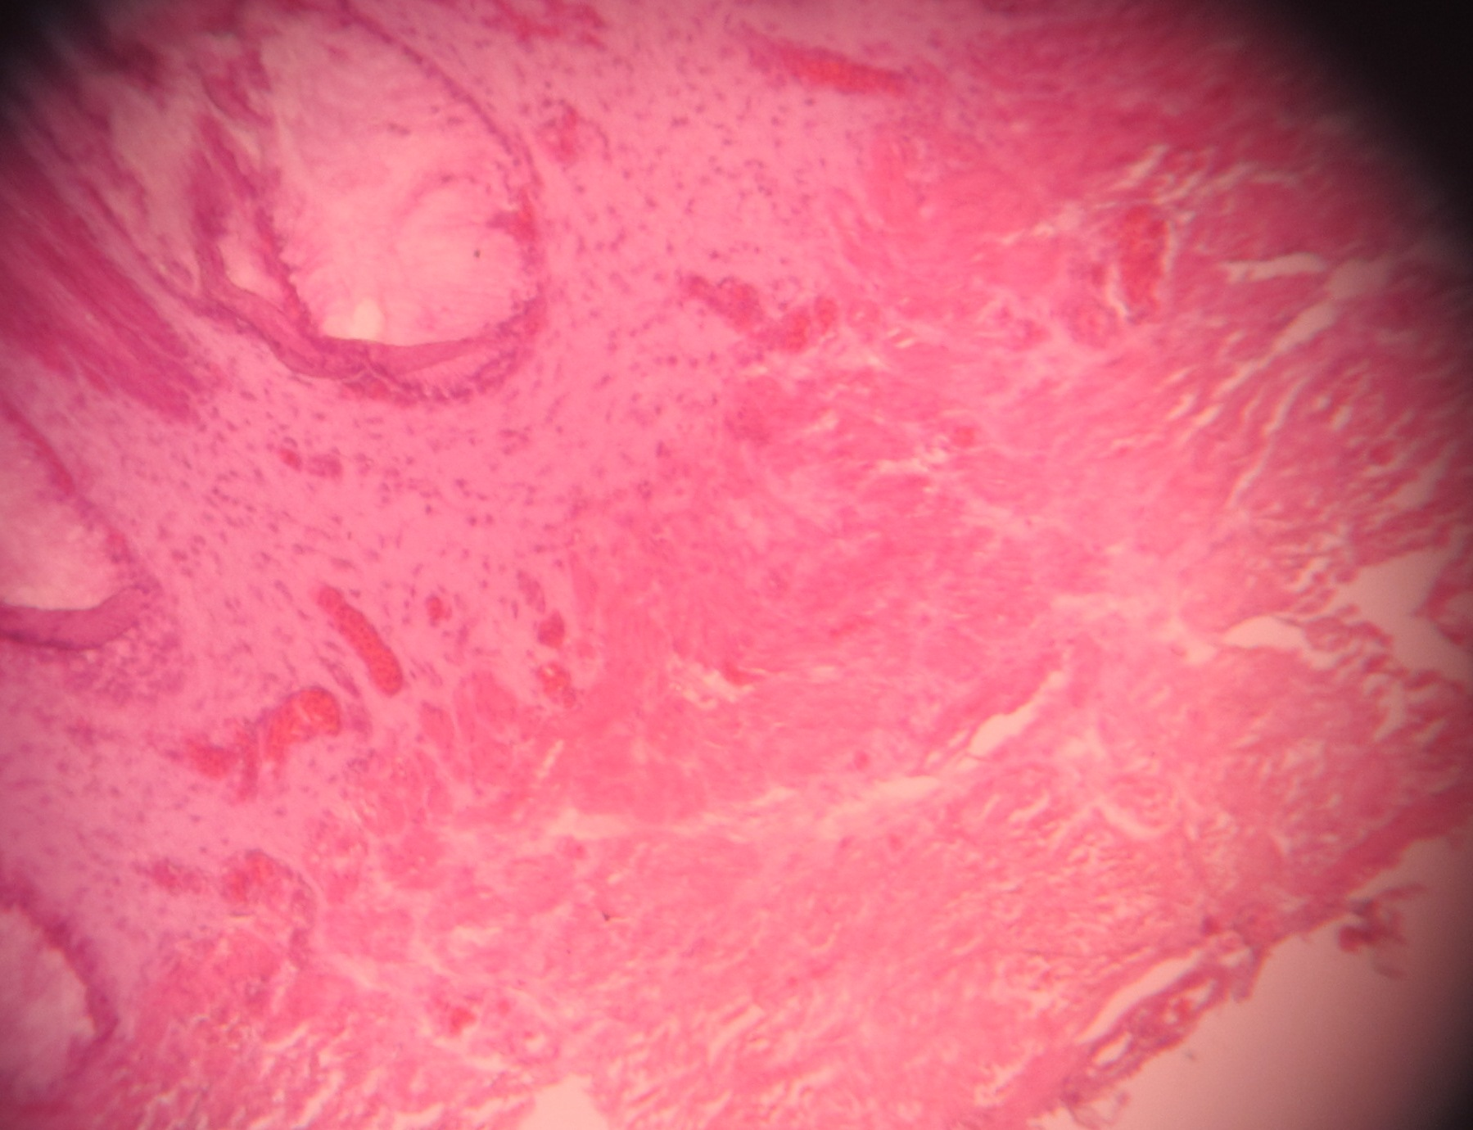
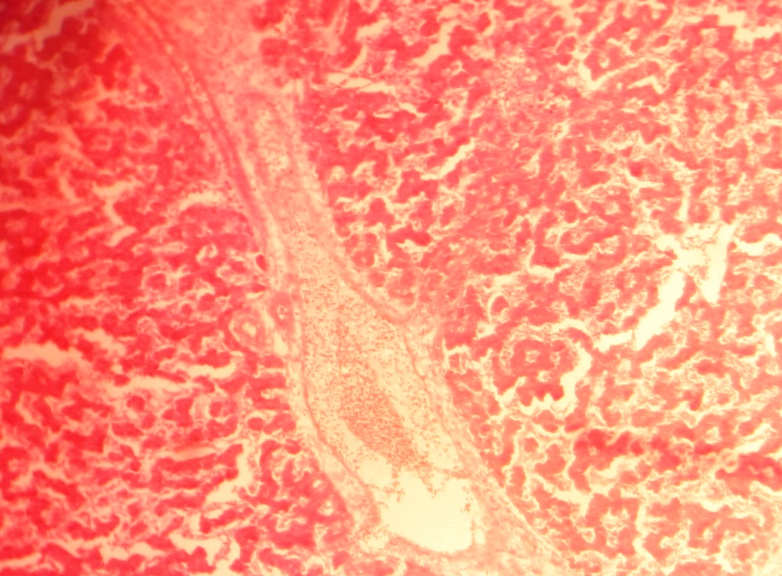
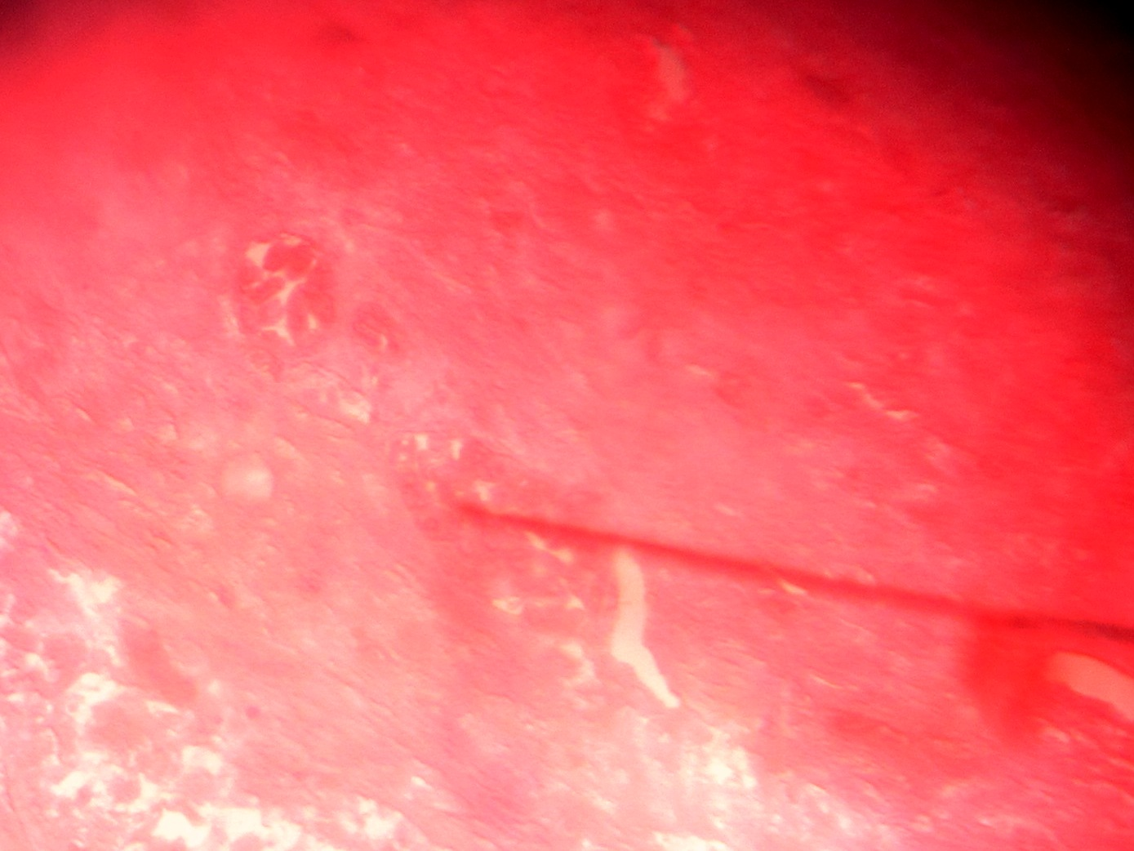
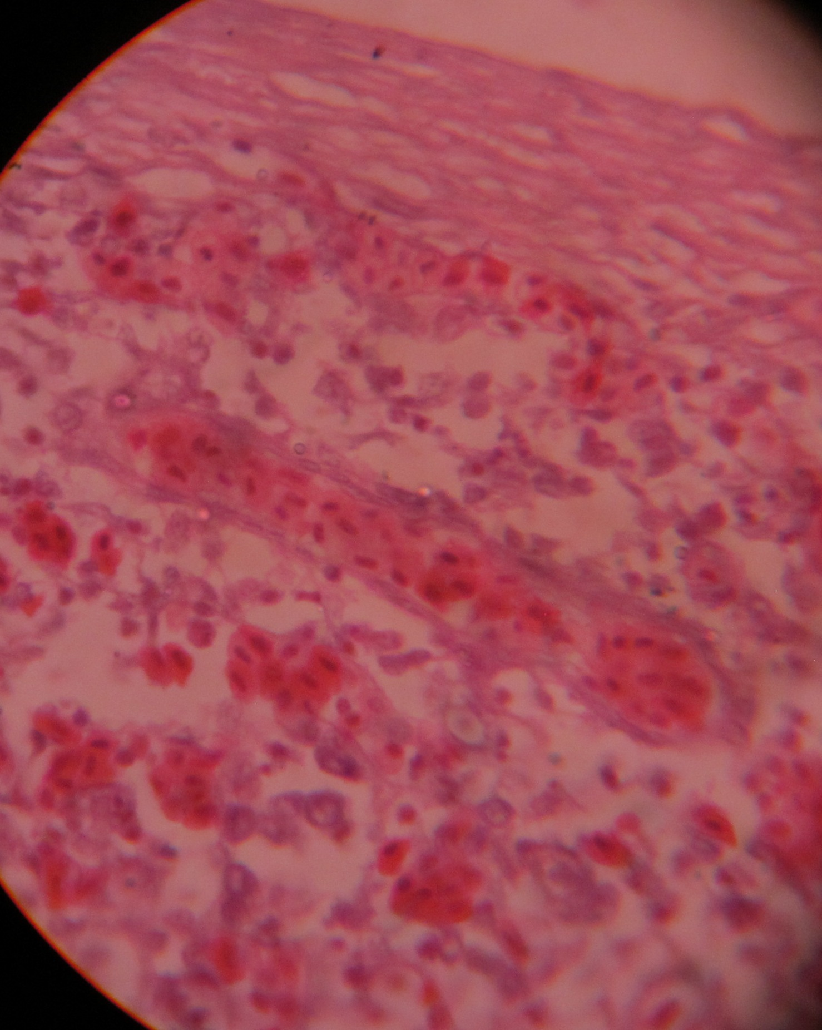
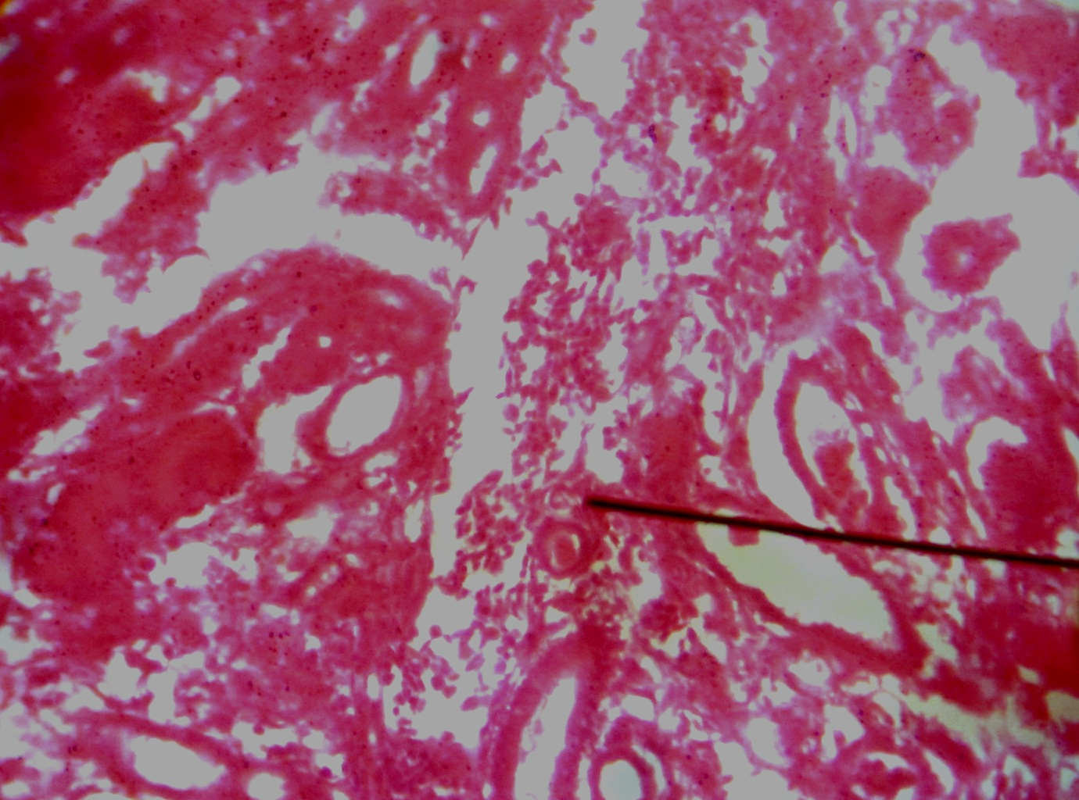
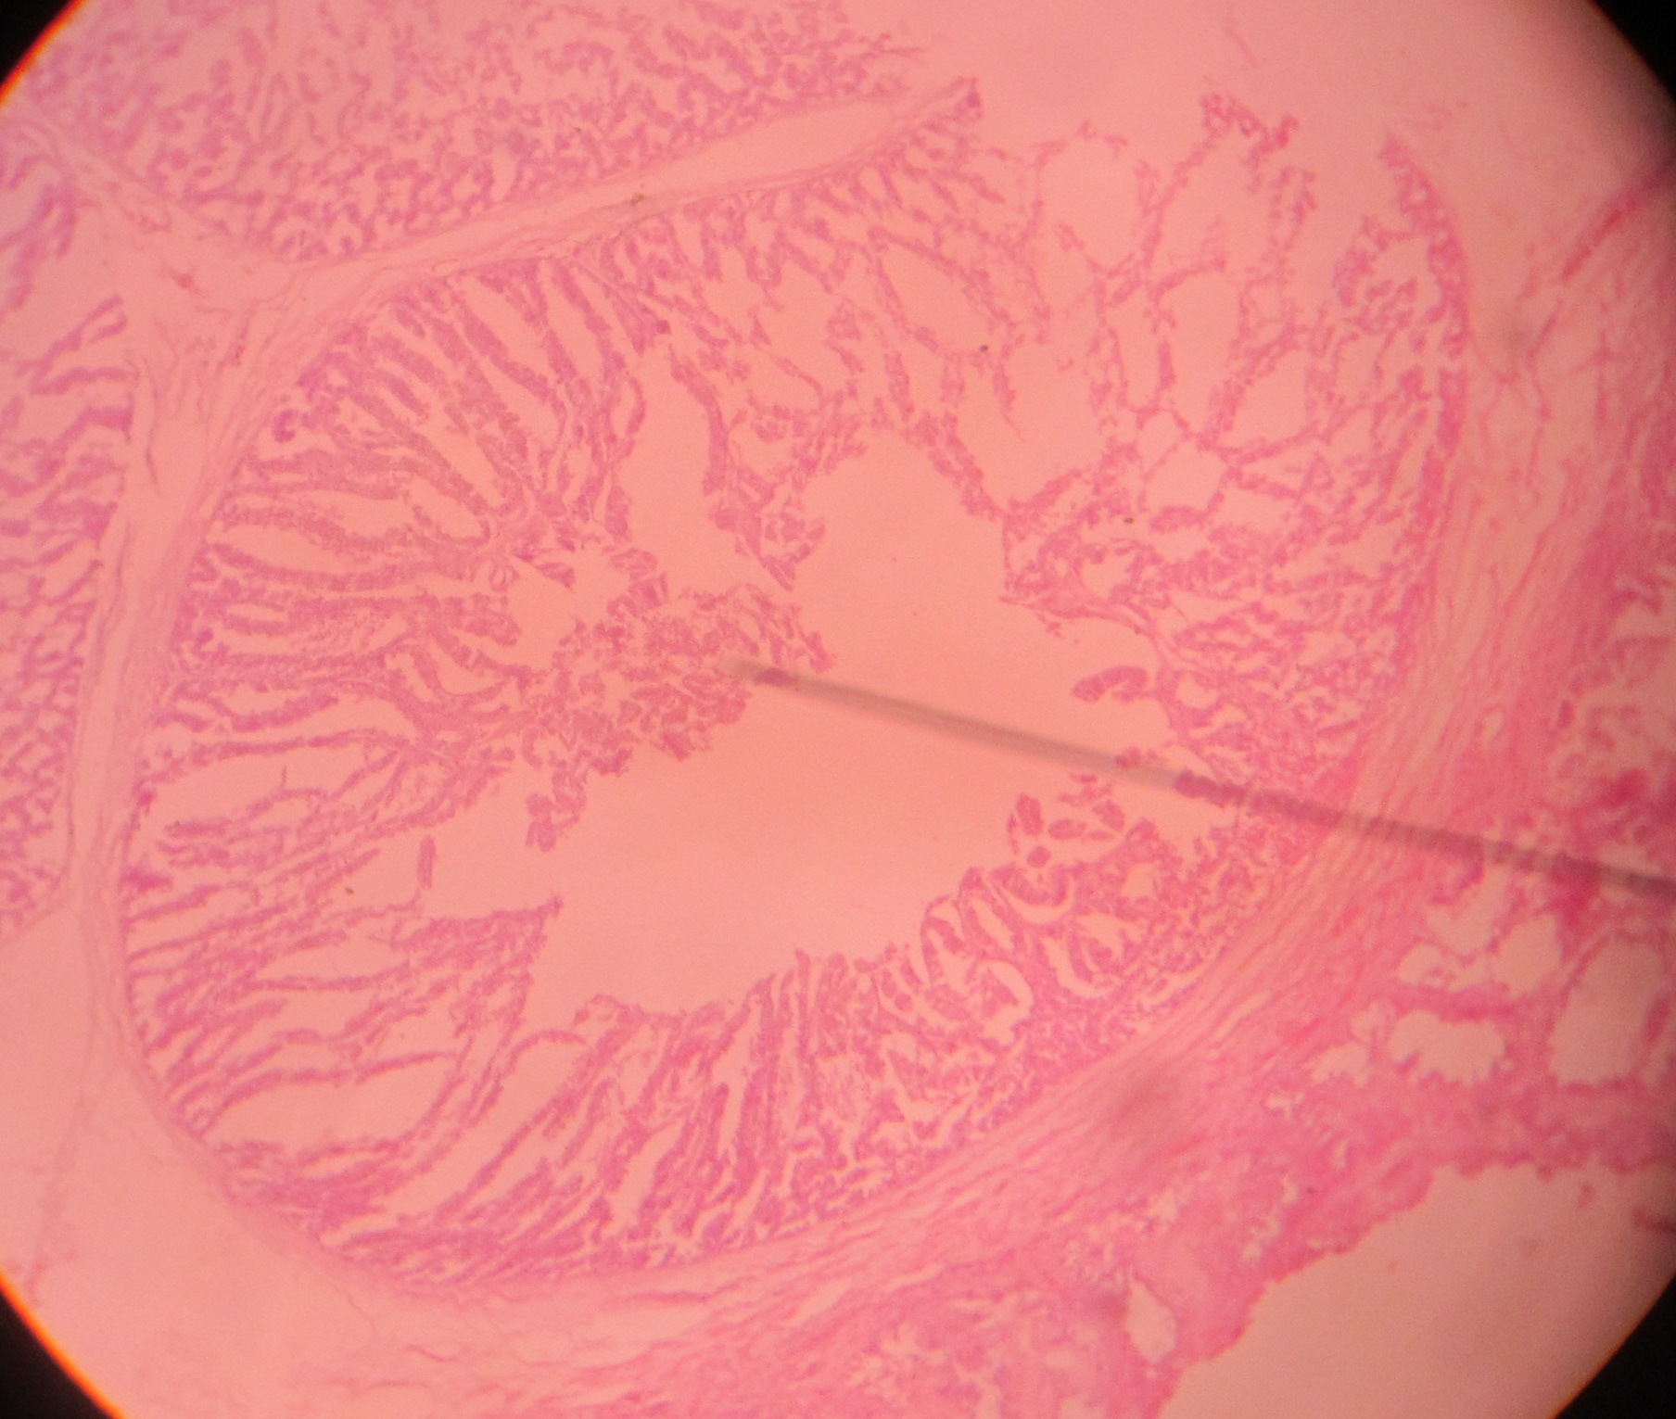
A
B
C
D
E
F
G
H
I
CHAPTER-V
DISCUSSION
Multiple diagnostic methods such as isolation and serological tests are required for detecting and differentiating several viral respiratory infections. However, these isolation and culture methods are time consuming and labor intensive. Molecular methods, like PCR enables rapid identification of pathotypes of the virus and is the sensitive and the specific method (Awan et al., 2012; Ayaz et al., 2013). Single tube multiplex reverse transcription-polymerase chain reaction (mRT-PCR) or multiplex polymerase chain reaction (mPCR) have been used for rapid detection of avian pathogens with a very high level of sensitivity (Alexander et al., 2000; Ali et al., 2000). Multiplex RT-PCR using oligonucleotide primers having viral RNA, is one of the fast, reliable and reproducible molecular techniques that can be used for the identification of pathotypes of NDV (Ali and Reynolds, 2000). Multiplex RT-PCR is one of the latest molecular techniques which can be used as an alternative of in vivo methods of virulence assessment of the viruses (Manzoor et al., 2013).The multiplex PCR has the ability to amplify and differentiate multiple specific nucleic acids. Although several studies describing individual PCR methods can be found for each avian respiratory agent (Jahanshiri et al., 2005). Previous studies have successfully applied the mRT-PCR techniques to distinguish four common avian viruses like ILTV, IBV, NDV, and AIV at a time in a single assay (Rashid et al., 2009; Wang et al., 2008). In this study I have also applied the mPCR technique to detect and differentiate the IBV, NDV, and AIV the three common respiratory infections found in Bangladesh. To validate the use of mPCR in field samples, 48 Ribonucleic acid was extracted from these samples and tested by both sRT-PCR and mPCR assays. The sRT-PCR assay resulted in the amplification of AIV, with an expected product size of 1029bp. Amplification of NDV and IBV with their specific primers in sRT-PCR assays produced expected products of 320bp and 149 bp, respectively after optimization of mPCR 3 bands of expected sizes (1029bp for AIV, 320 bp NDV, and 149bp for IBV respectively) was observed in single reaction. In our study among the 48 suspected cases total 33(68.75%) samples showed positive band in 1% agarose gel electrophoresis where 15(31.25%), 16(33.33%) and 2(4.16%) samples were positive for AI, ND and IB respectively and 31.25% was unidentified which may be due to other bacterial or mycoplasma infection that produces also similar lesion in necropsy.
Mortality of the bird can also occur due to IBD, E coli and salmonella infection which may cause respiratory lesion (Pang et al., 2002). Brown et al. (1999) reported that he found 10 (20%) farms were found to be infected with velogenic NDV through multiplex RT-PCR with sympmtoms of depression, paralysis of legs and conjunctivitis in experimental inoculation of viscerotropic and neurotropic velogeniec NDV in chickens. Similar symptoms were observed by Nakamura et al. (2004) and Wakamatsu et al. (2006) in experimentally infected commercial chickens by velogenic NDV.

After molecular confirmation it was found that among the diseases AI was diagnosed in 70.58% cases accurately through necropsy and 81.25% and 66.66% for ND and IB respectively. ILT was not diagnosed tentatively which was also proved by molecular diagnosis that indicates the 100% accuracy of the tentative diagnosis. The multiplex PCR was optimized for successful detection of three of the respiratory tract pathogens including Newcastle disease virus, Infectious bronchitis virus and Avian influenza virus that was also reported from various authors (Marois et al., 2000; Yousof et al., 2005; Seifi et al., 2010; Ehtisham et al., 2011). Several studies showed successful detection of individual pathogens which have been reported including multiplex PCR for the detection of Mycoplasma spp. (Wang et al., 1997) and multiplex RT-PCR for respiratory tract viruses (Pang et al., 2002). The multiplex PCR assay described here was able to detect RNA from IBV, AIV, and NDV, and in one-tube PCR reaction. In the multiplex PCR, it is known that the annealing temperature is one of the most important parameters that must be adjusted in the PCR reaction. Hence, different degrees of annealing temperature (45 to 60ºC) were pre-tested to evaluate the optimal condition and were finalized in 56.2ºC. The selected primers produced expected products in the single RT-PCR and in the multiplex PCR at 1029bp fpr AI, 320bp for ND, 149bp for IB. The amplified products with the primers in this study were used according to published sequence from Rashid et al. (2009). Yashpal et al. (2004) also reported a single tube mRT-PCR for three respiratory viruses (438, 218, and 532 bp for APV, AIV, and NDV, respectively) in an optimized annealing temperature of 53ºC. Huang and Wang (2008) reported a multiplex PCR using different primers of four viral respiratory agents where 619 bp for IBV, 534 bp for NDV, and 330bp for AIV in an optimized annealing temperature of 58ºC. Pang et al., (2001) was successfully developed a multiplex PCR of 6 respiratory pathogen like RNA from IBV, AIV, and NDV, as well as DNA from ILTV, MG, and MS, in a single reaction at 60ºC annealing temperature.
Clinical signs were recorded and post mortem were conducted to observe gross lesions. Trachea, lungs and spleen were used for histopathological studies. Microscopically there was found similar lesion in trachea and lungs like hemorrhage and congestion most of the samples. In contrast, the chickens infected with AI their present congested and hemorrhagic tracheas and lungs with infiltration of lymphocytes. Neufeld et al. (2009) described lesions in the respiratory system include mild inflammatory reaction. In some cases liver and spleenic blood vessels were found congested in ND manifested samples in association with congestion and hemorrhage in trachea, lungs and proventriculus (Alexander and Senne, 2008). In case of IB infected samples the tracheas revealed epithelial and glandular desquamation with mucus and slight congestion. In kidneys, congestion, haemorrhage and multifocal necrosis of the renal tubules focal infiltration of lymphocytes was seen between the urinary ducts was also seen. In addition hemorrhage and congestion was also found in kidney and heart muscle in IB infected samples. The most prominent histopathological changes in the lungs in IB were congestion, haemorrhage, infiltration of lymphocytes into the submucosa of secondary bronchi with fibrinous exudates and focal infiltration of lymphocytes. Crinion et al. (1972) also reported that kidneys are enlarged and may be pale or marbled, and deposits of urates may in the ureters of IB infected chicks. Some strains of IBV are nephropathogenic and replicate in respiratory tissues and kidney, but the lesions are more evident in the kidney (Lee et al., 2004).

Timely diagnosis of the disease is of utmost importance for effective control measures. Mostly conventional methods like necropsy are difficult to differentiate the different pathogens that causing similar lesion. For diagnosis of the disease on time and to know which pathotype has invaded the farm, a method is required which could help in such identifications more precisely, accurately and within short period of time. Molecular methods including RT-PCR are being used for accurate, precise, quick diagnosis and pathotyping of different infectious diseases including AI, ND as reported by Farkas et al. (2007). Keeping in view the above said facts, the present study was planned to differentiate different respiratory viral pathogens using multiplex PCR (mPCR) from field outbreaks.

CHAPTER-VI
CONCLUSION

To validate the use of mPCR in field samples, 48 extracted Ribonucleic acid from collected field samples were tested by both sRT-PCR, PCR and mPCR assays. Results of the mPCR assay were found to be similar to that of sRT-PCR and PCR, indicating the utility of this test in detecting multiple infections. This newly optimized mPCR procedure was validated for use in clinical trial. Samples that were positive in sRT-PCR were also positive in mPCR, indicating that mPCR procedure can be used for the detection of three viruses in field samples thus reducing the time and expense in evaluating clinical samples.

CHAPTER-VII
RECOMMENDATION
This study was performed only in viral respiratory diseases, but similar lesions in respiratory tract may also found in Mycoplasmosis, Infectious coryza, E.coli and salmonella infection. Increased Mortality rate also found in infectious bursal diseases (IBD), which may cause respiratory tract infection in associated with E. coli that can confuse with ND and other infection. So further study can occur to reveal the other respiratory pathogen and their optimization of mPCR for sensitive and rapid diagnosis. In this study three diseases are optimized in multiplex PCR. In future additionally mycoplasmosis (CRD), infectious coryza, IBD can also incuded with this study. And Molecular epidemiological study can also do. It was not possible to give sequence data of identified diseases in this result due to time limitation . In future full sequence data with bioinformatics can do for all identified pathogen to observe their genotype and similarity to vaccine in our country.
CHAPTER-VIII
REFERENCES

Adair BM, Todd D, McKillop ER, Burns K. 1985. Comparison of serological tests for detection of antibodies to infectious laryngotracheitis virus. Avian Pathology. 14(4): 461-469. Available from: http:// www.ncbi.nlm.nih.gov/pubmed/18766940
Akter A, Uddin S. 2009. Bangladesh poultry industry. Journal of Business and Technology Dhaka. 4(2): 97-112.
Alexander DJ, Bell JG, Alders RG. 2004. A Technology Review: Newcastle Disease. With special emphasis on its effect on village chickens. FAO Animal Production and health Paper (FAO). 0254-6019, no 161.
Alexander DJ, Gough RE. 1977. Isolation of avian infectious bronchitis virus from experimentally infected chickens. Research of Veterinary Science. 23(3): 344-347. Available from: http://www.ncbi.nlm.nih.gov/pubmed/203987
Alexander DJ, Jones RC. 2002. Paramyxoviridae. Poultry Diseases. WB Saunders, London. pp: 259-268.
Alexander DJ, Senne DA. 2008. Newcastle disease, other avian paramyxoviruses, and pneumovirus infections. Diseases of poultry. Blackwell Publishing, Ames, IA. pp: 75–98.
Ali A, Reynolds DL. 2000. A multiplex reverse transcription polymerase chain reaction assay for Newcastle disease virus and avian pneumovirus (Colorado strain). Avian Diseases. 44(4): 938-943. Available from: http:// www.ncbi.nlm.nih.gov/pubmed/11195650
Atmar RL, Baxter BD, Dominguez EA, Taber LH. 1996. Comparison of reverse transcription-PCR with tissue culture and other rapid diagnostic assays for detection of type A influenza virus. Journal of Clinical Microbiology. 34(10): 2604-2606. Available from: http://www.ncbi.nlm.nih.gov/pmc/articles/PMC229331/
Ausvetplan. 2005. Australian Veterinary Emergency Manual Plan Avian Influenza – Updated Interim Draft (1,891), 3rd edn, Version 3.1, 2005. Available from: http://www.animal healthaustralia. com.au/aahc
Awan MA, Abbas F, Zai MY, Tariq MY, Bajwa MA, Attique MA, Ahmed Z, Rashid N, Rafiq M, Shafee M. 2012. Prevalence of Mycoplasma species by polymerase chain reaction (PCR) directly from the nasal swab samples of Goats. Pakistan Journal of Life and Social Sciences. 10: 5-12.
Ayaz S, Anwar M, Khan S, Wasir FU, Hussain M, Akhtar M. 2013. Hepatitis B virus genotypes from clinical sample of hepatitis B antigen positive patients by using PCR method in Kohat region of Khyber pakhtunkhwa, Pakistan. 11: 112‐117
Bagust TJ, Guy JS. 1997. Laryngotracheitis. In: Calnek BW, editor. Diseases of poultry. Ames: Iowa State University Press. pp. 527-539.
Bagust TJ, Johnson MA. 1995. Avian infectious laryngotracheitis: Virus-host interactions in relation to prospects for eradication. Avian Pathology. 24(3): 373-391. Available from: http://www.ncbi.nlm.nih.gov/pubmed/18645796
Bagust TJ. 1986. Laryngotracheitis (Gallid-1) herpesvirus infection in the chicken. 4 Latency establishment by wild and vaccine strains of ILT virus. Avian Pathology. 15(3): 581-595. Available from: http://www.ncbi.nlm.nih.gov/pubmed/18766556
Bangladesh Bureau of Statistics (BBS). 2006. Agriculture sample Survey of Bangladesh-2005. Planning Division, Ministry of Planning And Government of peoples Republic of Bangladesh.
Barnes HJ, Gross WB. 1999. Colibacillosis. In: Diseases of poultry. Gross, W. B. (ed.). Ames Iowa, Iowa State University Press. pp. 131-141.
Bauer B, Lohr JE, Kaleta EF. 1999. Comparison of commercial ELISA kits from Australia and the USA with the serum neutralization test in cell cultures for the detection of antibodies to the infectious laryngotracheitis virus of chickens. Avian Pathology. 28(1): 65-72. Available from: http:// www.ncbi.nlm.nih.gov/pubmed/16147550
Beach JR. 1926. Infectious Bronchitis of fowls. Journal of American Veterinary Medical Association. 68: 570-580.
Beaudette FR. 1937. Infectious laryngotracheitis. Poultry Science. 16: 103-105.
Benton WJ, Cover MS, Greene LM. 1958. The clinical and serological response of chickens to certain laryngotracheitis viruses. Avian Diseases. 2(4): 383-396. Available from: http:// www.jstor.org/stable/1587478
Brandly CA. 1937. Studies on certain filterable viruses. I. Factors concerned with the egg propagation of fowl pox and infectious laryngotracheitis. Journal of American Veterinary Medical Association. 90: 479-487.
Brown C, King DJ, Seal BS. 1999. Pathogenesis of Newcastle disease in chickens experimentally infected with viruses of different virulence. Veterinary Pathology. 36: 125-132.
Capua I, Mutinelli F. 2001. Low pathogenic (LPAI) and highly pathogenic (HPAI) avian inﬂuenza in turkeys and chicken. In: Capua, I., Mutinelli, F. (eds.), A Colour Atlas and Text on Avian Inﬂuenza, Papi Editore, Bologna. pp: 13-20.
Caupa I, Alexander DJ. (Eds). 2009. Avian Influenza and Newcastle Disease. A Field and Laboratory Manual. Milan: Springer-Verlag. ISBN 978-88-470-0825-0.
Cavanagh D, Gelb J. 2008. Infectious Bronchitis. In: Saif, Y.M., et al. (Eds.). Diseases of Poultry (12 ed) Iowa State Press. pp: 117-135.
Cavanagh D, Naqi S. 1997. Infectious bronchitis. Diseases of poultry. Mosby-Wolfe. London. pp: 511- 526.
Cavanagh D. 2005. Coronaviruses in poultry and other birds. Avian Pathology. 34(6): 439-48. Available from: http:// www.ncbi.nlm.nih.gov/pubmed/16537157
Cavanagh D. 2007. Coronavirus avian infectious bronchitis virus. Veterinary Research. 38(2): 281-297. Available from: http:// www.ncbi.nlm.nih.gov/pubmed/17296157
Chang PW. 1981. Newcastle disease. CRC Handbook Series in Zoonoses. Section B: Viral Zoonoses Volume II. CRC Press. Boca Raton, Florida, USA. pp: 261–274.
Chen HW, Huang YP, Wang CH. 2009. Identification of Taiwan and China-like recombinant avian infectious bronchitis viruses in Taiwan. Virus Research. 140(1-2): 121-9. Available from: http:// www.ncbi.nlm.nih.gov/pubmed/19100792

Claas EC, De Jong JC, Van Beek R, Rimmelzwaan GF, Osterhaus AD. 1998. Human influenza Virus A/Hongkong/156/97/ (H₅N₁) infection. Vaccine. 16(9-10): 977-978. Available from: http:// www.ncbi.nlm.nih.gov/pubmed/9682346
Cook JK, Darbyshire JH, Peters RW. 1976. The use of chicken tracheal organ cultures for the isolation and assay of avian infectious bronchitis virus. Archives of Virology. 50(1-2): 109-18. Available from: http:// www.ncbi.nlm.nih.gov/pubmed/176965
Creelan JL, Graham DA, Mccullough SJ. 2002. Detection and differentiation of pathogenicity of avian paramyxovirus serotype 1 from field cases using one-step reverse transcriptase-polymerase chain reaction. Avian Pathology. 31(5): 493–499. Available from: http:// www.ncbi.nlm.nih.gov/pubmed/12427343
Crinion RA, Hofstad MS. 1972. Pathogenicity of four serotypes of avian infectious bronchitis virus for the oviduct of young chickens of various ages. Avian Diseases. 16(2): 351-363. Available from: http:// www.jstor.org/stable/1588800
Curran J. 1996. Reexamination of the Sendai virus P protein domains required for RNA synthesis: a possible supplemental role for the P protein. Virology. 221(1): 130-140. Available from: http:// www.ncbi.nlm.nih.gov/pubmed/8661421
Davidson S, Eckroade R, Miller K. 1988. Laryngotracheitis the Pennsylvania experience. Proceeding 23rd National Meet and Poultry Health Condemnations. Ocean City, MD. pp. 14-19.
De Jong JC, Claas ECJ, Osterhaus ADME, Webster RG, Lim WL. 1997. A pandemic warning. Nature. 389(6651): 554.Available from: http://www.nature.com/nature/ journal/v389/n6651/full/389554a0.html
de Leeuw OS, Hartog L, Koch G, Peeters BP. 2003. Effect of fusion protein cleavage site mutations on virulence of Newcastle disease virus:non-virulent cleavage site mutants revert to virulence after one passage in, chicken brain. Journal of General Virology. 84(Pt 2): 475–484. Available from: http:// www.ncbi.nlm.nih.gov/pubmed/12560582
de Leeuw OS, Koch G, Hartog L, Ravenshorst N, Peeters BP. 2005. Virulence of Newcastle disease virus is determined by the cleavage site of the fusion protein and by both the stem region and globular head of the haemagglutinin-neuraminidase protein. Journal of General Virology. 86(Pt 6): 1759–1769. Available from: http:// www.ncbi.nlm. nih.gov/pub med/15914855
Ehtisham S, Rahman SU, Siddique M, Qureshi AS. 2011. Involvement of Mycoplasma synoviae in respiratory distress cases of broilers. Pakistan Veterinary Journal. 31: 117-119
Elbers AR, Kamps B, Koch G. 2004. Performance of gross lesions at postmortem for the detection of outbreaks during the avian inﬂuenza A virus (H7N7) epidemic in The Netherlands in 2003. Avian Pathology. 33(4): 418-22. Available from: http:// www.ncbi.nlm.nih.gov/pubmed/15370039
El-Houadfi M, Jones RC, Cook JK, Ambali AG. 1986. The isolation and characterization of six avian infectious bronchitis viruses isolated in Morocco. Avian Pathology. 15(1): 93-105. Available from: http:// www.ncbi.nlm.nih.gov/pubmed/18766508
Fabricant J, Levine PP. 1962. Experimental production of complicated chronic respiratory disease infection ('air sac' disease). Avian Diseases. 6(1): 13-23. Available from: http:// www.ncbi.nlm.nih.gov/pubmed/17422362
Ficken MD, Guy JS, Gonder E. 1989. An outbreak of influenza (H1N1) in turkey breeder hens. Avian Diseases. 33(2): 370–374. Available from: http:// www.ncbi.nlm.nih.gov/ pubmed/2751570
Food and agriculture organization of the united (FAO). 2004. FAO, OIE and WHO Technical consultation on T he Control of Avian Influenza. Animal health special report. Available from: http://www.fao.org/ag/againfo/subjects/ en/health/diseases cards/avian_recomm.html.
Fouchier RA, Munster V, Wallensten A. 2005. Characterization of a novel inﬂuenza A virus hemagglutinin subtype (H16) obtained from black-headed gulls. Journal of Virology. 79(5): 2814-22. Available from: http:// www.ncbi.nlm.nih.gov/pubmed/15709000
Giasuddin M, Sil BK, Alam J, Islam MR, Rahman MM. 2002. Prevalance of poultry diseases in Bangladesh. Online Journal of Biological Science. 2(4): 212-213. Available from: http:// www.researchgate.net/26561081
Gibbs CS. 1931.Infectious tracheitis. Bulletin - Massachusetts Agricultural Experiment Station. 273: 27-55. Available from: http:// www.jstor.org/stable/1592256
Gonzalez JM, Gomez-Puertas P, Cavanagh D, Gorbalenya AE, Enjuanes L. 2003. A comparative sequence analysis to revise the current taxonomy of the family Coronaviridae. Archives of Virology. 148(11): 2207-35. Available from: http:// www.ncbi.nlm.nih.gov/pubmed/14579179
Gorman OT, Bean WJ, Webster RG. 1992. Evolutionary processes in inﬂuenza viruses: divergence, rapid evolution, and stasis. Current Top Microbial Immunology. 176: 75-97. Available from: http:// www.ncbi.nlm.nih.gov/pubmed/1600756
Gough RE, Randall CJM, Dagless M, Alexander DJ, Pearson D. 1992. A “new˝ strain of infectious bronchitis virus infecting domestic foul in Great Britain. Veterinary Record. 130(22): 493-494. Available from: http:// www.veterinaryrecord.bmj.com
Guo P, Scholz E, Turek J, Nordgreen R, Maloney B. 1993. Assembly pathway of avian infectious laryngotracheitisvirus. American Journal of Veterinary Research. 54(12): 2031-2039. Available from: http:// www.ncbi.nlm.nih.gov/pubmed/8116934
Guy JS, Bagust TJ, Saif YM, Barnes HJ, Fadly AM, Glisson JR, McDougald LR, Swayne DE. 2003. Laringotracheitis. Diseases of poultry. Iowa State University Press, Ames. pp. 121-134.
Guy JS, Garica M, Saif YM, Fadly AM, Glisson JR, McDeugald LR, Nolan LK, Sweyne DE. 2008. Laryngotracheitis. Disease of poultry. Blackwell publishing. pp: 137-152
Harrison MS, Sakaguchi T, Schmitt AP. 2010. Paramyxovirus assembly and budding: building particles that transmit infections. International Journal of Biochemistry and Cell Biology. 42(2): 1416-1429. Available from: http:// www.ncbi.nlm.nih.gov/ pubmed/20398786
Hidalgo H. 2003. Infectious laryngotracheitis: a review. Revista Brasileira de Ciencia Avicola. 5(3): 157- 168. Available from: http://dx.doi.org/10.1590/S1516-635X2003 000300001
Hinshaw WR, Jones EC, Graybill HW. 1931. A study of mortality and egg production in flocks affected with laryngotracheitis. Poultry Science. 10(7): 375-382. Available from: http:// www.ps.oxfordjournals.org/content/10/7/375
Hinshaw WR. 1925. Studies in poultry diseases found in poultry feeding stations. Nat. Poult., Butter and Egg Bull. 9(l-A):3-6.
Horikami SM, Curran J, Kolakofsky D, Moyer SA. 1992. Complexes of Sendai virus NP-P and P-L proteins are required for defective interfering particle genome replication in vitro. Journal of Virology. 66(8): 4901–4908. Available from: http:// www.ncbi.nlm.nih.gov › Journal List › J Virol › v.66(8); Aug 1992
Hughes LA, Savage C, Naylor C, Bennett M, Chantrey J, Jones R. 2009. Genetically diverse coronaviruses in wild bird populations of northern England. Emerging Infectious Diseases. 15(7): 1091-1094. Available from: http://www.ncbi.nlm.nih.gov/ pmc/ articles/PMC2744231/
IFPRI. 2000. Available from: http://www.cgiar.org/IFPRI.
Islam MR, Khan M, Das PM, Bari ASM. 1998. Poultry diseases diagnosed at necropsy in 1997 and 1998 in the department of pathology, Bangladesh Agricultural University, Mymensingh, Proceeding of BSVER annual scientific conference, 3rd - 4th December, 1998, Jaynul Abedin Auditorium, Bangladesh Agricultural University, Mymensingh, Bangladesh.
Jabbar MA, Rahman MH, Taluker RK, Raha SK. 2007. Contract farming as a market institution for poultry production in Bangladesh: Alternative institutional arrangements and implications for equity. Research Report. Nairobi, International Livestock Research Institute.
Jackwood MW, Hilt DA, Brown TP. 2003. Attenuation, safety and efficacy of an infectious bronchitis virus GA98 serotype vaccine. Avian Diseases. 47(3): 627-32. Available from: http:// www.ncbi.nlm.nih.gov/pubmed/18670913
Jahanshiri, F., M. Eshaghi, and K. Yusoff. 2005. Identification of phosphoprotein: phosphoprotein and phosphoprotein:nucleocapsid protein interaction domains of the Newcastle disease virus. Archive of Virology. 150: 611–618.
Jonassen CM, Kofstad T, Larsen IL, Lovland A, Handeland K, Follestad A, Lillehaug A. 2005. Molecular identification and characterization of novel coronaviruses infecting graylag geese (Anser anser), feral pigeons (Columbia livia) and mallards (Anas platyrhynchos). Journal of General Virology. 86(6): 1597-1607. Available from: http:// www.ncbi.nlm.nih.gov/pubmed/15914837
Jordan FT. 1963. Further observations of the epidemiology of infectious laryngotracheitis of poultry. Journal of Comparative Pathology. 73: 253-264. Available from: http://www.unboundmedicine.com
Jungherr EL, Chomiak TW, Luginbuhl RE. 1956. Immunological differences in strains of infectious bronchitis virus. Proceedings of the 60th Annual Meeting of the U.S. Livestock Sanitary Association, Chicago. pp. 203-209.
Keam L, York JJ, Sheppard M, Fahey KJ. 1991. Detection of infectious laryngotracheitis virus in chickens using a non-radioactive DNA probe. Avian Diseases. 35(2): 257-262. Available from: http:// www.ncbi.nlm.nih.gov/pubmed/1649586
Kernohan G. 1931. Infectious laryngotracheitis in fowls. Journal of American Veterinary Medical Association. 78: 196-202.
Key DW, Gough BC, Derbyshire JB, Nagy E. 1994. Development and evaluation of a non-isotopically labelled DNA probe for the diagnosis of infectious laryngotracheitis. Avian Diseases. 38(3): 467-474. Available from: http:// www.jstor.org /stable /1592067
Kingsbury FW, Jungherr EL. 1958. Indirect transmission of infectious laryngotracheitis in chickens .Avian Diseases. 2(l): 54-63.
Lai MM, Cavanagh D. 1997. The molecular biology of coronaviruses. Advances in Virus Research. 48: 1-100. Available from: http:// www.ncbi.nlm.nih.gov/pubmed/9233431
Lakadamyali M, Rust M, Babcock H, Zhuang X. 2003. Visualizing infection of individual influenza viruses. Proceedings of the National Academy of Sciences USA. 100 (16): 9280-9285. Available from: http:// www.ncbi.nlm.nih.gov/pubmed/12883000
Lamb RA, Parks GD. 2007. Paramyxoviridae: the viruses and their replication. Fields virology. Lippincott Williams and Wilkins, Philadelphia, PA. pp. 1449–1496.
Lancaster JE. 1976. A history of Newcastle Disease with comments on its economic effects. World’s Poultry Science Journal. 32(2): 167-175. Available from: http:// www.journals.cambridge.org/article_S0043933976000056
Lee MS, Chang PC, Shien JH, Cheng MC, Shieh HK. 2001. Identification and subtyping of avian influenza viruses by reverse transcription-PCR. Journal of Virological Methods. 97(1-2): 13-22. Available from: http:// www.ncbi.nlm.nih.gov/pubmed/11483213
Linares JA, Bickford AA, Cooper GL, Charlton BR, Woolcock PR. 1994. An outbreak of infectious laryngotracheitis in California broilers. Avian Diseases. 38(1): 188-192. Available from: http:// www.ncbi.nlm.nih.gov/pubmed/8002892
Lister SA, Beer JV, Gough RE, Holmes RG, Jones JMW, Orton RG. 1985. Outbreaks of nephritis in pheasants (Phasianus colchicus) with a possible coronavirus aetiology. Veterinary Record. 117(23): 612-613. Available from: http:// www.ncbi.nlm.nih.gov/ pubmed/3002000
Liu S, Chen J, Kong X, Shao Y, Han Z, Feng L, Cai X, Gu S, Liu M. 2005. Isolation of avian infectious bronchitis coronavirus from domestic peafowl (Pavo cristatus) and teal (Anas). Journal of General Virology. 86(3): 719-25. Available from: http:// www.ncbi.nlm.nih.gov/pubmed/15722532
Locke DP, Sellers HS, Crawford JM, Schultz-Cherry S, King DJ, Meinersmann RJ, Seal BS. 2000. Newcastle disease virus phosphoprotein gene analysis and transcriptional editing in avian cells. Virus Research. 69(1): 55–68. Available from: http:// www.ncbi.nlm.nih.gov/pubmed/10989186
Lu H, Castro AE, Pennick K, Liu J, Yang Q, Dunn P, Weinstock D, Henzler D. 2003. Survival of avian influenza virus H7N2 in SPF chickens and their environments. Avian Diseases. 47(3): 1015–1021. Available from: http:// www.ncbi. nlm.nih.gov/ pubmed/14575104
Luna LG. 1986. Manual of histologic staining methods of the Armed Forces Institute of Pathology. McGraw Hill Book Company, USA.
Manzoor AW, Farzana R, Mohsan J, Muhammad N, Khan A, Rehman SU. 2013. Pathotyping of Newcastle Disease Virus using Multiplex Reverse Transcription Polymerase Chain Reaction and Pathological Studies inNaturally Infected Broiler Chicks. Pakistan Journal of Life and Social Sciences. 11(3): 225-232
Manzoor AW, Rizvi F, Javed M, Numan M, Khan A and Rehman S. 2013. Pathotyping of Newcastle Disease Virus using Multiplex Reverse Transcription Polymerase Chain Reaction and Pathological Studies in Naturally Infected Broiler Chicks. Pakistan Journal of Life and Social Sciences. 11(3): 225-232. Available from: http://www. researchgate.net/publication/259604865
Marois C, Gesbert FD, Kempf I. 2002. Polymerase chain reaction for the detection of Mycoplasma gallisepticum from environmental samples. Avian Pathology. 31: 163-168.
May HG, Tittsler RP. 1925. Tracheo laryngitis in poultry. Journal of American Veterinary Medical Association. 67: 229-231.
McMartin DA. 1993. Infectious bronchitis. In Virus infections of birds (J.B. McFerran and M.S. McNulty, eds). Elsevier Science Publishers, Amsterdam. 249-274.
Mebatsion T, Verstegen S, De Vaan LT, Romer-Oberdorfer A, Schrier CC. 2001. A recombinant Newcastle disease virus with low-level V protein expression is immunogenic and lacks pathogenicity for chicken embryos. Journal of Virology. 75(1): 420– 428. Available from: http://www.jvi.asm.org/content/75/1/420.abstract
Meroz M, Samberg Y. 1995. Disinfecting poultry production premises. Rev. Sci. Tech. 14(2): 273–291. Available from: http:// www.ncbi.nlm.nih.gov/pubmed/7579631
Meulemans G, Halen P. 1978. A comparison of three methods for diagnosis of infectious laryngotracheitis. Avian Pathology. 7(3): 433-436. Available from: http:// www.ncbi.nlm.nih.gov/pubmed/18770397
Meulemans G, Halen P. 1978. Some physiochemical and biological properties of a Belgian strain (U76/1035) of infectious laryngotracheitis virus. Avian Pathology. 7(2): 311-315. Available from: http:// www.ncbi.nlm.nih.gov/pubmed/18770383
Mittal A, Shangguan T, Bentz J. 2002. Measuring pKa of activation and pKi of inactivation for hemagglutinin from kinetics of membrane fusion of virions and of HA expres- sing cells. Biophysics Journal. 83(5): 2652–2666. Available from: http://www. ncbi.nlm.nih.gov › Journal List › Biophys J › v.83(5); Nov 2002

Mutinelli F, Capua I, Terregino C, Cattoli G. 2003. Clinical, gross, and microscopic ﬁndings in different avian species naturally infected during the H7N1 low and high pathogenicity avian inﬂuenza epidemics in Italy during 1999 and 2000. Avian Diseases. 47: 844-8. Available from: http:// www.jstor.org/stable/1593355
Nakamura K, Ohtsu N, Nakamura T, Yamamoto Y, Yamada M, Mase M, Imai K. 2008. Pathologic and Immunohistochemical studies of Newcastle disease (ND) in Broiler Chicken Vaccinated with ND: Severe Nonpurulen Encephalitis and Necrotizing Pancreatitis. Veterinary Pathology. 45: 928-933.
Nanthakumar T, Kataria RS, Tiwari AK, Butchaiah G, Kataria JM. 2000. Pathotyping of Newcastle Disease viruses by RT-PCR and restriction enzyme analysis. Veterinary Research Communications. 24(4): 275–286. Available from: http:// www.ncbi.nlm. nih.gov/ pubmed/10836272
Neufeld JL, Embury-Hyatt C, Berhane Y, Manning L, Ganske S, Pasick J. 2009. Preliminary studies pathology of highly pathogenic Avian Influenza Virus (H5N1) infection in Canada geese (Branta canadensis). Veterinary Pathology. 46(5): 966-970. Available from: http:// vet.sagepub.com/content/46/5/966.abstract
Nidzworski D, Wasilewska E, Smietanka K, Szewczy B, Minta Z. 2013. Detection and differentiation of Newcastle disease virus and influenza virus by using duplex real-time PCR. Acta Biochemica polonica. 60(3): 475–480. Available from: http://www. yadda.icm.edu.pl/przyrbwn/element/bwmeta1.element.bwnjournal-article-abpv 60p475kz
Nili H, Asasi K. 2002. Natural cases and an experimental study of H9N2 avian influenza in commercial broiler chickens of Iran. Avian Pathology. 31(3): 247–252. Available from: http:// www.ncbi.nlm.nih.gov/pubmed/12396348
Office International des Epizooties (OIE) (1999). International animal health code: mammals, birds and bees, 8th Ed. OIE, Paris, 468 pp
OIE, 2008. Highly Pathogenic Avian Influenza. In terrestrial animal Health code. www.oie.int
OIE, 2012. Avian Inluenza.In terrestrial animal Health code. Available from: http:// www.oie.int/ fileadmin/Home/fr/Health_standards/tahm/2.03.04_AI.pdf
Panda A, Huang Z, Elankumaran S, Rockemann DD, Samal SK. 2004. Role of fusion protein cleavage site in the virulence of Newcastle disease virus. Microbial Pathogenesis. 36(1): 1–10. Available from: http:// www.ncbi.nlm.nih.gov/pubmed/14643634
Pang Y, Wang H, Girshick T, Xie Z, Khan MI. 2002. Development and application of a Multiplex Polymerase Chain Reaction for Avian Respiratory Agents. Avian Disease. 46: 691-699.
Pazhanivel N, Balsubramaniam GA, George VT, Mohan B. 2002. Study of natural outbreak of Newcastle disease in and around Namakkal. Indian Veterinary Journal. 79(3): 293-294. Available from: http://www. eurekamag.com
Pearson JE. 2003. International standards for the control of avian inﬂuenza. Avian Diseases. 47(3 suppl): 972-5. Available from: http:// www.ncbi.nlm.nih.gov/pubmed/14575096
Peiris JS, Yu WC, Leung CW, Cheung CY, Ng WF, Nicholls JM, Ng TK, Chan KH, Lai ST, Lim WL, Yuen KY, Guan Y. 2004. Re-emergence of fatal human influenza A subtype H5N1 disease. Lancet. 363 (9409): 617 - 619. Available from: http:// www.ncbi.nlm.nih.gov/pubmed/14987888
Pennycott TW. 2000. Causes of mortality and culling in adult pheasants. Veterinary Record. 146(10): 273-278. Available from: http:// www.ncbi.nlm.nih.gov/pubmed/10749040
Perdue M, Crawford J, Garcia M, Latimer J, Swayne DE. 1998. Occurrence and possible mechanisms of cleavage site insertions in the avian influenza hemagglutinin gene. In: Proceedings of the 4th International Symposium on Avian Influenza, Athens, Georgia. U.S. Animal Health Association. pp. 182–193.
Prideaux CT, Kongsuwan K, Johnson MA, Sheppard M, Fahey KJ. 1992. Infectious laryngotracheitis virus growth, DNA replication, and protein synthesis. Archives of Virology. 123(1-2): 181-192. Available from: http:// www.ncbi.nlm.nih.gov/ pubmed/1312821
Purcell DA. 1971. The ultra structural changes produced by infectious laryngotracheitis virus in tracheal epithelium of the fowl. Research of Veterinary Science. 12(5): 455-458. Available from: http:// www.ncbi.nlm.nih.gov/pubmed/4329017
Purchase HG, Cunningham CH, Burmester BR. 1966. Identification and epizootiology of infectious bronchitis in a closed flock. Avian Diseases. 10(1): 111-121. Available from: http:// www.jstor.org/stable/1588215
Raggi LG, Brownell JR, Stewart GF. 1961. Effect of infectious laryngotracheitis on egg production and quality. Poultry Science. 40(1): 134-140. Available from: http:// ps.oxfordjournals.org/content/40/1/134
Rahman MM, Rehman MM, Rahman A, Islam AHMN, Miah AH, Mazumder JV, Bhattacharjee PS. 1996. Observation on outbreak and subsequent control of the IBD in the central poultry farm in Bangladesh. Bangladesh Veterinary Journal. 30: 13-17.
Raj GD, Jones RC. 1997. Infectious bronchitis virus: Immunopathogenesis of infection in the chicken. Avian Pathology. 26(4): 677-706. Available from: http:// www.ncbi.nlm.nih. gov/ pubmed/18483939

Rashid S, Naeem K, Ahmed Z, Saddique N, Abbas MA, Malik SA. 2009. Multiplex polymerase chain reaction for the detection and differentiation of avian influenza viruses and other poultry respiratory pathogens. Poultry Science. 88: 2526–2531. Available from:http: doi: 10.3382/ps.2009-00262
Robertson GM, Egerton JR. 1981. Replication of infectious laryngotracheitis virus in chickens following vaccination. Australian Veterinary Journal. 57(3): 119-123. Available from: http:// www.ncbi.nlm.nih.gov/pubmed/6266383
Roizman B. 1982. The family Herpesviridae: General description, taxonomy and classification. In: B. Roizman (ed). The Herpesviruses, Vol. I. Plenum Press, New York. pp. 1-23.
Saleque MA. 2006. Poultry industry in Bangladesh: Current status and its future, presented in the seminar organized by Chittagong Veterinary and Animal Sciences University, Bangladesh.
Schalk AF, Hawn MC. 1931. An apparently new respiratory disease of chicks. Journal of American Veterinary Medical Association. 78: 431-422.
Seal BS, King DJ, Sellers HS. 2000. The avian response to Newcastle disease virus. Developmental and Comparative Immunology. 24(2-3): 257–268. Available from: http:// www.sciencedirect.com/science/article/pii/S0145305X99000774
Seifi S, Asasi K, Mohammadi A. 2010. Natural co-infection caused by avian influenza H9 subtype and infectious bronchitis viruses in broiler chicken farms. Vet Archive. 80: 269-281.
Sevoian M, Levine PP. 1957. Effects of infectious bronchitis on the reproductive tracts, egg production and egg quality of laying chickens. Avian Diseases. 1(2): 136-164. Available from: http:// www.jstor.org/stable/1587727
Shirley MW, Kemp DJ, Sheppard M, Fahey KJ. 1990. Detection of DNA from infectious laryngotracheitis virus by colourimetric analyses of polymerase chain reactions. Journal of Virological Methods. 30(3): 251-260. Available from: http:// www.ncbi. nlm.nih.gov/pubmed/1964943
Shortridge KF, Zhou NN, Guan Y, Gao P, Ito T, Kawaoka Y, Kodihalli S, Krauss S, Markwell D, Murti KG, Norwood M, Senne D, Sims L, Takada A, Webster RG. 1998. Characterization of avian H5N1 influenza viruses from poultry in Hong Kong. Virology. 252(2): 331–342. Available from: http:// www.ncbi.nlm.nih.gov /pubmed/9878612
Sjaak de Wit JJ, Cook JK, van der Heijden HM. 2011. Infectious bronchitis virus variants: a review of the history, current situation and control measures. Avian Pathology. 40(3): 223-35. Available from: http:// www.ncbi.nlm.nih.gov/pubmed/21711181
Starick E, Romer-Oberdorfer A, Werner O. 2000. Type and subtype-specific RT-PCR assays for avian influenza viruses. Journal of Veterinary Medicine. 47(4): 295–301. Available from: http:// www.ncbi.nlm.nih.gov/pubmed/10861198
Suarez D, Spackman E, Senne D, Bulaga L, Welsch A, Froberg K. 2003. The effect of various disinfectants on detection of avian influenza virus by real time RT-PCR. Avian Diseases. 47 (Suppl.3): 1091–1095. Available from: http:// www.ncbi. nlm.nih.gov/pubmed/14575118
Suarez DL, Das A, Ellis E. 2007. Review of rapid molecular diagnostic tools for avian influenza virus. Avian Diseases. 51(suppl.1): 201–208. Available from: http:// www.ncbi.nlm.nih.gov/pubmed/17494554

Subbarao EK, Klimor A, Katz J, Regnery H, Lim W, Hall H, Perdue M, Swayre D, Bender C, Huan J, Hemphill M, Rome T, Show M. 1998. Characterization of avian influenza A (H₅ N₁) virus isolated from a child with a fatal respiratory illness. Science. 279(5349): 393-396. Available from: http:// www.ncbi.nlm.nih.gov/pubmed/9430591
Swayne DE, Halvorson DA. 2003. Influenza. Diseases of Poultry. Iowa State University Press, Ames. pp. 135–160.
Swayne DE, Halvorson DA. 2008. Influenza. Diseases of Poultry. Wiley-Blackwell, Ames, Iowa, USA. pp. 153–184.
Swayne DE, King DJ. 2003. Avian influenza and Newcastle disease. Journal of American Veterinary Medical Association. 222 (11): 1534–1540. Available from: http://www.avma.org/News/Journals/Collections/Documents/javma_222_11_1534. pdf
Swayne DE, Suarez DL. 2000. Highly pathogenic avian inﬂuenza. Review of Science and Technology. 19(2): 463-482. Available from: http:// http://europepmc.org/ abstract/ MED/10935274
Takimoto S, Grandien M, Ishida MA, Pereira MS, Paiva TM, Ishimaru T, Makita EM, Martinez CH. 1991. Comparison of enzyme-linked immunosorbent assay, indirect immunofluorescence assay, and virus isolation for detection of respiratory viruses in nasopharyngeal secretions. Journal of Clinical Microbiology. 29(3): 470-474. Available from: http://www.ncbi.nlm.nih.gov/pmc/articles/PMC269802/
Takimoto T, Portner A. 2004. Molecular mechanism of paramyxovirus budding. Virus Research. 106(2): 133-145. Available from: http:// www.ncbi.nlm.nih.gov/ pubmed/15567493
Tomley FM, Mockett APA, Boursnell MEG, Binns MM, Cook JKA, Brown TDK, Smith GL. 1987. Expression of the infectious bronchitis virus spike protein by recombinant vaccinia virus and induction of neutralizing antibodies in vaccinated mice. Journal of General Virology. 68(pt 9): 2291-2298. Available from: http:// www.ncbi.nlm.nih.gov /pubmed/2821170
VanderKop MA. 1993. Infectious laryngotracheitis in commercial broiler chickens. Canadian of Veterinary Journal. 34: 185. Available from: http:// www.ncbi.nlm.nih.gov/ pubmed/2821170

Vinueza C, Orosco R, Cortegana V, Cisneros M (Ceva Animal Health Peru), Lozano F(Ceva Animal Health USA), Paulet P, Gardin Y(Ceva Animal Health France). 2011. Field experiences with infectious laryngotracheitis (ilt) in Peru and the use of a pox-vectored ilt vaccine. Available from:http://en.engormix.com/MA-poultry-industry/ health/articles/infectious-laryngotracheitis-in-poultry-t1956/165-p0.htm
Wakamatsu N, King DJ, Seal BS, Samal SK, Brown CC. 2006. The pathogenesis of Newcastle disease: A comparison of selected Newcastle disease virus wild-type strains and their infectious clones. Virology. 353: 333-343.
Wang CH, Huang YC. 2008. Development and Application of a Multiplex Reverse Transcription- Polymerase Chain Reaction for Avian Viral Respiratory Agents. Taiwan Veterinary Journal. 34 (1): 8-18. Available from: http:// www.csvs.org.tw/ html/journal/Vol.%2034/34-1/z-rb197-07.PDF
Wang H, Fadl AA, Khan MI. 1997. Multiplex PCR for avian pathogenic mycoplasmas. Mol Cell Probes, 11: 211–216.
Webby RJ, Woolcock PR, Krauss SL, Webster RG. 2002. Reassortment and interspecies transmission of North American H6N2 influenza viruses. Virology. 295(1): 44–53. Available from: http://www.sciencedirect.com/science/article/pii/S004268220191 3418
Webster RG, Peiris M, Chen H, Guan Y. 2006. H5N1 outbreaks and enzootic inﬂuenza. Emerging Infectious Disease. 12(1): 3-8. Available from: http:// www.ncbi.nlm. nih.gov/pubmed/2821170
WHO. 2004. Avian inﬂuenza H5N1 infection in humans: urgent need to eliminate the animal reservoir. Available from: http://www.who.int /csr/don/ 2004_01_22/ en/index.html
Wilks CR, Kogan VG. 1979. An immunofluorescence diagnostic test for avian infectious laryngotracheitis. Australian Veterinary Journal. 55(8): 385–388. Available from: http:// www.ncbi.nlm.nih.gov/pubmed/231428
Williams RA, Savage CE, Jones RC. 1994. A comparison of direct electron microscopy, virus isolation and a DNA amplification method for the detection of avian infectious laryngotracheitis virus in field material. Avian Pathology. 23(4): 709–720. Available from: http://www.tandfonline.com/doi/abs/10.1080/03079459408419039#.U6ggg5S Sz Co
Woolcock PR, Cardona CJ. 2005. Commercial immunoassay kits for the detection of influenza virus type A: evaluation of their use with poultry. Avian Diseases. 49(4): 477–481. Available from: http:// www.ncbi.nlm.nih.gov/pubmed/16404986
Yang CY, Shieh HK, Lin YL, Chang PC. 1999. Newcastle disease virus isolated from recent outbreak in Taiwan phylogenetically related to viruses (genotype II) from recent outbreaks in Western Europe. Avian Diseases. 43(1): 125-130. Available from: http:// www.ncbi.nlm.nih.gov/pubmed/10216769
Yousof MAM, Aradaib IA, Khairalla KMS. 2005. Evaluation of RT-PCR for rapid detection of Sudanese isolates and vaccine strains of Newcastle disease virus. Pakistan Journal of Life and Social Sciences. 8: 418-420.
Zeleke A, Gelaye E, Sori S, Ayelet G, Sirak A, Zekarias B. 2005a. Investigation on Infectious Bursal Disease outbreak in Debre Zeit. Asian Network for Scientific Information. International Journal of Poultry Science. 4(7): 504-506. Available from: http:// www.pjbs.org/ijps/fin357.pdf
Zeleke A, Sori T, Gelagay E, Ayelet G. 2005b. Newcastle Disease in village chickens in the southern and rift valley districts in Ethiopia. International Journal of Poultry Science. 4(7): 507-510. Available from: http:// www.docsdrive.com/pdfs/ansinet/ijps/2005/ 507-510.pdf
Ziegler AF, Ladman BS, Dunn PA, Schneider A, Davison S, Miller PG, Lu H, Weinstocl D, Salem M, Eckroade RJ, Gelb JJr. Nephropathogenic infectious bronchitis in Pennsylvania chickens 1997-2000. 2002. Avian Diseases. 46(4): 847-858. Available from: http:// www.ncbi.nlm.nih.gov/pubmed/12495045

APPENDIX
Pathological Investigation Data-Sheet
Dept. of Pathology and Parasitology
Chittagong Veterinary and Animal Sciences University. Khulshi. Chittagong.
SL. No…S………. Date…………….
Name of the Owner/Farm/other sources………………………………………………
Address:…………………………………………………………………………………
Mobile No:……………………………………………………………………………..
Clinical History :
Species: Breed: Sex: Age:
Onset of Clinical Sign (date)……………………… Symptom…………………
No. affected………………….No. of Death:……………Time of Death:……………
Vaccine/Treatment (If any)……………………………………………………………

Necropsy Findings:……………………………………………….............…………
Tentative Diagnosis:……………………………

Referred to: Cytology/Histopathology/PCR/RT-PCR/ELISA
Collected Samples
Organ:………………. ………………………………………………………………….
Preservation: 10%Formalin/100%Alcohol/Buines sol/Refrizarator/-80ºc/Liq N²
Tag No…………………………………………………………………………………..
Cytology………………………………………………………………………………
Histopathology…………………………………………………………………………
Others(PCR/ELISA/………………………………………………..………………….
Confirmatory Diagnosis:……………………………………………………………….

Table 12. An over view of 48 chickens data investigated for viral respiratory diseases in commercial poultry
SL No | Farm Location | Species | Flock Size | Age  Days | Collected samples | Tentative Diagnosis | Confirmatory Diagnosis  (PCR positive)
S-1 | Boalkhali | Broiler | 550 | 19 | Trachea,liver | ND | ND
S-2 | Hathazari | Broiler | 1500 | 10 | Kidney | IB | -
S-3 | Lohagara | Broiler | 2500 | 20 | Spleen, lungs, trachea | AI | AI
S-4 | Chadgou | Layer | 2000 | 385 | Trachea, liver, lungs | AI | -
S-5 | Noju Miah Hat | Layer | 1100 | 72 | Proventriculus, trachea | ND | ND
S-6 | Potia | Layer | 4500 | 455 | Proventriculus, trachea | AI+ND | ND
S-7 | Boalkhali | Layer | 1000 | 38 | Trachea, lungs | ND | ND
S-8 | Lohagara | Layer | 1400 | 175 | Spleen, lungs, trachea | AI | AI
S-9 | Rowjan | Broiler | 550 | 35 | Trachea, liver, lungs | AI | AI
S-10 | Bandorbon | Broiler | 15000 | 14 | Trachea, liver, lungs | ND | -
S-11 | Mohora | Layer | 1500 | 380 | Trachea, liver, lungs | AI | AI
S-12 | Coxsbazar | Layer | 2000 | 406 | Proventriculus, liver | AI | -
S-13 | Boalkhali | Broiler | 2000 | 15 | Spleen, proventriculus, liver | ND | ND
S-14 | Potia | Layer | 5000 | 217 | Trachea, liver, lungs, spleen | AI/ND | -
S-15 | Rowjan | Broiler | 1900 | 31 | Proventriculus, trachea, lungs, liver | ND | ND
S-16 | Anowara | Layer | 4500 | 224 | Trachea, liver, lungs, spleen | AI/ND | ND
S-17 | Potia | Layer | 4000 | 280 | Spleen, lungs, trachea | AI | AI
S-18 | Lohagara | Broiler | 2000 | 14 | Proventriculus, trachea, lungs | AI/ND | ND
S-19 | Potia | Broiler | 600 | 8 | Kidney, lungs | IB | IB
S-20 | Coxbazar | Layer | 2000 | 385 | Trachea | AI | AI
S-21 | Rangunia | Layer | 2500 | 70 | Liver, lungs,kidney | IB | -
S-22 | Hathazari | Broiler | 1000 | 7 | Trachea, liver, lungs, spleen | AI/ND | -
S-23 | Kumira | Broiler | 500 | 19 | Kidney, lungs | IB | IB
S-24 | Bandorban | Broiler | 15000 | 18 | Kidney, lungs, liver | IB/ND/other | -
S-25 | Hathazari | Broiler | 1200 | 19 | Kidney | IB | -
S-26 | Majar shah | Broiler | 1500 | 10 | Kidney, lungs, liver | IB | -
S-27 | Rowjan | Broiler | 100 | 6 | Trachea, liver, lungs | ND | ND
S-28 | Lohagara | Layer | 3000 | 540 | Proventriculus, trachea, lungs, liver | AI/ND | ND
S-29 | Rowjan | Broiler | 1000 | 11 | Trachea, liver, lungs | ND | ND
S-30 | Coxbazar | Layer | 1000 | 385 | Trachea, lungs | AI | AI
S-31 | Coxbazar | Layer | 2000 | 385 | Trachea | AI+ ND | AI
S-32 | Boalkhali | Broiler | 1000 | 15 | Liver, lungs | ND | -
S-33 | Coxbazar | Layer | 3000 | 203 | Proventriculus, liver | ND | ND
S-34 | Rowjan | Layer | 5000 | 217 | Proventriculus, trachea, lungs, liver | AI/ND | -
S-35 | Hathazari | Layer | 900 | 378 | Trachea, liver, lungs | ND | ND
S-36 | Bhatari | Broiler | 1500 | 19 | Trachea, lungs | AI | AI
S-37 | Fokirhat | Broiler | 1000 | 19 | Liver, lungs,intestine | ND | ND
S-38 | Rowjan | Broiler | 1000 | 20 | Trachea, liver, lungs | ND | AI
S-39 | Coxbazar | Layer | 2000 | 385 | Trachea | AI | -
S-40 | Rowjan | Broiler | 1000 | 30 | Proventriculus, trachea, lungs, liver | AI | AI
S-41 | Sorkerhat | Broiler | 500 | 16 | Trachea | AI | AI
S-42 | Fotiksori | Broiler | 1300 | 20 | Trachea, lungs | AI | AI
S-43 | Anoara | Broiler | 1400 | 22 | Trachea, lungs | AI | AI
S-44 | Rowjan | Broiler | 500 | 5 | Trachea, lungs | AI | AI
S-45 | Hathazari | Broiler | 1000 | 17 | Liver, lungs,intestine | AI | -
S-46 | Rowjan | Broiler | 1000 | 17 | Proventriculus, trachea, lungs, liver | ND | ND
S-47 | Boalkhali | Layer | 1000 | 231 | Trachea, liver, lungs | ND | -
S-48 | Kornafuli thana | Layer | 900 | 336 | Cecal tosil, lungs,intestine | ND | ND

BRIEF BIODATA OF THE STUDENT

Shahnaj Pervin is a Candidate for the degree of MS in Pathology under the Department of Pathology and Parasitology, Faculty of Veterinary Medicine, CVASU. She passed the Secondary School Certificate Examination in 2003 from Bangladesh Noubahini School and College, Chittagong and then Higher Secondary Certificate Examination in 2005 from Chittagong Government Women College. She obtained her Doctor of Veterinary Medicine Degree in 2010 from Chittagong Veterinary and Animal Sciences University (CVASU), Bangladesh. She has published two scientific articles.

