Critical Evaluation and Justifications of Whole Blood Transfusion in Native Dogs

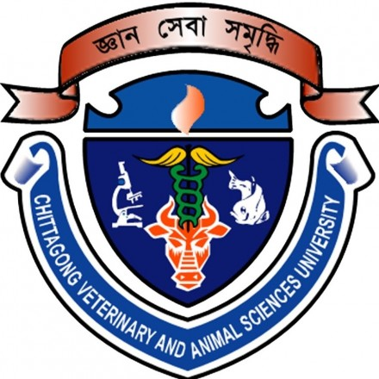

Ireen Sultana
Roll no: 0116/01
Registration no: 323
Session: January-June, 2016
A thesis submitted in the partial fulfillment of the requirements
for the degree of Masters of Science in Surgery

Department of Medicine and Surgery
Faculty of Veterinary Medicine
Chittagong Veterinary and Animal Sciences University
Chittagong-4225, Bangladesh

June, 2018

╣DEDICATION╠

To my Mother, thank you for your constant empowerment. You are the most positive person I know

&

To my Father, my mentor, I am forever grateful that you took me straight to the top and made me skip the bunny slope

Authorization

I hereby declare that I am the sole author of thIS thesis. I also authorize the Chittagong
Veterinary and Animal Sciences University (CVASU) to lend this thesis to other
institutions or individuals for the purpose of scholarly research. I further authorize the
CVASU to reproduce the thesis by photocopying or by other means, in total or in part, at the request of other institutions or individuals for the purpose of scholarly research.
I, the undersigned, the author of this work, declare that the electronic copy of this thesis provided to the CVASU Library, is an accurate copy of the print thesis submitted, within the limits of the technology available.

Ireen Sulltana
June, 2018

Critical Evaluation and Justifications of Whole Blood Transfusion in Native Dogs

Ireen Sultana
Roll no: 0116/01
Registration no: 323
Session: January-June, 2016-2017

This is to certify that we have examined the above Master’s thesis
and have found that is complete and satisfactory in all respects whether
all revisions required by the thesis examination
committee have been made.

--------------------------------------
Prof. Dr. Bibek Chandra Sutradhar
Supervisor

----------------------------------------
Prof. Dr. Md. Mizanur Rahman
Chairman of the Examination Committee

Department of Medicine and Surgery
Faculty of Veterinary Medicine
Chittagong Veterinary and Animal Sciences University
Chittagong-4225, Bangladesh

June, 2018

