***Lameness grade, Surgical technique and Radiographic evaluation of group II***

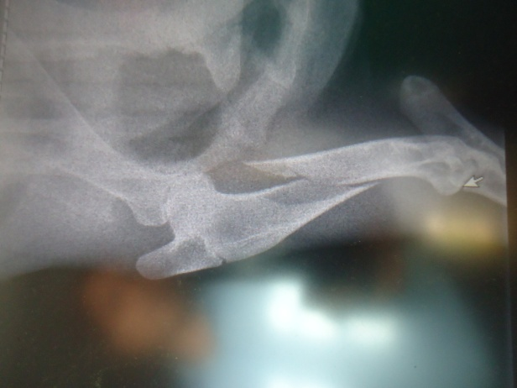

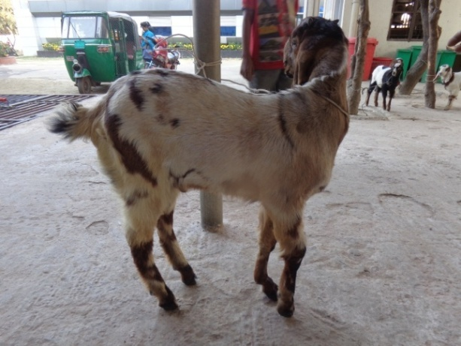

Fig.24 (a): case 1; Lameness grade 5 (non wt. bear) of Rt. fore limb, RAS 3 in pre fracture management

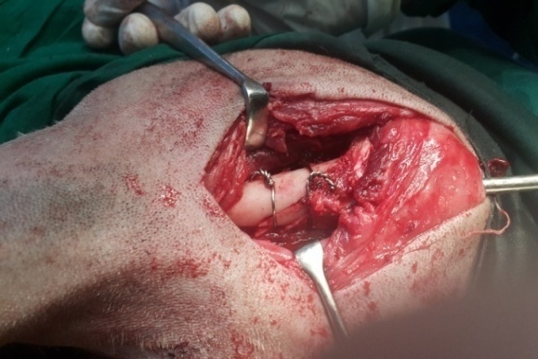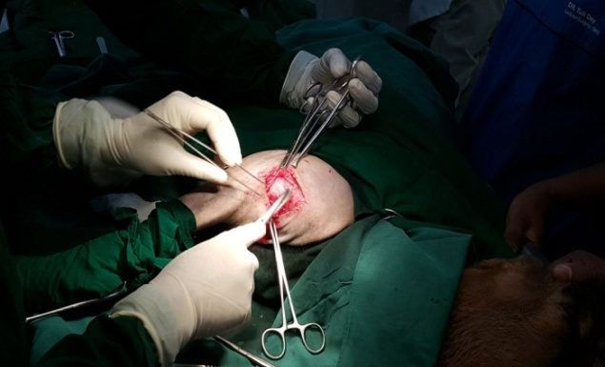

Fig.24 (b): case 1; surgical approach; IMP + wiring

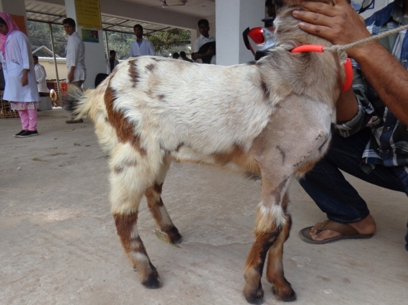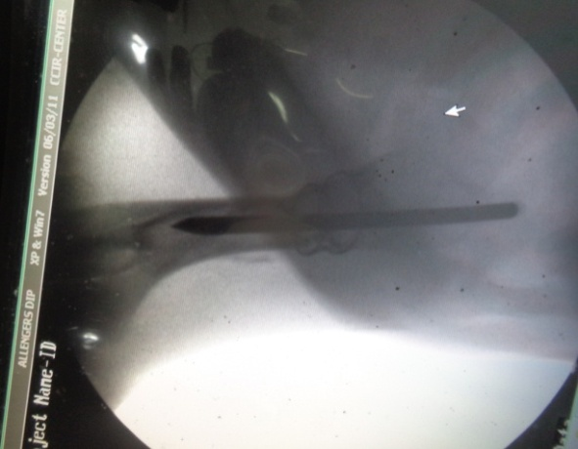

Fig.24 (c): case 1; Lameness grade 1 (mild wt. bear) of Rt. fore limb, RAS 0 in day 30 PO

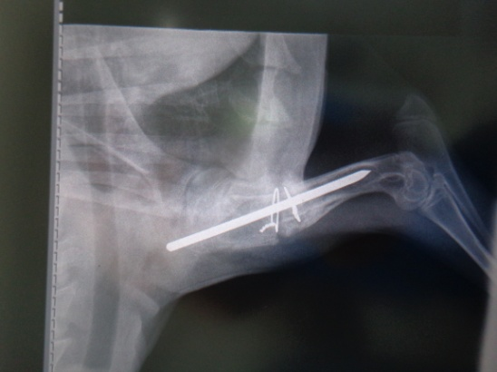

***Lameness grade, Surgical technique and Radiographic evaluation of group II***

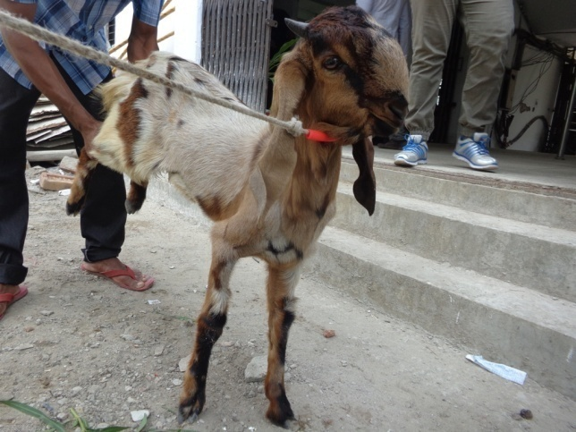

Fig.24 (d): case 1; Lameness grade 0 (full wt. bear) of Rt. fore limb, RAS 0 in day 45 PO

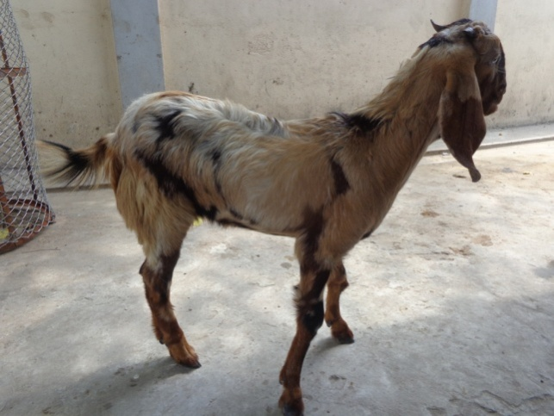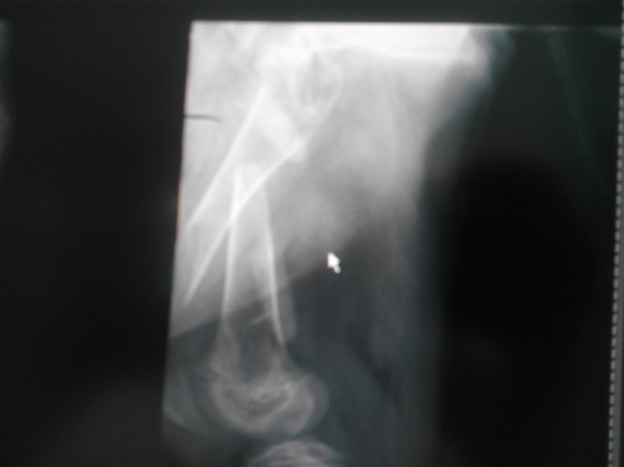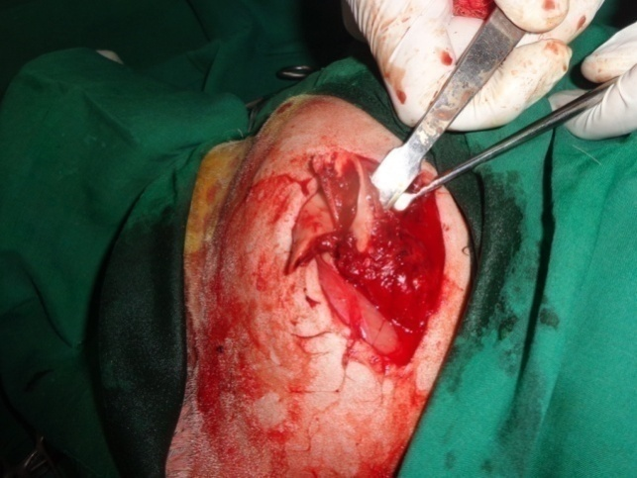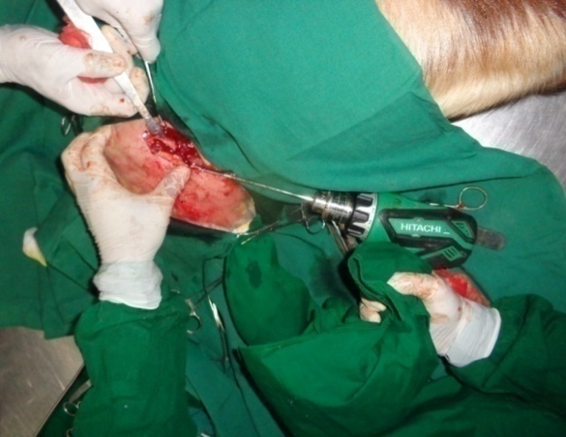

Fig.25 (a): case 2; Lameness grade 5 (non wt. bear) of Rt. hind limb, RAS 3 in pre fracture management

Fig.25 (b): case 2; surgical approach; IMP + wiring

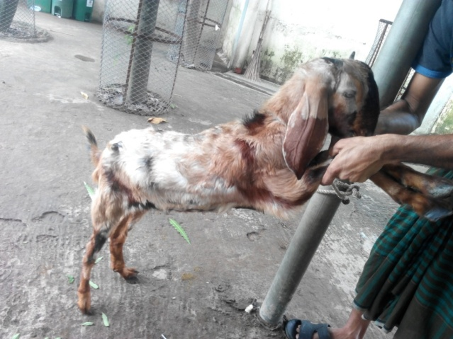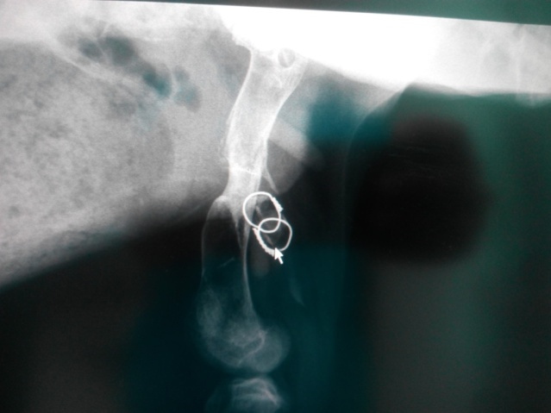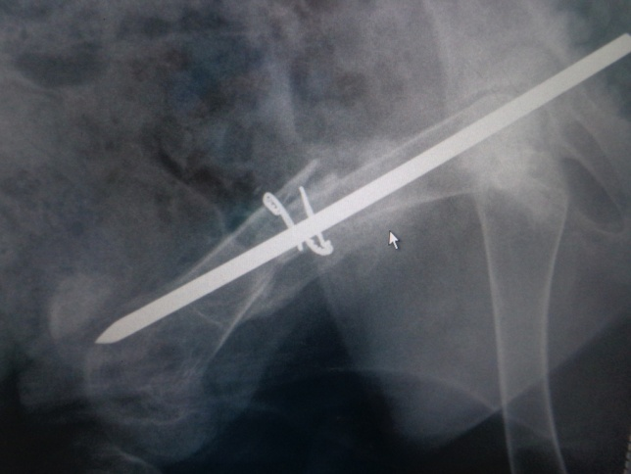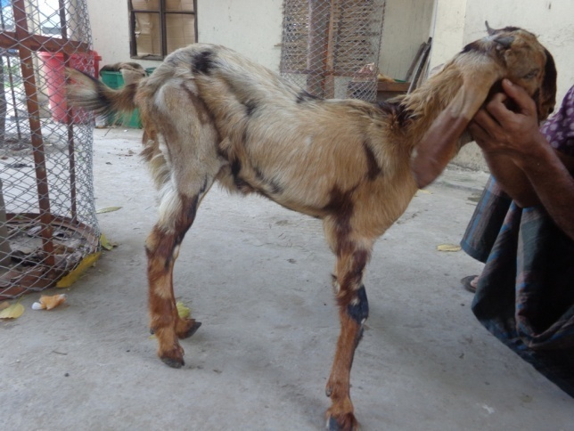

***Lameness grade, Surgical technique and Radiographic evaluation of group II***

Fig.25 (d): case 2; Lameness grade 0 (full wt. bear) of Rt. hind limb, RAS 0 in day 45 PO

Fig.25 (c): case 2; Lameness grade 1 (mild wt. bear) of Rt. hind limb, RAS 0 in day 30 PO