***Radiographic evaluation of group I***

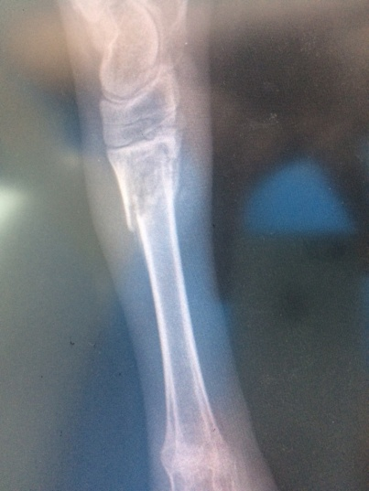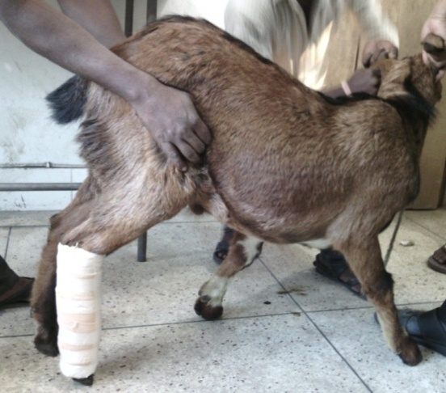

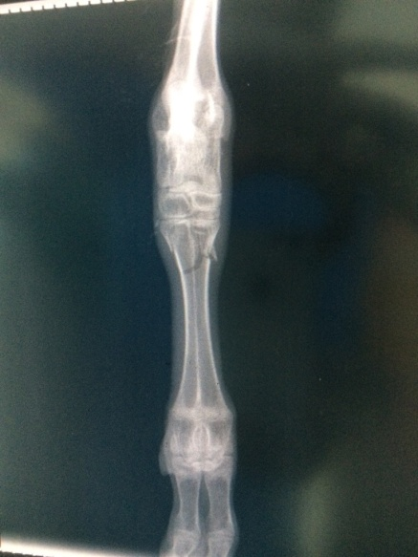

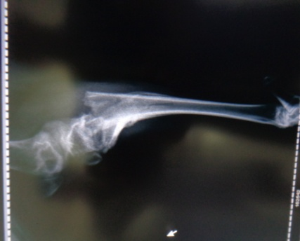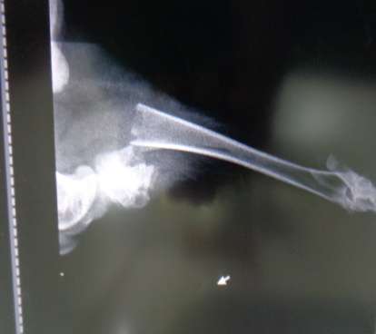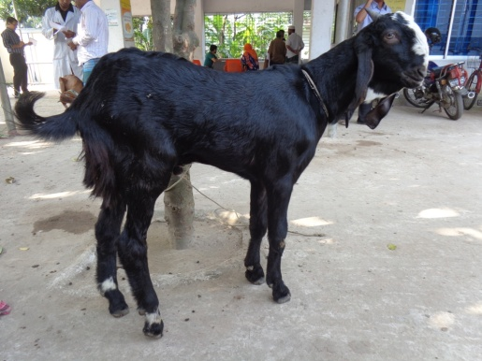

Fig.23(a): case 8; lameness grade 4, RAS 3 in pre fracture management

Fig.23 (b): case 8; RAS 2 in post fracture management day 45

Fig.22(a): case 7; lameness grade 4, RAS 2 in pre fracture management

Fig.22 (b): case 7; RAS 0 in post fracture management day 30

Fig.22(b): case 7; RAS O in post fracture management day 30

Fig.23(b): case 8; RAS 2 in post fracture management day 45