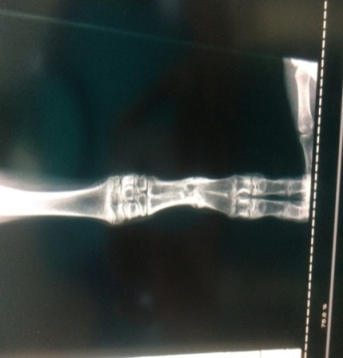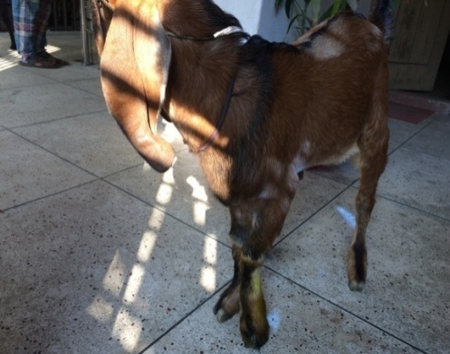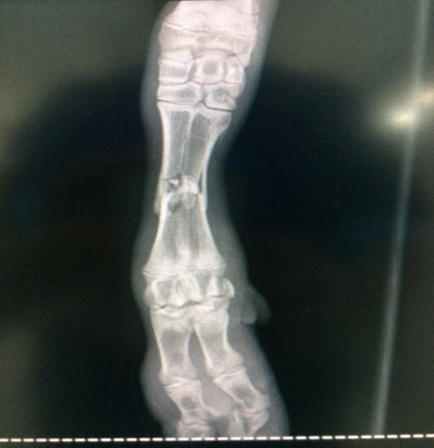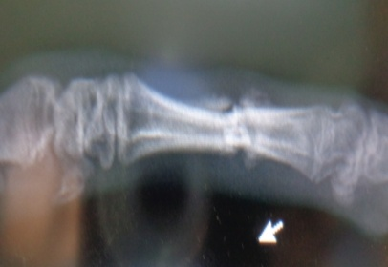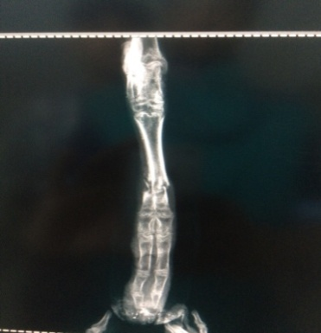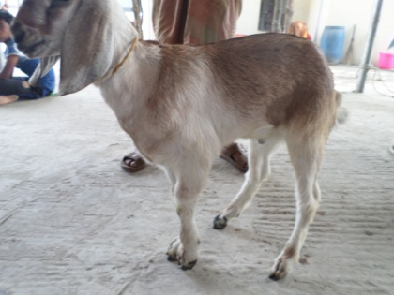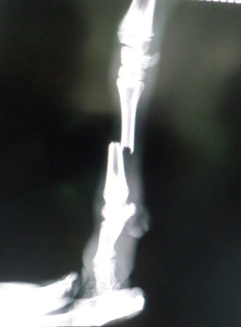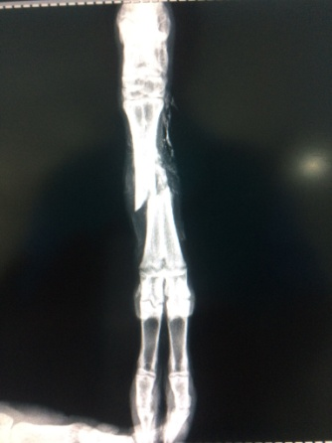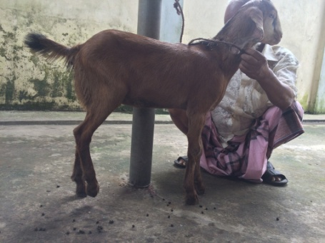

***Radiographic evaluation of group I***

Fig.21(a): case 6; lameness grade 4, RAS 2 in pre fracture management

Fig.21(b): case 6; RAS 0 in post fracture management day 30

Fig.20(a): case 5; lameness grade 5, RAS 3 in pre fracture management

Fig.20(b): case 5; RAS 0 post fracture management in day 30

Fig.19(b): case 4; RAS 1 in post fracture management day 15

Fig.19(a): case 4; lameness grade 5, RAS 3 in pre fracture management