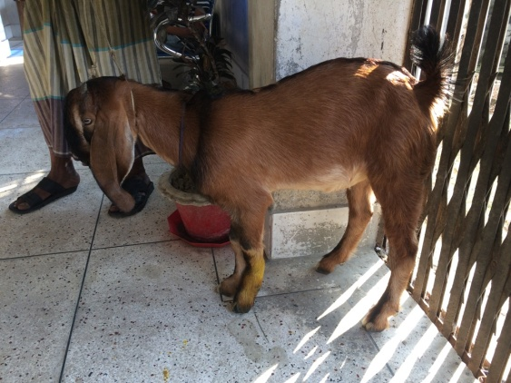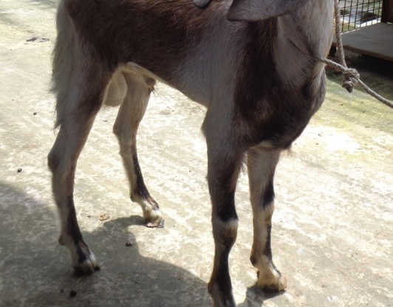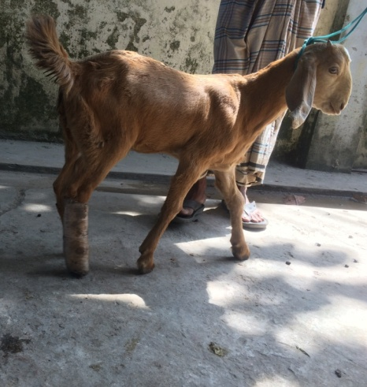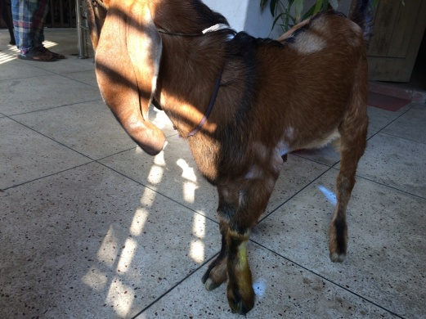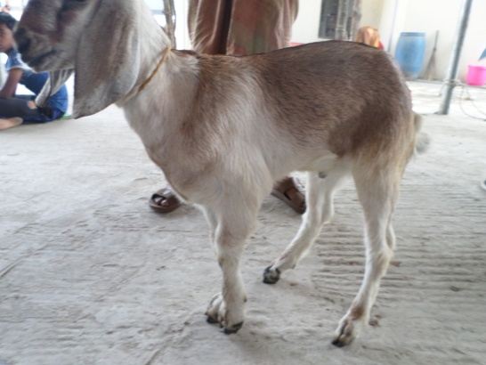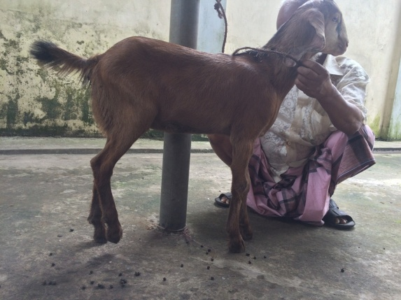

Fig.13 (a): case 6; Lameness grade 4 (hoof touching) of Lt. fore limb

)

Fig.13 (b): case 6; Lameness grade 3 (moderate wt. bear) of Lt. fore limb in post fracture management 15days

Fig.12 (b): case 5; Lameness grade 0 (full wt. bear) of Lt. fore limb in post fracture management 45days

Fig.12 (a): case 5; Lameness grade 5 (non wt. bear) of Lt. fore limb

)

Fig.11 (a): case 4; Lameness grade 5 (non wt. bear) of Rt. hind limb

)

Fig.11 (b): case 4; Lameness grade 1 (mild wt. bear) of Rt. hind limb in post fracture management 30days

***Lameness grade evaluation of group I***