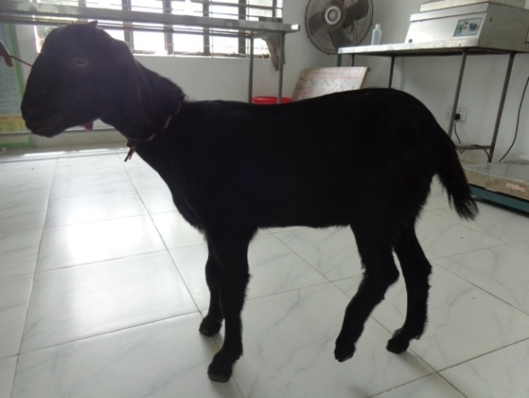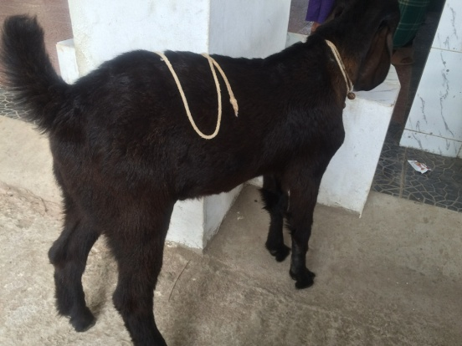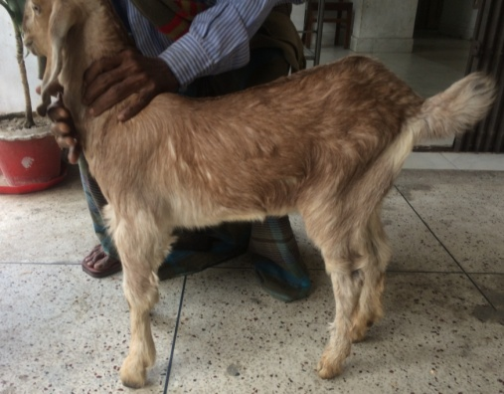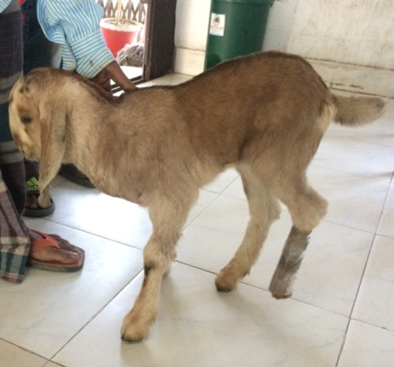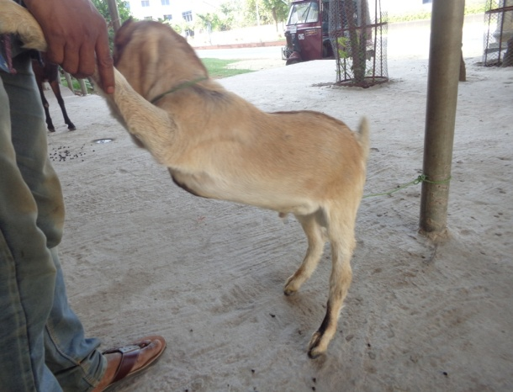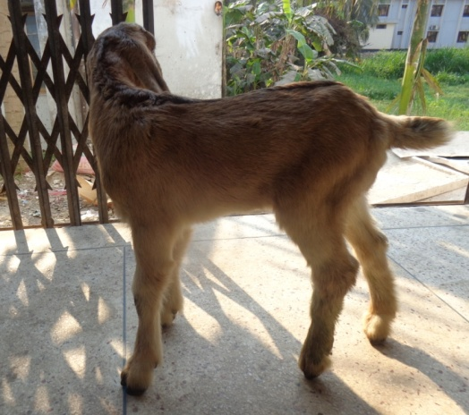

***Lameness grade evaluation of group I***

Fig.10 (a): case 3; Lameness grade 5 (Non wt. bear) of Lt. hind limb

Fig.10 (b): case 3; Lameness grade 0 (full wt. bear) of Lt. hind limb in post fracture management 45days

Fig.9 (b): case 2; Lameness grade 0 (full wt. bear) of Lt. hind limb in post fracture management 45days

Fig.9 (a): case 2; Lameness grade 5 (Non wt. bear) of Lt. hind limb

Fig.8 (b); case 1; Lameness grade 0 (full wt. bear) of Lt. hind limb in post fracture management 45 days

Fig.8 (a): case 1; Lameness grade 4 (hoof touching) of Lt. hind limb

)