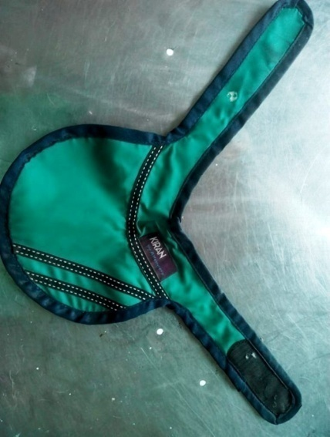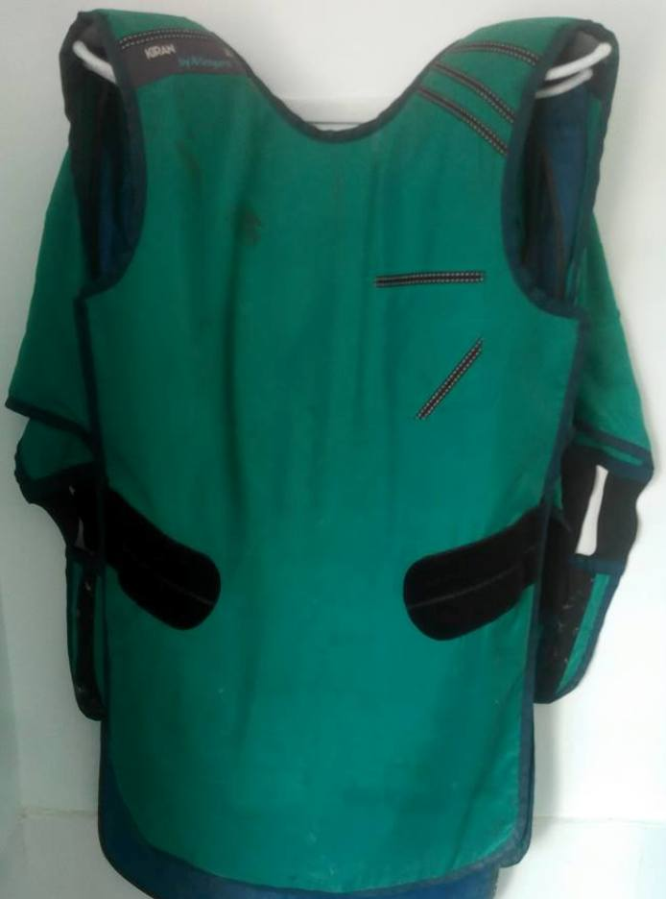

A

B

A

**Fig.5. A**. Lead apron. **B.** Thyroid Collar.

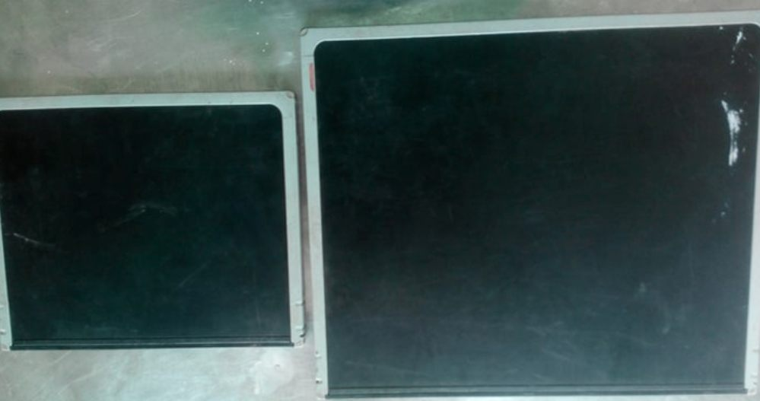

a

b

**Fig.6. CR X-ray Cassettes** a) 18 x 24 cm, b) 24 x24 cm.

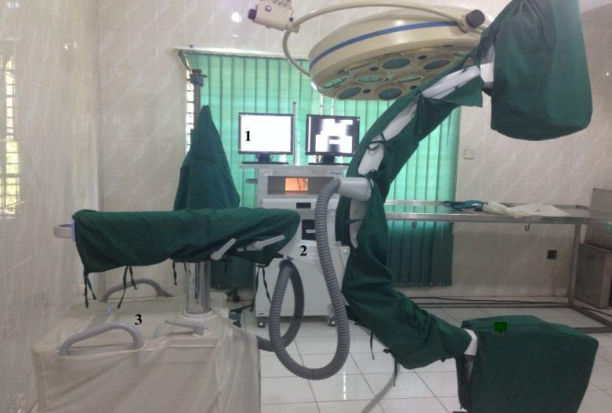

**Fig.7. C-Arm Fluoroscopy unit:** 1. Monitor, 2. Desktop computer, 3. C-Arm image intensifier

A