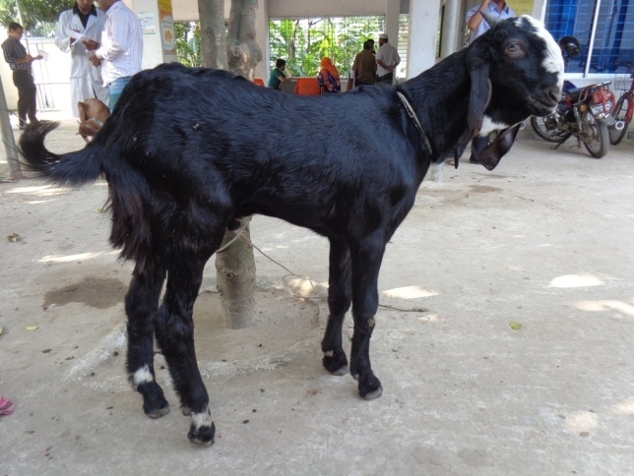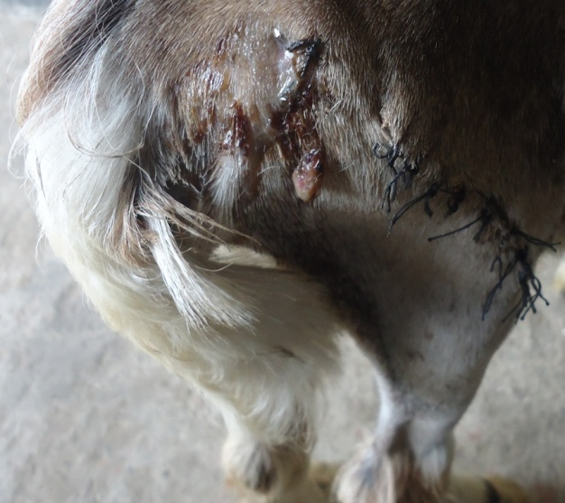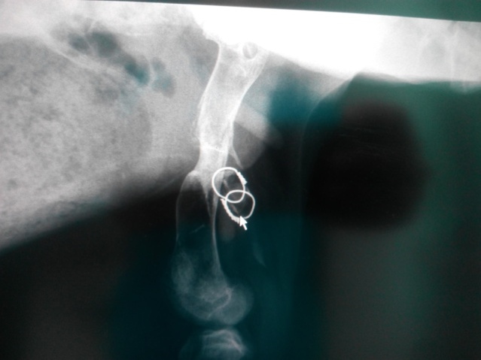

***Complication in group I and group II***

Fig.30: Group I, case 8; Lameness grade 2 (mild wt. bear) of Rt. hind limb 45th post operative day

Fig.32: Group II, case 5; Pin tract discharge in 30th post operative day

Fig.31: Group II, case 2; Wire loosening