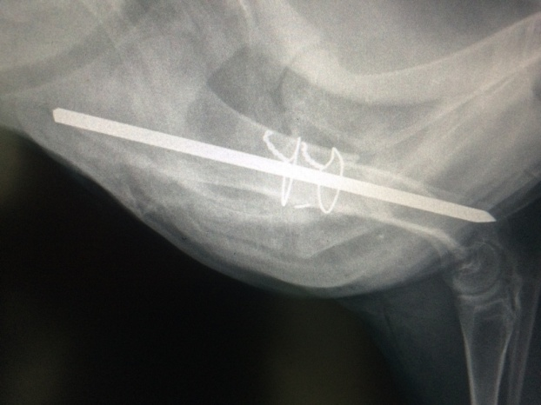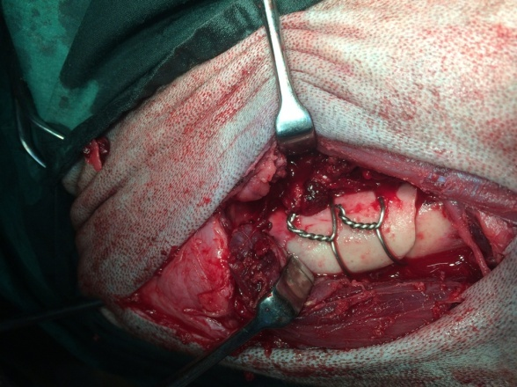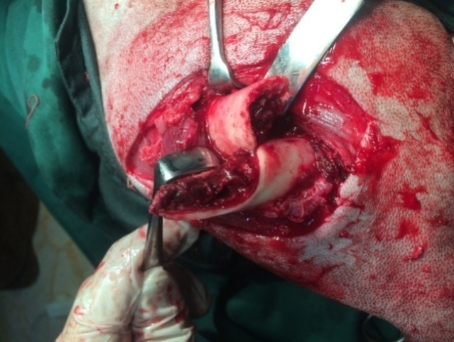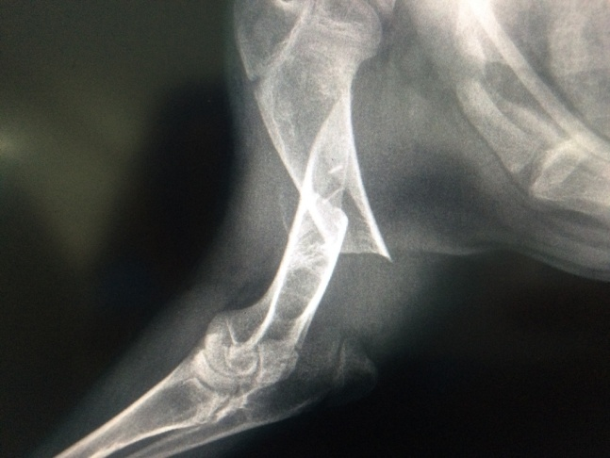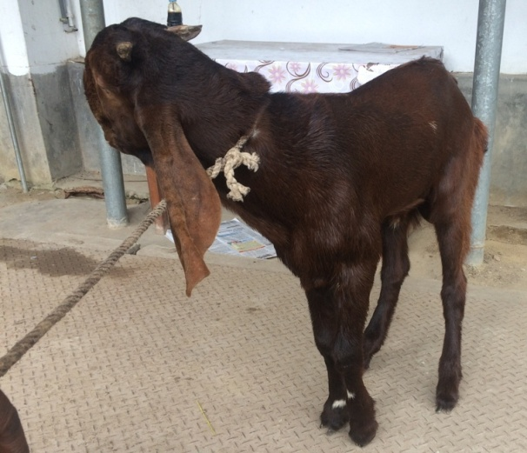

Fig.29 (c): case 6; RAS 0 in day 30 PO

Fig.29 (b): case 6; surgical approach; IMP + wiring

Fig.29 (a): case 6; Lameness grade 5 (non wt. bear) of Lt. fore limb, RAS 3 in pre fracture management

***Lameness grade, Surgical technique and Radiographic evaluation of group II***