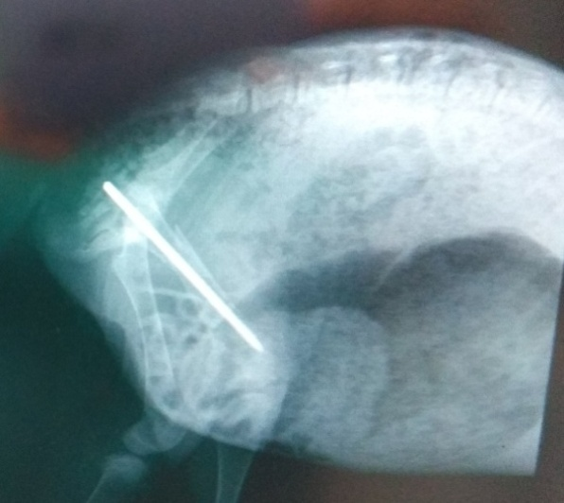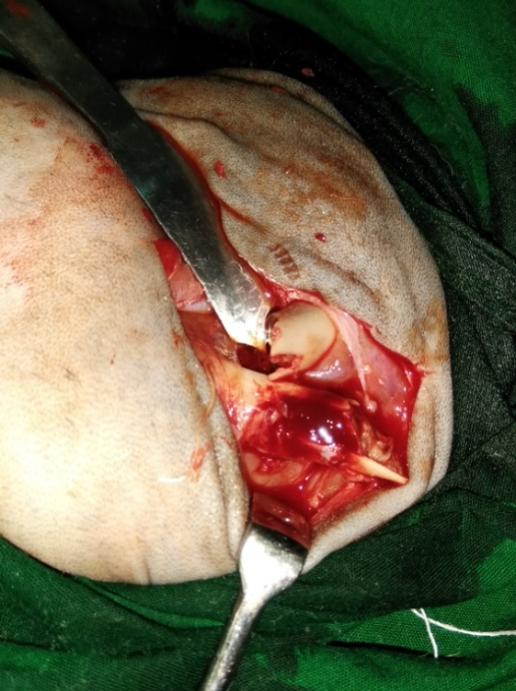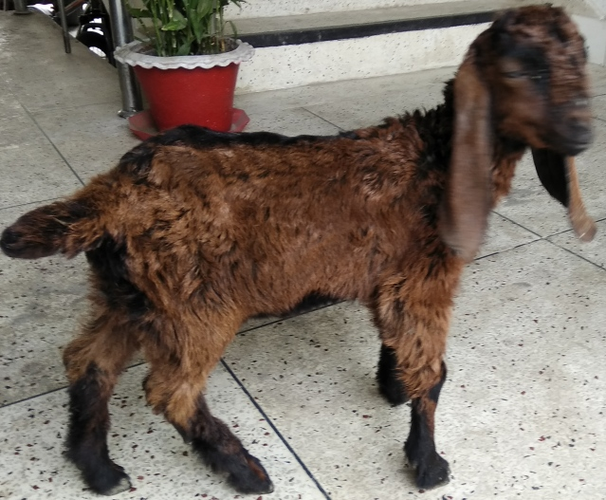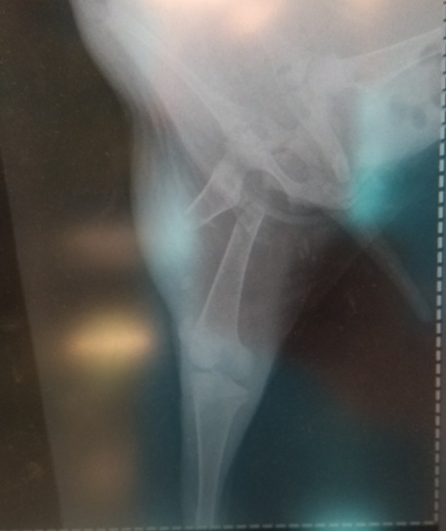

Fig.28 (a): case 5; Lameness grade 5 (non wt. bear) of Rt. hind limb, RAS 3 in pre fracture management

***Lameness grade, Surgical technique and Radiographic evaluation of group II***

Fig.28 (b): case 5; Surgical approach; IMP

Fig.28 (b): case 5; surgical approach; IMP