CHAPTER I
INTRODUCTION

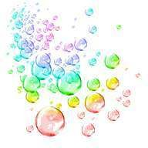

CHAPTERI INTRODUCTION

Eggplant or Brinjal (Solanum melongena L.,Solanaceae) originating from Asia is one of the most widespread vegetables in the world. The name eggplant derives from the shape of the fruit of some varieties, which are white and shaped very similarly to chicken eggs. The color, size, shape of the eggplant fruit vary significantly with the type of cultivar. Fruits and vegetables are ranked amongst the top ten vegetables in terms of antioxidant capacity due to the fruit phenols and flavonoic constituents (Timberlake, 198;Singh et al., 2009), which have been linked to various health benefits (Ames et al., 1993; Hung et al., 2004). Eggplant fruits have shown high hydrophilic oxygen radical absorbance capacity (Cao et al., 1996), which has been correlated to phenols compounds presence, including delphinidinas a major component in peel (Wu et al., 2006; Koponen et al., 2007) and chlorogenic acid in flesh (Winter and Hermann, 1986;Whitaker and Stommel, 2003). Extracts from eggplant are effective for curing a number of diseases, including cancer, high blood pressure, and hepatosis due to content of anthocyanins and strychnine (Magioli and Mansur, 2005; Silva et. al., 1999). There is a big diversity of eggplant cultivars on the market varying in shape and color, the most common ones being dark purple or violet. This color is due to anthocyanins widely distributed in fruits, vegetables and grains (Mazza and Miniati, 1993), but also flowers and grasses (Fossen et al., 2002; Haslam, 1995). The most common eggplant anthocyanin is nasunin (delphinidin-3-p-coumaroylrutinoside-5-glucoside), the presence of which was first reported by Kuroda and Wada (cited in Mazza and Miniati, 1993). Nasunin occurs as cis- and trans-isomers, and the latter has been reported to be more stable.
Color is one of the most important properties of food and beverages and is a basis for their identiﬁcation and acceptability by consumers; besides, it represents a very important attribute for marketing purposes (Clifford, 2000; Hardy, 2000). Anthocyanins are an important group of naturally occurring pigments of red fruits such as cherries, plums, strawberries, raspberries, blackberries, grapes, red currants and black currants, among others (Mazza, Cacace, & Kay, 2004). Research on new viable sources of anthocyanins as natural food colourings, is required to ﬁnd alternatives with desirable stability, low cost and high tinctorial strength. Besides color, anthocyanins have been reported to be beneﬁcial to health, with potential physiological effects such as antineoplastic, radiation-protective, vasotonic, vasoprotective, anti-inﬂammatory, chemo- and hepatoprotective (Cacace & Mazza, 2003a, 2003b; Kamei et al., 1995; Mazza & Miniati, 1993; Wang and Lin, 2000). Anthocyanins are also known to possess potent antioxidant properties (Cao, Soﬁc, & Prior, 1997; Spagna et al., 2002).

Nowadays, there is a drastic attention to polyphenols due to their positive impacts on health by preventing cardiovascular, inflammatory and neurological diseases (Silva et al., 2007). Anthocyanins as a subsidiary of polyphenols have been under investigations in recent years, and sources of anthocyanin are utilized highly in pharmaceutical, food and cosmetic industries. They obtained mostly from grape skin (Bleve et al., 2008; Corrales et al., 2009), blueberries (Buran et al., 2014; Wang et al., 2014), black rice (Kang et al., 2013), red cabbage (Chandrasekhar et al., 2012; Coutinho et al., 2004; Xavier et al., 2008), red radish (Patil et al., 2009), purple wheat (Hosseinian et al., 2008), eggplant peel (Todaro et al., 2009), purple corn (Yang and Zhai, 2010), and purple potato (Bridgers et al., 2010; Burgos et al., 2013; Fan et al., 2008a; Fan et al., 2008b; He et al., 2012; Lu et al., 2011; Motilla Elyana et al., 2011; Puertolas et al., 2013; Truong et al., 2010; Truong et al., 2012).

The phenolic compounds or pigments anthocyanins are belonging to the family named as flavinoid. There are only six anthocyanins found in food such aspelargonidin, cyanidin, delphinidin, peonidin, pentunidin and malvinidin (Malacrida and Motta, 2005). Anthocyanins are found in flowers, leaves, stems, fruits, seeds and the root tissue of plants. Anthocyanin is free from toxicity. It may help to prevent cardiovascular disorder, inflammatory response, cancer and deteriorative diseases. Anthocyanin also improves neurotral and cognitive brain functions, ocular health as well as protects geomic DNA integrity (He and Giusti, 2010).
Various study has been performed on the extraction of anthocyanin from various sources like graperesidues (Clemente and Galli, 2013), Red Cabbage (Chandrasekhar et al., 2012), Blood Orange, Blackberry and Roselle (Cisse et al., 2009), Litchi Pericarp (Zhang et al., 2004), Barberry (Sharifi and Hassani, 2012), Redradish (Patil et al., 2009) etc. The vacuoles of hypodermic cells which is close to the surface usually contain anthocyanins and the extraction method generally includes the use of solvents that denature the membrane of the cellular tissue and dissolve this coloring pigments spontaneously (Wrolstad and Giusti, 2001). Anthocyanin has been extracted by means of a reflux system (Sharifi and Hassani, 2012), an aqueous two-phase system (Hua et al., 2013) and by using various solvents like acidified water, acidified methanol, ethanol, methanol, acetone, acid such as HCl (Chandrasekhar et al., 2012). It had been found that the degree of extraction of anthocyanin was highest in case of Acetone followed by acidified methanol and then acidified ethanol (Chandrasekhar et al., 2012).
It has been reported that the use of acetone and methanol in the food industry is not preferable because of their possible toxicity (Spagna et al., 2003 and Patil et al., 2009). Ethanol has been considered as the most preferable one for food application in the food industry. It has been suggested that pure ethanol should not be used for the extraction of anthocyanin because little amount of water is needed to extract the hydrophilic anthocyanins (Patil et al., 2009). The stability of anthocyanin pigments is influenced by environmental and processing factors such as pH value, temperature and presence of oxygen, enzymes, metal ions, intermolecular association with other compounds (copigments, sugars, proteins, degradation products etc.), intermolecular association and condensation reactions (Andersen et al., 2008).
At low pH values, anthocyanins are most stable and highly colored but they gradually losing the color with the increasing pH values. Anthocyanins are almost colorless at pH 4.0 to 5.0. This color loss is reversible and the red hue will return upon acidification (Zhao et. al., 2004; Borkowski et al., 2005). This characteristic limits the application of anthocyanins as a food colorant to products with low pH values (Ramos et al., 2000). Brouillard (1982), reported that the stability of anthocyanins in spinach vine (Basella rubra) fruit are more in acidic than in neutral or alkaline solutions. Temperature markedly influences the stability of anthocyanin and the rate of anthocyanin degradation. Heat and light treatment increase the polymerization of monomeric anthocyanins and also degrades anthocyanins (Cevallos-Casals et al., 2004).
So, the degradation of anthocyanin is the main concern for the consumer and the food manufacturer to use anthocyanin as food additives.
Guava is one of the most common and important fruits in Bangladesh. It claims to be the most important fruit in area and production after mango (Anoymous, 1995). It is a native of South America. At present the major guava producing countries are the USA, Cuba, Brazil, Taiwan, Mexico, Peru, China, Malaysia, India, Pakistan, Thailand and Bangladesh.

Guava is rich source of vitamin C (260 mg/100g of fruit) and pectin which has industrial use for jelly production (Bose, 2011). Guava is also a good source of calcium and phosphorus. Guava contains 84.2% water, 9.68% total soluble solids, .50% ash, 4.45% reducing sugar, 5.23% non-reducing sugar, 1.25% acid, and 560 mg/100g vitamin C, which differ with the cultivar, stage of maturity, and season. It is mainly used in many countries as a dessert. It can be used in preparing jam, marmalade and juice.

Guava stands fifth in production among the most important fruit crops of Bangladesh and can be grown in all over the country. The annual production of guava is about 45,000 m. tons in an area of about 10,000 ha. Although guava grows throughout the country it is confined in some areas where guava is cultivated for commercial purposes. During harvesting season a market glut is occurred in the guava producing areas. Due to lack of marketing, storage facilities the growers bound to sell their produce at throw away prices and huge quantity of guava spoiled. As estimated by Lushly (1984) an approximately 30-50% fruit goes waste during post-harvest handling, storage and ripening. This post-harvest loss is highly prominent in guava because of its high perish ability. Once it fully ripe, the fruit becomes soggy and its edibility and marketing quality deteriorates rapidly.

The prevention of losses of the seasonal surplus of the fruit by processing and preservation techniques at farmer’s level and as well as industrial scale should be warranted. Such efforts will help the development of processing industries in the growing areas of the countries. Moreover this will stimulate an increase in production and bring better return to the guava growers.

In Bangladesh the guava is mostly consumed as fresh fruit. There is a wide prospect of producing guava products such as guava juice, pulp, jelly, squash, marmalade, ready to serve beverage, candy, vinegar, wine etc. But unfortunately the present technology of production, processing and preservation of guava in Bangladesh is not well developed up to the volume of its annual production. It is therefore essential to investigate to develop suitable inexpensive method for processing and preservation of guava. There are a number of methods for processing guava. It seems that guava juice and guava jelly could be stored at normal temperature by using preservatives.

Jelly is a semi-solid product prepared by boiling a clear strained fruit extracts free from pulp after the addition of required amount of sugar, citric acid and pectin. It should contain minimum 65 percent of total soluble solids and minimum 45 percent of fruit portion (Dhawan, 1998). Guava is a rich source of pectin and has thick flesh and is preferred for jelly making.

Guava jelly is well known to all and it can be caned in sugar syrup or made into fruit butter. Its juice is used for the preparation of sherbets and ice cream. Guava contains vitamin C, 2 to 5 times more than that of fresh orange juice. In some countries the leaves are used for curing diarrhea, and also for dyeing and tinning.

Color is one of most important properties of foods and beverages and is a basis for their recognition and acceptability. Usually synthetic colorants are often used in food industries to give the desired color to the final product but these synthetic food colorants are carcinogenic and harmful for the consumer’s health. Therefore, Processors have recently turned to naturally derived colorants as a viable alternative. The consumer and the food manufacturers are now taking growing interest on anthocyanin as a profuse Polyphenol type antioxidant (Scalbert and Williamson, 2000). There are no attempts on the extraction of anthocyanin from the peel of eggplant in the earlier literature. So that anthocyanin from the peel of eggplant could be a good alternative source of natural colorant.
Therefore the objectives of this research are given below:
- To evaluate the effects of solvent, pH and storage condition on anthocyanin content and find out an optimal extraction process for anthocyanin from the peel of eggplant
- Assessment of kinetic parameters (Half-life and color retention percentage) of anthocyanin extracted from the peel of eggplant
- Comparative assessment of physicochemical composition of guava jelly made with natural color (anthocyanin) and artificial color (a mixture of E104 quinoline, acetic acid and E122 carmosine)

CHAPTER II
REVIEW OF LITERATURE

CHAPTER II
REVIEW OF LITERATURE
2.1 Eggplant
Vegetable growing has been one of the oldest preoccupations of mankind, developing in parallel with the human society. That is why, together with the progress of technology from the last two centuries, vegetable growing has developed also, by introducing new culture techniques, perfecting the old ones and developing and diversifying varieties.
Eggplant (Solanum melongena L.) is a horticultural species with high nutritional value, since it is rich in vitamins and compounds in the flesh, and anthocyanins in the peel, all with antioxidant properties (Aramendiz-tatis et al., 2010). Eggplant (Solanum melongena L.) is an important solaneceous crop of tropics and sub-tropics. Eggplant fruit (unripe) is primarily consumed as cooked vegetable. In addition, it has some medicinal uses like antihaemorrhoidal and hypertensive effect and used as an antidote to poisonous mushrooms (Sudheesh et al., 1999). It is a good source of minerals and vitamins and is rich in total water soluble sugars, free reducing sugars, and proteins (Noda et al., 1998). Some phytochemicals of vegetables are strong antioxidants and are thought to reduce the risk of chronic disease by protecting against free-radical damage, by modifying metabolic activation and detoxification of carcinogens, or even influencing processes that alter the course of tumor cells (Herrera et al., 2009). Anthocyanins is an important group of naturally occurring phenolic compounds found in eggplant peel (Mazza et al., 2004). Eggplant (Solanum melongena L.), one of the most widespread vegetable consumed around the world contains a variety of phytochemicals such as flavonoids which provide a myriad of health benefits. Eggplant fruit is reported to be a rich source of ascorbic acid and phenolics, both of which are powerful antioxidants (Vinson et al., 1998). Eggplant extracts have been reported to successfully suppress the development and growth of tumors, lung cancer (Matsubara et al., 2005), inhibit inflammation (Keli et al., 1996), and cardiovascular diseases (Knekt et al., 1996 and 1997). Eggplant has received an increased interest among consumers and researchers worldwide because of its health benefits and is ranked amongst the top 10 vegetables in terms of antioxidant capacity (Cao et al., 1996)
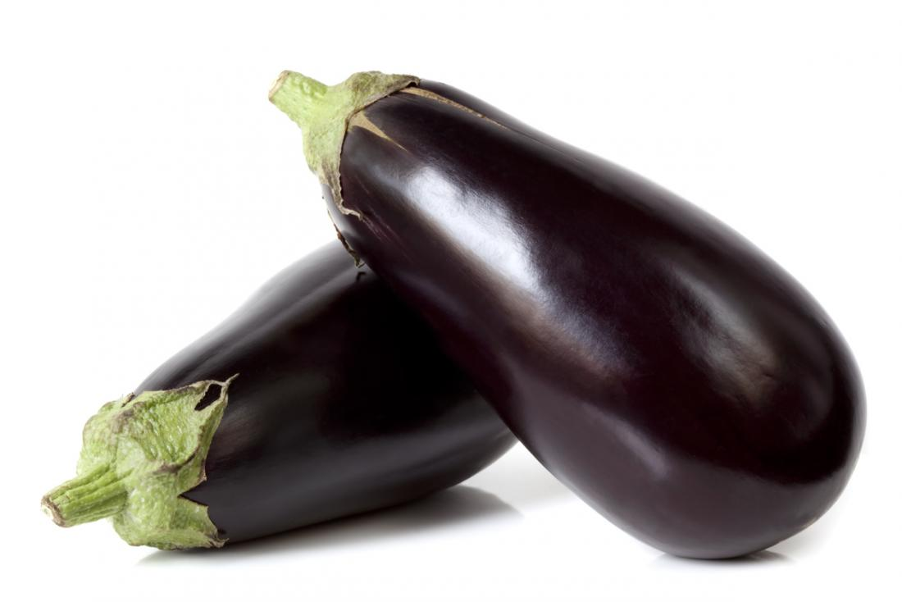
Figure 1: Eggplant (Solanum melongena L.)
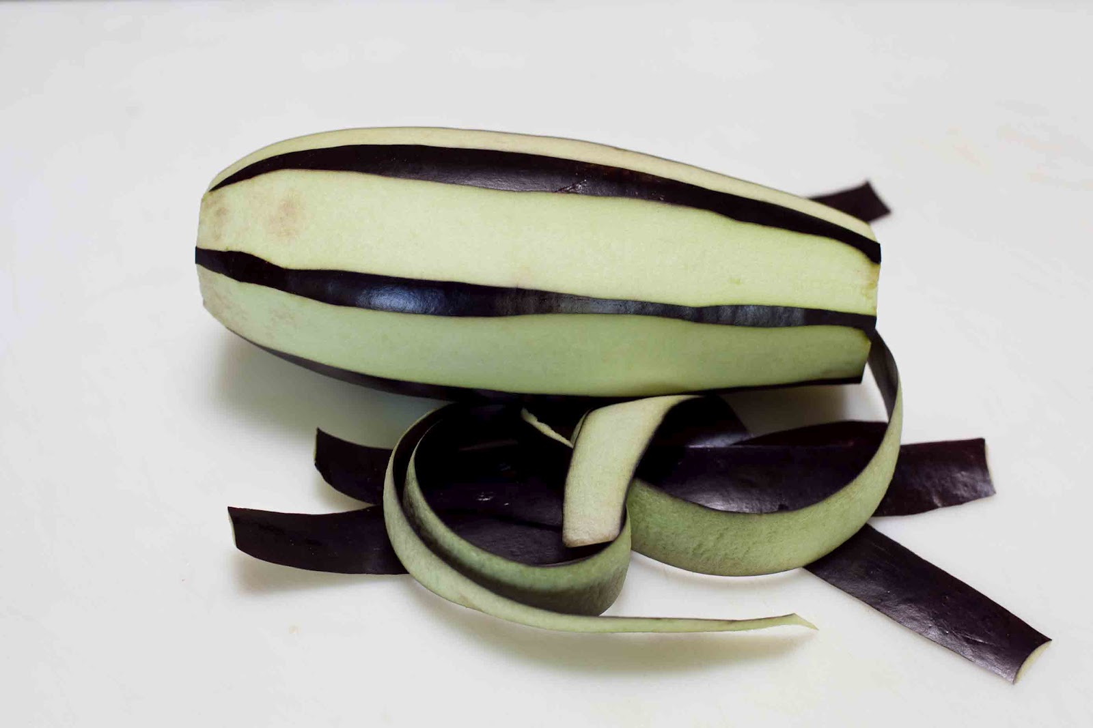
Figure 2: Sliced peel of eggplant (Solanum melongena L.)

2.1.1 History of Eggplant

Eggplant is an Old World crop of solanaceous family. Sanskrit documents have revealed that the domestication of eggplant was achieved as early as 100-300 BC. Archaeological records, based on the analysis of microfossils suggested that eggplant was present in the diet of inhabitants of the Indus valley during Harappan civilisation, thus Rajasthan might be the area of domestication (Kashyap, 2010). The use of eggplant as a vegetable crop was described in Chinese literature dating to 59 BC (Wang et al., 2008). The crop spread westwards to Persia by the ancient Greeks and Romans and was then introduced to the Mediterranean Basin by Muslim invaders in the 7th to 8th century. The scientific name Solanum melongena for brinjal is derived from a 16 century Arabic term. The name brinjal developed in the United States, Australia and Canada. Some 18th century European cultivars were yellow or white and resembled goose or hen’s egg hence brinjal was also named as “Eggplant”. The name Aubergine in English is based on the French word aubergine. In Indian and South African English the fruit is known as “Brinjal”. The fruit is called Vatiganah in Sanskrit and Baingan in Hindi and Urdu. At one time brinjal was believed to be poisonous because of its relationship with the Solanaceae (nightshade) family. While it is generally eaten by most people without any ill effects, it can cause or worsen arthritis. Bajaj et al (1979) reported that on an average, the oblong-fruited eggplant cultivars are rich in total soluble sugars, whereas the long-fruited cultivars contain a higher content of free reducing sugars, anthocyanins, phenols, glycoalkaloids (such as solasodine), dry matter, and amide proteins.

2.1.2 Soil and climatic requirements
Eggplant is grown on 1,957,603 hectares, with a total production of 32,699,078 tonnes (FAO, 2008). As the fourth leading eggplant producer after China, India and Egypt, Turkey is an important eggplant producer with an annual production of 813,686 tonnes (FAO, 2008). Eggplant is a warm-season crop and does not tolerate frost. A long growing season of 80 days is required for the transplanted crop. Optimal temperatures for eggplant production are 26°C at day and 20°C at night. Plant growth slows and pollination problems occur at temperatures below 17°C or above 35°C. Flowering is not affected by day length. Cooler temperatures can reduce fruit set. Higher temperatures and high humidity levels also reduce yields. Eggplant can tolerate drought and excessive rainfall. It will not tolerate extended periods of saturated soil owing to the build-up of root-rotting pathogens. Eggplant does well in a variety of soil textures. Previous crop residue must be stubble-disked to improve soil aeration and to adequately bury organic matter for decomposition. Eggplant grows best with a soil pH of 5.5 to 6.5. Eggplant is usually grown in light or sandy loam soils that provide good drainage and favorable soil temperatures. Eggplant will root to a depth of 90 to 120 cm; therefore, sandy loam or silt loam soils free of physical barriers are better for proper plant growth and development (Agriculture, forestry and fisheries, 2011).

2.1.3 Human health beneﬁts

Eggplant is nutritious, being low in calories, fat, sodium and is a non-starchy fruit that is cooked as a vegetable. It contains a large volume of water. It is good for balancing diets that are heavy in protein and starches. It is high in fibre and provides additional nutrients such as potassium, magnesium, folic acid, vitamin B6 and A. This vegetable is quite diverse and more versatile, both in the garden and in the kitchen. Eggplant has chemicals that can cause digestive upset if eaten raw, so is usually cooked. It can be grilled, stuffed, roasted, served in soups and stews and on kebabs, and used in curries and stir-fries (Agriculture, forestry and fisheries, 2011).

2.1.4 Nutritional values

Raw eggplant is composed of 92% water, 6% carbohydrates, 1% protein and negligible fat. It provides low amounts of essential nutrients, with only manganese having a moderate percentage (11%) of the Daily Value. Minor changes in nutrient composition occur with season, environment of cultivation (open field or greenhouse), and genotype (San Jose et al., 2014).

Table 1. Chemical composition of eggplant (Solanum melongena L.)

Nutritive value per 100 g (Raw)
Energy | 24 Kcal
Carbohydrates | 5.7 g
Protein | 1 g
Total Fat | 0.19 g
Cholesterol | 0 mg
Dietary Fiber | 3.40 g
Vitamins
Folates | 22 mcg
Niacin | 0.649 mg
Pantothenic acid | 0.281 mg
Pyridoxine | 0.084 mg
Riboflavin | 0.037 mg
Thiamin | 0.039 mg
Vitamin A | 27 IU
Zinc | 2.2 mg
Vitamin E | 0.30 mg
Vitamin K | 3.5 mcg
Vitamin C | 2.2 mg
Electrolytes
Sodium | 2 mg
Potassium | 230 mg
Minerals
Calcium | 9 mg
Copper | 0.082 mg
Iron | 0.24 mg
Magnesium | 14 mg
Manganese | 0.250 mg
Vitamin C | 0.16 mg
Source: USDA National Nutrient Data base, 2001.
2.2 Anthocyanin
Polyphenols are one group of the most favorable organic and natural chemical compounds due to their antioxidant activity and biological significance in plants. These components are known as secondary plant metabolites which means the chemicals produced by plants and divided into several classes according to the number of phenol rings that they contain and to the structural elements that bind these rings to each other. One of the main groups of polyphenols is flavonoids. They consist of two aromatic rings, which are joined together by a heterocyclic ring. Substitution patterns of heterocyclic ring are varied which cause to have different classes of flavonoids. Major flavonoids classes are anthocyanidins, flavones, isoflavones, flavanones, flavonols and flavanols. Anthocyanidins are the basic structure of anthocyanins (Ignat et al., 2011). The terms anthocyanins originates from the Greek words "antho" meaning flower and "cyan" meaning blue. They are natural water soluble pigments which appear as red, blue and purple color in flowers, fruits and vegetables (Valls et al., 2009). Anthocyanins have great potential in food and pharmaceutical industries because they act as antioxidants by donating hydrogen to highly reactive radicals (Lapornik et al., 2005). They can increase the protection of the body against diseases such as cancer and they are in the class of antitumor compounds in medical science. The mechanism for enhancing the body protection by anthocyanins lies in the fact that they scavenge free radicals in the body and contribute to reduce the oxidative stress (Silva et al., 2007). They possess antimicrobial, antiviral and anti-inflammatory properties (Burgos et al., 2013; Fan et al., 2008a). They can reduce risks of chronic diseases such as cancer, cardiovascular diseases, virus inhibition and Alzheimer’s disease (Andersen and Markham, 2005). Another advantage of anthocyanins is anti-diabetic property. Eye function of anthocyanins can improve the human night vision, which was investigated by Ghosh and Konishi (2007).

The word anthocyanin, derived from the Greek word was originally used to describe the blue pigments of the cornflower, Centaurea cyanus (Marquart, 1835). Anthocyanins are polyphenolic compounds responsible for cyanic colors ranging from salmon pink through red and violet to dark blue of most flowers, fruits, leaves and stems. They comprise the largest group of the water soluble pigments in the plant kingdom (Strack and Wray, 1994), and during the last few years it has been an exponential increase in the report of new anthocyanin structures (Andersen and Jordheim, 2006). This can be explained by the use of improved analytical techniques, but the potential use of Anthocyanins as health beneficial compounds is another reason for the increased scientific interest in these pigments.

The anthocyanins consist of anaglycon (anthocyanidin), sugar(s), and, in many cases, acylgroup(s). The classical anthocyanin aglycon is basedon a C15 skeleton (C6₋C3₋C6 skeleton) (Andersen and Jordheim, 2006). Anthocyanins are positively charged at acidic pH. Even though there are around 30 different anthocyanidins, approximately 90% of all anthocyanins are based on the six most common anthocyanidins pelargonidin, cyanidin, delphinidin, peonidin, petunidin and malvidin which only differ by the hydroxylation and methoxylation pattern on their B₋rings. The anthocyanins will differ with respect to glycoslyation of hydroxyl groups, nature of glycosyl units, substitution pattern, and potential aliphatic and aromatic acylation (Andersen and Jordheim, 2006). The 3-deoxyanthocyanidins (non glycosides) found in Sorghum. In plants spagnorubins and rosacyanin B are the only anthocyanidins (aglycon) found in their non glycosidated form. Andersen Jordheim, (2006) indicated the presence of cyanidin, peonidin and pelargonidin in black dried beans in glycosidated form (Phaseolus vulgaris L.). Pyranoanthocyanins have been discovered in small amounts in wines and grape pomace (Bakker and Timberlake et al., 1997; Fulcrand et al., 1998; Mateus et al., 2004; Cheynier, 2006). More recently, glucosides of carboxypyranocyanidin have been isolated from red onion (Fossen and Andersen, 2003), and carboxy₋pyranopelargonidin 3₋glucoside from strawberry (Andersen et al., 2004) extracts which are all in glycosidated form.
The anthocyanin pigments are belongs to the largest group of flavonoids. These are the derivatives of glycosylated and/oracylated flavonoid which are the source of most red, pink, purple and blue colors in plant parts depending on pH. The aglycone or nonglycosylated form is known as anthocyanidin. There are six commonly occurring anthocyanidins in higher plants such as pelargonidin, cyanidin, peonidin, delphinidin, malvidin and petunidin (Strack et al., 1989). Among them, cyaniding is most abundant and malvidin is least (Kong et al., 2003). Sugars are present most commonly at the C₋3 position, second at C₋5 position, and very rarely at C₋7 position. Sugars provide additional sites for modification as they may be acylated with acids such as p₋coumaric, caffeic, ferulic, sinapic, acetic, malonic or p₋ hydroxyl benzoic acid. Because of the diversity of glycosylation and acylation, there are at least 240 naturally occurring anthocyanins (Strack et al., 1989). The main anthocyanidin structure is an aromatic ring that contains oxygen, which is also bonded by a carbon₋carbon bond to a third aromatic ring (Ananthaswamy et al., 2004).
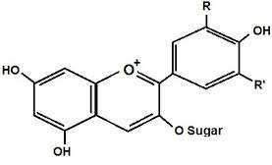
Figure 3: General structure of Anthocyanin
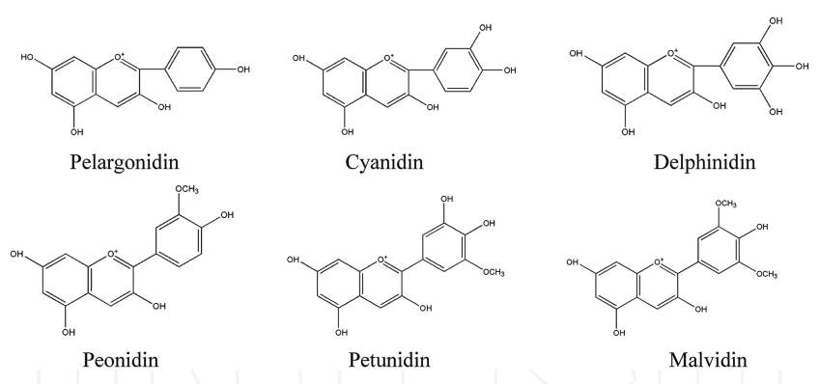
Figure 4: Structure of six types of Anthocyanin

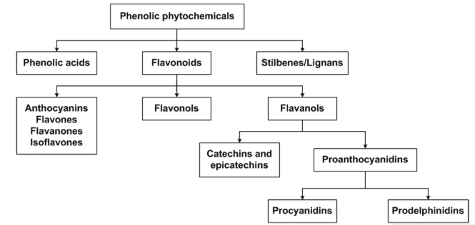
Figure 5: Types of Anthocyanin (Navas et al., 2012)
The sugars commonly linked to anthocyanidins are monosaccharides (glucose, galactose, rhamnose, and arabinose) and di₋or tri₋saccharides formed by combination of the 4 monosaccharides, which may also be acylated with a phenolic or aliphatic acid (Bureau et al., 2009). The glycoside derivatives that are more widespread in nature are 3₋monosides, 3₋biosides, 3, 5₋and 3, 7₋diglucosides (Kong, 2003). The huge variety of anthocyanins are formed by the different number of hydroxylated groups, the nature and number of the sugars bound to the anthocyanidin, the phenolic or aliphatic acid bound to the sugar in the molecule, and the different positions of these bonds. Anthocyanin (Mateus and Freitas, 2009). There are many sources suitable for extracting anthocyanins, including eggplant peel, red amaranth (lalshak), red beans, black beans, blood oranges, strawberries, raspberries and grapes (Clifford, 2000; Choung et al., 2003; Aguirre et al., 2010; Cao et al., 2010; Cerezo et al., 2010). Table 2 Shows the average amount of anthocyanins in some food stuffs.

Table 2. Averageamountofanthocyanins insomefoodstuffs
Anthocyaninsource | Amount(mg/L) | Anthocyaninsource | Amount(mg/L)
Blackberry | 1150 | Currant(black) | 1300–4000
Blueberry | 825–4200 | Elderberry | 2000–10000
Blackbean | 2100-2800 | Redgrapes | 300–7500
Cherry | 20–4500 | Bloodorange | 2000
Chokeberry | 5060–10000 | Raspberry(black) | 1700–4277
Redamaranth  Eggplant  (Solanum melongena L.) | 2500-6670  7500 | Redbean | 200-800
Sources: Summarized from Clifford (2000), Giusti and Wrolstad (2001). *The Daily Star, Friday, August 31, 2012.
From Table-2, we can see that Eggplant is a potential resource to extract anthocyanins. However, with new sources of natural colorants being in current demand by industry, food waste is being examined as a potential source to extract anthocaynins: for example, purple corn cob (Zea mays.), red grape pomace, and bract waste from harvesting bananas (Di Mauro et al., 2000; Pazmino₋Duran et al., 2001; Giusti and Wrolstad 2001; Mantell et al., 2002; Yang and Zhai, 2010).
2.3 Extraction of anthocyanins
Extraction of anthocyanin is a very crucial step in the isolation, identification and use of anthocyanin compounds and there is no single and standard extraction method. In order to extract phenolic compounds fruits, vegetables and herbs can be ground, dried, or lyophilized and some fresh plants can be soaked with respective solvent solution (Merken and Beecher, 2000). The co₋extraction of non₋phenolic substances such as sugars, organic acids and proteins are results of these methodologies and therefore requiring subsequent purification processes such as solid phase extraction (Castanedaovando et al., 2009).
A number of strategies are used for the characterization of phenolic samples in plant materials (Gleichenghagen and Schieber, 2016; Dai and Mumper, 2010; Rijkeet al., 2006). In any case extraction techniques and semi₋preparative isolation methods areusually powdering the plant material, it follows (Strack et al., 1989): (i) a previous extraction step of the plant materials as well as a preliminary consequent purification step; (ii) fractionation of the mixture in order to isolate pure pigments and (iii) the final characterization and identification of pure anthocyanins compounds.

Table 3. Strategies for preparation and characterization of anthocyanin samples from plant materials (Navas et al., 2012).

Major strategies Major unit operationSample pretreatment Air-drying, freeze drying
Milling
Grinding
Homogenization
Filtration
CentrifugationExtraction Direct
Solid phase extraction (SPE)
Liquid-liquid extraction (LLE)
Soxhlet extraction
Microwave-assisted extraction (MAE)
Ultrasound-assisted extraction (UAE)
Pressurized fluid extraction (PFE)
            - pressurized liquid extraction (PLE/ASE)
            - subcritical water extraction (SWE)
            - supercritical fluid extraction (SPE)
Enzyme-assisted extraction (EAE)
Solid phase microextraction (SPME)
Membrane extraction (ME)
High hydrostatic pressure (HHP)
Electric fields (EF)
Purification Solid phase extraction (SPE)
Column chromatography (CC)
Countercurrent chromatography (CCC)Analysis Spectrophotometric assays
Gas chromatography (GC)
Liquid chromatography techniques (LC)
Mass spectrometry (MS)
Nuclear magnetic resonance (NMR)
Capillary electrophoresis (CE)
Thin layer chromatography (TLC)
Voltammetry
Others
Hyphenated techniques
GC-MS, LC-MS, LC-DAD-ES-MS/MS,
CE-MS, LC-NMR, others.

2.3.1 Chemical extraction of anthocyanin

Solvents like aqueous mixtures of ethanol, methanol or acetone are better for the extraction of anthocyanins since these are polar molecules (Kahkonen et al., 2001). Acidic aqueous solvents have been used as extraction solvents in order to disrupt cell membranes and at the same time to dissolve the water₋soluble pigments since anthocyanins are not stable in neutral or alkaline solutions. The most familiar methods are those which use acidified methanol or ethanol as extractants. For acidulating the extraction solvent HCl (usually <1%) is chosen (Rodriguez₋Saona and Wrolstad, 2001). Ethylacetate, methanol and aqueous mixtures (50%₋90%, v/v) and ethanol and aqueous mixtures (10-90%) have been investigated (Ignat et al., 2011).
The most effective of these solvents is methanol. In anthocyanin extractions from grape pulp, extraction with methanol is 20% more effective than with ethanol and 73% more effective than only water (Ignat et al., 2011). It also has been found that acidified methanol resulted in significantly higher values for total anthocyanins than aqueous acetone, as the extraction with acidified methanol was twice as efficient asaqueous acetone (Lee et al., 2004). For food applications, although having a lower extraction capacity and being difficult to eliminate afterwards, ethanol is usually preferred due to its low toxicity (Mateus and Freitas, 2009).
It has been found that the degree of extraction of anthocyanin is highest in case of Acetone followed by acidified methanol and then acidified ethanol (Chandrasekhar et al., 2012). (Spagna et al., 2003; Patil et al., 2009) reported that the use of actone and methanol in the food industry as a food additives is not preferable because of their possible toxcity. Ethanol has been cosidered as the most preferable one for food application in the food industry. It has been suggested that pure ethanol should not be used for the extraction of anthocyanin because little amount of water is needed to exrtract the hydrophilic anthocyanins (Patil et al., 2009). The degree of extraction increased with an increase in concentration of ethanol in water up to 50% (v/v) and decreased with further increase. The decrease in anthocyanin content above 50% (v/v) ethanol concentration could be mainly due to the non₋extraction of hydrophilic anthocyanins as the concentration of water in the extraction media decreased with an increase of ethanol content.
For extracting anthocyanins from some plants like sorghum aqueous acetone may not be an appropriate solvent. Anthocyanin molecules can undergo significant structural modification in aqueous acetone through oxidative addition mediated by acetone and hence forming pyranoanthocyanins (Awika, 2005). These solutions are used to extract solid food waste when we use food waste as an anthocyanin resource. For the aqueous food waste, these methods may not be appropriate. As mentioned, soaking has also been extensively used for anthocyanin extraction. In some food processes like canning beans, soaking is an important step which also results in a “natural” extraction process. It could be directly applied to raw material in the food industry, is easy to control the soaking conditions and could extract a considerable amount of anthocyanins while maintaining the food product quality.

2.3.2 Physical extraction of anthocyanin
Various novel extraction techniques have been developed in the recent years as alternatives to traditional extraction which can take long extraction times. For example, ultrasound₋assisted extraction, microwave₋assisted extraction, supercritical fluid extraction and high hydrostatic pressure extraction can be used to extract phytochemicals from plants (Corrales et al., 2007).
2.4 Purification of anthocyanin
As mentioned earlier, due to the co₋extraction of non₋phenolic substances such as sugars, organic acids and proteins the extraction methods may not be selective for anthocyanins. A subsequent purification processes is required. A wide variety of techniques have been examined, varying from extractions in solid phase (SPE) and liquid₋liquid (LLE) to the use of sophisticated chromatographic techniques like countercurrent chromatography (Schwarz, 2003; Wybraniec and others, 2009), medium pressure liquid chromatography (MPLC) and HPLC (Diaz and others, 2010). The most common method used for anthocaynin separation is HPLC with UV₋Vis or photodiode array (PDA) detectors (Castanedaovando et al., 2009).
Although some reports are available, research on the use of plants or fruits for anthocyanin extraction at an industrial plant scale are limited. This might be due to three limiting factors, often overlooked in scientific studies: The effectiveness of recovery and extraction; the market ability of resulting extracts; and the practical suitability for food and pharmaceutical products (Castanedaovando and others, 2009).

2.5 Stability of anthocyanin
Anthocyanins have a high potential for use as natural colorants due to their attractive orange, red, purple, and blue colors; however, they have stability problems (Markakis, 1982; Francis, 1989). The color and stability of anthocyanin pigments are dependent on several factors, including structure and concentration of the pigment, pH, temperature, light intensity and quality, presence of copigments, metallic ions, enzymes, oxygen, ascorbic acid, sugars and their degradation products and sulfur dioxide, among others (Mazza & Miniati, 1993; Francis, 1989). They have antioxidant, anti-inflammatory and anticancerous property. That it can be better studied as the natural source of food colorant. However, the lower stability of natural plant pigments against environmental factors could pose restriction to their utilization as food colorant in industry (Tang and Norziah, 2007).

Stability of anthocyanin is important for bioactive functions and color for food products. This is dependent on many factors, including structure, pH, temperature, light intensity and quality, presence of co₋pigments, metallic ions, enzymes, oxygen, ascorbic acid, sugars and their degradation products (Cevallos₋Casals et al., 2004; Bao, J.; Cai and others, 2005; Malien₋Aubert et. al., 2001). The pH is one of the key factors affecting stability of anthocyanin structure. In acidic media four anthocyanins structures exist in equilibrium: flavilium cation, quinoidal base, carbinol pseudobase and chalcone. The relative amount of these structures at equilibrium varies with pH and anthocyanin structure, the red flavylium cation and the colorless carbinol base (Cevallos₋Casals et al., 2004). The flavylium cation has a positive charge associated with it, while the carbinol base is a hydrated form of the anthocyanin (Figure₋3) (Kahkonen et al., 2003). Anthocyanins are most stable and highly colored at low pH values but as the pH is increased they gradually lose the color. At pH 4.0 to 5.0, the anthocyanins are almost colorless. This color loss is reversible and the red hue will return upon acidification (Zhao et al., 2004; Borkowski et al., 2005). In aqueous media, anthocyanins appear as flavylium cation (red) at acidic pH 2.0 and as a colourless pseudobase with a small amount of colourless or slightly yellow chalcone structures between pH values 2.0 to 6.0 (Borkowski et al., 2005). Thus pH is one of the key factors affecting anthocyanin structure. This behavior of anthocyanins limits its applications as colorant in food industries. Heat and light treatment also degrades anthocyanins and increase the polymerization of monomeric anthocyanins (Cevallos₋Casals et al., 2004).
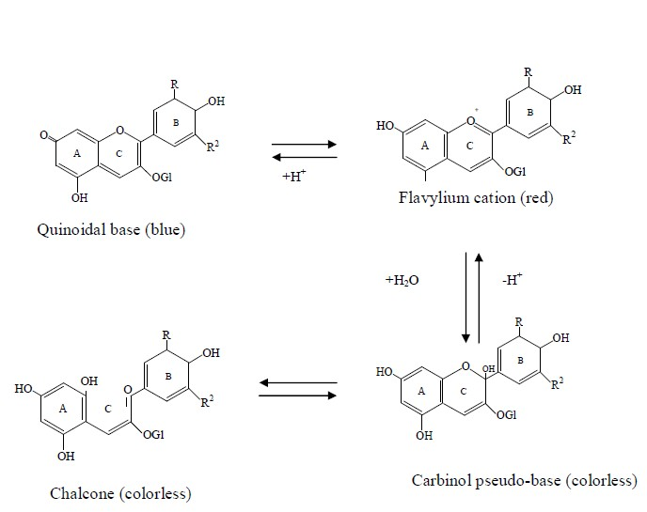
Figure 6: Effect of pH on malvidin₋3₋glucoside
2.6 Food application of anthocyanin
Consumers recognize their desired taste and flavor by the color of the food product. To improve or restore original appearance of foods or to ensure uniformity as indicator of food quality, the food industry has used colorants for centuries (Giusti and Wrolstad, 2003). So, color is a major concern for the food industry and the manufacturer will try its best to retain the natural appearance of the raw material. The action of light, temperature, oxygen, metal ions and endogenous enzymes may alter color during processing and storage. The color of fruits and vegetables will differ during seasons depending on their intra₋and interspecific variables and soil conditions at the site of cultivation and post₋harvest treatments (Stintzing and Carle, 2004). Now a days, consumers are more concern and careful about their health and they reject synthetic colorants often used in the food industry to make the food product attractive to the ultimate consumer because synthetic colorants are often harmful and carcinogenic for the consumer health. Therefore, these synthetic colorants are now being replaced with natural colorants. Many researches have been done on the extraction of anthocyanin from various sources to use anthocyanin as a natural food colorant that has positive health effects for the consumer. The antioxidant function of anthocyanin is 50times that of vitamin E, it can induce proper crosslinking of collagen, eliminate free radicals, and protect the skin. In addition, it can reduce serum cholesterol, triglyceride,and high-density lipoprotein, enhance low density lipoprotein, inhibit atherosclerosis, regulate blood fat, and prevent cardiovascular diseases and high blood pressure (Bornsek et al., 2012). For example, purple corn has been used as a food colorant since 1977 (Sugiyama Chemical Institute, 1977) and red rice is used as a functional food in China and is commonly used as a food colorant in bread, ice cream and liquor (Yoshinaga, 1986). Different types of anthocyanin natural food color solutions technically allow almost any food or beverage to be colored from orange, red, pink and purple to blue. However, anthocyanin is most commonly used as a natural food colorant in various types of food such as
- Coloring of beverages and soft drinks
- Confectionery and ice cream
- Anthocyanin based bread
- Anthocyanin based cakes
- Anthocyanin based Bhajia etc.

2.7 Guava
Guava (payara) is a berry like fruit of any of various myrtaceous trees or shrubs of the genus Pisidium, especially P. guajava (family Myrtaceae). It originated in tropical America (Mexico to Peru), where it still occurs in the wild. Guava is often called the “apple of the tropics”. The plant was introduced by the Portuguese to the Indian subcontinent by the early 17th century.

Guava is also an important fruit in Bangladesh, but research works on guava jelly. It has received much attention to the researchers throughout the tropics and sub-tropics. Some available research finding in this connection have been reviewed and presented below on the following heading.

2.7.1 Maturity

Mitra and Bose (1990) reported that the components responsible for flavor are the ester components which have the higher concentration (44.94%) in ripe fruits and the lowest (33.38%) in mature one.

Guava gets final size after maturity. Mukherjee and Dutta (1967) reported that guava cultivars, viz. Safeda, Pyrifrom, and L-49 took approximately 137, 110 and106 to 138 days respectively to reach maturity.

2.7.2 Ripening stage of guava

Yamdagni (1987) worked on the guava fruit cultivars sardar, Allhabad Safeda and Banarasi Surkha and they divided the fruit into different ripening stages viz. i)Green mature ii) Color break iii) Deep Yellow color and iii) over ripe stages.

Scientist divided the ripening process into a set of stages. They defined the stages on the basis of the eminent external changes at the onset and during the progress of ripening in the color of skin. Reyes and Paul (1995) divided the ripening period into the following color stages-i) Mature green ii) Quarter yellow iii) Half yellow.

2.7.3 Physical properties of guava

The guava includes about 150 species, but only a few have horticultural value. There are generally two kinds of guava. The common guava (P. guajava), the most important species is Cattley Guava (P. cattlecianum), which is also grown commercially. The plant is a shallow rooted sharb or small tree (3 to 10m), branching close to the ground and often producing sukers from the roots. The leaves are opposite, oblong, elliptic and hairy beneath. Flowers are bisexual, white and 2.5 cm in diameter, brone on new growth from mature branches, either singly or in clusters of two or three. The multiseeded, globose fruit is a fleshy berry.

The common guava has the scientific name Psidium guajava and is a part of the myrtly and eucalyptus family. The tree is small, with copper-coloured bark. It has leaves with many veins, and white or cream coloured flowers.

The fruit of the common guava varies in size and shape, but it is usually 4-8 centimeters (11/2-3 inches) long.

As the guava ripens, the outside skin changes color from green to light green or yellow. The flesh of the fruit may be white, yellow, pink or red. Inside the fruit are many stone-like seeds.

Another kind of guava is the Cattley guava, also called strawberry guava or Cherry guava. It is quite different from the common guava and has the scientific namePsidium Caffleianum.

The leaves of the Cattley guava are smaller, shinier and darker green than those of the common guava. The fruit is also small, rarely growing to more than 4 centimeters (11/2 inches) long. It is usually red or radish purple. Inside are several large, nut-like seeds. Both kinds of guava trees usually bear their fruit during the hot, rainy season.

Some of the important varieties are known by the name of the places where these are grown commercially. Thus Swarupkathi is from Barisal, Mukundapury from Brahmanbaria and Kanchannagar from Chittagong.

Guava cultivars display a great diversity in the tree size, bearing habit and yield, as well as in fruit size, flesh and skin color, taste and flavor and ripening season. There are three main types of guava: processing-type cultivars produce strong acidic fruit with colored flesh, dessert-type produce less acidic fruits with mostly white flesh and attractive skin colour, while dual purpose-types produce less acidic fruits that are a compromise between processing and dessert requirements.
Kazi, introduce in Thailand, is the only standard variety that has been released by the Bangladesh Agricultural Research Institute. It produces fruit weighing up to 500 g or even more. All other varieties have fruit weights ranging from 100 to 200 g.

Ullah et al. (1992) conducted an experiment at RaRa, Akbarpur Moulavibazar on physicochemical characteristics on the fruits of nine guava cultivars. From the experiment it was found that Kazi piara was very large in size and weight (9.5cm×8.59cm and 446.3g respectively) among the varieties. Weight of rest of the fruits ranged from 68.8 to 165.5g and size varied from 4.95cm, 4.66cm to 6.75×6.35cm. Number of seeds per fruit ranged from 222.2 to 426.8 minimum number of seeds was in Kanchan nagar and maximum number was in Kashi piara. Percent edible portion was the highest in Kazi piara (98.23%) and lowest in Syedi (96.65%).

Azad et al. (1987) conducted an experiment on physico-chemical characteristics of fruit of some guava varieties at BARI. The data indicated that Kazi piara produced significantly bigger fruits than other varieties.

Kazi piara was 505.10g in weight and 10cm×9.6cm in size, whereas weight of the ranged from 139.9 to 153.7g in rest of varieties. The minimum number of seeds per100g fruits was found in Kazi piara (109.3) followed by Kanchannagar (206.0), Swarkathi (255.1), Mukundapuri (256.5 and Allahabad, Kanchannagar, Mukundapuri were yellow when ripe except Kazi less smooth except that of Kanchannagar, which was rough . 1000 seed weight was the highest in Kazi piara(121g) followed by Allahabad (103g) Swarupkathi (9.2g. the highest percent edible portion was found in Kazi piara (98.96) whereas rest of the varieties ranged from 97.28 to 98.13.

Haque (1992) carried out an experiment at BAU, Mymensingh on the vitamin Cand mineral constituents of eleven guava varieties of Bangladesh. Among the varieties, Kazi piara and Thai were varying large in size and weight (424.77g and 388g), respectively. It is due to their genetical character. Soil fertility, management practices and environment also influenced fruit size.

Mitra et al. (1983) conducted an experiment on physicochemical composition of fruits of some guava cultivars and found that fruit weight of Allahabad and luck now-49 were 86.160g and 95.8-145.0g, respectively. Fruit lengths were 5.4-6.4cm and 5.8-6.6cm respectively.

Mitra et al. (1983) conducted an experiment on physicochemical composition offruits of some guava varieties of west Bengal and found that lucknow-49 was superior in yield, fruit and weight among the varieties.

Islam et al. (1993) observed that fruit of Kazi piara is the most imported piara in Bangladesh were hand thinned (0, 25, 500, and 75% fruit per plant) when the fruit weight was about 20g , to leave remaining fruit uniformly distributed throughout the tree.

Yousof (1988) carried out an experiment on physicochemical characteristics some guava varieties of Malaysia. Most of the local cultivars had diameter from 4.8 to 6.7cm and monocarp from 09 to 1.5cm, but the introduced varieties had diameter from 10 to 11cm and monocarp form 1.9 to 2.5cm. Monocarp color of fruit varied from pink to red or white.

Shanker (1967) studied the ripe fruit of five guava varieties and found that fruit weight ranged from 81.0g in seedless to 163.0g Allahbad Safada, seeds per fruit were 4 in. seedless, 230 (Luchknow-49), to 521 (hafsi) in other fruit seeded variety.

Zaman (1996) studied the effect of fruit thinning and use of growth regulator on the yield and quality of Kazi piara at the Bangladesh Agricultural University, Mymensingh. It was reported that the size and weight of individual fruit were maximum (255.7g) when 75% fruits were thinned.

2.7.4 Nutritive value
The guava significantly contributes to the nutrition of the people of this country. Guava contains nutritional value five times more than orange. The guava is a good source of Vitamin C and fibers in the pacific.
A seasonal (July-September) fruit, guava is rich in vitamin C (200-300 mg/100), carbohydrate, protein, iron, calcium and phosphorus and can be eaten fresh or processed to make guava juice, to prepare the juice for bottling, guava drink, guava sauce, guava milkshake, guava dumplings, guava Jelly, guava puree, stewed guavan and dairy or bakery items. Besides fruits, the young leaves and root bark are used in local medicines. The amount of vitamin C found in guavas varies greatly, but one small common guava usually has nearly four times the amount of vitamin C needed by the children and adults for one day.

Palaniswamy and Shanmugavelu (1974) conducted on 11 varieties of guava and found that Anakaplti had the highest vitamin C content of 392mg/100g fresh fruit.

El-Buluk et al. (1997) stated that ascorbic acid was increased significantly with fruit maturity. Yamdagni (1987) also found the similar result with the cultivars sardar, Allahabad Safeda and Banarasi Surkha.

Esteves et al. (1984) carried out an experiment and stated that vitamin C wasincreased in all the cultivars during ripening and decreased during senescence.

Phandis (1970) analyzed the guava fruit to find out its composition and reported that the fruit contained 260mg vitamin C per 100g fruit, which differed with the variety, stages of maturity, ripening and season.

Pozo et al. (1983) reported that ascorbic acid content of samples ranged from 69.28 to 74.76-mg/100g) pulps. Nag (1988) reported that Kazi piara contained (318.28mg/100g), Local (257.30) and Swarupkathi (205.58mg/100g) at matured stage.

Azad et al. conducted an experiment at BARI, Gazipur and found the highestvitamin C in Kazi piara (202.4mg/100g) followed by Allahabad (165.2mg) Swarupkathi and Mukundapur (116.2mg).
2.7.5 Chemical composition

Yusof (1988) carried out an experiment of physicochemical character ranged from teristics of some guava varieties of Malaysia stated that moisture content of the fruits ranged from 79.2 to 85.9%.

El-Buluk et al. (1995) conducted an experiment on biochemical and physical changes of four Guava cultivars-Ganib, Pakistani, Shambati and Shendi during growth and development. They found that moisture content was increased significantly with fruit growth and development in all cultivars and maximum of 76% in cv. Ganib.

Phandis (1970) worked on improvement of guava in India and reported that guava contained 48% ash, whereas in another experiment Wilson (1980) found 0.66% ash in guava. This difference might be due to varietals characteristics.

Nag (1998) carried out an experiment at the Bangladesh Agricultural University and observed the highest ash content in Swaruopkathi followed by Kazipiara and Mukundopuri respectively at the mature stage.

Salma and Suhalila (1987) stated that titrable acidity fluctuated at maturity according to Tendon et al. (1983), White flashed guava contained 0.45% acidity.

Phandis (1970) observed that sadar guava contained acidity 2.45%. Yusof (1990) carried out an experiment and stated that titratable acidity ranged from 0.26 to 0.52% in guava.
Azad et al. carried out an experiment on the physicochemical characteristics of fruits of some guava varieties such as Allahabad, Kanchannagar, Kazi piara, Mukundapur and Swarupkathi and found that TSS of fruits in the endocarp ranged from 10.8% in Swarupkathi to 13.2% in Mukundapuri. Ullah et al. (1992) carriedout an experiment and found that TSS of fruit juice in the mesocarp varied from7.1% in the Kazi piara to10.2% in Gu-008and in endocarp 10.7% in Kazi piara to13.9% in Gu-008.
Palaniswami and Shanmugavelu (1974) while conducting an experiment in India with 11 varieties of guava that total soluble solid (TSS) varied from 4.0% in Lucknow-49 to 12.5% in smooth green and red fleshed fruits.

Table 4. Chemical composition of Guava (Psidium guajava)
Nutritional value per 100 g (Raw)
Energy | 285 KJ
Carbohydrates | 14.32 g
Sugars | 8.92 g
Dietary fiber | 5.4 g
Fat | 0.95 g
Protein | 2.55 g
Vitamins
Vitamin A | 31 μg
Beta-Carotene | 374 μg
Thiamine (B1) | 0.067 mg
Riboflavin (B2) | 0.04 mg
Niacin (B3) | 1.084 mg
Pantothenic acid (B5) | 0.451 mg
Vitamin B6 | 0.11 mg
Folate (B9) | 49 μg
Vitamin C | 228.3 mg
Vitamin K | 2.2 μg
Minerals
Calcium | 18 mg
Iron | 0.26 mg
Magnesium | 22 mg
Manganese | 0.15 mg
Phosphorus | 40 mg
Potassium | 417 mg
Sodium | 2 mg
Zinc | 0.23 mg
Other constituents
Lycopene | 5204 µg
Source: USDA Nutrient Data base, 2016.
2.7.6 Storage
Josiet al. (1985) investigated that the effects of length and temperature of storage and relationship of oxygen, light, sugar, pH and ascorbic acid to deteriorative changes in color of these factors. Storage temperature and oxygen content were the most specific for color injury of both juices and isolated pigments. Exposure to light caused little deterioration in color adjustment of acidity within the range of pH 2.0 to 4.5 or sugar addition had little effect on color retention in fruit juices during storage.

Mitra (1997) studies on post harvest physiology and storage on tropical and subtropical fruits. He showed in his food that tropical and subtropical fruits are becoming increasingly important food items in countries where they are produced and also in an increasing number of importing countries in non-tropical areas. His book deals with the post harvest storage, physiology and conservation of all of the economically important tropical and subtropical fruits. It should be particular interest to all horticultural researchers’ exports and imports within the interest concerned with tropical and subtropical fruits.

2.7.7 Guava jelly

Desrosier (1963) reported that gel formation occurs only without certain range of hydrogen ion concentration, the optimum acidity figure for jelly being pH 3.2. The gel strength falls slowly on decreasing and rapidly on increasing the pH value. Beyond pH value 3.4 jelly formation occurs at the usual soluble solid range. The optimum concentration of sugar is about 67.5%, it is however possible to make jellies with high content of pectin and acid containing less than 60% sugar. Too high concentration of sugar results also in a jelly of stick consistency. The quality of pectin necessary to form a gel depends largely on the quality of pectin. One percent should be sufficient to produce a firm jelly.

El-Mubarak et al. (1977) observed that by using 100 grade pectin solution from citrus waste/kg pulp Guava good setting and flavor of jam manufacture from guava.

Parashkova (1982) conducted that fruit jelly manufacture with low sugar content preserved well the aroma and flavor of fresh fruit due to shorter heating time.

Donchonkoet al. (1988) observed that at pH 6.0 the strength of jam/jelly was 4 kpa; increasing citric acid concentration resulted in increased jelly (strength) at pH 3.2, the strength was 40.0 kpa and at pH (2.8 it was 53.2 kpa). pH values in the range 2.8-3.2 are considered optimum for maximum strength of jelly.

CHAPTER III
MATERIALS AND METHODS

CHAPTER III
MATERIALS AND METHODS

3.1. Materials
3.1.1. Sample collection and preparation
Fresh eggplant (Solanum melongena L.) and guava (Psidium guajava) were collected from the local market of Chittagong, Bangladesh. All of the experiments were held in food processing and engineering laboratory at Chittagong Veterinary and Animal Sciences University (CVASU) and were done by Spectrophotometer at Poultry Research and Training Center (PRTC) laboratory. The eggplant was washed by tap water to remove adherences, dirt and other surface impurities. Then thin peels of eggplant were taken manually with a stainless steel knife and cut into small pieces. The fresh small pieces of cut eggplant peels were kept in a dryer at 40⸰C for 25 hours. The dried eggplant peels were grinded by means of a blender and kept at 4⸰C for further assayed.
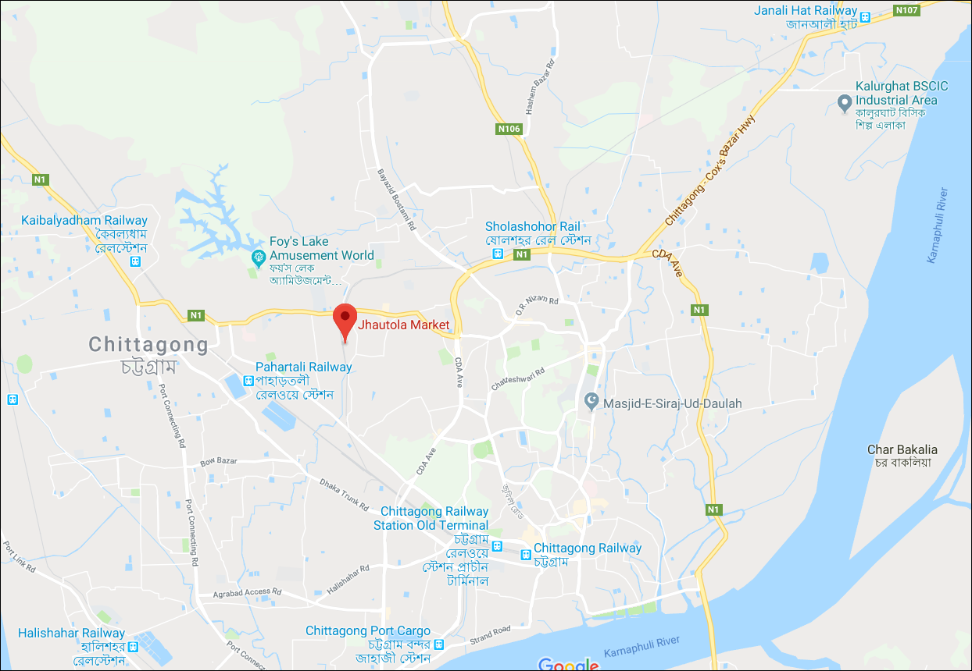
- Sampling location
3.1.2. Chemicalsandreagents
Buffer solution-4, Buffer solution-7, Hydrochloric acid, Sodium hydroxide, Ethanol, Methanol etc. was used in the study.
3.2. Methods
3.2.1. Extraction of anthocyanin with different solvent under different pH (1.0, 3.0, 5.0) and storage conditions (ambient and refrigeration)
In order to extract anthocyanin from the peel of eggplant, at least 25gm dried powder of eggplant feel was taken and soaked into each of the 1000ml solvent like water and 50% ethanol respectively. The pH of the solutions was maintained at 1.0, 3.0, 5.0 and the extraction process was carried out at 50⸰C for 60minutes. The anthocyanin extracts obtained from each of the extraction was filtered through a muslin cloth to remove coarse particles. Then vacuum filtration with what man filter paper (no.1) was also performed to remove the other dissolved minute particles. The filtrated extract was used for the determination of total anthocyanin. Subsequently, the filtrated anthocyanin extracts were kept in amber bottles at ambient temperature (30 ± 2)⸰C and refrigeration temperature (4⸰C) for the study of degradation kinetics and stability of anthocyanin.
3.2.2. Determination of anthocyanin content extracted with different solvents under different pH and storage conditions
Content of total anthocyanin was determined by using the modified method given by Giusti and Wrolstad (2001). Filtrated eggplant peel solution (15ml) was centrifuged at 4000 rpm for 20 minutes. Then 0.5 ml of aliquot was diluted with 4 ml of methanol and absorbance was measured at 530 nm using spectrophotometer (U-2900, Japan). The anthocyanin content was calculated on the basis of the following equation.
Anthocyanin content (mg/100gm of dry matter) = (A×MW×DF×100) ÷ (Ɛ×W)--------(1)
Where,
A=Absorbance
MW = Molecular weight of cyanidin-3-glucoside chloride (C21H21ClO11, 449.2)
DF = Dilution factor
Ɛ = Molar absorptivity (26900), W = Sample weight
3.2.3. Assessment of kinetic parameters (Half-life and color retention percentage) of anthocyanin extracted from the peel of eggplant
Kinetic parameters (Half-life and color retention percentage) of anthocyanin extracted from the peel of eggplant were examined after 4th, 8th and 12th days of storage at refrigerated (4⸰C) and ambient temperature (30 ± 2⸰C).

In order to investigate the anthocyanin pigments degradation as a function of time, the calculations of degradation speed constant (k), half-life (t_{1/2}) and percentage of color retention (%R) were calculated according to Equations (2), (3) and (4) respectively (Vanini et al., 2009).
k.t$=-2.303×log\frac{{At}_{x}}{{At}_{0}}……………(2)$
t_{1/2} $=\frac{0.693}{k}……………………………(3)$

Where:
$Atx$= Absorbance in relation to the final time of the experiment
At₀= Absorbance in time zero, initial time of the experiment
$k$ = Speed Constant (hs-1)
T = Time (days, hours, minutes, seconds) t_{1/2} = Half-life time.

%R $=\frac{{At}_{x}}{{At}_{0}} ×100……………………(4)$
Where:
%R = Percentage of color retention
$Atx$= Absorbance in relation to the final time of experiment
At₀=Absorbance in time zero, initial time of the experiment

3.2.4 Preparation of guava jelly with natural color (anthocyanin) and artificial color (a mixture of E104 quinoline, acetic acid and E122 carmosine)
Guava jelly was prepared by using the modified method given by Souza et al., (2014). Fresh and ripe guava was used for the extraction of juice. After washing they were cut into small pieces and 1 liter juice was extracted from guava by boiling. The juice was collected and residue was discarded. The juice was heated at 60°C for 10 minutes and cooled. 0.6 gm potassium meta-bi-sulfate (KMS) was mixed with warm water. 0.5 ml extracted anthocyanin as a natural colorant, 15gm pectin and 1.0 kg sugar mixed with extracted juice and keep heating until the TSS comes to 65%. Then the KMS solution and 12 gm citric acid were added in this solution and preserved in the bottle for further analysis. Another sample of guava jelly was prepared by using a mixture of E104 quinoline, acetic acid and E122 carmosine as an artificial food grade color available in the market and performed the same analysis for comparison.

3.2.5 Comparative assessment of physicochemical Properties of guava jelly made with natural color (anthocyanin) and artificial color (a mixture of E104 quinoline, acetic acid and E122 carmosine)
3.2.5.1 Determination of moisture content
Association of Analytical Chemists (AOAC) method 7.045 (2000) was used to determine the moisture content of guava jelly. 5gm jelly was taken in a clean, dry and pre-weighed crucible. Then the jelly was transferred to oven and dried at 105°C for 16 hours. After that it was cooled at desiccator and weighed. Again it was transferred to oven and dried until a constant weight was obtained. Finally it was cooled and weighed.
Moisture content was calculated by using following formula:
% Moisture$=\frac{w_{1}-w_{2}}{w} ×100$
Where,
$w_{1}$ $=$ Weight of jelly with crucible (gm)
$w_{2}$ $=$ Weight of dried jelly with crucible (gm)
$w$ $=$ Weight of jelly (gm)

3.2.5.2 Determination of acid insoluble ash
Association of Analytical Chemists (AOAC) method 7.045 (2000) was used to determine the total ash content. 5 gm jelly was taken in a clean, dry and pre-weighed crucible. Then the crucible was kept into muffle furnace at 550°C for 6 hours. It was cooled at desiccator and weighed.
The ash content was calculated by the following formula:
% Ash $=\frac{w_{1}-w_{2}}{w} ×100$
Where,
$w_{1}$ $=$ Weight of ash with crucible (gm)
$w_{2}$ $=$ Weight of crucible (gm)
$w$ $=$ Weight of jelly (gm)

3.2.5.3 Determination of percentage acidity
Acidity of jelly was determined by using the method as recommended by Ranganna (1977). 10 ml guava jelly was taken in a 100 ml conical flask. A few drops of 1% phenolphthalein solution (indicator) was added to the flask and titrated with 0.1 N NaOH solution from the burette until a light pink color appeared and persist for 15 seconds. The titration was done for several times for accuracy. Percent titrable acidity was calculated using the following formula:
% Titrable acidity$=\frac{T × N × V × E}{v × W × 1000}×$ 100
Where,
$T =$Titre
$N =$Normality (gml⁻¹)
V$=$Volume made up (ml)
E $=$ Equivalent wight of acid (gm)
ν$=$ Volume of sample taken for estimation (gm)
$w=$Weight of sample (gm)

3.2.5.4 Determination of reducing sugar
Estimation of reducing sugar of jelly was carried out using Lane and Eynon (1923). 5gm guava jelly was taken in a beaker and 30 ml of water was added. It was transferred to the water bath and heated at 60°C for 25 minutes. Then 100 ml of 95% ethanol was added to it and stirred by magnetic stirrer for 15 minutes. It was filtered through Whatman filter no. 2. The residue was soaked in the 50% ethanol solution for 1 hour. After that, the residue was washed on the filter paper with the 50% ethanol solution for 4 hours. The residue was collected to a round bottom flask and 100 ml of water and 20 ml of HCl were added to it. The flask was attached with the condenserand heated for 2.5 hours. Then it was allowed to cool and neutralized by adding NaOH solution (40%). 10 ml of Fehling’ solution was added into the conical flask and titrated against neutralized sample solution. When CuSO₄. 5H₂O like color was observed. Then 3 drops of methylene blue indicator was added and continued titration. The end point was indicated by brick red color.
The reducing sugar was calculated by the following formula:
% Reducing sugar$=\frac{F × D}{T × W}×$ 100
Where,
$F$ $=$ Factor for Fehling solution (gm)
$D$ $=$ Dilution
$T$ $=$ Titre value
$W$ $=$ Weight of sample (gm)

3.2.5.5 Determination of non-reducing sugar
50 ml purified solution was taken in conical flask. 50 ml distilled water and 5 ml citric acid were added to it. Then the conical flask was heated for 10 minutes for addition of sucrose and finally cooled. The sample was then neutralized by 0.1 N NaOH solution using phenolphthalein as indicator. The volume was made up to 100 ml with distilled water. The mixed Fehling’s solution was titrated using similar procedure as for reducing sugar from which the present non-reducing sugar was calculated as follows:
% Non-reducing sugar $=$ % Invert sugar - % Reducing sugar
3.2.5.6 Estimation of total sugar
Total sugar can be calculated as follows:
% Total sugar $=$ % Reducing sugar + % Non-reducing sugar

3.2.5.7 Determination of total soluble solids (TSS)
Guava jelly was taken in a hand refractometer (Model no. HI 96801) plate and the total soluble solids were read directly from the hand refractometer.

3.2.6 Statistical Analysis
All measurements were carried out in triplicate for each of the sample and average and standard deviations were calculated from this triplicate measurement. Data were analyzed using statistical software R (Windows versions 2.13.1). A single factor analysis of variance was carried out. Significant different were estimated using Duncan Multiple Range Tests (DMRT). Differences were considered to be significant at P≤0.05.

CHAPTER VI
RESULTS

CHAPTERIV
RESULTS

4.1. Anthocyanin content extracted with different solvent under different pH and storage conditions
Table-5 shows the effects of solvent and pH on anthocyanin content, extracted from eggplant under various storage conditions. The amount of extracted anthocyanin ranges from 156 to 247mg/100g in water and 71 to 190mg/100g in 50% ethanol at various pH values (1.0, 3.0, 5.0). Higher anthocyanin content was found at pH 3.0 for water solvent both in ambient and refrigerated conditions. Total anthocyanin content was determined at 4 days interval (0 day, 4th day, 8th day and 12th day). Total anthocyanin content degrades during the storage period both in ambient and refrigerated conditions.

Table 5. Effects of solvent and pH on anthocyanin content (mg/100g of dry matter) under various storage conditions
Span of storage | Storage Temperature | Ambient Temperature (30±2°C) |  |  |  |  |  | Stored Temperature (4°C)
 | Extracting Solvent | Water |  |  | 50% Ethanol |  |  | water |  |  | 50% Ethanol
 | Solvent pH | 1 | 3 | 5 | 1 | 3 | 5 | 1 | 3 | 5 | 1 | 3 | 5
0-Day | Anthocyanin content | ^{AB}176.34±8.02ª | ^{A}247.02±2.98ª | ^{AB}156.03±1.66ª | ^{B}71.34±3.5ª | ^{A}190.51±3.40ª | ^{B}73.74±7.65ª | ^{AB}176.34±8.02ª | ^{A}239.56±8.88ª | ^{AB}156.03±1.66ª | ^{B}71.34±3.5ª | ^{A}190.51±3.40ª | ^{B}73.74±7.65ª
4th Day | Anthocyanin content | ^{AB}91.24±1.36^{b} | ^{ABC}70.93±4.32^{b} | ^{ABC}71.07±1.23^{b} | ^{C}31.62±1.70^{b} | ^{ABC}67.86±7.95^{b} | ^{C}27.99±0.34^{b} | ^{AB}95.73±2.28^{b} | ^{AB}90.57±0.81^{b} | ^{A}97.79±2.12^{b} | ^{C}30.66±1.05^{b} | ^{BC}51.30±0.81^{b} | ^{ABC}64.12±0.81ª
8th Day | Anthocyanin content | ^{AB}88.87±1.40^{b} | ^{ABC}70.53±3.50^{b} | ^{ABC}70.53±2.89^{b} | ^{C}28.74±1.20^{b} | ^{ABC}64.81±10.53^{b} | ^{C}26.77±2.11^{b} | ^{AB}94.24±3.01^{b} | ^{AB}87.49±0.81^{b} | ^{A}96.31±1.28^{b} | ^{C}29.91±0.59^{b} | ^{BC}50.65±1.27^{b} | ^{ABC}55.31±27.07ª
12thDay | Anthocyanin content | ^{AB}88.75±1.82^{b} | ^{ABC}70.00±2.81^{b} | ^{ABC}67.86±2.01^{b} | ^{D}26.37±3.88^{b} | ^{ABCD}64.39±0.92^{b} | ^{D}25.79±1.97^{b} | ^{AB}94.05±15.76^{b} | ^{ABCD}67.06±1.22^{b} | ^{A}94.19±2.90^{b} | ^{CD}29.77±2.40^{b} | ^{BCD}50.56±5.32^{b} | ^{ABCD}52.78±2.04ª
a-c Means followed by different subscript alphabets in each row are significantly different (P<0.05) among different pH within the same solvent
A-C Means followed by different subscript alphabets in each column are significantly different (P<0.05) among storage duration
Mean ± SD

4.2 Kinetic degradation (Half-life and color retention percentage) of anthocyanin extracted from the peel of eggplant
Thermal stability of anthocyanin extracted from eggplant under various storage conditions was assessed at a range of selected pH and solvents variations. The half-life time (t_{1/2}) in days and the color retention percentage (%R) values as kinetic parameters for the assessment of anthocyanin stability extracted from eggplant is summarized in Table-6 and table-7 respectively. The values of half-life time (t_{1/2}) for water solvent ranges 1.56 to 5.69 days in ambient atmospheric condition (30 ± 2⸰C) and 2.75 to 36.76 days in refrigeration condition at 4thday of storage. On the other hand the values of half-life time (t_{1/2}) for 50% ethanol solvent ranges 6.97 to18.99 days in ambient atmospheric condition (30 ± 2⸰C) and 6.67 to 46.19 days in refrigeration condition at 4thday of storage.
The values of color retention percentage (%R) for water solvent ranges 61.95 to 83.66 in ambient atmospheric condition (30 ± 2⸰C) and 74.77 to 93.66 in refrigeration condition at 4thday of storage. On the other hand the values of color retention percentage (%R) for 50% ethanol solvent ranges 59.65 to 87.52 in ambient atmospheric condition (30 ± 2⸰C) and 72.67 to 93.07 in refrigeration condition at 4thday of storage.

Table 6. Half-life (t_{1/2}) time values in days as kinetic parameters for anthocyanin degradation from eggplant under various storage conditions
Span of storage | Storage Temperature | Ambient Temperature (30±2°C) |  |  |  |  |  | Stored Temperature (4°C)
 | Extracting Solvent | Water |  |  | 50% Ethanol |  |  | water |  |  | 50% Ethanol
 | Solvent pH | 1 | 3 | 5 | 1 | 3 | 5 | 1 | 3 | 5 | 1 | 3 | 5
4th Day | Half-life time  (t_{1/2}) | ^{C}1.56±0.11ª | ^{C}5.69±4.58ª | ^{C}2.72±3.15ª | ^{C}6.97±3.99ª | ^{C}12.64±0.17ª | ^{BC}18.99±8.15ª | ^{C}13.46±0.65ª | ^{AB}36.76±1.37ª | ^{C}2.75±0.13ª | ^{C}8.81±0.47ª | ^{C}6.67±0.10ª | ^{A}46.19±16.00ª
8th Day | Half-life time  (t_{1/2}) | ^{B}1.54±0.10ª | ^{B}4.33±0.49ª | ^{B}0.87±0.06ª | ^{B}4.50±0.59ª | ^{B}7.77±0.77^{b} | ^{B}9.39±1.88^{b} | ^{B}12.95±9.63ª | ^{A}36.20±30.91ª | ^{B}2.06±0.23^{b} | ^{B}8.51±0.95ª | ^{B}6.49±0.09ª | ^{A}39.77±7.41ª
12th Day | Half-life time  (t_{1/2}) | ^{B}1.53±0.09ª | ^{B}3.93±3.01ª | ^{B}0.83±0.04ª | ^{B}4.11±0.24ª | ^{B}5.62±0.32^{c} | ^{B}5.17±0.68^{b} | ^{B}12.18±0.23ª | ^{A}35.93±4.72ª | ^{B}2.05±0.13^{b} | ^{B}8.53±3.59ª | ^{B}5.11±0.31^{b} | ^{A}34.56±19.56ª
a-c Means followed by different subscript alphabets in each row are significantly different (P<0.05) among different pH within the same solvent
A-C Means followed by different subscript alphabets in each column are significantly different (P<0.05) among storage duration
Mean ± SD

Span of storage | Storage Temperature | Ambient Temperature (30±2°C) |  |  |  |  |  | Stored Temperature (4°C)
 | Extracting Solvent | Water |  |  | 50% Ethanol |  |  | water |  |  | 50% Ethanol
 | Solvent pH | 1 | 3 | 5 | 1 | 3 | 5 | 1 | 3 | 5 | 1 | 3 | 5
4th Day | Color Retention (R%) | ^{BCD}63.85±1.20ª | ^{AB}83.66±2.80ª | ^{CD}61.95±4.72ª | ^{A}87.52±8.63ª | ^{ABC}81.02±4.12ª | ^{D}59.65±2.06ª | ^{A}93.66±5.36ª | ^{AB}86.71±6.65ª | ^{ABCD}74.77±4.59ª | ^{A}93.07±8.76ª | ^{A}90.14±0.14ª | ^{ABCD}72.67±1.06ª
8th Day | Color Retention (R%) | ^{BCD}55.61±8.32ª | ^{ABCD}66.38±1.23^{b} | ^{CD}45.23±2.33^{b} | ^{AB}80.11±7.75ª | ^{AB}72.36±2.67^{b} | ^{D}41.34±3.09^{b} | ^{A}92.85±4.23ª | ^{AB}76.60±2.41^{ab} | ^{ABC}71.25±2.89ª | ^{A}90.14±2.62ª | ^{AB}82.95±7.53^{ab} | ^{ABC}70.60±1.64ª
12th Day | Color Retention (R%) | ^{BCD}54.80±7.85ª | ^{CD}49.03±2.10^{c} | ^{D}43.5±1.74^{b} | ^{AB}76.72±6.38ª | ^{ABC}70.17±3.28^{b} | ^{D}40.49±4.39^{b} | ^{CD}53.64±11.30^{b} | ^{ABC}70.60±6.64^{b} | ^{ABC}71.24±1.53ª | ^{A}85.27±1.55ª | ^{A}79.14±4.39^{b} | ^{ABC}69.77±6.58ª
Table 7. Color retention percentage (%R) as kineticparameters foranthocyanindegradationfromeggplantundervarious conditions
a-c Means followed by different subscript alphabets in each row are significantly different (P<0.05) among different pH within the same solvent
A-C Means followed by different subscript alphabets in each column are significantly different (P<0.05) among storage duration
Mean ± SD

4.3 Physicochemical composition of guava jelly made with natural color (anthocyanin) and artificial color
Physicochemical composition of guava jelly made with natural color (anthocyanin) and artificial color (a mixture of E104 quinoline, acetic acid and E122 carmosine) were shown in table-8. Both the guava jelly made with natural anthocyanin and artificial color were analyzed for moisture, ash, acidity, reducing sugar, non-reducing sugar, total sugar and total soluble solids (TSS).
Table-8. Physicochemical composition of guava jelly made with natural color (anthocyanin) and artificialcolor (a mixture of E104 quinoline, acetic acid and E122 carmosine)
Parameter | Physicochemical composition
 | Guava jelly with natural color (anthocyanin)  (Mean ± SD) | Guavajelly with artificial color (a mixture of E104 quinoline, acetic acid and E122 carmosine)  (Mean ± SD)
Moisture content (%) | 28.72±1.64 | 29.48±1.72
Ash (%) | 0.67±0.01 | 0.68±0.03
Acidity (%) | 0.35±0.01 | 0.34±0.01
Reducing sugar (%) | 27.08±1.98 | 27.64±2.05
Non- reducing sugar (%) | 35.81±1.15 | 35.79±1.20
Total sugar content (%) | 62.89±3.10 | 63.44±2.81
Total soluble solid (⸰brix) | 66.00±1.00 | 66.00±1.00

CHAPTER V
DISCUSSION

CHAPTERV
DISCUSSION

5.1 Effects of solvent, pH and storage condition on anthocyanin content
The effects of solvent and pH on anthocyanin content, extracted from eggplant under various storage conditions were shown in table-5. From the table-5 it is clear that these results were higher than Jabutica (10.29 ± 0.29mg/100g) obtained by Lima et al. (2011). A comparatively lower value of anthocyanin content 37.52mg/100ml in 50% ethanol and a range of 26-30mg/100ml in water for red radish were found by Patil et al., (2009). The quantification results of this study were also higher than the findings of Anttonen and karjalainen (2005) who found the values of anthocyanin content ranges from 19 to 51mg/100g for red raspberry fruit. These results are close to the values determined by Bridle and Timberlake (1997) 30-750 mg/100 g of grape, Kuskoski et al. (2000) found average values of 128.5 mg/100 g in table grapes. The variation in the results can be explained by the use of different cultivars and/or by factors such as the mixture of cultivars, crop time, maturation state or stage, climate and the soil in the producing areas (Malacrida and Motta, 2005; Tripoli et al., 2007). From the data presented so far ,it can be stated that the anthocyanin content was highest at pH-3 for both solvents and the degree of extraction was higher in water than 50% ethanol at higher pH. It was close to the observation of Thao et al., (2015) who reported that a pH of <2.2 and >2.4 would be best to achieve high anthocyanin content. There were no significant differences between the solvents within the respective pH value in 8th and 12th day samples. However Chandrasekhar et al. (2012) revealed that the degree of extraction was higher in case of acetone followed by HCl in methanol, ethanol and then water. Difference in extraction technique and also the purity of the solvents used to extract anthocyanin may result the disparity.
The total anthocyanin content of all the extracts was decreased during the storage period. From the tabulated data, it is found that in case of ambient condition, the degradation of anthocyanin was faster at 4th day (2 to 3 times) than 8th and 12th day of storage samples. Similar statement was recorded that the anthocyanin contents was decreased rapidly in the first week and then remains lightly stable from the second week of storage under various storage conditions (Vargas et al., 2013).
Same trend was followed for anthocyanin degradation in refrigeration storage conditions. However, anthocyanin degradation was much slower in refrigeration conditions than in ambient conditions. The phenomenon was close the earlier observation of literature that degradation rate of anthocyanins was faster at 37⸰C as compared to 2⸰C (Bianca et al., 2012). A good correlation was found between anthocyanin content and storage day. There were significant differences in anthocyanin content between 0 to 12th day samples for both the storage conditions. The results showed that the degradation was lower at pH 1.0 followed by pH 3.0 and pH 5.0 for both the solvents and the storage temperatures in this regard. Several studies have shown that anthocyanins are stable and highly colored at low pH values but they gradually losing the color with the increasing pH values (Zhao et al., 2004 and Borkowski et al., 2005). Usually high temperature and high pH value enhances the formation of a complex molecule chalcone that destroys the structure of anthocyanin, causes the deterioration of color and makes it unstable (Vargas et al., 2013)

5.2 Assessment of kinetic parameters (Half-life and color retention percentage) of anthocyanin extracted from the peel of eggplant

Kinetic degradation of anthocyanin extracted from eggplant under various storage conditions was assessed at a range of selected pH and solvents variations. The half-life time (t_{1/2}) in days and the color retention percentage (%R) values as kinetic parameters for the assessment of anthocyanin stability extracted from eggplant is summarized in Table-6 and table-7 respectively. The values of half-life time (t_{1/2}) for water solvent ranges 1.56 to 5.69 days in ambient atmospheric condition (30 ± 2⸰C) and 2.75 to 36.76 days in refrigeration condition at 4thday of storage. On the other hand the values of half-life time (t_{1/2}) for 50% ethanol solvent ranges 6.97 to18.99 days in ambient atmospheric condition (30 ± 2⸰C) and 6.67 to 46.19 days in refrigeration condition at 4thday of storage. This is higher than the reported range of 108.28 hours or 4.5 days for water and 50.95 hours or 2.13 days for ethanol/water mixture in cranberry bush fruits (Bianca et al., 2012). Again the quantification value was almost consistent with the value for butterfly Pea (32.1 days) found by Mohamad et al., (2011). These results for water was lower than the value for red and purple potatoes (41 and 89 days) (Reyes & Cisneros-Zevallos, 2007) and also consistent for the value for blackberries concentrate juice (32days) (Wang & Xu, 2007). Again the results for ethanol were close to butterfly pea (8 days) at 80⸰C (Mohamad et al., 2011). The obtained data for half-life were lower than that as reported by Arslan (2015) for sour cherry concentrate (138.6 days) at 4⸰C. All the Quantative data for t_{1/2} of this research was higher than 45 hours or 1.875 days for roselle anthocyanin (Lee et al., 2015). The variation in t_{1/2} values for both the solvents and storage condition might be due to the difference in storage time, treatments and presence of anthocyanin degrading enzymes (PPO, POD and β-glucosidase) (Carlson, 2003) and also the origin of sample used to extract anthocyanin. It had been observed that the half-life (t_{1/2}) values were 5 to 6 times higher for water and 2 to 3 times higher for 50% ethanol in refrigeration storage condition than the normal atmospheric condition. This is probably due to the effect of temperature and extraction solvent on anthocyanin stability. My findings is in accordance with the earlier recorded statement that anthocyanin were shown to be more stable at temperature (4 ± 1)⸰C with higher half-life values and showed lower half-life values at temperature (29 ± 2)⸰C (Denise et al., 2008). The stability of anthocyanin at high temperature or normal atmospheric temperature is known to be mostly affected by many environmental factors such as pH (Kirca et al., 2007), presence of anthocyanin degrading enzymes (Kader et al., 1998) oxygen (Patras et al., 2010) which are likely to differ depending on the processing condition and also the origin of samples. Many processing factors as well as environmental factors are also responsible for the degradation of anthocyanin pigment. Hence, it is not unexpected that fluctuated value of half-life time (t_{1/2}) was noticed throughout the entire storage study. It was observed that better result for half-life (t_{1/2}) was obtained in 50% ethanol at higher pH in refrigeration storage condition. Effects of storage temperature and pH on the stability of anthocyanin may probably responsible for the happening. The obtained results are in agreement with Buckow et. al., (2010) that thermal stability of anthocyanin was higher at pH>3 for sour cherry and black berry juice
The values of color retention percentage (%R) for water solvent ranges 61.95 to 87.82 in ambient atmospheric condition (30±2⸰C) and 74.77 to 93.66 in refrigeration condition at 4th day of storage. On the other hand the values of color retention percentage (%R) for 50% ethanol solvent ranges 59.65 to 87.52 in ambient atmospheric condition (30±2⸰C) and 72.67 to 93.07 in refrigeration condition at 4th day of storage. From the tabulated data, it is clear that the color retention percentage (%R) values were higher at lower pH (pH-1.0 and 3.0) in water and 50% ethanol for both the storage conditions (Table-7). Change in anthocyanin pigment structure, affected by pH may responsible for this phenomenon. Our results are quite resembled with the earlier assumption of Sari et. al., (2012) who assumed that anthocyanin absorbance was higher in lower pH (1.0, 2.0, 3.0) than higher pH for jambolan fruit which was co-related to %R value or anthocyanin color stability. Again from the previous study it had been informed that at pH<2, anthocyanins were primarily in the form of the red flavylium cation and it hydrates to yield the colorless carbinol with the increasing pH values (>4) (Mazza & Miniati, 1993). The degradation rate for color retention percentage was fast in ambient storage condition (30 ± 2⸰C) than in refrigeration storage condition. This could be due to the degradation of anthocyanin with the increasing time period and higher anthocyanin content in refrigeration temperature during the storage study. Tabulated data (Table-7) showed that %R values in refrigeration storage conditions (4⸰C) were higher than the ambient storage conditions (30 ± 2⸰C). The effect of temperature on the stability of anthocyanin may accountable for this incident. The phenomenon is relevant with the earlier recorded statement in the literature that jambolan (Syzygium cumini) fruit gave higher color stability at (4 ± 1⸰C) than at a temperature (29 ± 3⸰C) (Sari et. al., (2012). Duration of storage time and temperature had significantly affected the degradation kinetics parameters (t_{1/2}, R%) for both the solvents. Stability of the anthocyanin pigment was significantly affected by pH in the same solvent solution.

5.3 Comparative assessment of physicochemical composition of guava jelly made with natural color (anthocyanin) and artificial color (a mixture of E104 quinoline, acetic acid and E122 carmosine)
Physicochemical composition of guava jelly made with natural color (anthocyanin) and artificial color (a mixture of E104 quinoline, acetic acid and E122 carmosine) were shown in table-8. The result showed that the moisture content of the two jellies ranges 28.72 to 29.48%. This value was comparable to that found by Ali and Alghamdi (1999) who reported moisture content in date jelly 31.5 to 31.7%, Ellen et al., (2011) who reported moisture content in jambolen jelly 25% and Islam et al., (2012) who reported moisture content in dragon fruit jelly 9.3 to 13.1%. The differences in moisture value in different fruit jelly might be due to the variation in moisture content in fruit and processing technique.
The ash content of two jellies ranges 0.67 to 0.68%. This value was comparable to that found by Rasheda (2011) who reported ash content in guava jelly 0.69%. Again the value is comparable to that Ali and Alghamdi (1999) who reported ash content in date jelly 0.29 to 0.30% and Islam et al., (2012) who reported ash content in dragon fruit jelly 0.62%.
The acidity of two jellies ranges 0.34 to 0.35%. This value was comparable to that found by Rasheda (2011) who reported acidity in guava jelly 0.31%.
The reducing sugar, non-reducing sugar and total sugar content of two jellies ranges 27.08 to 27.64%, 35.79 to 35.81% and 62.89 to 63.44% respectively. These values were comparable to that found by Ellen et al., (2011) who reported reducing sugar, non-reducing sugar and total sugar content in jambolen jelly 29%, 39% and 68% respectively and Islam et al., (2012) who reported reducing sugar, non-reducing sugar and total sugar content in dragon fruit jelly 27.36%, 36.99% and 64.20% respectively. These values were also comparable to that found by Rasheda (2011) who reported reducing sugar, non-reducing sugar and total sugar content in guava jelly 29.1%, 8.23% and 37.33% respectively.

CHAPTER VI
CONCLUSIONS

CHAPTERVI CONCLUSIONS

In this research work, anthocyanin was fruitfully extracted as well as the effects of various parameter (pH, extraction media and storage conditions) on total anthocyanin content and stability of anthocyanin were also investigated from the peel of eggplant. From the data presented so far, It can be stated that the anthocyanin content was highest at pH 3.0 for both solvents and the degree of extraction was higher in water than in 50% ethanol at higher pH. Better results for thermal degradation parameters (t_{1/2}, %R) were noticed at lower pH for water followed by 50% ethanol at refrigeration temperature. Therefore, it can be concluded that this study would help the potential use of anthocyanin from the peel of eggplant as a source of natural colorants for the food industry to avoid the carcinogenic effect of synthetic colorants.

CHAPTER VII
RECOMMENDATIONAND FUTURE PERSPECTIVES

CHAPTER VII
RECOMMENDATION AND FUTURE PERSPECTIVES

The study (Assessment of extraction process, degradation kinetics of anthocyanin from the peel of eggplant and comparative analysis of the physicochemical properties of guava jelly made with this anthocyanin) suggests the following recommendations:
- Different novel technologies such as recrystrallization, column chromatography, preparative thin layer chromatography, Spectrophotometry etc. should be investigated to extract and purify anthocyanin from different sources.
- Evaluation of the other parameters of anthocyanin in different technologies in different conditions such as light, oxygen, temperature, acid, base etc.
- This study covered only eggplant. Therefore, a comprehensive study is required to study other fruits and vegetables which are rich sources of anthocyanin.
- This study can be carried out for other natural pigments such as lycopene, phenol, β-carotene etc. for various fruits and vegetables in different conditions.

REFERENCES

REFERENCES

Aguirre, M. J., Chen, Y. Y., Isaacs, M., Matsuhiro, B., Mendoza, L. and Torres, S. 2010. Electrochemical behavior and antioxidant capacity of anthocyanins from Chilean red wine, grape and raspberry. Journal of Food Chemistry, 121 (1): 44-8.

Ali, K. Y., Alghamdi, A. S. 1999. Suitability of some date cultivars for jelly making. Journal of food science technology. 36 (6): 515-518.

Ames, B. N., Shigenaga, M. K. and Hagen, T.M., (1993). Oxidants, antioxidants and the degenerative diseases of aging. Proc. Natl. Acad. Sci. U.S.A. 90, 79157922.

Ananthaswamy, H. N. Fellous, M. and Gressh off, P.M. 2004. Anthocyanins more than natural colors. Journal of Biomedicine and Biotechnology. 5:239–40.

Andersen, Q. M., Fossen, T., Torskangerpoll, K., Fossen, A., Hauge, U. (2004). Anthocyanin from strawberry (Fragari) with the novel laglycone, 5 carboxypyranopel argonidin. Phytochemistry, 65, 405–410.

Andersen, Q. M., Jordheim, Monica. 2008. "Anthocyanins-food applications". 5th Pigments in Food congress for quality and health. University of Helsinki. ISBN 978-952-10-4846-3.

Andersen, O. M. & Markham, K. R. 2005. Flavonoids: chemistry, biochemistry and applications, CRC Press.

Andersen, O. M., Jordheim, M. (2006) the Anthocyanins. In Flavonoids and Chemistry, Biochemistry and Applications, CRC Press: Boca Raton,; pp., 471–553.

Anoymous-de Moreno, I., M. Marin, C., Castro-de-Rinconand and L. Sandoval. 1995. HPLC determination of sugar of six guava (Psuidium Guajava L.) fruits from a commercial plantation in the mara Municipality Rev. Sta-del-zulia, 12(4):467- 483.

Anttonen, J. M. and Karjalainen, O. R. 2005. Environmental and Genetic Variation of Phenolic Compounds in Red Raspberry. Journal of Food Composition and Analysis, 18, 8, 759-769.

Ao, G., Sofic, E. and Prior, R. 1996. Antioxidant capacity of tea and common vegetables. J. Agric. Food Chem. 44(11), 3426 - 3431.

Aramendiz-Tatis, H. Espitia, M. Cardona, C. 2010. Análisis de sendero en berenjena (Solanummelongena L.). UDCA Actual. Divulg. Cient. 13: 115-123.

Arslan, D. 2015. Effects of degradation preventive agents on storage stability of anthocyanin in sour cherry concentrate. Journal of Agronomy Research, 13 (4), 892–899.

Awika, J., 2005. Anthocyanins from black sorghum and their antioxidant properties. Food Chemistry, 90 (1-2): 293-301.

Azad, A. K., Haque, A., Abdullah, A. K. M. 1987. Physico-chemical characteristics of fruits of some guava varieties Bangladesh Journal of Agril. Res., 12 (2): 53-49.

Bajaj, K. L., Kaur, G. and Chadha, M. L. 1979. Glyco alkaloid content and other chemical
constituents of the fruits of some eggplant (Solanum melongena L.) varieties. J. Plant Foods 3 (3): 163-68.

Bakker, J., Timberlake, C. F. 1997. Isolation, identification and characterization of new color‐stable anthocyanins occurring in some red wines. J. Agric. Food Chem, 45, 35–43.

Bao, J., Cai, Y., Sun, M., Wang, G. and Corke, H. 2005. Anthocyanins, flavonols, and Free
radical scavenging activity of Chinese bayberry (Myricarubra) extracts and their color
properties and stability. Journal of Agricultural and Food Chemistry, 53, 2327-2332.

Bianca, M., Luminita, D., Cristian, C., and Claudia, C. 2012. Degradation Kinetics of Anthocyanins from European Cranberry bush (ViburnumopulusL.) Fruit Extracts: Effect of Temperature, pH and Storage solvent. Journal of Molecules 2012, 17, 11655-11666.

Bleve, M., Ciurlia, L., Erroi, E., Lionetto, G., Longo, L., Rescio, L., Schettino, T. & Vasapollo, G. 2008. An innovative method for the purification of anthocyanins from grape skin extracts by using liquid and sub-critical carbon dioxide. Separation and Purification Technology, 64, 192-197.

Borkowski, T., Szymusiak, H., Gliszczynska-Rwiglo, A., Rietjens, I. M. and Tyrakowska, B. 2005. Radical scavenging capacity of wine anthocyanin is strongly pH dependent. Journal of Agricultural and Food Chemistry, 53, 526-5534.

Bose, T. K. 2011. Fruits of India, Tropical and Subtropical. 1st edn, Naya Proksash,Calcata
– 6 India. P-278.

Bridgers, E. N., Chinn, M. S. & truong, V.-D. 2010. Extraction of anthocyanins from industrial purple-fleshed sweet potatoes and enzymatic hydrolysis of residues for fermentable sugars. Industrial Crops and Products, 32, 613-620.

Brouillard, R. 1982. Chemical structure of anthocyanins. P.1-40. in: P. Markakls (ed.) Anthocyanins as Food Colors. Academic Press, NewYork, USA.

Buckow, R., kastle, A., Shiferaw, N. S. and Versteeg, C. 2010. Pressure and Temperature Effects on Degradation Kinetics and Storage Stability of Total Anthocyanins in Blue berry Juice. Journal of Agricultural and Food Chemistry, 58, 10076–10084.

Bureau, S., Renard, C., Reich, M., Ginies, C. and Audergon, J, 2009. Change in anthocyanin
Concentrations in red apricot fruits during ripening. LWT-Food Science and Technology 42 (1): 372-7.

Burgos, G., Amoros, W., Munoa, L., Sosa, P., Cayhualla, E., Sanchez, C., Diaz, C. & Bonierbale, M. 2013. Total phenolic, total anthocyanin and phenolic acid concentrations and antioxidant activity of purple-fleshed potatoes as affected by boiling. Journal of Food Composition and Analysis, 30, 6-12.

Cacace, J. E., & Mazza, G. (2003a). Mass transfer process during extraction of phenolic compounds from milled berries. Journal of Food Engineering, 59, 379–389.

Cacace, J. E., & Mazza, G. (2003b). Optimization of extraction of anthocyanins from black currants with aqueous ethanol. Journal of Food Science, 68, 240–248.

Cao, G., Sofic, E. and Prior, R.L. (1996). Antioxidant capacity of tea and common vegetables. J. Agr. Food Chem., 44(11):3426-3431.

Cao, G., Soﬁc, E., & Prior, R. L. (1997). Antioxidant and prooxidant behavior of ﬂavonoids: Structure-activity relationships. Free Radical Biology and Medicine, 22, 749 760.

Cao, S., Pan, S., Yao, X. and Fu, H. 2010. Isolation and purification of anthocyanin from blood oranges by column chromatography. Agricultural Science in China, 9(2):207-15.

Carlson, J. S. 2003. Processing effects on the antioxidant activities of blueberry juices. North Carolina State University, Raleigh, United States.

Castanedaovando, A., Pachecohernandez, M., Paezhernandez, M., Rodriguez. J. and Galanvidal, C. 2009. Chemical studies of anthocyanins: Food Chemistry, 113(4):859-71

Cerezo, A. B., Cuevas, E., Winter halter, P., Garcia-Parrilla, M. C. and Troncoso, A. M. 2010. Isolation, identification and antioxidant activity of anthocyanin compounds in Camarosa strawberry. Food Chemistry, 123(3): 574-82

Cevallos-Casals, B. A. and Cisneros-Zevallos, L., 2004. Stability of anthocyanin-based Aqueous extracts of Andean purple corn and red-fleshed sweet potato compared to synthetic and natural colorants. Food Chemistry, 86, 69-77.

Chandrasekhar, J., Madhusudhan, M. C. & Raghavarao, K. S. M. S. 2012. Extraction of anthocyanins from red cabbage and purification using adsorption. Food and Bio products Processing. P. 615-623.

Chandrasekhar, J., Madhusudhan, M. C. and Raghavarao, K. S. M. S. 2012. Extraction of Anthocyanins from red cabbage and purification using adsorption. Food and bio- product processing. Council of Scientific and Industrial Research, Mysore, India. vol. 90 (2012), pp.615-523.

Cheynier, V., Flavonoids in Wine, Flavonoids and Chemistry, Biochemistry and Applications

Choung, M., Chu, Y., Choi, B., An, Y. and Cho, Y., 2003. Anthocyanin profile of Korean Cultivated kidney bean (Phaseolus vulgaris L.). Journal of Agricultural Food Chemistry, 51(24):7040-3.

Cisse, M., Vaillant, F., Acosta, O., Dhuique, C., Mayer and Dornier, M. 2009. Thermal degradation kinetics of anthocyanins from Blood Orange, Blackberry and Roselle using the Arrhenius, Eyring and Ball Models. Journal of Agricultural Food Chemistry, 57, 6285-6291.

Clemente, E. and Galli, D. 2013. Stability Evaluation of Anthocyanin Extracted from Processed Grape Residues. Laboratory of Food Biochemistry, State University of Maringa, Brazil. International Journal of Sciences. ISSN 0101-2061, vol. 31 no.3.

Clifford, M. N. (2000). Anthocyanins – nature, occurrence and dietary burden. Journal of the Science of Food and Agriculture, 80, 1063–1072.

Corrales, M., Toepfl, S., Butz, P., Knorr, D. and Tauscher, B. 2007. Extraction of Anthocyanins from grape by-products assisted by ultrasonics, highhydrostatic pressure or pulsed electric fields: Acomparison. Journal of innovative food science

Coutinho, M. R., QuadrI, M. B., Moreira, R. F. P. M. & Quadri, M. G. N. 2004. Partial Purification of Anthocyanins fromBrassica oleracea(Red Cabbage). Separation Science and Technology, 39, 3769-3782.

Dai, J., Mumper RJ. Plant phenolics: extraction, analysis and their antioxidant an anticancer properties. Molecules. 2010; 15(10): 7313–7352.

Daunay. 2008, Prohens, J. and Nuez, F. (Eds). Handbook of Plant Breeding Vegetables II.
P. 163-220. New York: Springer.

Denise, L., Paula, A. and Fortes, E. 2008. Spectrophotometric study of the stability of Anthocyanins from Cabernet Sauvignon grape skins in a model system. Brazilian Journal of Food Technology, pp.42-47.

Desrosier, N. W. 1963. The technology of Food Preservation the AVI publishing company
2nd Ed. Westport, U.S.A 2(5): 40-279.

Dhawan, S. S. 1998. Practical Manual on Home-scale Processing of Fruits and Vegetable.

Di Mauro, A., Fallico, B., Passerini, A. and Maccarone, E. 2000. Waste water from citrus Processing as a source of hesperidin by concentration on styrene-divinyl benzene resin. Journal of Agricultural Food Chemistry 48(6): 2291-5.

Diaz, A. M., Caldas, G. V. and Blair, M. W. 2010. Concentrations of condensed tannins and bean seed coats. Food Research International, 43(2):595-601.

Donchonko, L. V., Karpovich, N. S., Uvarova, I. I. and Mironov, O.P. 1988. Effect of acidity of strength of Jam / Jelly. Pzvestiya vysshikh unhebnykh Zavedenil, Pishchevaya Tekhnologiya. USSR, 1:108.

Eggplant (Solanum melongena L.) of Agriculture, Forestry & Fisheries. 2011. (http://www.nda.agric.za/docs/Brochures/eggplant_A4.pdf), Republic of South Africa, Accessed 19 March 2018

El-Buluk, R., Babiker, E. E. E. and El- Tiany, A. H. 1997. Changes in sugar, ash and minerals in our guava cultivars during ripening. Plant Foods for Human Nutrition, 49 (2): 147-154.

El-Buluk, R., Babiker, E. E. E. and El-Tiany, A. H. 1995. Bio-chemical and physical changes in fruits of our guava cultivars during growth and development. Food chemistry, 54 93) 279-282.

Ellen, S. L., Ginaldo, V. D. S., Fernanda, A. L., Eleni, G., Roberto, D. 2011. Physico chemical, caloric and sensory characterization of light jambolan (Syzygium cumini Lamarck) jelly. Ciencia e Technologia de Alimentos, Campinas, 31 (3): 666-673

El-Mubarak, A., Bahi El-Din, I., Maqbul and Ali A. M. 1977. Optimization of citrus waste as a source of pectin in jam making. Sham bat, Sudan, 9: 55-59.

Esteves – MIF-Chitavra, A.B., Chitavra and De Mb- Paula. 1984. Characteristics of fruits of six guava (Psuidium guajava L.) cultivars during ripening. Anais do VII congress porasilero de-Furitivultura., 2: 477-489.

Fan, G., Han, Y., Gu, Z. & Chen, D. 2008a. Optimizing conditions for anthocyanin extraction from purple sweet potato using response surface methodology (RSM). LWT -Food Science and Technology, 41, 155-160.

Fan, G., Han, Y., Gu, Z. & Gu, F. 2008b. Composition and colour stability of anthocyanins extracted from fermented purple sweet potato culture. LWT - Food Science and Technology, 41, 1412-1416.

FAO. 2008. Food and Agriculture Organization of the United Nations (FAO). Faostat, Italy. [http://faostat.fao.org]. Accessed June 2, 2010.

Farahmandazad, H. 2015. Recovery and purification of anthocyanins from purple-blue potato. M. Sc. Thesis, Dept. of Chemical and Process Engineering, Lappeenranta University of Technology, LUT School of Engineering Science.

Fossen, T., Slimestad, R., Ovstedal, D. O. and Andersen, O. M. (2002), Anthocyanin of grasses. Biochem. Syst. Ecol. 30, 855864.

Fossen, T.; Andersen, O. M. 2003. Anthocyanins from red onion, Allium cepa, with novel aglycone. Phytochemistry, 62,1217–1220.

Francis, F. J. 1989. Food colorants: Anthocyanins. Critical Rev Food Sci Nutr; 28: 273–314.

Fulcrand, H. 1998. Benabdeljalil, C., Rigaud, J., Cheynier, V., Moutounet,M. 1998. A new class of wine pigments generated by reaction between pyruvic acid and grape anthocyanins. Phytochemistry, 47, 1401–1407.

Ghosh, D. & Konishi, T. 2007. Anthocyanins and anthocyanin-rich extracts: role in diabetes and eye function. Asia Pacific journal of clinical nutrition, 16, 200.

Giusti, M. M. and Wrolstad, R. E. 2001. Characterization and measurement of Anthocyanins by UV-visible spectroscopy, current Protocols in food analytical chemistry. New York: John Wiley & Sons. p. 1000.

Gleichenghagen, M., Schieber, A. Current challenges in polyphenol analytical chemistry. Curr. Opin. Food Sci. 2016;7:43–49.

Hao, N. L. 2015. Effect of ethanol on the anthocyanin extraction from the purple rice Of Vietnam. Journal of Food and Nutrition Sciences, 3(1-2): 45-48

Haque, H. H. 1992. Vitamin C and mineral constituents of guava varieties of Bangladesh. M. Sc. Thesis, Dept. of Agril. Chemistry, BAU, Mymensingh.

Hardy, G. 2000. Nutraceutical and functional foods: Introduction and meaning. Nutrition, 16, 688–689.

Haslam, E. 1995. Fruit and floral pigmentation. Rev. Progr. Coloration Rel. Topics 25,18D28.

He, J. and Giusti, M. M. 2010. Anthocyanins: natural colorants with health-promoting properties. Food Science and Technology 1:163-187.

HE, K., YE, X., LI, X., Chen, H., Yuan, L., Deng, Y., Chen, X. & Li, X. 2012. Separation of two constituents from purple sweet potato by combination of silica gel column and high-speed counter-current chromatography. Journal of chromatography. B, Analyticaltechnologies in the biomedical and life sciences, 881, 49.

Herrera, E., Jimenez, R.O., Aruoma, Hercberg, S., Sanchez-Garcia, I. and Fraga, C. 2009. Aspects of antioxidant foods and supplements in health and disease. Nutrition Rev. 67(1): 140-144.

Hosseinian, F. S., Li, W. & Beta, T. 2008. Measurement of anthocyanins and other phytochemicals in purple wheat. Food Chemistry, 109, 916-924.

Hua, Z., Yuesheng, D., Ge, X., Menglu, L., liya, D., LiJia, A. and Zhilomg, X. 2013. Extraction and Purification of Anthocyanin from the Fruit Reseidues of Vacciniumuliginosumlinn. School of Life Science and Biotechnology, Dalian University of Technology. Journal of Chromatography Separation Techniques 2013, 4:2.

Hung, H.C., Joshipura, K.J., Jiang, R., Hu, F.B., Hunter, D. and Smith-Warner, S.A. (2004). Fruit and vegetable intake and risk of major chronic disease. J. Nat. Cancer Inst., 96, 15771584.

Ignat, I., Vole, I. & Popa, V. I. 2011. A critical review of methods for characterisation of polyphenolic compounds in fruits and vegetables. Food Chem, 126, 1821-35.

Islam, M. Z., khan, M. T. H., Hoque, M. M., Rahman, M. M. 2012. Studies on the Processing and Preservation of Dragon fruit (Hylocereus undatus) Jelly. The Agriculturists. 10 (2):29-35

Islam, M. M.; M. A. J. Bhuyan; M. Biswas and M. S. Islam. 1993 fruit size, yield and quality of guava CV kazi piara as affected by fruit thinning. South Indian Horticulture. Bangladesh, 40 (2) : 71-72.

Josi, P. S., Waghmare, P. N., Zanjad and Khedker, D. M. 1985. Utilization of curd in the preparation of fruit jelly. Marath wada Agricultural University,Indian Food Packer, India, 39 (2):38-42.

Kader, F., Haluk, J.P., Nicolas, J.P. and Metche, M. 1998. Degradation of cyanidin3-glucoside by blueberry polyphenol oxidase: kinetic studies and mechanisms. Journal of Agricultural Food Chemistry, 46:3060–3065.

Kahkonen, M. P., Hopia, A. I. and Heinonen, M. 2001. Berry phenolics and their Antioxidant activity. Journal of Agricultural Food Chemistry, 49: 4076-82.

Kahkonen, M. P. and Heinonen, M. 2003. Antioxidant activity of anthocyanins and their aglycons. Journal of Agriculturaland Food Chemistry, 51: 628-633.

Kamei, H., Kojima, T., Hasegawa, M., Koide, T., Umeda, T., Yukawa, T.1995. Suppression of tumor cell growth by anthocyanins in vitro. Cancer Investigation, 13, 590–594.

Kashyap, A. A. S. W. 2010. Starch grains from Farmana give new insights into Harappan plant use. Antiquity 84: Issue 326.

Keli, S.O., Hertog, M.G.L., Feskens, E.J.M. and Kromhout, D. 1996. Dietary flavonoids, antioxidant vitamins and incidence of stroke: the Zutphen study. Arch. Int. Med. 156, 637642.

Kirca, A., Ozkan, M. and Cemeroglu, B. 2007. Effects of temperature, solid content and pH On the stability of black carrot anthocyanins. Journal of Food Chemistry, 101: 212 218.

Knekt, P., Jarvinen, R., Reunanen, A. and Maatela, J. (1996). Flavonoid intake and coronary
mortality in Finland: a cohort study. Br. Med. J. 312, 478 - 481.

Knekt, P., Jarvinen, R., Seppanen, R., Heliovaara, M., Teppo, L., Pukkala, E. and Aromaa, 1997. Dietary flavonoids and the risk of lung cancer and other malignant neoplasms. Am. J. Epidemiol. 146, 223 - 230.

Kong, J. 2003. Analysis and biological activities of anthocyanins. Phytochemistry 64(5):923-33.

Koponen, J.M., Happonen, A.M., Mattila, P.H., Torronen, R. 2007. Contents of anthocyanins and ellagitannins in selected foods consumed in Finland. J.Agr. Food Chem., 55(4):1612-1619.

Kuskoski, E. M., Marques, P. T., Fett, R. Estudo comparative da estabilidade das antocianinas do baguaçu, jambolão e da uva. Revista Brasileira de Corante Natural, Campina Grande, v. 4, n. 1/2, p. 73-76, 2000.

Lane, J. H., Eynon, L., 1923. Determination of reducing sugars by means of Fehling’s solution with methylene blue as internal indicator. Journal of the society of chemical industry. 42:32-36.

Lapornik, B., Prosek, M. & Golc Wondra, A. 2005. Comparison of extracts prepared from plant by-products using different solvents and extraction time. Journal of Food Engineering, 71, 214-222.

Lee, S. V., Hadi, A. N., Abidin, Z. H. Z. and Mazni, N. A. 2015. Thermal and UV degradation of roselle anthocyanin extracts and its mixtures with poly (vinylalcohol) in different acid. Journal of pigment and resin technology, Vol. 44, Iss 2pp. 109–115.

Lee, J., Finn, C. E. and Wrolstad, R. E. 2004. Comparison of anthocyanin pigment and Other phenolic compounds of Vaccinium, membranaceum and Vacciniumovatum native to the Pacific North west of North America. Journal of Agricultural Food Chemistry, 52(23): 7039-44.

Lima, A.J., Correa, A.D., Saczk, A.P., Martins, M.P. and Castilho, R.O. 2011. Anthocyanins, Pigment stability and antioxidant activity in Jabuticaba. Brazilian Journal, 33, 3, 877-887.

LU, Y., LI, J.-Y., LUO, J., LI, M.-L. & LIU, Z.-H. 2011. Preparative Separation of Anthocyanins from Purple Sweet Potatoes by High-Speed Counter-Current Chromatography. Chinese Journal of Analytical Chemistry, 39, 851-856.

Malacrida, C. R.; Motta, S. Compostos fenólicos totais e anthocyanins em suco de uva. Ciência e Tecnologia deAlimentos, Campinas, v. 25, n. 2, p. 659-664, 2005.

Magioli C, and Mansur E. (2005). Eggplant (Solanum melongena L.): Tissue culture, genetic transformation and use as an alternative model plant. ActaBotanica Brasilica , 19 (1): 139-148.

Malacrida, C. R. and Motta, S. 2005. Compostos fenolic ostotaise anthocyanins em suco de uva. Cienciae Tecnologia de Alimentos, Campinas, v. 25, n. 2, p. 659-664.

Malien-Aubert, C., Dangles, O. and Amiot, M. J. 2001. Color stability of commercial anthocyanin based extractsin relation to the phenolic composition. Protective effects by intra and intermolecular copigmentation. Journal of Agricultural and Food Chemistry, 49, 170-176.

Mantell, C., Rodrıguez, M. and Martınez, delaOssa, E. 2002. Semi-batch extraction of anthocyanins from red grape pomace in packed beds: experimental results and process modelling. Chemical Engineering Science, 57(18): 3831-8.

Markakis, P. 1982. Anthocyanins as food additives. Anthocyanins as food colours. New York: Academic Press (Chapter 9): 245-253.

Mateus, N. and Freitas, V. 2009. Anthocyanins as food colorants, Anthocyanins: biosynthesis, functions, and applications. NewYork: Springer Verlag 304p.

Mateus, N., Oliveira, J., Haettich‐Motta, M., de Freitas, V. New family of bluish Pyranoanthocyanins. J. Biomed. Biotechnol. 2004, 5, 299–305.

Matsubara, K., Kaneyuki, T., Miyake, T. and Mori, M. 2005. Antiangiogenic activity of nasunin, an antioxidant anthocyanin in eggplant peels. J. Agric. Food Chem. 53, 6272 -6275.

Mazza, G. and Miniati, E. 1993. Anthocyanins in fruits, vegetables and grains. CRC Press, Boca Raton/FL., USA, pp. 301D305.

Mazza, G., & Miniati, E. 1993. Introduction to Anthocyanins in fruits, vegetables and grains (pp.1–28). Boca Raton, FL: CRC Press (Chapter1)

Mazza, G., Cacace, J. E., & Kay, C. D. 2004. Methods of analysis for anthocyanins in plants and biological ﬂuids. Journal of AOAC International, 87, 129–145.

Merken, H. M. and Beecher, G. R. 2000. Measurement of food flavonoids by high Performance Liquid Chromotography. Journal of Agricultural Food Chemistry, 48: 577 99.

Mitra, R. J. and Bose. T. K. 1990. Guava Fruits: Tropical and subtropical. Nayaprokash. Calcatta-6 India. pp. 280-303

Mitra, S. K., S. C., Maiti, S. K., Sen and Bose, T. K. 1983. Physico-chemical characters of some guava varieties of West Bengal. South India Hort., 31:6265.

Mohamad, M. F., Nasir, S. N. S. and Sarmidi, M. R. 2011. Degradation kinetics and colour of anthocyanins in aqueous extracts of butterfly pea. Asian Journal of Food and Agro Industry,4(05),306-315.

Motillaelyana, C., Hillebrand, S. & Winterhalter, P. 2011. Anthocyanins in Purple Sweet Potato (Ipomoea batatas L.) Varieties. Fruit, Vegetable and Cereal Scienceand Biotechnology, 5, 19-24.

Mukherjee, S. K. and M. N. Dutta. 1967. Physicochemical changes in Indian guava (Psuidium guajava L) during fruit development. Current Sci., 36: 674-675.

Nag, A. R. 1998. Physicochemical changes of four guava varieties during different stages of ripening. M. S. Thesis, Dept. of Horticulture, BAU, Mymensingh. P. 75.

Navas, M. J., Jimenez-Moreno, A.M., Martin Bueno, J., Saez-Plaza, P., Asuero, A.G. Analysis and antioxidant capacity of anthocyanin pigments. Part III: an introduction to sample preparation and extraction. Crit. Rev. Anal. Chem. 2012; 42: 284–312.

Noda, Y., Kaneyuki, T., Igarashi, K., Moriand, A. and Pacer, L. 1998. Antioxidant activity of nasunin, an anthocyanin in eggplant. Res Com. Molecular Path. Pharma.102(2): 175-187.

Orrales, M., Garcia, A. F., Butz, P. & Tauscher, B. 2009. Extraction of anthocyanins from grape skins assisted by high hydrostatic pressure. Journal of Food Engineering, 90, 415-421.

Palaniswmy, K. P. and K. G. Shanmugavelu. 1974. Physicochemical characters of some guava varieties. South Indian Hort., 22(1-2): 8-11.

Parashkova, L. P. 1982. Use of low methylated pectine for the manufacture of jelly like fruit preserves. Konservanaya I ovoshchosuchil Inaya Promyshle most. USSR, 2:16-17.

Patil, G., Madhusudhan, M. C., Ravindra babu, B. & Raghavarao, K. S. M. S. 2009. Extraction, dealcoholization and concentration of anthocyanin from red radish. Chemical Engineering and Processing: Process Intensification, 48, 364-369.

Patil,G., Madhusudhan, M. C., Babu, B. R. and Raghavarao, K. S. M. S. 2009. Extraction, Dealcoholisation and concentration of anthocyanin from red radish peels. Chemical Engineering and Processing, 1(48), 364–369.

Patras, A., Brunton, N. P., O’Donnell, C., Tiwari, B. K. 2010. Effect of thermal processing on anthocyanin stability in foods; mechanisms and kinetics of degradation.Trends Food Science and Technology, 21,3–11.

Pazmino-Duran, EA., Giusti, M. M., Wrolstad, R. E. and Gloria, M. B. A. 2001. Anthocyanins from banana bracts (Musa X paradisiaca) as potential food colorants.Journal of Food Chemistry, 73: 327-32.

Phandis, N. A. 1970. Physicochemical composition of guava fruits. Indian J. Hort., 27: 417-433.

Pozo, L., Perez, I., Ascorbique, B. 1983. Determination of ascorbic acid in red guava pulp by the 2, 6- dichlorophenol indo phenol calorimenteric method with xylem extraction. Cicucia- Y- Teenica- enla- Agriculture, Citrico-y-others-Frutales. 6(4): 65-74.

Puertolas, E., Cregenzan, O., Luengo, E., Alvarez, I. & Raso, J. 2013. Pulsedelectric-field-assisted extraction of anthocyanins from purple-fleshed potato. FoodChem, 136, 1330-6.

Ramos, L. A., Lupetti, K.O., Carvalho, E.T. and Fatibello-Filho, O. 2000. Utilizacaodo extratobru to defrutosdeSolanumnigrumL. no ensino dequímica. Ecllética Química.(Brasil),25:110-120.

Ranganna S. 1977. Hand book of analysis and quality control for fruits and vegetable preducts, 2nd edition.pun. Tata Mcgraw Hill publishing company limited, New Delhi.

Rasheda K. 2011. Studies on storage stability of guava juice and jelly. Masters of Science (MS) in food engineering, department of food technology and rural industries, Bangladesh agricultural university, Mymensingh.

Reyes, L. F. & Cisneros-Zevallos, L. 2007. Degradation kinetics and colour of anthocyanins in aqueous extracts of purple and red-flesh potatoes (Solanum tuberosum L.). Food Chemistry, 100, 885–894.

Reyes, M. U. and Re. E. Paul. 1995. Effects of storage temperature and ethylene treatments of guava (Psuidium guajava L.) fruit ripening post–harvest Biology and Technology, 6(3-4): 357-365.

Rijke E de, Out P, Niessen WMA, Ariese F, Gooier C, Brinkman UA. Analytical separation and detection methods for flavonoids. J. Chromatogr. A. 2006; 1112(1–2):31–63.

Rodriguez-Saona, L. E. and Wrolstad, R. E. 2001. Extraction, isolation, and purification of anthocyanins-current protocols in food analytical chemistry. New York: John Wiley & Sons.1000p.

Bornsek, S. M., Ziberna, L., Polak, T., Vanzo, A., Ulrih, N. P., Abram, V., Tramer, F., Passamonti, S. Bilberry and blueberry anthocyanins act as powerful intrcellular antioxidants in mammalian cells, Food Chem. 134 (4) (2012) 1878–1884, doi: https://doi.org/10.1016/j.foodchem.2012.03.092.

Salma, Y. and M. Suhaila. 1987. Physicochemical changes in guava (Psuidium guajava L.) during development and maturation. J. Sci. Food Agril., 38 (1);31-39.

San José, R., Sánchez-Mata, M.C., Cámara, M., Prohens, J. 2014. "Eggplant fruit composition as affected by the cultivation environment and genetic constitution". J Sci Food Agric. 94 (13): 2774–84

Sari, p., Wijaya, C. H., Sajuthi, D. and Supratman, U. 2012. Color properties, stability and free radical scavenging activity of jambolan (Syzygiumcumini) fruit anthocyaninin beverage model system: Natural and copigmented anthocyanins. Journal of food chemistry, 132(2012) 1908-1914.

Schwarz, M., 2003. Application of high-speed countercurrent chromatography to the large scale isolation of anthocyanins. Journal of Biochemical Engineering, 14(3):179-89.

Shankar, G. 1967. Physicochemical studies of five guava varieties of Uttor Prodesh. Allahabad Faming, 41:9-12.

Sharifi, A. and Hassani, B. 2012. Extraction methods and stability of color extracted from barberry pigments. Department of Food Science and Technology, Islamic Azad University, Iran. Vol. 2(4): 320-327.

Silva, E., Pompeu, D., Larondelle, Y. & Rogez, H. 2007. Optimisation of the adsorption of polyphenols from Inga edulis leaves on macroporous resins using an experimental design methodology. Separation and Purification Technology, 53, 274280.

Silva, M. E., Santos, R. C., Oleary, M. C. and Santos, R. S. 1999. Effect of aubergine (Solanum melongena) on serum and hepatic cholesterol and triglycerides in rats. Braz. Arch. Biol. Technol., 42: 339-342.

Singh, A. P., Luthria, D., Wilson, T., Vorsa, N., Singh, V., Banuelos, G. S., Pasakdee, S., 2009. Polyphenols content and antioxidant capacity of eggplant pulp. Food Chem., 114: 955961.

Souza, V. R., Pereira, P. A. P., Pinheiro, C. M., Nunes, C. A., Pio, R., Queiroz, F. 2014. Evaluation of the jelly processing potential of raspberries adapted in Brazil. Juurnal of food science.79 (3): S407-S412.

Spagna, G., Barbagallo, R. N., Todaro, A., Durante, M. J. and Pifferi, P. G., 2003. A method for anthocyanin extraction from fresh grape skin. Italian Journal of Food Science, 3(15), 337–346.

Spagna, G., Tomaino, A., Cimino, F., Barbagallo, R. N., Ventura, D., Bonina, F. 2002. Chemical analysis and photoprotective effect of an extract of wine

Stintzing, F. C. and Carle, R. 2004. Functional properties of anthocyanins and betalins in plants, food and in human nutrition. Trends Food Science and Technology, 15: 19-38.

Strack D, Heilemann J, Wray V, Dirks H. 1989. Structures and accumulation patterns of soluble and insoluble phenolics from Norway spruce needles. Phytochem. 28(8): 2071–2078.

Strack, D., Wray, V. and Harborne, J. B. 1989. Anthocyanins in Plant Phenolics. Academic Press Inc.: San Diego, pp 325-356.

Sudheesh, S., Sandhya, C., Koshy, S. A. and Vijayalakshmi, N. R. 1999. Antioxidant activity of flavonoids from Solanum melongena. Phytotherapy13: 393-396.

Sugiyama Chemical Institute. 1977. Anthocyanin food colouring agent from purple corn. Japanese Patent 77130824.

Tandon, D. K.; S. K. Kalra, Singh and K. L. Chadha. 1983. Physicochemical character of some guava varieties. Prog. Hort., 15(1-2)42-44.

Tang, C. S, and Norziah, M.H. 2007. Stability of betacyanin pigments from red purple pitaya fruit (Hylocereus polyrhizus): influence of pH, temperature, metal ions and ascorbic acid. Indo J Chem; 7(3): 327-331.

Timberlake, C. F. 1981. Anthocyanins in Fruit and Vegetables. Recent Advances in the Biochemistry of Fruit and Vegetables. J and M.J.C. Rhodes Eds. Academic Press, New York; 1981 Friend USA. p. 221- 47.

Todaro, A., Cimino, F., Rapisarda, P., Catalano, A., Barbagallo, R. & Spagna, G. 2009. Recovery of anthocyanins from eggplant peel. Food Chemistry, 114, 434-439.

Tripoli, E., Laguardia, M., Giammanco, S., Dimajo, D., Giammanco, M. 2007 Citrus flavonoids: molecular structure, biological activity and nutritional properties: a review. Food Chemistry, Amsterdã, v. 104, n. 2, p. 466-479, 2007

Truong, V. D., Deighton, N., Thompson, R. T., Mcfeeters, R. F., Dean, L. O., Pecota, K. V. & Yencho, G. C. 2010. Characterization of anthocyanins and anthocyanidins in purple-fleshed sweetpotatoes by HPLC-DAD/ESI-MS/MS. J Agric Food Chem, 58, 404-10.

Truong, V. D., Hu, Z., Thompson, R. L., Yencho, G. C. & Pecota, K. V. 2012. Pressurized liquid extraction and quantification of anthocyanins in purple-fleshed sweet potato genotypes. Journal of Food Composition and Analysis, 26, 96-103.

Ullah, M. A., S. K., Saha, G. H., Ghose and Haque, M. A. 1992. Physicochemical characteristics of the fruits of nine guava cultivars. Bangladesh Hogt.; 20(1): 7-11.

Valls, J., Millán, S., Martí, M. P., Borràs, E. & Arola, L. 2009. Advanced separation methods of food anthocyanins, isoflavones and flavanols. Journal of Chromatography A, 1216, 7143-7172.

Vanini, L.S., Hirata, T.A., Kwiatkowski, A. and Clemente, E. 2009. Extraction and stability of anthocyanins from the Benitaka grape cultivar (Vitisvinifera L.) Brazilian Journal of Food Technology, 12, 3, 213-219.

Vargas, M. L. 2013. Extraction and Stability of Anthocyanins Present in the Skin of the Dragon Fruit (Hylocereusundatus). Food and Nutrition Sciences, 4, 1221-1228.

Vinson, J. A., Hao, Y., Su, X. and Zubik, L. 1998. Phenol antioxidant quantity and quality in foods: vegetables. J. Agric. Food Chem. 46, 3630 - 3634.

Wang, J., Gao, T. and Knapp, S. 2008. Ancient Chinese literature reveals pathways of eggplant domestication. Ann Bot 102 (6): 891-97.

Wang, S. Y., & Lin, H. S. 2000. Antioxidant activity in fruits and leaves of blackberry, raspberry, and strawberry varies with cultivar and developmental stage. Journal of Agricultural and Food Chemistry, 48, 140–146.

Wang, W. D. & Xu, S. Y. 2007. Degradation kinetics of anthocyanins in black berry juice and concentrate. Journal of Food Engineering, 82, 271–275.

Whitaker, B. D. and Stommel, J. R. 2003. Distribution of hydroxycinnamic acid conjugates in fruit of eggplant (Solanum melongena L.) cultivars. J. Agr. Food Chem., 51(11): 3448 3454.

Wilson, C. W. 1980. Guava In: Tropical and Sub-Tropical Fruits: Composition, Properties. AVI publishing, Westport, Conn. P. 179.

Winter, M. and Herrmann, K. 1986. Esters and glucosides of hydroxycinnamic acids in vegetables. J. Agr. Food Chem., 34(4): 616-620.

Worsltad, R. E. and Giusti, M. M. 2001. Characterization and measurement of anthocyanin by uv-visible spectroscopy. Current Protocols in Food Analytical Chemistry. New York, John Willey & sons. DOI: 10. 1002/0471142913.faf0102s00

Wu, X., Beecher, G. B., Holden, J. M., Haytowitz, D.B., Gebhardt, S. E. and Prior, R. L. 2006. Concentrations of anthocyanins in common foods in the United States and estimation of normal consumption. J. Agr. Food Chem., 54(11): 4069-4075.

Wybraniec, S., Stalica, P., Jerz, G., Klose, B., Gebers, N., Winterhalter, P., Sporna, A., Szaleniec, M. and Mizrahi, Y. 2009. Separation of polar betalain pigments from cacti fruits of Hylocereus polyrhizusbyion-pair high-speed countercurrent chromatography. Journal of Chromatography A, 1216(41): 6890-9.

Xavier, M. F., Lopes, T. J., Quadri, M. G. N. & Quadri, M. B. 2008. Extraction of red cabbage anthocyanins: optimization of the operation conditions of the column process. Brazilian Archives of Biology and Technology, 51, 143-152.

Yamdaghni, R. S. and R. K. Godara. 1987. Physicochemical changes in fruits of guava (Psuidium guajava L.) during different stages of ripening. Research and Development Report, 4 (2): 154-158.

Yang, Z. and Zhai, W. 2010. Optimization of microwave-assisted extraction of anthocyanins from purple corn (Zea mays L.) cob and identification with HPLC– MS.Innovative Food Science and Emerging Technology, 11(3): 470-6.

Yoshinaga, K. 1986. Liquor with pigments of red rice. Journal of the brewing society of Japan, 81: 337-342.

Yusof, S., Mohammed, S. and Abu. Barak, S. 1988. Effect of the fruit maturity on th quality and acceptability of guava puree. Food chemistry, 30 (10): 45-58.

Zaman, S. 1996. Effect of fruit thinning and growth regulators on the yield and quality of guava (Kazi piara). M.S. Thesis, Dept. of horticulture, BAU, Mymensingh. P.79.

Zhang, Z., Xuequn, P., Yang, C., J. Z. and Jiang, Y. 2004. Purification and structural analysis of anthocyanins from litchi pericarp. College of horticulture, South china Agricultural University 510642, People's Republic of China. 84(2004), 601-604.

Zhao, C., Giusti, M. M., Malik, M., Moyer, M.P. and Magnuson, B. A. 2004. Effects of commercial anthocyanin-rich extracts on colonic cancer and nontumorigenic colonic cell growth. Journal of Agricultural and Food Chemistry, 52, 6122-6128.

APPENDICES

APPENDICES
Appendix I

Effects of solvent, pH on anthocyanin content (mg/100g of dry matter) at ambient storage condition

Span  of  Storage | Extracting Solvent | Water |  |  | 50% Ethanol
 | Solvent pH | 1 | 3 | 5 | 1 | 3 | 5
0 Day | Anthocyanin content | 168.32  176.34  184.36 | 248.47  243.57  249.01 | 157.90  155.50  154.70 | 75.35  68.93  69.73 | 194.23  189.75  187.56 | 64.92  77.75  78.55
4th Day | Anthocyanin content | 92.43  89.76  91.54 | 75.72  67.33  69.73 | 69.73  71.34  72.14 | 29.97  31.52  33.37 | 76.34  66.12  60.92 | 27.67  28.34  27.97
8th Day | Anthocyanin content | 90.27  88.89  87.46 | 66.52  72.14  72.94 | 67.33  71.34  72.94 | 27.98  30.13  28.11 | 57.56  59.97  76.89 | 26.37  29.05  24.89
12th Day | Anthocyanin content | 86.67  89.53  90.05 | 67.33  69.73  72.94 | 65.73  68.13  69.73 | 27.56  22.03  29.51 | 63.32  64.92  64.92 | 27.56  23.67  26.15

Appendix II
Effects of solvent, pH on anthocyanin content (mg/100g of dry matter) at refrigeration storage condition
Span  of  Storage | Extracting Solvent | Water |  |  | 50% Ethanol
 | Solvent pH | 1 | 3 | 5 | 1 | 3 | 5
0 Day | Anthocyanin content | 168.32  176.34  184.36 | 248.47  230.70  239.50 | 157.90  155.50  154.70 | 75.35  68.93  69.73 | 194.23  189.75  187.56 | 64.92  77.75  78.55
4th Day | Anthocyanin content | 96.58  97.47  93.15 | 89.77  90.57  91.38 | 96.19  96.99  100.19 | 30.54  31.77  29.68 | 50.49  51.30  52.10 | 63.32  64.12  64.93
8th Day | Anthocyanin content | 95.13  90.89  96.71 | 88.30  87.50  86.67 | 96.55  94.89  97.38 | 29.26  30.07  30.41 | 49.64  50.23  52.08 | 24.05  70.54  71.34
12th Day | Anthocyanin content | 112.22  84.16  85.77 | 65.73  67.33  68.13 | 95.46  90.87  96.25 | 27.87  32.46  28.97 | 48.87  56.52  46.29 | 52.72  54.85  50.76

Appendix III
Half-life (t_{1/2}) time values in days as kinetic parameters for anthocyanin degradation from eggplant at ambient storage condition
Span  of  Storage | Extracting Solvent | Water |  |  | 50% Ethanol
 | Solvent pH | 1 | 3 | 5 | 1 | 3 | 5
4th Day | Half-life  time(t_{1/2}) | 1.65  1.58  1.44 | 0.55  9.35  7.18 | 6.37  0.89  0.91 | 2.74  10.59  7.57 | 12.47  12.64  12.81 | 28.41  14.20  14.37
8th Day | Half-life  time(t_{1/2}) | 1.53  1.54  1.55 | 4.87  4.22  3.91 | 0.81  0.89  0.92 | 4.68  4.99  3.85 | 7.27  7.37  8.66 | 11.56  8.26  8.36
12th Day | Half-life  time(t_{1/2}) | 1.62  1.53  1.44 | 0.55  6.34  4.89 | 0.79  0.84  0.87 | 4.36  4.12  3.87 | 5.73  5.26  5.88 | 5.95  4.96  4.65

Appendix IV
Half-life (t_{1/2}) time values in days as kinetic parameters for anthocyanin degradation from eggplant at refrigeration storage condition
Span  of  Storage | Extracting Solvent | Water |  |  | 50% Ethanol
 | Solvent pH | 1 | 3 | 5 | 1 | 3 | 5
4th Day | Half-life  time(t_{1/2}) | 13.50  12.79  14.09 | 36.57  35.49  38.21 | 2.62  2.89  2.76 | 9.13  8.27  6.03 | 6.57  6.67  6.77 | 27.71  55.08  55.77
8th Day | Half-life  time(t_{1/2}) | 23.90  9.18  5.78 | 0.51  53.69  54.39 | 1.80  2.12  2.26 | 7.79  8.16  9.58 | 6.40  6.49  6.58 | 47.31  39.51  32.49
12th Day | Half-life  time(t_{1/2}) | 12.43  11.97  12.13 | 30.56  39.42  37.81 | 1.91  2.08  2.16 | 12.68  6.42  6.50 | 4.75  5.26  5.32 | 56.46  18.82  28.41

Appendix V
Color retention percentage (%R) as kinetic parameters for anthocyanin degradation from eggplant at ambient storage condition
Span  of  Storage | Extracting Solvent | Water |  |  | 50% Ethanol
 | Solvent pH | 1 | 3 | 5 | 1 | 3 | 5
4th Day | Color retention(R%) | 65.71  64.09  61.74 | 83.85  80.77  86.36 | 69.39  59.48  58.97 | 77.65  93.67  91.25 | 77.03  85.26  80.78 | 57.33  61.28  60.38
8th Day | Color retention(R%) | 50.37  65.21  51.27 | 64.98  67.27  66.91 | 42.63  45.87  47.15 | 71.21  83.77  85.36 | 74.27  69.31  73.50 | 44.67  40.78  38.56
12th Day | Color retention(R%) | 46.28  56.37  61.74 | 48.54  51.33  47.21 | 41.62  43.81  45.07 | 84.04  73.75  72.36 | 67.41  73.80  69.29 | 36.87  45.37  39.23

Appendix VI
Color retention percentage (%R) as kinetic parameters for anthocyanin degradation from eggplant at refrigeration storage condition
Span  of  Storage | Extracting Solvent | Water |  |  | 50% Ethanol
 | Solvent pH | 1 | 3 | 5 | 1 | 3 | 5
4th Day | Color retention(R %) | 97.42  96.05  87.53 | 79.66  87.59  92.87 | 70.33  74.49  79.50 | 82.98  98.73  97.50 | 90.00  90.14  90.28 | 71.56  73.67  72.78
8th Day | Color retention(R %) | 97.14  92.73  88.69 | 74.19  76.59  79.01 | 68.02  72.16  73.58 | 87.45  90.30  92.68 | 88.27  86.25  74.33 | 69.06  70.42  72.33
12th Day | Color retention(R %) | 66.67  47.72  46.52 | 65.23  68.54  78.02 | 69.54  71.64  72.53 | 83.51  86.42  85.88 | 74.53  79.63  83.27 | 63.97  68.41  76.93

Appendix VII
Physicochemical composition of guava jelly made with natural (anthocyanin) color and artificial color
Parameter | Physicochemical composition
 | Guava jelly with natural (anthocyanin) color | Guava jelly with artificial color
Moisture content (%) | 30.25  26.98  28.93 | 27.85  31.25  29.33
Ash (%) | 0.68  0.67  0.66 | 0.65  0.68  0.71
Acidity (%) | 0.34  0.35  0.36 | 0.34  0.33  0.35
Reducing sugar (%) | 24.89  27.69  28.66 | 29.68  27.68  25.57
Non- Reducing sugar (%) | 34.58  35.98  36.87 | 36.97  34.56  35.85
Total sugar content (%) | 59.47  63.67  65.53 | 66.65  62.24  61.42
Total soluble solid (°brix) | 65  66  67 | 65  66  67

Appendix VIII
Photo Gallery

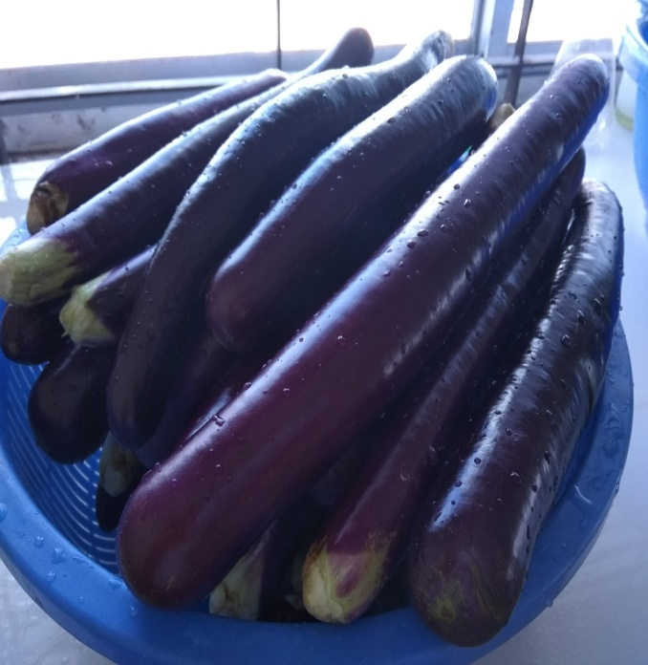 | 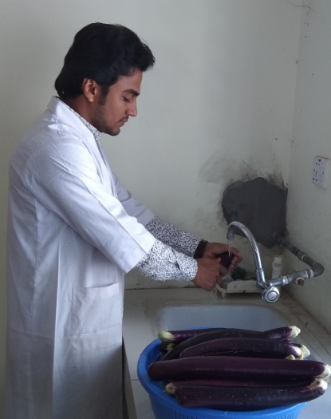
Eggplant | Washing of eggplant with tap water
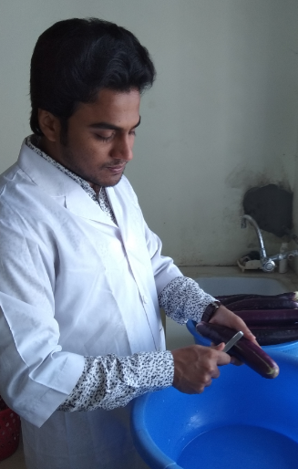 | 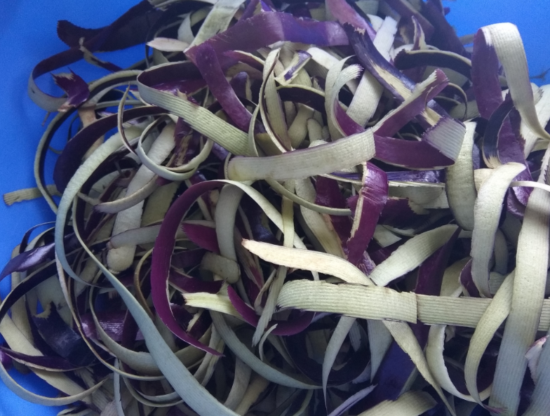
Taking peel of eggplant | Peel of eggplant
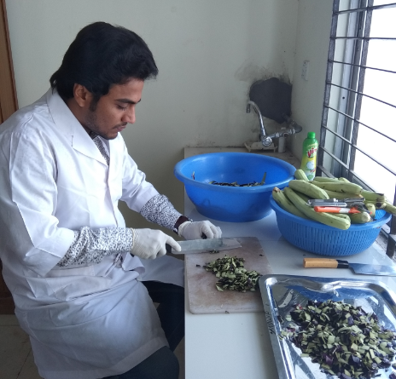 | 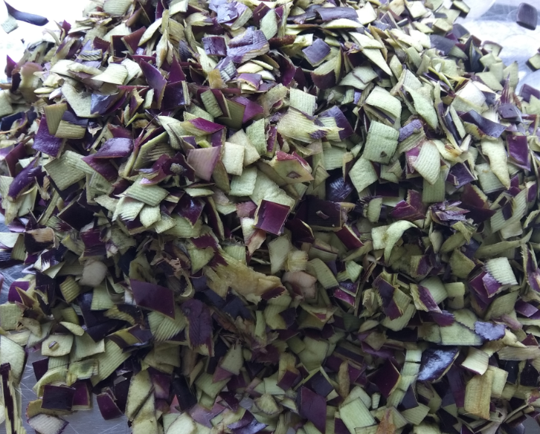
Cutting into small piece of eggplant peel | Small piece of eggplant peel
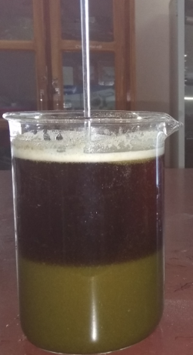 | 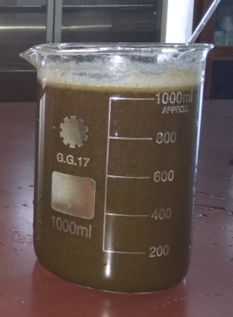
Extraction of anthocyanin
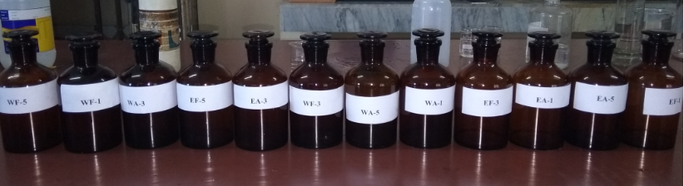
Anthocyanin solution in amberd bottle
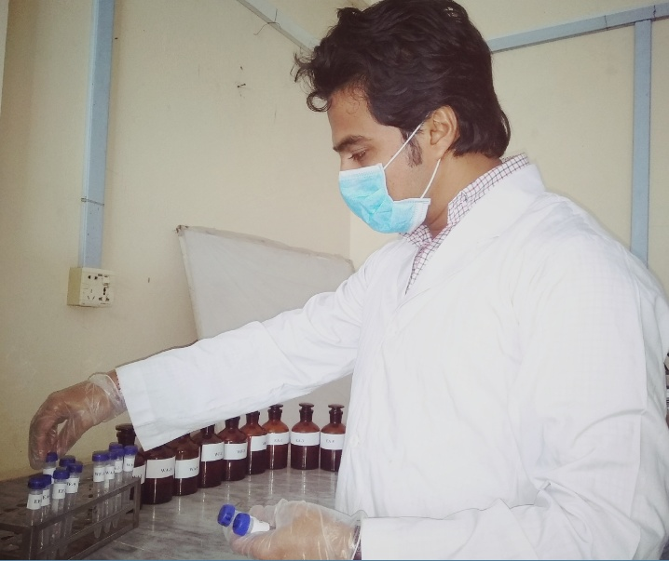 | 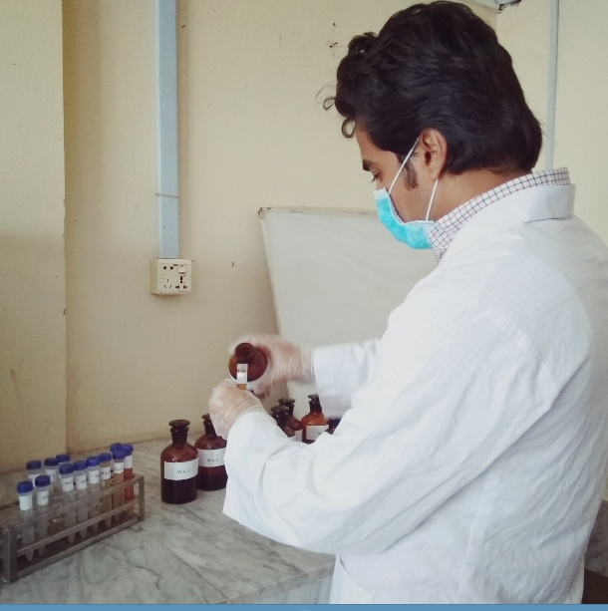
Taking sample in test tube for further analysis
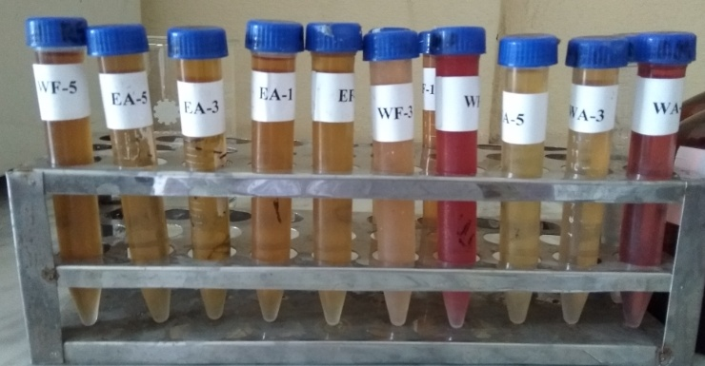
Anthocyanin solution at different pH
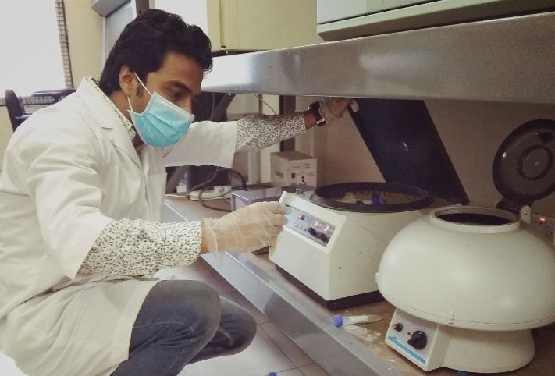
Centrifuge of sample
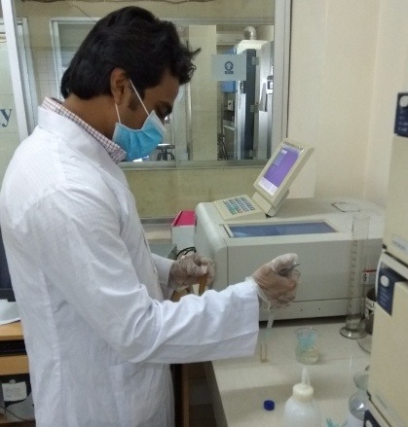 | 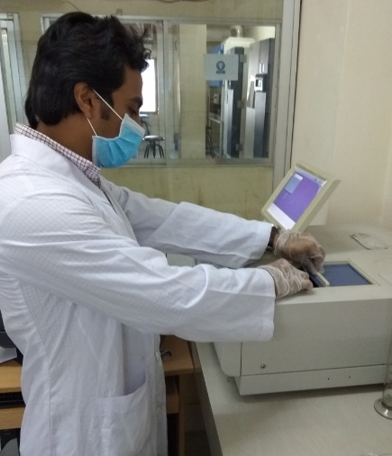
Determination of absorbance of anthocyanin solution by UV visible spectrophotometer
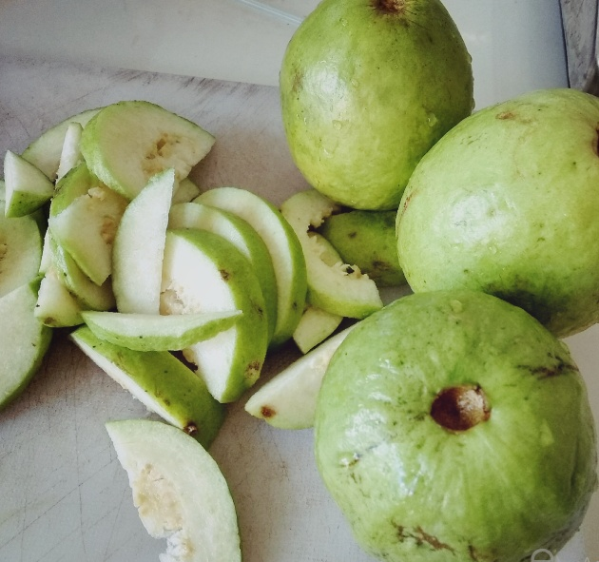 | 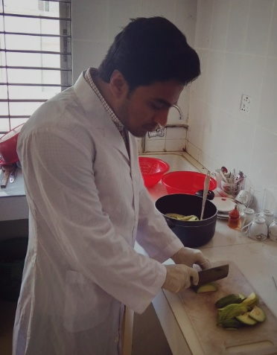
Raw guava for jelly | Slicing of guava for jelly
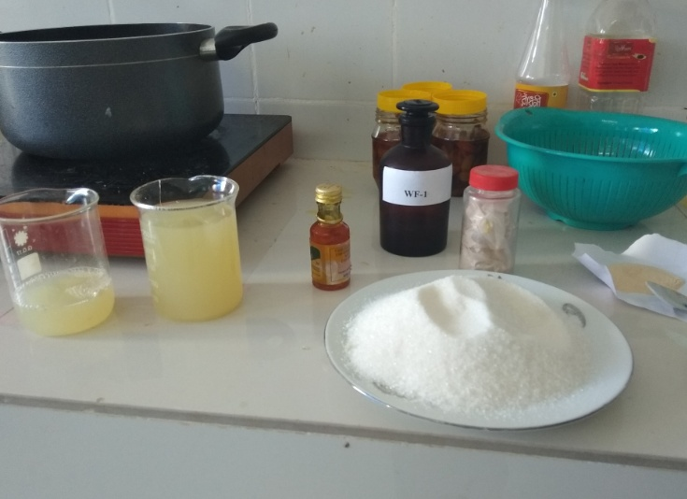 | 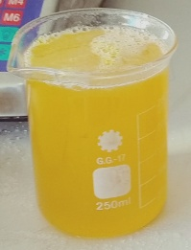
Ingredients for guava jelly | Guava jelly with natural colour (anthocyanin)

Brief bio-data of the student

Md. Jamshed Alam completed B.Sc (Hons.) in Food Science and Technology from the Faculty of Food Science and Technology (FFST) of Chittagong Veterinary and Animal Sciences University (CVASU), Chittagong, Bangladesh with CGPA 3.86 out of 4.00. Now, he is a candidate for the degree of MS in Food Processing and Engineering under the department of Food Processing and Engineering, Faculty of Food Science and Technology (FFST) of Chittagong Veterinary and Animal Sciences University (CVASU), Chittagong, Bangladesh. He has strong passionate in research of food science and published his undergraduate’s research project entitled “Physicochemical and microbiological properties of some potable water samples available in Chittagong area” in Bangladesh Journal of Veterinary and Animal Sciences. His research interests are in processing, preservation and development of modified food products, functional food product development and nutritional value analysis, relation of food properties and processing, quality control and quality assurance regarding food, characterization of physical properties of food materials, chemical and microbial analysis of food, new techniques to measure food quality, taste and flavor, control of unit operation in food processing and instrumental food analysis with UV Visible Spectroscopy, Atomic Absorbance Spectroscopy (AAS), Near-infrared Spectroscopy (NIRS), High Performance Liquid Chromatography (HPLC), Gas Chromatography (GC), Gas Chromatography-mass spectroscopy (GC-MS), GC-MS), etc.

