CHAPTER: 1

INTRODUCTION
Yoghurt is defined as a fermented milk product obtained from coagulation of milk by the agency of organisms of types Streptococcus thermophilus and Lactobacillus bulguricus, Lactobacillus acidophilus may be present (SLSI, 1989). It is one of the most popular dairy products available in worldwide and and the statistical evidences show that the daily market requirement of yoghurt exceeds one million cups (Kanakaratne, 2012). Fruit yoghurt is a product which is made by adding fruits, their nectars, jams, marmalade, fruit jellies, fruit drinks, fruit syrups and concentrated fruit drinks to yoghurt or cultured pasteurized milk.
Moreover, it is reported that incorporation of fruits can effectively enhance the taste and the therapeutic properties of the plain yoghurt (Zainoldin and Baba, 2009). Yoghurts vary in appearance, flavor and ingredients. The quality and composition of yoghurt of applied bacterial cultures affects the quality of the yoghurt obtained as the result of the milk fermentation processes. There is a symbiotic relationship between the two species of bacteriai. E Lactobacillus bulgaricus and Streptococcus thermophilus that‟s why there is more rapid acid development than in the single strain culture (Rasic et al., 1978; Tamime et al., 1980). Various combinations of starter cultures are selected during manufacturing of yoghurt to achieve desirable characteristics of product and also to provide the consumers with a wide choice of therapeutic benefits. Depending on its activity, manufacturer usually adds 2-4 % yoghurt starter culture. Now a days, there has been increasing trends to fortify the dairy product with fruits (natural fruit juice, pulp, dry fruits) (Desai et al., 1994; Ghadge et al., 2008). Aesthetic value of new product can be increased by using fruit juice as a functional pigment in fermented milks with array of colors and flavor properties. Coisson et al., (2005) used Euterpeoleracea juice as functional pigment for yoghurt, which is dark purple in color having high anthocynin and phenolic content. Yoghurt is a functional food. The functional food includes probiotics, prebiotics and synbiotics. Probiotics can be defined as “live microbial feed supplements that beneficially affect the host animal by improving its intestinal microbial balance” (Champagne et al., 2005).

F.A.O/W.H.O (1977), stated “Yoghurt is coagulated milk product obtained by lactic acid fermentation through the action of Lactobacillus Bulgaricus and Streptococcuc Thermophillus, form milk and milk products (pasteurized or concentrated milk) with or without optional additions (milk powder, skim milk powder, whey powder etc.). the micro organisms in the final products must be viable and abundant”.
Mckinley (2005) defined, “Yoghurt is one of the most popular fermented milk products worldwide and has gained widespread consumer acceptance as a healthy food. It provides an array of nutrients in significant amounts, in relation to its energy and fat content, making it a nutrient-dense food. In particular, yoghurt can provide the body with significant amounts of calcium in a bioavailable form. Furthermore, yoghurt has many health benefits beyond the basic nutrition it provides, such as improved lactose tolerance, a possible role in body weight and fat loss, and a variety of health attributes associated with probiotic bacteria”.
Yoghurt is custard like semi solid, acidified dairy product made by fermenting partially evaporated milk with a special culture containing lactic acid producing bacteria (Munzur et al., 2004).Of all, cultured milk products, yoghurts are well known and most popular worldwide (Mansour et al., 1994). The use of yoghurt dates back many centuries, although there is no accurate record of the date when it was first made. Like milk, yoghurt is a healthy and delicious food due to its high nutritive and therapeutic value (Perdigon et al., 2002). Due to low lactose content yoghurt is easily digestible and palatable than milk. Yoghurt is valued for controlling the growth of bacteria and in curing of intestinal disease like constipation, diarrhea and dysentery, anti-carcinogenic effect and lowering of blood cholesterol (Kamruzzaman et al., 2002). Yoghurt can be good sources of essential nutrients as minerals in the human diet. It could contribute significantly to the recommended daily requirements for calcium and magnesium to maintain the physiological process (Sanchez et al., 2000) including raw materials quality, manufacturing process and the strains involved (Kumar and Mishra, 2004). Good quality yoghurt should be smooth, glossy surface, no crakes or holes on the top of yoghurt, no whey syneresis, no off flavor or odor, clean layer on the surface of yoghurt. Yoghurt is generally considered as a safer product and its unique flavour appeals to so many that consideration is being, given by nutritionists to incorporate inexpensive source of nutrients to make it an almost complete food (Boghra and Mathur, 2000).
An increasing demand can be seen for fruit yoghurts. Introduction of various fruit-flavored yogurts has significantly contributed to the consumption of yogurt among all ages (Chandan et al., 1993). There could be many reasons behind this. Incorporation of fruits endorses the healthy image of yogurt. (Bardale et al, 1986) reported that the addition of fruit preparations, fruit flavors, fruit purees, and flavor extracts enhances versatility of taste, color, and texture for the consumer. Sensory appeal also is one of the essential strategies associated with market success of fermented product like yoghurt. The popularity of yoghurt as a food component has been linked to its sensory characteristics (Routray and Mishra, 2011). The key to the increase in sales of yoghurt is a continuous evaluation and modification of the product to match consumer expectations (Alan Hugunin, 1999).Strawberry and Mango are not only easily available and mostly consumed fruits in high amount but also they are rich in β- carotene, lycopene, phenol, anti-oxidants and minerals. Preparation of fruit yoghurt has been investigated by a number of researchers in different parts of world (Desai et al., 1994) and (Shukla et al., 1987). But in Bangladesh no research work has yet been done on the manufacture of yoghurt incorporating strawberry, orange and mango juice. For this reasons the present study was designed to manufacture fruit yoghurt fortified with different levels of strawberry, orange and mango juice with whole milk and to compare their qualities on the basis of physical, chemical and microbial parameters.

Aim and Objectives of the study:

- To compare the chemical characteristics of fruit yoghurt with different fruit juices.
- To compare the physical characteristics of fruit yoghurt with different fruit juices.
- To compare the overall acceptability of the developed products.
- To determine the microbial analysis of fruit yoghurt.

CHAPTER: 2

REVIEW OF LITERATURE

Yogurt, yoghurt, or yoghourt is a food produced by bacterial fermentation of milk. The bacteria used to make yogurt are known as "yogurt cultures". Fermentation of lactose by these bacteria produces lactic acid, which acts on milk protein to give yogurt its texture and characteristic tart flavor. Cow's milk is commonly available worldwide and as such, is the milk most commonly used to make yogurt. Milk from water buffalo, goats, ewes, mares, camels, and yaks is also used to produce yoghurt where available locally. Milk used may be homogenized or not (milk distributed in many parts of the world is homogenized); both types may be used, with substantially different results.
Yoghurt is produced using a culture of Lactobacillus delbrueckii subsp. bulgaricus and Streptococcus thermophilus bacteria. In addition, other lactobacilli and bifidobacteria are also sometimes added during or after culturing yogurt. Some countries require yogurt to contain a certain amount of colony-forming units (CFU) of bacteria; in China, for example, the requirement for the number of lactobacillus bacteria is at least 1 × 106 CFU per milliliter (Lee, Yuan Kee et al., 2012). Codex currently defines yogurt as a milk product obtained by fermentation using these two specific strains with or without optional additions (such as milk powder, other LAB, and sugar). In many countries (e.g., Sweden, France, Belgium, Portugal, Spain, USA) legislation exists allowing only L. bulgaricus and S. thermophilus to be used to produce yogurt. In the UK yogurt can be made using both of these strains or just one of them. In other countries (e.g., Switzerland) strains such as L. acidophilus and bifidobacteria may be used in addition to the traditional yogurt strains. It is likely that the new Codex standard will build on the draft definition currently used for mild yogurt (a product made from S. thermophilus and lactobacilli other than L. bulgaricus). In Japan no separate legislation exists for yogurt and so it is not obligatory that the two traditional strains are used, either collectively or separately. Similarly, in Finland there are also no compositional regulations for any milk products.

Different Types of Yoghurts
Yoghurt is typically classified into the following groups-

Set Yoghurt This type of yoghurt is incubated and cooled in the final package and is characterized by a firm jelly like texture.

Stirred Yoghurt This type of yoghurt is incubated in a tank and the final coagulum is "broken" by stirring before cooling and packing. The texture of stirred yoghurt will be less firm than a set yoghurt somewhat like a very thick cream. A little reformation of coagulum will occur after packaging.

Drinking Yoghurt It also has the coagulum "broken" prior to cooling. In drinking yoghurt the agitation used to "break" the coagulum is severe. Very little reformation of coagulum may occur.

Frozen Yoghurt Frozen yoghurt is inoculated and incubated in the same manner as stirred yoghurt. However, cooling is achieved by pumping through a Whipper / chiller / freezer in a fashion similar to ice-cream. The texture of the finished product is mainly influenced by the whipper/ freezer and the size and distribution of the ice crystals produced.

Concentrated Yoghurt This type of yoghurt is inoculated and fermented in the same manner as stirred yoghurt. Following the "breaking" of the coagulum the yoghurt is concentrated by boiling off some of the water, this is often done under vacuum to reduce the temperature required. Heating of low pH yoghurt can often lead to protein being totally denatured and producing rough and gritty textures. This is often called strained yoghurt due to the fact that the liquid that is released from the coagulum upon heating used to be "strained" off in a manner similar to making soft cheese.

Flavored Yoghurt The flavors are usually added at or just prior to filling into pots. Common additives are fruit or berries, usually as a puree or as whole fruit in syrup. These additives often have as much as 50% sugar in them, however with the trend towards healthy eating gaining momentum; many manufacturers offer a low sugar and low fat version of their products. Low or no sugar yoghurts are often sweetened with saccharin or more commonly aspartame.

Nutrient Profile
Yogurt is exceptionally nutrient dense and are an excellent source or various macro- and micronutrients: high-quality proteins, digestible carbohydrates, calcium, magnesium, phosphorus, vitamin B12, etc. The typical serving size for yogurt is equivalent to 187.5 mL (3/4 cup), 170–175 g, or 6 oz., although serving size may vary from country to country. An average 170 g portion of popular low-fat fruit-flavored yogurt provides 6% of potassium and magnesium, 20–24% of calcium, 26% of phosphorus, 21–25% of riboflavin, and 30% of vitamin B12 recommended daily allowances for adults (Agriculture Research Service, 2014; Institute of Medicine, 2015). In addition, plain yogurt is relatively high in protein, low in fat, and has a low glycemic index, making it an excellent snack or meal accompaniment. The nutritional value of yogurt is recognized by many national health agencies that promote yogurt as a viable option for one of the recommended daily servings of dairy products. Health Canada includes yogurt in its dairy and alternatives food group of the Canadian Food Guide (Health Canada, 2011). The USDA recommends the consumption of yogurt as a low-fat dairy alternative to help Americans achieve the recommended intakes of calcium, vitamin D, and phosphorus (US Department of Agriculture and US Department of Health and Human Services, 2010). Similarly, the British Nutrition Foundation advises the consumption of low-fat fruit yogurt instead of sweets and desserts (British Nutrition Foundation, 2015).
Yogurt micro- and macronutrients contribute to the growth and maintenance of muscle mass. Yogurt proteins and peptides are derived from milk, are highly digestible, and have excellent nutritional quality (Bos et al., 2000). Moreover, yogurt and dairy products are a richer source of calcium and phosphorus per kilocalorie than other foods in an adult diet (Heaney et al., 2000). These nutrients are essential for the structural integrity and development of bones, making yogurt an excellent dietary source of nutrients that help maintain bone health. There is a growing body of evidence that shows that yogurt consumption exerts beneficial effects beyond its impact on growth and development. Indeed, the bacteria present in yogurt and the bioactive compounds formed during fermentation have potential beneficial effects on health (Marsh et al., 2014).

Health Benefits of Yoghurt
Probiotic yoghurt is aimed at reducing medical conditions by restoring the beneficial microbial population in the colon, medical conditions such as constipation and diarrhea. It is beneficial to our digestive system, especially stomach and colon. Cow‟s milk is preferred for preparing yoghurt as having low fat. It provides immunity, protect us from cold, cough and strengthen body‟s defense mechanism. It strengthens the collagen in the skin and is good for our skin. It lowers the blood pressure, bad cholesterol and risk of heart attacks. Yoghurt is a source of natural proteins; it is safer for those having problem in tolerance of lactose. Yoghurt is rich in calcium so; it protects the bones against osteoporosis and arthritis. It discourages vaginal infections. It helps in cutting down calorie and thus helps in burning fat. By daily consumption of yoghurt, disease causing bacteria are flushed out from the colon and thus help in protecting against colon cancer. Consumption of yoghurt can shut down Helicobaterpylori; the bacterium responsible for most ulcers
History of yoghurt
Yogurt is an ancient food that has gone by many names over the millennia: katyk (Armenia), dahi (India), zabadi (Egypt), mast (Iran), leben raib (Saudi Arabia), laban (Iraq and Lebanon), roba (Sudan), iogurte (Brazil), cuajada (Spain), coalhada (Portugal), dovga (Azerbaijan), and matsoni (Georgia, Russia, and Japan). It is believed that milk products were incorporated into the human diet around 10 000–5000 BC, with the domestication of milk-producing animals (cows, sheep, and goats, as well as yaks, horses, buffalo, and camels (Moreno Aznar et al.,2013). However, milk spoiled easily, making it difficult to use. At that time, herdsmen in the Middle East carried milk in bags made of intestinal gut. It was discovered that contact with intestinal juices caused the milk to curdle and sour, preserving it and allowing for conservation of a dairy product for extended periods of time (McGee H, 2004).
Indian Ayurvedic scripts, dating from about 6000 BC, refer to the health benefits of consuming fermented milk products (Brothwell et al., 1997).Today, there are more than 700 yogurt and cheese products found in Indian cuisine. For millennia, making yogurt was the only known safe method for preserving milk, other than drying it. Yogurt was well known in the Greek and Roman empires, and the Greeks were the first to mention it in written references in 100 BC, noting the use of yogurt by barbarous nations. In the Bible (Book of Job), Abraham owed his longevity and fecundity to yogurt consumption, and there is reference to the “Land of Milk and Honey,” which many historians have interpreted to be a reference to yogurt (Batmanglij N, 2007).
It is believed that the word “yogurt” comes from the Turkish word “yoğurmak,” which means to thicken, coagulate, or curdle (McGee H, 2004). The use of yogurt by medieval Turks was recorded in the books Diwan Lughat al-Turk by Mahmud Kashgari (Kashgari M, 1984) and Kutadgu Bilig by K. H. Yusuf,( Yusuf KH, 1983)both written in the 11th century. The texts mention the word “yogurt” and describe its use by nomadic Turks. The Turks were also the first to evaluate yogurt’s medicinal use for a variety of illnesses and symptoms, such as diarrhea and cramps, and to alleviate the discomfort of sunburned skin.
Genghis Khan, the founder of the Mongol Empire, is reputed to have fed his army yogurt, a staple of the Mongolian diet, based on the belief that it instilled bravery in his warriors (McGee H, 2004). In 1542, King Francoise I of France introduced this dairy product to Western Europe after being offered yogurt as a treatment by the country’s Turkish allies for bouts of severe diarrhea. It was later mixed with a variety of ingredients, such as cinnamon, honey, fruits, and sweets, and was used as a dessert (McGee H, 2004).
It was not until the 20th century that researchers provided an explanation for the health benefits associated with yogurt consumption. In 1905, a Bulgarian medical student, Stamen Grigorov, was the first to discover Bacillus bulgaricus (now L. bulgaricus), a lactic acid bacteria that is still used in yogurt cultures today. Based on Grigorov’s findings, in 1909, the Russian Nobel laureate, Yllia Metchnikoff, from the Pasteur Institute in Paris, suggested that lactobacilli in yogurt were associated with longevity in the Bulgarian peasant population (McGee H, 2004). In the beginning of the 20th century, yogurt became known for its health benefits and was sold in pharmacies as a medicine. Yogurt found commercial success when Isaac Carasso, from Barcelona, began producing yogurt with jams. After fleeing the Nazi occupation, Daniel Carasso, Isaac Carasso’s son, founded Dannon (Danone in France). The first yogurt laboratory and factory were opened in France in 1932; in the United States, the first laboratory and factory were opened in 1941(Brothwell D Brothwell P,1997).

Yoghurt Today
Today, yogurt is typically milk that has been fermented and acidified with viable and well-defined bacteria, creating a thickened, often flavored, product with an extended shelf life. It contains essential nutrients and is a vehicle for fortification (added probiotics, fibers, vitamins, and minerals). It is also easily modified by sweeteners, fruits, and flavors to affect consistency and aroma. Yogurt can also be produced from rice, soy, or nuts.
Yogurt is defined by the symbiosis of 2 strains of bacteria (S. thermophiles and L. bulgaricus) in a sterile environment at a very low temperature (36°C–42°C) for 3–8 h. Both bacterial strains must remain active in the final product (with at least 10 million bacteria/g,according to CODEX 2003).The process to which prepasteurized skimmed milk is submitted, before it is turned into yogurt, is responsible for changes in carbohydrates, proteins, and lipids. It yields an acidic flavor and a product with an improved appearance, taste, consistency, and digestibility. When milk lactose is used as the fermentation substrate, lactic acid and a series of other compounds are formed, contributing to its aroma. As a consequence of a decrease in pH, the development of undesirable microorganisms is delayed, the calcium and phosphorus present in milk are converted into their soluble form, and the majority of proteins, now calcium free, are better digested by proteolytic enzymes, which enhance its digestibility and overall bioavailability (Cirone K Huberman Y Morsella Cet al., 2013).
Other bacterial strains, such as Lactobacillus acidophilus and Bifidobacterium bifidus, are often added for potential health benefits. When yogurt is consumed daily, there may be diminished growth of pathogens, which is ultimately beneficial to the human gut (Moreno Aznar LA Cervera Ral P Ortega Anta RM et al., 2013).The protein content of some yogurts, such as Greek yogurt, is modified by concentrating or adding protein to provide twice the amount present in regular yogurt products. Calcium and vitamin D are also added to some products, adding nutritional value for populations with a high incidence of lactose intolerance or a low intake of dairy foods.
The types of yogurt consumed today are influenced by local traditions or correspond to certain lifestyles. In Eastern Europe and Asia, people consume milk that has undergone alcoholic fermentation by combining bacteria and yeasts (e.g., Kefir, Koumis); in Germany and Spain, yogurt is typically heat-treated to kill the bacteria; and in other countries, various probiotics and/or prebiotics are added to the mix(Bodot V Soustre Y Reverend B.,2013).
Looking Ahead: Consumption Opportunities
The majority of populations worldwide do not consume enough dairy products to meet several nutrient needs, particularly calcium. Three common barriers to consuming enough dairy include an allergy to cow’s milk, lactose intolerance, and lack of accessibility. Of 16 European Union nations that provide data on dairy intake, the mean intake of dairy was 266 g/day. Denmark and Finland are 2 countries with population calcium intakes at or near 1000 mg/day, which is higher than the majority of the rest of the world. In the United States, 90%–95% of adult females and 75%–90% of adult males fall short of the recommended 3 servings of dairy per day.10 In Brazil, low calcium intakes are far worse; 99% of adults in Brazil do not reach the minimum amount of recommended calcium intake. Among Brazilian children, 99% consume only 500–600 mg of calcium per day.11 Patterns of yogurt consumption also vary greatly from country to country, but consumption is generally low. In the United States, where consumption of dairy products is broadly encouraged through nutrition education efforts, yogurt consumption is very low, with only about 6% of the population consuming yogurt on a daily basis. Contrast that to consumption levels in France, where the majority of the population consumes at least 1 serving per day and more than 1=3 of the population consumes at least 5 servings each week. Research in 15 countries also shows that those who consume the largest amounts of yogurt live in the Netherlands, France, Turkey, Spain, and Germany, while those who consume the smallest amounts live in Egypt, Colombia, Russia, Romania, and South Africa Euromonitor 2013 data collected by the A.C. Nielsen Center for Market Research at the University of Wisconsin, Madison (Danone Nutricia, 2014). In developing countries, yogurt consumption is often an indicator of economic change taking place. In Brazil, for example, though yogurt consumption is low, it increased more than 7-fold between 1974 and 2003.13 However, while 40% of the Brazilian population consumes dairy products, only 6% consumes yogurt (Instituo, 2010). In general, yogurt consumption is more common among healthier, leaner, more highly educated individuals from higher socioeconomic levels and is most common among women. In a survey of the population in Sa˜o Paulo, Brazil (G. Possa, R. Fisberg, and M. Fisberg, unpublished data), it was found that most consumers were younger, white, female, nondiabetic, nonhypertensive, more educated, nonsmokers, and from higher socioeconomic levels. This has also been found among American and French populations (Wang et al., 2014 and Samara et al., 2013).This new pattern of consumption leads to the assumption that consumers may be interested mostly in the health aspects of yogurt, which opens a window of opportunity to introduce new forms of preparation and presentation that could reach populations with the lowest rates of yogurt intake.

CHAPTER: 3

MATERIALS AND METHODS

The experiment was conducted in the laboratory of the department of food processing and engineering, Chittagong Veterinary and Animal Sciences University (CVASU). Fresh milk was collected from Dairy Farm of Chittagong Veterinary and Animal Science University. Fruits for juice preparation, sugar, and starter culture collected for culture preparation.

3.1 Preparation of fruit yoghurts:

3.1.1 Preparation of culture:
Weighed both 6.75gm MRS agar and 5.25gm M17 agar for preparing 100ml media in a sterilize conical flask, again weighed 5gm lactose dehydrated and preparing 50ml solution. Then sterilized the both media and solution for 15 mins at 121◦C in hot air oven. After that the media was poured in sterilized petridish and added 5ml lactose dehydrates with M17 before pouring into petridish. When the media was become hard sketch the culture on media by inoculating loof and incubated 12 hours at 37.5◦C.Later the culture stored at freezing temperature (-20°C) until preparation of mother culture( Pourahmad, R., Assadi, M., 2005).

3.1.2 Preparation of fruit juices (Strawberry, Orange and Mango)
Collected Strawberry (Fragaria alpina), Orange (Citrus sinensis) and Mango (Mangifera indica) fruit was washed with clean water and the skin was separated with the help of knife aseptically. The seeds were removed from the Strawberry and Oranges. Black spots were removed from strawberry. Strawberries were blended and oranges and mango juice was extracted by juicer. After blending, the juice was filtered with clean cloth (hot water washed). These were kept in plastic containers and stored at freezing temperature (-20°C) until preparation of yoghurt.

3.1.3 Preparation of plain yoghurt (control) and fruit (Strawberry, Orange and Mango) yoghurt
Yoghurt was manufactured according to International Dairy Federation’s yoghurt manufacture procedures (IDF 1988). Fresh cow milk was used for yoghurt production. Briefly, the milk was filtered to remove foreign matters and whole milk was pasteurized and heated to reduce about one-third of its original volume. Sugar was added to the milk at the rate of 12% after boiling. During heating milk was stirred continuously with the help of a stirrer to avoid formation of cream layer. After desired heating milk pan was taken out from the heater and allowed to cool. When the temperature was about 40°C, then milk was divided into equal portions and a different type of yoghurt was prepared from each portion. The fruit (Strawberry, Orange and Mango) juice which is previously pasteurized was incorporated into yoghurt at 5%, 10% and 15% level in different cups except control (Nahar et al., 2007). Juice was added before incubation with starter culture as suggested by (Guven & Karaca, 2002). Milk was inoculated with desirable proportion of starter culture (2%), which was made before. The plastic cups were pre-washed with boiled water before use. The samples were incubated at 37°C until the complete curd formation/coagulation of yoghurt (8-12 hrs). The yoghurt samples were stored at about 4°C at refrigeration until used.

3.2 Chemical analysis of fruit yoghurt
Moisture, Ash content of the different type of milk and juice samples was determined by using Association of Official Analytical Chemist (AOAC, 2005). Fat percent was determined by Rose-Gottlieb Method (A.O.A.C, 2012). Acidity was determined by titration with 0.1N sodium hydroxide solution using the procedure by Aggarwala and Sharma. Crude protein was determined by Kjeldahl described by Method (A.O.A.C, 1995). Total carbohydrate content of the sample was determined by subtracting the measured protein, fat, ash and moisture from 100.

3.2.1 Moisture content
Moisture content was determined adopting AOAC (2005) method 14.004.
Procedure
About 5g was taken in a pre-weight crucible (provide with cover) which was previously heated to 1300C. The sample was dried for 1 hour in an air oven maintained at temperature 130 $±$ 3$°$C. The crucible was while still in oven then transferred to desiccator and weighed immediately after reaching at room temperature.
The loss of weight from sample was determined and the percent of moisture was calculated as follows:

% Moisture content =$\frac{Weight of sample}{Loss in weight}$ $×$100

3.2.2 Ash
AOAC method 14.006 (2005) was used to determine the total ash content.
Procedure
A 5gm sample was weighed into clean, dry porcelain ashing dish which burned until white smoking stopped. The sample was then ignited with a gas burner until white smoking stopped. The sample was then placed in a muffle furnace at 550$°$C and ignited until light gray ash resulted (or to constant weight). The sample was then cooled in desiccators and weighed. The ash content was calculated by the following expression:
% Ash = $\frac{Weight of sample}{Loss in weight }×$100

3.2.3 Fat
AOAC 19th edn, 2012, Official method no.905.02, Fat in milk.
Reagents /Apparatus
- Ammonia Sp. gr. 0.8974 at 16°C.
- Ethyl alcohol (95%).
- Diethyl ether, peroxide-free.
- Petroleum ether, boiling range 40-60°C.
- Mojonnier fat extraction flask or any other suitable extraction tube (as per IS specification).
- Cork or stopper of synthetic rubber unaffected by usual fat solvents.
- 100 ml flat bottom flask with G/G joint or stainless steel or aluminium dishes of 5.5 cm height and 9 cm diameter or glass bowl.

Procedure
Weigh accurately about 10 g of sample (liquid milk), transfer to extraction tube. Add 1.25 ml of ammonia sp. gr. 0.8974, mix and shake thoroughly. Add 10 ml ethyl alcohol and mix again. Add 25 ml of diethyl ether (peroxide free) stopper and shake vigorously for about a minute. Then add 25 ml petroleum ether (boiling range 40 – 60°C and shake again vigorously for about half a minute. Let it stand until the upper ethereal layer has separated completely and is clear. (Alternatively use low r.p.m. Mojonnier centrifuge). If there is a tendency to form emulsion, a little alcohol may be added to help separation of the layers. Decant off the clear ethereal layer into a suitable vessel (flask, glass bowl, aluminium dish, etc.). Wash the delivery end of the extraction tube with a little ether and add the washings to the flask. Repeat twice extraction of the liquid remaining in the extraction tube using 15 ml of each solvent every time. Add the ethereal extract to the same container and evaporate off completely. Dry the flask in an air oven at 102 ± 2°C for two hours, cool in a desiccator and weigh. Heat the flask again in the oven for 30 min. Cool in a desiccator and weigh. Repeat the process of heating and cooling and weighing until the difference between two successive weights does not exceed 1 mg. Wash out the fat from the flask with petroleum ether carefully leaving any insoluble residue in the flask. Dry the flask in the oven and reweigh. The difference in weights represents the weight of fat extracted from the milk. Correct weight of extracted fat by blank determination on reagents used. If reagent blank is more than 0.5 mg purify or replace reagents. Difference between duplicate determinations obtained simultaneously by the same analyst should not be more than 0.03 g fat /100g product.

Fat % (w/w) =$\frac{Weight of Extracted Fat}{Weight of milk}$ $×$100

3.2.4 Protein
AOAC, 18th edn (1995) official method of analysis, protein in milk.
Reagent:
- Sulphuric acid, concentrated
- Potassium sulphate
- Sodium hydroxide and sodium thiosulphate mixture
- Add 25ml of 25% sodium thiosulphate to 100ml of 50% Sodium hydroxide
- Boric acid, saturated solution
- Mercuric oxide, 5% in 4N sulphuric acid
- Tashiro’s indicator
- Dissolve 80mg methyl red and 20mg methylene blue in 95% ethanol and make volume up to 100ml with 95% ethanol
- Hydrochloric acid (Hcl), 0.02N (N/50)
Procedure:
- Weighed accurately 0.5-3.5 g of the homogenized sample into a Kjeldhal digestion flask of capacity 30-35 ml.
- Added 1.2g potassium sulphate, 1ml of mercuric oxide solution,12ml concentrated sulphuric acid ,and a few boiling chips to prevent bumping.
- Heated the mixture in an inclined position on an electric coil heating rack in a fume cupboard.
- Heated more strongly so that the liquid boils at a moderate rate when the initial frothing had ceased.
- Shaked the flask from time to time and continue the heating for 1hour after the liquid has become clear(about 4-5 hours required)
- Prepared the Markham still for distillation. The delivery tube of the apparatus is arranged with its tip below the surface of 10ml of boric acid containing a few drops of Tashiro’s indicator in a125ml conical flask.
- Washed the cooled contents of the digestion tube into the still through the funnel.
- Added 10ml of alkali mixture through the funnel.
- Pass steam through the apparatus until the volume of the liquid in the receiver flask is about 50-100ml (about 8 minutes).
- Lower the receiver flask so that the delivery tube is above the liquid surface and continue the distillation for a further minute.
- Finally, washed down the delivery tube with water and allow the washing to drain into the flask.
- Titrated the contents of the receiver flask back to the original purplish colour with 0.02N HCl delivered from a burette.
- Performed a blank digest, distilled as described above and titrate the distillate
Calculation:
1ml 0.02N (N/50) HCl=0.28mg nitrogen
Therefore, total nitrogen (g) per 100g food
Sample $= \frac{Titre×0.28×100}{1000×Weight in g of food sample taken}$

3.2.5 Total carbohydrate
Total carbohydrate content of the sample was determined as total carbohydrate by difference, that is by subtracting the measured protein, fat, ash and moisture from 100 (Pearson, 1970).

3.2.6 Titratable acidity
The titratable acidity was measured by titrating 15 ml of the yoghurt with 0.1 M sodium hydroxide until the substance reached a pH value 8.2,corresponding to the end point of the phenolphthalein. Readings were done with pH meter (JENWAY 3505).When this value was reached, the spent NaOH volume was recorded and the acid percentage of the substance was calculated using the formula:

Titratable acidity =$\frac{Titre value x M x 90 x 100}{Volume of sample x 1000}$

3.3 Sensory quality evaluation of fruit yoghurt
Prepared fruit flavored yoghurt were subjected to sensory evaluation by ten semi- trained panelists. The panelists comprised of female and male members who had previous experience on milk and milk products evaluation. The evaluation of fruit flavored yoghurt was carried out on color, flavor, taste, odor and overall acceptability. Evaluation was done at room temperature in the laboratory of the department of food processing and engineering, Chittagong Veterinary and Animal Sciences University (CVASU).Each panelist scored samples independently and recorded the scores on the sheets provided. Panelists were served water and unsalted crackers to clean their mouths before tasting each sample (Bodyfelt et al., 1988). The scale were arranged such that: Like extremely = 9, Like very much = 8, Like moderately = 7, Like slightly = 6, Neither like nor dislike = 5, Dislike slight = 4, Dislike moderately = 3, Dislike very much = 2, Dislike Extremely = 1. This method does not, of course, reflect actual consumer perception, but it does strongly indicate attributes which a good quality product should possess (Sing et al, 2008). All analyses were carried out in duplicate for each sample and results obtained were computed into means.

3.4 Bacteriological Investigation
The bacteriological investigation of the samples was done in Poultry Research and
Training Centre (PRTC), Chittagong Veterinary and Animal Sciences University,to get an idea about the shelf life of the products.

3.4.1 Required apparatus:
- Balance
- Conical flask
- Autoclave machine
- Test tube
- Durham’s tube
- Pipette
- Rack
- Micropipette
- Water bath
- Incubator
- Hot air oven

3.4.2 Reagents:
- Plate Count Agar
- Saborauded Dextrose Agar
- MacConkey broth

3.4.3 Isolation of total viable count:
A total viable count was done according to (FAO 1997) using plate count agar (Oxoid, CM 0325). One ml of yogurt samples was homogenized using vortex mixer (VM-300, Taiwan) with 9 ml sterile peptone water to obtain first dilution. One ml of the sample from a selected dilution was pour-plated in duplicate and incubated for 24 hours at 37°C. The enumeration of bacteria was performed using digital colony counter and the result was expressed as colony forming units per ml (CFU/ml).

3.4.4 Isolation of total coliform count:
Total coliform count was done according to Standard Methods for Examination of Dairy products (Michael and Frank 2004). The media was prepared according to manufactures instructions.10ml macConkey broth distributed in every test tube (9 test tubes), where durhan’s tube placed inverted position. Then autoclaved at 121$℃$for 15 minutes and incubated at $37℃$ overnight for contamination check .After checking, then added 10:1:0.1ml ratio sample into test tube and incubated at $37℃$ 24hours.when color changed and gas produced coliform positive either negative.

3.4.5 Isolation of yeast and mould count:
Yeast and mould count was carried out according to FAO (1997). Saborauad Dextrose Agar (Himedia, M096) media was prepared according to manufactured .Then poured into petridish and incubated overnight for checking contamination. One ml of homogenized sample was taken and plated on prepared SDA media in duplicate. The result was expressed as yeast and mould growth was present or not.

CHAPTER: 4

RESULTS

4.1 Comparison of chemical characteristics of fruit yoghurts

4.1.1 Yoghurts with 5% fruit juice:

Table: 4.1Effect of chemical characteristics on quality of plain and different types of fruit yoghurt with 5% fruit juice.

Chemical characteristics | Different types of fruit yoghurt with 5% fruit juice
 | Moisture (%) | Protein  (g) | Fat(g) | Carbohydrate (g) | Ash (%) | Acidity (%)
P | 77.50±0.01 | 3.62±0.02 | 4.5±0.01 | 15.25±0.015 | 0.58±0.01 | 0.66±0.00
$$S_{1}$$ | 77.12±0.02 | 3.5±0.01 | 3.31±0.01 | 15.55±0.02 | 0.51±0.01 | 0.76±0.01
$$O_{1}$$ | 75.08±0.01 | 3.61±0.01 | 3.11±0.01 | 17.43±0.015 | 0.71±0.01 | 0.72±0.02
$$M_{1}$$ | 73.90±0.02 | 3.25±0.01 | 4.45±0.02 | 17.71±0.01 | 0.67±0.01 | 0.67±0.01
Level of Significance | ** | ** | ** | ** | ** | **

(P=plain,${ S}_{1 },O_{1},M_{1}$ =5% of strawberry, orange, mango), Mean± Standard Deviation, ** = significant at 1% level, * = significant at 5% level, NS = Non significant.

Statistical analysis showed that the differences of moisture percentage among 5% fruit yoghurts were significant at 1% level, highest record counted in plain yoghurt than other fruit yoghurt. Maximum fat percent was seen in plain (P) yoghurt and fat percent was found in fruit yoghurts with 5% mango juice was nearly equal. Generally fruit contains low level of fat, so the addition of fruit juice might have decreased the fat percent of fruit yoghurt. The protein content was decreased due to addition of fruit juice because fruit juice contains lower protein than milk. The protein content did not differ significantly (p>0.05) among the different treatments. The carbohydrates content was highest in M1 type yoghurt and the lowest in plain (P) yoghurt (Table 4.1). Acidity increased a little due to the addition of different type of fruit juice. The differences in fat percentage between plain yoghurt and yoghurt containing fruit juice were significant (p>0.05). Overall ash content of yoghurt with 5% fruit juice was somewhat higher than that of plain yoghurt except S1 but differences in ash content among the treatments was significant (p>0.05)

Figure 4.1: Comparison of Chemical Characteristics of 5% Fruit Yoghurts.

4.1.2 Yoghurts with 10% fruit juice:

Table: 4.2Effect of chemical characteristics on quality of plain and different types of fruit yoghurt with 10% fruit juice.
Chemical characteristics | Different types of fruit yoghurt with 10% fruit juice
 | Moisture (%) | Protein  (g) | Fat(g) | Carbohydrate  (g) | Ash (%) | Acidity (%)
P | 77.50±0.01 | 3.62±0.02 | 4.5±0.01 | 15.25±0.015 | 0.58±0.01 | 0.66±0.00
$$S_{2}$$ | 77.15±0.01 | 3.44±0.01 | 3.21±0.01 | 15.69±0.015 | 0.47±0.01 | 0.80±0.01
$$O_{2}$$ | 76.86±0.01 | 3.6±0.01 | 3.09±0.01 | 17.33±0.015 | 0.68±0.01 | 0.79±0.01
$$M_{2}$$ | 74.18±0.02 | 3.14±0.01 | 4.44±0.01 | 17.56±0.01 | 0.65±0.01 | 0.75±0.01
Level of Significance | ** | ** | ** | ** | ** | **

(P=plain, $S_{2},O_{2},M_{2}$=10% of strawberry, orange, mango), Mean± Standard Deviation,
** = significant at 1% level, * = significant at 5% level, NS = Non significant.
Maximum fat percent was seen in plain/control (P) yoghurt and lowest fat percent was found in case of O2 and S2 type yoghurt. The average values of protein content of P, S2, O2 and M2 types of yoghurt were 3.62, 3.44, 3.6 and 3.14 g respectively (Table 3). The protein content did not differ significantly (p>0.01) among the different treatments. Statistical analysis showed that there were significant (p<0.05) differences among the fruit yoghurts with 10% juice as far as carbohydrate is concerned. The carbohydrate content was highest in O2 type yoghurt and the lowest in plain (P) yoghurt (Table 4.2). Overall ash content of yoghurt with 10% strawberry juice was somewhat lower than that of plain yoghurt but differences in ash content between and among the treatments was significant (P>0.05). The differences of acidity percentage among yoghurts with 10% fruit juice were significant. Acidity increased a little due to the addition of different type of fruit juice, highest acidity recorded in O2 and lowest was in plain yoghurt. The differences in fat percent between plain yoghurt and yoghurt containing fruit juice at 10% concentration were significant (P>0.05).

Figure 4.2: Increasing of Acidity with Fruit Juice (Orange) Concentration.

4.1.3 Yoghurts with 15% fruit juice:

Table: 4.3 Effect of chemical characteristics on quality of plain and different types of fruit yoghurt with 15% fruit juice.

Chemical characteristics | Different types of fruit yoghurt with 15% fruit juice
 | Moisture (%) | Protein  (g) | Fat(g) | Carbohydrate  (g) | Ash (%) | Acidity (%)
P | 77.50±0.01 | 3.62±0.02 | 4.5±0.01 | 15.25±0.01 | 0.58±0.01 | 0.66±0.005
$$S_{3}$$ | 77.24±0.03 | 3.53±0.01 | 3.13±0.01 | 15.46±0.01 | 0.62±0.02 | 0.82±0.01
$$O_{3}$$ | 75.49±0.01 | 3.59±0.01 | 3.03±0.01 | 17.26±0.01 | 0.65±0.01 | 0.80±0.01
$$M_{3}$$ | 74.31±0.01 | 3.11±0.01 | 4.41±0.01 | 17.55±0.01 | 0.64±0.01 | 0.76±0.01
Level of Significance | ** | ** | ** | ** | ** | NS

(P=plain,$S_{3},O_{3 ,} M_{3}$ =15% of strawberry, orange, mango), Mean± Standard Deviation, ** = significant at 1% level, * = significant at 5% level, NS = Not significant.

The difference in the mean moisture percentage was significant among the different yoghurt samples. The highest value (77.50) was recorded in case of plain yoghurt. The differences in fat percent between plain yoghurt and yoghurt containing fruit juice at 15% concentration were significant (P>0.05). Maximum fat percent (4.5) was seen in plain yoghurt and fat percent was found to gradually decrease in addition of fruit juice. The average values of protein content of P, S3, O3 and M3 types of yoghurt were 3.62, 3.53, 3.59 and 3.11 g respectively (Table4. 3). The carbohydrate content was highest in M3 (15% grape juice) type yoghurt and the lowest in plain (P) yoghurt. Statistical analysis showed that there were significant (P<0.05) differences among the different types of fruit yoghurt in terms of carbohydrate content. As juice concentration increase, the nutrient content of yoghurt also increased. Overall ash content of yoghurt with 15% levels of grape juice was somewhat lower than that of plain yoghurt but differences in ash content between and among the treatments was significant (P>0.05).The average percentage of acidity of yoghurt samples P, S3, O3 and M3 type were 0.66, 0.82, 0.80 and 0.76 respectively (Table 4.3). Statistical analysis showed that the differences of acidity percentage among different treatments were not significant.

Figure 4.3: Comparison of Ash Percentage on Different Types of Yoghurts.

4.2 Comparison of physical characteristics of fruit yoghurts
Plain yoghurt (no fruit juice added) was compared with yoghurts incorporating different concentrations (5%, 10% & 15%) of juices of strawberry (S1, S2 & S3), orange (O1, O2 & O3) and Mango (M1, M2 & M3) for average smell and taste, body and consistency and color and flavor and overall Acceptability by a team of judges. Results of the organoleptic tests were presented in (Table 4.4, 4.5, 4.6).

4.2.1 Yoghurts with 5% fruit juice:

Table: 4.4 Effect of physical characteristics on quality of plain and different types of fruit yoghurt with 5% fruit juice.
Physical characteristics | Different types of fruit yoghurt with 5% fruit juice
 | Smell and Taste | Body and Consistency | Color and Texture | Overall Acceptability
P | 7.95±0.50 | 7.80±0.05 | 7.81±0.152 | 7.82±0.026
$$S_{1}$$ | 6.60±0.10 | 6.6±0.10 | 6.68±0.02 | 6.51±0.01
$$O_{1}$$ | 8.08±0.28 | 7.89±0.005 | 7.80±0.005 | 7.91±0.10
$$M_{1}$$ | 6.4±0.10 | 6.00±0.005 | 6.21±0.01 | 6.02±0.20
Level of Significance | ** | ** | NS | **

(P=plain,${ S}_{1 },O_{1},M_{1}$ =5% of strawberry, orange, mango), Mean± Standard Deviation, ** = significant at 1% level, * = significant at 5% level, NS = Not significant.

Statistical analysis shows that there was significant difference at 0.01% level among the smell and taste and body and consistency score of different types of yoghurt. Highest smell and taste score (8.08) was recorded in case of yoghurt with 5% orange juice (O1). On the other hand, lowest score (6.4) was seen in case of yoghurt with 5% Mango juice (M1). The highest score of body and consistency was found in O1 and plain yoghurt and the lowest score (6.0) was seen in case M1 type yoghurt. There was no significant difference for color and texture scores of different types of fruit yoghurt. From (Table 4.4), the highest score 7.82) was both equal for plain type and O1yoghurt, the lowest score (6.21) was for S1 type of yoghurt. Texture of strawberry fruit yoghurt was crack down due to high content of acid. Overall acceptability was highest recorded for O1 (7.91).0n the other hand, lowest was (6.02) for M1 fruit yoghurt.

4.2.2 Yoghurts with 10% fruit juice:

Table: 4.5Effect of physical characteristics on quality of plain and different types of fruit yoghurt with 10% fruit juice.
Physical characteristics | Different types of fruit yoghurt with 10% fruit juice
 | Smell and Taste | Body and Consistency | Color and Texture | Overall Acceptability
P | 7.95±0.50 | 7.80±0.05 | 7.81±0.152 | 7.82±0.026
$$S_{2}$$ | 6.60±0.10 | 6.11±0.01 | 6.46±0.15 | 6.35±0.03
$$O_{2}$$ | 8.36±0.057 | 8.29±0.02 | 8.24±0.46 | 8.33±0.01
$$M_{2}$$ | 5.95±0.50 | 5.91±0.28 | 6.02±0.25 | 5.7±0.01
Level of Significance | ** | ** | * | NS

(P=plain, $S_{2},O_{2},M_{2}$=10% of strawberry, orange, mango), Mean± Standard Deviation, ** = significant at 1% level, * = significant at 5% level, NS = Non significant.
Statistical analysis shows that there was significant difference at 0.01% level among the smell and taste scores of different types of yoghurt. Higher smell and taste score (8.36) was recorded in case of O2 (10% orange) type yoghurt. On the other hand, lowest score (5.95) was seen in case of M2 (10% strawberry) type yoghurt. The result of this experiment indicates that smell and taste of yoghurt was optimum level due to the addition of 10% orange juice which gave the best result. 10% grape juice yoghurt also gives good quality. There was no significant difference among the body and consistency scores of different types of fruit yoghurt with 10% juice.
Optimum body and consistency of yoghurt was found in yoghurt with 10% orange juice. There was significant difference (P<0.05) in color and texture scores of different types of fruit. The highest score was found for 10% orange juice yoghurt. The result of this experiment supports the findings of Desai et al. who observed that addition of fruit juice improved the color and texture score of yoghurt. Considering all the quality parameters the highest score is given to yoghurt with 10% orange juice.

Figure 4.5: Comparison of Overall Acceptability on Different Types of Yoghurts.

4.2.3 Yoghurts with 15% fruit juice:

Table: 4.6 Effect of physical characteristics on quality of plain and different types of fruit yoghurt with 15% fruit juice.
Physical characteristics | Different types of fruit yoghurt with 15% fruit juice
 | Smell and Taste | Body and Consistency | Color and Texture | Overall Acceptability
P | 7.95±0.50 | 7.80±0.05 | 7.81±0.152 | 7.82±0.026
$$S_{3}$$ | 6.60±0.05 | 5.9±0.01 | 6.32±0.02 | 6.35±0.05
$$O_{3}$$ | 7.8±0.01 | 7.81±0.01 | 7.74±0.04 | 8.30±0.01
$$M_{3}$$ | 5.73±0.05 | 5.82±0.02 | 5.91±0.01 | 5.70±0.01
Level of Significance | NS | ** | * | NS
(P=plain,$S_{3},O_{3 ,} M_{3}$ =15% of strawberry, orange, mango), Mean± Standard Deviation, ** = significant at 1% level, * = significant at 5% level, NS = Non significant.
Average smell and taste scores of yoghurt samples containing 15% fruit juice of strawberry (S3), Orange (O3) and Mango (M3) were 6.60, 7.8 and 5.73 respectively compared to 7.95 of plain yoghurt (Table 4.6). Statistical analysis shows that there was no significant difference among the smell and taste scores of different types of yoghurt with 15% juice. Higher smell and taste score (44.6) was recorded in case of O3 type yoghurt. On the other hand, lowest score (28.4) was seen in case of S3 type yoghurt. There was significant difference (P>0.01) among the body and consistency scores of fruit yoghurts. From (Table 4.6), the highest score (7.81) was found for O3 type and lowest score (5.82) was for M3 type yoghurt. The average color and texture score of yoghurt samples containing P, S3, O3 and M3 fruit yoghurt were 7.81, 6.32, 7.74 and 5.91 respectively (Table 4.6). There was no significant difference among the overall acceptability scores of different types of fruit yogurt with 15% juice.

4.3 Comparison of Microbiological characteristics of fruit yoghurts:
Microbiological characteristics are indicators of safety, quality and shelf life of prepared yoghurt. Total viable count, total coliform count and yeast and Mold count of the fruit yoghurt was determined 0, 5, and 9 days. Results obtained are shown in (Table 4.7, 4.8 & 4.9).

4.3.1 Yoghurts with 5% fruit juice:

Table: 4.7 Microbiological Quality of fruit yoghurts with 5% fruit juice.
Parameter | Different types of fruit yoghurt with 5% fruit juice
 | P |  |  | $$S_{1}$$ |  |  | $$O_{1}$$ |  |  | $$M_{1}$$
 | 0 | 5 | 9 | 0 | 5 | 9 | 0 | 5 | 9 | 0 | 5 | 9
TVC, log cfu/ml | 1.85 | 5 | 5.6 | 1.6 | 5.18 | 22 | 2.23 | 5.46 | 14 | 2.3 | 5.95 | 21
Coliform | -ve | -ve | -ve | -ve | -ve | -ve | -ve | -ve | -ve | -ve | -ve | -ve
Yeast & Mold | A | A | P | A | A | P | A | A | P | A | A | P
(P=plain,${ S}_{1 },O_{1},M_{1}$ =5% of strawberry, orange, mango),-ve=negative, A=Absent,
P =present.
Table revealed that data regarding total viable count, total coliform and yeast & mold count in plain and fruit yoghurt treatments and each treatment were enumerated on 0, 5thand 9th day of storage. In term of total viable count among the fruit yoghurt with 5% juice was significantly different. Highest total viable count recorded for M1 and the lowest value recorded for plain yoghurt. Higher organism count in yoghurt with different fruit juice might be due to increased level of juice in yoghurt. Similarly, Tarakci and Kucukoner (2003) also stated that, Total bacteria and yeast and mould counts in control sample was lower than yoghurt samples containing fruit juice. Data represented in Table also showed that, all treatments and control yoghurt were free from Coliform group, mould and yeast either in fresh or stored product.But after 9days the product was unacceptable to eat.

4.3.2 Yoghurts with 10% fruit juice:

Table: 4.8 Microbiological Quality of fruit yoghurts with 10% fruit juice.
Parameter | Different types of fruit yoghurt with 10% fruit juice
 | P |  |  | $$S_{2}$$ |  |  | $$O_{2}$$ |  |  | $$M_{2}$$
 | 0 | 5 | 9 | 0 | 5 | 9 | 0 | 5 | 9 | 0 | 5 | 9
TVC, log cfu/ml | 1.85 | 5 | 5.6 | 1.9 | 5.2 | 22.1 | 2.25 | 5.50 | 14.5 | 2.31 | 7.85 | 21.1
Colifor-m | -ve | -ve | -ve | -ve | -ve | -ve | -ve | -ve | -ve | -ve | -ve | -ve
Yeast & Mold | A | A | P | A | A | P | A | A | P | A | A | P
(P=plain, $S_{2},O_{2},M_{2}$=10% of strawberry, orange, mango),-ve=negative, A=Absent,
P =present.
Table showed that yoghurt with 10% mango juice contain highest number of total viable count after 5days but yoghurt sample with 10% strawberry juice shows that lowest total count. All organisms were found in low number in plain yoghurt. From the data, it was observed that might be related to the increased level of fruits in yoghurt and microbial load from fruits used for fruit yoghurt preparation. Similar results were reported by Con, et al., (1996) who found that, increased yeast and mould counted when fruit flavor increased in yoghurt.

4.3.3 Yoghurts with 15% fruit juice:

Table: 4.9 Microbiological Quality of fruit yoghurts with 15% fruit juice.
Parameter | Different types of fruit yoghurt with 15% fruit juice
 | P |  |  | $$S_{3}$$ |  |  | O3 |  |  | M3
 | 0 | 5 | 9 | 0 | 5 | 9 | 0 | 5 | 9 | 0 | 5 | 9
TVC,  log cfu/ml | 1.85 | 5 | 5.6 | 2.01 | 5.23 | 21.11 | 1.9 | 5.2 | 17.2 | 2.3 | 7.89 | 21.55
Coliform | -ve | -ve | -ve | -ve | -ve | -ve | -ve | -ve | -ve | -ve | -ve | -ve
Yeast & Mold | A | A | P | A | A | P | A | A | P | A | A | P

(P=plain,$S_{3},O_{3 ,} M_{3}$ =15% of strawberry, orange, mango),-ve=negative, A=Absent, P =present.
The total viable bacterial count, coliform count, yeast and mold count of plain yoghurt and yoghurt with 15% strawberry (S3), orange (O3) and mango (M3) were presented in (Table 6). Results revealed lowest viable count was observed in 15% strawberry juice yoghurt and highest in orange and mango juice yoghurt. Highest total viable organism and yeast & mold count were recorded for 15% grape juice yoghurt and lowest for plain yoghurt. Within 5days there were no growth of yeast & mold in plain yoghurt and all fruit yoghurt.

CHAPTER: 5

DISCUSSION

The study was conducted to develop fortified fruit yoghurt with acceptable chemical, physical and microbiological quality. Three different fruit (strawberry, orange and mango) with three different concentrations (5%, 10% and 15%) are used in this experiment. It is obvious from the study that the 10% orange juice (O2 type) improves the organoleptic quality and chemical characteristics of fruit yoghurt at the refrigeration temperature. On the other hand, all kinds of chemical characteristics are also acceptable comparing with other fruit yoghurt. The moisture content of fruit yoghurt was decreased because fruit (strawberry, orange and grape) contain slightly low water than milk. Highest and lowest recorded was plain yoghurt (77.50%) and 5% mango juice (73.90%) respectively. The fat and protein of fruit yoghurt were decreased comparing with plain/ control yoghurt. It was obtained that change in fat and protein contents in yoghurt samples was highly influenced by adding fruit juice. The protein and fat contents in yoghurt samples decreased with increasing fruit juice percentage. This might be attributed to the low protein and fat contains of fruit as compare to milk. This finding agrees with the work of Debashis et al., (2016) who reported that, the fat and protein content of yoghurt decreased with increase of banana, papaya and watermelon pulp percentages. Similar finding was also reported by Hossain et al., (2012) who found that, the fat and protein content of fruit yoghurt decreased with increase of strawberry, orange and grape percentages. The result of the study indicates that, the maximum and minimum fat and protein content were found in plain and yoghurt containing 15% fruit juice respectively 4.5g, 3.62g and 3.03g, 3.11g.
The ash content of fruit yoghurt was also decreased with increase of fruit juice percentage (concentration). The result was in accordance with the work of Debashis et al., (2016) who found that, ash content in papaya and watermelon yogurts decreased with the increase of pulp concentration. The fruit yoghurt contains more carbohydrate than plain/control yoghurt, highest value was found in 5%mango juice 17.71g. Highest acidity percentage was recorded in 15% strawberry juice and lowest was plain yoghurt respectively 0.80% and 0.66%.The acidity of all fruit yoghurt was increased because fruit (strawberry, orange and mango) contain more acid than milk. Similar observation was reported by Debashis et al., (2016) who reported that, the acidity of yoghurt was increased with increasing of banana, papaya and watermelon percentages.
The result obtained in this study indicates that, the highest mean scores (smell and taste, color and texture, body and consistency and overall acceptability) observed in 10% orange juice yoghurt respectively 8.36, 8.29, 8.24 and 8.33. Related result was reported by Amal et al., (2016) the yoghurt containing papaya pulp had the higher mean scores (appearance and color, flavor, body and texture and overall acceptability) as compared to plain yogurt. The result is more or less similar to other researcher (Madhu et al., 2012).
Fruits which are used for this research purposes contain more acid. For this reason the coliform, total viable count, yeast and molds are acceptable but the microbial load is increased highly in normal temperature for the time being and it is not acceptable after 9 days. The strawberry juice contains high amount of acid. For this reason strawberry fruit yoghurt is highly acidic but 5% strawberry juice (S1 type) yoghurt are acceptable because its pH and acidity is acceptable for human consumption. Above 5% level of strawberry juice is not suitable for fruit yoghurt making. The quality of fruit yoghurt can be improved by proper pasteurization of milk and fruit juice and necessary steps of sanitary conditions.

CHAPTER: 6

CONCLUSIONS

Yoghurt is a product with multiple health benefits given by viable bacteria. The addition of fruit juices in yoghurt can improve its nutritional and sensory properties. The mean hedonic scores for general appearance, color, taste, odor, flavor and texture (mouth-feel) and overall liking revealed that the most appreciated taste is obtained by sample 10% orange juice. Yoghurt fortified with 10% orange juice is the best in all quality aspects among the yoghurts formulated in this study. Yoghurts with 5% fruit juice are also of acceptable in quality but vary with each other slightly in organoleptic properties. 15% mango juice is not suitable for yoghurt making. This product has acceptable sensory values even without any addition of either of natural or artificial color and flavor .This formulation and quality findings may be useful for yoghurt industries to produce new variety of yoghurts.

CHAPTER: 7

RECOMMENDATIONS AND FUTURE PERSPECTIVES

Yogurt is a component of the DASH (Dietary Approaches to Stop Hypertension) diet designed to reduce the risk of high blood pressure. This diet, which includes three servings a day of low-fat and fat-free milk, yogurt and cheese, and 8 to 10 servings of fruits and vegetables, has also been shown to reduce risk of heart disease and stroke.
This formulation is suitable for yoghurt industries to produce new variety of yoghurts.
For this reason, local industry can pick up the product for large scale manufacturing and marketing throughout the country and could be benefited financially.

By adding flavor and color the quality of the product can be improved. Natural or food grade artificial color and flavor can be used according to the consumer preference. An appropriate packaging material for the product can also be selected which will protect the product from physical, chemical and microbial hazards.

REFERENCES

Aggarwala, A.C. and A. Sharma, 1961. A Laboratory Manual of Milk Inspection. 4th Edn., Asia Publishing House, New Delhi, India, pp:14.

Amal, A. Matter, Eman, A. M. Mahmoud, Nahla S. Zidan, 2016. Fruit Flavored Yoghurt: Chemical, Functional and Rheological Properties. International Journal of Environmental & Agriculture Research. Vol-2, Issue-5, 2016.

AOAC, 2005. Official methods of Analysis, 17th edition, Association of Official Analytical Chemists, Washington, D.C. USA.

AOAC, 1995. Official Methods of Analysis of the Association of Official Analytical Chemists. Vol II 16th ed.,AOAC Arlington, VA.

AOAC, 2002. Official Methods of Analysis. 17th Edn., Association of Analytical Chemists,Gaithersburg,MD.,USA.

Association of Official Analytical Chemists (1995). Official methods of Analysis.18th Eddition (Williams S.ed.),AOAC, Virginia.

AOAC. 2012 Official Methods of Analysis of AOAC International (19th) Method Nr 905.02.Gravimetric Method (Röse Gottlieb) association of official analytical chemists, USA.

AOAC (1995). Official Methods of Analysis.14th ed., Horwitz, W. (ed.). The Association of Official Analytical Chemists. Washington DC.

APHA, 1998. Standard Methods for Examination of Dairy Products. 20th Edn., American Public Health Association, Washington, DC., USA.

Atamian S, Olabi A, Kebbe Baghdadi O, et al. The characterization of the physicochemical and sensory properties of full-fat, reduced-fat and low-fat bovine, caprine, and ovine Greek yogurt (Labneh). Food Sci Nutr. 2014;2:164–173.

Bardale, P.S., Waghmare, P.S., Zanjad, P.N., and Khedkar, D.M., 1986. The preparation of shrikhand like product rom skin chakka by fortifying with fruit pulps, Indian J. 38,431-432.

Batmanglij N. A Taste of Persia: An Introduction to Persian Cooking. Washington, DC: Mage Publishers; 2007.

Begum,J.,A.Nahar, M.N. Islam and M.M. Rahman, 2011. Qualitative characteristics of Dahi prepared from non-fat-dry milk fortified with vegetable oil. Bangladesh Res. Publ. J., 6: 35-45.

Biswas, A.A., 1997. Effect of banana (Musa sapientum) leaf on the keeping quality of raw milk. M.S. Thesis, Department of Dairy Science, Bangladesh AgriculturalUniversity,Mymensingh,Bangladesh.

Bodot V, Soustre Y, Reverend B. Best of 2013: Yogurt Special. French National Dairy Council (CNIEL): Scientific and Technical Affairs Division; 2013.

Bodyfelt FW, Tobias J, Trout GM 1988. The Sensory Evaluation of Dairy Products. New York,NY, USA: Van Nostrand Reinhold.

Boghra, V.R. and O.N. Mathur, 2000. Physico-chemical status of major milk constituents and minerals at various stages of shrikhand preparation. J. Food Sci. Technol., 37:111-115.

Brothwell D, Brothwell P. Food in antiquity: a survey of the diet of early peoples. Baltimore: Johns Hopkins University Press; 1997.

Champagne CP and Gardener NJ (2005). Challenges in the Addition of Probiotic Cultures to Foods. Critical Reviews in Food Science and Nutrition 45 61-84.

Chandan, R.C., and Shahani K.M., 1993. Yogurt. In: Dairy Science and Technology Handbook: Product Manufacturing, Vol. 2, Y.H. Hui (Ed). New York: Wiley-VCH. pp.1-56.

Cirone K, Huberman Y, Morsella C, et al. Growth of Mycobacterium avium subsp. paratuberculosis, Escherichia coli, and Salmonella enteritidis during preparation and storage of yogurt. Microbiol. Dec. 16;2013:247018.

Coisson JD, Travaglia F, Piana G, Capasso M and Arlorio M (2005). Euterpeoleracea juice as a functional pigment for yogurt. Food Research International 38 893–897.

Con, A. H., Cakmakc S., Caglar A. and Gokalp H. Y. 1996. Effects of different fruits and storage periods on microbiological qualities of fruit-flavoured yogurt produced in Turkey. J. Food Prot., 59: 402-406.

Danone Nutricia Research. Global Yoghurt Consumption Per Capita and Per Year. The NutriJournal Web site. December 30, 2013.

Debashis Kumar Dutta Roy, Tanny Saha, Moriom Akter, Mojaffor Hosain, Habiba Khatun, Manik Chandra Roy.2015. Quality Evaluation of Yogurt Supplemented with Fruit Pulp (Banana, Papaya, and Water Melon).International Journal of Nutrition and Food Sciences.Vol. 4, pp. 695-699.

Desai, S.R., V.A. Toro and S.V. Joshi, 1994. Utilization of different fruit in the manufacture of yogurt. Indian J. Dairy Sci., 47: 870-874.
FAO/WHO (1977). Report joint FAO/WHO expert committee on the code of principles concerning milk and milk products. FAO/WHO, Rome.

FAO (Food and Agricultural Organization of the United Nations), 1997. Microbiology Analysis. Manual of Food Quality Control. FAO Food and Nutrition Paper 14/4 Rev. 1.

Ghadge PN, Prasad K, Kadam PS (2008). Effect of fortification on the physic chemical and sensory properties of buffalo milk yoghurt. Electronic Journal of Environmental, Agriculture and Food Chemistry 7 2890-2899.

Guven, M. and O.B. Karaca, 2002. The effects of varying sugar content and fruit concentration on the physical properties of vanilla and fruit ice-cream-type frozen yogurts. Int. J. Dairy Technol., 55: 27-31.

Harrigan, W.F., 1998. Laboratory Methods in Food Microbiology. 3rd Edn.,Academic Press, London.

H. Michael W. and Joseph F. Frank 2004. Standard Methods for the Analysis of Dairy Products. 17th edition,American Public Health Association, Washington, D.C., USA.

Hossain, M.N., M. Fakruddin and M.N. Islam, 2011. Effect of chemical additives on the shelf life of tomato juice. Am. J. Food Technol., 6: 914-923.

Instituo Brasileiro de Geografia e Estatistica. Pesquisa de orc¸amentos familiares 2008–2009: Antropometria e estado nutricional de crianc¸as adolescentes e adultos no Brasil Ministerio da Saude. Ministerio do Planejamento, Orcamento e Gestao, Rio de Janeiro; 2010.

International Dairy Federation (IDF). Global Dairy Plaform: Sustainable Dairy Nutrients Are Essential to Human Health. 2012. www.fil-idf.org. Accessed October 5, 2014.

Kamruzzaman, M., M.N. Islam, M.M. Rahman, S. Parvin and M.F. Rahman, 2002. Evaporation rate of moisture from dahi (yogurt) during storage at refrigerated condition.Pak.J.Nutr.,1:209-211.

Kanakaratne, T. (2012). CIC eyes youghurt market, Business News, Sunday Nation, Sri Lanka, 14th October 2014.

Kashgari M. Divan-Lugat at-Turk. Tranlated by R. Dankoff with J. Kelley as A Compendium of Turkish Dialects. Vol 2. Cambridge, MA: Cambridge University Press; 1984.

Keating, K.R. and C.H. White, 1990. Effect of alternative sweeteners in plain and fruit-flavored yogurts. J. Dairy Sci., 73: 54-62.

Kumar, P. and H.N. Mishra, 2004. Mango fortified set yoghurt: Effect of stabilizer addition of physicochemical, sensory and textural properties. Food Chem., 87: 501-507.

Lee, Yuan Kee et al. (2012) "Probiotic Regulation in Asian Countries". In Lahtinen, Sampo et al. (Eds.) (2012). Lactic Acid Bacteria: Microbiological and Functional Aspects, Fourth Edition. Boca Raton: CRC Press. ISBN 9780824753320. page 712.

Lopez, M.C., L.M. Medina and R. Jordano, 1998. Survival of lactic acid bacteria in commercial frozen yogurt. J. Food Sci., 63: 706-708.

Mansour, A.A., M.Y. Khalifa and N.M. Hanafy, 1994. Utilization of some dairy by product in yogurt manufacture. Egypt. J. Food Sci., 22: 87-97.

Madhu, M.Shiva Prakash, Anita Koc hhar,Neetu, 2012. An investigation of sensory evaluation of flavored yoghurt made with different starter culture during storage. International Journal of food Science and Nutrition Science. Vol.01.
McGee H. Fresh fermented milks and creams. In: P Dorfman, J Greene, A McGee, eds. Food and Cooking: The Science and Lore of the Kitchen. New York: Scribner; 2004; 44–51

Mckinley, M.C., 2005, The nutrition and health benefits of Yoghurt. International Journal of Dairy Technology, 58(1) 1-12

Munzur, M.M., M.N. Islam, S. Akhter and M.R. Islam, 2004. Effect of different levels of vegetable oil for the manufacture of Dahi from skim milk. Asian Aust. J. Anim. Sci., 17: 1019-1025.

Moreno Aznar LA, Cervera Ral P, Ortega Anta RM, et al. [Scientific evidence about the role of yogurt and other fermented milks in the healthy diet for the Spanish population (Spanish)]. Nutr Hosp. 2013;28:2039–2089.

Nahar, A., M. Al-Amin, S.M.K. Alam, A. Wadud and M.N. Islam, 2007. A comparative study on the quality of dahi (Yoghurt) prepared from cow, goat and buffalo milk. Int. J. Dairy. Sci., 2: 260-267.

Osundahunsi, O.F., D. Amosu and B.O.T. Ifesan, 2007. Quality evaluation and acceptability of Soy-yoghurt with different colours and fruit flavours. Am. J. Food Technol., 2: 273-280.

Pearson, D. 1970.The Chemical Analysis of foods, 7th edition Churchill Lavinstone, New York.

Perdigon, G., A.M. de LeBlanc, J. Valdez and M. Rachid, 2002. Role of yoghurt in the prevention of colon cancer. Eur. J. Clin. Nutr., 56: S65-S68.

Pourahmad, R., Assadi, M., (2005) Yoghurt Production by Iranian native starter cultures. Nutrition and Food science , 35, pp 410-415.
Ranganna, S.,1979. Manual of Analysis of Fruit and Vegetables Produts. 2nd Edn.,Tata MeGraw-Hill Publ. Co. Ltd., New Delhi, India, Pages: 634.
Rasic JL and Kurmann JA (1978). Yogurt Technical Dairy Publishing House. Copenhagen, Denmark 55-68.

Routray W and Mishra HN, Scientific and technical aspects of yoghurt aroma and taste: Comprehen Rev Food Sci Food Safety, 10(4) (2011) 208-220.

Samara A, Herbeth B, Ndiaye NC, et al. Dairy product consumption, calcium intakes, and metabolic syndrome-related factors over 5 years in the STANISLAS study. Nutrition. 2013;29:519–524.

Schlindwein MM, Kassouf AL. Mudancas o padrao de consumo de alimentos temp-intensivos e de alimentos poupadores de temp, por regiao do Brasil: Gasto e consumo das familias brasileiras contemporaneas. Brasilia: IPEA; 2007.

Shukla, F.C., S.C. Jain and K.S. Sandhu, 1987. Technological and physiological aspects of yoghurt and fruit yoghurt. Indian J. Dairy Science, 90: 12-16.

Singh AK, Tiwari S, Sing RRB, Tyagi RK, and Arora S. 2008. "Optimization of ingredient levels for manufacturing malted milk beverage using response surface methodology." International journal of dairy technology 61.2: 192-198.

Sri Lanka Standards specification for fermented milk products. part 2: yoghurt.SLS 824:1989. Colombo 08, Colombo 00800, Sri Lanka.

Sri Lanka Standards Institution (SLSI) (1989). Sri Lanka Standard 824: Specifications for Fermented Milk Products, Part 2: Yoghurts, Sri Lanka Standards Institution, Colombo, Sri Lanka.

Tamime AY and Deeth HC (1980). Yoghurt: Technology and Biochemistry. Journal of Food Protection 43(12) 939-977.

Wang H, Troy LM, Rogers GT, et al. Longitudinal association between dairy consumption and changes of body weight and waist circumference: the Framingham Heart Study. Int J Obes. 2014;38:299–305.

Yusuf KH. Wisdom of Royal Glory (Kutadgu Bilig): A Turko-Islamic Mirror for Princes, translated with an introduction and notes by Robert Dankoff. Chicago: University of Chicago Press; 1983.

Zainoldin, K.H. and Baba, A.S. (2009). The effect of Hylocereus polyrhizus and Hylocereus undatus on physico-chemical, proteolysis, and antioxidant activity in yoghurt. World Academy of Science, Engineering and Technology, Vol: 60, Pp. 361-366. ISSN 2010376X.

Appendix A: Photo gallery
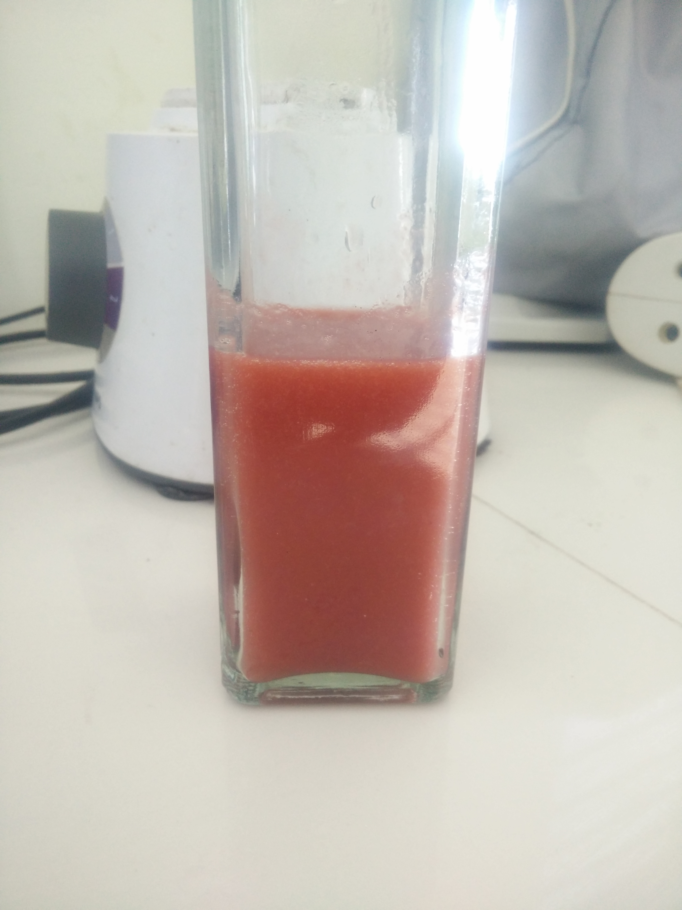
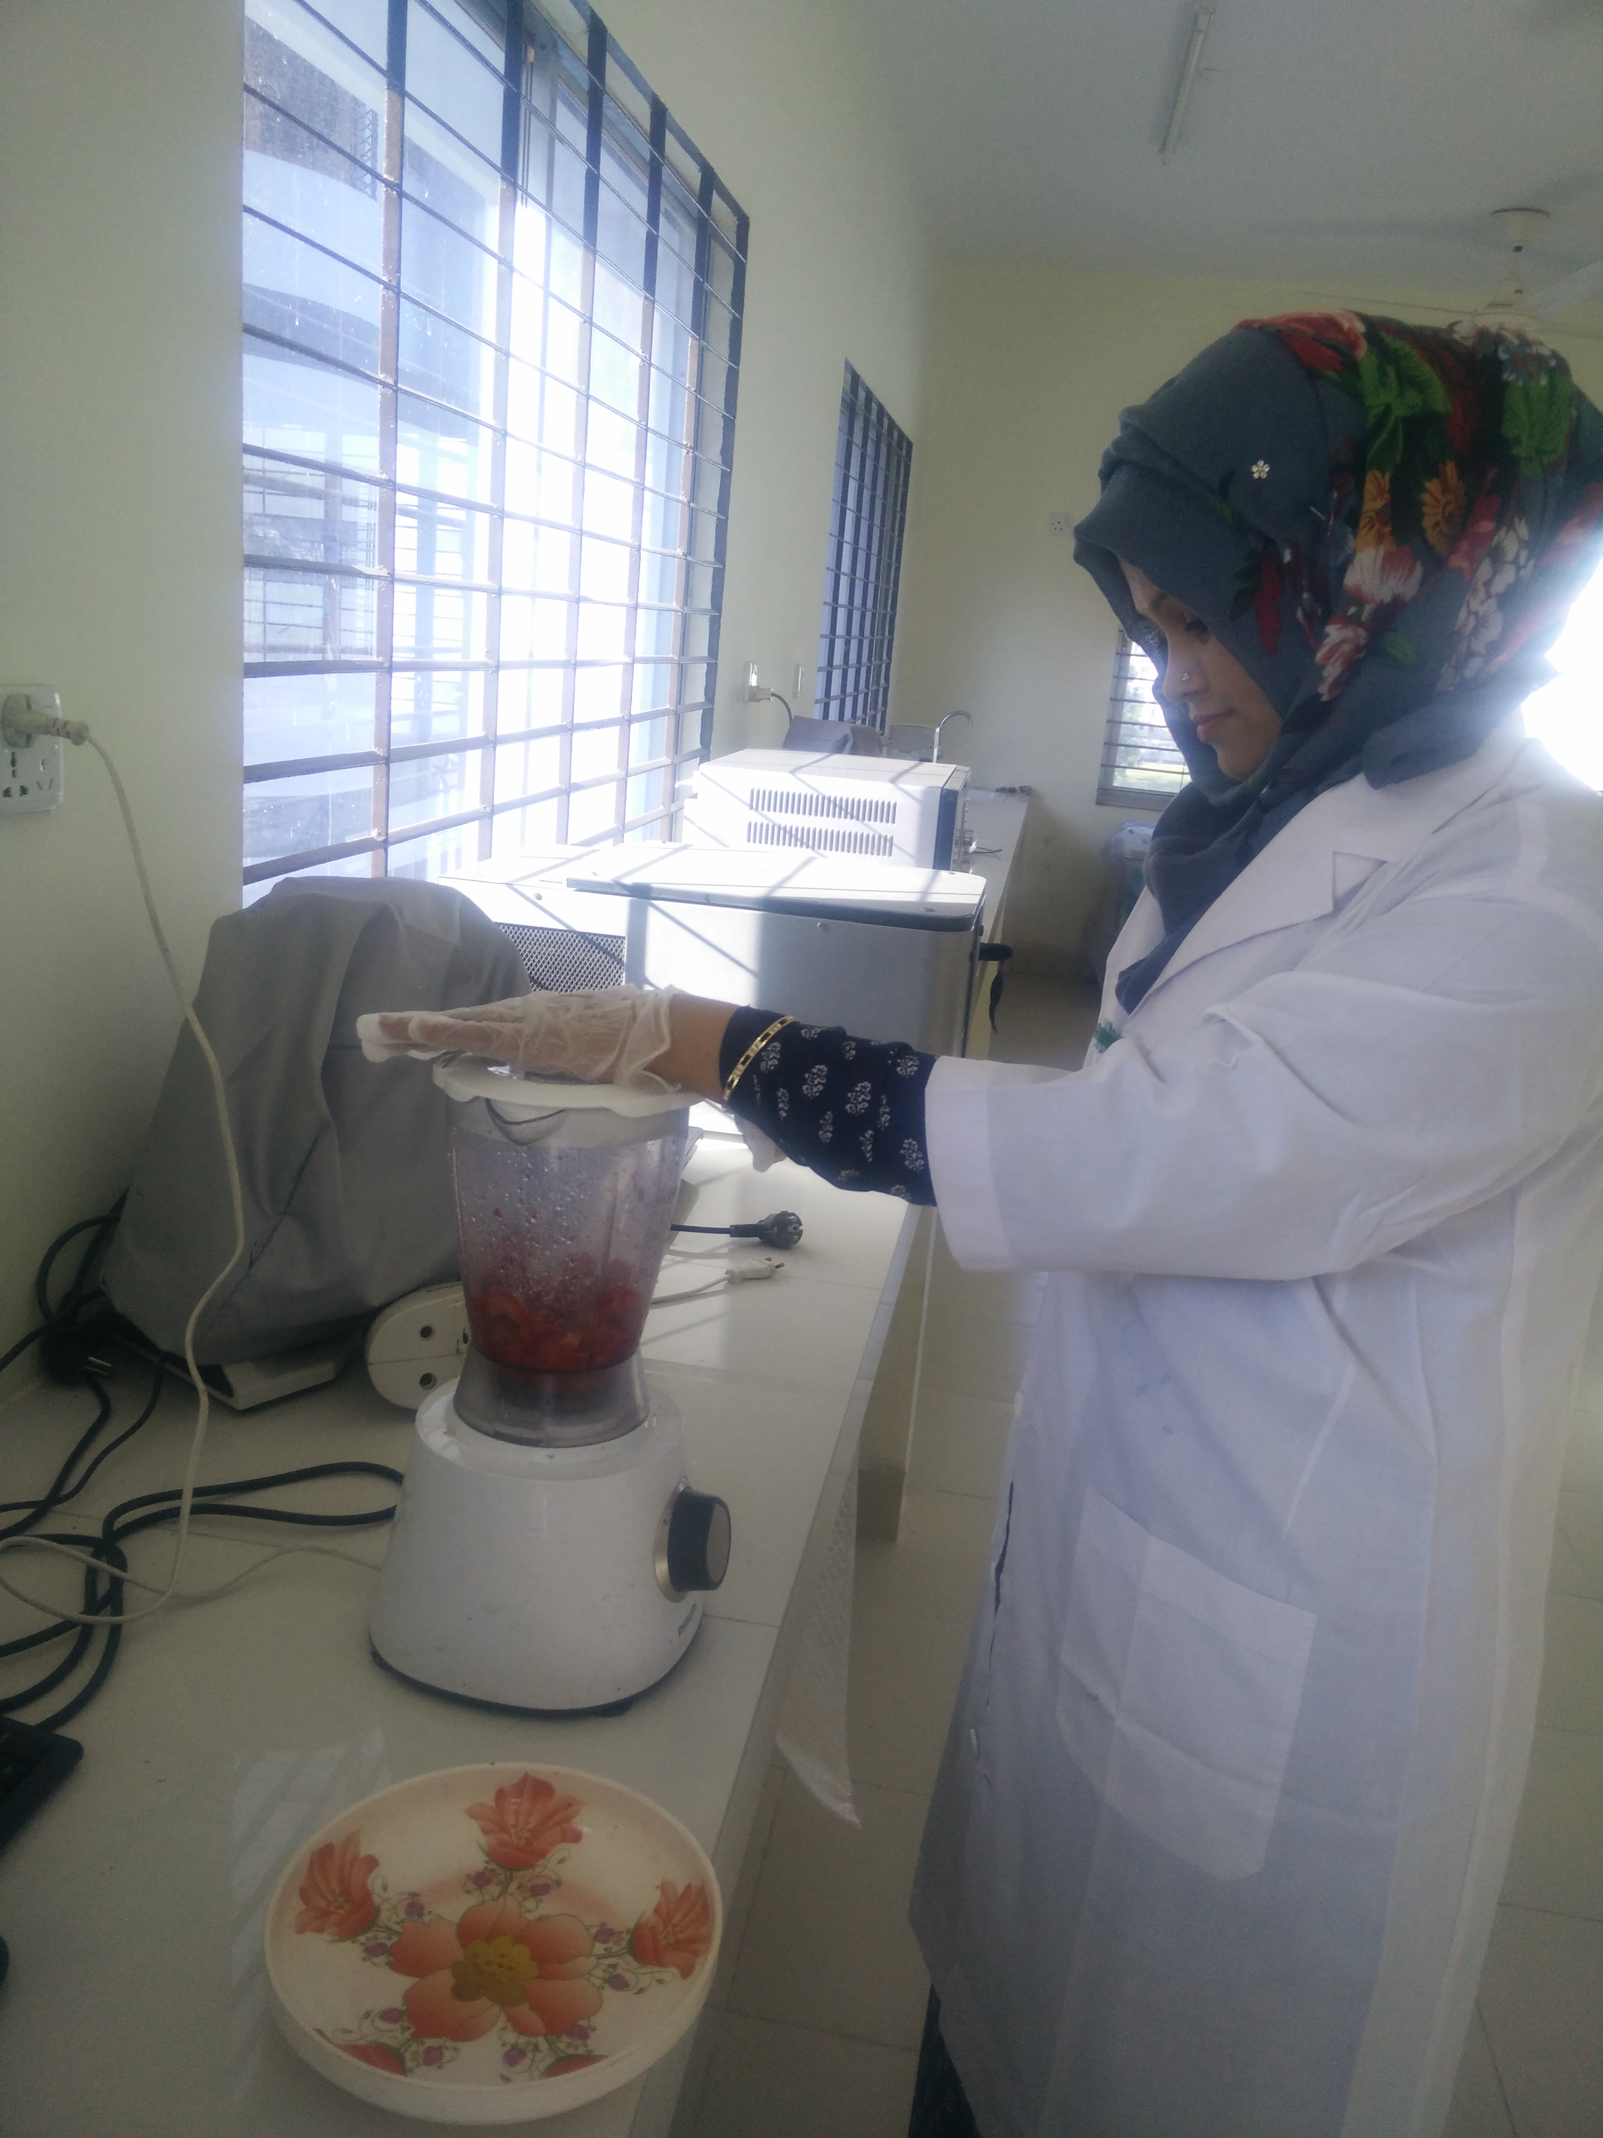

Juice preparation

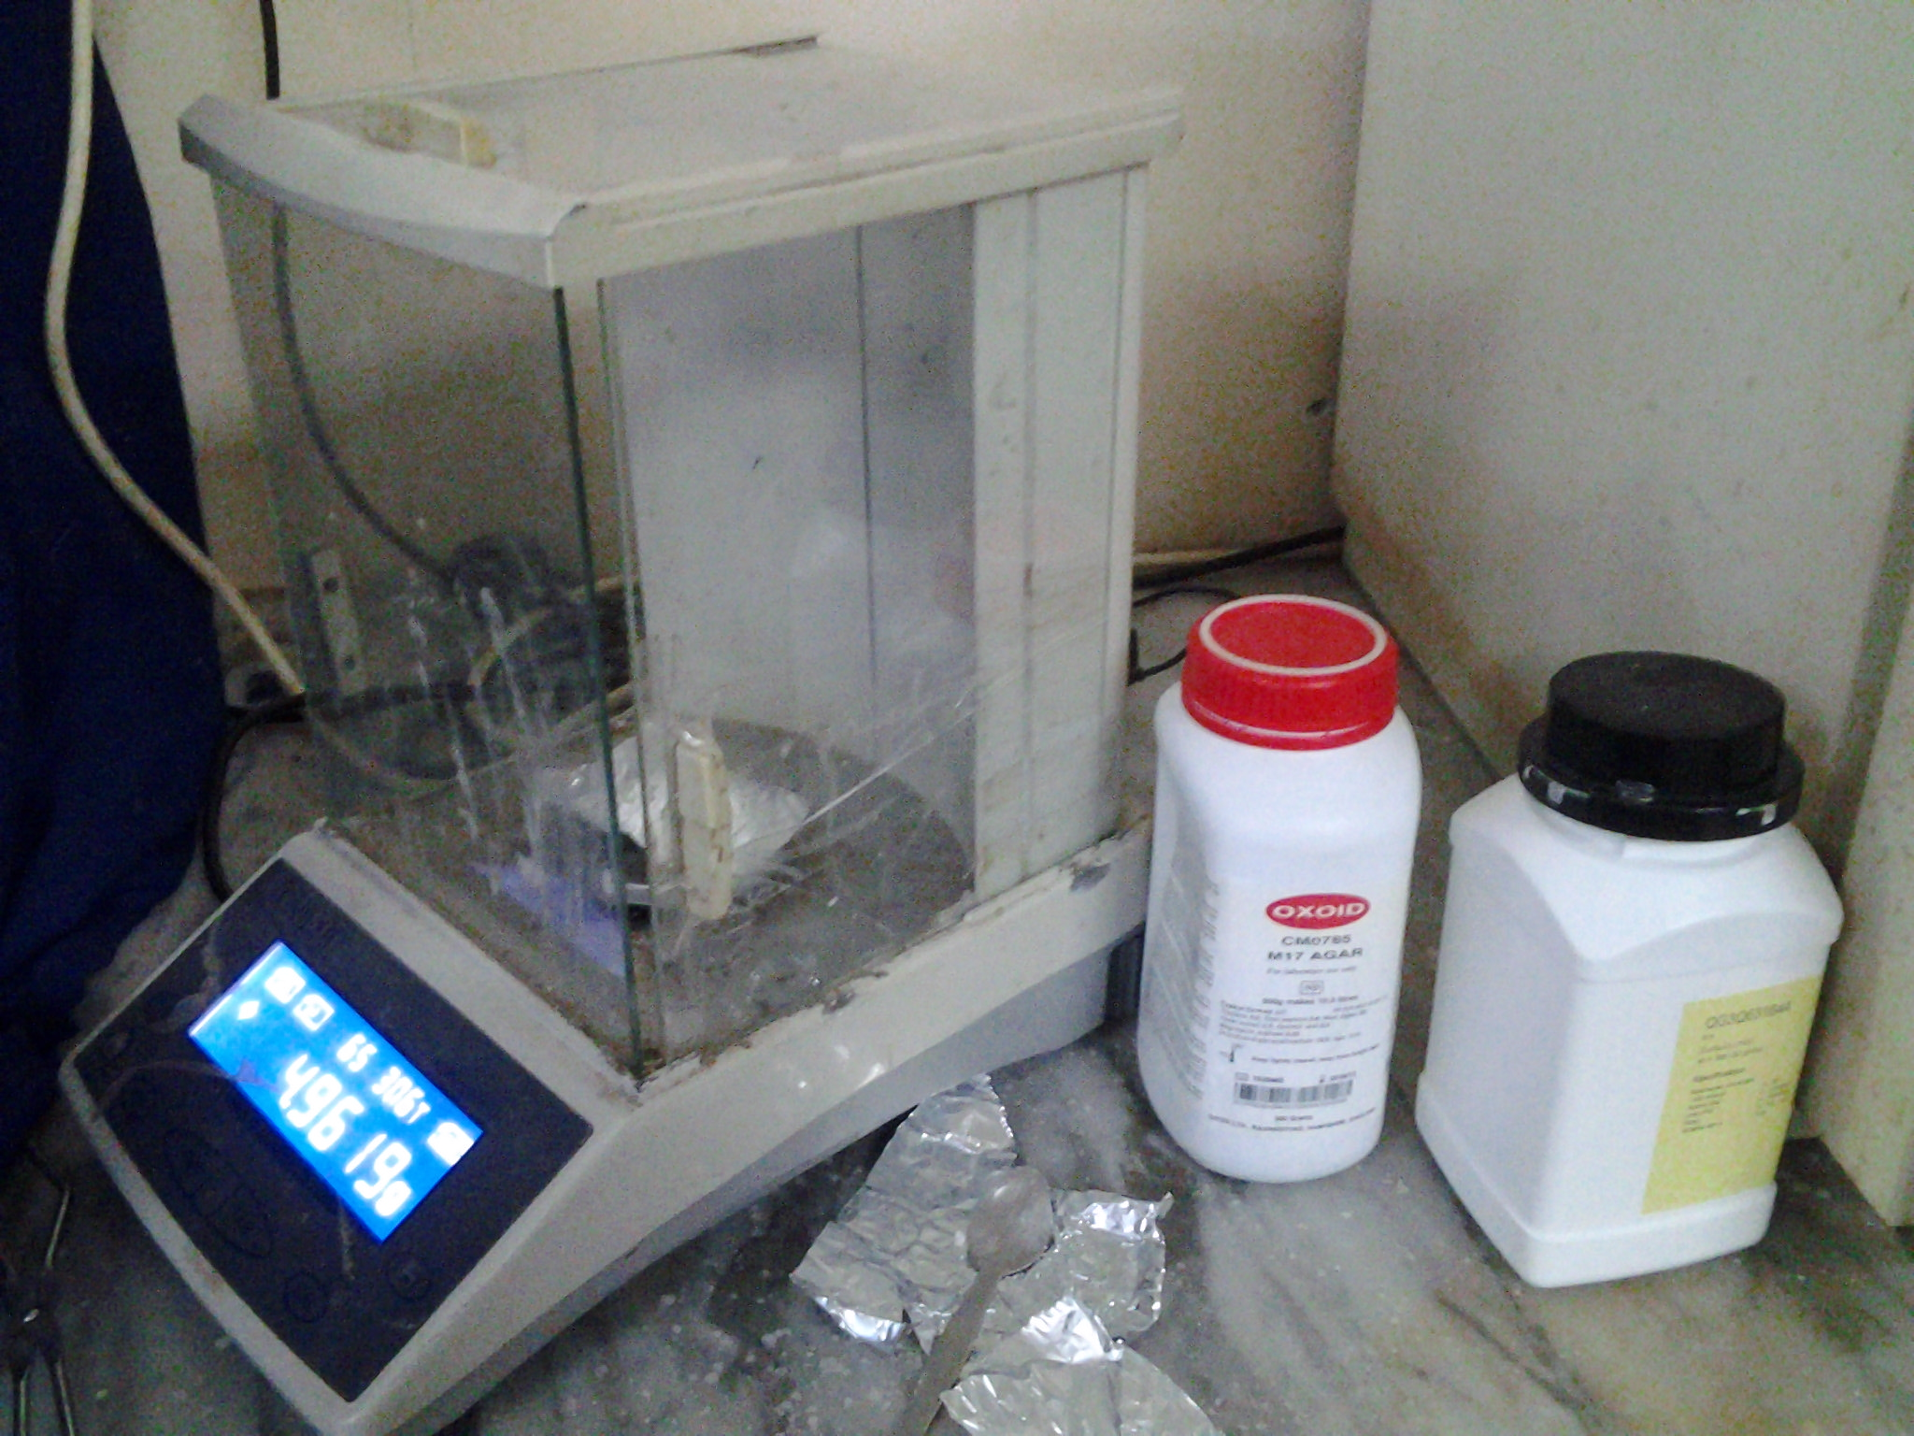
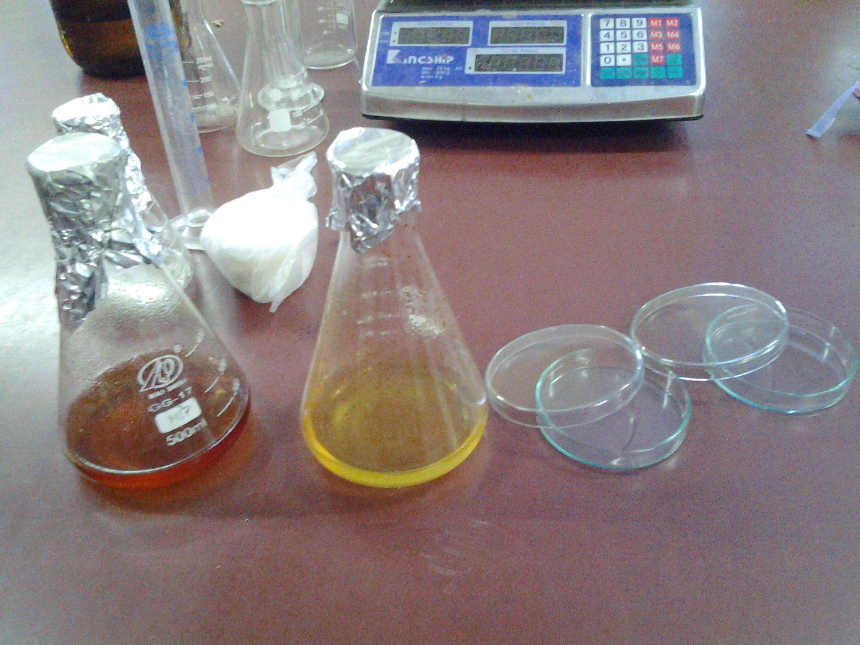

Media preparation

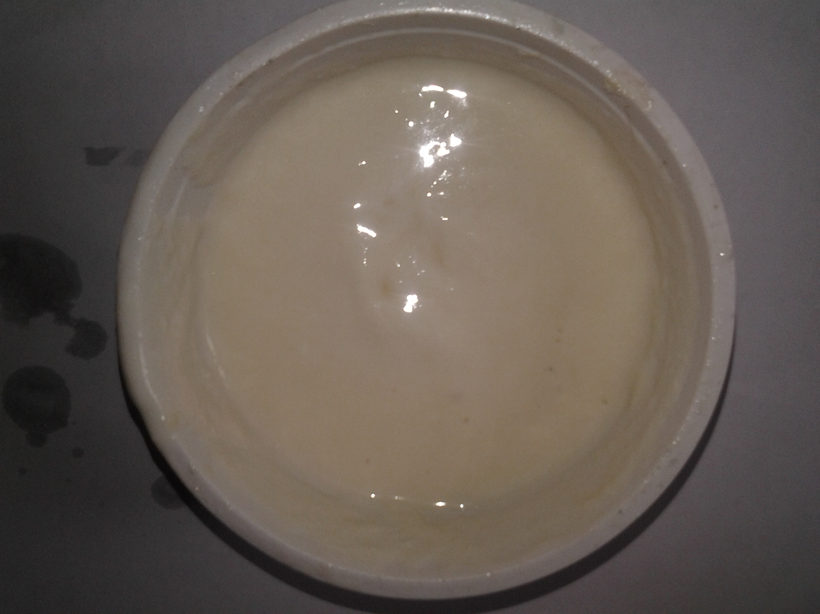

Developed product

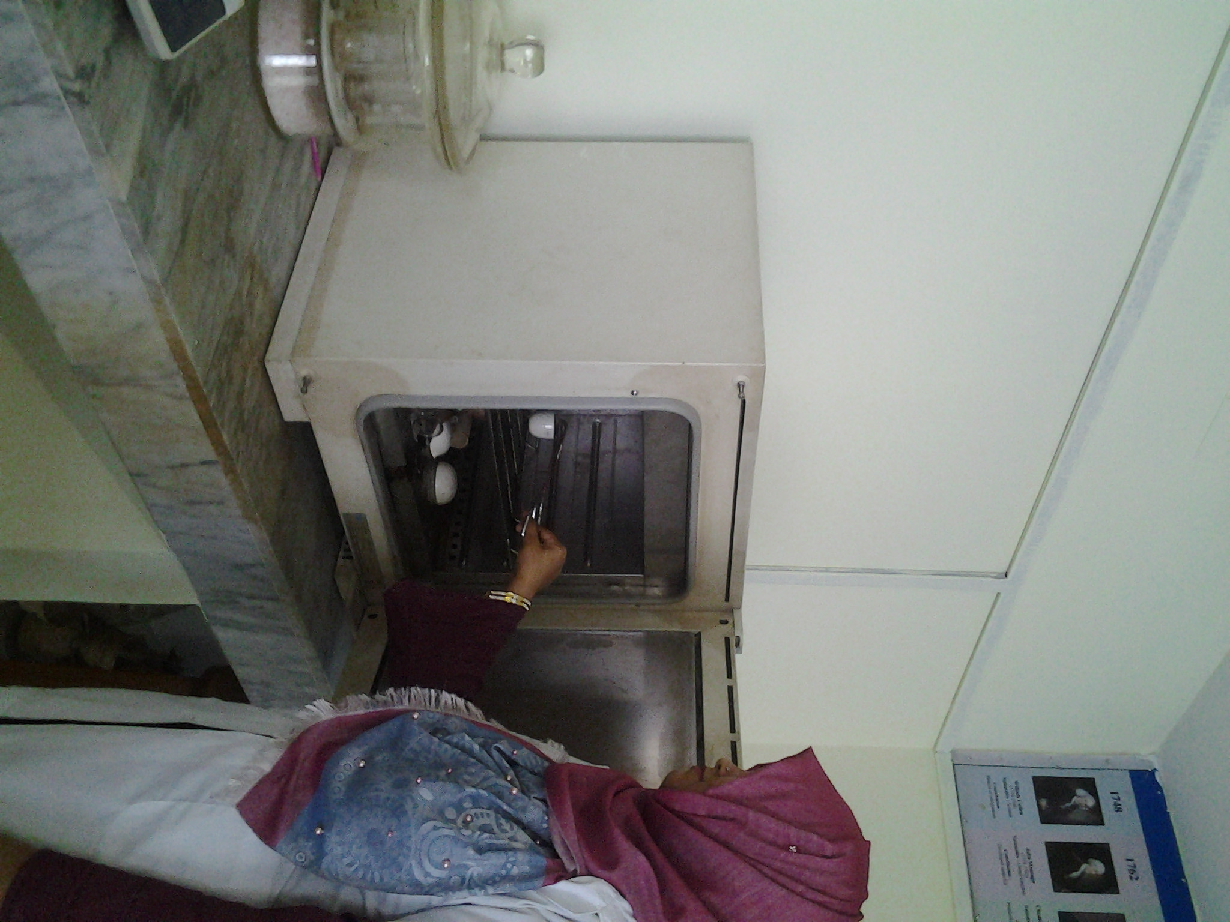

Chemical analysis

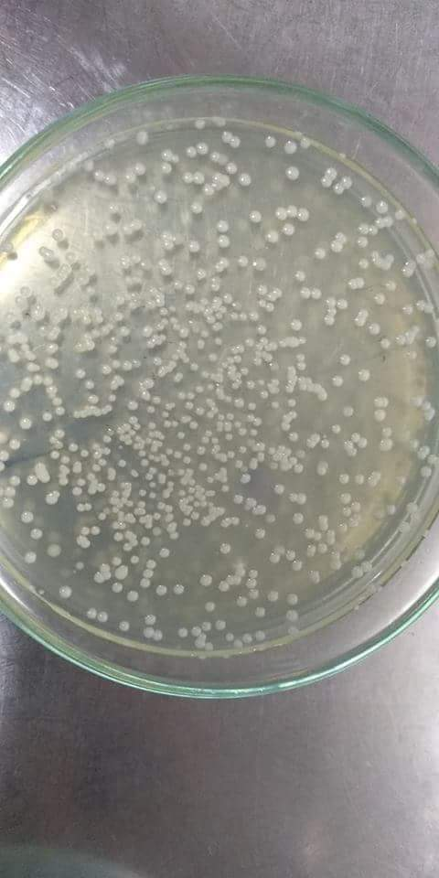
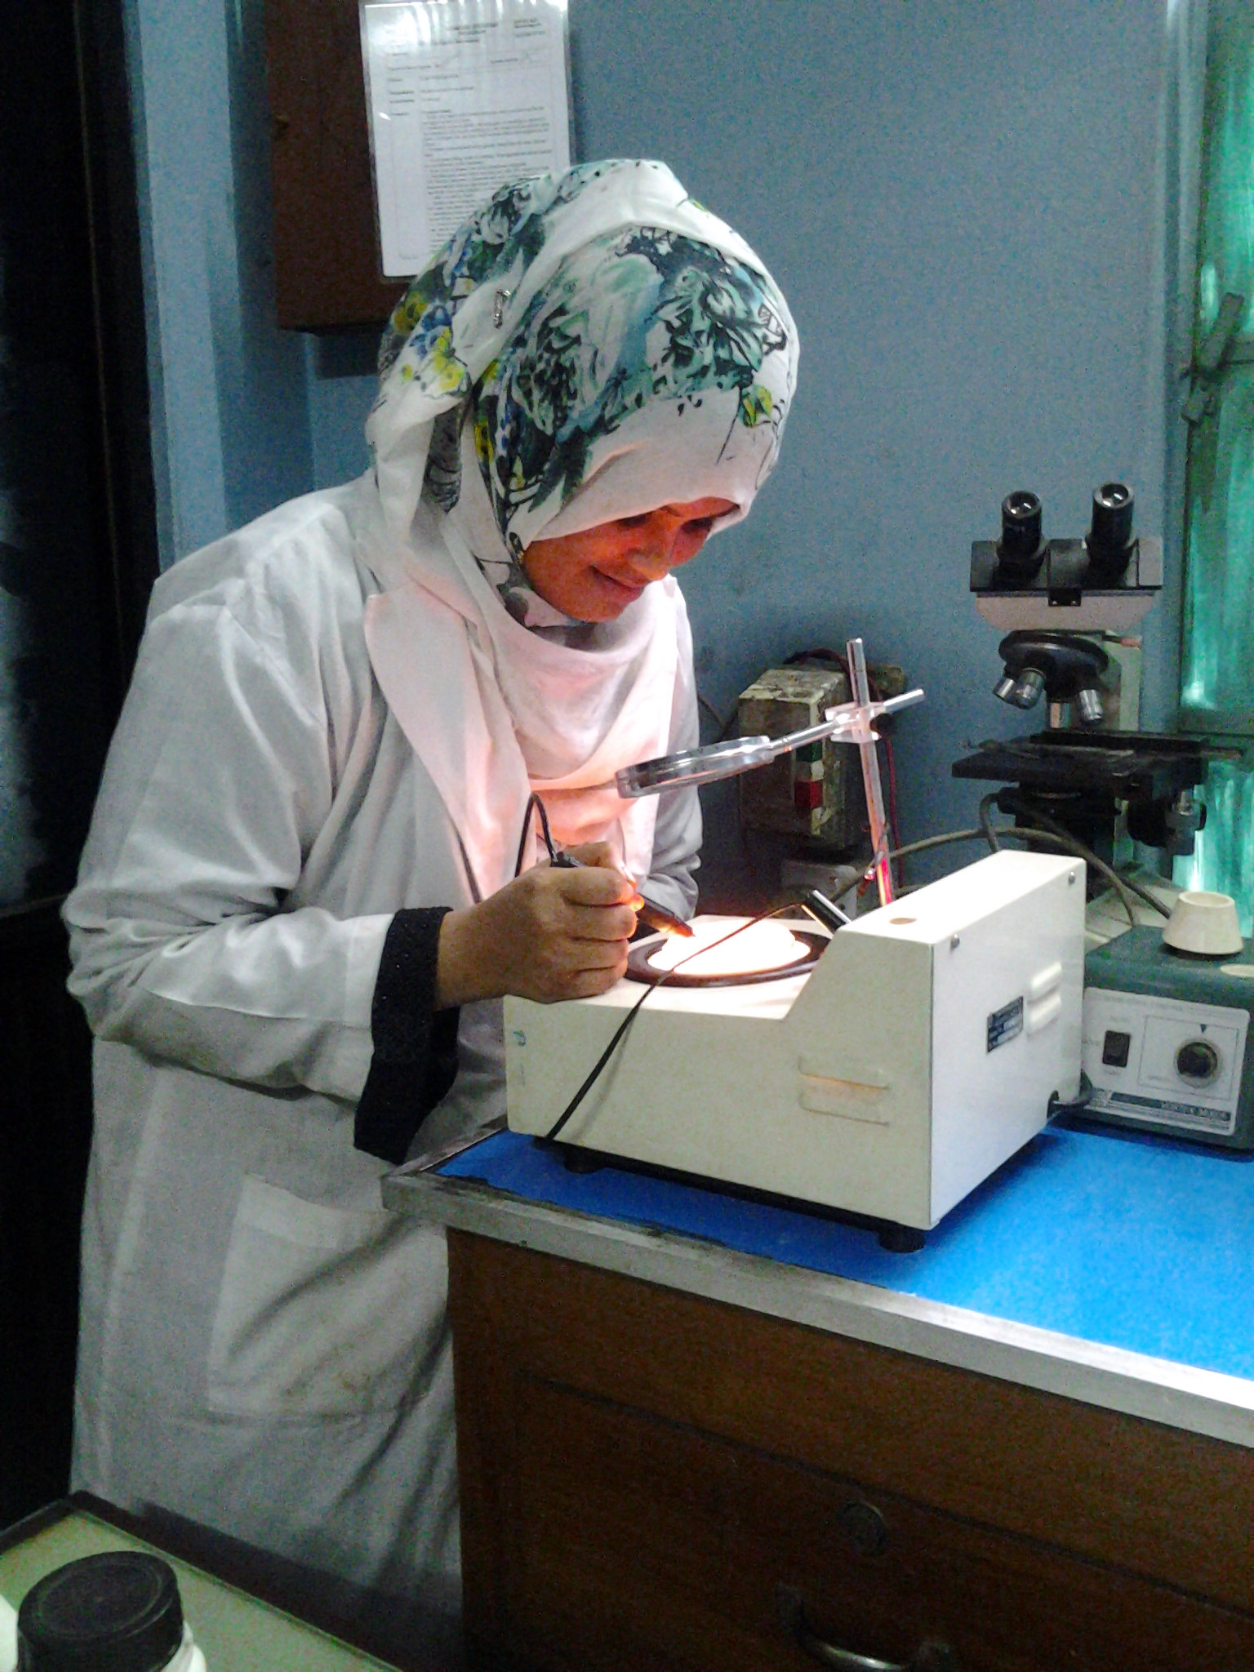

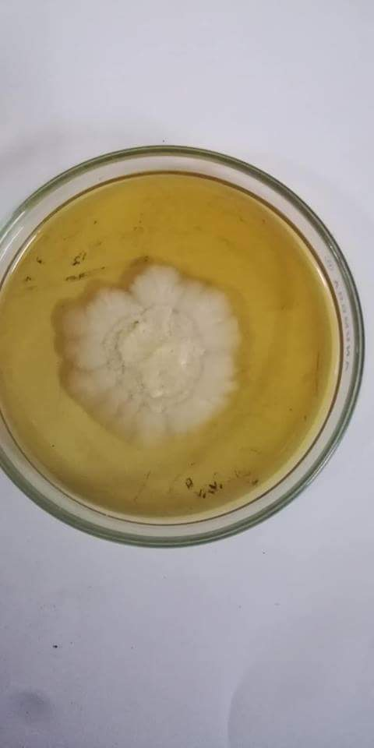

Microbiological analysis

TASTE TESTING FOR FRUIT JUICE YOGHURTS
(Hedonic Rating Test)

Name of the Tester --------------------- Date: ------------------------

Please taste these Samples and check how much you like or dislike each one on Sensory attributes such as Smell and Taste, Color and Texture, Body and Consistency and Overall Acceptability. Use the appropriate scale to show your attitude by checking at the point that best describes your feeling about the Sample. Please give a reason for this attitude. Remember you are the only one who can tell what you like. An honest expression of your personal feeling will help us.

Hedonic | Smell and Taste |  |  |  | Body and Consistency |  |  |  | Color and Texture |  |  |  | Overall Acceptability
 | Sample |  |  |  | Sample |  |  |  | Sample |  |  |  | Sample
Like extremely | P | S | O | M | P | S | O | M | P | S | O | M | P | S | O | M
Like very much
Like moderately
Like slightly
Neither like nor dislike
Dislike slightly
Dislike moderately
Dislike very much
Dislike extremely

P=Plain yoghurt, S=Strawberry, O=Orange, M=Mango.
Extra comments on each sample, if any
N.B: Overall Evaluation: Three sheets provides for 5%, 10%, 15% juice concentration.

Hedonic Scale used : Like extremely = 9, Like very much = 8, Like moderately = 7, Like slightly = 6, Neither like nor dislike = 5, Dislike slight = 4, Dislike moderately = 3, Dislike very much = 2, Dislike Extremely = 1 .

