CHAPTER-1: INTRODUCTION
Street food is ready-to-eat food or drink sold in a street or other public place, such as a market or fair, by a vendor, often from a portable stall (Artemis et al., 2000). According to a 2007 study from the Food and Agriculture Organization, 2.5 billion people eat street food every day (Spotlight et al., 2007). Today, people may purchase street food for a number of reasons, such as to obtain reasonably priced and flavorful food in a sociable setting, to experience ethnic cuisines and also for nostalgia which may lead to diseases or even fatal death. Street food, an important component of the informal food-distribution sector, is a source of nutrition for people in developing countries, including Bangladesh. The majority of studies demonstrated that street foods contributed significantly to the diet of children and adults in developing countries, both in terms of energy, protein and micronutrient intakes and in terms of food groups consumed (Nago et al., 2010). A study conducted in Haiti revealed that street foods contributed 16 % of the protein RDA in secondary-school children (Webb et al., 1988). Similarly in Mali Street foods provided 41 %, 19 % and 9 % of daily protein intake in persons of high, middle and low socioeconomic status people, respectively (Bendech et al., 1996). In Calcutta, a typical street meal comprised 20–30 g of protein as measured by proximate analyses (Chakravarty et al., 1996). Different types of study conducted on absolute vitamin A, iron and zinc intake from street foods which were found lower among the low-income groups as compared to middle-low income groups, these variations were not significant, except for zinc. Street foods are better dietary sources of iron (26%), zinc (21%) and vitamin A (12%), (Salvadogo et al., 2006). The majority of studies suggest that several data on fat and carbohydrate intakes are of some concern in terms of the high contribution of street foods to the total intakes of fat and sugar and their role in the development of obesity and non-communicable diseases.
Street foods are very much popular in developing countries. As a developing country a lot of street food are found in the street and open place in Bangladesh. Street food is much popular to the Bangladesh living in the urban area due to its cheap price and sharp taste. It is vendors by a hawker from a portable food truck. Some street foods are local and having spread beyond their place of ultimate and enjoyed locally for their unusual ingredients and flavors. Public enjoy street food for a number of reasons such as inexpensive bite on the run, to sample flavorful local in a social setting, to experience new ethnic cuisines, and to support entrepreneurs, small food businesses and local vendors (Oxford, 2012).
Street food satisfies the food consumption need of a significant section of the population. The food sold on the streets is relatively cheap and readily available. It is sometimes brought to the door step of the customers. Street food not only meets the food requirements particularly of those of the low-income categories but also the busy customers who do not have much time either to prepare their own food to go to other eating houses where probably the food is more expensive, and servicing is time consuming.
Street food Vendors stalls are usually located outdoors a roof which is easily accessible from the street. They have low-cost seating facilities which are sometimes rudimentary. Their marketing success depends exclusively on location and word-of-mouth promotion. Street food businesses are usually owned and operated by individual’s families and 94% of vendors are male and 88% of vendors have their own capital to continue their business, but benefits from their trade extend throughout the local economy (Higman et al., 2012).
Street foods and fast foods are low in cost compared with restaurant meals and offer an attractive alternative to home-cooked food. There are many kinds of Street Foods are found in Bangladesh such as Chanachur, Chotpoti, Fuchka, Jhalmuri, yogurt and salad dressing, Peaju, Shingara, Samosa, Butterbone, Ice cream, Bhel-puri, Chetoipitha, Vhapapitha, Puri, Buts, Nuts, Chop, Banana, Biscuit, Golgappa, Vegetable Role, Egg, Panipuri (Cathy et al., 2012).
Other Types of street foods like students of intake mostly prefer French fries, chicken fries, cake, vegetable role, tea, coffee, badam, boiled egg, biscuit and some people eat seasonal street food. They sell their product instantly making them, but they make their spices at their home such as pachforon, groommosla, darucheni, potato, golmorich, red chilli powder, tamarind (WHO, 1976).
There are many types of Prices street foods are different from each other. The estimate of Chittagong area we got some prices of street food such as, 3tk, 5tk, 15tk, 20tk, 25tk, 30tk, 40tk, 90tk, 150tk etc. The minimum price of street food is 3tk; the amount of money people spend on street food maximum is 150tk. The estimate in a month they spend 200tk to 300tk, 600tk, 700tk and maximum 1000tk on street food (Chakravarty et al., 1996).
There are many kind of Regional Street foods found of the world such as Africa, Asia, Europe, North America and South America etc. In South Africa, borrowers and other braai foods are available in the street, In townships ethnic foods are available, In Cape Town, meat, salad, cheese, and chips is sold as street food. Bangladesh street food vendors sell pitha, chotpoti, puchka, jhalmuri, badam, and various fried items. Some of the common items in Pakistan include bun kabab sandwiches, samosas, kulfi ice cream, popcorn, fried or grilled fish, sugar cane juice, chickpea juice, lemonade, sliced coconut, dried fruits and nuts, haleem, biryani, pakoras, falsa fruit, grilled chicken, french fries (Ackah et al., 2011).
The traditional processing methods that are used in the preparation, inappropriate holding temperature poor personal hygiene of food handlers are some of the main causes of contamination of street foods. In Bangladesh, street foods are mostly prepared and processed manually and sold to the public at various lorry terminals, by the roadside. An estimate of the socioeconomic conditions and determination of the hygienic and sanitary practices of street food vendors in Dhaka City Corporation was carried out by FAO 2010.
The research demonstrated that 25% street food vendors are illiterate and cannot write their names and have no formal education. As street food business requires low investment, most of the vendors (88%) were found to own the business. They reportedly work for 13–18 hours a day without having toilet facilities. Most of the vending shops (68%) were located on the footpath irrespective of areas and 30% vending carts were placed near the municipal drain and 18% near the sewerage. Microbiological reported of different foods items, yogurt, salad dressing and chotpoti and hand swab samples showed the prevalence of overwhelmingly high numbers of aerobic bacteria, coliform bacteria, E. coli and salmonella and different type of pathogenic bacteria (World Bank, 2007).
Street foods are perceived to be a major public health risk due to lack of basic infrastructure and services, difficulty in controlling the large numbers of street food vending operations because of their diversity, mobility and temporary nature (Ghosh 2007; Wahi 2007; Kumar 2007). In contrast to these potential benefits, it is also recognized that street food vendors are often poor, uneducated, and lack knowledge in safe food handling, environment, sanitation and hygiene, mode of food display, food service and hand washing, sources of raw materials, and use of potable water.
Street foods important socioeconomic role in meeting food and nutritional requirements of city consumers at affordable prices to the lower and middle-income people and are appreciated for their unique flavors and convenience (Ackah et al., 2011). Street foods also assure food security for low income urban population and livelihood for a significant proportion of the population in many developing countries.
Street foods can induce serious health problems, particularly for the inappropriate chemical composition, exemplified by high levels of carbohydrates and fats, including saturated fats (Steyn et al., 2013). Street food vending has become an important public health issue and a great concern to everybody. This is due to widespread food borne diseases, due to the mushrooming of wayside food vendors who lack an adequate understanding of the basic food safety issues. Major sources contributing to microbial contamination are the place of preparation, utensils for cooking and serving, raw materials, time and temperature abuse of cooked foods and the personal hygiene of vendors. Street food have identified the sources of food safety issues involved in street foods to be microorganism belonging to the genus Bacillus, Staphylococcus, Clostridium, Vibrio, Campylobacte,E. coliand Salmonella.
Streets foods Capable to contaminate at all stage of the food chain. Raw materials are therefore important to the safety of street vended food because of the biological chemical and physical hazard that may be introduced to the vending operation and which may persist through preparation and processing. Street food is double burden and malnutrition and over nutrition obesity in urban area of developing countries. The people change to lifestyle and shift to cash economy with movements to urban area. Street food relying on high fat street food and fast foods decrease physical labor and physical activity in urban setting and street food increase alcohol consumption of the public. As an epidemiologic link between street food and enteric infection, such as diarrhea and typhoid fever, has been established in several studies (Naheed et al., 2007). Food safety recalls in the absence of illness are an indicator the system is sort a working. In many parts of the world, including Bangladesh, there is an increase in consumption of raw fresh produce like cucumber, fruits and other foods such as chotpoti, fuska, lacchi etc. Vending of these types of foods is a common practice in Bangladesh. In Chittagong, with its growing urban population traveling long distances to the place of work, it has become increasingly popular to eat street foods. Street foods provide a source of readily available, inexpensive, nutritional meals, while providing a source of income for the vendors. In contrast to these potential benefits, concerns for the safety and quality of street-vended foods have been raised, because the vendors lack an adequate appreciation of basic food safety issues. Epidemiological associations between street vended foods and illnesses have been made by different studies (Tjoa et al., 1977). It has been recognized that in countries where street vending of foods is common, there is usually a dearth of epidemiological data on the incidence of food borne diseases, and outbreaks of such diseases are frequently not investigated (Bryan et al., 1988). There are very limited research works on comparative study on the nutritive value, microbiological and preservative quality of various fast foods from different restaurants, super markets and street- vended foods in Chittagong metropolitan areas. It is very important to identify possible microbiological hazards to safe public health. Since street-vended-food falls under primary-preparation & instant-consumption in food-chain, it is essential to know the current state of food-safety/hygiene in such. Also it is essential to increase awareness level of such vendors as this is a very important issue of public health.

Ensuring food safety and implementing HACCP remains crucial to ensure public health- which is currently at stake in Bangladesh. Food-contamination and gross-adulteration being rampant & street-vended foods under primary-production/ instant-consumption in city food-chain remains a daily havoc. Salmonella causes infections marked by diarrhea, vomiting, fever and abdominal pain. Healthy people generally recover without treatment, but salmonella can kill the very young, the elderly and people with weak immune systems. Since street-vended-food falls under primary-preparation/instant-consumption in food-chain, it is essential to know its current-state of food-safety/hygienic status in Chittagong. This study is expected to give an opportunity to uplift the research quality in light of the new developments worldwide and will have significant positive impact for designing the control strategies of important diseases and facilitate the necessary human resources to be developed.

1.1. Aim and Objectives
To assess the nutritive value and microbial load in selected street vended foods in Chittagong metropolitan areas for assessing the food safety issue.
Specific Objective(s)
- To analyze the nutritional composition (Moisture, Carbohydrate, Protein, and Fat) in street vended foods such as Chotpoti, Salad dressing and Yogurt.
- To identify the microbial load (Total Plate Count) in street vended foods such as Chotpoti, Salad dressing and Yogurt.
- To assess the food safety knowledge of selected street foods vendors.

CHAPTER-2: REVIEW OF LITERATURE
Salad dressing is fast becoming popular condiments for Malaysian. The nutritional composition of salad dressing commercially available in the Malaysian market. Salad dressing has been identified as potent sources of vitamin A and vitamin E and both condiments were found to contain high levels of these antioxidants. In 2017, a study conducted in Malaysia on nutritional composition of salad dressing where moisture, protein, fat, carbohydrate and ash level were present between 31.06 %- 59.79 %, 1.02 %-1.11%, 13.72 %- 53.47 %, 12.36 %- 33.43 % and 1.6 %-3.2 % respectively (Aswir et al., 2009).
The microbiological quality of retail based salads samples were collected between 1 February 2008 and 31 July 2009 in Ankara. In that study, pH values of the samples were measured in the range of 4.05-7.10 (average pH=5.69). The samples with pH higher than 4.6 (n=236/432, 54.6 %) were carried out for microbiological analysis. The samples were analysed for the presence of total aerobic bacteria (TAB), Esherichia coli, Salmonella spp. and Staphylococcus aureus. According to microbiological analysis, TAB was detected in 210 of 236 (89.4 %) retail based salads (range: 1.1x102-2.9×106 cfu/g). E.coli, Salmonella and S. aureus were detected in 143 (60.6 %) of 236 samples each, with a range of 1.3×102-3.6×104 cfu/g, 2.4×102 7.1×104 cfu/g (62 samples, 26.3%) and 1.8×102-8.3×103 cfu/g, respectively (Brause et al ., 2003) The results indicate that the type of based salads analysed may contain pathogenic bacteria and thereby represent a risk to the consumers in regard to food borne diseases. Thus, it is essential to include the effective hygiene practices as an important safety measure in the production based salad dressing.

A study conducted on food safety knowledge, attitudes and practices of chotpoti vendors in dhaka, bangladesh, 2017 among 110 vendors where all vendors were male, the majority was between 22 and 32 years of age. Majority (52.2%) of the vendors acquired the knowledge of chotpoti preparation through observation. Nearly all vendors (96.3 %) handled food with bare hands, 95% did not use aprons and hair covering and 91.3 % handled money while serving chotpoti. Most vendors had leftovers; out of those 30% reported discarding them and the rest stored them for following days sale with inappropriate storage. Nearly one-third (32.7%) of the vendors washed their utensils with dirty water which is recycled. Majority reported that they changed the bucket water only once per 12 hours. Presence of flies was observed on food and surroundings of 33% of the stalls. Of the vendors interviewed, most of them did not have garbage receptacles and 23% disposed wastes nearby their stalls and 76% disposed in nearby dustbin (Zakiul et al., 2017).
Chemical composition and microbial load of yoghurt from fresh and recombined milk powder in khartoum State, Sudan, August 02, 2011. In Sudan, some scientist worked on nutritive analysis on yoghurt from fresh milk and found total solids (TS), solids not fat (SNF), fat, protein and ash content and titratable acidity level were 14.02±0.91, 10.95±0.78, 3.06±0.41, 3.89±0.51, 0.66±0.09 and 1.31±0.19, respectively.Where as for the fresh milk yoghurt the means were found as 15.04±0.87, 11.51±0.82, 3.53±0.14, 4.42±0.23, 0.82±0.17 and 1.33±0.15, respectively. Yoghurt made from powder milk were 8.43±0.16, 5.15±1.17 and 5.65±1.86 for log total bacterial count, coliform count and yeast and mould counts respectively (Ekram et al., 2011).

The microbiological parameters for yoghurt made from powder milk were 8.32±0.18, 4.99±1.50 and 5.78±1.56 for log total bacterial count, coliform count and yeast and mould counts, respectively. Whereas for the fresh milk yoghurt, the means were 8.43±0.16, 5.15±1.17 and 5.65±1.86, respectively. The plates containing 25-250 cfu were enumerated for total bacterial count, whereas the plates containing 15-150 cfu were enumerated for coliform and yeast and mould count (Christen et al., 1992).
2.1. Street foods
Street food is ready-to-eat food or drink sold by a hawker, or vendor, in a street or other public place, such as at a market and fair. It is often sold from a portable food booth, food cart, food truck and meant for immediate consumption. Some street foods are regional; most street foods are classed as both finger food and fast food, and are cheaper on average than restaurant meals (Artemis et al., 2011).
Street food was widely consumed by poor urban residents of ancient Rome whose tenement homes did not have ovens or hearths. In ancient China, street food generally catered to the poor, however, wealthy residents would send servants to buy street food and bring it back for them to eat in their homes (Higman et al., 2012).
Culture and social stratification in which family street vendor enterprises are traditionally created and run vary in different areas of the world. Walking on the street while eating is considered rude in some cultures is acceptable for children. In India, Donner wrote about a "marked distinction between food that could be eaten outside, especially by women," and the food prepared and eaten at home, with some non-Indian food being too "strange" or tied too closely to non-vegetarian preparation methods to be made at home (Donner et al., 2012).
2.2. Physical appearance of street foods
Ingredients of Street food are not standardized on the other foods. Most of the time use of unhygienic water of the street food and water handling methods are poor. Biological, chemical and physical hazards are common seen in the working condition. Majority of the employee are not educated they cannot read and write, low knowledge, attitude and practices. Hygiene of equipment’s is not adequate most of the place investigated poor personal hygiene of the vendors is available. The street foods of waste management’s are not adequate some time street foods are contaminated by the waste materials and are not dumping of systematic way. Most the consumer is comments negative attitude of street food and street vendors authorizes.
Streets foods are susceptible to contaminated at all stage of the food chain. Raw materials are therefore important to the safety of street vended food because of the biological chemical and physical hazard that may be introduced to the vending operation and which may persist through preparation and processing. Street food is double burden and malnutrition and over nutrition obesity in urban area of developing countries. The people change to lifestyle and shift to cash economy with movements to urban area.
Street food ingredients are area-specific and mostly undocumented. There are so many varieties that it is impossible to provide a menu of all the different street foods consumed around the world. In Bangladesh, street foods include Chola boot (Chickpeas), Bhelpuri (puffed rice with potatoes), and Samucha as well as drinks like Sugar-cane juice and Lassi (yoghurt and water). Other popular snacks are Ghugni (boiled and mashed white peas with spices), Singara (flour wraps stuffed with vegetables, spices, and occasionally liver), and different types of Cakes.
2.3. Comparing of street foods and fast foods
The term "street foods" describes a wide range of ready-to-eat foods and beverages sold and sometimes prepared in public places, notably streets. Like fast foods, the final preparation of street foods occurs when the customer orders the meal which can be consumed where it is purchased or taken away. Street foods and fast foods are low in cost compared with restaurant meals and offer an attractive alternative to home-cooked food. In spite of these similarities, street food and fast food enterprises differ in variety, environment, marketing techniques and ownership (Winarno, 1986).
Street foods often reflect traditional local cultures and exist in an endless variety. There is much diversity in the raw materials as well as in the preparation of street food, snacks and meals. Vendors' stalls are usually located outdoors or under a roof which is easily accessible from the street. They have low-cost seating facilities which are sometimes rudimentary. Their marketing success depends exclusively on location and word-of-mouth promotion. Street food businesses are usually owned and operated by individuals or families but benefits from their trade extend throughout the local economy. For instance, vendors buy their fresh food locally, thus linking their enterprises directly with small-scale farms and market gardens.
Fast food outlets specialize in fewer foods which are usually prepared by frying. Hamburgers, chicken, chips and pizza often predominate. These enterprises, which are usually indoors, invest heavily in seating, air conditioning and bright decor. Marketing strategies are almost exclusively dependent on advertising, sponsorship and special offers which aim to create brand loyalty. Owners usually have a franchise arrangement with a transnational company which also controls the provision of raw materials, the menu and the mode of preparation. Profits from sales generated by foreign-controlled fast food chains often leave the country.

2.4. Classification of street foods
The street food vendors of Bangladesh are not enumerated in the formal sector of country’s economy. They are identified as the informal sector where their businesses are conducted as a form of irregular, unstable, and marginal economic activities. As such there is no systematic documentation of the numbers of street food vendors, their scale of businesses, or the viability of their pursuits. After rickshaw-pulling, street vending is probably the second most important employment opportunity for the urban poor in Bangladesh, and particularly important for young and middle-aged men who have migrated to Dhaka in the past five to ten years. Roughly 750,000 rickshaw pullers and 300,000 street vendors live and work in Dhaka (Islam et al., 2005).
Chittagong is among the world’s cities with the highest number of hawkers: in Asia, only Mumbai (250,000), Delhi (200,000), Calcutta (150,000), and Bangkok (100,000) have similarly large numbers of street vendors (Biswas et al., 2010).
This data indicates that each vendor serves 84 customers per day on average. This implies that almost 55 percent of the population of Chittagong takes some street food every day. The significance of street food system of Chittagong is beyond doubt and selling street food is not a marginal economic activity, but a normal yet highly visible social practice, that is, economically efficient and deeply embedded in the urban economy and in urban life. A glimpse of the socioeconomic background of the vendors is presented below to help understand who the street food vendors are.
- Both males and females and married and unmarried operate as street food vendors. Their age range is between 25 and 60 years with a majority being in the age group of 30–40 years.
- Many street food vendors and their families have their origin in rural backgrounds or have moved to urban centers at a later stage or else live in rural areas and travel daily to the city for their business operations.
- The level of education achieved by the street food vendors is comparatively low and in the case of a majority, education levels varied between grades 5 and 8.
- Many street food vendors are constrained by the unstable socioeconomic backgrounds in their families.

Table -1: Advantage and disadvantage of street foods
Benefits | Problems
- Use of local resources  - Employment opportunities  - Adequate earnings for vendors  - Varied and nutritious food  - Inexpensive, accessible service  - Quality upgraded by licensing and inspection  - Social needs met | - Contamination  - Poor hygiene  - Not a recognized industry  - Lack of social status  - Complex or non-existent licensing systems  - Ineffective and arbitrary inspection  - Traffic congestion aggravated
Customers and consumer organizations also have a role to play in association with government authorities, vendors' associations and scientists. Participation and advocacy by consumers can help to prevent food borne diseases. Better consumer information and education regarding food hygiene can help authorities to take quick remedial action and preventive measures.
The consumer's needs should be considered when establishing policies and regulations. By implementing policies which help street food trade, low-income consumers are favored. More licenses might be allowed for vendors selling low-cost, nutritionally sound foods or for those with good records of hygiene. Restraining permits can be created for the sale of foods that have negative consequences. Street foods deserve the attention of policy-makers and vendors should be given opportunities to improve their situation and develop their enterprises into city food establishments.

2.5. General characteristics of various street foods
2.5.1. Yogurt as foods
Yogurt is a fermented dairy product, which is a good source of calcium, phosphorus, magnesium, potassium, riboflavin, vitamin A, and protein (Pal et al., 2015). The bacteria used to make yogurt are known as “Yogurt Cultures”. The fermentation of lactose by these bacteria produces lactic acid, which act on milk protein to give yogurt its texture and its characteristic taste. It is an excellent growth medium for many kinds of microorganisms, as it provides rich nutrients for microbes. The exposure of yogurt to the potential for microbial contamination during processing, storage and transportation without basic sanitary practices in place and control temperature handling will quickly spoil the product and hence, become unacceptable for human consumption (Mohammed and Abdullahi, 2015)
Yogurt is made from milk cultured with live bacteria. The bacteria produce lactic acid, which coagulates the milk proteins, making yogurt thick and slightly sour in flavor. Yogurt can be used as a lower calorie substitute in cooking, to make dips and dressings, or consumed directly.
Yogurt is a milk product obtained by fermentation of milk specific microorganisms, which shall be viable, active and abundant in the product Lactobacillus delbrueckii subsp. bulgaricus& Streptococcus thermophilus (FAO et al., 2011). Yogurt is a very ancient food. Today, yogurt is widely recognized as a healthy food. Manufacturers have responded to the growth in yogurt consumption by introducing many different types of yogurt, including low-fat and no-fat, creamy, drinking, bio-yogurt, organic, baby, fruit, and frozen. However, the basic ingredients and manufacturing are essentially consistent.
Yoghurt is a food produced by bacterial fermentation of milk (FDA, 2016). The bacteria used to make yogurt are known as "yogurt cultures". Fermentation of lactose by these bacteria produces lactic acid, which acts on milk protein to give yogurt its texture and characteristic tart flavor. Cow's milk is commonly available worldwide and is the milk most commonly used to make yogurt. Milk from water buffalo, goats, ewes, mares, camels, and yaks is also used to produce yogurt where available locally.
The nutrient composition of yogurt is based on the nutrient composition of the milk from which it is derived. The final composition is determined by the source and type of milk solids that may be added before fermentation, lactic acid fermentation and the strains of bacteria used in the fermentation, the temperature, the duration of the fermentation process, storage time, and by ingredients which may be added in some types of yogurt. Yogurt is an excellent source of protein with a high-quality score, linked to high digestibility and richness in essential. The formation of lactic acid gives some acidity (pH 4.5), which helps to coagulate the proteins (caseins) and set the milk, producing the specific texture of yogurt. Lactic acid fermentation also produces compounds (carbon dioxide, peptides, amino acid) that give yogurt its distinctive flavor. Yogurt contains also a wide range of fatty acids.
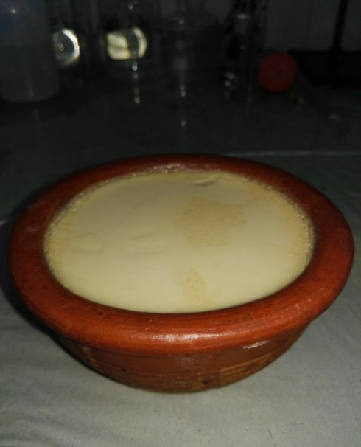
Yogurt is 81% water, 9% protein, 5% fat, and 4% carbohydrates, including 4% sugars. A 100-gram amount provides 406 kilojoules (97 kcal) of dietary energy. As a proportion of the Daily Val 14,20,22,36,67-69ue (DV), a serving of yogurt is a rich source of vitamin B₁₂ (31% DV) and riboflavin (23% DV), with moderate content of protein, phosphorus, and selenium 14 to 19% (Ekram et al., 2011).
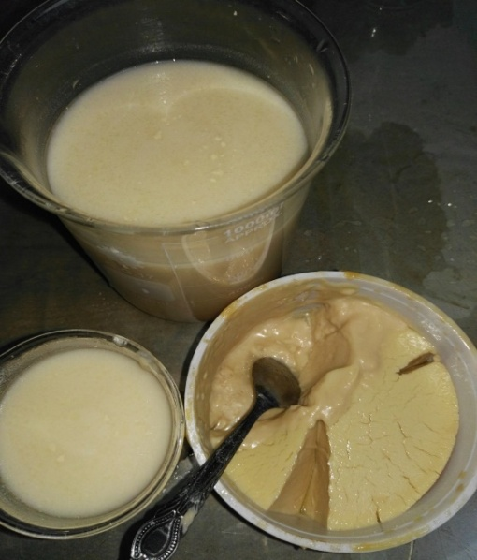
Figure-1: Photos of Yogurt in different markets
Table -2: Comparison of whole dairy milk and plain yogurt
Comparison of Whole Dairy Milk and Plain Yogurt from Whole Dairy Milk, one cup (245 g) each
Property | Milk | Yogurt
kilo calories | 146 | 149
Total Fat | 7.9 g | 8.5 g
Cholesterol | 24 mg | 32 mg
Sodium | 98 mg | 113 mg
Phosphorus | 222 mg | 233 mg
Potassium | 349 mg | 380 mg
Total Carbohydrates | 12.8 g | 12 g
Protein | 7.9 g | 9 g
Vitamin A | 249 IU | 243 IU
Vitamin C | 0.0 mg | 1.2 mg
Vitamin D | 96.5 IU | ~
Vitamin E | 0.1 mg | 0.1 mg
Vitamin K | 0.5 μg | 0.5 μg
Thiamine | 0.1 mg | 0.1 mg
Riboflavin | 0.3 mg | 0.3 mg
Niacin | 0.3 mg | 0.2 mg
Vitamin B6 | 0.1 mg | 0.1 mg
Folate | 12.2 μg | 17.2 μg
Vitamin B12 | 1.1 μg | 0.9 μg
Choline | 34.9 mg | 37.2 mg
Betaine | 1.5 mg | ~
Water | 215 g | 215 g
Ash | 1.7 g | 1.8 g
The above shows little difference exists between whole milk and yogurt made from whole milk with respect to the listed nutritional constituents.
Although yogurt is often associated with probiotics having positive effects on immune, cardiovascular or metabolic health, high-quality clinical evidence is insufficient to conclude that consuming yogurt lowers risk of diseases or improves health. The United Kingdom and the United States recommend different maximum amounts of daily sugar intake, but in both nations, many sweetened yogurts have too much. However, around 12 g of sugar per 150-g serving of yogurt is in the form of naturally occurring lactose. The American Heart Association recommends that men eat no more than 36 grams of sugar per day, and women no more than 20.
Yogurt is produced using a culture of Lactobacillus delbrueckii subsp. bulgaricus and Streptococcus thermophilus bacteria. In addition, other lactobacilli and Bifidobacteria are also sometimes added during or after culturing yogurt. Some countries require yogurt to contain a certain number of colony-forming units of bacteria; in China, for example, the requirement for the number of lactobacillus bacteria is at least 1 × 10⁶ CFU per milliliter (Kee et al., 2012).
To produce yogurt, milk is first heated, usually to about 85 °C, to denature the milk proteins so that they do not form curds. After heating, the milk is allowed to cool to about 45 °C. The bacterial culture is mixed in, and a temperature of 45 °C is maintained for four to twelve hours to allow fermentation.
2.5.2. Health benefit of yoghurt
Yogurt has been consumed by humans for hundreds of years. It's very nutritious and eating it regularly may boost several aspects of health. Yogurt has been found to reduce the risk of heart disease and osteoporosis as well as aid in weight management.
Yogurt is a popular dairy product that's made by the bacterial fermentation of milk. The bacteria used to make yogurt are called "yogurt cultures," which ferment lactose, the natural sugar found in milk. This process produces lactic acid, a substance that causes milk proteins to curdle, giving yogurt its unique flavor and texture. Yogurt can be made from all types of milk. Varieties made from skim milk are considered fat-free, whereas those made from whole milk are considered full-fat. Unfortunately, most commercial brands contain added ingredients, such as sugar and artificial flavors. These yogurts are not good for your health. On the other hand, plain, unsweetened yogurt offers many health benefits.
2.5.3. Rich important of nutrients
Yogurt contains some of nearly every nutrient that body needs. It's containing a lot of calcium, a mineral necessary for healthy teeth and bones. It is also high in B vitamins, particularly vitamin B12 and riboflavin, both of which may protect against heart disease and certain neural tube birth defects.
Yoghurt provides 38% of daily need phosphorus, 12% magnesium and 18% potassium. These minerals are essential for several biological processes, such as regulating blood pressure, metabolism and bone health. One nutrient that yogurt does not contain naturally is vitamin D, but it is commonly fortified with it. Vitamin D promotes bone and immune system health and may reduce the risk of some diseases, including heart disease and depression
2.5.4. Benefit digestive health
Some types of yogurt contain live bacteria, because of fermentation. These may benefit digestive health when consumed. Unfortunately, many yogurts have been pasteurized, which is a heat treatment that kills the beneficial bacteria they contain. To ensure your yogurt contains effective probiotics, look for one that contains live, active cultures, which should be listed on the label. Some types of probiotics found in yogurt, such as Bifidobacteria and Lactobacillus, have been shown to lessen the uncomfortable symptoms of irritable bowel syndrome (IBS), which is a common disorder that affects the colon.
2.5.5. Protect against osteoporosis
Yogurt contains some key nutrients for maintaining bone health, including calcium, protein, potassium, phosphorus and, sometimes, vitamin D. All of these vitamins and minerals are especially helpful for preventing osteoporosis, a condition characterized by weakening of the bones. It is common in the elderly.
2.5.6. Benefit heart health
Yogurt's fat content is one of the reasons why its healthiness is often controversial. It contains mostly saturated fat, with a small amount of monounsaturated fatty acids. Saturated fat was previously believed to cause heart disease, but current research shows that this isn't the case. Nevertheless, fat-free and low-fat varieties of yogurt are still popular in the US. There is no clear evidence that the fat in yogurt is harmful to health. In fact, it may benefit heart health.

2.5.7. Promote weight managements
The acidity of yogurt acts as a barrier to bacteria growth, as does the high temperature achieved during the yogurt-making process. However, milk must be pasteurized beforehand to sufficiently kill disease-causing pathogens, such as E. coli 0157:H7, which may be acid-tolerant.It is essential that all equipment and work spaces used in the yogurt-making process remain clean and sanitized to prevent the addition of unwanted bacteria to the yogurt.
The FDA requires that yogurt be made with live cultures, but some yogurts are heat-treated so that the final product contains no active cultures. The label should specify what microorganisms are present and in what amount in terms of colony-forming units (CFUs) as well as the known health benefits associated with the strains used. The label should also disclose the expiration or use-by date, serving size suggestion, company name, and proper storage of the product. Regardless of the use-by date, yogurt with visible signs of microbial growth or off-odors should be discarded immediately.
Regular yogurt intake appears necessary to provide a sustainable benefit on host. Yogurt and dairy products are recognized by most regulatory authorities and scientific institutions as part of a healthy diet. Yogurt is characterized by its living bacteria, which, in addition to its high nutrient density and its palatability, have been demonstrated to improve lactose digestion (EFSA 2010b). Recent studies suggest that yogurt could play a valuable role on health.
The shelf life of yogurt is 10-21 days. For liquid yogurt, the shelf life is 4-10 days and for yogurt cheese the shelf life is 7-14 days when refrigerated at 40°F.Yogurt can also be frozen for several months, but this may alter its texture.
The bacterial cultures required for making yogurt are Streptococcus thermophilus and Lactobacillus bulgaricus. About 80% of all yogurts manufactured in the U.S. contain an additional culture, Lactobacillus acidophilus, and many commercial yogurt products also contain Bifidobacteriumbifidum or Lactobacillus caseibecause of their potential health benefits.
Yogurt has several properties that may help with weight management. For starters, it is high in protein, which works along with calcium to increase levels of appetite-reducing hormones like peptide YY and GLP-1. Furthermore, several studies have found that yogurt consumption is associated with lower body weight, body fat percentage and waist circumference. One review found that the intake of full-fat dairy products, including yogurt, may reduce the incidence of obesity. This is contrary to what was previously believed about fat intake and weight gain.
2.6. Chotpoti as foods
Chotpoti is a popular street food among all groups of people from low to high income in most cities of Bangladesh. This study was conducted to describe the vending sites, the stalls and equipment’s used for food preparation, current level of food safety knowledge of vendors and the way to prepare foods to understand the risks of food contamination and opportunities for prevention. We selected chotpoti vending sites including market places, bus stops, road sides and amusement parks located under Chittagong city corporation areas by judgment sampling. A structured pretested questionnaire was used for data collection. Location of the chotpoti vendors, utensils used, handling of food, place of preparation of chotpoti, environment surroundings of the stall, general processing of chotpoti and hygienic practices were observed and recorded through an observation checklist. This study demonstrates that chotpoti vendors do not have formal education and formal training on food preparation. Moreover, lack of hand hygiene knowledge, infrequent cleaning of utensils with soap, inappropriate management of leftover foods, and lack of proper waste management create numerous possibilities for food contamination. Consumption of street vended chotpoti may pose a risk of food borne diseases and steps should be taken to educate and train the vendors on personal hygiene and food handling practices.

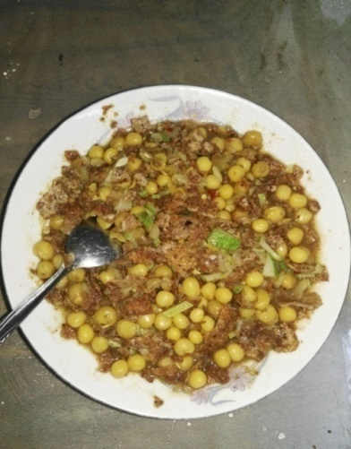
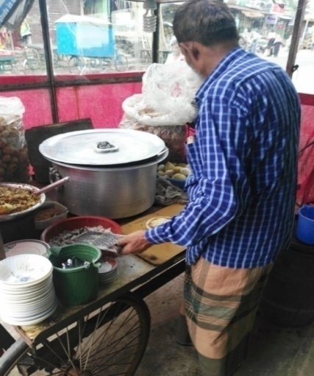

Figure-2: Physical appearance of local street foods (chotpoti)

2.7. Salad dressing as foods
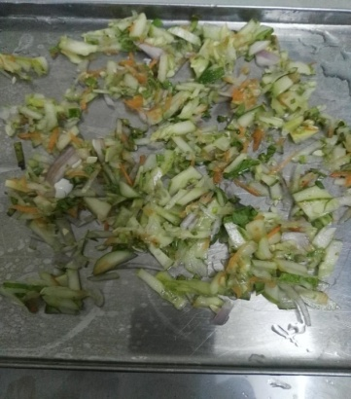
Salad is a dish of raw leafy green vegetables, often tossed with pieces of other raw or cooked vegetables, fruit, cheese, or other ingredients and served with a dressing. In Bangladesh salads are served with meals and snacks. However, food and water in particular have been described as vehicles for the transmission of microbial diseases, among which are those caused by coliforms (Ifediora et al., 2006). Some coliforms, including Salmonellae, Shigellae, and enteropathogenic Escherichia coli, are notable enteric pathogens. Escherichia coli O157:H7 and Salmonella spp. are the most dangerous food borne bacterial pathogens in terms of human health and disease (Olsen et al. 2000). The microbial load and the presence of the bacterial pathogens in foods are a good indication of the food quality and the potential health risk they pose to consumers (Rosmini et al. 2004). Various serotypes of Salmonella spp. have been reportedly responsible for food borne epidemics in various countries (Todd, 1997), emphasizing the importance of the pathogen as a food safety concern. In Europe, it has been reported that 25% of food borne outbreaks could be traced back to recontamination (WHO, 1995). Epidemiological evidence indicates that cholera is primarily a waterborne disease (Glass and Black, 1992). Besides drinking water, food has also been recognized to be an important vehicle of transmission of cholera. In developing countries, where both poverty and poor sanitation are common, fecal contamination of domestic and commercial food is likely to occur, and in many outbreaks the infection has been traced to consumption of fecal-contaminated foods (Rabbani and Greenough, 1999). In Dhaka, the capital city of Bangladesh, there were two outbreaks of cholera in 1974 and 1975 (Khan, 1983). The results of a case-control study indicated that the attack rates of cholera were significantly associated with eating in restaurants. Fresh fruits and vegetables are perceived by customers to be healthy and nutritious foods owing to health benefits derived from consuming fresh products. Meldrum et al., (2009) reported that two large outbreaks in the United Kingdom demonstrated the significant health problems that could arise from consumption of contaminated salads. In all cases where antimicrobial treatment in humans is indicated, resistance to the antimicrobials of choice is of clinical importance. Resistant Salmonella involved in human disease are mostly spread through foods. With regards to Salmonella, contaminated poultry meat, eggs, pork and beef are prominent in this regard. Food is also an important source for human infections with antimicrobial resistant Vibrio spp. The presence of antibiotic resistant bacteria in water sources throughout the world has been documented (Kelch and Lee, 1978; French et al., 1987; Ogan and Nwiika, 1993). The majority of the studies focused on transferable drug resistance because of its practical importance (Pitout et al. 1998; Stapleton et al. 1999; Byarugaba, 2004). The quality of drinking water in Bangladesh is also at high risk. Problems are acute, especially in the urban 160 areas due to increased migration of rural people and increased economic growth as well. Chittagong, the commercial capital of Bangladesh, is one of the densely populated urban areas which has been suffering from inadequate supply of drinking water often associated with water quality problems too (UNCED, 1992). The principles that are applied to the prevention and control of the spread of pathogenic bacteria via food will also contribute to the prevention and the spread of antimicrobial-resistant pathogenic bacteria. As antimicrobial resistance in food borne pathogens and commensally represents a specific public health hazard, additional control measures for antimicrobial resistant bacteria may therefore be necessary (EFSA, 2008). In Bangladesh, a large number of people living in major cities and suburbs eat their meals in various roadside restaurants. In recent times, the microbiological safety of drinking water has become a burning issue and public awareness is gradually increasing regarding waterborne diseases. This study was therefore carried out since there is currently no report on a comprehensive assessment of the bacterial health risk posed to consumers of salads across the Chittagong city.
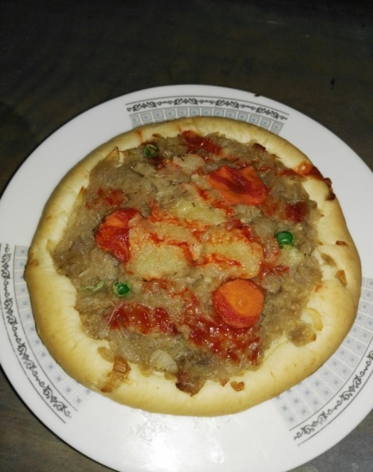

Figure -3: Picture of commonly sold Salad dressing
The urban population in Bangladesh is increasing rapidly. In the last decade, the number of people living in the country’s capital Dhaka almost doubled from 5.3 to 9.3 million. This development has led to an increase in the demand for relatively inexpensive and ready-to-eat foods as many urban residents spend most of the day outside of the house and have little time and money to spend on food. Rapid urbanization also turned street-food vending into an important business; in Dhaka alone, around 200,000 people earn their living by selling street foods. The low cost, accessibility, and convenience are the key factors for the growing popularity of street foods.
Women play a very vital role in the street food sector through their direct and indirect involvement in the business. Additionally, a significant number of street vendors are woman-headed households. The diversity that exists among street food vendors is reflected in the type of food they prepare the scale of their business, the mode in which they are operating, the locations in which they prepare and sell food, the type of clients to whom they sell food, and so forth.

2.8. Consumers of street foods
The consumption patterns of street foods and their contribution to dietary intake are scanty. The customer surveys undertaken by FAO 2006 (Burro et al., 2007) and other investigators revealed that the main consumers of street foods in most countries were other members of the informal sector, such as fellow hawkers and hustlers and casual wage laborers. Other important categories of customer were children and students, office workers, and housewives (Muinde et al., 2005).
The frequency and regularity of consumption were variable in some countries, street foods were bought daily and formed an integral part of the diet; in others, notably in Bangladesh, they appeared supplementary and few customers bought them daily. Some categories of consumer were found to buy almost all their food from vendors. The cost of street foods is usually competitive compared with that of foods purchased from larger food establishments, such as restaurants and fast food outlets. Also, due to the sometimes-high costs of fuel and ingredients in urban contexts, economies of scale can create a street food cheaper than the same food prepared at home.
2.9. Street foods create employment
Each street food enterprise is generally small in size, requires relatively simple skills, basic facilities and small amounts of capital, yet they are very numerous and have considerable potential for generating income and employment. Bogor, with a population of 250 000, has 18000 street food enterprises, nearly one for every 14 people. Roughly 26 percent of workers active in the informal sector in Bogor are directly employed as street food vendors (Chapman, 1984). Similarly, the International Labour Organization has found that street vendors comprise 29 percent of the active urban labour force in Central America (Allain, 1988).
The street food operation often involves entire families in the procurement of raw materials, preparation and cooking as well as the sale of food. Worldwide, women play a very large role in the street food industry (Tinker and Cohen, 1985). Street food sellers are attracted to this occupation because of the possibility of earning relatively high incomes. In Southeast Asia, the average earnings of a vendor may be three to ten times more than the minimum wage and they are often comparable to the wages of skilled labourers employed in the formal sector (Andringa and Kies, 1989).
The relatively low capital expenditures of street food businesses are also attractive for certain types of sellers. Furthermore, vendors can choose their work hours; they have few constraints on their movements and are self-employed. Despite the benefits of street food trade, vendors may have to work long hours under adverse conditions and the risks are borne exclusively by the seller. Vendors can face problems with local officials and may also have to deal with criminals who try to extort "protection money" from them. In. addition, their profession is often considered to be of low status.

2.10. Street foods' role in the economy
Street food micro-industries are vital for the economic planning and development of many towns. The contribution of street food vendors to the economies of developing countries has been vastly underestimated and neglected. However, statistics for some places do exist. In the Indonesian city of Bogor annual sales of street foods amount to US 67 million (Cohen, 1986). If one computes the average daily sales of the 100 000 (by conservative estimate) stalls in Malaysia, annual street food sales amount to US 2.2 billion (Allain, 1988). This is a relatively significant figure considering that most of the earnings are generated locally and thereby promote economic self-sufficiency.
The significance of the street food industry has often been ignored because it is considered part of the informal sector. Previously, the informal sector was thought to symbolize a lack of economic development that would and should disappear with modernization. Until more permanent jobs could be provided by the modern sector, the former was expected to absorb unskilled workers who migrated to the city from rural areas (Todaro, 1969).
The term "informal sector" has been widely applied to describe loosely organized and often non-enumerated economic activities in the rapidly growing cities of the developing world. Actually, the division between the informal and formal sectors is not always obvious. Suppliers and consumers may "cross sectors" to exchange goods and individuals may be active in both formal and informal economic endeavors.
However, this phenomenon has lasted longer and may be less transitional in nature than previously anticipated. The informal sector appears to be growing more rapidly than the formal sector in the urban areas of many countries (Farbman, 1980). Because of the rapid rise in urban populations and increasing awareness of the limited employment generated by large-scale industries, planners are beginning to acknowledge the importance of the informal sector.
2.11. Food safety issue
Food safety refers to limiting the presence of those hazards whether chronic or acute, that may make food injurious to the health of the consumer. Food safety is about producing, handling, storing and preparing food in such a way as to prevent infection and contamination in the food production chain, and to help ensure that food quality and wholesomeness are maintained to promote good health.
Food safety is everybody’s concern, and it is difficult to find anyone who has not encountered an unpleasant moment of food borne illness at least once in the past year. Food borne illnesses may result from the consumption of food contaminated by microbial pathogens, toxic chemicals or radioactive materials. Food allergy is another emerging problem. While many food borne diseases may be self-limiting, some can be very serious and even result in death. Ensuring food safety is becoming increasingly important in the context of changing food habits, popularization of mass catering establishments and the globalization of our food supply.
2.12. Raw materials
Food is susceptible to contamination at all stages of the food chain. Raw materials are therefore important to the safety of street-vended food because of the biological, chemical and physical hazards that may be introduced to the vending operation and which may persist through preparation and processing.

The type and extent of biological contamination of raw materials used in street food vending will differ little from those used in other businesses involved in the food service sector. The greatest differences will be noted when vendors purchase raw materials of a lower grade because of their lower cost. Consequently, raw materials should be obtained from known and reliable sources and not from clandestine dealers. Raw materials should also be observed for visible deterioration and off-odors. It may be necessary to examine potentially hazardous food for temperature abuse, including signs of thawing for frozen raw materials.

Raw materials also need to be examined for the presence of physical hazards and gross chemical contamination prior to purchase. Raw materials contaminated with obvious physical hazards should be avoided or the hazards removed. Control of chemical hazards in raw materials is often extremely difficult for street food vendors. Attention may be given to obtaining food colors and other additives from authorized dealers (where they exist), purchasing raw materials from reputable suppliers and examining foods for possible visible and olfactory signs of chemical contamination.

It should be assured that raw materials are not further exposed to contamination from accidental exposure to chemicals or growth of pathogens and toxin production during transport and storage.
2.13. Water and ice
Water is a critical raw material in many street food vending operations. It may also be contaminated with biological, chemical or physical hazards. As such contaminated water will create a public health risk if it is: used for drinking purposes; used for washing of food, incorporated into food as an ingredient and used in the processing of food; or used in the washing of equipment, utensils and containers. Freezing does not remove chemical hazards and should not be considered a safe processor the removal of biological hazards. Consequently, contaminated ice may introduce hazards to food and beverages with which it is in contact.

One of the most critical problems in street food vending is the supply of water of acceptable quality and in sufficient quantities for drinking, washing, cleaning and other operations. The ambulant vendor can carry only limited supplies and even stationary food stalls may not have direct access to a water supply. Indeed, water is generally scarce in low-income areas in most developing countries. Water taps may run only for a few hours during the day and sometimes not for days. Street vendors in various parts of the world are known to wash their utensils, including those in which food has been served, in water which has been used previously, perhaps many times. Therefore, water supply needs close attention in street food operations. This is particularly true if contaminated water may be added to a food or applied to utensils without a subsequent step to eliminate or reduce the potential hazards to an acceptable level.

As far as possible, the production and sales units should have their own supplies of potable water whether it is from a central system or an individual source, such as a hand pump. If potable water is not available, a suitable source of safe water should be used. Water used for drinking and preparation of beverages should be potable. In any case, the quality of the water should not be inferior to that of drinking water available in the community. Special care should be taken to assure that such water is maintained in a sanitary state.
Water used for washing utensils, food and hands should be safe and should not be re-used. As far as possible, running water should be available for these purposes. If this is not feasible, a bucket or similar container can be used for washing, but it should be emptied and cleaned after each washing. Hot water, where available, makes cleaning and washing easier and more effective but is not generally available to street vendors. Ice to be used in beverages and food should be prepared from potable water and should be transported and stored in a sanitary manner. Other items, such as food and beverages, should not be stored in the same container used to store ice intended for consumption.

Hazards often arise from a lack of clean water for direct consumption, food preparation, washing of utensils or personal hygiene. In some areas operators have to use well or river water that is often contaminated, especially with bacteria. In areas with good clean water, food handlers often use that water inappropriately, resulting in its contamination:
- Water for customer consumption or for the preparation of food is often kept in containers that are uncovered, dirty or difficult to clean;
- Water for washing dishes is rarely hot. It is used several times and ends up with a high physical and microbial load.
- Water is therefore a main source of contamination of street food.
Water is a critical raw material in many street-vended operations. Contaminated water can create a public health risk when it is used for drinking, washing of foods, incorporated in the food as an ingredient and used in the processing of food or used for washing equipment, utensils and hands. It is a well-known vehicle for enteropathogens such as E. coli, Salmonella spp. and Campylobacter Spp. Due to the shortage of clean potable water; many vendors tend to re-use the water, especially for cleaning utensils and used dishe (Dawson et al., 1991).

The bacteriological quality of the water used by some street vendors has revealed frequent contamination with coliforms and fecal coliforms (Chakravarty et al., 1996). When the street foods in Trinidad and Tobago were analyzed, it was reported found that 35% of foods were contaminated by E. coli while 57.5% of water used by vendors were contaminated by coliforms (Welch et al., 2000). These reports were like the findings that the stored water used by consumers and vendors, at the vending site, showed heavy bacteriological contamination of fecal origin. Such heavily contaminated water is a primary source of diarrheal diseases to the street food consumers. It was revealed that 29.6% of the water samples were not conforming to the WHO standards of potability and had coliform counts of more than 16/100 ml, while fecal coliform counts were more than 16/100 ml in 15.5% of water samples, 4.5% of samples was positive for E. coli and 2.7% for enteropathogenic E. coli. Similarly, pathogens like Salmonella and Shigella have been detected in the water used by vendors for dishwashing Chemical and Microbial Contaminants (Barro et al., 1987).
Use of proper utensils for cooking and storage of prepared food is often critical to the safety of street vended foods. Poor quality of material coupled with improper practices may lead to toxin formation, pathogen growth or recontamination. The design, construction and maintenance of equipment and utensils is very important to food safety, as their poor maintenance may lead to the inability to effectively clean and sanitize surfaces.
2.14. Personal hygiene of the vendors
Personal hygiene of the vendors found that 81.3% of the vendors did not use aprons, 60% handled food with their bare hands, 87.7% had short nails, which were not polished and 65% had their hair not covered. All the vendors handled money while serving food and only 10% of them had worn jewelry. Most of the vendors who sold chips, mandazi, and githeri and fish packed the foods in polythene bags for their customers. Packing street foods, they blew air into the polythene bags to open them so that they could put the food in the polythene bags. Clearly germs, some harmful can be passed on to the consumer through this process.
Thirty-five percent of the vendors interviewed said that they usually have left-overs. Out of those, 32.1% reported consuming them and the rest stored them for the following day’s sale. Vendors stored left-over food open place (26%), refrigerator (21%), and plastic containers (21%) while 16% kept them either in polythene bags or in cupboards for sale in the next day. Most of the vendors stored their left-over in ambient temperatures this is quite risky because safety from contamination by pathogenic organisms was not assured and the maintenance of optimal qualities of colour, texture and nutritive value were not put into consideration.
Personal hygiene is important because it is human beings are the largest contamination sources of food. Vendors did not wear aprons, caps and they handled food with bare hands. Handling with bare hands may result in cross contamination, hence introduction of microbes on safe food. The person handling money should not handle food. This is because money is dirty and can contaminate safe food. Observing personal hygiene is vital for any food establishment. Any food handler, who observes other forms of hygiene but not personal hygiene, will contaminate food. Training should, therefore, be conducted for the street food vendors on various aspects of personal hygiene.
The street foods were prepared in unhygienic and sanitary conditions. This is because the vendors deposited their food and water wastes beside the stalls this resulted in a dirty environment that attracted houseflies, the presence of which compromise sanitation.
2.15. Hazard analysis of street vended foods
The conditions under which some street vendors operate are reported to be unsuitable for the preparation and selling of food (Barro et al., 2006). The food is prepared either at home or at stalls, which are located on the street side and are made up of wood, polythene bags, tin, etc. The place of preparation is not always clean, well-lit and not far from source of contamination. Preparation surfaces used by some vendors have remains of foods prepared earlier that can promote cross contamination. Most of these foods are not covered and are exposed to flies and dust, which may harbor food borne pathogens. In 70–90% of the cases, presence of animals, insects and liquid wastes in food preparation areas have been reported (FAO, 1988). The two major sources from where the contaminants can enter the preparation area are: Improper food handling and waste disposal.
2.16. Food handling
Unsanitary handling of street foods by the some of the vendor has been commonly found to be the source of contamination (Akinyele et al., 1987). The vendors can be carriers of pathogens like Escherichia coli, Salmonella, Shigella, Campylobacter and S. aureus who eventually transfer these foods borne hazards to the consumers. The hands of the food handlers are the most important vehicle for the transfer of organisms from faeces, nose and skin to the food (WHO, 1989). The finding that Salmonella, non-typhi salmonellae, Campylobacter and E. coli can survive on finger tips and other surfaces for varying periods of time (Pethers et al., 1971) and in some cases even after washing, supports the reports of contamination of street vended food with toxigenic S. aureus, the major being suppurative lesions of human beings and the environment.
2.17. Waste disposal
Few vendors congregate in overcrowded areas where there are high numbers of potential customers, which usually provide limited access to basic sanitary facilities. Hence, the contamination of street foods is often linked to the waste generated by food processing, that is usually dumped near the vending site. The lack of facilities for liquid drainage and wastewater and garbage disposal encourages wastes to be thrown into nearby streets and gutters. Such areas act as habitats for rodents, breeding points for flies and media for growth of microorganisms.
2.18. Public health important of street foods
Street food is exposed to different contamination hazards (microbial, parasitic, physical, chemical) that sometimes make that food dangerous for consumers; hence the need to assess and control potential hazards that could undermine food sanitary quality. Because of its rigor and systematic nature, the hazard analysis method is useful for adapting the implementation of required hygiene measures and for specifying critical points. Unhygienic conditions and practices that are conducive to risk apply to operators, consumers, street food premises and supplies and processed materials.

2.18.1. The hazards associated with food are many and various:
- Unclean water;
- Contaminated or poorly washed raw materials;
- Dirty work materials;
- Preparation and sale of food in unhygienic or inappropriate surroundings;
- Use of unclean packaging;
- Failure to protect food from external contamination;
- Poor conditions of storage and preservation;
- Use of a small number of pots and plates;
- Unsatisfactory operator hygiene and health
- Other unhygienic traits and practices of operators and consumers (poor personal hygiene,
- Inappropriate clothing, improper conduct during food preparation, sale and consumption.

2.18.2. Preparation of food in unsanitary surroundings
When street food handlers set up their stalls in dusty surroundings close to piles of rubbish, waste water discharge points and toilets that attract flies, mosquitoes their products will inevitably be contaminated. The animals, insects and other impurities will act as vectors for an assortment of contamination agents.

2.18.3. Work materials and packaging
Unclean or poorly washed materials used for food preparation, preservation; storage and distribution contribute significantly to contamination. The use of dirty work materials is strictly forbidden as this affects food hygiene and endangers consumer health. The use of unclean packing materials (plant leaves, recycled boxes and bottles, newspaper) is a significant source of food contamination of street food.

2.18.4. Food preparation, storage and sales
Street food can also be contaminated by chemical agents such as lead (from water pipes, welded can seams or air pollution), mercury (detected especially in fishery products), pesticides (essentially from phytosanitary treatment), veterinary products and unauthorized additives. Whether introduced intentionally or inadvertently into street food, most of these chemical substances have proved to be toxic.
2.19. Contamination of street food
Street food vending represents an important food security strategy for low-income communities worldwide. However, no comprehensive risk analysis framework yet exists about specific aspects of chemical or toxicological hazards in street foods. Indeed, all steps of street food production and vending can be vulnerable, from the selection of raw materials, through to the storage and preparation of meals and even the vending site, often exposed to urban pollutants. Relevant examples are cheap ingredients with illegal or undesirable residues, substances arising in poorly stored commodities, metals leaching from cookware, and process contaminants. Therefore, greater awareness and preventive measures need to be implemented for coping with chemical or toxicological risk factors in a systematic and effective way. The proposed measures in street food vending could integrate the prevention of biological risk factors, to promote comprehensive and up-to-date consumer safety.
Street food vending has become an important public health issue and a great concern to everybody. This is due to widespread food borne diseases, due to the mushrooming of wayside food vendors who lack an adequate understanding of the basic food safety issues. Major sources contributing to microbial contamination are the place of preparation, utensils for cooking and serving, raw materials, time and temperature abuse of cooked foods and the personal hygiene of vendors. food safety issues involved in street foods to be microorganism belonging to the genus Bacillus, Staphylococcus, Clostridium, Vibrio, Campylobacter, Listeria, Salmonella.
As some containers will leach hazardous chemicals like copper, lead and cadmium into food, use of equipment and utensils incompatible with the food being handled, should be avoided. This has been observed particularly with acidic food and beverages (Ohiokpehai et al., 2003).
The serving utensils used at the vending site are often contaminated with Micrococcus spp. and Staphylococcus spp. which may have originated from the vendors hands when they touched the food preparation areas, dishcloths, or the water during dish washing or hand washing which indicates cross contamination between dishwater, food preparation surfaces, and the food itself (Cardinale et al., 2004).
Bacteria from dirty dish washing water and other sources adhere to the utensil surface and can constitute a risk during the food vending process. Microbiological analysis of utensils surface and knives have shown the presence of Salmonella and Shigella. It is also reported that during the preparation of food, the raw material is cut and chopped using the same knife without in between cleaning and such knives are often invaded by flies (Mensah et al., 2002).
Golden rules
To reduce the risk of microbial contamination of food it is important:

- To avoid crossing clean with unclean;
- To avoid moving products back into unclean areas;
- To store raw materials upstream from production areas;
- To adjust the organization of work to mitigate the constraints of non-conforming premises.

Key findings of the WHO report of street-vended foods
- 74% of countries reported street-vended foods to be a significant part of the urban food supply;
- Street-vended foods included foods as diverse as Chotpoti, fish, fruits, vegetables, grains, cereals, frozen produce and yoghurt;
- Types of preparation included foods without any preparation (65%), ready-to-eat food (97%) and food cooked on site (82%);
- Vending facilities varied from mobile carts to fixed stalls and food centers;
- Infrastructure developments were relatively limited with restricted access to potable water (47%), toilets (15%), refrigeration (43%) and washing and waste disposal facilities;
- Most of countries reported contamination of food (from raw food, infected handlers and inadequately cleaned equipment) and time and temperature abuse to be the major factors contributing to forborne disease; and
- Most countries reported insufficient inspection personnel, insufficient application of the HACCP concept and noted that registration, training and medical examinations were not amongst selected management strategies.

2.20. Hygienic status of street food and street food vendors
Street food vending has become a serious health issue and a great concern. This is due to an alarming rise in food-borne diseases which are a result of the mushrooming of wayside food vendors, who lack adequate understanding of the basic safety and hygiene issues. Major sources contributing to microbial contamination are the place of preparation of food, utensils used for cooking and serving, raw materials, lack of access to potable water, time and temperature abuse of cooked foods, inadequate solid waste management systems and the personal hygiene of the vendors.
Street food vendors are a traditional and indigenous fast food approaching most countries of the South-East Asia Region. Street food vendors provide cheap and enjoyable food to millions of consumers. It is difficult to say how safe street food is as there are many contributing factors associated with the safety of street food. The water quality, hygienic conditions and the level of cleanliness- particularly in the summer season may contribute to episodes of food poisoning. However, improvements in physical infrastructure and hygienic conditions are growing as consumers are also demanding quality food.
A poor production and marketing of the street foods exemplified using cheaper inputs and of dubious quality, as well as the lack of nutritional knowledge security on the part of the handlers, compromises the nutritional quality and sanitary-hygiene of food. Street food vending is a common phenomenon in towns and cities.
Street foods and street food vendors has become one of the most fascinating aspects of social life in urban and peri-urban centers. In fact, street food trade is becoming a viable and important informal-sector industry. Besides convenience, it offers business opportunities for many entrepreneurs. The sale of street foods enhances the income of the operators and meets the food demands of urban dwellers especially the low-income group. The country has been experiencing unprecedented rate of socio-economic challenges.
Unemployment has continued to rise due to the declining economic situation. Consequently, there has been increasing migration of youth to the urban centers. The migration has continued to create a high demand for ready-to-eat foods by the migrants. In the face of the harsh socio-economic situation, these foods are relatively cheap and readily available for the teeming unemployed. Though street vended foods are relatively cheap and accessible, their safety and quality have remained a serious issue of concern to health experts and international bodies (Agu, 2011) the World Health Organization (WHO, 1984) and Ashenafi (1995), street vended foods are prone to be contaminated by either spoilage or pathogenic micro-organisms. The Food and Agricultural Organization (FAO,1997) also maintained that street vended foods are prone to food poisoning due to improper and unhygienic handling of the foods and the unregulated nature of this sector of the economy.
2.21. Significant health problem of street food
Lack of basic infrastructure and service such as potable water supplies are the major health problem. Insufficient resource for inspection and laboratory analysis such as general lack knowledge about the microbiological status or paresis epidemiological significance of street food. The poor knowledge of street vendors in basic food safety measure of street food. In adequate public awareness of hazard by curdled street food. On the other hand, street foods most of the ingredients are not appropriate for the production of street foods. Hygiene and sanitation do not maintain.
The analysis revealed that majority of the street vended foods in safe for human consumption. Poor construction and location of vending sites, inadequate sanitary facilities, poor personal hygiene, temperature abuses and sub-standard packaging were identified as the main variables responsible for the low safety and quality of the street food.

CHAPTER-3: MATERIALS AND METHODS

3.1. Location and study period
The experiment was conducted in Department of food processing and Engineering, the laboratory of Poultry Research and Training Center (PRTC), Chittagong Veterinary and Animal Sciences University, Chittagong, Bangladesh and BCSIR Laboratories, Chittagong, Bangladesh and the laboratory of Banoful & Co. Research & Development Department. The experiment was conducted for a period of six months from 1st January, 2017 to 30th June, 2017.

3.2. Collection of Sample and data collection from street food vendors on food safety.issue

Totally 3 types of samples (salad dressing-500 g, yogurt-500 g, chotpoti-500 g) and 6 from each item were collected from Chittagong city (muradpur, Nasirabad, Bakalia, Pahartali,Foy’s Lake Khatungonj, Maished Para).

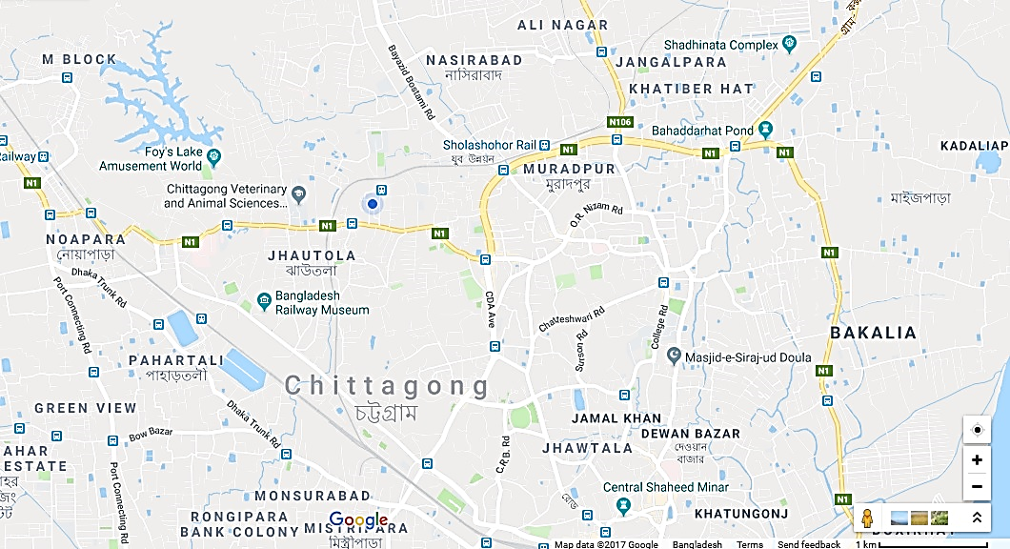
Figure- 4: Sampling area of Chittagong Metropolitan

3.3. Nutritional composition analysis of selected street foods
Moisture, protein, fat and ash contents of samples were measured according to AOAC methods. The crude protein content was measured by the kjeldahl procedure. Total fat was extracted by the AOAC (2016) method using the soxhlet system.
3.3.1. Protein
Reagents used: Concentrated H₂SO₄, Digestion mixture, boric acid solution, alkali solution, standard HCl for estimation of protein, the steps were followed;
Digestion: 2 gm sample, 3gm digestion mixture and 25 ml H₂SO₄ was taken in a kjeldahl digestion flask. It was heated for 4 hours in a kjeldahl digestion and apparatus. The digestion was completed when the color of the substance was pale yellow.
Distillation: After digestion 100 ml water ,100 ml 40%NaoH and glass bliotz were added to kjeldal flask which containing about 10 ml 2% boric acid and 2-3 drops mixed indicator. About 100 ml. distillate was collected just before the distillation was stopped. The receiving flask was moved so that the tip of the distillation tube was out the distillate. Some distillate was collected in this way to make sure the condenser tube was free from traces of ammonia.
Titration: The ammonia collected was titrated with .1N HCI Solution and titer value was recorded.
The calculation of the percent of protein in the sample using protein factor 6.25
$$\% Nitrogen=\frac{\left(T_{s}-T_{b}\right)×NormalityofAcid×milliequivalentofN_{2}}{WeightofSample (gm)}×100$$
Where,
Ts=titer value of sample
Tb=titer value of blank
Meq of N2=0.014
%protein = %nitrogen × 6.25

3.3.2. Fat
The dried sample remaining after moisture determination was transferred to a thimble and plugged the top of the thimble with a wad of fat free cotton. The thimble was dropped into the fat extraction tube attached to a soxhlet flask. Approximately 75 ml or more of anhydrous ether was poured into a flask. The top of the fat extraction tube was attached to the condenser. The sample was extracted for 16 hrs or longer on a water bath at 70-80 ˚C. At the end of the extraction period, the thimble was removed from the apparatus and distilled off most of the ether by allowing it or collected in soxhlet tube. The ether was poured off when the tube was nearly full. When the ether reached a small volume, it was poured into a small, dry beaker through a small funnel containing a plug of cotton. The flask was rinsed and filtered thoroughly, using ether. The ether was evaporated on a steam bath at low heat; it was then dried at 100 c for 1 hr, cooled and weighted. The difference in the weights gave the ether soluble material present in the sample.
$$\%fat =\frac{loss of ether soluble materials}{weight of sample }×100$$
3.3.3. Moisture
At first weight of empty crucibles were dried for 1hr at 100 c and 5 gm of sample was placed on it. Then the crucible was placed in air oven (thermostatically controlled) and dried at temperature of 100 to 105 ˚c for 24 hrs. After drying, the crucible was removed from the oven and cooled in desicator. It was then weighed with cover glass. The crucible was again placed in the oven, dried for 30 minutes, took out of the dryer, cooled in desiccator and weighed. Drying, cooling and weighing were repeated until the two consecutive weights were same. From these weights, the percentage of moisture in food samples was calculated as follows,
$$\% Moisture =\frac{loss of weight}{weight of sample }×100$$

3.3.4. Ash
The oven dried sample was taken in a muffle furnace at 600 ˚c for 4 hrs after charging over an electric heater. The difference between oven dried matter and final weight represented the ash, which was expressed in percentage. It was calculated using the following formula,
$$\% ash content =\frac{Weight of ash}{Initial weight of dry matter }×100$$
3.4. Microbiological analysis
3.4.1. Sample collection
Collection of samples Three types of food (chotpoti, salad dressing and yogurt) samples, 6 from each items, were collected from street food vendors.
3.4.2. Preparation of samples
Homogenization of food samples was done by sterilized motor and pestle after taking 10gm of both superficial and inner samples. These meshed samples were inserted aseptically into sterile cotton plugged conical flask containing 0.9% sterile sodium chloride solution. After that these were mixed thoroughly by shaking for 20 times. The solution was allowed to stand for 5-10 minutes.
3.4.3. Preparation of Agar plate
The petridishes were arranged and marked in a reasonable order for use. An aliquot was aseptically collected from the appropriate dilution and poured into the bottom of each petridish. After delivery the tip of the pipette was touched once to a dry spot in the dish. A separate sterile pipette was used to transfer an aliquot to each set of petridishes for each sample or sample dilution used. The undiluted samples and dilution containers were vigorously shaken before each transfer was done. Pouring Agar Plates Melted and cooled (44-46°c) agar medium not less than 12 ml (usually 12-15 ml) was added to each petridish containing an aliquot of the sample or its dilution. The inoculated medium was mixed carefully to prevent spilling. Care was taken not to splash the cover. The medium was allowed to set, then inverted and incubated for 18-48 hours. Then colony was counted to determine the microbial load (Christen et al., 1992).
3.5. Food safety knowledge of selected street food vendors
3.5.1 Sample collection area
This cross-sectional study was conducted in 18 selected sites including market places, bus stops, road sides and amusement parks located under Chittagong city corporation areas. These places are Nasirabad, Oxygen, Muradpur, Maished para, Bakalia, Khatungonj, Pahartoli, GEC more, Foy’s lake, New market, WASA, Agrabad, EPZ, Air Port, Andorkilla, Chokbazar. In the absence of sampling frame of street foods vendors selected these study sites by judgmental sampling. In most of the sites people gather in the evening and take street foods as evening snacks. Vendors use mobile stalls for preparation and selling street foods. Most vendors’ street food at a particular site rather than moving from one place to another. Data were collected from street food vendors using a structured questionnaire. Informed consent was taken before interviewing them.
3.5.2. Sample size calculation
It was an exploratory study. In sample size calculation my consideration was to collect data from a minimum number of vendors that will allow us to draw a conclusion. Data were not available on the total number of street foods vending sites and exact number of street foods vendors in Chittagong City Corporation areas. Considering these along with my time and resource constraint I selected 18 study sites and collected data from 55 vendors. From each of the 18 study sites we selected six street foods stalls. Usually in each site there were 15 to 20 street foods stalls. First I numbered every stall. Then I randomly selected six stalls using random number table (Jouve et al., 2010).
3.5.3. Data collection
I trained two field assistants (FA) on data collection. Based on previously published data,a structured questionnaire was developed and pretested for clarity and validity. The field workers used the pretested structured questionnaire for data collection. The four-page questionnaire contained 40 variables which were divided into four sections: (i) Socio economic and demographic profile of street foods vendors; (ii) Street vending knowledge of hand hygiene food handling and food preservation; (iii) Source ingredients preparation and managements of street foods (iv) Observation on food handling practices of street foods . Location of the street foods vendor, utensils used, handling of food, place of food preparation, environment surrounding the stall, general processing of the street foods and hygienic practices were observed and recorded through an observation checklist (Maxwell et al., 2000).
3.6. Statistical analysis
The obtained data were stored and analyzed in Microsoft Excel 2013 and the significance level was set at the level of p<0.05.

CHAPTER-4: RESULTS
Table -4.1. Socio economic and demographic profile of street foods vendors in Chittagong metropolitan area (N=55).
4.1.1. Age of Street foods vendors
Parameters | Number(N) | Percentage (%)
<20 | 1.5 | 2.7
21-30 | 26.5 | 48.1
31-39 | 21 | 38.1
>40 | 6 | 10.9

4.1.2. Level of education of street foods vendors
Parameter | Number (N) | Percentage (%)
No formal education | 24 | 43.63
Completed primary level | 25 | 45.45
Completed secondary level | 5 | 9.0
Above secondary level | 1 | 1.18

4.1.3. Monthly income of street foods vendors
Parameter | Number(N) | Percentage (%)
10000-20000 | 29 | 52.7
20001-30000 | 23 | 41.8
30001-40000 | 3 | 5.4

4.1.4. Marital status of street foods vendors
Parameter | Number(N) | Percentage (%)
Married | 47 | 85.45
Unmarried | 8 | 14.5

4.1.5. Type of housing of street foods vendors
Parameter | Number(N) | Percentage (%)
Slum | 9 | 16.36
Rented housed | 44 | 80
Owned housed | 2 | 3.6

4.1.6. Type of Vendors street foods
Parameter | Number(N) | Percentage (%)
Stationary vending | 51 | 92.72
Mobile Vending | 4 | 7.2

4.1.7. Acquisition of knowledge of street food preparation in vendors
Parameter | Number(N) | Percentage (%)
Self-taught | 16 | 29.09
Observation of other | 30 | 54.4
Taught by parents | 8 | 14.5
Formal training | 1 | 1.8

All the respondents in this study were male with 48.1% between 21 and 30 years of age and 38.1% between 31 and 40 years. Approximately forty three percent respondents had no formal education while 43.63 % had at least a primary school education. Most (92.72%) of the vendors surveyed were stationary and only 7.2 % were mobile. Only 2% of the vendors acquired their knowledge of street food preparation by formal training while the majority (54.4 %) acquired their knowledge through observation.

Table-4.2. Street vending knowledge of hand hygiene, food handling and food preservation (N=55).
4.2.1. Hand should be washed after toilet use street foods vendors
Parameter | Number (N) | Percentage (%)
Yes | 52 | 94.5
No | 3 | 5.4

4.2.2. Hand wash is necessary before food preparation in streets foods vendors
Parameter | Number (N) | Percentage (%)
Yes | 30 | 54.5
No | 25 | 45.45

4.2.3. Hand wash after using toilet of street foods vendors
Parameter | Number (N) | Percentage (%)
With sop | 15 | 27.2
Without sop | 40 | 72.72

About 94.5% of the vendors reported that hand should be washed after toilet use. Nearly half of them (54.5%) reported that it is necessary to clean hand before food preparation.
Near about 27.2% of the respondents reported using soap after using the toilet, and More than 72.72% use neither soap nor ash after toilet use.

Table-4.3. Source of ingredient, preparation, and management of street foods (N=55).
4.3.1. Source of water used by the street foods vendors
Parameter | Number (N) | Percentage (%)
Boiled water | 3 | 5.45
Untreated tap water | 51 | 92.72
Other | 2 | 3.63

4.3.2. Source of food ingredients in preparing street foods
Parameter | Number (N) | Percentage (%)
Prepared at home | 9 | 16.3
Brought from market | 46 | 83.6

4.1.14. Location of boiling or frying of street foods
Parameter | Number (N) | Percentage (%)
At home | 34 | 61.81
At the stall on road side | 21 | 38.18

Survey showed that vendors prepared foods either at home or at the stalls located roadside. Almost all of the vendors said they sauce preparation at home. 92.72 % of vendors used municipal tap water for street food preparation and washing of utensils. Moreover, this water was not enough for dish washing and street food preparation. 83.6 % of vendors bought raw food materials from market. Food ingredients were kept in open plastic bowls. Majority of the vendors (97%) interviewed said that they usually had leftover food. Out of those, 30% reported discarding the leftovers and the rest stored leftovers for the following day’s sale. Of those who kept leftover foods, majority used plastic containers to keep them for sale next day.
Table- 4.4. Observation on food handling practices of street foods (N=55).
4.4.1. Washed street food preparation place of vendors
Parameter | Number (N) | Percentage (%)
Yes | 54 | 98.18
No | 2 | 3.63

4.4.2. Used gloves during making street food vendors
Parameter | Number (N) | Percentage (%)
Yes | 1 | 1.8
No | 54 | 98.18

4.4.3. Used apron during making street foods vendors
Parameter | Number (N) | Percentage (%)
Yes | 2 | 3.6
No | 53 | 96.3

4.4.4. Touched money during handling of street foods
Parameter | Number (N) | Percentage (%)
Yes | 52 | 94.54
No | 3 | 5.45

4.4.5. Cover hair during handling foods street foods vendors
Parameter | Number (N) | Percentage (%)
Yes | 2 | 3.63
No | 53 | 96.36

Ninety eight percent (98.18%) of the vendors reported that they washed the preparation surfaces. But we observed that the preparation surfaces were dirty in most cases. Only 3.6 % used apron during making or serving street food preparation, 98.18% handled food without hand gloves, 3.63% wore hair covering and 94.54 % touched money while handling food.
4.5. Nutritional composition analysis results of yogurt
Yogurts (plain yogurt from whole milk) contain 81% water, 9% protein, 5% fat, and 4% carbohydrates, including 4% sugars (table). A 100-gram amount provides 406 kilojoules (97 kcal) of dietary energy (Cliver et al., 2011).
Table No -4.5.1. Nutritional composition analysis results of yogurt

Serial number | Fat  (%) | Protein  (%) | Moisture  (%) | Ash  (%) | Carbohydrate  (%)
Yogurt: A  (Nasirabad) | 2.47±0.015 | 10.55±0.060 | 60.16±0.063 | 2.12±0.007 | 24.85±0.026
Yogurt: B  (Muradpur) | 0.38±0.028 | 12.24±0.010 | 75.23±0.015 | 2.34±0.001 | 09.82±0.017
Yogurt: C  (Bakalia) | 4.19±0.002 | 09.64±0.020 | 78.05±0.030 | 1.74±0.002 | 06.65±0.017
Yogurt: D  (Pahartali) | 8.26±0.014 | 14.35±0.020 | 55.27±0.406 | 2.02±0.002 | 20.48±0.002
Yogurt: E  (Khatungonj) | 3.27±0.016 | 09.32±0.045 | 77.67±0.198 | 2.48±0.134 | 07.45±0.003
Yogurt: F  (Foy’slake) | 4.95±0.026 | 08.56±0.008 | 68.34±0.024 | 2.48±0.007 | 15.84±0.026
The amount of fat in yogurt depends on the type of milk it is made from. Yogurt can be produced from all kinds of milk, whole milk, low-fat milk or fat-free milk. The fat content can range from 0.38% to 8.26 % in this survey .The majority of fat in yogurt is saturated (70%), but it also contains a fair amount of monounsaturated fat. Milk fat is unique with respect to the diversity of fatty acids it provides; containing as many as 400 different types of fatty acids yogurt protein contain 9.32 % to 14.35 % with different type of samples. Highest moisture 78.05.67 % and lowest moisture 55.27 % and it’s variation depend processing methods. 1.74 %and 2.48 % ash and carbohydrate are also found 6.65 % to 24.85 % (Table 4.5.1).
4.6. Nutritional composition analysis results of chotpoti
Chotpoti is a roadside dish popular in Bangladesh (especially among urban people) and West Bengal, India. Chotpoti is thought to be of Bengali origin. It is spicy, sour and hot in taste. The snack is very popular owing to its availability, low price and ease of preparation. It is mostly sold in roadside stands and in various fast food stores. It can also be prepared at home. It is a mixture of boiled diced potatoes, boiled chickpeas and sliced onions and chillies with grated eggs on top. Many kinds of roasted spice powder are used in its preparation.
Table-4.6.1. Nutritional composition analysis results of chotpoti

Serial number | Fat  (%) | Protein  (%) | Moisture  (%) | Ash  (%) | Carbohydrate  (%)
Chotpoti: A  (Muradpur) | 11.39±0.014 | 12.96±0.011 | 63.30±0.384 | 4.35±0.018 | 08.34±0.041
Chotpoti: B  (Nasirabad) | 11.57±0.010 | 13.47±0.017 | 60.25±0.011 | 3.87±0.008 | 10.95±0.026
Chotpoti: C  (Bakalia) | 08.56±0.010 | 14.15±0.040 | 58.63±0.015 | 3.57±0.026 | 15.16±0.036
Chotpoti: D (Pahartali) | 05.66±0.040 | 10.38±0.016 | 54.37±0.013 | 4.35±0.036 | 25.44±0.023
Chotpoti: E  (Khatungonj) | 10.94±0.033 | 13.27±0.021 | 62.34±0.013 | 2.95±0.030 | 10.63±0.020
Chotpoti: F  (Foy’slake) | 09.35±0.023 | 17.22±0.010 | 53.26±0.031 | 3.96±0.028 | 16.59±0.029

Proximate compositions of different varieties of chotpoti are shown result in (Table-4.6.1). Moisture content of different chotpoti varied between 54.37% to 63.30 %. The highest value (63.30%) of moisture was found in sample A, while lowest value (53.26 %) was found in Sample F. The difference in moisture value in different chotpoti might be due to the variation in moisture content in raw materials and processing criteria. Protein content of different chotpoti varied from 10.38% to 17.22 % Samples F had highest protein value 17.22 %. Compared with other chotpoti. On the contrary, Sample D had the lowest value of protein (10.38) than other samples. The variation in protein value in different chotpoti could be due to the application of raw materials. Fat values were appreciably different among the chotpoti samples and highest was found in sample B (11.57), where lowest content (5.66) were studied in sample D. The variation in fat value in different chotpoti samples of the fat content in raw materials. The ash content of different chotpoti samples varied between 2.95 to 4.35 (Table 4.6.1)
4.7. Nutritional analysis results of salad dressing
Salad is a dish of raw leafy green vegetables, often tossed with pieces of other raw or cooked vegetables, fruit, cheese, or other ingredients and served with a dressing. In Bangladesh salads are served with meals and snacks.
Table -4.7.1. Nutritional composition analysis results of salad dressing

Serial number | Fat  (%) | Protein  (%) | Moisture  (%) | Ash  (%) | Carbohydrate  (%)
S.Dressing:A  (Pahartali) | 34.46±0.011 | 19.44±0.032 | 40.27±0.058 | 1.17±0.034 | 04.15±0.033
S.Dressing:B  (Bakalia) | 17.65±0.032 | 14.22±0.177 | 38.23±0.021 | 7.16±0.027 | 22.93±0.017
S.Dressing:C  (Khatungonj) | 51.45±0.041 | 10.64±0.032 | 30.28±0.017 | 3.66±0.036 | 04.04±0.030
S.Dressing:D  Muradpur) | 09.18±0.006 | 12.66±0.029 | 60.33±0.055 | 5.67±0.030 | 12.45±0.035
S.Dressing:E  (Nasirabad) | 26.37±0.018 | 09.17±0.030 | 45.33±0.021 | 3.56±0.036 | 15.66±0.025
S.Dressing:F  Foy’slake) | 15.33±0.070 | 17.66±0.046 | 35.36±0.024 | 2.85±0.033 | 29.55±0.030

Salad dressing is a high calorie food that is produced by different types of vegetable and animals fats. All the response on this study of highest types of fats 51.45 % sample C and lowest types of fats 9.18 % sample D.
The 2017, Some researcher from Malaysia conducted a proximate analysis on salad dressing. They found Water, Protein, Fat, Carbohydrate and Ash were 31.06- 59.79, 1.02-1.11, 13.72- 53.47, 12.36- 33.43 and 1.6-3.2 respectively (Aswir et al., 2017).
4.8. Microbiological analysis results
The result of Total Plate Count (TPC) of street foods were shown in figure 4.8.1 . The TPC value of yogurt, salad dressing, chotpoti was found as 15×10³, 50×10⁵, 15×10² CFU/g.
Table- 4.8.1. Total plate count of yogurt, chotpoti and salad dressing

Sample | Test parameter | Results
Yogurt (Nasirabad) | TPC | 15×10³ cfu/g
Salad dressing(Bakalia) | TPC | 50×10⁵ cfu/g
Chotpoti (Pahartali) | TPC | 15×10² cfu/g
The study was conducted to determine the microbiological quality of retail salads dressing is total plate count 50×105 cfu/g and where yogurt total plate counts result 15×10³ cfu/g and chotpoti results 15×10² cfu/g. According to microbiological analysis results indicate total plate count of yogurt, chotpoti represent a risk to the consumers in regard to food borne disease (Christen et al., 1992).
Food sold by roadside vendors was compared with French Standards (AFNOR, 1996) in order to determine the microbiological load of street foods. Satisfactorys, acceptable according to French standards (AFNOR, 1996) by an assessment of total plate counts level were measure is <5.5×10³ cfu/g, 5.5-6×10³cfu/g and unacceptable level were >6.0×10³ cfu/g.
Forty-two samples of street foods were collected between March and May 2013 in Kisangani (The Democratic Republic of Congo), and analysed. Analysis of variance (ANOVA) and post-hoc Tukey tests were used to analyse the level of contamination according to the category of street foods. For all three categories of sample, the average total plate count chotpoti, sauces and yogurt were above the critical threshold (6.70 ± 0.15 × l0³ cfu/g), smoked fish (6.44 ±0.09 × 10 cfu /g) and fresh fish (5.97 ± 0.33 × 10 cfu/ g). The difference in levels of contamination between groups was statistically significant (p<0.05, ANOVA test). Bushmeat was the most contaminated category (p < 0.05, Tukeytest). Most of the 42 samples were of unsatisfactory microbiological quality: 38 (90.5%) due to total plate count 24 (57.1%) to Salmonella spp.and 21 (50%) to Staphylococcus aureus. The application of hygienic practices during the preparation and sale of street food could reduce the microbial risk (AFNOR et al., 1996).
According to AFNOR (Association Francaise de Normalisation, 1996) microbiological analysis of street foods such as chotpoti, sauces and yogurt, microbial load (TPC) is <5.5×10³ cfu/g (satisfactory level), 5.5-6.0×10³ cfu/g (acceptable level) and unacceptable level >6×10³ cfu/g. My study result of total plate count (TPC) of street foods such as yogurt, salad dressing, chotpoti were found as 15×10³ cfu/g, 50×10⁵, cfu/g,15×10² cfu/g and it is higher than this standard value. Based on the above information it indicates that the hygienic quality of street foods are mostly unfit for consumption and present a significant risk of food poisoning to consumers.

CHAPTER-5: DISCUSSION
This study demonstrates that street foods vendors do not have formal education and formal training on food preparation. Most of them do not know about hand hygiene and appropriate food handling practices. Moreover, infrequent cleaning of utensils with soap, inappropriate management of leftover foods, and lack of proper waste management create numerous possibilities for food contamination. Consumption of contaminated street foods increases the risk of food-borne illness and outbreaks. Kenya where 61% of the vendors acquired cooking skills from observation and from Abeokuta, Nigeria where only 12% acquired the knowledge of food preparation by formal training. Regarding personal hygiene we found that most of the vendors do not use soap after toilet use. Only 5% used apron while making or serving street foods and nearly all handled food with bare hands without gloves (Humphrey,1994; Evans et al., 1998). Nigeria where 58% used aprons, and nearly 50% used gloves while preparing and serving food (Muinde et al., 1996) reported that 81% of the vendors at Nairobi, Kenya did not use aprons and majority handled food with their bare hands.
In my study most of the vendors used untreated municipal tap water supplied by water Sewerage Authority (WASA) for chotpoti and salad dressing preparation and washing of utensils. Stored water in plastic drums without lids, thus making it more susceptible to contamination. Majority of the vendors kept leftover foods for up to two days without appropriate storage. In Owerri, Nigeria nearly half of the vendors had leftover foods for serving on the next day and only one-third had refrigerators for storage. Also, majority infrequently washed the piece of cloth used for washing the plate following washing with bin lack proper knowledge on safe food preparation and their current food handling practices increase the risk of food contamination. This study demonstrates that popular street food item like chotpoti, yogurt and salad dressing in chittagong city is prepared and sold in unhygienic condition and poses a threat to health of the consumers.

Proximate compositions of different varieties of yogurt are shown in Table-4.5.1. Moisture content of different yogurt varied between 55.27/100 g to 78.05/100 g. The highest value (78.05%) of moisture was found in sample C, while lowest value (55.27/100 g) was found in Sample D. The difference in moisture value in different yogurt might be due to the variation in there processing technique. Protein content of different yogurt varied from 8.56 to 14.35/100 g. Sample D had highest protein value (14.35/100 g). Compared with other yogurts. On the contrary, Sample F had the lowest value of protein (8.56/100 g) than other samples. The variation in protein value in different yogurt could be due to the application of raw materials. Fat values were appreciably different among the yogurt samples and highest was found in sample D (8.26/100 g), where lowest content (0.38/100 g) were studied in sample B. The variation in fat value in different yogurt samples because most of the producer thinking there economic profit they collection cream from milk when milk processing. The ash content of different yogurt samples varied between 1.74/100 g to 2.48/100 g. Lowest ash value was found in Sample C (1.74/100 g) variety while highest value (2.48/100 g) was studied in Sample E and sample F. The Carbohydrate content of different yogurt samples varied between 6.65/100 g to 24.85/100 g. Lowest carbohydrate value was found in Sample C (6.65/100 g) variety while highest value (24.85/100 g) was studied in Sample A.
Yogurt is one of the most popular fermented dairy products in the world, made by adding live bacteria to milk. It has been eaten by humans throughout history, and is used as part of a meal, a snack, or as a component of sauces and desserts. In addition, yogurt can contain beneficial bacteria and function as a probiotic. This can provide a variety of health benefits that go well beyond those of plain milk. Most yogurts are a white, thick liquid, but many commercial brands have artificial colorants added to them.
Yogurt enhanced immune system develop and probiotic bacteria may promote enhanced immunity. Regular intake of certain types of probiotics and fermented milk products may lower blood cholesterol. Bifidobacteria can synthesize or make available many kinds of vitamins, including thiamine, niacin, vitamin B6, vitamin B12, folate, and vitamin K. Fermented milk containing bifidobacterium may promote digestive well-being and lessen the symptoms of irritable bowel syndrome. Probiotics may help treat diarrhea caused by antibiotics. Several studies suggest that regular consumption of yogurt, fermented with bifidobacterium, may reduce constipation. Probiotic bacteria have been shown to improve the digestion of lactose, lessening the symptoms of lactose intolerance. Many street foods vendors their thinking economical profit they separation nutrients from milk then produced yogurt that also caused public health problem of malnutrition’s. On the other hand many company producing of yogurt do not hygiene and sanitation maintain that also create serious health problem of people (Holy et al., 1999).
Proximate compositions of different varieties of chotpoti are shown in Table-4.6.1. Moisture content of different chotpoti varied between 53.26/100 g to 63.30/100 g. The highest value (63.30%) of moisture was found in sample A, while lowest value (53.26/100 g) was found in Sample F. The difference in moisture value in different chotpoti might be due to the variation in moisture content in raw materials and processing criteria. Protein content of different chotpoti varied from 10.38 to 17.22/100 g. Sample F had highest protein value (17.22/100 g). Compared with other chotpoti. On the contrary, Sample D had the lowest value of protein (10.38/100 g) than other samples. The variation in protein value in different chotpoti could be due to the application of raw materials. Fat values were appreciably different among the chotpoti samples and highest was found in sample B (11.57/100 g), where lowest content (5.66/100 g) were studied in sample D. The variation in fat value in different chotpoti samples in raw materials. The ash content of different chotpoti samples varied between 2.95/100 to 4.35/100 g. Lowest ash value was found in Sample E (2.95/100 g) variety while highest value (4.35/100 g) was studied in Sample A.The Carbohydrate content of different chotpoti samples varied between 8.34/100 to 25.44/100 g. Lowest carbohydrate value was found in Sample A (8.34/100 g) variety while highest value (25.44/100 g) was studied in Sample D.
Proximate compositions of different varieties of salad dressing are shown in Table-4.7.1. Moisture content of different salad dressing varied between 30.28/100 g to 60.33/100 g. The highest value (60.33%) of moisture was found in sample D, while lowest value (30.28/100 g) was found in Sample C. The difference in moisture value in different salad dressing might be due to the variation in moisture content in raw materials. Protein content of different salad dressing varied from 9.17 to 19.44/100 g. Sample A had highest protein value (19.44/100 g).Compared with other salad dressings. On the contrary, Sample E had the lowest value of protein (9.17/100 g) than other samples. The variation in protein value in different salad dressing could be due to the application of raw materials. Fat values were appreciably different among the salad dressing samples and highest was found in sample C (51.45/100 g), where lowest content (9.18/100 g) were studied in sample D. The variation in fat value in different salad dressing used of high fat ingredients. The ash content of different salad dressing samples varied between 1.17/100 to 7.16/100 g. Lowest ash value was found in Sample A (1.17/100 g) variety while highest value (7.16/100 g) was studied in Sample B. The Carbohydrate content of different salad dressing samples varied between 4.04/100 to 29.55/100 g. Lowest carbohydrate value was found in Sample C (4.04/100 g) variety while highest value (29.55/100 g) was studied in Sample F.
Chotpoti and salad dressing are the good source of nutrient supplements products for the middle income people. Most of the time they use un documents raw materials making this products. It also created serious health problem such as increase alcohol consumption of the people and decrease work labor physical activity (Apanga et al., 2011). Food is one of the basic needs in our life. It plays very important role in our health and life. The microbial quality of street food samples were studied in this research project. Low quality food can cause various types of diseases like: food poisoning, diarrhea, cholera, typhoid etc in the human body. If proper hygiene is not maintained during the preparation of food, then that food may easily cause any of the foodborne diseases. Not only that, addition of excess preservatives can also decrease the real quality of food items. In this study, yogurt, salad dressing, chotpoti samples were tested for detecting the microbial quality of those packaged and street food items respectively. The microbial quality of the salad dressing showed the highest colony forming unit. In the table-4.8.1, the number is 50×10⁵cfu /g. the microbial quality of the chotpoti, yougurt showed the colony forming unit. In the table-4.8.1, the number is 15×10² cfu/g). Presence of various microorganisms was observed on the agar plates. These microorganisms may easily cause different types of food borne diseases in the human body e.g. diarrhoea, cholera, food poisoning etc. The organisms gaining access to the food items were not only the cause of deterioration and spoilage but also responsible for giving warning signal of indication of the presence of many food borne disease outbreaks.
CHAPTER-6: CONCLUSION
This study demonstrates that street foods vendors do not have formal education and formal training on food preparation. Moreover, lack of hand hygiene knowledge, infrequent cleaning of utensils with cleaning agent, inappropriate management of leftover foods, and lack of proper waste management create numerous possibilities for food contamination. Consumption of street vended foods may pose a risk of food borne diseases and steps should be taken to educate and train the vendors on personal hygiene and food handling practices. Street foods are cheap perishable products for the urban and middle income people than restaurants meals. The International Expert Consultation on Street Foods, held in Jogjakarta in 1988 assessed the positive and negative aspects of street food and concluded that, in general, the socio-economic significance of street foods had been ignored. Before any regulation can be established for street vendors, the local authorities need to recognize the importance of street foods. The ability of vendors to produce cheap and nutritious, traditional meals must be safeguarded, encouraged and assisted. Rules and regulations for safe food manufacturing need to be enforced and information and education must provide the basis for enforcement. Street foods can induce serious health problems, particularly for the inappropriate chemical composition, exemplified by high levels of carbohydrates and fats, including saturated fats. Street foods are also engage of local resources and create employment opportunities and adequate extra earning vendors and supplements of varied nutritious supplement of poor people. Street foods are a micro foods invest that is important for the middle level people surviving their life.

CHAPTER-7: RECOMMENDATION
Government should formulate legislation to recognize the street foods developing code of practice for street food vending and legal implication of unsafe food selling. Government should also ensure basic infrastructure and services including availability of running water, waste disposal services, drainage system and available toilets. The next step should be educating the vendors on food borne disease transmission, personal hygiene and food handling practices. The consumer's needs should be considered when establishing policies and regulations. By implementing policies which help street food trade, low-income consumers are favored. More licenses might be allowed for vendors selling low-cost, or for those with good records of hygiene. Street foods deserve the attention of policy-makers and vendors should be given opportunities to improve their situation and develop their enterprises into city food establishments. Governments should made different food regulation for the street food sector. Acknowledgement of the need for research and assistance to improve the standards of street food activities is needed. Customers and consumer organizations also have a role to play in association with government authorities, vendors' associations and scientists. Participation and advocacy by consumers can help to prevent food borne diseases. Better consumer information and education regarding food hygiene can help authorities to take quick remedial action and preventive measures. As far as possible, the production and sales units should have their own supplies of potable water whether it is from a central system or an individual source, such as a hand pump. If potable water is not available, a suitable source of safe water should be used. Special care should be taken to assure that such water is maintained in a sanitary state. A training programme can help in good hygiene a practice (food handling and sale) is highly recommended for street food vendors. Further studies should include all sorts of street foods with large sample size to get a broader view of street food convention in Bangladesh.

Reference
Ababio PF, Adi DD, aluating food hygiene awareness and practices of food handlers in the Kumasi Metropolis. Internet Journal of Food Safety,2011, 14, 35–43.
Abdalla M, Siham ES, Alian Y, Amel OB. Food safety knowledge and practices of street food-vendors in Khartoum city. Sud J Vet Sci Anim Husb 2008; 47(1&2): 126−136.
Ackah, E. T, Gyamfi, A. K, Anim, J, Osei, J. K, Hasnsen. Agyemang, “Regional street foods, knowledge of hygiene and food safety practices among street-food vendors in some parts of Accra-Ghana,” Internet Journal of Food Safety, vol. 13, pp. 191–197, 2011. View at Google Scholar
Ag Bendech M, Chauliac M, Gerbouin-Rerolle P et al. (1999) Home and outside home food complementarity in Bamako (Mali): nutritional and economic aspects. What is the rationality behind consumers’ choices? Rev Epidemiol Sante Publique 47, 151–164.
Akintaro OA, “Food handling, hygiene and the role of food regulatory agencies in promoting good health and development in Nigeria,” International Journal of Health and Medical Information, vol. 1, no. 1–3, pp. 1–8, 2012.
Ali M, Khan M. L, “Antibiotic resistant patterns of bacterial isolates from ready-to-eat (RTE) street vended fresh vegetables and fruits in Dhaka City,” Bangladesh Journal of Scientific Research, vol. 24, no. 2, pp. 127–134, 2011. View at Google Scholar
Apanga S, Addah J, Sey DR, Food safety knowledge and practice of street food vendors in rural Northern Ghana. Food and Public Health, 4(3), 99–103. doi:10.5923/j.fph.20140403.05.
Artemis P, Simopoulos, Ramesh Venkataramana Bhat. Street Foods. Karger Publishers 2000. p. vii. Retrieved 18 April 2011.
Barro AR, Bello Y, “Street-vended foods improvement: contamination mechanisms and application of food safety objective strategy: critical review,” Pakistan Journal of Nutrition, vol. 6, no. 1, pp. 1–10, 2007. View at Google Scholar.
Barro N, Bello A, Savadogo A, Ouattara C, IIboudo A, Traore A. Hygienic status assessment of dish washing waters, utensils, hands and pieces of money from street food processing sites in Ouagadougou (Burkina Faso). African Journal of Biotechnology 2006; 5(11): 1107−1112
Barro N, Bello AR, Salvadogo Ouattara ACA, Traore AS, “Hygienic status assessement of dish washing waters, utensils, hands and pieces of monies from street food processing sites in Ouagadougou (Burkina Faso),” African Journal of Biotechnology, vol. 5, no. 11, pp. 1107–1117, 2006.
Bhowmik SK, Street vendors in Asia: a review. Economic and Political Weekly 2005: 2256−2264.
BhowmikS, Street Vendors in the Global Urban Economy, Routledge: Taylor & Francis, New Delhi, India, 2010.
Bryan, F.L., P. Teufel, S. Riaz, S. Rooth, F. Qadar and Z. Malik, 1992. Hazards and critical control points of street-vended chat, a regionally popular food in Pak. J. Food Prot., 55: 708-713.
Bryan, F.L., S.C. Michanie, P. Alvarez and A. Paniagua, 1988. Critical control points of street-vended foods in dominican republic. J. Food Prot., 51: 373-383.
Cathy F. Smith. Eating History: 30 Turning Points in the Making of American Cuisine. Retrieved 2012-08-16.
Chakravarty I & Canet C (1996) Street Foods in Calcutta. Rome: Agriculture and Consumer Protection Division, FAO.
Chen M A, “Rethinking the Informal Economy. Linkages with the Formal Economy and the Formal Regulatory Environment,” Research Paper no. 2005/10, United Nations University, papers/ researchpapers /2005/en_GB/rp2005-10/_files/78091752824112453/default/rp2005-10.pdf.
Chukuezi CO, “Food safety knowledge and practices of street food vendors in Owerri, Nigeria,” Studies in Sociology of Science, vol. 1, no. 1, pp. 50–57, 2010.
Cliver DO, Potter M, Riemann HP. Foodborne infections: Bacterial. In: Morris JG, Potter M Jr (eds). Foodborne infections and intoxications. London: Academic Press, 2011: 66−78.
Cohen MJ, and Garnet JL, “The food price crisis and urban food (in)security,” Human Settlement Working Paper Series; Urbanization & Emerging Population no. 2, IIED/UNFPA, 2002.
CrossJ C,and A, Morales, Street Entrepreneurs: People, Place and Politics in Local and Global Perspective, Routledge, London, UK, 2007.
Das A, Nagananda GS, Bhattacharya S, Bhardwaj S. Microbiological quality of street-vended Indian chaats sold in Bangalore. J Biol Sci 2010; 10: 255−260.
Dawson R, Canet C. International activities in street foods. Food Control 1991; 2(3): 135−139.
Donkor ES, BB. Kayang BB, Quaye J, Akyeh ML, “Application of the WHO keys of safer food to improve food handling practices of food vendors in a poor resource community in Ghana,” International Journal of Environmental Research and Public Health, vol. 6, no. 11, pp. 2833–2842, 2009.
Duse AG, da Silva MP, Zietsman I, “Coping with hygiene in South Africa, a water scarce country,” International Journal of Environmental Health Research, vol. 13, no. 1, pp. S95–S105, 2003.
Ekanem EO, The street food trade in Africa: safety and socio-environmental issues. Food Control 1998; 9(4): 211−215.
Faruque Q, Haque QF, Shekhar HU, Begum S, IMS I. Institutionalization of healthy street food system in Bangladesh: a pilot study with three wards of Dhaka city corporation as a model. National Food Policy Capacity Strengthening Programme (NFPCSP) 2010.

Feglo P, Sakyi K. Bacterial contamination of street vending food in Kumasi, Ghana. Journal of Medical and Biomedical Sciences 2012; 1(1): 1−8.
Foriwaa P, Lovatt P, A review on food safety and food hygiene studies in Ghana. Food Control, 47, 92–97. doi:10.1016/j.foodcont.2014.06.041.
Ghosh M, Wahi S, Kumar M, Ganguli DA. Prevalence of enterotoxigenic Staphylococcus aureus and Shigella spp. in some raw street vended Indian foods. International Journal of Environmental Health Research 2007; 17(2): 151−156
Ghosh M, Wahi, S, Kumar, M, and Ganguli A, Food and Agriculture Organization of the United Nations.(2007)Schoolkids and street food. Available: http://www.fao.org/ag/magazine/0702sp1.htm. Last accessed 12th June 2013. (2007). Prevalence of enterotoxigenic Staphylococcus aureus and Shigella spp. in some raw street vended Indian foods. International Journal of Enironmental Health Reasearch,17:151-156.
Idowu O, Rowland S. Oral fecal parasites and personal hygiene of food handlers in Abeokuta, Nigeria. African Health Sciences 2006; 6(3): 160−164.
Ifenkwe GE, “Food safety regulation: reducing the risk o f food-borne diseases in rural communities in Abia state, Nigeria,” Agricultural Science Research Journal, vol. 2, no. 7, pp. 384–389, 2012.
Ismail SA. Microbiological quality of hawawshy consumed in Ismailia, Egypt. Journal of Food Safety 2006; 26(4): 251−263.
Jouve JL, Aagaard-Hansen J, Aidara-Kane A. Food safety: equity and social determinants. In: Erik Blas, Anand SK (eds). Equity, social determinants and public health programmes. WHO, 2010: 95−114.
Kaul M, and Agarwal G, Microbial load of common chat products. Indian J Nutr Diet. 25, p197–199. (1988).
Kinton R, and Ceserani V, The theory of catering. Buttler & Tanner Ltd, London. p440-476.(1992).
Kruy S, Soares J, Ping S, Sainte-Marie FF. Microbiological quality of “ice, ice cream. sorbet” sold on the streets of Phnom Penh; April 1996-April 1997. Bulletin de la Societe de pathologie exotique (1990) 2001; 94(5): 411−414.
Latham M,Latham M, Michael C (eds), Human nutrition in tropical Africa. In: A textbook for health workers with special reference to community health problems in East Africa. Food and Agriculture Organization, 1965: 123−148.
Lynch M, Painter J, Woodruff R, and Braden C, Surveillance for foodborne-disease outbreaks-United States, 1998-2002. Morb. Mortal. Wkly. Rep. 55, p1-34. (2006)
Mahale DP, Khade RG, Vaidya VK. Microbiological analysis of street vended fruit juices from Mumbai city, India. Internet J Food Safety 2008; 10: 31−34.
Mahon BE, Sobel J, Townes JM, Mendoza C, GudielLemus M, & Tauxe, RV, 1999. Surveying Vendors of Street-Vended Food: A New Methodology Applied in Two Guatemalan Cities. Epidemiology and Infection, 122: 409-416.
Mamun MA, Rahman SMM, Turin TC. Microbiological quality of selected street food items vended by school-based street food vendors in Dhaka, Bangladesh. International Journal of Food Microbiology 2013; 166(3): 413−418.
Mankee A, Ali S, Chin A, Indalsingh R, Khan R, Mohammed F, Rahman R, Sooknanan S, Tota-Maharaj R, Simeon D, Adesiyun AA. (2003). Bacteriological Quality of doubles sold by street vendors in Trinidad and the attitudes, knowledge and perceptions of the public about its consumption and health risk. Food Microbiol. 20, p631–639.
Martins J, Socio-economic and hygiene features of street food vending in Gauteng. South African Journal of Clinical Nutrition 2006; 19(1): 18−25.
Mathur R, Reddy V, Bacterial contamination of infant foods. Indian Journal of Medical Research. 77, p342-6. (1983).
Maxwell D, Levin C, Armar-Klemesu M, Ruel M, Morris S, Ahiadeke C. Urban livelihoods and food and nutrition security in Greater Accra, Ghana: International Food Policy Research Institute Washington, DC; 2000.
Mensah P, Yeboah-Manu D, K. Owusu-Darko K, and A. Ablordey A, “Street foods in Accra, Ghana: how safe are they?” Bulletin of the World Health Organization, vol. 80, no. 7, pp. 546–554, 2002.
Monney I, Agyei D, Ewoenam BS, Priscilla C, Nyaw S, Food hygiene and safety practices among street food vendors: an assessment of compliance, institutional and legislative framework in Ghana. Food and Public Health, 4(6), 2005,306–315.
Mosupye FM, Holy A,Microbiological quality and safety of ready-to-eat street-vended foods in Johannesburg, South Africa. Journal of Food Protection 1999; 62(11): 1278−1284.
Muinde O, Kuria E, Hygienic and sanitary practices of vendors of street foods in Nairobi, Kenya 2005; 5(1): 1−13.
Muleta D, Ashenafi M, Salmonella, Shigella and growth potential of other food-borne pathogens in Ethiopian street vended foods. East African Medical Journal 2001; 78(11): 576−580.
MusaOI, AkandeTM, “Food hygiene practices of food vendors in secondary schools in Ilorin,” The Nigerian Postgraduate Medical Journal, vol. 10, no. 3, pp. 192–196, 2003.
Muzaffar AT, Huq I, MallikBA, Entrepreneurs of the Streets: an Analytical Work on the Street Food Vendors of Dhaka City. International Journal of Business and Management. 4(2), p80-88.. (2009).
Nago ES, Lachat CK, Huybregts L et al. (2010) Food, energy and macronutrient contribution of out-of-home foods in school-going adolescents in Cotonou, Benin. Br J Nutr 103, 281–288.
NunesBN,Cruz AG, Faria JAF, “A survey on the sanitary condition of commercial foods of plant origin sold in Brazil,” Food Control, vol. 21, no. 1, pp. 50–54, 2010.
Odonkor ST, Adom T, Boatin R, Bansa D and Odonkor CJ. Evaluation of hygiene practices among street food vendors in Accra metropolis,Ghana. Elixir Food Science. 41, p5807-5811(2011).
Okojie PW, Isah EC, Sanitary conditions of food vending sites and food handling practices of street food vendors in Benin City, Nigeria: Implication for food hygiene and safety. Journal of Environmental and Public Health, 2014, 6.
Oladipo IC, Adejumobi OD, Incidence of Antibiotic Resistance in Some Bacterial Pathogens from Street Vended Food in Ogbomoso, Nigeria. Pakistan Journal of Nutrition 9 (11): 1061-1068, 2010 (ISSN 1680-5194).
Olsen M, Bakang J, Takyi H, Konradsen F, Keeping up appearances: perceptions of street food safety in urban Kumasi, Ghana. Journal of Urban Health Bulletin of the New York Academy Medicine, 85(6), 952–964
OmotayoRK, Denloye SA, The Nigerian Experience on Food Safety Regulation, FAO/WHO Global Forum on Food Safety Regulations, Marrakesh, Morocco, 2002
Oyeneho SN, Hedberg CW, “An assessment of food safety needs of restaurants in Owerri, Imo State, Nigeria,” International Journal of Environmental Research and Public Health, vol. 10, no. 8, pp. 3296–3309, 2013.
Patricia V, Azanza CFG, Melba P, Ortega MA. Food safety knowledge and practices of street food vendors in a Philippines university campus. International Journal of Food Sciences and Nutrition 2000; 51(4): 235−246
Rane S. Street vended food in developing world: hazard analyses. Indian Journal of Microbiology. 2011; 51(1): 100−106.
Redmond EC, Griffith CJ, (2003), “Consumer food handling in the home: a review of food safety studies”, Journal of Food Protection, Vol. 66, pp. 130-61
Sabbithi A, Kumar RN, Kashinath L, Bhaskar V, Microbiological quality of salads served along with street foods of hyderabad , India. International Journal of Microbiology, (MAY), 6.doi:10.1155/2014/932191
Simopoulos AP, Bhat RV, Profile of street foods sold in Asian countries. In: Simopoulos AP, Bhat RV (eds). Street Foods. Rome: Karger, 2000: 53−99.
Spotlight: "School Children, Street Food and Micronutrient Deficiencies in Tanzania". Rome, Italy: Food and Agriculture Organization of the United Nations. February 2007. Retrieved 2008.
Tabashsum IZ, Khalil M, Nazim Uddin, AKM, Moniruzzaman Mollah Y, Inatsu Md,, “Prevalence of Foodborne Pathogens and Spoilage Microorganisms and their Drug resistant status in different street foods of Dhaka city,” Agriculture Food and Analytical Bacteriology, vol. 3, no. 4, pp. 281–292, 2013.
Tambekar D, Jaiswal V, Dhanorkar D, Gulhane P, Dudhane M. Identification of microbiological hazards and safety of ready-to-eat food vendee in streets of Amravati city, India. J Appl Biosci 2008; 7: 195−201.
Tambekar DH, Kulkarni RV, SD Shirsat DG, Bhadange. Bacteriological quality of street vended food panipuri: A case study of Amravati city (MS) India. Bioscience Discovery. 2(3), p350-354(2011).
Tavonga N, “Operations of street food vendors and their impact on sustainable urban life in high density suburbs of Harare, in Zimbabwe,” Asian Journal of Economic Modelling, vol. 2, no. 1, pp. 18–31, 2014.
Tjoa, W.S, H.L. Dupont, P. Sullivan, L.K. Pickering, A. Holguin, T. Olate, D.G. Evans and D.J.Evans Jr., 1977. Location of food consumption and traveler’s diarrhea. American J. Epidemiol., 106: 61-66.

Tortoe C, Johnson PT, Tomlins KI, Systematic approach for the management and control of food safety for the street / informal food sector in Ghana. Food and Ajayi, O. A., Oluwoye, J. O., & Williams, L. L. (2014). Policy options on reduction of foodborne diseases. Food and Nutrition Bulletin, 4(6), 266–271.
Umoh V, Odoba M. Safety and quality evaluation of street foods sold in Zaria, Nigeria. Food Control 1999; 10(1): 9−14.
Vollaard A, Ali S, Van Asten H, Suhariah Ismid I, Widjaja S, Visser L et al. Risk factors for transmission of foodborne illness in restaurants and street vendors in Jakarta, Indonesia. Epidemiology and infection 2004; 132(5): 863−872.
Vollaard AM, Ali S, van Asten HA, Widjaja S, Visser LG, Surjadi C et al. Risk factors for typhoid and paratyphoid fever in Jakarta, Indonesia. JAMA 2004;
Von Holy A, Makhoane F. Improving street food vending in South Africa: achievements and lessons learned. International Journal of Food Microbiology 2006; 111(2): 89−92.
Washington DC, Official Methods of Analysis. 20th Edition, Association of Official Analytical Chemists.., USA. AOAC. 2016.
Webb RE & Hyatt SA (1988) Haitian street foods and their nutritional contribution to dietary intake. Ecol Food Nutr 21, 199–208.
Wogu MD, Omoruyi HO, “Microbial load in ready-to-eat rice sold in Benin City,” Journal of Microbiology and Antimicrobials, vol. 3, no. 2, pp. 29–33, 2011.

Appendices: Picture Gallery
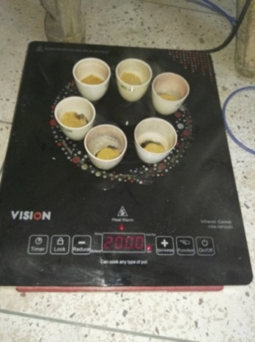
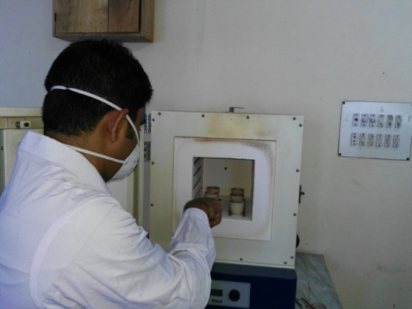

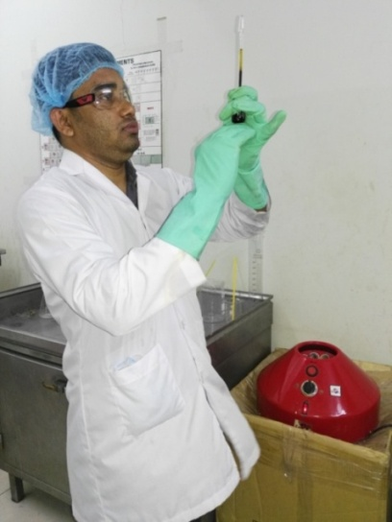
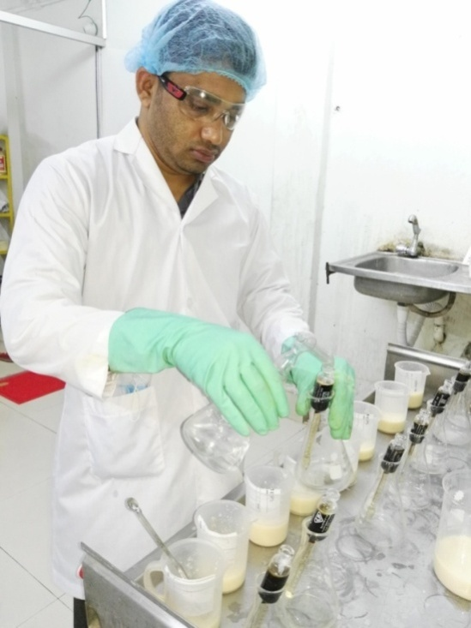
Figure: Determination of Ash

Figure: Determination of Fat

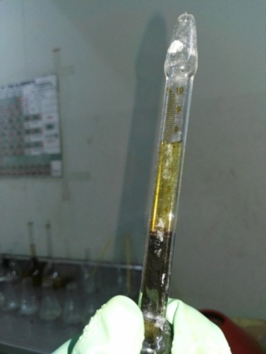
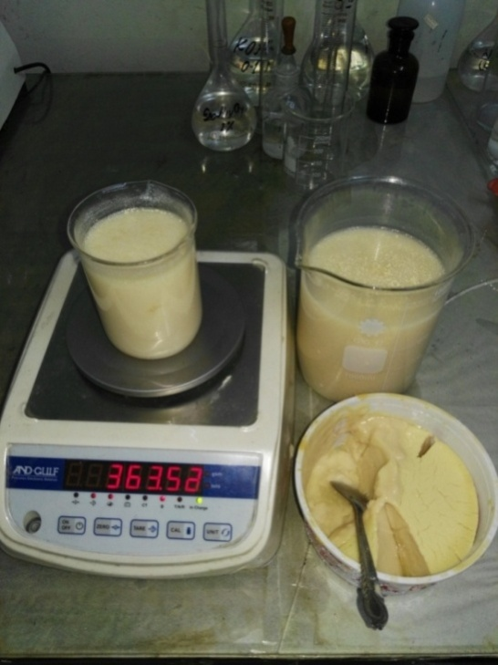

Figure: Sample Weighting

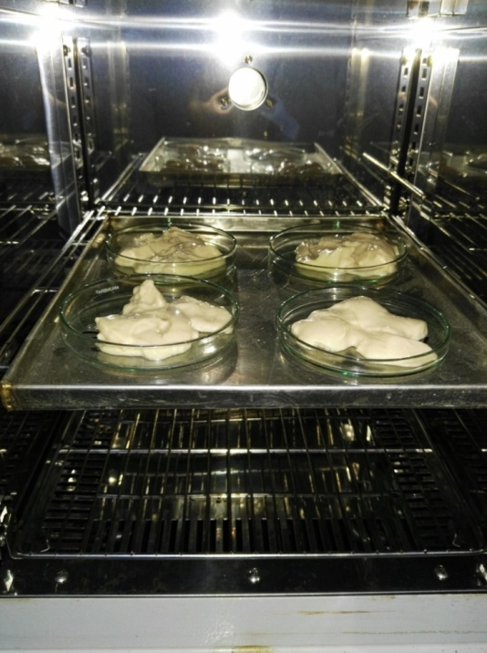
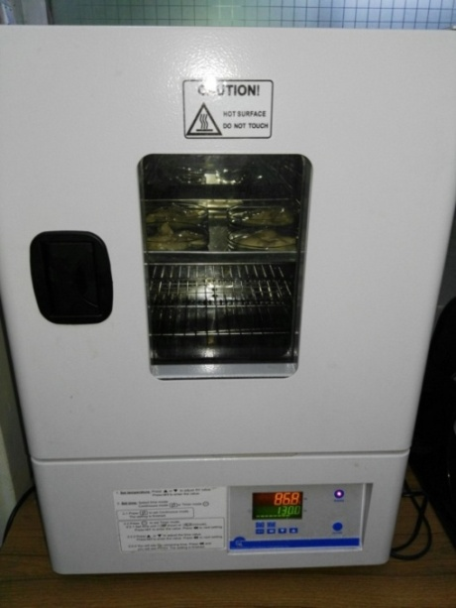

Figure: Determination of Moisture
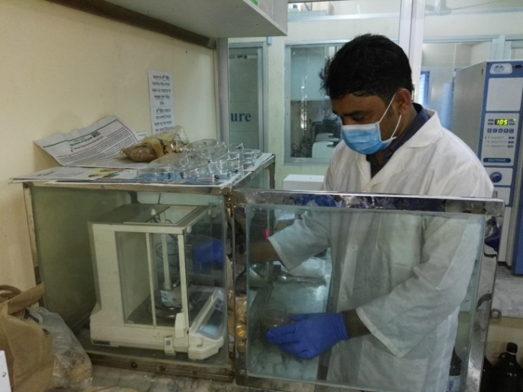
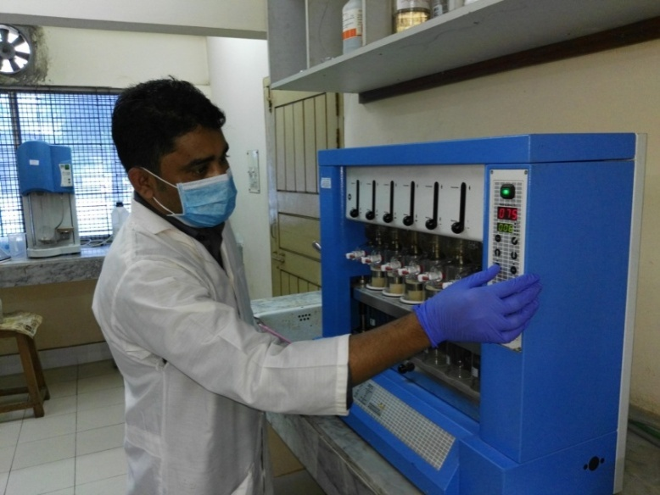
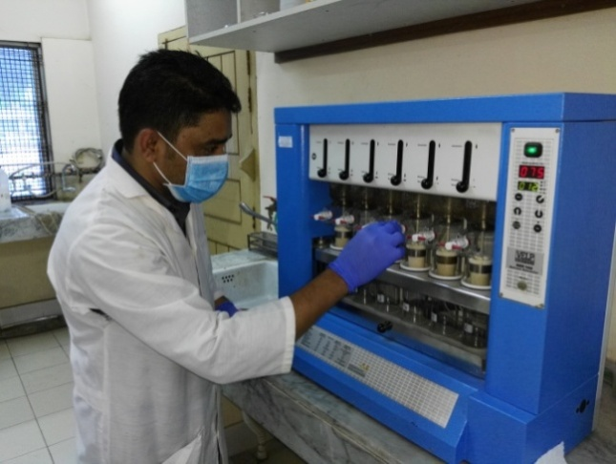
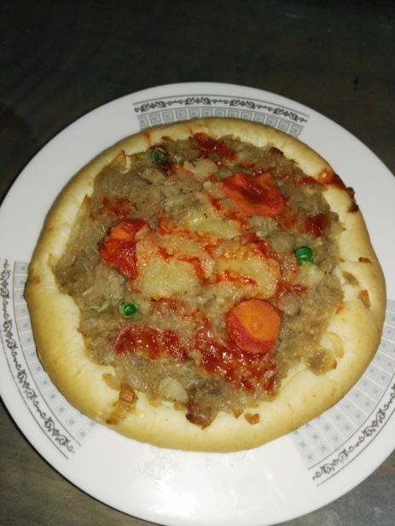

Figure: Determination of Protein

Brief Biography
Gias uddin passed the Secondary School Certificate Examination in 2006 from Palong Model High School, Court Bazar, Ukhiya, Cox’sbazar and the Diploma in Engineering in Food Technology Examination in 2010 from Cox’sbazar Polytechnic Institute, Cox’sbazar. Gias uddin obtained his B.Sc in Food Engineering and Technology in 2014 from State University of Bangladesh (SUB), Dhaka, Bangladesh. Now, he is a candidate for the degree of MS in Department of Food Processing & Engineering under Food Science & Technology Faculty; CVASU. He has immense interest to work in Nutritional value and Food safety issue of Street Food (Yogurt, Chotpoti and Salad dressing) that are Public health important.

